CHAPTER –I

INTRODUCTION

Poultry industry plays an important role in economic development and poverty alleviation of Bangladesh. The total chicken population is steadily increasing from about 143 million birds in 2001 to 195 million birds in 2006 (Dolberg, 2008) with growth rate of about 6.25% per year (Saleque, 2007).Normal requirement of animal protein as meat for a man is about 62.5 gm per day (Jabber, 1983).The total contribution of livestock sector to GDP in Bangladesh is approximately 6.5% (DLS, 2003) which generate 13% of foreign exchange and provides fulltime employment of about 20% and partial employment of 50% of the rural population (Ali, 1994). Poultry farming in Bangladesh is now considered as a growing industry.Poultry production is generally acknowledged as the most efficient and cost-effective way of increasing the availability of high protein food (FAO, 1987). Eggs have long been presented as the standard reference food that is perfectly balanced, containing most essential amino acids, minerals and vitamins. Approximately 11.5% of daily protein requirement and 5% of daily energy requirement is provided by one egg (Branckaert et al., 2000).

Among poultry, broiler rearing attributed its popularity to the farmers for its short life span and comparatively low capital investment (Raha, 2007). Broiler farming has also been playing a key role in providing meat containing high quality proteins and micronutrients, which has a tremendous impact on health and nutrition for the poor people in rural areas (Neumann et al., 2002 ) and (Barroetoa, 2007). Poultry meat production has had the largest expansion by a factor of four from 105 metric tons in 1992 to 420 metric tons in 2007. In 2006, total consumption of poultry meat is 5.9 kg per capita with 3.9 kg (66%) coming from the commercial broiler production sector (Dolberg, 2008).

Though the expansion and development of the poultry industry is remarkable but mortality of chickens due to outbreak of several infectious and non-infectious diseases are the major constrains for development of profitable poultry production in Bangladesh. Ali (1994) reported that almost 30% mortality of chickens in Bangladesh is due to outbreak of several infectious diseases. Outbreaks of concurrent diseases in poultry farm significantly affect the productivity and health status of the birds (Chanie et al., 2009). The prevalence of diseases in a particular area depends on various factors like geo-climatic condition, bio-security, management and

husbandry practices, immunization, social awareness, etc. To establish commercial poultry farms, the incidence of poultry diseases of the area should be considered for prevention and control of the diseases. Considering the above facts the present study was undertaken to study the prevalence of the infectious & non-infectious diseases in both broiler & layer chickens.The present study was undertaken to investigate (post mortem) the causes of mortality and to find out the cause of reduction of production in poultry in Bangladesh.

Objectives:
- To diagnose the poultry diseases by clinical findings and post-mortem examination in the study area.
- To estimate the prevalence of the diseases of poultry at Ramu Upazilla in Cox’s Bazar district.

CHAPTER-II

REVIEW OF LITERATURE

Literature on various aspects of diseases of poultry is highly voluminous, so only related literatures are reviewed here.
2.1 Occurrence of infectious diseases of poultry
Ahmed et al. (2009) conducted an investigation on 199 broiler chickens in Gazipur district showed that colibacillosis is the major problem for broiler production with a prevalence of 52.26%. Other prevalent diseases are mycoplasmosis (12.56%), omphalitis (11.56%), Infectious Bursal Disease (11.06%), coccidiosis (4.52%), salmonellosis (1.01%) and mixed infection of IBD and Coccidiosis (1.51%).

Yunus et al. (2009) conducted a study in Chakwal district of Pakistan showed in broilers, incidence of coccidiosis, ascites, and IBD decreased with increase in flock size, while coccidiosis was the most prevalent disease during 2nd and 3rd week of their life. Incidence of Newcastle Disease, mycoplasmosis and respiratory diseases increased linearly with increase in age of the broilers.

Rahman et al.( 2007) reported among bacterial diseases salmonellosis (53.90%), omphalitis (28.42%), colibacillosis (13.36%), mycoplasmosis (2.55%), necrotic enteritis (1.18%) and infectious coryza (0.59%) were found in chickens.

Islam et al.(2003) conducted a pathological investigation on poultry diseases in Sylhet region reported poultry diseases occur mostly in rainy season (56.36%), followed by summer (28.11%) and least in winter season (15.53%). IBD (24.26%) and aspergillosis (17.53%) are the major prevalent diseases.

Saleque et al. (2003) reported colibacillosis (26.6%), salmonellosis (24.2%), IBD (45.3%), ND (0.9%), coccidiosis (1.9%) and aspergillosis (1.1%) found in broiler chickens.
Rahman and Samad (2003) showed the pattern of occurance of single disease infection (76.30%) and mixed infections (23.70%) of two (21.53%), three (1.83%) and four (0.34%) were associated with mortality of chickens in Bangladesh.

Giasuddin et al.(2002) reported incidence of aflatoxicosis (27.59%) was highest followed by nutritional deficiency (12.40%), IBD (11.80%), Chronic Respiratory Disease (8.11%), ND (7.50%), salmonellosis (5.56%), colibacillosis (94.42%), and fowl cholera (3.08%).

Talha et al.(2001) conducted necropsy of 381 cases of either dead or sick birds and observed IBD in 19.16% , ND in 10.24% , lymphoid leucosis in 1.57% , colibacillosis in 5.51% , infectious coryza in 0.52% , mycoplasmosis in 8.66% , aspergillosis in 4.20% , aflatoxicosis in 1.05% , deficiency disorder in 8.14% and miscellaneous diseases condition in 7.09% .

2.2 Clinical signs and post-mortem findings
2.2.1 Colibacillosis
Ewers et al.(2003) stated that infections with pathogenic E. coli (APEC) cause colibacillosis, an acute and mostly systemic disease characterized by multiple organ lesions with air saculitis, pericarditis, perihepatitis and peritonitis resulting in significant economic losses in poultry industry worldwide.

Hanson et al.( 2001) pointed that cellulitis can develop at any age of bird, and the lesions were frequently associated with other manifestations of colibacillosis (pericarditis, perihepatitis, airsacculitis) in birds challenged from four to sixteen weeks of age.

Gross (1994) categorized the various pathological menifestations as yolk sac infection, air sac disease, bacteraemia, salpingitis, peritonitis, swollen head syndrome, cellulitis, enteritis, synovitis and osteomyelitis.

2.2.2 Salmonellosis
Samad (2005) reported in salmonellosis petechial haemorrhage or focal necrosis in the liver and spleen along with bronze discoloration are typical.
Whiteman et al. ( 1989) stated in pullorum disease classically there are gray nodules in one or more of the following sites: lung, liver, gizzard wall, heart, intestinal or caecal wall, spleen, peritoneum.

Chishti et al. (1985) reported that post-mortem lesion of pullorun infection which included bronze discoloration of liver (75%), mottling (25%), haemorrhagic (60%) and necrotic foci (11%). In infection due to Salmonella gallinarum the liver showed bronze discoloration (60%), mottling haemorrhage (45%) cases and necrotic foci (10%) .

2.2.3 Omphalitis
Kahn et al.(2008) said that omphalitis is a condition characterized by infected yolk sacs, often accompanied by unhealed navels in young fowl. It is infectious but noncontagious and affected chicks or poults usually appear normal until a few hours before death. Depression, drooping of the head, and huddling near the heat source usually are the only signs. Opportunistic bacteria (Coliforms, Staphylococci, Pseudomonas spp, and Proteus spp.) are often involved, and mixed infections are common.

Kamal (1989) described the necropsy lesions of omphalitis as curled and coinsiderably thicken unabsorbed yolk in all chicks. The covering of yolk appeared to be highly inflamed, thickened and edematous. The blood vessels around yolk were highly congested and hemorrhages were also evident in these areas. The livers in few chicks were markedly pale.

2.2.4 Mycoplasmosis
Whiteman et al. (1989) sited a history of chronic respiratory diseases accompanied by lowered feed consumption, poor gains or lowered egg production is suggestive of Mycoplasma gallisepticum.

Nunaya et al.(1995) Respiratory rales, sometimes coughing, ocular and nasal discharges characterize the disease ,but may often be confused with other diseases.
Bradburry (2001) stated gross lesions of respiratory tract may be almost rarely visible or consist of excess mucous and catarrhal exudates in nasal and Para nasal passages trachea bronchi and air sacs.

Rodrigues et al. ( 2001) reported in mixed infection with E. coli the pathological changes are gastroenteritis, hepatomegaly, hemorrhages on liver few pale colored foci, perihepatitis and congestion of kidneys. In addition hemorrhages in lungs exudates and linear hemorrhages in trachea, cloudiness and marked edema in the facial subcutis and eyelids due to exudation are also found.

2.2.5 Coccidiosis
Boado et al. (1991) reported coccidiosis could occur at any stage of the chicken's life and during any season of the year; however, it was found to be more prevalent in summer season.

Kahn et al. (2008) said that Eimeria tenella infections are found only in the ceca and can be recognized by accumulation of blood in the ceca and by bloody droppings. E. acervulina, the most common infection, is characterized by numerous, whitish, oval or transverse patches in the upper half of the small intestine and may be easily distinguished on gross examination. E. brunette is found in the lower small intestine, rectum, ceca, and cloaca. E. maxima develop in the small intestine, where it causes dilatation and thickening of the wall; petechial hemorrhage; and reddish, orange, or pink viscous mucous exudate and fluid.

2.2.6 Infectious Bursal Disease
Whiteman et al. (1989) stated IBD is an acute, contagious, viral disease of young chickens characterized by diarrhoea, vent pickling, trembling, incoordination, inflammation followed by atrophy of the bursa of fabricious and a variable degree of immunosupression.

Calnek (1997) reported that the incubation period of IBD is very short and clinical signs of the disease are seen within 2-3 days. It is characterized by thigh muscle hemorrhage, swollen and edematous bursa, high morbidity and mortality in chickens.

Butcher and Miles (2001) found IBD occurred in two form sub-clinical form and clinical form, depending on the age at which chickens were infected. The subclinical form occurred in chickens less than 3 weeks of age. The clinical signs of the disease include dehydration, trembling, ruffled feathers, vent pecking and depression. Initially the bursa of fabricius was swollen (inflamed); appears edematous and hyperemic and had a gelatinous, yellowish transudate covering the aerosol surface.

2.2.7 Newcastle disease
Alexander DJ (2008) said that ND virus strains are grouped into 5 pathotypes based on the clinical signs induced in chickens (i) Viscerotropic velogenic cause a high virulent form of disease in which haemorrhagic lesions are characteristically present in the intestinal tract (ii) Neurotropic velogenic cause high mortality following respiratory & nervous signs (iii) Mesogenic cause respiratory and sometimes nervous signs with low mortality (iv) Lentogenic respiratory cause mild or inapparent respiratory infection and (v) Asymptomatic enteric cause inapparent enteric infection.

Whiteman et al. (1989) stated at necropsy hemorrhagic or necrotic focal lesions are present in the mucosa of the intestine. Hemorrhages occasionally occur on the mucosal surface of the provetriculus. Caecal tonsils often are necrotic and hemorrhagic.

Chakrabaarti (1993) said that though there was no age restriction as regard infection but the young birds are more susceptible over the old birds. The post-mortem findings of ND were congestion, petechiation, cellular infiltration of iris and anterior chamber of eye, airsacculitis, cloudiness of air sac, edema, exudation, hypertrophy of mesothelium, pin point (petechial) haemorrhage on the apex of proventricular glands, haemorrhage under the horney layer of the gizzard, ulceration or bran like deposition in intestine.

2.2.8 Aspergillosis
Lange (1914) recorded nodules in the lungs and the thoracic and abdominal cavities of chickens.
The lesions depend considerably on the site of infection. Either localization/generalization may be observed. Individual lesions may be observed for example, in the syrinx or in a single air sac. The lungs are most frequently involved. Pulmonary lesions vary from miliary nodules up to larger nodules. In some cases there may be localized hepatization, and in others grossly visible mycelia masses may be present in the air passages and bronchi. There may be generalized involvement of the air sacs. Occasionally a circular disc-shaped necrotic mass with a concave surface, loosely attached to which there is a circular more or less flat or convex plaque, may be observed. Various manifestations of the disease have been described.

CHAPTER-III

MATERIALS AND METHODS

3.1 Study area
The study was undertaken at Ramu upazilla under Cox’s Bazar district .

3.2 Study period
The study was performed from May 2013 through June 2013 for a period of two months.

3.3. Data collection
Information about the management system and clinical signs exhibited by an individual bird during illness were recorded as provided by the respective poultry farm owners and stuffs through questionnaire. Beside this, name of the strains of birds, number of birds in farm, age of bird, vaccination record, diseases found in the batch, name of vaccine used, number of birds died, treatment measures if taken were also recorded.

3.4 Working procedure
Post-mortem examinations of the dead and affected birds were done in the Veterinary Hospital of Ramu Upazilla under the guidance of Veterinary Surgeon. A total of 61 cases broiler birds and 18 cases layer birds were examined during the study period. Necessary information and data related to the diagnosis was taken from the farmers and workers of the farm.

3.5 Post-mortem examination
Post mortem examination of dead and clinically ill birds supplied to the veterinary hospital was done and diseases were recorded. The birds were examined systematically and gross pathological changes were observed and recorded carefully. Final diagnosis of the diseases was done based on clinical history, clinical signs and post-mortem findings.

Clinical signs and post-mortem findings were considered to fix a diagnosis for a particular diseases are mentioned in Table -1 and Figure-1.
Table -1: Clinical signs and post-mortem findings of different diseases of poultry
Name of the disease | Clinical signs | Post-mortem findings
Colibacillosis | - Listless and ruffled feathers  - Reduced food and water intake  - Huddling at corner of the shed  - Loss of body weight  - Brown color droppings | - Distended and soft abdomen  - Pericarditis [ Fig.-1( d ) ]  - Perihepatitis [ Fig,-1( d ) ]  - Air sac infection  - Omphalitis  - Edema in the body cavities  - Swollen and inflamed intestine
Salmonellosis | - Ruffled feather  - Whitish to greenish diarrhea  - Chalky white excreta adhered with the vent  - Anemic comb and wattle | - Enlarged liver and spleen showing congestion and necrotic foci  - Unabsorbed and inflamed yolk sac  [ Fig.-1 ( f )]
Omphalitis | - Lathergic  - Depressed and  - Poor growth performance | - Distended and soft abdomen  - Thickened and unabsorbed yolk  - Cloudy and malodorous abdominal content [ Fig.-1 ( c ) ]  - Blood vessels around the yolk were highly congested
Coccidiosis | - Ruffled feather  - Poor growth  - Bloody diarrhea and anaemia  - Vent picking | - Caeca filled with blood tinged contents [ Fig.-1 ( h ) ]  - Caecal wall show patchy hemorrhages  - Diffuse hemorrhagic striation throughout the intestine

Name of the disease | Clinical signs | Post-mortem findings
Newcastle Disease (ND) | - Depression and prostration  - Loss of appetite  - Greenish/yellowish diarrhea  - Incoordination  - Twitching of neck | - Pin point haemorrhage at the tip of the proventicular glands. [ Fig.-1 (j) ]  - Haemorrhagic/diptheric ulcers on the intestine and caecal tonsils
Infectious Bursal Disease (IBD) | - Soiled vent and feathers  - Whitish and watery diarrhea  - Anorexia, trembling severe prostration and death | - Swollen and edematous bursa with necrotic mass  - Haemorrhages in the thigh and breast muscles [ Fig.-1 ( g ) ]  - Haemorrhage at the junction of proventiculas and gizzard  - Nephrosis
Avian Influenza | - Decreased egg production  - Coughing, sneezing, rales, lacrimation & sinusitis | - Thickened air sacs & contain fibrinous or caseous exudates  - Edema of tracheal mucosa  - Cyanosis, congestion , hemorrhages on wattle, combs & legs
Visceral gout | - Ruffled feather & moist vent  - Sometimes greenish diarrhea  - Depression, dehydration | - Swollen kidney  - Urate crystals deposited in liver, kidney,air sac, joints, pericardium [ Fig.-1 ( i ) ]
Aspergillosis | - Dysponea, gasping, Labored breathing. | - Yellow white pin point hemorrhage in body cavities  - white caseous nodule in the lung or air sac [ Fig.-1 (e) ]
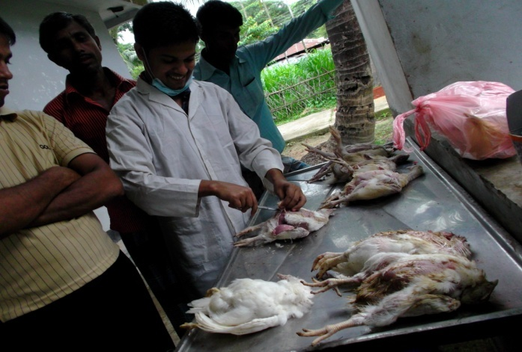
Fig. -1 : Post-mortem lesions and findings of poultry diseases
Fig.-1(a): Postmortem of Broiler

Fig.-1(b):Postmortem of Layer

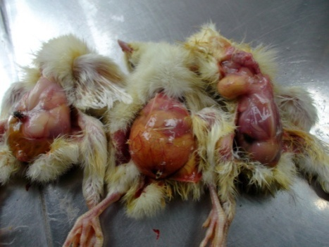
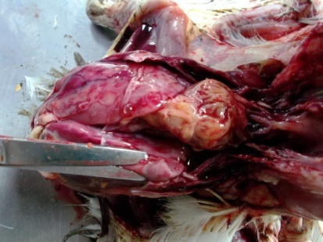
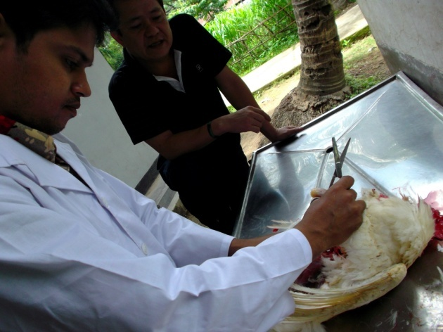
Pericarditis & Perihepatitis
Fig.-1(d): Colibacillosis
Fig.-1 (c): Omphalitis in Chickens
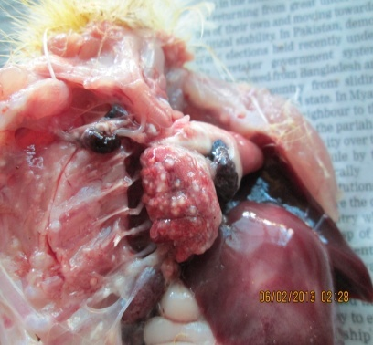
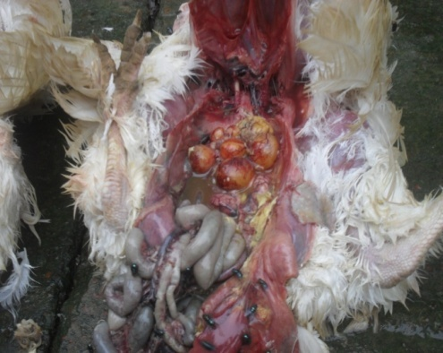
Mis-shaped eggs

Nodule in Lung
Fig.-1(e): Aspergillosis
Fig.-1(f): Salmonellosis
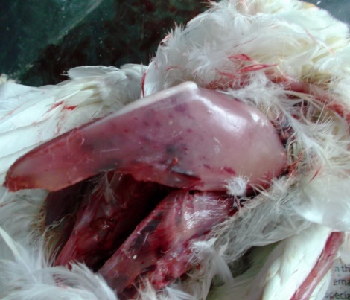
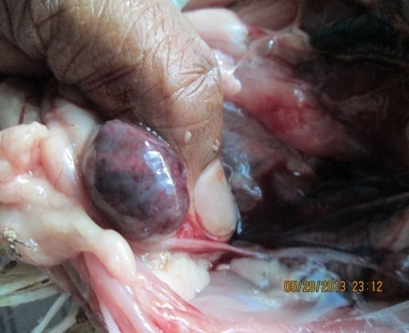

Hemorrhagic Bursa
Hemorrhagic breast muscle
Fig.-1(g): Infectious Bursal Disease (IBD)
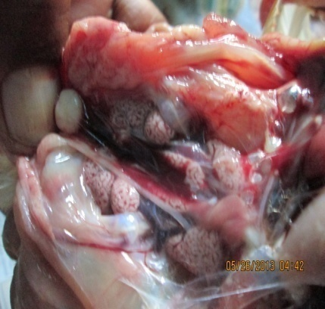
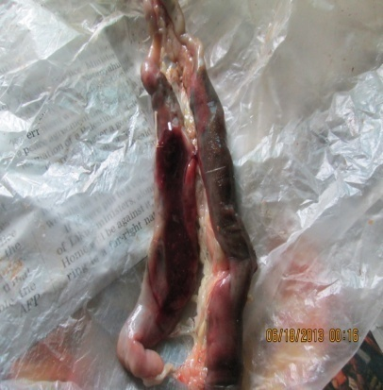

Urates Crystal in kidney
Clotted blood

Fig.-1(h): CecalCoccidiosis
Fig.-1(i): Visceral Gout
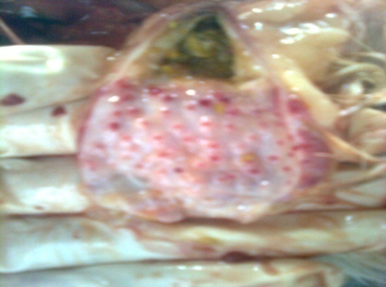
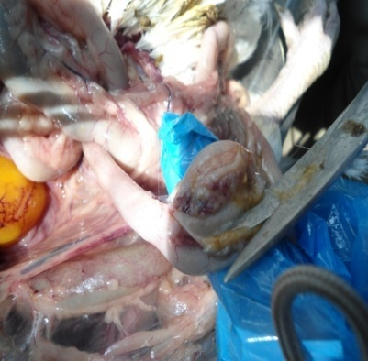

Hemorrhage in Cecal tonsil
Hemorrhage at top of Proventriculus

Fig.-1(j): Newcastle Disease (ND)

3.6 Laboratory based activites to diagnose poultry diseases
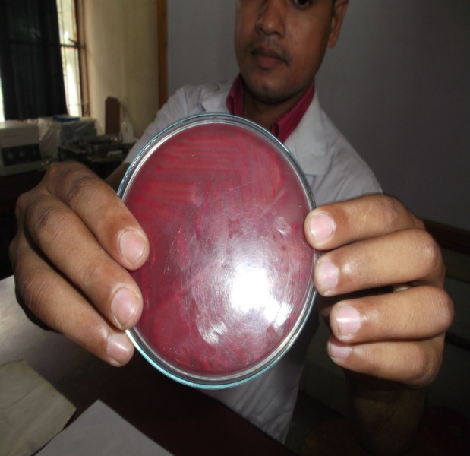
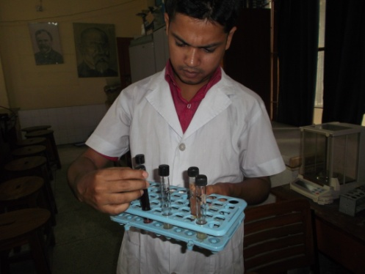

Colony in MacConkey Agar
Colibacillosis Test
Salmonellosis Test
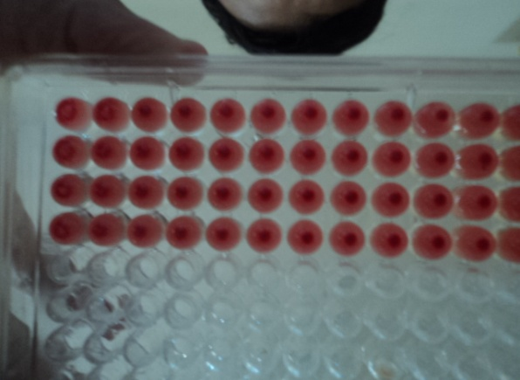
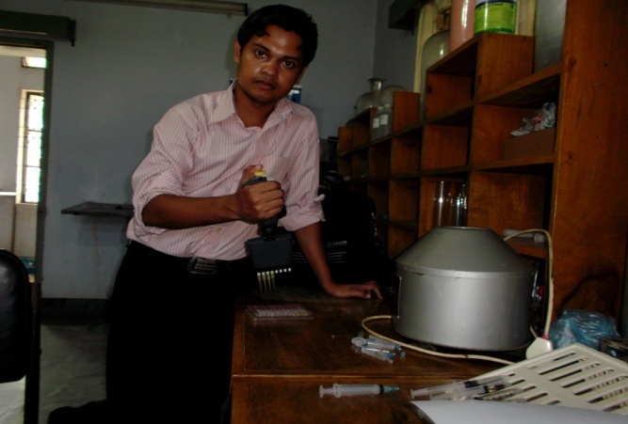

HI Test in Vet. Hospital to know the Titre of ND Vaccine in layer
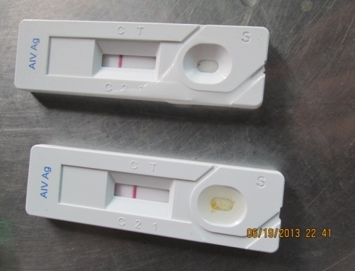
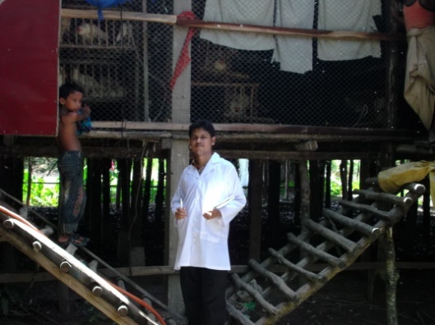

Rapid Test

Farm Visitation at Ramu Upazilla
Avian Influenza Test

3.7 Statistical analysis
Data were imported and stored in Epi- info Software,Version 3.5.4. Descriptive statistics were performed by using Microsoft Excel-2007.
CHAPTER-IV

RESULTS

A total number of 79 cases of which 61 broilers and 18 layers were examined through the entire study period. The prevalence of Infectious Bursal Disease (31.15%, 16.67%),Newcastle Disease (24.59%, 11.11%), Colibacillosis (13.11%, 16.66%), Coccidiosis (11.47%, 11.11%), Omphalitis (9.84%, 11.11%), Aspergillosis (4.92%, 5.56%), Visceral Gout (3.28%, 5.56%), salmonellosis (1.64%, 22.22%) were found in broiler and layer respectively. Prevalence of the different diseases of broiler and layer are given in Table- 2.

Table -2: Prevalence of different diseases of poultry ( broiler and layer )
Sl. No. | Name of Diseases | Prevalence of Poultry Diseases (%) |  |  |  | P-Value
 |  | Broiler |  | Layer
 |  | No. of cases | Prevalence (%) | No. of cases | Prevalence (%)
01 | Infectious Bursal Disease (IBD) | 19 | 31.15 | 3 | 16.67 | 0.228
02 | Newcastle Disease (ND) | 15 | 24.59 | 2 | 11.11 | 0.221
03 | Colibacillosis | 8 | 13.11 | 3 | 16.66 | 0.702
04 | Coccidiosis | 7 | 11.47 | 2 | 11.11 | 0.965
05 | Omphalitis | 6 | 9.84 | 2 | 11.11 | 0.874
06 | Aspergillosis | 3 | 4.92 | 1 | 5.56 | 0.914
07 | Visceral Gout | 2 | 3.28 | 1 | 5.56 | 0.657
08 | Salmonellosis | 1 | 1.64 | 4 | 22.22 | 0.002
Total |  | 61 | 100 | 18 | 100
*P-Value = level of significance at 95 % confidence interval

Table -3: Prevalence of different diseases of broiler in relation to age
Sl. No. | Name of Diseases | Prevalence of Broiler Diseases (%) |  |  |  |  |  |  |  | P-Value
 |  | Age Group (Days )
 |  | 0 - 7 |  | 8-14 |  | 15-21 |  | >21
 |  | No. | % | No. | % | No. | % | No. | %
01 | Infectious Bursal Disease (IBD) | 0 | 0 | 2 | 3.28 | 5 | 8.20 | 12 | 19.67 | <0.000
02 | Newcastle Disease (ND) | 0 | 0 | 2 | 3.28 | 7 | 11.47 | 6 | 9.84 | 0.025
03 | Colibacillosis | 1 | 1.64 | 0 | 0 | 4 | 6.56 | 3 | 4.91 | 0.160
04 | Coccidiosis | 1 | 1.64 | 2 | 3.28 | 0 | 0 | 4 | 6.55 | 0.161
05 | Omphalitis | 6 | 9.84 | 0 | 0 | 0 | 0 | 0 | 0 | <0.000
06 | Aspergillosis | 1 | 1.64 | 1 | 1.64 | 1 | 1.64 | 0 | 0 | 0.798
07 | Visceral Gout | 0 | 0 | 1 | 1.64 | 1 | 1.64 | 0 | 0 | 0.569
08 | Salmonellosis | 1 | 1.64 | 0 | 0 | 0 | 0 | 0 | 0 | 0.390
Total |  | 10 | 16.4 | 8 | 13.12 | 18 | 29.51 | 25 | 40.97
*P-Value = level of significance at 95 % confidence interval

Fig.-2 : Prevalence of different diseases of broiler in relation to age

The fig.- 2 showing that the highest number of cases was recorded in the age group of > 21 days (40.97%), followed by the age group of 15-21 (29.51%), 0-7 (16.40%) and 8- 14 days (13.12%) . Higher prevalence of IBD (19.67%) in > 21 days, ND (11.47%) in 15- 21 days, Colibacillosis (6.56%) in 15- 21 days, Coccidiosis (6.55%) in > 21 days , Omphalitis (9.84%) in 0-7 days, Aspergillosis (1.64%) in 0-7, 8-14 and 15-21days, Visceral Gout (1.64%) in 8-14, 15-21 days and Salmonellosis (1.64%) in 0-7 days were recorded .

Table 4: Prevalence of different diseases of layer in relation to age

Sl. No | Name of Diseases | Prevalence of Layer Diseases (%) |  |  |  |  |  | P-Value
 |  | Age Group
 |  | Grower (0- 8 wks) |  | Pullet ( 9-20wks) |  | Layer (>20 wks)
 |  | No. | % | No. | % | No. | %
01 | Infectious Bursal Disease (IBD) | 2 | 11.11 | 1 | 5.56 | 0 | 0 | 0.347
02 | Newcastle Disease (ND) | 0 | 0 | 0 | 0 | 2 | 11.11 | 0.125
03 | Colibacillosis | 1 | 5.55 | 1 | 5.55 | 1 | 5.56 | 1.00
04 | Coccidiosis | 1 | 5.56 | 1 | 5.55 | 0 | 0 | 0.595
05 | Omphalitis | 2 | 11.11 | 0 | 0 | 0 | 0 | 0.125
06 | Aspergillosis | 1 | 5.56 | 0 | 0 | 0 | 0 | 0.361
07 | Visceral Gout | 0 | 0 | 0 | 0 | 1 | 5.56 | 0.361
08 | Salmonellosis | 0 | 0 | 2 | 11.11 | 2 | 11.11 | 0.339
Total |  | 7 | 38.89 | 5 | 27.77 | 6 | 33.34
*P-Value = level of significance at 95 % confidence interval

Fig-3 : Prevalence of different diseases of layer in relation to age

The fig.- 3 showing that the highest number of cases was recorded in the age group of grower period (38.89%), followed by the age group of layer period (33.34%) and pullet period (27.77%) . Higher prevalence of IBD (11.11%) in grower period, ND (11.11%) in layer period, Colibacillosis (5.55%) in grower, pullet and layer period, Coccidiosis (5.56%) in grower and pullet period, Omphalitis (11.11%) in grower period, Aspergillosis (5.56%) in grower period, Visceral Gout (5.56%) in layer period and Salmonellosis (11.11%) in pullet and layer period were recorded.

CHAPTER-V
DISCUSSION
The study revealed that the prevalence of Infectious Bursal Disease of broiler was highest at Ramu Upazilla (31.15%) .The prevalence was higher than some of the previous reports evidenced by Islam et al. (2003) (24.26%), Talha et al. (2001) (19.16%), Ahmed et al. (2009) (11.06%) and Giasuddin et al. (2002) (11.80%). The prevalence of IBD in layer was recorded 16.67% which was lower than Talha et al. (2001) (19.16%) and higher than Ahmed et al. (2009) (11.06%) and Giasuddin et al. (2002) (11.80%). Most of the IBD infected farms in the study area were vaccinated against IBDV. Findings of the study indicated that in most cases vaccination could not protect the birds. This might be due to not maintaining proper cool chain, uneven level of maternal antibody, inexperience vaccinator, improper dose and faulty management system.The prevalence of Infectious Bursal Disease (31.15%) was higher in broiler in comparison to layer (16.67%). In relation to age in broiler, the prevalence of IBD was significantly ( p < 0.05) higher compared to layer which support the report of Mbuko et al. (2010 ).In relation to age in broiler and layer, the higher prevalence of IBD was recorded 19.67% in the age of > 21 days and 11.11% in grower period which supported the report of Mbuko et al. ( 2010 ).
In the investigation, prevalence of ND in broiler and layer was found 24.59% and 11.11% that was higher than Giasuddin et al. (2002) ; Islam et al. ( 2003) who reported 7.50% and 6.73% respectively. In relation to age in broiler and layer, the higher prevalence of ND was recorded 11.47% in the age of 15-21 days and 11.11% in layer period which supported the report of Yunus et al. ( 2008 ). In relation to age in broiler, the prevalence of ND was significantly ( p< 0.05) higher compared to layer which supported the report of Yunus et al. (2008 ).
Colibacillosis in broiler and layer was recorded 13.11% and 16.66%. The prevalence was lower than 52.26% that was reported by Ahmed et al. ( 2009) in Gazipur district, but higher than the 12.13% that was reported by Talha et al. ( 2001) in Mymensingh region. In relation to age in broiler and layer, the higher prevalence of Colibacillosis was recorded 6.56% in the age of 15-21 days and 5.56% in layer period. Pandey et al. (1998) conducted a systemic study on Escherichia coli outbreak prevalence in which November to March recorded much higher number of outbreaks due to hot, humid and rainy season, which support the study. Stress may enhance the virulence of E. coli, leading to disease Talha et al. (2001).
Coccidiosis in broiler and layer constituted 11.47% and 11.11% of prevalence in the study which was close to the result of Islam et al. (2003) (9.86%) but disagreed with the report of Talha et al. (2001) (4.2%) and Ahmed et al. (2009) (4.2%). some factors like improper cleaning disinfectant before introducing day old chick increase susceptibility of diseases of coccidiosis Saleque et al. ( 2003).
Omphalitis in broiler and layer was recorded 9.84% and 11.11% in the study which was close
to the report of Ahmed et al. (2009) (11.56%). In relation to age in broiler and layer, the higher prevalence of Omphalitis was recorded 9.84% in the age of 0-7 days and 11.11% in grower period which support the report of Amare et al. (2013 ) and the prevalence of Omphalitis was significantly ( p< 0.05) higher compared to layer which supported the report of Amare et al. ( 2013 ).
Aspergillosis in broiler and layer was recorded 4.92 % and 5.56 % which was lower than Islam et al. (2003) (17.53%). In relation to age , the prevalence of aspergillosis in layer in grower period (5.56%) was higher than broiler ( 1.64% ). This is due to faulty management system of poultry which supported the report of Kwanashie et al. (2012) .
Visceral Gout in broiler and layer was recorded 3.28 % and 5.56 % which was similar to the report of Sonmez ( 1992 ) but disagreed with the report of Ibrahim et al. ( 2010 ) ( 1.1 %) . The is due to intake high protein diet which support the findings of Mir et al. (2005 ) that mortality of 18.77 % was reported in Kashmir favorella poultry over a period of 6 month which was attributed to 16.39 % crude protein in poultry feed .
Salmonellosis in layer was recorded 22.22% .This finding was closely to the result of Sikder et al. (2005) (23.46%). But Uddin (2010) reported that prevalence of Salmonellosis was 7.68%. Salmonellosis in broiler was recorded 1.64% which was lower than Uddin (2010) ( 7.68%). The prevalence of Salmonellosis (22.22%) was significantly (P<0.05) higher in layer compared to broiler (1.64%).The prevalence can vary in terms of age groups.. It indicated that sero prevalence varied with the increase of age of the birds, which supported the findings of Truong and Tieuquang (2003), Sikder et al. ( 2005) and Islam et al. (2006).The prevalence of salmonella infection was higher in summer season than in winter Sarker(2004). It might be due to the influence of hot weather and sudden rainfall.
CHAPTER-VI

CONCLUSION AND RECOMMENDATIONS

According to the study findings of poultry diseases situation in the broiler and layer industry at Ramu Upazilla in Cox’s Bazar district is unsatisfactory. The prevalence of Infectious Bursal Disease (31.15%), Newcastle Disease(24.59%) in broiler and Salmonellosis (22.22%), Infectious Bursal Disease (16.67%), Colibacillosis (16.66%) in layer were the major constraints for broiler and layer production in this area. Hence the farmers cann’t earn their profit . Due to failure of vaccine in case of IBD, viral diseases and bactrial diseases farmers both losses their poultry as well as the vaccine cost. This study suggest that, to maintain good farm practices it is very important to vaccinate the birds of the flock at proper time with proper dose and schedule. Besides, It is necessary to assess the management system and husbandry practices of those farms that were affected by different diseases. For confirmatory diagnosis further laboratory examination and advance techniques is needed to identify the specific diseases. However this study will stimulate our interest and show new light on the level of disease episodes prevailing at present days. Therefore it is expected that the present work may be of great value to create awareness among the farmers and related quarters to direct preventive measures to make poultry farming a successful enterprise.

CHAPTER-VII

REFERENCES

Ahmed MS, Sarker A and Rahman MM (2009). Prevalence of Infectious Diseases of Broiler Chickens in Gazipur District. Bangladesh Journal of Veterinary Medicine. 7(2): 326 – 331.

Alexander JD (2008). Paramyxoviridae: Newcastle Disease and Other Paramyxoviruses in Poultry Diseases, 6th edition. Elsevier Limited. Chapter 25, Pp: 296.

Ali MJ (1994). Current Status of Veterinary Biologics Production in Bangladesh and Their Quality Control. Proceedings of the BSVER Symposium at NIPSOM auditorium, Mohakhali, Dhaka, Bangladesh.

Amare A, Amin AM, Shifera WA, Nazir S and Negussie H (2013). Yolk Sac Infection (Omphalitis) in Kombolcha Poultry Farm, Ethiopia. American-Eurasian Journal of Scientific Research. 8(1) : 10-14.

Barroetoe AC (2007). Nutritive Value of Poultry Meat and Relationship Between Vitamin E and PUFA. World Poultry Science Journal.63 : 21-22.

Boado E, Laurenl E, Herrera C, Quintero D and Canovas D (1991). Prevalence of the Major Diseases in Different Categories of Poultry During the Different Seasons of the Year. Poultry Abstract.19 :164.

Bradbury JM (2001). Avian Mycoplasmosis, In: Frank Jordan et al. (eds.) Poultry Diseases, 5th Edition. W.B. Saunders Company Iowa.Pp: 832-837.
Branckaert RDS, Gaviria I, Jallade J and Seiders RW (2000). Transfer of Technology in Poultry Production for Developing Countries.,FAO, Rome. http://www.fao.org/sd/cddirect/cdre0054.htm. (Accessed on 21st March,2014 ).

Butcher G and Miles RD (2001). Infectious Bursal Disease (Gumboro) in Commercial Broilers, University of Folorida. Pp: 01-07.

Calnek BW (1997). Diseases of Poultry, 10th Edition.Iowa State University Press, Ames, Iowa, USA.Pp :1012-1233.

Chakrabarti (1993). A Text Book of Veterinary Medicine, 3rd Edition.Kalayani Publishers, New Delhi.Pp :709-718.

Chakrabarti A (1993). Practice of Poultry Medicine. Kalyani Publishers, New Delhi.Pp : 709- 718.

Chanie M, Neqash T and Tilahan SB (2009). Occurrence of Concurrent Infectious Diseases in Broiler Chickens is a Threat to Commercial Poultry Farms in Central Ethiopia. Tropical Animal Health and Production .41 (7): 1309-1317.

Chishti MA, Khan MZ, Irfan M (1985). Pathology of Liver in Avian Salmonellosis in a Chicken.Pakistan Veterinary Journal. 5: 157-160.

DLS.(2003). Department of Livestock Services.Annual Report, Government of Bangladesh.

Dolberg F (2008). Poultry Sector Country Review of Bangladesh.Prepared by FAO Animal Production and Health Division, Emergency Centre for Transboundary Animal Diseases Socioeconomics, Production and Biodiversity Unit.Pp: 12.

Eldaghayes IM, Hamid AM, El-Attar SR and Kammon AM (2010).Pathology of Gout in Growing layers attributed to high calcium and protein. E-International Scientific journal.2:298.

Ewers C, Janssen T and Wieler LH (2003). Avian Pathogenic E. coli (APEC). Berliner and MunchenerWochenSchrift, Berlin, Germany.116:381-395.

FAO (1987).Termination Statement, Poultry development and Establishment of a poultry breeding farm, Bhutan, BHU/82/012, Rome.

Giasuddin M, Sil BK, Alam J, Koike I, Islam MR and Rahman MM (2002).Prevalence of Poultry Diseases in Bangladesh.Indian Journal of Poultry Science . 40 (1): 99-101.

Gross WB (1994). Disease due to Escherichia coli in poultry. Cited in E. coli in Domestic Animals & Humans. LL Gyler (ed). CAB International. Wallingtord, UK. Pp: 231-260 .

Hanson RP and Hichman SB (2001). C.H isolation and identification of avian pathogen. 5 : 12-16 .

Islam MM, Haider MG, Chowdhury EH, Kamruzzaman M and Hossain MM (2006).Sero prevalence and pathological study of Salmonella infections in layer chickens and isolation and identification of causal agents . Bangladesh Journal of Veterinary Medicine 4 (2): 79-85.

Islam MR, Das BC, Lucky NS and Mostafa MG (2003). A Study on Occurance of Poultry Diseases in Sylhet Region of Bangladesh. International Journal of Poultry Science.2 (5): 354-355.

Jabber M and Green DAG (1983). The status and potential of Livestock with context of agricultural policy in Bangladesh. The University of Wales Aberystwyth, UK .pp: 113.

Kwanashie CN , Abdu PA, Umoh JU and Kazeem HM ( 2012 ). Retrospective study of aspergillosis and other fungi in poultry . International Journal of Livestock Research . 2(3) : 84-88 .

Kahn CM (2008). Mark Veterinary Manual, 9th Edition. Merck & Co. Inc.
Whitehouse Station, NJ, USA .

Kamal AHM (1989). Pathological Investigation on the Mortality of Chicken in Bangladesh Agricultural University Poultry Farm.MSc thesis, Department of Pathology, Faculty of veterinary Science. BAU, Mymensingh.

Lange (1919). Wschimmlrilzenkankungen. 22: 642-43.
Mbuko IJ ,Musa WI , Ibrahim S , Saidu L, Abdu PA, Oladele SB, Kazeem HM (2010 ). A Retrospective Analysis of Infectious Bursal Diseases at Poultry Unit of Ahmadu Bello University, Nigeria.International Journal of Poultry Science.9(8): 784-790 .

Mir MS, Darzi MM, Khan AA, Ganaie NA, Gupta S, Nashiruddullah N and Kamil S (2005).Investigation of an Outbreak of Gout in Kashmir favorellaPoultry.Indian Journal of Veterinary Pathology . 29(1) : 35-37.

Neumann C, Harris DM and Rogers LM (2002). Contribution of Animal Source Foods in Improving Diet Quality and Function in Children in the Developing World. Nutrition Research.22 :193-220.

Nunoya TT, Yagihashi M and Nagasawa Y (1995).Occurance of Keratoconjunctivitis apparently caused by Mycoplasma gallisepticumin layer chickens. Veterinary Pathology. 32: 11-18.

Pandey GS, Tuchili CM, Kaneuchi C, Waya W and Nyeleti G (1998). Study on Avian Colibacillosis Outbreak and Drug Sensitivity of Escherichia coliIsolates in Luraka.Indian Veterinary Journal.75: 754-755.

Raha SK (2007). Broiler Industry in Bangladesh: Some Issues. International Poultry Show and Seminar.World's Poultry Science Association.Bangladesh Branch.

Rahman M (2007). Protein for All: Proceedings of 5th International Poultry Show and Seminar organized by World's Poultry Science Association, Bangladesh Branch.

Rahman M (2007). Bacterial diseases of Poultry prevailing in Bangladesh.Indian Journal of Poultry science.1 (1) : 1-6.
Rahman MA and Samad MA (2003). Pattern of Occurrence of Single and Concurrent Diseases Associated with Mortality in Commercial Chickens in Bangladesh. Bangladesh Journal of Veterinary medicine. 1 (1): 15-20 .

Rodrigues RE et al. (2001). Injuries in Broilers by Experimental Action of Mycoplasma gallisepticum and Escherichiacoli. International Journal of Veterinary Medicine.23(6): 240-243.

Saleque MA, Rahman MH and Hossain MI (2003). A Retrospective Analysis of Chicken Diseases Diagnosed at the BRAC Poultry Diagnostic Centre of Gazipur .Bangladesh Journal of Veterinary Medicine .1 (1) : 29-31.

Sarkar SK (2004). Epidemiology study of salmonella and Mycoplasma infection in selected model breeder poultry farm in Bangladesh , faculty of veterinary science,BAU, Mymensingh, Bangladesh.

Sikder AJ, Islam MA, Rahman MM and Rahman MB (2005). Seroprevalence of Salmonella and Mycoplasma galisepticum infection in the six model farms at Patuakhali district of Bangladesh. International Journal of Poultry Science 4: 905-910.
Sonmez, G (1992). Organ distribution and interrelationship of lesions in laying hens with gout And urolithiasis. Veteriner-Fakultesi-Dergisi, -Uludog –Universitesi.11: 81-92.

Talha AFSM, Hossain MM, Chowdury EH, Bari ASM, Islam MR and Das PM (2001). Poultry Diseases Occurring in Mymensingh District of Bangladesh. Bangladesh Journal of Veterinary Medicine.18:20-23.

Truong Q and Tieu QA (2003). Prevalence of Salmonella pulloruminfection in Luong Phuong chickens reared in the household sector. Khoa-Hoc-Ky-Thuat-Thu-Y-Veterinary Science and Technology.

Uddin MB, Ahmed SSU , Hassan MM , Khan SA and Mamun (2010 ). Prevalence of poultry diseases at Narsingdi , Bangladesh .International Journal of Biologic Research . 1( 6): 09-13.

Whiteman CE and Bickford AA (1989). Avian Disease Manual, 3rd edition.American association of avian pathologists.2:45-66.

Yunus AW, Nasir MK , Farooq U and Bohm J(2008).Prevalence of Poultry Diseases and Their Interation with Mycotoxicosis in District Chakwal: 1. Effects of Age and Flock Size .The Journal of Animal and Plant Sciences. 18(4): 108-112.

Yunus AW, Nasir MK, Aziz T and Bohm J (2009). Prevalence of Poultry Diseases in District Chakwal and Their Interaction with Mycotoxicosis: Effects of Season and Feed. The Journal of Animal and Plant Sciences. 19 (1): 1-5.

CHAPTER-VIII

APPENDIX

QUESTIONNAIRE

Diseases diagnosed in broiler and layer chickens by postmortem examination
Date: Sample No.:
1. Name of the owner & address:................................................
2. Total no. of birds:....................................................................
3. Total death with date:..................................................................
4. Age of the birds:......................................................................
5. Type of feed: a) mash b) pellet ………………………..............
6. Strain:....................................................................................
7. When the bird was died:.......................................................
8. Clinical signs described by the owners:………….…………..
9. Postmortem findings:
Head……………….......…… Spleen…………………....……..
Trachea……………………… Proventriculus………......………
Lung ……………………….. Gizzard………………………….
Liver ……………………… Air sac…………………………..
Intestine …………………… Caecal tonsil ……………………
Bursa ……………………… Yolk sac ……………………..….
others……………………..
10. Vaccination history:……………………………………………….
11. Tentative diagnosis based on post mortem examinations: ………
12. Treatment given: Rx………………………………………....……

…………………………………………
Signature of the interviewer

