**Chapter-I**

**INTRODUCTION**

The digestive tract of chickens conveys food of the stomach: this system comprises, the crop, an expansion of the esophagus, located in the lower neck area,the glandular stomach (Proventriculus), the muscular stomach gizzard & intestine .The anterior partition of the tract is adapted for ingestion, storage, and partial digestion of starch and proteins. The structure of the avian intestine is similar to that of other monogastrics except that lacteals are not found. Damage to the intestinal epithelium may decrease nutrient adsorption, whereas epithelial replacement may result in improved nutrient utilization.

The total length and weight of the avian GI tract is believed to markedly influence the utilization of feed processed by it. The total length and weight of the small intestine varied between the different species of birds (Hassouna,E.M.A et al..,2001).Nutrient absorption is important at all stages of life. The small intestine, especially the crypts and villi of the absorptive epithelium play significant roles in the final stage of nutrient digestion and assimilation. Studies on the small intestine have revealed that the size of the small intestine and its digestive activites are altered during development in animals(King et al,2000;Fan et al;2002;Wang et al;2003;Adeola and king 2006;Olukosi et al..;2007 a,b).

Differential development of the absorptive epithelium may be responsible for changes in absorption capacity of birds(Verdal et al..;2010). Available strains of broilers(eg.Cobb-500,cobb-700,arbor acress, lohman etc.) are the result of genetic modification. They grow fast with better feed conversion ratio (FCR) than any other indigenous variety of chicken. Histology of digestive tract of chickens were described by Aitken(1958);Calhoun (1954);Hassouna(2001).

They did not provide data about morphology and histology of digestive tract of broilersin details. However, there was no report in Bangladesh regarding postnatal growth and development of digestive tract of broiler chickens. Therefore, the present study was conducted to describe anatomy(weight, length, size and shape) and histology of different segments of digestive tract of broilers in newly hatched and progressively matures broilers in Bangladesh that may be a basis for further study on nutritional modulation in the field of Veterinary science.

After hatching, the small intestine of poultry grows faster,weight-wise,than total body mass. In broiler, small intestine relative growth reaches its peak between six and 10 day of age, independently of the presence of food(Mateos el al..;2004;Sklan,2004).However, feed intake stimulates the development of the gastrointestinal tract(GIT)(Gracia et al.;2003),and duodenum develops earlier than the jejunum and the ileum(Uni et al.;1999).

The weight of the small intestine of birds increase more rapidly than the body weight (Nitsan et at..;1991).However, this process of rapid relative intestinal growth is maximal between six to eight days of age in poults and six to 10 days of age in chicks(Sell et al.;1998).The small intestinal mucosa in chicks indicates that villus height of duodenum reaches a plateau at six to eight days of age,but only after 10 or more days of age in both the jejunum and ileum(Noy and Sklan,1997). Geese have a greater digestive capability than other types of poultry and appear to digest dietary fiber more efficiently.

Scanning electron microscopy(SEM) has given a new dimension to the study of gastrointestinal morphology in numerous mammalian species and chickens. Studies on intestines with the SEM reveled plate-like shaped villi in bovine and broiler intestines(Musgrave et al; Bayer et al..;1975). The intestinal villi of fowl vary in shape with age,from finger-like forms and closely resemble those found in mammals(Bayer et al.1975).

In broilers,morphological development and conswquent maturation of the small intestine occur during the first 10 days of life. Villi area and size rapidly increase between five and 10 days post-hatch(Uni et al..;1996).However,the proliferation of intestinal epithelial cells in broilers is not limited to the crypts;it also occurs along the villi during the first week of life(Uni et al..;1998a).The changes that occur in the intestine prepare the chicks to use the nutrients supplied by exogenous feeding(Uni et al..;1998b)

Some previous studies have examined the post hatch development of digestive organs in the broiler and indicated that intestine weight increased relatively faster than BW(Pinchasov and Noy,1996)

In general, to understand or speculate on the capacity of the small intestines to absorb nutrients, it is important to examine the morphological changes occurring there in during development. However.as mentioned above, some studies have focused on changes in the size of the small intestine during development ,but a few have investigated the morphological changes occurring in the small intestine. Therefore, in this study, weexamined the morphological changes occurring in the small intestine during development of Broiler chicks of different ages, to understand or speculate on the role of the small intestine according to body weight.

Therefore, the presence study was conducted to describe the anatomy(size, shape, length and diameter)and histology of different segments of small intestine of broilers of different age groups that may be a basis for further study on nutritional modulation in the field of Veterinary science in Bangladesh.

**Chapter-II**

**REVIEW OF LITERATURE**

In the domestic fowl, the digestive system is very simple but efficient when compared to many other species like cattle. In the process of evolution, those avian species that developed simple but effective digestive systems were more able to fly and hence survive –the simple digestive system would very likely be lighter in weight. Because of the simplicity in the structure and function it is necessary that the diet provide to fowls be of high quality to be easily digested especially if the birds are to attain the productive performance expected of them(Noy YA,Geyr A,Sklan D,2001).

**Parts of digestive system:**

The GI tract consists of the alimentary canal along which the food passes after eating to where the residual wastes are eliminated from the body, together with the liver and the pancreas. The digestive system is responsible for the ingestion of food, its breakdown into its constituent nutrients and their absorption into the blood stream, and the elimination of wastes from that process. The liver produces bile and is associated with the metabolism of nutrients together with a number of to other functions . The main function of the pancreas is the production of digestive enzymes and special compounds called hormones.

**The alimentary Canal:**

**Anatomy**:

The alimentary canal is along tube like organ starting at the beak and ending with the vent or cloaca in the abdominal region. The small intestine begins at the exit from the gizzard and ends at the junction of the small intestine, caeca and colon.It is relatively long and has a constant diameter. Of the three parts of the mammalian small intestine – the duodenum, jejunum and ileum, only the duodenum can be easily distinguished in the fowl. There is no clear demarcation between the jejunum and ileum and the small intestine appears as one long tube. Generally the alimentary canal has layers of muscle running lengthwise and around it and is lined with mucous membranes. Glands producing important digestive juices are found in different locations of the canal. The nutrients from the food,after digestion, are absorbedthrough the wall of the alimentary canal into the circulatory system for transport to the liver or other parts of the body. The waste remaining is eliminated from the body via the cloaca or vent.

**Histology**:

Much of the digestion of the food and all of the absorption of the nutrients takes place in the small intestine and hence its structure is quite important. Generally the alimentary canal has layers of muscle running length and around it and is lined with mucous membranes. According to Poult. Sci.80:912-919,the structure is as follows:

1. Serous membrane on the outside of the intestine.
2. A layer of longitudinal muscle- fibers run along the length of the intestine.
3. A layer of circular muscle – three times as thick as the longitudinal muscle. Located between the two muscle layers are:

* Blood Vessels.
* Lymph vessels.
* A network of nerve fibers.

1. An ill-defined sub-mucosa-the areolar of the esophagus.
2. Mucous membrane consisting of :

* A thick muscular is mucosae of longitudinal and circular muscle.
* Corium – many glands,lymphoid tissue, muscle fibers and a variety of free cells.
* Epithelium of surface.

The small intestine has a number of very important functions:

1. Produces a number of enzymes involved in the digestion process

2. Site of much of the digestion of the food.

3. Site of much of the absorption of food.

Scanning electron microscope (SEM) has given a new dimension to the study of gastrointestinal morphology in numerous mammalian species and chickens.Studies on intestine with the SEM revealed plate-like shaped villi in bovine and broiler intestines(Musgrave et al,1973;Bayer et al,1975).The intestinal villi of fowl vary in shape with agefrom finger-like to leaf-like forms, and closely resemble those found in mammals(Bayer et al;1975). A study of the intestinal villus surface (Yamanchi and Isshiki, 1991) indicates that meat-type chickens develop more villus surface area as early as one day after hatching, and have larger villi,wider microvilli and more activated epithelial cell extrusions on the duodenal and jejunal villus surface at 10 days of age than egg-type chickens. The greater absorption are and intestinal cell activation of villi are related to the faster growth rate in the meat-type than egg-type chickens(Yamauchi 1992)

**Small Intestine**

The small intestine of poultry grows faster,weight-wise, than total body mass.In broiler small intestine relative growth reaches its peak between six and 10 days of age,independently of the presence of food (Mateo’s et al..,2004; Sklan, 2004). However,feed intake stimulates the development of the gastrointestinal tract (GIT) (Garcia et al..;2003), and duodenum develops earlier than the jejunum and the ileum(Uni et al.;1999). The small intestine is made up of the duodenum (also referred to as the duodenal loop) and the lower small intestine. The remainder of the digestion occurs in the duodenum, and the released nutrients are absorbed mainly in the lower small intestine.

**Duodenum**

After the duodenum the small intestine forms a coil and is suspended from the dorsal wall of the abdominal wall by a thin membrane- the mesentery. This membrane carries the blood vessels associated with the intestine (Yamauchi K, Hida S, Isshiki Y,1992). The duodenum starts at the gizzard and forms and elongated loop about 20 centimeters long. The pancreas lies between the arms of the loop and being attached to each arm of the duodenum actually holds the arms together (Noy Y, Skland D, 1995).

Lymphoid tissue in the duodenum is very plentiful and is usually located in the corium. The lymphoid tissue collects the lymph the lymph. vessel transport a special fluid other than blood that is found in the spaces between cells and tissues till it passes into the blood system(Yamauchi K, Hida S, Isshiki Y, 1992). Bile ducts from the gall bladder attached to the liver and two to three pancreatic ducts enter the small intestine by a common papilla at the duodenal loop and lying between the two arms (Noy Y, Sklan D, 1995)

The duodenum receives enzymes and bicarbonate (to counter the hydrochloric acid from the proventriculus) from the pancreas and bile from the liver (via the gall bladder). The digestive juices produced by the pancreas are involved primarily in protein digestion. Bile is a detergent that is important in the digestion of lipids and the absorption of fat-soluble vitamins(A,D,E, and K).

**Jejunum and the ileum**

The lower small intestine is composed of two parts the jejunum and the ileum. The Meckel’s diverticulum is formed during a chicken’s embryonic stage. In the egg, the yolk sac supplies the nutrients needed for the embryo to develop and grow. Right before hatch, the yolks sac is taken into the navel cavity of the embryo. The residual tiny sac is the Meckel’s diverticulum (Uni Z,Ganot s, Sklan D, 1998).

The jejunum and the ileum, together about 120 cm long commerce at the caudal and of the duodenum where the bile and pancreatic duct papilla is located and terminates at the ileo-caecal-colic junction . This junction is where the small intestine, the two caeca and the colon all meet. This portion of the small intestine is similar in structure to the duodenum except that:

1. It is suspended in the mesentery.

2. The villi are shorter.

3. There is less lymphoid tissue.

**Species Differences:**

The duck and goose have several loops of U shaped jejunum. Pigeons have a circular mass of jejunum with inner and outer turns. Long caeca are present in the turkey and chicken. Pigeons and song birds have short caeca. Parrots do not have caeca. The dorsal and ventral lobes of the pancreas are connected dorsally in poultry.

**Chapter-III**

**MATERIALS AND METHODS**

A total of five chickens (broilers) from each of 1 day, 7 day, 12 day, 25 days, and 34 days old groups were collected from poultry farm of Bangladesh. All thechickens were reared in the Department of Anatomy and Histology with food and water adlibitum. After Cervical subluxation, the digestive tracts were collected for gross and histological study.

The location,0 Gross and histological studies of digestive tract of broilersshape, size, length, breadth and weight of the segments of digestive tract were considered for gross study. For histological study, small pieces of small intestine were taken.The present experiment was undertaken to find out the postnatal development of the villi (anatomical and Histological) of small intestine of broilers.

The experiment was carried out in the laboratory of Department of Anatomy and Histology, Faculty of Veterinary Science, Chittagong Veterinary and Animal Science University (CVASU). All procedures were approved by the Animal care and Welfare Committee of our institute.

**Study population**:

A total of 05(five )chickens-“Cobb-500” broiler chickens of both sexes.These broiler were collected from “ CP poultry farm”,Mirsarai upazilla, Chittagong. The physical examinations of the birds were performed and the healthy birds were selected for the collection of the simple. The chickens had no developmental disorders and detectable diseases that may influence this study.

**Design of the Experiment**:

The sample after collecting,they were carried directly into the laboratory of Department of Anatomy and Histology, Faculty of Veterinaty Science, Chittagong Veterinary and animal sciences University (CVASU), These birds were divided into five sections.Section-1(1days),Section-2(7 days), Section-3(12 days),.Section-4(24 days), Section-5(34 days).

**Sacrificing of Boilers**:

There are several methods of slaughtering .The birds were sacrificed by Halal method.

**Sample Collection**:

After cessation of respiration and heartbeat, the abdomen was cut open, and entire small intestine from the pylorus to the ileo-cecal sphincter was removed for gross and histological study. The small intestine comprises 3 segments. The first segment, termed the duodenum, extends from the pylorus to extends from the distal portion of the duodenal loop to Meckel’s diverticulum. The third segment is the ileum that extends Meckel’s diverticulum to the ileocecal junction, with its distal portion connected to a pair of ceca via mesenteric tissue. The total length and diameter of the duodenum, jejunum, and ileum were determined in those broilers of different ages.

Furthermore, tissue samples (approximately 2cm) were obtained from the midpoints of the 3 segments. Samples were collected from each group per day.

**Sample preservation**:

Intestinal samples were placed into 10% buffered neutral formaldehyde solution(pH 7.4) and shaken for 24 h for fixation.

**Preparation of samples for histological study**:

**Dehydration**:

For histological study, dehydration is necessary for ideal consistency of tissue for sectioning or cutting thin slice. For this all samples were dehydrated gradually by increasing concentrations of ethyl alcohol(70%,80%,90%,95%,100%)for 3 hour each.

**Cleaning**:

From absolute alcohol the samples were passed through successive changes of xylene until alcohol from the tissue was replaced by xylene. The following reagents were used- Alcohol + xylene(50%) -2 hours

Xylene 1st use-2hours

Xylene 2nd use 2 hours

**Infiltration in paraffin**:

After cleaning the samples were placed in melted paraffin in the oven usually at 58-60 c. Heat causes evaporation of xylene and the space in the tissue become infiltrated with paraffin.

**Preparation of block:**

After infiltration the samples were placed in between two L-Shaped angles, which was filled with melted paraffin. Before hardening of paraffin, and identifying tag was added with each block.

**Sectioning**:

The small embedded paraffin block with tissue was sectioned by the hand rotatory microtome to a thickness about 6Um.(1 micro miter =1/1000 mm,10 mm= 1cm)

**Floating of section in water bath**:

After sectioning , the ribbons like sections were floated in luke warm water bath for stretching, below melting temperature of paraffin.

**Attaching of section on glass slide and drying**:

The wall spread ribbon of sections from water bath were transferred to glass slide treated with adhesive-egg albumin and dried.

**Staining of the slides:**

Following steps were followed for staining the tissue for H& E stain:

**Deparaffinization:**

For dissolving the paraffin in the sections the following reagents were used-

Xylene -1, for 3 minutes

Xylene -2,for 3 minutes

3.10.2 Rehydration:

Aall samples were rehydrated gradually by decreasing concentrations of ethyl alcohol (100%,100%,95%,70%) for 5 minutes each. Then washed in running water for 5 min.

**Hematoxilin staining**

Then the slides were stained by Hematoxyline for 15 min and then washed in running water until clearing

**A few dips(2-4) in 1% acid alcohol:**

To remove the excess stain this spep was done. Then washed in running water for 5 minutes.

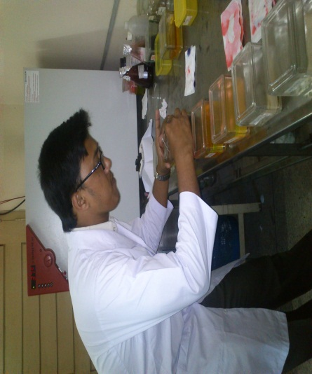 Eosin (1%) staining for 1 min.

**Working at Cell Biology Lab During Slide preparation**

**Redehydration:**

All slides were redehydrated gradually by increasing concentrations of ethyl alchol(70%,95%,100%) for 5 min each Cleaning & staining for 1 min.

Finally, the following reagents were used to clean and remove the alcohol-Alcohol(51%) + xylene(50%)- 5 mins

Xylene 1-4 min

Xylene 2-4 min

**Mounting:**

After staining tissue sections with glass slid were protected by thin cover slip attached to the slide with “Canada Balsam” – a mounting medium. Mounted slides were allowed to harden.

**Measurement of the parameter of the samples (gross & histological):**

For the histological study, the prepared slides were examined under the microscope and their photographs were taken. The muscle diameter, length & width of villi of duodenum are taken from the photographs of their microscopic slides using “Canvas 12” software.

**Chapter-IV**

**RESULTS & DISCUSSION**

**1 Post natal development (Gross characteristics)of the small intestine of broilers:**

**1.1 Duodenum:** The duodenum started at the gizzard and formed an elongated loop. The pancreas lies between the arms of the loop and being attached to each arm of the duodenum actually holds the two arms together After the duodenum, the small intestine formed a coil and was suspended from the dorsal abdominal wall the by a thin membrane- the mesentery. This membrane carried the blood vessels associated with the intestine.

This observation was similar with hassonuna (2001),where the author stated that length of the duodenal loop and its parts as its shape and extension varied in birds. This observation is quiet similar to Nasrin et.al(2012), where the author stated that the length of Duodenum increased gradually with age.

**The gross morphometric of duodenum:**

|  |  |  |
| --- | --- | --- |
| **Age (Days)** | **Length (cm)** | **Diameter (mm)** |
| 1 | 14.95 | 2.75 |
| 7 | 17.25 | 4.35 |
| 12 | 19.50 | 4.70 |
| 24 | 28.12 | 5.25 |
| 34 | 30.55 | 7.1 |

2 **Histology of different segments of the small intestine of broilers:**

2.1 **Duodenum:**

The villi of the duodenum of chicken studied were lined by simple columnar epithelium. This observation was similar with Aitken (1958),Nasri et al.(2012), where the author started that in small intestine, the surface epithelium was simple columnar. The apical parts of villi of the duodenum were slightly pointed and basal parts of the villi were wider.

**The average lengths & width of villi and muscle diameter of duodenum were found given in the table below.**

**Histomorphometry of Duodenum:**

|  |  |  |  |
| --- | --- | --- | --- |
| Age(Days) | Length of Villi(µm) | Width of villi(µm) | Muscle Layer diameter(mm) |
| 1 | 101.3 | 17.30 | 20.44 |
| 7 | 127.2 | 18.50 | 26.24 |
| 12 | 132.6 | 19.92 | 27.4 |
| 24 | 145.2 | 20.30 | 30.46 |
| 34 | 145.75 | 21.24 | 30.75 |

Comparative presentation of the length(µm) of the segments of small intestine according to age. The chart represents that in case of Duodenum its length increased very slowly where’s the highest length at day34 and lowest at day 1 .

Comparative presentation of the width of the segments of small intestine according to age the chart integrate the diameter of the five segments of small intestine was highest at day 34 and lowest at day 1. The relationship of age of diameter of small intestine is significant.

The chart below represents the variation of diameter during postnatal development of the three segments of small intestine of “Cob- 500” broilers.

Comparative presentation of the diameter of the segments of small intestine according to age the chart integrate the diameter of the five segments of small intestine was highest at day 34 and lowest at day 1. The relationship of age of diameter of small intestine is significant.

The chart below represents the variation of villi per (sqr.mm) and area of villi (sq.mm) during postnatal development of the five segments of small intestine of “Cob- 500” broilers is given bellow:

|  |  |  |
| --- | --- | --- |
| Age(Days) | Villi per sq.mm | Area of villi(sq.mm) |
| 1 | 12 | 41.47 |
| 7 | 9 | 121.50 |
| 12 | 7 | 200.92 |
| 24 | 5 | 255.30 |
| 34 | 3 | 309.24 |

**No. of Villi**

Comparative presentation of the villi per 1 per sq.mm of the of small intestine according to age the chart integrate the villi per 1 sq.mm of the five segments of small intestine was highest at day 1 and lowest at day 34.

Comparative presentation of the area of villi per sq.mm of the of small intestine according to age the chart integrate the villi per sq.mm of the five segments of small intestine was highest at day 34 and lowest at day 1. The relationship of age of diameter of small intestine is significant.

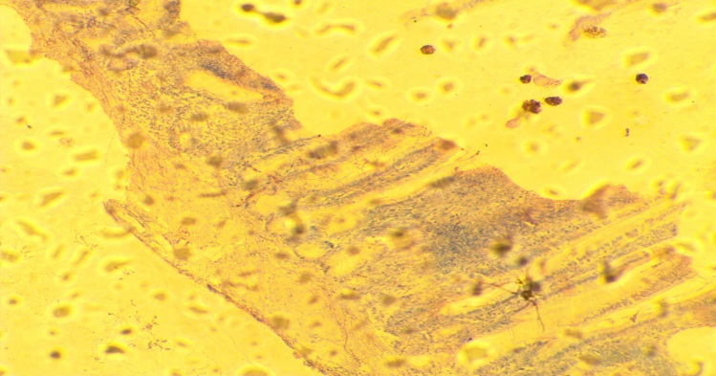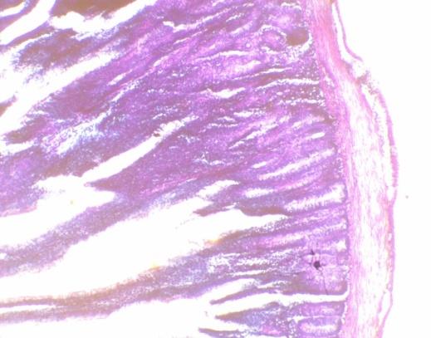

**V**

**V**

**V**

**V**

**IM** **V**

**S**

**S**

**S** **IG**

**IG**

**ME**

**IG**

**ME**

**IG**

**ME**

**IG**

**ME**

**IG**

**S**

Histology of Duodenum of the chickens at D1 Here, Villi (V), ntestinal gland (IG), Muscularis mucosae (MM), Muscularis externa (ME) and Serosa (S) are shown. Apical point of villi is pointed (single arrow), basal part is wider (double arrow)

Histology of Duodenum of the chickens at D7 Here, Villi (V), Intestinal gland (IG), Muscularis mucosae (MM), Muscularis externa (ME) and Serosa (S) are shown. Apical point of villi is pointed (single arrow), basal part is wider (double arrow)



Histology of Duodenum of the chickens at D12 Here, Villi (V), Intestinal gland (IG), Muscularis

mucosae (MM), Muscularis externa (ME) and Serosa (S) are shown. Apical point of villi is

pointed (single arrow), basal part is wider (double arrow)

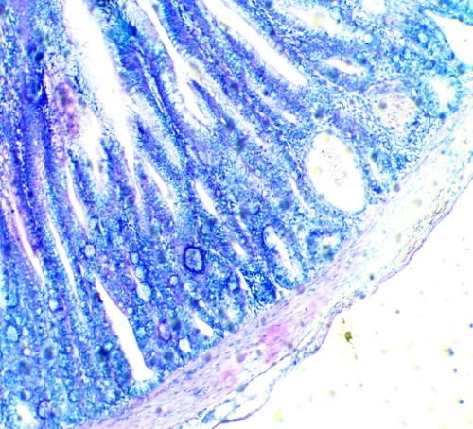

**V**

**ME**

**S**

**S**

Histology of Duodenum of the chickens at D24 Here, Villi (V), Intestinal gland (IG), Muscularis mucosae (MM), Muscularis externa (ME) and Serosa (S) are shown. Apical point of villi is

pointed (single arrow), basal part is wider (double arrow)

Histology of Duodenum of the chickens at D34 Here, Villi (V), Intestinal gland (IG), Muscularis mucosae (MM), Muscularis externa (ME) and Serosa (S) are shown. Apical point of villi is

pointed (single arrow), basal part is wider (double arrow)

**Chapter-V**

**CONCLUSION**

The average length, width, diameter & area of villi during postnatal development of the Cob-500 broilers increased day by day with their age. The average lengths and diameter of Duodenum of small intestine were significantly higher at day 34 than that at day 24, day 12, day 7& day 1. Histologically, variations found in the villus length and width and also in muscle diameter during the postnatal development of the small intestine segments (Duodenum). The average lengths, widths & diameter of villi of Duodenum of small intestine were higher at day 34 than that at day 24, day 12, day7& day 1. The villi became broader and the depths intestinal glands are increased considerably in duodenum. In the present study, the villus height and width in all segments of the small intestine increased with age, and these results were similar to those of previous studies (Fry et al., 1962; Holt et al., 1984; Miller et al., 2007; Wang et al., 2008).

**Chapter-VI**

**REFERENCES**

Aitken, R.N.C 1958. A histochemical study of the stomach and intestine of the chicken. *Journal of Anatomy*, 453-466.

Bradley, O.C. and GraHame, T. 1950. The structure of the fowl. *Pathology* 35, 12-32.

Calhoun, M. Lois. 1954. Microscopic anatomy of the digestive system of the chicken. *Ames lowa: lowa State Colleage Press*.

Gridley, M.F. 1960. Manual of histologic and special staining technique. *MacGraw-Hill Book Company*, 28-29, 82-83.

Hassouna, E.M.A. 2001. Some anatomical and morphometrical studies on the intestinal tract of chicken. duck, goose, turkey, pigeon, dove, quail, sparrow, heron, jackdaw, hoopoe, kestrel and owl. *Assiut Veterinary Medical Journal*. 44:47-78.

Verdal, H. de, Mignon-Grastea, S, Jeulin, C., Bihan-Duval, E.Le, Leconte, M., Mallet, S., Martrin, C, and Narcy, A. 2010. Digestive tract measurements and histological adaptation in broiler lines for digestive efficiency. *Poultry Science*. 89: 1955-1961.

Chewan, C.B. Bird, F.H. and Gerry, R. W. 1978. Relationship between intestinal movements and pancreatic juice secretion in the domestic chicken. Poult. Sci. 57: 1084-1086.

Sklan, D, Shachaf, B.bARON, J. and Hurwitz, S.1978. Retrograde movement of digesta in the duodenum of the chick: Extent, frequency and nutritional implication. J. Nutr. 108: 1485-1490.

Uni, Z, Platin, R. and Sklan, D, 1999, Cell proliferation in chicken intestinal epithelium occurs both in the crypt and along the villus. J. Comp. Physiol. [B] 168:241-247.

Bayer RC, Chawan, CB, Bird FH. Musgrave SD 1975. Characteristics of the absorptive surface of the small intestine of the chicken form 1 day to 14 weeks of age. Poult. Sci. 54:155-169.

Nitsan Z, Avrahm GB, Zorfe Z, Nir I 1991. Growth and development of the digestive organs and some enzymes in the broiler chick after hatching. Br.Poult. Sci. 32; 515-523.

Noy, Y, Sklan, D. 1995. Digestion and absorption in the young chicks. Poult. Sci 74:366-373.

Noy, Y, Sklan, D. 1996. Uptake capacity for glucose, methionine and oleic acid in the proximal small intestine of post hatch chicks. Poultry Sci. 75:998-1002.

Noy, Y, Sklan, D. 1997. Post hatch development in poultry. Appl. Poult.Res. 6:344-354.

Noy YA, Geyr A, Sklan D. 2001. The effect of early feeding on growth and small intestinal development in the post hatch poultry. Poult. Sci. 80:912-919.

Uni, Z., and Sklan, D. 1995. Post hatch changes in morphology and function of the small intestines in heavy and light strain chicks Poultry Sci. 74:1622-1629.

Uni, Z., A. Smirno, and Sklan, D. 2003. Pre-and post hatch development of goblet cells in the broiler small intestine: Effect of delayed access to feed. Poult. Sci. 82:320-327.

Uni Z, Ganot, S. Sklan, D. 1998. Post hatch development of mucosal function in the broiler small intestine. Poult . Sci. 77:75-82.

Uni Z, Noy Y, Sklan, D. 1995. Development of the mall int5estine in heavy and light strain chicks before and after hatching. Br. Poult. Sci. 37:63-71.

Yamauchi K, Hida S, Isshiki Y. 1992. Post-Hatching developmental changes in the ultra structure of the duodenal absorptive epithelial cell in 1, 10 and 60 d-old chickens, with special reference to mitochondria. Br. Poult. Sci. 33:475-488.

Yamauchi K, Nakamura E, Isshiki Y. 1993. Development of the intestine villi associated with the increased epithelial cell mitosis in chickens. Anim. Sci. Tech. 64:340-350.

Yamauchi K, Isshiki Y. 1991. Scanning electron microscopic observations on the intestine villi in growing White Leghorn and broiler chickens from 1 to 30 days of age. Br. Poult. Sci. 32:67-78