Chapter I
INTRODUCTION

Livestock plays an important role in the national economy of Bangladesh with a direct contribution of around three percent to the agricultural GDP and providing fifteen percent of total employment in the economy. About 75 percent people rely on livestock to some extent for their livelihood, which clearly indicates that the poverty reduction potential of the livestock sub-sector is high. Livestock is one of the most potential sub-sectors of agriculture in Bangladesh which plays an indispensable role in promoting human health and national economy of the country. Livestock not only assists to upgrade the financial condition but also makes a substantial contribution to human nutrition. The present population of cattle, goat, sheep and pig are 22970000, 22400000, 2870000 and 100000 respectively (DLS, 2010). The country has a relative density of livestock population well above the averages for many other countries of the world. In spite of a high density of livestock population, the country suffers from an acute shortage of livestock products like milk, meat and eggs. Per capita availability of animal protein presently stands at around 21 gm meat/day vis-a-vis the recommended intakes of 120 gm meat/day. Pigs are fast growing and one of the most prolific livestock breeds (Durranc and maxson, 2008; Phookan et al., 2006; Prakash et al., 2008; Taylor and Roese, 2006). Pig is considered as the richest source of animal protein at a lower cost for the peoples who consume pork. Pork is one of the most popular forms of meat for human consumption, accounting for 38% of worldwide meat production.
In global perspective, pigs were used for production of meat and bristles. However, with the advent of nylon, pig bristles have lost its market value (Long et al., 1990). Nevertheless, till date, pork is an important source of protein in western countries (Hossain et al., 2011). Pig production can yield rapid returns on the capital invested (Taylor and Roese, 2006). Pig needs less space in which to be raised unlike traditional beef cattle farming, which is popular in Greater Chittagong Hill Tracts, Narayangonj, Mymenshingh, Tangail, Naogaon, Dinajpur, Barishal are reared mainly by some ethnics communities in Bangladesh for household consumption (Islam et al., 2006)
Gastrointestinal parasites occur frequently in domestic pigs in all kinds of production systems and all around the World. Because pigs are omnivores and have been known to eat any kind of food, including dead insects, worms, tree bark, rotting carcasses, garbage, kitchen waste and even human excreta. Swine raised in intensive operations are less prone to gastrointestinal infection however; the large round worms (Ascaris sp), whipworms (Trichuris sp) and the nodular worms (Oesophagostomum sp) are often found in such operation (Weng et al., 2005; Eijck and Borgsteede, 2005).Nevertheless, they have generally received much less attention from veterinary parasitologists than ruminant endoparasites. The main reason is presumably that most common porcine endoparasites very seldom cause clinical disease and therefore remain largely unrecognized by farmers and their veterinarians, whereas the most important ruminant parasites, if not controlled, will eventually lead to overt poor performance, severe economic losses or even fatal clinical disease.

The major helminth species in temperate pig production include Ascaris suum (the large round worm), Trichuris suis (whipworm), and Oesophagostomum sp. (nodular worm). Despite the common subclinical course of infections, pigs infected with one or more of the above mentioned species have reduced food utilization and growth rate (Hale and Stewart, 1979; Hale et al., 1981, 1985) as well as a changed body composition (heavier plucks and less meat; Thamsborg, Mejer, Roepstorff, unpublished), while migration of Ascais suum. larvae results in substantial liver condemnations (reviewed by Roepstorff, 2003), so for the financial perspective alone, pig endoparasite have to be controlled. They’ve also been associated with depressed immunity in infected animals leading to decreased ability to fight off infection thereby predisposing them to concurrent infections with disease pathogens (Intervet, 2011).The disease is also associated with a lot of economic losses compounded by the fact that once roundworm infection establishes in a conventional farm, it’s always very difficult to eliminate (Intervet, 2011).
However, there are other good reasons to study these parasites. Some porcine parasites can be transferred to humans directly or indirectly, especially farmers. For example, Cryptosporidium is a common zoonotic parasite which could cause serious diarrhea in human, it is particularly serious in children and people with immunodeficiency diseases; Balantidium coli could be an occasional human pathogen as well (Garcia et al., 2007). Ascais. suum and maybe Trichuris suis are zoonoses and closely related to Ascais lumbricoides and Trichuris trichiura, which infect 1221 and 795 million people worldwide, respectively (de Silva et al., 2003) and controlled infections in pigs make up the very best experimental animal models (Boes and Helwigh, 2000).
Despite significant losses by gastrointestinal parasitism, the problem is often neglected and overlook as majority of infected animals show a number of little obvious clinical signs throughout their productive life and their effects are gradual and chronic ( Reza et al.,2010). Considering the above facts, the present study was undertaken to fulfill the following objectives:
- To investigate the prevalence of gastrointestinal parasitic infestations in Chittagong Division.
- To determine the effect of different modifiable risk factors such as sex, age etc. in the occurrence of such diseases.

Chapter II
Review of Literature
Different literature on gastrointestinal parasitism along with their prevalence in pigs is reviewed in this chapter. The main purpose of this chapter is to provide information concerning the research work which is addressed here. Important information related to present study was represented below under the following headings:
Gastrointestinal parasitism in pigs:
2.1 Epidemiology:
Gastrointestinal parasites occur frequently in domestic pigs in all kinds of production systems and all around the World. Swine production systems are characterized by a high diversity with regard to management type and the level of intensity of management.
2.1.1 Factor affecting the size of gastrointestinal infection
The size of any gastrointestinal nematode infection depends on the following six main factors:
- The number of infective larvae/eggs ingested by the host, which in turn is influenced by the climate, the amount of protection provided by vegetation, the livestock density and the grazing pattern of the ruminants present.
- The rate at which acquired resistance develops in the host, which is influenced by species of parasites and host, genetics factors, nutrition and physiological stress(e.g., parturition)
- The intrinsic multiplication rates of the species of parasites present which are controlled by the fecundity, pre-patent period, and environmental development and survival rates of these species.
- Management, particularly grazing patterns (Radostits et al., 1994).
- Geographical distribution and availability intermediates hosts.
- Uses of anthelmintics, including the timing and frequently of administration.( Radostits et al., 1994; Hansen and Perry, 1993)
2.2 Diagnosis of gastrointestinal parasitism
To diagnose gastrointestinal parasitic infection of herbivores, the parasites or their eggs/ larvae must be recovered from the digestive tract of the animal or from faecal material. These are subsequently identified and quantified. The following are the main tasks involved in this process:
- Collection of faecal samples.
- Separation of eggs/larvae from faecal materials and their concentration.
- Microscopical examination of prepared specimen.
- Preparation faecal cultures.
- Isolation and identification of larvae from culture (Baermann apparatus techniques)

The following Qualitative and Quantitative tests were used for the diagnosis of gastrointestinal parasitism:

Fecal sample

Quantitative test
Qualitative test

- McMaster technique
- Stools ova counting technique
Indirect method
Direct method

Direct smear

Sedimentation
Floatation

Simple floatation
Test tube floatation
Centrifugal floatation

Simple sedimentation
Centrifugal sedimentation

(Urquhart et al., 1996; Hansen and Perry, 1993; Soulsby, 1982 )

2.3 Prevalence of gastrointestinal parasites:
Islam et al. (2013), was designed to determine the prevalence of helminthes parasites of pigs in Barisal and Patuakhali Districts. The overall prevalence was highest for Ascaris sp. illustrates 63.3% and followed by Trichuris sp., Strongyloides sp., Oesophagostomum sp., Capillaria sp., Fasciola sp. and Schistosoma sp. constitutes 56.6%, 40%, 36.3%, 23.3%, 23.3% and 10%, respectively. In intensive system, animals were more susceptible to Ascaris sp. constituting 66.7% and followed by Trichuris sp., Strongyloides sp. ,Oesophagostomum sp. And Fasciola sp.that makes up 53.3% , 46.7%, 46.7 % and26.7%, respectively and, 60%,60,40%, 40% 33.3% and 33.3% for Ascaris sp., Trichuris sp.,Strongyloides sp., Oesophagostomum sp., Fasciola sp. and Capillaria sp., respectively in semi intensive system. Capillaria sp. was absent in in intensive system Schistosoma sp. was not found in semi intensive system

Tomass et al. (2013), investigated the prevalence of gastrointestinal parasites and Cryptosporidium species in extensively managed pigs in Mekelle and urban areas of southern zone of Tigray Region, Ethiopia and found Ascaris suum (25.9%) was the most prevalent parasite followed by Fasciola hepatica (1.8%), Eimeria spp. (1.7%) and Trichuris suis (0.3%). About 7% of pigs examined were positive for oocysts of Cryptosporidium spp. Moreover, 72% of the soil samples found to be contaminated with eggs of Ascaris spp. in the study area.

Pam et al. (2013), conducted a study to determine the prevalence of haemo and gastro-intestinal parasites of pigs in some parts of Langtang north local government area of Plateau State. Results of the analysis showed that 36.84% pigs were tested positive for haemoparasites and 35.09% pigs were tested positive for gastro-intestinal parasites. The study recorded high prevalence with Babesia trautmanni 32(18.17%) and lowest prevalence with Eperythrozoon suis for haemopara sites parasites prevalence. For gastro-intestinal parasites prevalence, Oesophagostomum dentatum & Coccidia spp recorded equal high prevalence with 34(14.04) in each case while Ascaris suum, Fasciolopsis buski and Globourcephalus diducta recorded lowest with 1(0.58) in each case. In both haemo and gastro-intestinal parasites prevalence, there was no significant different (p>0.05) among the parasites encountered. No significant variations (p>0.05) were observed in relation to sex and age prevalence

Sowemimo et al. (2012), conducted a cross-sectional study to determine the prevalence and intensity of gastrointestinal parasites in pigs from the Teaching and Research Farm of the University of Ibadan, Ibadan, Oyo State, Nigeria. Five types of parasites were identified, including Trichuris suis, Ascaris suum, human hookworm, Stephanurus dentatus and Isospora suis. T. suis was the most prevalent parasite. The prevalence of intestinal parasites was significantly higher in male pigs than in females (P<0.05).

Sardar et al. (2012), conducted to determine the prevalence of helminths among domestic pigs. The prevalence of Metastrongylus sp. and Fasciolopsis sp. was significantly (p<0.05) higher in the pigs of 0-12 months age and 0-70 kg body weight groups compared to over 12 months and 70 kg body weight groups.The prevalence of Fasciolopsis sp. was significantly (p<0.05)higher in males and local pigs than females and cross-breed pigs, respectively.

Obonyo et al. (2012), conducted a cross-sectional study to determine the prevalence, intensity and spectrum of helminths of free range pigs in Homabay District, Kenya. The nematode eggs encountered were those of Strongyles (75%), Strongyloides spp (26.6%), Trichuris spp (7.8%), Ascaris spp (5.4%) and Metastrongylus spp (0.3%). Coproculture of Strongyle-type nematode egg positive faecal samples revealed the presence of Oesophagostomum spp (74%), Hyostrongylus rubidus (22%) and Trichostrongylus spp (4%). The post-mortem examination revealed presence of Hyostrongylus rubidus, Physocephalus sexalatus, Trichostrongylus axei, Ascaris suum, Oesophagostomun dentatum, Trichuris suis and Metastrongylus pudendodectus. The highest prevalence of helminth infections was recorded in finishers (88%) and the lowest in adults (79%). The highest mean helminth egg per gram of faeces (epg) was recorded in adults (1,175) and the lowest was in piglets (526). Pigs from Riana division had the highest prevalence (91%) of infection and mean epg (1,109), while those from Asego Division had the lowest prevalence (50%) and mean epg (100). Female pigs recorded a higher mean epg (567) compared to males (416). Age had significant influence on infection with Strongyles (p = 0.04) with growers and finishers recording higher levels of infection than adults. Sex had significant effect on the prevalence of infections with Strongyles (p = 0.028) and Ascaris suum (p = 0.012) with females recording higher levels of infection than males. Division of origin of pigs had significant influence on the prevalence of infection with Ascaris suum (p = 0.000) and Strongyles (p = 0.000) with the mean epgs for Riana and Ndhiwa divisions being significantly higher than those of Pala Division.

Nwoha et al. (2011), investigated the prevalence of intestinal parasites in intensive Pig farms in Umuahia city of Abia State. He found the samples were of mixed infections comprised of Ascaris suum150 (50%); Physocephalus sexalatus (33%), Paragonimus westermanii 100(33%) and Bracchylaemus suis 100(33%); Hyostrongylus rubidus100 (17%) and Bourgelatia diducta 50(17%). Piglets and winners had high prevalence of Paragonimus westermanii (88, 66) % resp. Piglets, Winners and Dams had zero prevalence of Physocephalus sexalatus; Hyostrongylus rubidus; Bracchylaemus suis and Bourgelatia diducta. Sows and Boars had most of the parasites except for Paragonimus westermanii which was not found. However, the prevalence of the parasites were higher in the Sow (60%) compared to Boars (70%). Generally, the prevalence of gastrointestinal parasites were higher in the undewormed (36%) than in the dewormed (10%).
Aernan et al. (2011), conducted a survey of helminth parasites associated with pork slaughtered in Makurdi metropolis and reported 217(83.6%) were infected. Oesophagostomum spp,(43.7%), Hydrostrongylus spp,(15.7%), Ascaris suum,(10.5%), Strongyloides spp, (6.9%), Trichuris suis (4.6%), and Metastrongylus spp, (1.8%) in their intestines, lungs and kidneys. Of the 260 carcasses examined, 119(45.8%) were infected with cystercercosis. 84/185(45.4%) males and 35/75(46.7%) famales. Results shows no significant difference in infection between males and females x=0.07; p=0.05).

Ismail et al. (2010), performed a study to investigate the infection status of intestinal parasites in pigs and beef cattle in rural areas of Chungcheongnam-do, Korea. The overall positive rates of intestinal parasites among pigs and beef cattle were 73.5% and 4.8%, respectively, and the double-infection rate was 10.3% in pigs. Of 136 specimens from pigs, Balantidium coli, Ascaris suum, and Entamoeba spp. infections were found in 88 (64.7%), 24 (17.6%), and 5 cases (3.7%), respectively. Of 105 beef cattle, Entamoeba spp. infections were detected in 5 cases (4.8%). From these results, it is shown that pigs raised on rural farms in Chungcheongnam-do had a high B. coli infection rate and a moderate A. suum infection rate. These results demonstrate that environmentally resistant cysts or eggs could be widespread on the farms examined, and thus an effective hygienic management system is needed to prevent them from serving as the source of infection for human beings.
Tiwari et al. (2009), estimated the prevalence of intestinal parasites in pigs of Grenada and the overall prevalence of intestinal parasites was 68.78% (95% CI, 62.67 to 74.89%). Four types of parasites were identified including Oesophagostomum spp., Strongyloides spp. Trichuris suis and coccidia. Mixed infections were common on some farms, comprising 6/10 (60.0%) in small herds and 5/6 (83.3%) in large herds. There was no significant difference between infection rates on larger and smaller pig farms (p > 0.05). There was also no association between infection rate and age group on either smaller farms (p = 0.12) or larger farms (p = 0.06). There was no evidence of infection with Ascaris suum.

Uysal et al. (2009), performed a study to know the Intestinal Parasites in pig feces that are also Human Pathogens. A total of 238 pig fecal specimens were collected from pig farms in Çorlu (Tekirdağ), Ayazma, and Arnavutköy (Istanbul) of Turkey during the summer. During the investigation the findings showed that Cryptosporidium spp. was detected In 21 fecal specimens (8.8%), Giardia spp. in 9 (3.7%), Balantidium coli cysts in 4 (1.6%) and Ascaris suum eggs in 9 (4.1%). Giardia lamblia were found in 8 (7.6%) of 105 pigs younger than 6 months, Cryptosporidium spp. in 12 (11.4%), Balantidium coli cysts in 2 (1.5%). In the pigs older than 6 months Giardia lamblia were found in 1 (0.7%), Cryptosporidium spp. in 9 (6.7%), Balantidium coli cysts in 2 (1.5%) and Ascaris suum eggs in 9 (6.7%).

Marufu et al. (2008), conducted one year monitoring to determine the prevalence of gastrointestinal nematodes in indigenous Mukota pigs in Hama-Mavhaire communal area of Chirumhanzu District, Zimbabwe. He found 58.7% were positive for gastrointestinal (GI) nematodes, 17.5% having mixed infections. Four parasite species were identified; Oesophagostomum species (54.6%) being the most prevalent followed by Strongyloides ransomi (14%), Ascaris species (7%) and Trichuris suis (4.2%).

Tamboura et al. (2006), studied the prevalence of common gastrointestinal nematode parasites in scavenging pigs of different ages and sexes in Eastern Centre province, Burkina Fasoa and report 91 % were infected by one or more parasites. Ascaris suum (40 %; 100–1 400 EPG) was the most prevalent parasite followed by Strongyloides ransomi (21 %; 100–4 200 EPG), Oesophagostomum spp. (18 %; 100–1 000 EPG), Hyostrongylus rubidus (11 %; 100–1 800 EPG), Globocephalus spp. (10 %; 100–400 EPG) and Trichuris suis (1 %; 100–200 EPG). The prevalence was significantly higher in female pigs (n = 239) than in males. In addition, females excreted significantly (P < 0.05) more eggs in their faeces than males,except in the case of Globocephalus spp. The age of the animal had no effect on the prevalence of A.suum whereas there were significant differences in age categories concerning S. ransomi, H. rubidus, Oesophagostumum spp. and Globocephalus spp. Unexpectedly, the high prevalence of these common parasites was not accompanied by elevated EPG values, which suggests the existence of moderate infestations.

Weng et al. (2005), conducted a study on the prevalence of intestinal parasites in intensive pig farms in Guangdong Province, China between July 2000 and July 2002. Faecal samples from 3636 pigs (both sexes and five age groups) from 38 representative intensive pig farms employing different parasite control strategies were examined for the presence of helminth ova and protozoan oocysts, cysts and/ or trophozoites using standard techniques. Of the 3636 pigs sampled, 209 (5.7%) were infected withTrichuris suis, 189 (5.2%) with Ascaris, 91 (2.5%) with Oesophagostomum spp, 905 (24.9%) with coccidia (Eimeria spp and/or Isospora suis) and 1716 (47.2%) with Balantidium coli. These infected pigs were mainly from farms without a strategic anti-parasite treatment regime. Concurrent infection of multiple parasites was common, and T. suis was the most common nematode infecting breeding, young and mature pigs.
Nsoso et al. (2000), carried out the prevalence of internal and external parasites in pigs of different ages and sexes in Southeast District, Botswana. He found 54,55% were infected with Ascaris suum, 20,45 % with Trichostrongylus spp. and 6,82 % with Trichuris suis. Ascaris suum was found to be the most common endoparasite infesting both mature, i.e. 12 months and older, and young,i.e. less than 12 months old, pigs. Although not significantly different (P > 0,05), the prevalence of this parasite species was slightly higher (68,42 % with an average of 1 023 ± 545 eggs per gram (EPG)of faeces per pig) in mature than in young pigs (55 % with an of average 1 500 ± 846 EPG of faeces per pig). The prevalence of Trichostrongylus spp. was lower in mature (5 ,26% with 20 ± 14 EPG of faeces per pig) than in young pigs (25 % with 22 ± 9 EPG of faeces per pig). The prevalence of T.suis was also lower in mature (0 % infection) than in young pigs (15 % with 9 ± 4 EPG of faeces per pig). The prevalence of the three endoparasite species was not significantly different between the sexes A. suum (1 020 ± 883 v. 1 503 ± 522 EPG of faeces per pig), Trichostrongylus spp. (24 ± 14 v. 18 ± 8 EPG of faeces per pig) and T. suis (11 ± 6 v. 2 ± 4 EPG of faeces per pig) for male and female pigs respectively.

Permin et al (1999), was carried out a cross-sectional study in the Upper East Region (UER) of Ghana in order to estimate the prevalence of parasitic infections in local cross-bred pigs. He reported the prevalence of Eimeria spp. was 77.2%, Isospora suis (27%) and Balantidium coli (19.3%).The following helminth eggs were identified: Metastrongylus salmi (19.3%); Physocephalus sexalatus (17.4%); Oesophagostomum spp./Hyostrongylus rubidus (60.6%); Trichuris suis (4.6%); Ascaris suum (12.7%); Ascarops strongylina (8.1%); Brachylaemus suis (1.9%); Paragonimus suis (0.8%); Globocephalus urosubulatus (2.7%); and Schistosoma suis (0.4%). The clinical examinations revealed ectoparasites on 98.3% of the animals. The ectoparasites were: Haematopinus suis (66.7%); Boophilus spp. (58.3%); Amblyomma spp (45.0%); Sarcoptes suis (38.3%); and Rhipicephalus spp. (8.3%). All pigs were examined for the presence of haemoparasites and found that 23.3% of the animals had haemoparasites. These were: Babesia perroncitoi (23.3%); Babesia trautmanni (13.3%); and Eperytrozoon suis (1.7%). Based on postmortem examinations Metastrongylus salmi (83.3%); Oesophagostomum dentatum (63.3%); Oesophagostomum quadrispinulatum (38.3%); Hyostrongylus rubidus (23.3%); Ascarops strongylina (76.7%); Globocephalus urosubulatus (20.0%); Strongyloides spp. (1.7%); and Physocephalus sexalatus (65.0%) were identified.

Chapter III
Materials and Methods
3.1 Description of study area and duration
The study was conducted in Chittagong Division. The study was under taken for a period of 4 months starting from May’2013 to August’ 2013.
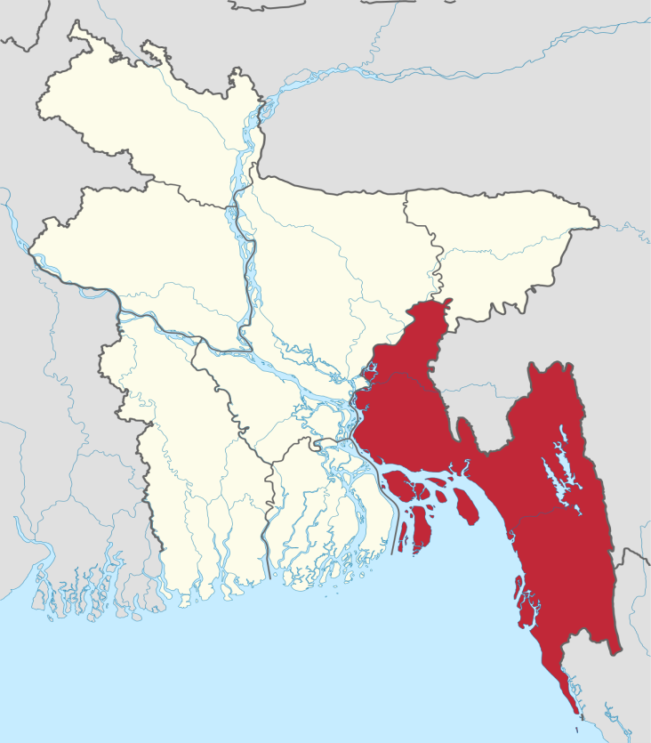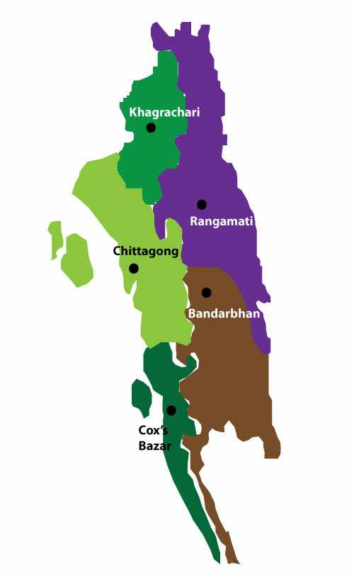
Figure 1: Location of Study Area
3.2 Selection of animals and survey design
3.2.1 Target animal and sex groups
Indigenous/crossbred pigs were selected for this day as target animal. To determine the sex susceptibility of different parasitic infections, pigs were categorized into two sub-groups as male (71) and female (29).

3.2.2 Target sampling
A total of 100 fecal samples were collected randomly from several areas of Chittagong. A prototype questionnaire was used to record the information like area, breed, age, sex. In the present study, the minimum age of the pig was 2 months and maximum 24 months.
3.3 Sample collection and preservation
Feces were collected directly from rectum and stored in plastic containers. Then, the container was filled with formalin (10%) and refrigerated at 4⁰C temperature. During sample collection, labeling of the samples were strictly maintained to prevent the misinterpretation.
3.4 Examination of the sample
In addition to gross examination of fecal samples (color, consistency, blood or mucus, etc.), three different types of qualitative tests, namely direct smear, floatation and sedimentation techniques were used to examine the fecal sample. Sugar Salt Solution was used as floatation fluid. At least two smear were prepared from each sample for each test to identify the morphological characteristics of eggs, cyst, oocyst (Hendrix, 2006; Urquhart et al., 1996; Soulsby, 1982).

Sample
Faeces
Qualitative tests
Direct smear
Flotation
Sedimentation

`

Figure 2: Experimental Design (at a glance)

3.5 Statistical analysis
The obtained information was imported, stored and coded accordingly using Microsoft Excel-2007 to STATA/IC-12.0 (Stata Corporation College Station) for analysis. The result were expressed in percentage with P-value for Chi-Square Test. Significance was determined when P<0.05.

PLATE - i
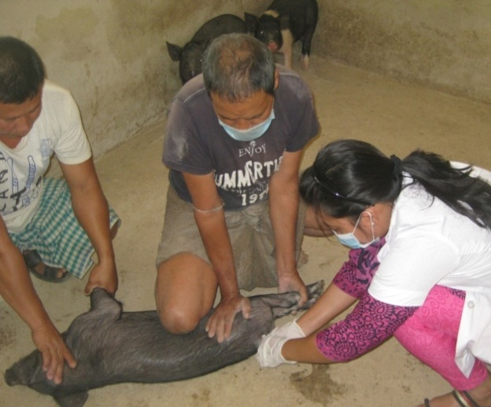
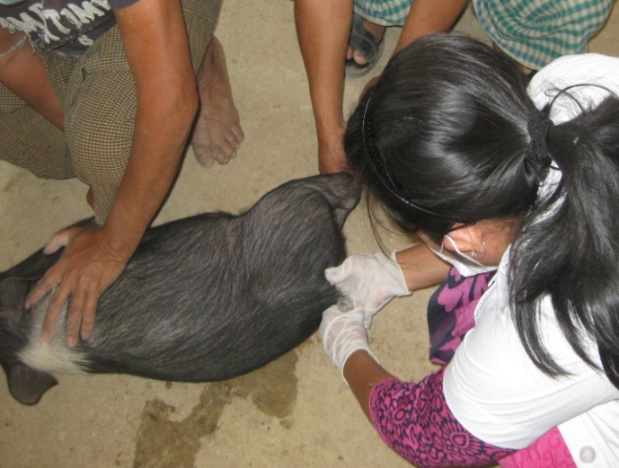
PLATE - i

Egg of Ascaris suum

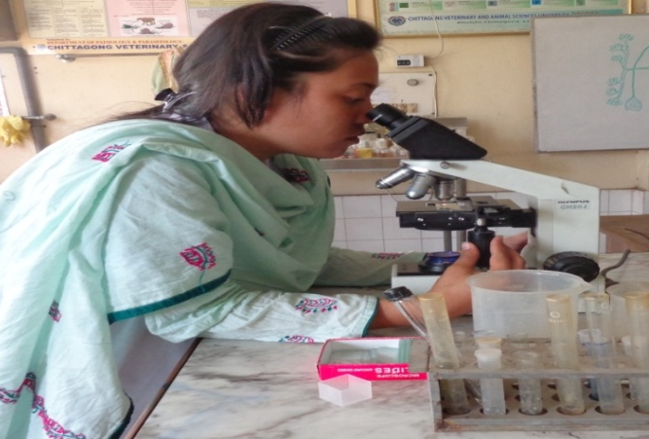
Egg of Trichuris suis

Plate- i: Collection of fecal sample from pig and examine under microscope

PLATE - II

Egg of Ascaris suum
Egg of Oesophagostomum dentatum

Egg of Trichuris suis
Hyostrongylus rubidus egg
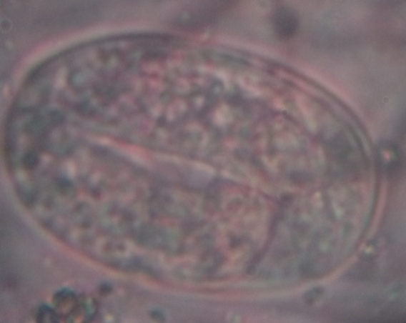

Egg of Strongyloides ransomni
Plate- II: Microscopic pictures of gastrointestinal parasitic eggs of pig. (During the study)

PLATE- III
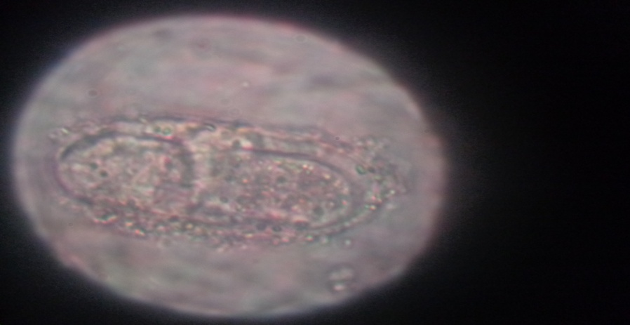
Balantidium coli oocyst
Ocyst of Coccidia (higher magnification)

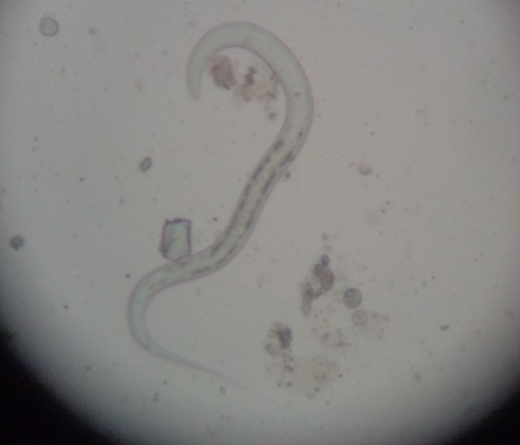
PLATE- III: Microscopic pictures of oocyst, some unidentified larvae. (During the study)
:

CHAPTER IV
RESULTS

4.1 Overall percentage of gastrointestinal parasites of pig
During the current investigation, an approach was taken to determine the status of gastrointestinal parasitic infections in study pigs. Out of 100 pigs, 49 pigs were infected with one or more parasite species, giving an overall prevalence of 49% (either single or mixed infection). There were found seven different types of gastro-intestinal parasite and protozoa. They were Ascaris suum, Oesophagostomum dentatum, Hyostrongylus rubidus, Trichuris suis, Strngyloides sp, oocyst of coccidia & Balantidium coli. (Table:1)

Table 1: Overall infection rate of gastrointestinal parasitic infections
Area | Parasitic infection | Percentage (%)
Chittagong | Ascaris suum | 11
 | Strongyloids spp | 3
 | Hyostrogylus rubidus | 4
 | Esophagostomum dentatum | 17
 | Trichuris suis | 03
 | Balantidium coli | 07
 | Coccidian oocyst | 4
 | Overall prevalence | 49%

Figure 3: Prevalence of different parasites in the study population
Among different gastrointestinal parasitic infections, prevalence of Oesophagostomum dentate (17%) was found highest in my study. The second most common parasitic infection was Ascaris suum (11%) followed by Balantidium coli (7%). The lowest parasitic infections were also recorded for Hyostrongylus rubidus, (4%) coccidian oocyst (4%) Trichuris suis (3%) and Strongyloides ransomni (3%) infection (Fig: 3).

4.2 Sex specific infection rate of gastrointestinal parasitic infection in pig
In the current study, it was found that female pig showed more susceptible to different gastrointestinal parasitic infections than male but it was not statistically significant (p<0.05). However, prevalence of Balantidium coli infection was the highest in female pig (14%) followed by male (4%). Occurrence of Hyostrongylus rubidus infection was maximum in female (7%) compare to male (3%). On the other hand, occurrence of Ascaris suum was slightly higher in male (11%) group than female(10%) (Table: 2)
Table 2: Sex wise prevalence of gastrointestinal parasitic infection:
Parasitic infection | Sex | Total observation | Number Positive (%) | P -value
Ascaris suum | Male | 71 | 8(11%) | 0.89
 | Female | 29 | 3(10%)
Strongyloides sp | Male | 71 | 2(3%) | 0.36
 | Female | 29 | 0
Hyostrogylus rubidus | Male | 71 | 2(3%) | 0.34
 | Female | 29 | 2(7%)
Trichuris suis | Male | 71 | 2(3%) | 0.86
 | Female | 29 | 1(3%)
Balantidium coli | Male | 71 | 3(4%) | 0.08
 | Female | 29 | 4(14%)
Coccidian oocyst | Male | 71 | 3(4%) | 0.85
 | Female | 29 | 1(3%)

Significant when P<0.05

Chapter V
Discussion

5.1 Prevalence of gastrointestinal parasitic infections in pig

5.1.1 Overall prevalence of gastrointestinal parasitic infections

The overall prevalence of gastrointestinal parasitic infections in pig of this study found similar with the reports of Sardar et al. (2012) and Marufu et al. (2008) who recorded 57.8% and 58.7% respectively. This finding is not supported by the findings of Islam et al (2013) who reported 100% prevalence of helminthiasis in Barisal and Patuakhali Districts. Disparity occurred may be due to geographical location and sampling time. This observation also varied from the reports of Ismail et al. (2010) and Aernan et al (2011) who recorded 73.5% and 83.6% at different countries of the world. Variation in the occurrence of such gastrointestinal parasitic infections might be due to geo- climate conditions, sample size, breed, age, sex, plane of nutrition, stress, availability of intermediate host, vegetation, grazing pattern, rearing and husbandry measures, anthelmintic therapy, genetic resistance etc. (Hansen and Perry, 1993).

Prevalence of Oesophagostomum dentatum infection of this study was quite similar with the findings of Sardar et al. (2012) who recorded 15.6% in Rangamati of Bangladesh. On the other hand, greater variation was found by Islam et al. (2013) Weng et al. (2005), who recorded 36.3%, 24.95% in different corner of the world. Variation in the occurrence of such infections might be due to geo- climate diversity, animal enterprises, husbandry measures and nutritional status, deworming etc. (Hansen and Perry, 1993).

Prevalence of Ascaris suum infection of this study was consistent with the observation of Sardar et al.( 2012) at Rangamati in Bangladesh who recorded 18.5%.On the other hand, the present result varied from the findings of Islam et al. (2013), Morris et al. (2009) and Nwoha and Danie (2011) who recorded 66.3%, 53%, and 50% respectively at different corners which was greater than the result of this present study. The prevalence of Ascaris suum of this study was higher due to the thick egg shell which make the egg resistant to cool and harse circumstances for its prolong survival in soil. (Soulsby, 1982).Further, contamination of the habitats as well as scavenging nature of the pig may also contributed to higher prevalence of such parasitic infections in the study population.

Infection rate of Blantidium coli was partially similar with the observation of Uysal et al (2009) who noticed 1.6% infections in Istambul of Turkey. Further the result of present study varied from Ismail et al. (2011) Weng et al. (2005) and Lai. et al. (2011) who recorded 64.7%,47.2% in Chungcheongnam-do, Korea, Guangdong Province and 22.79% in Chongqing in China respectively.

Occurrence of Strongyloides ransomni infection found in accordance with the observation of Aernan et al. (2011) who recorded 6.9%. Higher prevalence about 21% infection of Strongyloides ransomni was observed by Tamboura et al. (2006) Variation in the occurrence of such infection might be due to geo-climatic condition ( Kakar et al., 2008) or poor sample size (Bachal, 2002).

Infection caused by Trichuris suis of this study was in line with the findings of Weng et al. (2005), Nsoso et al. (2000), Permin et al. (1999) and Marufu et al. (2008) who recorded 5.7%, 6.8%, 4.6% and 4.2% respectively in different places of the world. Higher prevalence was recorded by Islam et al. (2013) which was 56.6%. Conversely, lower prevalence was recorded by Tamboura et al. (2006) about 1%.Variation in the occurrence of such infection might be due to geo-climate conditions of the study areas as well as husbandry practices. (Hansen and Perry, 1993)
Occurrence of Hystrongylus rubidus infection found somewhat consistent with the result of Tamboura et al. (2006) who reported 11% infection in Burkina Faso of Nigeria. Similarly, the result of the present study varied from the observation of Aernan et al.(2011) and Nwoha and Danie (2011) who estimated 15.7% and 17% in Makurdi metropolis and Umuahia city of Abia state respectively.

Infection caused by the Oocyst of Coccidian parasite of this study showed greater variation from the findings of Permin et al. (1999) Weng et al. (2005), Morris et al. (2009) and Kagira et.al (2010) who recorded 27%, 24.9%, 21% and 33% respectively in different countries of the world.

5.1.3 Sex specific prevalence of gastrointestinal parasitic infection

In the present study, infection caused by Hyostrongylus rubidus and Balantidium coli were found predominant in female pigs than male pigs. Finding of the study was found in accordance with the reports of Sowemimo et al. (2012).Occurance of Acaris suum infection was found slightly higher in male than female which was also consistent with the reports of Sowemimo et al. (2012) who revealed 18%; male vs 7%; female. In this study, variation in occurrence of such helminthes in male and female animals might be due to the variation in sample size (Bachal et al., 2002), age immunity in boars (Urquhart et al., 1996), lower resistance of female animals or on the part of their reproductive events or temporary loss of acquired immunity near parturition (Garcia et al., 2007 and Barger, 1993), stress, genetic resistance of host and insufficient/ imbalanced feed against needs (Raza et al.,2010 and Hansen and Perry, 1993).

5.2: Limitations:
- The study period was very short because most of the time of our internship we were at different regions of our country except at the time of lab rotation.
- Inability to perform Egg per gram (EPG), prepare faecal cultures and isolation and identification of larvae from culture (Baermann apparatus techniques)

CHAPTER VI

CONCLUSION

The study was performed aiming to determine the prevalence of gastrointestinal parasitic diseases in pig. The study revealed comparatively higher prevalence of Oesophagostomum dentatum, Ascaris suum, and Balantidium coli in pig in relation to sex. The occurance of gastrointestinal parasite was higher in female pig than male. It is predicted that gastrointestinal parasitism were more might be due to hot and humid climate which was ideally suitable for development of such parasites. However, poor management, insufficient diet, lack of awareness about deworming also enhances the high incidence of the infection. The study was limited study and due to time constrains topographical variation, seasonal pattern of the diseases as well as local and crossbred pig. Hence, it can be recommended further extensive investigation on gastrointestinal parasitism to overcome the limitation of the current studies which will assist to determine the important predictor related to such diseases.

CHAPTER VII
refernce

Aernan, P .T., Agbulu, C.O., Adi, I.A., and Deke, O.S., 2011. Helminth Parasites of Pork Slaughthered in Makurdi, Benue State, Nigeria. Journal of Agriculture and Veterinary Sciences., 3: 35-38.
Bachal, B., Phullan, M.S., Rind, R. and Soomro, A.H. 2002. Prevalence of Gastrointestinal Helminths in Buffalo calves. Online J. Bio. Sci., 21: 43- 45.
Boes, J. and Helwigh, A.B., 2000. Animal models of intestinal nematode infections of humans. Parasitology.,121: 97–111.
de Silva, N.R., Brooker, S., Hotez, P.J., Montresor, A., Engels, D., Savioli,L.,2003. Soil-transmitted helminth infections: updating the global picture. Trends Parasitol., 19: 547–551.
DLS 2010. Personal communication With Project Director, Animal Health Care, Management and Expansion Project, DLS, Dhaka.
Durranc, L. and Maxson, C.A., 2008. Swine production on a small scale. J. Anim. Sci., 2(3): 523-557.
Ejick, I.A.I.M. and Borgsteede, F.H.M. 2005. A survey of gastrointestinal parasites on free-range, organic and conventional pig farms in Netherland, Vet. Res. Comm., 29: 407-414.
Gracia, J.A., Rodriguez-Diego, J.G., Torres-Hernandez, G., Mahuieu, M., Garcia, E.G. and Gonzal-Garduno, R. 2007. The epizootiology of ovine gastrointestinal strongyles in province of Matanzas. Small Rumin. Res., 72: 119-126.
Hale, O.M., Stewart, T.B., 1979. Influence of an experimental infection of Trichuris suis on performance of pigs. J. Anim. Sci., 49: 1000–1010.
Hale, O.M., Stewart, T.B., Marti, O.G., 1985. Influence of an experimental infection of Ascaris suum on performance of pigs. J. Anim. Sci., 60: 220– 225.
Hale, O.M., Stewart, T.B., Marti, O.G., Wheat, B.E., McCormick, W.C., 1981.Influence of an experimental infection of nodular worms (Oesophagostomum spp.) on performance in pigs. J. Anim. Sci., 52: 316 322.
Hansen, J. and Perry, B. 1993. The Epidemiology, Diagnosis and Control of Helminth Parasites of Ruminants. 2nd edn, Nairobi,Kenya; I.L.R.A.D.,20-22.
Hossain, M.E., Chakma, S., Khatun M.M., Hasanuzzaman, M., Miah, M.Y. and Biswas, M.A.A. 2011. Production systems of swine in the rural areas of Rangamati and Khagrachari districts of Bangladesh, Bang. J. Anim. Sci., 40(1-2): 28-33.
Intervet. 2011. www, intervetusa.com.
Islam, A., Majumder, S., Anisuzzaman, Rabbi, A.K.M.A., Rahman, M.H., 2006. Helminthiasis in pigs in Bangladesh: In relation to age and management systems. Bangladesh Vet J., 40: 27-37.
Islam, M.S., Khan, M.S.I., Kader, H.A., Begum, M.R., Akter, S. & Hassan, M.N. 2013. Study on helminthes parasites of pig in Barisal and Patuakhali district, BJPST., 11(1): 121-124.
Ismail, H.A., Jeon, H.K., Yu, Y.M., Do, C. and Lee, Y.H. 2010. Intestinal Parasite Infections in Pigs and Beef Cattle in Rural Areas of Chungcheongnam-do, Korea, Korean J. Parasitol., 48(4): 347-349.
Kagira, J.M., Githigia, S.M., Ng’ang’a, J.C., Kanyari, P.W.N., Maingi, N. and Gachohi, J.M. 2010. Prevalence of gastrointestinal protozoa and association with risk factors in free-range pigs in Kenya, J. Protozool. Res.,20: 1-9.
Kakar, M.N. and Kakarsulemankhel, J.K. 2008. Prevalnce of endo (trematodes) and ecto-parasites in cows and buffaloes of Quetta, Pakistan. Pak. Vet. J., 28(1): 34, 34-36.
Lai, M. and Zhou, R.Q., 2011. Prevalence and risk factors associated with intestinal parasites in pigs in Chongqing, China. Res. Vet. Sci. 91 (3): 121- 4.
Long, T.F., Johnson, R.K. and Keele, J.W.,1990. Intensive production system of swine. J.Anim. Sci., 68: 4069-4078.
Marufu, M.C., Chanayiwa, P., Chimonyo, M. and Bhebhe, E. 2008. Prevalence of gastrointestinal nematodes in Mukota pigs in a communal area of Zimbabwe, Afr. J. Agric. Res., 3(2): 91-95.
Nsoso, S.J., Mosala, K.P., Ndebele, R.T. and Ramabu, S.S. 2000.The prevalence of internal and external parasites in pigs of different ages and sexes in Southeast District, Bostwana, Onderstepoort J.Vet. Res., 67: 217-220.
Nwoha, R.I.O and Daniel, G., 2011.Department of Veterinary Medicine and Department of Pathology, Michael Okpara University of Agriculture, Prevalance of Gastrointestinal Nenatodes Parasites In Intensively Managed Pigs Of Different Ages And Sexes In Umuahia City Of ABIA STATE. Continental J. Vet. Sciences., 5 (1): 11 - 17.
Pam,V. A., Daniel, L. N., Bata, S. I., Udokaninyene, A. D., Hassan, A. A., Kemza ,S. Y., Igeh, C. P. and Ogbu, K. I., 2013. An Investigation of Haemo and Gastrointestinal Parasites of Pigs in Some Parts of Langtang North Local Government Area of Plateau State. J. vet Adv., 3(2): 79-86.
Permin, A., Yelifari, L., Bloch, P., Steenhard, N., Hansen, N.P. and Nansen, 1999. Parasites in crossbred pigs in upper East region of Ghana, Vet. Parasitol., 87(1): 63-71.
Phookan A, Laskar S, Aziz A and Goswami RN 2006. Reproductive performance of indigenous pigs of the Brahmaputra Valley of Assam. Tamilnadu J. Vet. and Anim. Sci.,2: 121-125.
Prakash MG, Ravi A, Kumari BP and Srinivas Rao D 2008. Reproductive and Productive Performance of Crossbred Pigs. Indian J. Anim. Sci. 78: 1291- 1297.
Reza, A.M., Murtaza, S., Bachaya H.A., Qayyum, A. AND Zaman, M.A. 2010. Point Prevalence of Toxocara vitulorum in Large Riminants Slaughtered at Multan Abattior, Pak. Vet. J., 30(4): 242-244.
Roepstorff, A., 2003. Ascaris suum in Pigs: Population Biology and Epidemiology. Dr. Diss. The Royal Vet. Agri. University, 112.
Roepstorff, A., Mejer, H., Nejsum, P. and Thamsborg, S.M. 2011. Helminth parasites in pigs: new challenges in pig production and current research highlights. Vet. Parasitol., 180(1-2): 72-81.
Sardar, S. A., Chakma, D., Hossain, K., & Islam, A. (2012). Helminthiasis in the pigs of Rangamati district of Bangladesh. Eurasian J Vet Sci., 28(4): 233- 236.
Soulsby, E.J.L. 1982. Helminthes, Arthropods and Protozoa of Domesticated Animals, 7th edn. Baillere Tindall, London.707-717, 729-735.
Sowemimo, O. A., Asaolu S. O., Adegoke F. O. and Ayanniyi O. O. 2012. Epidemiological survey of gastrointestinal parasites of pigs in Ibadan, Southwest Nigeria. Journal of Public Health and Epidemiology.,4(10): 294-298.
Tamboura, H.H., Banga-Mboko, H., Maes, D., Youssao, I., Traore, A., Bayala, B. and Dembele, M.A. 2006. Prevalence of common gastrointestinal nematode parasites in scavenging pigs of different ages sexes in eastern centre province, Burkina Faso, Ondersteport J. Vet. Res., 73: 53-60.
Taylor G and Roese G 2006. Basic pig husbandry. NSW, New South Wales.
Tiwari K.P., Chikweto A., Belot G., Vanpee G., Deallie C., Stratton G., Sharma R. N.2009 Prevalence of intestinal parasites in pigs in Grenada, West Indies West Indian Veterinary Journal., 9 (1): 22-27.
Tomass, Z., E. Imam , T. Kifleyohannes , Y. Tekle and Weldu K. 2013, Prevalence of gastrointestinal parasites and Cryptosporidium species in extensively managed pigs in Mekelle and urban areas of southern zone of Tigray region, Northern Ethiopia, vet. world., 46: 433-439.
Urquhart, G.M., Armour, J., Duncan, J.L. and Jennings, F.W. 1996. Vet. Parasitol., Black well Science Ltd., 2nd edn. 242-251.
Uysal, H.K., Borali, O., Metiner, K and Ilgaz, A. 2009. Investigation of Intestinal Parasites in Pig Feces, Türkiye Parazitoloji Dergisi., 33 (2): 218 – 221.
Weng, Y.B., Hu, Y.J., Li, Y., Li, B.S., Lin, R.Q., Xie, D.H., Gasser, R.B., and Zhu, X.Q.,2005. Survey of intestinal parasites in pigs from intensive farms in Guangdong Province, People’s Republic of China, Vet. Parasitol., 127 (3-4): 333–336.

