PREVALENCE OF GASTOINTESTINAL PARASITIC INFESTATION OF PIGS IN CHITTAGONG DIVISION.
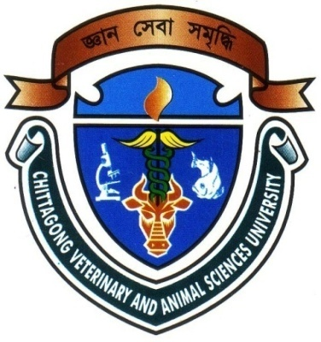

A Clinical Report Submitted By

Roll No: 2008/61
Reg. No: 403
Internship ID: D-40
Session: 2007-2008

This Clinical Report is Submitted for Partial Fulfillment of the Degree of Doctor of Veterinary Medicine (DVM)

Chittagong Veterinary and Animal Sciences University

Khulshi, Chittagong-4202

March, 2014

PREVALENCE OF GASTOINTESTINAL PARASITIC INFESTATION OF PIGS IN CHITTAGONG DIVISION.
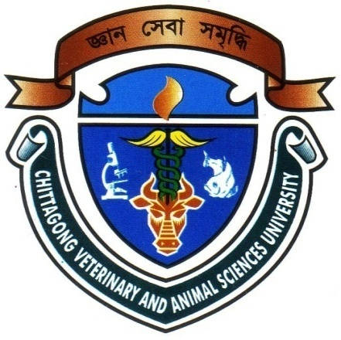

A Clinical Report Submitted as per Approved Style and Contents

……………………….
Signature of Supervisor
Dr. Md. Rayhan Faruque
Professor,
Dept. of Medicine & Surgery
Faculty of Veterinary Medicine
Chittagong Veterinary and Animal
Sciences University.

…………………..
Signature of Author
Flora Chakma
Roll No: 2008/61
Reg. No: 403
Intern ID: D-40
Session: 2007/2008

March, 2014

ACKNOWLEDGEMENT
The author is ever grateful and indebted to the Almighty Allah without whose grace it would have ever been possible to pursue this study in this field of science and to complete this clinical report writing for the Degree of Doctor Of Veterinary Medicine (DVM).
The author would like to express his deep sense of gratitude and thanks to Professor Dr. Nitish Chandra Debnath, Vice Chancellor, Chittagong Veterinary and Animal Sciences University.
The author would like to express his deep sense of gratitude and heartfelt appreciation to Professor Dr. Abdul Motin Prodhan, Dean, Faculty of Veterinary Medicine,Chittagong Veterinary And Animal Sciences University.
The author would like to express his ever indebtedness, deepest sense of gratitude, sincere appreciation and profound regards to his reverend and beloved teacher and Supervisor Dr. Krisna Roy, Asst. professor, Department of Pathology & Parasitology, Chittagong Veterinary And Animal Sciences University for his scholastic guidance, sympathetic supervision, valuable advice, constant inspiration, affectionate feeling, radical investigation and constructive criticism in all phases of this study.pt also.
The author highly express his sincere gratitude and gratefulness to the internship Coordinator, MR. Ashraf A. Biswash, Associate professor, Department of Animal Science And Nutrition, Chittagong Veterinary And Animal Sciences University., for his constant inspiration, cordial co-operation, valuable suggestion for completion of the report work.
The author would like to express his heartfelt appreciation & thanks to Dr.Md. Liakot Hossain, Veterinary Surgeon, sujanagar for his kind cooperation during the study period.
The author is a ever indebted to his parents, brothers, sisters & friends, for their sacrifices, blessing and encouragement to get him in this position.

