Chapter-I

**INTRODUCTION**

Bangladesh, a densely populated agro-based developing country, has a total area of 1,47,570 square kilometers and a total population of 142.6 million people with a density of over 966 persons per square kilometer **(SPBB, 2008)**. Bangladesh livestock population statistics indicates poultry is the most important species of farm animals. It is an emerging sub sector of livestock, play a vital role in the economic development by providing employment to different sections of people which has started here practically during 1980s **(Huque & Paul, 2001)**.

Poultry industry is an emerging agribusiness started during eighties in Bangladesh. Poultry farming is an important sector which provides a large share to the increasing demand for animal protein, cash income and employment opportunities.

In 1998-99, total meat production in Bangladesh was 656,000 tones, of which chicken and duck meat contributed 154,000 tones, which ranked second after beef. Per capita meat consumption was only 5.12 kg per year **(BBS, 2000)** and per capita protein intake 63gm per day **(BBS, 2003)** which is markedly below recommended requirements. Thus there is a need to increase the animal protein production to fulfill the demand of the increasing people. For that reason the production of poultry meat should be increased by fulfilling the demand of birds. If the proper utilization of food by digestive tract of poultry can be increased, the growth rate and meat production will be raised.

The digestive system of bird has some unique aspects in that they ingests their feed whole, stores it temporarily in the crop and masticates it in the gizzard rather than in the mouth **(Das *et al.*, 1965).**

The digestive tract of chickens conveys food to the stomach: this system comprises of- a) The crop (an expansion of the esophagus), located in the lower neck area;

b) The glandular stomach (proventriculus),

c) The muscular stomach (gizzard) and

d) intestines.

The oesophagus is wide and is capable of being significantly stretched. It connects the mouth region to the crop in close association with the trachea. The crop is a large dilatation of the oesophagus located just prior to where the oesophagus enters the thoracic cavity. The crop provides the capacity to hold food for some time before further digestion commences. This capacity enables the bird to take its food as “meals” at time intervals but permits continuous digestion. Although the mouth excretes the digestive enzyme amylase, very little, if any, digestion takes place in the crop – it is simply a temporary storage pouch that evolved for prey birds which need to move to the open to feed. They are able to consume relatively large quantities of food rapidly and then return to a more secure location to digest it **(Aspinall V and O’Reilly M, 2004).**

Occasionally the crop becomes impacted (**crop impaction**,also referred to as **crop binding** or **pendulous crop**). This may occur when feed is withheld for a period of time, causing chickens to eat too much too fast when the feed is returned. A crop may also become impacted in a chicken that is free-ranged on a pasture of tough, fibrous vegetation. With a crop impaction, even if a chicken continues to eat, the feed cannot get pass the impacted crop. The swollen crop may also cut off the windpipe, suffocating the chicken. Crop impaction is unlikely to occur in properly fed broilers or broiler breeders **(Jordan and Pattison, 1996).**

The length and weight of the segment of digestive tract are varied between the different species of birds **(Hassouna *et al*., 2001)**. Differential development of the absorptive epithelium may be responsible for changes in absorption capacity of birds (**Verdal *et al*., 2010).** Available strains of broilers (eg. Cobb-500, cobb-700, arbor acress, lohman meat etc.) are the result of genetic modification. They grow fast with better feed conversion ratio (FCR) than any other indigenous variety of chicken.

Histology of crop and proventriculus of chickens were described by **Aitken (1958);** **Calhoun (1954); Hassouna (2001)** they did not provide data about morphology and histology of crop and proventriculus of broilers in details.

However, there was no report in Bangladesh regarding postnatal growth and development of crop and proventriculus of broiler chickens digestive tract.

Therefore, the present study was conducted to describe gross morphometrical (weight, length, size and shape) and histology of crop and proventriculus of digestive tract of broiler in newly hatched and progressively matures broilers chicken of different age in Bangladesh. In our country broiler chickens are reared for the purpose of lean meant production at a period of maximum 35 days. During this period the broiler chickens are fed and medicated haphazardly due to the need for money and urgency of early marketing considering the increased demand for consumption. Therefore the growth rate of these birds is surely affected. Based on the fact that this study portraits a clear picture about the growth rate of Cobb-500 broiler chickens, specially their crop and proventriculus which are also related with the digestion of feed in birds. So that we can come to a certain understanding about the anatomy and histology of these organs as well as a basis for further study on nutritional, anatomical and histological field of Veterinary science.

**Objectives:**

1. To observe the gross characteristics (weight, length, size and shape) of crop and proventiiculus.
2. To observe the histological structure (arrangement of different layer) of crop and proventricular wall.

Chapter-II

**REVIEW OF LITERATURE**

The digestive tract of chicken is simple but more efficient when compared to other species. Avian digestive tract is a simple tube like structure.

**Parts of avian digestive tract:**

Birds lack teeth that chew food before swallowing, that’s why their digestive system is specialized to process unmasticated food. The major parts of the digestive system are- oral cavity, esophagus, crop, two chambered stomach (proventriculus and gizzard),liver, pancreas, intestine, and cloaca, are further specialized to accommodate particular types of diets and feeding practices. Linked to the development of flight and high metabolic rates, the digestive system most of the birds extracts nutrients and energy with high efficiency from small volumes of rapidly processed food. In embryonic life, the gut is derived from endoderm surrounded by splanchnic mesoderm and can be distinguished into foregut, midgut, and hindgut by day 3 of incubation( **Gilbert, 1997; Romanoff, 1960**). The endoderm will give rise to the epithelial lining of the gut and the ducts of the mucous glands, whereas the mesoderm will give rise to the muscular wall and connective tissue (**Gilbert, 1997**).

**Anatomy of chicken digestive tract:**

The anatomy of the chicken digestive tract is most notably different from that of mammals in the mouth area, in the presence of a crop in the esophagus, and in the presences of a muscular stomach or gizzard. The mouth and pharynx are not sharply delimited in birds, and in most species no soft palate. The hard palate communicates with the nasal cavity. Teeth are absent, their function being accomplish by the horny beak and the gizzard **(Ziswiler and Farner, 1972)**. The chicken esophagus is generally comparatively long and rather large in diameter, being larger in species which swallow larger food items. A dilatation of the esophagus, the crop is present in most species. The glandular stomach or proventriculus of bird extends from thoracic esophagus to isthmus (junction between the proventriculus and gizzard).Gizzard after the proventriculus, then intstine are the last part of the digestive tract.

**Crop:**

The crop is an out-pocketing of the esophagus and is located just outside the body cavity in the neck region. In the entrance of the thorax, its ventral wall is enlarged broadly, forming a diverticule (crop) **(Chikilian and De Speroni, 1996; Dyce *et al.*, 1996)**. The crop is responsible for the storage of victuals **(Turk, 1982).**

Consumed feed and water are stored in the crop until the remainder of the digestive tract is ready to receive more feed. When empty, or nearly empty, the crop sends hunger signals to the brain so that more feed is consumed. Thus crop is generally regarded as a food storage area when the stomach is full (**Dyce *et al*., 1996**) and also moistens food with mucus to ease transit through the alimentary tract.

**Whittow (2000)** reported that in pigeons and doves, crop milk is produced during the breeding season under the influence of prolactin. **Hodge (1974) reported that Mucous gland are absent at the crop region, the absence of secretory gland if there may occur any digestion in crop caused either by enzymes already present in the food, by enzyme from micro-organism or else by enzyme regurgitated from lower down the alimentary canal.**

**Philip and fuller (1983) reported that in chicken some carbohydrate digestion may occur in the crop due to the presence of amylase activity. Balton (1965) reported that starch is hydrolyzed within the crop where it can be absorbed; convert to alcohol, lactic or other acids; transported down to gastrointestinal tract.**

**Duke (1994)** reported that without specifying age, the normal crop pH has a mean value ranging from 4 to 5.

**Hinton *et al.,* (2000)** reported that High *Lactobacillus* counts and low pH in the crop reduce the occurrence of pathogenic bacteria, such as *Salmonella*.

**Proventriculus:**

**Encarta (2007)** reported that the proventriculus is the first part of a bird's stomach, where digestive enzymes are mixed with food before it goes to the gizzard. Inside the thoracic cavity, the oesophagus enters or becomes the proventriculus which is a very glandular part of the digestive tract (often called the glandular stomach) and the esophagus continues pass the crop to connect the crop to the proventriculus. It extends in the male between approximately the levels of the 5th thoracic and 3rd lumbosacral vertebrae, and in the female between 4th and 7th thoracic vertebrae **(Getty 1975).**

**McLeod *et al.,* (1964)** reported that the glandular stomach has a length of 5cm and a width at its widest part of 1.5cm. **Marsden (1940)** reported that length of proventriculus in male 6.25cm and in female 5.25cm. The proventriculus (also known as the **‘true stomach’**) is the **glandular stomach** where digestion begins. As with human stomachs, hydrochloric acid and digestive enzymes (e.g. pepsin) are added to the food here and digestion begins. At this point, however the food has not yet been ground up. The term ‘proventriculus’ is used since it comes before the ‘ventriculus’ or gizzard, with ‘pro’ being the Latin term meaning before.

**Arai *et al.,* (1988)** reported that immunoglobulin-positive cells are present in the proventriculus of chickens.

**Matsumoto and Hashimoto (2000)** reported that B- and T-cell populations are in the chicken proventriculus.

**Vervelde and Jeurissen (1993)** reported that T-cell population and macrophage are in the chicken proventriculus.

**Latimer (1925)** reported that between hatching and maturity the weight of the glandular stomach increases14.5-fold.

**Malewitaz and Calhoun (1958)** reported that the structure of the chicken stomach is similar to turkey.

**Histological structure:**

**Crop**

Crop is important for bird to storage of food and it is a flexible structure when bird fed it become larger when empty it become smaller in size. The structure is as follows:

The wall of the crop is composed of four layers of tissue, the innermost being mucous membrane. The mucous membrane is an important barrier to the entry of microbes and the mucous it produces is a lubricant that aids the passage of the food along the alimentary canal. The structure, upper and below the crop is similar to that above except there is less lymphoid tissue below the crop. The crop structure is similar to that of the oesophagus except there are no glands present in fowls (**Elias, 1945)**. Ducks and geese have glands in the crop mucous membranes. In pigeons the surface cells of the crop slough off during brooding to form pigeon’s milk which is used to feed the baby pigeons in the nest.

**Dyce *et al*., (1996)** reported that at the time of breeding, the large symmetrical crop of both male and female pigeons elaborates a crumbly material (crop milk) consisting of desquamated lipid- laden cells; mixed ingested food, it is regurgitated and fed to the nestlings.

**Proventriculus**

The glandular stomach, or proventriculus, is relatively small and tubular. The wall is very thick and is composed of five layers:

1. Outer serous membrane
2. Muscle layer composed of three separate layers:
   * Two thin longitudinal layers
   * Thick circular layer
3. Layer of areolar tissue containing blood and lymph vessels
4. Thick layer composed mainly of glandular tissue
5. Mucous membrane

The glands form the greater part of the thickness of the organ. Simple single glands group to form lobules each of which converges into a common cavity near the surface. The cavities converge to form a common duct that leads to the surface through the apex of a small papilla. These glands produce a number of juices or enzymes that are used in the digestion or breaking down of food into its constituent nutrients. The mucous membrane is raised into folds and between these folds are numerous simple tubular glands that produce hydrochloric acid as well as lymphoid tissue (**Elias, 1945).**

**Hill (1971)** reported that mucus, pepsin, and hydrochloric acid are added to the digesta as it passes through the proventriculus, but there is no storage function associated with the bird’s glandular stomach. Thus, the functions of the monogastric stomach are provided by several organs rather than one.

**Species differences:**

**Crop is varies in size and shape according to the diet of the species- grain- eating birds have large bilobed crops while in owls and insectivores the crop may be rudimentay or absent.**

In ducks and geeses, as in most of the birds, the crop is merely a fusiform expansion of the oesophagus **(Dyce *et al.*, 1996**). In bustards, the crop is absent (**Bailey *et al.*, 1997**). The crop is absent in the gulls and penguins, and the food passes directly for the proventriculus. The comparison with chicken, crop absent in ostrich **(Camiruaga & Simonetti, 2003).**

**Nickel (1977**) reported that the chicken oesophagus as unilateral and the pigeon crop is symmetrically bilateral. The crop epithelia in fowl are stratified squamous, and in some species such as the pigeon it is extremely keratinized **(Banks, 1992).**

**Marsden (1940)** reported that turkey esophagus lack of crop.

**Cazin 1887; Das and Biswal, 1967** reported that the gland in the proventriculus of duck are unilobular.

**Kolda and Komarek (1958)** reported that the papillae are more in number in duck and goose than chicken and those of the duck are more numerous and smaller than in the goose.

**Chapter-III**

**METERIALS AND METHOD**

The study was carried out to determine the postnatal development (Anatomical and histological) points of crop and proventriculus of “Cobb-500” broiler chickens. The study was carried out in the Dept. of Anatomy & histology, Faculty of veterinary medicine, Chittagong Veterinary and animal sciences University.

**3.1 Selection of study population:**

The study was carried out in 15 broiler chickens “Cobb-500” of different ages; at 1 day, 14 day, and 28 days. The samples were collected at two weeks intervals; each group consists of 5 birds of either sex.

**3.2 Source of the samples:**

The broiler chickens were collected from Agha poultry farm, Hathazari, situated in various places surrounding the Chittagong district. The samples were collected at two week intervals from different farmers. After the physical examination of birds, apparently healthy and without any detectable signs of abnormalities and disease were selected as sample. Abnormal and disease bird could manipulate the result of the study.

**3.3 Experimental design**:

Prior to the starting of the study, an experimental schedule was fixed specifying different aspects of the total work and it was maintained during the whole study. Samples were divided into 3 groups according to their ages and regardless of sex. Each group consists of five broiler chickens of equal ages- group I (1 day), group II (14 days), and group III (28 days).The experiment was carried out on each group at different days for efficiency of work and to minimize the result errors.

**3.4 Management:**

After collection, all the broiler chickens were preserved in a cage, in the department of Anatomy and Histology, Faculty of Veterinary Science, Chittagong Veterinary and Animal Sciences University (CVASU). Optimum temperature, lighting and ventilation were maintained. Water and feed were provided adlibitum. All procedures were maintained by the Animal Care and Welfare Committee of our institute.

**3.5 Determination of live weight of bird:**

Live weight was measured using sensitive electronic balance (Mettler Toledo B154, ± 0.001g, China) prior to sacrifice of the broilers. In the laboratory of Department of Anatomy and Histology, Faculty of Veterinary Science, CVASU

**3.6 Sacrifice of broilers**

The birds were slaughtered by Halal method.

**3.7 Collection of sample:**

After slaughtering of chicken and cessation of the heartbeat, respiration and after evacuation of entire blood, crop and proventriculus were collected by cutting skin, cervical bone and abdomen**.** The collected samples were washed properly using normal saline and dried properly. The total length and diameter of the crop and proventriculus were determined in those broilers of different ages. Samples were collected from each group per day.

**3.8 Gross Anatomical investigation and measurement:**

The shape, color and consistency of the crop and proventriculus were observed. After that, weight of both of the samples were taken and recorded. By using digital “slide calipers” the longitudinal diameter, transverse diameter are measured and tabulated.

**3.9 Preservation of the sample:**

After the gross anatomical examination the samples were cut to a appropriate size and tagged with a piece of paper to identify the sample age, name and number and then fixed by chemical fixation using 10% buffered formalin solution(pH 7.4) and shaken 24 h for fixation.

**3.10 Preparation of slide:**

Procedure of histological slide preparation:

**3.10.1. Dehydration:**

The tissues are washed in water overnight prior to the dehydration process. The tissues are dehydrated in the dehydration process using different concentration of alcohol (ethyl alcohol) and xylene. The tissues were placed in different solutions as following-

50% alcohol- (ethyl alcohol) (starting from water) - 2 hours

70% alcohol- 2 hours.

90% alcohol- 2 hours.

95% alcohol- 2hours.

100% alcohol (first time) - 1 hour

100% alcohol (second time) - 1 hour

**3.10.2. Cleaning:**

Alcohol+ xylene(50%) – 2 hours or overnight.

Toluene or xylene (first time)- 1/2–1 hour

Toluene or xylene (second time) - 1/2–1 hour

**3.10.3. Paraffin infiltration:**

From the second change of xylene the tissues are moved through several changes of xylene +paraffin and kept in oven for maintaining specific temperature (58-600 c).

**3.10.4. Embedding of tissue:**

The tissues are then embedded in 100% paraffin and paraffin blocks were mounted using suitable pieces of metal (two L shaped metal join together to make a block).

**3.10.5. Sectioning of tissues:**

Prior to sectioning of the tissues using rotary microtome machine the face of each paraffin blocks were trimmed properly so that it is in the shape of a trapezoid with the top and bottom sides being parallel. The block was then cut at a diameter of 6 µm (1 micro miter =1/1000 mm, 10 mm= 1cm).

Fig: Shape of the paraffin block

**3.10.6 .Placing the tissues in the water bath:**

Bundles of cut sections (paraffin ribbon) were then placed in water bath at a temperature of 58ºc in order to melt the paraffin and also to spread the tissues properly. Necessary amount of slides are taken and cleaned properly using blotting paper. Then with a diamond marker one end of the each slide were scratch marked to identify the sample name and number. Egg albumin was applied as an adhesive to hold up the tissues so that they won’t fall down or detach during further processing. The tissues from the water bath are then wiped into the slides very gently. The slides were then dried overnight and placed in slide tray for further processing.



**Fig: Ribbons of paraffin sections floating on water on a slide.**

**3.10.7. Staining of the tissue:**

For the staining procedure Hematoxylin and Eosin stain was used. Prior to staining the paraffin was completely removed from the tissues using xylene. The slides are then washed in water and rehydrated again using graded series of alcohol (ethyl alcohol) after staining with hematoxylin and eosin the slides are then washed in xylene.

**3.10.7.1. Deparaffinization:**

For dissolving the paraffin in the sections the following reagents were used-

Xylene -I, for 5minutes.

Xylene -II, for 5 minutes.

**3.10.7.2. Rehydration:**

All samples were rehydrated gradually by decreasing concentrations of ethyl alcohol (100%, 100%, 95%, and 70%) for 5 minutes each. Then washed in running tape water for 5 minutes.

**3.10.7.3. Hematoxilin staining:**

Then the slides were stained by Hematoxyline for 15 minutes and then washed in running tape water until clearing for 5 minutes.

**3.10.7.4.** **Acid alcohol:**

Then a few dips (2-4) in 1% acid alcohol.To remove the excess stain this step was done. Then washed in running tape water for 5 minutes.

**3.10.7.5. Eosin staining:**

Eosin (1%) staining for 1 minutes.

**3.10.7.6. Redehydration:**

All slides were redehydrated gradually by increasing concentrations of ethyl alchol (70%,95%,100%) for 5 minutes each.

**3.10.7.7. Cleaning & staining for 1 minutes:**

Finally, the following reagents were used to clean and remove the alcohol Alcohol(50%) + xylene(50%)- 5 minutes.

Xylene I-5 minutes.

Xylene II-5 minutes.

**3.10.8. Mounting of slide:**

After completing the staining procedure the slides were air dried properly. Then cover slips were mounted in the slides very carefully using a suitable mounting medium (Canada balsam) without producing any bubbles. The excess mountant was removed very carefully with tissue paper. Mounted slides were allowed to harden.

**3.10.9. Visualization under microscope:**

After the slides were properly fixed and dried the slides were taken under microscope. Slides are then visualized at 4x objective and still images were taken by using a computer operated (toup view) software. Along with this operation different cellular structures like mucosa, sub mucosa, muscle layer and serosa were observed, marked and noted the findings.

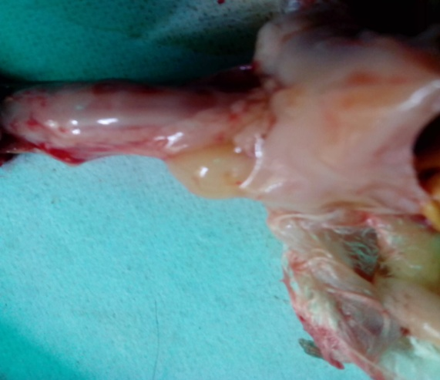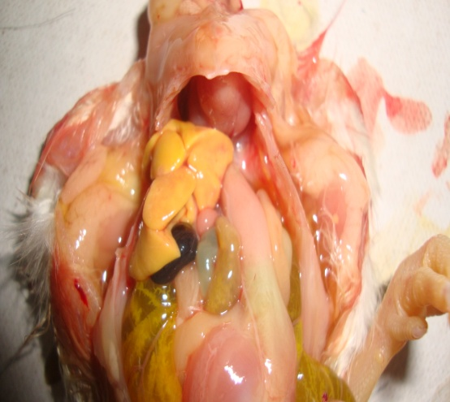

**Crop**

**Proventriculus**

**Fig-2:** After dissecting observing the anatomical position of the proventriculus in broiler.

**Fig-1:** After dissecting observing the anatomical position of the crop in broiler.

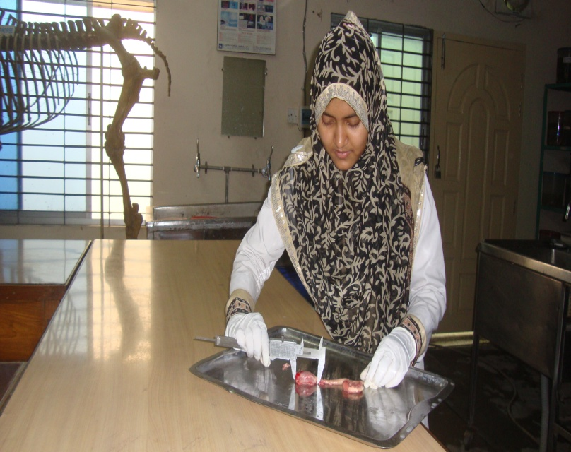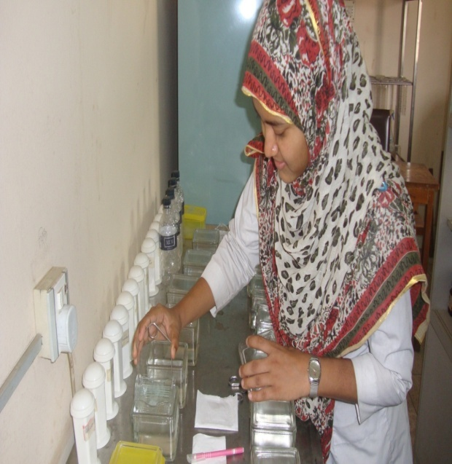

**Fig-3:** Working at anatomy lab and measuring the morphometrical characteristics of crop and proventriculus in broiler.

**Fig-4:** Staining of slide for histologcal observation at cell biology lab.

CHAPTER-IV

**RESULT AND DISCUSSION**

**Gross characteristical Discussion:**

**Crop or Ingluvies:**

Crop is the part of the proximal esophagus of chicken. The bird esophagus has two parts, one is cervical esophagus and another one is thoracic esophagus. Crop is the part of the cervical esophagus This finding is similar to the **Getty (1974)**. The course of esophagus starts from oropharynx of the mouth to the glandular stomach.

**Course of crop:**

The cervical esophagus is shorter than the unextended S-shaped vertebral column of the cervical region. Cranially it lies in the midline dorsal to larynx and trachea, to which it is closely attached by connective tissue. Caudal to the 5th cervical vertebra it is on the right of the neck between the jugular vein, vagus and thymus dorsally and the trachea ventrally. Immediately cranial to the thoracic inlet it returns to the midline and enlarges ventrally to form a saccular diverticulum known as the crop, which lies ventrolateral to the esophagus and cranial to the clavicle and pectoral muscles. The adventitia of the crop is strongly attach to the skin and has striated muscle fibers from the cutaneous muscle or the clavicle. **Getty (1975) and Bradley and Grahame (1960)** also reported the same findings in crop.

**Shape:**

The shape of the crop of broiler chicken is unilateral and situated at the right side.

This finding is similar to the **Nickel (1977).**

**Inner structure:**

In between the esophagus and crop, there is present distinct sphincter like opening. The inner surface of the esophagus and crop has longitudinal folds and is lined by a stratified squamous epithelium where open the numerous mucous glands of the lamina propria. Mucous glands however are present in the crop only close to the esophagus. This finding is as like as **Getty (1975), Calhoun (1954), Lucas and stettenheim, (1965).**

**Proventriculus (Glandular stomach):**

Proventriculus was relatively small and tubular. It was located caudal to the crop. **Nasrin *et al.* (2012)** also reported the characters**.**

**Shape:**

The shape of proventriculus is an elongate, spindle-shaped organ and directed craniocaudally, somewhat ventrally and to the left, in the left ventral part of the body cavity. This finding is agreed to the **Getty (1975).**

It is extends from level of 4th thoracic to 2nd lumbo-sacral vertebrae, this finding is close to the **Getty (1975), Calhoun (1954).**

**Inner structure:**

The junction of the glandular stomach is not obvious externally. Caudally at the junction with the muscular stomach there is a distinct lighter colored constriction, called isthmus. This finding is similar to **Getty (1975).**

Most of the left and ventral surfaces of the glandular stomach is close to the liver, and especially to the left lobe in which it produces an impression. The right side is caudodorsally close to spleen. The cranial part of the dorsal surface is separated from the ventral surface of the lung by the cranial thoracic air sac. Ileum and ceca are sometimes dorsal to the proventriculus. This finding is Close to the **Getty (1975).**

The wall of the proventriculus is thicker than that of the esophagus and crop, the width of the lumen is little different. Most of the internal surface is reddish in color and mucus layer containing mucin granules. Numbers of low, wide, macroscopically visible papillae are projecting into the lumen. This finding is as same as **Getty (1975), Calhoun (1954).**The proventriculus generally lacks the Longitudinal folds of the thoracic esophagus. There may be fold internally in both the storage and intermediate stomach types. This finding is as same as **Getty (1975).**

**The morphometric study in different age:**

**Crop:**

|  |  |  |  |
| --- | --- | --- | --- |
| **Age(days)** | **Length(cm)** | **Diameter(cm)** | **No. of mucosal fold** |
| 1 | 0.7 | 0.9 | 17 |
| 14 | 1.9 | 2.9 | 12 |
| 28 | 2.3 | 3.4 | 8 |

**Graphical represention of variation in crop according to age:**

Comparative presentation of the length (cm) and diameter (cm) of broiler crop according to age. The chart represents in that case the length increased very slowly where’s the highest length at day 28 and lowest at day 1and the diameter also increased very slowly where’s the heighest diameter at day 28 and lowest at day 1. The number of mucosal fold of crop is decreased modarately slow where’s the high number of mucosal fold at day 1 and low at day 28.

**Proventriculus:**

|  |  |  |
| --- | --- | --- |
| Age(days) | Length(cm) | Diameter(cm) at mid point |
| 1 | 1.25 | 0.7 |
| 14 | 2.81 | 1.1 |
| 28 | 3.72 | 2.2 |

**Graphical representation of variation in proventriculus at different ages:**

Comparative presentation of the length (cm) and diameter (cm) of proventriculus of broiler digestive tract according to age. The chart represents in that case the length increased modarately where’s the highest length at day 28 and lowest at day 1. Also the diameter is increased very slowly where’s the heighest diameter at day 28 and lowest at day 1.

**Weight of crop and proventriculus:**

|  |  |  |
| --- | --- | --- |
| Age (days) | Weight of proventriculus(gm) | Weight of crop  (gm) |
| 1 | 0.34 | 0.19 |
| 14 | 3.32 | 2.13 |
| 28 | 6.86 | 7.80 |

**Graphical representation of weight variation of crop & proventriculus at different ages:**

Comparative presentation of the Weight of crop and proventriculus of broiler digestive tract according to age. The chart represents in that case the weight of crop increased modarately where’s the highest length at day 28 and lowest at day 1. Also the weight of proventriculus increased at highly where’s the highest length at day 28 and lowest at day 1.

**Histological structure:**

**Crop:**

The histologic structure of the crop similar to the structure of the esophagus. It is characterized by a thick nonkeratinized stratified squamous epithelium.The lamina propria is a loose connective tissue containing large mucous gland. The lamina muscularis consist of longitudinal arranged smooth muscle fibers. The submucosa consists of a thin layer of loose connective tissue. The tunica muscularis is composed of a thick inner circular layer and a thin outer longitudinal layer of smooth muscle. This findings was similar to **Nasrin *et al ., (*2012).** The crop covered by a typical Adventitia.

The lining epithelium of the crop was keratinized stratified squamous epithelium which was thicker in the chickens of D28 than at D14 and at D1.

**Proventriculus:**

The mucosa of the proventriculus is characterized by macroscopic papillae with numerous microscopic folds of varying height that are arranged concentrically around the single duct opening at the apex of each papilla. The mucosal fold into proventriculus called plicae and depression between the folds are called sulci. Simple columner epithelium lines the lumen and continues into three generations of ducts of the submucosal glands This findings was similar to the result made by **Aitken (1958), Nasrin *et al,. (*2012)**, where, the author reported that the mucosa contains simple tubular glands lined throughout their length by a columnar epithelium.

The glands are lined by a simple cuboidal to low columner epithelium in which the adjacent cells are in direct contact only on their basal half, thereby giving a serrated appearance to the luminal surface. The proventicular wall is occupied large compound tubular gland and the gland are multilobular. The lamina propria is typical loose connective tissue. The lamina muscularis consists of scattered bundles of smooth muscle. The loose connective tissue of the submucosa is followed peripherally by a tunica muscularis consisting entirely of smooth muscle. The proventriculus covered by a typical serosa.this finding is similar to **Randall and Reece (1996)**. The proventicular gland were neumeros and the size of the gland were large in D28, D14, D1.

**Histological (microscopical) stucture of crop and proventriculus are shown below as D1, D14 and D28:**

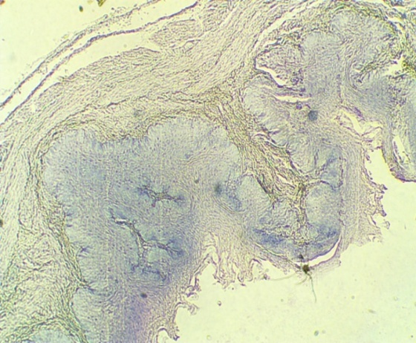 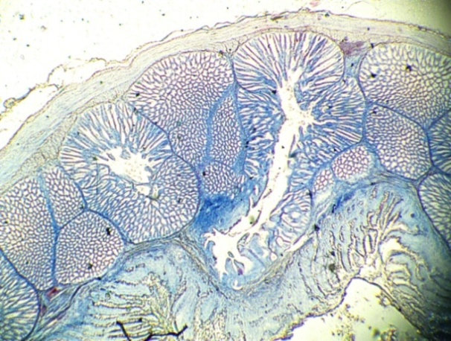

Histology of crop of the chickens at D1. Here, Stratified squamous epithelium (SSM), Lamina propria (LP), Muscularis mucosae (MM), Submucosa(SM), Muscularis externa (ME) and Serosa (S) are shown.

Histology of proventriculus of the chickens at D1. Here, Lumen (L), Papilla (P) with plicae arrrows, Submucosa gland (SG),Tunica muscularis (TM), Primary duct (PD) and Serosa (S) are shown.

**S**

**TM**

**L**

**PD**

**P**

**SG**

**LP**

**S**

**ME**

**SM**

**SSM**

**MMMM**

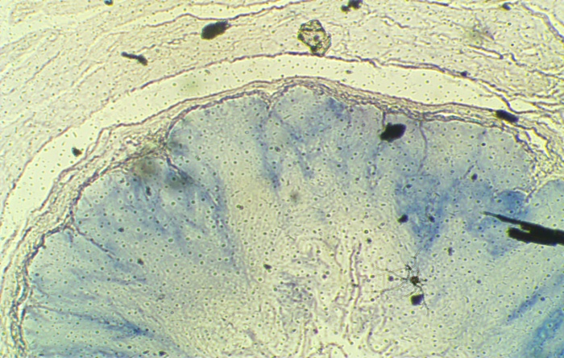 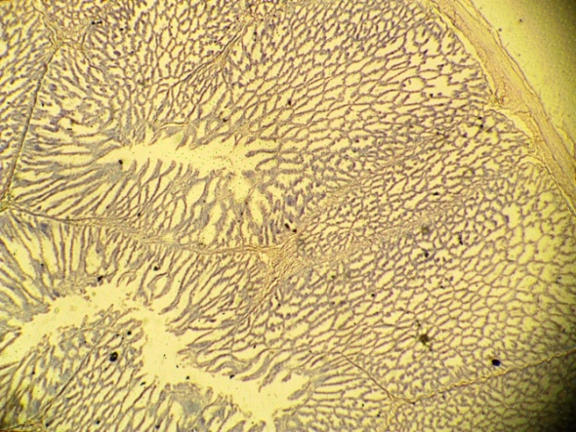

Histology of crop of the chickens at D14. Here, Stratified squamous epithelium(SM), Lamina propria (LP), Muscularis mucosae (MM), Submucosa(SM), Muscularis externa (ME) and Serosa (S) are shown.

**SG**

**SU**

**PL**

**PD**

**TM**

**SM**

**ME**

**LP**

**SSM**

**MMMM**

Histology of proventriculus of the chickens at D1. Here, Papilla (P) with plicae (PL) arrrows, Submucosa gland (SG),Tunica muscularis (TM), Primary duct (PD) and Sulcus (SU) are shown.

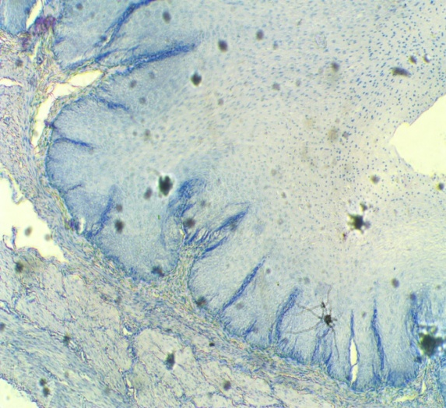 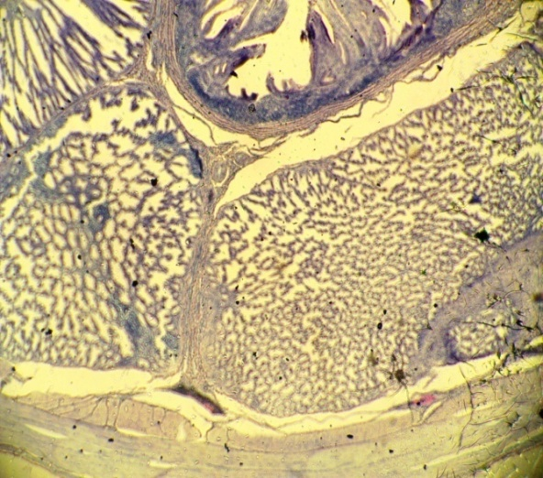

Histology of proventriculus of the chickens at D1. Here, Lumen (L), Papilla (P) with plicae arrrows, Submucosa gland (SG),Tunica muscularis (TM), Primary duct (PD) and Serosa (S) are shown.

Histology of crop of the chickens at D28. Here, Stratified squamous epithelium(SM), Lamina propria (LP), Muscularis mucosae (MM), Submucosa(SM), Muscularis externa (ME) and Serosa (S) are shown.

**S**

**TM**

**PD**

**SG**

**ME**

**MMMM**

**SM**

**LP**

**SSM**

CHAPTER-V

**CONCLUSION**

The average lengths and weights of crop, proventriculus, were significantly higher at D28 than that at D14 and at D1. Various layers of crop and proventriculus were lamina epithelia, lamina propria, lamina muscularis, submucosa, tunica muscularis and serosa was found. The histological structure of the crop is similar to the oesophagus. The mucous glands are reduced in size and the lymphatic tissues are dispersed in the connective tissue. There is a thin stratum of smooth muscle and other two wider layers of longitudinal and circular musculature. The lining epithelium of the crop was nonkeratinized stratified squamous epithelium which was thicker in the broiler at D28 than that at D14 and at D1. The histological stucture of the proventriculus is found the mucasa of the papilla is arranged into folds (plicae) and depression (sulcus) and it also covered by columner cells and a primary duct lined by columner cells, joins the lumen of the proventriculus.Submucosa contain loose connective tissue, tunica muscularis contain smooth musle and serosa. The proventicular gland were more and the size of the gland were large in D28 and then D14, D1.

**REFERENCES**

Aitken RNC (1958). A histochemical study of the stomach and intestine of the chicken. J. Anat*.,* 453-466.

Arai N, Hashimoto Y, Kitagawa H, Kon Y, and Kud N (1988). Immunohistochemical study on the distribution of lymphoid tissues in the upper alimentary and respiratory tracts of chickens. Jpn. J. Vet. Sci. 50:183–192.

Aspinall V and O’Reilly M. (2004). Introduction to veterinary anatomy and physiology. 1st edn., British Library Cataloging in Publication Data, Library of Congress Cataloging in Publication data.

Bailey TA (1997) Comparative morphology of the alimentary tract and its glandular derivatives of captive bustards. J. Anat, Cambridge, v. 191. P-387-398,

Banks WJ (1992). Histologia veterinária aplicada. 2. ed. São Paulo,Manole.

BBS (2000). Bangladesh Bureau of Statistics. Statistical Year Book of Bangladesh. Published June 2002, 21st edn,. http://www.bbs.gov.bd

BBS (2003). Bangladesh Bureau of Statistics. Statistical Bulletin Bangladesh, July. <http://www.bbs.gov.bd>

Bolton W(1965).Digetion in crop. British Poultry Science.6:97-102.

Calhoun ML (1954). Microscopic Anatomy of the digestive system of the chicken lowa state University Press, Ames.

Camiruaga M and Simonetti C (2003). Avestruces, his food and digestive system. Rev. Agronomy and forestry UC, 12:10 - 4.

Cazin M (1887). L’appareil gastrique des oiseaux. Ann. Sci.nat. (Zool.), 4:177-323.

Chikilian M, Speroni DE (1996). Comparative study of digestive system of three species of tinamou I. Crypturellus tataupa, Nothoprocta cinerascens, and Nothura maculosa (aves: Tinamidae). J. Morph., Hoboken, 228(1):77-88.

**Das LN and Biswal G (1967). Microscopic anatomy of esophagus, Proventriculus, and Gizzard of the domestic duck (Anas boscus) Indian vet. J., 44:284-289**

Das LN, Mishra DW and Biswal G (1965). Comparative anatomy of the domestic duck. Indian vet. J., 42:320-326.

Duke GE (1994). Physiology of digestion and metabolism. Zootec Internacional, 17: 50-53,

Dyce KM, Sack WO and Wensing CJG (1996). Textbook of Veterinary Anatomy. W. B Saunders Co, Philadelphia.

Elias H (1945). Comparative histology of domestic animals. I. The digestive system. 3. Oesophagus and stomach of domesticated birds. The Middlesex veterinarian 4:1-6.

Encarta (2007). World English Dictionary (North American Edition). Proventriculus. Source: (accessed: December 18, 2007).

Farner DS (1960). Digestion and the digestive system. In: Marshall AJ (eds.) Biology and comparative physiology of Birds, Vol. I.Academic Press, London.

Getty R (1975). Sisson and Grossman’s The Anatomy of the Domestic Animals. 5th edn., Vol.II, W.B. Sunders Co, Philadelphia, USA.

Gilbert SF (1997). Early Vertebrate development: mesoderm and endoderm. Developmental Biology. 5th eds. Sinauer Assoc., Sunderland, MA.

Hassouna EMA (2001).Some anatomical and morphometrical studies on the intestinal tract of chicken, duck, goose, turkey, pigeon, dove, quail, sparrow, heron, jackdaw, hoopoe, kestrel and owl. Assiut Vet. Med. J.,44: 47-78.

Hill KJ (1971). The structure of the alimentary tract. In: Bell DJ and Freeman BM (eds.) Physiology and Biochemistry of the Domestic Fowl, Academic Press, New York.

Hinton JRA, Buhr RJ, Ingram KD (2000) Reduction of *Salmonella* in the crop of broiler chickens subjected to feed withdrawal. Poult. Sci, 79:1566-1570.

Hodges RD (1974). The histology of the fowl. Academic press, New York.

Huque QME and Paul DC (2001). Strategies for family poultry with special reference to women participation. Paper presented la In SAARC Poultry Conference Held On 24-26, September 2001 At Pune .India

Jordan FTW and Pattison M (1996). Poultry diseases 4th edn., W.B. Saunders Company Ltd. London.

Kolda J and Komarek V (1958). Anatomie Domacich Ptaku. State Agricultural publishing House, Prague.

Latimer HB (1925). The relative post natal growth of the systems and organs of the chicken. Anat. Rec., 31:233-253.

Lucas AM and Stettenheim (1965).Avian Anatomy. In: Biester HE and Schwarte LH (eds.) Diseases of Poultry. 5th eds., lowa state University Press, Ames.

Malewitz TD and Calhoun ML (1958). The gross and microscopic anatomy of the digestive tract, spleen, kidney, lungs and heart of the turkey. Poult. Sci.37:388-398.

Marsden SJ (1940). weights and measurement of the parts and organs of turkey. poult. Sci., 19:23-28.

Matsumoto R and Hashimoto Y (2000). Distibution and developmental change of lymphoid tissues in the chicken proventriculus. J. Vet. Med. Sci., 62:161–167.

Mcleod WM, Trotter DM and Lumb JW (1964). Avian Anatomy. Minneapolis, Burgess Publishing Company.

Nasrin M, Siddiqi MNH, Masum MA and Wares MA (2012).Gross and histological studies of digestive tract of broilers during postnatal growth and development. J. Bangladesh Agril. Univ. 10(1): 69–77.

Nickel R, Suchummer A and Seiferle E (1977). Anatomy of the domestic birds. Verlag Paul Parey, Berlin.

Philip SM and Fuller R (1983). The activities of amylase and a trypsin-like protease in the gut contents of germ-free and conventional chickens. Bri. Poult. Sci.,24:115-121.

Randall CJ and Reece RL (1996). Color atlas of avian histology. New South Wales. Australia.

Romanoff AL (1960). The digestive system. Avian Embryo. Macmillan Company, New York.

SPBB (2001). Statistical Pocket Book of Bangladesh (2008) Published at January 2009. http://www.bbs. govbd

Turk DE (1982).The anatomy of the avian digestive tract as related to feed utilization. Poult. Sci., Savoy, 61(7):1225-1244,

Verdal Hde, Mignon-Grasteau S, Jeulin C, Bihan-Duval ELe, Leconte M, Mallet S, Martin C and Narcy A (2010). Digestive tract measurements and histological adaptation in broiler lines divergently selected for digestive efficiency. Poult. Sci.89: 1955-1961.

Vervelde L and Jeurissen SHM (1993). Postnatal development of intra-epithelial leukocytes in the chicken digestive tract: phenotypical characterization in situ. Cell Tissue Res. 274:295–301.

**Whittow GC (2000). Sturkie’s Avian physiology, Academic press, New York.**

Ziswiler V & Farner DS (1972). Digestion and digestive system. In: Farner DS and King JR (eds), avian biology ,Vol. II, Academic Press, London.