A STUDY ON THE OCCURRENCE OF INFECTIOUS BURSAL DISEASE IN BROILER CHCIKENS OF NARSINGDI DISTRICT, BANGLADESH
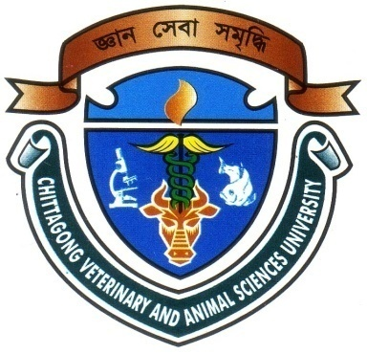

A Clinical Report Submitted by
Roll No: 2007/42
Reg. No: 329
Internship ID: D-38
Session: 2006-07

Report Presented in Partial Fulfillment of the Requirement for the Degree of Doctor of Veterinary Medicine

Faculty of Veterinary Medicine
Chittagong Veterinary and Animal Sciences University
Khulshi, Chittagong-4225

June 2013

A STUDY ON THE OCCURRENCE OF INFECTIOUS BURSAL DISEASE IN BROILER CHCIKENS OF NARSINGDI DISTRICT, BANGLADESH

A Clinical Report Submitted as per approved style and content

….........................................  Signature of Author  Md. Rezwanur Rakib  Roll No. 2007/42  Reg. No. 329  Internship ID: D-38  Session: 2006-2007  Date: | ….......................................  Signature of Supervisor  Dr. Himel Barua  Associate Professor Department of Microbiology  Chittagong Veterinary and Animal  Sciences University  Khulshi, Chittagong – 4225  Date:

Faculty of Veterinary Medicine
Chittagong Veterinary and Animal Sciences University
June 2013

CONTENTS

SI. NO. | SUBJECT | PAGE NO.
01 | Acknowledgement | i
02 | Abstract | ii
03 | Introduction | 01
04 | Objectives | 01
05 | Review of Literature | 02-05
06 | Materials and Methods | 06
07 | Result and Discussion | 07-08
08 | Conclusion |  | 09
09 | Limitation |  | 10
10 | References | 11-13

ACKNOWLEDGEMENT

This clinical report is the part of my internship programme under Chittagong Veterinary and Animal Sciences University (CVASU), Khulshi, Chittagong.

I want to take the privilege to acknowledge the Almighty ALLAH, who enables me the opportunity to accomplish the report.

I would like to express my gratefulness to my supervisor, Dr. Himel Barua, Associate Professor, Department of Microbiology, Faculty of Veterinary Science, Chittagong Veterinary and Animal Sciences University,for his sympathetic supervision, inspiration, constructive criticism, valuable suggestion and providing important information throughout the course work and reach towards the preparation of the manuscript in time.

The author is deeply owe, Professor Dr. Abdul Ahad, Head of The Department, Department of Microbiology, Chittagong Veterinary and Animal Sciences University, for his constant help and valuable advice during research work.

The author also would like to express his thanks to DR. Abdus Sukur, General poultry practitioner for his constant help during the study.
I convey thanks to those who help me in various aspects to complete this report.

The Author
June, 2013.

i

ABSTRACT

An investigation on the occurrence of infectious bursal disease (IBD) in broiler chickens was conducted in Narsingdi district during the period from 1st January to 31stJanuary 2013. A total of 64 dead broiler chickens were collected from different broiler farms and examined. The diagnosis of the disease was performed based on post mortem findings. IBD was diagnosed in 21.9% birds with the highest number of cases recorded in the age group of 15-28 days (54.69%). Other concurrent infections found with IBD included colibacillosis, coccidiosis and chronic respiratory disease.

Keywords: Infectious bursal disease, broiler, post mortem findings, Narsingdi.

ii

