ANALYSIS OF PHYSICAL, BIOCHEMICAL AND HEMATOLOGICAL PARAMETERS OF RUMEN FLUID AND BLOOD IN DIGESTIVE DISORDERED GOAT

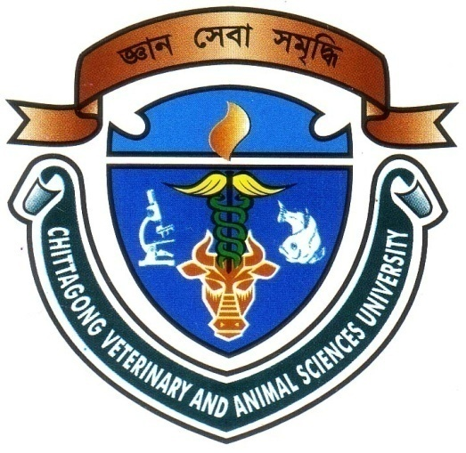

A clinical report submitted by
Intern ID: D-39
Roll No: 2007/43
Registration No: 330

In Partial Fulfillment for the Degree of Veterinary Medicine
Chittagong Veterinary and Animal Sciences University
Khulshi, Chittagong
JUNE 2013
ANALYSIS OF PHYSICAL, BIOCHEMICAL AND HEMATOLOGICAL PARAMETERS OF RUMEN FLUID AND BLOOD IN DIGESTIVE DISORDERED GOAT

A clinical report submitted by
Intern ID: D-39
Roll No: 2007/43
Registration No: 330

Approved as to style and content by

-------------------------------- -----------------------------------
Signature of Author Signature of supervisor
Dr. S.K.M. Azizul Islam
Designation: Assosiate professor Dept. of Bio-Chemistry, Physiology and Pharmacology Chittagong Veterinary and Animal Sciences University, Chittagong.
Jagrity Chakma
Roll No: 2007/ 43
Reg.No:330
Intern ID: D-39

CONTENTS

ACKNOWLEDGEMENTS = I
ABSTRACT = II

CHAPTER | NAME OF CONTENTS | PAGE NO.
I. | INTRODUCTION | 1-2
II. | REVIEW OF LITERATURE | 3-9
III. | MATERIALS & METHODS | 10-12
IV. | RESULTS & DISCUSSION | 13-17
V. | CONCLUSION | 18
VI. | REFERENCES | 19-21

LISTS OF TABLES

Table | Title |  | Pages
Table 1 | Physical parameters of rumen fluid |  | 13
Table 2 | Biochemical parameters of rumen fluid and blood |  | 15
Table 3 | Hematological parameters of blood |  | 16

LISTS OF CHART
Figure | Title |  | Pages
Figure 1  [  Figure 2 | Chart showing the physical parameters of rumen fluid (color and consistency )  Chart showing the physical parameters of rumen fluid (odor and motility). |  | 14  15

ACKNOWLEDGEMENTS
All praises are due to the Almighty Allah, the creator and supreme authority of the universe, who empowers the author to complete the research work successfully.
The author wishes to express her deepest sense of gratitude, sincere appreciation, indebtedness and profound regards to his respected teacher and reverend supervisor, Dr. S.K .M. Azizul Islam, Assosiate Professor, Department of Bio-chemistry, Physiology and Pharmacology, Faculty of Veterinary Science, Chittagong Veterinary and Animal Sciences University, for his constructive and constant guidance in planning and execution of this research work, continuous encouragement, scholastic guidance, and affectionate feelings throughout the course of research work.
The author is deeply owe, Professor Dr. A.K.M. Saifuddin, Head of The Department, Department of Bio-chemistry, Physiology and Pharmacology, , Chittagong Veterinary and Animal Sciences University, for his constant help and valuable advice during research work.
The author whishes to express her gratitude to the Dr. Bibek Chandra Sutradhar, Associate professor and Director External Affairs, Chittagong Veterinary and Animal Sciences University, for his supervision and kind co-operation during the period of internship.
Finally, the author wishes to express her sincere gratefulness to his Father, Mother and brother for their blessing throughout her academic life.

The Author

I
ABSTRACT

The study was carried out by collecting sample of rumen fluid and blood from the goat at SAQTVH, Chittagong during my internship programme. After collection of rumen fluid from diseased (anorexic, digestive disordered animal) different physiological parameters of rumen fluid (e.g. color, odor, consistency, pH) and motility and number of protozoa observed and studied in relation with different digestive disorder of goat. This study reveal three colors of rumen fluid such as-greenish, greenish brown, milky grey were found respectively 20%, 40%, 40%, which indicate the normal, alkalosis, acidosis respectively. Odor was found different types, these were –sour (40%), aromatic (20%), pungent (40%) indicating the acid indigestion, normal condition sub acute indigestion respectively. Consistency was found in following order-watery (20%), gruel like (40%), thick watery (40%) respectively. In the same way pH ranged from 5 to 5.9 (40%), 6 to 7 (20%) and remaining above pH 7(40%) that indicate acidosis, normal condition and alkaline indigestion of animal respectively. Study of rumen protozoal motility showed that vigorous (20%), moderate (20%), mild (20%) and absent (40%) were found respectively which indicate that animals in anorexic condition their protozoal motility were mild or absent. Besides the study helps to know about biochemical parameters of different types of minerals and hematological parameters in rumen fluid and blood of digestive disordered goat.

Key words: Rumen acidosis, alkalosis, Biochemical, Hematological.

II

