CHAPTER- I
INTRODUCTION

Most of the cattle of Bangladesh are non descriptive types, which do not belong to any specific breed and termed as indigenous breed. The dairy farm of Bangladesh generally consists of indigenous breeds and different temperate and tropical breeds and their crossbreds. For example-Holstein-Friesian, Jersey, Sahiwal and Red-shindhi. The indigenous cattle are smaller in size and their milk production capacity is lower than exotic breeds. The crossbred cattle produce 5-10 liters milk per day (Nahar et al. 1992. Majid et al. 1998. and Hossain et al. 2002). The average milk production of zebu type cattle is 0.5-2.5 liters per day (Hossain et al. 2002). The goal of dairy farming in Bangladesh is to make profit from milk production. The farm profitability depends on how many cattle to be run; which genotype/breed is most suitable; what type and level of supplementary feeding is required; the area to be cultivated for fodder; the amount of feed to be conserved to meet up the period of feed shortage; how to breed the cattle effectively. The farm contains temperate crossbreds showed a higher profit than tropical crosses and indigenous cows. Studies on the economics of small holder dairy farming under the government support programs in Bangladesh have shown that dairying is a profitable business and the profitability is greater with crossbred than local cattle ( Khan et al. 2005).
Recently, farmers have shown growing interest in rearing cattle exclusively for the milk production. Mini-dairy farms have been developed mostly in urban and semi-urban areas where farmers prefer crossbred cows for producing milk (Shamsuddin et al. 2006). About 95% of the produced milk in Bangladesh handled as a liquid. The small scale producers sell their milk direct to the end consumers and some are selling their milk to the milk processing shops (sweetmeat shops). However, middlemen ( Farias or Paikers) collect milk from some commercial farmers and some small-scale producers and sell it to the retailers or milk processing shops (sweetmeat shops) who sell it to the consumers. Milk has always been valued and often is referred to as nature’s most nearly perfect food because it has a remarkable combination of nutrients (Norman and Powell. 1999). Milk constitutes the most important source of nourishment for both vegetarians and non-vegetarians, for young and old alike.
Rearing of dairy cattle has been increasingly viewed as a means of alleviating poverty in Bangladesh and is believed to improve the livelihoods of landless and small households. Many non-governmental organizations (NGOs), such as Proshika Manobik Unnayan Kendra (PROSHIKA), BRAC (Bangladesh Rural Advancement Committee), Grameen Bank and Aftab Dairy are involved in the promotion of micro-credit for small livestock enterprises including dairy cattle. There is insufficient of literature about the profitability of the smallholder village dairy system in Bangladesh particularly in Rangamati and Khagrachari area. Considering the significance of public health, it is needed to conduct detailed study to standardize milk.
Objectives of the studies: With a view of the above facts the study will be conducted with an aim to achieve the following objectives:
- To know the profitability of small holder dairy farms in selected areas.
- To know the rearing and management practices in small holder village dairy farming system.
- To determine the constraints in the smallholder village dairy system.

CHAPTER- II
REVIEW OF LITERATURE

Studies on assessment of the status and profitability of the smallholder village dairy system limited in number in Bangladesh. Most of the studies examined the comparative analysis of cross breed and local breed of dairy cows, productive, reproductive and economic performances of dairy cattle. But very few studies are related to the present study. The important studies that have relevance to the present study discussed here.
Alam et al. (1995) reported the economics of small/ medium scale dairy farming in selected areas of Bangladesh have shown that dairying is a profitable business and the profitability is greater with crossbreds.
Khan et al. (2009) showed that the profitability of a farm depends on the number of cows reared, breed, feeding system and other management system on the farm.
Nahar et al. (1992), Majid et al. (1998), and Hossain et al. (2002) reported that the dairy farms of Bangladesh generally consist of indigenous breeds and their crossbreds are Holstein-Friesian, Jersey, Sahiwal and Red Shindhi. The crossbred cattle produce 5-10 liters milk per day.
Ahmed and Islam. (1987). Hossain et al. (2002) reported that the average milk production of zebu type cattle is 0.5 – 2.5 liters per day.
Shamsuddin et al. (1995) reported that milk production in Bangladesh is increasing day by day in urban, semi urban and rural area.
Norman and Powell. (1999) described on the utility of milk and its nutrients that has been valued as nature’s most nearly perfect food.
Moran (2005) showed the sources of income of the farm and the cost of farm. He also reported that about 70% cost is the feed cost.
Hemme et al. (2004) reported that the annual net profit of farm varying from 15000 taka to 17000 taka on a per cow per year basis. Similar net profits (12000 taka per year per cow).
Environment and social development department of the International Finance Corporation, (2006) reported that the animal welfare is important for commercial reason. Adherence to animal welfare guideline and standards can lead to improved animal productivity and business profitability.
Scientific committee on animal health and animal welfare (2000) reported that the animal welfare can be considered in relation to the housing and management condition to which it is subjected.

CHAPTER- III
MATERIALS AND METHOD

This study was carried out in the veterinary undergraduate internship placement in Rangamati and khagrachari upazilla during July 2012 to September 2012. A total of 7 dairy farms was studied from two different places. The farm size was ranging from 4 to 6 milking cows. The dairy farms were interviewed personally and data were collected from farm owners and workers. The study dairy herd consisted of 62 crossbreds (Holstein-Friesian, Sahiwal, Red- shindhi ) and 9 indigenous/local cows.
Data Collection Area: Data were collected from two places.
- Khagrachari Farm1 (Modhupur, khagrachari sadar)
Farm2 (Ferachara, khagrachari sadar)
Farm3 (Newzealand road, khagrachari sadar)
- Rangamati Farm4 (Pathor ghata, rangamati sadar)
Farm5 (Tabalchari, rangamati)
Farm6 (Rangapani, rangamati)
Farm7 (Tabalchari, rangamati)
A structured questionnaire was designed and used for the study of the farm size, types of animal, types of housing, length of lactation, milk yield per day per cow, types of fodder used, items and quality of supplying food stuffs, selling price of milk, feed cost, labor cost, and other costs for estimate the net profit of farms was collected. The average daily milk yield per cow was calculated by the total quantity of milk per day divided by the total number of cows for each farm for both indigenous and crossbred cows.

Preparation of the interview schedule:
The interview schedule was developed in purposefully with the objectives of the research. A survey schedule was prepared to record the desired information from the dairy cow owners. Before preparing the final schedule a preliminary survey schedule was designed for recording the desired information in conformity with the objectives of the study. After preparing a draft schedule it was however pretested in the areas. The survey schedule then changed, modified and rearranged according to the experience gathered in the preliminary field survey. Finally a set of interview schedules was prepared for recording the necessary information for the study.

Method of data collection:
The data were collected through direct interviewing method of farm owners and workers.

The survey of dairy farm includes:
- Total asset value: It includes mainly fixed cost: possession of land, land for housing, pasture land, farm building, equipments, current animal value, interest of bank loan, depreciation cost of building and farm equipment.
- Variable cost: It includes feed cost per month, labor cost, medication, vaccination, artificial insemination, treatment cost, transportation cost, electricity cost, other maintenance cost.
- Income from farm output: It includes- milk sale (total income per month), live animal sale (replacement stock sale, culled cow/bull) and animal by products sale.

The farmers sell their milk directly to the consumers or middle man (Farias / ghosh). Then middlemen sell their milk to the retailers or sweetmeat shops who sell it to the consumers.
The farm profit was calculated by deduction of all variable cost from gross returns. Deducting all costs from gross returns arrived at a net return from the farm (Hossain et al., 2005).The following equation used for estimating net return from the farm,
$Net profit=TI-TC$
Where, TI=Total Income and

TC=Total cost

PHOTO GALLERY

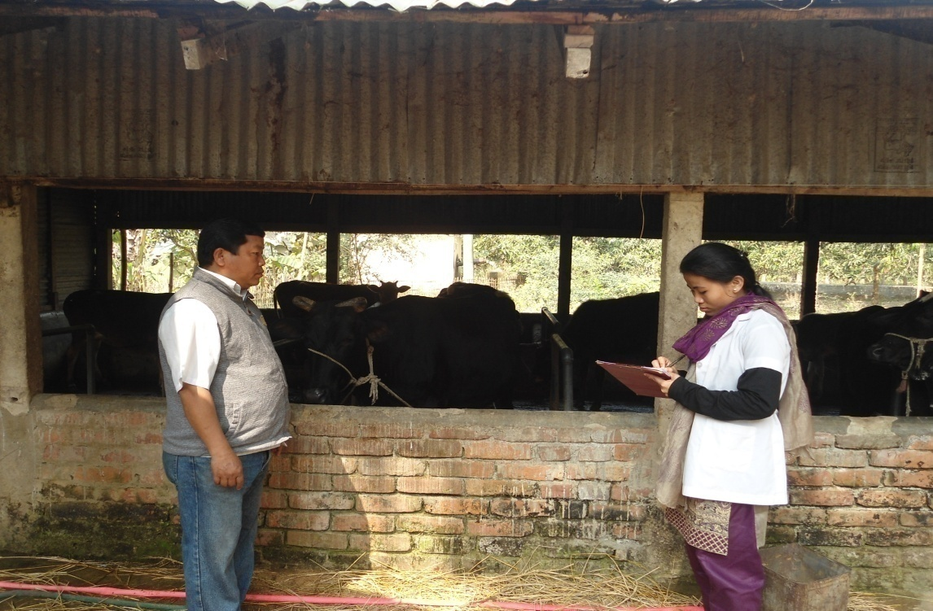
Fig 1: Data collection of farm at Khagrachari.

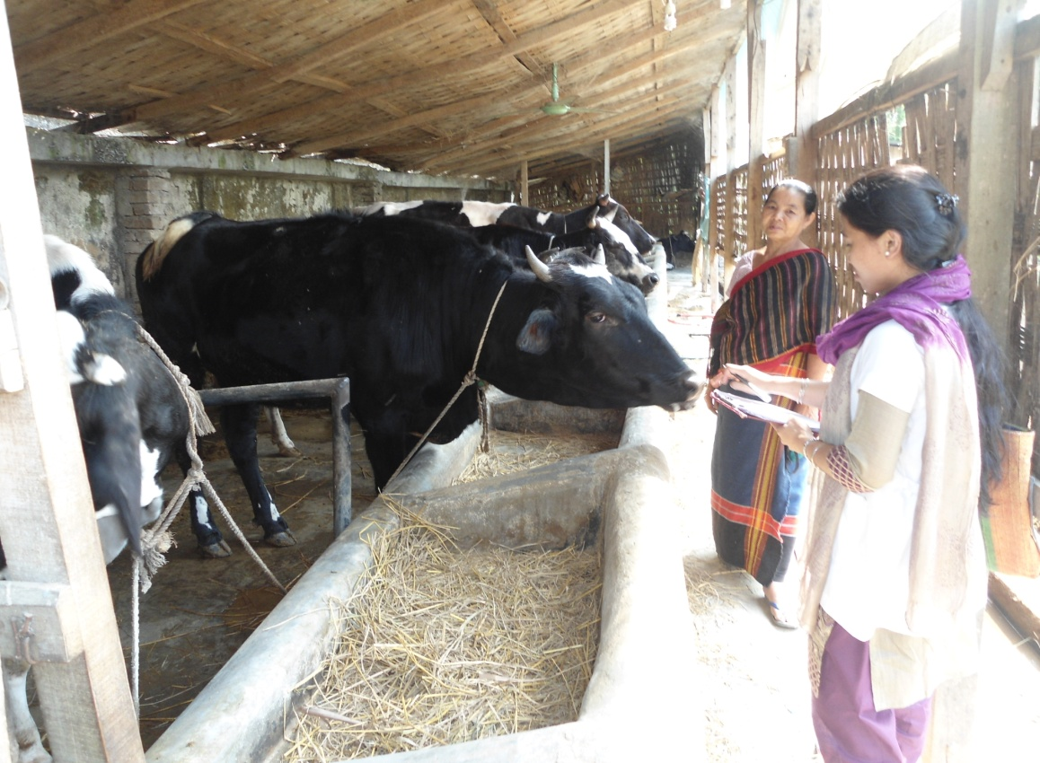
Fig 2: Data collection of farm at Rangamati.

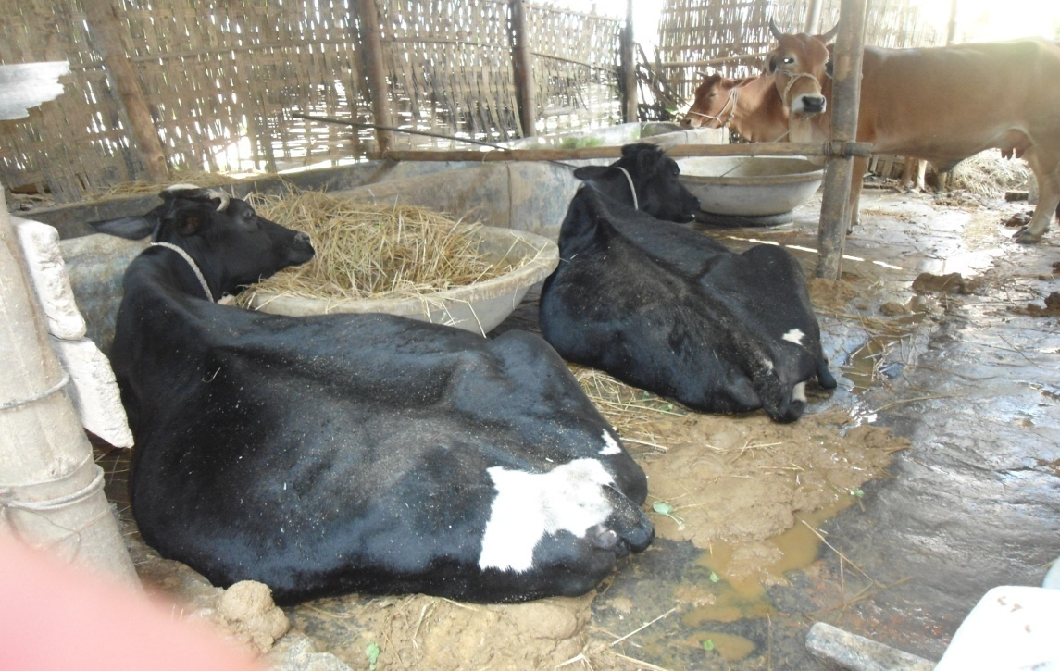
Fig 3: Farm maintaining poor management.

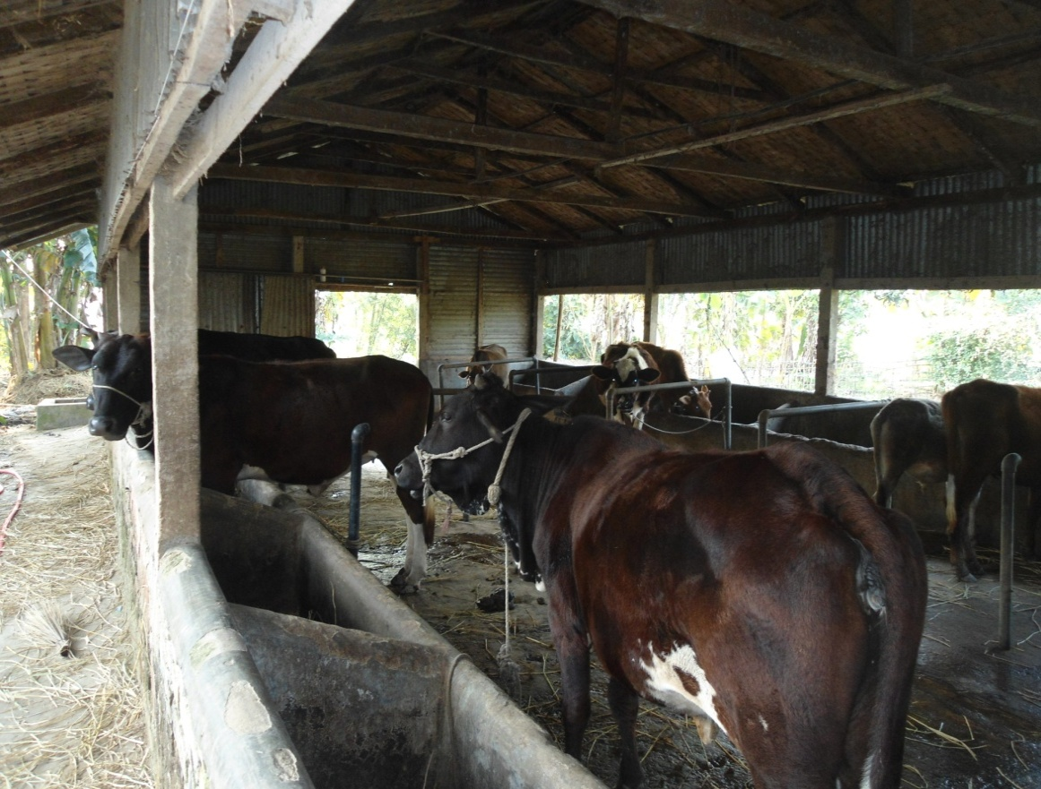

Fig 4: Farm maintaining good management.

CHAPTER- IV
RESULTS AND DISCUSSION

Management of studied farm: It is said that management is the art and science of combining ideas, facilities, processes, materials and labor to produce and market a worthwhile product or service successfully. The management of the whole dairy farm is a complex operation. It includes- feeding management, housing management, farm record management etc.
Feeding System: The studied farmers followed stall feeding system not grazing. They fed the cattle according to the breed of cows and state of the cows. Farmers supply feed to them regularly. Both roughage (rice straw, green grass, water hyacinth etc.) and concentrate (rice polish, wheat bran, soybean meal, molasses etc) are fed to the milch cows. Including these feed they also fed some unconventional feed such as jaba (local name), which is finished product during alcohol preparation from rice, Kitchen wastage etc. On an average 3-4 kg rice straw/day/cow are provided to the indigenous cows and 4-6 kg rice straw /day/cow to the crossbreds. Farm-1, farm-2 and farm-3 farmers given adlibitum rice straw due to availability. Furthermore, about 8-10 kg and 15-20 kg green grasses are fed to the indigenous and crossbred cows in these farms. Farm-5, farm-6, farm-7 farmer can not provide green grass to their cattle due to unavailability of green grass and sufficient land area. The crossbreds are provided more concentrate than indigenous cows because they produce higher milk than indigenous cows. In addition to normal drinking water rice gruel and pulse washed water are supplied for drinking to the cows. All calves were fed milk by suckling.
Housing Condition: The studied farmers used tin shed and straw shed with paved and concrete floor for housing. For boundary wall, they used bamboo and brick. The floor space per animal were varied farm to farm. The studied farm-1, farm-2, farm-3 farmers provided floor spaces for a cow about 20 to 30 sq.ft., Farm-4,farm-5, farm-6,farm-7 farmers provided 15 to 20 sq.ft. for a cow, which is not satisfactory. Floor space for a cow in closed area requires 20 to 30 sq.ft. (A text book of Animal husbandry, 8th edition). For better production animal house should be kept in clean and dry. In studying farm-3 and farm-7, the animals were kept in un hygienic condition such as moist floor and a floor filled with dung and urine. There was no drainage facility in these farms. Overall most of the farm housing management were in average condition, not so clean not also dirt.
Studied farms and breeds: Types and number of cows reared in the studied farms are presented in Table 1, different categories of the cows are presented in Table 2 and average milk yield and lactation length of different breeds are presented in Table 3.Price of milk, calf and the cost of labor are presented in table-4.
Table 1: Number of cattle reared in the studied farms
Name of Farms | Crossbred | Indigenous breed | Total
Farm-1 | 10 | 01 | 11
Farm -2 | 11 | 02 | 13
Farm -3 | 08 | 01 | 09
Farm -4 | 13 | 02 | 15
Farm -5 | 07 | 01 | 08
Farm -6 | 06 | 01 | 07
Farm -7 | 07 | 01 | 08
From the above table, we have seen that the no. of crossbred cows were more than indigenous cows in studying farm. The milk yield and different expenditure were higher in crossbreds than indigenous cows. The temperate breeds and their crossbreds produce more milk were reported by Khan et al. 2005. That’s why farmers are interested in rearing more crossbred cows than indigenous.

Fig 1: Chart showing the number of crossbred and indigenous cattle.

Table 2: Different categories of the cattle in the studied farms
Types of animal | Farm-1 | Farm -2 | Farm -3 | Farm -4 | Farm-5 | Farm -6 | Farm -7
Lactating cows | 06 | 06 | 05 | 08 | 05 | 04 | 05
Dry cows | 02 | 03 | 02 | 03 | 01 | 02 | 01
Heifer calf | 01 | - | 01 | 01 | - | - | 02
Bull calf | 02 | 02 | 01 | 02 | 02 | 01 | -
Total | 11 | 13 | 09 | 15 | 08 | 07 | 08

Table 3: Average per day milk yield and lactation length of the cows in the studied farms
Farms | Milk yield (liter per cow) |  | Lactation length
 | Crossbred | Indigenous breed | Crossbred | Indigenous breed
Farm -1 | 10.0 | 2.5 | 280 | 160
Farm -2 | 8.5 | 2.0 | 280 | 160
Farm -3 | 7.5 | 1.0 | 265 | 150
Farm -4 | 10 | 2.5 | 280 | 160
Farm -5 | 9.0 | 1.5 | 275 | 150
Farm -6 | 8.5 | Data not found | 270 | Data not found
Farm-7 | 7.5 | 1.5 | 270 | 150

From the above table, we have seen that the crossbred cows produce 7.5 to 10 liters milk and the indigenous cows produce 1 to 2.5 liters milk per day. The crossbred cows produce more milk than indigenous cows in studying farm. Farm with crossbred more profitable than indigenous reported by Alam et al. 1995.

Fig 2: Average milk production of crossbred and indigenous cow.

Table 4: Price of milk, calf, the labor cost are
Price of milk per liter | 50 taka
Price of calf | 8,000-15,000 taka
Labor cost per person per day | 150-170taka

Table 5: Annual net income of selected dairy farms
Items | Farm -1 | Farm-2 | Farm -3 | Farm -4 | Farm -5 | Farm-6 | Farm-7
Income
Milk sale(tk) | 965730 | 1113250 | 784750 | 1505625 | 848625 | 620500 | 666125
Animal &by product(tk) | 38000 | 38600 | 29000 | 51600 | 27600 | 21000 | 22000
Total income(Tk) | 1003730 | 1151850 | 813750 | 1557225 | 876225 | 641500 | 688125
Cost
Feed cost(tk) | 628855 | 759200 | 558450 | 1095000 | 617580 | 423875 | 494940
Labor cost(tk) | 109500 | 110400 | 100800 | 158775 | 108000 | 98550 | 104025
Treatment +AI cost (tk) | 23700 | 29400 | 35000 | 36400 | 25800 | 23450 | 35450
Electricity cost | 12670 | 13480 | 10500 | 14400 | 8640 | 7150 | 8570
Transport cost+Others (tk) | 11000 | 13000 | 15000 | 18760 | 11570 | 10210 | 16500
Total variable cost(tk) | 785725 | 925480 | 719750 | 1323335 | 771590 | 563225 | 659485
Net profit (tk/year) | 218005 | 226370 | 94000 | 233890 | 104635 | 78275 | 28640

The annual net income of dairy farms is presented in Table-5. A table showing that the income varied in between farms. This variation might be due to variation in milk yield, the management practices of the farms and breed differences. Table-5 indicated that the annual income from dairy farm was ranging from taka 28,000 to taka 2,33,000. The variable cost includes feed cost, labor cost, treatment cost, artificial insemination cost, electric cost, transportation cost and others. The fixed cost of the farm is more or less similar so that the fixed cost of the farm is not included in this table. Small amount of purchase green roughage was fed to cows and the amount of maximum green roughage comes from roadside, crop field, river side. The income from dairy farm includes annual milk sale, live animal sale (heifer /bull calf, culled cow) and selling of byproducts (dung). The profitability of each farm was calculated by dividing the total farm income with total number of animals of the farm.
Farm-1 and farm-2 which are located in the same places. Their housing and feeding management and operational cost was similar But the profitability of the farms differs due to crossbred variety. Temperate crossbred shows higher profitability than tropical crossbred. Crossbred Sahiwal x Pabna and Holstein-Friesian x Local showed higher profitability than Sahiwal and Red-Sindhi cross. (Khan et al. 2005). In farm-3, farm-4, farm-5 and farm-6 farm-7 crossbred were similar in type but their profitability also varies might be due to management practices and operational cost.
Farm-1, farm-3 were in the same places and their crossbred variety were similar. But in farm-3 housing and feeding management were poor so that the profitability of this farm were less than farm-1. Also less than farm-2, though this farm reared low yielding crossbred. In farm-4, farm-5, farm-6, farm-7 though the crossbred were similar due to variation in management practices their profitability varies. Farm-4 feeding and housing management were good so that the production and profit were higher. But in farm-7 management were poor condition so that production and profit were lower. Better management of and care for livestock can improve productivity and food quality. Higher animal welfare standards are also seen to be a prerequisite to enhancing business efficiency and business profitability. (Animal welfare in livestock operation, 2006).
At first difference of operational cost of different farm due to location. In Khagrachari availability of feed like green grass, rice straw, rice polish, safe drinking water and land area, low transport cost than Rangamati. So that, the farm located in Khagrachari having lower operational cost and more profitable. Though, farm-1, farm-2 and farm-3 were in the same places the market value of all ingredients were similar. But the operational cost of the farm-3 were greater than two farms due to poor management. Farm-4, farm-5, farm-6 and farm-7 were from the same place. But in farm-7 due to poor feeding and housing management operational cost were higher than three other farms. So that the profitability of farm-3 and farm-7 were less than others. The profitability depends on the lower operational cost. (Hemme et al. 2004). Farms with high production level will usually generate greater profit especially when cost control measures are the part of the total management. ( David B. Fischer, 1998).

Constraints to smallholder dairy production
Feed resources
Dairy farms face problems with the availability of feeds and fodder; there are problems with both quality and quantity and a lack of economical technology for optimum utilization of local feed resources.

Breeds of cattle
Cattle breeds available are mostly indigenous. Efforts are being made to improve milk production through crossbreeding with exotic breeds.

Artificial insemination (AI) and reproductive performance
Presently, AI activities are carried out by the Bangladeshi Government’s Department of Livestock Services (DLS) from 22 centre’s, 423 sub centre’s and 554 AI point. The total number of AIs carried out each year is about 1.5 million (DLS 2000). In order to extend AI activities, a massive development project focusing on AI is being undertaken for the development of cattle for milk and meat production.

Climate and disease
Diseases present a major constraint to cattle production in Bangladesh; the extent of losses due to disease is very high. The country’s climate, along with the poor nutritional status of cattle, contributes to a high incidence of cattle diseases, especially in the calves. The major diseases are anthrax, haemorrhagic septicemia (HS), foot-and-mouth disease (FMD), black quarter (BQ), diseases caused by infestation with liver flukes and calf diarrhoea (Ahmed 2000).

Government policy and activities for dairy development
Recent livestock development activities of the Bangladeshi Government’s DLS have attracted the attention of development partners, international organizations and NGOs. The livestock subsector has emerged as an important source of gainful employment and income for the vast majority of the rural poor for their poverty alleviation. Important features of government policies towards the livestock subsector include-
- The non-involvement of the government in production, processing and marketing activities.
- Support of the private sector and NGOs in dairy development activities through research, extension, training, credit and the development of appropriate infrastructure.
- Reduction of import tariffs on equipment, animals, raw materials and other inputs.
- Reduction and eventual elimination of subsidies on inputs, including veterinary drugs, vaccines and AI services.

The major activities of the DLS
The major activities of the DLS include
- Conservation of livestock (by providing veterinary health care/ensuring veterinary coverage),
- Development of livestock (development of breeds, productivity and appropriate technology),
- Provision of extension services (training, entrepreneur development, assistance to establish farms, feeds and fodder production, and technology transfer), and
- Employment generation (assistance for credit, input supply and technical support to NGOs working with livestock development).
The Bangladesh Milk Producers’ Co-operative Union Ltd is the oldest and only dairy venture in the country providing feeds, vaccines and AI facilities for a large number of participants in selected milk pocket areas. However, this co-operative is incapable of providing feed, marketing and veterinary health care services to dispersed dairy farmers all over the country; therefore, milk collection, distribution, processing and marketing services in non-supported areas of Bangladesh are less organized.

Recommendations
- Farmers training on the rearing of cattle and calves.
- Feed resources of cattle are one of the major constraints prevailing in the existing production system. Cattle production should appropriately be integrated with agricultural operation to meet the challenge of feeding the cattle. A 3- tier system involving production of surface vegetation through reseeding with perennial and nutritious grasses and legumes creating middle level vegetation through fodder shrubs and top level through trees to meet the serious seasonal variation in feed availability. It is essential that the feed availability during season of higher production is harvested and conserved to be utilized during scarcity period. It will also be desirable to face animal feed security utilizing chemically treated and densely baled crop residues forest grasses and tree leaves etc.
- Establishment of specialized diagnostic facilities laboratories to extend reliable diagnostic facilities to the farmer’s.
- Improvement of the economic and other traits of cattle through selective breeding and conservation of superior breeds through establishing a national breeding herd.
- Farmer’s motivation to change traditional attitudes for cattle rearing through leaflets, booklets, radio & television programmes etc.
- Strengthening of veterinary health and extension service at farmers’ level.
- Introduction of micro credit facilities.
- Involvement of NGOs and private sectors with the dairy production activities.
- A proper extension service similar to that for crop production should be established to create awareness of the rural farmers regarding the importance of dairy production and to make available the improved technologies to the flock owners.
- The Directorate of Livestock Services (DLS) should undertake animal nutrition development programme (ANDP) and suitable training programmes for the cattle rearers.
- Increasing the availability of superior breeding bulls.
- Development of marketing system / channel through the involvement of milk markentizers and maintain stable market facilities.
- Establishment of modern processing units.
- National Dairy improvement Board should be established with priority basis.
- Proper coordination with the NGOs, the dairy development program could be strengthened.
- An extended research for sustainable dairy development from the standpoint of nutrition, farming system, genotypic development, health management and preventative care is urgently required.
- Policy and regulation must be adopted considering the economic and social importance of dairy cattle for their improvement and conservation in the country.
Limitations of the Research:
- Sometimes could not approach and convince the farmers satisfactorily to collect the required information.
- Farmers were found not to be equally cooperative and friendly.
- The research area was very small.

CHAPTER- V
CONCLUSION
It might be concluded that the small holder dairy farm is profitable in spite of remaining some constraints, if the farms keep preferable crossbred, maintain proper management (housing and feeding) and maintain low operational cost. Poor management required high operational cost that leads to less profit on the farm. Farms with less profitability should maintain proper or standard management which leads decrease operational cost and improve productivity.

.

REFERENCES
Ahmed Z.U. and Islam T.S., 1987. Cattle breeding program through artificial insemination in Bangladesh . A report from CCBS Dhaka, Bangladesh.
Hemme T., Garcia O. and Khan A.R., 2004. A review on milk production in Bangladesh emphasis on small scale producers. International farm comparision network, PPLPI working paper-7.
Khan M.K.I., Blair H.T., Lopez-Villabos and Johnson P.L., 2005. Productive, reproductive and economics performance of dairy cattle in Bangladesh .Proc. Assoc. advmt. Anim. Breed.Genet.
Majid M.A., Nahar T.N., Talukder A.I. and Rahman M.A., 1998. Reproductive performance of purebreds, F1, F2 and F3 cows raised in Savar dairy farm, Bangladesh .J.Livest.Res.
Alam J., Yasmin F., Sayeed M.A. and Rahman S.M.A., 1995.Economics of mini dairy farms in selected areas of Bangladesh .Bangladesh Livestock Research Institute, Dhaka.
Moran J., 2005. Economics of feeding dairy cows. Tropical dairy farming management for small dairy farming in the humid tropics.Pp:201-208.
Nahar T.N., Islam M. and Hasnat H.A., 1992.A comparative study on the performances of F1 crossbred cows under rural conditions. Asian-Aust. J.Anim.Sci.
Norman and Powell., 1999. Cow evaluation at different milk yields in herds.Pp:148-154.
Shamsuddin M., Goodger W.J., Hossain M.S., Azizunnesa, Bennette T. and Nordlund K., 2006.A study to identify economic opportunities for small holder dairy farms in Bangladesh.Tropl.Anim.Healt.Prod.
G.C.Banerjee. A textbook of animal husbandry . 8th edition.
David B.Fischer., 1998.Improving dairy farm profitability. Illiani daily net papers.
Department of Environment and Social Development., 2006. A Good note on Animal Welfare on Livestock Operation.
The scientific committee on Animal Welfare. 2000. A Report of the Scientific committee on Animal Health and Animal Welfare.

APPENDIX
Questionnaire

Date:
- Name of the farmer……………………………………………………………
- Address of the farmer…………………………………………………………
- Occupation of the farmer……………………………………………………...
- Total no. of cattle’s…………………………………………………………....
- Milch cow ………………………………………………….
- Heifer calf…………………………………………………..
- Bull calf …………………………………………………….
- Total milk production/per cow/day…………………………………………..
- Lactation length of cow………………………………………………………
- Feed ingredients supplied to the animal………………………………………
- Cost for management :
- Housing cost…………………………………………………
- Feeding cost…………………………………………………
- Vaccine and medicine cost………………………………….
- Artificial insemination cost…………………………………
- Electricity cost………………………………………………
- Labor cost……………………………………………………
- Others ………………………………………………………

- Source of income:
- Milk selling…………………………………………………..
- Calf selling……………………………………………………
- Culled cow selling……………………………………………
- Manure selling ……………………………………………….

- Problems facing by small holder dairy farmer………........................................

……………………………………………………………………………………

……………………………………………………………………………………

Signature of reviewer

