CHAPTER-III

MATERIALS AND METHODS

3.1 Description of the study area and duration

The study was conducted three different Thanas namely, Sitakunda, Hathazari, Raozan, Banshkhali, Patiya, Mirsharai of Chittagong districts. The study was undertaken for a period of 2 months starting from January’ 2013 to Februaru’2013.

3.2 Selection of animals and Survey design
3.2.1 Target animals and age groups
A cross sectional study design was conducted to attain the targeted objectives. Holstein Friesian (HF) crossbred cattle were selected for this study as target animals. To determine the age susceptibility to different parasites, cattle were categorized into three different sub-groups as calf (≤1 year), Young (>1 to < 2.5 years) and Adult (≥2.5years) (Sastrt et al., 2005).

3.2.2 Target sampling
A total of 60 fecal samples were collected randomly from 12 small or medium scale dairy farms of three different Thanas of Chittagong district. Among 200 samples, 24 were calves, 76 were young and 100 samples were collected from adult animals. A prototype questionnaire was used to record the information like owner’s name and address, animal identification (ID), farm size, breed, age, sex, deworming history.

3.3 Sample collection and preservation
Fecal samples (approximately 5-10gm) were collected directly from the rectum and stored in plastic containers. Then, the container was filled with formalin (10%) and refrigerated at 4⁰C temperature. During sample collection, labeling of the samples were strictly maintained to prevent the misinterpretation.

3.4 Examination of samples

3.4.1 Fecal Samples Examination
In addition to gross examination of fecal samples (color, consistency, blood or mucus, etc.), three different types of qualitative tests, namely direct smear, flotation and sedimentation techniques were used to examine the fecal samples (Hendrix, 2006).

Sugar salt solution was used as floatation fluid. At least, two smears were prepared from each sample for each test to identify the morphological characteristics of eggs, cyst, oocysts etc (Hendrix, 2006, Urquhart et al., 1996 and Soulsby, 1982).

3.5 Experimental Design (at a glance)
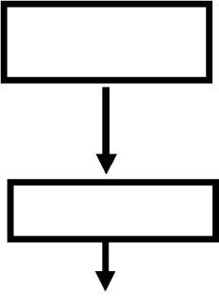
Sample

Faeces
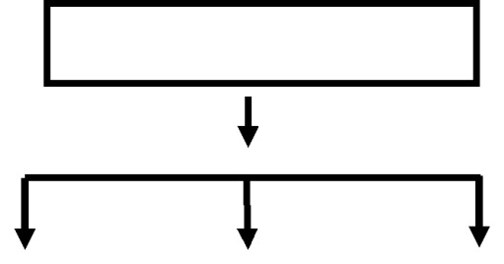

Qualitative Tests

Direct smear | Flotation | Sedimentation

3.6 Statistical Analysis

The obtained information was imported, stored and coded accordingly using Microsoft Excel for analysis. Excel spreadsheet was imported to the statistical software STATA version 12 (Stata Corp. College Station, Texas) for further analysis. Descriptive analysis was done by means of frequency stratified by different levels of the categorical variables. Total number of cases was divided by the total number of population to calculate the overall and individual parasite specific prevalence. To identify the effect of the categorical exposure variables (sex, deworming etc.) on the outcome variable (parasite +/-), Chi square test was conducted. To test if the mean age of the animals is different between parasite positive and negative animals, t-test was conducted. An association was regarded as significant when the p value was of the significance test <0.05.

