CHAPTER III
MATERIALS AND METHODS

3. I. Area and study population
The study was conducted on commercial and backyard dairy cows at Chittagong metropolitan area (CMA), Birgonj upozilla of Dinajpur district and Sadar area of Thakurgaon district of Bangladesh. The total period was divided into three seasons namely rainy (June 2013 to August 2013), autumn (September 2013 to November 2013) and winter (December 2013 to January 2014). Among 500 cases, different breeds were examined (1700 cross breeds and 400 local). The examined animals were categorized into three age groups as >8 years, <5 years and within 5 to 8 years old. The study was done only on the dairy cows. The commercial dairy farms were located at city and rural areas. The type of animals kept under commercial farming system were cent-percent cross of local with different exotic breeds and the backyard system mostly of indigenous. A total of 300 cows from CMA, 400 cows from Birgonj and 1400 cows from Thakurgaon, were examined under the study.

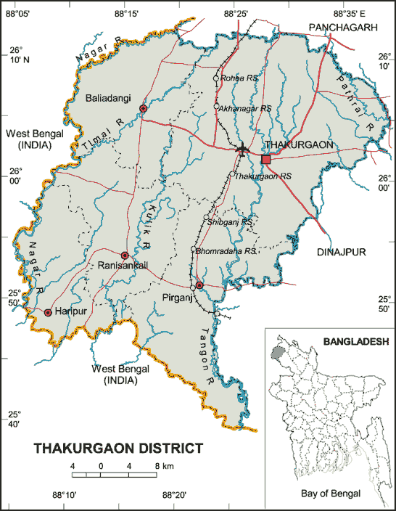
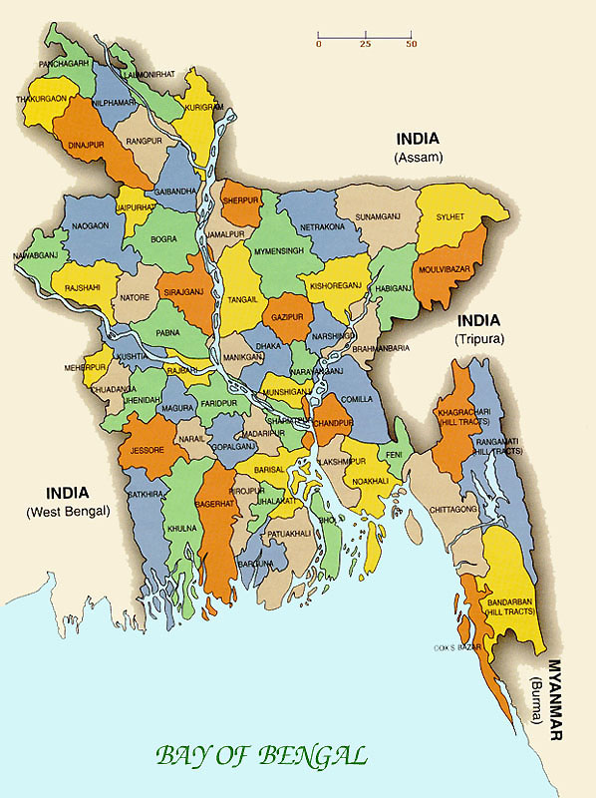

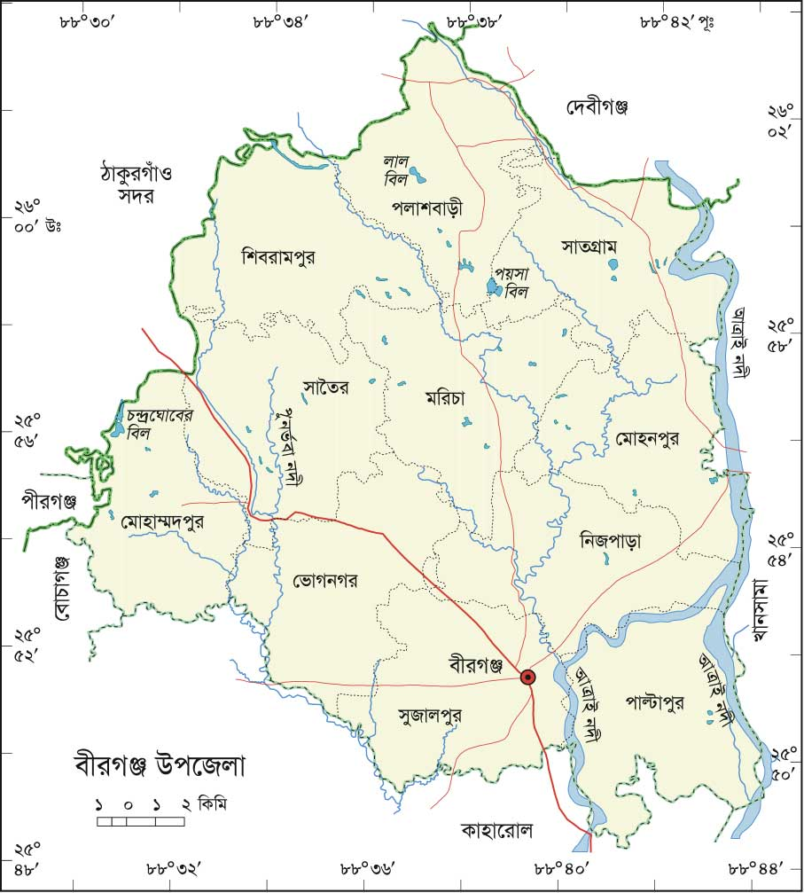

Figure 1: Map of Study Area (Chittagong region, Thakurgaon and Birgonj of Dinajpur)

3. II. Study design
A prospective study was undertaken from June 2013 to January 2014. The study was conducted on 2100 dairy animals belonging to 85 farms (including small backyard dairy farms) kept under different management system. The farms were selected by simple random sampling technique and all animals of each selected farm were included under the study. The study design is schematically shown in the Figure 2.
Patient data
Species, Breed, Age, Sex and Weight of patient, feed habit, composition of feed

Epidemiological study (Questionnaire)

Identify the target groups or population

Selection of the study area

Depthness of the crack, fissure etc.
Disease history
Pre-disposing factor
Onset and duration of illness
Weakness of patient, floor condition
Clinical History (Anamnesis)

Clinical Examination

Inspection/ Observation

Palpation and determination

General attitude of the patient
Affected region of the body
Posture
Gait
Lameness
Body Condition Score (BCS)

Figure 2: Schematic representation of the study design

3. III. Questionnaire design and Data collection
In order to collect relevant case for the study, a structured questionnaire was carefully prepared on the basis of the objectives. The questionnaire was designed to comprise mostly closed ended (categorical) questions to ease data processing, minimize variation and improve precision of responses (Thrusfield, 2005). The questionnaire was filled up by repeated questioning to the animal owner, personal observation of patient and taking records from register book. On this work, Important animal level data recorded including affected animals (species), breed, age, sex, body condition of the animal, posture, major diseases, type of floor, rearing system, washing system, involvement of hoof diseases of hoof, physical status, parity, housing pattern, type of the floor in the animal house (katcha/ dirt/ muddy/ brick/ concrete/ rubber bedded), rearing system (intensive/ semi-intensive/ free-range) as well as whether or not a system of grazing or zero-grazing was practiced. Clinical examinations findings were noted down accordingly. A complete form of questionnaire is given in the Annex-I.

3. IV. Case identification
In the study, a total of 500 cases were investigated from approximately 2100 cows. Diagnosis was made on the basis of clinical history and close, careful examination of hooves scientifically. Firstly, careful inspection was performed to detect the general attitude of the cows like alertness, dullness or depression. In addition, body condition scores (BCS) of the animals were taken into account whether cachectic, poor, fair, good, fatty or obese. Posture and gait were examined according to the condition of the animal as well. Finally, closed examinations of hooves were done upon proper physical restraining of cows to detect hoof disorders. The major disorders like fissure, crack, luxation, avulsion or overgrowth as well as major diseases seems FMD, foot rot, laminitis, physical injury, wounds, abscess, arthritis, bed sore revealed were recorded.

3. V. Data Analysis
All the data that were collected (categorical variables like breed, season, type of floor, housing system etc. and continuous variables like age, milk yield etc.) were entered into MS excel (Microsoft office excel-2007, USA). Data management and data analysis were done by STATA version-12.1 (STATA Corporation, College Station, Texus, USA). Descriptive analysis was done by means of creating histogram, pie chart and boxplot. To identify the association between a categorical explanatory variable with the outcome (occurrence of hoof problems), chi- square (χ² test) test was performed. An association was regarded as significant if the p value was <0.05.

