ACKNOWLEDGEMENT
It goes without saying that all praises goes to Almighty “God”, the omnipotent, omnipresent and omniscient, Who has enabled the author to complete this manuscript successfully.
The author doesn’t have adequate words to express deepest sense of gratitude, respect and immense indebtness to her honorable teacher and internship supervisor, Professor Dr. Goutam Buddha Das, Dept. of Animal Science and Nutrition, Chittagong Veterinary and Animal Sciences University for his scholastic guidance, sympathetic supervision, valuable advice, continuous inspiration, radical investigation and constructive criticism in all phases of study.
The author would like to give special thanks to Dr. Md. Hasanuzzaman, Head, Dept. of Animal Science and Nutrition, Chittagong Veterinary and Animal Sciences University for providing facilities and inspiration to test the collected feed samples. The author would like to express her heartfelt gratitude and respect to the honorable Vice Chancellor Prof. Dr. A. S. Mahfuzul Bari and Prof. Dr. Md. Kabirul Islam Khan, Dean, Faculty of Vet. Medicine and Dr. Bibek Chandra Sutradhar, Director of External Affairs, Chittagong Veterinary and Animal Sciences University for continuing this internship programme.
The author would like to thanks all the staff of the Dept. of Animal Science and Nutrition, Poultry Research and Training Center, Chittagong Veterinary and Animal Sciences University, for their active cooperation and support in this course of study.
The author also expresses gratitude to her parents and friends for their inspiration and sacrifice from the beginning to the end of this work.
A work of this dimension is the product of many individual efforts. Supervisor’s help and cooperation have been received from many persons during the tenure of this place of report. Although it isn’t possible to mention everyone by name, the author is immensely grateful to them.

The Author

Comparative Study on Different Layer Feeds in Farm Levels

ABSTRACT
As the quality of feed is one of the main determinant factors in successful poultry farming, an attempt was made to compare the quality of both hand mixed and commercial layer layer feeds to identify either using hand mixed or commercial feed is profitable for the layer farm owners. For this 4 feed samples were collected from 4 layer farms, randomly selected & which are located scatteredly in different areas of Chittagong district. Among 4 feeds, 2 were hand mixed feeds and 2 were commercial feeds - CP and Paragon. Cost of productions and income data were also collected from those 4 layer farms to estimate the profit. To suggest which feed is best on the basis of quality and profitability, proximate analysis was done to see the nutritive values. Those values were then compared with the standard and company value. Finally both data of proximate analysis & economic one were compiled by using Microsoft Excel 2007(Chi-square test by using SPSS 16.0). The proximate analysis of 4 feeds showed the following ranges of nutrient compositions: DM(88-90)%, Moisture(10-12)%, CP(16-20)%, CF(4-6)%, EE(3-4.3)%, Ash(6-6.8)%, NFE(53.2-58.6)% & ME(2632-2743)Kcal/kg. Statistically there were no significant differences among the nutrient compositions of different feeds used by different farms. But it was found significant differences among the incomes & profits of different farms using different layer feeds. The highest gross income & profit earned by Samia Dairy and Poultry farm using CP feed were 474.8 tk &284.5tk/bird/month respectively. The lowest gross income & profit earned by Islam Poultry farm using Hand mixed feed were 348.9tk &148.9tk/bird/month respectively. On the basis of quality of feed & profitability at farm level it can be said that commercial layer feed is best than hand mixed feed.
Key Words: Feed, layer layer, Proximate analysis, DM, ME, CP, CF, EE, Income, Profit.
CHAPTER-1

INTRODUCTION
Bangladesh is an agro-based developing country in the world. Livestock is one of the most important sectors of agriculture which plays a vital role to promote national economy and human health. The estimated contribution to GDP during FY 2012-13 from this subsector was 3.49% (DLS, 2012-2013).Though the share of this sub sector in GDP is small; it has immense contribution to meet the daily protein needs. Among this, poultry constitutes 30% of animal protein and will increase to 40% before 2015 (IFPRI, 2000). As an important sub sector of livestock, the poultry industry plays a vital role in economy and simultaneously creates numerous employment opportunities. In Bangladesh, small and large scale poultry farms are expanding rapidly, providing meat, eggs and employment. According to DLS, the production of poultry (projected) rose to 29, 32, 35, 000 in 2012-13. There are 24, 66, 00, 000 chickens (DLS, 2012-13) and about 50,000 poultry farms (FFYP, 2003) available in Bangladesh presently. However from another census it was found that 12.89% poultry birds came from nonfarm source, 51.95% from small farms, 27.43% from medium farms and 7.73% from large farms (BBS, 2003). The poultry industry, as a fundamental part of animal production, is committed to supply the nation which is a cheap source of good quality nutritious animal protein in terms of meat and eggs (Akter and Uddin, 2009). Person from low income group may also start the business on a small scale. Poultry farming offers opportunities for fulltime or part-time employment for rural women, children or elderly person on the farm operation.

Poultry is basically a source of economical, palatable and healthy food protein. Poultry meat and eggs contribute approximately 33% of total animal protein supplied in the country (Ahmed and Islam, 1990). According to DLS, total production of meat was 25.32 million ton and egg was 51347 million in numbers in FY 2012-13. Hossain, 1999 stated that farm produced broilers, spent hens, cockerels constitute about 55% of the total chicken meat while farm produced eggs are 82% of the total eggs marketed in Dhaka. The per capita availability of meat was 20 gm/day and 40 eggs/ year in the year 2007-08. Total production in the years 2002-2008 was meat-0.91-1.04 million ton at a growth rate of 114.3% and eggs-4770-5653 million numbers at a growth rate of 118.5% (DLS, 2007). The demand was 15174 million numbers (104/head/year) and supply was 5653 (38.74/head/year) in the year of 2008 (BBS, 2009). The demand of egg and meat is higher in our country than the supply. The egg production of deshi hen is about 30-70 eggs per year where as the exotic strains produce 300 eggs per year (Haque et al., 1993). This data clearly indicate that the abundance of poultry meat and egg is still very much lower in Bangladesh in spite of the significant development in the commercial poultry sector during last 10 years.

Poultry feed is food for farm poultry including chickens, ducks, geese and other domestic birds. Feed for poultry mostly consists of grains (Pattison, 2008). The quantity and nutritional requirements of feed depend on the weight, age of the poultry as well as the season (Damerow, 2012). Healthy poultry needs a sufficient amount of protein, carbohydrate, along with the necessary vitamins, dietary minerals and adequate supply of water. It should be dry, clean and contamination free. Damp feed encourages fungal growth i.e. Mycotoxicosis. Rosenberry, (2002) stated that, good quality feed has a several advantages over lower quality feeds i. e; better feed efficiency, faster growth rate, lower mortality, higher survivability and better meat and egg quality etc. Moreover higher quality feed drastically reduces the chance of diseases. For commercial poultry farming, feed serves as the largest cost of operation. According to McNab (1999), this cost lies between 65 to 75%. So any improvement in the performance of layers due to their diet can inevitably have a profound effect on profitability. A good number of feed mills in our country are producing compound poultry feeds. It was reported in 1999 that there were 40 feed mills with 900 dealers within private sector that were producing and distributing commercial poultry feeds all over the country (Latif, 1999). These commercial poultry feeds are purchased by farm owners according to their needs to nourish the poultry. On the other hand, some farmers used to produce poultry feeds by their own according to the requirement of their birds on the supervision of poultry consultants. Those farmers use that type of mixed feed due to high price of commercial one, availability of feed ingredients of his yard, lack of trust on commercial feed about its quality etc. Seasonal availability of locally produced feed ingredients has made the feed situation unsatisfactory from the quality standpoint. Inadequate feed analytical services as well as statutory control over feed quality have further aggravated the situation. Few of the feed mills are serious in maintaining the quality of their products. Farmers don’t have facility to evaluate the quality of the prepared or compound feeds. In view of the limited availability and varying sources of different feed ingredients, the level of nutrients in the prepared feeds may differ from what is actually required. Deficiency of a particular nutrient in the ration, generally unnoticed by the farm owners can cause an undesirable effect on production and as well as on profitability. Considering all the above mentioned points, the present study was designed with the following aims and objectives:
- To explore the quality of both hand mixed and commercial layer layer feeds on basis of proximate analysis in laboratory.
- To ascertain the nutrient status of commercial layer layer feeds produced in two different feed mills in Bangladesh.
- To compare between the company standard value and observed value of nutrients in layer layer ration in different companies.
- To identify either using hand mixed feed or commercial feed is profitable for the layer farm owners on the basis of feed quality and production data of farm level on the basis of economic analysis.
- To suggest which one (layer feed) is the best on the basis of quality and profitability on the farm level.
- To solve the problems faced by different poultry farms.

CHAPTER-2

REVIEW OF LITERATURE
Poultry is one of the prospective sectors for development. It is a quick returnable enterprise that needs relatively small investment. To meet the shortage of protein supply with in a shortage possible time, expansion of the poultry sector is essential. The expansion of poultry sector depends on the profitability of chicken rearing, egg production on farmer’s level. Feed represents the major cost of farm operation. According to McNab, (1999), this cost lies between 65 to 75%. So any improvement in the performance of layers and broilers due to diet inevitability can have a profound effect on profitability. To ensure quality, different companies produce poultry feeds in their feed mills providing all the nutrients in required amount.

Livestock and poultry feeds:
Livestock feeds are generally classified according to the amount of a specific nutrient they furnish in the ration. They are divided into 2 classes- roughages and concentrates. Concentrates are feeds containing relatively smaller amount (<18%) of fibre and have a comparatively high digestibility (Banerjee, 2005). Roughages are bulky feeds containing relatively large amount of less digestible material. There are various methods of feeding poultry. Some of the popular methods are- 1.Whole grain feeding system 2.Grain and mash method 3. All mash method 4. Pellet feeding (Singh, 2004).

Layer feeding:
Mash form of feed is specially suitable for layers. The essence of a “mash” is that, each bite of feed is a balanced diet containing all the known nutrients in finely ground form. But birds find the finely ground mashes unpalatable, they are too dry or sticky. Therefore, mashes composed of materials of medium particle size improve the birds’ ability to eat them readily. Dry mash is better than wet mash due to wet mash feeding will not increase egg production, egg weight, growth and feed conversion ratio as dry mash (North and Bell, 1990).Hens consume feed for body maintenance and the excess goes into the production of eggs. In order to hens to reach their full egg laying potential, poultry feed must contain the necessary nutrients in proper amount. Layer mash is a feeding system designed specifically for laying hens. Layer mash is higher in protein and various minerals than other feeds. Layer feed includes higher calcium content suited to the nutritional needs of hens to produce eggs (Hawthorne, 1980).

Nutrients:
Plants and animals are composed of similar types of chemical compounds, but their quantitative composition varies to a very great extent. These chemical compound having similar nature and function are grouped together and called nutrient. These nutrients are – Carbohydrate, Protein, Fat, Vitamins, Minerals and Water. The objective of poultry feeding is to convert low quality feed like grain, oil cake into high quality feed like meat and egg. About 30% to 40% of consumed feed is converted into meat and egg. The egg type chickens produce approximately 6 times more nutrient than their body weight in forms of egg (Singh, 1990).The requirement for a given nutrient is the minimum quantity of that nutrient, when all other nutrients are supplied in adequate quantities that will maintain normal growth and production and prevent the development of symptoms of nutritional deficiencies (Verma, 2006).

Proximate Analysis:
Wilhelm Hennenberg and Friedrich Stohmann devised a method called proximate analysis. Weende or proximate analysis is partitioning of compounds in a feed into six categories based on the chemical properties of the compounds. The six categories are: Moisture, Total Ash (TA), Crude Protein (CP), Crude Fibre (CF), Ether Extract (EE), Nitrogen Free Extract (NFE). The proximate principles are expressed in percentage by weight basis and more commonly on dry matter basis (Reddy, 2008).

Nutrient requirements for layers:
Larbier and Leclerck, (1994) stated that dietary energy concentrations 2700-2900 kcal of metabolized energy/kg may be recommended to the laying hen according to cost of minarels. A level of 15% crude protein appears to be sufficient on condition that the diet is balanced with respect to sulphur amino acid and lysine. The dietary level of calcium must be equal to 3.5% to obtain strong shells. At the end of lay, when shell strength tends to fail, the dietary levels of calcium may be reduced. The egg shell contains calcium carbonates and very little phosphorus. The yolk contains the majority of phosphorus but the amount deposited daily is much lower than calcium. So phosphorus requirement of layer is less than calcium. Recommended dietary level of phosphorus is 0.30 to 0.35%.

Spralt and Lesson, (1987) reported that excess intake of feed is predominantly stored as fat which gradually results in increased body weight. Excessive body weight in females is negatively correlated with hen-day-egg production. With laying hens the ratio between the metabolized energy and the protein of diet should be 187:1. For a medium hybrid layer, the respective figures are 2800:15, a ratio of 186.7:1. Protein % varies from 15% for the birds on pasture in summer to 18% for high energy intensive ration.

In construction of a ration, consideration must also be given to the content of indigestible organic material. A birds’ gut must have a fibrous content to maintain its natural functioning. In young chicks this proportion is about 3% rising to 5% in the adult (Sainsbury, 2000). Egg production can be affected by protein (Liu et al., 2005), lysine (Wu et al., 2005), and supplemental fat (Grobas et al., 1999).There are contradictory results about the effect of fat on egg production .The addition of fat have no effects on egg production (Harms et al., 2002). In contrast (Grobas et al., 1999) reported that addition of supplemental fat significantly increased egg production from 38 to 61 wk of age.

Leghorn and medium sized layers producing brown shelled eggs require a diet with about 2860 kcal/kg of ME. CP% required for laying hens is closely related with the rate of egg production. 18-20% protein needed for early growth. When egg production reaches to peak, the protein requirement may be as 17-19%. At the end of production cycle, it may drop to as low as 14%. More eggs are produced when some animal protein is included in ration, as compared with rations containing only vegetable protein. In an experiment showed that with the increase of protein (1-1.5%) in the ration; hen day egg production, egg weight, egg mass, body wt gain increases and FCR (feed intake/egg mass) decreases.

Feed mills in Bangladesh:
The numbers of feed mills are increasing rapidly throughout the country keeping consistent with poultry industry in order to meet up the existing feed need of the farmers. A report stated that there are 40 feed mills with 900 dealers at the private sector who are producing and distributing poultry feeds all over the country (Latif, 1999). Banerjee, 2005 stated that most rations in market are well balanced. However, if an unbalanced state, or badly mixed feed is given, smaller eggs may result. Although a good number of feed mills are in operation in the country, only a few of these are serious in maintaining quality of their products. CP(Charoen Pokphand), Paragon , ACI Godrej Agrovet Private Limited, Quality Feeds Limited, Aftab Bahumukhi Farm Limited, etc are companies in Bangladesh producing feeds for layers and broilers.

CP (Charoen Pokphand) is a truly multinational company with registered corporate head quarter in Thailand. With vision to be “Kitchen of the World”, the company is committed to fulfill quality of food products. The company is the leader and pioneer in the manufacture and distribution of livestock feed in the forms of concentrate, powder and pellets for broilers, mash for layers. CP has 4 feed mills and 6 hatcheries all over Bangladesh (C. P. Bangladesh, 2008).

Summary:
Egg production is one of the most important economic traits in layers which mostly depend on quality of feed. Deficiency of one nutrient can greatly affect the weight, shape, size, shell quality of eggs. So, care must be taken while formulating a balanced ration for layer specially during laying period. Any effort to improve the quality of feed through knowledge of poultry nutrition will go a long way to improve the profit margin of poultry farmers.

CHAPTER-3

MATERIALS AND METHODS

Study area:
Four feed samples were collected from four layer farms, randomly selected and which are located scatteredly in different areas of Chittagong district. The collected feed samples were layer layer feed and in the form of mash. Among four feeds two were hand mixed feeds and two were commercial feeds - CP and Paragon. Production data were also collected from those four layer farms.
Table-3.1: Name, location of farms and feeds using:
Sl No | Name of farms | Location | Feeds using
1. | Islam Poultry Farm | Potya, Chittagong | Hand mixed feed
2. | Liza Poultry Farm | Potya, Chittagong | Hand mixed feed
3. | Ahmed Hossain Traders | Amirabad, Lohagara, Chittagong | Paragon
4. | Samia Dairy and Poultry Farm | Halishahar, Chittagong | CP

Study Period:
The study was conducted from 2nd December to 26th December, 2013 for collection of feed samples and data of cost of production, income of above farms and for performing proximate analysis of feed samples and for statistical analysis of data.

Collection of samples:
Samples were collected by using simple random sampling technique. Several physical characteristics were seen during collection. The feed samples were brownish color with good flavor, free from foreign particles (soil, dust, weeds, iron, nails etc) and no offensive odor was present. Samples were wrapped up by polythene bags and preserved in the laboratory for proximate analysis.

Preparation of samples:
The feed samples were ground by using micro grinder to make it homogenous powder. Later on, it was mixed properly and exposed to cool down for sampling.

Estimation of nutrients content of feed samples:

Proximate Analysis:
Proximate Analysis of collected samples were carried for Dry Matter (DM), Moisture, Total Ash (TA), Crude Protein (CP), Crude Fibre (CF), Ether Extract (EE), Nitrogen Free Extract (NFE) in Animal Nutrition Lab and in Feed Analysis Lab of PRTC in Chittagong Veterinary and Animal Sciences University, Chittagong.

Estimation of DM and Moisture:
The enamel disc or crucible was dried in an oven regulated at 105°C which was cooled in a dessicator and weighted. 5 gm of feed sample was weighted into the enamel disc and kept into the oven for 24 hours. The enamel disc was removed from the oven with metal tong. After that it was cooled in dessicator and the final weight was taken after getting constant weight (AOAC, 1990).

%DM =$\frac{Weight of crucible with dry sample - Weight of empty crucible}{Weight of feed sample} ×100$
%Moisture = 100 - %DM

Estimation of Ash:
The crucible was cleaned and dried in hot air oven. Than it was cooled in dessicator and weighted. 5gm of feed sample was placed there and the sample was burned up to no smoke in heater. The crucible with sample was cooled and transferred to the muffle furnace. Then the sample was ignited at 550-600°C for 6-8 hours until white ash. The furnace was cooled at 150°C and the sample was transferred to dessicator and weighted (AOAC, 1990).

%Ash = $\frac{Weight of crucible and ash-Weight of crucible}{Weight of feed sample} ×100$

Estimation of Crude Fibre (CF):
2 gm of feed sample was weighted and taken into a beaker. 125 ml of 1.25% H₂SO₄ was added into the beaker. Then it was fitted in condenser and placed on heater. After that it was cooled and filtered through filtering cloth. The sample was washed until it was free from acid. Residue of sample was transferred into same beaker. 125 ml of 1.25% NaOH was added there and again fitted in condenser and placed on heater. It was boiled for 30 minutes and removed from heater which was cooled and filtered through filtering cloth. The sample was washed until it was free from alkali. The residue of sample was transferred in a previously weighted crucible. The crucible was into the muffle furnace and ignited at 600⁰C temperature for 5 hours. Then it was weighted after cooling.

%CF = $\frac{Wt of CF}{Weight of feed sample} ×10$0
= $\frac{Wt of crucible with dry sample-Wtbof crucible with ash}{Wt of feed sample} ×100$

Estimation of Crude Protein (CP):
0.5 gm sample was weighted and one spoonful of catalyzer mixer (KOH, NaOH, Se) was added there. 10 ml concentrated H₂SO₄ was added and the digestion flask was placed in Kzeldhal Digestion Set. After that heat was increased gradually and continued up to clear residue (45 min to 1 hr). The flask was removed and cooled. 10 ml 2% boric acid solution, 2 drops mixed indicator were taken in a conical flask. The conical flask was fitted in the collection arm of distillation set. 50 ml distilled H₂O was added in the digestion tube and fitted in the distillation flask. 40 ml of 40% NaOH was added there and the distillation was continued up to 100ml of distillate. The distillate was titrated against 0.1 N HCl. Titration was continued until the color changed into pink. Then the titration volume was calculated (AOAC, 1990).
% CP = $\frac{\left(Titre-Blank\right)×Normality of HCl ×14.007 ×6.25}{Wt of sample} ×100$

Estimation of Ether Extracts (EE):
One gram dry sample was taken in an extraction thimble having porocity, then placed in the Soxhlet flask. The cork of thimble was above the syphone tube. A receiving flask was weighted and fitted with Soxhlet apparatus and was placed in water bath at 50⁰ to 60⁰ C. Ether extract was poured down in to the soxlet falsk. The flask was filled up to ¾th portion with ether and it was sured that water was running through the condenser. When extraction was over, the thimble with sample was removed and heated in the water bath to remove all the ether from receiving flask. The receiving flask was placed into the oven at 105⁰C to eliminate left of the ether and water. After drying, the flask was taken out and weighted (AOAC, 1990).
%EE = $\frac{Initial wt-Weight after extraction}{Sample wt} ×100$

Calculation of Nitrogen Free Extracts (NFE):
The NFE content was calculated by deducing the sum of the values for moisture, crude protein, crude fibre ether extracts, total mineral matter in 100 (Raghuramulu et al., 1983).
%NFE = 100 – (%Moisture +%CF + %CP + %EE + %Ash)

Metabolizable Energy (ME):
The ME was calculated by using following formula (Lodhi et al., 1976).
ME (Kcal/kg) = 32.959 {%CP + (%EE × 2.25) + %NFE} – 29.20

Statistical Analysis:
Data related to nutrient composition of different layer layer feeds resulted from proximate analysis and data of cost of production and income of different farms were compiled by using Microsoft Excel 2007.Chi- square test was done to analyze the data by using SPSS 16.0. Statistical significance was accepted at 1% and 5% level.

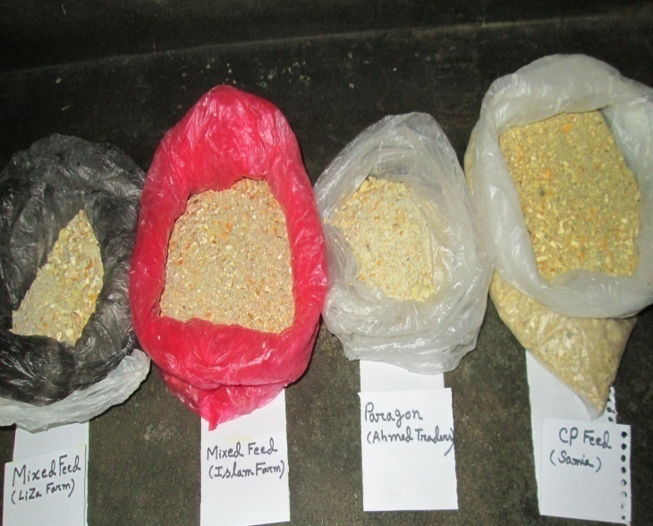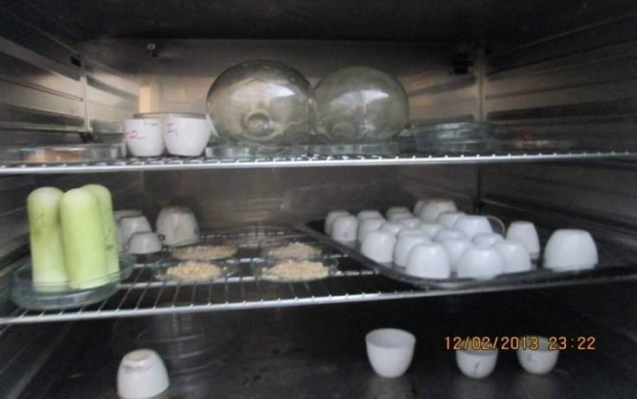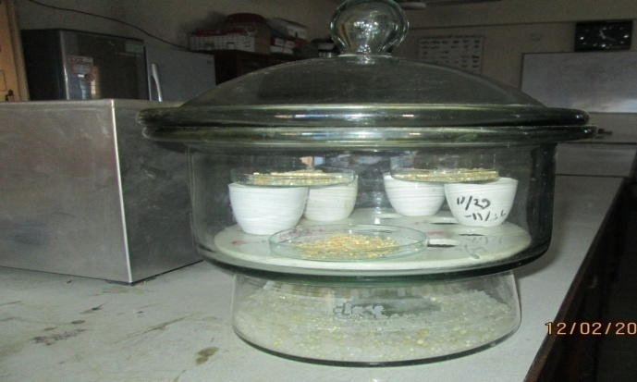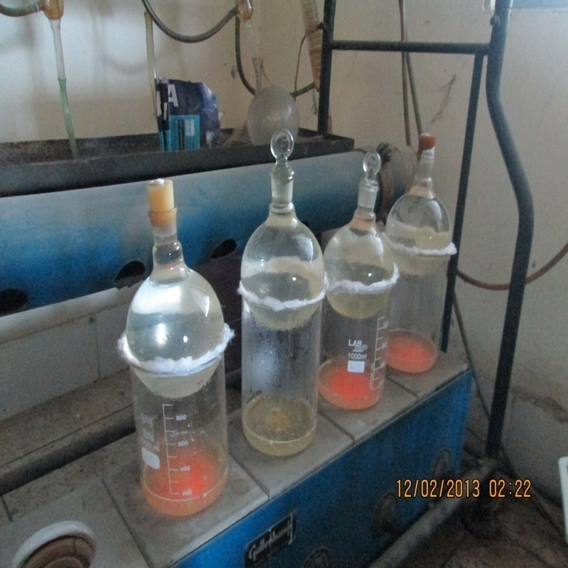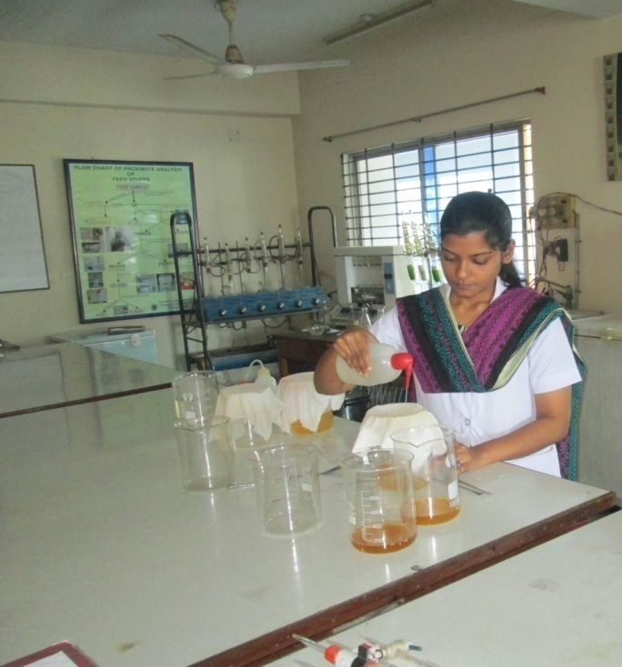
Pic vi: Washing for removing of acid/alkali for estimation of CF
Pic v: Beaker fitted with condenser on heater for acid/alkali boiling for estimation of CF

Pic iv: Dessicator with for estimation of DM
Pic iii: Hot air oven for estimation of DM
Pic ii: Weighing of samples
Pic i: Collected Sample for Proximate Analysis

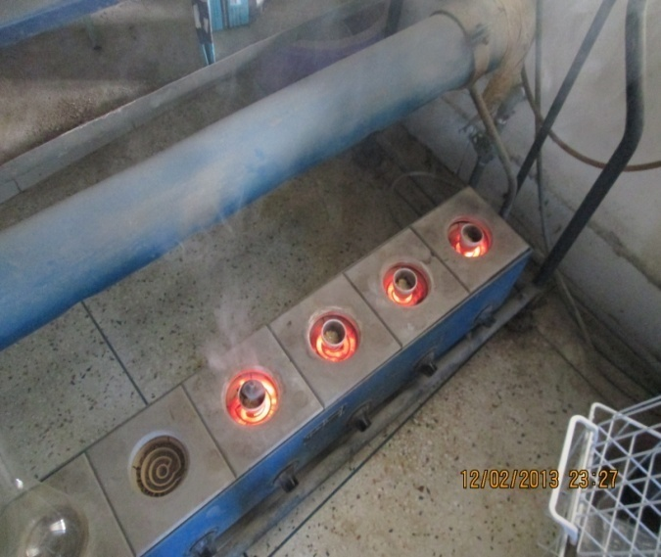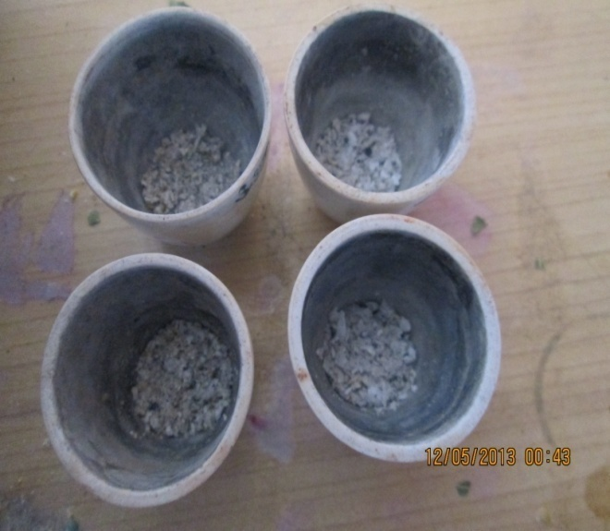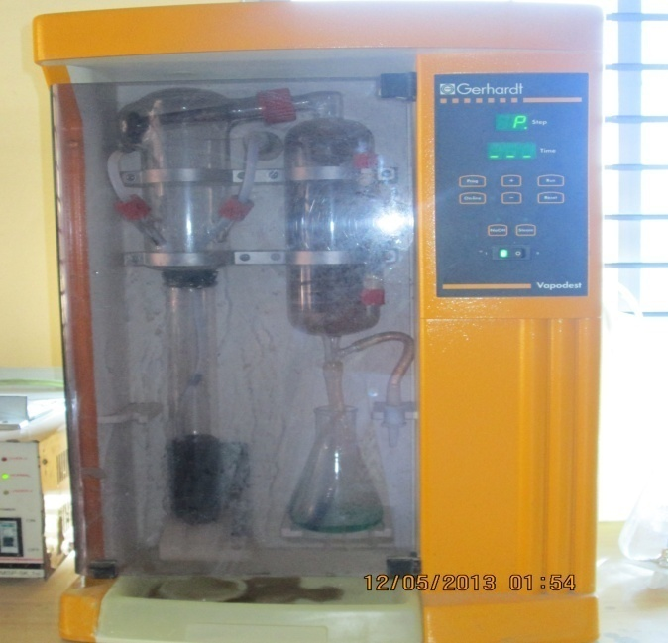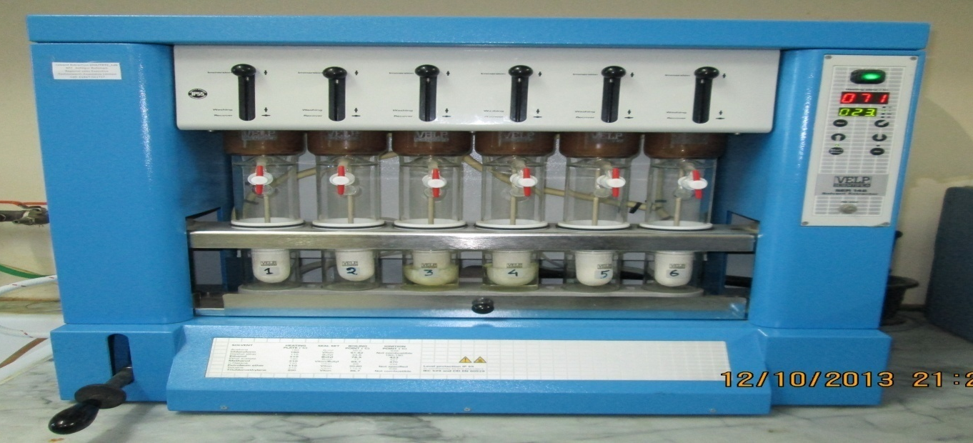
Pic x: Estimation of EE
Pic viii: Distillation for CP estimation
Pic ix: Titration for CP estimation
Pic vii: Estimation of Ash

CHAPTER-4

RESULTS AND DISCUSSIONS
RESULTS:
The results of chemical analysis and also of statistical analysis of data are given below in tabulated form:
Table 4.1: Nutrient composition of layer layer diet with different types of feeds used in different layer farms:
Parameters | Hand mixed feed(Islam farm) | Hand mixed feed(Liza farm) | Paragon feed(Ahmed Hossain Traders) | CP feed(Samia dairy and Poultry) | Significance
DM% | 88 | 90 | 89 | 88 | NS
Moisture% | 12 | 10 | 11 | 12 | NS
CF% | 6 | 4 | 5 | 5 | NS
Ash% | 6 | 6.3 | 6.8 | 6 | NS
EE% | 3.9 | 4.3 | 3.2 | 3 | NS
CP% | 18.9 | 20 | 16 | 16.8 | NS
NFE% | 53.2 | 55.5 | 58.3 | 58.6 | NS
ME(Kcal/Kg) | 2701.7 | 2743 | 2647 | 2632 | NS
N.B: NS= Non significant
Table 4.2: Standard values for nutrients of layer layer diet recommended by different researchers:
References | ME (Kcal/Kg) | CP (%) | CF (%) | EE (%) | Moisture  (%)
Larbier, M. and Leclerc, B. (1992) | 2750-2900 | 17-18 | 4 | 3.5-4.0 | 12
Banerjee, G.C.(1995) | 2700 | 18 | 8 | - | 10
Verma D.N. (2006) | 2700 | 18 | - | - | -

Table 4.3: Cost of production and returns of different farms having layers receiving different types of layer layer feeds:
 | Different types of feeds
Parameters | T₀ |  | T₁ | T₂ |  | T₃ | Significance
 | Hand mixed feed(Islam farm) |  | Hand mixed feed(Liza farm) | Paragon feed(Ahmed Hossain Traders) |  | CP feed(Samia dairy and Poultry)
Costs (Tk):
Chick cost/bird | 26 | 24 |  | 27 |  | 26.5 | NS
Equipment cost/bird | 6.2 |  | 6.8 | 7.1 |  | 6.9 | NS
Cost of feed/bird/month | 145.8 |  | 162 | 129.6 |  | 141.9 | NS
Cost of labour/bird/month | 3.5 |  | 6.8 | 11.4 |  | 6.3 | NS
Cost of electricity/bird/month | 1.1 |  | 1.1 | 5.7 |  | 2 | NS
Cost of medicine/bird/month | 17.4 |  | 1.1 | 7.1 |  | 6.7 | **
Total cost /bird/month | 200 |  | 201.6 | 188 | 190.3 |  | NS
Income (Tk):
Income from eggs/bird/month | 153.9 |  | 159.3 | 185.5 |  | 204.8 | *
Income from selling birds/bird | 195 |  | 225 | 225 |  | 270 | **
Gross income /bird/month | 348.9 |  | 384.3 | 410.5 |  | 474.8 | **
Profit (Tk):
Gross profit /bird/month | 148.9 |  | 182.7 | 222.5 |  | 284.5 | **
N.B: NS= Non significant, *= Significant at 5% level of significant, **= Significant at 5% level of significant

Table 4.4: Proximate components of feeds of two companies with company standard:
Parameters | CP |  | Paragon
 | Observed values | Company values | Observed values | Company values
Moisture % | 12 | 12 | 11 | 11
ME(Kcal/kg) | 2632 | 2800 | 2647 | 2800
CP% | 16.8 | 17.5 | 16 | 17
CF% | 5 | 6 | 5 | 5
EE% | 3 | 4 | 3.2 | 3.5
Source of company report: Specification attached with the collected feed bag.

DISCUSSIONS:
From above observation (Table 4.1), it can be said that there are no significant differences among the nutrient compositions of layer layer diet with different types of feeds used in different layer farms.
From Table 4.3, it can be said that there are no significant differences among the chick cost/bird, equipment cost/bird, cost of feed/bird/month, cost of labour/bird/month, cost of electricity/bird/month and total cost/bird/month of different farms having layers receiving different types of layer layer feeds.
From Table 4.3, it can be revealed that there are significant differences among the cost of medicine/bird/month in different layer farms receiving various types of layer layer feeds. This cost is highest in Islam farms using hand mixed feed (17.4tk/bird/mon) and lowest in Liza farms using hand mixed feed too (1.1tk/bird/mon).It might be due to variation in nutrient composition which varies from standard value. According to Larbier and Leclerc (1992) layer layer diet should contain 2750-2900 Kcal/kg ME, 17-18% CP, 4% CF, 3.5-4% EE and 12% Moisture. The ME, CP, CF, EE, Moisture content of hand mixed feed of Islam farm were 2701.7kcal/kg, 18.9%, 6%, 3.9% and 12% respectively where ME was less than standard and CF% was excess than the standard. Increased amount of fibre in diet leads to indigestion and results poor digestion and decreased FCR. Less energy causes poor wt gain, lower immunity and makes susceptible to stress factors. As a result diseases attack the flock and causes higher medicine cost. On the other hand in Liza farm, the ME, CP, CF, EE, Moisture content of hand mixed feed were 2743 kcal/kg, 20%, 4%, 4.3% and 10% respectively which are near about the standard.
From Table 4.3, it can be stated that there are significant differences among the income from eggs/bird/month, income from birds selling/bird and gross income/bird/month in different layer farms receiving various layer layer feeds. The incomes (income from eggs/bird/month, income from birds selling/bird and gross income/bird/month) were highest in Samia Dairy and Poultry farm using CP feed were 204.8 tk, 270 tk, 474.8 tk respectively. Islam farm earned lowest incomes (income from eggs/bird/month, income from birds selling/bird and gross income/bird/month) using hand mixed feed were 153.9 tk, 195 tk, 348.9 tk respectively. Those variations were occurred due to nutritional cause mainly. According to Larbier and Leclerc (1992) layer layer diet should contain 2750-2900 Kcal/kg ME, 17-18% CP, 4% CF, 3.5-4% EE and 12% Moisture. The ME, CP, CF, EE, Moisture content of CP feed were 2632kcal/kg, 16.8%, 5%, 3% and 12% respectively which are close to the standard. The egg production in layer depends upon the CP%. The crude protein percentage (16.8%) of CP feed is very close to the standard value. On the other hand the CP% (18.9%) of hand mixed feed of Islam farm is over than the standard and the CF% is also excess 6%.These hamper the egg production and digestibility of layers and less no of eggs, poor FCR, decreased wt gain, high mortality rate occur in the farms and thus lowers the income.
From Table 4.3, it is found that there are significant differences among the Gross Profit /bird/month in different layer farms receiving various layer layer feeds. The highest profit making farm was Samia Dairy and Poultry using CP feed (284.5 tk) then Ahmed Hossain Traders using Paragon feed (222.5 tk) and then lowest is Islam farm using hand mixed feed (148.9 tk). The variation was occurred due to significant variations in the incomes of those farms and those variations occurred mostly due to nutritional cause that was stated briefly in before.
4.5: Graphical presentation of total costs, returns and profits (Taka/bird/month) of different farms having layers receiving different types of layer layer feeds:
Fig I: Graph of total costs, returns and profits (Taka/bird/month) of different farms having layers receiving different types of layer layer feeds

From Table 4.4, all the chemical compositions found by the CP layer layer feed i.e moisture%, CP%, CF%, EE% were more or less close to the specified levels given by the feed company, except the ME (2632 kcal/kg) which was lower in contrast to the standard level of this feed company.

From Table 4.4, all the chemical compositions found by the Paragon layer layer feed i.e moisture%, CP%, CF%, EE% were more or less close to the specified levels given by the feed company, except the ME (2647 kcal/kg) which was lower in contrast to the standard level of this feed company.

4.6: Graphical presentation of nutrient composition of layer layer diet with different types of feeds used in different layer farms:
4.6.1: Graphical presentation of Metabolized energy (ME) of layer layer diet with different types of feeds used in different layer farms:

Fig II: Graph of Metabolized energy (ME) of layer layer diet with different types of feeds used in different layer farms
From the above graph, it is seen that ME is higher in hand mixed feed provided by the Liza farm than any other farms which is 2743 kcal/kg. ME is lower in Samia Dairy and Poultry farms using CP feed which is 2632 kcal/kg. The specified level given by the company is 2800 kcal/kg. But the standard level is 2750-2900 kcal/kg (Larbier and Leclerc , 1992).

4.6.2: Graphical presentation of Crude Protein (CP%) of layer layer diet with different types of feeds used in different layer farms:

Fig III: Graph of Crude Protein (CP%) of layer layer diet with different types of feeds used in different layer farms
From the above graph, it is seen that CP% is higher in hand mixed feed provided by the Liza farm than any other farms which is 20%. CP% is lower in Ahmed Hossain Traders using Paragon feed which is 16%. The specified level given by the company is 17%. But the standard level is 17-18% (Larbier and Leclerc, 1992).

4.6.3: Graphical presentation of Crude Fibre (CF%) of layer layer diet with different types of feeds used in different layer farms:

Fig IV: Graph of Crude Fibre (CF%) of layer layer diet with different types of feeds used in different layer farms
From the above graph, it is seen that CF% is higher in hand mixed feed provided by the Islam farm than any other farms which is 6%. CF% is lower in Liza farm using hand mixed feed which is 4%. The specified level given by the two companies are 5-6%. But the standard level is 4% (Larbier and Leclerc, 1992).

4.6.3: Graphical presentation of Ether Extracts (EE%) of layer layer diet with different types of feeds used in different layer farms:

Fig V: Graph of Ether Extracts (EE%) of layer layer diet with different types of feeds used in different layer farms
From the above graph, it is seen that EE% is higher in hand mixed feed provided by the Liza farm than any other farms which is 4.3%. EE% is lower in Samia Dairy and Poultry farm using CP feed which is 3%. The specified level given by the two companies is 4-3.5% and the standard level is 4-3.5% (Larbier and Leclerc, 1992) also.

Limitations of the study:
- In this proximate analysis, we estimate total N₂, not the ultimate protein & NPN (Non Protein Nitrogenous Substance).
- Again it estimates %CP from N₂ multiplying by 6.25 assuming that all protein contains 14-18% N₂. So over & under estimation of N₂ can be happened.
- During estimation of %CF, acid & alkali boiling is going on the hemicelluloses is partially destroyed. So there can be a little variation from the real value of %CF.
- We can’t estimate vitamins, calcium and phosphorus level of feed by using this method.
- Any deviation in results may be due to environmental or experimental error.
- The study area was also limited.
- It was not all possible to get economic date from record sheet of those farms exactly because most interviews were done over phone call. So some deviation from exact data was occurred.

CHAPTER-5
CONCLUSION
Poultry requires more scientific ration than any other livestock. The deficiency of a nutrient in layer ration can greatly affect the production and quality of eggs. Fortunately the nutrient requirement of chicken is known as much detail and accurate than any other livestock. The data included in the study represents the variation among the quality of layer feeds from selected manufacturers and farms which are somewhat slightly differed from standard and also from their company standard. Each manufactures has its own formulation which doesn’t remain constant throughout the whole year but changes according to the feasibility of the constituents of the poultry feed. The existing information about the composition and nutritive value of the layer feed permits the layer farmers to select the best one for the better growth and health of the poultry on the basis of cost and profitability. All the companies and layer farm owners should be concerned during ration formulation of layer layer birds to fulfill nutrient requirement of them and hence to increase productivity of eggs and meat and to make more profit to make a happy, poverty free Bangladesh

RECOMMENDATIONS:
- Layer feeds from CP can be used for profitable commercial farming.
- The quality of feed ingredients affects the quality of feeds. So best quality feed ingredients should be used.
- The layer farm owners should be aware enough to make hand mixed feed and during ration formulation, consultancy of a Poultry Nutritionist must be taken.
- Regular feeding trial and chemical analysis of feeds are essential to sustain the quality of feed.

QUESTIONNAIRE
Name of the Farms: ------------------------------------------------------
Total no of layers: ------------------------------------------------------
Total no of waterer & feeder: -----------------------------------------
Cost of waterer & feeder: ---------------------------------------------
Chick cost: ------------------------------------------------------------------
Cost of feed: ---------------------------------------------------------------
No of labourers: ----------------------------------------------------------
Cost of labourers: --------------------------------------------------------
Cost of electricity: --------------------------------------------------------
Cost of medicine, vacc, doctors: --------------------------------------
Birds’ mortality rate: -----------------------------------------------------
Egg production%: ----------------------------------------------------------
Price of egg/piece: ---------------------------------------------------------
Price of cull bird/kg: -------------------------------------------------------
Total income: ----------------------------------------------------------------
Total cost: ---------------------------------------------------------------------
Gross profit: ------------------------------------------------------------------
CHAPTER - 6

REFERENCES
AOAC, 1990. Official Methods of Analysis, Association of Official Analytical Chemists, 20th edition, Washington, D. C.

Ahmed, S. and Islam, I., 1990. Backyard Poultry Development Project in 100 village proceeding of the 1st conference of Bangladesh Animal Husbandry Association, Dhaka, Bangladesh. Pp: 133-138.

Akter, A. and Uddin, S., 2009. Bangladesh Poultry Industry, Journal of Business and Technology (Dhaka), Vol. 4, No. 2, July-December. Pp:97-112.

Banerjee, G. C. 2005. Poultry, A Textbook of Animal Husbdndry, 8th edition, Raju Primlani for Oxford and IBH Publishing Company Private Limited, New Delhi. Pp: 858-931.

BBS, 2003. Bangladesh Bureau of Statistics, Statistical Yearbook of Bangladesh. Ministry of Planning, Dhaka, Bangladesh.

BBS, 2009. Bangladesh Bureau of Statistics, Statistical Yearbook of Bangladesh. Ministry of Planning, Dhaka, Bangladesh.

C.P.BangladeshCo.ltd,2008.http://www.linkedin.com/company/c.p.-bangladesh-co.-lid./products.trk=tabs_biz_product.
Damerow, G. 2012. The Chicken Encyclopedia: An Illustrated Reference. Storey Publication, Pp: 118-119, 135-136.

DLS (Department of Livestock Services), 2007. General information related to livestock, Monthly livestock and fisheries bulletin published by fisheries and livestock information office, Khamarbhari, Farmgate, Dhaka, Bangladesh.

DLS (Department of Livestock Services), 2012-2013. Ministry of Fisheries and Livestock, economic review, 2013 upto February, Chapter-7_Bangla_2013, Pp: 103.

FFYP, 2003. The Fifth Five Year Plan, planning commission, Ministry of Planning, Govt. of Peoples Republic of Bangladesh.

Grobas, S., Mendez, J., Blas, C. and Mateos, G. G., 1999. Laying hen productivity as affected by energy, supplemental fat, and linolic acid concentration of the diet. Poultry Science. Vol: 78. Pp: 1542-1552.

Haque, Q. M. E. 1993. Current Status of Poultry Production and Marketing System in Bangladesh Agricultural Research Council, UAAID/Checchi and company consulting, Inc. Pp:1039-1044.

Harms, R. H., Russel, G. B. and Sloan, D. R., 2002. Performance of four strains of commercial layer with major chances in dietary energy. Journal of Applied Poultry Research. Vol: 9. Pp: 535-541.

Hawthorne,K.1980.http://www.ehow.com/info_10064312_layer-mash.htm.

Hossain, S. 1999. Recent trends in the rural economy of Bangladesh poverty and dwvelopment. Institute of Development Studies Journal. Dhaka, Bangladesh. Pp:216-236.

IFPRI, 2000. www.cgiar.org/IFPRI.

Larbier, M. and Leclercq, B., 1992. Metabolism of Water and Minerals, Nutrition and Feeding of Poultry, Midlands Books Typesting Company, Leicestershire. Pp:113-115.

Larbier, M. and Leclercq, B., 1992. The egg and feeding of laying hen, Nutrition and Feeding of Poultry, Midlands Books Typesting Company, Leicestershire. Pp:189-196.

Latif, M. 1999. History of Poultry Industry in Bangladesh. Proceeding of the seminar of International Poultry Show. WPSA. Bangladesh Branch. Pp: 11-17.

McNab, J., 1999.Advance in poultry nutrition in the world. Proceeding of the seminar and international poultry show. WPSA. Bangladesh Branch. Pp: 52.

North, M. O. and Bell D. D., 1990. Feeding Egg-Type Layers, Commercial Chicken Production Mannual, 4th edition, Chapman and Hall, New York. Pp: 659-673.

North, M. O. and Bell D. D., 1990. Feed Fundamentals, Commercial Chicken Production Mannual, 4th edition, Chapman and Hall, New York. Pp: 616-619.

Pattinson, M. 2008. Poultry Diseases 6e. Elsevier Health Sciences. P.550. ISBN 978-0-7020-2862-5. Retrieved 7 November 2012.

Reddy, D.V. 2008. Nutritional Terms, Proximate composition and chemical composition, Principles of animal nutrition and feed technology. Kalyani Publishers, New Delhi. Pp: 18.

Rahman, M. 2003. Growth of poultry in Bangladesh. Poverty aiieviation and employment opportunity. In proceeding of the 3th international poultry show and seminar, the world’s poultry science association. Bangladesh branch, Februry 28-March 2 at Bangladesh-China Friendship Centre, Dhaka, Bangladesh. Pp: 1-7.

Raghuramulu, N., Nair, M.K. and Kalyansundaram, S., 1983. A Manual of Laboratory Technique, NIN, ICMR, Hyderabad, India.

Rosenberry, B. 2002. Critical Care of Shrimp. Feed quality. Feed international. Pp: 10.

Sainsbury, D. 2000. Practical Poultry Feeding, Poultry Feed and Management, Pp: 31-38.

Samad, M.A. 2005. Poultry Science and Medicine. 1th edition, LEP publication, BAU,Mymensingh, Bangladesh.

Singh R. A. 2004. Poultry feeding, Poultry production, 5th edition, Kalyani publishers, New Delhi. Pp: 197-198.

Singh R. A. 1990. Poultry feeding, Poultry production, 5th edition, Kalyani publishers, New Delhi. Pp: 197-198.

Sohail, S. S., Bryant, M. M., and Roland, Sr., D. A. 2003. Influence of Dietary fat on economic returns of Leghorns. Journal of Applied Poultry. Pp: 36-361.

Spralt, R. S. and Lesson, S. 1987. Broiler Beeder Performance in Response to Diet Protein and Energy. Poultry Science, Pp: 683-693.

Verma, D. N. 2006. Feeding of Poultrty, A Textbook of Animal Nutrition, 2th edition, Kalyani publishers, New Delhi. Pp: 386-391.

Wu, G., Bryant, M. M. and Roland, Sr. D. A. 2005. Effects of synthetic lysine on performance of commercial Leghorns in phase 2 and 3 while maintaining the methionine,cystine/lysine ratio at 0.75. International Poultry Science Forum, Atlanta, USA. Pp:43.

