ABSTRACT
The study was conducted during the period of 05.05.2013 to 31.12.2013.This study was conducted to analyze the present status of doves. There are close to 300 species of dove but there are no breeds in the world. The aim of the study was to know variety of doves, health status and behavioral and reproductive characteristics of the doves. The method of this study includes phenotypic observation of doves through photography, query from internet. Doves are very loved by common people. Doves feed on seeds (granivorus), fruits (frugivorus), and plants. The normal body temperature ranges between 109-110 degree F( month old or even two weeks old squabs tended to be close to adult temperature) ,respiration rate 20-35 per minute, heart rate 180-250 per minute. A temperature of 99-102 degree F would work to incubate dove eggs but anything over 103 degree F will result in a dead embryo. Doves reach sexual maturity between the ages of 6 and 8 months. Doves mate throughout their life but the peak times are usually in spring and summer. Males choose the nest and attract a mate by puffing-up their hind neck feathers. The mating usually occurs for a short period and when ready to mate, the female crouches and the male jumps on her back flapping his wings to maintain balance on the female. Sometimes the pair’s beaks are locked together during breeding. Females usually lay an average of two eggs in a nest loosely constructed from feathers and twigs. Both male and female incubate the eggs, which hatch after 18 days. Males incubate the eggs from mid-morning to late afternoon whereas a female takes her turn in late afternoon and overnight to mid-morning. Both parents feed them from regurgitated “crop milk” secreted by the lining of a bird’s crop. The young are independent at four to five weeks of age. Doves can raise an average of five broods per year under optimal conditions. When doves are not involved in courtship behavior, caring for young, or eating, their day is spent cooing, preening, and sunbathing at their loafing and roosting sites. Common dove diseased are canker, pox, colibacillosis, typhoid, paramyxovirus infection, Chlamydia infection, histoplasmosis etc. Other health problems are egg bound, tick, mite, flies, lice infestation. Common drugs used in SAQTVH,CVASU are Renamox powder, Enroflox, Civox vet, Doxy-A vet, Sulfatrim pow, Furidon-vet, Cosomix plus, Coliprim pow, Denaguard, piper vet, Vit AD3E etc.

Key words: Dove, photography, Psychology, Observation, Temperature, Maturity, Incubation, Crop milk, diseases.

Contents

SL. NO | NAME OF THE CONTENTS | PAGE NO.
1 | ABSTRACT | 01
2 | CHAPTER-1:INTRODUCTION | 03-06
3 | CHAPTER-2:REVIEW OF LITERATURE | 07-09
4 | CHAPTER-3:MATERIALS AND METHODS | 10
5 | CHAPTER-4: RESULTS AND DISCUSSION  - Breeds of dove  - Social status  - Common food  - Behavioral characteristics  - Common physiological characteristics  - Reproductive characteristics  - Husbandry practices in cases of pets  - Merits and demerits of doves as pet  - Doves diseases and remedial care | 11-36  37  37-38  38-45  45-46  46-49  49-51  52  52-55
6 | CHAPTER-5: CONCLUSION | 56
7 | ACKNOWLEDGEMENT | 57
8 | REFERENCES | 58-61

CHAPTER-1
INTRODUCTION

The dove is a kind of bird in the pigeon family, Columbidae. They are perhaps best known as birds of gentle nature, but are also popular game birds. The symbolism of a white dove (though most "white doves" are actually white homing pigeons), has been used for peace, purity, and innocent love. In general, the terms "dove" and "pigeon" are used somewhat interchangeably. Pigeon derives from the Latin pipio, for a "peeping" chick, while Dove is a Germanic word that refers to the bird's diving flight (1).In ornithological practice, "dove" tends to be used for smaller species, they have longer tails, and "pigeon" for larger ones, but this is in no way consistently applied, and historically, the common names for these birds involve a great deal of variation between the terms. We will use the two terms ‘doves’ and ‘pigeon’ synonymously in this study. The domestic pigeon is frequently called the "rock dove". This bird is called the "dove of peace”.

The meaning of the word “dove” is-any of various widely distributed birds of the family Columbidae, which includes the pigeons, having a small head and a characteristic cooing call; A gentle, innocent person; and A person who advocates peace, conciliation, or negotiation in preference to confrontation or armed conflict.
Doves, usually white in color, are used in a variety of settings as symbols of love, peace or as messengers. Doves appear in the symbology of Judaism, Christianity and Paganism, and of both military and pacifist groups. Release Doves used in ceremonies.
While Ring neck Doves such as the white Dove originally hail from Africa, other Dove species originate from places all over the world. For example, Fruit Doves are endemic to Australia while Mourning Doves are one of the most prolific and widely recognized wild bird species in North America.
Doves are distributed everywhere on Earth, except for the driest areas of the Sahara Desert, Antarctica and its surrounding islands, and the high Arctic. They have colonized most of the world's oceanic islands, reaching eastern Polynesia and the Chatham Islands in the Pacific, Mauritius, the Seychelles and Réunion in the Indian Ocean, and the Azores in the Atlantic Ocean. The family has adapted to most of the habitats available on the planet. The largest number of species is found in tropical forests and woodlands. These species may be arboreal, terrestrial or semi terrestrial. Various species also inhabit savannas, grasslands, deserts, temperate woodlands and forests, mangrove forests, and even the barren sands and gravels of atolls. Some species have large natural ranges.
The dove is perching bird. A group of doves is known as a dole, flight or piteousness. The male of a dove is known as a cock, the female is known as a hen and their young are called squabs or chicks. The male progenitor of a dove especially a pedigreed dove is its ‘sire’, and its female progenitor is its ‘dam’
While different species of Doves come in different sizes, as a general rule, most types of doves fall between 8 and 12 inches in length from the beak to the tips of the tail feathers. Doves exhibit considerable variations in size. The largest species is the Crowned Pigeon of New Guinea, which is nearly turkey-sized, at a weight of 2–4 kg (4.4–8.8 lb) The smallest is the New World Ground-Dove of the genus Columbina, which is the same size as a House Sparrow and weighs as little as 22g (2). With a total length of more than 50cm (19 in) and weight of almost 1kg (2 lb), the largest arboreal species is the Marquesan Imperial Pigeon while the Dwarf Fruit Dove, which may measure as little as 13cm (5.1 in), has a marginally smaller total length than any other species from this family(2). Smaller species tend to be known as doves, while larger species as pigeons, but no taxonomic basis distinguishes between the two (2). Doves have thick bodies and short necks with short, narrow bills. Doves may be sexually monochromatic or dichromatic. In addition to bright colors, doves may sport crests or other ornamentation.
In the wild, most Dove species subsist on a diet comprised mainly of fruits, berries, and seeds. Some species have been known to ingest the occasional insect, but the vast majority of Doves thrive on a vegetarian diet. When they grab seeds off the ground, they are not necessarily eating them. Instead, they are stockpiling for digesting later. The seeds collect in the “crop,” which is simply an enlarged part of their esophagus.
Male dove spends time to collect materials – twigs, sticks, etc. – while the female makes a nest from them. Doves reuse their nests many times, and they do not carry away the feces of their nestlings as many birds do. As a result the initially lightweight nests become heavier and more solid with time. Usually the nests are situated on houses, barns, buildings, bridges and cliffs (3).The nests of doves are usually made of sticks. Almost all dove species produce a "cooing" sound for mating calls. Each species sounds different. Peruvian ground doves (Columbina cruziana) sound like small croaking frogs. Black-wing ground doves (Metriopelia melanopter) chirp like birds. Each species has its own unique coo!
Doves mate throughout their life but the peak times are usually in spring and summer. Males choose the nest and attract a mate by puffing-up their hind neck feathers. A male dove courts his mate by bowing, cooing and strutting in a circle around the female. The mating usually occurs for a short period and when ready to mate, the female crouches and the male jumps on her back flapping his wings to maintain balance on the female. Sometimes the pair’s beaks are locked together during breeding. Most doves’ lay two eggs; some species only lay one. Their two white eggs are incubated by both the male and the female parent. Males incubate the eggs from mid-morning to late afternoon whereas a female takes her turn in late afternoon and overnight to mid-morning. Unlike most birds, both sexes of doves and pigeons produce "crop milk" to feed to their young, secreted by a sloughing of fluid-filled cells from the lining of the crop. Crop milk is rich in protein and fat, resembles cottage cheese. Weaning is fast, though—by the fourth day of life, the diet starts to segue to seeds. Ring dove squab go from complete dependence on their parents to independent feeding during the third and fourth week post-hatch (4). They learn to identify food and to consume it through their interaction with food and their parents. They can raise an average of five broods per year under optimal conditions.
Most species of doves are notoriously hard to sex by external appearance, and even experts can be fooled by behavior. Some species of doves are easy to sex, being dimorphic (males are a different color or pattern than females). Vent sexing is not always reliable. Some species are so alike that surgical or DNA sexing is the answer. Male doves are usually larger, brighter, and bolder than hens. Sexual maturity occurs from 6 to 8 months in most species. Doves mate or bond for life, until one of the partners dies. Then the survivor will seek another mate.
In the wild, life-spans are short -3 to 5 years. In captivity doves can live to be 12 to 15 years old. It is not uncommon to hear of some doves living beyond 20 years.
While many species of doves have benefited from human activities and have increased their ranges, many other species have declined in numbers and some have become threatened or even succumbed to extinction. Among the 10 species to have become extinct since 1600 (the conventional date for estimating modern extinctions) are two of the most famous extinct species, the Dodo and the Passenger Pigeon. Around 59 species of pigeons and doves are threatened with extinction today, about 19% of all species. (5)
Conservation status of the world’s doves and pigeons (336) are Extinct 5% , Threatened 18% , Near-threatened 12% , Low risk 65% ; and there is no data deficient. (IUCN Red List 2012 )
Extinct dove species are-St. Helena dove (Dysmoropelia dekarchiskos ) , Tanna Ground dove (Gallicolumba ferruginea ) , Norfolk Island Ground dove (G. norfolciensis), Thick-billed Ground dove (G. salamonis) , Red-moustached Fruit dove (Ptilinopus mercierii) , Socorro dove (Zenaida graysoni).

Scientific classification:
Kingdom : Animalia
Phylum : Chordata
Class : Aves
Order : Columbiformes
Family : Columbidae
Sub-Family : Didunculinae, Gourinae, Otidiphabinae, Ptilinopinae, Treroninae, Columbinae
Selected Genera & Species
Columbina-C.passerina (American ground doves), C. inca (Inca Dove); Geotrygon-G. versicolor (crested quail dove);Leptotila verreauxi (white-tipped dove);Oena capensis (Namaqua dove) ; Streptopelia- S. roseogrisea ( African collared dove ), S. decaocto ( Eurasian collared dove ) ; Turtur afer ( African wood doves ) ; Zenaida- Z. asiatica (White-winged dove ), Z. macroura ( Mourning dove ).
Objectives of the study are -to know the different species of doves, to know the health status of doves, to know the behavioral characteristics, to know the reproductive characteristics.

Chapter -2
REVIEW OF LITERATURE
Doves and pigeons build relatively flimsy nests from sticks and other debris, which may be placed in trees, on ledges, or on the ground, depending on species. They lay one or two eggs, and both parents care for the young, which leave the nest after seven to 28 days. (4)
The Columbidae tend to have short bills and legs, and small heads on large compact bodies. Their characteristic head bobbing was shown to be due to their natural desire to keep their vision constant in a 1978 experiment by B. J. Frost in which they were placed on treadmills – they did not bob their heads as their surroundings were constant (6).
The plumage of the family is variable. Granivorus species tend to have dull plumage, with a few exceptions, whereas the frugivorus species have brightly colored plumage. (2)
Like some other birds, Columbidae have no gallbladders (7).Some medieval naturalists concluded they have no bile (gall), which in the medieval theory of the four humours explained the allegedly sweet disposition of doves (8). In fact, however, they do have gall (as Aristotle already realized), which is secreted directly into the gut (9).
Seeds and fruit form the major component of the diets of pigeons and doves. In fact, the family can be divided into the seed-eating or granivorus species (subfamily Columbinae) and the fruit- and mast-eating or frugivorus species (the other four subfamilies). The granivorus species typically feed on seed found on the ground, whereas the frugivorus species tend to feed in trees. There are morphological adaptations that can be used to distinguish between the two groups; granivores tend to have thick walls in their gizzards, whereas the frugivores tend to have thin walls. In addition, fruit-eating species have short intestines, whereas those that eat seeds have longer ones. Frugivores are capable of clinging to branches and even hang upside down to reach fruit (2).
In addition to fruit and seeds, a number of other food items are taken by many species. Some, particularly the ground-doves and quail-doves, take a large number of prey items such as insects and worms. One species, the Atoll Fruit Dove is specialized in taking insect and reptile prey. Snails, moths and other insects are taken by White-crowned Pigeons, Orange Doves and Ruddy Ground Doves (2).
Male dove spends time to collect materials – twigs, sticks, etc. – while the female makes a nest from them. Doves reuse their nests many times, and they do not carry away the feces of their nestlings as many birds do. As a result the initially lightweight nests become heavier and more solid with time. Usually the nests are situated on houses, barns, buildings, bridges and cliffs. (3)
Doves mate throughout their life but the peak times are usually in spring and summer. Males choose the nest and attract a mate by puffing-up their hind neck feathers. A male pigeon courts
his mate by bowing, cooing and strutting in a circle around the female. The mating usually occurs for a short period and when ready to mate, the female crouches and the male jumps on her back flapping his wings to maintain balance on the female. Sometimes the pair’s beaks are locked together during breeding.
Females usually lay an average of two eggs in a nest loosely constructed from feathers and twigs. The male brings one twig or stem at a time to the female to build a nest. Males incubate the eggs from mid-morning to late afternoon whereas a female takes her turn in late afternoon and overnight to mid-morning. Doves can raise an average of five broods per year under optimal conditions. When doves are not involved in courtship behavior, caring for young, or eating, their day is spent cooing, preening, and sunbathing at their loafing and roosting sites (10).
After a male and female ring dove has mated, the female typically lays a clutch of two eggs that are incubated by both parents for 14-15 days prior to hatching. Initially, the young are unable to feed themselves. The parents feed the squab "crop-milk" (11), a cheese-like substance produced in the crop. Both parents participate in the regurgitative feeding of the young. These feedings are initiated by the parents after hatching, but by the time the young leave the nest on about post-natal day 10 (PD 10), the squab beg vigorously to obtain parental feeding. The begging consists of the squab thrusting its beak at the parent's beak while making very rapid fluttering motions with its wings. The begging is sometimes accompanied by a chirping-like call. During regurgitative feeding, the parent grasps the bill of the squab between its mandibles and makes vigorous pumping movements with its upper body, particularly with its neck and head. From around the third day post-hatching until the squab begin getting food on their own; the parents feed the squab crop-milk mixed with increasing amounts of seed (12). The amount of crop-milk fed to the squab increases through about PD 5 and declines thereafter. The amount of seed fed to the squab steadily increases until they are eating seed on their own during the fourth week after hatching.
Bare faced ground dove made a loud clattering noise when the bird is in flight(13),(14);which is typical of most ground doves (15).The sound is a descending series of approximately 5-9 rapid staccattoed ‘hoots’, similar in pattern to the‘laughing’vocalization in domesticated Barbary doves(Streptopelia risoria)(15).
Blue eared dove appears to be partially migratory, its movements driven by food supplies (16).
The blue-headed quail-dove is classified as Endangered (EN) on the IUCN Red List (17). It is threatened by habitat loss. Breeding takes place mainly between April and July (18).
An unusual behavior in a Rock Dove has been reported as it attempts to mate with a dead bird (19).
The avian respiratory system includes cells known as "free avian respiratory macrophages" (FARMS) or "free respiratory macrophages" (FRM). FRMs are the first line of defense, protecting the blood gas barrier from pathogens that may cause potential damage. In a healthy avian respiratory system, FRMs are not present on the respiratory surface such as the air capillaries but are on the atria (20).
These macrophages are also present on epithelial tissue below the atria and septa. FARMs also assist with cleansing the air inhaled by the animal before reaching the air capillaries, which may consist of harmful particles (21).

Chapter-3
MATERIALS AND METHODS

The materials and methods followed for the study are-
- Preliminary survey for the doves
- Browsing internet and websites
- Photography for phenotypic and behavioral characteristics of doves
- Direct observation on doves
- Studying secondary data.

Chapter-4
RESULTS AND DISCUSSIONS

Species:
All countries and continents have dove species except the Antarctic.
The available species of doves in the world are given below.
Common name | Species | Other name | Distribution | Characteristics | Extra info | Image
Bare Faced Ground Dove | Metriopelia ceciliae | Yellow Eyed Dove, Spectacle Dove, Cecilia's Dove | Peru, Bolivia, N Chile | It ranges from the coastal deserts to the  central Andes (northern  Peru –northern  Argentina) where it may range up to 4500 m (13). Three subspecies are recognized: the nominate form (western Peru),  M. c. obsoleta (northern and eastern Peru) and M.c.zimmeri (southern  Peru, western Bolivia and northwestern  Argentina) (2).  They have large wings and orange skin around the eyes. | A loud clattering  noise is made when the bird is in flight(13),(14);which is  typical of most ground doves(15).The sound is a descending series of approximately 5-9 rapid staccattoed ‘hoots’, similar  in pattern  to the  ‘laughing’  vocalization  in  domesticated  Barbary dove (Streptopelia risoria  ) (15). | 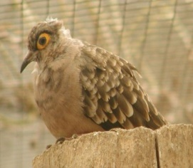
Barred Cuckoo Dove | Macropygia unchall | Bar-Tailed Cuckoo Dove,  Bared Cuckoo Dove | Bangladesh,Bhutan,N India to S China, SE Asia, Sumatra,  Java | It has a long, graduated tail and is generally 27-45cm long and slim-looking. The neck has a green to purple iridescence while the remaining upperparts are barred black and chestnut. Under parts are pinkish-grey to buff on the male while the female has fine black barring below. | It is found in dense, evergreen forest where it is often seen hanging acrobatically while it feeds on berries, seeds, buds, etc. | 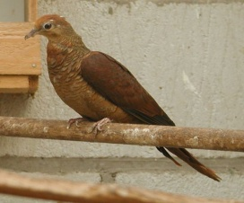
Black-billed Wood Dove | Turtur abyssinicus | Abyssinian Wood dove, Blue Spotted Wood dove | The drier parts of tropical Africa, north of the equator | It is a small plump pigeon, 20 cm in length. Its back, hind neck, wings and tail are pale grey brown, and the folded wings have dark metallic patches. There are two blackish bands on the back. The forehead, crown and nape are bluish grey, fading to whitish on the face. The underparts are pinkish, becoming whiter on the belly. The bill of this dove is, of course, black. When flying, it shows chestnut in the underwing. Sexes are similar, but immature are duller than adults, scaly below, and lack the wing spots. They eat grass and other small seeds. They are quite terrestrial, and usually forage on the ground. | It builds a stick nest in a tree, often an acacia, and lays two cream-colored eggs. Its flight is quick, with the regular beats and an occasional sharp flick of the wings and it tends to stay quite low. The call is a persistent fluted coo-coo-cu-coo. They are not very gregarious, but form large flocks at waterholes. | 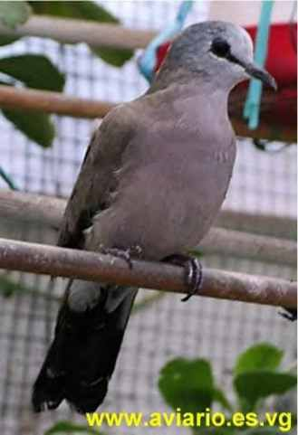
Black-naped Fruit Dove | Ptilinopus melanospilus | Black headed fruit dove | The Philippine Islands of Palawan | Medium-sized, up to 24 cm long, green Fruit dove with yellowish bill and iris. The male has a pale grey head with black nape, yellow throat, and golden yellow and pink undertail coverts. The female and the young have an entirely green plumages. | The diet consists mainly of various fruits, figs and berries. The female usually lays one single white egg. | 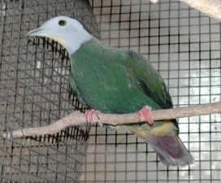
Blue eared Dove | Zenaida auriculata | Violet-eared Dove, Torpedo Dove | Western Indian Islands, Cuba, Bahamas, Jamaica, Caiman islands | It is 24 cm (9.4 in) long with a long wedge-shaped tail, and weighs about 112 g (4.0 oz). Adult males have olive-brown upperparts plumage, with black spots on the wings. The head has a grey crown, black line behind the eye, and the blue-black on the lower ear coverts. These black markings give the species its English and specific name. The underparts are vinous, and the tail is tipped with cinnamon. The bill is black and the legs dark red. The female is duller than the male, and immature birds are grayish-brown, very dull, with pale barring. | It appears to be partially migratory, its movements driven by food supplies (16).  The species' call is a deep soft oo-ah-oo. | 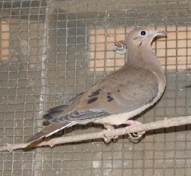
Blue-headed Quail Dove | Starnoenas cyanocephala | Blue-headed ground Pigeon, Black bearded Dove | Cuba | Length 29-34 cm & weight 242 gm.It taking its name from the brilliant cobalt blue crown and forehead. A contrasting black eye stripe and a characteristic white facial stripe run from the beak to the back of the neck. The face and throat are black, with slight bluish or purple mottling around the sides of the head, and there is a bib-like patch of black, bordered narrowly with white, just below the throat; has a pinkish-purple breast, which becomes olive-brown, tinged with purple on the sides and the back of the neck. The rest of the plumage is generally buff-brown to dark brown, except for the darker primaries and the slate-grey outer tail feathers. The legs and feet are reddish, with distinct hexagonal scales down the front. The short, rather slender bill is bright red at the base, becoming blue at the tip (18) (22) (23) (24) (25). | It is threatened by habitat loss. Breeding takes place mainly between April and July (18)  The blue-headed quail-dove is classified as Endangered (EN) on the IUCN Red List (17) | 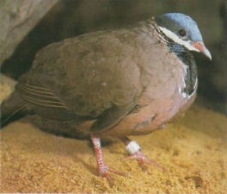
Blue Ground Dove | Claravis petiosa | Ashy Dove, Blue Dove, Cinereous Dove | Central & south America | 20 cm long with a weight of 65-72 g. Adult males have blue-grey upperparts and paler grey underparts, becoming grey-white on the face. The flight feathers and outer tail feathers are blackish, and the wings are boldly spotted black (these spots often forming distinct bands). The iris is red or yellow, the bare eye ring is green, and the legs are flesh-pink. The female has a grey-brown head neck and breast, becoming pale blue-grey on the underwings and belly. The back is ruddy brown, contrasting with the chestnut rump and tail. The spots in the wings are chestnut-brown. Young birds resemble the female, but have ruddy scaling on the back. | The male’s song, given from the treetops, is a loud boop. | 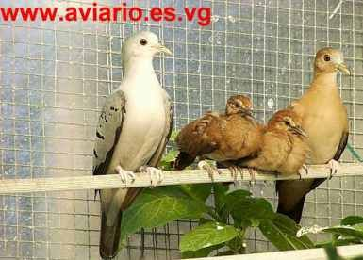
Blue Spotted Wood Dove | Turtur afer | Red Billed Wood Dove | woodland & riparian scrub of Africa S of Sahara | It is probably omnivorous, foraging mainly on the ground. It lays about 2 eggs, which are incubated for about 15-17 days. The chicks stay in the nest for roughly 15-18 days (recorded in captivity). | The nest is a fragile saucer, made up of twigs, petioles and rootlets, usually placed on a leafy stump, tree or bush. | 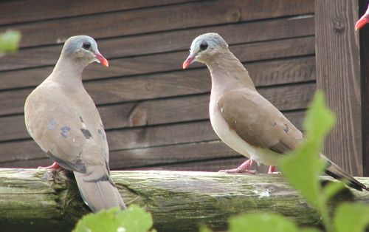
Brush Bronze wing Dove | Phaps elegans | Elegant Dove | S Australia & Tasmania | Robust, medium sized with small rounded head, deep chest, short rounded wings and short tail.  Uniform rich brown above and blue grey below, with a rufous brown to light brown forehead and dark  Maroon eye stripes that join on nape. Buff cheek  Stripe and chestnut chin. At rest wings appear rufous  brown, boldly barred with blue-grey and black with  Iridescent patch of green/purple. Underwings rufous  brown. Legs and feet red. Call is a repeated ‘hoo, hoo, hoo, hoo’.  (26) | Breeds in any month but mostly October to January. Nest is a shallow saucer of twigs in a dense, low shrub,  Sometimes on the ground in low cover. Clutch size is  two eggs with the sexes sharing the incubation for 16-18 days. Young fledge by three weeks. If flushed from the nest, the adults will readily desert the nest. (26)(27). | 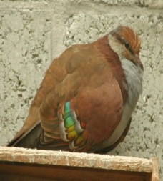
Celebes Quail Dove | Gallicolumba tristigmata | Sulawesi ground dove, yellow-breasted ground dove | Celebes island in the Philippine | 35 cm long, olive brown ground-dove with golden forehead, yellow breast, red legs, iridescence bluish-green crown ended with purple patch behind ear coverts, dark brown tail and white below. Both sexes are similar. | The female lays a single white egg. | 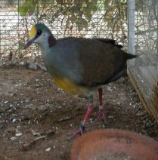
Common Bronze wing | Phaps chalcoptera | Forest Bronze wing | Australia, Tasmania | Common Bronzewings are between 30 and 36 cm (12–14 in) in length (29).Males have pale-yellow to yellow-white foreheads and pink breasts (28) (30). Both males and females have an easily discernible white line around and proximate to their eyes. They also have patches of red, blue and green on their wings, a feature which is characteristic of all Bronzewings pigeons (28) (30). | Young birds are usually duller in color and browner than the mature. | 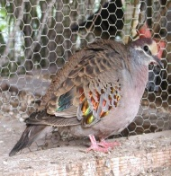
Costa Rica Quail Dove | Geotrygon costaricensis | Red-backed Quail Dove, buff-fronted quail dove | Costa Rica, Western Panama | Buff or pinkish-buff forehead. The rest of the head and underparts are largely gray, with a black line from the throat to the ear coverts, and dark reddish-brown upperparts suffused with purple. |  | 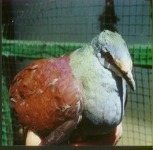
Crested Quail Dove | Geotrygon versicolor | Mountain witch | Jamaica | Male has darker feathers and female has brighter feathers. | It is threatened by habitat loss. | 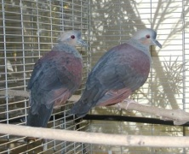
Diamond Dove | Geopelia cueneata | Little turtle dove | North and center of Australia | Small pigeons with a length of 19-21 cm or 9-11 inches (31). Regardless of the gender, they have white spots and black edges on their wings, orange eyes and red eye-rings. The genders look similar except the female's eye ring is less vivid and has more of a brown color to the plumage. The male's head, neck, and breast are light blue-grey. The bill is a dark grey color. The abdomen is a creamy color while the back and tail is a brown-grey color. The legs and feet are pink. The juveniles have a light grey bill; the iris and eye ring is fawn in color; the feet and legs are grey; the breast is grey and they do not possess any white spots on their wings. They live for 15–25 years in captivity. In the wild they only live for about 3–5 years. The doves tend to breed after rain but mostly in spring in Southern Australia. Two white eggs are usually laid and incubated for 13-14 days. Chicks are usually fully feathered and flying by two weeks | They can often be seen on the ground with a toddling run. Their flight is strong, direct and can be undulating. The wings can make a whistling "frrr" noise when flying. They will also eat ants. Nests are usually built from interwoven grasses and/or twig. They are of fragile construction.. The calls sound mournful, slow and have a falsetto quality to them. Two calls consist of two long coos followed by a pause and then a long, short and long coo. Sometimes they call two long coos. The alarm coo consists of a few short but loud coos. | 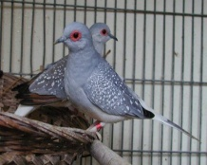
Emerald Dove | Chalcophaps indica | Green Winged pigeon, green dove | East Australia, New guinea and east Asia | Stocky, medium-sized pigeon, 23-28 cm (10-11.2 in) in length. The back and wings are bright emerald green. The flight feathers and tail are blackish, and broad black and white bars show on the lower back in flight. The head and underparts are dark vinous pink fading to grayish on the lower belly. The eyes are dark brown, the bill bright red and legs and feet rufous. The male has a white patch on the edge of the shoulders and a grey crown, which the female lacks. Females have a browner complexion with a grey mark on the shoulder. Immature birds resemble females but have brown scallops on their body and wing plumage. | It builds a scant stick nest in a tree up to five meters and lays two cream-colored eggs. Flight is fast and direct, with the regular beats and an occasional sharp flick of the wings.  The call is a low soft moaning cooing consisting of about 6-7 coos starting quietly and rising. They also call a nasal "hoo-hoo-hoon". Males perform a bobbing dance during courtship. | 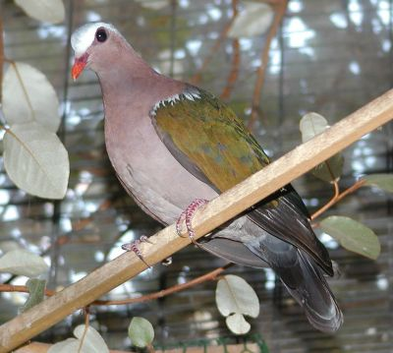
Emerald-spotted wood dove | Turtur chalcospilos | Green Spotted Wood dove | Africa from Ethiopia and Northern Somaliland, Angola | Small plump pigeon, 20 cm in length. Its back, hind neck, wings and tail are pale grey brown, and the folded wings have green metallic patches. There are blackish bands on the lower back and tail. The forehead, crown and nape are bluish grey, fading to pinkish grey on the throat. The underparts are mauve-pink, becoming whiter on the belly. The bill is blackish with a red base. The sexes are similar, but the female slightly duller than the male. The immature has duller green spots and buff fringes to the feathers. | The call is in three parts: two soft long coos, followed by a series of slow descending coos lasting 10 seconds, and concluding with 4 seconds of rapid coos, which decrease in volume. | 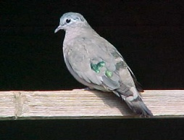
Eurasian Collared Dove | Streptopelia decaocto | Ring neck dove, Collared dove. | W Europe to Kazakhstan, Mongolia,  Sri Lanka and Burma | 30–33 cm long from tip of beak to tip of tail, with a wingspan of 47–55 cm, and a weight of 125–240 g. It is grey-buff to pinkish-grey overall, a little darker above than below, with a blue-grey under wing patch. The tail feathers are grey-buff above, and dark grey tipped white below; the outer tail feathers also tipped whitish above. It has a black half-collar edged with white on its nape from which it gets its name. The short legs are red and the bill is black. The iris is red, but from a distance the eyes appear to be black, as the pupil is relatively large and only a narrow rim of reddish-brown iris can be seen around the black pupil. The eye is surrounded by a small area of bare skin, which is either white or yellow. The two sexes are virtually indistinguishable; juveniles differ in having a poorly developed collar, and a brown iris (32) (34) (35).The male's mating display is a ritual flight, which, as many other pigeons, consists of a rapid, near-vertical climb to height followed by a long glide downward in a circle, with the wings held below the body in an inverted "V" shape. | The female lays two white eggs in a stick nest, which she incubates during the night and which the male incubates during the day. Incubation lasts between 14 and 18 days, with the young fledging after 15-19 days. Breeding occurs throughout the year when abundant food is available, rarely in winter in areas with cold winters such as northeastern Europe.3-4 broods per year is common, although up to 6 broods in a year has been recorded (34).  Flocks most commonly number between ten and fifty. Flight is typically direct using fast and clipped wing beats and without use of gliding. | 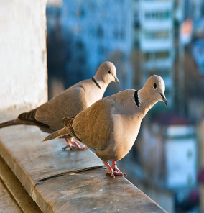
European turtle dove | Streptopelia turtur | Turtle dove | W Pale arctic to n Afghanistan, winters to Africa | It measures 24–29 cm (9.4–11 in) in length, 47–55 cm (19–22 in) in wingspan and weighs 85–170 g.It may be recognized by its browner color, and the black-and-white-striped patch on the side of its neck. The tail is notable as the bird flies from the observer; it is wedge shaped, with a dark centre and white borders and tips. When viewed from below, this pattern, owing to the white under-tail coverts obscuring the dark bases, is a blackish chevron on a white ground. This can be seen when the bird stoops to drink and raises its spread tail. mature bird has the head, neck, flanks, and rump blue grey, and the wings cinnamon, mottled with black. The breast is vinaceous, the abdomen and under tail coverts are white. (36) | The bill is black, the legs and eye rims are red. The black and white patch on the side of the neck is absent in the browner and duller juvenile bird, which also has the legs brown. The nuptial flight, high and circling, but the undulations are less decided; it is accompanied by the whip-crack of the downward flicked wings. The arrival in spring is heralded by its purring song, a rather deep, vibrating “turrr, turrr”, from which the bird's name is derived. | 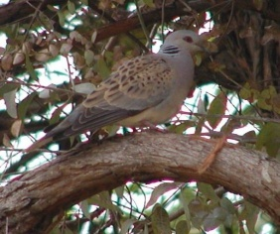
Galapagos dove | Nesopelia galapagaonesis |  | Galapagos Islands |  |  | 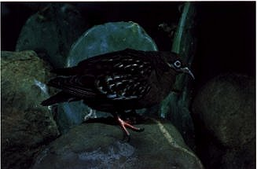
Inca dove | Columbina inca |  | S.N. America, Central America from Arizona,  S. new Mexico, Central Texas, Nicaragua, S.N. Costa Rica | Length 16.5–23 cm (6.5–9.1 in) and weigh 30–58 g (1.1–2.0 oz) (37). They are slender, with a gray-brown body covered in feathers that resemble a scaled pattern. The tail is long and square, edged with white feathers that may flare out in flight. In flight, the underwing is reddish, like other ground doves, and on takeoff, the wings produce a distinctive, quiet rattling noise | The song, a forceful cooing rendered as "cowl-coo" or "POO-pup", may be given from a tree, wire, or other open, high perch such as a television aerial.  During winter, they roost in communal huddles in a pyramid formation that helps them conserve heat. These pyramids can contain up to 12 birds (38). | 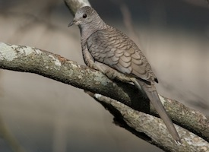
Jobi island dove | Gallicolumba jobiensis | White-breasted Ground Pigeon, purple ground dove | New Guinea, the Bismark Archipelago, Joby, Dampier, Solomon Island | Length 24-25 cm and weight 126-158 gm. Head and face grayish black with a broad white superciliary line extending from base of upper mandible over and behind eye, throat and breast white, hindneck and sides of neck, mantle, scapulars and area bordering white throat and breast purple, rest of Upper and basal parts of purple feathers slaty black with faint greenish gloss on back, rump and inner secondaries, tail slaty black, outer feathers with grey tips, underparts below white breast shields very dark slate grey, iris dark brown, bill black, feet and legs purplish red. Female similar, but white breast Buffy or grayish pink, underparts except area bordering breast shield part are paler slate grey, and purple tips to upperparts feathers are less extensive, giving the impression that the purple erae are mottled greenish black. | Juvenile dark brownish grey with rufous fringes to most feathers , in some birds, white or cream breast feathers appear in first moult, in others the first breast feathers are whitish grey (male) or dull grey (female). | 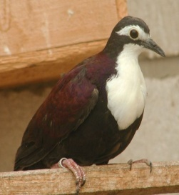
Key West quail dove | Geotrygon chrysia |  | Bahamas islands, Cuba | 27–31 cm in length. It is distinguished by having dark rust colored back and similarly colored wings. It has some amethyst or bronze green iridescence on its crown, nape and in the back of its neck. The mantle, back, rump and inner wing coverts show some purplish red iridescence. It also has a bold white facial stripe. | It lays two buff colored eggs on a flimsy platform built on a shrub. Some nests are built on the ground. | 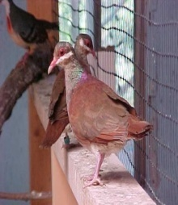
Lace necked Dove | Streptopelia chinensis | Spotted Turtle dove, Spotted dove, mountain dove, pearl-necked dove | S Asia from Afghanistan to Greater Sundas and Palwan | Light brown above, with darker centers to the feathers of the back and wings. The head is grey, and the neck and underparts are grey-brown, tinged with pink. In flight the white-tipped tail is clearly seen. The distinguishing feature is the large black collar on the base of the hind-neck, which has many white spots. Sexes are similar in plumage. Young are similar to adults, but have a mostly dark grey collar instead of black and white. Length ranges from 28 to 32 cm (11.2 to 12.8 inches) (39) (40) (41). They breed at any time of the year, but mostly from September to December. | The vocalizations include cooing softly with a Krookruk-krukroo... kroo kroo kroo with the number of terminal kroos varying in the Indian population and absent in tigrina and other populations to the east (42). The male performs a display flight, which consists of a steep rising flight with loud wing-clapping. Once the bird reaches a height of about 30 or 40 m above the ground, he then spreads his tail and wings and glides down to a perch. Males also court by walking in front of the female with the black and white neck patch fluffed up while bowing the head up and down. | 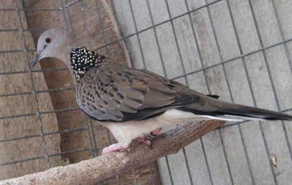
Lawrence Quail dove | Geotrygon Lawrencil | Purplish-back Quail Dove | Caribbean slopes of western Panama, Costa Rica,  Mexico, Vera Cruz |  |  | 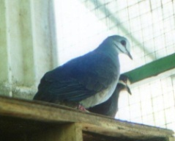
Lesser bar-tailed cuckoo dove | Macrpygia nigrirostris | Black-billed Cuckoo Dove | New Guinea, Jobi, Bismarck Archipelago | It is a threatened species (43). |  | 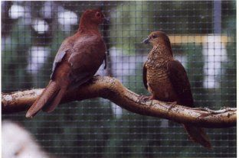
Masked dove | Oena capensis | Cape Dove, Long-tailed dove  Namaqua Dove | Africa from Senegal S Sahara, Red Sea coast  Arabia & Madagascar | A tiny sparrow-sized pigeon, typically 22 cm in length with a 28–33 cm wingspan, and weighing 40g. It has a very long black tapered tail, and the size and shape have led to comparison with the Budgerigar. The plumage is mostly grey apart from a white belly, and chestnut primary feathers which are visible in flight. The adult male has a black face, throat and breast, and a yellow and red beak. The adult female lacks the black and has a red-based grey bill. Young birds are dark blotched on the wings and shoulders, and otherwise resemble the females. | The flight is fast with clipped beats and a tendency to stay low.  The song is a quiet, short, double hoo, higher on the longer second note kuh-whooo, mournful and frequently repeated. | 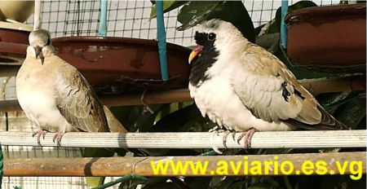
Oriental turtle dove | Streptopelia orientalis | Rufous Turtle Dove, Mountain Turtle Dove,  Japanese Turtle Dove | Asia from W Siberia to Manchuria,  Japan to S India, Burma, Indo-China | Length 33-35 cm (18), wingspan 55 cm (44),weight 165-274 gm.Easily identified by the distinctive patch of black and whitish stripes on either side of its neck (45) (46). The upperparts are reddish-brown (47), with some of the wing feathers having almost black centers and whitish or reddish edges, resulting in an overall ‘scaly’ appearance (46) (48). The underparts are pinkish and the dark tail feathers are tipped with pale grey. The feet are red and the bill is grey (45). | The call of the oriental turtle-dove is a four-note ‘croo croo-croo crooo’ (45) (49). It is hard to distinguish between the male and female oriental turtle-dove (47). Juveniles usually lack the distinctive neck patches and are paler in color (46). | 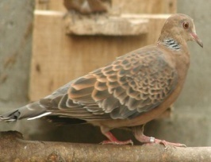
Peaceful dove | Geopelia placida | Peace dove | Lowland savanna of S New Guinea and Australia. | Male length 20.8-21.4 & female length 17.9-19.1.weight 36-60 gm.adult has a grey forehead. the rest of its head gradually becomes more greenish-brown towards the nape, which has indistinct blackish barring. The sides of its neck are pale yellowish-brown, and each feather has three black, horizontal bars at the tip. The throat is pinkish-grey, as is the breast which also has bar-like markings. Its belly and flanks are reddish-pink in color. Wings have square-edged feathers that are grayish-brown and tipped with black, giving its plumage a distinctive barred pattern. Its outer tail feathers are black with white tips, compared to the central feathers which are grayish-brown and those underneath the tail which are whitish. The pale blue eyes of the peaceful dove are the same color as the surrounding skin. Its grey bill becomes increasingly more bluish towards the base, and has a blue cere. This species has pinkish-red feet (50). | The juvenile peaceful dove is similar to the adult except for some reddish-brown on the wing feathers, which are also partially tipped white. Its underparts are light brownish-orange and the barring on its breast is more apparent. Calls of the Peaceful Dove are high-pitched "doodle-doo", "co-co-coo" and "croorrr!”  The doves fly in a rapid, undulating motion. The wings make a flushing "frrr" noise when the birds are in flight (50). | 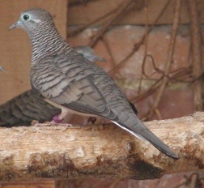
Peruvian ground dove | Columbina cruziana | Gold Billed ground dove, Gold Ringed Ground Dove | Ecuador, Peru, Northern Chile | They occur in open arid habitat, including agricultural and urban areas. Although primarily found on the lower Andean slopes, they also enter intermontane valleys and occur up to 2800 meters. They are often in groups, in which they forage for seeds on the ground. Visually, they can be separated from other ground-doves by the black primaries, distinctive chestnut scapular bar, and orange-yellow color on the bill’s base. | Their call is distinctive and very undovelike: a harsh, creaking, "po-WEE-at". | 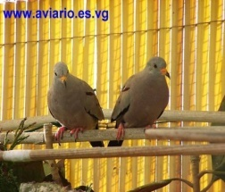
Picui dove | Columbina picui | White winged grownd dove,  Steel-barred Dove, Long-tailed Dove | S America from NE Brazil to Argentina  Uroguay & Central Chile | The Picui Ground-Dove is usually found either when flushed off the ground or when it sings singing the hollow, tooting song. It is small and brown with conspicuous white patches on the upperwings, and like other ground-doves, the Picui Ground-Dove is fairly shy and skittish. |  | 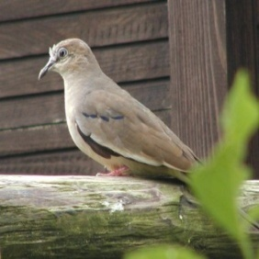
Red collared dove | Streptopelia tranquebarica | Red Ring Dove, Red Turtle Dove | E & SE Asia from NW India E to  NE Tibet,N China,Burma,Siam,  Indo-China,N Philippine, Ceylon | Small (23 cm) dove in which the male has a bluish gray head, a prominent black collar on the nape and vinaceous-red mantle, back, wing-coverts and underparts. The flight feathers are black, the tail is grayish centrally and blackish on the sides, with the outermost pair of feathers having white edges. The undertail coverts are white, the bill is black or dark grayish and the legs and feet are purplish black or purplish red. The female looks quite different: she is drab brown where the male is vinaceous-red, and brownish gray on the head (51). | The call of Dove is described as "cru-u-u-u-u" or "goo-goo-goo", repeated several times. Like many doves, this species builds a flimsy platform nest of twigs, placed usually 3-8 m. high in a tree or bush. Usually two eggs are laid.It is a common and wide-spread resident of Taiwan year-round (51). | 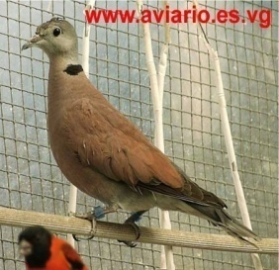
Ring neck dove | Streptopelia risoria | Domestic Ring Dove, Domestic Collard Dove, Fawn Dove, Java Dove, Ringdove, Blond Ringdove, Barbary Dove. | U.S | Their length is approx. 305 mm (52). Their tail is shorter than that for the African collared dove (15).S. risoria is a warm creamy buff colored bird. There is a black semi-collar on the hind neck. On the chin, belly, and under the tail coverts, the coloration is whitish. The primaries and proximal wing coverts are a light grey with lighter grey on the wing edge. Under the tail, the feathers are black and white patterned. The eye is a ruby red, the bill is a dark purplish-black with silvery edging, and the feet are purplish-red. Juveniles are paler than the adults and similar to juvenile Streptopelia roseogrisea (15). They come in many colors, the most common one is the white and used by magicians in their performances. | Do not exist in nature, they are long-domesticated form of the African Collard Dove - Streptopelia roseogrisea..many doves breeders beginners all over the world start with them.  Despite being domesticated, ringed turtle-doves will freeze in place if a large shadow overhead appears to be hawk-like (15).  It has been observed that at least the female can not only coo but emit a high pitched laughing sound. | 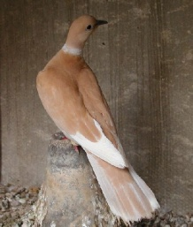
Ruddy quail dove | Geotrygon montana | Partridge Dove, Red Cuban,  Red Mountain Dove | cuba | Approx 19–28 cm in length. The bird is distinguished by having a rust colored back, facial mask and similarly colored wings. The breast, rump and undereye stripe are lighter brown. |  | 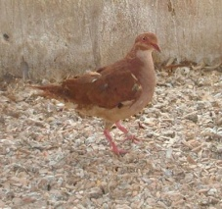
Senegal dove | Streptopelia senegalensis | Laughing Turtle-Dove, Palm Dove | Africa’s of the Sahara to India | Length 11-12 inches,weight 0.25-0.3 lbs,wingspan 16-18 inch,incubation 14 days,lifespan 6 years.The head and back are pinky-brown, the wings blue-grey and the belly whitish. There is a small white patch on the chin and long white tips on the outer tail feathers. To identifyh the Laughing Dove look for the blue-grey wings and a brown band across the lower fore-neck that is spotted with black. This band is lacking in juvenile birds which are generally a pale fawn but have the distinctive grey wings. Males make display flights similar to the Spotted Dove S. chinensis. | It earned its name because of the distinctive coo that sounds just like a human laughing. It breeds throughout the year with peak breeding periods in spring and autumn. A fragile nest platform of twigs, leaves and grasses is constructed in trees or on buildings and other structures. 2 white eggs are laid. | 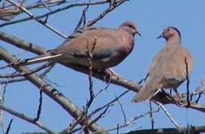
Socorro dove | Zenaida graysoni |  | Small extent captive population, formely Socoro Island of W Mexico | 26.5-30.5 cm,weight 190 gm. Medium-sized, principally terrestrial dove. Male has deep cinnamon head and underparts, with black streak on lower ear-coverts, blue-grey nape and iridescent pink neck patch. Dark brownish upperparts, boldly spotted with black on scapulars, tertials and inner wing-coverts. Dark grey flight feathers. Dark brown central tail, outer feathers grey with black subterminal band and grey tips. Female duller, with smaller blue-grey nape and pink neck-side patches. Juvenile similar to female, except coarse breast streaking and cinnamon-buff tips to upperparts feathering. In all plumages has pale blue orbital ring, pinkish legs and dark grey bill with reddish-pink base. | Voice-Hoarse cooing song, wah-ah ah ah ah ahh-ah.It is thought to have been extirpated mainly by feral cats,  Classified as Extinct in the Wild (EW) on the IUCN Red List (53). | 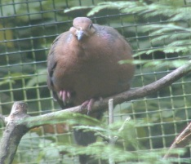
Superb fruit dove | Ptilinopus superbus | Purple-crowned Fruit dove, Superb Fruit-Pigeon. | Eastern Australia, Celebes Island,  Archipelagos | 22-24 cm in length. It is a compact bird, with short rounded wings and a short tail. Male has a purple crown, an orange hindneck, a blue-black breastband that separates a grey upper breast from white underparts. These are partly barred green, and the rest of the body is green. The green tail has grey tips. The female is green, with a grey breast and white underparts. There is a smallish purple patch on the crown. Young birds resemble females but lack the purple crown patch. The breeding season lasts from September to January. | They are arboreal and feed almost exclusively on fruit, mainly in large trees. They have a large gape, which allows them to swallow bulky items.  The call is a distinctive cooing, rising in pitch and volume to a loud and clear ‘whoop, whoop’. Also gives a low ‘oom’ in a steady sequence. | 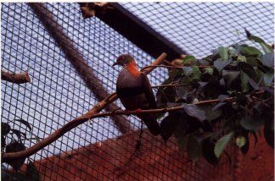
Stephan’s Emerald dove | Chalcophaps stephani | Brown-backed Emerald Dove,  Brown-backed Green Winged Dove. | S Asia & Malay Archipelgo to  Indonesia & Australia | Male has a white forehead and a purple wash on his crown and nape. Breeding season mid July. | Known to be locally nomandic in habitat with seasonally dry climatic conditions.Probably also wanders in response to changing food conditions. | 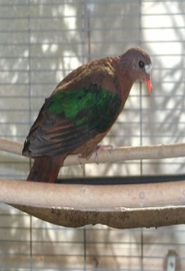
Tambourine dove | Turtur tympanistria | White breasted dove | Africa | A small plump pigeon, 22 cm in length. Male has a white face with a black spot behind the eye, white underparts and a grey crown. Its back, hind neck, wings and tail are pale grey brown, and the folded wings have large dark purple patches. The under tail is brown. The eye ring and feet are purple-red, and the bill is purple.The female is duller, and is white only on the belly, the face and breast being a pale grey-brown. The crown is grey-brown, without the blue-grey of the male. The juvenile resembles the female but has chestnut fringes to the feathers of the back, breast and flanks. Even in these plumages, this species is paler below than other small African doves. | Flight is fast and agile, and it tends to stay quite low when flushed. In flight it shows chestnut primary flight feathers and under wings.The call of this bird is a persistently repeated du-du-du-du-du.Tambourine Dove is usually solitary, but is sometimes seen in family groups or with Lemon Doves. | 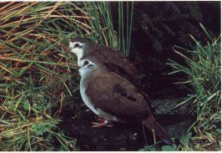
Veragua quail dove | Geotrygon veraguensis |  | Caribbian Costa Rica south through Panama,  Westren Colombia,n-w Ecuador  humid tropical forests | It is a small Geotrygon species with a striking face pattern, marked by a white throat and broad cheek stripe, and black malar stripe. Furthermore, the flanks are distinctively suffused with reddish buff. |  | 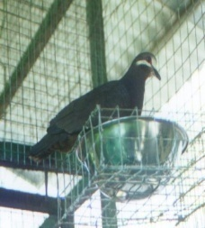
White faced quail dove | Geotrygon chiriquensis | Chiriqui Quail Dove, Rufous-breasted Quail dove | Costa Rica, Westren Panama | It is more frequently heard than seen, and is most usually seen when feeding on a forest trail. |  | 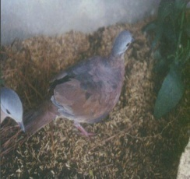
White winged dove | Zenaida asiatica | Singing dove | S U.S.A, New Mexico, Costa Rica,Jamaica | Weight 170 gm, wingspan 50 cm, length 30 cm. large, pigeon-like doves. Adult birds are brownish-gray above and gray below, with distinct white wing markings found in no other New World dove. When perched with wings folded, the white wing bars form a narrow (1cm wide) margin along the leading and lower edges of the wings. In flight, they appear as brilliant white crescents framing the body on the upper surface of each wing. Both male and female adults also have a ring of blue, featherless skin around each eye, red irises, a patch of black feathers or “ear spot” beneath and behind the eye, and red or pinkish-red legs and feet. Males and females are difficult to differentiate in the field, although males tend to be slightly larger and a bit more colorful than females, with a hint of purple on the neck and head, and a bolder black ear spot. Juveniles are more gray-brown than adults. They have no blue eye ring, their irises are black, and their legs and feet are pink or brownish-pink (54). | Their long, hooting “whoo-OOO-oo, ooo-oo” calls are an increasingly common sound in the southern U.S.  Clutch Size  1–2 eggs,  Number of Broods  1-2 broods,  Egg Length  1.1–1.3 in  2.7–3.2 cm,  Egg Width  0.7–0.9 in  1.9–2.3 cm,  Incubation Period  14–20 days,  Nestling Period  13–18 days,  Egg Description-  Creamy white or buff with a dull texture. Condition at Hatching-  Eyes closed and dark skin coated with long off-white down feathers. Weak and uncoordinated (55). | 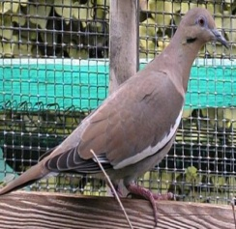
Zebra dove | Geopelia striata | Peaceful Dove, Barred Ground Dove | South New Guinea. | small, sturdy dove, with a long graduated tail and wedge-shaped wings. Length 20-23 cm,wingspan 24-26 cm,The eye-ring, eye and cere (the soft parts above the bill) are all blue-grey. The upper body is mainly brown-grey, with dark barring. The head and lower throat is a softer grey, with dark scallops. The throat is white and lower body pinkish. The feet are a deep pink. They are usually seen in pairs or small parties, never far from water. The flight is direct, low to the ground and undulating (57).males are dark maroon and females legs and feet are pinker. | In its native range the breeding season is from September to June(56).The call is very distinctive and is the source of one of their common names, 'Doodle-Doo'.(57). | 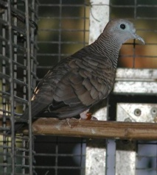

Social status :
Generally doves are not commonly pet. They are seldom found as pet. The wild doves collect food from their own. Doves are generally loved by common people.

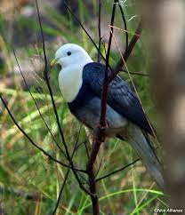
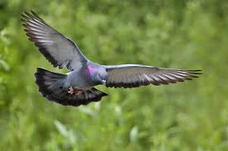
Fig: Dove in tree Fig : Flying dove

Common foods:
In the wild, most Dove species subsist on a diet comprised mainly of fruits, berries, and seeds. Some species have been known to ingest the occasional insect, but the vast majority of Doves thrive on a vegetarian diet. When they grab seeds off the ground, they are not necessarily eating them. Instead, they are stockpiling for digesting later. The seeds collect in the “crop,” which is simply an enlarged part of their esophagus.
Seeds and fruit form the major component of the diets of pigeons and doves. In fact, the family can be divided into the seed-eating or granivorus species (subfamily Columbinae) and the fruit- and mast-eating or frugivorus species (the other four subfamilies). The granivorus species typically feed on seed found on the ground, whereas the frugivorus species tend to feed in trees. There are morphological adaptations that can be used to distinguish between the two groups; granivores tend to have thick walls in their gizzards, whereas the frugivores tend to have thin walls. In addition, fruit-eating species have short intestines, whereas those that eat seeds have longer ones. Frugivores are capable of clinging to branches and even hang upside down to reach fruit (2).
In addition to fruit and seeds, a number of other food items are taken by many species. Some, particularly the ground-doves and quail-doves, take a large number of prey items such as insects and worms. One species, the Atoll Fruit Dove is specialized in taking insect and reptile prey. Snails, moths and other insects are taken by White-crowned Pigeons, Orange Doves and Ruddy Ground Doves (2).
Mealworms are an excellent source of vitamins for birds. Mealworms should be fed sparingly; too many can cause fatty liver disease.

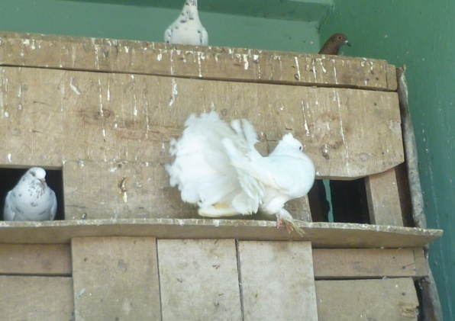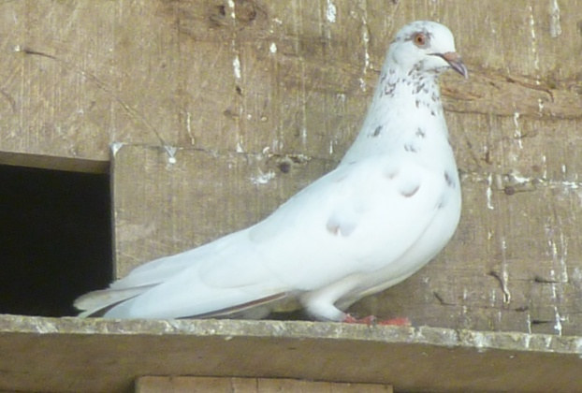
Fig : Resting dove Fig : Moody dove
Common behavioral characteristics:
Doves bob their heads while walking. So do cranes, magpies and quails. In fact, head bobbing is a unique feature in birds and occurs in at least 8 of the 27 families of birds.
There are a few theories why dove birds bob their heads when they walk-Assists with balance; Provides depth perception; Sharpens their vision. However, most studies suggest that birds in motion bob their heads to stabilize their visual surrounding.
A. Infantile and Juvenile Behavior (in approximate order of development) (63)
1. Clutching. The newly hatched squab clutches the nest sticks or toes of its brooding parent with its feet, and hangs on tightly if disturbed. This behavior persists until the squab is nearly full fledged (about 3 weeks). It might serve in providing a solid purchase for the sometimes vigorous regurgitation-feeding .
2. Head Waggle. Very young squabs (decreasingly true for older ones) may shake or waggle the head as if the muscles were unable to properly maneuver the head. It apparently occurs when the squab is searching for food or seeking a new position.
3. Squab Note. Apparently when hungry, the squab will give a prolonged shrill, sometimes ascending whistle of low intensity. Rarely the whistle tends to descend the scale. The duration is 1-3 seconds, but it may be longer in older squabs and repeated several times. It is usually accompanied by the squab wing shake (A 4) and bill searching (A 5). A very faint "peep" occasionally may be heard in the pipping egg, and the strength of this squab note increases with each day of growth.

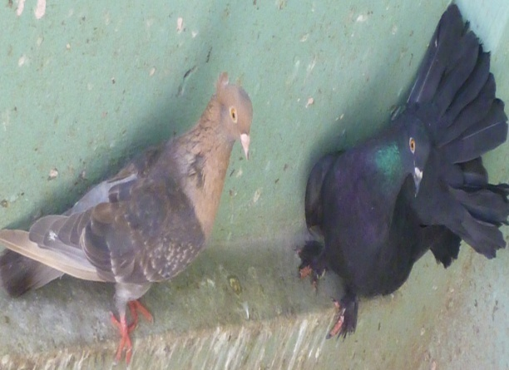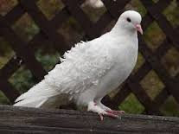
Fig: Tensed dove Fig: Angry dove
4. Squab Wing Shake. The squab may shake its wings rapidly (perhaps two or four shakes per second) for a few seconds and repeat intermittently in food begging movements (A 3, A 5). It becomes increasingly obvious beyond the first week after hatching.
5. Bill Searching. Accompanying A 3 and 4, an older squab thrusts its bill towards the parent's body in rapid "wiggling" movements. The squab learns to aim at and thrust its bill near and into the parent's mouth, but very hungry older squabs will thrust at the tail, rump, legs or wings of the parents, the nest mate squab or even their own wings. It may represent a more advanced form of the head waggle (A 2).
6. Nest Defecation. As the squabs grow they tend to back toward the edge of the nest to defecate. Not until the pin feathers are well developed do the squabs manage to defecate out of the nest.
7. Bill Snapping. Squabs and immature may "click" or snap their bills one or more times when closely accosted by an unfamiliar object or movement. It develops rather suddenly (as the pin feather open) as does the fight or flight stance which appears with bill snapping and hissing (A 8). Bill snapping may be given by nesting adults in an extremely soft version.
8. Hissing and Puffing. Squabs and immature may fluff the feather, especially those of the breast, and "hiss" when accosted as above. The wings may be raised as in the fight or flight stance .Nesting adults may express a faint hiss.
9. Squeaker Notes. Immature birds about four to eight weeks of age are termed "squeakers" by fanciers. Their voice is "squeaky", somewhat harsh and variable. As they become older, a similarity of the squeaker notes with the adult alarm note (C 6), "challenge" note and the bow-coo becomes evident.
B.Aggressive Behavior:
1. Attack Posture. The head is held low and horizontal and drawn close to the body. Sometimes the head is jerked up and down just before or after challenge notes are given. The rump feathers are fluffed, and the pupil of the eye may contract and expand.
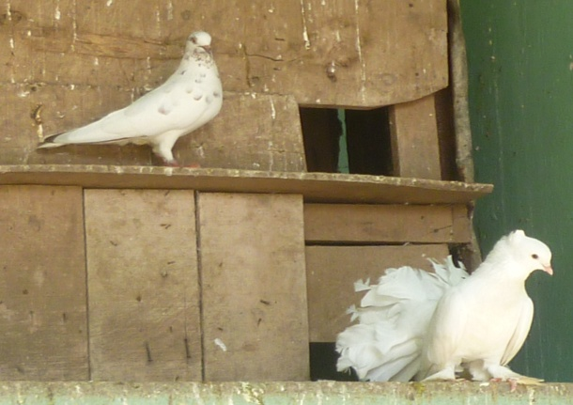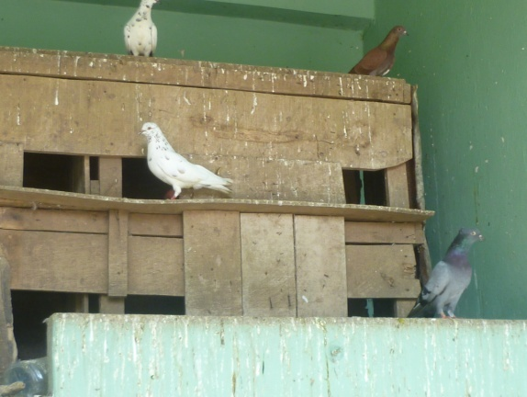
Fig : Thinkful bird Fig : Lazy dove
2. Rush. Maintaining and attack posture, the dove often runs or rushes at the opponent. At times the dove will fly toward the opponent but cage conditions ten to inhibit a rush by flying.
3. Challenge Note: Kah or "laugh". This note is nearly always given from an attack posture and is often proceeded or followed by a forward hop or jump. It consists of a series of similar high pitched, rapid, short notes (often five notes), hinh-hinh, hinh-hinh-hinh, frequently in one of the following ways.
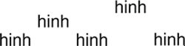 | OR | 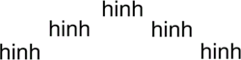
They may ascend and descend the scale slightly or alternate notes may go higher; other combinations are more rare. The high notes are accented. The challenge note given by a male often leads to bow-coos if the "opponent" is a female and to a fight or flight stance if the opponent is a male. Females usually give it only to newcomers, mates or territorial transgressors.
4. Fight or Flight Stance: Fear-threat display. A position nearly broadside to the opponent may be assumed with the wing opposite the opponent half raised. Initially the forebody is often raised slightly. Either escape (C 2, 3, 4, 5) or fighting may ensue from the position. It is especially easy to observe contrasting "intention" movements of the aggressive escape "conflict" within a dove in this posture.
5. Fight. (Intermittently accompanied by challenge notes).
a. Pecking. The aggressor dove pecks intermittently at the head, neck and shoulders of the opponent who may return pecks and wing blows.
b. Wing boxing. From the fight or flight stance the opponent may be hit with single or multiple wing blows more or less directed to the head, neck and shoulders. It is the wing nearest the opponent which does the "boxing". Sometimes the opponent is hit by the wings of the aggressor in flight.
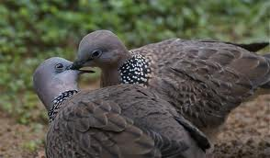
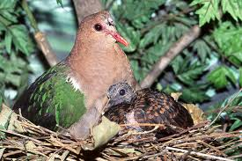
Fig: Affectionate bird Fig: Squab with mother
c. Standing on opponent. The aggressor often flies or hops to stand on the back of the opponent. Thereupon pecking or wing boxing may ensue; but strangely enough these are minimized and standing alone may satisfy the aggressor.
C. Escape Behavior:
1. Alert Stance. The body is held erect by straightened legs with the tail low, neck stretched and held high. The plumage is tightened close to the body. It is usually accompanied by the alarm note (C 6). The alert stance and the alarm note may be stimulated by the appearance of hawks, unfamiliar moving objects, or by humans, cats, rats, and snakes.
2. Flight Stance. The bird crouches, stretches the head forward, and raises the tail somewhat. It may follow an alert stance (C 1).
3. Avoidance. The head us held low and away from the attacker with the body in a crouch and sometimes leaning to one side; or, less often, the head may be held high, as the bird attempts to climb out of reach. It may be an intermediate form of the flight stance (C 2).
4. Flight. Outright flight often occurs immediately after an aggressor approach, as when one dove is in another's territory. Flight usually terminates any persistent attack. When frightened from the ground by a hawk, the dove most commonly flies forward and upward with a noisy clatter or wings (58).
5. Wings Vertical. Adults, juveniles or older squabs may spread the tail, fluff the feathers, and hold one or usually both wings vertically over the body which is sometimes inclined away from the attacker. It may follow a fight or flight stance.
6. Alarm Note. A soft "hinnnnh" may be given, often repeatedly. The character of this note may vary from time to time in the same individual, occasionally approaching a louder harsh quality. The latter may occur during feeding of the young. The duration of a single note is nearly one second, but a repeat note may be given every 5 to 10 seconds.
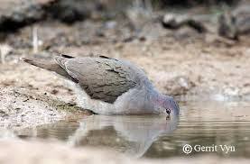
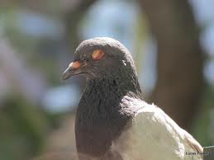
Fig: Drinking dove Fig: Sleepy dove

D. Other Behavior:
1. Sunbathing. In direct sunshine, a dove may spread the tail, incline the body to one side and lift the wings, alternately holding one aloft during a few seconds or minutes.
2. Water Bathing. Doves may step into shallow water or sit on a perch near water level and fluff the feathers, crouch, and flutter the wings so that the water is "sprayed" throughout the plumage. The head is rapidly dipped or passed through the surface of the water a few times in a "sideswipe" motion. Often the wing is held vertical, but the tail is seldom spread. This response may also occur at the beginning of a light rain or spray of water. The bird always preens and shakes afterwards, if undisturbed.
3. Relaxed Resting. Beyond the usual "perching" a dove may lean its body to one side so that one wing is partly laid upon. Sometimes both wings are at an unusual angle (shoulders out, wrists in near feet). It occurs frequently in immatures and more rarely in adults.
4. Stretch
a. Gape. The neck is stretched forward and the mouth opened widely and moved forward and up.
b. Back stretch. Both wings are held vertically over the body but not spread. The tail and head are depressed. It frequently precedes or follows a foot stretch.
c. Foot Stretch. (or foot and wing stretch). One foot and leg are stretched backwards; the tail and one wing are spread and extended toward the leg being stretched.
d. Upper Mandible Stretch. The terminal half (distal) of the upper mandible is sometimes lifted above the lower bill while the mouth is held closed.
5. Rapid Peering. The head is moved more or less up, forward, and back in what appears to be visual "searching" movements. The head also may be turned side to side allowing each eye in turn to see the object of attention.
6. Questioning Bill. When no escape behavior is exhibited and when the bird is watching action or objects seemingly peculiar or unfamiliar to the bird, a "silent" rapid opening and closing of the bill occurs singly or repeatedly.
7. Huddled. When cold, ill, or "frustrated" (?) the bird may fluff the feathers, draw its head in very close to the body and perhaps even close its eyes. It may remain thus for hours in extreme cases.
8. Shivering. When very cold, ill or "ill at ease" (?) a shivering of the body and especially of the wings may occur.
9. Sneeze. The bird may be stimulated by illness, [eating too much salt], or by unknown factors to "sneeze" in a sharp "pttk" accompanied by a sudden sideways jerk of the bill and head. If the bird does have a "cold," the sneeze may be followed by a wheezing sound.
10. Preening (homo-preening). The dove may arrange its feathers and their parts with the bill, each feather being passed between the mandibles in turn. A dove cannot reach its own head and many of the neck feathers for preening. The uropygial gland is used relatively infrequently.
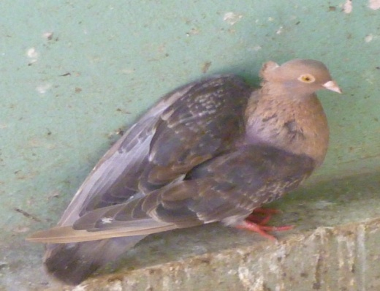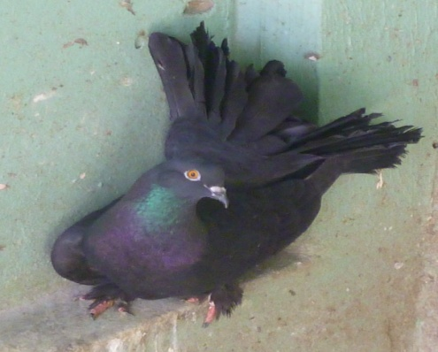
Fig : Careful dove Fig : Observing dove
11. Ruffling and Shaking. Practically all the feathers of the body are raised or "fluffed" and the wings and body are shaken vigorously. The feathers smooth down quickly afterwards. It often occurs during or after preening.
12. Tail Wag. Often after preening or ruffling and shaking or if an object drops on the bird's tail, the dove may shake the tail sideways somewhat like a duck but with only one or two shakes.
13. Scratching. The dove scratches its head and neck with its toes. The leg is not held dorsal to the wing as occurs in some birds when they scratch.
14. Eye Wipe. When a feather or foreign object adheres to the eye or when illness affects it, the dove may wipe its eye on its shoulder.
15. Flight Exercise or Wing Fanning. Immature and adults after a period of relative inactivity may beat their wings somewhat as in flight but remain grasping the perch or floor.
16. Flight
a. Pen Flight or "hovering flight." The characteristic details of a dove flying in a pen or for short distances of a few feet have not been adequately distinguished. However, there seems to be a "hovering" quality distinct from distance flight.
b. Distance Flight. Since this species is usually caged, such flight is only rarely observed, but it is swift and direct (58).
c. Gliding Flight. The distance flight may be interrupted by gliding or sailing aspects with the wings held nearly motionless.
d. Display Flight. The male flies upward wing-clapping, then with the wings and tail spread widely he glides down, often in a half-circle (58). In wing-clapping, common in the domestic pigeon but less marked in the ring neck dove, the wings meet above the body in flight, producing a clapping sound.
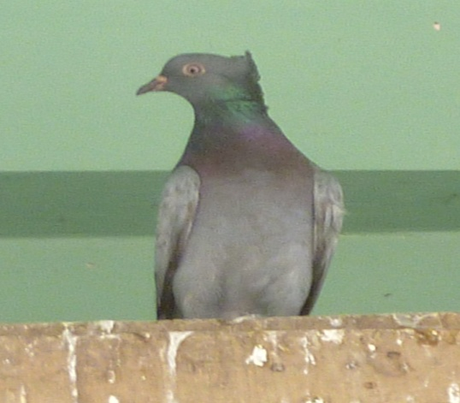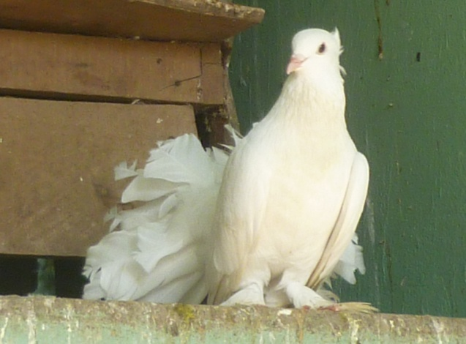
Fig : Sharp dove Fig : Agile dove
17. Defecation. In normal defecation the vent feathers are fluffed, a semi-solid mass is expelled and the vent muscles are rhythmically contracted a few times. (59)
[(64) (65) (66) (67) (68)].
Common physiological characteristics:
The normal body temperature ranges between 109-110 degree F( month old or even two weeks old squabs tended to be close to adult temperature) ,respiration rate 20-35 per minute, heart rate 180-250 per minute. A temperature of 99-102 degree F would work to incubate dove eggs but anything over 103 degree F will result in a dead embryo. Doves reach sexual maturity between the ages of 6 and 8 months. Doves mate throughout their life but the peak times are usually in spring and summer.
The integumentary system consists of the skin, the feathers and the appendages (claws and beak). The skin covers the majority of the body and contains glands in the outer ear canal and the preen gland at the base of the tail, that the bird uses to preen its feathers. The integumentary system is very important in providing protection to the bird from a number of potentially dangerous situations. The skin is usually covered by the feathers is therefore normally protected and hence is thinner. Over the wings and thighs, the skin is more closely joined to underlying tissue than over the rest of the body.
The beak is composed of two parts: the internal skeleton of bone and a closely attached layer of highly keratinized skin over the bony skeleton
The crop becomes glandular in response to small amounts of the hormone prolactin. Prolactin was first discovered in pigeons by American zoologist Oscar Riddle in the 1930s, it reduces aggressive behavior during the incubation and early brood-care stages of the reproductive cycle.
They have a light skeletal system and light but powerful musculature which, along with circulatory and respiratory systems capable of very high metabolic rates and oxygen supply, permit the bird to fly.
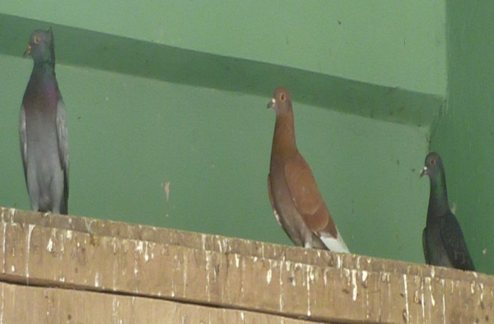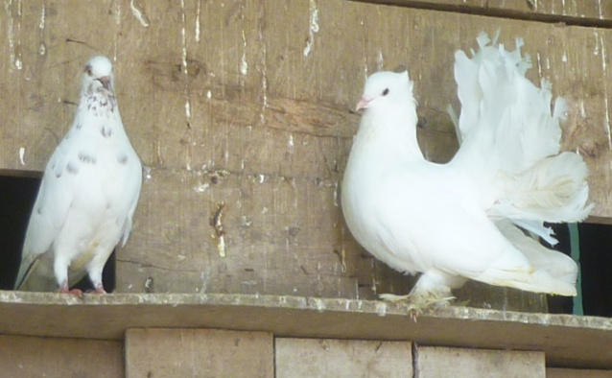
Fig : Interested dove Fig : Subconscious mind dove
In doves and pigeons, Intestinal ceca absent or minute; Young altricial (helpless) and hatched blind; without real down. Basal part of bill soft and covered with swollen skin that envelops the slitlike nostrils as a cap (operculum). 14–15 cervical vertebrae. 11 primary feathers, the outermost much reduced. Usually 12–14, and exceptionally 16–20, retrices. Crop bilobed. Nesting in tree holes or caves or building flimsy platform of sticks on trees or ground. Eggs usually white, except brown or cream in some quail doves. Two eggs in most clutches, but some genera produce only one (60).
The sense of taste, as with most other birds, is poorly developed, and it is probably not an important factor in selecting food. Shape and tactile characteristics and, to a lesser extent, colour are much more important. The average number of taste buds is only 37, confined to the soft area at the base of the tongue and palatine region (in contrast, humans have about 9,000 and rabbits about 17,000). Pigeons can, however, exhibit a surprising sensitivity to certain substances, such as acids; only at extremely low concentrations are acetic acid solutions accepted as readily as pure water. The olfactory organs are well developed, but smell seems to be of little significance in the daily lives of pigeons; experiments to demonstrate their olfactory abilities have yielded conflicting results. Visual acuity is highly developed, as in most other birds, although training experiments demonstrate that pigeons can attain acuity little better than humans (60).

Reproductive characteristics:
Sexual maturity occurs from 6 to 8 months in most species. Like domestic pigeons, doves mate or bond for life, until one of the partners dies. Then the survivor will seek another mate.
Reproductive Behavior (Non-sexual)
1. Stick Nest Building. (May belong with sexual behavior C). Either sex, but more often the male, may walk around the ground picking up "suitable" (small, irregular shaped) sticks with its bill. [Nevertheless, pine needles about 6 inches long are favored.] Many sticks are discarded. The sticks are carried, a single stick at a time, to the nest site and placed near the partner. Usually, a longer section of the stick as held by the dove is carried projecting forward and down. Sticks beneath the nest site are ignored. The female predominates in arranging the sticks. However, a reversal of the roles occurs to some extent. Frequently the partner will "grab" the stick before it is placed and a short "tug-of-war" usually results. Juveniles have been observed to "play" with sticks.
2. Egg Laying. During oviposition, the female will stand and slowly raise the forebody. She appears to be straining for perhaps half a minute before the egg drops. She may ease the straining briefly and start again with a faint "ptk" expressed. During the straining period and especially near its termination, the eyes may be partially closed, or covered by the nictitating membrane. Also, the wings may droop, perhaps to assist the bird maintain balance. As the egg drops, the head may by thrown up and back. The bird usually "rests" five to ten minutes standing over the egg before leaving the nest, or before starting incubation, if the second egg was laid. (Usually the female will lay the first egg in the afternoon and the second egg about 42 hours later. In this species a clutch usually consists of two eggs, occasionally one.)
3. Incubation. The parent crouches over the eggs, more or less orients then in a fore and aft position with the aid of the bill, the sides of the legs, and the keel, fluffs the ventral feather which exposes bare skin, and then settles down on the eggs. Eggs in an unsuitable position may be retrieved by gently placing the bill over the egg until the egg can be rolled carefully underneath the bird.(The female parent sets during the night and contiguous light periods. The male sets six to fourteen hours during the middle of the day, 9:30 a.m. to 4 p.m. being typical, the duration depending largely on the photoperiod. The length of the incubation period to hatching is 14 days.)
4.Faeces Retention. During incubation, the faeces of the settling parent are retained until the bird has departed from the nest, when a relatively enormous load may be released.
5. "Hiding". When closely approached either sex may remain motionless (crouch and freeze) on a nest of eggs or very young squabs. The head is drawn in and the feathers held tightly. This may be an alternative to the fight-or-flight stance which also may be exhibited by a nesting bird. It is characteristic for any one bird to exhibit only one of these reactions in such a situation.
6. "Squared". When hiding either sex may further tighten one wing (occasionally both) to the body so that the wing and back nearly form a right angle and tiny coverts near the shoulders are not smoothed to the rest of the wing but stand out.
7. Broken Wing Ruse or Injury Feigning. (Very rare.) When its nest was disturbed by the senior author, one white ring neck female clearly exhibited this behaviour common to mourning doves and other birds in which one or both wings are held awkwardly extended and shaken as the bird hesitatingly moves away from the nest site.
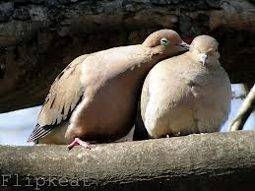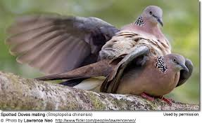
Fig: Paired dove Fig: Mating dove
8. Shell Removal. After emergence of the squab from the egg, a parent frequently removes the two shell parts one at a time with the bill and flies some distance from the nest before dropping them.
9. Regurgitation Feeding. Either parent may feed one of both young together by opening its mouth and receiving the bill of the young in its bill. The parent usually lowers its head as it "pumps" food from its crop to the throat by violent "shivering" of the wings and crop. Nearly always the head is raised and the "pumping" process is repeated several times. Regurgitation feeding is sometime initiated by a parent which may very gently peek or preen the newly hatched squab. During this process the head of the parent is often lowered and the bill partly opened. This peeking and preening usually stimulates the young squab to head waggle and bill search (A 2 and 5), although these may occur without detectable parental stimulation (61).
Sexual Behavior
1. Bow-coo. (The most frequent of coos.) The neck is inflated ventrally, the head and body held high; then the head is brought low suddenly with the bill pointed at or touching the ground. The pupil of the eye contracts. The first "note" of the call usually starts immediately as the head comes down. The first "note" is short; the middle notes form a rolling coo; and the last "note" is 2-3 times the duration of the first note, sometimes slightly descending the scale. If the observer is close, a strident, low, "appendix" note (one or two) is often heard at the end of the last note in the coo, as if the bird were regaining its breath or redistributing its air. The call may be indicated as huk' prrrroooo wah (wah). The bow-coo is always directed to or at a particular bird. It may by repeated as rapidly as 5 per ten seconds but usually longer interval occurs between calls. One bow-coo averages about 2 and 1/2 seconds per call. Between repeated bow-coos the male always "stamps" his feet lightly or steps toward the object-dove. However, sometimes one foot is only slightly raised and replaced. This call, occasionally given by unmated females, was never observed to be given by mated females.
2. Perch-coo. The notes are nearly the same as in a bow-coo, but they are given less hurriedly than the sometimes "frenzied" bow-coo. The perch-coo may be given with the eyes open, or nearly completely closed and is the only coo also given at night. It is never obviously directed at any particular bird in sight.
3. Nest-coo. The notes of this call are nearly the same as in a bow-coo, but the call is softer, less forceful, and more intermittent. It is always accompanied by wing "flipping" .The head may "nod" at the beginning of each nest-coo. In a potential nest site males give this call more frequently than the female before a nest site is chosen, but afterwards the female may give it more frequently. (Apparently, doves sometimes consider a thin perch as a nest site and may even carry sticks to it).
4. Wing Flip. Either or both sexes in a nest site or more rarely on a perch may jerk their shoulders so that the wing, especially the tips, flip. Rarely only one wing is so flipped. Wing flipping may be constantly repeated and maintained intermittently for several minutes with a frequency of approximately two flips per second. Nearly always the head is held low and the tail high when the wingflip is given.
5. Hetero-preening. The male and female of a pair may "preen" each other especially about the face and neck or head. Hetero-preening may be somewhat ritualized since the preening movement is often more cursory than in homo-preening. Parents may hetero-preen their young, apparently assisting the feathers to break out of the sheath.
6. Billing. Billing occurs in a situation similar to hetero-preening. Billing is often initiated be the female which preens the neck and face of the male. After variable amounts of this hetero-preening the male may reciprocate and then take the bill of the female in his and apparently feed her as he would a squab. (It is not clear whether or not food is actually passed.) [A very small amount of food likely is taken or tasted by the female.]
7. Sex-crouch. The sex-crouch usually follows billing .The female squats, lowers her head, and raises her shoulders which will support the feet of the male.
8. Sex-mount. (Treading). The male's posterior feathers fluff out and he repeatedly "cranes" his neck above the female. He may even "preen" or place his neck above the female. He may "preen" or place his bill between his wing tips and rump. Then he mounts the female (both facing in the same direction) which is in a sex-crouch and maintains his balance by fluttering his wings. The tail of the male bends anterio-ventrally and swings from side to side until copulation. Normally, the sex-mount is always followed by the "laugh" or challenge note by both sexes. The sex-mount takes about 5 to 10 seconds for completion, but the "preening" and "neck craning" by the male may be prolonged. Females very rarely try to mount mature males but may mount a partner frequently if paired with another female.
9. Driving. A few days prior to the female laying the first egg of a clutch, the male tends to follow her wherever she goes with occasional incomplete pecking movements. Driving in ringneck doves is much less distinct than in C. livia (62).It believes that driving normally occurs only if the potential sexual rivals are present.
10. Display Flight.
[(64) (65) (66) (67) (68)].
Husbandry practices in cases of pets:
If pets are the goal, domestic or semi-domestic doves should be kept. No wild doves should be kept as pet. Doves should be shipped in special cardboard boxes. The top of the box should have soft foam rubber to prevent the doves from banging their heads. Arrangements should be made for pickup within 24 hours.
Most doves are seedeaters. Seedeaters can be fed finch mix, cockatiel mix, wild bird seed, and semisoft dog food .Dog food is put in the food processor, and a tablespoon is put on the seed daily (1 teaspoon for fewer than four doves). As a special treat, doves like leafy vegetables, broccoli, cut up apples, bread crumbs, mashed hard boiled eggs, and occasionally mealworms. Fresh water and grit should always be provided. Oyster shells and chicken eggshells baked in the oven for several hours at 300 degrees Fahrenheit and crushed finely make an excellent source of calcium. Doves also like vegetables, cooked rice, leafy vegetables, peanut butter, grated cheese, and mashed hard boiled eggs. Some doves have to learn to eat other foods. Most doves will soon eat vegetables and fruit with gusto. Mealworms are an excellent source of vitamins for birds. Mealworms should be fed sparingly; too many can cause fatty liver disease.
Some avian fanciers leave lots of seed available for their doves. Others separate the seed in separate containers, and it is hoped that the doves will select their favorite seed first, but later learn to eat a balanced diet of seeds. We feed our doves once a day; in the evening. We know how much the doves will eat, so there is little waste or no waste to attract rats and mice. We also use a shot glass of niger seed thrown onto the pebbled flights. Doves are active all day, searching out these tidbits. We believe that in their natural state, doves work hard at finding food. The challenge provided here keeps our doves active and in top shape. Overfed, fat doves are not active and are “bored.” Of course, if we are gone for the weekend, feed hoppers or containers are filled to allow birds to eat at will.
Small seed hoppers, trays, and dishes all can be used as seed feeders. Keep feed containers away from places where they can be soiled by droppings. Sterilize seed dishes regularly. Cleanliness is extremely important to keep doves healthy.
Once a week we put cod liver oil and brewers yeast on the seed. Avian veterinarians can suggest the appropriate vitamins and minerals.
The water should be changed often. One or two drops of bleach in a gallon of water will keep water free of algae. Covered water fountains are best in keeping droppings out of the water.
Doves bathe naturally in the rain or enjoy a fine mist of water from a hose. Most doves, unlike pigeons, will not bathe in a water-filled container. Some ground-dove species enjoy dust baths.
Housing-
Foreign doves are wild creatures, and a bird cage is too small to make the dove feel safe and secure. Wild, foreign doves should be kept in spacious aviaries.
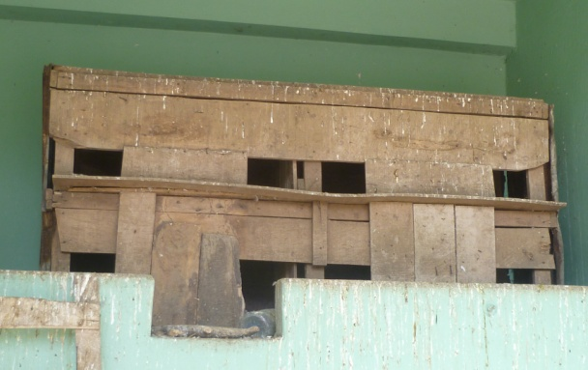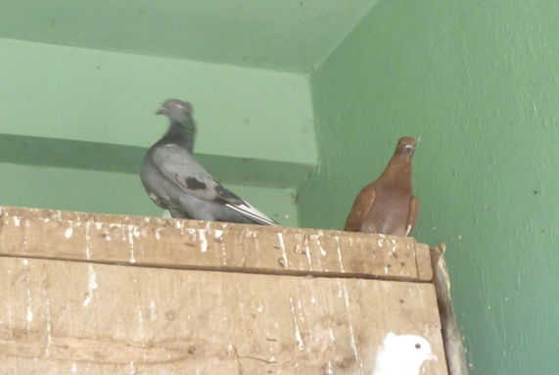
Fig: Aviary at Chittagong Zoo Fig: Doves on the house
The ideal aviary should not have less than 10 square feet per pair for small doves and double that for large species. The aviary should face south or southeast.
Compatible species can be kept together in a roomy aviary. Compatibility is important; even gentle species can have individuals that are aggressive. Observe your doves to see if they are living together harmoniously. During breeding, even gentle species can be quite aggressive toward other doves. Aggressive species need to be kept to one pair per aviary. Aggressive doves can injure and kill weaker species. In winter, doves can be kept in outside. Many species can be sheltered outside as long as the aviary is dry, insulated, draft free, and located in a sunny location.
Aviary floors can be wooden and off the ground, cement, or dirt. We prefer dirt with a berm at least 18 inches deep around the aviary. We use pebbles on the top of the dirt, or small bark and have various plants growing in the aviary. Some of our aviaries have wooden floors, and we use corn cob litter to keep them dry and clean.
Some species of doves are easy to sex, being dimorphic (males are a different color or pattern than females). Vent sexing is not always reliable. Some species are so alike that surgical or DNA sexing is the answer. Male doves are usually larger, brighter, and bolder than hens.
Foreign doves sometimes abandon their eggs. Abandoning eggs may be due to biting pests (lice, mites), noises that frighten brooding birds, or overcrowding and fighting. Frightened doves will abandon young, or if the nest is disturbed in any way, parents may refuse to care for the young. Hand-feeding formulas are available from pet shops, feed stores, etc. Small feeding syringes are available from veterinarians. Young doves should be placed in a box with a light bulb for heat. Some of the young doves are’ Scalped’ or killed by other doves. Young doves that are scalped or killed wander into the territory of another dove. Shrubbery provides hiding places for young doves from more aggressive adults.
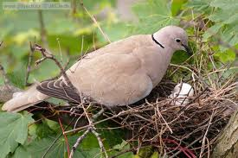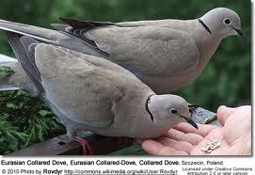
Fig: Nest of dove Fig: Feeding of dove

Merits and demerits of doves as pet:
Tame, domesticated, handfed Doves are known for their sweet and gentle dispositions. Unlike parrots, softbills such as Doves have a reputation for rarely trying to bite or otherwise put up a fuss with their beaks. Some doves can be a bit more nervous with people than others, but this can often be calmed by utilizing positive socialization and bonding techniques. Because of their largely peaceful nature, pet Doves can be a good choice as a pet for older children who understand the need to be calm and gentle with companion animals.
Doves’ diseases and remedial care:
The common signs of illness of doves are appearing fluffed up or droopy, having watery green droppings are some common signs of illness. Upon seeing a dove that looks and acts sick, isolate it and put it under a heat source (40 watt bulb). Heat is vital for a sick dove. If it is not eating, feed it hand-feeding formula, and take it to an avian veterinarian. Doves are generally seldom sick.

Doves Lice, Mites, and Flies
Lice can be seen under the wings and tail feathers of pigeons. They look like a tiny dashes - and survive on feather dander. Pigeon lice thrive in the late summer and early fall molting season. red mites are found on the chest of doves and pigeons as tiny red dots. Other mites are invisible to the eye but you can see the damage to the feather edges and quills. Mites are blood suckers and may hide at night in the aviary or cage.
Bloodsucking parasites such as mites, pigeon flies, and mosquitoes can also transmit pigeon pox to pigeons, a minor viral infection characterized by small blisters around the eyes, beak, or feet, which fester and scab before falling off. The dove or pigeon becomes immune to the virus after infection.
Inspect the birds under their wings and tail feathers regularly for these parasites. You can spray them under the wings and tail feathers with a lice and mite spray. The easiest way to prevent and control lice is to clean the aviary or loft regularly and remove the loose feathers, which provide food for the lice. You should also allow the birds to fly and bathe outdoors regularly to prevent these parasites.
Dove Worms
Doves can carry roundworms, hair worms, stomach wall worms, gape worms, stronglylids, and tapeworms. Worm infections can cause droopiness, weight loss, diarrhea, and breathing problems. Doves can ingest the worm eggs from infected droppings, slugs, earthworms, and pill bugs. If a worm infection is suspected we can purchase deworming medicine. The worms are released with the stools once you apply the medication.
To prevent dove worm infection following works are done - the doves should not allow to forage in the free range fields; they should be released for a couple of times a day and otherwise keep them trapped in the coop; Removal of stray feral pigeons from loft. We have to just driving them away a short distance and they won't know how to find their way back; Always providing the birds clean fresh water outside the coop and removal of the bird droppings from their living quarters regularly.
E. Coli (Collibacillosis)
A bacterial infection of the intestines and blood stream affecting young pigeons, which may die in the nest, and adult birds, which lose weight their droppings turn lose and slimy. Treatment is done with antibiotics.
The loft should keep clean and the rodents should be kept outside the loft. Make sure that the structure does not allow rodents to come in to the coop. Plug holes in coop and use 1/2 inch grade poultry wire maximum to keep small rodents away.
Paratyphoid (Salmonellosis)
A fatal dove disease caused by the salmonella bacteria characterized by swollen joints, fluid filled lumps, swelling in the legs, and limping. The disease can be spread by contaminated water and droppings from wild birds and rodents. Once it is sure that a bird has contracted the bird should be isolated from the rest of the flock.
Coccidiosis (Going Light)
Dove infection of the intestines cause by ingesting a protozoan in the fecal matter of the dove causing the dove lose weight (going light). The dove loses appetite and its stools become lose and green. The easiest way to prevent this is to keep the feeding area free of droppings and water, which should be given outside the loft to prevent moisture.
Paramyxovirus (MPV-1)
A highly contagious and incurable viral disease unique to doves characterized by watery droppings, loss of appetite, and loss of coordination, paralysis of the wings, and twisted neck.The disease can be spread from contaminated feed, water, and direct and indirect contact.
Canker
Canker is a deadly respiratory disease characterized by a swelling in the throat and cheesy growth in the mouth of the birds. It is caused by a protozoan and spread from pigeon to pigeon. It is principally a disease of young birds and is often fatal. Nearly all pigeons and doves harbor the organism and can be a source of infection (in one case, 80-90% of adult pigeons were infected, but exhibited no clinical signs). . Adult doves and pigeons infect their offspring during feeding, infect other adult birds through contaminated food, water, and bedding and via courtship behavior. The birds are depressed, salivate excessively, are emaciated, appear listless, ruffled and dull, have difficulty closing their mouth, display repeated swallowing movements, exhibit open mouth and noisy breathing, have watery eyes, have difficulty eating and drinking, have difficulty standing or maintaining their balance, have diarrhea, may have a puffy appearance of the neck, exhibit a sunken and empty crop and have a fetid odor. Birds will usually die from starvation due to the blockage of the esophagus or from suffocation caused by blockage of the trachea by the caseous (cheese-like) necrotic masses. Treatment is only feasible in captive birds because the drugs used for treatment must be administered orally, either by force feeding or by treating the food and/or water. Antiprotozoal medications that have been used are Dimetridazole, Metronidazole (Flagyl), Copper sulfate, Quaternary Ammonia, Carnidazole, Enheptin (curing carrier birds), Emtryl (1,2-dimethyl-5-nitroimidazole), and Aminonitrothiazole. Some of these medications are under review and some can be specifically used only on non-food birds (Metronidazole). Treatment of wild birds is difficult because of the availability of natural food and water sources.
Chlamydia
Chlamydia infections can be transmitted from birds to humans. Here common sense applies: The dove or pigeon caretakers should disinfect the aviary regularly and wash his or her hands with soap and warm water after handling the birds to wash off the bacteria.
Histoplasmosis (Mold and Dander)
Histoplasmosis is probably the most common and dreaded disease associated with doves and their caretakers. Histoplasmosis is a fungal lung disease that can be transmitted from pigeons, chickens, and other birds to humans via dust and dander. Under damp and humid conditions in some parts of the country, mold can grow in the coop. The mold mixes with dirt and dander. When the feather dander and dust are disturbed and fly in the air, the mold can be inhaled and lodged in the lungs, where it can multiply if not caught and treated. An infection can cause flu-like symptoms.
The dove or pigeon caretaker can take the following steps to avoid mold infection:
- A loft build off the ground or with a cement foundation is easier to clean and is not likely to create such moldy conditions.
- The coop should include plenty of windows for air circulation.
- Water should be given to the pigeons outside the coop to prevent humidity inside the coop and mold growth.
- The dove caretaker should spray a light mist of water on the dirt before stirring the dust and dander inside the coop.
- The dove caretaker should wear work cloths, rubber boots, and a dust mask when cleaning the aviary. Those clothes should be washed separately and the boots should be kept outdoors.
- The dove worker should inspect and clean the loft regularly, at least once a month. Dander should be kept to a minimum during molting season in the late summer and early fall. Flying the birds at this time is a good way to keep feather dander to a minimum and keep the birds in top shape!
- Keep the flock to a manageable size to prevent overcrowding and disease. Remove eggs before they hatch or sell the young birds and make some money!
- The birds should take regular baths to get rid of the dust and dander. You can purchase inexpensive plastic or clay plant vase trays for bird baths. Keep these bird bath trays outside the aviary or loft to prevent moisture inside the coop.
There are no known cases of doves or pigeons transmitting bird flu to humans. Nevertheless, as a preventive measure and to protect the flock, the dove caretaker should gradually introduce new birds into the flock. New birds should be placed in a holding loft or hutch, where sick birds and new birds can be quarantined and treated until they are free of disease.
Cleaning the coop with disinfectant sprays or bleach solutions can be used to prevent any potential viruses.Like most animals and birds, doves can carry disease and require good care. The best way to keep them healthy is to keep the coop, feed, and water clean and disinfected. The dove caretaker should have a medicine chest readily available in case the birds get sick. It's good for us, it's good for the birds, and it's good for the business.
A seemingly healthy dove can die of sudden heart failure, becoming frightened and hitting the wall could be some possible reasons.Egg-bound is another common health problems of doves. An egg-bound hen can be placed under a heat source. A few drops of warm (not hot) mineral oil is dropped on its cloaca. Do not attempt to manipulate the egg out. The hen should be left alone!
Catching doves can injure them. Be careful netting doves; many doves are severely injured or killed by the ring or handle of the net, or die of stress.

Chapter-5
CONCLUSION

Doves are very amazing creature. They are birds of gentle nature. They are very good as companion birds. Many people are fond of doves. As a companion, we must know about their behaviors, feeding, breeding, psychology, likes and dislikes. Most dove species feeds on fruits, berries, seeds etc. Some species ingest insects also. Their sense of taste is poorly developed. Their crop is bilobed and glandular. They reach sexual maturity at the age of 6-8 months. Doves may be sexually monochromatic or dichromatic. Males are usually larger, brighter and bolder than hens. Male dove spends time to collect materials like twigs, sticks while female makes a nest from them. Almost all dove species produce a ‘cooing’ sound for mating calls. Each species sounds different. Different types of calls are included in sexual behavior; like bow-coo, perch-coo, nest-coo. Other sexual behaviors are wing flipping, hetero-preening, billing, and sex crouch, sex-mounting and driving. Doves mate throughout their life. Most doves lay two eggs; some species lay only one. Their two white eggs are incubated by both male and female. Incubation period for dove is 18 days. Young dove are called squab. Young altrical (helpless) and hatched blind, without real down. Their infantile and juvenile behavior include- clutching, head waggle, squab note, wing shake, bill searching, nest defecation, bill snapping, hissing and puffing. Aggressive behavior of doves include attack posture, rush, challenge note, fight or flight stance, fighting. Among other behavior sunbathing, water bathing, relaxed resting, rapid peering, huddling, stretching, shivering, sneezing, preening, tail wagging, wing fanning are very common. Their normal body temperature is 109-110 degree F. To improve relationship with doves and make sound mental and physical health we must provide facilities to them. The measurement for dove housing is 10 sq. feet for one pair small doves and double for large species. The aviary should face south or southeast. Skills of veterinarians should have to be improved in handling diseases and management of doves. Doves can be infected by different diseases like Colibacillosis, Salmonellosis, Coccidiosis, Canker, Chlamydiosis, Histoplasmosis etc. The best way to keep the birds disease-free, we have to keep the coop, feed and water clean and disinfected. In a nutshell, it can be said that doves also be pet as companion birds.
Limitation of study:
The study covers only a limited area during the study period (5 May to 31 December).Due to limitation of time duration whole area was not possible to include in the study. This is simply an introduction to study on doves.

Chapter-6
ACKNOWLEDGEMENT

All praise is due to almighty Allah, who enables the author to complete the study successfully.

The author would like to express her deep sense of gratitude and thanks to Professor Dr. A.S.M. Bari, Vice-Chancellor, Chittagong Veterinary & Animal Sciences University.

The author would like to express her deep sense of gratitude and heartfelt appreciation to Prof. Dr. Gouranga Ch. Chanda, MSc, Ph.D, MBA, Head of Department of Dairy & Poultry Sciences, Chittagong Veterinary & Animal Sciences University for his scholastic guidance and cordial cooperation in all phases of this study.

The author finally is ever indebted to her family members, friends and well wishers.

Author.

References
- Harper, Douglas. "Dove". Online Etymology Dictionary
- Baptista, L. F.; Trail, P. W. & Horblit, H. M. (1997): Family Columbidae (Doves and Pigeons). In: del Hoyo, J.; Elliott, A. & Sargatal, J. (editors): Handbook of birds of the world, Volume 4: Sandgrouse to Cuckoos. Lynx Edicions, Barcelona.
- Rock Pigeon Columba livia. animals.nationalgeographic.com
- Crome, Francis H.J. (1991). Forshaw, Joseph, ed. Encyclopedia of Animals: Birds. London: Merehurst Press. pp. 115–116.
- Walker, J. (2007). "Geographical patterns of threat among pigeons and doves (Columbidae)".
- Necker, R (2007). "Head-bobbing of walking birds". Journal of comparative physiology A 193 (12): 1177–83.
- Hagey, LR; Schteingart, CD; Ton-Nu, HT; Hofmann, AF (1994). "Biliary bile acids of fruit pigeons and doves (Columbiformes)". Journal of Lipid Research 35 (11): 2041–8.
- The Medieval Bestiary, Doves, last checked 2010-01-31
- Thomas Browne, 1646; Pseudodoxia Epidemica III.iii; 1672 edition available online, last checked 2010-01-31
- Domestic Pigeons (Rock Doves) – Living with Wildlife | Washington Department of Fish & Wildlife. Wdfw.wa.gov. Retrieved on 2013-12-26
- Wortis, R.P. (1969). The transition from dependent to independent feeding in the young ring dove. Animal Behavior Monographs, 2, 1-54
- Graf, J.G., Balsam, P.D., & Silver, R. (1985). Associative factors and the development of pecking in the Ring Dove. Developmental Psychobiology, 18, 447-460.
- Gibbs, D., E. Barnes & J. COX. 2001. A Guide to the Pigeons and Doves of the World. Yale Univ. Press.
- Schulenberg, T. S., D. F. Stotz, D. F. Lane, J. P. O’Neilli & T. A. Parker. 2007. Birds of Peru. Princeton University Press, Princeton, New Jersey, USA
- Goodwin, D. 1983. Pigeons and Doves of the World, 3rdEd. Cornell Univ. Press, Ithaca, NY.
- Chu, M., and G. Walsberg. 1999. "Phainopepla (Phainopepla nitens)". In The Birds of North America, No. 415 (A. Poole and F. Gill, eds.). The Birds of North America, Inc., Philadelphia, PA.
- IUCN Red List (June, 2011) http://www.iucnredlist.org/
- Del Hoyo, J., Elliott, A. and Sargatal, J. (1997) Handbook of the Birds of the World. Volume 4: Sandgrouse to Cuckoos. Lynx Edicions, Barcelona.
- Dab, Koosha. "More unusual bird behavior as dove attempts to mate with a dead bird". Wildlife Extra. Retrieved April 2013.
- Nganpiep, L., & Maina, J. (2002). "Composite cellular defense strategy in the avian respiratory system: Functional morphology of the free (surface) macrophages and specialized pulmonary epithelia". Journal of Anatomy 200 (5): 499–516.
- Schat, Karel A.; Kaspers, Bernd and Kaiser, Pete (2 December 2012). Avian Immunology. Academic Press. pp. 257
- Bird Life International - Blue-headed quail-dove (June, 2011)
http://www.birdlife.org/datazone/speciesfactsheet.php?id=2603
- Schulenberg, T.S. (2010) Blue-headed Quail-Dove (Starnoenas cyanocephala). Neotropical Birds Online, Cornell Lab of Ornithology, Ithaca. Available at:
http://neotropical.birds.cornell.edu/portal/species/overview?p_p_spp=180341
- Leavelle, K.M. (2008) Occupancy and associated habitat characteristics, fruit preferences and nesting behaviors of the blue-headed quail-dove (Starnoenas cyanocephala) of Cuba. MSc Thesis, The Graduate College at the University of Nebraska, United States.
- The National Audubon Society - Blue-headed quail-dove (June, 2011)
http://web4.audubon.org/bird/BoA/F29_G1f.htm
- Higgins, P. J. and Davies, S. J. J. F., eds. (1996). Handbook of Australian, New Zealand and Antarctic Birds. Volume 3: Snipe to Pigeon Oxford University Press, Melbourne.
- Morcombe, M. (2000).Field Guide to Australian Birds. Steve Parish Publishing Pty Ltd, Queensland.
- "Birds in Backyards - Common Bronzewing". Retrieved 19 June 2007.
- "Wildlife of Sydney website". Archived from the original on 29 August 2007. Retrieved 19 June 2007.
- "Common Bronzewing (Phaps chalcoptera)". Australian Museum Online. Retrieved 19 June 2007.
- Petco Doves Page.
- Snow, D. W.; & Perrins, C. M. (1998). The Birds of the Western Pale arctic (Concise Edition ed.). Oxford: Oxford University Press.
- Hagemeijer, W. J. M., & Blair, M. J., eds. (1997). The EBCC Atlas of European Breeding Birds. Poyser, London.
- Cramp, S., ed. (1985). The Birds of the Western Pale arctic 4: 340-353.
- Javier Blasco-Zumeta, Laboratorio Virtual Ibercaja Collared Dove).
- CRC Handbook of Avian Body Masses by John B. Dunning Jr. (Editor). CRC Press (1992).
- "Inca Dove". All about Birds. The Cornell Lab of Ornithology. Retrieved 19 December 2012.
- Paul B. Robertson; Ann F. Schnapf (1987) Pyramiding Behavior in the Inca Dove: Adaptive Aspects of Day-Night Differences. The Condor 89(1):185-187.
- Baker, ECS (1928). The Fauna of British India. Birds. Volume 5. London: Taylor and Francis. pp. 241–245.
- Baker, EC Stuart (1913). 203-213 Indian pigeons and doves. London: Witherby & Co.
- Blanford, WT (1898). The Fauna of British India. Birds. Volume 4. London: Taylor and Francis. pp. 43–44.
- Handbook of the birds of India and Pakistan. Volume 3 (2 ed.). New Delhi: Oxford University Press. 1981. pp. 151–155.
- IUCN Red List of Threatened Species. Version 2013.
- Wu, C.P., Horng, Y.M., Wang, R.T., Yang, K.T. and Huang, M.C. (2007) A novel sex-specific DNA marker in Columbidae birds. Theriogenology, 67(2): 328-333.
- Mackinnon, J. and Phillipps, K. (2000) A Field Guide to the Birds of China. Oxford University Press, Oxford.
- Peterson, R.T., Mountfort, G. and Hollum, P.A.D. (2001) A Field Guide to the Birds of Britain and Europe. Houghton Mifflin Harcourt, Boston.
- Whistler, H. (1941) Popular Handbook of Indian Birds. Gurney and Jackson, London.
- Dunn, J.L. and Alderfer, J. (2006) Field Guide to the Birds of North America. National Geographic Society, Washington D.C.
- Strange, M. (2003) A Photographic Guide to the Birds of Southeast Asia: Including the Philippines and Borneo. Christopher Helm Publishers Ltd, London.
- Gibbs, D. (2010) Pigeons and Doves: A Guide to the Pigeons and Doves of the World. A&C Black Publishers, London.
- Handbook of Birds of the World Vol. 4; A Field Guide to the Birds of China (Mackinnon and Phillipps); 100 Common Birds of Taiwan (Wild Bird Society of Taipei).
- Honolulu Zoo, 2002. "Ring-Necked or Barbary Dove" (On-line). Accessed July 30, 2002 at http://www.honoluluzoo.org/ringnecked_or_barbary_dove.htm.
- IUCN Red List (August, 2009).
- Cottam, C., J. Trefethen. 1968. Whitewings: the life history, status, and management of the white-winged dove. Princeton, N.J.: D. Van Nostrand Co..
- Schwertner, T. W., H. A. Mathewson, J. A. Roberson, M. Small, and G. L. Waggerman. 2002. White-winged Dove (Zenaida asiatica). In The Birds of North America, No. 710 (A. Poole and F. Gill, eds.).The Birds of North America Online, Ithaca, New York.
- Robert Kennedy (2000). A Guide to the Birds of the Philippines. Oxford University Press. pp. 149–150.
- Australian Birds: Their Nests and Eggs. Handbook of Australian, New Zealand and Antarctic Birds, Volume 3 (Snipe to Pigeons).Parrots and Pigeons of Australia.
- Goodwin, D. 1952. Observations on Barbary-doves kept at semi-liberty. Avic. Mag., 58, 205-219
- Wilmer J. Miller and Lotus S. Miller.Paper No. 595 from the Department of Genetics, Univ. of Wisconsin, Madison, Wisconsin. Present address of the authors: Dept. of Zoology and Genetics, Iowa State University, Ames, Iowa.
- Ronald K. Murton, Encyclopedia Britannica.
- Lehrman, D. S. 1955. The physiological basis of parental feeding behavior in the ringdoves (Streptopelia risoria). Behavior, 7, 241-286.
- Goodwin, D. 1956a. The significance of some behavior patterns of pigeons. Bird Study, 3, 25-37.
- Synopsis of behavior traits of the ring neck dove by Wilmer J. Miller and Lotus S. Miller. Department of Zoology and Genetics, University of Wisconsin, Madison, Wisconsin. Animal Behavior 1958 VI, 1-2: pp. 3-8.
- Bennett, M. A. 1939. The social hierarchy in ring doves. Ecology, 20, 337-357.
- Bennett, M.A. 1940. The social hierarchy in ring doves. II. The effect of treatment with
testosterone. Ecology, 21, 148-165.
- Craig, W. 1909. The expression of emotion in the pigeons. I. The blond Ring-Dove.
J. comp. Neur. Psych., 19, 30-80.
- Goodwin, D. 1956b. Observations on the voice and displays of certain pigeons. Avic. Mag.,62, 17-33, 62-70.
- Whitman, C. O. 1919. The behavior of pigeons. Carnegie Inst. Wash. Publ. 257, 3, 1-161.
- http://www.allaboutbirds.org/guide/browse_tax/19/
- http://creationwiki.org

.

.

