STUDY ON PIG PRODUCTION, DIAGNOSIS AND TREATMENT PATTERN AT CHITTAGONG HILL TRACTS

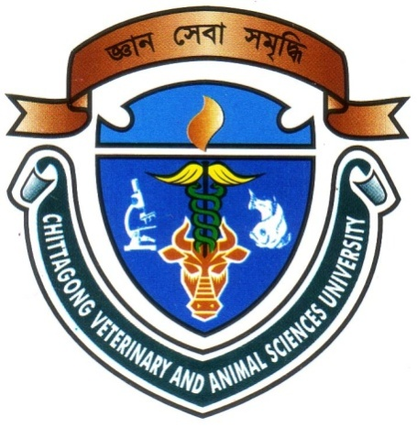

A Clinical report
Submitted as per approved style and contents

Signature of Author
Brishti Barua
Roll. No.: 08/10
Registration No.: 353
Internship ID.: A-05
Session: 2007-2008

Signature of Supervisor
Dr. A. K. M. Saifuddin
Professor & Head of the Department
Department of Physiology, Biochemistry and Pharmacology
Chittagong Veterinary and Animal Sciences University, Chittagong-4225.

March, 2014

STUDY ON PIG PRODUCTION, DIAGNOSIS AND TREATMENT PATTERN AT CHITTAGONG HILL TRACTS

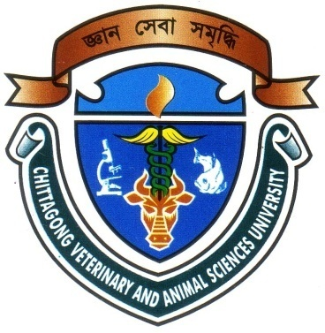
March, 2014

CHITTAGONG VETERINARY AND ANIMAL
SCIENCES UNIVERSITY

A Clinical Report Submitted by
Roll No.: 2008/10
Registration No.: 353
Internship ID.: A-05
Session: 2007-2008

A Clinical report presented in partial fulfillment of the requirements for the Degree of Doctor of Veterinary Medicine

