**CHAPTER 1**

**INTRODUCTION**

Bangladesh is an agro-based country. Livestock is one of the important wings as it provides protein, solve the unemployment problem through generating employments and earn foreign exchange. The share of the livestock sub-sector in GDP at constant price was 2.92%, which was 17.2% of agriculture and forestry sector in FY-2005-06. The share of this sector is projected at 2.9% of GDP which would be 17.7% of Agriculture and Forestry sector in FY-2006-07 (Economic Review’2007).

Pigs are fast growing and most prolific livestock breed. Due to these characteristics, they are considered a rich source of animal protein at a low cost. The rearing of pigs is done by poor people who neither have means nor know how to improve production. The pig breeds were used for bristles and meat. However, with the advent of nylon, pig bristles have lost their market value. Indigenous pigs are adopted for survival in most unfavorable condition of mal-nutrition. In general, pigs are fattened on garbage, kitchen waste and human excreta. Therefore, current of the govt. endeavor is to improve native pigs by crossbreeding them with superior exotic genes. Exotic breeds include Yorkshire, Landrace, Hampshire and Poland China. Under field conditions, crossbreds are gradually gaining popularity owing to their higher potential for growth. Under such perspective it is imperative that indigenous pig resources might be up-graded to meet the requirement of animal protein. (Taneja, 1995).

Profitable pig production depends largely on the design and provision of suitable housing. Pigs need warmth, a dry bed and protection from winter draughts and summer heat. They have certain minimum requirements for space, fresh air, hygienic conditions and access to feed and water, and accommodation should not predispose to illness or injury. (Moore, 2002). Sows may be kept indoors or outdoors in a variety of systems. Indoors, sows may be kept in individual crates, stalls or tethers or in pens of various sizes. The tether includes a collar or belt that has a chain that is bolted to the side pen wall or to the floor. Outdoors, sows are almost never kept in crates or stalls but rather in pens or pastures of various sizes that allow social grouping. Reasons for choice of a sow housing or penning system include the preferences of the pork producer, economics, legal requirements, geographic location and welfare of the sows Outdoor-housed sows have few problems with social stress and with skin lesions (such as shoulder lesions). The social stress is reduced because of the large amount of space given the sows and due to their ability to get away from boss sows. (Johnson et. al. 2001)

The study was carried out so as to perform the following objectives:

1. To investigate production system of pigs under farming condition and backyard farming system.
2. To find out the major constraints of swine production.
3. To find out the disease prevalence.
4. To identify the feasibility.

**CHAPTER 2**

**REVIEW OF LITERATURE**

**2.1 Housing of swine**

Curtis (1989) stated that within the European community (EU), countries vary widely in use of sow crates. While tethers (an uncommon system in the USA) are outlawed (and being phasing out) in the EU. However, at least three European countries (UK, Sweden, and Switzerland) have unilaterally banned the crate while other countries (most notably the Netherlands) are actively seeking an alternative to the sow crate.

**England and Spurr (**1969**)** reported that 28% and 16%, respectively, of the gilts confined individuallyand in groups exhibited some interference with normal expressionof estrus and mating behavior; 17% and 6%, respectively, failedto breed.

McGlone (2002) stated that intensive piggeries (or hog lots) are a type of factory farm specialized for the raising of domestic pigs up to slaughter weight. In this system of pig production, grower pigs are housed indoors in group-housing or straw-lined sheds, whilst pregnant sows are confined in sow stalls (gestation crates) and give birth in farrowing crates.

Morris *et al*. (1993) reported that there is an alternative to both intensive and outdoor piggeries of pastured pigs where pigs are truly raised on pasture getting most or all of their diet from grazing and foraging. When provided with appropriate field settings, brush and forage the pigs do not have problems with heat stress, sunburn, manure is naturally spread over larger areas returning the nutrients to the soil and morbidity levels are far lower providing for a higher survival rate as well as better profits for small farms.

Long (1990) stated that intensive piggeries represent a corporatization of the traditional rural lifestyle. The rise of intensive piggeries has largely replaced family farming. Between 1982 and 1987 some 21% of Iwoa hog farmers went out of business. By 1992, another 12% had gone out of business. In many pork-producing countries (e.g., US, Canada, Australia, Denmark) the use of intensive piggeries has led to market rationalization and concentration.

Safranski, (1999) reported that overstocking has a significant effect on the water logging and poaching of soils. The stocking density suitable for a particular site depends on the soil type, climate and other management factors. In ideal conditions, stocking densities of up to 25 sows per hectare (10sows/acre) can be used. However, on marginal soil types, in high rainfall areas or where management is less experienced, stocking densities should be considerably lower.

Takai *et al*. (2008) reported that older pigs can stand lower temperatures for short periods without apparent ill-health, but food conversion efficiency will suffer. The most favourable temperature for newborn piglets is between 27 and 29°C. Piglet losses can occur very quickly where the micro-climate remains much below 16°C. At temperatures below 2°C, fatal chilling will occur within minutes unless warmth is provided.

**2.2 Feeding system**

Anonymous (2008) reported that Swine, as nonruminants, utilize large quantities of concentrate feeds; it is estimated that 30% of the maize grain produced is fed to swine. Swine can utilize only limited quantities of roughage in their diet.

Baker, *et al*. (1968) reported that as gestation-diet intake increased, weight gain ofgilts increased quadratically during gestation but decreasedlinearly during lactation. Birth weight per pig decreased 43g for each additional pig in the litter.Farrowing percentage was less for gilts fed 0.9 kg/daythan for those fed more, and was less for purebreds than forcrossbreds.

Britt (1998) reported that treatment with vitamin A at weaning will benefit subsequent litter size, and under certain circumstances, may be beneficial in promoting earlier rebreeding and higher conception rate.

Chwen *et al*. (2001) Stated that Early administration of oral iron within the first few days of life will meet the iron needs of the suckling pig. It is advisable to give multiple doses of oral iron to piglets in order to prevent iron deficiency anemia.

Cole *et al*. (2000) reported that the numerous wastes produced by intensive swine production not only pose a significant challenge to effective environmental management but also are associated with decreased air quality in confinement houses, potentially transferable antimicrobial resistance patterns, and several infectious agents that can be pathogenic to humans

Durrance and Maxson (2008) reported the growing hogs (40 to 120 pounds) should be provided with a self-feeder containing a complete feed, or corn mixed with a supplement and gain 1.5 lbs per day. In either case, 16 percent protein with the vitamins and minerals is recommended

Johnson *et al*. (2001) stated that still now, outdoor sow herds are found in England, Scotland, Denmark and Sweden. Interesting tent systems are available for protecting outdoor sows in cold and wet climates.

Kenneth (2003) reported that spring is the best time for farrowing; the weather is mild and extra shelter is not needed. However, individual houses such as A-frame huts provide more protection to baby pigs.

Klindt (2003) stated that Birth-to-weaning average daily gain and weaning weight are decreasedwith an increased number of pigs nursing a sow. Providing creepfeed from 5 days of age increases birth-to-weaning average dailygain and weaning weight at larger litters.

Marija and Dejan (2004) stated that insufficient feeding during lactation and a decrease in body mass, low back fat thickness at weaning, short/insufficient lactation, inadequate time of mating and a high environment temperature all had negative influences on the time between weaning and first re-mating of primiparous sows.

Moore (2002) stated that a fundamental principle of the economics of pork production is to feed the most economical cereal grains and to correct the deficiencies by supplementation with good-quality protein sources, minerals, and vitamins. Farm grains are the most common and best source of energy. Soybean meal accounts for >90% of the supplemental protein fed to pigs in the USA.

Paul (2006) stated that organic pigs should be fed with an organic feed ration balanced to meet their nutritional requirements. Pig diets must not include feed medications, growth promoters, lactation promoters, synthetic appetite enhancers, animal by-products, preservation agents, coloring agents and genetically engineered or modified organisms (GMOs) or their products.

Pitcher (1999) reported that growth performance can be determined by gender when fed comparable diets over the same amount of time. In this case, boars are more in feed efficiency and faster in protein and weight gain whether sows are faster in fat gain.

Rommel *et al*. (2008) stated that sows have greater capacities to meet their nutritional needs due to their higher feed intake and larger body reserves compared to gilts. More problems are encountered with first- and second-litter sows due to their lower feed intakes, smaller body frames and less fat reserves. These lower reserves produce large gilt body condition losses after farrowing, resulting in lower subsequent litter size and longer wean-to-estrus intervals.

**Wagner (1999)** reported that there weresignificant changes in the ratio and composition of the tissues of barrowsand gilts during growth. Carcass lean and fat tissues significantly increased in lipid percentageand decreased in moisture percentage as live weight increased. Differences (P<0.05)existed between barrows and gilts for nearly all components.

Walker (2003) reported that performance of weanling, growing, and finishing pigs; gestating sows; and lactating sows and their nursing pigs is related to both the quality of the diet and the amount that is consumed on a daily basis which is affected by the energy density of the diet, environmental temperature, gender and feed quality (eg, absence of molds), as well as a host of other management factors such as feeder design, crowding, etc.

2.3 **Breeding system**

Bereskin, B., (1968) reported that the inbreeding of the sire ofthe litter had little or no effect on litter size at farrowing.The inbreeding of the dam significantly depressed litter size,total litter weight, and average weight per live pig at farrowing.

**Christenson (1986) reported that m**anagement practices to improve reproductive efficiency of thegilt will enable more efficient introduction of gilts into thebreeding herd. Puberty and continuation of regularestrous cycles, ovulation rate and embryonic/fetal survivalare the aspects of gilt reproductive efficiency to be considered.

Flowers (1993) reported that several aspects of the mating process itself can advance the onset of ovulation and enhance sperm transport and storage in the female reproductive tract. As a result, the use of these stimuli in conjunction with natural and artificial matings provides opportunities for enhancing fecundity.

Johnson (1981) stated that variation among experimentsin observed heterosis for specific crosses was large for reproductionand sow productivity traits. It seems likely that heterosis, expressed inabsolute values or in percentage units, is different for specificcrosses.

King, *et al*. (1998) reported that producers change their management systems to decrease lactation length, the percentage of gilts in the breeding-female inventory, and female culling rate, and increase percentage of multiple mating in order to improve breeding-herd productivity on swine farms.

Niemann (2006) stated that reproductive performance is critical to the profitability of a producer, along with the welfare of the animals involved. Because reproductive performance is negatively affected by stress. Gilts housed in pens had an 11% lower farrowing rate than gilts housed in crates. There was an increased 12% at weaning on sows that had been housed in gestation pens compared to those kept in group pens.

Robinson (1972) stared that the influence of a dam on her young,through the nutrients provided by the uterus and the mammarygland, was recognized as a special case of the joint actionof genotype and environment.

**Robison,** *et al*. **(**1973**)** reported that the genetic correlations between efficiency and carcass traitssuggest that selection for increased efficiency would be expectedto produce negative effects in *Longissimus* muscle area, freemoisture, color and pH. However, percent lean cuts, back fatand marbling should be improved.

Schukken, *et al*. (1994) reported that combining the effect of litter size and herd life led to the conclusionthat the profit per gilt (sow) was not significantly affected by her age atfirst conception. The optimal economic age at firstconception was considered to be approximately 200 to 220 d of age when thecost of housing and feed of the gilt from different categories of pigs reared in the households.

Smith (2005) reported that at weaning, pigs weighing less than 3.6 kg require a higher level of management and more complex diets, which increase production costs for pork producers and piglets weighing < 1 kg at birth, have very little chance of still being alive at weaning or of producing a standard pig.

Taylor and Roese (2006) stated that a boar has a tremendous influence on a farm’s productivity and profitability. By following basic husbandry principles the stockperson will be able to satisfy the boar’s requirements and demands of his working life.

**Young**, *et al*. **(**1976**)** reported that Duroc and Hampshire dams expressed significantresponse to crossbreeding regardless of the breed of sire usedfor crossbred litter production, but Yorkshires did not. However,Yorkshire dams had larger and heavier litters when mated toDuroc boars compared to Yorkshire boars.

**2.4 Weaning and lactating**

Dewey (2000) reported that with the advent of early weaning and off-site production, there are both healthier and sicker nursery pigs than there have ever been before.

Dritz *et al*. (2007) stated that reducing sow inventory to increase lactation length leads to little improvement in overall system profitability. The marginal addition of additional farrowing crates results in increased growth and productivity of every pig produced from the farm.

Duran (1997) stated that the rapid implementation of Segregated Early Weaning (SEW) in the US swine industry has posed some new challenges to the health of piglets and early weaning will increase labor and feed costs to care for these smaller and younger piglets in the nursery.

Fenton *et al*. (1985) reported that weaning age can affect post weaning body fat composition. Pigs weaned at 2 wk experience a slower post weaning growth rate with lower empty body weights than those either concurrently nursing the dam or weaned at 5 wk of age. Pigs weaned at 2 wk lost approximately 25% of their body fat at the first week post weaning while later-weaned pigs did not lose body fat post weaning.

Hubert and McGlone (2007) stated that the average piglet weaning age in the United States declined from 28.8 days to 19.3 days between 1990 and 2000.Early weaning allowed the production of healthier, more uniform pigs and improved lifetime productivity of the sows by allowing a herd to market more pigs per year.

Neelsen (1999) reported that number of litters produced per sow per year and through-put in farrowing facilities are maximized by early weaning and prompt rebreeding of the weaned sows. Today, it is possible to raise pigs successfully and economically after weaning as early as 1 week of age; however, weaning too early results in potential problems in managing the weaned sows.

Todd (2006) stated that Farms with the same genetics, nutrition, facilities, health status and standard operating procedures can have very different responses to short lactations. Shorter lactation lengths negatively impact the numbers of live born pigs; it can improve pre-weaning mortality and litters per female per year.

Xue, *et al*. (1993) reported longer lactation lengths were associated with higher subsequent litter sizes (both total-born and born-alive), shorter weaning-to-service intervals, longer farrowing to-service intervals, and longer farrowing-to-farrowing intervals (p< 0.0001). The total number of pigs born per sow per year and the number of live born pigs per sow per year were not significantly associated with lactation length (p> 0.2)

**2.5 Vaccination**

Floyd (1996) stated that disease prevention is the first line of defence in an organic animal health strategy. Vaccinations are only allowed when the targeted diseases are communicable and 10 to 21 days required after vaccination for the pig to mount a protective immune response and the animal should be vaccinated before clinical diseases occurs.

**2.6 Deworming**

Keynes (2007) stated that worm burden can result in a loss of up to 10% in daily gain and 13% in feed conversion in growing/finishing pigs, increasing the cost of production by 11p/kg DW through increased food usage and reduced sale weight. The financial impact of a deterioration of both feed conversion ratio (FCR) and daily live weight gain (DLWG) by 5% on slaughter pig production to 73 kg deadweight is a rise in the cost of production (CoP) by up to 4.6 p/kg deadweight.

**CHAPTER 3**

**MATERIALS AND METHODS**

**3.1 Selection of study area**

Usually swines had been rearing by the tribes living mostly in Chittagong Hill tracts. Pork (swine meat) was exclusively used to entertain on various occasion in that place. So, I had chosen Rangamati and Khagrachari districts as my study area.

**3.2 Duration of work**

The study was carried out for a period of 60 days from 5th May’ 2013 to 6th July’ 2013.

**3.3 Sources of information**

As the study period was very short, the study was conducted in different villages of Rangamati and Khagrachari district indiscriminately. For collecting necessary information, pig owners were interviewed following a questionnaire. They tried to help me at every step of data collection on swine production by sharing their ideas and experience. All the information was collected with the same questionnaire from different households.

**3.4 Methods of data collection**

As the data were raw data, it required more hard works and information was extracted from various households indiscriminately as follows:-

**3.4.1 Preparation of questionnaire**

Firstly, questionnaire was prepared in accordance with the objectives of the study containing some basic questions with a view to extract information regarding swine production system. In the questionnaire, emphasis was given on socio-economic views of pig owner, housing, feeding, breeding, marketing, disease prevalence, and major constraints of pig production along with other supportive information.

**3.4.2 Interviewing the pig owner**

For collection of data, various households in different villages were visited. Of which, the pig owners were identified and approached for interviewing and necessary data were collected.

**3.5 De-worming**

**Table 3.5.1:** Program for de-worming the growing/finishing pigs

|  |  |  |  |  |  |  |  |  |  |  |  |  |  |  |  |  |  |  |  |  |  |  |  |  |  |
| --- | --- | --- | --- | --- | --- | --- | --- | --- | --- | --- | --- | --- | --- | --- | --- | --- | --- | --- | --- | --- | --- | --- | --- | --- | --- |
| **Age (wks)** | **1** | **2** | **3** | **4** | **5** | **6** | **7** | **8** | **9** | **10** | **11** | **12** | **13** | **14** | **15** | **16** | **17** | **18** | **19** | **20** | **21** | **22** | **23** | **24** | **25** |
| Lactation  Maternal  Immunity | | | | | Nursery  Accommodation  First potential  Infection. | | | | |  | Grower  Phase | | | | |  | Finisher  Phase | | | |  | | W  I  T  H  D  R  A  W  A  L | S  L  A  U  G  H  T  E  R | |
| 3rd treatment in feed prevents eggs shedding  First treatment in feed prevents eggs shedding  2nd treatment in feed prevents eggs shedding | | | | |

Q

This is the plan to de-worm all Growers and Finishers at 5 weeks interval. They use government supplied albendazol for de-worming purpose.

**3.6 Analytical technique**

After collection of data, raw data were summarized, tabulated, and then analyzed by using simple statistical tools like mean, ratio, percentage etc. Finally they were represented in various graphs.

**CHAPTER 4**

**RESULTS AND DISCUSSION**

The study was conducted on both semi-intensive and backyard farming system. The overall production system of swine were presented in the headings like socio-economic status of the pig owners, pig structure in study area, housing system, feeding and watering, breeding, care of new born piglets, prevalence of diseases, marketing system, major constraints of pig production with possible recommendations.

**4.1 Socio-economic status of the pig owners**

**4.1.1 Literacy level of the pig owners**

**Table 4.1.1.1:** Literacy percentage of the pig owners

|  |  |  |  |
| --- | --- | --- | --- |
| **Sl. no.** | **Literacy level** | **No. of households** | **Percentage**  **(%)** |
| 1 | Illiterate | 23 | 43.39 |
| 2 | Primary | 19 | 35.85 |
| 3 | Secondary | 7 | 13.21 |
| 4 | Higher secondary & above | 4 | 7.54 |
|  | Total | (N=53) | 100% |

**Graph 4.1.1. Literacy level of the pig owners**

From the above figure, it can be said that majority of the pig owners are illiterate and primary literate people also rear the pigs.

**4.1.2 Land holding size of the pig owners**

**Table 4.1.2.1:** Category of the pig owners

|  |  |  |  |
| --- | --- | --- | --- |
| **Sl. no.** | **Category of the pig owners** | **No. of households (N=53)** | **Percentage**  **(%)** |
| 1 | Landless (0-0.49 acres) | 29 | 54.71 |
| 2 | small & marginal scale (0.50-1.0 acres) | 17 | 32.07 |
| 3 | medium scale (1.0-1.5 acres) | 5 | 9.43 |
| 4 | large scale (›1.50 acres) | 2 | 3.77 |
|  | Total | 53 | 100% |

**Graph 4.1.2.1:** Land holding size of the pig owners

From above figure, it can be stated that mostly landless people rear pigs to support their livelihood.

**Table 4.1.3.1:** Involvement of farmers in backyard pig rearing according to age

|  |  |  |
| --- | --- | --- |
| **Sl. no.** | **Age groups(years)** | **Percentage (%)** |
| 1 | 10-20 | 12.33 |
| 2 | 21-30 | 19.12 |
| 3 | 31 onwards | 68.71 |

**4.2 Structure of the pig distribution in the study area**

**Table 4.2.1:** Present population of the Rangamati pig farm

|  |  |  |
| --- | --- | --- |
| **Description** | **No. of pigs** | **Percentage (%)** |
| Boar | 3 | 1.72 |
| Sow | 70 | 40 |
| Grower | 16 | 9.14 |
| Gilts | 7 | 4 |
| Piglets | 79 | 45.14 |
| Total | N=175 | 100% |

**Graph 4.2.1. Present population of pigs in Rangamati pig farm**

**Table 4.2.2 Different categories of pigs reared in the households**

|  |  |  |  |
| --- | --- | --- | --- |
| **Sl. no.** | **Categories of pigs** | **No. of households** | **Percentage (%)** |
| 1 | Boar (breeding) | 1 | 1.88 |
| 2 | Boar (castrated) | 7 | 13.20 |
| 3 | Grower pig | 26 | 49.05 |
| 4 | Sow | 19 | 35.85 |
|  | Total | N=53 | 100% |



**Graph 4.2.2 Different categories of pigs reared in the households**

From the above figure, it is seen that the farmers mostly (around 49%) reared the grower pigs as they bought the weaned piglets from the market or from their neighbours and started a family level farming. The next highest (35.85%) was sow rearing. It was done due to sell weaned piglet in the market.

**Table 4.2.3** Breeds of pig reared in backyard farming system

|  |  |  |  |
| --- | --- | --- | --- |
| **Sl. no.** | **Breeds of pig** | **No. of cases** | **Percentage**  **(%)** |
| 1 | Deshi breeds | 13 | 24.53 |
| 2 | Deshi **×** Hampshire | 33 | 62.26 |
| 3 | Hampshire | 7 | 13.21 |
|  | Total | (N=53) | 100% |

**Graph 4.2.3 Breeds of pigs reared in backyard farming**

**4.3 Housing system of pigs under backyard farming**

In Rangamati District pig farm, the pigs were reared in semi- intensive house.

**Table 4.3.1 Rearing system of pigs in backyard farming**

|  |  |  |  |
| --- | --- | --- | --- |
| **Sl. no.** | **Type of house** | **No. of cases (N=53)** | **Percentage (%)** |
| 1 | Fencing system | 11 | 20.75 = 21 |
| 2 | Free ranging system | 23 | 43.40 |
| 3 | Girth tethering system | 6 | 11.32 |
| 4 | Tin shed housing | 13 | 24.53 =25 |
|  | Total | 53 | 100% |

**Graph 4.3.1 Rearing system in backyard farming**

From the above figure, it is seen that free ranging rearing system was most common (43.40%) because it required less feed cost where pigs get chance to scavenge freely.

**4.3.1 Orientation of buildings**

The buildings were located in moderately high land so the rain water easily drained out from the farm premises. The direction of the farm sheds was east-west.

**4.3.2 Measurement of the sheds**

There were two sheds in the farm. The measurement of 1st shed: lenght-250 ft, width-25 ft, height-10 ft. and 2nd shed: lenght- 36 ft, width- 25 ft, height-10 ft. But in backyard farm, no ideal measurement was followed.

**4.3.3 Space for the pig house**

**Table 4.3.3.1 Space requirement for swine**

|  |  |
| --- | --- |
| **Description** | **Space (m2 /pig)** |
| Growing pigs up to 10kg  11-20 kg  21-40 kg  41-60 kg  61-80 kg  81-100 kg | 0.11 0.18 0.32 0.44 0.56 0.65 |
| sows (in crates) and litters | 3.2 |
| Adult pigs in stalls | 0.6m x 2m |
| Adult pigs in groups | 1.4 |
| Boars in pens used for mating | 6.25 |

**Table 4.3.3.2 Space requirement for trough**

|  |  |  |
| --- | --- | --- |
| **Sl. no.** | **Description** | **Space of troughs (m /pig)** |
| 1 | Pig at 8 weeks | 0.15 m |
| 2 | Grower pigs | 0.25 m |
| 3 | Finishers | 0.30 m |
| 4 | Breeding stock | 0.45 m |

**4.3.4 Shape of roof and roof exhausts**

The roof of the sheds of Rangamati farmwas tin shed. But in backyard farming, it was chawn and tin shed roof.

**4.3.5 Housing construction**

The foundation of the building made up of concrete, concrete blocks and bricks.

**4.3.6 Cleaning and disinfection procedures**

It was done daily in the morning before feeding with the help of long hose pipe. At first, they removed swine dung with spade and then used plain water to clean the floor. Lastly, they used spray or disinfectants like Bioclean®, Dettol®, PPM, And Bleaching powder etc. Water tanks and pipes were carefully cleaned with an alkaline detergent (DSC 1000®) and double rinsed with clean water. Usually it was done twice a week.

**4.3.7 Insect control**

Organophosphorus-type insecticide (Ectodip Forte®) which was sprayed over the premises, sow crates, cages and lower part of the wall up to 1 meter high.

**4.4 Temperature management**

**4.4.1 Keeping warm**

Creep boxes or covers were used to retain warmth and reduced draughts. For very young pigs, dry straw or sawdust provided excellent insulation against cold conditions.

**4.4.2 Keeping dry**

There was easy access of fresh air in the sheds and the floor remained dry sufficiently, as the sheds were open sided.

**4.4.3 Keeping cool**

Heat stress in dry climates was reduced with the use of drip or spray cooling. The resulting evaporation of water from the pig's skin could effectively remove excessive body heat. They also allowed the pigs to wallow in nearby muddy area during hot summer.

**4.4.4 Ventilation and insulation**

The piggery was sited to take full advantage of prevailing winds for coolness in summer as both sides are open. Conversely, ventilation openings could be protected from prevailing winds in winter by using thick cloths.

**4.5 Feeding and watering system**

**4.5.1 Feeding system**

They supplied a formulated ration two times a day at 10.00 AM and 4.00 PM but in family level farming, they did not follow any ration and supplied rice polish, boiled broken rice, and some unconventional feeds like cauliflowers, arum, grass etc.

**Table 4.5.1.1 Ration for pig in Rangamati pig farm**

|  |  |  |
| --- | --- | --- |
| **Sl. no.** | **Ingredients** | **Relative proportion (%)** |
| 1. | Rice polish | 52 |
| 2. | Maize (broken) | 32 |
| 3. | Til oil cake | 5 |
| 4. | Soybean meal | 4 |
| 5. | Protein concentrate | 4 |
| 6. | Lime stone | 0.8 |
| 7. | DCP | 0.8 |
| 8. | Common salt | 0.2 |
| 9. | Halquinol | 0.2 |
| 10. | Toxin binder | 1 |
| Total | | 100% |

**Table 4.5.1.2 Daily feed supplied for different categories of pig**

|  |  |  |
| --- | --- | --- |
| **Sl. no.** | **Different animal** | **Amount of feed (kg)** |
| 1 | Boar | 1.50 |
| 2 | Sow | 1.50 |
| 3 | Lactating sow | 4.50-5.0 |
| 4 | Gilts | 1.50 |
| 5 | Grower pig | 1.25 |

Occasionally vegetables like–cauliflowers, sweet guard, bottle guard, sweet potato, arum, Para grass etc. in adult @ 1 kg and growers @ 900-950 gm daily were supplied.

**4.5.2 Watering system**

In the farm, Deep well was the major source of water for pig.

**4.6 Breeding system**

**4.6.1 Signs of approaching heat**

Average age of sexual maturity in boar and sow were 8 months and 6 months respectively. Estrus cycle was normally 21 days (18-24 days). A sow was in oestrus 3–10 days after the litter had been weaned. The signs of heat included increased activity, restlessness and frequently sniffs, swelling and reddening of the vulva, mucous appears, clear vaginal discharge, attempted to mount other sows or be mounted.

**4.6.2 Boar-sow mating ratio**

There were 3 boars used for breeding purpose in the farm.Ratio was one boar per 20 sows and it could be between 15 and 18 sows per boar maintained.

**4.6.3 Breeding habit**

When the gilts or sows came in heat, they were allowed to move around i.e. their pen doors were being opened and parallelly the boar being used for breeding were also opened and placing the gilt or sow in close proximity (i.e. within sight, sound and smell of the boar) would induce and aid in the detection of oestrus and natural mating occured. Usually one service was enough for conception .

**4.6.4 Signs of approaching farrowing**

Signs included restless, lie down and get up, increased pulse and respiration rates, nest-making activity, flank drops, vulva swells, secretion from teats, slight discharge from the vulva.

**4.6.5 Production performance**

**Table 4.6.5.1: Productive performance of sows under backyard farming**

|  |  |  |  |  |
| --- | --- | --- | --- | --- |
| **Sl. no. of sow** | **Av. Litter size** | **Av. Birth wt. of litter (kg)** | **Av. Weaning period of litter (days)** | **Post-weaning wt. of litter (kg.)** |
| Sow-1 | 7.33 | 1.30 | 48 | 6.60 |
| Sow-2 | 8.42 | 1.10 | 50 | 7.40 |
| Sow-3 | 8.10 | 1.20 | 40 | 6.40 |
| Sow-4 | 6.50 | 1.40 | 50 | 7.50 |
| Sow-5 | 8.43 | 1.80 | 42 | 7.30 |
| Sow-6 | 7.81 | 1.30 | 40 | 7.20 |
| Sow-7 | 7.70 | 1.40 | 42 | 7.60 |
| Sow-8 | 9.10 | 1.30 | 55 | 7.70 |
| Sow-9 | 7.60 | 1.20 | 44 | 6.30 |
| Sow-10 | 9.20 | 1.10 | 50 | 7.60 |
| Sow-11 | 7.30 | 1.10 | 48 | 6.30 |
| Sow-12 | 9.20 | 1.40 | 52 | 8.20 |
| Sow-13 | 7.76 | 1.20 | 38 | 6.60 |
| Sow-14 | 6.80 | 1.60 | 40 | 6.80 |
| Sow-15 | 8.30 | 1.50 | 40 | 6.70 |
| Sow-16 | 6.87 | 1.50 | 45 | 7.80 |
| Sow-17 | 8.20 | 1.40 | 35 | 7.10 |
| Sow-18 | 8.32 | 1.20 | 40 | 6.60 |
| Sow-19 | 7.20 | 1.40 | 44 | 7.30 |
| Average | 7.57 | 1.33 | 44.36 | 7.10 |

**Graph 4.6.5.1 Average litter size of sows in backyard farming**

**Table 4.6.5.2 Productive performance of sows in Rangamati pig farm**

|  |  |  |  |  |  |
| --- | --- | --- | --- | --- | --- |
| **Parity group** | **No. of sows** | **Av. Litter size** | **Av. Birth wt. of litter (kg)** | **Av. Weaning period of litter (days)** | **Post-weaning wt.**  **of litter (kg.)** |
| 1-2 | 6 | 8.30 | 1.80 | 38 | 9.70 |
| 3-4 | 11 | 9.30 | 1.70 | 42 | 9.40 |
| 5-6 | 21 | 9.70 | 1.60 | 45 | 8.60 |
| 7-8 | 26 | 10.20 | 1.60 | 50 | 8.20 |
| 9-10 | 4 | 9.80 | 1.70 | 35 | 8.70 |
| ›10 | 2 | 9.50 | 1.80 | 40 | 8.60 |
| Average | | 9.46 | 1.7 | 41.66 | 8.86 |

**Graph 4.6.5.2 Average litter size of sows of Rangamati pig farm**

From above figure, it was concluded that the overall productive performances of pigs under indoor system was better than that of pigs rearing under backyard farming.

**4.7 Care of new born piglets**

As the piglets born, cleared any mucous from the mouth and nostrils, dipped the navel cord in ppm solution. The farrowing room was usually kept warm with gunny bags, cloths, dry straw etc. Assisted small and weak piglets to suckle with the hand.

**4.8 Prevalence of common diseases and health problems**

**Table 4.8.1 Diseases prevalence in Rangamati pig farm**

|  |  |  |  |
| --- | --- | --- | --- |
| **Sl. no.** | **Name of diseases** | **No. of cases** | **Relative proportion (%)** |
| 1 | H.S | 7 | 13.73 |
| 2 | Pneumonia | 9 | 17.64 |
| 3 | Coccidiosis | 11 | 21.57 |
| 4 | NS diarrhea | 19 | 37.25 |
| 5 | Others (FMD, Salmonellosis, Ectoparasitic infesation) | 5 | 9.8 |
|  | Total | (N=51) | 100% |

**Graph 4.8.1 Prevalence of disease**

**4.9 Vaccination system**

They practiced vaccine against the diseases of HS, anthrax, FMD. HS require being booster after 15 days of 1st dose. The interval of two vaccinations is usually 15-21 days.

**4.10 Bio-security management**

* Limited entrance and entrance of unauthorized visitors into the farm was strictly prohibited.
* Area adjacent to the farm sheds were disinfected two times ( once in the morning and other in the evening ) using several disinfectant solution.
* Animal regularly vaccinated and dewormed.
* Water tank, water pipe, troughs were regularly washed and disinfected.
* Dead animals were disposed through buried in the earth.
* There was a wall encircling the farm area.

**4.11 Treatment of disease**

Diseased animals were isolated into isolation shed and courses of treatment were given.

**Table 4.11.1** Treatment of the diseases that were usually found in Rangamati pig farm

|  |  |  |  |  |  |
| --- | --- | --- | --- | --- | --- |
| Name of the Disease | Generic name of the drug | Trade name of the drug | Composition | Dose | Duration of treatment |
| H.S | Ciprofloxacin | Inj. Cipro-A vet | 10% | 1ml/10kg | 7 days |
| Pheneramine meleate | Inj. Antihista vet | 22.75 mg/ml | 5ml |
| Coccidiosis | Sulphadiazine  Sulphadimidine  Sulphapyridine | Trisulpha bolus | Sulphadiazine: 1.66gm  Sulphadimidine: 1.66gm  Sulphapyridine: 1.66gm | 1 bolus for 35kg b. wt in 1st day followed by ½ of first dose | 5 days |
|  | Administration of Normal saline (NS 0.9%). | | | | |
| Pneumonia | Ciprofloxacin | Inj. Cipro-A vet | 10% | 1ml/10kg | 5 days |
| Pheneramine meleate | Inj. Hista vet | 22.75 mg/ml | 5ml |
| NS (non specific)  diarrhea | Sulphadiazine  and Trimethoprim | Renatrim bolus | Sulphadiazine: 1000mg and Trimethoprim: 200mg | 1 bolus for 35kg b. wt in 1st day followed by ½ of first dose | 3 days |
| Administration of Normal saline (NS 0.9%). | | | | |
| FMD | Sulphadimidine | Inj. Sulfasol vet | 333mg/ml | 30ml/50kg | 7 days |
| Pheneramine meleate | Inj. Antihista vet | 22.75 mg/ml | 5ml |
|  | Wash the infected area using Apthocare (100gm powder). | | | | |
| Salmonellosis | Sulphadiazine  and Trimethoprim | Renatrim bolus | Sulphadiazine: 1000mg and Trimethoprim: 200mg | 1 bolus for 35kg b. wt in 1st day followed by ½ of first dose | 5 days |
| Administration of Normal saline (NS 0.9%). | | | | |
| Ectoparasitic infesation | Ivermectin | Inj. Ivertin | 1% solution | 1ml/50kg | 2 times at 7 days interval |
| Pheneramine meleate | Inj. Hista vet | 22.75 mg/ml | 5ml |

**4.12 Marketing system**

As the main objective of the Rangamati pig farm was to supply piglets to the poor people, they supplied piglets @ 100 Tk. per kg piglet on 50% discount which was compensated by the Govt. subsidiaries.

**Table 4.12.1 Target products for marketing under backyard farming**

|  |  |  |  |
| --- | --- | --- | --- |
| **Sl. no.** | **Target products** | **No. of cases** | **Percentage (%)** |
| 1 | Piglets (weaned) | 39 | 73.58 |
| 2 | Boar (castrated) | 11 | 20.75 |
| 3 | Boar (breeding) | 3 | 5.67 |
| 4 | sow | -- | -- |
|  | Total | (N=53) | 100% |

From above figure, it is clearly observed that the purpose of backyard pig farming is to sell piglets because the litter size per pig is high and it weaned after 1.5-2.0 month and quick return from small input is possible. It is not possible for the farmers to rear sows together with piglets due to unavailability of feeds and higher feed cost.

**Discussion**

Spurr (1969) reported that 28% pig reared in gilts but in this study found that 11% which is lower than Spurr. Morins *et al.,*(1993) observed intensive and outdoor piggeries of pastured pig where this study confined with intensive housing.

Anonymous (2008) found that 30% maize given as a source of feed for pig which is similar to my study where 32% given as feed but here rice polish (52%) was the major source of feed ingredients. Smith (2005) stated that more complex diet preferred and higher level of management but this study does not suggest any complex diet.

Moore (2002) stated that soyabean meal (>90%) used as a supplement protein feed to pig but in our country protein concentrate and soyabean meal given only 8% which is lower than energy source.

Taylor and Roese (2006) stated a boar has a tremendous influence on a farms productivity and profitability which followed by this farm where three boar used for breeding purpose and the ratio was 1:20 and 15 to 18 sows per boar maintained.

Young *et al.,* (1976) said Hampshire dams expressed significant response to cross breeding which was agreed by this studied farm on which pure Hampshire used as a dam and also their productive performance was very profitable and used as a crossed breed with local (Deshi × Hampshire).

Hubert and Maglone (2007) analyzed average piglet weaning age in USA declined from 28.8 days to 19.3 days between a period of 1992-2000 where in our country the average weaning period is 42 days which is much more higher than USA. It is due to high cost of pig rearing in our country however weaning too early results in potential in managing a weaned sow.

Bangladesh is a muslim country, pork is Haram for muslims. So, that they does not prefer pig farming which is responsible for decreasing the public demand. Generally tribal people and Buddhist community prefer pig farming. In our country pig farming cannot get its popularity due to religious restriction.

Among some common disease the non specific diarrhea (37.25%) is common, which may due to lack of proper hygienic management.

**CHAPTER 5**

**Limitation**

**5.1 Major limitations of pig production**

Major constraints of pig production were as follows:

**5.1.1 Shortage of feed and proper nutrition**

Pigs are omnivorous and voracious animal. So they require more amount of feed daily. In pig rearing, it is actually quite difficult to meet up their feed demand. So pigs suffer from malnutrition.

**5.1.2 High feed cost of livestock**

It is very cost effective to supply market feed to the animal if the farm owner lacks feedstuff cultivated in own field.

**5.1.3 Low quality feed**

The major feedstuff of pigs that available is of low quality. Low quality feeds that supplied to pigs influence the productive and reproductive performance of pigs.

**5.1.4 Low grade pigs**

The maximum pig population of our country is indigenous type which is inferior to the exotic breeds. So it is natural that indigenous pig’s productive performance is lower.

**5.1.5 Mortality during delivery**

It is one of the major constraints of pig production. High percentage of mortality of piglets is due to mother crushing and aggregating during delivery. Sometimes the young piglets fail to suckle their mother and gradually become weak and subsequently do not survive.

**5.1.6 Unavailability of wallowing ponds**

In the Rangamati pig farm, there is no wallowing pond for pigs. Pigs are very much susceptible to heat stress. Wallowing ponds is essential for pig to recover the heat stress particularly in summer season.

**5.1.7 Lack of proper vaccination**

Proper vaccination is also a barrier for the establishment of pig farm in rural areas. The farm owners lack the knowledge of vaccination in the pig. So pigs in family level farming, often face the occurrence of diseases like FMD, HS, anthrax, erysipelas etc.

**5.1.8 Lack of well established diagnosis laboratory**

There is no opportunity for diagnosis of diseases in rural areas as because of lack of well established laboratory.

**5.1.9 Lack of post mortem facilities**

There is lack of proper post mortem facilities of dead swine for the diagnosis of diseases. As a result, they do not know the causes of diseases and do not take the preventive measure for diseases.

**5.1.10 Lack of proper bio-security knowledge**

There is lack of proper bio-security particularly in family level farming. So pigs are always exposed to other livestock and migratory birds and affected by diseases.

**5.1.11 High cost of livestock drugs**

The doses of livestock drugs are high in comparison to human. So treatment of animal is cost effective. This is the reason why the farm owners often refuse to treat their animal.

**5.1.12 Lack of knowledge about pig rearing**

Maximum farm owner of pig production are illiterate and lack scientific knowledge about pig rearing. So mortality of pigs occurs from many diseases and from unskilled husbandry.

**5.1.13 Public nuisance and annoyance**

Pigs required muddy and marshy area to be reared which is, in most cases, a major cause of public nuisance and many man may not allow the pig rearing to their neighbors.

**5.1.14 Lack of established pork marketing system**

There is no established pork marketing system due to religious restriction as a result many farmers discourages to rear pigs.

**CHAPTER 6**

**RECOMMENDATIONS**

**Recommendations to overcome existing problems**

* Government initiatives should be provided in the poor people to start swine farming.
* Establishment of particular pork marketing system.
* Farmers should be trained on the pig rearing system.
* Feeding the pig with unconventional feedstuff may reduce the feed cost for the farmer.
* Maintain the vaccination schedule which reduce the disease prevalence of pigs.
* Maintain the cleaning and disinfectant procedures properly to eliminate the microorganism in the farm premises.
* Grow pasture in some selected area to support swine feeding.

**CHAPTER 7**

**CONCLUSION**

The results emerged from the study clearly concluded that “low investment and quick return” this principle could be applicable for swine business. The overall productive performance of pigs assured the feasibility of pig rearing in Bangladesh. Majority proportion of piggery farmers in the study area was poor, landless, illiterate having few technical knowledge about pig management and production system. They should be provided with initiatives for starting swine farms both from Government and NGOs and technical training by the experts on pig management system for solutions of major constraints faced during swine rearing like mortality of piglets, disease prevalence, mal-nutritional symptoms etc. and conscious about the occurrence of diseases (bio-security, vaccination program, regular deworming etc.). Thus it is possible to encourage the farmers for pig rearing and expand the pig farming throughout the country and to contribute in GDP in National Economy of Bangladesh from the export of swine and its products.

**CHAPTER 8**

**REFERENCES**

**Baker, D. H. Becker, D.H. Norton, H.W. Sasse, C. E. Jensen, A. H. and Harmon, B.G.** 1968. Reproductive performance and progeny development in swine as influenced by feed intake during pregnancy, Journal of Nutrition, 84(9):2316 –2337

Bereskin, B. Shelby, C.E. Lasley, J.F. and Blunn, C.T. 1968 .Inbreeding and swine productivity traits, Jr. Animal science, 27: 339-350

Britt, J. 1998. Maximizing productivity in early weaned sows, Jr. Swine News, 21(2): 674-685

**Christenson, R. K.1986.** Swine management to increase gilt reproductive efficiency, Jr, Animal science, 63:1280-1287

Chwen, L.T. Heng, L.K. and Lee, L,T. Kong, M.C. and Yoon, C.P. 2001. The effect of Iron supplementation in pre-weaning piglets, Malaysian Journal of Nutrition, 7 (1&2):41-49

Curtis, S.E. Hurst, R.J. Gonyou, H.W.Jensen, A.H. and Muehling, A.J.1989. The physical space requirement of the sow, Jr.Animal Science. 67: 1242-1248

Cole, D. Todd, L. and Wing, S. 2000. Concentrated swine feeding operations and public health, Jr. Environmental health perspectives,108(8):685-699

Dewey, C.D. 2000. Risk factors associated with post-weaning multi-systemic wasting syndrome of swine (PMWS), Manitoba Agriculture, Food and Rural initiatives, Manitoba, Canada. ARDI: 98-074.l

Dritz,S. S. Main, G.R., Tokach, M.D. Goodband, R.D. and Nelssen, J.L. 2007. Economic impact of strategies to increase pig weaning age, Kansas State University, Manitoba Swine Seminar, July.

Duran, D. O. 1997. Minimizing light weight pigs, Jr. Swine news, 22(2): 752-782

Durranc, L. and Maxson, C.A.2008. Swine production on a small scale, Jr. Animal science, 23(7): 523-557

**England**, **D. C. and Spurr, D. T.** 1969**. Litter size of swine confined during gestation, Jr. Animal science, 28:**220-223

Fenton, J.P. Roehrig, K.L. Mahan, D,C.and Corley, J.R. 1985. Effect of swine weaning age on body fat and lipogenic activity in liver and adipose tissue, Jr. Animal Science. 60(1):190-199

Flowers. W.L. and Esbenshade, K.L. 1993. Optimizing management of natural and artificial mating in swine, Jr. Animal science, 48:217-228

Floyd, J.G 1996. Vaccinations for the Swine Herd, Jr. Extension Veterinarian, 21(5):623- 654

Hubert, L.E. and McGlone,J.J. 2007. Weaner management, Jr.Animal Sciences, 84: 1004-1014

Huqa, Q.M.E. 1999. Development of poultry in Bangladesh and International poultry show seminar.

Johnson, R. K. 1981. Crossbreeding in swine, Jr. Animal science, 52: 906-923.

Johnson, A. K. Morrow, J. L. and McGlone, J.J. 2001. Behavior and performance of lactating sows and piglets reared indoors and outdoors. Jr. Animal Science, 79: 2571-2579

Kenneth, L 2003.Raising a litter, Jr. Swine production, 43:389-399. Web Site at <http://edis.ifas.ufl.edu>.

Keynes, M.2007. Action for productivity, Jr. Health-management interaction of pigs,21:2-8

King, V.L. Koketsu,Y. Reeves, D. Xue, J. and Gary D. D.1998. Management factors associated with swine breeding-herd productivity in USA, Preventive Veterinary Medicine, 35: 255-264

Klindt, J.2003. Influence of litter size and creep feeding on pre-weaning gain and influence of pre-weaning growth on growth to slaughter in barrows, Jr. Animal Science, 81: 2434-2439

Long, T.F. Johnson, R.K. and Keele, J.W. 1990. Intensive production system of swine, Jr. Animal science, 68:4069-4078

Marija, V. and Dejan, S. 2004. Factors influencing on post-weaning performance of primiparous and multiparous sows: a review, Agriculture Scientific Journal, 78: 5-12

McGlone, J.J. 2002. Intensive pig farming, Jr. Swine news, 67(8):678-698

Moore, M. J. 2002. Basic requirements for intensive pig housing, Jr. Animal science, 78(3):234-267

Morris, J.R. and Hurnik, J.K. 1993. Alternate housing system of swine, Jr. Animal science, 71:4069-4078

Morrow, M. 1998. Pseudorabies eradication, Jr. Swine News, 25: 03-12

Neelsen, J. 1999. Effects of early weaning of piglets, Jr. Swine News, 26(07):867-890

Niemann, C. 2006. Effects of feeding and housing systems for gestating sows and gilts, Jr. Swine production news, 57(3): 884-904

Pitcher, P. D.1999. Maximizing growth performance, Jr. Animal science, 12: 123-156

**Robison, O.W. and Berruecos, J. M.**1973**.** Prediction of efficiency and genetic correlations with carcass traits, Jr. Animal science, 37: 650-657

Robison, O.W. 1972. Maternal effect in swine, Jr. Animal science, 35:1303-1315

Rommel C. Steve, S. and Dritz, J. 2008. Modern sows have higher nutrient requirements, Jr. National hog farmers, 8:323-345

Safranski, T. 1999. Outdoor pig farming, Jr. Action on Animal health and wealth, 11:1&6

Schukken, Y.H. **Buurman, R.B. Willemse,A.H. Vernooy, j.C. and Broek, J.V.** 1994. Evaluation of optimal age at first conception in gilts from data collected in commercial swine herds, Jr. Animal science, 72(6): 1387-1392

Smith, J.K. 2005. Swine housing requirement, Jr. Animal Science, 74: 924-940

Smith, A.L. Stalder, K.J. Serenius, T.V. 2007. Effect of piglet birth weight on weights at weaning and 42 days post weaning, Jr. Swine Health Production; 15(4):213–218

Takai, Y. and Koketsu, Y. 2008. Effect of temperature on swine herd, Livestock science, Canada, 114(1):42-47

Taneja, V.K. and Sahai, R.1995. The proceedings of the first national coordinators meeting, conservation and use of Animal Genetic Resources in Asia and the pacific, Bali, Indonesia, July11-15, pp:62-63

Taylor,G. and Roese, G. 2006. Basic pig husbandry, 9:543-578

Todd, S. 2006. Effect of weaning age on sow herd performance, Jr. Swine News, 29(07): 734-756

**Wagner, J. R. Schinckel, A. P. Chen, W. Forrest, J. C. and Coe, B. L. 1999.** Analysis of body composition changes of swine during growth and development, Jr. Animal science, 21:1151-1189

Walker, R. 2003. Swine feeding, Jr. Swine news, 45:789-810

Xue, J.L. Dial, G.D. Marsh, W.E. Davies, P.R. Momont, H.W. 1993. Influence of lactation length on sow productivity, Livestock production science, 34(3-4): 253- 265

**Young, L.D. Johnson, R.K. and Omtvedt, I.T.** 1976**.** Reproductive performance of swine bred to produce purebred and two-breed cross litters, Jr. Animal Science, 42:1133-1149

**ANNEX**

For interviewing, the following questionnaire model was used:

**EXISTING PRODUCTION SYSTEM OF SWINE IN SOME SELECTED AREAS**

**1. General information of the farm:**

a) Name of the farm: .................................................................................................

b) Owner of the farm: ................ c) Educational status: ..........................................

d) Age: ………….. e) Amount of land owned: …………f) Address: .......................

g) Total no. of pigs: ............ Male: ........Female: ......Piglets: ......h) Breed of pigs:

i) Purpose of farming: ..............................................................................................

**2. Housing system:**

a) Type of house: Floor / Slatted floor / Others……b) Housing materials: ................

c) Ceiling type: Tin/Chawn /Mixed /others...d) Floor type: Soil / Brick / Cemented / others......

e) Direction: East-west / North-south / Others...................

f) Length: .........Width: ........Height: ......g) Light: ............Ventilation: ....................

h) Procedure of minimizing high/low temperature: ..........................................

**3. Feeding system:**

a) Individual feeding ( name of feeds): .......... b) Group feeding ( name of feeds):

|  |  |  |  |  |  |
| --- | --- | --- | --- | --- | --- |
| Sl. no. | Ingredients | Amount (kg/day) | Proportion (g/100g) | Time of feeding | |
| am | pm |
| 1. |  |  |  |  |  |
| 2. |  |  |  |  |  |
| 3. |  |  |  |  |  |

**4. Breeding system:**

a) Av. age of sexual maturity: Male: ........Female: ......b) Sings of heat:...........

c) Time of service following heat: ...........d) Type of service: ........................

No. of service….........e) Av. litter size: ........ Birth wt.........Weaning period: ..........

f) Growth rate: Pre-weaning: ...........Post-weaning:.........

**5. Prevalence of common diseases and health problems:**

|  |  |  |  |
| --- | --- | --- | --- |
| Name of diseases | Type | Total cases | Relative proportion (%) |
|  |  |  |  |
|  |  |  |  |
|  |  |  |  |

**6. Marketing system:**

a)Organized:….b)local:…..(i)As live (ii) As dressed (iii) Others……………………

c)Av. age of marketing: .........d) Market price: ........e) Is it profitable? (i) Yes (ii)No

**7. Major constraints of pig production:**

a)Related to housing:................. .b) Related to feeding: ...........................................

c) Related to breeding: ..............d)Related to disease prevalence: ....... e) others…….

**8. Recommendation to overcome existing problems:**

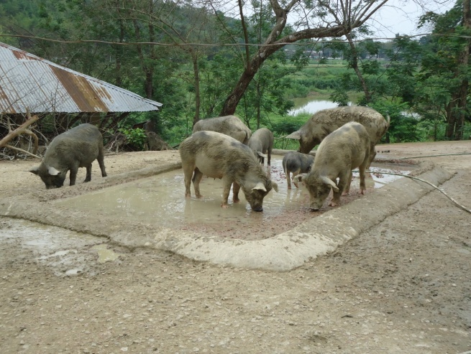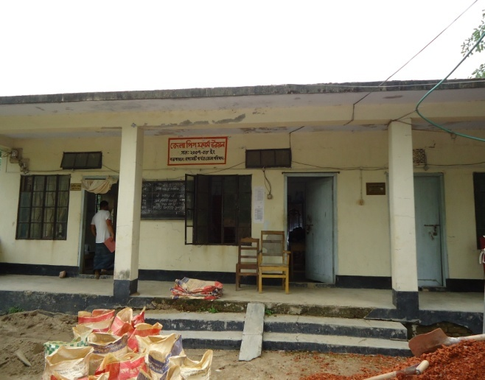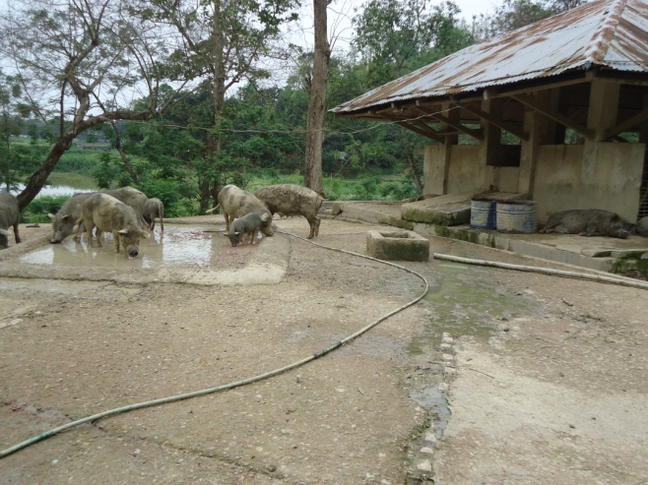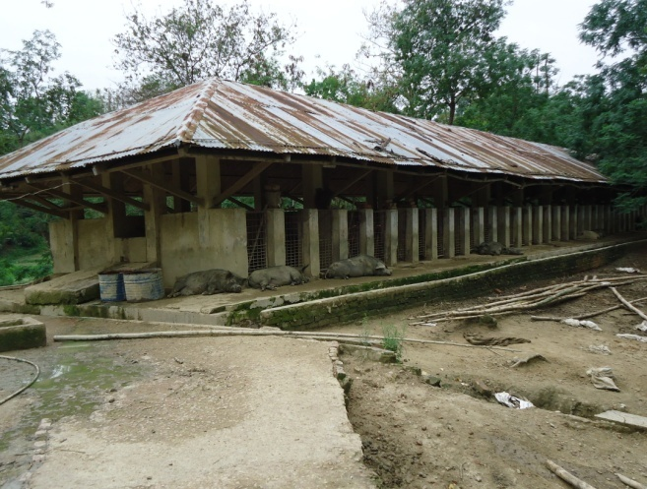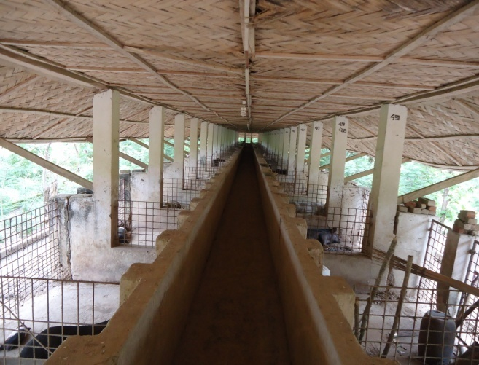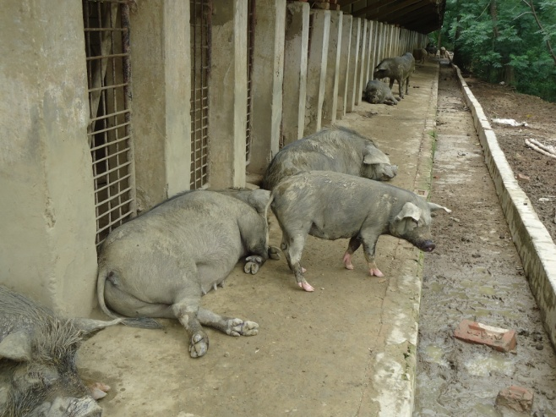**ANNEX**

**Overview of the Pig farm**

**Images**