ACKNOWLEDGEMENT

It goes without saying that all praises goes to Almighty “God”, the omnipotent, omnipresent and omniscient, Who has enabled the author to complete this manuscript successfully.
The author doesn’t have adequate words to express deepest sense of gratitude, respect and immense indebtness to her honorable teacher and internship supervisor, Professor Dr. Paritosh Kumar Biswas, Dean, Faculty of Food Science & Technology, Chittagong Veterinary and Animal Sciences University for his scholastic guidance, sympathetic supervision, valuable advice, continuous inspiration, radical investigation and constructive criticism in all phases of study.
The author would like to give respect and express immense indebtness and thanks to Dr. Md. Motaleb Khan, Thana Livestock Officer (TLO), Kotwali, Chittagong for providing regular guidance, facilities and inspiration for conducting my study during my UVH placement to collect my necessary informations and blood samples. The author would like to express her heartfelt gratitude and respect to the honorable Vice Chancellor Prof. Dr. A. S. Mahfuzul Bari and Prof. Dr. Md. Kabirul Islam Khan, Dean, Faculty of Vet. Medicine and Dr. Bibek Chandra Sutradhar, Director of External Affairs, Chittagong Veterinary and Animal Sciences University for continuing this internship program.
The author would like to give special thanks to the honorable teachers and staffs of the Dept. of Physiology, Biochemistry & Pharmacology, Chittagong Veterinary and Animal Sciences University, for conducting test of poultry blood samples in the Physiology Laboratory.
The author also expresses gratitude to her parents and friends for their inspiration and sacrifice from the beginning to the end of this work.
A work of this dimension is the product of many individual efforts. Supervisor’s help and cooperation have been received from many persons during the tenure of this place of report. Although it isn’t possible to mention everyone by name, the author is immensely grateful to them.

The Author
March, 2014

Prevalence of Infectious Bursal Disease Associated with Other Concomitant Infections in Broiler Poultry Submitted to Thana Livestock Hospital, Kotwali, for Examination
ABSTRACT
The study was carried out at Thana Livestock Hospital, Kotwali, Chittagong district during the period of 8 weeks, starting from 5th May to 4th July, 2013 to know the prevalence of Infectious Bursal Disase (IBD) associated with other concomitant infections in broiler in terms of age group, farm size, strains. For this purpose a total of 50 farms were included in this study where 25 were positive for IBD, which was carried out by maintaining a case study sheet containing clinical sings and post mortem findings of the birds that were brought in Hospital by farm owners. The diagnosis of disease was done on the basis of clinical sings and post mortem lesions shown by the affected birds. Ten blood samples were collected from the affected birds and TEC and DLC were done to know the blood parameters of the IBD infected birds. The prevalence of IBD was higher (4.2%) in medium sized farms than large sized farms (0.9%). The prevalence of IBD associated with other concomitant infections was higher in medium scale farms and less in small scale farms. In medium scale farms, the prevalence of IBD+Coccidiosis was 5.4%, IBD+CRD was 2.6% and IBD+Colibacillosis was 1.1%. On the other hand, in small scale farms the prevalence of IBD+Coccidiosis was 0.6%, IBD+Cocci+CNE was 1.1% and IBD+CRD+Cocci was 2%. The prevalence of the IBD was 1.1% (Lower), 2.5% (Higher) among the age groups of (14-21) days and (22-28) days, respectively. It shows that the prevalence of IBD associated with other concomitant infections was higher in chickens of 22-28 days of age and less in chickens of 14-21 days of age. The highest prevalence of IBD with coccidiosis was 1.7% in 22-28 days and low (1.3%) in 14-21 days and the prevalence of IBD+Cocci+CNE was high (2%) in 14 to 21 days and low (0.4%) in 22-28 days of chickens. The prevalence was higher (2%) in Lohman Meat and lower in (0.8%) Arbor Acres Plus and (1.3%) Cobb 500. The average TEC of infected bird was 68.9 million/mm³ and DLC showed that average neutrophils, lymphocytes, eosinophlis, monocytes and basophils were 10%, 78%, 2%, 5% and 0% respectively.
Key Words: IBD, Prevalence, Diagnosis, Farm size, Age group, Strains, TEC, DLC.
CHAPTER – I
INTRODUCTION
Bangladesh is an agro based developing country in the world. Livestock is one of the most important sectors of agriculture which plays a vital role to promote national economy and human health. The contribution of the livestock sub sector to GDP at constant prices 3.49% in 2012-13 (DLS, 2013). Though the share of this subsector in GDP is small it has immense contribution towards meeting the daily protein requirements. According to the estimate of DLS, the production of poultry (projected) rose to 29 core 32 lakh 35 thousand in which 24 core 66 lakh were chickens in the 2012-13. Livestock is not only help to uplift the financial status of the farmers but it has made a substantial contribution to human nutrition. The production statistics of meat and eggs in 2012-13 was 25.32 million ton and 51347 million in numbers respectively (DLS, 2013). Normal requirement of animal protein for a man is about 62.5 gm meat per day while people of our country get only 6.9 gm per day (Jabber, 1983). Poultry meat contributes app 38% of the total animal supplied in Bangladesh (FAO, 1999) where broiler meat plays a vital role which meets the deficit.

Poultry farming in our country now considered as a growing industry. Government of the Peoples Republic of Bangladesh has recently give priority in potential poultry sector. Scientific breeding, feeding, management and disease control are the key points of success in poultry improvement program. One of the major constraints in development of poultry industry is the outbreak of diseases that cause about 30% mortality of chickens (Ali, 1994). Spatial and temporal distribution of diseases that would be authentic in the results of the project does carry little relevance for the costal belt areas of Bangladesh. Rigorous climatic condition with more humid atmosphere and saline water may have got different influence on the occurrence of the diseases (Biswas, 2004). Among all the diseases Infectious Bursal Disease (IBD) is very common and one of the most important diseases of the poultry industry. This disease is now major problem in poultry farm causing 80% mortality in field outbreak (Chowdhury et al., 1996). It is an acute highly contagious viral disease of young chickens of 3-6 weeks characterized by marked depression, ruffled feather, diarrhea, atrophied bursa and by variable degree of immune suppression. At first the disease was discovered as a specific new disease by Crosgrove in 1962 and was termed as “Avian Nephrosis” due to extreme kidney damage in affected birds. IBD is also known as Gumboro disease since outbreaks were first observed on farms in the neighborhood of Gumboro, Delaware, USA. It causes high morbidity and mortality. In classical form of outbreak, the mortality rate may range from 1 to 50% in broilers, infection may result up to 50% morbidity, but mortality is seldom more than 3% in flocks aged 3-6 weeks. Infections by IBD may exacerbate infections with other etiologic agents and reduce the ability of chickens to response to vaccination. The disease causes severe economic losses and most of the economic devastation associated with IBD is due to its immunosuppressive effects that lead to poor vaccination response and secondary infections and poor performance. The economic impact of IBD is influenced by strains of virus, breeds, inter-current primary and secondary pathogens, environment and management factors. The economic importance of IBD is manifested in two ways. The first is due to the clinical disease and mortality in three weeks old chickens. The second and more important manifestation is severe immune-suppression. The sequelae of immune-suppression includes gangrenous dermatitis, inclusion body hepatitis - anemia syndrome, E. coli infections, CRD, CCRD, coccidiosis, CNE, ND and vaccination failures. IBD has no public health significance. The disease is prevalent in the concentrated poultry producing areas and may account for considerable losses in individual flocks. Affected flocks have reduced antibody response to vaccination and increased susceptibility to current secondary infections.

Diagnosis of IBD is based on flock history, clinical sings and post mortem lesions. Post mortem lesions include dehydration and changes in the bursa, skeletal muscle, liver and kidneys. Laboratory procedures may be used to substantiate the diagnosis. Vaccines are available but must be carefully used. The outbreak of IBD directly or indirectly related to the management status of the farm. A thorough knowledge about epidemiology, pathogenesis and pathology of a particular disease is a prerequisite for proper diagnosis of a malady as well as the prevention and control of the illness. Considering all the above mentioned points the present study was designed with the following aims and objectives:
- To measure the prevalence of IBD associated with other concomitant infections in broilers.
- To observe the risk factors related to the production of diseases in commercial broilers.
- To describe the clinical sings, post mortem lesions in IBD disease associated with other concomitant infection in affected birds.
- To know the prevention and control measures of the IBD.

CHAPTER – II
REVIEW OF LITERATURE
Infectious Bursal Disease (IBD) is an acute, highly contagious viral infection of young chickens. Lymphoid cells, specially B cells are the primary target cells and the lymphoid tissues of the cloacal bursa is the most severely affected.

History
IBD also known as Gumboro was first described by Cosgrove (1962) as a clinical entity, in 1957, in Southern Delaware, USA and termed as “Avian Nephrosis”. Its outbreak was first observed on farms in near of Gumboro, Delaware, USA. The etiological vital agent was isolated by Winterfield in 1962 (Lukert and Saif, 1997) who differentiated the disease from a previously established disease known as nephrotoxic infectious bronchitis, a viral infection of chickens. The term infectious bursal was proposed by Hitchner (1970).
There are two serotypes of Infectious Bursal Disease virus (IBDV) (Mc Ferran et al., 1980). Serotype 1 is pathogenic while serotype 2 is non pathogenic for chickens. Within serotype 1 many subtypes or pathotypes have evolved (Brown and Grieve, 1992). Clinical evidence suggests that the standard or classical serotype 1 IBDV was predominant throughout the world until early 1980s (Brown and Grieve, 1992). In 1984/85 variant strains of IBDV started to appear in Delmarava Peninsula, USA with increased mortality even in vaccinated flocks and these new American strains were antigenically different from the classical strain (Synder et al., 1988). These strain variation was due to a very rapid bursal atrophy with minimal inflammation. Vaccines prepared from classical strains did not give full protection against the variant IBDV strains (Synder, 1990). Despite the high contagious nature, the mortality from infection with classical and variant strains of IBDV was very low. Most of the mortalities were due to immunosuppression and subsequent secondary infections.
In 1987 a highly pathogenic strain (849 VB) of type 1 IBDV emerged in Holland and Belgium (Van den Berg et al., 1991). Mortality in exposed 3-15 weeks old layer replacement pullets attained 70% and 100% mortality in experimental infections. Gaudry (1993) reported outbreaks of vvIBDV (very virulent infectious bursal disease virus) in China and Russia in 1993, associated with 60% mortality in 10 days old Leghorn pullets. A virus responsible for outbreaks of vvIBDV in UK designated the DV86 strain was characterized by Chettle et al., 1989, who confirmed that spontaneous enhancement of virulence had occurred without any major alteration in antigenic structure. The acute forms of IBD were then described in Japan in early 1990s (Nunoya et al., 1992; Lin et al., 1993), and they have rapidly spread all over Asia and to other countries. In Bangladesh first outbreaks of IBDV occurred in the early nineties. Since then, they have been isolated in many countries including Central Europe (Savic et al., 1997), the Middle East, South America (Di Fabio et al., 1999) and Asia (Chen et al., 1998). On the other hand Australia, New Zealand, Canada and the USA are so far unaffected described in Finland (Nevalainen et al., 1999), where as the other northen European countries are still (Synder, 1990). Moreover, only a sporadic outbreak has been free (Czifra and Janson, 1999).

Distribution
IBD has worldwide distribution. Infection with serotype 1 IBDV are of worldwide distribution, occurring in all major poultry producing areas (Lukert and Saif, 1997). One exception to the ubiquitous nature of IBDV is New Zealand. It has been reported that there is no evidence of IBDV infections in that country. Because of vaccination program carried out by most producers, all chickens eventually become seropositive to IBDV (Jones, 1989; With, 1985).
In India the disease was first reported by Mohanty et al., (1971). (Ajinkya et al., 1980) reported heavy mortality due to New Castle disease in association with IBD in broilers in Maharastra. Precipitration of latebt infections like anemia, gangrenous dermatitis and Inclusion Body Hepatitis (IBH) has been recorded. The very virulent form of this disease with 40-70% mortality along with very virulent New Castle disease has been found to occur from West Bengal to Orissa, Hyderabad- Chittir- Nellore of Andhrapradesh and Tamilnadu. It has been spread to Maharastra, Karnaatak including Gujrat And Madgyapradesh (Giambrone et al., 1978).
The occurrence of IBD was studied for the first time in Bangladesh during the period of 1992-93. The work was carried in CDIL (Central Disease Investigation Laboratory), Dhaka and in the laboratory in the department of Microbiology and Hygiene, BAU (Bangladesh Agricultural University), Mymensingh (Chowdhury et al., 1996).
All the strains of the IBDV will grow in the chicken embryo but require many passages to embryos before they will grow in cell culture (Baxendale et al., 1981).

Epidemiology
IBD usually occurs in birds of 3-6 weeks of age. An early subclinical infection before rthree weeks of age (Lukert and Saif, 1997), even in newly hatched chicks (Fadley and Nazerian, 1983), may occur. The disease has also been reported to occur up to 20 weeks of age on chickens (Okoye and Uzoukwu, 1981). All breeds are affected but severe reactions with highest mortality rate (70-80%) in the Fayomi breed as compared to White Leghorn (40%) in a limited no of field outbreaks. 13-85% mortality due to IBDV was found in different breeds of chickens in field outbreaks. Mortality due to IBD on various farms ranged from 1-40% in broilers and from 2 to 40% in layers (Kurade et al., 2000) and from 1.5 to 30% in native and broilers respectively (Saif et al., 2000). However, Meroz (1966) found that there was no difference in mortality between heavy and light breeds. Natural infections of turkeys and ducks have been reported (Mc Ferran et al., 1980).
The morbidity following infection with classical strains of IBD may be higher than 80% while mortality may be as low as 5-12% (Mohanty et al., 1971) or may peak as 25% in broilers (Lukert and Saif, 1997). Ismail et al., (1990) observed that approximately 50% morbidity and low mortality with variant strains of IBD. However, infection with newly emerged very virulent strain of IBD may cause up to 100% morbidity and over 70% mortality (Brown et al., 1994). Concomitant infections with New Castle Disease, Infectious Laryngotracheitis, Infestious Bronchitis, Marek`s disease, E.coli, Salmonellosis, Coccidiosis, anemia, Gangrenous Dermatitis have been recorded (Mc Nulty et al., 1979).
In field investigations conducted in Mississippi, outbreaks of IBD which resulted in 5-6% mortality at a mean age of 25 days (Anderson et al., 1979). The initial outbreaks of IBD were characterized by high morbidity (80%) and correspondingly significant mortality, attaining 25% in broilers (Chettle et al., 1980). Broilers flocks often experience mortality rates of 20-30% although and average rate is more like 15% (Stuart et al., 1989).
The disease spreads rapidly by direct contact of the highly contagious nature (Benton et al., 1967). There is no report of egg transmission of IBDV. Infected birds have excreted the virus in their droppings for at least 14 days (Baxendale, 2002). Fish meal in feed contaminated with EBDV may act as a transmitter of the disease (Yongshan et al., 1994), while lesser mealworm as erll as mosquito may act as a reserviour of IBDV (Synder et al., 1986; Howie and Thorson, 1981; Mc Allister et al., 1995).

Structure of the virus
IBDV is a naked icosashedral, double stranded RNA virus with a diameter of 55-60 nm (Hirai and Shimakura, 1974; Nick et al., 1976; Dobos et al., 1979; Jackwood et al., 1982) belonging to the family of Birnaviridae (Kibenge et al., 1988). The protype of the family is infectious pancreatic necreosis of vius (IPNV) of fish. Other members of the family can affect the insects and mollusks. The molecular weight of the virus ranged from 2.2 to 2.5*106 daltons (Nick et al., 1976; Müller et al., 1979) with the buoyant density of 1.34 g/ml (Hirai and Shimakura, 1974; Nick et al., 1976; Dobos et al., 1979; Jackwood et al., 1982). The virion has a single capsid shell composed of 32 capsomers and a diameter of 60 to 70 nm. It has 2 genome segments A and B. The larger segment A (approximately 3.4 kilo base pairs) monocistronic and encodes a poly protein that is auto processed after several steps into mature VP2, VP3 which form viral capsid. VP4 encodes protease. VP5 is a nonstructural protein, considered have a function in virus release and the induction of apoptosis. (Müller and Becht, 1982; Azad et al., 1985; Hudson et al., 1986; Kibenge et al., 1997). Segment A can also encode VP5, a short 17KDa protein (Mundt et al., 1995). The smaller segment B (approximately 2.8 kilo base pairs) encodes VP1, the viral RNA polymerase of 90KDa and is a structural protein linked with the ends of both segments viral genome and with multiple enzyme activities (Müller and Nitschke, 1987). Virus replication takes place in cytoplasm. The virus is very much stable, can survive in premises up to 2 months. It resists P^{H} and to ether and chloroform (Benton et al., 1967). Certainly the hardy nature of this virus is one of the main reasons for its persistent survival in the poultry sheds even though cleaning and disinfection procedures are followed.

Strain Classification
IBDV has 2 serotypes: serotype 1 and serotype 2. Serotype 1 is pathogenic in chicken and serotype 2 is non pathogenic isolated from chicken, turkey by Mc Ferran in 1980.this two serotypes can be distinguished by cross protection and neutralization tests. Serotype 1 has three pathotypes: Classical Virulent, Variant, Very Virulent. All vaccine strains are derived from Classical Virulent Strain. The vaccines are classified as mild, intermediate or intermediate plus (Hot strain) on the basis of residual pathogenicity.

Pathogenesis
The severity of the disease is directly related to the number of susceptible cells present in the Bursa of Febricius. Therefore the highest age of susceptibility is between three to six weeks, when the Bursa of Febricius attains its maximum size. This age susceptibility is broader in the case of vvIBDV strains (Van den Berg et al., 1991; Nunoya et al., 1992). After oral infection/inhalation, the virus replicates in the lymphocytes and macrophage of gut-associated tissues. Then virus travels to the bursa via blood stream, where replication occurs. By 13th post inoculation, most follicles are positive for the virus and by 16th day post inoculation a second and pronounced viremia occurs with secondary replication in other organs leading to disease and death (Müller et al., 1979). The incubation period ranges from 2-3 days after exposure.

Clinical Signs
Rodriguez-Chavez et al., (2002) said that the clinical sings of the IBD were depression, reluctant to move, poor feed and water intake, Watery diarrhea, ruffled feathers, reduced growth and prostration and dehydration in severely affected birds. Mortality was observed with a rapid increase at 3 days post-infection and a sharp decrease at 5 days post-infection.
Dalgaard et al., (2002) observed that in the clinical disease, morbidity could be seen in nearly 100% and mortality could range from 0% to over 50% with some very virulent IBDV strains. Immuno-suppression is presumably transient in the clinical disease.
Butcher and Miles (2001) found IBD occurred in 2 forms: subclinical and clinical, depending on the age of birds. The subclinical form occurs at the age of 3 weeks of chickens. The affected birds don`t show any clinical signs but experience permanent and severe immuno-suppression and it occurs due to damage of Bursa of Febricius. The clinical form usually occurs in chickens of 3-6 weeks of age. The clinical signs include a sudden onset and the increased rate of mortality in the flock. The affected chickens show dehydration, trembling, ruffled feather, vent picking, increased temperature and depression. Affected chickens experience a transient immuno-suppression.
Anku (2003) observed that the severity of signs was depended upon age, breed and maternal derived antibody level of the chick as well as the virulency of the virus and reported that the disease had a high morbidity and mortality of 30-35%. It had serious economic consequences to farmers, both directly (through mortalities) and indirectly e.g. stunted growth, increased feed conversion ratio, high susceptibility to other infections and poor response to other vaccinations.
Wyeth (1980) said that the acute form was seen in chicks between 3 to 6 weeks of age with the following signs after an incubation period of 2-3 days; depression, white watery diarrhea, soiled vents, anorexia, ruffled feathers and reluctant to move, closed eyes and death. Morbidity ranged from 10% to 100% and mortality 0% to 20% occasionally reaching 50%.
Sharma et al., (1977) said that the onset of the disease in all farms was rapid. In general, the clinical signs consist of white watery diarrhea, ruffled feathers, soiling of vents with vent picking, severe prostration and incardination.
Cosgrove (1962) reported that one of the earliest signs of IBD in a flock was the tendency for some birds to pick at their own vent.

Post Mortem Findings
Butcher and Miles (2001) observed that initially the bursa of Febricius was swollen; appears edematous and hyperemic, and had a gelatinous, yellowish transudate covering the serosal surface.
Anku (2003) found that the carcasses of the birds dying from IBD were dehydrated; there were petechial hemorrhages in the legs and thigh muscles, and occasionally on the mucosa of the proventriculus and increased mucus in the intestine.
Rodriguez-Chavez et al., (2002) said that on the necropsy, bursal lesions were characterized b on the necropsy, bursal lesions were characterized by occasional hemorrhage, pronounced enlargement of the organ, frequent accumulation of a yellowish exudates, and pronounced longitudinal striation. Atrophic bursa was clearly observed after 6 days post infection.
Saif et al., (2001) said that gross lesions could be seen for the most part on the bursa of Febricius. The bursa might be swollen or showed signs of hemorrhages. In the some cases, however, no lesions were observed and the bursa was shrunk in size.
Dybing et al., (1998) reported that on the 3rd day post infection, the bursa began to increase in size and weight due to edema and hyperemia. It was approximately double in its normal weight and size by the 4th day and then began back to its original size. By the 5th day it had returned to its normal weight, but the bursa then continued to atrophy rapidly, and from the 8th day onward it was approximately 1/3 of its original weight. By the 2nd or 3rd post infection day, bursa had a gelatinous, yellowish transudate covering the serosal surface.
Cullen and Wyeth (1978) found that the spleen might be slightly enlarged and very often had small grey foci uniformly dispersed on the surface, occasionally hemorrhages were observed in the mucosa at the junction of the proventriculus and gizzard.
Histopathology
IBD affects the lymphoid structures- cloacal bursa, spleen, thymus, harderian gland and cecal tonsil, gut associated lymphoid tissues, head associated lymphoid tissues (Lukert and Saif, 1997). All lymphoid follicles were affected by 3 or 4 days post infection. Lymphocytes were soon replaced by heteriphils, pyknotic debris and hyperplastic reticuloendothelial cells. Hemorrhages often appeared but were not consistent lesions (Helmbodt and Garner, 1964; Cheville, 1967). Following lytic activities, follicles are replaced by cysts lined by columnar epithelium surrounded by a fibroplastic interfollicular stroma (Okoye and Uzoukwu, 1990). Cystic cavity develops after subsiding the inflammatory reaction and there was fibroplasia in interfollicular connective tissue (Cheville, 1967).
In spleen following initial perivascular reticuloendothelial hyperplasia, lymphoid necrosis was observed in the germinal centers by the 3rd day post infection (Helmbodt and Garner, 1964).
Histologic lesions of the kidney are non specific and probably occur because of severe dehydration of affected chickens. The liver may have slight perivascular infiltration of monocytes (Peter, 1967).

Immuno - suppression and interaction with other pathogens
The first published description of the immunosuppressive effect of IBDV in the chicken demonstrated a diminished antibody response to New Castle disease vaccination (Faragher et al., 1974). Pattinson and Allen (1974) demonstrated the persistence of New Castle disease virus in the respiratory tract of the chickens which had earlier been exposed to IBDV. There was moderate suppression when chicks were infected at 7 days and negligible effects when infection was at 14 or 21 days (Faragher et al., 1974) demonstrated decreased humoral antibody response to other vaccine as well. Sivanandan and Maheswaran (1981) observed suppression of cell mediated immune responsiveness, using the lymphoblast transformation assay.
Chickens infected with IBDV, at day old age, were completely deficient in serum IgG and produced only a monomeric IgM (Ivanyi, 1975; Ivanyi and Morris, 1976). The number of B cells in peripheral blood was decreased following infection with IBDV but T cells were not appreciably affected (Hirai et al., 1979; Sivanandan and Maheswaran, 1980). The virus primarily replicates in B lymphocytes of chickens (Hiari and Calnek, 1979). Apparently IBDV has a predilection site for actively proliferating cells (Müller, 1986) and it was suggested that the virus affected “immature” or precursor B lymphocytes to a great extent than mature B lymphocytes (Sivanandan and Maheswaran, 1980). Chicks infected early with IBDV were more susceptible to inclusion body hepatitis (Fadley et al., 1976), coccidiosis (Anderson et al., 1977), Marek`s disease (Cho, 1970; Sharma, 1984), anemia and gangrenous dermatitis (Rosenberger et al., 1978), infectious laryngotracheitis, infectious bronchitis (Pejkovski et al., 1979), chicken infectious anemia (Yuasa et al., 1978), salmonella and colibacillosis (Wyeth, 1975).

Diagnosis of IBD
In an acute outbreak in susceptible chicks, the short course bursal lesions are very suggestive of IBD. Signs and lesions often are less apparent in subsequent outbreaks and in chicks with parental immunity. Serological testing using the Agar Gel Precipitation, Virus Neutralization or ELISA tests will usually confirm the diagnosis. If susceptible chicken embryos and known positive antiserum are available in a lab, the virus can be isolated from the bursa or spleen and then identified by Neutralization test. If facilities and chicks are available, one can challenge small groups of known susceptible and known immune chickens with the isolated unknown virus and signs and lesions in the two groups can be compared. Avian Infectious Bursitis, which usually only affects chicks was diagnosed in Nigeria in flock of 1031 of broilers. The disease was spread rapidly but mortality rate was low (3.5%) (Okoye et al., 1981).

Prevention and Control
Huang et al., (2002) found that effective control of IBD in commercial broilers required that field virus exposure be reduced by proper clean up and disinfection between flocks and the traffic onto the farms be controlled. The development and enforcement of a comprehensive biosecurity program was the most important factor in limiting losses due to IBD. Phenolic and formaldehyde compounds had been shown to be effective for disinfection of contaminated premises. Efforts at biosequeity (cleaning, disinfecting, traffic control) must be continually practices, as improvement was gradual and often only seen after 3 or 4 flocks.
Saif et al., (2001) said that a third factor to consider in the IBD prevention was vaccination of the broilers to prevent clinical infection.
Butcher and Miles (2001) reported that the timing of the broilers vaccination depended on the maternal antibody at the time of vaccination would neutralize the vaccine virus. Thus only a limited active immune response results and chickens would be susceptible to disease as maternal titres decrease. It decreases levels of maternal IBD titres in the chicks. Vaccination might not be effective on farms contaminated with virulent field virus.
Mandaville et al., (2000) said that approximately 10 to 12 days were required after vaccination for chickens to develop minimal protective titres. During this “Lag time” chickens are susceptible to IBD.
Jackwood et al., (1999) observed that if maternal antibody titre was not confirm in the broiler flock, multiple costly vaccines would be required.
Sharma, (1977) reported that the important factors to consider in the control of IBD were the prevention of broiler losses through an effective breeder vaccination program (maternal antibody) and decreasing exposure through a comprehensive biosequrity program.

CHAPTER-III
MATERIALS AND METHODS

Duration of Study and Study Area
The study was conducted at Thana Livestock Hospital, Kotwali, Chittagong district. The duration of the study was the period of 8 weeks, starting from 5th May, 2013 to 4th July, 2013.
Target Population
All chickens of commercial broiler farms at Chittagong Sadar are considered to target population.
Source Population
Chickens affected with diseases in 50 commercial broiler farms (where 25 farms were found positive to IBDV) at Chittagong Sadar brought for the treatment in Thana Livestock Hospital, at Kotwali thana, in Chittagong district.
Case Defination
Most of the time sick birds or dead birds brought to the Veterinary Hospital, examined first, history taken from the farmers and finally postmortem examination was done. The bird which represent the clinical sings such as high temperature, cream to whitish colored feces, reduced feed intake, mortality and swollen or atrophied bursa, hemorrhage /edematous fluid in bursa, hemorrhage on thigh muscles and breast muscles etc found on the postmortem examination were considered as case of IBD and also the clinical sings and post mortem findings of other concomitant infections with IBD were included in the case for the study.

Post Mortem Examination of birds
The post mortem examinations were performed as early as possible after death. Samad, (1988) noted that examination should not exceed 12 hours after death. Most of the post mortem was performed at early morning hours so that there was little chance to exceed the recommended time.
Equipments for Post Mortem Examination
- Post mortem trays
- Scissors
- Simple forceps
- Gloves
- Masks
- Apron
Procedure of Post Mortem Examination
- Firstly I prepared myself by wearing apron, masks and gloves before examination.
- Then the birds were examined outwardly before opening the bird. At first general inspection was done regarding the state of eye, presence/absence of litter materials in beak, nostrils, vent.
- Then the bird was sprinkled with water for preventing any dust.
- Then the bird was placed on the post mortem tray ventral side upwardly.
- Then the skin of abdomen was cut by scissors.
- After that the skin, muscles near xiphoid cartilage were cut and opened the abdomen.
- Then the muscle of the posterior side of thoracic region was cut.
- Then the ribs were cut at dorsal extremity.
- Then the whole thoracic region was pushed outwardly to open the inner organ.
- Then the organs were followed inside condition, then each organ dissects and examined separately.
- Every organ examined systematically and thoroughly.
- The inspection of proventriculus, gizzard, liver, intestine was done both internally and externally for detecting any sorts of lesions.
- The caecal tonsil and bursa also inspected for any edema, haemorrhages.
- Lungs and air sacs were inspected for edema and caseous exudates, froths, cloudyness.
- The esophagus, trachea were also inspected for detecting lesions.
Measures taken after Post Mortem Examination
- The birds were properly disposed by burial.
- The lesions on different organs that were found noted down in the questionnaire.
- Then the tentative diagnosis was done in relation to lesions.
Diagnosis of diseases
The following clinical sings and post mortem findings were found during study to fix a diagnosis of IBD and IBD associated with other concomitant infections in broilers. The clinical sings and post mortem findings are given in Table - 3.a.

Table- 3.a: Clinical sings and post mortem findings of IBD and IBD associated with other concomitant infections in broilers
Name of disease | Clinical signs | Post mortem findings
Infectious Bursal Disease (IBD) | Ruffled feather, soiled vent, increase temperature, whitish/watery diarrhea, anorexia, trembling, high morbidity, severe prostration and death. | Pin point hemorrhage on thigh and breast muscles, Edematous/atrophied bursa of Febricius depends on course of disease, necrosed bursa, hemorrhages on the bursa, yellowish gelatinous fluid found over the swollen bursa, hemorrhage in the junction of proventriculus and gizzard, excess mucus in the ascending part of small intestine, swollen kidneys
Collibacilllosis | Dullness, reduced feed and water intake, losses of weight, huddling. | Cloudy air sacs due to accumulation of caseous exudates and inflammation in air sacculitis form of collibacillosis, Fibrinous perihepatitis and pericarditis etc.
Coccidiosis | Bloody diarrhea, ruffled feather, anorexia, vent picking, weight loss, birds tends to fly, sprinkling of feeds. | In cecal coccidiosis, two ceca were engorged with dark colored hemorrhagic plaque. In intestinal cocccidiosis, diffuse hemorrhagic striation throughout the intestine.
Clostridial Necrotic Enteritis (CNE) | Unabsorbed feed materials and excess water passed through droppings, loss of body weight. | Thickened intestinal mucosa and hemorrhage in intestine.
Name of disease | Clinical signs | Post mortem findings
Mycoplasmosis | Oculonasal discharge, gasping on mouth, coughing. | Soiled nostrils, catarrhal exudates in nasal passages, trachea, bronchi, cloudy air sacs and congestion of the lungs.
CRD | Oculonasal discharge, gasping on mouth, coughing. | Soiled nostrils, catarrhal exudates in nasal passages, trachea, bronchi, cloudy air sacs and congestion of the lungs, fibrinous perihepatitis and pericarditis etc.

Calculation ofthe prevalence
The prevalence of IBD in suspected birds is estimated by the following formula:
% Prevalence = $\frac{Total number of infected birds}{Total number of birds}$ $×100$
Data analysis
Questionnaire data were entered into the Excel spreadsheet. Data management and analysis were performed using ANOVA Test: Single Factor using Microsoft Excel 2007. ANOVA Test: Single Factor done for the explanatory variables (Farm size, Age groups, Strains of broilers) and those having P-value ≤ 0.05 were considered significant.
Measuring of blood parameter of IBD infected birds
Ten blood samples were collected to estimate the Total Erythrocyte Count (TEC) and Differential Leucocyte Count (DLC) of IBD infected birds.

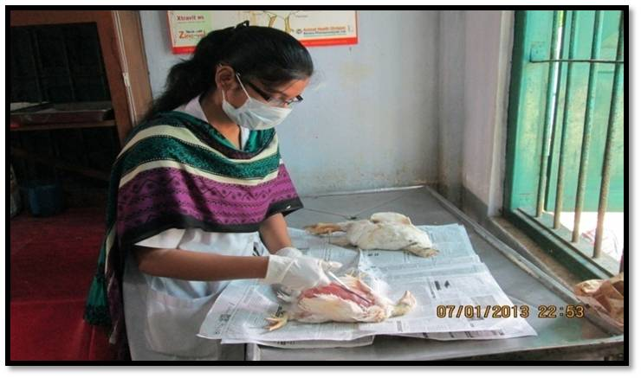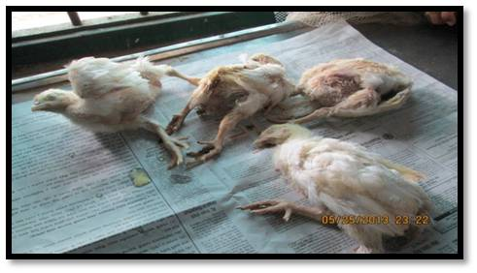
Fig 3.2: IBD infected broilers
Fig 3.1: post mortem examination of poultry
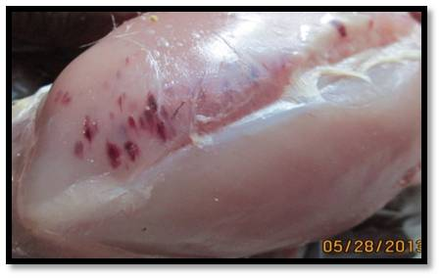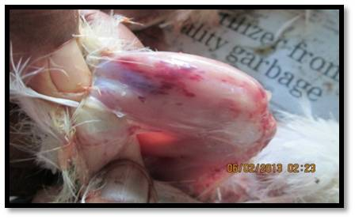
Fig 3.4: Hemorrhage on thigh muscle in IBD
Fig 3.3: Hemorrhage on breast muscle in IBD
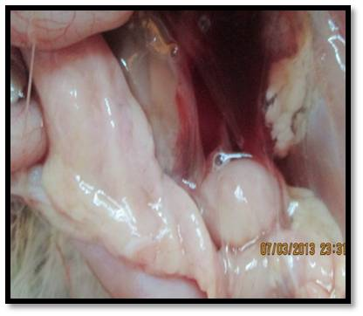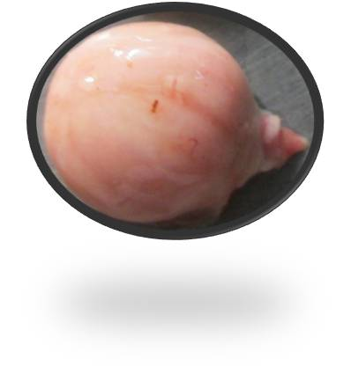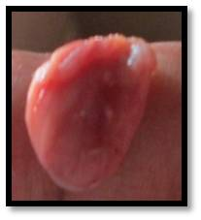
Fig 3.5: Edematous bursa with gelatinous covering in IBD
Fig 3.6: Atrophied
Bursa in IBD
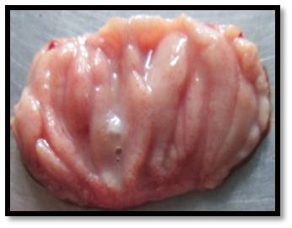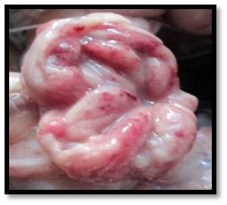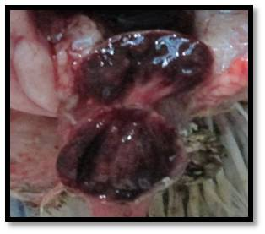
Fig 3.7: Caseous mass inside the edematous bursa in IBD
Fig 3.9: Clotted blood inside the swollen bursa in IBD
Fig 3.8: Hemorrhage in the fold of edematous bursa in IBD

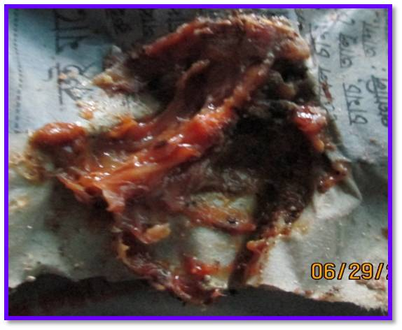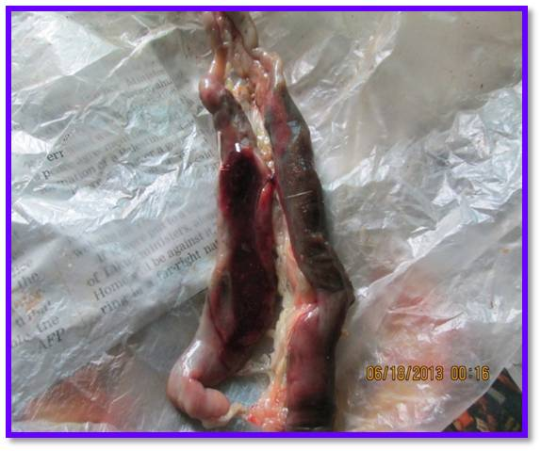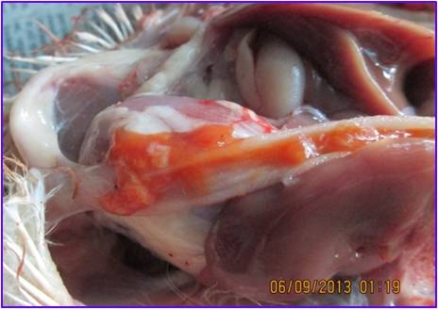
Fig 3.12: Bloody ingesta in the small intestine in intestinal cocccidiosis
Fig 3.11: Clotted blood inside the ceca in cecal coccidiosis
Fig 3.10: Bloody droppings in Coccidiosis

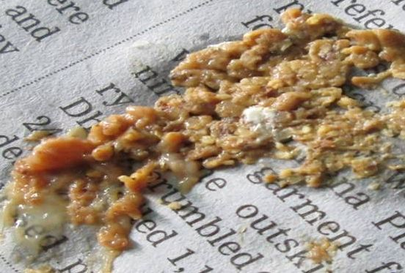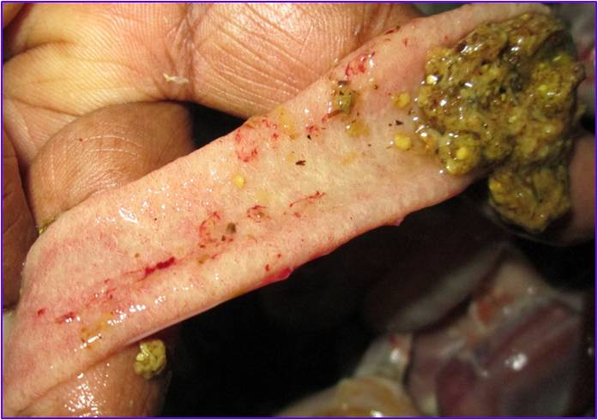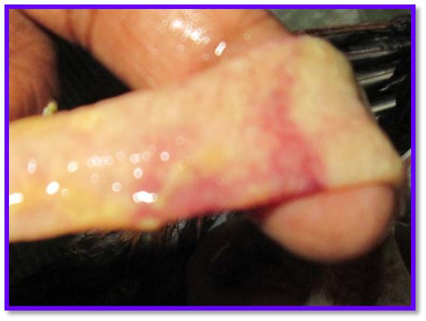
Fig 3.15: Necrosis in small intestine in ( CNE)

Fig 3.14: Undigested feeds in lumen of small intestine in (CNE)

Fig 3.13: Undigested feeds in droppings in Clostridial Necrotic Enteritis ( CNE)

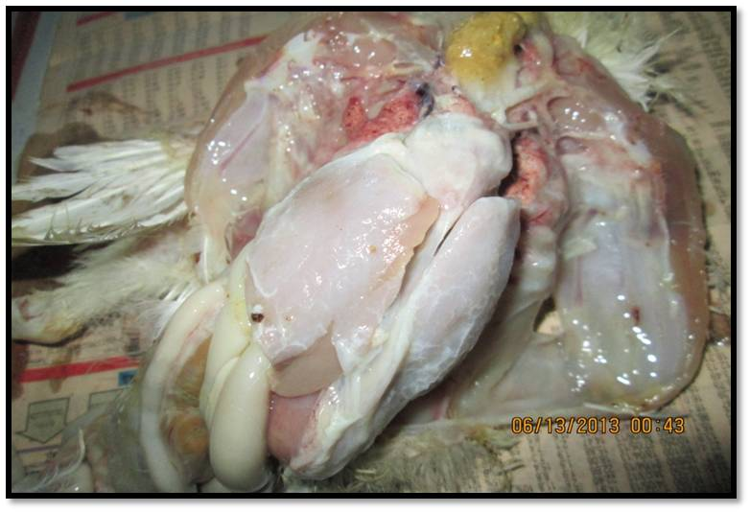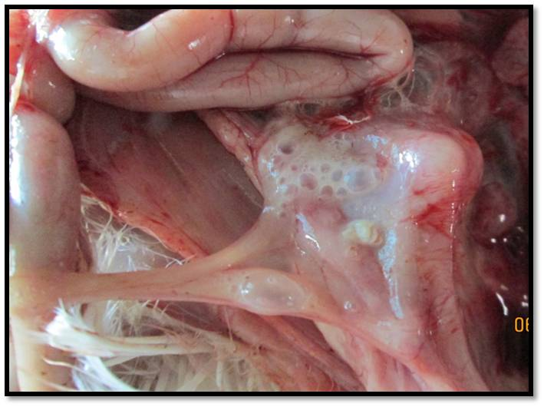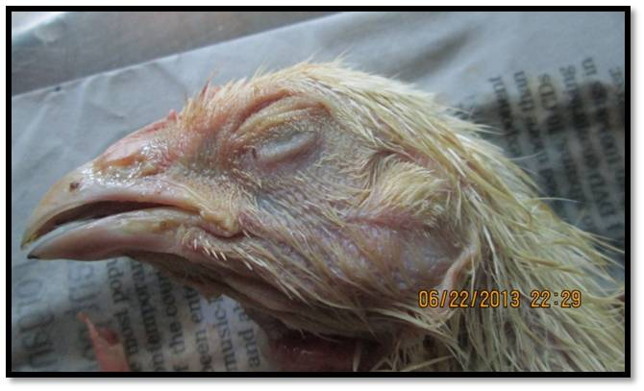
Fig 3.18: Exudates coming from nostrils in mycoplasmosis

;
Fig 3.17: Frothy and cloudy air sac with nodule of E. coli in colibacillosis
Fig 3.16: Fibrinous pericarditis,perihpatitis in colibacillosis and CCRD

Fig 3.19: Eosinophil in the slide of DLC of blood of IBD infected broiler
Fig 3.20: Heterophils with double lobed nucleus in the slide of DLC of blood of IBD infected broiler

Fig: 3.21: Lymphocytes in the slide of DLC of blood of IBD infected broiler

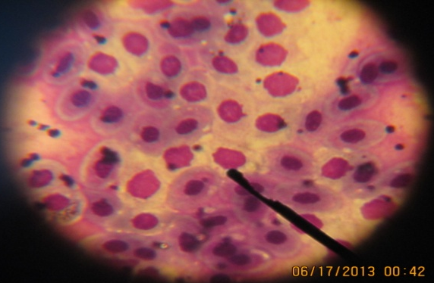
CHAPTER - V
RESULTS AND DISCUSSIONS
RESULTS
In the placement area, overall 50 farms were investigated of which 25 farms where found IBD associated with other concomitant infections during my study period (5th May to 4th July, 2013) at Thana Livestock Hospital, Kotwali, Chittagong district. The distribution and association of IBD and IBD associated with other concomitant infections with farm size, age group and strain is presented below in tabular form.
Table 4.1: Measuring the prevalence of IBD in different farm size
Type of farm |  | No of total birds | Infected birds | Prevalence % | P value
Small scale farm  (300-600) | 1550 |  | 18 | 1.2 | 1.21
Medium scale farm  (>600-1500) | 8500 |  | 359 | 4.2
Large scale farm  (>1500) |  | 22900 | 214 | 0.9
The result shows that there was no significant differences (P>0.05) among the variables (farm sizes).

Table 4.2: Measuring the prevalence of IBD associated with other concomitant infections in different farm size
Farm size | Name of infections | Total no of chickens | No of infected chickens | % prevalence | P value
Small scale(300-600) | IBD+CRD+Cocci | 400 | 8 | 2
 | IBD+Cocci+CNE | 550 | 6 | 1.1 | < o.oo1
 | IBD+Cocci | 600 | 4 | 0.6
Medium scale farm  (>600-1500) | IBD | 3600 | 220 | 6%
 | IBD+Colibacillosis | 1500 | 17 | 1.1%
 | IBD+CRD | 2200 | 57 | 2.6%
 | IBD+Cocci | 1200 | 65 | 5.4%
Large scale farm  (>1500) | IBD | 6200 | 70 | 1.1%
 | IBD+Cocci | 8600 | 96 | 1.1%
 | IBD+Coli+Cocci | 4000 | 32 | 0.8%
 | IBD+Mycoplasmosis | 2000 | 6 | 0.3%
 | IBD+Cocci+CNE | 2100 | 10 | 0.5%
The result shows that there was significant differences (P<0.05) among the variables (farm sizes).

Fig no: 4.1: Graphical presentation of prevalence of IBD in different age groups.
The previous Pie chart shows that the prevalence of the IBD was 1.1%, 2.5% among the age groups of (14-21) days and (22-28) days respectively.

Table 4.3: Measuring the prevalence of IBD associated with other concomitant infections in different age groups
Age groups | Name of infections | Total no of chickens | No of infected chickens | % prevalence | P value
14-21 days | IBD+Cocci+CNE | 550 | 6 | 1.1 | 0.0001
 | IBD+Cocci | 5200 | 71 | 1.3
 | IBD | 1000 | 10 | 1
 | IBD+Colibacillosis | 1500 | 17 | 1.1
 | IBD+mycoplasmosis | 2000 | 6 | 0.3
 | IBD+Cocci+colli | 4000 | 32 | 1
22-28 days | IBD | 8800 | 280 | 3.2
 | IBD+Cocci | 2600 | 44 | 1.7
 | IBD+CRD | 2200 | 57 | 2.6
 | IBD+CRD+Cocci | 400 | 8 | 2
 | IBD+Cocci+CNE | 2100 | 10 | 0.5
The result shows that there was significant differences (P<0.05) in the variables (Age groups).

1.7%
1.3%
Fig no: 4.2: Graphical presentation of prevalence of IBD in different Strains of broilers.
The above Pie chart shows that the prevalence of IBD in Cobb 500 was 1.3%, Cobb 100 was 1.7%, Lohman Meat was 2.1% and Arbor Acres Plus was 0.8%.

Fig no 4.3: Graphical presentation of prevalence of IBD associated with other concomitant infections in different strains of broilers.
The previous graph shows that in strain, Cobb 500, the prevalence of IBD, IBD+CRD+Cocci, IBD+Cocci+CNE, IBD+Cocci, IBD+Coli+Cocci, IBD+Colibacillosis and IBD+CRD was 1%, 2%, 0.5%, 1,7%, 0.8%, 1% and 2.7% respectively. In strain Cobb 100, the prevalence of IBD and IBD+CRD was 1% and 2.5% respectively. In strain Lohman Meat, the prevalence of IBD, IBD+Mycoplasmosis was 5.4% and 0.3% respectively. In strain Arbor Acres Plus, the prevalence of IBD+Cocci+CNE and IBD+Cocci was 1.1% and 0.6% respectively.

Table 4.4: Blood parameters (TEC, DLC) of IBD infected flock
Observation no |  | TEC  (million/mm³) |  | DLC %
 |  |  |  | Lymphocytes% | Monocytes % |  | Eosinophil % | Neutrophils % | Basophils %
1 |  | 44 |  | 85 | 3 |  | 3 | 6 | 3
2 |  | 81 |  | 87 | 7 |  | 2 | 4 | -
3 |  | 44 |  | 82 | 7 |  | 3 | 8 | -
4 |  | 46 |  | 82 | 2 |  | 4 | 10 | 2
5 |  | 117 |  | 93 | 3 |  | 4 | 0 | 0
6 |  | 90 |  | 80 | 2 |  | 1 | 15 | 0
7 |  | 81 |  | 30 | 5 |  | 1 | 15 | 0
8 |  | 40 |  | 82 | 3 |  | 3 | 4 | 0
9 |  | 56 |  | 87 | 7 |  | 1 | 15 | 0
10 |  | 87 |  | 70 | 6 |  | 1 | 20 | 0
Average | 68.9 |  | 78 |  |  | 5 | 2 | 10 | 0

DISCUSSIONS
In the placement area overall 50 farms were investigated of which 25 farms where found IBD associated with other concomitant infections during my study period (5th May to 4th July, 2013) at Thana Livestock Hospital, Kotwali, Chittagong district. The distribution and association of IBD and IBD associated with other concomitant infections were explained in terms of farm size, age group and strains. The study was revealed that the prevalence of the IBD was 1.2%, 4.2% and 0.9% among the small sized farms, medium sized farms and large sized farms respectively. This result indicates that IBD was more frequent in medium sized farms (4.2%) than large sized farms (0.9%) which supported by early report of Sharma et al., (2002). However it was observed that higher prevalence in medium sized farms might be due to overcrowding, poor ventilation.
The study found that the prevalence of IBD associated with other concomitant infections was higher in medium scale farms and less in small scale farms. In medium scale farms, the prevalence of only IBD was 6%, IBD+Coccidiosis was 5.4%, IBD+CRD was 2.6% and IBD+Colibacillosis was 1.1%. On the other hand, in small scale farms the prevalence of IBD+Coccidiosis was 0.6%, IBD+Cocci+CNE was 1.1% and IBD+CRD+Cocci was 2%. It has been found that among the concominant infections of IBD, the IBD with coccidiosis was common for three farm types and the highest prevalence of IBD with coccidiosis was 5.4% in medium sized farms and low in small scale farms and it was 0.6%. The mixed infection with IBD occurs due to immunosuppressive nature of IBD Virus as they does the destruction of lymphocytes of Bursa and IBD with coccidiosis is very common (Anderson et al., 1977); as the coccisiosis organism are generally present in gut and become virulent during immunosupression. The farm size variation in this case may be occurred due to overcrowding, poor ventilation, lack of cleanliness, climate variation etc.
The prevalence of the IBD was 1.1%, 2.5% among the age groups of (14-21) days and (22-28) days respectively. This result indicates that IBD was more frequent in age group of (22-28) days (2.5%) which is not supported by early report by Sharma et al., (1997); Rodviguez-Chavez et al., (2002). However it was observed that higher prevalence in (22-28) days might be due to stress, improper vaccination, high environmental temperature, low level of immunity, poor management practices, existence of very virulent field virus in the farm premises etc.
The study reveals that the prevalence of IBD associated with other concomitant infections was higher in chickens of 22-28 days of age and less in chickens of 14-21 days of age; which is not supported by early report by Sharma et al., (1997); Rodviguez-Chavez et al., (2002).. In chickens of 22-28 days of age, the prevalence of only IBD was 3.2%, IBD+Coccidiosis was 1.7%, IBD+CRD was 2.6% and IBD+CRD+Coccidiosis was 2% and IBD+Cocci+CNE was 0.5%. On the other hand, in chickens of 14-21 days of age, the prevalence of only IBD was 1%, IBD+Coccidiosis was 1.3%, IBD+Coccidiosis+Colibacillosis was 1%, IBD+Cocci+CNE was 1.1% IBD+Colibacillosis was 1.1% and IBD+Mycoplasmosis was 0.3%. The study found that the prevalence of only IBD is higher in chickens of 22-28 days of old (3.2%) and lower in chickens of 14-21 days of old (1%). We also see that among the concominant infections of IBD, the IBD with coccidiosis, IBD with coccidiosis and Clostridial Necrotic Enteritis (CNE) were common for 2 age groups and the highest prevalence of IBD with coccidiosis of was 1.7% in 22-28 days and low (1.3%) in 14-21 days and the prevalence of IBD+Cocci+CNE was high (2%) in 14 to 21 days and low (0.4%) in 22-28 days of chickens. The mixed infection with IBD occurs due to immunosuppressive nature of IBV Virus as they does the destruction of lymphocytes of Bursa and IBD with coccidiosis and IBD+Cocci+CNE are very common (Anderson et al., 1977); as the coccisiosis organism and Clostridial organisms are generally present in gut and become virulent during immunosupression. Organisms of Coccidiosis makes the path easier for Clostridial organisms to get entrance in to the epithelium of small intestine as Cocccidia makes anerobic condition in small intestine by doing destruction and haemorrhage in the gut epithelium. The variation in age groups in this case might be due to stress, low level of maternal antibody titre, improper vaccination, high environmental temperature, low level of immunity, poor management practices, existence of very virulent field virus in the farm premises etc.
It different strains of broilers, the prevalence was higher in Lohman Meat and lower in Arbor Acres Plus and then in Cobb 500 which was not same as the earlier report made by Rajeswar et al., (1992). So the study can say that Arbor Acres Plus and Cobb 500 were more resistant to IBD. The resistency of Strains may be varied due to genetical causes, environmental and managemental causes also.
The prevalence of IBD associated with other concomitant infections in different strains of broilers shows that the prevalence of only IBD was 2%, IBD+Coccidiosis was (Higher) 1.7%, IBD+CRD was (Higher) 2.7% IBD+Colibacillosis, IBD+Coli+Cocci was 0.8%, IBD+CRD+Cocci was 2%, IBD+Cocci+CNE was (a little bit lower) 0.5% in Cobb 500. In Cobb 1oo, the prevalence of only IBD was 1%, IBD+CRD was (Lower) 2.5%. In Lohman Meat the prevalence of only IBD was (Higher) 5.4%, IBD+ Mycoplasmosis was 0.3%. In Arbor Acres Plus, the prevalence of IBD+Cocci was (Lower) 0.6% and IBD+Cocci+CNE was (Higher) 1.1%. This was not same as the previous report made by Rosales et al., (1989); Vladimir et al., (1997). This strain variation depends on genetic potentiality to fight against stress, environmental cause, immunosupression and managemental cause also.
The ten blood samples were collected for checking the Total Erythrocyte Count (TEC) and Differential Leucocyte Count (DLC) of IBD infected birds. The study revealed that the average TEC of IBD infected bird was 68.9 million/mm³ and DLC % showed that average neutrophil was 10%, lymphocyte was 78%, eosinophil was 2%,monocytes was 5%, basophil was 0%. The normal TEC of poultry is 2.5 to 3.5*10⁶ µl and in DLC, the neutrophil -15 to 40%, lymphocyte - 45 to 70%, eosinophil – 1.5 to 0.6 %, monocytes - 5 to 10 %, basophils are rare. From the study it found that the lymphocyte count was higher than the normal, monocytes were within range, basophils were not so available, neutrophils were lower and eosinophils were a little bit higher than normal. In viral infection the amount of lymphocytes become increased, it might be the cause of increased amount of Lymphocyte count in IBD. But early report said that IBD virus cause huge destruction of B lymphocytes of bursa and its amount decreased in peripheral blood (Hirai et al., 1979; Sivanandan and Maheswaran, 1980) and the bursa become atrophied on 8th day onward (Post infection) and it was approximately 1/3 of its original weight (Dybing et al., 1998).

CHAPTER - V
CONCLUSION AND RECOMMENDATIONS
In my study time, my focus was on the most common occurring disease Infectious Bursal Disease (IBD). Diagnosis of the disease done mostly by postmortem and clinical history from the farmers and clinical signs were also taken to aid the diagnosis. The study revealed that the prevalence of IBD was higher (4.2%) in medium sized farms, 2.5% (Higher) among the age groups at (22-28) days and 2% (higher) in Lohman Meat strain than large sized farms (0.9%), 1.1% (Lower) at age group of 14-21 days and lower (0.8%) in Arbor Acres Plus strain respectively. The prevalence of IBD associated with other concomitant infections was higher in medium scale farms, age group of 22-28 days than small scale farms and age group of 14-21 days respectively. In mixed infection, IBD+Coccidiosis, IBD+Cocci+CNE, IBD+CRD, IBD+Colibacillosis were common in different farm sizes, age groups and strains and their prevalences varied accordingly. In this study, lack of quality feed, lack of quality chicks, lack of vaccination, overcrowding, poor ventilation, wrong method of vaccine administration, faulty brooding, stress, lack of biosequrity and farmers awareness etc are the risk factors are revealed which increased the both prevalence and loss by disease. Mixed infections like coccidiosis, collibacillosis, mycoplasmosis, CRD, clostridial infections with IBD occurred due to immunosuppression and increase the mortality rate. After critical review of the result of this investigation, it is felt that among the many constrains of the development of the poultry sector, maintenance of the farm and disease especially IBD is still a havoc; top of the list. In this regard, the efficacy of vaccination can be significantly hampered by IBDV virus infection affecting the chickens` immune system and so IBD has a great economic impact on the farmer not only by losses of bird and costly treatment but also failure of other vaccination programs in the farms and thus making the farm more prone to be diseased. So strong and fruitful measures (proper vaccination program, strict biosequrity maintenance etc) should be taken in the farms and farmers should be aware enough to stop the harmful IBD virus.
Finally it is recommended that the specific and sensitive diagnostic tools, checking of maternal antibody titre of chicks before vaccination, effective and proper routine vaccination program, good quality chicks, perfect floor spacing, good ventilation and overall good biosequrity maintenance should be taken to check this IBD virus.
CHAPTER - VI
LIMITATIONS
- My study period was short (only 8 weeks). But it is not sufficient for such type of study.
- There was no effective laboratory opportunity in Thana Livestock Hostpital, Kotwali, Chittagong.
- Most of the farmers were illiterate, from whose information was collected. So there also a great possibility in giving wrong data.
- The disease was diagnosed by recording clinical signs and post mortem lesions, which could be confused with other diseases. If there were facilities of serology testing, the disease could be more appropriately diagnosed.

CHAPTER - VII
REFERENCES
Abdu, A. A., Ezwokoli, C.D., 1987. Challenge study on infectious disease in chicks derived
fromVaccinated hens. Tropical Animal Health and Production. 19: 47-52.
Anderson, W. I., Reid, W. M., Lukert, P. D., Fletcher, O. J. 1977. Influence of infectious
bursal disease on development of immunity to Eimeria tenella. Avian Dis. 21: 637-641.
Baxendale, D., Lutticken. 1981. The result of field trials within inactibvated Gumboro vaccine.
Dev Biol Stand. 51: 211-219.
Baxendale, W. 2002. Birnaviridae. In Poultry Disease edited by Frank Jordan, Mark Pattinson,
Dennis Alexander & Trevor Faragher. 5th edition. W. B. Saunders: 319-323.
Benton, W. J., Cover, M. S., Rosenberger, J. K. 1967.Studies on the transmission of the
Infectious bursal agent (IBA) of chickens. Avian Dis. 11: 430-438.
Becht, H., Müller, H., Müller, H. K. 1988. Comparative studies on structural and antigenic
properties of two serotypes of Infectious bural disease virus. J. Gen. Virol. 69:
631-640.
Bian, C. Z., Yuan, D. Q., Zhao, C. S.1999. Isolation and identification of Infectious
bursal disease virus from ducklings. Chin. J. Vet . Sci. Tech. 29.(8), 32-33.
Brown, B. S., Grieve, D. 1992. The antigenic and pathogenic diversity of the IBD virus.
Misset-World Poult. 8: 41.
Cao, Y. C.,Yeung, W. S., Lim, B. L. 1998. Molecular characterization of seven Chinese
isolates of IBD virus: classical very virulent variant strains. Avian Dis. 42: 340-351.
Chen, H. Y., Zhang, Giambrose, J. J. 1998. Sequence analysis of the VP2 region of
nine infectious bursal disease virus isolates from mainland China. Avian Dis. 42:
762-769.
Chettle, N., Stuart, J. C., Wyeth, P. J. 1989. Outbreak of virulent IBD in East Anglia.
Vet. Rec. 125: 271-272.
Cheville N. F. 1967. Studies on the pathogenesis of Gumboro disease in the bursa of febricius,
Spleen and thymus of chicken. Am. J. Pathol. 51: 527.
Chowdhury, E. H., Islam, M. R., Das, P. M., Dewan, M. L., Khan, M. S. R. 1996. Acute IBD
in chickens: pathological observation and virus isolation. Asian-Australian J. Anim. Sci.
9:665-675.
Cosgrove, A. S. 1962. An apparently new disease of chickens-avian nephrosis. Avian Dis. 6:
384 -386.
Cullen, G. A., Wyeth. 1978. Susceptibility of chicks to IBD following vaccination of their
parents with live IBD vaccine. Vet. Rec. 103: 281-282.
Dalgaard, T. S., Nielsen O.L. 2002. Major histocompattability complex linked immune
response of young chickens vaccinated with an attenuated live IBD virus followed by
an infection. Poult. Sci. 81: 649-656.
DLS (Department of Livestock Services), 2013. Ministry of Fisheries and Livestock,
Economic Review, 2013 upto February, Chapter-7_Bangla_2013. Pp-103.
Dybing, J. K., Jackwood D. J. 1998. Antigenic and immunogenic properties of infectious
bursal disease viral protein. Avian Dis. 42: 80-91.
Giamborne, J. J., Feetcher, O.J., Lukert, P. D., Edison C. F. 1978. Experimental infection of
Turkey with infectious bursal disease virus. Avian Dis. 22: 451-458.
Huang, G.M., Qia Sulan. 2002. Early stages of IBD Virus infection in chicken detected by
in situ reverse transcriptase polymerase chain reaction. Avian Pathology. 31: 97-104.
Islam, M. R., Zierenberg, K., Müller, H. 2001. The genome segment B encoding the RNA
dependent RNA polymerase protein VP1 of very virulent IBDV in phylogenetically
distinct from that of all other IBDV strains. Arch. Virol. 146: 2481-2492.
Ivanyi, J., Morris, R. 1976. Immunodeficiency in the chicken. IV. An immunological study of
IBD. Clin. Exp. Immunol. 23: 154-165.
Jackwood D.J., Jackwood R. J. 1997. Molecular identification of infectious bursal virus
strain. Avian Dis. 41: 97-104.
Jones, B. A. H., 1986. Infectious bursal disease serology in New Zealand poultry
flocks. NZ.Vet. J. 34: 36.
Kibenge, F.S.B., Dhilon, A. S., Russle, R. G. 1988. Biochemistry and immunology of IBD
Virus. J. Gen. Virol. 69: 1757-1775.
Kurade, N. P., Bhat, T.K., Jithendran, K. P. 2000. Occurance of IBD and its pathology in
the birds of Himachal Pradesh. Indian J. Vet. Pathol. 2492: 133-134.
Landgraf, H., Vielitz, E., Kirsch, R. 1967. Untersuchugen über das auftreten einer infectiö
-sen erkrankung mit beteligung der bursa Fabricii Deutsche Tierärxztl. Wochenschr.
74: 6-10.

Lasher, H. N., Shane, S. M. 1994. Infectious bursal disease.World`s Poult. Sci. J. 50: 133-166.
Ley, D. H., Strom, N., Bickford, A. A. 1983. An Infectious bursal disease outbreak in 14- and
15 week old chickens. Avian Dis. 23: 235-240.
Lukert, P.D., Davis, R. B., 1974. Infectious bursal disease virus: Growth & Characterization
in cell cultures. Avian Dis. 18: 243-250.
Marquardt, W. W., Johnson, R. B., Odenwald, W. F., Schlotthober, B.A. 1980. An indirect
Enzyme linked immunosolvent assay (ELISA) for measuring antibodies in chickens in
-fected with IBDV. Avian Dis. 24: 375-385.
Mandaville, W. D., D. K. cook. 2002. Heat liability of five strains of infectious bursal disease
Virus. Poult. Sci. 79: 838-842.
Mc Nulty, M. S., Allan, G. M., Mc Ferran, J. B. 1980. Isolation of infectious bursal disease
from fowl, turkey and duck: demonstration of second type. Avian Pathol. 9: 395-404.
Mc Allister, J.C., Steelman, C.D., Nowberry, L.A., Skeeles, J. K. 1995. Isolation of IBD
Virus from lesser mealworm, Alphitobus deaperinus. Poult. Sci. 74: 45-49.
Meroz, M. 1966. An epidemiological survey of Gumboro disease. Refuah Vet. 23: 227-235.
Mülller, H. 1986. Replication of infectious bursal disease virus in lymphoid cell. Arch.Virol.
87: 191-203.
Mundt, E., Beyer, J., Mülller, H. 1995. Identification of a novel viral protein in IBD virus
infected cells. J. Gen. Virol. 76: 437-443.

Nunoya, T., Otaki, Y., Tajima, M., Hiraga, M., Saito, T. 1992. Occurance of acute IBD
with high mortality in Japan and pathogenesis of field isolates in specific pathogen
free chickens. Avian Dis. 36: 597-609.
Pattinson, M., Allan, W. H. 1974. Infection of chicks with infectious bursal disease and its
effect on the carrier state with New castle disease virus. Vet. Rec. 95: 65-66.
Peters, G. 1967. Histology of Gumboro disease. Berl Muench Tierärztl Wochenscher. 80: 394-
396.
Rahman, M. M. 1994. Gumboro disease and some observations on its outbreak in a poultry
breeding farm. Paper presented in the Sympoosium of Gumboro disease. Sponsored
by Intervet International, Dhaka, 19 th October, 1994.
Rosenberger, J. K., Gelb, J. Jr. 1978. Response to several avian respiratory viruses as
affected by infectious bursal disease virus. Avian Dis. 22: 95-105.
Rodriguez- Chavez, R. Issac, Cloud, S., Sandra. 2002. Characterization of the antigenic,
immunogenic, anfd pathogenic variation of infectious bursal disease virus due to
propagation in different host systems (Bursa, embryo, cell culture). Iii. Pathogeni
-city. Avian Pathology. 31: 485-492.
Saif, Y . M., Adbel- Amin, G. A. 2001. Pathogenicity of cell culture derived and bursa
derived infectious bursal disease viruss in specific. Avian Dis. 45: 844-852.
Sharma, R. N., Benko. 1977. Preliminary observation on infectious bursal disease in
Zambia. Veterinary infectious bursal disease.Vet. Rec. 101: 153.

Stuart, J. C. 1989. Acute infectious bursal diseasevin poultry. Vet. Rec. 125: 281.
Syender, D. B., Lana. D. P., Savage, P. K. 1988. Differentiation of infectious bursal disease
directly from infected tissues with neutralizing antibodies. Avian Dis. 32: 535-539.
Sivanandan, V., Maheswaram, S. K. 1980. Immune profile of infectious bursal disease. I.
Effect of infectious bursal disease virus on peripheral blood T and B lymphocytes
of chickens. Avian Dis. 24: 715-725.
Sivanandan, V., Maheswaram, S. K. 1980. Immune profile of infectious bursal disease. II.
Effect of infectious bursal disease virus on pokeweed-mitogen-stimulated peripheral
Blood ltmphocytes of chickens. Avian Dis.25: 734-742.
Sivanandan, V., Maheswaram, S. K. 1980. Immune profile of infectious bursal disease. III.
Effect of infectious bursal disease virus on the responses to phytomitogens and on
Mixed lymphocyte reactions of chickens. Avian Dis. 25: 112-120.
Winterfield, B.A. 1989. Infectivity and distribution of infectious bursal disease virus in chicken.
Avian Dis. 16: 622-632.
Wyeth, P. J. 1980. Passively transferred immunity to IBD following live vaccinationof parent
Chicks by two different routes. Vet. Rec. 106: 89-220.
Yuasa, N., Taniguchi, T., Yoshida, I. 1980. Effect of infectious bursal disease virus on inci-
dence of anemia by chicken anemia agent. Avian Dis. 24: 202-209.

CASE STUDY SHEET
Case no:----------- Date:----------------Address of the farm:---------------------------------------------------------------------------
Patient data:
Age:----------------------------------------------------------------------------------
Strain:--------------------------------------------------------------------------------
Total no of birds:------------------------------------------------------------------
Day of first infection:-------------------------------------------------------------
No of dead birds:-------------------------------------------------------------------
Vaccination status:-----------------------------------------------------------------
Farmer`s complain:--------------------------------------------------------------------------------------------------------------------------------------------------------------------------------
Management system:
Feeding:----------------------------------------------------------------------------
Lighting:---------------------------------------------------------------------------
Ventilation:-------------------------------------------------------------------------
Litter condition:-------------------------------------------------------------------
Hygiene:---------------------------------------------------------------------------
Biosequrity:------------------------------------------------------------------------
Clinical signs:---------------------------------------------------------------------------------------------------------------------------------------------------------------------------------------
Post mortem findings:-----------------------------------------------------------------------------------------------------------------------------------------------------------------------------
Tentative diagnosis:----------------------------------------------------------------------------
Treatment: -------------------------------------------------------------------------------------------------------------------------------------------------------------------------------------- ---

Signature

