Correction and Management of Ruminal Acidosis in Cattle: A Case Report

ABSTRACT

A comprehensive study was conducted in a cattle that was suffering from acidosis after feeding of large amount of grain and cooked rice. My study on ruminal acidosis in cattle’’ was conducted during internship program at Madras Veterinary College, Chennai, india. Tentative diagnosis of the case was performed from relevant history, clinical signs, clinical examination of color, odor and consistency of rumen fluid and rumen microflora movements. Confirmation diagnosis was performed by measuring the rumen fluid and blood pH. The predisposing factors of ruminal acidosis were from feeding of cooked rice, rice gruel. The mean temperature, rumen motility, rumen fluid pH and serum pH of the affected cattle 101.5$℉$, 5.6, 5.5 and 7.2 respectively. The most effective treatment of acidosis in cattle was observed from the use of ruminal alkalizer (magnesium hydroxide, sodium bicarbonate ,5% sodium bicarbonate, some antibiotics potentiated Sulphonamides and Tetracycline along with fluid therapy. This study suggests that carbohydrate in dairy feed should be cautiously in dairy farm to prevent ruminal acidosis.
Key words: Acidosis, Rumen pH, Alkalizer, Cattle.

INTRODUCTION
Ruminant suffers from many infectious and non-infectious diseases. Ruminal acidosis is one of the most important non-infectious disease for all ruminants. Many ruminants suffer from ruminal acidosis due to improper practice of feeding resulting from the lack of knowledge about risk factors. Ruminal acidosis occurs when a ruminant animal intake large amount of rapidly fermentable carbohydrates, primarily starches and sugars (Beauchemin and Penner, 2009). A large number of farmers involved in cattle fattening program just before 3 or 4 months of Eid-ul-Azha. In this time feeding of easily digestible carbohydrate in large volume leads to found this disorder. Lactic acidosis is a clinical condition due to accumulation of $H^{+}$ ions from lactic acid, characterized by blood lactate level > 5 mmole/L and arterial pH < 7.25 (Robert et al., 1982). Lactic acidosis can cause ruminitis, metabolic acidosis, lameness, hepatic abscessation, pneumonia and finally death (Lean et al., 2000).In addition, apart from compromises to dairy cow health and economics and the clinical condition lameness and laminitis impact significantly on cow comfort and general well being (Hall and Averhof, 2000; Oetzel, 2003). Sub-acute ruminal acidosis often goes unrecognized and undiagnosed until significant herd involvement and obvious clinical signs are evident. At this stage, large financial losses and long-term health issues, such as a high prevalence of herd lameness, may be inevitable (Nocek, 1997).The study was conducted at Madras Veterinary College Hospital, Chennai, India. In my study a eight year non-lactating dairy cow (Holstein Friesian) accidentally intake large amount of excess green grasses, cooked rice and rice gruel showing ruminal acidosis, which may severely compromise gastrointestinal fuction of animal. The owner reported that the cow was off feed, reduce milk productiom and suffering from diarrhea.

Case presentation
A eight-year-old 450 kg body weight named Shamoli non-lactating ( Holstein Friesian ) dairy cow accidentally intake large amount of green grasses, cooked rice and rice gruel that consequently suffered from ruminal acidosis. The owner reported that the cow showed off feed and diarrhea. The cow was brought to Madras Veterinary College Hospital ,Chennai, India. Presumptive diagnosis of the cases was performed on the basis of feeding history that was intaking of large amount of grain, cooked rice and rice gruel. The owner also reported that a diet consisting exclusively of hay and with supplemental minerals and vitamins in one week ago where associated with clinical signs and examination of rumen fluid color, consistency and odor. Confirmatory diagnosis was performed by exploring the low pH of rumen fluid. At first the stomach tube was cleaned and washed by antiseptic solution. Finally dry and use lubricants for use. The stomach tube suited to collecting ruminal fluid can be constructed using a 3½ m long, 19 mm diameter plastic reinforced garden hose that was attached to a paddle pump. The another end should be riveted to a 10 cm to 15 cm length of copper pipe with multiple holes drilled along all sides [Fig.1:A]. This reduces the risk of blockages with ingesta. The stomach tube was penetrated slowly and cautiously. When the cow became coughing then make a interval and tried again. Sample of ruminal fluid was taken by stomach tube. Generally this sample had a higher pH than those obtained through a rumen cannula. There is no chance of salivary contamination in this method of rumen fluid collection. Therefore, ruminal pH samples was collected by stomach tube and interpreted with cautiously. Physical characteristics (Color, consistency and odor) of rumen fluid was determined by using organoleptic test. In most of cases the color of rumen fluid was milky grey [Fig.1:C ]. The consistency of rumen fluid were found thick watery and the odor of the rumen fluid were sour. One ml of collected rumen fluid was taken into a watch glass and a piece of pH indicator paper (Merck-universal indicator pH 1-10, Merck Limited, Worli, Mumbai-400 018) inserted into the fluid for a few seconds. Color change was observed in pH indicator paper. This color matched with the one of the different color of the color scale.

FAA
DAA
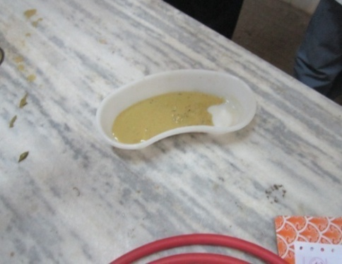
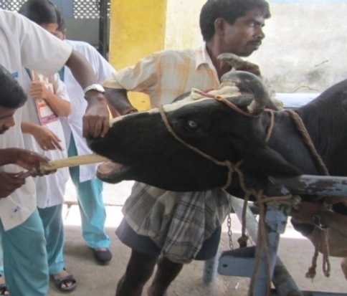
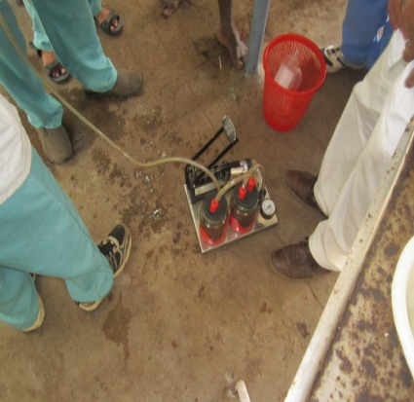

CAA
BAA
AAA
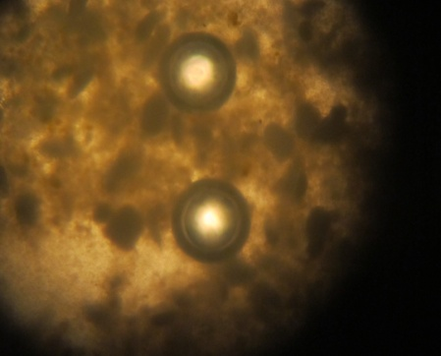
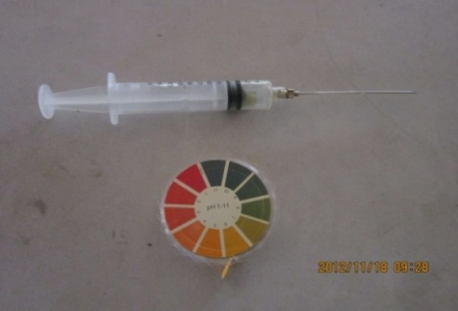
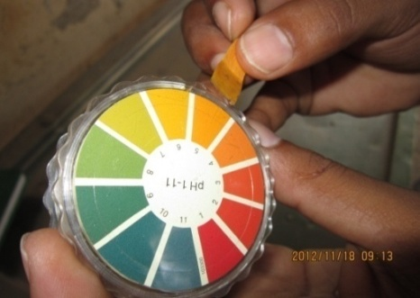

FAA
EAA
DAA

Figures1: A: Penetrating of stomach tube through mouth cavity. B : Paddle pump part of
stomach tube. C: Rumem fluid in kidney. tray D: Syringe with 14 gauge needle and pH Indicator paper for estimation of ruminal and serum pH E: Matching of pH
indicator paper with standard F: Rumen microflora movement observed under
microscope.
E
D

The value of matched color was indicating the pH of the rumen fluid [Fig.1:E ]. The result of rumen fluid pH was 5.5 and serum pH was 7.3,the temperature was 101.5$℉$. To identify the motility of the rumen microflora,two drops of rumen fluid were taken into two clean glass slides ,make slide smear and then observed under microscope at low power objective (10x). The ruminal microflora movement was dramatically reduced in one slide and another slide was absent but some protozoas were found due to acidic environment in the rumen [Fig.1:F ]. After diagnosis of ruminal acidosis case then decision was taken for treatment. Firstly the cow was restrained by keeping into a travies. Therapy includes oral antacids such as magnesium hydroxide, sodium bicarbonate at the rate of 1 gm/kg body weight mixed with double volume of water administered orally initially to neutralize the rumen pH, and oral electrolyte solutions to minimise the dehydration, preferably those containing additional sodium bicarbonate to treat metabolic acidosis [Solorzano, 1989]. Then use systemic ruminal alkalizer: Sodium bicarbonate (Inj. Sodib®, M. R. Chemicals, India) which was 5% sodium bicarbonate and administered at the rate of 750 ml for 450 kg body weight initially over a period of 30 minutes followed by isotonic sodium bicarbonate (1.3%) at 15 ml/kg body weight, I/V over next 6-12 hours. This cases should be treated by withholding concentrates, giving intravenous fluids, e.g. hypertonic saline (0.9% sodium chloride solution) at the rate of 50-100 ml/kg body weight (Depending upon severity of dehydration), I/V, once daily for 3 days and access to water or balanced electrolyte solutions not containing lactic acid. There can be a considerable level of dehydration of affected cow because fluid is sequestered in the rumen as a consequence of increased ruminal osmolarity. Antibiotics including potentiated Sulphonamides (333mg/kg) and Tetracycline (20mg/kg) should be given to reduce the risk of liver abscessation. Administered oral Meronidazole bolus (Menid @16mg/kg) to kill the protozoa. Other supportive treatments include flunixin meglumine (1 mg/kg) for endotoxaemia, antihistamines to control histamine production, and calcium/magnesium solutions either intravenously or subcutaneously to counteract secondary hypocalcaemia and hypomagnesaemia. Thiamine (10 mg/kg) every 24 to 48 hours for up to three doses may also be helpful to prevent polioencephalomalacia. As already discussed in the document, cow that are successfully treated in the acute stage of acidosis and became cure. Finally after three days of sickness, the cow became cure without complications.
The objective of this case report was to describe how the structure and fuction of the rumen adapts during the initial stage of ruminal acidosis just after correction of rumen pH. It was revealed in the present study that sudden intake of large amount of easily digestible non-fibre carbohydrates eg. feeding of cooked rice, rice gruel predispose the ruminal acidosis in most of the cases. In the case a remarkable changes the physical characteristics of ruminal fluid observed during the period of rumen acidosis, such as becoming milky color, watery consistency and souring odor. These findings were in agreement with those reported by some authors that relate changes with decreasing pH in the rumen caused by excessive rise in the concentration of VFA and lactic acid, which increases the osmolarity of the medium, making it hypertonic in relation to plasma, causing a greater flow of water from the intracellular and extracellular compartments into the digestive tract, especially the rumen [Kolver, E. S. and De Veth, M.J. 2002]. In present study, there was found abdominal distension in the case as a clinical sign, it is due to high osmotic pressure inhibit bacterial digestion of fiber and starch causing ruminal content to become stagnant and also due to pulls up water from systemic circulation by high osmotic pressure of rumen reported that abdominal distension is a clinical sign of acute ruminal acidosis. Diarrhoea found as a clinical sign of ruminal acidosis. Changes in microbial fauna of the rumen fluid of animal studied with respect to decreased motility or absence of motility. Protozoa lose their activity when the pH drops to values ​​between 5.0 to 5.5, disintegrating or suffering rumen mucosa layer lysis occurs when an increase in acidity of the medium and pH reaches values ​​below 5.0; In present study it was revealed that use of ruminal and systemic alkalizer is more effective treatment in ruminal acidosis. These findings have similarity with Khafipour et al. (2009), they use ruminal alkalizer (Sodium bicarbonate) and intravenous hypertonic sodium bicarbonate (5%) in severe cases in an induced acidosis and observed all the animal recovered. (Redostits et al, 2006) suggested to use ruminal antacids orally to neutralize the ruminal acids and intravenous hypertonic sodium bicarbonate to neutralize systemic acidosis and correction of dehydration. The recovery of the animals is due to full utilization of the acids and the gradual modification of the microbial population of the rumen fluid.

CONCLUSION
Ruminal acidosis is an important nutritional problem in ruminants in terms of economic point of view and as a substantial health problem. The cause of ruminal acidosis is not a pathogen, but self created complication by owner and the major predisposing factors are in feeding practices. This study indicate feeding of large amount of grain, cooked rice, rice gruel that predispose the ruminal acidosis. In present study, the rumen fluid color, consistency, odor, absent of ruminal flora movement, lower rumen fluid pH gives clues for diagnosis. This study shows the use of ruminal and systemic alkalizer along with fluid in treatment of ruminal acidosis is more effective and has a quicker resolution. This study also shows correct feeding practice can reduce change of ruminal acidosis. Feeding habit should be gradually changed.

Acknowledgements
I am the author wishes to acknowledge the immeasurable grace and kindness of Almighty, the supreme authority and supreme ruler of universe, who empowers the author to complete the clinical report successfully. The author wishes to express his deep sense of gratitude and thanks to internship supervisor Dr.Bibek Chandra Sutradhar, Associate professor, Department of Medicine and Surgery, Faculty of Veterinary Medicine and Director of External affairs in Chittagong Veterinary and Animal Sciences University for his skillful supervision and guidance constant inspiration, suggestion and cordial co-operation to make this report. The author also grateful to honorable professor Dr.Abu Saley Mahfuzul Bari, Vice Chancellor and Professor Dr. Md. Kabirul Islam Khan , Dean, Faculty of Veterinary Medicine of Chittagong Veterinary and Animal Sciences University for arranging this type of clinical report as a compulsory part of this internship program.

REFERRENCES
- Beauchemin, K. and Penner, G. 2009. New developments in understanding ruminal acidosis in dairy cows. Tri-State Dairy Nutrition Conference, pp: 1-12.
- Duffield, T., Plaizier, J.C., Fairfield, A., Bagg R. and Vessie, G. 2004. Comparison of techniques for measurement of rumen pH in lactating dairy cows. Journal of Dairy Science, 87: 59-66.
- Dunlop, R.H. 1972. Pathogenesis of ruminant lactic acidosis. Advances in Veterinary Science and Comparative Medicine, 16: 259-302.
- Enemark, J.M.D. 2008. The monitoring, prevention and treatment of sub-acute ruminal acidosis (SARA): A review. Veterinary Journal, 176: 32-43.
- Enemark, J.M.D., Jorgensen, R.J. and Enemark, P.S. 2002. Rumen acidosis with special emphasis on diagnosis aspects of subclinical rumen acidosis: A review. Veterinarija ir Zootechnika, 42: 16-29.
- Hall, M. B. 2005. Ruminal acidosis: beyond the rumen. Journal of Dairy Science, 88 (1): 377.
- Hart, S. P. and Polan, C.E. 1984. Effect of sodium bicarbonate and disodium phosphate on animal performance, ruminal metabolism, digestion, and rate of passage in ruminating calves. Journal of Dairy Science, 67:2356-2368.
- Howard. J. L. 1981. Ruminal metabolic acidesis. The Bovine Practitioner, 16: 44·53.
- Kleen, J.L., Hooijer, G.A., Rehage, J. and Noordhuizen, J.P.T.M. 2004. Rumenocentesis (rumen puncture): a viable instrument in herd health diagnosis. German Veterinary Weekly, 111: 458 – 462.
- Kolver, E. S. and De Veth, M.J. 2002. Prediction of Ruminal pH from Pasture- Based Diets. Journal of Dairy Science, 85: 1255-1266.
- Krause, M.K. and Oetzel, G.R. 2006. Understanding and preventing subacute ruminal acidosis in dairy herds: A review. Journal of Animal Feed Science and Technology, 126: 215–236.
- Lean, I. J. and Wade, L. K. 2000. New Approaches to Control of Ruminal Acidosis in Dairy Cattle. Asian-Australasian Journal of Animal Sciences,13 (l): 266-269.
- Nocek, J. E.1997. Bovine Acidosis: Implications on Laminitis. Journal of Dairy Science, 80(5): 1005-1028.
- Oetzel, G.R. 2003. Subacute ruminal acidosis in dairy cattle. Journal of Dairy Science, 15: 307 317.
- Oetzel, G.R. 2005. Applied aspects of ruminal acidosis induction and prevention. Journal of Dairy Science, 88: 377-377.
- Robert, P., Allen I., Arieff, Willium, L. and Virginia, C. 1982. Treatment of Lactic acidosis with Dichloroacetate in Dogs. Journal of Clinical Investigation, 70(4):853-862.
- Sarma, P.K. and Ahmed, J.U. 2011. An economic study of small scale cattle fattening enterprise of Rajbari district. Journal of Bangladesh Agricultural University, 9(1):141-146.
- Shaver, R.D. 2005. Feeding to minimize acidosis and laminitis in dairy cows. Proceedings of the Seventh Western Dairy Management Conference., pp:157-166.
- Solorzano, L. C., Armentano, L.E., Grummer, R.R. and Dentine, M.R. 1989. Effects of sodium bicarbonate or sodium sesquicarbonate on lactating Holsteins fed a high grain diet. Journal of Dairy Science, 72:453-461.
- Stone, W.C. 2004. Nutritional approaches to minimize subacute ruminal acidosis and laminitis in dairy cattle. Journal of Dairy Science, 87: 13-26.
- Underwood, W. J. 1992. Rumen Lactic Acidosis, Clinical Signs, diagnosis, treatment, and prevention. Food animal compendium, 14(9): 1265-1270

