Chapter-I

INTRODUCTION

Importance of livestock
The livestock sector represents a significant part of the global economy, particularly in the developing world. Thus, livestock provides energy, food, raw material, and manure for crops. It is therefore not surprising that the livestock sector, especially the dairy sector, has emerged as an important economic source for a vast majority of the rural population and a target for agribusiness in the dairy, meat, and various other products in the processed foods sector (Ahmed et al., 2007).

Bangladesh is a subtropical country with agro-based economy. Livestock is an important sub sector of agriculture. Most of the people, about 80%, live in villages and they are directly or indirectly involved in agriculture of which livestock rearing in an important part. Livestock is an important component of farming system and is playing a crucial rule in the traditional economic system of Bangladesh. Livestock plays an important rule in poverty alleviation and economic development of our country. Ruminants, especially the large (cattle and buffaloes) and small (sheep and goat) ruminants constitute the major portion of the livestock. The total contribution of livestock sector in Bangladesh to GDP is approximately 6.51 (DLS, 2003). It generates 13% of the foreign exchange and fulltime employment to about 20% and partial employment to about 50% of the rural population (Ali, 1994; Alam, 1993).

Importance of cattle in Bangladesh
Cattle have multipurpose functions; it is used for traction of lands and cartage and produces milk and meat. Cow dung is used as manure and as fuel, and a substrate for methane production. Cattle hides and skin are used for clothing, bags, shoes etc. In Bangladesh the total cattle population is about 23.4 million of which 11.91 million are males and 11.49 million are females. Included among the cattle population are about 3.53 million milking cows, 2.61 million dry cows (cows without milk), 2.13 million draught cattle, and 4.20 million improved cattle. Farming is a way of rearing cattle for profitable production of milk and meat in Bangladesh (Banglapedia, 2003).

Cattle as a source of fuel and fertilizer
As an input to cropping systems, manure continues to be an important link between crop and animal production in Bangladesh (Banglapedia). The yearly total cattle manure/ dung production in Bangladesh is estimated to be 80 million tones of which 68 and 52% is used as manure in rural and urban areas, respectively and the use of dung as a household fuel is mostly on small farms and represents 25% of total production (DLS,2000)

The importance of reproductive diseases
Reproductive diseases of cattle are of great economic importance to the rural sector of developing countries, particularly in Africa (Obese and others 1999, Fekadu and others 2007). Although infectious conditions are likely to be major contributors to poor reproductive efficiency (Romero and others 1999), relatively few studies have been carried out in Africa. Livestock management practices in Ghana, such as natural breeding using aged bulls in communal settings, and the lack of routine veterinary care, could play a role in the prevalence of multiple reproductive tract diseases (Akinboade 1980, Pefanis and others 1988).

In Namakkal we found different reproductive diseases of cattle and buffaloes such as dystocia, retained placenta, abortion and ovarian cyst. Out of these diseases, dystocia was more common.

The word dystocia comes from a Greek word means difficult birth. When the 1st or especially the 2nd stage of parturition is markedly prolonged or becomes difficult or impossible for the dam to deliver without artificial,the condition is termed as dystocia
Causes of dystocia:

Dystocia may result due to maternal and/or fetal causes.

Maternal causes of dystocia

Forces Birth canal
Immaturity.
Breed.
Diet.
Development.
Diseases.

Insufficientdilatation.

A.Uterine inertia Abdominal cause

Age.
Debility.
Pain.
Ruptured diaphragm.
Perforated trachea.

Primary
Secondary

1. Myometrial defect
Intrinsic weakness
Overstretching
Cervix
Vagina
Vulva
Inertia.
Hormonal. Imbalance.
Fibrosis.

Congenital defect.
Fibrosis.
Immaturity

Congenital defect.
Fibrosis.
Cyst.
Abscess.
Prolapse.
Toxic degeneration
Adiposity
Senility
Uterus

Dietetic deficiencies
Systemic illness
Heredity
2. Chemical deficiencies
3. Premature birth
4. Enviormental disturbance
B.Rupture of uterus

Fetal causes of dystocia

Fetal death
Fetal over size

Faulty disposition

Developmental defect
Duplication
Ascites
Anasarca
Hydrocephalus

Absolute
Small litter
Breed
Prolonged gestation

Posture
Presentation

Transverse
Simultaneous
Position

Ventral
Lateral

Anterior

Posterior
Hock flexion
Hip flexion

Head flexion
Lateral
Upward
Downward
Limb flexion
Carpal
Elbow
Shoulder

Downward deviation of the head between the forelimbs is occasionally seen in all species except swine. In mild cases, only the nose of the fetus is caught on the brim of the pelvis with the fore head entering the pelvic inlet, “vertex presentation” in more severe flexing of the head and neck the ears and top of the head presenting “pool presentation”. This is usually corrected by mutation by repelling the fetus and grasping the muzzle of the fetus and raising it into the pelvic cavity. In the more severe cases the neck extends between the forelimbs, “nape presentation” and the head is against the fetal sternum or abdomen. This latter condition is more difficult to diagnose but by the forelimbs do not come together.

In severe cases diagnosed after prolonged dystocia, foetotomy is necessary. It may be advisable to amputed the head and neck and one forelimb by a single cut with the foetotomy when the fetus is emphysematous or the uterus strongly

Effects of dystocia :
a. Difficult to delivery
b. Economical losses

Complications of dystocia:
- Vaginal prolapsed.
- Uterine inertia.
- Vaginal rupture.
- Pyometra
- Retained placenta
- Endometritis

Dystocia is one of the most important obstetrical conditions and requires immediate attention by the veterinarians. For calving difficulties causes severe economic losses to the farmers. Bovines are the most commonly species affected with dystocia which develops when the birth process is hindered by some physical obstacle or functional defect. Dystocia has been classified as maternal, fetal or placental in type (Sloss and Dufty, 1980).

Dystocia is a great problem in village farming due to the ignorance of the farmer and the physical condition of the cow and heifers. Birth canal of our local cows and heifers are somewhat constricted than the other pure and crossbred cows. Due to the AI of local cows and heifers with the semen of heavy breeds, fetal oversize occurs at the time of parturition. On the other hand farmer do not offer sufficient amount of nutritious feed to the local cows due to their lower production performances, so most of the cow suffer from malnutrition during pregnancy.
Considering the above mentioned factors of dystocia in cows and buffaloes, the present study was undertaken with the following objectives:

- To study the prevalence of dystocia in cows and buffaloes.
- To know the clinical features of the dystocia and its complication in cows and buffaloes.
- To know about the diagnosis and management of dystocia in field condition.

Chapter-II

REVIEW OF LITERATURE

Dystocia means difficult birth and the term comes from Greek word. When the first or especially the second stages of parturition is markedly prolonged and becomes difficult or impossible for the dam to deliver fetus without artificial aid, the condition is termed as dystocia. (Roberts. S. J. 2004).

Williams (1943) indicated that the incidence of dystocia in cattle was about 3.3%. Tt is apparently higher in dairy cattle than beef cattle. The incidence of dystocia appears higher in the larger breeds, such as the Holstein, Brown Swiss, and Hereford. Maternal dystocia occurs less frequently than fetal dystocia in the cow.

Tutt (1944) has recorded 85.5% of fetal dystocia and 14.5% maternal dystocia is commoner in primipara than in multipara as regards the effect of parity in cattle.

Edwards (1979) recorded 66.5%, 23.1%, and 14.3% of assisted deliveries in the first, second and third calvings in a Friesian herd. In cattle the heavier male calves are more frequently associated with difficult birth than in female calves. Twins birth increases the incidence of dystocia, while the multiparus species an abnormally low litter size predisposes to large fetuses and difficult births. Pregnancies that terminate early are conductive to dystocia through the medium of uterine inertia and fetal malposture, while one type of prolonged gestation increases difficult birth by leading to fetal oversize. Close confinement and overfeeding of the mother act against normal birth, while gross underfeeding or too early breeding of primipara are deleterious factors causing retarded skeletal developments in the dam.

Williams (1968) found more difficult births in heifers than cows, due to the higher frequency in heifers of disproportion. Fetal maldisposition and uterine inertia were much commoner in cows. There are important breed differences in cattle dystocia.

Morton and Cox (1968) found the three most important causes of dystocia to be fetal malpresentation were 44.5%, fetomaternal disproportion 21.8% and uterine inertia 18%.

O’Brien and Stott (1977) analyzed the blood hormone daily from day 260 to until term on 12 Holstein 1st calving heifers from a herd with a high incidence of dystocia. They found that the 1st calving heifers were suffered more from dystocia than other cows. They showed lower concentrations of oestradiol-17ß and higher concentration of progesterone from day 23 to day 12 before calving of the dam.

Jochle et al. (1972) found that when progesterone was given to cows in which labour had been induced by flumethasone there was a high incidence of dystocia due to postural deviation.

Hendricks et al. (1977) found that five of 12 pregnant Hereford heifers in which premature parturition was induced with prostaglandin F₂α given at day 267 and which calved 90 hours later had developed dystocia due to flexion of either the head or a forelimb.

Wilthers (1953) reported that dystocia was almost three times more common in heifers than in cows. He studied 6309 pregnancies in cows and 2814 pregnancies in heifer and observed 1.38% birth difficulties in cows and 3.8% calving difficulties in heifers.

Adams and Bishop (1963) found that 85% of all the dystocia were in heifers and they were classified as excessive calf size 66%, small maternal pelvis 15% and combination of two 19%.

Lindhe (1966) reported that the younger the heifer, the higher is the dystocia rate.

Wright (1958) recorded that there is an important breed differences in cattle dystocia. He worked in two Friesian and two Ayreshire herds and reported the incidences of 8.25% and 11.7% in Friesian as against 2.7% and 3% in Ayreshire herds and the most common forms of dystocia in these four herds were fetal oversize (55%), uterine inertia (17%) and postural abnormalities (16%).

Sloss and Duffy (1980) reported that about a third of the total of 17% of fetal and calf losses occur at the time of parturition and most of these were arised from calving difficulties.

Greene (1984) reported that a stillbirth rate of 5.2% of all calves on dairy farms and major causes of these losses were dystocia due to fetopelvic disproportion.

Laster et al. (1973) found that cows which had calving difficulties experienced delay in resuming estrus and showed 15.9% reduction in conception rate compared with cows which had calved normally.

In 800 births in Holsteins reported by Ben- David, 4.5% were posterior presentation but 47.2 percent of these were accompanied by dystocia.

By far the most common cause of dystocia is a kid larger than the birth canal. It means that either the birth canal of the dam is too small, quite a variety of factors may contribute to the small size of the dam & to the large size of the dam & to the large size of the fetus (Benesch et al, 1951).

Scar tissue structure or fibrous adhesions which may be remnants of the healing of severe inflammation or traumatic injury from previous kidding may narrow all of parts of the birth canal. There may also be deformities, fractures, or dislocation of pelvic bones, which can decrease the size of pelvic inlet and cause dystocia. Sire selection can also play a role in the future cause of kidding. Unfortunately, these small dams have small birth canals which cannot accommodate the huge kids. (Cunn, 1968) there are several abnormal conditions which produce oversized calves and thus dystocia. Some of this conditions like rigid or contorted joints, hydrocephalus (enlarged, fluid filled head) and fused twins, have genetic causes.
Fetal death can lead to a dystocia because the fetus plays a critical role in parturition. Umbilical cord rupture or compression or trauma to the fetus, can cause an enlarged fetus because of improper circulation and accumulation of blood and fluids within certain parts of the fetus. The fetus may bloat or become distended with gas after death, and the increased size may prevent its easy delivery (wiltbank et al., 1969)

Chapter-III

MATERIALS AND METHODS

Study area
The study was conducted at Namakkal Veterinary Hospital, Namakkal, Tamilnadu, India, The study period was September (03-18) 2013.

Study population:
All dairy cows, buffaloes and pregnant heifers came at hospital for treatment purpose were considered as study population. Sometimes some field cases related to delivery were also included in this population during the study period. The recorded animals were local breed. Cows and buffaloes having different parity ranging from 1-5 and the body condition score was calculated by the theory of Nicholson and Butterworth,( 1986).The body condition score was considered as (1) Cachectic (2) Moderate (3) Good.

Methods of study:
Cows, buffaloes and heifers at different ages and breeds were registered from different places of Namakkal during the study period. The case data were collected by the following methods:

Data collection:
In order to collect data we were took with the farmers whose visited in hospital with animal and recorded the information regarding type of animals (cows/ pregnant heifers), age, breed, parity, (if cows), events around last calving. The information was collected by direct interviewing the owners and from the hospital’s record book.

Diagnosis of the dystocia case:
The general clinical examination, inspection, palpation methods were used to diagnose either it is dystocia or utocia. Dystocia was confirmed by taking history of straining time, water bag ruptured or not, part of the fetus visible through the birth canal or not, condition of the animal at the time of case handling and finally it was confirmed by direct palpation of the fetus by inserting hand through the vagina.

Correction of the dystocia case:
Before correction of the cases diagnosis was made by thorough inspection of the cows and position of the fetus in the birth canal of the cow. During correction different instruments were used like rope, hook, snaire etc. All the cases were corrected as per approved methods and facilities available at the time of correction in the field level.

Methods applied during correction

Obstetrics operation may be divided into four types:
1. Mutation: Fetus is returned from different position, presentation and posture by repulsion, version, adjustment or extension.
2. Forced extraction
3. Faetotomy
4. Caesarean section
In Namakkal we observed mutation and forced extraction methods during correction of dystocia

Chapter-IV

RESULTS

The study was carried out at Namakkal Veterinary hospital, Namakkal, Tamilnadu for a period of 03-18 September 2013 to find out the incidence of dystocia in cows and buffaloes. Total study populations were 315 cattle and buffaloes, among them 18 were dystocia which was 5.71% of different diseases in the cows and buffaloes (table-1 and figure-1).

Table-1: Different diseases and their percentage
Sl.No | Disease | Number | Percentage
01 | Dystocia | 18(n=315) | 5.71
02 | Retained Placenta | 19(n=315) | 6.05
03 | Abortion | 06 (n=315) | 1.92
04 | Parasitic infection | 111 (n=315) | 35.47
05 | FMD | 24 (n=315) | 7.78
06 | Ovarian cyst | 14 (n=315) | 4.28
07 | Mastitis | 50 (n=315) | 15.75
08 | BQ | 06 (n=315) | 1.98
09 | Tetanus | 04 (n=315) | 1.32

Figure-1: Percentage of dystocia among different diseases in cows.
We found 57 different reproductive disorders in cows and buffaloes. Out of these, 18 cases were dystocia which was 31.57% (Table 2 and figure-2)

Table-2: Different reproductive disorders in cows and buffaloes

Sl.No. | Parameter | Number | Percentage
01 | Dystocia | 18(n=57) | 31.57
02 | Retained placenta | 19 (n=57) | 33.33
03 | Abortion | 06 (n=57) | 10.52
04 | Ovarian cyst | 14 (n=57) | 24.56

Figure-2: Different reproductive disorders in cows and buffaloes

We also observed out of 18 dystocia cases, 14 in 1st calving heifers and cows, buffaloes which was 75.84% and 4 in more than one calving which was 24.16%( table-3 and figure-3)

Table-3: Effect of parity on dystocia

Sl. No. | Parameter | Number | Percentage
01 | 1st calving heifers | 14 ( n=18) | 75.84
02 | Cows/Buffaloes (> 1 parity) | 04 (n=18) | 24.16

Figure-3: Percentage of occurrence of dystocia in1st calving heifers and cows

Variation in the occurrence of dystocia was also observed in AI (88.34%) which was more than naturally served cows and buffaloes (11.16%) (Table-4 and figure-4).

Table-4: Nature of breeding and dystocia in cows and buffaloes
Sl.No | Parameter | Number | Percentage
01 | AI | 16 ( n=18) | 88.34
02 | Natural service | 02 ( n=18) | 11.66

Figure-4: Percentage of dystocia in cows and buffaloes served by artificially and naturally.

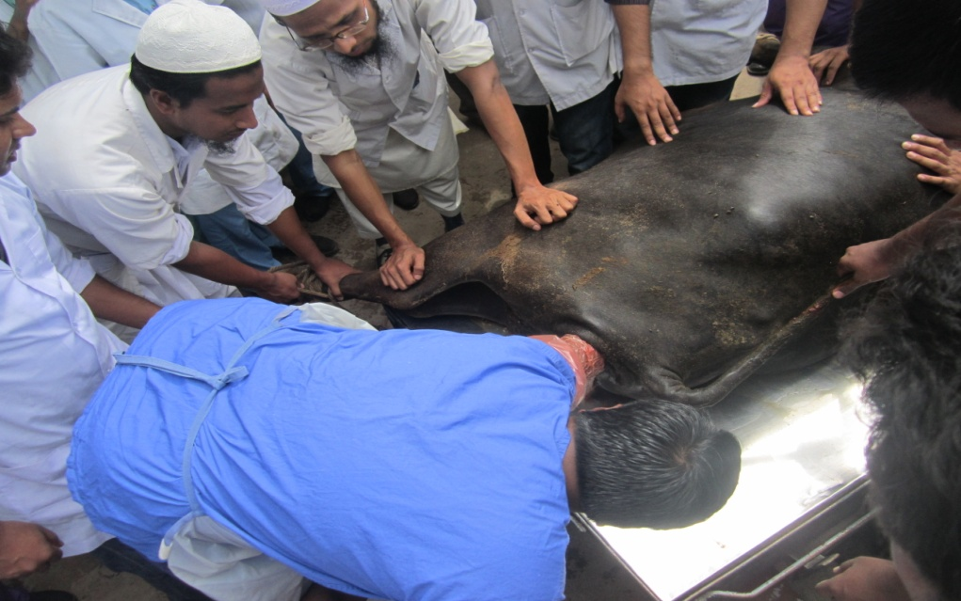

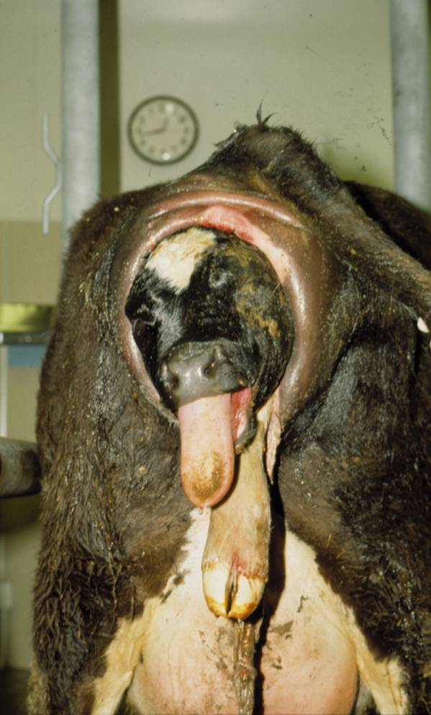
Figure: Correction of dystocia in 1st calving (buffalo) heifer.

Figure: Dystocia in a cow.

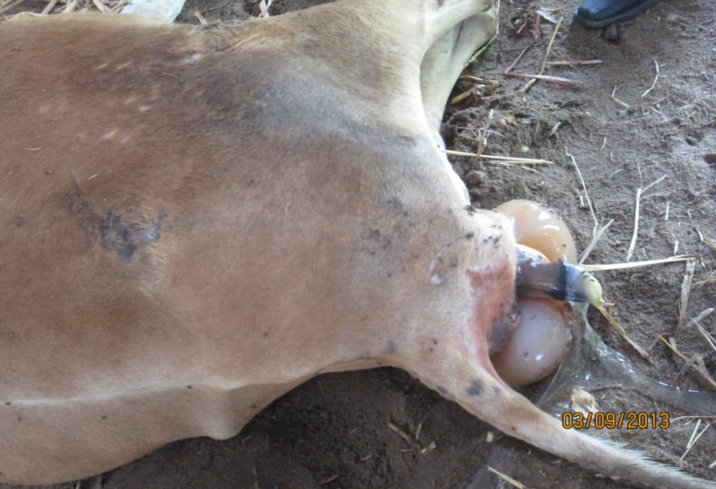

Figure: Correction of dystocia in a cow.

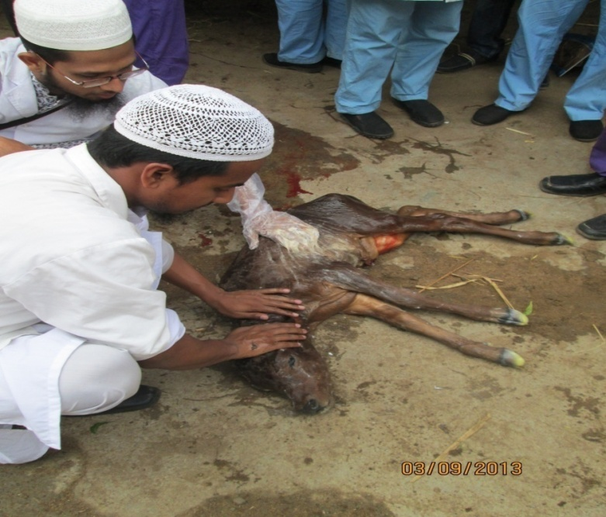

Figure: Fetus after correction of difficult birth.

Chapter-V

DISCUSSION

Total study populations were 315 cattle and buffaloes, among them 18 were dystocia which were 5.71% of different diseases in the cows and buffaloes at Namakkal. Williams (1943) indicated that incidence of dystocia in cow was about 5.56% which is very similar to this result.

The recorded different reproductive diseases and disorders in Namakkal veterinary hospital were dystocia 31.57%, retained placenta 33.33%, abortion 10.52% and ovarian cyst 24.56% (Table 2) among the different reproductive problems. Kesler et al. (1982) reported that the incidence of ovarian cyst in cow is 5.6-47.4% and Whitmore et al. (1974) reported that the average incidence of retained placenta for all calvings were seem to be about 11%; for normal calving it is about 8% and for dystocias it is about 25-55%.

This study showed that occurrence of dystocia was higher in heifers (75.84%) than in cows and buffaloes (24.16%). Edwards (1979) recorded 66.5%, 23.1%, and 14.3% of assisted deliveries in the first, second and third calvings. This is because the heifers have relatively constricted birth canal, low supply of balanced feed, poor management and lack of knowledge of the farmers about the occurrence of dystocia. Lindhe (1966) reported that the younger the heifer, the higher is the dystocia rate. This study gave the similar result like Edwards (1979) and Lindhe (1966). This study also gave support to result of the Adams and Bishop (1963). They found that 85% of all the dystocia were in heifers. Wilthers (1953) also reported that dystocia was almost three times more common in heifers than in cows. This study result also support to the Williams (1968) observation. He reported that difficult birth occur more in heifers than in cows. O’Brien and Stott (1977) reported that the 1st calving heifer suffered more from dystocia than other cows.

This study showed that the occurrence of dystocia was higher in case of artificially inseminated cows and buffaloes than the served naturally. Percentage of occurrence was 88.34% in artificially served and 11.66% in naturally. This is because incase of AI service mostly the semen of heavy bull is used and most of this cases dystocia occur due to the fetal oversize

Chapter-VI

CONCLUSION

From above study we can say that dystocia is a great problem along with other reproductive diseases in cows and buffaloes at Namakkal. The incidence and severity of dystocia can be reduced by breeding sound management provided with balanced nutrition, routine deworming and vaccination. Some calving difficulties may occur lack of conciousness. Scientific management system should be provided to the cows and buffaloes during pregnancy and after parturition especially last 3 months of pregnancy and first 3 months of parturition to reduce the dystocia. Farmer awareness is a great important thing in rearing dairy cows and buffaloes in village level. Losses from dystocia can be minimized by:

1. Close observation of animal during calving.
2. Provision of suitable handling facilities.
3. Technical support to aid delivery.
4. Judgement to seek professional assistance promptly when indicated.
5. Proper hygienic management of the farm house.
6. Govt. Officials should have to try to implement all the programmers accordingly.

Chapter-VII

REFERENCE

Ahmed, J; Alp H., Aksin, M. and Seitzer, U. 2007. Current status of ticks in Asia. Parasitol. Res. Sep; 101 (2): 159-162.

Ali, M. J. 1994. Current status of Veterinary Biologics Production in Bangladesh and their quality control proceeding of BSVER symposium held on July 28, 1994 at NIPSOM auditorium, Mohakhali, Dhaka, Bangladesh.

Arther, G. H. (1964) Wrights Veterinary obstetrics, 3rd edition,Wiliams and Wilkins Co.,Baltimare, Md

Arthur, G. H. (1966) Recent Advances in ovine obatetrics, Veterinary Record. 79, 22, 630

Baglapedia, National Enchyclopedia of Bangladesh, 2003. Published by Asiatic Society of Bangladesh. Dhaka, Bangladesh. 515pp.

Bendavid, B. (1961) Obstretical problems in the Observations on Abnormal Parturition, Refua Vet. 18. 152.

Benesch,F. and Wright, J. G. Veterinary Obstetrics, Williams and Wilkins Co.Baltimore,Md.19,789.

Boyd, L. J. and Hafs, H. D.(1965) Body Size of Calves from Holstein Dams and Sired by Holstein and Angus Bulls, Journal Dairy Science. 48,9,1236.
Bratton, RW. (1957) Breeding Difficulties in ovine, Cornell Univ. Agr. Exp. Stat. Bull. 924, Ithaca, N.Y.

Corah, L. A. Fleck, M. McKee, and R. Schalles. 1978. Eflëct of energy level during late gestation on the performance of heifers calving for the first time. Kansas Agr.Exp. Sta.Rep.of Progress 320.

Deutscher, G.H. 1990. Pelvic measurements for reducing calving difficulty.Extension Resource Committee Handbook.BCH-2 130.

Deutscher, GD. Colburn, and R Davis. 1999. Climate affects birth weights and calving difficulty. 1999. Nebraska Report.MP-7 1.

DLS (Department of Livestock Services). 2000. Department of Livestock Services-An overview. DLS, Dhaka, Bangladesh.

DLS (Department of Livestock Services). 2003. Department of Livestock Services-An overview.

Edward, S.A. (1979). Journal. Agricultural Science, Cambridge. 93,359.

Greene, H. J. (1984). Proc. 13th World Congress. Diseases of Cattle, London, P. 859.

Hendricks, D. M., Rawlings, N. C., Ellicott, A.R., Dickey, J. F. and Hill, JR (1977). J. Animal Science. 44,438.

Jochie, W, Esparza, P., Gimenez, T. and Hidaigo, M. A. (1972). J. Reprod. Fertil., 28, 407.

Kesler, D. J. and Garverick, H. A. (1982). J. Animal Science, 55, 1147.

Laster, D. B. Glimp, H. A., Cundiff, L.V. and Gregory, K.E. (1973). J. Animal Science.36,695.

Lindhe. (1966). wild Rev.Animal production. 2, 53.

Morton, D. H. and Cox, J. E. (1968). Veterinary Record., 82, 530.

O’Brien, T. and Stott, G.H. (1977). J. Dairy Science., 60, 249.

Right, J. G. (1958). Veterinary Record, 70, 347.

Roberts. S. J. (2004). Dystocia- its causes Veterinary obstetrics and genital diseases, 2nd edition, p-227.

Sloss. V. Ai1 Duftv, JH. (1980). Handbook of Bovine Obstetrics. Baltimore: Williams and Wilkins.

Tint. J. B. (1944). Veterinary Journal. 100, 154, 182.

Whitmore, H. L., Tyler, W. J. and Casida, L. E. (1974). Journal Animal Science., 38, 339.

Williams, K. R. (1949). Proc. N. Z. Soc. Animal Production., 85.

Williams, W. L. (1943). Veterinary obstetrics, 4th edition. Miss louella Williams, upland Rd. Ithaca, N.Y.
Wiltbank, J. N., Kasson, C. W., and J. E Ingalls. 1969.Puberty in crossbred and straightbred beef heifers on two levels of feed. J. Animal Science 28; 602—605.

Withers, F. W. (1953). British Veterinary Journal. 109,122.

Williams, K. R. (1968). Veterinary Record. 83, 87.

