DYSTOCIA MANAGEMENT AND ITS COMPLICATION IN COMPARE WITH OTHER REPRODUCTIVE DESEASES IN COWS AND BUFFALOES AT NAMAKKAL, INDIA

A Clinical Report Submitted by
Roll No.: 08/33
Registration No.: 375
Internship ID : C-22
Session: 2007-2008

CHITTAGONG VETERINARY AND ANIMAL SCIENCES UNIVERSITY

March, 2014

DYSTOCIA MANAGEMENT AND ITS COMPLICATION IN COMPARE WITH OTHER REPRODUCTIVE DESEASES IN COWS AND BUFFALOES AT NAMAKKAL, INDIA

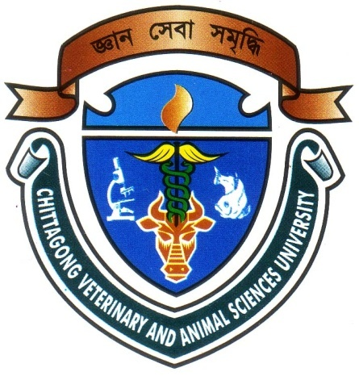

A Clinical Report Submitted as per approved style and content

Signature of Supervisor
Dr. Md. Masuduzzaman
Professor and Head
Dept. of Pathology and Parasitology
Chittagong Veterinary and Animal Sciences University, Chittagong.
Signature of Author
Md. Hannan Mia
Roll. No: 08/33
Registration No.: 375
Internship ID : C-22
Session: 2007-2008

March, 2014

Plagiarism certificate

I’m pleased to declare that all of the information’s were collected by me in a correct and appropriate way during my study period and some information were taken from the doctors of Namakkal Veterinary Hospital.

I also declare that I did not copy any information or model to analyze the whole study from any of my classmates. Only some literatures were collected from some books and journals.

Date
Signature of Author

INDEX

Sl. No | Contents | Page
01 | Acknowledgement | i
02 | Abstract | ii
03 | Introduction | 1-6
04 | Review of Literature | 7-10
05 | Materials and Methods | 11-12
06 | Results | 13-18
07 | Discussion | 19-20
08 | Conclusion | 21
09 | References | 22-24

GRAPH

Sl.No. | Contents | Page
01 | Percentage of occurrence of dystocia among different diseases in cows and buffaloes. | 13
02 | Different reproductive disorders in cows and buffaloes. | 14
03 | Percentage of occurrence of dystocia in 1st calving heifers, cows and buffaloes. | 15
04 | Percentage of dystocia in cows served by artificially and naturally. | 16

PHOTOGRAPH

Sl.No. | Contents | Page
01 | Dystocia in a cows and buffaloes. | 17
02 | Correction of dystocia in 1st calving heifer. | 17
03 | Correction of dystocia in a cow. | 18
04 | Fetus immediately after difficult birth. | 18

ACKNOWLEDGEMENT

The author is ever grateful and indebted to the Almighty Allah without whose grace; it would have never been possible to pursue this study in this field of Science and to complete this clinical report writing for the Degree of Doctor of Veterinary Medicine.

The author express his deepest sense of gratitude, sincere appreciation and profound regards to authors reverend and beloved teacher and supervisor Dr. Md. Masuduzzaman, Professor and Head, Dept. of Pathology and Parasitology, Chittagong Veterinary and Animal Sciences University for her scholastics guidance, uncompromising principles, sympathetic supervision, valuable advice, constant inspiration, radical investigation and constructive criticism in all phases of this study and preparing the manuscript.

The author would like to express his deep sense of gratitude and gratefulness to the Internship Co coordinator Dr. Bibek Chandra Sutradhar, Associate Professor, Dept. of Medicine and Surgery, Chittagong Veterinary and Animal Sciences University, for his constant inspiration and valuable suggestion for completion of the report work.

The author would like to express his deep sense of gratitude and gratefulness to Dr.Silvarajo,Professor ,Dept. of Gynecology and Obstetrics, Namakkal Veterinary College and Research Institute, Namakkal, India.

The author

i
Dystocia management and its complication in compare with other reproductive deseases in cows and buffaloes at Namakkal, India

ABSTRACT

The study was carried out at Namakkal Veterinary hospital, Namakkal, Tamilnadu for a period of 03-18 September 2013 to find out the incidence of dystocia in cows and buffaloes. Total study populations were 315 cattle and buffaloes, among them 18 were dystocia. The frequency of occurrence of dystocia in cows and buffaloes was 5.71% among different diseases in cows and buffaloes. Among the reproductive diseases (total 57) it was 31.57%.Out of 18 dystocia cases, in 1st calving heifers it was 75.84% and 24.16% having more than one parity. The incidence of dystocia was 88.34% and 11.66% which were bred by artificially and naturally respectively.

Key words: Dystocia, Natural Service, 1st calving heifers,

ii

