A report on
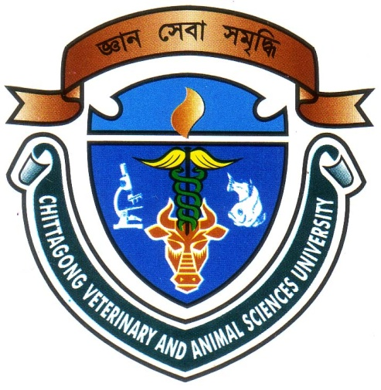
Hematological and blood biochemical studies of semi-captive elephants at Dulahazra Safari Park, Cox’s bazar

A CLINICAL REPORT SUBMITTED
BY
ROLL NO: 08/43
INTERN ID: C-28
REG. NO: 385
SESSION: 2007-2008

A PART OF FULLFILLMENT OF THE REQUIREMENTS FOR THE DEGREE OF
DOCTOR OF VETERINARY MEDICINE (DVM)

CHITTAGONG VETERINARY AND ANIMAL SCIENCES UNIVERSITY
March, 2014
Hematological and blood biochemical studies of semi-captive elephants at Dulahazra Safari Park, Cox’s bazar

A Report Submitted as Per Approved Style and Content

Signature of author  Mohammed Muslim Uddin  Intern ID: C-28  Roll No. : 08/43  Reg. No. : 385  Session : 2007-2008 | Signature of supervisor  Dr. S. K. M. Azizul Islam  Associate Professor  Department of Physiology Biochemistry & Pharmacology  Chittagong Veterinary and Animal Sciences University
CHITAGONG VETERINARY AND ANIMAL SCIENCES UNIVERSITY
MARCH, 2014
CONTENTS
Chapter | Contents | Page No
 | Acknowledgement | i
 | Abstract | ii
I | Introduction | 01 – 02
II | Review of Literature | 03 – 07
III | Materials and Method | 08 – 09
IV | Result and Discussion | 10 – 14
V | Conclusion | 15
VI | References | 16 – 19

LIST OF THE TABLES
Table 1 | Hematological parameters of elephants | 11
Table 2 | Hematological parameters between male and female elephants | 12
Table 3 | Biochemical parameters of elephants | 13
Table 4 | Biochemical parameters between male and female elephants | 14

ACKNOWLEDGEMENTS

The reverence is to the omnipotent “Almighty ALLAH” who enabled the author to complete this work successfully.

The author expresses his sincere gratitude, heartfelt respect and immense indebtedness to his honorable supervisor and respected teacher Dr. S. K. M. Azizul Islam, Associate Professor, Department of Physiology, Biochemistry and Pharmacology, Faculty of Veterinary Science, Chittagong Veterinary and Animal Sciences University, for his constructive and constant guidance in planning and execution of this research work.

The author would like to express his deep sense of gratitude and great fullness to the Director of External Affairs Dr. Bibek Chandra Sutradhar, Associate Professor, Department of Medicine and Surgery, Chittagong Veterinary and Animal Sciences University for his constant inspiration and valuable suggestion for completion of the report work.

The author expresses his very special thanks to DR. Md. Hatem Julkarnine (Manik) for his constant help at Safari Park.

The author is grateful to Mr. Rafiqul Islam, technician of biochemistry lab. & Mr. Md. Enamul Hoque, Technician of physiology lab. for their help during lab Work.

Finally, the author wishes to express his sincere gratefulness to his Parents, brother, sisters and all other well wishers for their blessing throughout his academic life.

The Author
March, 2014
i
Abstract

This study was conducted in semi-captive Asian elephants (Elephas maximus) at Dulahazra Safari Park, Cox’s bazaar for a period of 1 month 25th December ’13 to 23th January ’14 to know the existing management systems and haemato-biochemical parameters. Haematological and biochemical parameters were determined following standard procedure. On hemato-biochemical examination, hemoglobin concentration 9.48$±$0.576$\%$, packed cell volume 30$±$3.80$\%$, erythrocyte sedimentation rate 34.8$±$9.20, total erythrocyte count 1.91$±$0.30 million/cmm, total leukocyte count 9.77$±$5.37 thousand/cmm were nearby similar to normal range. Serum levels of glucose 98.38$±$38.321 mg/dl, calcium 20.44$±$9.058 mg/dl, potassium 7.76$±$0.86 mmol/l, phosphorus 6.56$±$0.58mg/dl, chlorine 116.32$±$33.82 mmol/l, albumin 6.92$±$1.69 g/dl, bilirubin 0.04$±$0.05 mg/dl, glutamic pyruvate transaminase 12.68$±$3.65U/L, glutamic oxaloacetic transaminase 26.88$±$6.77U/L and uric acid 6.56$±$7.17 mg/dl were recorded in this study was slightly higher; total protein 7.32$±$0.60 g/dl, magnesium 1.3$±$0.4 mg/dl were slightly lower than that of normal range. In male ESR, TEC, TLC, neutrophils, monocytes, glucose, total protein, calcium, magnesium, potassium chlorine , bilirubin and uric acid were found higher as compared to female. Further comprehensive study is necessary with large number of study population.

Keywords: Elephant, Hematology, Serum, Biochemistry.

ii

