Correction of femoral fracture in a cat by intramedullary pinning at UMK Teaching Hospital, Malaysia.

Submitted By:
MD.MOSHIUR RAHMAN
Roll No: 17/110; Reg No: 01888
Intern ID: 81
Session: 2016-17

A clinical report submitted in partial satisfaction of the requirements for the degree of Doctor of Veterinary Medicine (DVM)

Faculty of Veterinary Medicine
Chattogram Veterinary and Animal Sciences University, Khulshi, Chattogram-4225, Bangladesh

November 2023
Correction of femoral fracture in a cat by intramedullary pinning at UMK Teaching Hospital, Malaysia.

Approved By:

Prof. Md. Rayhan Faruque, PhD
Department of Medicine and Surgery

Faculty of Veterinary Medicine
Chattogram Veterinary and Animal Sciences University, Khulshi, Chattogram-4225, Bangladesh

November 2023

TABLE OF CONTENTS

Contents | Page No.
List of tables | ii
List of figures | ii
List of abbreviations | iii
Abstract | iv
Chapter I: Introduction | 1-2
Chapter II: Materials and Methods
2.1 Case History | 3
2.2 Radiographic Examination | 4
2.3 Restraining and Anesthesia | 4
2.4 Preoperative Medication | 4
2.5 Surgical Technique | 5-7
2.6 Post-operative Care | 8-9
Chapter III: Result and Discussion | 10-11
Chapter IV: Conclusion | 12
Limitations | 12
References | 13-14
Acknowledgment | 15
Biography | 16

LIST OF TABLES

Table No. | Table Tile | Page No.
Table 1 | CBC report of Oreo | 3

LIST OF FIGURES

Figure No. | Figure Tile | Page No.
Figure 1 | Lateral view of X-ray of hind limb | 4
Figure 2 | Ventral view of X-ray of hind limb | 4
Figure 3 | Induction of anesthesia, endotracheal intubation, surgical site preparation, and preoperative patient preparation | 5
Figure 4 | Incision of skin exposing the underlying tissue | 6
Figure 5 | Exposing fractured bone | 6
Figure 6 | Insertion of intramedullary pin | 6
Figure 7 | Fixation of fractured bone | 6
Figure 8 | Fixation and cutting of pin | 7
Figure 9 | Suturing muscle, subcutaneous tissue, and skin | 7
Figure 10 | Vital signs monitoring and record keeping | 7
Figure 11 | Applying a modified Robert Jones bandage on the affected limb | 8
Figure 12 | Ventral view of postoperative X-ray of hind limb | 9
Figure 13 | Lateral view of postoperative X-ray of hind limb | 9

LIST OF ABBREVIATIONS

Abbreviation | Elaboration
% | Percentage
µL | Microliter
µm | Micrometer
BID | Two times a day
gm/dl | Gram per liter
GRA | Granulocytes
HCT | Hematocrit
HGB | Hemoglobin
IM | Intramuscular
IMP | Intra medullary pinning
IV | Intravenous
LYM | Lymphocytes
MCH | Mean corpuscular hemoglobin
MCHC | Mean corpuscular hemoglobin concentration
MCV | Mean corpuscular volume
Mg | Milligram
MON | Monocytes
MPV | Mean platelet volume
PCT | Plateletcrit
PCV | Packed cell volume
PDW | Platelet distribution width
Pg | Picogram
PLT | Platelet
RBC | Red blood cell
RDW | Red cell distribution width
SC | Subcutaneous
SID | Once daily
WBC | White blood cell

ABSTRACT

The current case report's goal was to outline a surgical strategy for treating a cat's femur fracture. During an externship placement, the case was documented at the University Malaysia Kelantan Veterinary Medicine Teaching Hospital located in Bachok, Kelantan, Malaysia. A Domestic short-haired male cat, nine months old and weighing 3.7 kg, named Oreo was brought to the UMK hospital after experiencing leg-carrying lameness as a result of being struck by a car on the road. Physical examination revealed that the cat was alert and active. Right femur discomfort and crepitation were felt upon palpation, and a complete femoral fracture was confirmed by radiography. The doctor fixed the bone by pinning but it came out by rupture of skin Then they decided to do pinning for the second time. Using a conventional surgical technique, retrograde intramedullary pinning (pin type K WYRE, 1.6 mm) was used to treat the fracture. Throughout the procedure, general anesthesia (Isoflurane only, 5% for induction and 3% for maintenance) was administered and maintained. Amoxicillin and clavulanic acid combination (17 mg/kg, IM), Meloxicam (0.3mg/kg, SC), Tramadol (4 mg/kg, slow IV), vitamin K1 (2.5 mg/kg, SC) and vitamin B12 (100 mcg/kg, IM) were used as preoperative medications. Clindamycin (30 mg/kg, IM, SID, 6days), Meloxicam (0.3 mg/kg, SC, SID, 3days), Methylcobalamine (500 mcg, orally, BID, 6days), Beazyme tablet ( 1 tab/1,50000 IU Papain, orally, BID, 6days) and Sonoton therapy (15 mins, BID, for 6days) were given together with protective bandages as part of the post-operative treatment. On the seventh postoperative day, mild weight-bearing was noted, and on the tenth day following surgery, the sutures were removed. Three months following surgery, the cat was fully recovered and able to bear weight on the injured limb, with no difficulties related to bone repair. The current case study indicates that treating feline femur fractures with intramedullary pinning with wires is highly successful.

Keywords: Femur fracture, intramedullary pinning (IMP), radiography.

CHAPTER I

INTRODUCTION

Cats have long been cherished companions and members of countless households worldwide. Their role as pets has evolved from mere utility to that of valued family members. This elevated status places a significant responsibility on veterinarians and the field of veterinary medicine to ensure the health and well-being of these beloved feline friends. Orthopedic injuries, particularly fractures, are among the most common and challenging medical issues to treating cats (Aithal et al., 1999; Scott, 2005). A fracture is a loss of continuity and balance in the bones and cartilages caused by injury to the bone tissue. A frequent issue in the field of orthopedics in both dogs and cats is the occurrence of long bone fractures. Among the various bones susceptible to fracture, the femur, the longest and one of the strongest bones in the feline skeletal system. According to Scott (2005), these fractures make up 50% of all feline fractures, and the femur is a commonly broken bone in both dogs and cats, as noted by Johnson et al. in 1989. Furthermore, it was demonstrated that femoral fractures constitute 45 percent of all long bone fractures, with femoral diaphysis fractures making up 28 percent of these fractures (Harasen, 2003). Another study by Das et al. in 2010 found that the femur had the highest proportion of fractures at 42.86 percent, followed by the humerus at 25.40 percent, the radius and ulna at 20.63 percent, and the tibia and fibula at 11.11 percent.
Fracture patterns will vary based on the specific forces the bone experiences, such as compression, bending, tension, or torsion (Cullinane et. al., 2001). Additionally, the rate at which force is applied, as pointed out by Johnson in 2002, can influence both the type of fracture and the extent of soft tissue damage. Various types of femur fractures, including those involving the capital physeal, femoral neck, trochanteric, subtrochanteric, diaphyseal, supracondylar, condylar, or distal physeal regions, can occur. In immature dogs and cats, femur fractures are most commonly found at the proximal or distal physis. For long bones, the metaphyseal, diaphyseal, and epiphyseal segments may also be affected (Tercanlioglu and Sarierler, 2009).
The evaluation of a femur fracture in a cat is crucial for effective treatment planning. Cats have a tiny body size and a tendency to wander into traffic, which makes them vulnerable to complex fractures. Both palpation and radiography are effective means of identifying fractures in cats. It's essential to assess factors like the fracture's location, whether it's open or closed, the type of fracture, joint involvement, and the direction of distal fragment displacement. When treating femoral fractures, techniques such as biological osteosynthesis and anatomic reduction with stabilization can be employed. The choice of surgical approach will vary depending on the chosen method. However, in less severe cases, cats can often be restored to health through less invasive treatments rather than extensive reconstructive surgery. The fundamental idea is to realign two fracture fragments to their natural positions, either through closed or open fixation procedures. Repairing long bone fractures can be achieved using a range of devices, each with its advantages and disadvantages. These devices include the lag screw, intramedullary pin, bone plate, and screws, interlocking and cross pins, dynamic compression plate, and cerclage wire (Perren, 2002; Horstman et al., 2004).
Among all the surgical techniques that have been developed to address femur fractures in cats, intramedullary pinning emerging as a notable option (Scott, 2005). Intramedullary pinning involves the placement of a metal pin or rod within the medullary cavity of the femur to stabilize the fracture and promote healing (Stigen, 1999; Scott, 2005). The process of inserting pins is straightforward from a technical standpoint, and the required tools and implants are both affordable and readily accessible. The feline femur is characterized by being a straight, tubular bone with a large medullary canal. It's important for the pin to fill approximately 70% of the medullary canal's diameter, thanks to a significant additional blood supply outside the bone, which contributes to speedy healing. Most fractures typically affect the diaphysis and the distal shaft of the femur. Intramedullary pinning approach has gained popularity due to its potential benefits, such as reduced complications and improved postoperative function.

The aim of this case report is to explore the clinical and radiological evaluation of a femoral fracture in a cat and the successful stabilization of the fracture using intramedullary pinning guided by a C-arm X-ray.

CHAPTER II
MATERIALS AND METHODS
2.1 Case History
Haemogram | Test Result | Reference value
WBC 10^3/µL | 16.4 | 6.0-15.15
LYM | 7.3 H | 1.0-5.0
MON | 1.5 H | 0.1-1.0
GRA 10^3/µL | 7.6 | 2.0-8.0
LYM% % | 44.3 | 20.0-55.0
MON% % | 9.3 | 2.0-12.0
GRA% % | 46.4 | 35.0-75.0
RBC 10^6/µL | 9.48 D | 6.5-10.00
HGB g/dl | 12.2 | 10.0-15.0
HCT % | 45.0 | 30.0-45.0
MCV µ^3 | 47.5 | 39.0-55.0
MCH pg | 12.9 L | 25.9-34.0
MCHC g/dl | 2.1 L | 30.0-35.9
RDW % | 17.3 H | 10.0-16.0
PLT 10^3/µl | 102 | 300-800
MPV µm^3 | 9.5 | 7.0-11.0
PCT % | 0.097 L | 0.200-0.500
PDW % | 42.4 H | 10.0-18.0
Oreo, a nine-month-old domestic short-hair cat, arrived at the UMK Veterinary Medicine Teaching Hospital weighing 3.7 kg and presenting with a history of injury to his right-hind limb. Oreo was struck by a car on the road, according to the owner's complaint. The cat was unable to support its weight on its right hind limb upon presentation. Upon palpating the afflicted limb, palpation revealed signs of discomfort and crepitation. To locate the fracture, a preoperative radiograph was obtained. Radiographs revealed a proximal segmental fracture of the right femur. Using the results of the radiographic evaluation as a guide, C-arm guided intramedullary pinning was done but the pin came out by rupture of skin. Then the doctor decided to do intramedullary pinning for second time. The owner's verbal consent was obtained to carry out the procedure. Before surgery, the patient's overall health was also recorded.
Table 1: CBC report of Oreo

2.2 Radiographic Examination

A radiographical examination was performed on lateral and ventral views by using a digital X-ray machine which confirmed that the cat had suffered from a postoperative injury with a pin that came out by rupture of the skin (Figures 1 and 2).
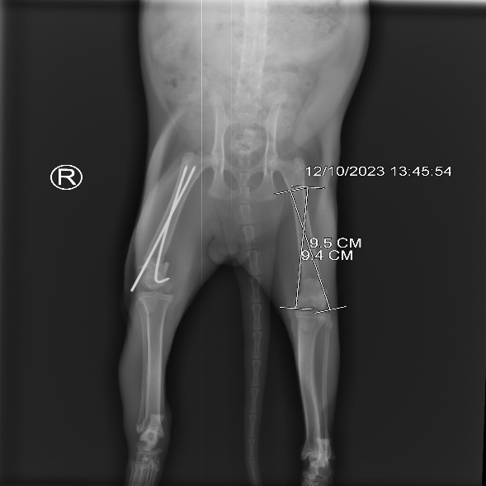
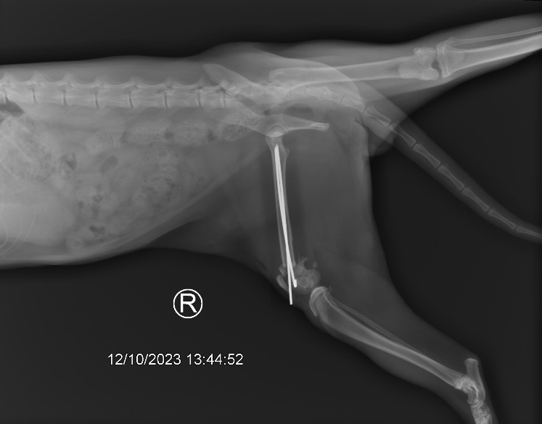

Figure 2: Ventral view of X-ray of hind limb
Figure 1: Lateral view of X-ray of hind limb

2.3 Restraining and Anesthesia
The cat was restrained by a towel and an assistant held the cat and another assistant provided inhalation anesthesia (Isoflurane 5%). After 5-6 minutes the cat was relaxed and anesthetized. Then they inserted a 3.5 mm cuffed endotracheal tube through the trachea and reduced the Isoflurane percentage to 3%. The area was shaved with a trimmer and washed the skin with chlorhexidine, then alcohol, and then 5% povidone-iodine. Then shifted the cat to the OT table.

2.4 Preoperative Medication
The doctor injected a combination of Amoxicillin and Clavulanic acid @ 17mg/kg, IM; meloxicam @ 0.3 mg/kg, SC; Tramadol @ 4 mg/kg, slow IV; vitamin K1 @ 2.5 mg/kg, IM; and vitamin B12 @ 100 mcg/kg, IM as preoperative medication to reduce pain and infection during surgery.
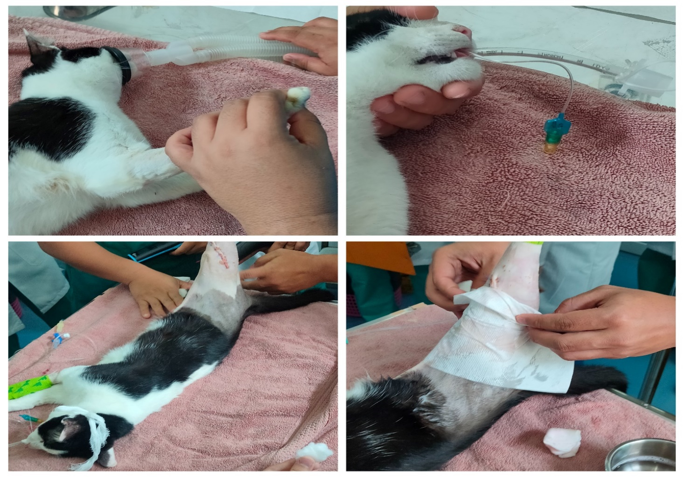
Figure 3: Induction of anesthesia, endotracheal intubation, surgical site preparation and preoperative patient preparation.

2.5 Surgical Technique
After patient preparation and draping of the patient, the previous suture was removed, and the previous incision line was opened by blunt dissection. The incision was given on the subcuticular muscle layer to expose the underlying muscle bundles. Then by blunt dissection, the muscle bundles of vastus lateralis and biceps femoris were separated to expose the underlying bone. The point of fracture was identified by retracting the muscle bundle and exposing the fractured bone. The fractured parts were taken in apposition with each other and held by bone-holding forceps. Then two intramedullary pins (k-WYRE 1.6mm) were inserted obliquely through the lateral and medial condyle into the medullary cavity of the femur. Then holding the condyle using bone-holding forceps the intramedullary pins were curved according to the natural curvature of the condyle. The pins were cut at the appropriate size (8.9 mm for both pins) using a pin cutter. The site was washed with metronidazole solution (5 mg/ml) and Normal saline solution. Then the muscle layer was closed using absorbable suture materials Ecosyn 3/0, Poly (Glycolide-co-Caprolactone) in a simple continuous pattern. The subcuticular layer was closed using the same suture material in a simple continuous pattern. The skin was closed by non-absorbable suture material Brilon 3/0 Synthetic, Monofilament, Polyamide in an interrupted horizontal mattress pattern.
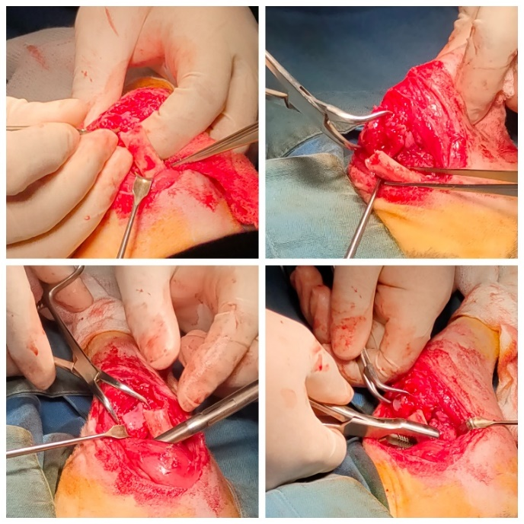
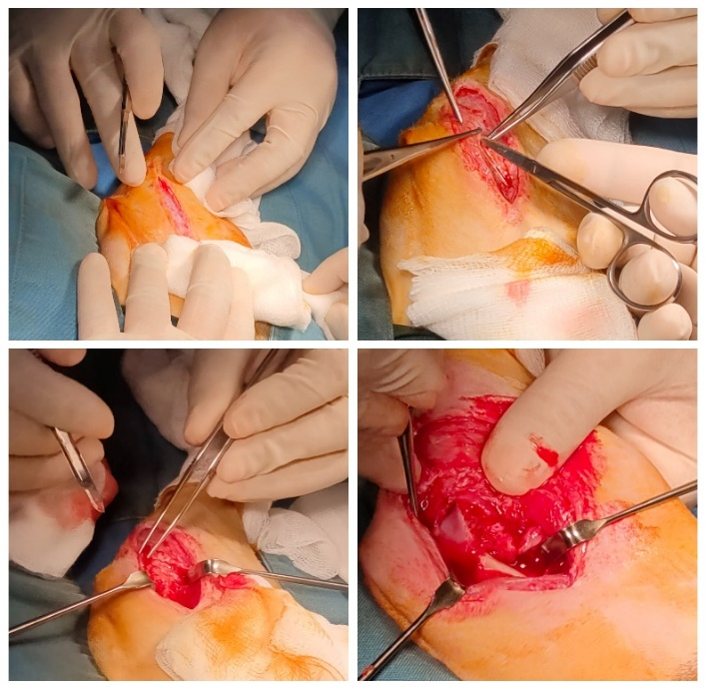

Figure 5: Exposing fractured bone

Figure 4: Incision of skin exposing underlying tissue

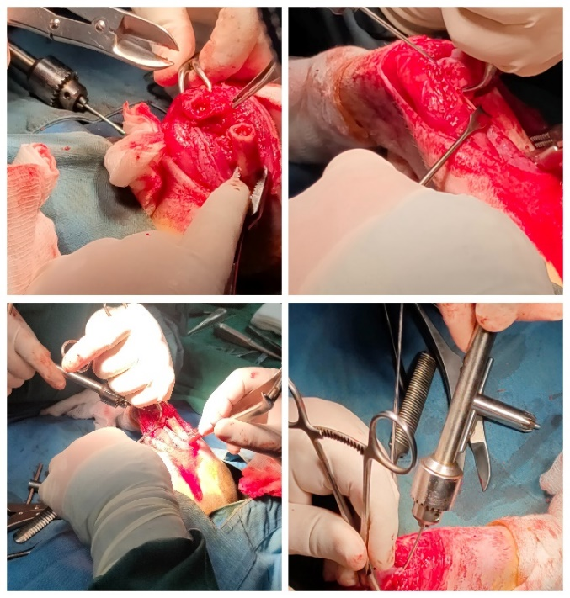
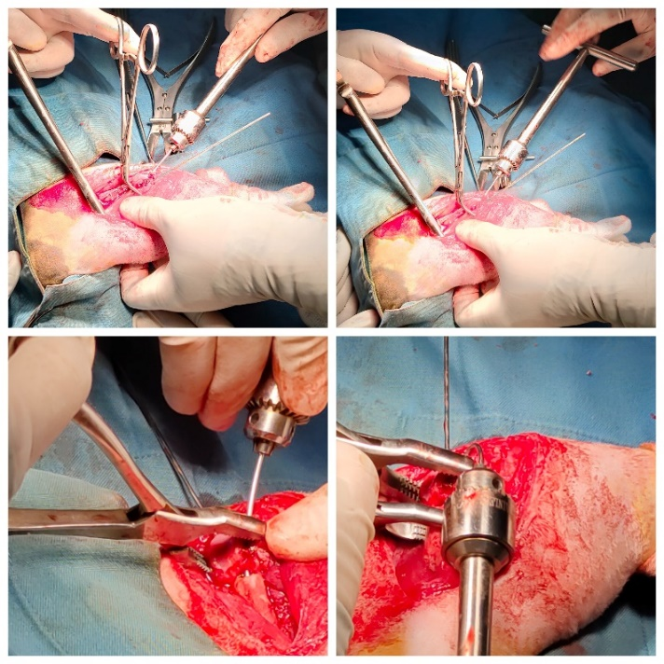

Figure 7: Fixation of fractured bone

Figure 6: Insertion of intramedullary pin

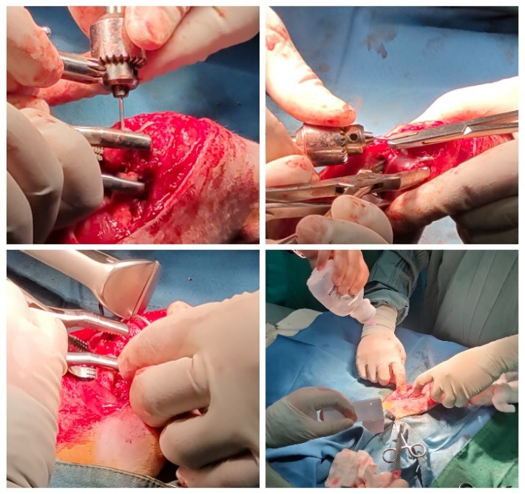
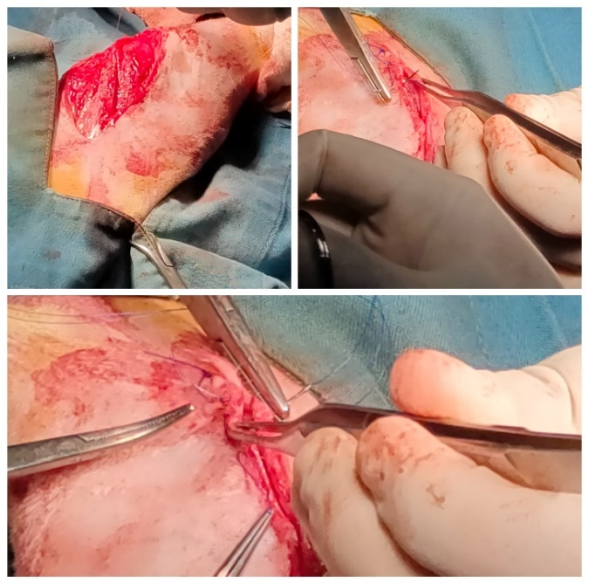

Figure 9: Suturing muscle, subcutaneous tissue and skin
Figure 8: Fixation and cutting of pin

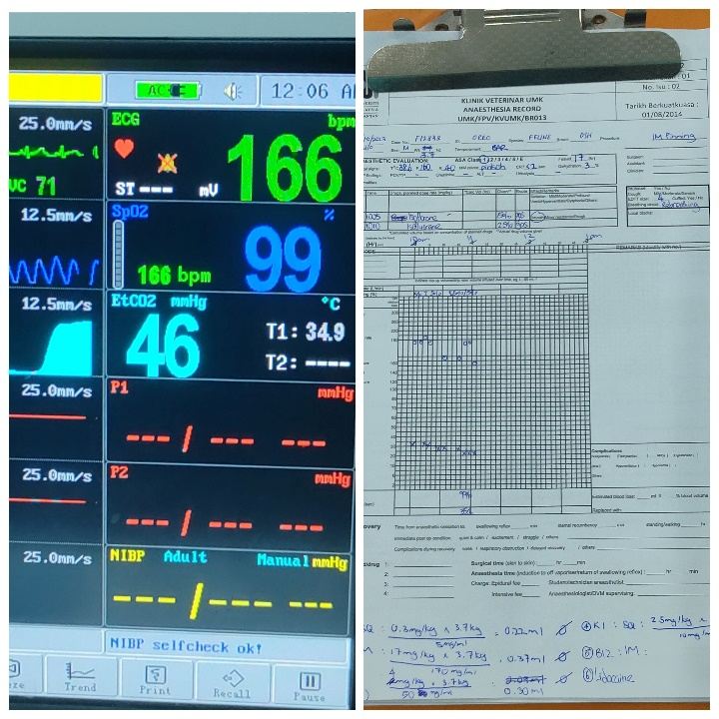

Figure 10: Vital signs monitoring and record keeping
2.6 Post-operative Care
After surgery Chloramphenicol 1% ointment and ‘Opsite spray’ was applied to surgical wound then modified Robert Johnes Bandage was applied on the affected leg. Postoperatively the cat was treated with systemic antibiotics, analgesics, and nerve tonic with a protective bandage and restricted movement for one week. Fentanyl @ 50 mcg/kg was given in a single dose to reduce post-surgical pain. Clindamycin @ 30 mg/kg, IM, SID, for 6 days; meloxicam @ 0.3 mg/kg, SC, SID, for 3 days; methylcobalamine @ 500 mcg, orally, BID, for 6 days; Beazyme tablet @ 1 tab (1,50000 IU Papain), orally, BID, for 6 days and ‘Sonoton’ applied on the affected area for 15 minutes, BID, for 6 days.
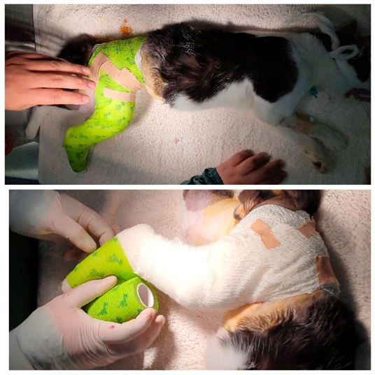
Again, the radiographical examination was performed after the the surgery on both lateral and ventral view by using a digital X-ray machine which confirmed that the pins were in good condition (Figures 12 and 13).

Figure 11: Applying modified Robert Jones bandage on the affected limb
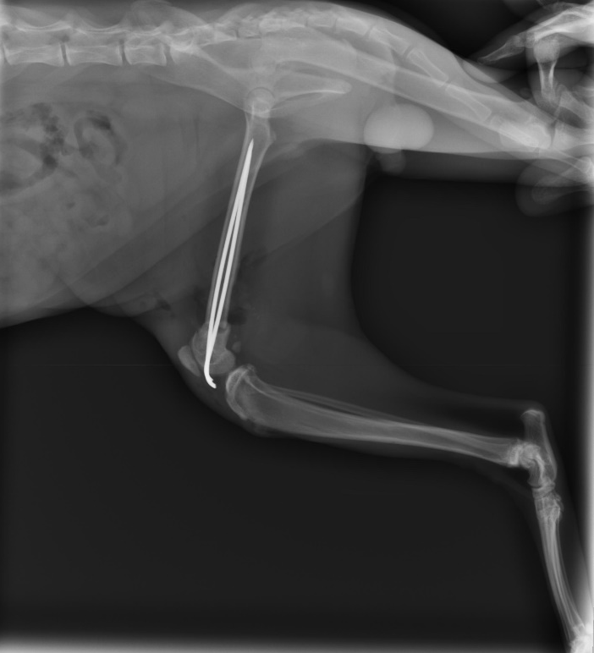
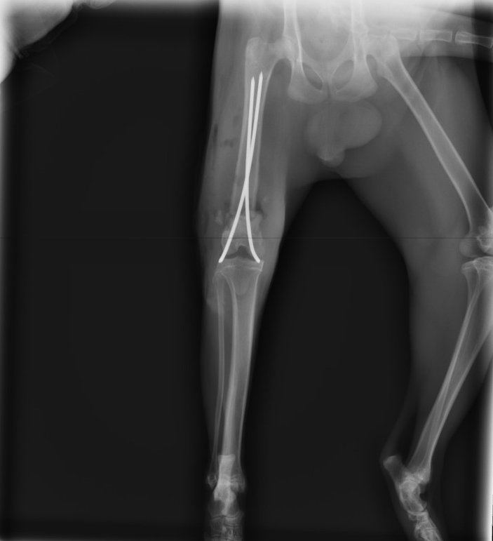

Figure 13: Lateral view of postoperative X-ray of hind limb
Figure 12: Ventral view of postoperative X-ray of hind limb

CHAPTER III
RESULT AND DISCUSSION

The results of this study show that the cat was able to begin bearing some weight 7 days after the procedure and to be able to bear its entire weight 2 months and 15 days later. The femur's bone and shaft are the most often fractured locations in cats. Research into the past has revealed that falls from a considerable height and severe injuries are the two most common causes of fractures. (Denny and Butterworth, 2008). Anatomically reduced fractures were tightly anchored using pins, wires, screws, and plates in traditional internal fracture healing techniques. This was carried out to reduce the possibility of more fractures. (Sultana, 2019). There are techniques that need to have pins inserted into the intramedullary area in order to be used with the femur. There are intrinsic problems in several of the well-established procedures for treating distal femoral fractures, including muscle tie-down, inappropriate reduction or pin placement, irritation of soft tissues, and joint pain or arthritis due to damage from pin cuts. These are, however, a few of the various methods. Furthermore, some techniques require additional surgical intervention to remove the implants after they have been placed. (Dehghani et al., 2013). However, it was shown that treating distal end femoral fractures with an arrow pin in addition to external fixation was effective. This was done to get around the issues mentioned before. Generally speaking, an intramedullary pin should occupy between 70 and 80 percent of the medullary cavity's diameter. An intramedullary pin can be inserted more quickly and easily, and once the osteosynthesis material has been withdrawn, the healing process is simple. The intramedullary two-way stacked Kirschner wire application is a more economical and successful technique for treating supracondylar and diaphyseal femoral fractures in cats. (Altunatmaz et al., 2017). Making the right pin selections is crucial because of the potential for pin migration and loosening. The size of the IMP cavity in the bone that needs to be fixed, the shape of the fracture, and the use of any additional means of fixing should all be taken into account when selecting an appropriate pin. It is advisable to use pins with sizes between 1.6 and 4.8 mm for most cats. (Sultana, 2019). However, since the cat was overly active in our situation, we utilized 2.5mm pins for greater stiffness. In this study, the subjective assessment of a patient's mobility throughout the postoperative period was based on a limited number of characteristics. Nonetheless, if a suitable scaled-based assessment for pain and mobility is employed in a longer study for the basic findings that we found in the majority of cats, it may be possible to argue that the arrow pin technique is a better way to fix femoral fractures in cats. This would only be the case if a longer study period was used to examine the outcomes found in the majority of cats. (Rathnadiwakara et al., 2020). The patient was given post-operative antibiotic medicine after surgery with the hope that it would help treat any secondary bacterial infections that could have arisen. In cats, the absence of discharges or post-operative edema at the surgery site indicated that the post-operative treatment was being successfully delivered there. (Erwin et al., 2018). Postoperative care must be managed carefully to prevent problems. Pin detachment and migration are the most frequent problems associated with intramedullary pinning procedures, which are considered to carry a significant risk. Conversely, another risk associated with open fractures is infection. The cat's immunity in this investigation also aided in his speedy recovery.

CHAPTER IV
CONCLUSION

The research indicates that intramedullary pinning is a reasonably priced, effective treatment option for femur fractures that provides satisfactory stability with few complications. Strong fixation and good alignment are given to the broken bone by the intramedullary pinning. Considerations for managing fractures include using the right surgical approach, providing sufficient reduction and stability, choosing the right fixing method, preserving soft tissue, and providing the right postoperative care. In the end, we determined that the use of intramedullary pins was a safe and economical fracture care technique for a cat with a complete femur fracture.

LIMITATIONS
No serum biochemical test of the patient was done. A cultural sensitivity test of the sample from the wound was not done to aid in appropriate antibiotic selection. No supplemental heat source was supplied to prevent hypothermia during surgery.

REFERENCES

- Aithal, H. P., Singh, G. R., & Bisht, G. S. (1999). Fractures in dogs: A survey of 402 cases. Indian Journal of Veterinary Surgery, 20(1), 15-21.
- Altunatmaz, K., Karabağli, M., Aydin, D., Güzel, Ö., Yalin, E. E., Uğurlu, Ü., ... & Ekici, H. (2017). The treatment of supracondylar and diaphyseal femoral fractures incats using intramedullary two-way stacked Kirschner wire application. Turkish Journal of Veterinary & Animal Sciences, 41(2), 282-287.
- Cullinane, D. M., & Einhorn, T. A. (2002). Biomechanics of bone. In Principles of bone biology (pp. 17-32). Academic Press.
- Dehghani N. S., Raayat J. A. R., Foroud, M., Vesal, N., & Hooman, F. (2013). Surgical repair of distal femoral fracture in a wild gray wolf (Canis lupus). Iranian Journal of Veterinary Research, 14(2), 165-168.
- Denny, H., & Butterworth, S. (2008). A guide to canine and feline orthopaedic surgery, 72(1), 18-22.
- Erwin, E., Noviana, D., Umbu, D., & Dewi, T. I. T. (2018). Management femoral fracture in cats using intramedullary pin and wires fixation. The International Journal of Tropical Veterinary and Biomedical Research, 3(2), 32-35.
- Harasen, G. (2003). Common long bone fractures in small animal practice—part 1. The Canadian Veterinary Journal, 44(4), 333.
- Horstman, C. L., Beale, B. S., Conzemius, M. G., & Evans, R. (2004). Biological osteosynthesis versus traditional anatomic reconstruction of 20 long‐bone fractures using an interlocking nail: 1994–2001. Veterinary Surgery, 33(3), 232-237.
- Johnson, A. L. (2002). Bone healing with external skeletal fixation. In Proceedings of the Ninth Annual Complete Course in External Skeletal Fixation (p. 99). University of Georgia, Athens (GA).
- Johnson, A. L., Smith, C. W., & Schaeffer, D. J. (1998). Fragment reconstruction and bone plate fixation versus bridging plate fixation for treating highly comminuted femoral fractures in dogs: 35 cases (1987-1997). Journal of the American Veterinary Medical Association, 213(8), 1157-1161.
- Perren, S. M. (2002). Evolution of the internal fixation of long bone fractures: the scientific basis of biological internal fixation: choosing a new balance between stability and biology. The Journal of bone and joint surgery. British volume, 84(8), 1093-1110.
- Rathnadiwakara, R. W. M. H., De Silva, D. D. N., & Wijekoon, H. S. (2020). Treatment of supracondylar femoral fractures in young cats and dogs using “Arrow Pin” technique. J Vet Med Animal Sci, 3(1), 1017-21.
- Scott, H. (2005). Repair of long bone fractures in cats. In Practice, 27(8), 390-397.
- Stigen, Ø. (1999). Supracondylar femoral fractures in 159 dogs and cats treated using a normograde intramedullary pinning technique. Journal of small animal practice, 40(11), 519-523.
- Sultana, P. (2019). A case report on internal fixation of femur fracture in a cat using C-arm guided intramedullary pinning. A clinical report submitted in partial satisfaction of the requirements for the degree of Doctor of Veterinary Medicine Faculty of Veterinary Medicine Chittagong Veterinary and Animal Sciences University Khulshi, Chittagong-4225, Bangladesh.
- Tercanlioglu, H., & Sarierler, M. (2009). Femur fractures and treatment options in dogs which brought our clinics. Lucrari Stiiniiifice Medicina Veterinara, 42(2), 98-101.

ACKNOWLEDGMENT

All praises go to Almighty “Allah”, the omnipotent, omnipresent, and omniscient, who has enabled the author to complete this manuscript successfully.
The author is also grateful to the honorable Professor Dr. A.S.M Lutful Ahasan vice Chancellor of Chattogram Veterinary and Animal Sciences University and honorable Professor Dr. Mohammad Lutfur Rahman Dean of the Faculty of Veterinary Medicine, Chattogram Veterinary and Animal Sciences University for arranging this type of clinical report as a compulsory part of internship program especially in abroad.
The author is also grateful to the honorable Professor Dr. A. K. M. Saifuddin Director of External Affairs, Chattogram Veterinary and Animal Sciences University
The author wishes to acknowledge Dr. Mohd Farhan Hanif Reduan, Dean Faculty of Veterinary Medicine, University of Malaysia Kelantan.
The author expresses his wholehearted sense of gratification to his respected teacher and supervisor Professor. Md Rayhan Faruque Department of Medicine & Surgery, Chittagong Veterinary & Animal Sciences University, whose encouragement & support helped to complete the report.
Finally, the author would like to express his sincere gratitude and gratefulness to Dr.Nadiah Syuhada Bt Roslan, Veterinary Officer of UMK Veterinary Medicine Teaching Hospital.
The author would like to thank all the staff of the University Malaysia Kelantan Veterinary Medicine Teaching Hospital and also the personnel of the Graduation Research division of the University, for their active cooperation and ongoing support in the course of this study.
Last, but not least, the author expresses thanks to all of his family members, friends, seniors, and juniors of UMK for their cordial helping hands.

The Author
BIOGRAPHY

Name | MD. MOSHIUR RAHMAN
Present status | Intern student, Faculty of Veterinary Medicine  (FVM), Chattogram Veterinary and Animal Sciences University (CVASU).
Educational background | HSC (2016), Bangladesh Navy school and college, Khulna.  SSC (2014), Bangladesh Navy school and college, Chattogram.
Research Interest | Poultry nutrition and feeding.

