INVESTIGATION OF CLINICAL CASES IN LIVESTOCK AND POULTRY IN UPAZILA VETERINARY HOSPITAL, BOALKHALI, CHITTAGONG.
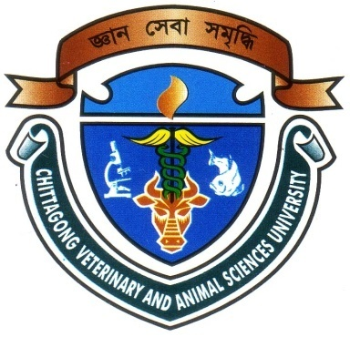

A Clinical Report Presented in Partial Fulfillment of the Requirement for the Degree of Doctor of Veterinary Medicine

A Report submitted by

Roll No: 08/20

Reg No: 363

Intern ID: B-13

Session: 2007-2008

Faculty of Veterinary Medicine

Chittagong Veterinary and Animal Sciences University

Khulshi, Chittagong-4225.

March-2014
INVESTIGATION OF CLINICAL CASES IN LIVESTOCK AND POULTRY IN UPOZILA VETERINARY HOSPITAL, BOALKHALI, CHITTAGONG

A Clinical Report Submitted as per approved style and content

--------------------------  Signature of Author  Md. Nurul Azim  Roll No: 08/20  Reg No: 363  Intern ID: B-13  Session: 2007-2008 | -------------------------------  Signature of Supervisor  Md. Ahasanul Hoque  Professor and Coordinator of CASR  Dept. of Medicine and Surgery  Faculty of Veterinary Medicine  Chittagong Veterinary and Animal Sciences University

Chittagong Veterinary and Animal Sciences University,

Khulshi, Chittagong-4225.

March-2014
ACKNOWLEDGEMENT

The author is ever grateful and indebted to the Almighty Allah without whose grace it would have ever been possible to pursue this study in this field of science and to complete this clinical report writing for the Degree of Doctor of Veterinary Medicine (DVM).
The author would like to express his deep sense of gratitude and thanks to Professor Dr. A. S. Mahfuzul Bari, honorable Vice Chancellor, Chittagong Veterinary and Animal Sciences University.
The author would like to express his ever indebtedness, deepest sense of gratitude, sincere appreciation and profound regards to his reverend and beloved teacher and Supervisor Dr. Md. Ahasanul Hoque, Professor and coordinator of CASR, Department of Medicine and Surgery, Chittagong Veterinary and Animal Sciences University for his scholastic guidance, sympathetic supervision, valuable advice, constant inspiration, affectionate feeling, radical investigation and constructive criticism in all phases of this study.
The author highly express his sincere gratitude and gratefulness to the internship Coordinator, Dr. Bibek Chandra Sutradhar, Associate professor, Department of Medicine and Surgery, Chittagong Veterinary And Animal Sciences University for his constant inspiration, cordial co-operation and valuable suggestion for completion of the report work.
The author would like to express his pleasure and thanks to DR. Mohammed Ashif Imtiaz Shawn, MS Fellow (Pharmacology) for his help during the time of report writing.
Last but the least the author gives his great appreciation to his friends, kith and kins and the well wishers.

The Author
March, 2014

CONTENTS
SL NO | CHAPTER | NAME OF THE TOPICS | PAGE NO
1 |  | ACKNOWLEDGEMENTS | I
2 |  | ABSTRACT | II
3 | I | INTRODUCTION | 1-2
4 | II | REVIEW OF LITERATURE | 3-9
5 | III | RESEARCH METHODOLOGY | 10-11
6 | IV | RESULTS | 12-19
7 | V | DISCUSSION | 20-22
8 | VI | LIMITATION OF THE STUDY | 23
9 | VII | CONCLUSION | 24
10 | VIII | REFERENCES | 25
11 | IX | ANNEX | 26

