CHAPTER – I
INTRODUCTION
Bangladesh is a densely populated country with an area of 147570 square kilometers contains almost 165 million people and 70% of the people’s economy is basically depend on agriculture and livestock (Bangladesh Bureau of Statistics, 2002) production. In the last few decades, livestock has been turned into industrials production system from traditional rearing system. Bangladesh has 24 million cattle, out of which 6 million are dairy cattle of local and crossbreds (DLS, 2008). Almost 5.3% GDP of the Bangladesh is largely depended on the livestock production. Among the different species of livestock, cattle are the most vital component for supply of meat, milk, and skin. Most of the cattle population of Bangladesh is indigenous which can receive maintenance levels of nutrition. As a result they produce minimum level of production. In contrast the number of crossbreed cattle is increasing day by day to fulfill the growing demand of milk and meat products for people. As the number of animal s is increasing day by day so the rate of diseases prevalence is increasing day by day. For this reason the economic efficiency is decreasing day by day.In Bangladesh among the endemic diseases Foot and Mouth Disease(FMD) is one of the most economic disease commonly found in all over the country such as in village farm and commercial dairy farms.

Foot and mouth disease (FMD), a highly communicable viral disease concerned primarily with cloven hoofed animals, is caused by RNA virus belong ing to genus Aphthovirus of family Picornaviridae (Belsham 1993). FMDV exists in seven distinct serotypes i.e. O, A, C, SAT1, SAT2, SAT3 and Asia 1 (Domingo et al., 2003). FMD serotype A and O viruses that caused these outbreaks originated in mainland Southeast Asia to which these viruses are endemic (Rweyemamu et al;2008) . FMDV produced extensive vesicular lesions on the lips, tongue, gums, dental pad, feet and udder (Lubroth et al, 2002; Rweyemamu et al., 2008). Although mortality in adult animals due to FMDV infection is rare, but other losses associated with FMD are weight loss, decreased milk production and loss of draft power (Blacksell et al., 2008), while farmer has to face substantial losses in terms of treatment expenses and time spent caring for sick animals (Rushton et al., 2002). Sometimes it occured in vaccinated flock due to vaccine failure (Abubakar et al; 2014). This disease has constraint international trade of animal products and FMD control to protect the livestock industries of industrialized countries as well as the livelihoods and income generation of developing countries where FMD continues to be endemic (Rweyemamu et al., 2008) with serious impact on social and economic consequences of reduced milk and meat production as result of high morbidity and loss of market value (Sangare et al., 2004). The disease in cattle is usually obvious in the unvaccinated herds. However, in vaccinated herds and in some breeds indigenous to areas in which FMD is endemic, it may circulate undetected (Kitching et al, 2002b). Consequently high economic impact results from the severe loss in body weight of meat cattle and a significant reduction in milk yield in lactating anima l(Meyer et al, 2001). Numerous outbreaks have been reported around the globe since first outbreak of FMD in America in 1870 (Gibbs et al, 2003; Sumption et al., 2008). The disease causes heavy economic losses to the livestock industry in terms of high morbidity in adult animals and mortality in young stock Moreover, FMD has restricted the trade of animal and animal products from endemic countries (Abubakar et al., 2012).
Most clinical signs are related to the development and subsequent rupturing of vesicles at the coronary band and in the oral cavity. Vesicles and ulcerations can also occur on the mammary gland. Recovery in adult animals usually occurs in 8-15 days. The disease was more frequent in the agro-climatic zones than in hilly areas (Abubakar et al., 2012).. In animals with a history of vesicular disease, the detection of FMDV in samples of vesicular fluid, epithelial tissue, oesophageal–pharyngeal (OP) sample, milk, or blood is sufficient to establish a diagnosis. FMD virus has also been shown to persist in a nonreplicative form in lymph nodes (Juleff et al., 2008).
Movement or shipment of people and animals around infected farms was restricted; however these contingency measures proved insufficient to prevent FMD spread (Roeder et al;2013).

With the background mentioned above this study was undertaken with the following specific objectives:
1. To record the significant comparative difference of Hematological features between the FMD infested cattle and Healthy cattle.
2. To record the significant comparative difference of Biochemical features between the FMD infected cattle and Healthy cattle.
3. To assess the impact of variables on occurrence of Foot and Mouth Disease (FMD) at field level.

CHAPTER—II
REVIEW OF LITERATURE
(Zelnickova et al., 2008): Viral infection activates the immune system. It causes the release of reactive oxygen species (ROS) and reactive nitrogen species (RNS) with the potency of inducing oxidative stress.

(Alexandersen and Mowat, 2005): Foot and mouth disease (FMD) is the most contagious animal disease. It affects all the hoof stock animals.

(Belsham et al,2005): The disease is economically important as it causes heavy losses for the livestock industry in terms of high morbidity in adult animals, sharp reduction in milk production, weight losses, reproductive inefficiencies and death in young animals.

(Rockett et al., 2007): Infectious diseases generally activate macrophages to synthesize large quantities of nitric oxide (NO) that plays an important role as a defense mechanism.

(Halliwell et al., 1992): ROS and RNS are capable of degrading numerous biomolecules including protein and nucleic acid. In addition, it can attack the polyunsaturated fatty acids of
membrane lipids causing lipid peroxidation and the disorganization of cell structure and function.

(Magni et al., 1994): Lipid peroxidation is a well-established mechanism of cellular injury and is used as an indicator of oxidative stress in cells and tissues.

(Heidarpour et al., 2013): The most abundant lipid peroxide by product is Malondialdehyde (MDA).

(Kandemir et al., 2011):MDA used as an inductive marker for oxidative damage .

(Zalbaet et al., 2006): The body minimizes the cellular effects of ROS by production of antioxidants which depleted with increasing of ROS production.

Yeotikar et al., 2003 and El-Saied et al., 2007): Hematological analysis revealed significant increase in MCV and MCH (p≤0.001); PCV (p≤0.01); while significant decrease in RBCs (p≤0.001) was (p≤0.001) in serum level of calcium, total protein and globulin; while significant increase in serum phosphorus (p≤0.05) and glucose levels (p≤0.001) were observed. Nitric oxide (NO), Malondialdehyde (MDA) and DNA fragmentation percentage were significantly increased (p≤0.001) in diseased cattle. However significant reduction in total antioxidant capacity (p≤0.001) and albumin as biomarker for antioxidant status were detected. The highest levels of MDA and NO indicate the occurrence of oxidative stress and lipid per oxidation.
Olabode et al;(2013): revealed that 71.0% (27/38) were anemic, 70% (21/30) showed leucopenia, 86% (6/7) indicated leucocytosis, 2 showed anisocytosis while 3 presented poikilocytosis and 60% (7/10) showed both anisocytosis and poikilocytosis.

(Radostitis et al., 2000) reported that anemia occurred in bovine FMD but as a sequel probably due to endocrine damage which lead to chronic syndrome.

Reece et al, (2009) showed that leucopenia is usually associated with early stages of viral infections as the blood samples were collected within 3-10days post outbreak reports as well as that reported by Mohan et al., (2008) in cattle and buffaloes infected with FMD virus (Asia 1) .

Ahmed et al(2008):Showed that serum concentrations of MDA increased, while SOD and TAC decreased significantly in infected animals. This implies that the affected animals are under stress condition. Oxidative stress has been implicated as major initiators of tissue damage and can affect enzymatic activity, signal transcription and gene expression, especially apoptotic gene [Sen et al;1996]. In animal suffering from stressful conditions such as lead pollution, parasitism and retained placenta [Patra et al;2000] found high values of SOD [Kolodziejezyk et al;2005] showed low SOD with high level of MDA and [Wischral et al;2001] found an increase of SOD, respectively.

(Mohan et al., 2009): Revealed that lower phagocytic power & WBCS count in FMD infected calves than those non infected ones (Tables 4,5), as FMD virus causes a transient immunosuppression as it causes lymphopnea and decreases lymphocyte proliferative response.

Halil et al(2004);There was a significant decrease in the total number of RBCs (P < 0.05) and a significant increase in MCV (P < 0.05) in cattle with FMD compared to the control group. There were no significant differences in the other hematological parameters evaluated. Serum glucose concentration was significantly higher (P < 0.001) in the FMD group than in the control group. Serum total protein (P < 0.05), calcium (P < 0.01), albumin (P < 0.001) and cholesterol (P < 0.01) levels were significantly low in the FMD group compared to those in the control group. However, there were no significant differences in the other biochemical parameters between the groups. The concentration of serum NO3 was significantly high in the FMD group, suggesting that Aphtovirus induces the production of nitric oxide in vivo.

Mousa et al ;(2013):Hematological analysis revealed significant increase in MCV and MCH (p≤0.001); PCV (p≤0.01); while significant decrease in RBCs (p≤0.001) was (p≤0.001) in serum level of calcium, total protein and globulin; while significant increase in serum phosphorus (p≤0.05) and glucose levels (p≤0.001) were observed. Nitric oxide (NO), Malondialdehyde (MDA) and DNA fragmentation percentage were significantly increased (p≤0.001) in diseased cattle. However significant reduction in total antioxidant capacity (p≤0.001) and albumin as biomarker for antioxidant status were detected. The highest levels of MDA and NO indicate the occurrence of oxidative stress and lipid per oxidation. In conclusions cattle affected with FMDV experienced strong oxidative stress. So antioxidant drugs recommended during treatment of
viral diseases as FMD.

Anim et al;(2013):Hematological analysis revealed significant increase in MCV and MCH (p≤0.001); PCV (p≤0.01); while significant decrease in RBCs (p≤0.001) was (p≤0.001) in serum level of calcium, total protein and globulin ; while significant increase in serum phosphorus (p≤0.05) and glucose levels (p≤0.001) were observed. Nitric oxide (NO), Malondialdehyde (MDA) and DNA fragmentation percentage were significantly increased (p≤0.001) in diseased cattle. However significant reduction in total antioxidant capacity (p≤0.001) and albumin as biomarker for antioxidant status were detected. The highest levels of MDA and NO indicate the occurrence of oxidative stress and lipid per oxidation.

Naveen et al (2009):Results revealed that the mean value of the total serum protein significantly decreased on days 4 and 8 of infection in crossbred cows. Serum albumin significantly decreased on days 4, 8 and 12 of infection, while the mean globulin value significantly increased on day 12 of infection. Serum albumin: globulin ratio also decreased significantly on days 4 and 8, but decreased on day 12 of infection. Plasma glucose increased on days 4 and 8 of infection. Serum alkaline phosphatase significantly increased on days 4, 8 and 12 of infection.
The serum aspartate aminotransferase significantly increased on days 4 and 8 of infection. The serum phosphorus level was higher in FMD infected cows than the control.

Nahed et al (2010): Results showed a significant increase in serum level of glucose , cholesterol, phosphorus, AST and cortisol and a significant decrease in serum concentration of total protein ,calcium and insulin . Serum protein electrophoretic fraction showed a significant decrease in albumin and gamma globulins. There was a significant negative correlation between insulin and serum level of glucose , cholesterol, phosphorus and cortisol and a significant positive correlation with serum levels of calcium and total protein. Serum cortisol concentration was positively correlated with glucose ,phosphorus and AST and was negatively correlated with albumin ,calcium and insulin . Our results indicates that FMD infection in cattle results in hypoinsulinemia and significant increase in serum cortisol levels. further, alteration in the biochemical variables and protein electrophoresis pattern seen in FMd-infected cattle are likely seen to be related to changes in serum concentrations of insulin and cortisol providing an importance of considering these hormones when interpreting blood biochemical changes in cattle infected with FMD . Finally, the present data may provide a better understanding of the disease process and clinical pathology of FMD in cattle.
Kadir et al;(2012): . TOC and NO levels were found to be significantly higher in FMD group compared to those of control group. However, no significant differences were present in TAC levels between FMD and control groups. It was concluded that FMD increases serum NO levels and TOC, but do not affect TAC in cattle.
Ghanem et al;(2010):Serological tests confirmed the presence of non-structural protein of foot-and-mouth disease (FMD) infection. There were significant reductions in the total red blood cell count with increased leucocytic and lymphocytic counts in diseased group compared to control. The serum Na, Cl, Ca, Mg, Zn and Fe were significantly reduced but P was increased in diseased animals compared to control. The total protein, albumin, cholesterol and cortisol were significantly reduced but the glucose and malonaldehyde were significantly increased in diseased cows.
(Peterhans et al; 1997):Reactive oxygen and nitrogen metabolites play a complex role in many diseases and in metabolic regulation. Because viruses replicate in living cells, such metabolites influence the growth of viruses in addition to serving as a host defense mechanism. Low levels of reactive oxygen species (ROS) play a role in mitogenic activation, and the early phase of lytic and nonlytic virus infection indeed resembles that of mitogenic cell activation.
(Gulbahar et al., 2007): A significant high level of nitrate, an indicator of NO production suggests that FMDV induce the production of NO.
(Ghiselli et al., 2000): The measure of antioxidant capacity (AC) considers the cumulative action of all the antioxidants present in plasma and body fluids, thus providing an integrated parameter rather than the simple sum of measurable antioxidants. The capacity of known and unknown antioxidants and their synergistic interaction is therefore assessed, thus giving an insight into the delicate balance in vivo between oxidants and antioxidants.
(Castillo et al; 2005): He confirmed that the characteristic metabolic changes associated with late pregnancy and early lactation . MDA and TAS provided an accurate reflection of the internal physiological status of the animal.
Carolina et al; (2011): He showed that there was a significant increase in serum concentrations of both APPs and type 1 IFN in infected animals coinciding with the onset of viremia and clinical disease. The measured parameters declined to baseline levels within 21 days after inoculation, indicating that there was no systemically measurable inflammatory reaction related to the carrier state of FMD. There was a statistically significant difference in the HP response between carriers and non-carriers with a lower response in the animals that subsequently developed into FMDV carriers. It was concluded that the induction of SAA, HP and type 1 IFN in serum can be used as markers of acute infection by FMDV in cattle.
Prakash et al;(2009): He revealed thatIn FMD affected animals , the was a significant decrease (p<0.010 in Hb content ,TEC and LC .In recovered animals , Hb content and TLC were recovering towards the normal but the TEC showed further decrease indicating the persistence of depression of erythropoiesis due to the disease .The different leukocyte count showed increase number and a non significant changes in neotrophil count in FMD affected animals . The increase in TLC was mainly due to increase in lymphocytes .There was significant (p<0.01) reduction in the blood glucose ,s erum concentration of calcium , Total protein and albumin in the FMD affected animals, when compared with normal animals. interestingly , the phosphorus level was significantly higher (p<0,010)in FMD affected cattle. serum cholesterol, serum urea, and globulin incase of disease animals were found to be decreased.

CHAPTER--III
MATERIALS AND METHODS
3.1.1. Place of the study: The research was conducted at the Upazilla Veterinary Hospital (UVH) in Shibpur upazilla under Narsingdi District and Shahedul Alam Quadery Teaching Veterinary hospital ( SAQTVH ) at Chittagong Veterinary and Animal Sciences( CVASU) University as my internee placement .
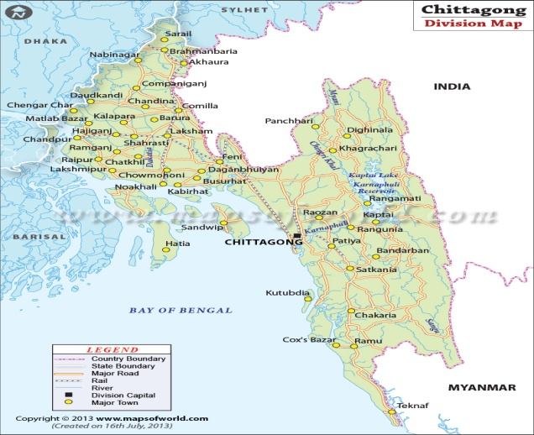

Fig 1: Chittagong District
Fig2: Sample collection site from SAQTVH at CVASU

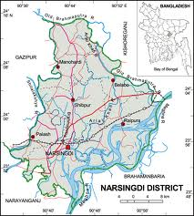
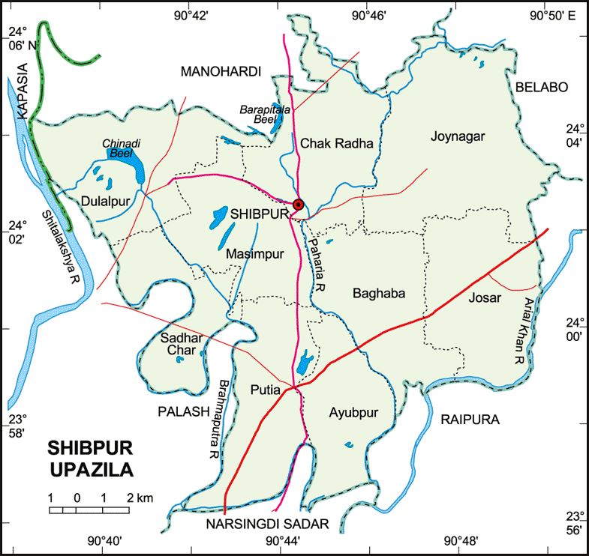

Fig 3: Narsingdi District
Fig 4: Sample collected from UVH at Shibpur Upazilla

3.1.2. Period of the study: The study was conducted in the period of 5th May, 2013 to 5th July, 2013 In UVH and 6th July 2013 to 14 th July 2013 in Shahedul Alam Quadery Teaching Veterinary Hospital (SAQTVH) during my internee study period.
3.1.3. Study animals: Two groups of cattle were used in this case control study. Case consist of 10 naturally infected FMD cattle and other is 10 healthy cattle were considered as control. Initial sign includes, pyrexia [up to 106°F (40oC) lasting 1-2 days before other clinical signs], pyrexia is followed by anorexia, agalactia in milking animals and appearance of vesicles (Clavijo et al., 2004). Painful lesions cause profuse drooling of saliva, bruxism, foot stamping, and lip smacking with rupture of vesicles occurring within hours to 2 days, leaving erosions ,ulceration and sometimes sloughing of tissue in foot and tongue.

3.1.4. Sample collection:
Peripheral blood samples collected from the jugular vein into EDTA treated tubes were used to establish total white blood cells (WBCs), total red blood cells (RBCs), packed cell volume (PCV %) and haemoglobin concentration (Hb) manually. About 5ml blood sample was collected from jugular vein of cattle aseptically, with 10ml syringe and needle.

3.2.1. Sample Transportation
Blood samples were transported to the Biochemistry laboratory, Chittagong Veterinary and Animal Sciences University within keeping in a thermo flask with ice and then fresh blood was examined for Total Erythrocyte Count (TEC), Different Leucocyte Count (DLC), Hemoglobin (Hb%) and Packed Cell Volume (PCV%).

3.2.2. Preparation of serum sample
Peripheral blood samples collected into plain tubes. the blood sample containing test tubes were kept in 45°angle for 2-3 hours in room temperature and then in cooler chamber for overnight. After that the supernatant serum sample were collected into several test tubes. This collected serum sample were centrifuged and after centrifugation they were taken into separate eppendorf tube. The serum was kept in freezer until use.

3.2.3. Marking of sample:
Then the eppendorf tubes were marked separately indicating N1- N10 for non infecting animals and I1 – I10 for infecting animal and also marking the blood with anticoagulant containing tubes.

3.2.4. Sample examination
3.2.4.1 Hematological Examination
Different hematological parameters were studied according to the methods described by (Giovanni et al –2013).The details of the parameters studied as follows: For hemoglobin determination fresh blood mixed with EDTA was kept in the Wintrobe tube and centrifuge at 3000 rpm for 30 minutes. Thus PCV was determined. For hemoglobin determination N/10 HCl was taken in a graduated hemoglobinometer up to 10 marks and blood was mixed upto 20 cu mm mark. Then diluted the acid hematin using water and match the color thus hb% was determined. TEC determined from freshly collected blood using hemocytometer. DLC determined by making of blood smear on the clear glass slide and then drying of the smear. Then blood smear was stained by the Wright’s stain and dried. Prepared smear was examined under microscope (100xs

3.2.4.1.1. Enumeration of red blood or total erythrocyte count (TEC)
Procedure:
A dry and clean counting chamber was placed under the microscope. There after the chamber was examined under low power objective without the cover slip in order to understand the ruling. Blood mixed properly with EDTA was sucked into the RBC pipette upto the mark 0.5 keeping the pipette nearly horizontal. The diluting fluid was sucked into the pipette until the mixture of blood and the fluid reaches 101 mark above the bulb. The pipette was rotated and inverted several times to ensure thorough mixture blood with diluting fluid. A few drop of mixture was discarded from the pipette and wiped out its tip. A small drop of diluting fluid mixture was allowed to form at the tip of the pipette. The tip was placed on the surface of the chamber touching the edge of the cover slip at an angle of 45 to the horizontal. The dilute blood was allowed to flow evenly and slowly under the cover slip by capillary action. There should be no overflow into the central or side trenches as the excess fluid will lift up the cover slip and gives false high count. A few minutes were spent before the count to allow the corpuscles to settle.

Counting of RBC
All blood cells were counted at 80 smallest squares. i.e. five small square (4 corner square and the middle square) In counting the cells which touched the left hand line or upper line of the square were taken to be within that square and those which touched the lower and right lines were omitted as outside the square. This technique was followed to avoid the duplicate counting and counting was started from upper left chamber.

Calculation factor
- Area of chamber: 1/5 sq. mm
- Depth of chamber: 1/10 mm
- Dilution obtained: 1:200 =1/200

Total volume: 1/5*1/10*1/200 cu. mm
=1/10000 cu. Mm
Suppose 1/10000 cu. mm contains x number of cells
So, 1 cu. mm contains x*10000 number of cells.
The total number of cells were multiplied by the calculation factor. i.e. 10000 and expressed the result in million/cu.mm by dividing the total number of cell by 1 million.
3.2.4.1.2.Enumeration on total leucocyte count (TLC)
Procedure: A dry and clean counting chamber was placed under the microscope. There after the chamber was examined under low power objective without the cover slip in order to understand the ruling. Blood mixed properly with EDTA was sucked into the WBC pipette upto the mark 0.5 keeping the pipette nearly horizontal. The diluting fluid was sucked into the pipette until the mixture of blood and the fluid reaches 11 mark above the bulb. The pipette was rotated and inverted several times to ensure thorough mixture blood with diluting fluid. A few drop of mixture was discarded from the pipette and wiped out its tip. A small drop of diluting fluid mixture was allowed to form at the tip of the pipette. The tip was placed on the surface of the chamber touching the edge of the cover slip at an angle of 45 to the horizontal. The dilute blood was allowed to flow evenly and slowly under the cover slip by capillary action. There should be no overflow into the central or side trenches as the excess fluid will lift up the cover slip and gives false high count. A few minutes were spent before the count to allow the corpuscles to settle.
Counting the WBC: The leucocytes were counted in four large squares (each having 1 sq. mm are divided into 16 small squares) at the four corners of the counting chamber. This means that the white blood corpuscle in 64 small squares were counted. The white blood cells were appeared as round faintly dark and refractive dots under low power where as high power the stained nucleus were visible with clear granular cytoplasm around it. In counting the cells which touched the left hand line or upper line of the square were taken to be within that square and those which touched the lower and right lines were omitted as outside the square. This technique was followed to avoid the duplicate counting and counting was started from upper left chamber.
Calculation factor
- Area of chamber: 4 sq. mm
- Depth of chamber: 1/10 mm
- Dilution obtained: 1:20 =1/20

Total volume: 4*1/10*1/20 cu. mm
=1/50 cu. mm
Suppose 1/50 cu. mm contains x number of cells
So, 1 cu. mm contains x*50 number of cells.

The total number of cells were multiplied by the calculation factor. i.e. 50 and expressed the result in thousand/cu.mm by dividing the total number of cell by 1000.

3.2.4.1.3: Estimation on differential leukocyte count (DLC)
Procedure: Several clean grease free slide with smooth unbroken end were selected, then a drop of blood was placed at right end of the slide. The slide was taken on a piece of paper on the table holding firmly by the force or thumb finger on left hand. The even edges of the second slide was placed near the drop of blood towards the middle of slide. The second slide was drawn towards the drop of the blood at an angle of 45 and the blood was spread along the edge. Keeping the second slide in the same angle a quick even push was given with an uniform force toward the other end of slide.When the blood film dried, it was placed in the staining rack. 8-10 drops of Wright’s stain was poured over the slide to cover the blood smear and allowed to stain for 2 minutes. Distilled water above double quantity of stain was added and mixed by blowing pipe and allowed to stand for 5 minutes. Then the film was washed with distilled water without much distribution the slide till the slide film become pinkish. The slide was placed against the support and allowed to dry in air.
Counting of WBC
The slide was placed on a fixed place and a drop of immersion oil on the slide. Then the cell s were identified by using high power objective 100x following parallel stripe method. The counting was continued till 100 or 200 cells were counted. Different type of cells were counted by tally method. 200 cells counting is the best method.
3.2.4.1.4: Determination of hemoglobin by acid hematin method
Procedure: N/10 HCl was taken in a graduated hemoglobin tube of haemoglobinometer upto 2 mark. The blood sucked into the Hb pipette (holding in nearing horizontal) upto the 20 µl mark. There should be no air bubble in the pipette. The blood of the haemoglobin pipette was transferred slowly into the acid of the haemoglobin. A little of the acid blood mixture was sucked up into the pipette and this was added to the mixture. The mixing tube was kept in its place for 5 minutes in the matching box for the formation of acid hematin. Then distilled water was added gradually drop by drop to the solution and stirred for thorough mixing. In this way distilled water was added till the colour of the acid hematin solution exactly match with the colour with the standard. The graduated mixing tube was removed from the matching box and volume of the fluid was read both in percentage and gm%.
3.2.4.1.5: Estimation of erythrocyte sedimentation rate (ESR) by Wintrobe’s method
Procedure:A dry and clean counting chamber was placed under the microscope. There after the chamber was examined under low power objective without the cover slip in order to understand the ruling.Blood mixed properly with EDTA was sucked into the RBC pipette upto the mark 0.5 keeping the pipette nearly horizontal.The diluting fluid was sucked into the pipette until the mixture of blood and the fluid reaches 101 mark above the bulb.The pipette was rotated and inverted several times to ensure thorough mixture blood with diluting fluid.A few drop of mixture was discarded from the pipette and wiped out its tip. A small drop of diluting fluid mixture was allowed to form at the tip of the pipette. The tip was placed on the surface of the chamber touching the edge of the cover slip at an angle of 45 to the horizontal. The dilute blood was allowed to flow evenly and slowly under the cover slip by capillary action. There should be no overflow into the central or side trenches as the excess fluid will lift up the cover slip and gives false high count.A few minutes were spent before the count to allow the corpuscles to settle.
Counting of RBC
- All blood cells were counted at 80 smallest squares. i.e. five small square (4 corner square and the middle square)
- In counting the cells which touched the left hand line or upper line of the square were taken to be within that square and those which touched the lower and right lines were omitted as outside the square. This technique was followed to avoid the duplicate counting and counting was started from upper left chamber.

Total volume: 1/5*1/10*1/200 cu. mm
=1/10000 cu. Mm
Suppose 1/10000 cu. mm contains x number of cells
So, 1 cu. mm contains x*10000 number of cells.
The total number of cells were multiplied by the calculation factor. i.e. 10000 and expressed the result in million/cu.mm by dividing the total number of cell by 1 million.
3.2.4.2 Biochemical Examination
Total protein, Albumin, Glucose, Serum Calcium, Serum phosphorus were determined by Automated Analyser (Humalyzer 3000® ) (AOAC 1995)established in physiology lab of Chittagong Veterinary and Animal Sciences University .

3.2.4.2.1 Photometric Colorimetric Test for Total Proteins (Biuret Method)
Contents
Reagents: | 4×100 ml or 1×1000 ml Color reagent
 | Sodium hydroxide | 200mmol/l
 | Potassium sodium tartrate | 200mmol/l
 | Copper sulfate | 12 mmol/l
 | Potassium iodide | 30 mmol/l
 | Irritant R 36/38

Standard | 1×3 ml Standard
 | Protein | 8g/dl
 | Or | 80g/l
 | Sodium azaid | 0.095%

Assay
Wavelength: Hg 546 nm, 520-580 nm
Optical path: 1 cm
Temperature: 20---25⁰C
Measurement: Against reagent blank
Only one reagent blank per series was required.

Pipetting Scheme
1000 μl of reagent was taken in previously marked three eppendorf tubes for reagent blank, sample and standard separately by micropipette. 20μl of sample and standard were added in the previously marked eppendorf tube, respectively. Reagent blank eppendorf tube only contain reagent. Sample and standard for total protein were mixed separately in each eppendorf tube and incubated for 10 minutes at 25⁰C. Absorbance of the sample and standard were measured against the reagent blank within 30 min (ΔA) λ_{max} in 546 nm by spectrophotometer of the Humalyzer 3000®.

Pipette into cuvettes | Reagent blank | Sample/Standard
Sample/Standard | ------ | 20μl
Reagent | 1000μl | 1000μl
Mixed and incubated for 10 min. at 20---25⁰C. Absorbance of the sample and standard were measured against the reagent blank within 30 min(ΔA)

Calculation of the Protein Concentration
With standard-
C=80× ΔA _{sample}/ ΔA _{standard [g/l]}

3.2.4.2.2 Determination of Glucose by Randox method
Procedure:
First hand was washed and put on goggles and gloves. Then all the assembled all the equipment. Then all four test tubes were labeled,-blank, standard, control and patient. After that 0.5ml distilled water was added in each tube. Then 25microlitre of D₂0 was added in each blank tube. Then placed 25 microlitre of standard solution to the standard tube. Pipette 25 microlitre of the control to the control tube. Finally 25 microlitre of the patient serum to the patient test tube and 5.0 ml of glucose working solution to each tube was placed. Mix each of tube and incubate room temperature for 45 minutes. Then read the absorbance (a) for each tube at 425 to 475nm against the blank within 30 minuits.

Calculation:

Glucose (mg/dl = A (patient or control) x (standard value)

A (standard)

3.2.4.2.3 Determination of Calcium by Colorimetric method
Procedure:
Place 2 cc. of blood serum in a small flask and add 4 cc. of distilled water and 4 cc. of 20 per cent trichloroacetic acid. Mix thoroughly; allow standing 10 minutes, and filtering through a double acid-washed calcium-free filter paper. Transfer 5 cc. of the trichloroacetic acid filtrate to a 15 cc. conical centrifuge tube which has been thoroughly cleaned by immersion in bichromate sulfuric acid “cleaning solution” for several hours. Place 1 drop of 1 per cent phenolphthalein in the tube and add, drop at a time, 20 per cent calcium-free sodium hydroxide until a definite pink color is obtained. Add 1 cc. of 1 per cent trisodium phosphate, twirl the tube until thoroughly mixed, cork, and set aside for 1 hour. After 1 hour’s standing, centrifuge for 3 minutes. Decant carefully the supernatant fluid from the calcium phosphate precipitate. Place the inverted tube upon a pad of filter paper to drain for 2 or 3 minutes, and then wipe away adherent solution from the mouth of the tube with a clean cloth or paper. Wash twice with 5 cc. portions of 50 per cent alcohol made faintly alkaline to phenolphthalein with a few drops of calcium-free alkali. In washing, the mat of calcium phosphate in the bottom of the tube must be thoroughly broken up with a glass stirring rod, and the process of centrifuging, decanting, and draining the tube should be carried out as described above. Dissolve the washed precipitate in 5 cc. of 5 per cent sulfuric acid by volume (5 cc. concentrated H₂S0₄ per 100 cc. of water), and decant into a Rothberg-Evans sugar tube, or a graduated test-tube; wash the centrifuge tube twice with approximately 3 cc. and 2 cc. portions of the 5 per cent sulfuric acid, adding the washings to the graduated tube. In a similarly graduated tube place 10 cc. of standard phosphate solution containing 0.05 mg. of phosphorus, and add 0.5 cc. of concentrated sulfuric acid. Now add to each tube 1 cc. of 5 per cent sodium molybdate and 1 cc. of hydroquinone bisulfite reagent. Place the tubes in a boiling water bath for 10 minutes. Remove, cool, dilute the standard to 15 cc. and the unknown to a volume giving a color that will approximately match the standard (15 cc. in normal bloods), and compare in a calorimeter in the usual manner.

Calculation:

Concentration= A_{sample}/A_{standard} x Standard conc

(mmol/l) (mmol/l)

3.2.4.2.4 Estimation of Phosphorus

Procedure:
Firstly working reagent , samples and controls were separated from other instruments and placed in to reaction temperature. Then adjust the photometer to 0 absorbance with the reagent blank. Then pipette placed in to a cuvette. After that mix, insert and start the alarm clock, then incubate for 5 minuites at selectet temperature. Finally read the absorbsnce(A) of the samples and the standard at 340nm against the reagent blank.

The color is stable for 1 houre.
Calculation:

A_{sample} /A_{standard} x C_{standard} = mg/dl Phosphorus

3.3: Data entry and Analysis:
All recorded data entered into the MS Excel-2007and sorted out. These data were brought to the STARTA 11.0 for descriptive statistical analysis (mean, SD, median).To identify the association of hematological and Biochemical parameters t-test was conducted to evaluate if them mean values between healthy cattle and FMD infected cattle groups of animals differ significantly or an association was regarded as significant if the P value was <0.05.

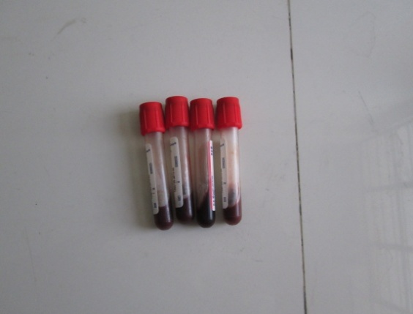
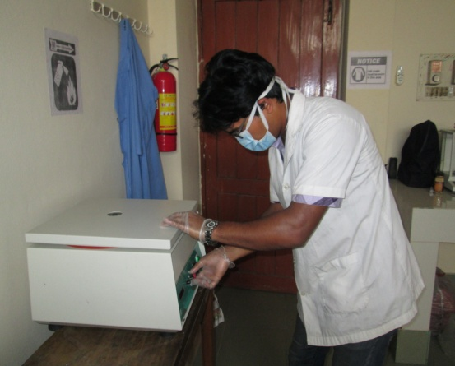

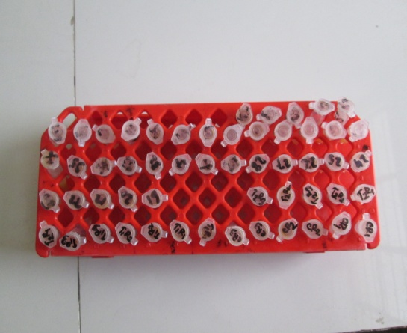
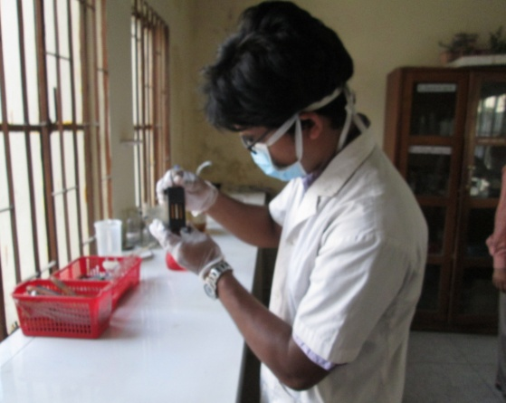
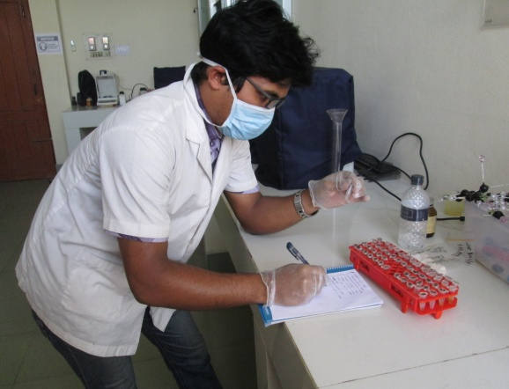
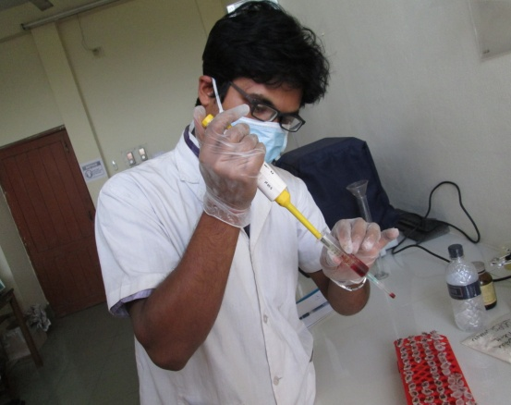
f
e
Figure 5: Hematological and biochemical test performed in laboratory.(a)collection of blood (b) centrifugation of blood (c) collection of serum.(d) marking and identification of serum.(e)storage of serum sample.(f) determination of hemoglobin by hematin method
b
a
d
c
CHAPTER---IV
RESULTS
Hematological parameters of healthy and FMD infected cattle
The mean and standard error of hematological parameters in healthy cattle and FMD infected cattle are as follows:
Healthy cattle: Hb 7.97±0.15 (g/dl),PCV 25.2±1.14 (%), ESR 0 (1st hour), TEC 6.9±0.28(×10⁶/µl) , TLC 6.9±0.28(×10³/µl), Lymphocyte 49.2 ± 4.30( %), Neutrophil 26±1.55(%), Eosinophil 23.1 ± 1.33(%), Monocyte 3.4±0.89 (%), Basophil 0.8 ± 0.13(%) (Table-1).
FMD infected cattle: Hb 7.17 ± 0.07 (g/dl), PCV 28.6±0.98 (%), ESR-0(1st hour ) ,TEC 6.7±0.25 (×10⁶/µ^{l}), TLC 10.7 ± 1.14 (×10³/µl, Lymphocyte 70.2 ± 6.20(%), Neutrophil l3. 04 ± 3.16 (%) Eosinophil 16.5 ±1.83 (%), Monocyte 8.2±1.08(%), Basophil 0.3±0.16(%) (Table-1).
In case of FMD infected cattle there is increase of PCV, lymphocyte, monocyte significantly (P<0.05) and increase TLC, neutrophil not significantly (P>0.05) compare with healthy cattle .Incase of FMD infected animal there is decrease in hemoglobin, eosinophil, basophil significantly(p<0.05) and decrease TEC not significantly(P>0.05) (Table-1)
Table 1: Hematological parameters of healthy and FMD infected cattle
Parameter | Health status | Mean ±SE | t-statistic | P-value
Hb(g/dl) | Healthy | 7.97±0.15 | -4.87 | 0.0004
 | FMD infected | 7.17±0.07
PCV (%) | Healthy | 25.2±1.14 | 2.27 | 0.036
 | FMD infected | 28.6±0.98
ESR(1st hour) | Healthy | 0
 | FMD infected | 0
TEC((×10^{6/µl}) | Healthy | 6.9±0.28 | -0.52 | 0.6066
 | FMD infected | 6.7±0.25
TLC(×10^{3/ µl)} | Healthy | 8.8±1.39 | 1.03 | 0.3169
 | FMD infected | 10.7±1.14
Lymphocyte(%) | Healthy | 49.2±4.30 | 2.79 | 0.0132
 | FMD infected | 70.2±6.20
Neutrophil(%) | Healthy | 26±1.55 | 1.24 | 0.2358
 | FMD infected | 30.4±3.16
Eososinophil(%) | Healthy | 23.1±1.33 | -2.92 | 0.0097
 | FMD infected | 16.5±1.83
Monocyte(%) | Healthy | 3.4±0.89 | 3.47 | 0.0028
 | FMD infected | 8.2±1.08
Basophil(%) | Healthy | 0.8±0.13 | -2.47 | 0.0241
 | FMD infected | 0.3±0.16
**= P< 0.05 (significant in 95% confidence interval).

Biochemical parameters of healthy and FMD infected cattle
The mean and standard error of biochemical parameters of healthy cattle and infected cattle are as follows:
Healthy cattle: Glucose (46.9 ± 6.70 mg/dl), total protein (9.7 ± 0.98 mg/dl), Calcium (9.4 ± 0.28 mg/dl), P (5.1 ± 0.8mg/dl ) (Table-2) .
FMD infected cattle: Glucose (104.2 ± 15.59 mg/dl), total protein(6.2±0.19mg/dl ), Ca (8±0.41mg/dl )and P (5.9±0.63mg/dl ) (Table-2).
In case of FMD infected animal the level of glucose is significantly (0.05 >P) higher and the level of phosphorus is non significantly (0.05<P ) higher than the healthy cattle but the level of Total Protein(TP) is significantly (0.05>P )lower and the level of calcium(ca) is non significantly (0.05<p) lower than the healthy cattle (Table-2).

Table 2: Biochemical Parameters of healthy and FMD infected cattle
Parameter | Health status | Mean ± SE | t-statistic | P-value
Glucose(mg/dl ) | Healthy | 46.9±6.70 | 3.38 | 0.0053
 | FMD infected | 104.2±15.59
Total protein(mg/dl ) | Healthy | 9.7±0.98 | -3.52 | 0.0058
 | FMD infected | 6.2±0.19
Ca(mg/dl ) | Healthy | 9.4±0.28 | -2.8 | 0.0125
 | FMD infected | 8±0.41
P(mg/dl ) | Healthy | 5.1±0.8 | 1.21 | 0.2507
 | FMD infected | 5.9±0.63
**= P< 0.05 (significant in 95% confidence interval).

CHAPTER—V

DISCUSSION

There is significant (0.05>P) reduction of the Hb value in the FMD infected cattle group as compared with Healthy cattle group. These findings may indicate anemia.
The PCV value of FMD infected cattle is significantly (0.05>P) increase than Healthy cattle group. The ESR value is zero in both healthy cattle and FMD infected cattle. The TEC value of FMD infected cattle is decreased not significantly (p>0.05) than healthy cattle group. The TLC value of FMD infected cattle is increased not significantly (0.05<P) then the Healthy cattle group. The lymphocyte value of FMD infected cattle is significantly (0.05>P) higher compare with healthy cattle group. The neutrophil value of FMD infected cattle is increased significantly (0.05>P) in FMD infected cattle compare with healthy cattle. The eosinophil value is decreased significantly (0.05>P) in FMD infected cattle compare with healthy cattle. The monocyte value of FMD infected animal is increased significantly (0.05>P) than healthy cattle group. The basophil value of FMD infected cattle is decreased significantly (0.05>P) compare with healthy cattle group.
The neutrophils and other phagocytic cells considered as the potent cells of immune response against viral and microbial infections. Those cells generated large amounts of Reactive Oxygen Species ( ROS )and Reactive Nitrogen Species (RNS) that considered as the main cause of lipid peroxidation supported (Bozukluhan et al., 2013) because viral infection activates the immune system. It causes the release of reactive oxygen species (ROS) and reactive nitrogen species (RNS) with the potency of inducing oxidative stress agree with (Zelnickova et al., 2008).
The Total Protein (TP) levels of FMD infected cattle is significantly (0.05>P) lower than the healthy cattle. Reductions in serum total protein concentrations (Ghanem and Abdel-Hamid, 2010) have been reported to be associated with hepatic and renal damage, starvation, and enteropathties resulting in protein loss, parasitic infestation and chronic organ diseases indicating abnormal hepatic function. Possible causes of the decreases in serum total protein concentrations observed in the study may be associated with lesions on the oral mucosa and interdigital regions. It is known that protein requirement increases in the presence of any lesions on the body. It is also known that consumption of protein increases in animals with diabetes mellitus, as was detected in cattle with FMD. Therefore, diabetes mellitus may be another reason for the decrease in protein concentrations observed in this study. Increase cortisol cause decrease protein bound calcium which causes decrease calcium in extracellular fluid that interfere the production of insulin from β-cell of pancreas and result is hypoproteinemia.

In the FMD group, serum concentrations of glucose increased significantly (0.05>P) than healthy group. It is well documented that an increase in glucose concentration is a common finding in cattle affected by the stress of a systemic disease (Turgut et al.,2000). Decrease protein causes the unutilization of glucose due to interfere the glucose to enter into the cell wichh result hyperglycemia and it support to (Yeotikar et al; 2003 , Gokce et al; 2004 ).

This calcium concentrations of serum significantly (0.05>p) decreased in FMD group compared with healthy group. Hypocalcemia could be attributed to hypoproteinemia resulting in decrease protein bounded calcium. The increase in blood glucose concentration was in response to hypocalcaemia because of interference with the secretion of insulin from the pancreas. An adequate amount of calcium ions in extracellular fluids is required for insulin secretion in response to glucose and other secretagogues for insulin. This may explain the increase in glucose concentrations observed in this study and it may be associated with the diabetes mellitus. Stress due to febrile condition, systemic infections and general body illness increase cortisol which is agreement with ( Trop, and Ho, 2007 , Adcock et al; 2007) depress the calcium uptake from the gut due to inhibition of vitamin D. The low calcium concentration in this study may be associated with in appetence and hypoproteinaemia. Therefore, in the study there was a significant decrease in serum protein levels and severe anorexia in cattle with FMD, which may be the possible explanation for the hypocalcaemia observed.

This phosphorus value is increased not significantly (0.05<P) in FMD infected cattle compare with healthy cattle. Significant negative correlation between calcium and phosphorus. Hyperphosphatemia were similar as that reported by (Yeotikar et al., 2003 and Ghanem and Abdel, 2010). Hyperphosphatemia is due to higher ATP utilization and breakdown by the virus present in the body of affected animals. Serum phosphorus is significantly increased in the FMD group, hypocalcemia leads to reciprocal increase in the serum phosphorus concentration.
CHAPTER-VI
CONCLUSION AND LIMITATION

6.1. Conclusion
Foot and Mouth Disease (FMD) is endemic in all over the year in Bangladesh .The occurance of FMD was higher in the non- vaccinated cattles than the vaccinated cattles. In conclusion, biochemical and haemotological alterations may indicate the development of anaemia and pancreatic dysfunction in cattle suffering from FMD. These findings provided information on our understanding of the clinical pathology and pathogenesis of FMD in cattle. So Hematenic drugs , Liver stimulant , calcium ,antioxidant and immune stimulant drugs recommended during treatment of viral disease as FMD

6.2. Limitation of the study
During the course of Blood collection , all aspects were observed carefully but there were also some limitations that influence the present study.The duration of the study was short that might have resulted in improper estimation and fluctuation in observing seasonal variations.The sample size was small- again relating to the short period of the study.

CHAPTER--VII

REFERENCES

Abubakar M , Kanwal S, Saeed A (2012). Persistence, Emergence and Distribution of Foot and Mouth Disease Virus (FMDV); Global and Pakistan Perspectives. Paki-stan. J. Life & Soc. Sci., 10, 84-90.

Abubakar M, Jamil A , Ali Q (2014). An evaluation of FMD outbreak in relation to vaccination in a herd of cattle and Buffaloes.Res .j.vet pract, 2(2):28-29.

Ahmed ZM, Masmoudi S, Kalay E, Belyantseva IA, Mosrati MA, Collin RW, Riazuddin S (2008): Hematological alteration in FMD infected cattle. 40(11):1335-40.

Akarid K, Sinet M, Desforges B, Gougerot-Pocidale MA (1995) .Inhibitory effect of nitric oxide on the replication of a murine retrovirus in vitro and in vivo. J. Virol. ,69: 7001-7005.

Alexandersen S, Mowat N (2005). Foot-and-mouth disease: host range and pathogenesis Curr. Top. Microbiol. Immunol., 288: 9-42.

Anim.R T, Lictira.G, Hermmandez.T M (2013): Standardization of procedures for nitrogen fractionation of ruminant feeds.V.57.pp:347-358.

Bangladesh Bureau of Statistics (2002). Ministry of Planning, Dhaka, Bangladesh.

Belsham GJ (2005). Translation and replication of FMDVRNA. Curr. Top. Microbiol. Immunol., 288: 43-70.

Blacksell S, Khounsy S, Conlan J ,Gleeson L, Colling A, and Westbury H (2008). Foot and mouth disease in the Lao People’s Democratic Republic: II. Sero–prevalence estimates, using structured surveillance and surveys of abattoirs. Rev. Sci. Tech. Off. Int. Epiz. 27, 851–859.
Carolina Stenfeldt, Peter MH Heegaard, Anders Stockmarr, Kirsten Tjørnehøj, Graham J Belsham (2014).

Castillo C, Hernandez J, Bravo A (2005). Oxidative status during late pregnancy and early lactation in dairy cows. Vete. J., 169: 286-292.

Celi P (2010). The role of oxidative stress in small ruminants’ health and production R. Bras. Zootec., 39: 348-363.

Clavijo A, Zhou EM, Hole K, Galic B, Kitching P (2004). Development and use of a bioti nylated 3ABC recombinant protein in a solid-phase competitive ELISA for the detection of antibodies against foot-and-mouth disease virus. J. Virol. Meth., 120: 217-227

DLS (2008). Department of livestock services. Annual report on livestock, Division of Livestock Statistics, Ministry of Fisheries and Livestock, Farmgate, Dhaka, Bangladesh.

Domingo E, Escarmis C, Baranowski E, Ruiz– Jarabo C M, Carrillo E, Nunez J I, Sobrino F (2003). Evolution of foot and–mouth disease virus.Res 91(1):47–63.

G R B Z G K E, Halil Übrahim GKCE, Vehbi GNEÞ, Hidayet Metin erdouan, Mehmet ÜTÜL (2004).

Ghanem MM and Abdel-Hamid OM (2010). Clinical, haematological and biochemical alterations in heat intolerance (panting) syndrome in Egyptian cattle following natural foot-and- mouth disease (FMD). Trop. Anim. Health Prod., 42(6): 1167-1173.

Ghiselli A, Serafini M, Natella F (2000). Total antioxidant capacity as a tool to assess redox status: critical view and experimental data. Free Radic. Biol. Med., 29: 1106- 1114.

Gibbs, P (2003). The Foot-and-Mouth Disease epidemic of 2001 in the UK: Implications for the USA and the” War on Terror”. J. Vet. Med. Educ., 30, 121-132.

Gulbahar MY, Davis WC, Guvenc T, Yarim M, Parlak U, Kabak Y (2007). Myocarditis associated with foot-and- mouth disease virus type O in lambs. Vet. Pathol., 44: 589-599.

Halliwell B, Gutteridge JM , Cross CE (1992). Free radicals, antioxidants, and animal disease: where are we now? J Laboratory Clin. Med., 119: 598-620.

Halit W D,Claudin P, Silvia Loureio (2004) :Efficient Production of FMDV empty capsid cells ,J Viro Methods.18(2):406-412.

Heidarpour M, Mohri M, Borji H , Moghdass E (2013). Oxidant/antioxidant status in cattle with liver cystic echinococcosis. Vet. Parasitol., 195: 131-135.

J.Anim (2013).Sci.Adv,3(9):485-491.

Juleff.N,Windsor.M,Reid.E,Seago.J,Zhang.Z,Monaghan.P,Mirrison.P,Morrison.I.W.Charleston.B (2008): Foot and- mouth disease virus persists in the light zone of germinal centres. Plos one , 3 (10), e3434.

Kadir Bozukluhan, Emine Atakisi , Onur Atakisi( 2008): Makale Kodu (Article Code): KVFD-2012-7244.

Kandemir FM, Issi M, Benzer F, Gul Y, Başbug O, Ozdemir N (2011). Plasma nitric oxide concentrations and erythrocyte arginase activities in lambs with contagious ecthyma Revue Med. Vet., 162(6): 275-278.

Kitching RP (2002a). Clinical variation in Foot and Mouth Disease: Cattle Rev. Sci. Off. Int. Epiz., 21(3): 499-504.

Kitching RP (2002b). Identification of foot and mouth disease virus carrier and subclinically infected animals and differentiation from vaccinated animals In: Foot and mouth disease: facing the new dilemmas (GR, Thomson, ed.). Rev. Sci. Tech., 21: 531-538.

Kolodziejczyk L, Siemieniuk E , Skrzydlewska E (2005). Antioxidant potential of rat liver in experimental infection with Fasciola hepatica. Parasitological Research, 96: 367-372.

Lubroth J (2002). Foot and mouth disease: a review for the practitioner. Vet. Clin. North Am. Food Ani. Pract. 18, 475 –499.

Magni F, Panduri G , Paolocci N (1994). Hyprothermia triggers iron-dependent lipoperoxidative damage in the isolated rat heart. Free Radic. Biol. Med., 16: 465-476

Mohan B , Daim GH(2009) : Serumvalue of healthy cattle Pp. D767-D772.

Mousa S A, Galal M KH (2013). Journal of Animal Science Advances (Vol. 3 , Issue 9 : Pages 485-491).

Muhammad Abubakar,Muhammad Javed Arshed,Qurban (2012 ). Spatial Trend of Foot and Mouth Disease Virus (FMDV) Serotypes in Cattle and Buffaloes, Pakistan[J]. Virologica Sinica 27(5): 320-323.

Nahed S(2006). Thavbet,Department of Clinical Pathology,Faculty of Veterinary Medicine,Menufiya University.

Naveen Kumar,Suchitra Roy (2009).Indian Veterinary Journal .Vol.86.No2:pp.135-137.

Olabode H O K., Kazeem H M., Raji M A., Ibrahim N D G., Adah B M J Obafemi F A. J Vet Adv 2013, 3(9): 245-250.
Patra, R C, Swarup D (2000). Effect of lead on erythrocytic antioxidants defense, lipid peroxide level and thiol group in calves. Research in Veterinary Science, 68: 71-74.

Peterhans E (1997). Oxidants and antioxidants in viral diseases: Disease mechanisms and metabolic regulation. J. Nutr., 127: 962S- 965S.

Prakash Krupakaran, Porcheziyan .T , Sivseelan .S (2009).

Radoms MW, Palmer RM J, Moncada S (2005): Glucocorticoids inhibit the expression of an inducible, but not the constitutive, nitric oxide synthase in vascular endothelial cells. Proc. Nat. Acad. Sci ; 87: 10043.

Radostitis OM, Gay CC, Blood DC, Hinchcliff KW (2000). Veterinary Medicine: A textbook of the diseases of Cattle, Sheep, Pigs, Goats and Horses In Book Powder-Tubeney Trust 9th Ed :pp. 1062.

Radostits OM, Gay CC, Hinchcliff KW, Constable PD (2007). Veterinary Medicine: A textbook of the diseases of cattle, horses, sheep, pigs and goats. 10th Edition. Philadephia.

Reece WO (2009). Blood and its functions In: Functional Anatomy and Physiology of Domestic Animal Chapter 3 In William O Reece 4th Ed: pp. 54.

Remond M, Kaiser C, Lebreton F (2002). Diagnosis and screening of Foot and Mouth disease.Comp. Immun. Micro. Inf. Dis., 25(5-6): 309-20

Rockett EJ, Cowden WB, Clark IA (2007). Possible role of nitric oxide in malarial immune suppression. Parasit. Immunol., 16(5): 243-249.

Roeder P, Mackay D, Sumption K, Brownlie J, Leforban Y, Valarcher JF, Knowles NJ, Saraiva V,(2013). Epidemiological patterns of foot-and-mouth –Disease; 36(6):243-254.

Rushton J, Pilling D and Heffernan C (2002). A literature review of livestock diseases and their importance in the lives of poor people. In: Perry, B., J. Randolph, J. Madermott, K. Sones, and P. Thornton (eds), Investigation in Animal Health Research to Alleviate Poverty. pp. 129. International Livestock Research Institute, Nairobi, Kenya.

Rweyemamu M, Roeder P, Mackay D, Sumption K, Brownlie J, Leforban Y (2008). Planning for the Progressive Control of Foot-and-Mouth Disease Worldwide. J. Trans. Emer. Dis., 55: 73-87.

Rweyemamu M, Roeder P, Mackay D, Sumption K, Brownlie J, Leforban Y; (2008): Transbound Emerg Dis. ;55:57–72.

Rweyemamu M, Roeder P,Mackay D, Sumption K, Brownlie J, Leforban Y, Valarcher J , Knowles N and Saraiva V (2008): Review: epidemiology patterns of foot–and–mouth disease worldwide. Transbound. Emerg.Dis. 55, 57–72.

Sangare O, Dungu B, Bastos ADS (2004). Foot and mouth disease in Mali: the current Situation and proposed control strategies Rev. Sci. Tech. Off. Int. Epiz., 23(3): 863-872.

Schalm OW (1975). Veterinary Haemotology. 3rd ed. Lea and Febiger, Philadelphia, USA: PP 122-143.

Sen CK, Packer L (1996 ) : Antioxidant and redox regulation of gene transcription. The Federal American Society Experimental Biology Journal, 10: 709-720.

Sumption, K, Rweyemamu M, Wint W (2008). Inci-dence and Distribution of Foot‐and‐Mouth Disease in Asia, Africa and South America; Combining Expert Opin-ion, Official Disease Information and Livestock Popula-tions to Assist Risk Assessment. Transboundary. Emerg. Dis., 55, 5-13.

Þahal M, .zlem MB, Ümren HY, Tanyel B (2004). S.t ineklerinde ßap hastalÝÛÝ ve diabetes mellitus arasÝndaki ilißki. Ankara .niv. Vet. Fak. Derg.; 41: 169-181.

Willar M D, Tvedten H, Turnwald, G.H (1989). Small animal clinical diagnosis by laboratory methods. W.B. Saunders. Philadelphia: Pp 17-25.

Wischral AR, Nishiyama-Naruke, Curi.R, Barnabe C (2001). Plasma concentrations of estradiol 17â and PGF2á metabolite and placental fatty acid composition and antioxidant enzyme activity in cows with and without retained fetal membranes. Prostaglandins and. Other Lipids Mediators, 65: 117-124.

Yang PC, Chu RM., Chung WB., Sung HT (1999): Epidemiological characteristic and financial costs of the 1997, foot-and-mouth disease epidemic in Taiwan. Vet Ref; 145: 731-734.

Yeotikal H,Said.El (2003 ):Alteration of hematological and biochemical parameters ofviral diseases.JASA,39:485-491.
Zalva G,Ana Fortuno,Gorka San Jose, Maria U Moreno,Javier Dfez (2006):Oxidative sress and vascular remodeling.
Zelnickova P (2008):Age dependent changes of proinflammatory cytokine productionby porcine peripheral blood phagocytes.Vet immunopatho;124:367-378.

ANNEX- 1

Chittagong Veterinary and Animal Sciences University
Format of case recording sheet :

Case Registration No.: Date of Registration:
- Name of the owner: …………………………………………………………...
Occupation: ……………….……… Village/Ward: …………………………………
Upazilla: …………………………………… District: …………………………….....
- Patients Data:
Species: Cattle Breed: HF × Local /Shahiwal × Local
Age: ………………Sex: M/FParity: ………… Weight: ……………
Body Condition Score (BCS): 1(Cachectic)/ 2(Poor)/ 3(Fair)/ 4(Good)/ 5 (Over weight/Fat)
- Clinical History:
Onset: Sudden/Gradual Duration of illness: ……. hrs/days Weakness: Yes/No.
Pre-disposing Factors:……………………………………………….........................
- Clinical Examination:
Temperature: ………. °F Hair Coat: Shiny/ Rough and Stray/ lesions/ other.
Visible mucous membrane: Pale/ Pink/ Icteric/ Cyanotic/ other (……………)
Dehydration: Normal/ mild/ moderate/ Severe Abdomen size: Normal/ Distended
Feces: Visible worm/ Bloody/ Blackish/ Greenish/ Milky white/ mucous/ foul odors/ others
Major Clinical Sign: ………………………………………………………
General attitude: Alert/ Dull/ Depressed/ Other. Mouth lesion: Y/N.
- Referred for: Hematology.
- Samples/ specimen: Blood.
- Diagnosis:

Presumptive: ……………………. Confirmatory: ………………………….

Signature

Serum Type | Units | Normal Ranges
INTERNATIONAL SYSTEM (SI) UNITS
Calcium | mmol/L | 2.1 - 2.67
Phosphorus | mmol/L | 1.32 - 2.65
Magnesium | mmol/L | 0.79 - 1.19
Sodium | mmol/L | 135 - 145
Potassium | mmol/L | 3.6 - 5.1
Chloride | mmol/L | 96 - 105
Osmolality | mmol/kg | 276 - 296
Urea Nitrogen | mmol/L | 1.4 - 15.7
Creatinine | umol/L | 62 - 124
Glucose | mmol/L | 2.5 - 3.8
Cholestrol | mmol/L | 2.0 - 6.2
Bilirubin | umol/L | 0 - 8.6
Unconjugated Bilirubin | umol/L | 0.0 - 5.1
Conjugated Bilirubin | umol/L | 0.0 - 5.1
Iron | umol/L | 14 - 37
Iron Binding Capacity | umol/L | 48 - 80
Iron Binding Saturation | % | 25 - 58
Aspartate Aminotransferase (AST) | u/L | 24 - 45
Alanine Aminotransferase (ALT) | u/L | 5 - 18
Alkaline Phosphatase | u/L | 3 - 46
Creatine Phosphokinase | u/L | 17 - 59
Lactate Dehydrogenase | u/L | 284 - 511
Amylase | Caraway Units | 100 - 800
Protein | g/L | 59 - 81
Albumin | g/L | 29 - 39
αGlobulin | g/L | 5 - 8
β1-Globulin | g/L | 4 - 10
β2-Globulin | g/L | 4 - 10
δ-Globulin | g/L | 5 - 18
Fibrinogen | g/L | 2.4 - 7.4

Haematologic Type | Internarional Standard Units (SI) | Normal Ranges
International Standard Units (SI)
Haemoglobin | g/L | 85 - 132
Haematocrit (PCV) | % | 24 - 36
Erythrocytes | x10-12/L | 5.0 - 7.7
MCV | fL | 37.8 - 56.0
MCH | pg | 14.2 - 20.1
MCHC | g/L | 317 - 404
Platelets | x10-9/L | 220 - 640
Leukocytes | x10-9/L | 3.8 - 11.0
Segmented Neutrophils | x10-9/L | 0.7 - 4.9
Segmented Neutrophils | % | 15 - 61
Band Neutrophils | x10-9/L | 0.0 - 0.2
Band Neutrophils | % | 0 - 2
Lymphocytes | x10-9/L | 1.0 - 5.8
Lymphocytes | % | 26 - 68
Monocytes | x10-9/L | 0.0 - 0.9
Monocytes | % | 0 - 12
Eosinophils | x10-9/L | 0 - 1.9
Eosinophils | % | 0 - 28
Basophils | x10-9/L | 0 - 0.1
Basophils | % | 0 - 1

ANNEX II

Table 01:Different Hematological parameters of FMD infected cattle
ID | Age (year) | Sex | Hb(g/dl) | PCV(%) | ESR(1st hour) | TEC() | TLC
1 | 1.5 | male | 7.21 | 27 | 0 | 5.69 | 6.28
2 | 2.2 | male | 7.3 | 29 | 0 | 5.6 | 18.2
3 | 2.5 | male | 6.9 | 32 | 0 | 7.67 | 12.72
4 | 1 | male | 7.4 | 25 | 0 | 6.73 | 9.39
5 | 1.2 | male | 7.4 | 31 | 0 | 6.95 | 11.27
6 | 3 | male | 7.2 | 28 | 0 | 5.85 | 13.29
7 | 3.5 | female | 6.8 | 27 | 0 | 7.35 | 8.29
8 | 2.3 | female | 7.2 | 34 | 0 | 7.28 | 12.27
9 | 2.4 | female | 7 | 29 | 0 | 7.6 | 8.45
10 | 2.5 | female | 7.3 | 24 | 0 | 5.85 | 6.5
 | Mean |  | 7.171 | 28.6 | 0 | 6.657 | 10.666
 |  |  | 0.205937 | 3.098387 | 0 | 0.831986 | 3.645086

Table 02: Differential Leukocyte Count of the infected Cattle
ID | Age (year) | Sex | Lmphocyte(%) | Neotrophil(%) | Eosinophil(%) | Monocyte(%) | Basophil(%)
1 | 1.5 | Male | 67 | 15 | 8 | 9 | 1
2 | 2.2 | Male | 38 | 48 | 11 | 9 | 0
3 | 2.5 | Male | 85 | 30 | 10 | 2 | 0
4 | 1 | Male | 82 | 28 | 18 | 11 | 0
5 | 1.2 | Male | 56 | 26 | 19 | 13 | 0
6 | 3 | Male | 48 | 31 | 24 | 8 | 1
7 | 3.5 | Female | 82 | 26 | 12 | 5 | 1
8 | 2.3 | Female | 58 | 32 | 19 | 7 | 0
9 | 2.4 | Female | 86 | 46 | 21 | 6 | 0
10 | 2.5 | Female | 99 | 22 | 23 | 12 | 0
 | Mean |  | 70.1 | 30.4 | 16.5 | 8.2 | 0.3
 |  |  | 19.62679574 | 10.04655828 | 5.759050848 | 3.359894178 | 0.48304589

Table 03: Different Hematological parameters in FMD healthy cattle
ID | Age (year) | Sex | Hb(g/dl) | PCV(%) | ESR(1st hour) | TEC() | TLC
1 | 1.8 | male | 8.2 | 22 | 0 | 5.96 | 7.85
2 | 1 | male | 7.8 | 21 | 0 | 5.96 | 11.3
3 | 2.5 | male | 7.2 | 23 | 0 | 5.97 | 20.65
4 | 2.3 | male | 8.4 | 32 | 0 | 7.75 | 6.21
5 | 1.2 | male | 8.5 | 23 | 0 | 7.29 | 6.25
6 | 3.5 | femle | 7.9 | 22 | 0 | 5.85 | 6.89
7 | 2.2 | femle | 8.7 | 26 | 0 | 6.9 | 6.5
8 | 2.5 | femle | 7.6 | 27 | 0 | 8.2 | 7.23
9 | 2 | femle | 7.5 | 29 | 0 | 7.75 | 8.2
10 | 2 | female | 7.9 | 27 | 0 | 6.95 | 6.9
 | Mean |  | 7.97 | 25.2 | 0 | 6.858 | 8.798
 |  |  | 0.476212 | 3.583915 | 0 | 0.88233 | 4.424158

Table 04: Different Leukocyte count in Healthy cattle
ID | Age (year) | Sex | Lmphocyte  (%) | Neotrophil (%) | Eosinophi l(%) | Monocyte (%) | Basophil (%)
1 | 1.8 | male | 56 | 28 | 22 | 10 | 1
2 | 1 | male | 36 | 30 | 30 | 5 | 1
3 | 2.5 | male | 29 | 15 | 15 | 2 | 1
4 | 2.3 | male | 48 | 23 | 23 | 1 | 0
5 | 1.2 | male | 53 | 26 | 28 | 2 | 1
6 | 3.5 | femle | 42 | 29 | 21 | 1 | 1
7 | 2.2 | femle | 39 | 32 | 26 | 5 | 0
8 | 2.5 | femle | 49 | 26 | 20 | 3 | 1
9 | 2 | femle | 68 | 22 | 23 | 1 | 1
10 | 2 | female | 72 | 29 | 23 | 4 | 1
 | Mean |  | 49.2 | 26 | 23.1 | 3.4 | 0.8
 |  |  | 13.63655219 | 4.944132325 | 4.228212125 | 2.796823595 | 0.42163702

Table 5: Different Biochemical parameters of FMD infected cattle
ID | Age (year) | Sex | Glucose(mg/dl) | Total Protein(mg/dl) | Calcium(mg/dl) | Phosphorus(mg/dl)
1 | 1.5 | male | 103.9 | 5.9 | 8.5 | 7.8
2 | 2.2 | male | 79.6 | 5.7 | 10.2 | 8.7
3 | 2.5 | male | 105.1 | 6.9 | 10.1 | 8
4 | 1 | male | 240 | 6.9 | 7.7 | 5.3
5 | 1.2 | male | 82.5 | 6.6 | 7.9 | 5.2
6 | 3 | male | 77.8 | 6.8 | 6.9 | 6.3
7 | 3.5 | Female | 83.1 | 5.9 | 7.2 | 6.8
8 | 2.3 | female | 79.8 | 6.3 | 7.6 | 2.5
9 | 2.4 | female | 80.2 | 5.5 | 6.8 | 3.8
10 | 2.5 | female | 110.4 | 5.2 | 6.9 | 4.4
 | Mean |  | 104.24 | 6.17 | 7.98 | 5.88
 |  |  | 49.29564326 | 0.616531517 | 1.258570618 | 1.997109022

Table 6: Different biochemical parameters of Healthy cattle
ID | Age (year) | Sex | Glucose (mg/dl) | Total Protein (mg/dl) | Calcium  (mg/dl) | Phoshorus (mg/dl)
1 | 1.8 | male | 7.3 | 7.8 | 9.45 | 5.9
2 | 1 | male | 53.8 | 7 | 7.9 | 6.3
3 | 2.5 | male | 74.9 | 7.3 | 8.9 | 4.7
4 | 2.3 | male | 42.9 | 16.1 | 10.3 | 4.8
5 | 1.2 | male | 73.6 | 13.2 | 10.1 | 4.2
6 | 3.5 | femle | 68.5 | 12.3 | 8.7 | 4.9
7 | 2.2 | femle | 32.2 | 8.2 | 9.2 | 5.9
8 | 2.5 | femle | 38.9 | 9.2 | 10.2 | 3.8
9 | 2 | femle | 36.7 | 7.8 | 8.3 | 4.9
10 | 2 | female | 39.8 | 7.9 | 10.5 | 5.2
 |  |  | 46.86 | 9.68 | 9.355 | 5.06
 |  |  | 21.16008822 | 3.090774804 | 0.90506292 | 0.784856675

