CHAPTER III
MATERIALS AND METHODS

The study was conducted at Feni Sadar Upazilla Veterinary Hospital of Feni district to determine the general clinical prevalence of diseases and disorders in calves, cattle and goats. The study period was 2 months standing from May to July 2013.
All the sick animals brought for the treatment to this hospital were registered at first in the registered book. The owners complain as well as animals descriptions were recorded in the registered book.
  - Reference population
All the calves, cattle and goats that were brought in Feni sadar Upazilla Veterinary Hospital were considered to be reference population.
3.2. Source population
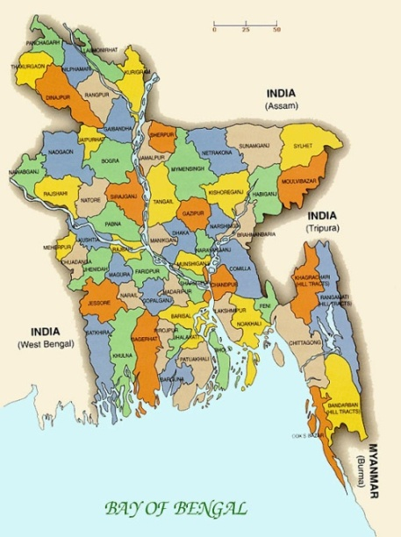
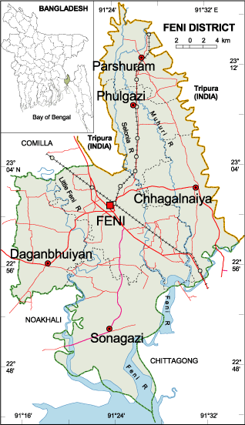
Villages and union under Feni Sadar Upazilla with household raising at least one goat with history and clinical sign of diseases were considered to be the study population. Though the cattle population was not so large in number but a lot of cattle affected by different diseases at the time of my internship program at Feni Sadar Upazilla
.

Figure:1: Location of Feni Sadar Upazila.
  - Study population
131cattle and 121 goats were recorded during that period.
3.4. Population and tools used for data collection
All the sick animals are brought for the treatment to this hospital were first registered in the patient registered book.
There were two ways of to have attended patients; one was clinic at which farmers willingly came with the patients with their complaints and another was at field where Veterinary surgeon along with me went to the field for registration of diseased animals. The age and other clinical history of sick animal were determined by asking the owner. A total of 252 animals including 131 cattle and 121 goats were available during the study period and the clinical examinations were conducted according to the merit of the cases. Materials considered significant for the diagnostic purposes were collected.
  - Clinical examination
Examination of body condition, temperature, feces and any prominent clinical signs were recorded. Based on these findings a presumptive diagnosis was made. Clinical examinations of all 131 cattle and 121 goats were conducted on the basis of diseases history, owner complaint, symptoms, to diagnose the following diseases and disorders. History of each case (present and past) was carefully taken which gave a guideline for examination of the animals. According the merit of the individual case, general clinical examination were conducted on the basis of disease history and owners complaint, symptoms and techniques such as microscopic examination, laboratory common techniques used by Rosenberger, 1979 and Samad et al., 1988.
3.5.1 Fever
Fever was diagnosed on the basis of recorded rectal temperature (Blood and Radostits, 1989).
3.5.2 Anorexia
Anorexia syndrome were diagnosed on the basis owner’s complaint with the history of partial and complete absence of appetite with varying decreased food intake and following the procedure of Prasad et al., 1976.
3.5.3 Digestive disorders (diarrhoea)
Fecal samples of the diarrheic selected animals were examined in the veterinary hospital laboratory as well as in FDIL(Field Disease Investigation Laboratory) and those samples found negative on parasitological examination were diagnosed as diarrhea and also by taking history whether of regular anthelmintic treatment of this animals were practiced or not.
3.5.4 Respiratory disorders (pneumonia)
This disorder was diagnosed on the basis of owner’s complaint and recording abnormal respiratory function like polypnoea, dyspnoea, coughing, sneezing, nasal discharging, thoracoabdominal breathing etc and by examining the entire respiratory tract as described by Blood and Radostits, 1989.
3.5.5 Skin diseases
Different type discrete and diffuse skin lesions were diagnosed clinically by visual examination.
3.5.6 Corneal opacity
Corneal opacity was diagnosed on examination. The presence of non-transparence, cloudiness and opaque condition on the cornea was diagnosed as corneal opacity.
3.5.7 Mastitis
Clinical findings of mastitis are with only mild change in either the milk or the udder, with the gross changes in the milk and or udder. Udder grossly enlarged and may be hot and painful, the milk have large clots or be purulent, body temperature more than 2°F above normal. (Rahman et al, 1984)
3.5.8 FMD
Foot and Mouth Disease (FMD) were diagnosed in calves and adult cattle on the basis clinico-epidemiological determinants. The presence of fever and vesicular eruption in the mouth and on the feet of same animal with the history of rapid spread of the disease in bovine population were regarded as Foot and Mouth Diseases. PPR was diagnosed in both kids and goat on the basis of clinico-epidemiological determinants (Samad, 2008).
3.5.9 Papillomatosis
Papillomatosis was diagnosed in calves and visual examination and palpation of solid outgrowth of epidermis.
3.5.10 Black quarter (BQ)
Black quarter diagnosed in young cattle on the basis of clinical examination. The presence of fever, lameness and palpation of the affected muscles revealed crepitating and needle puncture of the affected muscles resulted oozing blackish fluid confirmed the diagnosis of black quarter.
3.5.11 Arthritis
Clinically arthritis in sucking and growing animals was diagnosed using clinical signs of lameness and swollen joints.
3.5.12 Urogenital diseases
Urolithiasis was diagnosed mainly in castrated goats with the history and owners complain of complete retention of urine, and clinical findings of distension of urinary bladder, restlessness, occasionally rupture of urinary bladder and aspiration of fluid from the abdominal cavity rupture of the bladder. Repeat breeders was diagnosed on the basis of reproductive history of the cow, checking of individual breeding records and giving a special view to the characteristic of repeat breeder’s cow (Samad, 2008). Anestrus was diagnosed on the basis of history of not coming into heat within the normal cycle length. Uterovaginal prolapse was diagnosed when uterus was descended into the vagina and visible of the vaginal orifice. Clinical mastitis was diagnosed on the basis of owner’s complaint about abnormalities of udder and milk production. Palpation of udder revealed enlarged and painful with the presence of clots/ flakes in the milk confirmed the diagnosis of mastitis.
3.5.13 Protozoal dysentery
Clinical Presumptive diagnosis of dysentery can be on history of growing animals and clinical signs including dysentery, tenesmus, mild systemic involvement and dehydration. Confirmatory diagnosis can be made by demonstrating the oocysts in faecal sample of clinically affected animals.
3.5.14 Parsitological diseases
Humpsore (Stephanofilariasis), fascioliasis and paramphistomiasis were diagnosed on the basis of history and clinical findings and faeces examination (Blood and Radostits, 2000).
3.6 Statistical analysis
The data generated were entered into Microsoft Excel Worksheet. Descriptive statistics were performed to calculate mean, standard error of mean and percentage.

