Comparative production efficiency of commercial broiler farming in Noakhali district of Bangladesh

A thesis submitted in the partial fulfillment of the requirements for the degree of Master of Agricultural Economics

Department of Agricultural Economics and Social Sciences
Faculty of Veterinary Medicine

Chattogram Veterinary and Animal Sciences University
Khulshi, Chattogram-4225, Bangladesh

December, 2020

Comparative production efficiency of commercial broiler farming in Noakhali district of Bangladesh

DR. MD. AZMOL HOSSAIN
Roll no. : 0118/01
Reg no.: 531
Session : 2018-2019

A thesis submitted in the partial fulfillment of the requirement for the degree of Masters of Sciences in Agricultural Economics.

Department of Agricultural Economics and Social Science.
Faculty of Veterinary Medicine

Chattogram Veterinary and Animal Sciences University
Khulshi ,Chattogram-4225, Bangladesh

December, 2020

Comparative production efficiency of commercial broiler farming in Noakhali District of Bangladesh

DR. Md.Azmol Hossain
Roll no. :0118/01
Reg no. :531
Session :2018-2019

A thesis submitted in the partial fulfillment of the requirement for the degree of Masters of Sciences in Agricultural Economics.

( Prof. Md. A. Halim)  Co-supervisor | (Prof. Meherunnesa Chowdhury Sumy)  Supervisor

(Meherunnesa Chowdhury Sumy)
Professor and Head
Chairman of the Examination Committee
Department of agricultural economics and social sciences
Faculty of veterinary medicine

Chattogram Veterinary and Animal Sciences University
Khulshi , Chattogram-4225, Bangladesh

December, 2020

AUTHORIZATION

I hereby declare that I am the sole Author of the thesis entitled as “Comparative production efficiency of commercial broiler framing in Noakhali district of Bangladesh” here under the department of Agricultural Economics and Social Sciences, Chattogram Veterinary and Animal Sciences University (CVASU). I also authorize the CVASU to lend this thesis to other institutions or individuals for the purpose of scholarly research. I also authorize CVASU to reproduce the thesis by photocopying or by other means in total or in part, at the request of other institutions or individuals for the purpose of scholarly research.

I, the undersigned, and author of this work , declare that the electronic copy of this thesis provided to the CVASU library , is an accurate copy of the print thesis submitted , within the limits of the technology available.

The Author

…………………..
DR. Md. Azmol Hossain
December, 2020

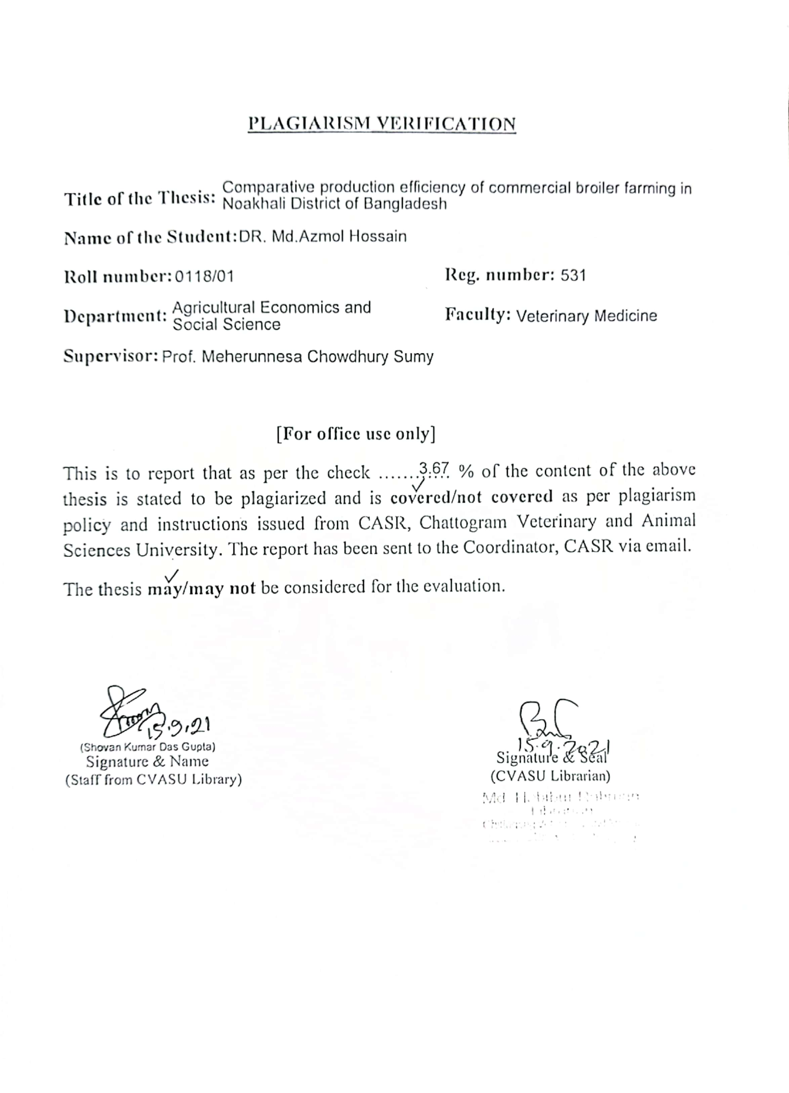

LIST OF CONTENTS

Content No. | Particulars of contents | Page No.
i  ii  iii  iv  v  vi | Authorization…………………………………………………..  List of Contents………………………………………………..  List of tables…………………………………..........................  List of figures and maps .......................................................  Acknowledgement……………………………………………..  Abstract……………………………………………………….. | iv  v  viii  ix  x  xi
CHAPTER-I | INTRODUCTION | 1-3
 | 1.1: Problem Statement…………………………………….... | 1
 | 1.2: Rationale of the Study…………………………………….. | 2
 | 1.3 : The Specific objectives of the study are............................... | 3
CHAPTER-II | REVIEW OF THE LITERATURE:………………………….  2.1 : Investment pattern in Broiler farming………………………... | 4-17  4-8
 | 2.2 : Profitability of broiler farming.............................. | 9-10
 | 2.3 : Resource productivity and returns to scale........................................ | 11-13
 | 2.4 : Marketing problems and prospects of broiler farmers....... | 14-17
CHAPTER-III | MATERIAL AND METHODS................................................... | 18-24
 | 3.1.1: Selection of the study area............................................... | 18
 | 3.1.2 : Sampling desgnand sample size............................ | 18
 | 3.1.3 : Selection of farms...................................................... | 18
 | 3.1.4 : Collection of sample............................................ | 18
 | 3.2 : Concepts and Estimation Procedures Adopted...................... | 19
 | 3.2.1 : Capital Investment................................................................. | 19
 | 3.2.2 : Fixed costs.................................................................... | 19
 | 3.2.3 : Variable costs....................................................................... | 20
 | 3.2.4 : Chick cost............................................................................. | 20
 | 3.2.5 : Feed cost................................................................................... | 20
 | 3.2.6 : Labour cost.............................................................................. | 20
 | 3.2.7 : Medicinal cost...................................................................... | 20

Content No. | Particulars of contents | Page No.
 | 3.2.8 : Electricity and fuel cost..................................................... | 20
 | 3.2.9 : Litter cost.......................................................................... | 20
 | 3.2.10 : Miscellaneous costs......................................................... | 21
 | 3.2.11 : Quantity of meat production per broiler......................... | 21
 | 3.2.12 : Total returns..................................................................... | 21
 | 3.2.13 : Net returns....................................................................... | 21
 | 3.2.14 : Benefit-cost ration (BCR)............................................... | 21
 | 3.2.15 : Deprectiation on fixed capital.......................................... | 21
 | 3.2.16 : Interest on fixed capital.................................................... | 21
 | 3.2.17 : Interest on working capital............................................... | 21
 | 3.3. Data coding, entry and cleaning.......................................... | 22
 | 3.4. Analytical Tools and Techniques........................................ | 22
 | 3.4.1 : Costs and returns in broiler farming ................................. | 22
 | 3.4.2 : Break-Even output.............................................................. | 22
 | 3.4.3 : Resource productivity and returns to scale in poultry farming : | 22
 | 3.4.4 : Returns to scale.................................................................. | 23
 | 3.4.5 : Marginal Value Products (MVP)....................................... | 23
 | 3.4.6 : Garrett's ranking technique :.............................................. | 24
CHAPTER-IV | RESULTS AND DISCUSSIONS:………………………… | 25-42
 | 4.1. Socio-economic characteristics of the selected broiler farms | 25
 | 4.1.1 : Size of the farm................................................................ | 25
 | 4.1.2 : Family composition and family labour availability on the selected Broiler farms : | 26
 | 4.1.3 : Occupational distribution............................................... | 27
 | 4.1.4 : Educational status of selected broiler farmers.................... | 28
 | 4.1.5 : Distribution far size according to land area ...................... | 29
 | 4.1.6 : Infrastructure of sample farms .......................................... | 29
 | 4.2 : Feed conversion in broiler farming ................................. | 30
 | 4.3 : Profitability in Broiler Production . ................................ | 31
 | 4.3.1 : Production costs in broiler farming................................... | 31-33
 | 4.3.2 : Returns from Broiler Farming ......................................... | 34
 | 4.3.3 : Net Income ........................................................................ | 35
 | 4.3.4 : BCR (Benefit Cost Ratio) ................................................. | 36
 | 4.3.5 : Returns on investment in broiler farming......................... | 36
Content No. | Particulars of contents | Page No.
 | 4.4 : Break-Even Analysis......................................................... | 37-38
 | 4.5 : Resource Productivity, returns to scale and resource  use-efficiency in Broiler Production. | 39
 | 4.5.1 : Resource Productivity..................................................... | 39
 | 4.5.1.1 : Flock Size (X₁).............................................................. | 39
 | 4.5.1.2 : Feed cost (X₂)................................................................. | 40
 | 4.5.1.3 : Labour cost (X₃)............................................................ | 40
 | 4.5.1.4 : Miscellaneous cost (X₄)................................................. | 41
 | 4.5.1.5 : Coefficient of Determinations (R²) .............................. | 41
 | 4.5.2 : Returns to scale .............................................................. | 41
 | 4.5.3 : Resource-use efficiency.................................................... | 41-42
CHAPTER-V | PROBLEMS AND SUGGESTION | 43-44
 | 5.1 : Problems involved in Broiler farming............................. | 43
 | 5.1 : Problems in the production of broilers................................. | 43-44
CHAPTER-VI | CONCLUSION AND RECOMMENDATIONS .................... | 45-7
References……………………………………………………………… |  | 48-53
Biography………………………………………………………………………. |  | 54

LIST OF TABLES

Table  No. | Particulars of Table | Page No.
4.1 | Farm size and number of birds per year | 25
4.2 | Family composition of broiler entrepreneurs | 26
4.3 | Occupational distribution of sampled broiler entrepreneurs | 27
4.4 | Educational status of sampled broiler entrepreneurs | 28
4.5 | Frequency distribution of rented and owned farms | 29
4.6 | Asset structure of broiler entrepreneurs according to farm size (TK) | 30
4.7 | Per bird Production cost in broiler farming in different size groups (in TK) | 32
4.8 | Per bird gross return in broiler farming according to farm size (in TK.) | 34
4.9 | Per bird profitability in broiler farming according to farm size (in TK.) | 35
4.10 | Returns on investment in broiler farming according to the farm size (in TK.) | 36
4.11 | Break-even analysis on broiler farming according to farm size for 1000 birds. | 38
4.12 | Production elasticitis and scale returns in broiler farming. | 40
4.13 | Marginal value products, factor costs and opportunity cost ratios in broiler farming according to farm size. | 42
5.1 | Garrett ranking of problems in the production of broiler farming | 43

LIST OF FIGURES AND MAPS

Figure No. | Particulars of maps and figures: | Page No.
3.1 | Study areas map | 19
4.1 | Educational status of different sizes of broiler farm owners | 28
4.2 | Feed conversion ratio according to farm | 31
4.3 | Per bird production cost in broiler farming in different size groups (in TK) | 33
4.4 | Per bird profitability in broiler farming according to farm size | 35

ACKNOWLEDGEMENT

With the hearted gratefulness first of all Alhamdulillah I would like to express my gratitude to the Almighty Allah (SWT), the lord of the universe who gave me the opportunity to complete this study.

I expressed heartily gratitude to Professor Dr. Goutam Buddha Das, Vice-Chancellor, CVASU for giving special opportunity and providing research fund to conduct the study.
.
I might want to give exceptional heartiest gratitude to my M.S Supervisor and respected Teacher, Professor Meherunnesa Chowdhury Sumy Department Agricultural Economics and Social Sciences, CVASU, Chattogram for checking my exploration exercises and his sharp help during the study works.

I likewise express my significant appreciation and genuine appreciation to the Co-supervisor, Professor Md. A. Halim Department Agricultural Economics and Social Sciences, CVASU, Chattogram for her valuable guidance, suggestions and constructive criticism finishing the last exploration the thesis.

I likewise appreciation to Professor Meherunnesa Chowdhury Sumy, Head & Chairman of Examination committee Department of Agricultural Economics and Social Science , CVASU for giving me motivation and consent to seek after this investigation.

The author expresses his deep sense of gratitude to all commercial broiler farm owners, DLS and NGO personnel for their kind co-operation in field works during data collection and processing.

The Author

ABSTRACT

The present study was under taken to estimate profitability, resource productivity, resource use efficiency and returns to scale in commercial broiler production in Noakhali district of Bangladesh. The study was undertaken through a survey method by contacting 60 broiler farms, representing small, medium and large farms 20 in each following random sampling method. Both the descriptive and Cobb-Douglas production method was used to analyze the data.
The study revealed that FCR for small farms was 1.56, while 1.49 and 1.48 for medium and large farms, respectively. The total cost of production per bird was maximum (Tk.78.09) in small farms and minimum (Tk.68.95) in large farms, it was Tk.73.03 in medium farms with an all average of Tk.73.35 for the pooled farms respectively. In case of small farms, total returns were Tk. 171.37 while Tk. 169.84 and Tk. 167.26 in medium and large farms, respectively. BCR were 2.19 for small farms, 2.33 for medium farms, 2.43 for large farms. It indicates commercial broiler farming is profitable for all farm sizes in the study areas.

The study also shown that the break-even sale weight per 1000 birds according to prices was found to be more favorable, as the farm size increases. The coefficients of flock size were statistically significant at one percent level in small and large farms but the coefficient of feed cost was found to be statistically significant for the medium farms only. Labour costs were not statistically significant though the values were positive for small and negative for medium and large farms. The (R²) values indicated that 65, 46, and 42 percent variation in total income on small, medium and large farms. The return to scale coefficients were 1.15, 1.42 and 1.32 for the small, medium and large farms, respectively. The marginal value product to factor cost ratios indicated inefficient use of resources in broiler farming on all farm size groups. Problem associated in the study are high feed cost, high cost of day old chicks , high labour cost, high cost of medicine, mortality, diseases, miscellaneous charges and inadequate veterinary services. Proper veterinary service, training facilities should be provided by private and government organizations and reduced feed cost to increase broiler production in Bangladesh.

Key Words: Broiler, comparative, commercial, efficiency, farming.

