**A Clinical report on:**

**Study on Complication and Management of PPR**



# 

# A CLINICAL REPORT SUBMITTED

**BY**

Intern ID: B-12

Roll No: 2008/19

Registration No: 362

**Chittagong Veterinary and Animal Sciences University**

**Khulshi, Chittagong.**

**Study on Complication and Management of PPR**



# 

# A CLINICAL REPORT SUBMITTED

**BY**

Intern ID: B-12

Roll No: 2008/19

Registration No: 362

**-------------------------------- -----------------------------------** Signature of Author Signature of supervisor

**Name: Farhana Hossain Name: Dr. Md. Masuduzzaman**

**Roll No: 2008/19 Professor and Head**

**Reg.No:362 Dept. of Pathology and Parasitology**

**Intern ID: B-12 Chittagong Veterinary and Animal Sciences University**

**CONTENTS**

ACKNOWLEDGEMENT = I

ABSTRACT =II

|  |  |  |
| --- | --- | --- |
| **CHAPTER** | **NAME OF CONTENTS** | **PAGE NO.** |
| I. | INTRODUCTION |  |
| II. | REVIEW OF LITERATURE |  |
| III. | MATERIALS & METHOD |  |
| IV. | RESULTS & DISCUSSION |  |
| V. | CONCLUSION |  |
|  | REFERENCES |  |
|  | | | | |
| **LISTS OF TABLES**   |  |  |  |  | | --- | --- | --- | --- | | **Table** | **Title** |  | **Pages** | | Table 1 | Overall overview of PPR affected goat in the study |  |  | | Table 2 | Effect of PPR in different age and sex |  |  | | Table 3 | Effect of vaccination on PPR |  |  | | Table 4 | complications in PPR affected goat |  |  | |  |  |  |  | | | | | |

**ACKNOWLEDGEMENT**

All praises are due to “Almighty Allah”, who has given the opportunity to accomplish of this report successfully.

The author wishes to express her deepest sense of gratitude, sincere appreciation, indebtedness and profound regards to his respected supervisor **Dr. Md. Masuduzzaman** Professor and Head Department of pathology and parasitology, Chittagong Veterinary and Animal Sciences University, for his constructive and constant guidance in planning and execution of this research work, continuous encouragement, scholastic guidance, and affectionate feelings throughout the course of research work.

The author whishes to express her gratitude to **Dr. Bibek Chandra Sutradhar,** Associate professor and Director External Affairs, Chittagong Veterinary and Animal Sciences University, for his supervision and kind co-operation during the period of internship.

Finally, it is my pleasure to express big thanks to all of my well-wishers, roommates, close friends for this encouragement and inspiration to complete my production report during study period.

The Author

**ABSTRACT**

The study was carried out to know the complications and management of Peste des Petits Ruminants (PPR) at upazilla veterinary hospital, Pabna sadar. The study population was comprised of 46 goats and the disease was diagnosed on the basis of clinical history and clinical findings. Prevalence of PPR was found in 57% cases of which 33% goat were died. PPR was found higher in non vaccinated goat which was statistically significant (P<0.05). The disease was complicated with gastrointestinal parasit**e** (45%) and myiasis (29%).complication may occur after recovery from PPR due to improper treatment and management. To reduce the infection rate successful vaccination program to healthy animal and quarantine the affected animal will help to control the PPR.

**Key words:** PPR, complication, management, pabna sadar.

**CHAPTER-I**

**INTRODUCTION**

Peste des Petits Ruminants (PPR) is the French name of a Rinderpest-like disease in sheep and goats caused by PPR virus (PPRV), a ribonucleic acid virus belonging to the genus *Morbillivirus* and family *Paramyxoviridae* which was first described in Ivory Coast, West Africa in 1942. It is an acute, highly contagious viral disease. For many years, PPR was considered as an African disease localized mainly in western and central Africa (Losos, 1989). Initially described in 1942 (Gargadennec and Lalanne, 1942), PPR has long been considered as confined to West Africa. More recently, it has become endemic across Sub- Saharan Africa, the Middle East, the Arabian Peninsula, Turkey, Iran, Iraq, Pakistan, India, Bangladesh, Tajikistan and Kazakhstan in Central Asia (Taylor and Barrett, 2007). In India, although PPR was believed to have been present in southern India prior to the late 1980s, the disease was not officially recorded in this region until 1987. Presently, PPR outbreaks are reported regularly and the disease is considered to be endemic throughout India ( Singh *et al.,* 2004). The existence of PPR in goats has been recognized and confirmed in Bangladesh by the World Reference Laboratory, National Reference Laboratory for PPR, Greifswald, as early as 1993 (Sil *et al.,* 1995). It was found that the isolates from Bangladesh were closely related with other strains from India and clustered within the Asian group of PPR viruses (Barrett *et al.,* 1997). PPRV mostly affects sheep and goats although goats are often more severely affected than sheep (Albina *et al*., 2012).In unprotected animals the morbidity can be up to 100% and mortality may vary from 20 to 90% and in severe outbreaks with 100% case fatality particularly in goats **.** Goats and sheep are the natural hosts of PPR, but goats appear to be more susceptible and suffer a more severe clinical disease than sheep. In endemic areas, goats more than 4 months up to 24 months age are affected (Samad, 2008).

Clinically, it is an acute or sub-acute viral disease of goats which results sudden dullness in infected animals, with high fever and inappetence. One or two days later, congestion of oral, ocular and nasal mucosae leads to serous discharges that later on become more abundant and mucopurulent (Roeder and Obi, 1999 ). Bronchopneumonia, revealed by productive cough and dyspnea, and diarrhea usually appears 3 days after the oral lesions. As a consequence of pneumonia and dehydration caused by diarrhea, severely affected animals may die within 5–10 days after the onset of clinical signs (Diallo, 2006). Abortions are often observed during PPR outbreaks, caused by PPRV alone or in combination with other pathogens (Kulkarni *et al.,* 1996; Abubakar *et al.,* 2008). At an early stage of infection, virus excretion is massive in the exhaled air. Nasal and ocular discharges, saliva, and feces also contain large amounts of virus (Abubakar *et al.,* 2012).

Necropsy of diseased goats revealed congested and consolidated pneumonic lungs, generalized enlargement of lymphnodes accompanied with necrosis and congestion of some lymphnodes, atrophied congested spleen and haemorrhagic gastroenteritis (Khan *et al*., 2005). Hemorrhagic ulceration is marked in the ileocecal region, colon and rectum where they produce typical “zebras stripes” (Radostits *et al.,* 2005).

Control of PPR is based on a concerted effort of vaccination and sanitary measures. At present homologous PPR vaccine has been practiced against PPR to make up strong immunity in Bangladesh. Ravages caused by PPR act as one of the prime production limiting factors in goats all over the world. Infectious and contagious diseases are important impediments to the economical rearing of small ruminants (Radostits *et al.,* 2000). Among these diseases, Peste des petits ruminants (PPR) has become a concern because it causes heavy economic losses. In this study efforts have been made to estimate the prevalence of PPR of goats in UVH, Pabna Sadar, Pabna of Bangladesh. In this report the diagnosis was based on owners complain, clinical history, clinical signs.

With the background mentioned above this study was undertaken with the following specific objectives:

* To know the prevalence of PPR affected goat in UVH, Pabna Sadar, Pabna
* To know the complication and management associated with PPR

**CHAPTER-II**

**REVIEW OF LITERATURE**

Peste des petits ruminants (PPR) is an acute and highly contagious viral disease of small ruminants that is caused by a non-segmented negative strand RNA virus, peste des petits ruminants virus (PPRV). This virus is a member of the morbillivirus genus and as such is closely related to rinderpest virus (RPV). The recent eradication of (RPV) has increased the global interest in PPRV and has highlighted its potential for elimination using a similar vaccination and surveillance strategy (Baron *et al.,* 2011).PPRV infection causes an acute, highly contagious disease characterized by fever, anorexia, necrotic stomatitis, diarrhea, purulent ocular and nasal discharges, and respiratory distress (OIE, 2000). Infection rates in animals rise with age, and the disease, which varies in severity, is rapidly fatal in young animals. As with other morbillivirus infections, PPRV needs close contact between infected and susceptible animals to spread (Lefevre and Diallo, 1990).

**PPR (Peste des petits ruminants):**

For centuries morbillivirus infections have had a huge impact on both human beings and animals. Morbilliviruses are highly contagious pathogens that cause some of the most devastating viral diseases of humans and animals worldwide. They include measles virus (MV), canine distemper virus (CDV), rinderpest virus (RPV) and peste des petits ruminants (PPRV) virus. Peste des petits ruminants (PPR) is a highly contagious ,infectious , an acute or sub acute viral disease of domestic and wild small ruminants characterized by fever, oculonasal discharges, stomatitis, conjunctivitis, gastroenteritis and pneumonia. Goats are more severely affected than sheep. It is also known as pseudorinderpest of small ruminants, pest of small ruminants, pest of sheep and goats, kata, stomatitis- pneumoentritis syndrome, contagious pustular stomatitis and pneumoentritis complex (Chauhan *et al,* 2009*).*

**Etiology of the Disease:**

The etiological agent, Peste des Petits Ruminants virus (PPRV) has been classified under Order Mononegavirales, family Paramyxoviridae and Genus Morbillivirus (Murphy *et al.,* 1999).

The virus is closely related to Rinderpest virus (RPV).The virus is also serologically related to Measles and Canine distemper virus (Gibbs *et al.,* 1979). Antibodies to PPRV and rinderpest are cross-protective, and vaccination for rinderpest can mask the presence of peste des petits ruminants.

**Morphology of the PPRV:**

The virus particle is pleomorphic with a diameter of intact particles varying between 130-390 nm. The virus has an envelope of 8-15 nm thickness with spikes of 8.5-14.5 nm length. The herring bone like ribonucleoprotien strands measure approximately 14-23 nm in thickness (Durojaiye *et al.,* 1985).PPR virus is non-segmented single stranded RNA of negative polarity. The genome of PPRV encodes for eight proteins: the nucleocapsid protein (N), the phosphoprotein (P), the matrix protein (M), the fusion protein (F), the haemagglutinin protein (H), the polymerase protein (L) and the two non-structural proteins, C and V (Maganga *et al.,* 2013).

**Geographical Distribution :**

The global spread of PPR is probably related to the progressive control and later, eradication, of rinderpest. The cessation of rinderpest vaccination campaigns and loss of antibody cross-protection between the two diseases means that small ruminants are now fully exposed to PPR. PPR was first reported in the Ivory Coast of West Africa and was later found in other parts of the world incuding sub-Saharan Africa, the Arabian Peninsula, the Middle East, and the parts of Asia (Balamurugan *et al.,* 2012). The first PPR observation outside West Africa was in Sudan, between 1970 and 1972 (El Hag Ali and Taylor, 1984). In 1983, it was confirmed in the Arabic Peninsula and subsequently in Asia (Maillard *et al.,* 2008). In recent years, field data and laboratory findings have confirmed the dramatic spread of PPR toward the south of Africa, affecting Gabon, Democratic Republic of Congo, Somalia, Kenya and Tanzania (Swai *et al.,* 2009). PPR has now been identified in Tunisia (Ayari-Fakhfakh *et al.,* 2011) and Algeria (De Nardi *et al.,* 2012). Outbreaks of PPR are now known to be common in India, Nepal, Bangladesh, Pakistan and Afghanistan (Abdollahpour *et al.*, 2006). In India, PPR was first recorded in the Tamil Nadu state during 1987 and was later an epidemic in northern India. At present, PPR is enzootic in India and outbreaks occur regularly among small ruminants throughout the country, incurring significant economic losses in terms of morbidity, mortality, and loss of productivity due to trade restriction (Balamurugan *et al.,* 2012). PPR has been recognised in Pakistan since 1991 when rinderpest like disease in goats was reported in the province of Punjab (Athar *et al*., 1991).In Bangladesh, the presence of PPR in goats was detected by FAO expert team in 1993. Disease investigation among organized goat farm in Bangladesh showed that outbreaks were always associated with introduction of new goats to the farm. Occurrence of PPR in an epidemic form has a drastic effect on the goat population in Bangladesh ( Khan *et al.,* 2005).

**Incidence of PPRV :**

Environmental factors influence disease occurrence. (Hegde *et al.* 2009) showed that incidences were highest during the rainy season and in the dry agro-climatic zones. The dusty and dry winds that characterize winter season of the year has been shown to enhance the spread of PPR (Obi, 1983). (Aruni *et al.,* 1998)observed more than ten outbreaks of PPR in goats from Tamil Nadu. They observed that kids were susceptible than adult. An outbreak of PPRV in approximately 100 goats was diagnosed in Rawalpindi city, Pakistan in June 1997 by (Hussain *et al.,*1998)with mortality rate of 80 %. PPRV was detected in blood and various tissue samples using a competitive ELISA and immunocapture ELISA. It was found that the isolates from Bangladesh were closely related with other strains from India, and clustered within the Asian group of PPR viruses (Barrett *et al.,* 1997). The outbreaks of 74.13% morbidity and 54.83% mortality in Black Bengal goats in Bangladesh (Islam *et al.,* 2001 and Das *et al.,* 2007).

**Host Range of PPRV :**

Cattle, buffaloes, camels and pigs can also be infected but there is little or no evidence of disease associated with their infection. PPRV antigen has been detected in an outbreak of respiratory disease in camel and sick domestic buffaloes (Taylor *et al.*, 1990; Scott, 2000; Abraham *et al.*, 2005)Antelope and other small wild ruminant species can also be severely affected (Abu Elzein *et al.*, 2004).

**Transmission of PPRV :**

Although the virus is highly contagious, it can only be transmitted when a healthy animal comes into direct contact with the secretions or excretions of a sick animal. Inhalation is thought to be an important route of spread. PPRV is shed in nasal and ocular secretions, saliva, urine and feces. It probably occurs in milk (CFSPH, 2008). Since the virus is enveloped, it is extremely sensitive to inactivation by environmental factors such as heat, sunlight and chemicals. It, therefore, require close contact with an infected animals for successful transmission. The disease is transmitted by aerosols between animals living in close contact (Lefevre and Diallo, 1990).

**Association between PPR and age of goat:**

Young kids of below one year are much more susceptible than adult one. The maximum proportionate of PPR was encountered 37.5% at the category of 7 to 12 month subacute manner (Radostits *et al*, 2000). The young goat may die due to anoxia. Kids over 4 months and under 1 year of age are at higher risk and cause huge economic loss (Venkataramanam*et al*, 2005).

**Association between PPR and sex of goat :**

There is no detail finding about the PPR infection of goat in different sex.Both male and female goats are equally susceptible to PPR (Samad, 2001).

**Association between PPR and vaccination in goat :**

Vaccination contributes to lowering Peste des petitsruminans outbreak in goats (Taylor *et al*., 1990 and Majiyabe *et al*., 1994).

**Pathogenesis :**

PPR virus, Like all morbilliviruses, PPRV has an established lymphatic and epithelial tropism. The signaling lymphocyte activation molecule (SLAM) is well recognized as the universal receptor for morbillivirus infection of immune cells, and this receptor tropism results in the leukopenia observed during infection ( Bao *et al*., 2012). Consequently, it induces the most severe lesions in organ systems rich in lymphoid and epithelial tissues. The respiratory route is the likely portal to entry. After the entry of the virus through the respiratory tract system, it localizes first replicating in the pharyngeal and mandibular lymph nodes as well as tonsil. Viremia may develop 2-3 days after infection and 1-2 days before the first clinical sign appears. Subsequently viremia results in dissemination of the virus to spleen, bone marrow and mucosa of the gastro-intestinal tract and the respiratory system (Scott, 1981).

**Clinical signs of PPR :**

Animal affected by PPR shed the virus in exhaled air, in secretions and excretions (from the mouth, eye and nose, and in feces, semen, and urine) approximately 10 days after the onset of fever (Maganga *et al*., 2013). Clinical signs of PPR have been well documented (Hamdy *et al*., 1976; Obi, 1984; Lefèvre, 1987; Taylor, 1984; Bundza *et al*., 1988; Roeder *et al*., 1994; Roeder and Obi, 1999). Following infection there is a 3–4 day incubation period. The predominant form of the disease is the acute form. The salient clinical signs start with sudden rise in body temperature to 39.5 - 41°C. Affected animals breathe fast, sometimes so fast that they exhibit rocking movements with both the chest and abdominal walls moving as the animal breathes. They have obvious signs of pneumonia. A clear watery discharge starts from the eyes, nose and mouth, later becoming thick and yellow as a result of secondary bacterial infection. Appearance of a serous to muco-purulent nasal discharge which may crust over and occlude the nostril, sneezing, ocular discharge resulting in matting of the eyelids. The discharges wet the chin and the hair below the eye; they tend to dry, causing matting together of the eyelids, obstruction of the nose and difficulty in breathing. Unlike RP, there is a definite but inconstant, respiratory system component (Brown *et al*., 1991; Bundza *et al*., 1988).

Body temperature usually remains high for about 5-8 days, and then slowly returns to normal prior to recovery or drops below normal before death. Diarrhea commonly appears about two to three days after the onset of fever although, and death is usually preceded by pneumonia (Hamdy *et al*., 1976). The faeces are initially soft and then watery, foul-smelling and may contain blood streaks and pieces of dead gut tissue. Such victims may eventually become dehydrated with sunken eyeballs, and death often follows within seven to ten days from onset of the clinical reaction. Other animals will recover after a protracted convalescence.

**Post mortem findings :**

It was reported that the carcass of an affected animal is usually emaciated, the hindquarters soiled with soft/watery faeces and the eyeballs sunken. The eyes and nose contain dried-up discharges (Chauhan *et al.* 2009). Lips may be swollen; erosions and possibly scabs or nodules in late cases. The nasal cavity is congested (reddened) lining with clear or creamy yellow exudates and erosions. Oral mucosa was congested in almost all cases with presence of minor erosions on lips and tongue in about 60% cases (Kumar *et al*., 2004). There may be dry with erosions on the gums, soft and hard palates, tongue and cheeks and into the esophagus. The lung is dark red or purple with areas firm to the touch, mainly in the anterior and cardiac lobes (evidence of pneumonia). Mesenteric lymph nodes were swollen and oedematous in more than 80% cases (Kumar *et al.,* 2004). Abomasum congested with lining haemorrhages. The pathology caused by PPR is dominated by necrotizing and ulcerative lesions in the mouth and the gastro-intestinal tract (Roeder *et al*., 1994). The rumen, reticulum and omasum rarely exhibit lesions.

**Concomitant infection with PPR :**

Obi *et al*. (1983) showed that, the most significant bacteria associated with PPR infected goats were *Pasteurella haemolytica, Klebsiella* sp., *Pseudomonas aeruginosa* and *Staphylococus pyogenes* from the lungs, *Salmonella sp.* and *E. coli* from the faeces, *Moraxella bovis* from the eyes and *Staphylococcus pyogenes* from the oral cavity. Pneumonia is usually a very obviously presented sign in PPR. Pneumonic pasteurellosis is a purely respiratory disease of sheep and goats caused by the bacterium *Pasteurella haemolytica.*

**Differential Diagnosis:**

The disease must be differentially diagnosed from Foot and Mouth disease, Bluetongue, Contagious ecthyma, Pasteurellosis, Contagious caprine pleuropneumonia, Nirobi sheep disease, Coccidiosis, Plant and Mineral poisoning etc. (Appel *et al*., 1981).

**Treatment of PPR :**

There is no specific treatment for PPR, however hyperimmune PPR serum produced in goats reverses the disease process if administered at the onset of fever (Ihemelandu *et al.,* 1985). The affected animals were given antibiotics to control secondary bacterial infections along with anti-inflammatory drugs. Specifically, oxytetracycline and chlortetracycline are recommended to prevent secondary pulmonary infections (OIE, 2000). Sil *et al.* (2006) reported that, the use of combined antibiotic hyper immune serum therapy (ACHST) for PPR helpful to overcome the condition. For diarrhoeal conditions, they suggested that 10 ml hyperimmune serum intravenous route per animal three doses every 3 days interval. Long acting Oxytetracycline tabs 1ml/10 kg body weight 2nd dose after 72 hours of 1st dose. A mixture of Oxytetracycline tabs and Metranidiozol (1:1) oral doses twice daily until diarrhea subsides.

**Prevention and control of PPR:**

Control of PPR outbreaks depends on movement control combined with the use of vaccine. Although vaccination against PPR is being practiced in Bangladesh and other countries, PPR is still causing major constraints to the productivity of small ruminants. Therefore, development of effective prophylactic procedures along with rapid, specific and sensitive diagnostic methods is extremely important for effective control of the disease. (Singh *et al.* 2009) said that, the availability of an effective vaccine, accurate diagnostic tests for PPR and an experienced infrastructure prompt us to propose a national project for a Peste des Petits Ruminants eradication programme on the lines of National Project on Rinderpest Eradication. To control peste des petits ruminants (PPR) in Bangladesh a live attenuated conventional PPR vaccine was developed by Bangladesh Livestock Research Institute (BLRI) and currently being used in the country (Rahman *et al.,* 2011). This would greatly enhance the prospects of PPR eradication not only on a national level but also from the Asian continent, alleviate poverty and, in turn, contribute to the national economy.

**CHAPTER-III**

**MATERIALS AND METHODS**

**Location and duration of the study :**

The study was conducted in different breeds of goats registered at the Upazilla Veterinary Hospital, Pabna Shadar, Pabna from 4 May 2013 to 5 July 2013.

**Study population:**

The study was conducted on natural PPR infected goats of various age, sex and breed that were brought to the Upazilla Veterinary Hospital. During the study period about 80 goats were brought for treatment pupose among them 46 goats were recorded as PPR affected.

**Case definition:**

Diagnosis was made by means of Anamnesis and clinical signs. A PPR case was initially suspected if an animal showed signs of fever in the initial stage followed by pneumoenteritis evidenced by nasal and ocular discharges, conjunctivitis, erosion in oral mucosa, dyspnoea, diarrhea, dehydration, generalized weakness and finally death. The degree of dehydration was estimated by conventional skin fold test. All the clinical signs were properly noted in the record sheet. Sometimes the tentative diagnosis was supported with post mortem examinations.

**Clinical examinations of PPR cases:**

**History:**

Data were recorded by interviewing the owners regarding the breed/sex/age of the animals; probable date of clinical onset of the disease with the signs like fever, nasal and ocular discharges, diarrhea, depressed appetite from the last two or three days of clinical onset.

**Clinical examination:**

The following clinical examinations were done carefully and the findings were recorded.

**Distance inspection**

The posture and gait of each animal was inspected by careful observation from distance.

**Close inspection**

Close inspections were performed properly in order to observe the presenting signs such as a sharp rise of temperature of 104°F – 106°F, oculonasal discharge, diarrhea, respiratory distress and any other significant clinical signs.

**Temperature**

Per rectal temperature was recorded with the clinical thermometer

**Indirect auscultation**

Normal and abnormal sound of respiratory and cardiovascular system were observed initially by direct hearing and then with the help of stethoscope.

**Dehydration test**

On the basis of skin fold test three types of dehydration were examined namely

* Severe dehydrated
* Moderate dehydrated
* Slight dehydrated

**Clinical signs and symptoms:**

the following clinical signs were observed while treating the patients :

1. Markedly depressed and dull appearance
2. Rough hair coat
3. Thick serous or purulent discharge from the eyes and nose
4. Sudden high fever ( 104˚-106˚ F), remaining high for 5 to 8 days, will return to normal before recovery or drop below normal before death.
5. Anorexia, severe dehydration and emaciation followed by hypothermia.

The mucous membrane of the mouth and eyes become much reddened and small pinpoint grayish areas appeared on the gum, dental pad, palate, lips, and upper surface of the tongue and characteristics foul smell came out from mouth.

1. Faces were semisolid and liquid brown, yellow and black colored, watery foul smelling and contain blood streaks and pieces of dead gut tissue.
2. In severe cases, difficulty in breathing marked by extension of head and neck, dilation of nostril, protrusion of the tongue and soft painful coughs.

**Treatment:**

After the presumptive diagnosis supportive treatment was given to the patients:

1. Antibiotic / Sulphur drug
2. Respiratory stimulant
3. Fluid therapy

**Vaccination history of PPR:**

Each owner was asked about previous vaccination history of his or her goats suffering from PPR and 18 goats were vaccinated and remaining 28 goats were non vaccinated among the handled goats of different breeds.

**Complications:**

The affected goat had signs of pneumonia like difficult and noisy breathing marked by extension of the head and neck, dilation of nostrils, protrusion of tounge and soft painful cough. Because of secondary bacterial infection, ulceration was found in mouth and nose. Feces contain blood streaks and pieces of dead gut tissue. Appearance of a serous to mucopurulent nasal discharge which crust over and occlude the nostrils, sneezing, ocular discharge resulting in matting of the eyelids. Malnutrition due to parasite infestation was aggravate PPR. Sometimes maggot may developed in anus region.

**Management:**

PPR is one of the contagious viral disease. So doctor suggested to restrict the affected animal movement. Affected goats were kept in quarantine measure. As there was no specigic drug for PPR so supportive treatment was given as antibiotic for secondary bacterial infection, fluid therapy, respiratory stimulant. If any goat were complicated with maggot infestation then that animal treated with oil of turpentine locally, ivermectin. To prevent the secondary bacterial infection suggested antibiotic. Respiratory stimulant used for the respiratory problem.

**CHAPTER-IV**

**RESULTS AND DISCUSSION**

The study was conducted among the naturally infected PPR goats of different breed, sex and age that were brought to the Upazilla Veterinary Hospital May 2013 to July 2013. Every goats registered here was clinically examined during the course of study. The investigation was carried out to determine the prevalence of PPR in relation with age, sex, vaccination status and to record clinical signs, complication and management. A number of 80 goats of different breeds were brought to the hospital, of which 46 goats of different breeds were examined, treated and followed up as PPRV affected goats.

Prevalence of PPR:

A total of 80 goats were brought to hospital among them 46 goats were PPR affected. The overall prevalence of PPR during the study period was estimated as 57%. (Table: 1)

Table 1: Overall overview of PPR affected goat in the study

|  |  |  |
| --- | --- | --- |
| **Total No. of goat in UVH** | **No. of PPR affected goat** | **Prevalence of PPR (%)** |
| 80 | 46 | 57% |

The prevalanceof PPR is little bit higher in female than male (Table 2). The female goat showing higher rate (65%) compared to male (35%). The prevalence among different age group of animal are also demonstrated in Table 2. Among the 46 affected goats 67% is below 1 year and 33% are above 1 year.

Table 2: Effect on PPR in different age and sex

|  |  |  |  |  |
| --- | --- | --- | --- | --- |
| **No. of PPR affected goat** | **Age of goat** | | **Sex** | **P value** |
| **<1year** | **≥1year** |
| 46 | 31 (67%) | 15 (33%) | Male 16 (35%)Female 30 (65%) | 0.33 |

Table 2 showing the percentages of PPR on the basis of Sex. The disease was 69% in female and 31% in male. The fact that small ruminants producers keep more females for breeding purposes may explain this observation. Hence, the probability for females getting exposed to PPRV throughout their life time is more, than for males (Abdalla *et al*., 2012).

|  |  |  |  |
| --- | --- | --- | --- |
| **Total No. of PPR goat** | **Vaccinated** | **Non vaccinated** | **P value** |
| 46 | 18 (39%) | 28 (61%) | 0.008 |

Table 3: PPR in vaccinated and non vaccinated goat

Impact of vaccination in the prevalence of PPR are illustrated in Table 3. The rate of vaccination against PPR among rural community is very poor. Among 46 cases, only 18 cases having the history of vaccination. The prevalence of PPR in the vaccinated group (39%) is much lower than that of non vaccinated group (61%) which is statisticaly significant P value.

Table 4: Complication in PPR affected goat

|  |  |  |  |
| --- | --- | --- | --- |
| **Total PPR affected goat** | **Parasitic infestation** | **Myiasis** | **Dead** |
| 46 | 21 (45%) | 13 (29%) | 15 (33%) |

On the other hand, most of the cases are complicated with other diseases. Among them 45% and are, parasitic infection and 29% were myiasis. Among 46 PPR affected goat 33% were found dead.

**PPR Infected goat**

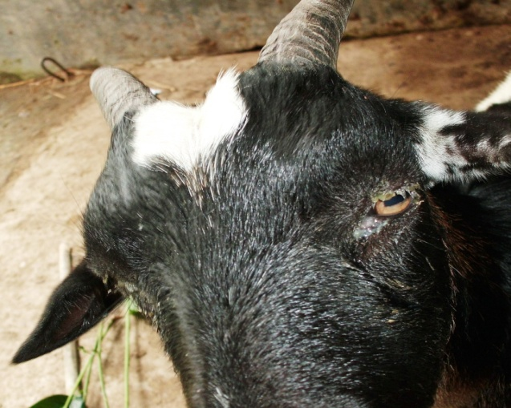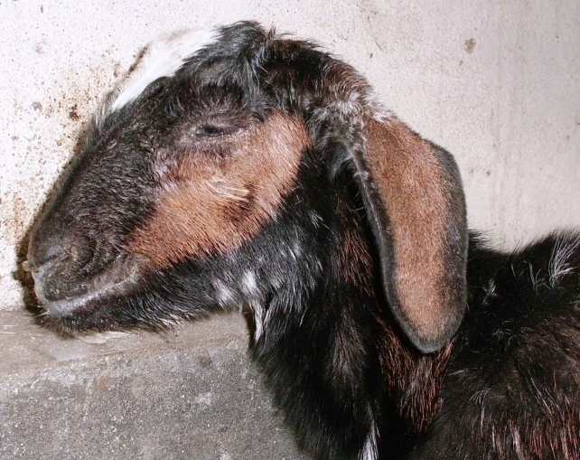

**b**

**a**

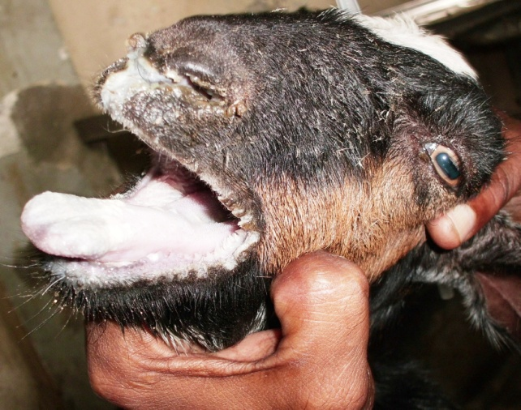



**d**

**c**

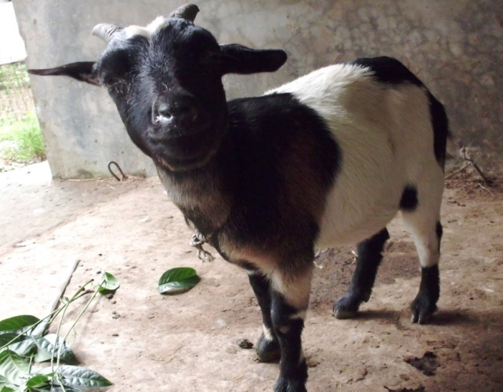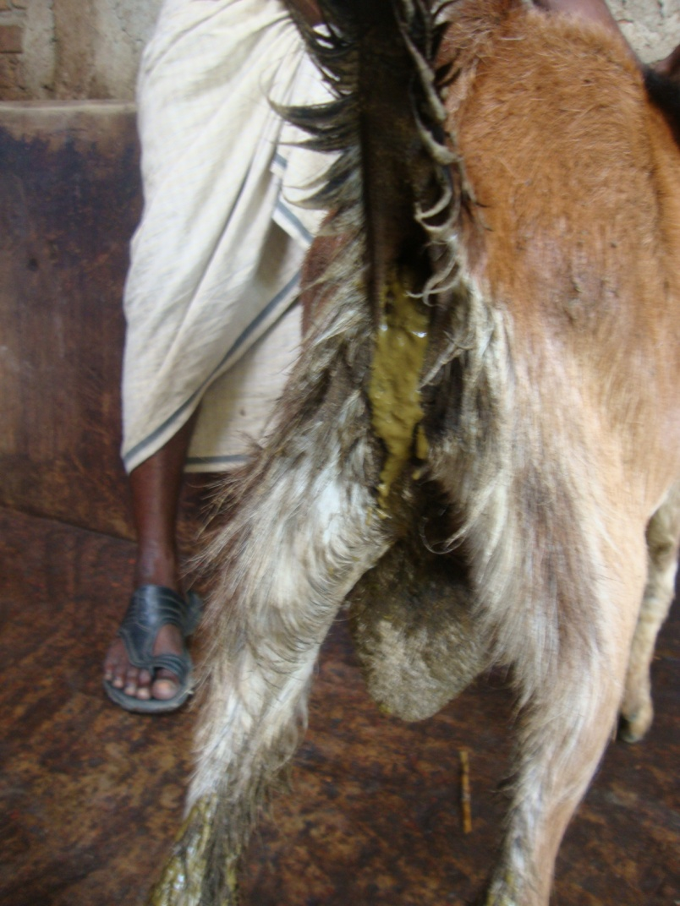

**f**

**e**

**Plate- 1: Clinical signs of PPR affected goats.** **( a )** Goat showing ocular discharge **( b )** Goat showing nasal discharge **( c + d )** oral lesions (erosions) in PPR affected goat **(e )** Diarrhoea in PPR affected goats **( f )** PPR affected goat having high fever .

**Some complications**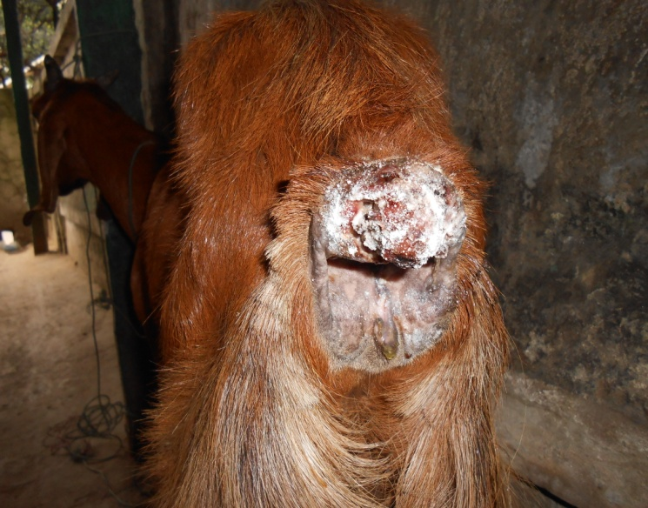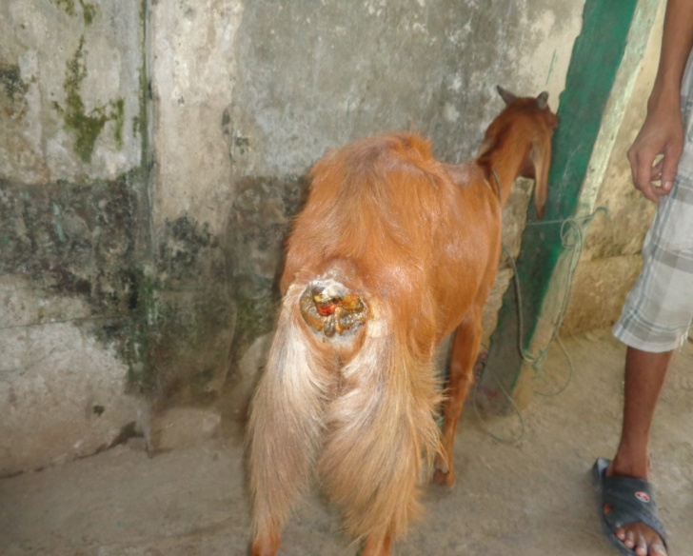

**b**

**a**

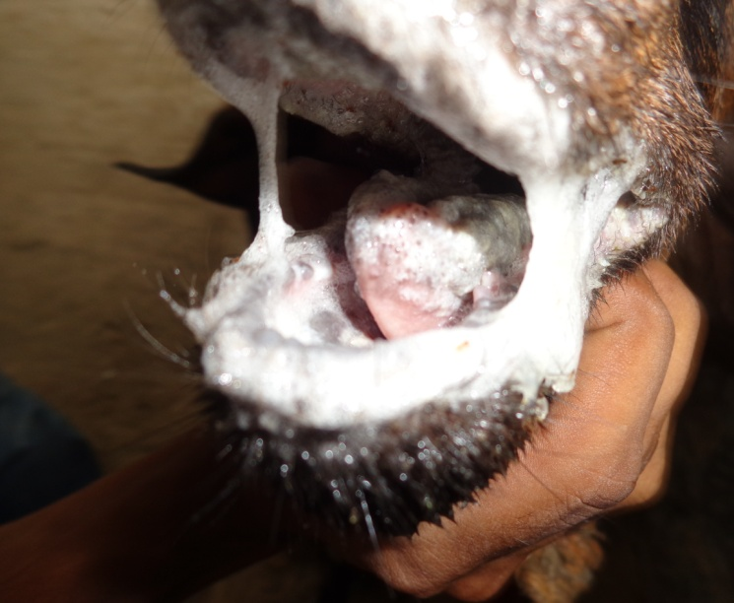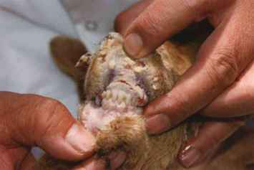

**Plate- 2: Complications of PPR affected goats.** **( a+b )** Goat showing myiasis in anal region **( c+d )** Goat showing ulceration in mouth and tounge.

**d**

**c**

**Comparative analysis of PPR on Age:**

It is reported that the age between 4 to 12 months were more prone to PPR than older ( > 1 year) (Gupta *et al,* 2007). Singh *et al.* (2004) also assessed that the disease is most prevalent in the goats less than one year of age. The increased susceptibility of young goats were might be due to malnutrition, poor immunity and poor management systems (Sarker and Islam, 2011).

**Prevalence of PPR based on Immunization status:**

According to vaccination status, 65% prevalence was recorded for non vaccinated goats and 26% prevalence was recorded despite of vaccination showing in Table 1. This result supports the early reports of (Islam *et al*., 2012) where the prevalence of PPR is higher (66.40%) in non-vaccinated as compare with vaccinated (19.56%) animals. (Gibbs *et al.,* 1979) also found higher prevalence of PPR in the non vaccinated goat population. Current study present the disease differ significantly ( P<0.05) between vaccinated and non vaccinated goats as non vaccinated animal were higher in risk. It may be due to lack of antibody level in non vaccinated animals. Vaccination against the disease leads to decrease the prevalence, but not gives guarantee. (Banik *et al.,* 2008) detect the protective level of antibody against PPR in the vaccinated goats indicates that the vaccine has actively stimulated the immune system in the inoculated animals against PPRV. This findings support the earlier observation of (Das *et al*. 2007) who reported the efficacy of PPR vaccine against natural PPR infection.

**Complications:**

Severely affected cases show difficult and noisy breathing marked by extension of the head and neck, dilation of the nostrils, protrusion of the tounge and soft painful cough. They have obvious sign of pneumonia. A clear watery discharge starts to issue from the eyes, nose and mouth, later becoming thick and yellow because of secondary bacterial infection. The lining of the mouth is changed in appearance. Myiasis occur in anal region due to excessive diarrhea.Some bacteria usually find their way into underlying epithelial surfaces of pneumonic lungs damaged by viral or parasitic agents and hence complicate the infection (Adekeye, 1984; Al-Tazari 1997).

The prognosis of acute PPR is usually poor. The severity of the disease and outcome in the individual is correlated with the extent of the mouth lesions. Prognosis is good in case where the lesions resolve within 2 to 3 days. It is poor when extensive necrosis and secondary bacterial infections result in a fetid odor from the animals mouth.

The parasites reduce immunity by causing malnutrition in animal because some gastrointestinal parasites serious blood suckers (Githigia *et al.,* 2001). The parasites cause serious malnutrition, it may predispose the PPR virus causing acute and severe infection.Poor nutritional status, stress of movement, and concurrent parasitic and bacterial infections enhance the severity of clinical signs of PPR disease (Rautmare, 2010). Parasite reduce immunity by causing malnutrition in animal because some gastrointestinal parasites serious blood suckers (Githigia *et al*., 2001). Parasite cause malnutrition so any viral disease may cause severity (Al-Quaisy, *et al*., 1987).From these observations it can be said that history of previous disease exposure and the history of no deworming enhance the PPR disease susceptibility.

**Management:**

There are no known effective drugs against of this disease. However, hyperimmune serum and supportive treatment with fluid therapy for dehydration and to prevent secondary bacterial infection used antibiotics to save the life of the infected goats. If affected goat are treated within 1 week then the goat may recover easily. The outbreak of this disease causes a heavy economic loss in Bangladesh. To control this disease use PPR TC vaccine used which produced by LRI. Kids and lambs should be vaccinated at 3-4 months of age.

Currently Bangladesh government has taken a national scheme of poverty alleviation through goat rearing. The total program will be nill and void if the disease will not control in Bangladesh. PPR is immunologically similar to rinderpest and produce solid immunity so prevention of the disease by vaccination is easier than any other method (Sil, 2000).

Hyperimmune serum can be used successfully along with long acting antibiotic to limit the spread of virus and recover those animals, which are under incubation and in early stage of infection. Good nursing, symptomatic treatment with broad-spectrum antibiotic/sulphur drugs can save life of sick animal of and can improve the immunosuppressive condition of the affected goat (Sil et al.,2006 and Scott,2000).

Vaccination contributes to lowering Peste des petits ruminans outbreak in goats (Taylor *et al*., 1990 and Majiyabe *et al*., 1994). Recently a homologous PPR vaccine has been developed. This vaccine of choice is becoming increasingly available. The vaccine can protect small ruminant against PPR for atleast three years (Roeder, P.L. and Obi, T.U. 1999). PPR being an exotic disease in Bangladesh, there is a very little knowledge about its epidemic nature, diagnostic techniques and control strategy.A control programme using locally produced tissue culture live attenuated rinderpest vaccine, as well as imported rinderpest vaccine were adapted against PPR in this country, but failed (Sil *et al*., 1995). The efficacy of the thermo stable PPR vaccine incubated at room temperature for 14 days. Hyper immune serum can be used successfully along with long acting antibiotic to limit the the spread of virus and recover those animals which are under incubation and in early stage of infection. Good nursing, symptomatic treatment with broad spectrum antibiotic, sulphur drugscan safe life of sick animal and also can improve the immunosuppressive condition of the affected goat (Sil, 2000).

**Limitation of the study:**

During the course of examination, all aspects were observed carefully but there is also some limitations that influence the present study. The duration for the study of disease was short that may results improper estimation, fluctuation in seasonal variation, sometimes diagnosis was made through tentative variables, inappropriate data collection, small number of sample size etc were limitate the study.

**CHAPTER-V**

**CONCLUSION**

PPR is highly contagious disease with higher mortality and morbidity in goat. In this study it is revealed that younger (<1year) goats were more susceptible than older age. The occurance of PPR were higher in non-vaccinated animal than vaccinated goats. Most of the cases are complicated with other disease. Complication like severe gastrointestinal problem due to parasite, secondary bacterial infection like pneumonia, myiasis in nasal and anal region may occur. No deworming history is act as predisposing factor of PPR. The goats which had previous disease exposure history were more susceptible to PPR than those goats which had no history of disease exposure. It was also observed that vaccination reduces the PPR disease susceptibility. Although against virus, there is no specific treatment, combined therapy containing antibiotic, antihistamines as well as fluid therapy noticed line of treatment in PPR infection of goat. PPR causes heavy economic losses in every year especially in winter and rainy seasons and also decreases the productive performances of goat. A great deal of more research into this aspect of the disease is urgently required. So, Proper surveillance and regular vaccination program should be taken to eradicate PPRV throughout the country.

**CHAPTER-VI**

**REFERENCES**

Abdalla, S. A., Majok, A. A., El Malik, K.H. and Ali, A. S. (2012) Sero-prevalence of peste des petits ruminants virus (PPRV) in small ruminants in Blue Nile, Gadaref and North Kordofan States of Sudan. *Journal of Public Health and Epidemiology* 4(3): 59-64.

Abdollahpour, G., Roofi, A., Najafi, J., Sasani, F. and Sakhaie, E. (2006) Clinical and para-clinical findings of a recent outbreak of Peste des petits ruminants in Iran. *J. Vet. Med. B,* 53: 14-16.

Abraham, G., Sintayehu, A., Libeau, G., Albina, E., Roger, F., Laekemariam, Y., Abayneh, D. and Awoke, K. M. (2005) Antibody seroprevalence against PPR in camels, cattle, goats, and sheep in Ethiopia. *Prev. Vet. Med.* 70: 51–57.

Abu Elzein, E. M. E., Housawi, F. M. T., Bashareek, Y., Gameel, A. A., Al- Afaleq, A. I. and Anderson, E. C. (2004) Severe PPR infection in Gazelles kept under semi-free range conditions in Saudi Arabia*. J. Vet. Microbiol*. 51 (2): 68–71.

Abubakar, M., Ali, Q., Khan, H.A. (2008) Prevalence and mortality rate of peste des petits ruminant (PPR): possible association with abortion in goat. *Trop. Anim. Health Prod*. 40: 317–321.

Abubakar, M., Arshed, M.J., Zahur, A.B., Ali, Q., Banyard, A.C. (2012) Natural infection with peste des petits ruminants virus: a pre and post vaccinal assessment following an outbreak scenario. *Virus Res.* 167: 43–47.

Adekeye, J.O.(1984) Studies on aerobic bacteria associated with ovine and caprine pneumonic lungs in Zaria, Nigeria Vet J.13(1):5-8.

Albina, E., Kwiatek , O., Minet, C.C., Lancelot, R., Almeida, R.S., Libeau, G. (2012) Peste des petits ruminants, the next eradicated animal disease, An expanding fatal disease of small ruminants: journal home page: www.elsevier.co m/lo cat e/vetmic*,* Pp: 2

Albina, E., Kwiatek , O., Minet, C.C., Lancelot, R., Almeida, R.S., Libeau, G. (2012) Peste des petits ruminants, the next eradicated animal disease, State of the art in diagnosis and control strategies : journal home page: www.elsevier.co m/lo cat e/vetmic*,* Pp: 3

Al-Tazari, Y.H.M., Daghall, G.J.K. (1997) Nasal carriage of Pasteurella hemolytica serotypes by the sheep and goats in the Jordan. Trop. Ani. Heal. Prod.29:177-179.

Al-Quaisy, H.H.K., Al-Zubaidy, A.J., Altaf, K.I. and Makkawi, T.A. (1987).The pathogenicity of haemonchosis in sheep and goat in Iraq.Clinical parasitological and haematological findings. Vet. Parasitol., 24: 221-228.

Anderson, E. C., Hassan, A., Barrett, T. and Anderson, J. (1990) Observation on the pathogenicity for sheep and goats and the transmissibility of the strain of virus isolated during the rinderpest outbreak in Sri Lanka in 1987. Vet. Microbiol. 21: 309-318.

Appel, M. J. G., Gibbs, E. P. J., Martin, S. J., Ter Meulen, V., Rima, B. K., Stephenson, J. R. and Taylor, W. P. (1981) Morbillivirus Diseases of Animals and Man. In Comparative Diagnosis of Viral Diseases IV, E. Kurstak and C. Kurstak, eds. New York: Acad. Press, Pp: 235-297.

Aruni, A. W., Lalitha, P.S., Mohan, A.C.,Chitravelu, P. and Anbumani, S. P. (1998) Histopathological study of a natural outbreak of peste des petits ruminants in goats of Tamilnadu. *Small Rum. Res.* 28(3): 233-240.

Ayari-Fakhfakh, E., Ghram, A., Bouattour, A., Larbi, I., Gribaˆa-Dridi, L., Kwiatek, O., Bouloy, M., Libeau, G., Albina, E., Ceˆtre-Sossah, C. (2011) First serological investigation of peste-des-petits-ruminants and Rift Valley fever in Tunisia. *Vet. J.* 187: 402–404.

Bailey, D., Banyard A., Dash P., Ozkul, A. and Barrett, T. (2005) Full genome sequence of peste des petits ruminants virus, a member of the Morbillivirus genus. *Virus Research* **110:** 119-124.

Balamurugan, V., Saravanan, P., Sen, A., Rajak, K.K., Venkatesan, G., Krishnamoorthy, P., Bhanuprakash, V., Singh, R.K. (2012) Prevalence of *peste des petits ruminants* among sheep and goats in India. *Journal of Veterinary Science*, **13**(3): 279-285.

Banik, S. C., Podder, S. C., Samad, M. A. and Islam, M. T. (2008) Sero surveillance and immunization in sheep and goats against Peste des Petits Ruminants in Bangladesh. *Bangladesh Journal Veterinary Medicine* 6 (2): 185–190.

Bao, J., Wang, Q., Parida, S., Liu, C., Zhang, L., Zhao, W. and Wang, Z. (2012) Complete Genome Sequence of a Peste des Petits Ruminants Virus Recovered from Wild Bharal in Tibet, China. *Journal of Virology* 86(19): 10885.

Baron, M.D., Parida, S., Oura, C.A. (2011) Peste des petits ruminants: a suitable candidate for eradication? Veterinary Record 169: 16.

Barrett T, Pronob D, Sreenivasa BP and Corteyn M (1997) Recent epidemiology of PPRV. *Veterinary Microbiology* 88: 125-130.

Barrett T, Pronob D, Sreenivasa BP and Corteyn M (1998) Recent epidemiology of PPRV. *Veterinary Microbiology* 88: 125-130.

Barrett, T., Pronob, D., Sreenivasa, B.P., and Corteyn, M. (1997) Recent epidemiology of Peste des Petits Ruminants Virus. *Veterinary Microbiology* 88: 125-130.

Barrett, T., Romero, C. H., Baron, M. D., Yamanouchi, K., Diallo, A., Bostock, C. J. and Black, B. (1993) The molecular biology of rinderpest and peste des petits ruminants. *Ann. Med. Vet.* 137 (2): 77-85.

Bhikane, A. U., Kulkarni, D. D., Narladkar, B. W. and Ali, M. S. (1997) Clinico-pathological and therapeutic investigations on peste des petits ruminants in goats. *Indian Vet J.* 74: 377-9.

Brown, C. C., Mariner, J. C., Olander, H. J. (1991) An immunohistochemical study of the pneumonia caused by PPR virus. *Vet. Path.* 28: 166-170.

Brown, C. C., Mariner, J. C., Olander, H. J. (1991) An immunohistochemical study of the pneumonia caused by PPR virus. *Vet. Path.* 28: 166-170.

Bundza, A., Afshar, A., Dukes, T. W., Myers, D. J., Dulac Susi, G., Becker, A. W. E. (1988): Experimental PPR (goat plague) in Goats and sheep. *Canadian J. Vet. Res.* 52: 46-52.

Bundza, A., Afshar, A., Dukes, T. W., Myers, D. J., Dulac Susi, G., Becker, A. W. E. (1988) Experimental PPR (goat plague) in Goats and sheep. *Canadian J. Vet. Res.* 52: 46-52.

Calain, P. and Roux, L. (1993) The rule of six, a basic feature for efficient replication of Sendai virus defective interfering RNA. *J. Virology.* 67: 4822–4830.

CFSPH (The Centre for Food Security and Public Health),(2008) Peste des Petits Ruminants.http://www.cfsph.iastate.edu/Factsheets/pdfs/peste_des_petits_ruminants.pdf. Access on 14th May, 2011.

Chauhan, H. C., Chandel, B. S., Kher, H. N., Dadawala, A. I. and Agrawal, S. M. (2009) Pesti des petits ruminants virus infection in animals. *Veterinary World* 2 (4):150-155.

Couacy-Hymann, E. R. F., Bidjeh, K., Angba, A., Domenech, J. and Diallo, A. (1995) Protection of goats against rinderpest by vaccination with attenuated peste des petits ruminants virus. *Res. Vet. Sci.* 59: 106-109.

Das, K.K., Shil, N.K. and Islam, M.R. (2007) Sero-epidemiological investigation on Peste des Petits Ruminants in black Bengal goats. *Bangladesh Journal of Microbiology* 24 : 143 – 145.

Das, K.K., Shil, N.K. and Islam, M.R. (2007) Sero-epidemiological investigation on Peste des Petits Ruminants in black Bengal goats. *Bang. J. of Microbiol.* 24: 143–145.

De Nardi, M., Lamin Saleh, S.M., Batten, C., Oura, C., Di Nardo, A., Rossi, D., (2012) First evidence of peste des petits ruminants (PPR) virus circulation in Algeria (Sahrawi territories): outbreak investigation and virus lineage identification. *Transbound. Emerg. Dis.* 59: 214–222.

Dhar, P., Sreenivasa, B. P., Barrett, T., Singh, R. P. and Bandyopadhyay, S. K. (2002) Recent epidemiology of peste des petits ruminants virus (PPRV). *Vet. Microbiol.* 8 (2): 153- 159.

Dhar, P., Sreenivasa, B. P., Barrett, T., Singh, R. P. and Bandyopadhyay, S. K. (2002) Recent epidemiology of peste des petits ruminants virus (PPRV). *Vet. Microbiol.* 8 (2): 153- 159.

Dhar, P., Sreenivasa, B.P., Barrett, T., Corteyn, M., Singh, R.P., Bandyopadhyay, S.K. (2002) Recent epidemiology of peste des petits ruminants virus (PPRV). *Veterinary Microbiology* **88:** 153–159.

Diallo, A. (2003) Peste des petits ruminants. In: Paris: Lavoisier, editor. Principales maladies infectieuses et parasitaires du bétail Europe et régions chaudes Tome 1: Généralités: Maladies virales. Lefèvre PC, Blancou J, Chermette R. Pp. 307–322.

Diallo, A. (2006) Control of peste des petits ruminants and poverty alleviation? *J. Vet. Med. B Infect. Dis. Vet. Public Health* 53: 11–13.

Durojaiye, O. A., Taylor, W. P. and Smale, C. (1985) The ultrastructure of peste des petits ruminants virus. *Zbl. Vet. Med. B*. 32 (6): 460-465.

El Hag Ali, B., Taylor, W.P., 1984. Isolation of peste des petits ruminants virus from Sudan. *Res. vet. Sci.* 36: 1–4.

FAO (Food and Agriculture Organization of the United Nations), (2009) Peste Des Petitis Ruminants (PPR): A Challenge for Small Ruminants’ Production Animal Production and Health Division.

FAO (Food and Agriculture Organization of the United Nations), (2003) Asian Livestock. Monthly Technical Magazine of the FAO. Anim. Prod. Health Comm. Asia Pac. (APHCA) 8: 85-87.

Gargadennec, L. and Lalanne, A. (1942) La peste des petits ruminants. Bull. Serv. Zoo AOF 5: 16–21.

Gargadennec, L., Lalanne, A. (1942) La peste des petits ruminants. Bull. Serv. Zoo AOF 5, 16–21.

Gibbs, E. P. J., Taylor, W. P., Lawman, M. P. J. and Bryant, J. (1979) Classification of the peste des- petits-ruminants virus as the fourth member of the genus *Morbillivirus*. *Intervirology* 11: 268-274.

Gibbs, E. P. J., Taylor, W. P., Lawman, M. P. J. and Bryant, J. (1979) Classification of the peste des- petits-ruminants virus as the fourth member of the genus *Morbillivirus*. *Intervirology, Veterinary Journal.* 11: 268-274.

Githigia, S.M., Thamsborg, S.M., Munyua, W.K. and Maingi, N. (2001).Impact of gastro intestinal helminthes on production ingoats in Kenya.Small.Rum. Res., 42: 21-29.

Gupta, S.D., Biswas, P.K., Habib, S. and Debnath, N.C. (2007) Prevalence of PPR in the greater Chittagong district of Bangladesh. g-science, 3 (2):36-41

Hamdy, F. M. and Dardiri, A. H. (1976) Response of white tailed deer to infection with peste des petits ruminants virus. *J. Wildlife Dis.* 1: 516-522.

Hamdy, F. M., Dardiri, A. H., Nduaka, O., Breese, S. S. and Ihemelandu, E. C. (1976): Etiology of the stomatitis pneumoenteritis complex in Nigerian dwarf goats. Can. J. Comp.Med. 40: 276-284.

Heaney, J., Barrett, T. and Cosby, S. L. (2002) Inhibition of in vitro leukocyte proliferation by morbilliviruses. *J Virol.* 76: 3579-84.

[Hegde, R](http://www.ncbi.nlm.nih.gov/pubmed?term=%22Hegde%20R%22%5BAuthor%5D)., [Gomes, A. R](http://www.ncbi.nlm.nih.gov/pubmed?term=%22Gomes%20AR%22%5BAuthor%5D)., [Muniyellappa, H. K](http://www.ncbi.nlm.nih.gov/pubmed?term=%22Muniyellappa%20HK%22%5BAuthor%5D)., [Byregowda, S. M](http://www.ncbi.nlm.nih.gov/pubmed?term=%22Byregowda%20SM%22%5BAuthor%5D)., [Giridhar, P](http://www.ncbi.nlm.nih.gov/pubmed?term=%22Giridhar%20P%22%5BAuthor%5D). and [Renukaprasad, C](http://www.ncbi.nlm.nih.gov/pubmed?term=%22Renukaprasad%20C%22%5BAuthor%5D). (2009) A short note on peste des petits ruminants in Karnataka, India. [*Rev Sci Tech.*](javascript:AL_get(this,%20'jour',%20'Rev%20Sci%20Tech.');) 28(3): 1031-5.

Hussain, M., Afzal, M., Muneer, R., Ashfaq, M. and Haq, E. U. (1998) An outbreak of peste des petits ruminants in goats in Rawalpindi. *Pakistan Veterinary Journal* 18: 224–226.

Ihemelandu, E. C., Nduaka, O. and Ojukwu, E. M. (1985) Hyperimmune serum in the control of peste des petits ruminants. *Trop Anim Health Prod.* 17:83-88.

Islam, M. A., Khan, M. S. I., Kader, H. A., Begum, M. R. and Asgar, M. A. (2012) Prevalence of PPR of Goat and Their Response to Antibiotic Treatment at Mirzaganj Upazila of Patuakhali District*. Journal of Environmental Science and Natural Resources* 5(2): 181-184.

Islam, M.R., Shamsuddin, M., Das, P.M. and Dewan, M.L. (2001) An outbreak of Peste des Petits Ruminants (PPR) in Black Bengal goats in Mymensingh, Bangladesh. *The Bang. Vet.*18:14–19.

Islam, M.R., Shamsuddin, M., Rahman, M.A., Das, P.M. and Dewan, M.L. (2001) An outbreak of peste des petits ruminants in Black Bengal goats in Mymensingh, Bangladesh. *The* *Bangladesh Veterinarian* **18:** 14-19.

Kaneko, J., Harvey, J. and Bruss, M. (1997) Clinical Biochem of Domestic Animals. 5th Ed. Academic Press, New York. Pp: 932.

Kataria, N. and Kataria, A. K. (2004) Use of blood analytes in assessment of stress due to drought in camel. *J Camel Pract Res.* 11: 129-33.

Khan, M.R., Haider, M.G., Alam, K.J., Hossain, M.G., Chowdhury, S.M.Z.H and Hossain, M.M. (2005) Pathological investigation of Peste des Petits Ruminants (PPR) in goats. Bangladesh *Journal of Veterinary Medicine* 3 (2): 134.

Kulkarni, D. D., Bhikane, A.U., Shila, M.S., Varalakshmi, P., Aple, M. P. and Narlabker, B.W. (1996) Peste des petits ruminant in goat in India. *Veterinary record*, 138: 187-188.

Kulkarni, D.D., Bhikane, M.S., Shaila, M.S., Varalakshmi, P., Apte, M.P., Narladkar, B.W. (1996) Peste des petits ruminants in goats India. *Vet. Rec.* 138: 187–188.

Kumar, P.,Tripathi, B.N., Sharma1,A.K., Kumar, R., Sreenivasa, B.P., Singh, P., Dhar, P., and Bandyopadhyay, S.K., (2004): Pathological and Immunohistochemical Study of Experimental Peste Des Petits Ruminants Virus Infection in Goats. *Journal of Veterinary Medicine B* 51: 153–159

Lefèvre, P. C. (1987) Peste des petits ruminants et infection bovipestique des ovins et caprins (Synthèse bibliographique), Institute d’Elevage et de Médecine vétérinaire des pays tropicaux, 94704 Maison-Alfort, France, Pp: 99.

Lefevre, P. C. and Diallo, A. (1990) Peste des petits ruminants virus. *Rev. Sci. Tech. Off. Int.* *Epiz.* 9: 951-965.

Liermann, H., Harder, T. C., Lochelt, M., Von Messling, V., Baumgartner, W., Moennig, V. and Haas, L. (1998) Genetic analysis of the central untranslated genome region and the proximal coding part of the F gene of wild-type and vaccine canine distemper morbilliviruses. *Virus Genes* 17: 259-70.

Losos, G.J. (1989). Infectious tropical diseases of domestic animals. *Longman Sci. Techn., Can.* 12, 549–556.

Majiyabe, K.A., D. Shamaki, T.K.C. Udeani (1994) Further studies on epidemiology of peste des petits ruminants in Nigeria.The small rumi. Res. Net. New., 29: 2-5.

Maganga, G.D., Verrier, D., Zerbinati, R.M., Drosten, C., Drexler, J.F.,and M Leroy, E.M. (2013) Molecular typing of PPRV strains detected during an outbreak in sheep and goats in south-eastern Gabon in 2011. *Virology Journal* 10:82. <http://www.virologyj.com/content/10/1/82>

Murphy, F. A., Gibbs, E. P. J., Horzinek, M. C. and Studdert, M. J. (1999) Classification and nomenclature of viruses. In: Veterinary Virology, 3rd Edn, Academic press, NewYork. Pp 4-13.

Obi, T. U. (1984) The detection of PPR virus antigen by agar gel precipitation test and counter-immunoelectrophoresis. *J.Hyg.* 93: 579-586.

Obi, T. U., Ojo, M. O., Durojaiye, O. A., Kasali, O. B., Akpavie, S. and Opasina, D. B. (1983) Peste des Petits Ruminants (PPR) in Goats in Nigeria: Clinical, Microbiological and Pathological Features. Zentralblatt für Veterin0000e4rmedizin Reihe B, 30: 751–761.

Obi, T.U. (1983) Studies on the epidemiology of PPR in Southern Nigeria. *Trop. Vet.* 1:209-217.

Office International des Epizooties (2000) OIE manual of standards for diagnostic tests and vaccines. List A and B diseases of mammals, birds and bees. Paris: The Office; 2000.

OIE (Office International des Epizooties/World Organization for Animal Health) (2000) Peste des petits ruminants. In: Manual of standards for diagnostic tests and vaccines. Ed 4. Chap 2.1.5. Paris: OIE, 2000.

Osman, N.A. (2005) *Peste des petits ruminants* in Sudan: Detection, virus isolation and identification, pathogenicity and serosurveilance. Thesis for master degree, University of Khartoum, Sudan.

Ozkul, A., Akca, Y., Alkan, F., Barrett, T., Karaoglu, T., Dagalp, S. B., Anderson, J., Yesilbag, K., Cokcaliskan, C., Gensay, A. and Burgu, I. (2002) Prevalence, distribution, and host range of Peste des petits ruminants virus, Turkey. *Emerg Infect Dis.* 8: 708–712.

R.P. Singh , P. Saravanan , B.P. Sreenivasa , R.K. Singh & S.K. Bandyopadhyay (2004) Prevalence and distribution of peste des petits ruminants virus infection in small ruminants in India. *Rev. sci. tech.* 23: 807-819.

Radecke, F., Spielhofer, P., Schneider, H., Kaelin, K., Huber, M., Dotsch, C., Christiansen, G. and Billeter, M. (1995) Rescue of measles viruses from cloned DNA. *EMBO J.* 14: 5773–5784.

Radostits, O.M., Gay, C.C., Blood, D.C. and Hinchcliff, K.W. (2000) Veterinary Medicine, 9th ed. W. B. Saunders Company Ltd. London. Pp: 563–565.

Radostits, O.M., Gay, C.C., Blood, D.C. and Hinchcliff, K.W. (2005) Diseases caused by viruses and Chlamydia, Veterinary Medicine, 9th ed. W. B. Saunders Company Ltd. London. Pp: 177-179

Rahman, M. A., Shadmin, I., Noor, M., Parvin, R., Chowdhury, E. H. and Islam, M. R. (2011) Peste des petits ruminants virus infection of goats in Bangladesh: Pathological investigation, molecular detection and isolation of the virus. *The Bangladesh Veterinarian,* 28(1) : 1 – 7

Rahman, M.M., Bhuiyan, A.R., Parvin, R., Giasuddin, M., Haque, M.E., Sayem, S.M., Islam, M.R. and Chowdhury, E.H. (2011) Immune response of goats to thermostable PPR vaccine in Bangladesh. *SAARC Journal of Agriculture 9 (2) : 73-81.*

Rautmare, S.S. (2010). Emerging diseases of sheep and goat with special reference to peste des petits ruminants and blue tongue in small ruminants.Virology and FMD Lab. Disease Ivestigation Section, Pune 411007.

Roeder, P. L. and Obi, T. U. (1999) Recognizing peste des petites ruminants: A field manual, FAO Animal Health Manual (5), Pp: 28.

Roeder, P. L., Abraham, G., Kenfe, G. and Barrett, T. (1994) Peste des petits ruminants in Ethiopian goats. *Trop. Anim. Hlth. Prod*. 26 (2): 69-73.

Rowland, A. C., Scott, G. R., Ramachadran, S. and Hill, D. H. (1971) Comparative study of peste des petits ruminants and kata in West African dwarf goats. *Trop. Anim. Health Prod.* 3: 241-245.

Samad, M.A. (2001) Poshu palan o chikitsa vidya LEP publication BAU Mymensingh, Pp: 693.

Samad, M.A. (2008) *Animal Husbandry and Veterinary Science.* Volume 2, 1st Pub., LEP No. 12, BAU Campus, Mymensingh, Bangladesh.

Sarker, S. and Islam, M.H. (2011) Prevalence and Risk Factor Assessment of Peste des petits ruminants in Goats in Rajshahi, Bangladesh. *Veterinary World* 4(12): 546-549

Sarker, S. and Islam, M.H. (2011) Prevalence and Risk Factor Assessment of Peste des petits ruminants in Goats in Rajshahi, Bangladesh. *Veterinary World*. 4(12): 547.

Scott, G. R. (1981) Rinderpest and peste des petits ruminants. In : Gibbs, E.P.J. (Ed.). Virus Diseases of Food Animals, Vol.II, Disease monographs. Academic Press, New York. Pp: 401-425.

Scott, G. R. (2000) Peste des petits ruminants and rinderpest. In: Martin W. B., and I. Aitken (ed), Diseases of Sheep, 3rd edn, pp. 398. Blackwell Publishing, Oxford, UK.

Sil (2000) Pesti des petits ruminants , A brief introduction ,its diagnosis ,treatment and control Pp: 1,6.

Sil, B. K., Rahman, M. F., and Taimur, M. J. F. A. (1995) Observation on outbreaks of peste des petits ruminants in organized goat farms and approach of its treatment and preversation. Second BSVER Annual Scientific Conference. Programme and Abstracts. Dhaka, 2-3 December, Pp: 10.

Sil, B. K., Taimur, M. J. F. A. and Giasuddin, M. (2006). Combined Antibiotic Hyper Immune Serum Therapy (ACHST) for PPR. A Compendium of Livestock Technologies developed by Bangladesh Livestock Research Institute. BLRI publication No. 130. pp. 65.

[Singh, R. K](http://www.ncbi.nlm.nih.gov/pubmed?term=%22Singh%20RK%22%5BAuthor%5D)., [Balamurugan, V](http://www.ncbi.nlm.nih.gov/pubmed?term=%22Balamurugan%20V%22%5BAuthor%5D)., [Bhanuprakash, V](http://www.ncbi.nlm.nih.gov/pubmed?term=%22Bhanuprakash%20V%22%5BAuthor%5D)., [Sen, A](http://www.ncbi.nlm.nih.gov/pubmed?term=%22Sen%20A%22%5BAuthor%5D)., [Saravanan, P](http://www.ncbi.nlm.nih.gov/pubmed?term=%22Saravanan%20P%22%5BAuthor%5D). and [Pal Yadav, M](http://www.ncbi.nlm.nih.gov/pubmed?term=%22Pal%20Yadav%20M%22%5BAuthor%5D). (2009): Possible control and eradication of peste des petits ruminants from India: technical aspects. [*Vet Ital.*](javascript:AL_get(this,%20'jour',%20'Vet%20Ital.');)Jul-Sep; 45(3):449-62.

Singh, R. P., Saravanan, P., Sreenivasa, B. P., Singh, R. K. and Bandyopadhyay, S. K. (2004) Prevalence and distribution of peste des petits ruminants (PPR) virus infection in small ruminants of India. *Rev sci tech Off int Epiz*. 23: 807–819.

Swai, E.S., Kapaga, A., Kivaria, F., Tinuga, D., Joshua, G., Sanka, P. (2009) Prevalence and distribution of Peste des petits ruminants virus antibodies in various districts of Tanzania.*Vet. Res. Commun.* 33: 927– 936.

Taylor, W. P. (1984) The distribution and epidemiology of PPR. Preventive Veterinary Medicine. 2: 157-166.

Taylor, W. P.(1984) The distribution and epidemiology of peste des petits ruminants. *Preventive Veterinary Medicine* 2: 157-166.

Taylor, W. P., Busaidy, S. A. and Barrett, T. (1990) The epidemiology of peste des petits ruminants in the Sultanate of Oman. *Vet. Microbiol.* 22 (4): 341-352.

Taylor, W.P., Barrett, T. (2007) Diseases of Sheep, 4th ed. Blackwell publishing, Oxford, UK, Pp. 460–469 (Chapter 61).

Taylor,W.P. (1979) Protection of goats against peste des petits ruminants with attenuated rinderpest virus. *Res. Vet. Sci*. 27: 321–4.

Wang, Z., Bao, J., Wu, X., Liu, Y., Li, L., Liu, C., Suo, L., Xie, Z., Zhao, W., Zhang, W., Yang, N., Li, J., Wang, S., Wang, J. (2009) Peste des petites ruminants virus in Tibet, China. *Emerg. Infect. Dis.* 15 (2): 299–301, [www.cdc.gov/eid](http://www.cdc.gov/eid).

Venkataramanan, R., Bandyopadhyay, S.K., Oberoi, M.S. (2005). Present status and strategies for the control of transboundary and other economically important animal diseases in India. A review. Indian J. Anim. Sci., 75(4): 456-464.