A STUDY ON SKIN DISEASES OF DOMESTICATED RUMINANTS (CATTLE & GOAT) AT VETERINARY HOSPITAL, ISHWARGANJ, MYMENSINGH
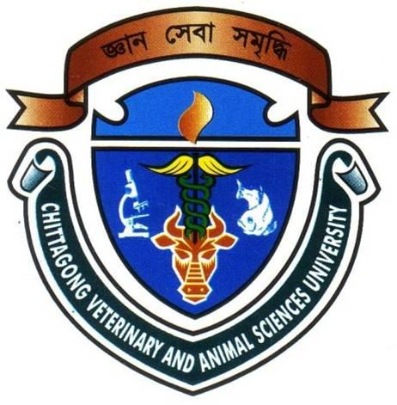

A Clinical report presented in partial fulfillment of the requirement for the
Degree of DVM (Doctor of Veterinary Medicine)

A Clinical Report
Submitted by
Roll No: 07/54
Reg: No: 342
Intern ID: E-49
Session: 2006-2007

Faculty of Veterinary Medicine
Chittagong Veterinary and Animal Sciences University

A STUDY ON SKIN DISEASES OF DOMESTICATED RUMINANTS (CATTLE & GOAT) AT VETERINARY HOSPITAL, ISHWARGANJ, MYMENSINGH

Approved as to style and content by

-------------------------- ------------------------
Signature of Author Signature of Supervisor
MD. Ali Haider DR. Md. Anowar Parvez
Intern ID: E-49 Lecturer
Roll No: 07/54 Department of Medicine & Surgery
Reg No: 342 Faculty of Veterinary Medicine
Session: 2006-2007

Chittagong Veterinary and Animal Sciences University
Khulshi, Chittagong-4202
March, 2014

ACKNOWLEDGMENT
All praises go to the Almighty God, the creator and supreme ruler of the Universe, who enabled the author to complete the work successfully.
The author expresses his sincere gratitude, humble respect and immense indebtedness to my reverend teacher and internship supervisor DR. Md.Anowar Parvez Lecturer, Department of Medicine & Surgery , Chittagong Veterinary and Animal Sciences University, Chittagong; for his scholastic guidance, kind cooperation, sincere help, valuable suggestions, inspiration, who was involved with this study from its inception.
I take the opportunities to express my deepest sense of respect and appreciations to the honorable Vice Chancellor Dr.A.S.Mahfuzul Bari and our Dean Dr. Kabirul Islam Khan, Faculty of Veterinary Medicine, Chittagong Veterinary and Animal Sciences University.
The author is thankful to placement supervisor Dr.Jesmin Akter, Veterinary Surgeon and Malay Kanti Modak, Upazila Livestock Officer,Department of Livestock Services, Ishwarganj, Mymensingh, for their kind co-operation, help and advice. Author also grateful to all farmers of study area, who were helping in various aspects of the study.
Last but not least, the author extended his appreciation to all of his teachers and his parents for their unforgettable support, suggestions, criticisms, cordial help and inspiration regarding my study from its inception to the last.

The Author

ABSTRACT
The skin, sometimes known as the Integumentary System is, in fact, the largest organ of the body. It has a complex structure, being composed of many different tissues. It performs many functions that are important in maintaining homeostasis in the body. Probably the most important of these functions is the control of body temperature. The skin also protects the body from physical damage and bacterial invasion. The skin has an array of sense organs which sense the external environment, and also cells which can make vitamin D in sunlight.
The skin is one of the first systems affected when an animal becomes sick so it is important for anyone working with animals to have a sound knowledge of the structure and functioning of the skin so they can quickly recognize signs of disease.
A study of skin diseases of domesticated ruminants (cattle & goat) were carried out at Ishwarganj Upazila Veterinary Hospital (UVH) under the district of Mymensingh from 5th May, 2013 to 3rd July, 2013. Total 536 domesticated ruminants (354 cattle + 182 goats) were treated at veterinary hospital suffering from different diseases. Among them 20.9% (74 cattle) cattle and 23.07 %( 42 goats) goat were found to be affected with skin diseases. The prevalence of skin diseases: lice infestation 37% (35 cattle, 8 goat), mite infestation 21.5 %( 9 cattle, 16 goat), hump sore (Stephanofilariasis)2.5% (3cattle) , alopecia18.1% (7cattle, 14 goat, maggot infestation 4.3% (5 cattle) , contagious ecthyma3.44% (4 goat) , yoke gall4.3% (5 cattle) and burn 0.86% (1 cattle) were found . This study demonstrates that skin diseases are among the most important health constraints of ruminants in this upazila leading to important economic losses and they urgently require some control intervention.

Key word: Prevalence, Skin disease, Ruminants, UVH

CHAPTER- 1

INTRODUCTION
Bangladesh is an over populated, rural and agrarian country in the world and livestock has been an important component of the mixed farming system practiced in Bangladesh for centuries. About 80% of our population is employed in agriculture and livestock farming. Twenty percent people are involved in livestock sector as permanent occupation. The contribution of Livestock in the magnitude of Gross Domestic Product (GDP) is about 16.23 % in Bangladesh (BBS, 2008). But the livestock diseases and disorders of animals are the most important hindrance towards livestock development in our country. There are about 22.53 million cattle and 14.69 million goats in our country (DLS, 2008-2009). Most of the animals are weak, emaciated and non satisfactory productive performance due to mainly malnutrition and diseases.
Hides and skins, the basic raw materials of leather industries, are obtained as by-products of livestock industries. The annual availability of hides and skins in Bangladesh is 15 million square meters. Unlike others, it is a constant source of export earnings and contributes about 10.7% of the total export earnings. However a large proportion of the materials is downgraded and rejected by their defects. An annual (1990-91) economic loss of Taka 818 crores or US $ 220.95 million (cattle US $ 194.5 m., buffalo US $ 1.9 m., goat US $ 24.1 m., sheep US $ 0.5 m) was estimated to be associated with leather defects in Bangladesh (Dey and Nooruddin, 1993) Bangladesh has a fairly large livestock population to support a strong and growing tanning industry. Cow hides account for 56% of the production, goat skins for 30% and buffalo makes up the rest. The current output in Bangladesh is about 200 million sq.ft. of leather annually (Hide and Skin Merchants Association (HSMA), Survey report.2005, Dhaka, Bangladesh).
Skin diseases are the major cause of hindering the development of livestock population in Bangladesh. Skin diseases also keep impact on tannery sector; reduce the market value of hides & skin. Skin diseases are widely prevalent in Bangladesh and produce a substantial economic loss. The quality of tanned leather is greatly reduced by various skin diseases (Coles, Hadly, 2003). They also affect the health and productivity of livestock.
Skin diseases have zoonotic importance as it is spread from animal to human, animal to animal by direct contact.
Skin diseases are responsible factor for discomfort, zoonoses and loss of market value, weight gain, milk production and draught power of the animal. Annual financial loss amounting to Tk. 818 cores (US$221 million) was estimated to be due to down grading and rejection of leathers associated with the defects caused by skin diseases lesion and post mortem & industrial defects ( Nooruddin and Dey, 1993).
The tropical environment of Bangladesh creates a favorable condition for the easy growth of micro- organism and parasites. Skin diseases are very common in ruminants both rural as well as urban areas of Bangladesh. A wide variety of skin diseases are found at field levels, but very few of them can be confirmed by laboratory diagnosis. Moreover, laboratory diagnosis facilities are limited at field level. From my two months of field experience at Upazila veterinary Hospital, it has been seen that skin diseases are diagnosed mainly by clinical signs, taking clinical history of patients, age, animal’s management, etc. The common skin disease conditions are:
- Diseases of the epidermis and dermis:
- Pityriasis
- Parakeratosis
- Hyperkeratosis
- Pachydermia
- Impetigo
- Urticaria
- Eczema
- Dermatitis
- Photosensitization.
- Diseases of the hypodermis / subcutis:
- Sub cutaneous edema
- Angioneurotic edema
- Emphysema
- Sub cutaneous
- Sub cutaneous abscess
- Lymphangitis
- Other diseases of the skin:
- Alopecia
- Burns
- Yoke gall
- Cutaneous neoplasm
- Congenital defects
Skin diseases hamper production of animals by various ways such as: mite infestation produce scales, alopecia, itching, erythema, hyperkeratosis; lice produce marked itching, irritation, formation of erythematous macula’s, dermatic lesions and anemia incase of heavy infestation. Lice, mites also create marked inanition that leads to weakness and poor health. Dermatophilosis, dermatophytosis and hump sore produce crust formation, alopecia and hyperkeratosis in the skin of animals.
Rural people are not so much conscious about livestock skin problem. So, it is a common phenomenon that their animals always having skin diseases either to a greater or lesser extent. But when the condition turn into severe condition, then they take the animal to the hospital. So, initially when major clinical signs were appeared, it is beneficial for the veterinarian to diagnosis and treatment.
Veterinary hospital is an ideal and reliable source of information about animal diseases and their solution. People from the neighboring areas bring their sick animals to the Veterinary hospital every day. Analysis of the case record gives a comprehensive idea about the disease problems at local areas..
Therefore my study was undertaken at Upazila Veterinary Hospital, Ishwarganj, Mymensingh with the following objectives:
- To know the prevalence of skin diseases of ruminants( cattle & goat)
- To know the epidemiology of the diseases.
- Comparison between different skin disease in large & small ruminants.

CHAPTER-2

REVIEW OF LITERATURE
Skin diseases are very common throughout the rural area at Bangladesh.
2.1 Lice Infestation:
The prevalence of lice in sheep & goat at Dhaka, Nilphamari and part of Sirajgonj district were studied. The prevalence of lice on sheep & goats in this area was found 40.57% in sheep and 36.20% in goats respectively. Both young and adults are equally infested; incidence gradually increases from early winter to early spring and falls sharply from May to August (Huq and Mollah, 1969). The common lice of ruminants are Bovicola bovis (Biting lice) and Haematopinus eurysternus (Suckling lice) in cattle and Bovicola caprae (Biting lice) and Linognathus vituli (Suckling lice) in goat. Light spot during the winter and spring is associated with infestation by the chewing louse, Bovicola bovis and result in area of erosion of the grain enamel (Webster and Bug, 1990).
Poor hygienic environments, malnutrition, high density of animal and long dirty hair are the common predisposing factors enhance the breeding of lice.
Lice infestation commonly causes irritation, which leads to rubbing, damage to the fleece of skin and loss of milk production. In heavy infestation in some species causes anemia.
Ivermectin injection is effective in lice infestation ( Amalendu, C.2005)

2.2 Mite Infestation (Mange)
It is an important disease of the skin caused by mites. The common mites of ruminants are Sarcoptes scabiei( Cattle & Goat), Psorptes bovis( Cattle), Psorptes caprae( Goat), Demodex bovis( Cattle), Demodex caprae(Goat) and Chorioptes caprae in goat. Prevalence of mange in cattle and goat is 2.47% and 39.37% respectively (Nooruddin and Rahman, 1985). The disease was transmitted through direct contact with infected animals and disease may spread from one species to other species of animal. Indirect transmission is possible by various objects like harness, blankets, grooming tools, etc. The common clinical findings are itching, excoriation, scale formation, thickening of skin, alopecia, popular of pastular lesions.

2.3 Hump Sore
Stephanofilariasis or Hump sore is a chronic ulcerative, granulomatous dermatitis of cattle caused by filarial worm Stephanofilaria assamensis (Pande, 1935), located on or near the hump and neck regions of cattle.
It is rampant in cattle of Bangladesh except in the hilly region, affecting about 30% of its total population and the infection is specially found in healthy ones (Islam, 1979). Patnaik(1973) reported that more than one species of flies infested the hump sore lesions and only Musca conducens is the vector of Stephanofilaria assamensis. Its causes a leather defect which is around US$ 220.95 million loss annually in Bangladesh (Nooruddin and Dey, 1993). In addition to this as the affected animals remains in constant agony, irritation and itching. There is gradual decrease of health and performance with impaired milk production.

2.4 Alopecia
Loss of hairs, far or wool is known as alopecia. Falling of hairs may be seasonal or as a consequence of certain disease. Alopecia may be primary or secondary in origin. It may be patchy or diffuse. The prevalence of alopecia in Bangladesh is 4.8% (Nooruddin and Dey, 1990).
The alopecia may be congenital or acquired. Congenital alopecia cause due to mendelian recessive genes effect and acquired alopecia occurs due to deficiency of certain minerals, severe internal worm infestation, mange mite, fungus and other ecto-parasite, hypothyroidism and traumatic causes.
The common clinical findings are hair loss usually starts as a focal patch that may enlarge and coalese with adjacent lesions or remain static and pruritus is variable. Primary causes are to be ruled out, removed and corrected. Deficiency may be it ought to be corrected with supplement arrangement.

2.5 Myiasis
Maggot wound (Myiasis) causes by screw worms has been a cause of great financial loss in livestock in the western hemisphere Africa and Asia. Death may be heavy in groups of livestock where are at range and seen infrequently (Blood et al. 2000). In case of goat, 19.59% are affected by myiaisis (Huq and Mollah, 1983).
Larva of the flies Cochliomya hominivorax and Chrysomya spp causes myiasis in animal. Chrysomya spp only found in Asia and Africa. Chrysomya spp cannot initiate a strike. They usually attack on already struck or damaged and greatly extended the area of damage.
Following invasion of the wound a cavernous lesion is formed, characterized by progressive liquefaction, necrosis and hemorrhage; anemia and decreased total serum protein results from hemorrhage into the wound (Blood et al. 2000).
Secondary bacterial infection, toxemia and fluid loss contribute to the death of animal (Blood et al.2000). The young larvae, surround the tissue vigorously and unlike other maggot, burrow deeply rather than a necrotic superficial tissue. Profuse brownish exudates pour from the wound and an objectionable odor is apparent. This is highly attractive to other flies and multiple infestation of a single wound may occur within a few days. The resulting tissue damage may be so extensive that the animal is virtually eaten alive (Blood et al.2000). Removal of maggots by using antiseptic solution of oil of turpentine and antibiotic therapy reduce the secondary bacterial infection.

2.6 Dermatophytosis

Dermatophytosis is a superficial fungal infection of the cornified epidermis (Chatterjee, 1989). The dermatophytosis create a change of the invaded structure and this alteration along with immunological reactions are clinically known as ‘ring worm’ (Kaplan et al. 1953). These are caused by two different types of fungi called Trichophyton spp and Microsporum sp. (Cambell and Stewart, 1980). Dermatophytosis occurs in every parts of the world affecting animal and human population. Dermatophytosis has a seasonal distribution and affected during summer months and in related to high rainfall and humidity. The prevalence of dermatophytosis is 3.0% in goat and 1.7% in cattle (Nooruddin and Dey, 1990). Another report also conducted in Nilphamari thana, Saidpur (5 villages) the prevalence of dermatophytosis in cattle (9.3%), goats (18.6%) and human (25.2%) were found. Higher prevalence of the diseases was recorded in young calves up to 5 months of age, labourer, animal attendant and housewife, 30-50 year old people in monsoon season. Higher prevalence of the disease in human population is probably due to greater contact with animals (Rashid et al.1996). Infection spreads in healthy animals with direct contact with infected animals. Overcrowding predispose the animals to come in close contact. The infection may spread through animal attended/handler by mechanical transmission of infected materials through their hands. Animals have been found to carry the dermatophytes on their healthy skin and thus remain as a transmitting agent to susceptible animals (Chatterjee, 1989).

The lesions are mostly located on the head, around the eyes, neck, ears and dewlap. The affected areas of the skin become erythematous and the hairs over the area fall of thus giving a picture of alopecia. The lesions are discrete and almost circular and borders are raised having thick grayish crusts. The lesions having tendency to extend peripherally from central.

Whitfield’s ointment (6% benzoic acid, 6% salicylic acid) should be affective against dermatophytosis. They are acids having both fungi static and fungicidal activities.

2.7 Papillomatosis

Blood et al (2000) reported that papillomatosis (cutaneous wart) are caused by papilloma virus. Some types have site and lesion specificity. It is worldwide distributed, almost found in all species but most common in young cattle. Transmission is by direct contact and fomaites. Clinical findings solid outgrowth of epidermis may be sessile or pedunculated, cauliflower like appurtenance.

Nooruddin & Dey (1990) reported that 0.7% incidence of warts in cattle from Bangladesh. However Nooruddin et al. (1986) reported 3.04% incidence of warts under rural cattle.

2.8 Burn

Davis (1980) reveled that superficial partial thickness burn are moist, blanch with pressure and are sensitive to pain. They usually heal within 3 weeks because of epithelialization from deeper portion of the skin appendages. Healing is usually complete and occurs without grafting. Deep partial thickness or second degree burn cause marked distribution of the dermis. The only remaining (adnezal) epithelium is the upper layer of the subcutaneous fat. Subcutaneous edema and marked inflammation occur and hair does not epilate easily.

2.9 Yolk gall

Samad (2001) reveled that injury or friction caused by yoke at the neck during ploughing or pulling on the ligamentum nuchae in cattle. Continuous friction due to yoke may cause formation of fibrosis tissue to form a cavity. The prevalence of yoke gall in cattle was 0.4% (Nooruddin and Dey, 1990).

2.10 Contagious ecthyma

Young lambs and kid’s zoonosis outbreak occur and morbidity may reach 100% and cause fatality rate 5-15%. Rapid spread in flock by contact or inanimate object (Blood et al.2000). The prevalence of contagious ecthyma in goat was 1.3% (Nooruddin & Dey, 1990).

2.11 Common causes of skin diseases:

- Physical cause:
- Trauma
- Injury
- Sunburn
- Excessive hot or cold
- Ingestion of photodynamic paints.
- Chemical cause :
- Irritant chemicals: acid, alkali, corrosive agents
- Sodium hydroxide
- Potassium hydroxide
- Mercuric iodide
- Nutritional cause:
- Vitamin A, B deficiency
- Mineral (zinc) deficiency
- Allergic cause:
- Different types allergen
- Some plants
- Parasitic cause:
- Lice infestation
- Bovicola bovis,
- Haematopinus eurysternus,
- Linognathus vituli)
- Mite infestation (mange)
- Sarcoptes scabiei
- Psorptes caprae
- Demodex bovis
- Demodex caprae
- Chorioptes caprae
- Maggot wound (Myiasis)
- Cochliomya hominivorax
- Chrysomya spp
- Hump sore
- Stephanofilaria assamensis

- Fungal cause:
- Ringworm
- Trichophyton verrucosum (Cattle)
- Trichophyton mentagrophytes ( Cattle & Goat)
- Viral cause:
- Papillomatosis (Wart)
- Bovine papilloma virus
Non-Infectious Causes
Infectious Causes
Skin diseases in ruminants

General clinical findings

Skin diseases of animals may be grouped as primary or secondary In relation to their genesis. In primary skin diseases, the lesions are directly reflected on the skin and are independent in origin.

Primary skin lesions may be two types viz. Localized or Generalized. Localized skin disease is confined to particular area of the skin as discrete or diffused lesions. Demodectic mange lesion may be localized around the skin of the eyes termed as ‘spectacular lesion’. Generalized skin disease occurs almost all through the skin surface. Primary skin lesion may be superficial or deep in distribution.

2.11.2 Different skin lesions

Scale

Excessive accumulation of discarded keratinous debris over the skin surface is known as scale. It remains as bran like deposition over the skin. It is the discharge of sebaceous and sweat glands which are dried up. This dried up materials form thin layers and fall of. This type of lesion also considered as ‘dandruff’ or ‘pityriasis’. Scale may present due to ectoparasite or mycotic infection and/or nutritional deficiency. Seborrohoeic conditions cause excessive epidermal turnover giving rise to excessive amount of keratin debris, known as seborrhoeic sicca.

Crust (Scab)

It is dried discharge of exudates on the skin. Skin surface formed of serum, blood, pus, epithelium cells cutaneous debris micro organisms and medicines- if applies upon. In exudative (allergic) dermatitis hairs are matted in tufts. The crust of some diseases are very much characteristics e.g. sheep scab(crust), dermatophyllosis and ringworm crust. Crust which results from slough due to burn are known as eschar. Dry shiny necrotic membrane on the floor of the ulcer as seen in decubital ulcer is termed as sphacelus.

Erosion

An erosion is considered as loss of superficial later (epidermis) of the skin without any breach of the basement membrane. It has got healing tendency.

Ulcer

A breach in the continuity of epidermis is known as ulcer. Ulcer has got fewer tendencies to heal. Ulcer usually turns to scarring. Ulcer may result due to break down of vesicles or pustules. When examined, following points are to be ulcer, discharge from ulcer and neighboring tissue reactions

Excoriation

Superficial erosion of the skin in known as excoriation. Excoriation results due to pruritius. Mechanical damage caused by scratching is responsible for excoriation. Excoriated lesion is observed in Sarcoptes scabies due to scratching to allevation pruritius.

Scar

A scar is formed by the proliferation of fibrous tissue in an area replacing healed up lesions. Scar is devoid of hairs and atrophic. Scar is formed following traumatic damage, ulceration, surgical intervention and cauterization; scar may be flat, raised or depressed. Color of it may vary from white, red, or purple.

2.12 Diagnostic approach

Adequate lighting facility is required for proper visualization of skin lesion. Animal should be placed in a well lighted place or under the spectrum of illuminating lamp. There may be some hidden lesions under the long hairs. Clipping of hairs may require detecting the nature and extending of lesion. Following points are to be noted for investigations of skin diseases.

2.12.1 History of the animal

In the history following aspects may be considered: duration of lesions, nature of lesions, number of other animals affected with similar lesions, previous treatment rendered and history of environment.

2.12.2 Age of the animal

Certain skin diseases occur predominantly in younger age group of animal e.g. Demodecosis and ringworm. On the other hand, neoplasms of skin occur frequently in old animal. There are certain conditions which do not have any age barrier.

2.12.3 Breed of the animal

Lomg haired breeds are susceptible to acaro dermatitis.

2.12.4 Sex of the animal

Ovary induced skin lesions are observed in female and lesions attributed to sertoli cell tumors are observed in male.

2.13 General treatment of skin diseases
Topical therapy is an important part of veterinary dermatology. It is often beneficial in improving the cosmetic appearance or odor of the animal, pending the final diagnosis. It can be beneficial as an adjunct to systemic therapy. Finally, it may be the preferred method of treatment for some diseases, eg, flea infestations.
The following are some basic guidelines to consider when prescribing topical therapy: 1) as much of the hair coat as possible should be removed when treating skin diseases. Good grooming practices facilitate topical therapy and can significantly help shorten the course of disease. 2) The cooperation of the owner (and animal) should be evaluated before any topical therapy is prescribed. 3) Animals tend to groom off topical products and may vomit after ingestion. The risk of toxicity is a constant worry for clients. Local ointments, gels, and sprays are best used sparingly, under occlusion, and for specific diseases. Such medications often sting when applied to the skin, especially many of those instilled into the ears. Many agents also may mat the hair. 4) Tepid water is the temperature of choice for bathing animals. 5) The old adage, “If it's wet, dry it and if it's dry, wet it,” has some truth to it; however, this advice should not be carried to extremes. Exudative lesions, eg, areas of pyotraumatic dermatitis, heal faster if they are kept clean and covered with an antibiotic ointment or gel (previous recommendations suggested aggressive astringent use). Dry, lichenified skin is often pruritic, and the judicious use of emollients may be beneficial. 6) The animal should be monitored closely for possible development of irritant or allergic contact dermatitis from topical agents. Many topical agents have very similar bases or ingredients, and changing from one to another may only exacerbate the problem. 7) Owners should be given careful and thorough instructions on how to administer the therapy (Karen A. Moriello, 2013).
Shampoos are the most commonly used topical treatments. There are three broad classes of shampoos: cleansing, antiparasitic, and medicated. Cleansing shampoos remove dirt and excess oils from the coat. These products include over-the-counter dog grooming shampoos, flea shampoos, and many mild products for people. These products lather well and must be rinsed from the coat. Antiparasitic shampoos are “flea shampoos.” In most cases, the amount of insecticide in these products is not adequate to kill all of the fleas in a severe infestation. However, these products are excellent routine cleansing products. Medicated Shampoos include antimicrobial and antiseborrheic products. The most widely used antibacterial shampoos contain chlorhexidine or benzoyl peroxide. Antiseborrheic shampoos contain some combination of tar, sulfur, and salicylic acid—ingredients that are keratoplastic and keratolytic. Tar is recommended for oily seborrhea, and sulfur and salicylic acid are recommended for scaly seborrhea. Most animals benefit from products that contain all three agents; however, tar products are contraindicated in cats ((Karen A. Moriello, 2013).
When a medicated shampoo is used, the animal should be washed in a cleansing shampoo before the medicated shampoo and rinsed well. Medicated shampoos often are not good cleansing agents, do not lather well, or do not work well in the presence of organic debris. The medicated shampoo should be applied evenly to the hair coat after being prediluted in water. Prediluting the shampoo will facilitate it being rinsed from the coat and minimize the potential for irritant or allergic contact dermatitis. Depending on the shampoo, the concentration of shampoo to water will vary between 1:3 and 1:4. If possible, the medicated shampoo should be allowed to have a contact time of 10 min with the skin and then rinsed thoroughly from the coat. Shampoo residue is a common cause of irritant reactions. Finally, the medicated shampoo should be used often, usually 2–3 times/wk during the early stages of therapy.
2.14 Diseases prevention & control
Disease outbreaks among farm animals can cause significant economic damage. However, it can limit the impact through preventative and control measures. There are several hygiene and bio security measures that should be part of farmer routine. The key to good bio security is reducing and controlling the movements of people, vehicles or equipment into areas where farm animals are kept. Some diseases are more prevalent than others. It should cleanse and disinfect protective clothing, footwear, equipment and vehicles before and after contact with farm animals. Where practicable, it should use disposable protective clothing.
Good hygiene and bio security is essential to:
- Prevent the introduction of animal disease.
- Protect the health of animals and workers.
- Reduce the risk of disease exposure to any members of the public who visit farm.
Bio security measures need to be routine because, farm animal diseases can be easily spread & disease may not always be apparent - especially in the early stages.
Farm animal diseases are mainly spread through:
- animals, people and machinery moving between and within farms
- farm visitors - people and vehicles
- introducing new animals
- contact with neighbor’s livestock
- shared farm equipment
- contamination by vermin and wild birds
- Animals drinking from contaminated rivers and streams.

Livestock movements, identification and tracking is an important factor for the prevention of any diseases. Strict rules control identifying and moving livestock - even if you only keep one animal. You should know the health status of any animals before buying them. When new animals first arrive, you should keep them separate from other livestock and handle them last (General guide line of animal diseases prevention & control by UK Govt).

CHAPTER – III

METHODOLOGY

3.1 Study area & Study period

The study area was Ishwarganj Upazila under the district of Mymensingh in the division of Dhaka, Bangladesh.

The study was carried out in Upazila Veterinary Hospital (UVH), Ishwarganj, Mymensingh district during my internship placement from 05 May, 2013 to 03 July, 2013; total 8 weeks.

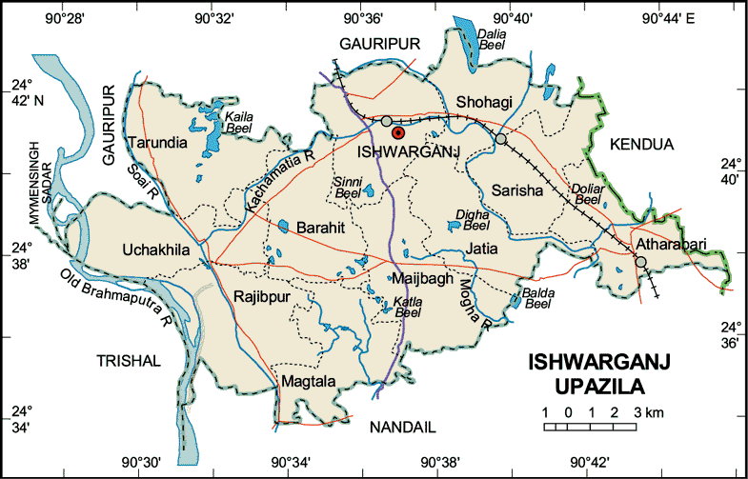

3.2 Data collection

Domesticated ruminants (cattle & goats) under Ishwarganj Upazila, Mymensingh were considered to be reference population. In study periods about 536 animals (cattle = 354, goats= 182) were treated in Upazila Veterinary Hospital due to different diseased condition.

Among them total skin diseases affected animal were 116, where cattle 74 & goat 42 in number.

The necessary information for the diagnosis of skin diseases was collected directly from the owner of the animal through questionnaire. The questionnaire includes following information such as: Demographic information (age, sex, body weight, breed, color, and species), socio-economic status of the farmer (farmers occupation, monthly income), patient data (duration of illness, history of previous treatment, number of infected animal, body condition), management system (feeding, housing, vaccination, hygienic measurement), and owner complain.

The skin diseases were diagnosed by physical examination, laboratory diagnosis and clinical findings of diseases condition.

3.3 Diagnosis

3.3.1 Physical Examination:

The animals were examined individually using dermatological examination techniques of taking history, close inspection, palpation , parting of hair coats and itch reflex (Kral and Schwartzman, 1964). The signs, number, location and physical characteristics of lesions viz, size shape, color were recorded.

3.3.2 Laboratory Examination:

Examination of skin scraping for isolation and identification of arthropod parasites on morphological basis was following conventional technique of Veterinary Entomology (Benbrook and Sloss, 1968). Diagnosis of the skin diseases was made on the basis of interpretation of epidemiological features, history, findings of clinical examination of the specimen like recovery of mites from skin scrapings digested with 10% KOH solution and examined under microscope.

Examination of skin scraping and hair for isolation and identification of dermatophytes was made by following procedure described by (Nooruddin and Sing, 1987).

3.3.2.1 Procedure

A) Direct KOH Method:

At first skin scraping was taken from the suspected case

Then placed on glass slide
1 drop of 10% KOH was added
Specimen was allowed to stain for few minutes with gentle warming

Microscopic examination was revealed hyphae and
Spores (Trichophyton spp) in the infected materials.

B) Sedimentation Method:
Skin scraping was taking from suspected case

Place the skin scraping in glass test tube

Treat with 10% KOH

Then heat gently (not boiled) the treated materials till the skin debris is digested.

Centrifuge the digested material at 3000RPM for 5 minutes

Spread the sediment over the glass slide and examine under low power of microscope.

Table: Disease with diagnosis and picture
Diseases | Clinical examination | Lab based examination | Figure
Pediculosis | Scratching, rubbing and licking, damage to fleece and hides  Inanition, anemia | Lice are wingless, flattened insects, usually 2–4 mm long. The claws of the legs are adapted for clinging to and moving among hairs or feathers | 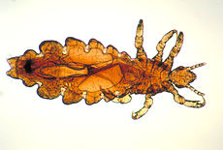
Mange | Irritation with encrustation  Loss of hair & excoridation from rubbing & scratching | Six-legged larvae hatch from fusiform-shaped eggs and undergo several molts to become eight-legged nymphs and ultimately adults.  Adults are eight-legged, slender, and elongated mites; their appearance is often described as cigar-shaped. | 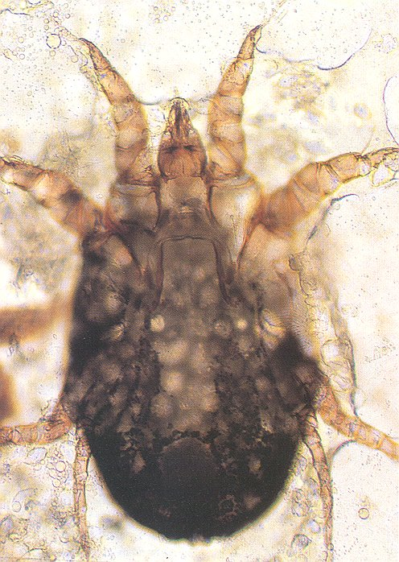
Humpsore (Stephanofilariasis) | 1. Chronic ulcerative, granulomatous dermatitis present around the hump, poll, chest etc. |  | 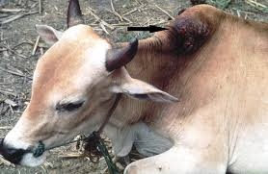
Myiasis | Presence of maggot in and around the wound lesions |  | 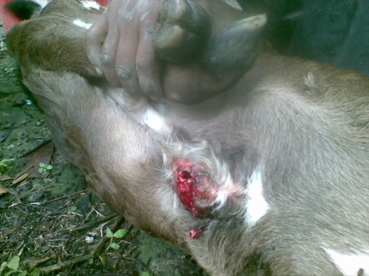
Papillomatosis | Skin surfaces of the neck, legs, back and abdomen are usual sites.  Cutaneous papillomatosis with various sizes, cauliflower like appearance |  | 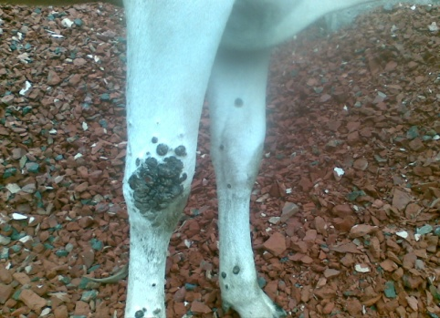
Alopecia | Hair loss usually starts as afocal patch that may enlarge and coalese with adjacent lesions. |  | 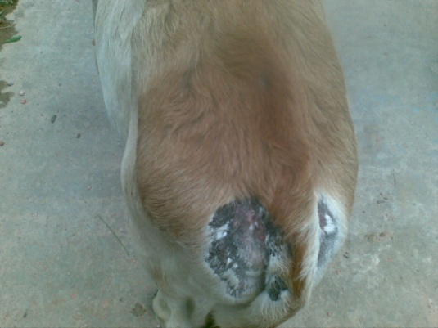

3.4 Treatment
Table 01: Treatment schedule
Name of diseases condition | Drug  (Generic name) | Drug  (Trade name) | Dose | Route of administration | Duration
Lice infestation | - Ivermectin 1% | - Inj. Amectin / inj. Parasitinvet | 0.2mg/kg b.wt | S/C | SD
Mite infestation | - Trichlophen  Or,  - Ivermectin 1% | - Pulp.Neguvon  - Inj.Parasitinvet | 0.5% solution  0.2mg/kg | Spray or dipping  S/C | 1st day, 8th day, 15th day, SD
Hump spore | - Trichlophen 8-20%  Or,  - Ivermectin 1%  - Or, Levamisol Hcl 600mg | - Oint.Neguvon  - Inj.Parasitinvet  - Bol.Technomysol | 20% solution  0.2mg/kg b.wt  7.5mg/kg b.wt | Topically,  S/C  Orally | 2-3times in a day for 10day,SD ,5days
Alopecia | Antihistaminic  Promethazine Hcl 50mg/ml  Zincsulphate 20%  Iodine .25% | - Inj.Astavet  - D-zinc  - Zis vet | 0.2mg/kg b.wt  5-10gm/day | IM  Orally | 5days
Dermatophytosis | - Salicylic acid 3%  - Benzoic acid 6%  & Vaseline | Whitefield ointment | 3% solution  6% solution | Topically | 7days
Papillomatosis | - Lithium antimony  - Thiomalate  - Autohemotherapy | Inj.Antheomalin | 15-20ml/animal  10-15ml/animal | I/M | 5days intevel for 5times
Myiasis | - Oil of turpentine  - OTC-100mg/ml | Inj.Renamycin | 10mg/kg | Dressing | Daily
Contagious ecthyma | - Potash Borax + honey  - OTC | 10% solution | Adlibitum 1ml/10kg | Topically  I/M | Until recovery
Yoke gall | - Manthole & thimol 11%  - Antibiotic OTC | -  Inj. Tetravet100 | 1% ointment  1ml/10kg | Topically  IM | Until recovery
Burn | - 0.1% acriflavin  - Antihistaminc  - Promethazine Hcl  - Antibiotic  OTC | Inj. Astavet  Inj.Tetravet | 0.1% solution  2mg/kg  1ml/10kg | Topically  IM  IM | 5 days  7days
SD = Single Dose Inj. = Injection IM = Intra Muscular
SC = Subcutaneous OTC = Oxytetracycline B.wt = Body weight

3.5 Prevention & Control
- Primary cause(s) are to be ruled out, removed & corrected.
- Deficiency, if any, should be corrected with supplemental arrangement.
- High calcium & protein containing diets are useful.
- Vitamin A preparations are indicated.
- Quarantine bedding materials and utensils

CHAPTER-4

RESULTS & DISCUSSION
The prevalence of skin diseases were measured in two different species like cattle & goat in Upazila Veterinary Hospital under Mymensingh district. Total 536 animals were suffering from different types of diseases; among them 112 cases were suffering from skin disease. Out of 354 cattle 74 were (20.9%) found as different types of skin diseases. In the same time 42 goats (23.07%) from 182 were found suffering from skin diseases. (74cattle skin + 42 skin goat₌ 116)

354
Figure 01: Graphical Presentation of skin diseases in different species (Cattle & Goat)
.

Table 4.1: Frequency Distribution of different types of skin diseases in different species (Cattle & Goat)
Name of diseases | Total No of cases | Cattle |  | Goat |  | Percentage
 |  | Cases | Percentage | Cases | Percentage
Lice infestation | 43 | 35 | 81.3% | 8 | 18% | 37%
Mite infestation | 25 | 9 | 36% | 16 | 64% | 21.5%
Humspore | 3 | 3 | 100% | - | - | 2.5%
Alopecia | 21 | 7 | 33.3% | 14 | 14% | 18.1%
Myiasis | 5 | 5 | 100% | - | - | 4.3%
Dermatophytosis | 6 | 6 | 100% | - | - | 5.17%
Papillomatosis | 3 | 3 | 100% | - | - | 2.58%
Contagirnous ecthyma | 4 | - | - | 4 | 100% | 3.44%
Yokegall | 5 | 5 | 110% | - | - | 4.3%
Burn | 1 | 1 | 100% | - | - | 0.86%
Total | 116 | 74 |  | 42 |  | 100%

The remaining result showed in Table 02 and figure 02. It was also observed that the highest estimation was observed ecto-parasite infestation 65.50% followed by nutritional deficiency 18.10%, viral infestation 6.03% and fungal infestation 5.17% and other injury 5.17%.
Table 4.2: Frequency distribution of skin diseases according to different etiological agent.
Causal agent | No. of affected animal | Percentage of disease
Ectoparasite | 76 | 65.50%
Fungus | 6 | 5.17%
Virus | 7 | 6.03%
Nutritional deficiency | 21 | 18.10%
Other injury | 6 | 5.17%
Total | 116 | 100%

Table 4.3: Different types of skin diseases in cattle and goats
Diseased condition | Cattle | Goat | Total
Lice infestation | 35 | 8 | 43
Mite infestation | 9 | 16 | 25
Hump sore | 3 | - | 3
Alopecia | 7 | 14 | 21
Myiasis | 5 | - | 5
Dermatophytosis | 6 | - | 6
Papillomatosis | 3 | - | 3
Contagious ecthyma | - | 4 | 4
Yoke gall | 5 | - | 5
Burn | 1 | - | 1
Total | 74 | 42 | 116

CHAPTER-5

CONCLUSION
From the study period 20.90% cattle and 23.07% goat were found as different types of skin disease. It was revealed that a skin disease is a great problem in case of domestic animal. Considering the effect of skin disease on health and productivity of animals, lather quality and greater extends of skin diseases in ruminants of Bangladesh. Control of skin disease is essential for the improvement of national economy so, special attention should be taken for rearing the livestock a profitable business. These types of problems can be overcome by taking following necessary steps such as:
- Proper hygienic measures in animal shed.
- Regular de-worming at 6 month interval.
- Isolation of diseased animal from the healthy stock
- It should motivate the farmers for taking veterinarian suggestion at any disease.
- Farmers should avoid treatment from quack.
Due to short duration of study period, it’s not possible for me to establish the relationship of disease with seasonal. Season is an important factor for different parasitic disease. Moreover, due to small number of sample size study result may not accurate. Proper diagnosis facilities is also an important lacking for my study, so that sometimes it’s difficult for me to diagnosis the confirm diagnosis.

CHAPTER- 6

REFERENCES
A.K.M.A.Rahman and M.Aktaruzzaman (2001), Association of skin diseases with demographic variables in cattle, Bangladesh Veterinarian (18(1):79-8.
Amalendu Chakrabarti, A. (2005), Common Ectoparasites Infestation in Animals. A textbook of preventive veterinary medicine, third revised and Enlarged edition, kalyata, publishers. Ludhiana, New Delhi, Noida, Hyderabad, Chennai, Kolkata, Cuttak. pp. 663-667
Amalendu Chakrabarti, A. (2006), Common Ectoparasites Infestation in Animals. A textbook of preventive veterinary medicine, third revised and Enlarged edition, kalyata, publishers. Ludhiana, New Delhi, Noida, Hyderabad, Chennai, Kolkata, Cuttak. pp. 505-534
Bloods,D.C.radostitrs, O.M.Gay,C.C. and Hincheliff,K.W. (2000). Diseased caused by Arthropod parasites. Veterinary Medicine, 9th edition, Book power formerly ELST with Saunders in co-operative with the British Council. pp. 1391-1397
Cambell, M.C. and Stewart,J.L (1980). The medical mycology Hand book, John wile and sons, New York.
Chatterjee, A. (1989). Skin infection in Domestic Animals, Motripub.Cal.
Chatterjee, A.et.al., (1980). Vet Rec.107:399
Coles, G.C. Hadly, P.J;Milnes, A.S.Green, L.E; Stosic,P.J.Garnsworthy, P.C.(2003). Relationship between lice infestation and leather damage in cattle; Veterinary Record,153-259
Davis, L.E (1980): Thermal burns In: Swaim,S.F.(ed) Surgery of traumatized skin management and reconstruction in the cattle and goat. Dhilacleplphia, W.B.Daunders.
Economic census,(2004). pp.25.
Gill, B.S. Balakrishman,P.Hosin,M. and Singh,J. (1988). Treatment of humpspore (Stephanofilarisis) of cattle with invermectin. Indian J. Anim.Sci.58 : 552-560
Huq,M.M. and Mollah, M.A (1972). A survey of the prevalence of lice in sheep and goats of Dhaka and Mymensingh district, Bangladesh veterinary Joutnal.7: 10-15
Hussain, M.M.Alam, M.S. and Abedin, M.Z. (1994-98). Farm level Disease incidence and vaccination use for livestock in some selected areas of Bangladesh. Bangladesh Journal of Livestock Research, l-5(2); 175-183
Islam, A.W.M.S (1953). Stephanofilarisis in cattle Bangladesh. Indian Journal of animal health 18(I): 7:8.
Kaplan, W.et al. (1953).Ann.N.Y.Acad, Sci, 70:636
Kral, Eand Sehwartzman, R.M.( 1964). Veterinary and comparative Dermatology. 1st edition J.P. Lipincott co.Philadelphia
Mannan, M.A. Rafiq, K,Mostofa, M.and Hasan,q (1997). Comparative Efficacy of Ivermectin , Neguvon and Neem-tobacco Herbal preparation against Naturally. Occurring Humpsore lesion in Cattle Bangladesh Vet.J.31.(3-4): 119-122
Nooruddin, M.and dey,A.S. (1990). Further study on the prevalence of skin diseases in domestic ruminants in Bangladesh. The Bangladesh Veterinarian 7(2).75-81
Nooruddin,M. and Singh,B.(1987). Dermatophytes in buffaloes, cattle and their attendants. Mykosen.30:594-600
Samad, M.A. (2001). Observation of clinical Disease in Ruminants at the Bangladesh Agricultural University Clinic. Bangladesh Vet. J.35(3-4) 93-120

APPENDIX

QUESTIONAIRE
Upazila Veterinary Hospital, Ishwarganj, Mymensingh
Case No: | Date:

- Owner’s Name: …………………………………………………………………………….
- Owner’s address: ………………………………………………………………………......
- Occupation: ……………………………………………………………………………….
- Rearing experience: ………………………………………………………………………
- Demographic information:
a). Age:…………….. b) Body weight:……………..
c). Sex: …………….. d). Breed: …………………..
e). Colour: …………… f). Species: …………………..
6. Patient date:
a). Duration of illness: …………………………………………………….
b). History of previous treatment: ………………………………………………
c). Number of infected animal(s): ………………………………………………
d). Body condition score (BCS): ………………………………………………….
7. Farmer’s complain: …………………………………………………………………………
8. Management system: ………………………………………………………………………..
9. Clinical sign(s): …………………………………………………………………………….
10. Tentative diagnosis: ……………………………………………………………………….
11. Treatment: ………………………………………………………………………………..

Owner’s signature

