**CHAPTER-I**

**INTRODUCTION**

Poultry farming in Bangladesh are getting momentum during the last two decades. This is highly sensitive and risk oriented venture. Poultry production in Bangladesh is characterized predominantly by the backyard type and small scale farming for a long time. In Bangladesh around 19.6% of the people have no cultivable land, but homestead only (BBS, 1995). In our country the native birds are reared in scavenging system.

Except for some city-states, Bangladesh has more people per Sq. Km. of land than any other country. More than 125 million people are living in1, 48,393 Sq. km. The population growth rate is 2.17% and literacy is around 51%.Bangladesh is mainly a land of agriculture and about eighty percent of its people live in villages. Average cultivable land per person is only 0.25 acre, but it is not evenly distributed. According to the Human Development report of UNDP 10% of the landowners possess 49% of the agricultural land, while the 10% with the least own only 2%. The favored 20% of the population enjoy 49% of the national income and the share of the bottom 20% is only 7.5%. Around 47.5% of the people of Bangladesh still live below the poverty margin (U.S. Census Bureau, 2010).

Poultry rearing play a very vital role for income generation of this group, as this requires minimum land, short capital and not very high skills. Poultry (Chickens and Ducks) rearing at household level in Bangladesh is a traditional method. It is an integral part of agro-business of the village community. About 89% of the rural households’ rear poultry and the average no of birds per household are 6.8% (BBS, 1995).The People's Republic of Bangladesh is a small and densely populated country located in South Asia bordering India and Myanmar on three sides and the Bay of Bengal on the fourth's side.

Poultry is essential to the national economy of Bangladesh and the welfare of human beings. Several constraints such as the diseases, poor husbandry, low productivity and shortage of feed affect the optimal performance of this industry in Bangladesh (Haque *et al.,* 1991). In recent days, the prevalence of Salmonellosis in both breeder flock, commercial broiler and layer flocks is increasing day by day. For the control and proper treatment of Salmonellosis in a particular commercial poultry farm, the Salmonellosis status of that commercial farm should be determined. Salmonellosis in poultry causes heavy economic loss through mortality and reduced production (Khan *et al.*, 1998). With great expansion of poultry rearing and farming, pullorum disease and fowl typhoid have become wide spread problem in Bangladesh (Rahman *et al.*, 1997). Age wise prevalence of avian Salmonellosis showed highest infection rate in adult layers (53.25%) in comparison to brooding (14.55%), growing (16.10%) and pullet (16.10%) (Rahman *et al*., 2004).

*Salmonella* are Gram negative, short plump shaped rods, non-sporeforming, non- capsulated, aerobic and facultative anaerobic organisms and classified under the family Enterobacteriaceae (OIE Manual, 2006). More than 2300 serotypes of *Salmonella* have been identified, only about 10% of these have been isolated from poultry (Gast, 1997). Chickens are the natural hosts for both *S*. *pullorum* and *S*. *gallinarum* (Snoeyenbos, 1991). Pullorum disease is usually confined to the first 2-3 weeks of age and occasionally occurs in adults (Shivaprashad, 1997).The transmission of disease from one generation to the next are known to be closely associated with infected eggs (Wigley *et al.,* 2001). Contaminated eggs produced by infected laying hens are thought to be one of the main sources of human infection with *Salmonella enteritidis* (Humphrey *et al*., 1989).

Fowl typhoid, caused by *Salmonella gallinarum*, is an acute or chronicdisease that most often affects mature birds, and is a serious problem resulting inmortality and lowered egg production and hatchability (Christensen *et al*., 1997; Khan *et al*., 1998). *Salmonella gallinarum* can produce lesions in chicks, indistinguishable from those associated with pullorum disease. The seroprevalence of *Salmonella* infection is 45.9% in layer birds at Mymensingh district (Ahmed *et. al.,* 2008). Village chickens can act as a reservoir of salmonellosis (Bouzoubaa *et al*., 1992). Transmission is primarily through the egg but also via direct or indirect contact with infected birds. Infection transmitted via egg or hatchery contamination usually results in death up to 2-3 weeks of age (Wigley *et al.,* 2001; World Poultry VIV, 2008). The birds that survive clinical disease when infected at a young age may show few signs of infection but can act as carriers (Berchieri *et al.,* 2001). Environmental factors such as air, dirty litter and unclean facilities, and vectors, such as insects, humans, and rodents are responsible for *Salmonella* contamination in poultry farms (Jones *et al*., 1991; Hoover *et al*., 1997; Amick-Morris, 1998). The prevalence of salmonellosis in breeder flocks and specially layer flocks is increasing in Bangladesh.

Pathogenesis and sequential pathology of Pullorum Disease (PD) is an important factor to understand the disease mechanism. For the detection of *Salmonella* organism many of technologies have been developed. Immuno-histochemistry is a latest technique for that purpose (Christine *et al*., 1999). A few researches have been completed on *Salmonella pullorum* infections using the conventional methods like necropsy, histopathology and isolation of bacteria by culture, stain and sugar fermentation tests (Islam *et al*., 2006; Haider *et al*., 2003).

Selection procedures for detection of *Salmonella* infection in poultry is the aim of many studies (Seran *et al*., 2010). In vitro culture is the predominant means for isolating and identifying *Salmonella* species from fecal samples. This is time consuming usually require 72 to 96 hours for the organism to be defined by its cultural, biochemical and serological properties (Pomeroy B. S. ,1991). A number of serological test have been developed for detecting invasive serotypes, the most successful being slide agglutination using either serum or whole blood for the detection of poultry flocks infected with *Salmonella gallinarum* or its biovarpullorum (Snoeyenbos G. S., 1991; Nagaraja *et al*., 1991). This test has been applied for successfully for more than 50 years and has contributed considerably to the control of pullorum disease and fowl typhoid from flocks in several countries. This test is however crude and has been found to be too unreliable and insensitive for use with other serotypes (Barrow, 1992). Tube and micro agglutination test and the more sensitive micro antiglobulin tests have been applied to experimental and field infection with serogroups with B, C and D. However these tests are cumbersome and do not lend themselves readily to extensive use for large scale flock screening (Feberwee *et al*., 2001).

Knowledge of the prevalence of the disease with confirmatory diagnosis is of paramount importance to embark on a control or prevention program as clinical signs; post-mortem findings and flock history are of limited value in arriving at a diagnosis because of the similarity of the diseases to a number of other diseases.

This study was undertaken (a) to determine the seroprevalence of *Salmonella* infection using colored antigen in layer, commercial broiler, breeder birds and backyard chicken at Chittagong district in Bangladesh, (b) to study the pathological lesions of organs of *Salmonella-*infected birds.

**CHAPTER-II**

**REVIEW OF LITERATURE**

**2.1 History**

In the early 19th century, the association of human intestinal ulceration with a contagious agent was reported by clinical pathologists in France. The agent later was identified as typhoid fever. During the first 2 decades of the 20th century, a great step forward occurred with the serological detection of somatic and flagellar antigens within the *Salmonella* groups. An antigenic scheme for the classification of Salmonellaewas first proposed by White (1926) and Kauffmann (1941); nowadays more than 2,500 serovars are included in the Kauffmann-White scheme (D’ Aoust *et al*., 2001).

The genus salmonella (of the family Enterobacteriaceae) named for the eminent United States Department of Agriculture (USDA) veterinarian and bacteriologist Daniel E. Salmon, consist of more than 2300 serologically distinguishable variants (Gast, 1997). Towards the end of the 19th century, infectious enteritis causing heavy mortality in chicken was described in Europe and North America. Initially the causal agent was called Bacillus Gallinarum and the name Fowl Typhoid was applied in 1902 (Shivaprasad *et al*.,1997). *Salmonella* *pullorum* was first isolated from chicks suffering from severe diarrhea and was described by Rettger and Stoneburn in 1909. The disease had been previously known as Bacillary White Diarrhoea (BWD), but as white diarrhea is not always a clinical feature, it becomes known Pullorum Disease.

**2.2 Microbiology**

*Salmonella spp*. is facultatively aerobic, gram negative rod-shaped bacteria belonging to the family *Enterobacteriaceae.* Most of the members of this genus are motile by peritrichous flagella except *Salmonella enterica* serovar Pullorum and *Salmonella enterica* serovar Gallinarum, and non-motile strains resulting from dysfunctional flagella (D’ Aoust *et al*., 2001).

**Table 2.2.1:** *Salmonella* species and subspecies (WHO, 2001)

|  |  |
| --- | --- |
| *Salmonella* species and subspecies | No. of serotypes |
| *Salmonella enteric* | 2,480 |
| *S. enterica* subspecies *enteric* | 1,478 |
| *S. enterica* subspecies *salamae* | 498 |
| *S. enterica* subspecies *Arizona*e | 94 |
| *S. enterica* subspecies *diarizonae* | 327 |
| S. enterica subspecies *houtenae* | 71 |
| *S. enteric*a subspecies *indica*. | 12 |
| *Salmonella bongori* | 21 |
| TOTAL | 2,501 |

**2.3 Etiology**

The disease is caused bacteria known as *Salmonella* *pullorum* which is motile and looks like slender rod measuring 0.3-0.5×1-2.5 µm. It is non-liquefying, non-chromogenic, non-sporogenic facultative anaerobe (Snoeyenbos *et al*., 1991).

It grows on beef agar or broth very readily. MacConkey agar can be very used for growth. The organism is non-lactose fermentater. The organism is resistant to heat and many chemicals. In suitable environment the organism contains a thermostable toxin. *S. gallinarum* is a short bacillus 1-2 µm broad, which does not posses flagellae. Pullorum disease is caused by bacterium *S. pullorum* (Shivaprasad *et al*.,1997). In addition to *S. gallinarum, S. pullorum*, other Salmonallae such as *S. enteritidis*, *S. panama* and *S. Dublin* also belongs to the serogroup D1 (Le Minor, 1984). The various motile and non hosts adapted highly invasive serotypes such as *Salmonella enteritidis* and *Salmonella tytyphimurium* are commonly referred to as paratyphoid salmonellae (Gast, 1997).

**2.4 Serotyping**

*Salmonella* species are classified into serovars (serotypes) based on the lipopolysaccharide (O), flagellar protein (H), and sometimes the capsular (Vi) antigens. Within a serovar, there may be strains that differ in virulence.



**Fig. 2.4.1:** Schematic representation of the antigen structure of *Salmonella typhi* showing the relative locations of O, H and Vi antigens (Axelsson and Sorin , 1997)

Based on the similarities in content of one or more O antigens, members of *Salmonella,* are placed in groups designated A, B, C and so on. Thus, *S. hirschfeldii*, *S. choleraesuis*, *S. oranienburg* and *S. montevideo* are placed in group C1 because they all have O antigens 6 and 7 in common*. S.* Newport is placed in group C2 due to its possession of O antigens K and 8. For further classification, the flagellar or H antigens are employed. These antigens are devided into 2 groups: specific phase or phase 1 and group phase or phase 2. Phase 1 antigens are shared with only a few other species or varieties of *Salmonella*; Phase 2 may be more widely distributed among several serotypes. Any given culture may consist of organisms in only one phase or of organisms in both flagellar phases. The H antigens of phase 1 are named with small letters, and those of phase 2 are designated by Arabic numerals. Thus, the complete antigenic analysis of *S. choleraesuis* is as follow: 6, 6, c, 1, 5, where 6 and 7 refer to O antigens, c to phase 1 flagellar antigen and 1 and 5 to phase 2 flagellar antigens. (Table 2.4.1)

**Table 2.4.1:** Antigenic structure of some common Salmonellae. (Jay *et al*., 2005)

|  |  |  |  |  |
| --- | --- | --- | --- | --- |
| Group | Serovars (serotypes) | O antigens* | H antigens | |
| Phase 1 | Phase 2 |
| A | *S. Paratyphi A* | 1, 2, 12 | a | (1, 5) |
| B | *S. Schottmuelleri* | 1, 4, (5), 12 | b | 1, 2 |
| *S. Typhimurium* | 1, 4, (5), 12 | i | 1, 2 |
| C1 | *S. Hirschfeldii* | 6, 7 (vi) | c | 1, 5 |
| *S. Choleraesuis* | 6, 7 | (c) | 1, 5 |
| *S. Oranienburg* | 6, 7 | m, t | - |
| *S. Montevideo* | 6, 7 | g, m, s, (p) | (1, 2, 7) |
| C2 | *S. Newport* | 6, 8 | e, h | 1, 2 |
| D | *S. Typhi* | 9, 12, (Vi) | d | - |
| *S. Enteritidis* | 1, 9, 12 | g, m | (1, 7) |
| *S. Gallinarum* | 1, 9, 12 | - | - |
| E1 | *S. Anatum* | 3, 10 | e, h | 1, 6 |

*The italicized antigens are associated with phage conversion. () = May be absent.

**2.5 Foodborne Salmonellosis**

Salmonellosis is one of the main infectious causes of enteric disease in human being worldwide, and most cases are more likely to be related to food products of animal origin. The incubation period for *Salmonella gastroenteritis* is usually 12 hours to 3 days. Enteric fever usually appears after 7-28 days (D’Aoust, 2001). Salmonellosis varies from a self-limiting gastroenteritis to septicemia. Clinical signs include diarrhea, nausea, abdominal pain, mild fever and chills. The diarrhea varies from a few thin vegetable-soup-like stools to a massive evacuation with accompanying dehydration. Vomiting, prostration, anorexia, headache and malaise may also occur. The syndrome usually lasts for 2 to 7 days. Systemic infections sometimes occur, and usually involve the very young people, the elderly or the immuno-compromised. A fatal outcome is rare. Infected patients can excrete a large numbers of *Salmonella spp.* at the onset of illness and the number of the organism will decrease with the passing of time. Asymptomatic infections can also be seen.

**2.6 Species Affected**

All species of birds should be considered susceptible to infection by salmonellae. The outcome of *Salmonella* infections is reported to be highly dependent upon the age of the birds, concurrent stress, serovar and strain virulence, and susceptibility of the host species.

Salmonellosis has been studied as a disease of poultry since at least 1899 (Field Manual of Wildlife Diseases: Birds, 2013**)**. Wild bird surveys have often been concurrent with studies of this disease in poultry and as sources for human infections. These and other investigations have resulted in numerous strains of *Salmonella spp*. being isolated from free-ranging and captive wild birds. However, findings from these studies have also disclosed a much lower infection rate than anticipated and have caused numerous investigators to conclude that in general, salmonellosis is not an important disease of free-ranging wild birds (Field Manual of Wildlife Diseases: Birds, 2013**)**.

The historic patterns of salmonellosis in wild birds are of isolated mortality events involving individual or very small numbers of birds and incidental findings associated with concurrent infections involving other disease agents. Before the 1980s, major mortality events from this disease were rare in free-ranging wild birds (Field Manual of Wildlife Diseases: Birds, 2013**)**.

Prior to the 1980s most isolations of *Salmonella spp*. From free-ranging wild birds were made from apparently healthy birds, were incidental findings from birds with other disease conditions, or were from lethal cases of salmonellosis involving small number of birds (Field Manual of Wildlife Diseases: Birds, 2013**)**. This is no longer the situation. Large-scale mortalities of birds using feeding stations have become common in the United States, and such mortalities are also reported from Canada and Europe, including Scandinavia. Typically, these events are caused by *S. typhimurium* and usually involve passerine birds. European starling, blackbirds, common grackle, and mourning dove are also among the species that have been found dead from *S. typhimurium* at bird feeding stations (Field Manual of Wildlife Diseases: Birds, 2013**)**.

Salmonellosis has also been the cause of die-offs of aquatic birds including several species of ducks, mute swan, various species of gulls and terns, American coot, double-crested cormorant, eared grebe, and several species of egrets and herons. However, large-scale mortality events in free ranging populations, except for songbirds and colonial nesting birds, have rarely been reported (Field Manual of Wildlife Diseases: Birds, 2013**)**.

Many species of captive-reared birds commonly become infected with salmonellae and die from salmonellosis. Aquatic species have died from salmonellosis in zoological gardens and other captive collections. Gamebirds, such as grouse and pheasants, being reared in captivity for sporting purposes and cranes being reared for species conservation efforts are often victims of salmonellosis. Mortality is generally confined to chicks (Field Manual of Wildlife Diseases: Birds, 2013**)**.

**Table 2.6.1:** Relative rates of isolation of ***Salmonella*** *spp*. In free-ranging wild birds.

|  |  |
| --- | --- |
| **Name of Birds** | Relative rates of isolation |
| Gulls/terns | Frequent |
| Songbirds | Frequent |
| Ducks/geese/swans | Common |
| Herons/egrets | Common |
| Doves/pigeons | Common |
| Pheasants/quail/grouse/partridges | Occasional |
| Starlings/blackbirds/cowbirds | Occasional |
| Coots | Infrequent |
| Cranes | Infrequent |
| Cormorants/gannets | Infrequent |
| Guillemots/razorbills | Infrequent |
| Penguins | Infrequent |
| Falcons/hawks/owls | Infrequent |
| Crows/rooks/magpies | Infrequent |

(Field Manual of Wildlife Diseases: Birds, 2013**)**

**2.7 Salmonellosis in poultry**

Salmonellosis is a serious systemic disease of domestic poultry which cause large scale economic losses through mortality, morbidity and reduction in egg production. The disease occur sporadically and enzotically in most countries of the world including Bangladesh. It causes severe economic losses of the poultry with morbidity and mortality varying in chicken from 10-50% or more. Salmonellosis is distributed in many countries of the world, and has economic significance (Barrow, 1992). They are mainly distributed in Latin America, the Middle East, the Indian Subcontinent, Africa and perhaps other part of the world (Shivaprasad *et al*.,1997; Bouzoubaa *et al*., 1992). Salmonellosis has also been reported in many countries of South-East Asia including Bangladesh (Bhattacharjee *et al*., 1996), India (Ghosh, 1988), Pakistan (Muneer *et al*., 1988) and Nepal (Jha *et al*., 1995). Salmonellosis is common in both backyard chickens and in commercial poultry.

**2.7.1 Incidence in Bangladesh**

Fowl typhoid and Pullorum disease are the most common disease in Bangladesh.

**2.7.2 Mode of Transmission**

The infection spreads in two ways (a) Vertical Transmission and (b) Horizontal Transmission. The vertical transmission takes place through the infected eggs. Extensive dissemination of infection may occur during hatching from infected embryos to non-infected chicks. The horizontal transmission takes place through contaminated utensils, contaminated water, contaminate feed, diseased pullets, dead embryos, dead chicks, infected eggs, cannibalism of infected birds, egg eating, visitors rodents and Flies etc (Shivaprasad *et al*.,1997).

**Table 2.7.1:** Examples of reported environmental persistence for ***Salmonella*** *spp.* in different substrates. [-----, no data available.]

|  |  |  |  |  |  |
| --- | --- | --- | --- | --- | --- |
| Substrate | Temperature | | | | Serovar |
| 11 °C | 25 °C | 38 °C | Ambient |
| Poultry feed | 18 months | 16 months | 40 days | **-----** | ***S. typhimurium*** |
| Poultry litter | 18 months | 16 months | 13 days | **-----** | ***S. typhimurium*** |
| Soil from vacated Turkey pens | **-----** | **-----** | **-----** | 6–7 months | Unspecified paratyphoid form |
| Urban garden soil | **-----** | **-----** | **-----** | 280 days | ***S. typhimurium*** |
| Hatchery fluff | **-----** | **-----** | **-----** | 5 years | Unspecified paratyphoid form |
| Avian feces | **-----** | **-----** | **-----** | 28 months | Unspecified paratyphoid form |
| Reptilian feces | **-----** | **-----** | **-----** | 30 months | Unspecified paratyphoid form |
| Manure | **-----** | **-----** | **-----** | 36 months | Unspecified paratyphoid form |

(Field Manual of Wildlife Diseases, 2013: Birds**)**

**2.7.3 Disease Syndromes**

**2.7.3.1 Pullorum Disease**

**Synonyms:** Bacillary White Diarrhea (BWD).

This is an acute systemic infection disease of chicks which is chronic in form in adult birds. The baby chicks sustain a heavy mortality within initial few weeks of life. Adults may remain as carrier.

**2.7.3.2 Fowl Typhoid**

**Synonyms:** *Salmonella gallinerum*; Infectious leukaemia.

It is an infectious septicemic disease of domestic fows and Turkeys characterizes by acute manifestation having high mortality. Acute form is widely prevalent by chronic form is not uncommon in poultry farm.

**2.7.4 Isolation of *Salmonella***

*Salmonella* organisms were most frequently encountered in fowls. In India, 25 serotypes have been so far isolated from poultry. The caeca have long been considered the primary source of *Salmonella* in the chicken.

**2.7.5 Identification**

**2.7.5.1 Staining properties of *Salmonella***

This organisms are gram negative, slender rods, mostly occur singly but occasionally two or more can be found in smear preparation (Calnek *et al*., 1991).

**2.7.5.2 Colony morphology of *Salmonella***

**On Nutrient Agar:** The organisms produce smooth, glistering, opalescent colonies. On MacConkey Agar and Deoxychoclate Agar (DCA): appear colorless colonies. On S.S. Agar it produces smooth, blackish colonies.

**2.7.5.3 Biochemical Character of *Salmonella***

In TSI agar it produces acidic (Yellow) butt and alkaline slant (Red) with blackening due to production of H2S gas (Waltman and Home, 1993).

**2.8 Pathogenesis and pathogenecity**

The organism has got the tendency to produce severe pathogenic effect in chicks within the first 2-3 weeks age. The birds above 3 weeks of age are fairly resistant due to increased blood lymphocytes and increased body temperature. Adult birds do not show any clinical manifestation and remain as carrier. Some breeds are more susceptible to infection over other breeds. Healthy birds are more prone to infection. A sizeable proportion of eggs laid by hen contain the organism as a contamination following ovulation. Birds hatched from infected eggs become dead within the incubator or within few minutes after hatching.

The pathogenecity of *Salmonella* depends on the invasive properties and the ability of the bacteria to survive and multiply within the cells, particularly macrophages. The principal site of multiplication of these bacteria is the digestive tract, which may result in widespread contamination of the environment due to bacterial excretion through feces. Following invasion through the intestinal mucosa, caecal tonsils and Peyer’s patches, the organisms are taken up by macrophages and through the blood stream and/or lymphatic systems, they spread to organs rich in reticulo-endothelial tissues (RES), such as liver and spleen, which are the main sites of multiplication. In case of inadequate body defense mechanism, they may lead to second invasion and be localized in other organs, particularly ovary, oviduct, myocardium, pericardium, gizzard, yolk sac and/or lungs.

**2.9 Lesions**

**2.9.1 Gross lesions**

Grey nodules in one or more of the following sites: lungs, liver, gizzard wall, heart, intestinal wall, peritoneum etc. May there petechial hemorrhage or foci of necrosis in the liver along with bronze discoloration.

On necropsy, muscle degeneration or necrosis, hepatomegaly, spleno-megaly, air-sacculitis, gastroenteritis and nephropathy. Numerous yellow necrotic foci are often present in organs.

**2.9.2 Histopathological Lesions**

Severe vascular congestion in various organ, especially liver, spleen, kidney, multiple necrosis in hepatocytes with accumulation of fibrin and infiltration of heterophils. Caecal extensive necrosis in the mucosa and submucosa of young chicks. In gizzard and heart initially necrosis of myofibrils with infiltration of heterophils mixed with lymphocytes and plasma cells.

Serositis of various organs such as pericardium, pleuroperitoneum, synovium and serosa of intestine and masentary. In ovary, acute fibrino suppurative inflammation to severe pyogranulomatous inflammation. Other changes are catarrhal bronchitis, catarrhal enteritis and intestinal inflammation of lung and kidney (Calnek *et al*., 1991).

The prevalence of *Salmonella* infection in liver, ovary and intestinal swabs of dead poultry was 11.42%. The findings revealed that prevalence was higher in liver and ovarian samples than intestinal samples (Hossain *et al*., 2006).

Some sequential gross pathological lesions were observed in the study of Shahinuzzaman *et al*., (2011).Chicks were sacrificed at day 1 (D1), day 3 (D3), day 5 (D5), day 7 (D7) and day 9 (D9) of Post Infection (PI) and observed the remarkable gross lesions in liver, lung, heart and cecum. Grossly, liver found fragile (40%) at D7 and D9. Cheesy materials in cecum (20%) showed at D9. The highest re isolation of *S.pullorum* demonstrated in cecum (68%).To get the complete information caused by inoculated *Salmonella pullorum* bacteria, reisolation procedures were performed by some routine methods. Cecum (68%) was the prominent organ for re isolation of *Salmonella pullorum* and then liver (52%), lung (48%), crop (44%), spleen (12%) and heart (4%) respectively from D1 to D9. It was confirmed by observing the colony characters of *Salmonella pullorum* on Brilliant Green Agar (BGA), *Salmonella-Shigella*(SS) agar and TripleSugar Iron (TSI) agar. Out of 150 samples 57 gave positive colony characters of *Salmonella pullorum*. For more confirmation of *Salmonella pullorum* re isolation, carbohydrate fermentation test of some basic sugars and biochemical test was performed. 5 Isolates were selected for this purpose (Shahinuzzaman *et al*., 2011).Enlarged and congested liver with focal necrosis; haemorrhagic and discoloured ovary with stalk formation and mild haemorrhagic to catarrhal enteritis in intestine and caecum were recorded during necropsy (Islam *et al*., 2006).

**2.10 Prevalence of *Salmonella* infection in different ages**

Concerning to the prevalence depending on the ages, the highest prevalence of *Salmonella* was 37.6% (27.2+10.4) at 64 weeks and above age group whereas the lowest prevalence was 16.6% (3.3+13.3) at 16-23 weeks age group (Hossain *et al*., 2010). Similar report was demonstrated by Sikder *et al*., (2005) who reported the highest *Salmonella* infection was 30.8% at 39 weeks of age and the lowest was 13.3% at 32 weeks of age. The prevalence of *Salmonella* infection increased with the increase of age (Truong *et al*., 2003).

**2.11 Seasonal incidence of *Salmonella* infection**

The prevalence of *Salmonella* infection was the highest (18.5+11.9=30.4%) in summer followed by winter (11.6+12.1=23.7%), rainy (14.2+10.8=25.0%) and autumn (13.3+10.0=23.3%) (Hossain *et al*., 2010). In summer 48.1% prevalence of *Salmonella* infection in comparison to 23.7% in winter (Rahman *et al*. ,2004). The highest (25.0%) prevalence of *Salmonella* infection in rainy season than in winter (21.9%) (Sikder *et al*., 2005). The highest prevalence of salmonellosis during pre-monsoon (13.1%) in comparison to winter (10.4%), monsoon (6.8%) and post-monsoon (6.8%) period (Bhattacharjee *et al*., 1996). The highest rate of *Salmonella* infection in summer season is probably due to the high growth rate of bacteria and the influence of hot weather that might reduce the immune status of the birds against infection.

**2.12 Prevalence of *Salmonella* infection with regard to flock size**

Serological investigation showed the highest (17.1+17.1=34.2%) *Salmonella* infection in large flocks (≥5001 birds) in comparison to small (≤1000 birds) flocks (12.5+8.8=21.3%) (Hossain *et al*., 2010). The present data were higher than those in the report of Skov *et al*., (1999) who recorded 16.8% *Salmonella* infection in a flock containing 30-40 thousand chickens in comparison to 11.9% in a flock containing 10-20 thousand and 9.7% in a flock containing less than 10 thousand chickens. Mdegela *et al*., (2000) recorded higher prevalence of *Salmonella* infection in commercial flocks (18.4%) than in scavenging chickens (6.3%) and reported that infection rate increased with the increase of flock size.

**CHAPTER-III**

**MATERIALS AND METHODS**

The study was conducted in Chittagong region from 20th October, 2013 to 22nd December, 2013. The study population comprised chicken from six commercial farms- two breeder, two broiler and two layer farms and 50 backyard chickens from live bird market.

**3.1 Sampling procedure**

A total 200 blood samples were collected from the birds belonging to six commercial farms and backyard chickens. Two ml of blood was collected aseptically from wing vein using 3ml sterile syringe and needle. Then the samples were kept at room temperature for two hours to clot blood inside the syringe. After clotting, fluid portion of blood were placed in graduated centrifuge tubes and centrifuged at 1500 rpm for 30 minutes. The clear sera samples were poured in sterile vials which was labeled and transferred to the Laboratory of the Department of Microbiology, CVASU, Chittagong in iceboxes for the detection of *Salmonella* by RPA

(Rapid Plate Agglutination) test. Sera samples were stored at -20°C in the laboratory until use for RPA test (OIE, 2002).

**3.2 Preparation of antigens**

Antigens are the killed and colored *Salmonella* organisms. *Salmonella pullorum* antigens from standard (O: 1, 9,121 and 123) and variant (O: 1, 9,121 and 122) strains were used in this surveillance program for pullorum disease and fowl typhoid (Proux *et al*.*,* 2002). The *Salmonella* antigen (Nobilis® SP) used in this study were purchased from the Intervet International B.V. Boxmeer-Holland.

**3.3 Rapid plate agglutination (RPA) test**

The RPA test was conducted according to the instructions of OIE Manual (2002). For this test 0.02 ml of antigen and 0.02 ml of chicken serum were placed side by side with micropipettes on a glass plate. Then antigen and serum sample were mixed thoroughly by stirring with a small tooth pick. The glass plate was illuminated from below so as to facilitate observing the reaction, avoiding excessive heat from the light source. Positive reaction was characterized by the formation of definite clumps within 2 minutes after mixing the test serum with antigen (Fig.3.3.1 and 3.3.2). The clumps usually started appearing and became concentrated at the periphery of the mixture. Negative reaction was judged by the absence of agglutination reaction. Care was taken so that the natural granulation of the antigen showed not to be taken as a positive reaction.

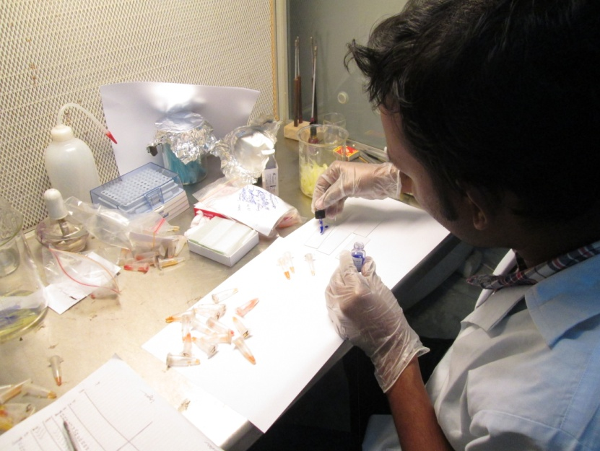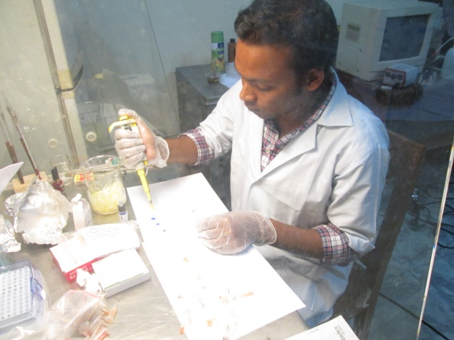

**Fig. 3.3.2: Mixing of antigen with test serum.**

**Fig. 3.3.1: Pouring of antigen from bottle and serum from eppendorf tube in glass slide.**

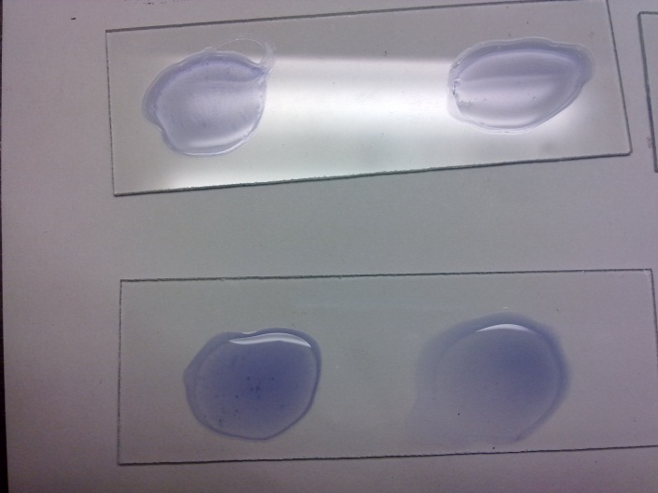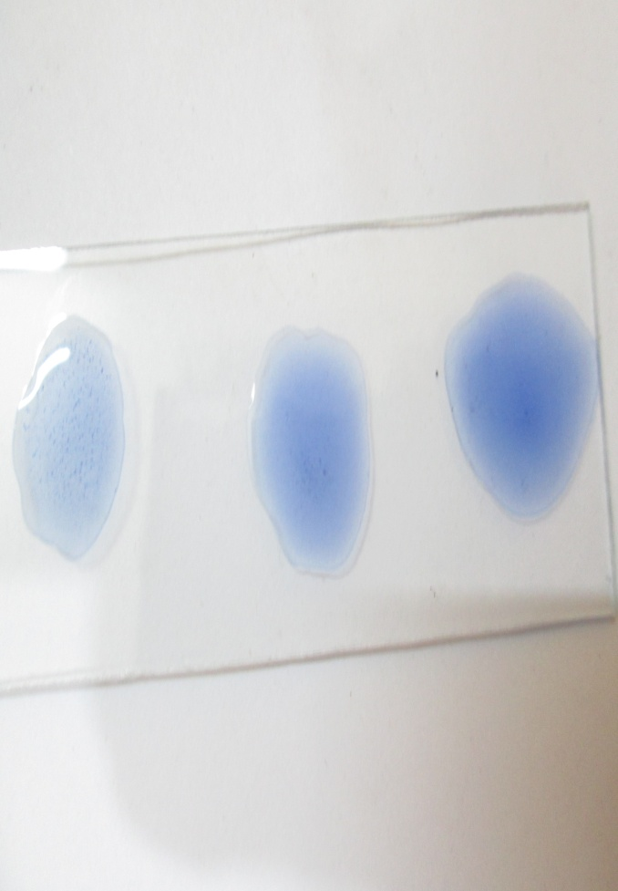

**Fig. 3.3.3: Medium size clumps show moderately positive reaction.**

**Fig. 3.3.4: Large clumps, almost complete background clearing show highly positive reaction.**

**3.4 Post mortem examination**

Among the seropositive chicken 10 chicken were examined for postmortem findings. The postmortem findings were also supportive to the probable *Salmonella pullorum* infection.

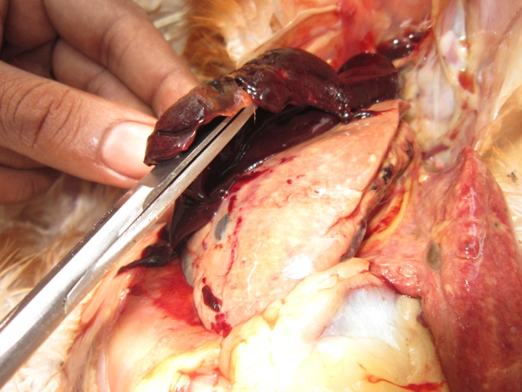

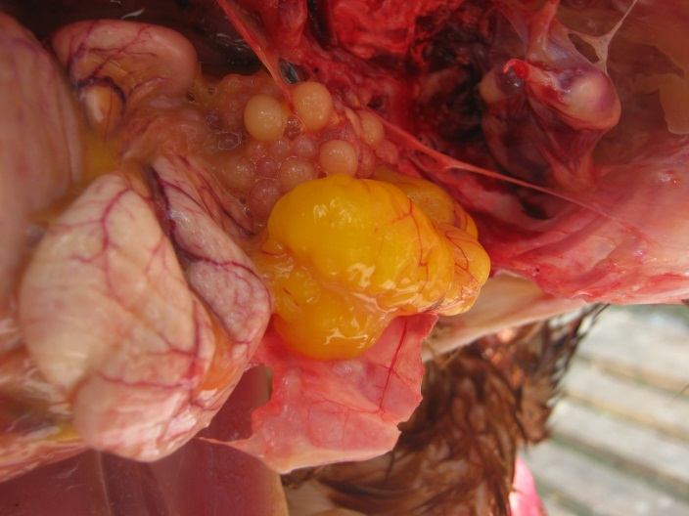

**Fig. 3.4.1: Salmonella infected chicken shows congestion, discoloration and misshaped ova formation.**

**Fig. 3.4.2: The liver shows friable congestion and bronze discoloration with focal necrosis.**

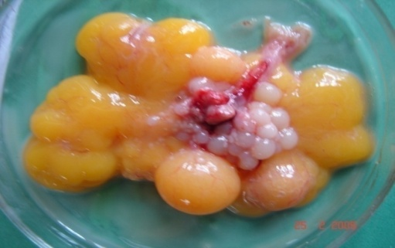

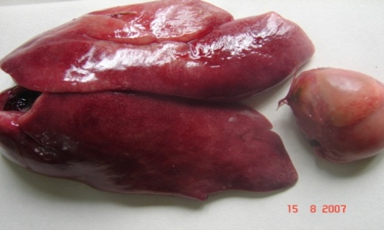

**Fig. 3.4.3: Salmonellosis (Big liver and misshapen egg in layer).**

**3.5 Method of sample collection during post mortem examination**

Clinical tissue samples from Liver, spleen, heart, retained egg yolk were collected. These samples were primarily cultured on the plates of MacConkey agar and were incubated at 370C for 24 hours. On MacConkey agar media gives the colorless, smooth, shiny and round colonies.

**CHAPTER-IV**

**RESULTS AND DISCUSSION**

The collected serum samples were tested in Microbiology Laboratory of Chittagong Veterinary and Animal Sciences University and the result was recorded.

**Table 4.1:** Determination of the prevalence of Salmonellosis

|  |  |  |  |
| --- | --- | --- | --- |
| Variable | (N) | Prevalence %  (no. of positive) | 95% CI |
| Breeder | 12/50 | 24% | 14.16 - 37.55 |
| Broiler | 5/50 | 10% | 3.91 - 21.79 |
| Layer | 22/50 | 44% | 31.16 - 57.70 |
| Backyard | 13/50 | 26% | 15.76 – 39.67 |
| Total | 52/200 | 26% | 20.40 – 32.51 |

N = Number of positive sample, CI = Confidence interval

The results showed that, the prevalence of salmonellosis in breeder, broiler, layer and backyard was 24% (95% CI 14.16-37.55), 10% (95% CI 3.91-21.79), 44% (95% CI 31.16-57.70) and 26% (95% CI 20.40 – 32.51) respectively.

**Graph 4.1:** Distribution of Salmonellosis based on RPA test

**10**

**Graph 4.2:** Prevalence of Salmonellosis based on RPA test

**Table 4.2:** Pathological lesions recorded during post mortem examination of the sampling dead birds

|  |  |  |
| --- | --- | --- |
| Name of the Disease | Pathological lesions recorded during Post Mortem examination | |
| Organ | Lesions |
| Salmonellosis | Liver | Enlarge, fragile, greenish-bronze color on exposure to air, large few necrotic foci. |
| Heart | Necrotic foci or nodules in myocardium, pericarditis. |
| Ovary | Haemorrhagic, misshapen and discolored, egg peritonitis. Unabsorbed yolk in chicks change in color and consistency. |
| Caecal tonsil | Thick and slight haemorrhagic. |
| Lung | Congested , edematous and brown in color. |

A total of 200 sera samples were collected from four categories of chickens - breeder, broiler, commercial layer and backyard chickens. These were subjected to Rapid Serum Agglutination test. Out of these, 52 (26%) are found positive for single *Salmonella* infection. The overall seroprevalence of Salmonellosis was recorded as 43.4% (Islam *et al*., 2006). Yang *et al*., (1996) reported relatively similar findings (39.02%) which are higher than that of the present study.

But the present finding (44%) for commercial layer and (26%) for backyard chickens are higher than the seroprevalence (23.46%) recorded by Sikder *et al*., (2005) in local chickens. On the other hand in case of breeder (24%) and broiler (10%), the present findings value are lower than the seroprevalence (23.46%) recorded by Sikder *et al*., (2005) in local chickens.

Most of the author showed that the seroprevalence of Salmonellosis in case of backyard chicken was 23.46% whereas the study findings is 26% which is slight higher, this variation might be speculated due to geographical variation or seasonal difference.

In case of overall seroprevalence the findings is 26% whereas 23.8% seropositive chickens for *Salmonella* infection were found in Dinajpur district of Bangladesh (Alam *et al*., 2003). Bouzoubaa *et al*., (1992) recorded 23.5% seropositive chickens for salmonellosis from Morocco. Besides Minga *et al*., (1987) and Bhattacharya *et al*., (2001) reported 33.8% and 37.7% seropositive chickens for *Salmonella* infection in Tanzania and India, respectively. Whereas Terzolo *et al*., (1977); Prukner, (1987); Ghosh (1988); Muneer *et al*., (1988); Waltman and Home (1993); Yang *et al*., (1996); Hasegawa *et al*., (1999); reported 9.0%, 13.9%, 19.6%, 7.5%, 15.0%, 10.0% and 16.0% prevalence of *Salmonella* infection in chickens, respectively. So the study findings was slightly higher than other previous study.

**CHAPTER-V**

**CONCLUSION**

Although the sample size was small, an effort was made to conclude the average seroprevalence of *Salmonella* infection which is 26% in respect to breeder, layer, broiler and backyard chickens. This may conform that a significant level of *Salmonella* was present in different areas of Chittagong region. Besides friable congestion and bronze discoloration of liver with focal necrosis; hemorrhagic, discolored and misshaped ovary with mild hemorrhagic to catarrhal enteritis in intestine and caecum were recorded during necropsy.From the above findings, it may be concluded that Salmonellosis has emerged as one of the most serious problems having adverse effects on poultry. In future for the control of *Salmonella* infection in poultry, vaccine production and more study need to be performed in Bangladesh to save the poultry industry.

**CHAPTER-VI**

**REFERENCES**

Ahmed AKM, Islam MT, Haider MG, Hossain MM 2008: Seroprevalence and pathology of naturally infected salmonellosis in poultry with isolation and identification of causal agents. Journal of Bangladesh Agricultural University 6 327-334.

Alam, J., Koike, I., Giasuddin, M., and Rahman, M. 2003. Seroprevalence of poultry diseases in native chickens in Bangladesh. Ninth BSVER Annual Scientific Conference, Publication No. 24, pp. 26.

Amick-Morris J 1998: Insects’ contribution to *Salmonella* transmission in turkey flocks. MS Thesis West Virginia University, Morgantown, WV, USA.

Axelsson, F., Sorin, M.-L. (1997): Transia *Salmonella* Technical Handbook 1997. Version 1.1. Hisings Backa: Diffchamb AB. pp. 6-20.

Barrow, P.A., 1992. Further observations on the serological response to experimental *Salmonella* *typhimurium* in chickens measured by ELISA. Epidem. Infect, 108: 231-241.

BBS (1995), Bangladesh Bureau of Statistics, Ministry of Planning, Dhaka.

Berchieri Jr A, Murphy CK, Marston K, Barrow PA 2001: Observations on the persistence and vertical transmission of *Salmonella* *enterica* serovars Pullorum and Gallinarum in chickens effect of bacterial and host genetic background. Avian Pathology 30 221–231.

Bhattacharjee, P.S., Kundu, R.L., Biswas, R.K., Mazumder, J.U., Hossain, E. and Miah, A.H.(1996). A retrospective analysis of chicken diseases diagnosed at the Central Disease Investigation Laboratory, Dhaka. Bangladesh Veterinary Journal, 30 (3 – 4): 105 – 113.

Bhattacharya, A., and Majumder, P. 2001. Fowl typhoid outbreak in broiler chick flocks in Tripura and its control. Indian Journal of Animal Science, 71, 1034-1035.

Bouzoubaa, K., Lemainguer, K. and Bell, J. G. 1992. Village chickens as a reservoir of *Salmonella* *pullorum* and *Salmonella* *gallinarum* in Morocco. Preventive Veterinary Medicine, 12, 95-100.

C.W., McDoughald, L.R., Saif, Y.M., Eds.; Iowa State University press: Ames, IA, USA. Pp 82-96.

Christensen JP, Brown DJ, Madsen M, Olsen JE, Bisgaard M. 1997 Hatchery borne *Salmonella* *enterica* serover Tennessee infections in broilers. Avian Pathology 26 155-167.

Christensen, J.P., Olsen, J.E., Hansen, H.C. and Bisgaard, M. 1992. Characterization of *Salmonella* *enterica* serovar Gallinarum biovars Gallinarum and Pullorum by plasmid profiling and biochemical analysis. Avian Pathol. 21: 461-470.

Christine, S., Henderson, I., Denise, Bounous and Margie, D.L., 1999. Early events in the pathogenesis of avian salmonellosis. Infect. Immun., 67: 3580-3586.

Clanek, B.W., Barnes, H.J., Beard, C.W., Mcdougald, L.R. and Saif, Y.M. 1991. Diseases of Poultry. 10th edn. Iowa State University Press, Ames, USA. Pp 81-130.

D’Aoust, J.-Y. 2001. *Salmonella*. In: Guide to foodborne pathogens. R.G. Labbe and S. Garcia, ed. John Wiley and Sons, Inc., New York. pp. 163-191.

Feberwee, A.T.S., Hartman, E.G., Wit, J.J., Elbers A.R.W. and de Jong, W.A., 2001. Vaccination against *Salmonella* *enteritidis* in Dutch commercial layer flocks with a vaccine based on a live *Salmonella gallinarum* 9R strain: evaluation of efficacy, safety and performance of serologic *Salmonella* test. Avian Dis., 45: 83-91.

Field Manual of Wildlife Diseases, 2013 : Birds, Chapter 9, Page no. 103

Gast, R.K. 1997. Paratyphoid Infections. In: Diseases of Poultry, Calnek, B.W., Barnes, H.J., Beard, C.W., McDoughald, L.R., and Saif, Y.M., (eds). 10th ED. Iowa State University press. Ames, IA. Pp: 97-121.

Ghosh, S. S. 1988. Incidence of pullorum disease in Nagaland. Indian Veterinary Journal, 65, 949-951.

Haider, M.G., Hossain, M.G., Hossain, M.S., Chowdhury, E.H., Das P.M. and Hossain, M.M., 2003. Isolation and characterization of enterobacteria associated with health and disease in Sonali chickens. Bangl. J. Vet. Med., 2: 15-21.

Haque, M.E., Hamid, M.A., Howleder, M.A.R. and Haque, Q.M.E. 1991. Performance of native chicks and hens reared together or separately under rural condition in Bangladesh. Bangladesh Vet. 8: 11-13.

Hasegawa, M., Pandey, G. S., Tuchili, L. M., Babe, E., and Kobayshi, K. 1999. The epidemiology survey of certain poultry diseases in commercial breeding farms in Zambia. International Journal of Animal Science, 14, 17-21.

Hoover NJ, Kenney PB, Amick JD, Hypes WA 1997: Preharvest sources of *Salmonella* colonization in turkey production. Poultry Science 76 1232–1238.

Hossain, K.M.M., Hossain M.T. and Yamato, I. 2010. Seroprevalencs of *Salmonella* and Mycoplasma gallisepticum infections in chicken in Rajshahi and surrounding districts of Bangladesh. International Journal of Biology. Vol. 2, No. 2.

Hossain, M.S., Chowdhury, E.H., Islam, M.M., Haiderand, M.G. and Hossain, M.M. 2006. Avian salmonellosis Infection: Isolation and identification of organisms and histopathological study. Bangl. J. Vet. Med., 4:07-12.

Humphrey, T.J., Baskerville, A., Mawer, S., Rowe, B. & Hopper, S. 1989. *Salmonella* Enteritidis phage type 4 from the contents of intact eggs: a study involving naturally infected hens. Epidemiol. Infect. 103: 415-423.

Islam, M.M., Haider, M.G. Chowdhury, E.H. Kamruzzaman, M. and Hossain, M.M. 2006. Seroprevalence and pathological study of *Salmonella* infections in layer chickens and isolation and identification of causal agents. Bangl. J. Vet. Med., 4: 79-85.

Jay M.J., Loessner M.J., Golden D.A. (2005): Modern food microbiology, 7 ed. United State: Springer Science& Business media, Inc. pp. 619-650.

Jha, V.C., Thakur, R.P., Chand, T.K. and Yadav, J.N. 1995. Prevalence of Salmonellosis in chickens in the Eastern Nepal. Vet. Bull. 65: 7.

Jones FT, Axtell RC, Rives DV, Scheideler SE, Tarver J, Walker RL, Wineland MJ 1991: A survey of *Salmonella* contamination in modern broiler production. Journal of Food Protection 54 502–507.

Kauffmann, F. 1941. A Typhoid Variant and a New Serological Variation in the *Salmonella* Grouop. 41(2): 127-140.

Khan, M.A.H.N.A., Bari, A.S.M., Islam, M.R., Das, P.M. and Ali, M.Y. 1998. Pullorum disease in semimature chicks and its experimental pathology. Bangladesh Vet. J. 32: 124-128.

Le Minor, 1984. Bergey’s Manual of Systemic Bacteriology vol. 1. Pp: 427-458

Minga, U.M., Kikopa, R., Minja, K.S.G.Z., and Mwasha, J.D. 1987. The prevalence and improved serodiagnosis of fowl typhoid in Tanzania. Proceedings of the 5th Tanzania Veterinary Association Scientific Conference, Tanzania Veterinary Association, pp. 325-338.

Muneer, M.A., Arhad, M., Sheikh, M.A., and Ahmad, M.D. 1988. Identification of pullorum disease carriersusing spot agglutination test. Pakistan Veterinary Journal, 8, 93-94.

Mdegela, R.H., Yongolo, M.G.S., Minga, U. M., and Olsen, J.E. 2000. Molecular epidemiology of *Salmonella gallinarum* in chickens in Tanzania, *Avian Pathology*, 29, 457-463.

Nagaraja, K.V., B.S. Pomeroy B.S. and Williams, J.E., 1991. Paratyphoid infections. In: Calnek BW. Barnes HJ. Beard C(1, Reid WVM, Yoder HWN, eds. Diseases of poultry. Ames, Iowa: Iowa State University Press, pp: 99-130.

OIE Manual, 2006. Salmonellosis. Office International des Epizooties. http:www.oie.int/chapter X.4.T.

OIE. 2002. Office International Des Epizooties. Manual of Standards for Diagnostic Tests and Vaccines. 4th eds., Paris, France.

Pomeroy, B.S. and Nagaraja, K.V. 1991. Fowl typhoid. In: Diseases of poultry. Eds., Calnek B.W.N.T., H.J. Barnes, C.W. Beard, W.M.A. Reid and H.W.N. Yoder. Ames, Iowa: Iowa State University Press, pp: 87-99.

Prukner, E. 1987. Bacterial infections in the etiology of poultry diseases. Peradarstvo, 22 (11-12), 295-298.

Rahman, M.A., Samad, M.A., Rahman, M.B. and Kabir, S.M.L. 2004. Bacterio-pathological studies on Salmonellosis, colibacillosis and pasteurellosis in natural and experimental infections in chickens. Bangladesh J. Vet. Med. 2: 1-8.

Rahman, M.M. and Rahman, A. 1998. Cattle and Poultry development activities. In: Kromobikash O Karjakrom, Directorate of Livestock Services (DLS), Bangladesh. 1st ed., pp: 31-55.

Rahman, M.M., Chowdhury, TIMF, Rahman, M.M. and Hossain, WIMA. 1997. Survillance of *Salmonella* & Escherichia organisms in poultry feed. Bangladesh Vet. J. 15: 59-62.

Seran, T., Aysegul, E. and Kamil, T.C. 2010. *Salmonella* Serogroup Detection in Poultry Meat Samples by Examining Multiple Colonies from Selective Plates of Two Standard Culture Methods Foodborne Pathogens and Disease, 7(10): 1229-1234

Shahinuzzaman, A.B.M., Saha, A.K., Mazumder, A.C., Das, S., Sufian, M.A., Baki, M.A. and Hossain, M.M. 2011. Sequential pathological and immunohistochemical study of pullorum disease in experimentally infected chicks. International Journal of Poultry Science 4 (11): 905-910, 2005

Shivaprasad, H.L. Calnek, B.W., Barnes, H.J., Bearb, C.W., McDoughald, L.R., and Saif, Y.M., (1997).. (eds). Diseases of Poultry, 10th Edition. Iowa State University Press. Ames, IA.pp:82-96.

Shivaprashad, H.L. 1997. Pullorum disease and fowl typhoid. In: Diseases of Poultry, 10th ed.; Calnek, B.W., Barnes, H.J., Beard,

Sikder, A.J., Islam, M.A., Rahman, M.M., and Rahman, M.B. 2005. Seroprevalence of *Salmonella* and *Mycoplasma gallisetpticum* infection in the six model breeder poultry farms at Patuakhili district in Bangladesh. International Journal of Poultry Science, 4 (11), 905-910.

Skov, M. N., Angen, Chriel, M., Olsen, J. E. and Bisgaard, M. 1999. Risk factors associated with *Salmonella enterica* serovar *typhimurium* infection in Danish broiler flocks. *Poultry Science*, 78, 848-854.

Snoeyenbos, G.H. 1991. Pullorum disease. In: Calnek BM',Barnes H.J, Beard CXV, Reid WN'M, Yoder HW. eds. Diseases of poultry. Ames. Iowa: Iowa State University Press, pp: 73-86.

Terzolo, H. R., Verona, A. Z., Furowiez, de. A. J. J. D., and Verona, De. A. Z. 1977. Finding in fowls Escherichia coli strains having common antigens with the *Salmonella* genus. Revista-de-la-Association-Argentina-de-Microbhiologia, 9, 4-10.

Truong, Q. and Tieu, Q. A. 2003. Prevalence of *Salmonella* *gallinarum* and pullorum infection in the Luong Phuong chickens reared in the household sector. Khoa-Hoc-Ky-Thuat-Thu-Y-Veterinary Science and Technology, 10, 15-19.

U.S. Census Bureau, 2010; world Population Profile.

Waltman, W. D., and Home, A. M. 1993. Isolation of *Salmonella* from chickens reacting in the pullorum typhoid agglutination test. Avian Diseases, 37, 805-810.

White, P. B. 1926. Further Studies of the *Salmonella* group. Great Britain Medical Research Council 103, (Hey Majesty’s Station Office), 3-160.

WHO (2001): WHO International Training Course (Level-1) on Surveillance ofFoodborne Diseases and Antimicrobial Resistance in Foodborne Pathogens. Bangkok: Global Salm-Surv. pp. 41-47 (WHO laboratory protocols).

Wigley P, Berchieri A Jr, Page KL, Smith AL, Barrow PA 2001: *Salmonella* enterica serovar Pullorum persists in splenic macrophages and in the reproductive tract during persistent, disease free carriage in chickens. Infection and Immunology 69 591-592.

Wigley, P., Berchieri, A. Jr., Page, K.L., Smith, A.L. and Barrow, P.A. 2001. *Salmonella* enterica serovar pullorum persists in splenic macrophages and in the reproductive tract during persistent, disease free carriage in chickens. Infect. Immun. 69: 7873-7879.

World Poultry VIV 2008: WWW. World Poultry. Net/Poultry. *Salmonella* *pullorum*.

Yang, Y. C., Sun, Y., Wang, M. M., Zhang, Y. K. Li. X. X., and Sun, B. A. 1996. Discussion of on site detection of pullorum disease in breeding chickens and control measures. Chinese Journal of Veterinary Medicine, 22, 20-22.