NUTRITIONAL EVALUATION OF BREAD MADE FROM POTATO AND WHEAT COMPOSITE FLOUR

Trishna Banik Roll No: 0121/11 Registration No: 980
Session: January-June 2021

A thesis submitted in the partial fulfilment of the requirements for the degree of Master of Science in Food Chemistry and Quality Assurance

Department of Applied Chemistry and Chemical Technology Faculty of Food Science & Technology

Chattogram Veterinary and Animal Sciences University, Chattogram-4225, Bangladesh

JUNE-2023

Authorization

I hereby declare that I am the sole author of the thesis. I authorize the Chattogram Veterinary and Animal Sciences University (CVASU) to lend this thesis to other institutions or individuals for the purpose of Scholarly research. I further authorize the CVASU to reproduce the thesis by photocopying or by other means, in total or in part, at the request of other institutions or individuals for the purpose of scholarly research.

I, the undersigned, and author of this work, declare that the electronic copy of this Thesis provided to the CVASU Library, is an accurate copy of the print thesis Submitted, within the limits of the technology available.

Trishna Banik JUNE 2023

NUTRITIONAL EVALUATION OF BREAD MADE FROM POTATO AND WHEAT COMPOSITE FLOUR

Trishna Banik
Roll No: 0121/11 Registration No: 980
Session: January-June 2021

This is to certify that we have examined the above Master’s thesis and have found that is complete and satisfactory in all respects, and that all revisions required by the thesis examination committee have been made

-----------------------------------------------

Dr. Md. Kauser-Ul-Alam
Supervisor Associate Professor and Head
Department of Food Processing and Engineering

-----------------------------------------------------

Chairman of the Examination Committee Monsur Ahmad
Associate Professor and Head
Department of Applied Chemistry and Chemical Technology

Faculty of Food Science & Technology Chattogram Veterinary and Animal Sciences University
Khulshi, Chattogram-4225, Bangladesh

JUNE, 2023

PLAGIARISM VERIFICATION

Title of Thesis:
Nutritional Evaluation of bread made from potato and wheat composite flour

Name of the Student: Trishna Banik Roll number: 0121/11
Reg. no: 980
Department: Applied Chemistry and Chemical Technology Faculty: Food Science and Technology

Supervisor:
Dr. Md. Kauser-Ul-Alam, Associate Professor and Head, Department of Food Processing and Engineering

This is to report that as per the check 20% of the content of the above thesis is stated to be plagiarized and is covered/not covered as per plagiarism policy and institutions which has been issued from CASR, Chattogram Veterinary and Animal Sciences University. The report has been sent to the coordinator, CASR via email.

The thesis may/may not be considered for the evaluation.

Dr. Md. Kauser-Ul-Alam
Supervisor
Associate Professor and Head
Department of Food Processing and Engineering Chattogram Veterinary and Animal Sciences University

Dedicated To my Beloved
Friends, Family and Honorable Teachers

Acknowledgements

All glory to the most merciful, all-powerful God who gave me the fortitude, talent, and patience necessary to seek higher education and finish the thesis for the degree of Masters of Science (MS) in Food Chemistry and Quality Assurance under the Department of Applied Chemistry and Chemical Technology, Chattogram Veterinary and Animal Sciences University, Chattogram, Bangladesh.

I also want to express my sincere gratitude to Professor Dr. A.S.M Lutful Ahasan, Vice Chancellor, Chattogram Veterinary and Animal Sciences University (CVASU), for his outstanding assistance and thanks to Professor Md. Ashraf Ali Biswas, Dean of the Faculty of Food Science and Technology at CVASU, for providing the time and resources needed to complete the task for the entire period.

I would like to express my sincere gratitude, admiration, and respect to my supervisor, Dr. Md. Kauser-Ul-Alam, Associate professor and Head, Dept. of Food Processing And Engineering, for his academic supervision with great delight.

I'd like to take this opportunity to thank the esteemed staff and authority of Poultry Research and Training Center, Bangladesh Council for Scientific and Industrial Research for their assistance and cooperation in conducting the research at their lab.

Finally, I would like to offer my sincere appreciation and respect to my friends and family for their tremendous sacrifices, blessings, and support.

The Author JUNE, 2023

Table of Contents

Page No.

Authorization ii
Acknowledgements vi
List of Tables ix
List of Figures x
List of Abbreviations iv
Abstract v
Chapter 1: Introduction 1-2
1.1 Aims and Objectives 2
Chapter 02 : Review and Literature 3-8
  - Potato flour 3
  - Proximate Composition of potato flour 4
  - Functional properties of potato flour 5-6
    - Potato flour pH 5
    - Bulk Density 5-6
    - Water Capacity 6
    - Emulsification Capacity 6
  - Benefits of Potato flour 6
  - Use in bread as a partial substitute for wheat flour 7
  - Effect of potato flour on the caliber of bread 8
Chapter 3: Materials and Methods 9-17
  - Study area 9
  - Duration of study 9
  - Experimental Design 9
  - Sample Collection 9
  - Production of Potato flour 10
  - Composite flour blend formulation 11
  - Bread making 11-12
  - Nutritional composition of bread 12
    - Moisture content 12-16
    - Ash Content 13
    - Estimation of Crude Fiber 13
    - Estimation of Crude Fat 14
    - Estimation of Crude Protein 15-15

    - Determination of Total Carbohydrate 16-16
  - Determination of mineral content 16-18
    - Determination of Sodium (Na) 16
    - Determination of potassium (K) 17
    - Determination of Calcium (Ca) 17
    - Determination of magnesium (Mg) 17
  - Sensory Evaluation 18
  - Statistical analysis 19
Chapter 4: Result 20-23
  - Proximate composition of bread samples 20
  - Mineral Content of Bread 21
  - Sensory evaluation 22-23
Chapter 5: Discussion 24-25
Chapter 6 : Conclusion 26
Chapter 7 : Recommendations and Future Aspect 27
References 28-31
Brief biography 32
Appendices 33-35

List of Tables

Table No. | Name of the content | Page No.
Table 3.1 | Formulation of Wheat and potato flour blends for bread making | 10
Table 4.1 | Proximate composition of bread samples | 17
Table 4.2 | Mineral composition of bread samples (mg/100g). | 18
Table 4.3 | Hedonic rating test for sensory evaluation | 19

List of figures

Figure No. | Name of the figures | Page No.
Figure 3.1 | Experiment's step-by-step design | 9
Figure 3.2 | Processing steps of Potato flour | 10
Figure 3.2 | Manufacturing of bread | 12
Figure 4.1 | Sensory Evaluation of Bread samples | 23

List of Abbreviation

Mg | Milligram
g/L | gram per liter
mg/dl. | Mili gram per deciliter
mmol/L | Millimole per liter
M | Molar
Kg | Kilogram
mL | Milliliter
% | Percentage
°C | Degree Celsius
ANOVA | One way analysis of variance
AOAC | Association of Official Analytical Chemists
et al | Et alii/ et aliae/ et alia
FAO | Food and Agricultural Organization
W.H.C | Water Holding Capacity
CVASU | Chattogram Veterinary and Animal Sciences University
N.A. | Not Applicable

Abstract

Incorporating potato flour into wheat flour for baking not only improves the nutritional profile but also introduces beneficial compounds for overall health. It can therefore be used to make bread. The objective of this study was to evaluate the bread quality achieved by utilizing composite flour blends of wheat and both matured and freshly harvested potatoes sourced from a local market. The tubers underwent a comprehensive process of washing, peeling, chipping, oven drying, milling, sieving, and packaging. The research focused on assessing bread quality using different ratios of potato and wheat composite flour (0:100, 100:0, 10:90, and 5:95), conducting analyses encompassing proximate composition, mineral properties, and sensory attributes of the resulting product. To establish their significance level at P < 0.05, the results were compared using one-way analysis of variance (ANOVA).The study's results indicated significant variations (P < 0.05) among the prepared breads, encompassing moisture (ranging from 32.42% to 36.15%), carbohydrate (91.48% - 105.47%), protein (10.15% - 15.44%), fat (1.06% - 3.93%), fiber (0.99% - 2.75%), and ash (1.18% - 2.40%) content, as well as sodium (Na), potassium (K), calcium (Ca), magnesium (Mg), and sensory characteristics, highlighting the diverse nutritional and sensory attributes of the different bread formulations. The sensory evaluation revealed notable distinctions among the bread samples in terms of color, taste, texture, appearance, and overall acceptance, underscoring the varying sensory attributes among the formulations. None of the panelists expressed a strong dislike for any of the sample. The study's conclusion suggests that substituting wheat flour with potato flour at a 10% level in bread making is viable, as it maintains a substantial portion of the physicochemical and sensory characteristics of the final product.

Keywords: Bread, Potato flour, Wheat flour, proximate composition, Sensory properties

Chapter 1: Introduction
Everyone acknowledges the importance of bread as a very practical food for all populations. Its origins can be found in the Neolithic era, and it is still one of the most well-liked and widely recognized staple meals in the entire world. It is a made mostly through baking from a dough made of flour (typically wheat) and water. Across recorded history around the globe, it has played a significant role in the diets of numerous societies. Being a staple of both secular and religious culture, it is among the earliest foods produced by humans, having been valued from the beginning of agriculture. The basic diets of the Middle East, Central Asia, North Africa, Europe, and cultures descended from the Europeans, including those in the Americas, Australia, and Southern Africa, are bread and water. In contrast, rice or noodles are the primary food in some regions of South and East Asia. Typically, to make bread, a dough comprised of wheat and flour is cultivated with yeast, allowed to rise, and then baked in an oven. The air pockets in bread are caused by ethanol and carbon dioxide vapors created during yeast fermentation (Meitton et al., 2022). Common, or bread wheat, is the most widely used grain for making bread because of its high gluten content, which gives the dough its elasticity and sponginess. Bread contributes more than any other food to the global food supply (Pena et al., 2016). Naturally occurring microorganisms (like sourdough), chemicals (like baking soda), commercially manufactured yeast, or high-pressure aeration—which produces the gas bubbles that give bread fluff can all leaven bread.
Commercial bread is frequently enriched with ingredients to enhance its flavor, texture, color, shelf life, nutritional value, and ease of production in numerous nations. It is a good source of macronutrients (carbohydrates, protein, and fat), vitamins, minerals, and other nutrients that are essential for preserving human health. Wheat flour, water, yeast, and salt are mixed, kneaded, proved, shaped, and baked to create this fermented baked treat. Wheat flour is one of the essential ingredients in making bread because of its high gluten content. But it’s bad for health. For health reasons, certain people like those with celiac disease or intolerances need to stay away from it. Nonetheless, a lot of people in the wellness and health sectors advise that everyone, whether or not they are gluten intolerant, should eat a gluten-free diet.

Potato flour can be the best alternative because it is frequently used as a gluten-free substitute for ordinary flour. In contrast to conventional flour, potato flour boasts higher fiber content and enriches baked goods with additional vitamins and minerals. Its unique water-attracting property results in moist yeast bread and extended shelf life, making it a valuable addition, particularly in gluten-free baking, where it imparts a moist crumb texture with just a teaspoon or two. It can be used to reduce the amount of gluten that can lead to celiac disease. Wheat, a key component in making bread, is mostly imported into Nigeria, requiring a significant outlay of foreign currency. As a result, bread manufacture is expensive and may not be accessible to those with low incomes. Those who are allergic to gluten in wheat bread may find potato flour to be an acceptable substitute. By turning potatoes into flour and using it in baking, the adoption of this new flour will aid in lowering post-harvest losses of potatoes.
The method of combining a ratio of two or more flours (grains, tuberous plants, or legumes) with or without wheat flour to create composite bread, which has the appropriate quality characteristics, is referred to as composite flour technology. Since the 1960s, composite flour has been utilized in developing nations where the poor agronomic circumstances prevent wheat from growing. To increase the nutritional value and economically available wheat flour can be combined in a variety of ratios with potato flour. Potato bread has long been cherished by Southern bakers due to its simplicity in preparation, excellent shelf life, and the delightful fact that it ranks among the most flavorful "white breads" one can create. The study will promote the use of locally accessible crops in bread production, lower the high cost of wheat flour importation, and lessen the allergic reaction risk associated with gluten.

Aims and Objectives
    - To reduce post-harvest losses of potatoes by converting it to flour and using it in baking.
    - To improve nutritive values in bread
    - To evaluate proximate composition of bread
    - To assess the sensory evaluation.

Chapter 02: Review and Literature

Potato flour

Potato flour is a type of flour that is made from potatoes. The generic term "potato" (Solanum tuberosum L.) refers to a wide range of recognized and undiscovered variants. The most prevalent types in daily production and existence are the mealy, waxy, and soggy potatoes. Potatoes have several benefits in China, including tenacious life, remarkable environmental adaptation, and various nutritional value, in addition to their high yield and large planting area. It is a good source of nutrients, including micronutrients like vitamins and minerals and macronutrients like protein, fat, and carbohydrates that are necessary for human health. China produces the majority of the 374 million tons of potatoes produced year worldwide which are cultivated all over the world. China has only been farming potatoes for 460 years; Peru's potato cultivation history extends back to 8000–5000 BC.
In addition to being regarded as one of the top four global products, along with wheat, rice, and corn, potatoes are also one of the world's five principal crops. Large amounts of carbs found in potato whole flour can give people energy for daily tasks. Apart from its energy-giving properties, potatoes are a multipurpose food with numerous other benefits. Fresh potatoes are perishable while being transported and are not suitable for long-term storage. Dehydrating fresh potatoes and turning them into flour would efficiently alleviate the aforementioned issues. In cakes, puffed foods, breakfast foods, baby food, sauces, and soups, potato flour is a great food additive and raw material (Zhang et al., 2002). The production and use of potato flour have received a lot of attention in industrialized nations lately, and poorer nations have also committed a significant amount of financial and human resources (Gao j et al., 2010).
In addition to being a raw material for many items, potato flour can be used to make composite flour, which is used to make pastries and pastry goods. By promoting the use of regional produce, it improves the nutritional value, functional qualities, and decreases the importation of wheat. The amount of fiber and carotenoids in wheat flour can be increased by adding different amounts of potato flour. Additionally, it lowers gluten levels and guards against celiac disease.

Proximate Composition of potato flour

One important factor influencing the stability of food products is their moisture level. The examined cultivars' moisture content did not differ statistically significantly at (P>0.05). According to Vedaste and Peninah (2019), it varied from 9.71% for Sangema and CIP393251.64 to 11.26% for Mabondo. This could have resulted from drying, in which every product was dried to the point of equilibrium with the relative humidity of the surroundings. According to Chandra and Samsher (2013), potato flour has a moisture content of 9.60%. According to Adeleke and Odedeji (2010), the moisture content of sweet potato flour was 3.68% while wheat flour was 3.06%. According to Adeleke and Odedeji (2010), the potato flour under study had a moisture level of less than 14%, which is the permitted limit for dry goods. As shown in this study, flours with less than 10% moisture are better for long-term storage (Onimawo and Akubor et al., 2012), with the exception of Mabondo which had a little higher moisture content of 11.26%. Low moisture content slows the rate of chemical reactions in the products and inhibits the growth of mold, extending the storage stability of flour (Onimawo and Akubor et al., 2012). Reduced moisture content prolongs product shelf life by preventing microbial degradation.
Compared to other roots and tubers like cassava and yams, potato roots are said to typically have a higher protein content (Oloo et al., 2014). Its leaves are known to be a good source of important amino acids like tryptophan and lysine, which are infrequent in cereals.In addition to providing natural color and flavor to processed foods, potato flour has been shown to be a good source of energy, carbohydrates, minerals (calcium, phosphorus, iron, manganese, and potassium), vitamin C, vitamin B6, and beta carotene (pro-Vitamin A). On the other hand, industrial productions utilize its flour.

Functional properties of potato flour

Potato flour pH

A product's ability to remain stable depends on how alkaline or acidic it is by nature. The pH of potato flour is acidic. Food that has an acidic pH is more resistant to microbiological degradation. Flour's low pH guarantees its microbiological stability while it's being stored. The pH of the potato flours under study did not differ significantly at (P > 0.05). Vedaste and Peninah (2019) report that it varied from 5.15 for Kirundo to 5.65 for CIP393251.64. According to Adeleke and Odedeji (2010), the results are consistent with the pH of other flours, with potato flour having a pH of 5.4 and wheat flour having a pH of 6.01. Adding sweet potato flour to wheat flour increased its acidity. The addition of citric acid to stop enzymatic browning may have contributed to the low pH of the potato flour in this investigation. A low pH helps preserve food by reducing the susceptibility of food to rotting microbes by inhibiting their proliferation.

Bulk Density

Food's bulk density is influenced by a number of variables, including particle size, shape, attractive interparticle forces, and preparation methods (Onimawo & Akubor et al., 2012). According to reports, flour with a high bulk density comprises small particles, which are in charge of the physicochemical characteristics of the flour, such as its capacity to absorb water (Kulkarni et al., 1996). Furthermore, bulk density plays a crucial role in determining the packing specifications for potato flour (Kulkarni et al., 1996). According to reports, the structure of starch polymers affects bulk density; loose starch polymer structure is associated with low bulk density (Iwe et al., 2016). Vedaste and Peninah (2019) state that the bulk density of the potato flour under study was high, making it suitable for foods that require vigorous mixing as well as for usage as a thickening agent in a variety of food products.

Water Capacity

When estimating the amount of water necessary for products like dough, water absorption capacity is a crucial factor to consider. The absorption of water is correlated with particle size, protein, and starch. More water is often absorbed by fine particles than by coarse ones. The ability of potato flour to take in and hold onto water is known

as its water absorption capacity. According to (Kulkarni et al., 1996) potato flour has a water absorption capacity of 388 to 405.61 % for fine particles and 375 to 357.61% for coarse particles. High phosphorus content in the amylopectin group of potato starch may contribute to its high water absorption capacity. This property represses neighboring phosphate groups, increasing hydration and weakening the bonds that hold crystalline starch together (Hoover et al., 2001).

Emulsification Capacity

Flour's emulsification capacity refers to its power to bind molecules that are hydrophilic and hydrophobic. Vedaste and Peninah (2019) shown that potato flour has a high capacity for emulsification and stability, making it suitable for use in the production of food products that need an emulsion to stabilize colloidal food systems.

Benefits of Potato flour

For those suffering from wheat allergies, intolerances, or celiac disease, gluten-free diets are crucial to maintaining their quality of life (Brown et al., 2005). Gluten sensitivity enteropathy, another name for celiac disease, is a chronic small intestinal disorder that develops in individuals with a hereditary vulnerability to gluten. People with celiac disease have nutritional malabsorption and adverse effects on multiple bodily systems when they consume gluten-containing foods or products because their immune systems attack and destroy the intestinal villi. Gluten consumption can damage the intestines, which can result in malnutrition from the loss of essential nutrients (Brown et al., 2005). These side effects include lethargy, persistent diarrhoea, weight loss, and failure to thrive in babies, along with bloating and pain in the abdomen.
Following a gluten-free diet can help patients with celiac disease be adequately managed for the rest of their lives (Murray et al., 1999). A gluten-free diet has benefits such as accelerating the healing of small intestinal villi and reducing the risk of cancerous outcomes (Seraphin and Mobarhan et al., 2002).

Gluten is the main protein in flour that helps to build structures. Gluten contributes to the elastic qualities of dough and influences the texture and appearance of many baked items. In addition to various commercial applications, they are essential to the production of food items. Flour is a common element in both culinary preparation and

pharmaceutical formulations. When it comes to our daily diet, rice is significantly less used than flour. Root and tuber crops are essential sources of dietary fibre. The fiber in potato flour can help food to move through your digestive system more quickly.
It has been linked to several health benefits, including enhanced bulk motility, lowered blood glucose and cholesterol, decreased risks of obesity, type 2 diabetes, and cardiovascular disease, constipation elimination, prebiotic activity, and protection against some cancers .

Use in bread as a partial substitute for wheat flour

The high dry matter content of potato flour which is good for human health contains protein, cellulose, vitamins, minerals, and trace amounts of fat and sugar (Nielsen et al., 2016). It might be consumed on its own or combined with pasta dishes. A greater variety of uses exist for potato flour, and the effects of flour products have drawn significant attention. The nutritional content of bread could be increased by adding some potato flour. Cake and bread flour can be made with potato flour, which is a gluten-free flour.
Also, it slows down the rate at which bread deteriorates and lengthens its shelf life. A suitable proportion of potato flour enhances bread variation and modifies flavor. According to Zhang et al., 2017 adding more potato flour raised the bread's water content but had little effect on its acidity. Increasing or decreasing the proportion of potato flour from 5% to 15% had no effect on bread volume. The specific volume of bread was impacted when the percentage of potato flour exceeded 15%, and its value declined as the percentage of potato flour increased. In comparison to wheat starches, potato starches are more able to draw and hold water, which contributes to the increased moisture content of baked foods. Adding potato flour to whole wheat, bread, or all- purpose flour facilitates the handling and shaping of yeast dough. When the right amount of potato flour is used, the bread can become soft, elastic, and delicious. The bread and potato flavors come together beautifully and are really appealing. To produce the highest-quality bread, Liu et al. continuously changed the amount of potato flour used. The finest bread quality was found to occur when 20% of the total flour used was potato flour. According to Curti et al., 2012 15% potato flour was required for the highest-quality bread.

There isn't a consensus yet, therefore more study is required. Bread's shelf life may be extended and its aging process slowed down by using a proper ratio of potato flour to wheat flour (Zhang et al., 2017).

Effect of potato flour on the caliber of bread

The possibility of using potato and wheat composite flour to produce bread was shown by (Oluwalana et al., 2014) Potato flour may replace wheat flour up to a 15% replacement level without negatively affecting the bread's flavor, consistency, hardness, crumb color, weight, or amount of texture. This suggests that replacing wheat flour with potato flour may benefit humans by enhancing the physicochemical and sensory aspects of the resulting products.

Chapter 3: Materials and Methods

Study area

The study was conducted in the Department of Food Processing and Engineering, Department of Applied Chemistry and Chemical Technology of Chattogram Veterinary and Animal Sciences University.

Duration of study

The experiment was conducted for a period of six months from January – June2023.

Experimental Design
Sample Collection

Product development

Sensory Analysis
Mineral Analysis
Proximate Analysis
Analysis

Figure 3.1: Experiment's step-by-step design

Sample Collection

Mature, insect free and freshly harvested potato tubers were purchased from a local market in Korbaniganj. Wheat flour and baking ingredients (sugar, salt, yeast and butter) were obtained from super shop Shwapno in Chattogram. They will be taken to
Food Processing and Engineering lab for immediate use and processing. Water used was obtained from Chemistry lab

Production of Potato flour
Raw Potatoes

Sorting

Washing

Slicing to 2 -3 cm

Crushing or Milling

Drying at 50°c in Cabinet Drier for 3days
Blanching
Potato flour

Store in air tight plastic jar

Figure 3.2: Processing steps of Potato flour

Composite flour blend formulation
Four blends were prepared by homogenously mixing potato flour with wheat flour in the Percentage proportions (0:100, 5:95, 10:90 and 100:0 (PF: WF))

Sample | Wheat/Potato flour blends
A | Wheat flour, WF (100%)
B | Potato flour, PF (100%)
C | Wheat/Potato flour, WF/PF1 (90:10%)
D | Wheat/Potato flour, WF/PF2 (95:5%)

Table 3.1: Formulation of Wheat and potato flour blends for bread making

Bread making

Ingredients:

    - Wheat Flour
    - Potato Flour
    - Yeast
    - Sunflower oil
    - ACI salt
    - Fresh Sugar
    - Drinking Water

Selection of Raw material

Formulation of The product to be prepared
Mixing of all ingredients through straight dough method
Kneading of Dough

Scaling into 500g sections

Proofing (60 min)
Moulding
Dough left for Resting (5 min.)

Baking at 180°C for 30 min baking oven

Cooling

Figure 3.3 Manufacturing of bread

Storing

Nutritional composition of bread

In accordance with the Association of Official Analytical Chemists, the protein, fat, carbohydrate, fiber and ash content of products were evaluated on a dry weight basis in triplicate. (AOAC International 2016

Moisture content

One of the most significant and frequently used metrics in the production and monitoring of meals is water analysis. The water content is directly important economically to both the producer and the buyer since the quantity of dry mass in a bit of food is inversely related to the amount of water it has. Yet, the impact of moisture on food stability and quality is considerably more significant. The Association of Official Analytical Chemists' standard technique was used to identify the moisture level (AOAC, 2016).

Procedure:
- An empty crucible was weighed
- Powdered sample of 5 gm was placed in the crucible
- The weight of the crucible with the sample was noted.
- The crucible was then dried in a hot air oven at 105°C for 48–72 hours.
- After removing the crucible from the oven, it was placed in a desiccator to cool.
- The crucible's final weight was determined.

Calculation: The percent of moisture was calculated as follow Moisture % = {(Initial weight – Final weight)/ Sample weight} × 100

Ash Content

AOAC procedures were used to determine the ash content (2016). The inorganic residue left over after organic stuff is destroyed is known as ash content.

Procedure

- A pre-dried, weighted crucible containing 5 grams of sample was taken
- Afterwards it was turned into charcoal.
- The charcoal was then placed in a muffle furnace to be heated for 4 hours at a temperature of about 650°C to remove all of the charcoal.
- It was properly cooled in a desiccators before being weighed. The crucible was removed from the furnace. It was properly cooled in a desiccators before being weighed.
Calculation: The below phrase was used to determine the ash content. Ash % = (Amount of ash supplied by sample/ sample weight) × 100

Estimation of Crude Fiber
The liquid portion of carbohydrates known as "crude fiber" is mostly made up of cellulose, hemicelluloses, and lignin. The AOAC technique was used to determine the crude fiber (2016).

Procedure:
- A measured quantity (5gm) of fat-free foodstuff in a mild acidic medium (1.25% H2SO4) for 30 min was heated.
- Heating was also done in a low alkaline medium (1.25% NaOH) for 30 minutes at fixed volume.
- Afterwards subtracting ash from the residue generated, it was calculated by digestion. The AOAC technique was used to determine the crude fiber (2016).
- The leftovers were then heated to 550–600 °C (or white ash) in a muffle furnace.

Calculation
Calculation of the crude fiber percentage as follows:
% crude fiber = {(w- w1) ̸ w2} × 100 Here,
W= Weight of crucible, crude fiber and ash W1=Weight of crucible and ash W2=Weight of Sample

Estimation of Crude Fat
Different foods are dissolved in polar compounds (such as methanol or chloroform) to determine their fat content and the supernatant is then separated by filtering. The filtrate is split into various funnel, the mix is left to dry to quantify the extracts, after which the anticipated fat percent is calculated. The crude fat content of the samples was ascertained using AOAC (2016) techniques and a Soxhlet equipment.

Procedure:
- Sample (5gm) was taken in a thimble
- Hydrolysis of sample was done with HCl
- Extraction of hydrolyzed lipid materials with ether
- Evaporation of ether
- The lipid residue was heated constantly at 100
- Residue was expressed as % crude fat
Calculation: The percentage of crude fat was expressed as follows expression. Fat % = (weight of the extract / weight of the sample) × 100

Estimation of Crude Protein
Both organic and inorganic samples can have their nitrogen concentration determined using the Kjeldahl method. Again, for purpose of calculating the crude protein, Kjeldahl nitrogen is measured in foods and beverages, flesh, feeds, grains, and forage crops. The Kjeldahl method is also used to determine the nitrogen content of soil, wastewater, and other substances. It is a recognized procedure that is defined in various prescriptive sources, including (AOAC, 2016). Digestion of sample was done by using a digestion mixture of sodium sulphate (Na2SO4), mercuric oxide (HgO) and concentrated sulphuric acid (H₂SO₄)

Procedure
- A clean and dry kjehldahl flask was used to collect 1 gm sample which was wrapped in an ash free filter paper
- 10 ml concentrated sulphuric acid (H₂SO₄) with a digestion mixture of sodium sulphate (Na2SO4), mercuric oxide (HgO) and concentrated sulphuric acid (H₂SO₄) in (1:1) ratio was added.
- Digestion was done for 6 hours
- After that the beaker was let to cool and transferred to volumetric flask
- Then 10 ml of 50% NaOH and 2.5 ml of 15% of Na2S2O3 mixture was taken in that flask.
- Distillation was done for 10 minutes
- Distillate was collected with 2% Boric acid with an indicator
- The solution was titrated with 0.02N HCl
- At the same time a blank digestion was carried out.

Calculation
The calculations for % nitrogen or % protein must take into account which type of receiving solution was used and any dilution factors used during the distillation process. In the equations below, “N” represents normality. “ml blank” refers to the milliliters of base needed to back titrate a reagent blank if standard acid is the receiving solution, or refers to milliliters of standard acid needed to titrate a reagent blank if boric acid is the receiving solution. When boric acid is used as the receiving solution the equation is Nitrogen % = {(ml of standard acid – ml of blank) × N of acid × 1.4007} ̸ sample weight mal parts was presented as the answer.

Determination of Total Carbohydrate
For estimating the differences between both the Nitrogen Free Extractive and the carbohydrate content (NFE). The gap between 100 and the sum of the other proximal parts was presented as the answer.

Calculation: Hence it was calculated using the formula below-
% CHO = 100% - % (Protein + Fat + Fiber + Ash + Moisture content)

Determination of mineral content
The minerals are extracted from the food source by digestion, according to AOAC (2010). After being dissolved in a 2:1 HNO3/HCIO4 acid solution, bread was then consumed. A conical flask was filled with one gram of sample, which had been weighed. To promote full digestion, the conical flask was placed on a hot plate set to 200W for 3 minutes after adding 7 ml of HNO3 and 3 ml of HClO4. The produced solution was chilled, filtered into a 100 ml standard flask using filter paper, and then diluted with distilled water to volume. This solution was examined using the AAS method of mineral content analysis. (Humalyzer-3000, Germany's Origin)

Determination of Sodium (Na)
Magnesium and uranyl acetate help to dissolve the sodium into a triple salt. In an acidic solution, ferro cyanide combines with extra uranyl ions to generate a reddish tint. The amount of sodium contained in the sample affects the color development in an inverse manner. During the precipitation procedure, pipettes were used to add 0.02 ml of sodium standard and 1 ml of the precipitating reagent to the cuvette. In the cuvette, just
0.02 ml of sample and 1 ml of precipitating agent were used. After allowing the components to rest for five minutes, they were thoroughly combined and forcefully shaken. After that, the clear supernatant was separated using centrifugation at 2500– 3000 RPM. For the blank, 1 ml of acid reagent was used throughout the color development phase. Using a pipette, 0.02 ml of the precipitating reagent and 0.1 ml of the coloring reagent were then injected into the cuvette. A cuvette was filled with 1 ml of acid reagent, 0.02 ml of supernatant, and 0.1 ml of color reagent to create standards and samples. After the components were combined, they were incubated for 5 minutes at room temperature. Within 15 minutes, the absorbance of the blank, the standard, and

the sample were all measured in comparison to distilled water. The sodium concentration in mmol/L was obtained by multiplying the sample absorbance by the standard absorbance at a certain concentration (mmol/L).

Determination of potassium (K)
When potassium and sodium tetraphenyl boron are combined, a fine turbidity of potassium tetra phenyl boron is produced. The amount of turbidity and the potassium concentration in the sample are inversely associated. The blank solution was made by pipetting 0.02 ml of deionized water and 1 ml of potassium reagent into a cuvette. To make the sample solution, a cuvette was stocked with 1 ml of potassium reagent, 0.02 ml of potassium standard, and 1 g of sample extract. These were mixed, followed by a retention time incubation for 5 minutes. Absorbance was assessed after 15 minutes and compared to both the Standard and a blank. The millimoles per liter (mmol/L) potassium concentration were determined by dividing the ratio of the sample absorbance to the standard absorbance by the specified concentration standard (mmol/L).

Determination of Calcium (Ca)
In an alkaline environment, o-cresolphthalein and calcium ions combine to generate a violet chemical. A reagent blank solution was made by combining 1 mL of the working reagent with 25 L of distilled water in a cuvette. The standard was adjusted by adding 1 ml of the working reagent and 25 L of the (Ca++) standard. 1 ml of the working reagent was combined with 25 L of the sample extract to form the sample solution. The absorbance was determined for both the sample and the standard.
To calculate the concentration in milligrams per deciliter, the standard calcium concentration (mg/dL) was multiplied by the ratio of sample absorbance to standard absorbance.

Determination of magnesium (Mg)
In order to specifically bind the metallochromic indicator calmagite to magnesium, an alkaline pH is used. The approach is based on this change in absorption wavelength. It has been discovered that the ratio of the sample's magnesium concentration to the strength of the generated chromophores is linear. One milliliter of the reagent was added to the cuvette to make the reagent blank solution. The 10 L sample solution was prepared in a cuvette with 1 ml of the reagent. By mixing 1 ml of reagent with 10 ml of

magnesium standard in the cuvette, the standard solution was created. The cuvettes were allowed to sit at room temperature for two minutes after mixing. The absorbance at 520 nm of each sample and standard was contrasted with the reagent blank. By dividing the sample's absorbance value by the reference concentration, the concentration of magnesium was calculated as milligrams per deciliter (mg/dl).

Sensory Evaluation

For the purpose of determining whether consumers would generally accept the finished product, sensory evaluation was carried out. A group of taste testers assessed if the developed product was acceptable to consumers. There were both teachers and students on the panel for the test, which was conducted on the grounds of CVASU. The item was delivered to the 15 panelists. The samples A, B, C, and D were used to encode four different formulas. Four samples were tasted by each participant without their being aware of their composition. According to the request, the panelists assigned scores for the jelly's appearance, color, fragrance, taste, sweetness, thickness, and overall acceptability. Four samples were given ratings by the panelists based on their opinions after tasting. Using nine point Hedonic scales, the four samples' sensory evaluation of their qualitative qualities (taste, appearance, smell, thickness, sweetness, and overall acceptance) was conducted (Larmond et al., 1977).

Rank | Scores
Like extremely | 9
Like very much | 8
Like moderately | 7
Like slightly | 6
Neither like nor dislike | 5
Dislike slightly | 4
Dislike moderately | 3
Dislike very much | 2
Dislike extremely | 1

Table 3.2: Rating Scale for sensory evaluation

Statistical analysis

A Microsoft Excel 2019 spreadsheet was used to gather and store the data for statistical analysis. For samples, descriptive statistics (mean and standard deviation) were computed. MINITAB 19 was used to code, arrange, and record the data. The outcomes of these experiments were then statistically examined. One-way ANOVA was used to evaluate the data on sensory and proximal evaluation in order to calculate the amount of significant variance at a 95% confidence level. A level of 5% significance was used in the statistical study (p<0.05).

Chapter 4: Results
This section contains information on the proximate composition, mineral content, and sensory evaluation of the samples, as well as the outcomes and findings of the studies.

Proximate composition of bread samples
The bread samples moisture contents varied from 32.42% to 36.15%, and there was no discernible difference in the moisture content between samples B and C (p>0.05). At 36.44±0.06%, Sample A had the greatest moisture content. There are significant differences (P<0.05) in the carbohydrate and protein content of samples ranging from (91.48% - 105.47%.) and 15.44±0.06% -10.15±0.02%. With respect to fat content, Sample A had the greatest fat content (3.93±0.06%), while Sample C had the lowest (3.58±0.06%).There was no discernible difference in the crude fiber between samples C and D (p>0.05).Sample B's ash content was found to be the highest at 2.40±0.17%

Parameter | Sample A | Sample B | Sample C | Sample D
Moisture (%) | 36.44±0.06ª | 34.15±0.02^{b} | 32.42±0.06^{d} | 33.67±0.06^{c}
CHO (%) | 95.44±0.02^{d} | 105.47±0.06^{c} | 112.47±0.06ª | 110.48±0.01^{b}
Crude Protein (%) | 14.44±0.06^{b} | 10.15±0.02^{d} | 15.44±0.06ª | 14.66±0.06^{b}
Crude fat (%) | 3.93±0.06ª | 3.66±0.06^{c} | 3.58±0.06^{d} | 3.69±0.01^{b}
Crude fiber (%) | 1.70±0.01^{d} | 3.67±0.06^{c} | 4.75±0.06ª | 3.71±0.01^{b}
Ash (%) | 1.18±0.00^{c} | 2.36±0.17^{b} | 2.40±0.01ª | 2.38±0.06ª

Table 4.1: Proximate analysis report showing nutritional composition

A-100% wheat flour B- 100% potato flour
C- 90% wheat flour and 10% potato flour
D- 95% wheat flour and 5% potato flour
Mean values with the same superscript within the same column are not significantly different (p>0.05)

Mineral Content of Bread

Table 4.2 shows the mineral composition of the bread samples. Sample B had the highest calcium (5.28 ±0.01%), magnesium (34.42 ±0.01%), sodium (305.95±24.8), potassium 300.77±0.00% contents, all of which are significantly different (p<0.05). Sample A had the lowest calcium (3.5 ±0.05 %), magnesium (22.33 ±0.02%), sodium
(265.86 ±0.02%), potassium 200.75 ±0.03% contents. The potassium contents of the sample C and D did not differ significantly (p>0.05)

Formulation | Sample A | Sample B | Sample C | Sample D
Ca | 3.5 ±0.05^{c} | 4.63 ±0.01^{b} | 5.28 ±0.02ª | 4.42 ±0.01^{b}
Mg | 22.33 ±0.02^{d} | 34.42 ±0.01ª | 33.42 ±0.01^{b} | 32.12 ±0.01^{c}
K | 200.77±0.03^{d} | 320.77±0.00^{c} | 350.42 ±0.01ª | 345.22 ±0.01^{b}
Na | 265.86 ±0.02^{d} | 305.95±24.8ª | 251.5 ±0.01^{b} | 242.02±0.01^{c}

Table 4.2: Result of Mineral content of bread samples (mg/100g).

A-100% wheat flour B- 100% potato flour
C- 90% wheat flour and 10% potato flour
D- 95% wheat flour and 5% potato flour

Mean values with the same superscript within the same column are not significantly different (p>0.05)

Sensory evaluation

The breads (Sample A, sample B, sample C, sample D) were evaluated for their mean scores for color, smell, appearance, taste, internal texture, and overall acceptability and the mean scores of their responses are shown in the table 4.3
Sample C differed significantly from the others in terms of taste, color, appearance, taste, internal texture, and overall acceptability. Sample C had the highest overall acceptance, whereas sample B scored lowest.

Parameter for Sensory  evaluation | Sample A | Sample B | Sample C | Sample D
Appearance | 7.43±0.79ª | 5.71±0.49^{d} | 7.10±0.79^{b} | 7.03±0.79^{c}
Color | 7.00±0.69^{b} | 6.71±0.49^{c} | 7.30±0.43ª | 7.20±0.42ª
Smell | 7.60±0.483ª | 5.00±0.00^{c} | 7.75±0.316ª | 7.70±0.516ª
Taste | 7.05±0.422^{c} | 6.20±0.422^{d} | 7.30±0.422ª | 7.11±0.316^{b}
Texture | 7.70±0.483ª | 5.80±0.422^{d} | 7.65±0.516^{b} | 7.61±0.471^{c}
Overall acceptance | 6.60±516^{c} | 5.55±0.422^{d} | 7.25±0.568ª | 7.00±0.516^{b}

4.3 Hedonic rating test for sensory evaluation

A-100% wheat flour B- 100% potato flour
C- 90% wheat flour and 10% potato flour
D- 95% wheat flour and 5% potato flour

Mean values with the same superscript within the same column are not significantly different (p>0.05)
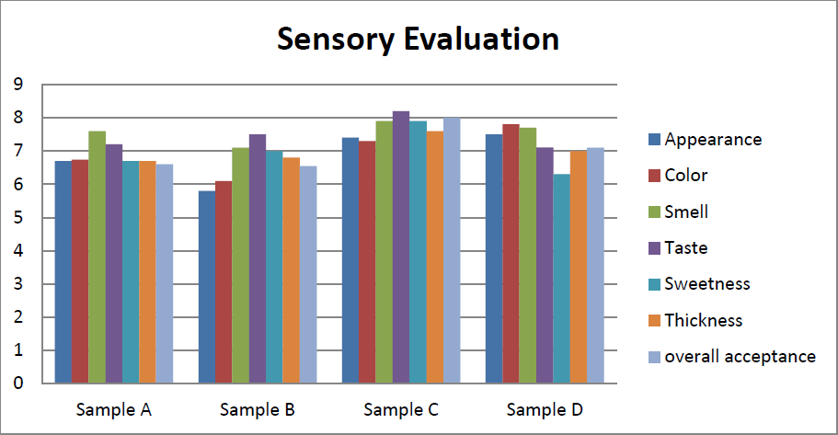

Figure 4.1: Sensory Evaluation of Bread samples

A-100% wheat flour B- 100% potato flour
C- 90% wheat flour and 10% potato flour
D- 95% wheat flour and 5% potato flour

Chapter 5: Discussion

Bread Made from a Blend of Wheat and Potato Flours Approximately. According to the relative composition analysis, the composite bread's protein, ash, and crude fiber contents all increased. On the other hand, as the amount of potato flour substitution increased, the moisture and crude fat content dropped. Increases in substitution level and a decrease in moisture content demonstrate the likelihood of extending shelf life. Since it is well known that the moisture and water activity of a product impact the shelf life of food goods, the range of moisture content implied that the potato bread had good storage capacity.
The results of (Olagunju et al., 2020) who reported that the moisture content of the composite bread grew with increasing non-wheat flour replacement found values that were comparable to those lower than the values 28.94%–36.95%.The bread's protein content increases (p> 0.05) as the amount of potato in the composite bread increases. However, the protein content is sufficient to guard against protein-energy malnutrition. Since potatoes are said to be high in protein and contain all the essential amino acids, particularly lysine, the protein level rises (Korese et al., 2021). The levels were higher than what earlier researchers had discovered (Ofori et al., 2020).
Ash contents provide information on the samples' inorganic content, which could be used to extract the mineral contents. The results for the ash content indicated that the composite bread may deliver necessary elements for bodily metabolism. The fiber values exceeded the 0.29%–0.59% range reported by (Beghin et al., 2022) and (Cappelli , Bettaccini et al., 2020). Crude fiber helps keep the human metabolic system and gastrointestinal tract healthy (Sahin et al., 2019). The amount of potato bread substituted raised the amount of carbohydrates significantly. Comparing the results of the sensory evaluation of bread samples made with various amounts of potato bread to the control. For all of the bread samples, there was no consistent pattern in the bread color or crust color data. The fragrant chemicals in potato—bread texture may be the cause of this. The status of the bread ingredients, including fiber, starch, protein (gluten), and the proportions of absorbed water during dough mixing, as well as the baking circumstances (temperature and time variables), all affect the final texture of the bread (Korese et al., 2021; Torbica et al., 2019). In all of the sensory qualities considered, it was found that bread swapped with 10% potato was most favored. The

minerals calcium, potassium, magnesium and sodium are listed in the content of the bread. With the growing substitution of wheat bread with potato, all the minerals typically rose. The micronutrient concentration of zinc, copper, and iron is increased by potatoes' high nutritional content (Bou-Orm & Jury et al., 2021). Calcium is necessary for the health of the teeth and bones. Sodium regulates extracellular fluid levels, while potassium facilitates muscle contractions and contributes to maintaining healthy blood pressure. Magnesium promotes a healthy, steady heart rhythm through the maintenance of these electrolytes.

Chapter 6: Conclusion

The proximate composition, mineral contents and sensory properties of the bread samples were all impacted by the addition of potatoes to composites used in the creation of bread. Regarding the proximate composition of the bread samples, the addition of potatoes increased their nutritious value. The potato-containing bread samples had high protein contents that were higher than the bread made entirely of wheat, as well as high carbohydrate contents that were higher than the bread made entirely of wheat. In order to increase the nutritional value of bread and snack items generally, potatoes can be included with wheat when making bread. More potassium, sodium, magnesium and sodium were present in the mineral makeup of the potato bread samples than in bread made entirely of. Sensory evaluations indicated that the bread samples were satisfactory.

Chapter 7: Recommendations and Future Aspect
- In order to improve the nutritional adequacy of snacks and help address the issue of protein-energy malnutrition that is a problem in developing nations, the use of composite potatoes, which are nutrient-dense plant products, in the production of snacks like bread should be encouraged.
- To minimize post-harvest losses and enhance food diversification, potato should be encouraged for use in the manufacturing of whole or composite flour for snacking.
- To determine the bread's shelf stability, more research needs to be done.

References

- Brown, “Understanding Food Principles and Preparation,” Singapore: Thomson Learning Asia, 2nd Edition, 2005 2005.
  - Hegazy, M.S. Ammar ,M.I. Ibrahium, “Production of Egyptian gluten-free bread,” World Journal of Dairy and Food Sciences, 4(2) 123-128, 2009.
Adeleke RO and Odedeji JO (2010) Functional properties of wheat and sweet potato flour blends. Pakistan J Nutr. 9(6), 535–538
Banwart G. 2012. Basic food microbiology.Springer Science and Business Media.
Bou-Orm, R., Jury, V. (2021). Microwave baking of bread; a review on the impact of formulation and process on bread quality. Taylor & Francis.
C. Feighery, “Celiac disease,” British Medical Journal, 319:236-239,

Cappelli, A.,Bettaccini, L. (2020). The kneading process: A systematic review of the effects on dough rheology and resulting bread characteristics, including improvement strategies. Elsevier.
Chandra S , Samsher (2013) Assessment of functionalproperties of different flours.Afr J Agric Res. 8(38):4849–4852.Composite flour blends, Department of Food Science and Technology, The Federal University of Technology, Akure, OndoState,Nigeria. , Int. J. Biol. Chem. Sci. 6(1): 65-76, February 2012
Curti e, Carini e, Diantom a, the use of potato fibre to improve bread physico-chemical properties during storage [J].Food Chemistry, 2016, 195: 64-70.
Dong, Y. N., &Karboune, S. (2021). A review of bread qualities and current strategies for bread bioprotection: Flavor, sensory, rheological, and textural attributes. Comprehensive Reviews in Food Science and Food Safety, 20(2), 1937–1981.
Gao J. Food Research and Development, 2010, 31(10): 43-66. Gil-Cardoso, K., Saldaña, G., Luengo, E., Pastor, J., Virto, R., Alcaide-Hidalgo, J. M., del Bas,
J. M., Arola, L., & Caimari, A. (2021). Consumption of Sourdough Breads Improves Postprandial Glucose Response and Produces Sourdough-Specific Effects on Biochemical and Inflammatory Parameters and Mineral Absorption. Journal of Agricultural and Food Chemistry.
Hoover R (2001) Composition, molecular structure and physicochemical properties of tuber and root starches: a review. CarbohydrPolym. 45: 253–267.

Hu, X., Cheng, L., Hong, Y., Li, Z., Li, C., & Gu, Z. (2021). An extensive review: How starch and gluten impact dough machinability and resultant bread qualities. Critical Reviews in Food Science and Nutrition.
I., Hill, M.H. Dirks, G.S. Liptak, R.B. Colletti, A. Fasano and S. Guandalini, “Guideline for the diagnosis and treatment of celiac disease in children: recommendations of the North American Society for pediatric gastroenterology, hepatology and nutrition,” Journal of Pediatric Gastroenterology and Nutrition, 40:1-19, 2005.
Isaac Babatunde Oluwalana*, Sunday Abiodun Malomo and Ezekiel Owurie Ogbodogbo, Quality assessment of flour and bread from sweet potato wheat
J.A. Murray, “The widening spectrum of celiac disease,” American Journal of Pediatric Gastroenterology and Nutrition, 1999, 27: 519-523.
Korese, J. K., Chikpah, S. K., Hensel, O., Pawelzik, E., & Sturm, B. (2021).Effect of orange-fleshed sweet potato flour particle size and degree of wheat flour substitution on physical, nutritional, textural and sensory properties of cookies. European Food Research and Technology, 247(4), 889–905.
KulkarniKD, Govinden N and Kulkarni D (1996) Production and use of raw potato flour in Mauritian traditional foods. Food Nutr Bull. 17(2): 1–8.
Liu X, Mu T, Yamul, K D. Evaluation of different hydrocolloids to improve doughrheological properties and bread quality of potato-wheat flour [J]. Jouranl Food Science Technolgy, 2017, 54(6): 1597-1607.
Mietton, Lauriane; Samson, Marie-Françoise; Marlin, Thérèse; Godet, Teddy; Nolleau, Valérie; Guezenec, Stéphane; Segond, Diego; Nidelet, Thibault; Desclaux, Dominique; Sicard, Delphine (July 2022). "Impact of Leavening Agent and Wheat Variety on Bread Organoleptic and Nutritional Quality". Microorganisms. 10 (7):1416.Doi10.3390/microorganisms10071416
. ISSN 20762607. PMC 9317705. PMID 35889135.
Misra A, Kulshrestha K. Effect of storage on nutritional value of potato flour made from three potato varieties. Plant Foods for Human Nutrition, 2003, 58(3): 1- 10.
Millets, C. C. (2019). Gluten-free dough-based foods and technologies. Elsevier.

Nielsen G G B, Kjçr A, Klösgen B (2016) Dielectric spectroscopy for evaluating dry matter content of potato tubers. Journal of Food Engineering, 189: 9-16.

Ofori, J., &Tortoe, C. (2020). Physicochemical and functional properties of dried okra (Abelmoschusesculentus L.) seed flour. Wiley Online Library, 8(8), 4291–4296.
Olagunju, A. I., Ekeogu, P. C., & Bamisi, O. C. (2020). Partial substitution of whole wheat with acha and pigeon pea flours influences rheological properties of composite flours and quality of bread. British Food Journal, 122(11), 3585– 3600.
Oloo Bo, Shitandi A, Mahungu S, MalingaJB, Ogata BR (2014). Effects of Lactic Acid Fermentation on the Retention of Beta Carotene Content in Orange Fleshed Sweet Potatoes. Int. J. Food Stud. 3:13-33.
Onimawo IA and Akubor PI (2012) Food Chemistry: Integrated Approach with Biochemical background (2nd Ed.). Joytal Printing Press, Agbowo, Ibada, Nigeria.
P. Seraphin and S. Mobarhan, “Mortality in patients with celiac disease,” Nutritional Review, 60:116-118, 2002.
Pena, R.Food and Agriculture Organization Retrieved 1 October 2016.Wheat, in the form of bread, provides more nutrients to the world population than any other single food source.
R.J. Hamer, “Coeliac disease: background and biochemical aspects,” Biotechnology Advances, 23:401-408, 2005.
S. O. Oluwajoba, O. Malomo, O. A. B. Ogunmoyela, O. E. O. Dudu, and A. Odeyemi, “Microbiological and nutritional quality of warankashi enriched bread,” Journal of Microbiology, Biotechnology and Food Sciences, vol. 2, no. 1, pp. 42–68, 2012
Sun P, Zhou Q Z, Gao J, et al. Color protecting of potato granules [J]. Food Research and Development, 2010, 31(10): 43-66.
Vedaste Ndungutse12*,Peninah Muthoni Njiraine Ngoda2, Functional Properties of Flour From selected potato (Solanumtuberosum L). Cultivers Grown in Rwanda, Potato J 46 (2), 2019

Zhang H, Xu, F, Wu Y. Progress of potato staple food research and industry development in China [J]. Journal of Integrative Agriculture, 2017, 16(12): 2924-2932
Zhang Z, Wheatley C C, Corke H. Biochemical changes during storage of sweet potato roots differing in dry matter content [J]. Postharvest Biology and Technology, 2002, 24(3):317-325.

Brief biography

Trishna Banik passed the Secondary School Certificate Examination in 2012 and then Higher Secondary Certificate Examination in 2014. She obtained her B.Sc. (Hons.) in Food Science & Technology in 2019 (held in 2020) from Chattogram Veterinary and Animal Sciences University (CVASU), Bangladesh. Now, she is a candidate for the degree of MS in Department of Applied Chemistry and Chemical Technology in Food Chemistry and Quality Assurance under Food Science & Technology Faculty, CVASU. She has immense interest to work in food safety issues including food chemistry, quality assurance, food quality control, environmental chemistry, product development and processing, malnutrition, reduction of nutritional changes in food processing etc.

Appendices

Appendix A
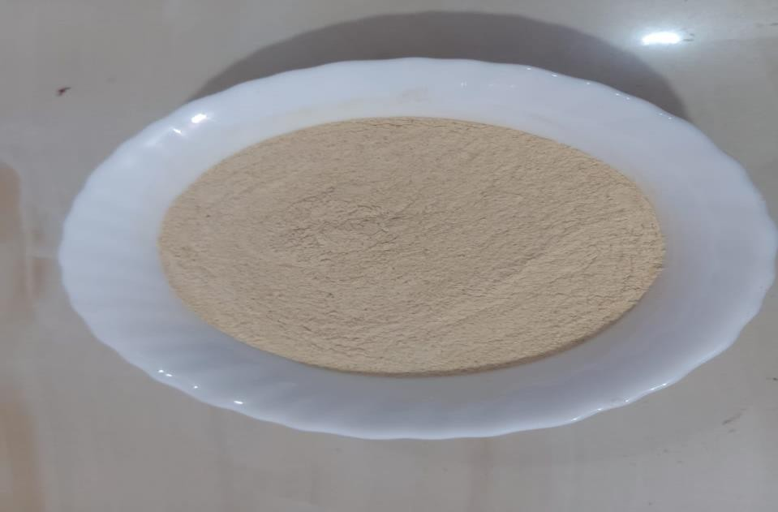

Potato Flour

Appendix B: Formulation

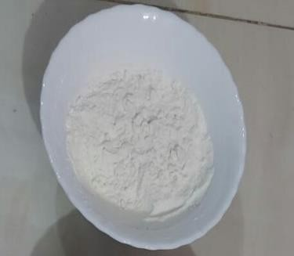
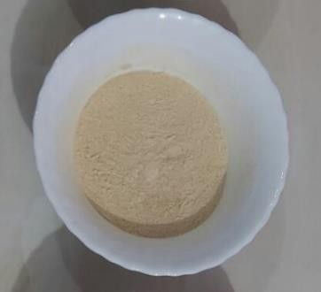

Wheat flour, WF (100%) Potato flour, PF (100%)

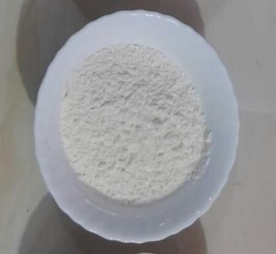
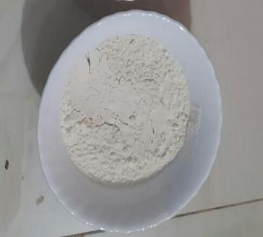

Wheat/Potato flour, WF/PF1 (90:10%) Wheat/Potato flour, WF/PF2 (95:5%)

Appendix C: Final Product

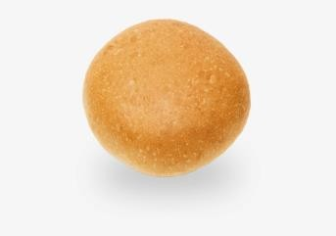
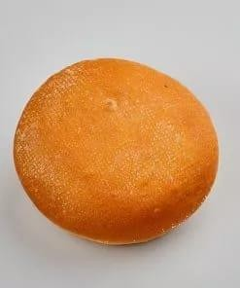
Wheat flour bread (100%) Potato flour bread (100%)

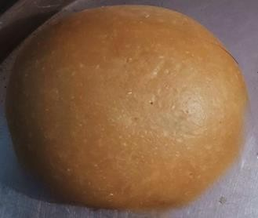
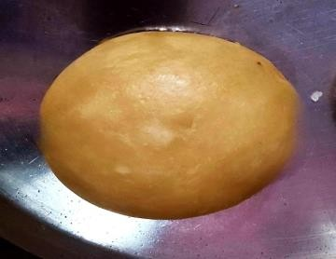

Wheat/Potato flour bread, Wheat/Potato flour bread, WF/PF2 (95:5%) WF/PF1 (90:10%)

