A longitudinal Survey on Quantification of Antimicrobial Use in Some Selected Commercial Poultry and Dairy Farms of Bangladesh

Dr. Mohammad Eliyas
Roll No: 0220/3
Registration No: 915
Session: 2020-2021

This is to certify that we have examined the above master’s thesis and have found that is complete and satisfactory in all respects, and that all revisions required by the thesis examination committee have been made

One Health Institute
Chattogram Veterinary and Animal Sciences University
Chattogram-4225, Bangladesh

December 2022

Authorization

I hereby declare that I am the sole author of the thesis. I also authorize the Chattogram Veterinary and Animal Sciences University (CVASU) to lend this thesis to other institutions or individuals for the purpose of scholarly research. I further authorize the CVASU to reproduce the thesis by photocopying or by other means, in total or in part, at the request of other institutions or individuals for the purpose of scholarly research.
I, the undersigned, and author of this work, declare that the electronic copy of this thesis provided to the CVASU Library, is an accurate copy of the print thesis submitted, within the limits of the technology available.

Dr. Mohammad Eliyas
December 2022

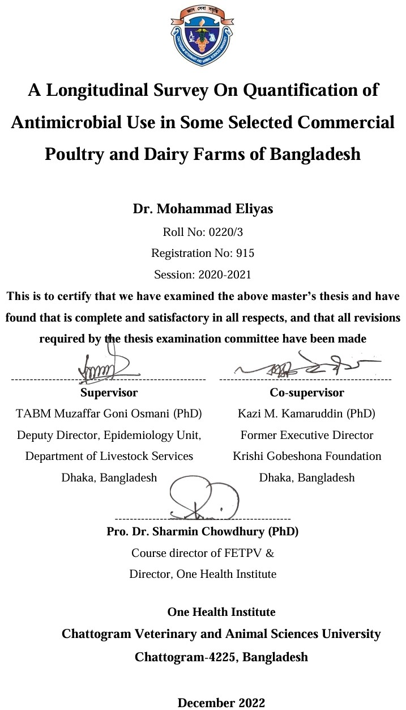
Acknowledgments
The author would like to acknowledge Allah, the Most Merciful, for providing him life, hope, courage, strength, and the fortitude to carry on despite all the challenges. The author feels incredibly privileged to express his profound sense of gratitude and honor to his supervisor Dr. TABM Muzaffar Goni Osmani and co-supervisor Dr. Kazi M. Kamaruddin for their valuable and critical suggestions, scientific acumen, perspicacious remarks, scholarly guidance, blessings, and inspiration throughout the course of this study, research works and preparation of this manuscript. The author expresses his sincere and unfathomable sense of gratitude to Dr. Sharmin Chowdhury, Director One Health Institute, CVASU for providing him with a research grant as well as for her constructive advice and encouragement at various stages of this study.
With special pleasure, author acknowledged the Eastern Mediterranean Public Health Network (GHD|EMPHNET) and the Fleming Fund Country Grant to Bangladesh (FFCGB) for supporting him to accomplish this research work.
The author gives sincere thanks to his family, especially his mother, and wife who constantly support him and also grateful to brothers and sisters for their moral support. Very sincere thanks are due to the examiners for helping to refine his work further.
The author once again records his deep-felt gratitude to all those who are not mentioned here but directly or indirectly cooperated in this endeavor.

Table of Contents
Authorization i
Acknowledgments iii
Table of Contents iv
List of Figures vii
List of Tables viii
List of Symbols and Abbreviations ix
Abstract x
Chapter I: Introduction 1
1.1 Rational for the study of AMU at farm level 2
1.2 Objectives 3
1.3 Operational Definition of Some Important Variables Used in This Study 4
Chapter II: Review of Literature 5
2.1. Livestock in the economy of Bangladesh 5
2.2. Poultry sector in Bangladesh 5
2.3. Dairy sector of Bangladesh 6
2.4. Challenges for poultry and dairy production in Bangladesh 7
2.5. AMR in Human 8
2.6. AMR in poultry and dairy 8
2.7. AMU/AMC in human and animals including food animals 9
2.8. AMU Metrics 10
2.8.1. Antimicrobial usage calculation 10
2.8.2. Descriptive calculation 10
2.8.3. Importance AMU Quantification Metrics 11
2.8.4. Antimicrobial Active Ingredients in Kilogram (AAI) 12
2.8.5. Milligram/kg 13
2.8.6. Daily dose metrics 14
2.8.7. Course dose metrics 16
2.8.8. Cow calculated course 16
2.9. Biosecurity practices in poultry and dairy farms 17
Chapter III: Materials and Methods 20
3.1. Approaches 20
3.2. Study settings and farm selection 21
3.3. Farmers’ training 22
3.4. Trash can, Zipper bag and Marker supply 22
3.5. Employment of data Collectors 22
3.6. Data collection pathway 23
3.7. Data Analysis 24
3.7.1. Antimicrobial Active Ingredient (AAI) in Broiler Farms 24
3.7.2. Milligrams of active ingredient per population correction unit (mg/PCU) 25
3.7.3. Milligrams of active ingredient per final flock weight (mg/FFW) 25
3.7.4. Antimicrobial Active Ingredient (AAI) Layer and Dairy Farms 25
3.7.5. Milligrams of active ingredient per population correction unit (mg/PCU) 26
3.7.6. Antimicrobial treatment incidence (ATI) 26
Chapter IV: Results 28
4.1. Response to AMU Data Collection 28
4.2. Population Size and Housing 28
4.3. Broiler Farms 28
4.3.1 Quantitative AMU in Broiler Chicken 28
4.3.2. WHO-CIA and AWaRe Classification of Broiler AMU 29
4.3.3. Purposes and Prescribers of Broiler AMU 31
4.3.4. Age Wise Distribution of Broiler AMU 32
4.3.5. Broiler AMU Differences Between Gazipur and Chattogram 33
4.4. Layer Farms 33
4.4.1. Quantitative Antimicrobial Use in Layer Chicken 34
4.4.2. Spatial Variations in Antimicrobial Use in Layer Chicken 35
4.4.3. Disposal of litter materials 36
4.5. Dairy Farms 38
4.5.1. Calculation of Antimicrobial Active Ingredients (AAI) 38
4.5.2. Population Correction Unit (PCU) 40
4.5.3. Milligrams of active ingredient per population correction unit (mg/PCU) 41
4.5.4. Antimicrobial Treatment Incidence (ATI) 42
4.5.5. WHO-CIA and WHO-AWaRe Classification of Dairy AMU 43
4.5.6. Purposes of Dairy AMU 44
4.5.7. Possible causes of the excessive use of antimicrobials in Chattogram 44
Chapter V: Discussion 46
5.1. Limitations 49
Chapter VI: Conclusion and Recommendations 50
6.1. Conclusion 50
6.2. Recommendations 50
References: 52
Appendix I: AMU data collection form (poultry farms) 60
Appendix II: AMU data collection form (dairy farms) 62
Appendix III: Some Pictures 64
Brief Biodata of the Author 66

List of Figures
Figure 1: Conceptual model on factors affecting the implementation biosecurity measures in cattle farm 18
Figure 2: Geolocations of selected Layer, Dairy and Broiler farms in Chattogram and Gazipur 21
Figure 3: Farmers' Training (top); Zipper Bags, Marker, Trash Can (middle) and 4 Data Collectors (bottom) 23
Figure 4: Farms are being cross-checked for monitoring of AMU surveillance at farm level and the zipper bags containing empty sachets/containers are stored in the trash can. 24
Figure 5: Top 10 Antimicrobials of Selected Broiler Farms. 29
Figure 6: WHO-CIA Classification of Broiler AMU 30
Figure 7: WHO-AWaRe Classification of Broiler AMU. 30
Figure 8: Purposes of AMU in Selected Broiler Farms 31
Figure 9: Prescribers of AMs in Selected Broiler Farms 32
Figure 10: Age Wise Distribution of Broiler AMU 32
Figure 11: Broiler AMU (mg/PCU) Differences in Gazipur and Chattogram 33
Figure 12: Antimicrobial Active Ingredients (AAI) in layer farms 33
Figure 13 & 14: WHO-CIA and AWaRe Classification of AMU along with Their ATI (DDDA/1000 Chicken-Days) in Selected Layer Farms of Chattogram and Gazipur 35
Figure 15: The ATI (DDDA/1000 Chicken-Days) % difference in Chattogram as compared to Gazipur values in layer chicken 36
Figure 16:Direct Pouring of Excreta into the Pond 36
Figure 17:Daily Layer Droppings, Being Used as Fish Feed 37
Figure 18:Empty Medicine Packages, Plastic Feeders, Waterers and Leftover Medicines 37
Figure 19: Body Weight of Cow, Heifer and Calf 38
Figure 20: Antimicrobial Active Ingredients (AAI) of Selected Dairy Farms 39
Figure 21: Top Five Dairy AMs (mg/PCU) 41
Figure 22: WHO-AWaRe Classification of Dairy AMs 44
Figure 23: Purposes of Antimicrobial Uses in the Selected Dairy farms 44

List of Tables

Table 1: Selected Farms in Chattogram and Gazipur. 22
Table 2: Quantification and WHO-CIA Classification of Used AMs in Selected Broiler Farms. 29
Table 3: WHO-CIA and AWaRe Classification along with Quantification of Used...34 Table 4: Antimicrobial Active Ingredients (AAI) of Selected Dairy Farms. 39
Table 5: PCU of Cow, Heifer and Calf. 40
Table 6: Quantification of Milligram per Population Correction Unit (mg/PCU) Using Color Scale Table. 41
Table 7: Adjusted Number of Animals (Cows) [ANadj]. 42
Table 8: Defined Daily Dose for Animal (mg/Cow-Day). 42
Table 9: Antimicrobial Treatment Incidence (ATI) Using Color Scale Table. 43

List of symbols and abbreviations
Abbreviations | Full Meanings
AACTING | Network on quantification of veterinary Antimicrobial usage at herd level and Analysis, CommunicaTion and benchmarkING to improve responsible usage
AI | Active ingredients
AMC | Antimicrobial consumption
AMR | Antimicrobial resistance
AMR Ix | Antimicrobial resistance indicator index
AMU | Antimicrobial use
ATI | Antimicrobial treatment incidence
CVASU | Chattogram Veterinary and Animal Sciences University
CIA | Critically important antimicrobials
DDDA | Defined daily dose animal
DoF | Department of Fisheries
DLS | Department of Livestock Services
DLO | District Livestock Officer
EMA | European Medicines Agencies
ESVAC | European Surveillance for Veterinary Antimicrobial Consumption
FAO | Food and Agricultural Organization
FFCGB | Fleming Fund Country Grant to Bangladesh
FFW | Final Flock Weight
GAP | Global Action Plan
IBD | Infectious Bursal Disease
icddr,b | International Centre for Diarrheal Disease Research, Bangladesh
LMICs | Low and Low Middle Income Countries
ND | Newcastle Disease
OHPH | One Health Poultry Hub
PCU | Population Correction Unit

Abstract
Making available of antimicrobial use (AMU) and antimicrobial consumption (AMC) data is very important for antimicrobial resistance containment. One of the activities in this regard is the AMU surveillance in food animals. The study quantifies antimicrobials used in Bangladeshi chicken and dairy farms, establishes rationale for their use, and categorizes them into WHO-CIA and WHO-AWaRe classes. This piece of work has thus been undertaken with the major objectives of quantification, categorization and rationalization of antimicrobials, used in the selected commercial chicken and dairy farms of Bangladesh. A longitudinal study was conducted to collect the antimicrobial usage data in commercial poultry and dairy farms involving summer/wet season. For the study, a total of 36 farms were selected purposively from Gazipur and Chattogram (18 from each district) that included 6 dairy, 6 layer chicken and 6 broiler chicken farms from each of the districts. Farmers from the selected farms were supplied with one trash can, zipper bags and data collection forms with a training on how to use those tools. Each farm was visited by the data collectors at least once in a week for data collection. There were correspondingly 285, 9690, and 13529 cattle, broiler chicken, and layer chicken involved in the study in Chattogram and 428, 9365, and 20312 in Gazipur. For data collection, one production cycle was considered in case broiler chicken whereas, in case of layer chicken and dairy cattle the study was conducted involving three summer months. None of the participating farms used antimicrobials as a feed premix or growth booster aside from preventive applications.
The survey discovered 20 antimicrobial drugs used on broiler, 17 on layer, and 14 on dairy farms, respectively, weighing 3.3 kg, 9.67 kg and 1.072 kg. The total combined broiler AMU was 173.29 mg/PCU, layer was 285.80mg/PCU or 103.22 DDDA/1000 Chicken-Days and dairy was 32.93 DDDA/1000 Cow-Days. The study reveals that neomycin, amoxicillin, and oxytetracycline were the top three antimicrobial medications used in broiler, layer, and cattle farms respectively.
The majority of these drugs fall within WHO-CIA classes for human medicine. A reserve antimicrobial, Colistin, was also used in both broilers and layers but no reserve antimicrobials were used in selected dairy farms.
Keywords: Antimicrobial resistance, Bangladesh, Multi-drug resistance, AMU

Chapter I: Introduction
Making available of surveillance data in relation to the antimicrobial use (AMU) and antimicrobial consumption (AMC) for antimicrobial resistance containment has been identified as one of the strategic objectives of the National Antimicrobial Resistance (AMR) Surveillance Strategy of Bangladesh (National Antimicrobial Resistance (AMR) Surveillance Strategy of Bangladesh, 2020). This objective also aligns with the global call to address AMR by the World Health Organization's (WHO) Global Action Plan (GAP) on AMR (WHO, 2015), the Food and Agriculture Organization of the United Nation's (FAO) action plan on AMR (FAO, 2018) and the World Organization for Animal Health's (OIE, 2016) strategy on AMR and the prudent use of antimicrobials (AMs) (OIE, 2016). In Bangladesh, the problem of AMR is being addressed using One Health platform with the support from Fleming Fund Country Grant to Bangladesh (FFCGB). One of the activities in this regard is the AMU surveillance in food animals through data collection, reporting and development of AMU metrics and indicators including training of the relevant field staffs on monitoring of AMU in the poultry and dairy farms.
Guidance for AMU data collection, measurements and reporting for AMU monitoring in this Study has been adapted from the European Medicines Agency (EMA)'s European Surveillance for Veterinary Antimicrobial Consumption (ESVAC) project (Seventh ESVAC Report, 2017; EMA, 2018). As suggested in the revised ESVAC reflection paper, AMU data was collected at the farm level to assess temporal trends and understand overall AMU context and impacts of interventions in terms of prudent use/stewardship (EMA,2013). For estimating antimicrobial use in food animals the Guidelines for AMU data collection and measurements at the farm level has been adapted from the document of the AACTING project "Network on quantification, benchmarking, and reporting of veterinary AMU at farm level" (AACTING, 2018) and from the study titled "Quantification and Trends of Antimicrobial Use in Commercial Broiler Chicken Production in Pakistan" (Umair et al., 2021).
For AMU surveillance, metrics (the technical units of measurement, such as frequency of use) and indicators (an AMU metric in relation to a denominator, such as animal biomass or animal time unit described below) that was used include: Milligrams weighted by population and weight (mg/PCU) which were used for reporting national sales and distribution data across countries in the European Union (ESVAC, 2018). Another AMU indicator is treatment incidence (TI), which pertains to the total number of defined daily doses in animals adjusted for animal-time units (Timmerman et al., 2006; Callens et al., 2012; Persoons et al., 2012). The number of defined daily doses in animals per PCU is an AMU measurement to monitor AMU sales data in animals (ECDC/EFSA/EMA, 2017). Requirements for AMU measurements varies depending on surveillance objectives and include spatial and temporal resolution (frequency on which AMU data are collected), comprehensiveness (capacity to collect usage data from all units in the target population), stability over time, and comparability between populations (Collineau et al., 2016). An AMR indicator is a summarized AMR measurement integrating selected AMR data across different bacterial species (e.g., of public health importance) at the national level, aimed at monitoring national and multi-stakeholder stewardship efforts and initiatives to mitigate AMR risks (ECDC/EFSA/EMA, 2017). The antimicrobial resistance indicator index (AMR Ix) is a novel AMR indicator, calculated as the percentage of resistance (or susceptibility) to a certain antimicrobial/s, adjusted by PCU (ECDC/EFSA/EMA, 2017).
  - Rational for the study of AMU at farm level
To address the multifaceted problem of AMR in Bangladesh a point prevalence survey (PPS) on AMU in human, commercial chicken and aquaculture was conducted under the project “Antimicrobial Use in Human, Commercial Chicken and Aquaculture Using One Health Approach in Bangladesh” supported by FFCGB. The project was conducted by the International Diarrhoeal Diseases Research, Bangladesh (icddr,b) in collaboration with One Health Poultry Hub (OHPH), Department of Livestock Services (DLS), Department of Fisheries (DOF) and Chattogram Veterinary and Animal Sciences University (CVASU). The project was conducted in five districts of Bangladesh including Gazipur, Chattogram, Cumilla, Joypurhat and Bogura involving four poultry dominated upazilas from each districts with a total of 20 upazilas. The project revealed overall prevalence of antibiotic use to be 47% in commercial broiler chicken farms, 31% in commercial layer chicken farms, 47% in sonali chicken farms and 5% in commercial freshwater fish farms. Doxycycline, oxytetracycline, and amoxicillin were found to be used predominantly in commercial chicken production. However, the project did not involve commercial dairy farms, the potential user of antibiotics in Bangladesh, and also that the knowledge generated from the project lacks information concerning quantification and the seasonal variations of the use of AMs in the poultry farms. To address the global call for the prudent use of AMs for AMR containment estimation of the prevalence of antimicrobial uses in commercial chicken only may not serve the purpose. This study, therefore, has been designed to monitor AMU by quantifying the amount of AMs used in the food animals along with farm biosecurity levels as national and multi-stakeholder stewardship efforts and initiatives to mitigate AMR risks. It was hoped that this study will help collect AMU from farm records (end-user data), which is required for reporting to the WOAH (former OIE) along with the Purchase data, Import data and veterinary prescription data.
1.2. Objectives:
The general goal of this baseline study is to train field vets and technical staffs on collecting farm-level antimicrobial use data, promoting awareness of its importance for monitoring antimicrobial resistance trends and informing policy decisions in livestock. Accurate recording aids in tracking progress and supporting evidence-based policy development. This baseline study also provides idea on present status of antimicrobial usages in livestock farming in Bangladesh. Furthermore, by understanding the patterns of antimicrobial use, stakeholders can identify areas where interventions are needed to reduce unnecessary usage and promote responsible antimicrobial stewardship.
However, the explicit objectives of this survey is as follows-
- Quantification of antimicrobials used in selected commercial chicken and dairy farms of Bangladesh.
- Justify the antimicrobial therapy in food animals.
- Calculations for WHO Critically Important Antimicrobials (CIA) and WHO AWaRe antimicrobials.

  - Operational Definition of Some Important Variables Used in This Study:
- Antimicrobial Active Ingredients in Kilogram (AAI): It is the total amount of active ingredient used in the selected farms in kilograms. It does not consider time as well as total weight of animals or bids.
- Population Correction Unit (PCU): It is calculated by multiplying the number of birds, cows, heifers and calves in respective flocks/herds with 1 kg, 425 kg, 200 kg and 140 kg respectively [considering 1 kg per bird (broiler/layer), 425 kg per cow, 200 kg per heifer and 140 kg per calf as the standardized average weight at the time of treatment].
- Milligrams of active ingredient per population correction unit (mg/PCU): The total amount of active ingredient used in farms (milligrams) was divided by the population correction unit (PCU) of the flocks on which the respective antimicrobial was administered to calculate mg/PCU.
- Milligrams of active ingredient per final flock weight (mg/FFW): The total amount of active ingredient used in milligrams was divided by the final flock weight (FFW) (weight at the time of harvesting) on which the respective antimicrobial was administered.
- Antimicrobial Treatment Incidence (ATI): It is the total number of antimicrobial treatments per 1000 animals/birds per day and is calculated as DDDA/1000 animal-days. DDDAs (Defined Daily Dose Animal i.e., milligrams of antimicrobial active agent recommended to be administered per animal per day) for single or multiple active ingredient products. For long-acting products (products to be repeated after 48 hours), DDDAs for each antimicrobial are to be divided by two. For intramammary applicators, one applicator is accounted as a single DDDA

Chapter II: Review of Literature
2.1. Livestock in the economy of Bangladesh
Bangladesh, formally The People's Republic of Bangladesh, is a country in South Asia. It is bordered by India to the west, north, and east, and Myanmar to the southeast. With a population of over 166 million people, Bangladesh is the eighth-most populous country in the world. Agriculture is the mainstay of its economy. One of the main pillars of the nation's agriculture is livestock. Bangladesh has a variety of livestock, including cattle, goats, sheep, and poultry. The livestock sector plays a crucial role in providing employment opportunities and contributing to the country's GDP. Additionally, it also provides a source of nutrition through milk, meat, and eggs for the population. The Department of Livestock Services (DLS) under the Ministry of Fisheries and Livestock is the foremost service provider and regulatory agency of the livestock sector in Bangladesh. The services of the DLS extend to the farm yard to ensure safe supply of animal feed. Since its inception, the DLS has been working successfully in the areas of livestock-poultry disease control and cure, livestock productivity enhancement, entrepreneurship creation and skill development, animal nutrition development, value chain and market management of livestock products. Key Performance Indicator (KPI) of Livestock i.e. milk, meat and egg production has increased significantly in the last decade (2010-2020). In FY 2021-22, GDP growth rate in livestock sub-sector increased to 3.10 percent and contribution of livestock sector to agricultural GDP increased to 16.52 percent. About 20 percent of people are directly involved in this sector and 50 percent indirectly (Hamid et al., 2016, Rahman et al., 2014).
2.2. Poultry sector in Bangladesh
The poultry sector is an important component of agriculture of Bangladesh. It is one of the biggest sources of protein to population and also a source of employment specially to rural people. According to a report of Food and Agricultural Organization (FAO) of United Nation, Bangladesh’s poultry sector is one of the fastest growing. A strong development of the commercial poultry production did not only address the nutritional demand for high-quality animal protein of consumers, but it also uplifted the economic status of the farmers as well as increased the employment opportunities of people in Bangladesh (Farrell, 2003). Thus, commercial poultry production has greatly contributed to the economic development of Bangladesh (Das et al., 2008). Commercial poultry production in Bangladesh consists of small-scale farms with up to 3,000 birds and medium to large-scale farms ranging between 3,000 and 20,000 birds (Hamid et al., 2017). Chickens are the main poultry species reared on commercial farms (Dolberg, 2008). Commercial chicken production can be classified into broiler and layer farming (Jabbar et al., 2007). In broiler farming, chickens are reared for meat while on layer farms, chickens are reared for egg production although unproductive layer birds are also sold for meat (Dolberg, 2008). The most common broiler breeds in Bangladesh are Indian River, Hubbard Classic, Cobb 500, and Hybro-PG whereas the most common layer breeds are Bovans brown, White Shaver, Hisex brown, Bovine gold line and ISA brown. These chickens, largely hatched from domestic hatcheries, are placed in the farms as day old chicks (DOCs) (Dolberg, 2008).
2.3. Dairy sector of Bangladesh
The dairy sector in Bangladesh is progressively emerging, and a major part of the national milk supply is produced by cross-bred cows (Uddin et al., 2010). In developing countries like Bangladesh, an emphasis has been put on high milk production to alleviate poverty and to meet the daily requirement of milk of 250 mL/person (WHO, 2015). The present national production is 69% of the quantity of milk needed to be self-sufficient according to recent reports (WHO, 2015; FAO, 2018). For this purpose, across the country, indigenous cows have been replaced by cross-bred cows (Holstein Friesian × Indigenous and Holstein Friesian × Sahiwal × indigenous) (OIE, 2017) using a national AI program since 1959 (Seventh ESVAC Report, 2017). However, these cows are more susceptible to production diseases like mastitis (EMA, 2013). In Bangladesh, cows are the main source of milk. About 90% of the produced milk in the country comes from cows, 8% from goat, and the remaining 2% from buffalo (DLS, 2013). Smallholder producers dominate the dairy sector in Bangladesh. More than 70% of the dairy farmers are smallholders and produce around 70–80% of the country’s total milk (Uddin et al. 2012). To ensure sustainable production of milk, far-reaching initiatives have been taken to improve cattle breeds, improve market management of milk and milk products, ensure quality control and availability, and promote milk drinking habits. In FY 2020-21, milk production was 11.985 million MT, which is a 4-fold increase over FY 2010-2011, increasing per capita availability to 193.38 ml/day. Expansion of artificial insemination technology, breed development and productivity enhancement and numerical growth of dairy stock have been key drivers in increasing milk production in the last decade (DLS).

2.4. Challenges for poultry and dairy production in Bangladesh
The major challenges for commercial chicken producers is the occurrence of infectious diseases (Giasuddin et al., 2002; Hassan et al., 2016; Kabir et al., 2016), and poor biosecurity (Rimi et al., 2017). Moreover, Bangladesh has a lack of policies on antimicrobial usage (Ferdous et al., 2019). Other challenges include lack of veterinary health care and diagnostic support (Haque, 2017), lack of proper vaccination programs (Ansari et al., 2016), nutritional deficiencies of chickens that are not met (Dolberg, 2008), and marketing constraints (Hamid et al., 2017) that might also hinder profitable and successful commercial poultry trade. Salmonellosis, colibacillosis, mycoplasmosis, necrotic enteritis, fowl cholera and infectious coryza were the most frequent bacterial diseases whereas Avian influenza, Newcastle disease (ND), Infectious bursal disease (IBD), Infectious bronchitis (IB), Avian leucosis were the most frequent viral reported from commercial chicken farms between 2002 and 2018 in Bangladesh.
Production disease like mastitis is the major hindrance of getting the optimum benefit from a dairy farm (ESVAC, 2018). In Bangladesh, mastitis impedes the dairy sector's growth due to decreased production (Persoons et al., 2012). Mastitis generates a considerable loss to the dairy industry, which has been estimated for Bangladesh as Tk. 122.6 (US $2.11) million per year (Callens et al., 2012).
Vaccination is not effective unless good biosecurity practices are implemented on farms (Hasan et al., 2011). Unfortunately, in Bangladesh, there is no strategic and harmonized animal health care plan including vaccination, nutritional deficiency and marketing constraints (DLS, 2007).
The term antibiotic was coined from the word ‘antibiosis’ which literally means ‘against life’. In the past, antibiotics were considered to be organic compounds produced by one microorganism which are toxic to other microorganisms (Russell, 2004). As a result of this notion, an antibiotic was originally, broadly defined as a substance, produced by one microorganism (Denyer et al., 2004), or of biological origin (Schlegel, 2003) which at low concentrations can inhibit the growth of, or are lethal to other microorganisms (Russell, 2004). However, this definition has been modified in modern times, to include AMs that are also produced partly or whole through synthetic means. Whilst some antibiotics are able to completely kill other bacteria, some are only able to inhibit their growth. Although antibiotic generally refers to antibacterial, antibiotic compounds are differentiated as antibacterials, antifungals and antivirals to reflect the group of microorganisms they antagonize (Brooks et al., 2004; Russell, 2004). Penicillin was the first antibiotic discovered in September 1928 by an English Bacteriologist, late Sir Alexander Fleming who fortuitously obtained the antibiotic from a soil inhabiting fungus Penicillium notatum but its discovery was first reported in 1929. The continual discovery, development and introduction of antibiotics into our health care delivery system has no doubt immensely aided our fight against infectious diseases caused by bacteria and thus contributed to individual and societal well-being. However, the ever-developing emergence of bacteria resistant to virtually all known antibiotic is a cause of grave concern and this phenomenon makes the search for new and more effective antibiotics to continue unabated. Although about 2,000 antibiotics have so far been discovered, only a few scores of them are currently used therapeutically (Schlegel, 2003), apparently owing to the attendant side effects of most of those discovered.
2.5. AMR in Human
Antimicrobial Resistance (AMR) is a condition in which bacteria, viruses, fungi, and parasites evolve over time and cease to respond to antibiotics, making infections more difficult to cure and raising the risk of disease transmission, life-threatening sickness, and death (WHO, 2021). Antimicrobial resistance (AMR) defines a situation where microbes (e.g. bacteria, fungi, parasites or viruses) causing infections in humans, plants or animals develop the ability to remain unaffected by the drugs designed to kill them, making such ‘antimicrobial-resistant infections’ difficult to treat. Antimicrobial resistance happens when germs like bacteria and fungi develop the ability to defeat the drugs designed to kill them. That means the germs are not killed and continue to grow. Resistant infections can be difficult, and sometimes impossible, to treat (CDC, 2023). Antimicrobial resistance (AMR) is a slow but inevitable public health threat and a “wicked problem.” According to the UK Review on Antimicrobial Resistance forecasted that up to 10 million deaths could be attributable to AMR by 2050, whereas the World Bank estimated that AMR could independently result in global GDP falling by 1.1–3.8% by 2050 if existing practices continue. AMR is, undeniably, a considerable global health security issue. In 2016, the United Nations General Assembly addressed the issue of AMR and announced a global commitment to action.
2.6. AMR in poultry and dairy
Antibiotic resistance has gained a global health concern as it is attributed to the death of about 0.7 million people every year, which is forecasted to rise to 10 million per year by 2050 (DLS 2023; FAO, 2023). The spread of AMR is the most divisive issue in the health of humans, animals, and ecosystems in the twenty-first century (Collineau, 2016). The spread of AMR has also emerged as a significant barrier to economic development (ECDC, EFSA and EMA, 2017). The overuse and misuse of antibiotics play a significant role in the emergence and spread of antibiotic-resistant E. coli, which can be transmitted to humans through food or direct contact with sick animals (FFCGB). Antibiotics are widely used in poultry rearing as growth stimulants or to treat infectious diseases (ESVAC, 2018; Fleming Fund Country Grant Pakistan, 2021). A development in AMR is inevitable because of the widespread use of antibiotics in both clinical and nonclinical settings in developing countries like Bangladesh (Mohsin et al., 2019). Bacteria including E. coli and M. tuberculosis have developed multidrug resistance (MDR) due to the haphazard way in which antibiotics are used (EMA, 2015). Increased morbidity, death, and healthcare expenditures may result from the emergence of MDR strains to antimicrobial therapies (Firth et al., 2017). In the last 20 years, the emergence of MDR strains has increased dramatically. Food-producing animals and their products have been identified as a source of resistance genes (WHO). The resistance genes in E. coli are acquired through selective pressure, induction, or mutation (Schuurmans et al., 2014). Bacterial AMR genes can be spread horizontally and vertically to other bacteria, and they can also infiltrate the human food chain (WHO, 2015).
2.7. AMU/AMC in human and animals including food animals
Antimicrobial use, or AMU, refers to data on the antimicrobials taken by individual patients (humans or animals). Data are collected at patient level, which allows for a more comprehensive set of data to be gathered, such as information on indication, treatment regimen, route of administration and patient characteristics. In general, the collection of data on antimicrobial use requires more resources but provides additional information on prescribing practices, which is important for guiding antimicrobial stewardship activities.
Antimicrobial use (AMU) and antimicrobial consumption (AMC) monitoring are important complementary activities to One Health AMR surveillance (IACG, 2018). It should be noted that AMU and AMC are two closely related concepts, with the terminology often used inconsistently.
2.8. AMU Metrics
Metrics are the technical units of measurement. There are many metrics for antimicrobial quantification. Some are non-comparable, and some are internationally acceptable and easily comparable. These metrics play a crucial role in evaluating the effectiveness of antimicrobial agents and monitoring their usage. They provide valuable insights into the potency, concentration, and activity of these agents, allowing for informed decision-making in healthcare settings. Additionally, standardized and internationally accepted metrics enable meaningful comparisons across different studies and regions, facilitating the exchange of knowledge and best practices in antimicrobial stewardship.
The technical units of measurement are metric. Antimicrobial quantification can be done with a variety of metrics. Some are incomparable, while others are easily comparable and accepted around the world. These metrics are essential for assessing the potency of antimicrobial agents and keeping track of their use. They offer insightful information on the strength, concentration, and activity of these agents, enabling healthcare settings to make wise decisions. Furthermore, standardized and globally accepted metrics allow for meaningful comparisons between studies and geographical areas, promoting the sharing of information and best practices in antimicrobial stewardship.
2.8.1. Antimicrobial usage calculation
Various drug consumption and usage quantifying units, including financial units (cost analysis), commercial units (sales statistics), weight indicators, dose metrics, and descriptive units, have been detailed in previous studies. (Merlo et al., 1996; Chauvin et al., 2001).
2.8.2. Descriptive calculation
According to Khatun et al. (2016), the extent of AMU in Bangladesh's livestock output remains unrevealed. The amount of research on AMU is insufficient, but the studies that are available indicate that the majority (almost 100%) of small and medium-sized broiler farms employed AMs for treatment and prevention, frequently using a multi-drug approach (Islam et al., 2016; Chowdhury et al., 2021; Tasmim et al., 2020). Commonly used AMs in broilers in Bangladesh were amoxicillin (5-33%), oxytetracycline (11-63%), ciprofloxacin (19-55%), enrofloxacin (18-55%), doxycycline (15-26%), erythromycin (26-38%), neomycin (38%), tiamulin (32%), colistin sulfate (15-65%), sulfa drugs (14-16.6%), sulfa-trimethoprim (26-41%) (Islam et al., 2016; Rahman et al., 2018; Ferdous et al., 2019; Islam et al., 2020; Imam et al., 2020). According to studies by Islam et al. (2016) and Tasmim et al. (2020), farmers frequently use AMs on the advice of veterinarians (25.7–38.4%) as well as self-medication (16.4%), veterinary field assistants (24.7%), technicians (11%) and local dealers (9.6%).
In Bangladesh, there are few farmers that are aware of and agree with the withdrawal period. According to a survey by Ferdous et al. (2019), 94.2% of the layer farmers in the Mymensigh area had no interest in continuing the withdrawal phase. In addition to Tanzania (Nonga et al., 2008), Nigeria (Kabir et al., 2004), and Ghana (Boamah et al., 2016), non-compliance with the withdrawal time by farmers has also been documented in these countries. Additionally, it appears that antibiotics were prescribed based purely on the veterinarian's expertise rather than following a set hospital-wide treatment procedure for each chicken disease (Rahman et al., 2019).
The information given above revealed that a few research attempted to determine AMU at the farm and veterinary hospital levels using a cross-sectional descriptive approach, which may result in recall bias due to its retrospective nature. Therefore, using a prospective longitudinal technique, we devised this study to measure farm-level AMU in broiler, layer, and dairy farms in Chattogram and Gazipur.
2.8.3. Importance of AMU Quantification Metrics
Once upon a time, there were no internationally acceptable and comparable AMU metrics. Comparisons were made by using expenditure for AMs or by quantifying AMs rather than active ingredients. However, this lack of standardized metrics posed challenges in accurately assessing the global usage and impact of AMs. It became crucial to develop a universally accepted metric that could provide a more comprehensive understanding of antimicrobial usage across countries and enable effective policy-making in the field of public and animal health. Global standard AMU quantification metrics are necessary to compare the usages of AMs in different countries of the world. Some important metrics are - Antimicrobial Active Ingredients in kilograms (AAI), Milligrams per kilogram (mg/kg), Defined Daily Dose Animal (DDDA), and Population Correction Unit (PCU). These metrics help in understanding and monitoring antimicrobial usage patterns, identifying areas of concern, and evaluating the effectiveness of intervention strategies. Having globally standardized quantification metrics ensures consistency and accuracy in reporting and allows for meaningful comparisons between countries. This is crucial in addressing the global issue of antimicrobial resistance and developing targeted strategies to mitigate its impact. Five metrics for AMU are described in the following section.
2.8.4. Antimicrobial Active Ingredients in Kilogram (AAI)
It is straightforward to calculate and understand the total amount (kg) of active ingredients. However, it disregards the variations in dosage rates among AMs and the unique characteristics of farms and veterinarians. It is crucial to note that this is particularly true for the HP-CIAs, which typically have low dose rates. As an example, one farm may compare favorably to another simply due to variances in the dose rates of the drugs they use. Additionally, total kg should not be used to compare farms with various numbers of cattle since, even if a farm uses the same dosage of a certain medication per animal, the total kg will vary based on the operation's cow count. Even if the number of doses per animal is higher on farms with smaller or lighter animals, the total quantity (kg) will be lower even if the number of doses per animal is the same as a farm with larger or heavier animals.
This highlights the importance of considering the dosage rate per animal rather than the total quantity (kg) when comparing farms with different cattle populations. It ensures a fair comparison and accurate assessment of medication usage across different operations. Moreover, this approach allows for a more precise evaluation of the effectiveness and efficiency of drug administration on each farm.
Total mg of active substance is simple to calculate and easy to understand. However, it ignores variation in dose rates across AMs and individual differences between farms and veterinarians. For example, one farm may compare favorably to another only because of dose rate differences in the medicines they use; importantly, this is especially true for the HP-CIAs, which tend to have low dose rates. Total mg is also not suitable for comparison across farms with different numbers of cattle: farms using the same amount of a particular medicine per animal will have different total mg depending on the number of cattle on each operation. On farms with smaller or lighter animals, total mg will be lower even if the number of doses per animal is the same as a farm with larger or heavier animals. For cattle, AMs (such as lincomycin and tylosin) are sometimes used in footbaths in a way that does not follow the clinical recommendations on the summary of product characteristics (SPC), under the Cascade system (Veterinary medicine directorate, 2015). This use could be at such quantities that the increase in total mg for active substances in those AMs would be heavily inflated compared with farms not using AM footbaths - this applies to all AMU metrics.
On farms with smaller or lighter animals, total mg will be lower even if the number of doses per animal is the same as a farm with larger or heavier animals. For cattle, AMs (such as lincomycin and tylosin) are sometimes used in footbaths in a way that does not follow the clinical recommendations on the summary of product characteristics (SPC), under the Cascade system (Veterinary medicine directorate, 2015). This use could be at such quantities that the increase in total mg for active substances in those AMs would be heavily inflated compared with farms not using AM footbaths - this applies to all AMU metrics.
2.8.5. Milligram/kg
Milligram/kg (UK VARSS, 2016) improves on total mg by dividing the mass of the medicines by the total weight of cattle at risk of treatment, therefore accounting for variation in cattle numbers and weights across farms. However, as with total mg, use of this metric may encourage favoring of the HP-CIAs for their lower mg per dose. O’Neill’s review on AMR recommended a reduction in the use of the HP-CIAs, although they did not specifically suggest a separate target (Jim O'Neill, 2016). In order to prevent a shift towards the use of HP-CIAs to meet an overall mg/ kg figure, there should always be a separate calculation for HP-CIAs (UK VARSS, 2016). The O'Neill review was primarily motivated by concerns to human health; however, the use of HP-CIAs in livestock can increase resistance towards medicines that are of last resort in human health, increasing the chance of limiting effective medicines for humans. In the drive to reduce AMR, it is therefore necessary to recognize that, in some instances, using more mg of medicine in livestock (moving from the use of fluoroquinolones classified as HP-CIAs to tetracyclines, for instance) may actually be beneficial. Commonly, actual cattle weights on farms are not known and so most systems rely on estimated weights. The published literature presents a large range of cattle weights, for example, weights used for adult milking cattle range from 425 kg (estimated mean weight at time of treatment defined by the European Surveillance of Veterinary Consumption (ESVAC) group (EMA, 2017): if this weight is used, the metric is commonly referred to as mg/PCU (population correction unit (Veterinary Medicines Directorate, 2016), 600 kg (used by the Netherlands and Denmark for national reporting (Jensen and Jacobsen 2004; Netherlands Veterinary Medicines Authority, 2016) to 680 kg (Pol and Ruegg 2007). Cattle weight also varies by age and breed, with the additional complication that many herds are of mixed breeds, making the use of a standard weight potentially problematic. Additionally, many AMs are specifically (or predominantly) used in young stock, dairy or beef cattle and there is variation in disease susceptibility between breeds (Berry et al., 2011 and Snowder et al., 2005). If an average cattle weight is known for the farm (through systems such as robotic milking machines that have a weigh floor), or if an average weight for the farm’s most common breed is used, and/or use is divided by age, metrics will give a more accurate result for the farm. Data to inform current mean weights of the UK cattle for different breeds have been collected and these up-to-date estimates will help improve accuracy in the UK metrics. Using an inaccurate weight for the animals at risk of treatment on a farm may result in any of the ‘per kg’ metrics under-representing or over-representing actual AM use, thereby rendering comparisons across farms with different mean weights (eg, due to different breeds) inaccurate.
The Per kg metrics are also subject to further inaccuracies and lack of comparability between users if the total kgs of animal at risk of treatment take different animal populations into account. For example, if only adult milking cattle are included when calculating total kgs, a dairy farm that rears its own young stock will have the same kg weight assigned as an equivalent farm that does not rear young stock, even though there are more animals at risk of treatment with AMs. Similarly, if all animals on the holding are included, a dairy farm keeping beef animals is likely to have a lower mg/kg when compared with a dairy-only farm with the same number of animals, due to the relatively low use of AMs in beef animals when compared with dairy. An alternative to mg/kg would use production data instead of weight, such as mg/1000 L of milk produced. These sorts of metrics might be valued by some farmers. There have, however, been suggestions that metrics taking into account production data imply to the public that AMs are present in animal products at substantial levels, which is misleading to consumers.
2.8.6. Daily dose metrics
Defined daily dose (DDD) metrics divide the total mg of medicine used by both total animal weight and an estimate of the daily dose for that medicine. These metrics are commonly used in human medicine (WHO, 2018) and help to overcome the issue of total mg and mg/kg metrics not accounting for different dose rates in AMs. As well as using either actual or standard weights for animals at risk of treatment (see mg/kg), daily dose metrics can use ‘actual’ daily doses (eg, farm-specific) or ‘defined’ daily doses (eg, recommended or standard doses). The ESVAC group have formalized a defined daily dose for animals (DDDvet) metric for dairy cattle, which uses fixed daily dose definitions and a standard weight of 425 kg (estimated mean weight at time of treatment for dairy cattle) (EMA, 2016). Daily doses for DDDvet are defined per active substance and administration route rather than per-individual product, and are based on the arithmetic mean dose of all veterinary medicine products, given by the standard product documentation from nine countries: Czech Republic, Denmark, Finland, France, Germany, the Netherlands, Spain, Sweden and the UK. Because these definitions represent an average across countries and do not take into account within-product variation they may not reflect actual prescription and use practices in an individual country, meaning DDDvet may be less representative at a country, farm or veterinary practice level.
Daily dose definitions have been published for all products except long-acting azithromycin and tildipirosin (which will be published at a later date) (EMA, 2016). For dairy cattle specifically, there is a problem accounting for use of intramammary tubes. These have low mg per dose (and therefore do not substantially increase mg/ kg), but do impact the number of daily doses administered. Currently, dry cow antibiotic tubes have not been assigned a DDDvet value, although lactating cow tubes have (1/teat) (EMA, 2016). Another issue for cattle is the inclusion of AMs used under the Cascade in footbaths—because there are no defined doses for this method, this use cannot be included in daily dose metrics. However, AMs can be used at very high quantities in footbaths, meaning that excluding them can under-represent actual AMU on farms.
To improve representativeness, daily dose metrics can be defined at country level (ie, the fixed daily dose definitions and standardized weights would be specific to that country) or at the unit level (eg, farms or veterinary practices, by using the individualized dose regimens and even weights actually reported by the farm or veterinary practice). These versions are potentially powerful, as the inclusion of more accurate data improves the representativeness of the metric and allows better comparisons across countries or units (Postma et al., 2015). Whether the minimum, mean or maximum recommended rates are chosen as the defined dose rate significantly impacts the final DDD metric, illustrating how different choices - even taken within the recommended range - could alter the interpretation of AMU. These biases also apply if the actual dose rate used on the farm is different to the defined dose rate, for example, the maximum dose rate may often be administered on farms so the mean may not accurately reflect use. The choice of animal weight can also cause similar biases, as previously discussed.
Note that for different countries and AMU monitoring systems, daily dose metrics have also been termed animal daily dose (ADD), defined animal daily dose (DADD) and defined daily dose animal (DDDA). Calculations are the same, but different countries and systems use different daily doses and cattle weights, and include different specific (eg, age) groups.
2.8.7. Course dose metrics
Course dose metricsattempt to assign the number of courses an animal receives, taking into account the daily dose and the course length. The ESVAC group have formalised a defined course dose for animals (DCDvet) (EMA, 2016) as a suitable metric for monitoring across the EU. DCDvet is similar to DDDvet but uses fixed course dose definitions instead of fixed daily dose definitions (based on the same nine European countries as DDD vet) as well as an assumed weight of 425 kg. These assumptions introduce the same problems as for DDDvet discussed above. Unlike DDD vet, however, both intramammary lactating and dry cow tubes have DCD vet values: 3/teat for lactating cow tubes and 4/udder for dry cow tubes (EMA, 2016). As with daily dose metrics, if actual dosage regimens, course lengths and cattle weights are used, these would produce the most accurate DCD metric for each unit. However, this level of detail is not always available.
2.8.8. Cow calculated course
Cow calculated course (CCC) is a metric conceived in the UK as part of an XLVet initiative (T. Clarke, personal communication). This metric uses course length data and dosing regimen as per the UK SPC documents and the number of cattle on the holding (taken from the Cattle Tracing System, which uses British Cattle Movement Systems (BCMS) data). CCC splits out medicine use into young stock and adult stock by assuming certain products are only used in certain age groups. Udder preparations and short acting injectable antibiotics are allocated to adults, and long-acting injectable and oral antibiotic products are deemed as young stock treatments. CCC tallies the courses of each medicine used in a set time period and divides this by the number of animals on the holding. CCC makes assumptions on cattle weight (100 kg for young stock (<24 months) and 600 kg for adult dairy animals (>24 months)) in order to work out how many courses are in a given saleable unit of medicine. When the course length is a range of days on the SPC, CCC uses the longest course length and the highest dose rate as assumptions for calculating how many courses one saleable unit of medicine contains. To make the metric more accurate at a farm level, the actual course length per medicine as given by the farmer and ideally the on-farm cattle weights and dose rates per medicine could be used. Although these parameters should be derivable from on-farm records, this level of detail may not be easy to collect.
2.9. Biosecurity practices in poultry and dairy farms
Biosecurity practices implemented by commercial poultry farmers in Bangladesh were reviewed in 2008 (Dolberg, 2008). This review highlighted that small-scale commercial farms, which represent 96% of all commercial farms in the country, have generally ‘poor’ biosecurity, while large-scale commercial farms (4%) have “moderate to high” biosecurity (Dolberg, 2008). In response to the Highly Pathogenic Avian Influenza (HPAI) outbreaks which affected Bangladesh in 2007 (Biswas et al., 2008), enhanced biosecurity guidelines were formulated by the Food and Agriculture Organization (FAO) for commercial poultry producers in Bangladesh (DLS, 2010). In case of dairy farms, the management related risk factors reported for were stall feeding of cows, a higher stock density, cracked floors, open drains, the presence of flies, poor drainage, peri-parturient diseases, infrequent dung removal and earth floors. It was hypothesized that inadequate biosecurity practices contribute to increased use of AMs on commercial farms.
Biosecurity in animal productions systems can be divided into five stages or compartments in order to highlight its importance in animal health as well as in public health. These five compartments are: (i) bio-exclusion, biosecurity measures (BSM) preventing the introduction of a pathogen at a farm, (ii) bio-compartmentalization, BSM preventing the spread of a pathogen within the farm, (iii) bio-containment, BSM preventing the spread of the pathogen to other farms or premises, (iv) bio-prevention, BSM preventing the spread of zoonotic pathogens to humans, and (v) bio-preservation, BSM preventing environmental contamination. The new European Union animal health law provides a legal framework to biosecurity actions and measures (European Union, 2016). It emphasizes that “biosecurity is a key prevention tool” and clarifies that “the biosecurity measures adopted should be sufficiently flexible, suit the type of production and the species or categories of animals involved and take account of the local circumstances and technical developments”.

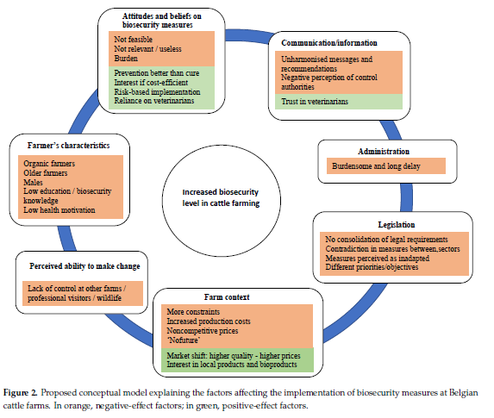
Figure 1: Conceptual model on factors affecting the implementation biosecurity measures in cattle farm. (Renault et al., 2021).

Nevertheless, this text does not provide any specific recommendation in terms of biosecurity measures to be prioritized and/or be made mandatory. It defines biosecurity as “the sum of management and physical measures designed to reduce the risk of the introduction, development and spread of diseases to, from and within animal population or an establishment, zone, compartment, means of transport or any other facilities, premises or location” which does not reflect the importance of biosecurity in terms of public and environmental health and might lead to the omission of these important aspects in any future document or policy. The importance of animal welfare and of a safe and stress-free environment is also often omitted while it is an important component of animal health and represents a growing concern for the consumers.

Chapter III: Materials and Methods

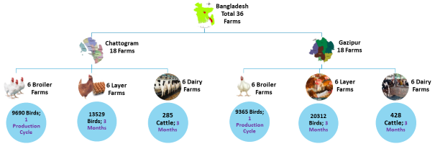
3.1. Approaches
- Epidemiology Unit of the Department of Livestock Services in collaboration with Fleming Fund Country Grant to Bangladesh (FFCGB).
- One DLS officer (Vet) studying/pursuing Masters under FETP-V fellowship program was involved for continuous/regular supervision and monitoring of the activities like data collection, data compilation and analysis, motivation of farm staff, etc.
- District Livestock Officers (DLO) from corresponding districts (Gazipur or Chattogram) were involved in selecting poultry (Broiler and layer) and dairy farms. DLO was also involved in arranging training programs for the farm staff and employing data collector.
- Upazila Livestock Officers (ULOs) in collaboration with FFCGB. Respective ULOs took part in collecting data and monitoring and supervision of the data collection process.
- The evaluation conducted by the Chattogram Veterinary and Animal Sciences University's One Health Institute provided valuable insights into the research. Their expertise in one health concept contributed to a comprehensive assessment of the study's methodology and findings.

3.2. Study settings and farm selection: A prospective longitudinal active survey was conducted to collect the AMU data in commercial poultry and dairy farms involving summer/wet (June to August) season.
Figure 2: Geolocations of selected Layer, Dairy and Broiler farms in Chattogram and Gazipur
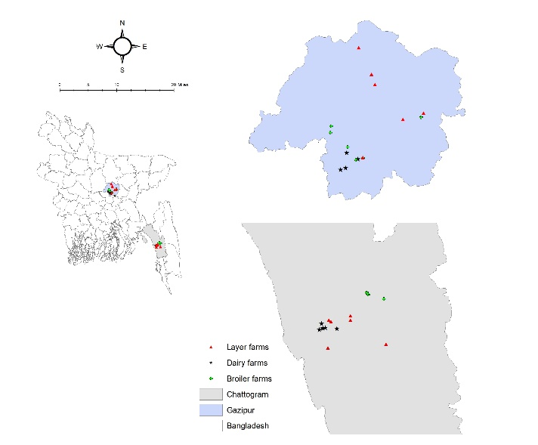
For selecting the chicken and cattle farms, help from the local officials of the Department of Livestock Services (DLS) was sought of. For dairy farms, medium to large-scale commercial dairy farms was selected as the small-scale farmers are not habituated to maintain any production records. From the two selected districts a total of 36 farms (18 from each district), 12 from dairy farms (6 from each district), 12 from layer farms (6 from each district), 12 farms from broiler farms (6 from each district) for selection of dairy farms, a herd of ≥15 dairy cattle were considered and for poultry farms a flock of ≤1000 were considered for the study. All of the selected farms committed to take part in the research during both the summer and winter months. The practice of keeping production records was considered as a crucial inclusion criterion. Additionally, the researchers believed that farmers' patience, ability and mentality to keep accurate records in prescribed formats would be crucial
Table 1: Selected Farms in Chattogram and Gazipur
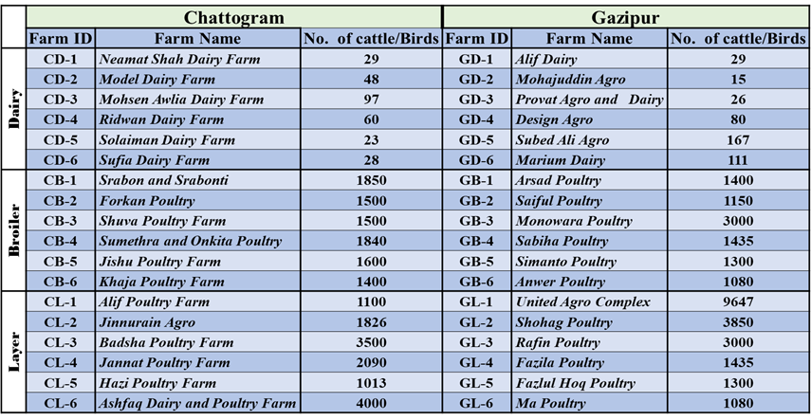
in order to observe any potential changes or trends over time and to quantify AMU successfully. Therefore, only self-motivated farmers were purposively included in the study.
3.3. Farmers’ training: Two sessions of training for selected farmers were held in two districts. The participants were motivated on the importance of maintaining actual medication records at the farm level. Formats for daily record keeping were also made easy to them. Additionally, we taught them how to put dates on zipper bags and to keep empty pharmaceutical ampoules, bottles, sachets etc. into the supplied trash cans. The significance of keeping accurate records for future reference and to adhere to legal standards was also stressed to the farmers. To promote environmental sustainability, instructions on how to properly dispose of empty pharmaceutical packages were also given to the group.
3.4. Trash can, Zipper bag and Marker supply: All farmers were supplied one trash can and sufficient zipper bags to keep empty packages of medicines. All empty packages of each day were put into a zipper bag then mentioned the date on the zipper bag and finally kept into the trash can.
3.5. Employment of data Collectors: Four competent data collectors were appointed to visit all 36 farms once a week.
3.6. Data collection pathway:
- Farm demography- This data were collected at the beginning of the study.
- Daily AMU data- farmers used to keep these data carefully using zipper bags and trash cans and then respective data collector compiled one week’s data in the formatted AMU data collection sheet. Data collector took A clear snap of 7 days’ AMU data and sent it to FETP-V Fellow through WhatsApp for crosscheck.

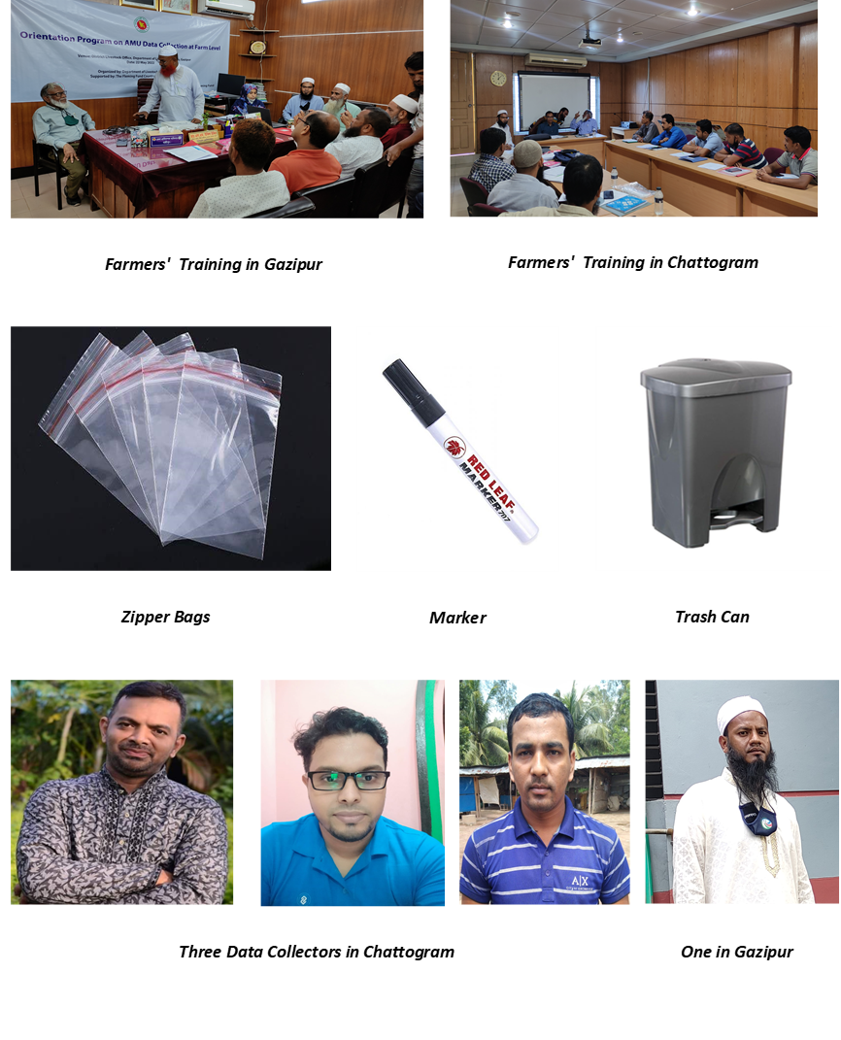
Figure 3: Farmers' Training (top); Zipper Bags, Marker, Trash Can (middle) and 4 Data Collectors (bottom)
- Data collector also took two clear snaps of empty packages (both sides) and sent it in the same way.
- FETP-V Fellow compiled these data into excel sheet for further analysis
- At the end of summer study- Each farm's empty packages and daily AMU data collection forms were double and triple checked before being placed in a single large polybag and kept on hand for storage.
- The whole data collection process was monitored by an expert from Fleming Fund Country Grant Bangladesh (FFCGB) assigned by the supervisor.
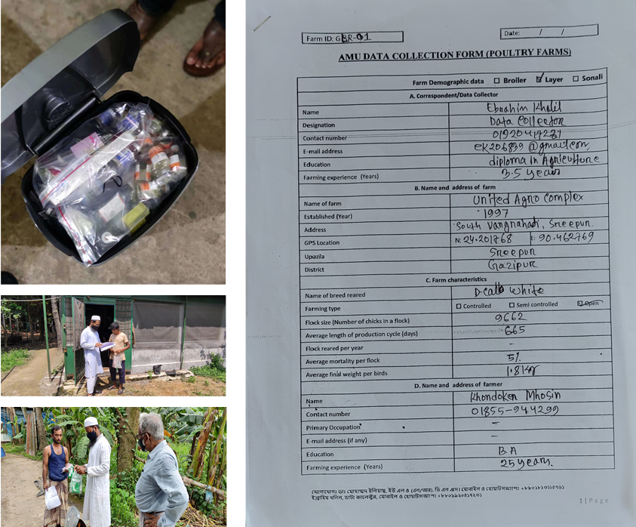
Figure 4: Farms are being cross-checked for monitoring of AMU surveillance at farm level and the zipper bags containing empty sachets/containers are stored in the trash can.
3.7. Data Analysis
Broiler AMU was calculated using the following three metrics:
3.7.1. Antimicrobial Active Ingredient (AAI) in Broiler
Formulation of each antimicrobial product i.e., antimicrobial active ingredient(s) and their concentration(s) were taken from the trash can contents or through the online search. Product quantities used and active ingredient concentrations were employed to calculate the amount of active ingredient for each antimicrobial (Eq. 1).

$${AI}_{kg}=\frac{{Amount of product used}_{g-ml}×{Conc. of antimicrobial}_{{mg}/{g-ml}}}{1000000}$$ | (Eq. 1)

3.7.2. Milligrams of active ingredient per population correction unit (mg/PCU)
The total amount of active ingredient used in milligrams was divided by the population correction unit (PCU) of the flocks on which the respective antimicrobial was administered to calculate mg/PCU. PCU was calculated by multiplying the number of birds in respective flocks with 1 kg (standardized average weight of broiler at the time of treatment) (ECDC/EFSA/EMA, 2017) (Eq. 2, Eq. 3).

$${mg/PCU}_{mg/kg}=\frac{{Total amount of the active ingredient used}_{mg}}{Population of treated flocks×1kg}$$ | (Eq. 2)

Cumulative mg/PCU was calculated as:
$$\sum_{n=1}^{N}{{mg/PCU}_{mg/kg}}=\frac{\sum_{n=1}^{N}{{({Total amount of the active ingredient used}_{mg})}_{N}}}{\sum_{n=1}^{N}{{(PCU)}_{N}}}$$ | (Eq. 3)
Where N is the total number of flocks treated.

3.7.3. Milligrams of active ingredient per final flock weight (mg/FFW)
The total amount of active ingredient used in milligrams was divided by the final flock weight (FFW) (weight at the time of harvesting) on which the respective antimicrobial was administered (ECDC/EFSA/EMA, 2017) (Eq. 4, Eq. 5).

$${mg/FFW}_{mg/kg}=\frac{{Total amount of the active ingredient used}_{mg}}{FFW}$$ | (Eq. 4)

Cumulative mg/FFW was calculated as:
$$\sum_{n=1}^{N}{{mg/FFW}_{mg/kg}}=\frac{\sum_{n=1}^{N}{{({Total amount of the active ingredient used}_{mg})}_{N}}}{\sum_{n=1}^{N}{{(FFW)}_{N}}}$$ | (Eq. 5)
Where N is the total number of flocks treated.
Layer and Dairy AMU was calculated using the following three metrics:
3.7.4. Antimicrobial Active Ingredient (AAI) in Layer and Dairy Farms
Formulation of each antimicrobial product i.e., antimicrobial active ingredient(s) and their concentration(s) was taken from the trash can contents or through the online search. Product quantities used and active ingredient concentrations were employed to calculate the amount of active ingredient for each antimicrobial (Eq. 1).

3.7.5. Milligrams of active ingredient per population correction unit (mg/PCU)
The total amount of active ingredient used in milligrams was divided by the population correction unit (PCU) for dairy cattle and calves to calculate the mg/PCU for dairy cattle or calves, respectively. PCU was calculated by multiplying the total number of dairy cattle or calves with 425 kg or 140 kg, respectively (standardized average weight of dairy cattle and calves at the time of treatment) (ECDC/EFSA/EMA, 2017) (Eq. 6).

$${mg/PCU}_{mg/kg}=\frac{{Total amount of the active ingredient used}_{mg}}{Population×Standardised weight}$$ | (Eq. 6)

Cumulative mg/PCU was calculated using Eq. 3.

3.7.6. Antimicrobial treatment incidence (ATI)
The total number of antimicrobial treatments per 1000 animals per day was calculated as DDDA/1000 animal-days. DDDAs (Defined Daily Dose Animal i.e., milligrams of antimicrobial active agent recommended to be administered per animal per day) for single or multiple active ingredient products. These are to be taken from the product labelling obtained from the trash can contents or visiting the manufacturer’s website. For long-acting products (products to be repeated after 48 hours), DDDAs for each antimicrobial are to be divided in two. For intramammary applicators, one applicator was accounted as a single DDDA (AACTING, 2018) (Eq. 7, Eq. 8 and Eq. 9).

$${ATI}_{{DDDA}/{1000 animal-days}}=TF×1000$$ | (Eq. 7)
Where TF is the treatment factor, calculated as:

$$TF=\frac{{Total amount of the active ingredient used}_{mg}}{{DDDA}_{mg/Animal-Day}×Animal-Days}$$ | (Eq. 8)

Where, “animal-days” is the product of the total number of animals at risk of drug exposure and the days of study.
Cumulative ATI was calculated as:
$$\sum_{n=1}^{N}{ATI}=\frac{\sum_{n=1}^{N}{{(nDDDA)}_{N}}}{\sum_{n=1}^{N}{{(Animal-Days)}_{N}}}×1000$$ | (Eq. 9)
Where nDDDA is the total number of DDDAs used and N is the total number of dairy farms.

Chapter IV: Results
4.1. Response to AMU Data Collection
Data collectors provided AMU data from all the 36 farms in summer. The list of Dairy, Broiler and Layer farms, number of cattle/birds, and locations are mentioned in Table 1 and Figure 2.
4.2. Population Size and Housing
The dairy and poultry farms in this study belonged to the 2 different districts in Bangladesh. The farms reared a total of 713 cattle, 19055 broilers and 33841 layers and all were conventional open sheds.
An average 33 days’ broiler production cycle was observed in this study and only one cycle per farm was considered for summer AMU quantification. In case of layer and dairy farms, study was conducted for three summer months (1 June to 30 August, 2022). None of the participating farms used AMs as a feed premix or growth promoter but prophylactic usages of AMs were found recurrently in the study.
4.3. Broiler Farms
Out of the 12 broiler farms, 3 were contract farms and all 6 were fully involved in this farming in Chattogram as opposed to 5 of the 6 farmers in Gazipur who were merchants. All 12 of the farmers were literate, and three of them in Gazipur and one in Chattogram had post-secondary degrees. One farmer in Chattogram and 3 in Gazipur had more than 10 years of farming experience.
4.3.1 Quantitative AMU in Broiler Chicken
A total of 20 antimicrobial drugs (3.298 kg) were used for therapeutic or prophylactic purposes on surveyed broiler chicken farms. The total combined AMU was 121.71 mg/kg of final flock weight and 173.29 mg/PCU. The top three antimicrobial drugs used during the summer were neomycin (21.44 mg/PCU), amoxicillin (18.78 mg/PCU), and oxytetracycline (18.22 mg/PCU) (Table 3; Figure 5)

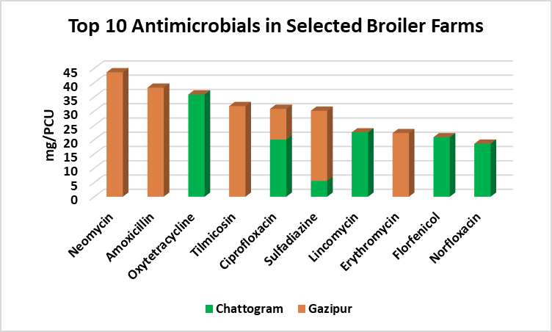
Figure 5: Top 10 Antimicrobials of Selected Broiler Farms
4.3.2. WHO-CIA and AWaRe Classification of Broiler AMU
Overall, 77% of AMs used in broiler chicken fall within the category of critically important antimicrobial classes (CIA) for human medicine, as defined by the WHO.
Table 2: Quantification and WHO-CIA Classification of Used AMs in Selected Broiler Farms [AAI (kg), mg/PCU, and mg/FFW].
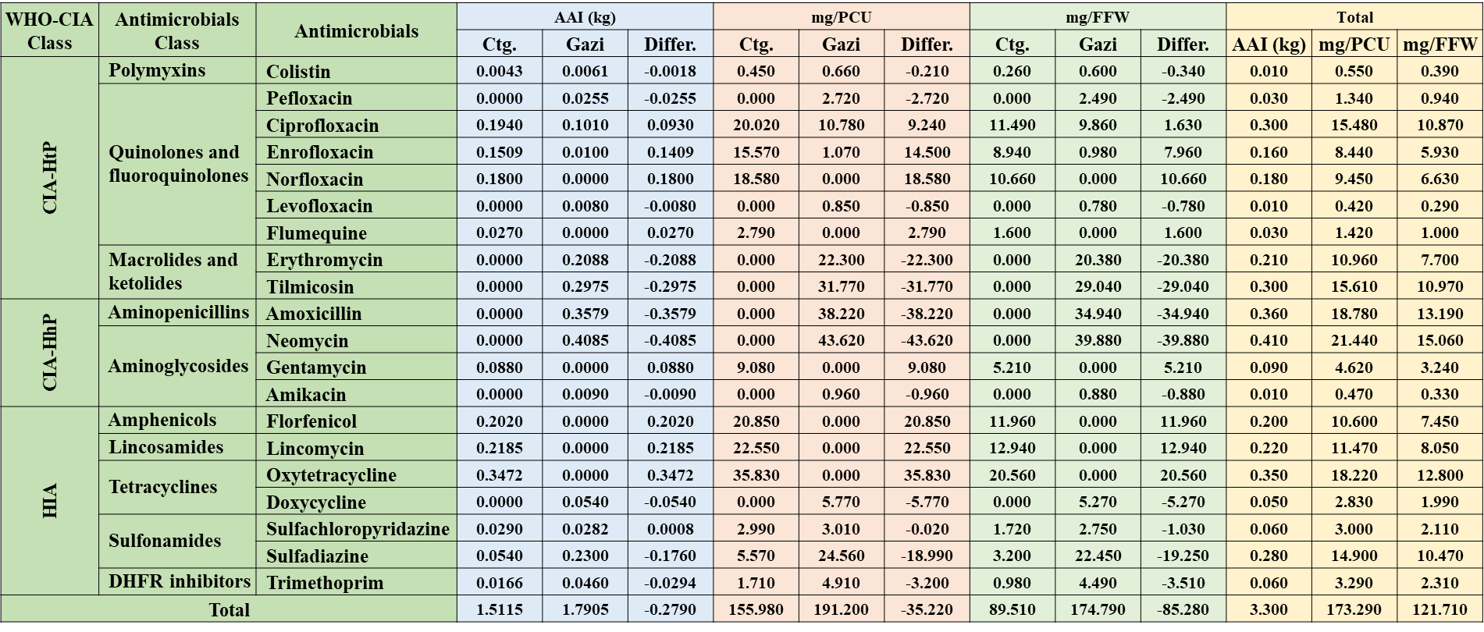
Table 3 and Figure 6 provides details on the use of CIA with the highest priority (CIA-HtP), CIA with higher priority (CIA-HhP), highly important AMs (HIA), and important AMs (IA) in broiler chicken. Around 66% of the broiler AMU was within the ‘Watch’ group and at the same time ‘Reserve’ group AMs were also being used in broiler farms which is awful (Figure 7).
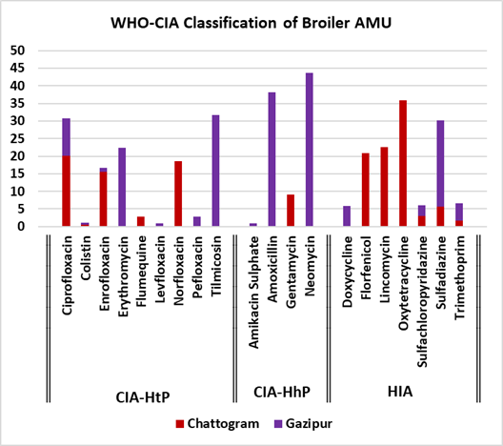
Figure 6: WHO-CIA Classification of Broiler AMU
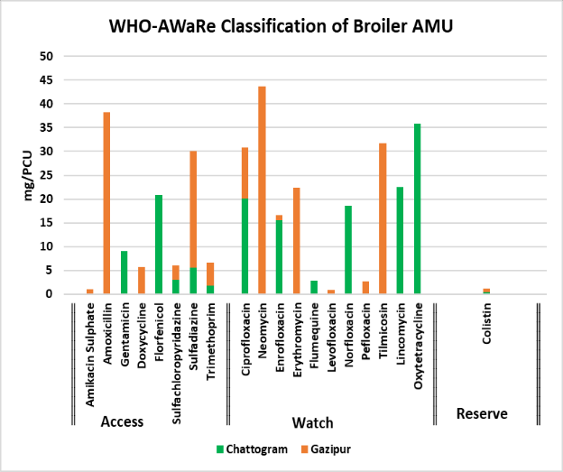
Figure 7: WHO-AWaRe Classification of Broiler AMU
4.3.3. Purposes and Prescribers of Broiler AMU: More than 42% of the AMU in broilers was to treat IBD or IBD+ND, and more than 32% of the AMU was administered as a preventive
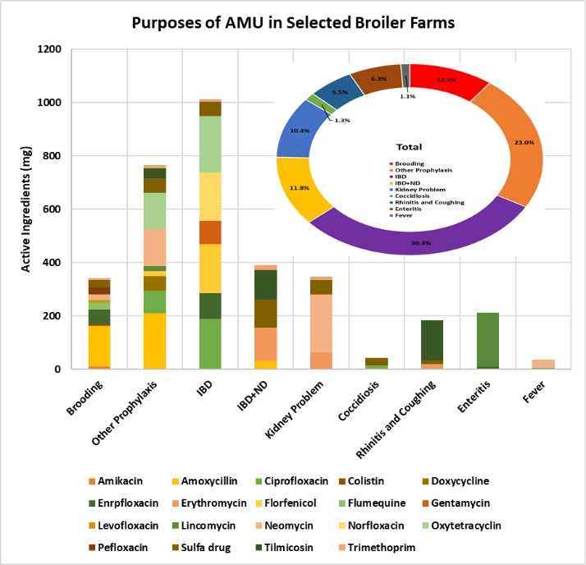
Figure 8: Purposes of AMU in Selected Broiler Farms
measure either during or after brooding. The two main issues that convinced almost all of the broiler producers surveyed to repeatedly use prophylactic antibiotics were lower grade DOC and vaccination failure. Amikacin, Colistin, Doxycycline, Flumequin, Levofloxacin, and Pefloxacin were all taken prophylactically during the brooding or post brooding stage (Figure 7). Maximum 43.07% AMU was prescribed by the farmers themselves and minimum (18.08%) was by the dealers (Figure 8). Among 19 AMs, 17 including Colistin were prescribed by farmers themselves. Veterinarians prescribed 38.85% of the total broiler AMU.

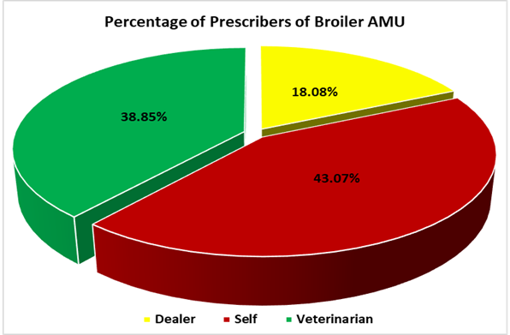
Figure 9: Prescribers of AMs in Selected Broiler Farms
4.3.4. Age Wise Distribution of Broiler AMU: Evidently, we discovered three waves of AMU: the first, or brooding wave, which lasted up to 6 days of age; the second, or middle, wave, which lasted up to 18 days of age; and the third, or final, wave, which lasted up to 29 days of age. Lowest and highest amount of AMs were utilized during the first wave and middle wave, respectively, due to the differences in chicks' sizes. Yet, when AMs per kilogram of body weight were calculated, the initial wave had the greatest value. No AMs were used after 29th day of age (Figure 10).
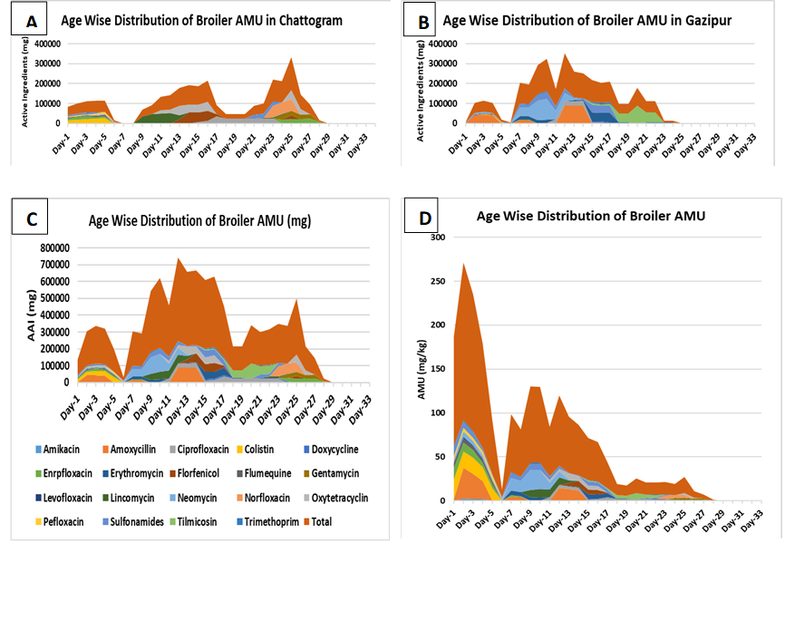
Figure 10: Age Wise Distribution of Broiler AMU ‘A’ – Chattogram, ‘B’- Gazipur ‘C’- Overall (mg) and ‘D’- Overall (mg/kg). Apparently, there are always three waves of AMU in Broiler Lifecycle
4.3.5. Broiler AMU Differences Between Gazipur and Chattogram
Out of the 19 AMs used in the selected broiler farms, six were frequently used in both Chattogram and Gazipur, six were used only in Chattogram, and eight were used only in Gazipur. Maximum positive difference of AMU (mg/PCU) was found in neomycin and maximum negative difference was found in oxytetracycline (Figure 10).
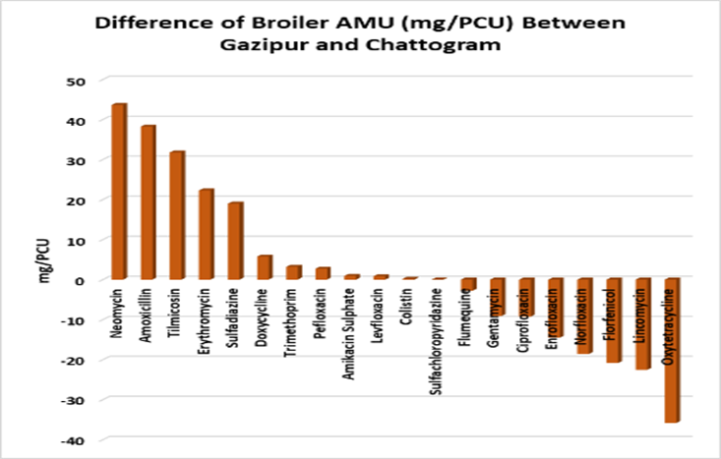
Figure 11: Broiler AMU (mg/PCU) Differences in Gazipur and Chattogram
4.4. Layer Farms: Unlike broilers, full lifecycle of layer chicken could not be included in the study.
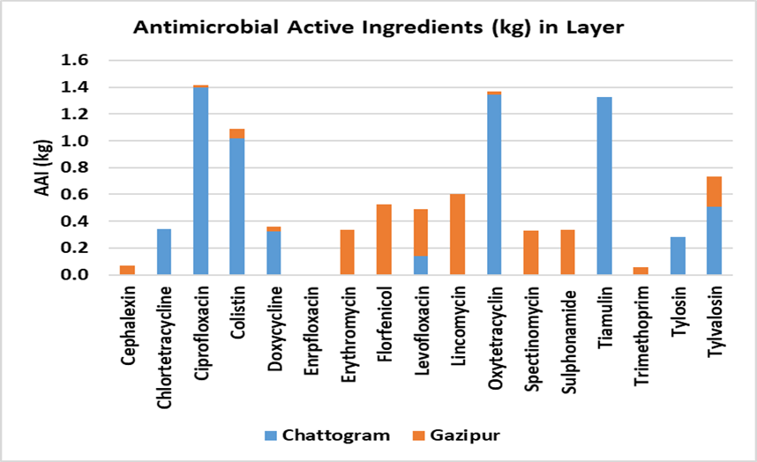
Figure 12: Antimicrobial Active Ingredients (AAI) in layer farms
Three wet months, June-August, were studied for layer AMU quantification. Out of the 12-layer farms, 3 used self-mixed feed in Gazipur and others used branded feed. All 6 farmers in Chattogram were fully involved in farming as opposed to 1 businessman and 1 artificial inseminator of dairy cattle in Gazipur. All 12 of the farmers were literate and all of them except one in Gazipur passed Secondary School Certificate (SSC). Four farmers in Chattogram and 5 in Gazipur had more than 10 years of farming experience.
4.4.1. Quantitative Antimicrobial Use in Layer Chicken: Ten of the 12 layer farms used AMs, while the other two were kept up without any. A total of 17 antimicrobial drugs (9.67kg) were used for therapeutic or prophylactic purposes on surveyed layer chicken farms. The total combined AMU was 494.27 mg per kg of composite weight (Wc) in Chattogram and 146.95 mg per kg in Gazipur. The top three AMs used during the summer were ciprofloxacin (41.90 mg/PCU), oxytetracycline (40.42 mg/PCU), and tiamulin (39.28 mg/PCU) were the top three
Table 3: WHO-CIA and AWaRe Classification along with Quantification of Used AMs in Selected Layer Farms [AAI (kg), mg/PCU, and ATI] Using Color Scale. Here Red is for Maximum Value; Yellow is for Mid Value and Green is for Minimum Value. Note: Estimated chicken weight at the time of treatment was considered as 1 kg/bird.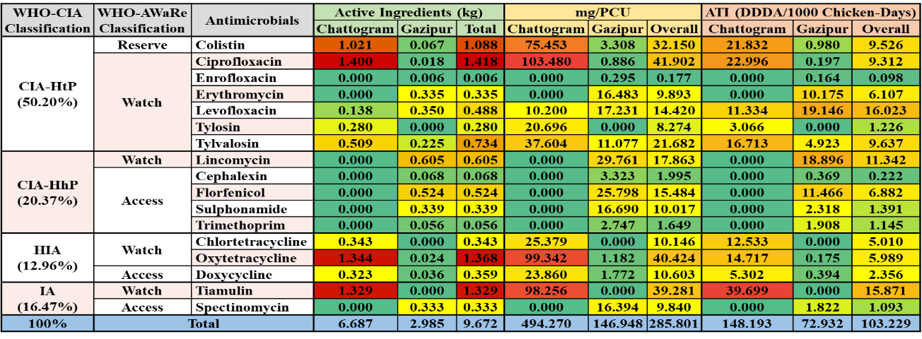
AMs used during the summer.
Overall ATI (Antimicrobial Treatment Incidence) in the selected layer farms was 103.23 DDDA/1000 Chicken-Days whereas in Chattogram it was 148.19 DDDA/1000 Chicken-Days and in Gazipur it was 72.93 DDDA/1000 Chicken-Days. More than 50% of the overall layer ATI was in the CIA-HtP class. More than 78% of the overall layer ATI was from Watch Group and more than 9% was Colistin which belongs to the Reserve Group of WHO-AWaRe classes of AMs (Table 3; Figure 12, 13 and 14). Overall ATI (Antimicrobial Treatment Incidence) in the selected layer farms was 103.23 DDDA/1000 Chicken-Days whereas in Chattogram it was 148.19 DDDA/1000 Chicken-Days and in Gazipur it was 72.93 DDDA/1000 Chicken-Days. More than 50% of the overall layer ATI was in the CIA-HtP class. More than 78% of the overall layer ATI was from Watch Group and more than 9% was Colistin which belongs to the Reserve Group of WHO-AWaRe classes of AMs. These findings suggest that there is a higher incidence of antimicrobial treatment in layer farms in Chattogram compared to Gazipur. Additionally, the majority of the overall layer ATI comes from the CIA-HtP class, indicating a potential need for targeted interventions in this area. Furthermore, the high percentage of Watch Group and Colistin use highlights the importance of monitoring and regulating these antimicrobials to preserve their effectiveness as part of the Reserve Group.

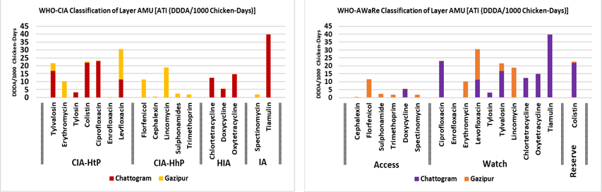
Figure 13 & 14: WHO-CIA and AWaRe Classification of AMU along with Their ATI (DDDA/1000 Chicken-Days) in Selected Layer Farms of Chattogram and Gazipur.
4.4.2. Spatial Variations in Antimicrobial Use in Layer Chicken
Out of the 17 AMs used in the selected layer farms, 6 were frequently used in both Chattogram and Gazipur, 3 were used only in Chattogram, and 8 were used only in Gazipur. Maximum values of ATI (DDDA/1000 Chicken-Days) were 39.7 (tiamulin) in Chattogram and 19.15 (levofloxacin) in Gazipur, respectively. Results from our study also indicated that in layer chicken, the overall AMU was almost double in Chattogram (148.19 DDDA/1000 Chicken-Days). Many of the AMs, including ciprofloxacin, oxytetracycline, and colistin, were alarmingly high in Chattogram. An increase was more prominent for ciprofloxacin in Chattogram (11577%) when compared to Gazipur (22.996 and 0.197 DDDA/1000 chicken-days in Chattogram and Gazipur). These findings suggest that there is a significant disparity in antibiotic usage between the two regions, with Chattogram exhibiting much higher levels. This raises concerns about the potential for antibiotic resistance and the need for targeted interventions to address this issue in Chattogram's layer chicken industry.
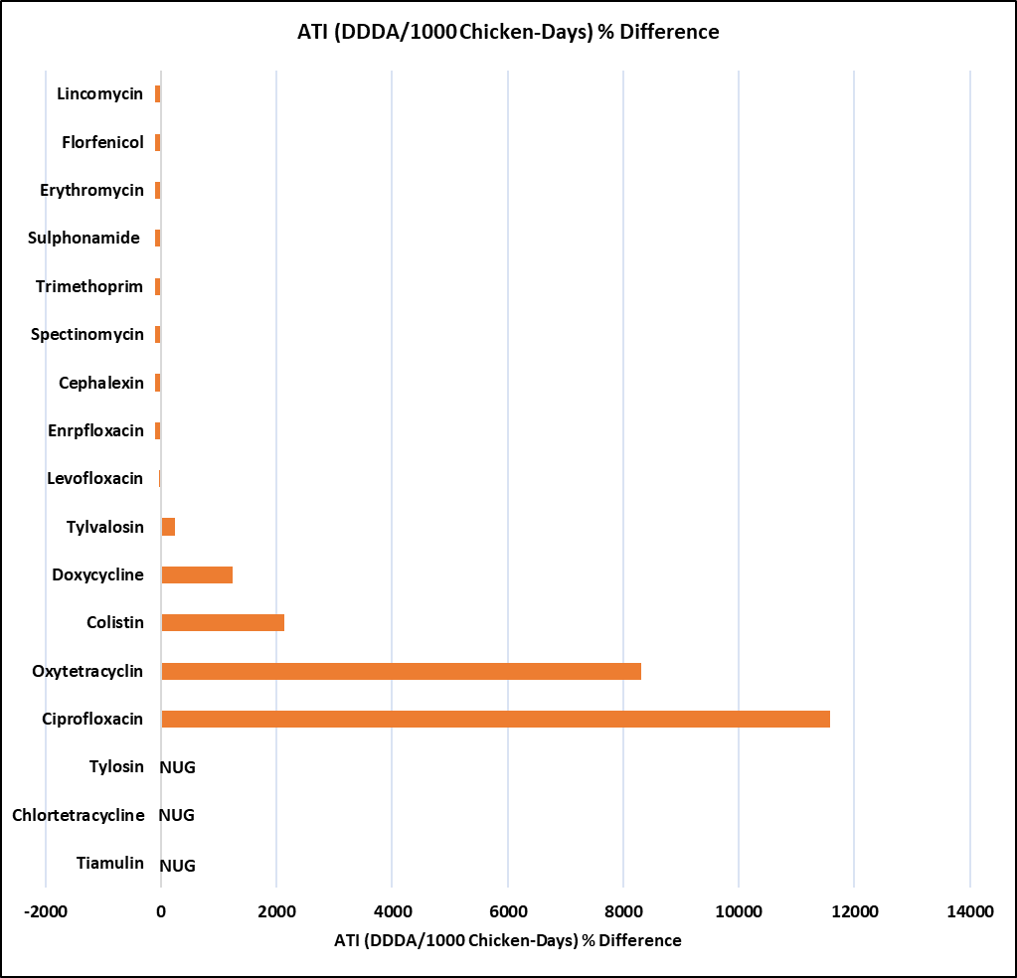
Figure 15: The ATI (DDDA/1000 Chicken-Days) % difference in Chattogram as compared to Gazipur values in layer chicken. NUG: Not used in Gazipur.
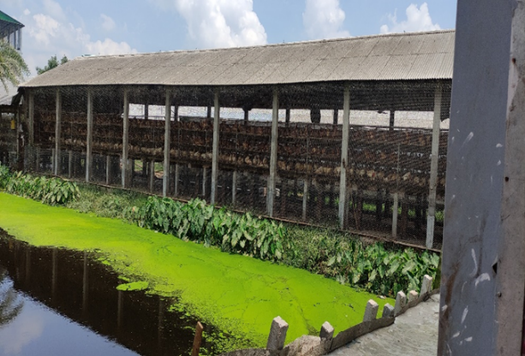
4.4.3. Disposal of litter materials: Litter improperly disposed off can negatively impact the environment, particularly water bodies. Layer farms often sell their daily droppings to fish farmers, causing residues to accumulate in waterbodies. This practice threatens aquatic ecosystems, fish health, and human health. Additionally, it disrupts natural balance, decreases biodiversity, and contributes to antibiotic resistance in bacteria, making it difficult to treat infections effectively.
Figure 16: Direct Pouring of Excreta into the Pond.
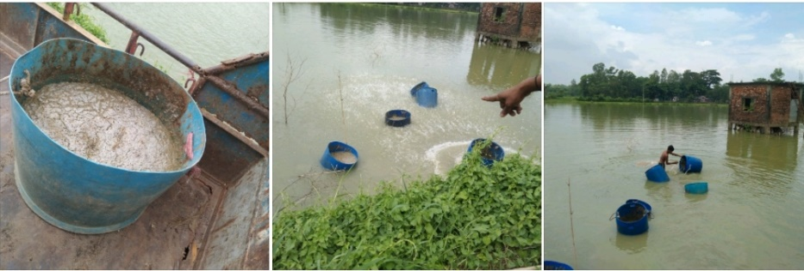
Figure 17: Daily Layer Droppings, Being Used as Fish Feed.
4.4.4. Disposal of empty sachets/containers of antibiotics:
If not properly disposed off, unused drugs can harm the environment. The packaging for medicines, whether it be cardboard, plastic, or glass bottles, can potentially harm the environment if it is not recycled. We detected previously discarded bottles and sachets in locations close to 10 out of 12 layer farms (83%) during our monitoring visits. This suggests that farmers might not be knowledgeable about the correct ways
Figure 18: Empty Medicine Packages, Plastic Feeders, Waterers and Leftover Medicines.
to dispose of leftover medicines and their packages. Farmers were informed and made more aware of the potential environmental risks linked to inappropriate disposal of these things. The farmers were advised to recycle, bury or otherwise properly get rid of the empty bottles, sachets, and packages. The farmers also requested to provide training on how to get rid of leftover medicines and other farm wastes.

4.5. Dairy Farms: Dairy farms were not uniform like broiler and layer farms. They included cows that were lactating, dry, pregnant, and non-pregnant. Heifers and calves were also present. Six dairy farms in Gazipur included 147 cows, 192 heifers and 89 calves whereas six dairy farms in Chattogram included 173 cows, 45 heifers and 67 calves.
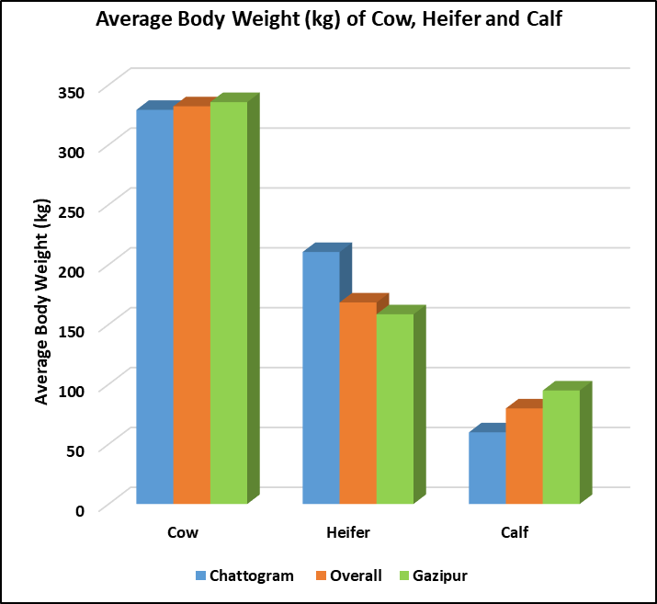

Figure 19: Body Weight of Cow, Heifer and Calf.
All were cross-bred cattle and most the crosses were of indigenous and Holstein Friesians. Three wet months, June-August, were studied for dairy AMU quantification.
4.5.1. Calculation of Antimicrobial Active Ingredients (AAI): These were collected from vials/sachets/Intramammary applicators, intrauterine pessaries, etc.
- Product quantities used
- Antimicrobial active ingredients with their concentrations were considered to calculate AI in Kg for each antimicrobial.
A total of 14 antimicrobial drugs (1.0718 kg) were used for therapeutic or prophylactic purposes on surveyed dairy farms. In Chattogram, it was 0.8728 kg and in Gazipur, it was 0.2359 kg. Penicillin (0.351 kg) and streptomycin (0.350 kg) were two extremely used AMs in both Chattogram and Gazipur (Table 4 and Figure 15).
Table 4: Antimicrobial Active Ingredients (AAI) of Selected Dairy Farms
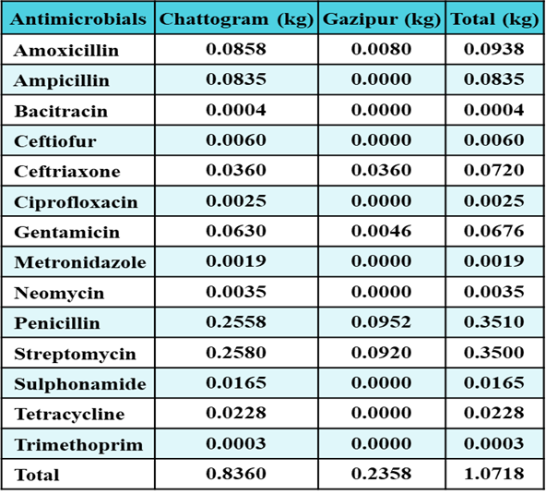
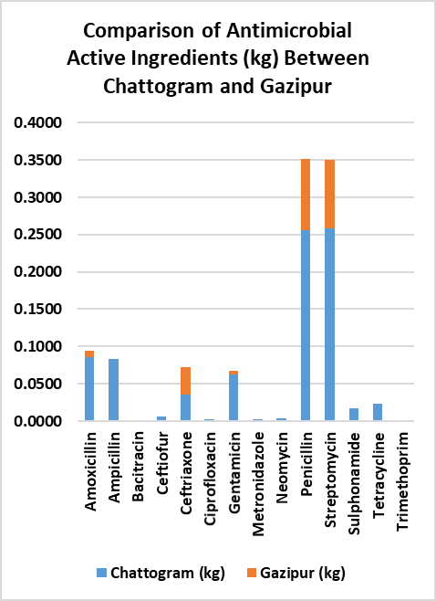
Figure 20: Antimicrobial Active Ingredients (AAI) of Selected Dairy Farms

4.5.2. Population Correction Unit (PCU): Unlike purebred dairy cattle in European countries, Bangladeshi crossbred dairy cattle are not homogenous in size, shape, body weight and production. As most of the crosses are of small-sized indigenous cattle breeds with Holstein Friesians, our crossbred cattle size is smaller than that of European countries. This variation is due to genetic differences in various generations and the dairy herds' nutrition and management practices.
Table 5: PCU of Cow, Heifer and Calf
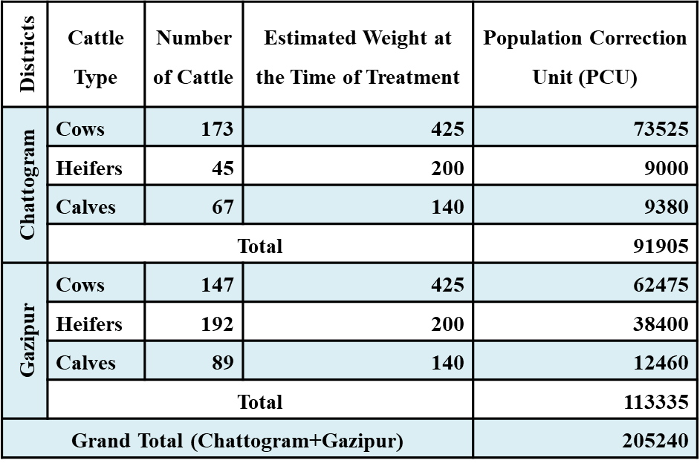

In this study, we found the actual average body weight of cows, heifers, and calves were 332kg, 168kg, and 80kg respectively which is significantly below from the EMA (European Medicines Agency) estimated/standardized weight at the time of treatment. In Bangladesh, there are no such standardized weights and that’s why here we used EMA weights in calculating our Population Correction Unit (PCU). To calculate Milligram per Population Correction Unit (mg/PCU), we considered following three points-
- Total amount of active ingredient used (in milligrams)
- Total number of dairy cows, heifers or calves
- Standardized average weights of dairy cows, heifers and calves at the time of treatment (425 kg, 200 kg and 140 kg, respectively)
4.5.3. Milligrams of active ingredient per population correction unit (mg/PCU) The overall values of mg/PCU in selected dairy farms were 9.028 in Chattogram and 2.082 in Gazipur. In case of cow, these were 10.410 and 3.659 mg/PCU respectively.
Figure 21: Top Five Dairy AMs (mg/PCU)
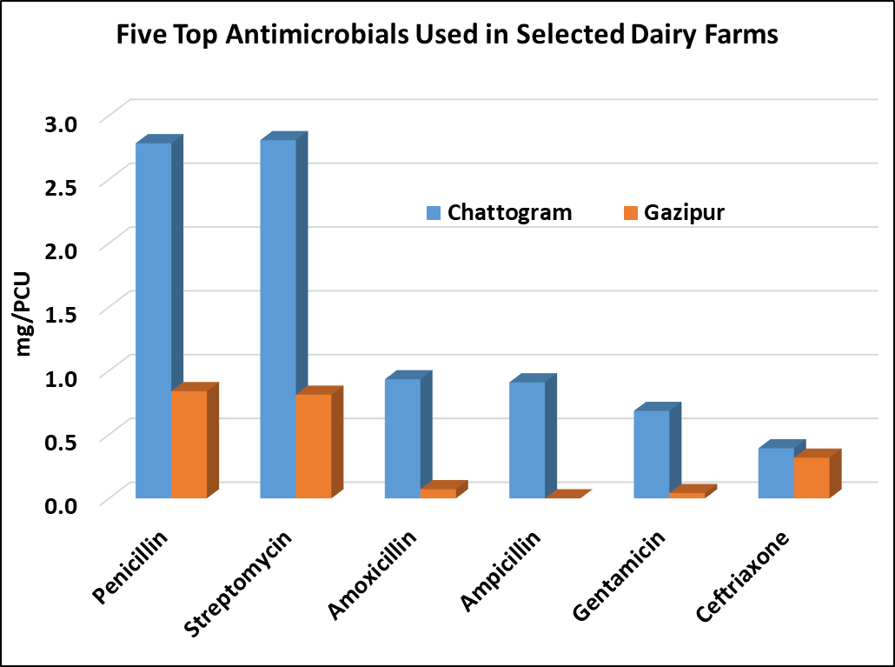
The lowest value was found in the heifer of Gazipur (0.063 mg/PCU). Penicillin and streptomycin were the two most frequently used AMs in the selected dairy farms of Bangladesh (Figure 19 & Table 6).
Table 6: Quantification of Milligram per Population Correction Unit (mg/PCU) Using Color Scale Table. Here Red is for Maximum Value; Yellow is for Mid Value and Green is for Minimum Value in Each Column.
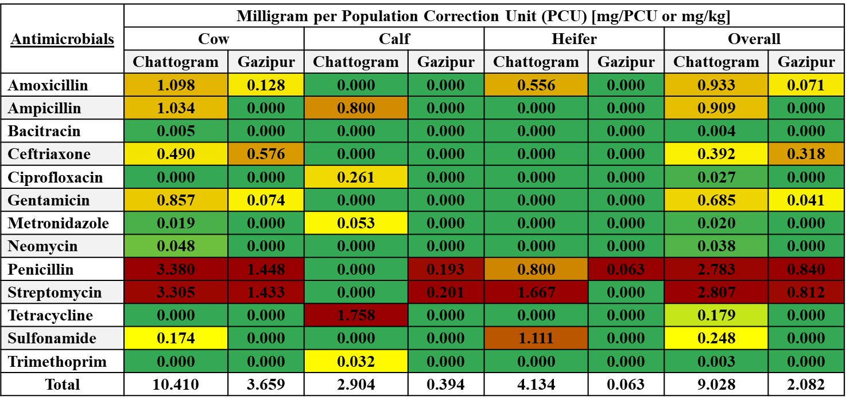

4.5.4. Antimicrobial Treatment Incidence (ATI): Adjusted number of cows (ANadj) and DDDA were necessary to calculate ATI. In this study, we found ANadj 216.24 in Chattogram and 266.67 in Gazipur, with a total ANadj of 482.91. (Table 7). We estimated the DDDA of all AMs used in the chosen dairy farms using the cow weight of 425 kg at the time of treatment.
Table 7: Adjusted Number of Animals (Cows) [ANadj]
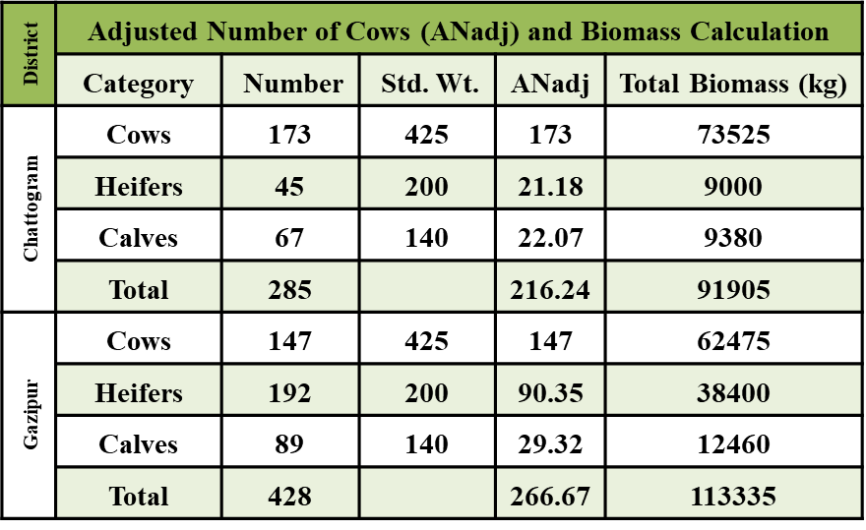

Four of the fourteen AMs used in the studied dairy farms were administered orally, while 11 were administered parenterally. Three AMs were administered in the udder, and only metronidazole was used in the uterus (Table 8).
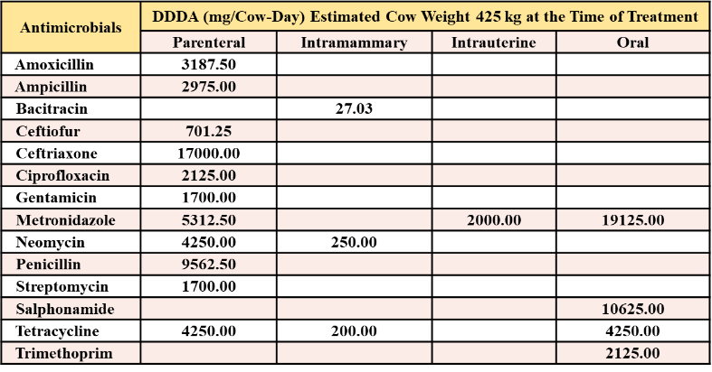
Table 8: Defined Daily Dose for Animal (mg/Cow-Day) [Collected from Websites]
Total ATI were 44.911 and 3.567 in Chattogram andGazipur respectively whereas, parenteral ATI was found 19.198 in Chattogram and 3.181 in Gazipur (Table 9).

Table 9: Antimicrobial Treatment Incidence (ATI) Using Color Scale Table.
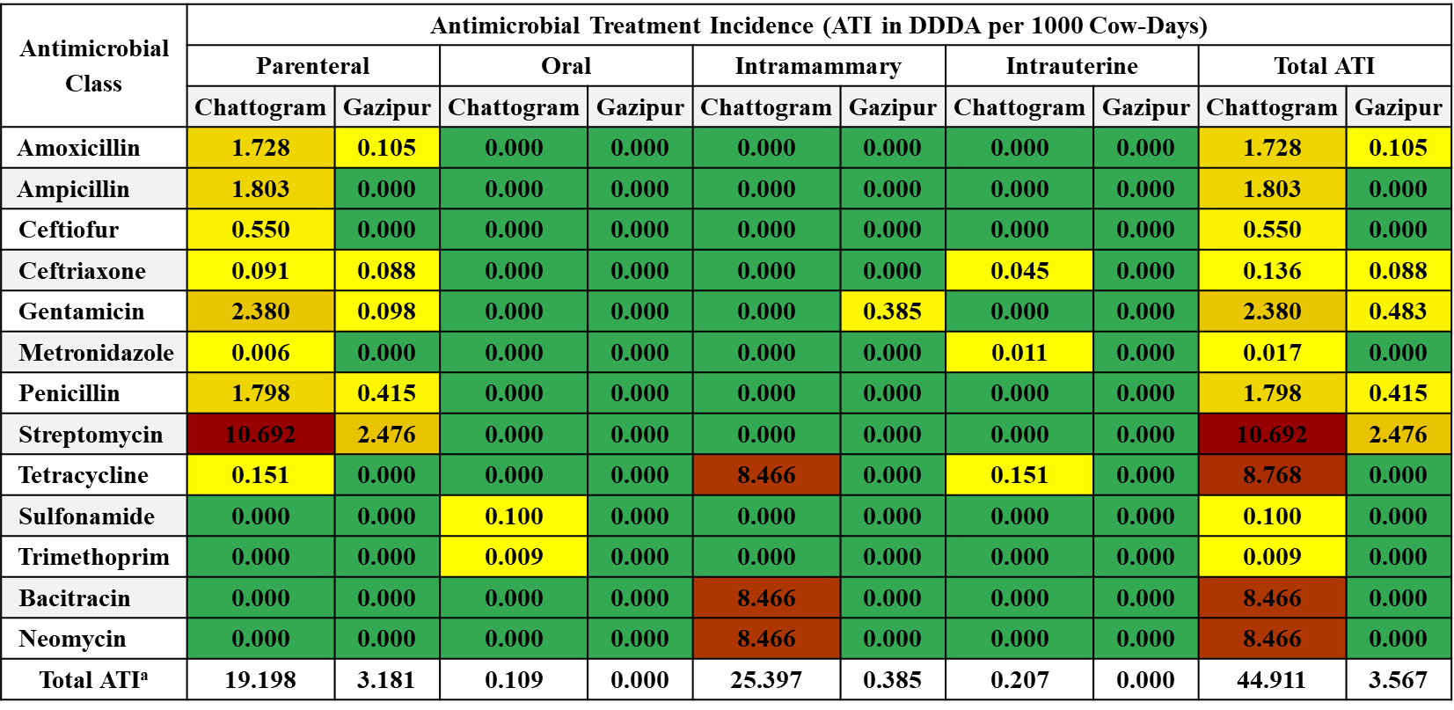
ATIª: The number of antimicrobial treatments per 1,000 cow–days (DDDA/1,000 cow-days).
4.5.5. WHO-CIA and WHO-AWaRe Classification of Dairy AMU:
Overall, 64.25% of AMs used in dairy farms fall within the category of critically important antimicrobial classes (CIA) for human medicine. Figure 17 provides details on the use of CIA with highest priority (CIA-HtP), CIA with high priority (CIA-HhP), highly important AMs (HIA), and important AMs (IA) in dairy farms. The data from Figure 17 reveals that 35.75% of AMs used in dairy farms belong to the CIA-HtP category, indicating their utmost significance for human medicine. Additionally, the remaining 28.5% of AMs used in dairy farms are distributed between CIA-HhP, HIA, and IA categories, further highlighting the overall importance of these antimicrobial classes in the dairy industry.
Yet, 35.64% of all AMs used in dairy farms are part of the WHO-AWaRe watch group for human medicine. Details on the application of access, watch, and reserve groups on dairy farms are shown in Figure 21. Fortunately, none of the "Reserve" AMs were applied to the selected dairy farms.
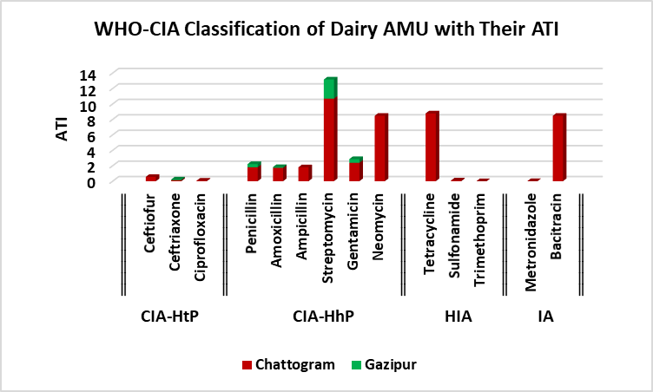  Figure 22: WHO-CIA Classification of Dairy AMs. | 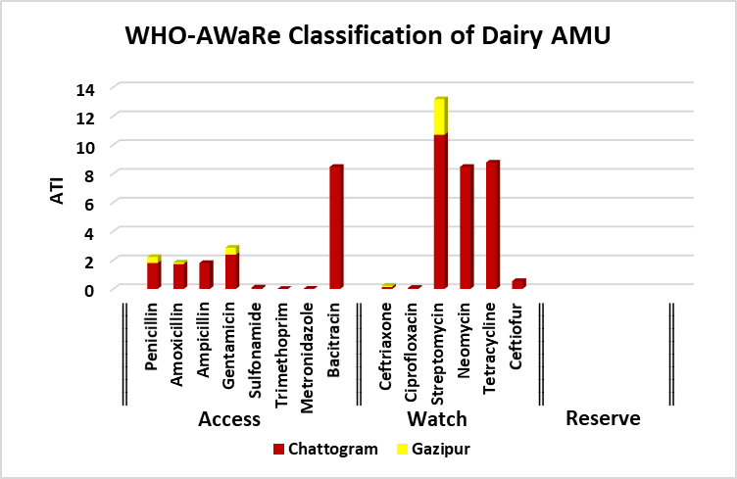  Figure 23: WHO-AWaRe Classification of Dairy AMs.

4.5.6. Purposes of Dairy AMU: Around 77% of the AMs were used to treat mastitis and 13% were to treat joint ill. Viral diseases like FMD (0.54%) and LSD (1.80%) were not highly responsible for AMU in the selected dairy farms.
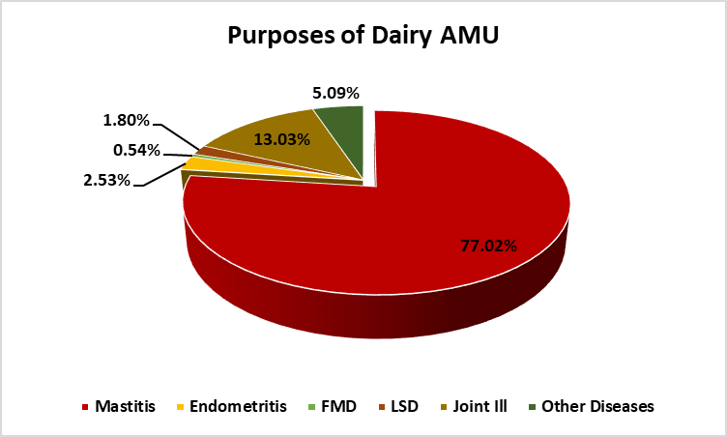

Figure 24: Purposes of Antimicrobial Uses in the Selected Dairy farms.
4.5.7. Possible causes of the excessive use of AMs in Chattogram compared to Gazipur: According to the demographic data, farms in Chattogram were older, had more lactating cows (60.7%), and producing more milk (12.17 liters on average per cow per day) than farms in Gazipur, which had sheds that were relatively newer, had 34.35% lactating cows, and had an average milk production of 10.84 liters. More than 77% of the AMU was to treat mastitis (Figure 22). Mastitis is one of the diseases that cows, especially high yielding lactating cows, are particularly prone to. Older farm layouts don't lend farmers as well to biosecurity measures, and old cowsheds are a breeding ground for pathogens. Additionally, older farmers are more likely to use AMs without veterinarians’ prescriptions. Furthermore, all of the chosen farms were located close to Chattogram city, a large city where access to AMs is simpler than in Gazipur. However, more thorough research is required to identify the actual contributing elements. These contributing elements could include factors such as the farmers' knowledge and awareness about biosecurity practices, their financial resources to invest in modern farm infrastructure, and the availability of veterinary services in their respective areas. Additionally, cultural beliefs and traditional farming practices may also play a role in the prevalence of antimicrobial misuse among older farmers. Further investigation is needed to fully understand the complex dynamics at play in this issue.

Chapter V: Discussion
In recent years, the use of antibiotics has had a significant negative impact on the evolution of antimicrobial resistance (AMR) in both humans and animals. The AMU surveillance in food animal production systems is one of the key objectives of the Global Action Plan on AMR by WHO (National Antimicrobial Resistance (AMR) Surveillance Strategy of Bangladesh, 2020). In many European Union countries, the implementation of national and farm-level AMU surveillance programs has resulted in a substantial reduction of AMU in food animals (Persoons et al., 2012). There are a few national level studies on AMU in food animals from LMICs. However, Bangladesh rarely carried out studies on indiscriminate antimicrobial usage (AMU) in the dairy and poultry industries using a quantitative approach. This study made an effort to fill this knowledge vacuum by attempting to quantify and describe the level of AMU in commercial broiler, layer and dairy farms in Chattogram and Gazipur, Bangladesh. Significant findings, their ramifications, and limitations have been discussed in this chapter under various subheadings, as follows.
Bangladesh lacks any formal AMU surveillance in food animals due to many reasons but weak legislation and poor implementation of the any existing law are among the leading causes. In parallel, the Bangladesh government enacted a regulation in 2010 prohibiting the addition of antibiotics during the production process of animal feed. Nevertheless, there are no rules or regulations in place addressing the proper use of antibiotics in industries that produce animals. Regular use of antibiotics in healthy animals for preventative and growth-promoting purposes has the potential to significantly contribute to the development of antibiotic resistance. The current study provides quantitative AMU data in support of the on-going national AMR surveillance efforts in Bangladesh and is the first study conducted on a relatively large area, i.e., representing commercial broiler and layer chicken as well as dairy production from two districts of Bangladesh. To the best of our knowledge, no South Asian AMU research have combined such three cohorts. The absence of internationally accepted standardized AMU indicators also present a difficulty in comparison of data across species, production type, and countries (Timmerman et al., 2006). In the present study, we used multiple AMU indicators for broiler chicken, i.e., kg, mg/PCU, and mg/kg of final flock weight. We also used DDDA/1000 Chicken-Days for layer and DDDA/1000 Cow-Days for dairy farms. The use of multiple AMU indicators is valuable and provides more comprehensive AMU data.
Our results demonstrate a very high AMU in commercial broiler chicken farms (173.29 mg/PCU) compared to two previous farm-level studies from Canada of 134 (ECDC/EFSA/EMA, 2017) and 98—104 mg/PCU (Collineau et al., 2016). This figure is also excessively high when compared to the sales-data based global AMU of 148 mg/PCU (EMA, 2018). However, this amount is comparatively low from a previous study in broiler chicken from Pakistan where AMU was 462.5 mg/PCU (Umair et al., 2021) but higher than reported from Morocco (63.48 mg/kg of the average weight at treatment (ECDC/EFSA/EMA, 2017). Differences in production types and calculation methodologies pose difficulties in comparing data among different countries and regions. European countries mainly publish their sales data using various methodologies. Different reports from Europe publishing AMU data in food animals include ANSESANMV (France), BelVet-SAC (Belgium), DANMAP (Denmark), NethMap (Netherlands), SWEDRES-SVARM (Sweden), and UK-VARSS (UK) FFCGB; Firth et al., 2017; ESVAC, 2018; Mohsin et al., 2019; Fleming Fund Country Grant Pakistan, 2021. ESVAC also publish a yearly sales data from different European countries (Persoons et al., 2012). Comparing sales data from the UK (12 mg/kg in broilers) and France (34.24 mg/kg in poultry) our results show substantially high amounts of AMs being used in broiler chicken production.
All the surveyed broiler chicken farms were observed administering prophylactic antimicrobial courses at different stages of the production cycle. In particular, all the farms administered prophylactic antimicrobial courses during the first week of a bird's life. Oral antimicrobial administration via drinking water was the only source of AMs in this study. Farmers were unaware of any AMs pre-added in a commercial feed. The use of AMs for prophylactic courses in a routine practice, could be avoided by the introduction of good hygiene and management practices at farms.
During the study period in summer (June-August), the average maximum temperatures recorded in Chattogram and Gazipur were 31.5 and 32.4°C respectively. Stress may not have a substantial effect on animal health and consequently AMU given the negligible difference in environmental temperature between the two regions.
The percentage use of critically important antimicrobial classes (77%) in our study was found almost comparable to study from Europe (76%) (EMA, 2013) but higher than the studies from other countries such as Belgium (61%) (Seventh ESVAC Report, 2017), Thailand (63%) (EMA, 2018), and Vietnam (36.4%) (AACTING, 2018). The use of CIA in veterinary medicine requires strict regulations in Bangladesh.
Mind-numbingly, our study also identified a large number broiler and layer farms that had used critically important antimicrobial classes such as colistin and fluoroquinolones. This extensive use of medically important antibiotics in commercial chicken production may promote the development of resistance in microbial populations infecting animals and humans.
Almost all the broiler farmers interviewed reported lower grade day-old chicks (DOC). These farmers expressed concerns about the quality of the DOC they were receiving, which they believed was of lower grade. They also highlighted the frequent occurrence of vaccine failure, leading them to resort to the repeated use of prophylactic antibiotics as a solution. Additionally, they mentioned that these challenges were impacting their overall productivity and profitability in the broiler farming industry.
This longitudinal survey revealed that the use of antibiotics in commercial layer chicken production was also extensive in Bangladesh. Most antibiotics were administered for therapeutic and prophylactic purposes. Antibiotics were more commonly used in broiler than in layer farms. These results line up with recently released reports (Chowdhury et al., 2022). The occurrence of antibiotic use in the 24 hours preceding our visit was significantly higher in flocks with clinically sick chickens than in healthy flocks. The findings from this study emphasize that the improvement of chicken health through good farming practices can help to reduce antibiotic use and the consequential development of antimicrobial resistance. Regular monitoring of antibiotic usage, educating farmers, drug sellers and feed dealers about effective use of antibiotics, and restricting ease of access to antibiotics, may also be useful to reduce unnecessary use of antibiotics in commercial chicken production systems.
All of the dairy farmers in our survey utilized antibiotics. Antimicrobial treatments were often employed in livestock production by the selected large-animal farmers in the study regions, despite improvements in biosecurity and management to reduce infection. These results line up with recently released reports. (Moffo et al., 2020, Geta and Kibret, 2021). Our research revealed that antimicrobial usage can differ significantly between districts, species and production systems; these factors are in agreement with a previous report (Sawant et al., 2005). This present study also observed that there was some heterogeneity in drug choice and the number of respondents who had used AMs. In addition, the present study showed that several AMs were used to treat various large-animal diseases, either alone or in combination with other AMs. The most common antibiotic used by the farmers was penicillin, which is similar to a previous study among dairy farmers in the United Kingdom (Higham et al., 2018). Common AMs such as beta lactams, tetracycline, sulfonamides, aminoglycosides, macrolides, and cephalosporin were used in the study area, which is consistent with previous studies, and they reported that these groups of AMs are widely used in large-animal production (Adesokan et al., 2015; Eagar et al., 2012; Sadiq et al., 2018). The World Health Organization considers the majority of these AMs to be either critical (amoxicillin, gentamicin, and ampicillin) or highly important (sulfonamides, doxycycline, and oxytetracycline) for humans (WHO, 2018). As a result, their residues in dairy products are conveyed to people through consumption. Human consumption of antimicrobial-contaminated milk and meat could lead to teratogenic effects, reduction in reproductive performance, allergies, acute toxicity, carcinogenicity, and the emergence of AMR bacteria, leading to the risk of AMR development (Singh et al., 2014; Asredie and Engdaw 2015).
5.1. Limitations: Our data represent the overall 12 flocks of broiler chicken, 12 flocks of layer chicken and 12 herds of dairy cows across two districts and account for the summer season only. One of the main limitations of our study is that it was based on a purposively selected small number of samples of broiler, layer and dairy farms that are not representative of the country's commercial poultry and dairy which includes environmental control sheds too. Our results are therefore not generalizable to the rest of Bangladesh's poultry and dairy sectors. Caution is necessary in the interpretation of the results.

Chapter VI: Conclusion and Recommendations
6.1. Conclusion
The two main factors contributing to the AMU in the farms were IBD in broiler and mastitis in dairy. AMs are being excessively used as prophylactic or therapeutic measures in broiler and layer chicken production as well as in dairy production. For the duration of the three-month study period, two layer farms with high bio-security measures—such as complete visitor bans, isolated farm areas, separate clothing and shoes for farm employees, scientifically constructed sheds etc.—were able to carry on farming without the use of antibiotics. A large percentage of the on-farm AMU is of critically important antimicrobial classes with the highest or high priority for human medicine. The broiler AMU in Chattogram was meaningfully lower but the layer and dairy AMUs were found to be considerably higher when compared to the Gazipur data. These findings should provide policymakers with high-resolution AMU data at the farm level to devise national-level strategies to monitor AMU in food animals and combat the AMR crisis. This information is crucial for policymakers to address the growing concern of antimicrobial resistance (AMR) in both human and animal health. By understanding the patterns of antimicrobial use (AMU) in different regions, policymakers can develop targeted interventions and regulations to reduce unnecessary AMU and promote responsible use practices. Additionally, this data can serve as a baseline for monitoring progress and evaluating the effectiveness of future interventions aimed at combating the AMR crisis.
6.2. Recommendations
The development of mastitis control plan for dairy farms and effective IBD immunizations for broilers, as well as improving farmers' knowledge of the need to improve biosecurity, avoid non-vet prescriptions, avoid using antibiotics prophylactically and proper waste management practices are strongly suggested.
In order to understand the actual AMU and AMR status of the nation in the global context, AMU surveillance should be continuously conducted using metrics that are internationally acceptable and comparable. This will enable policymakers to make intelligent decisions and implement lively strategies to address antimicrobial resistance (AMR) effectively. Additionally, regular surveillance can help identify emerging trends and patterns in AMU and AMR, allowing for timely and targeted interventions. Therefore, the current study highlights the need for a robust and sustainable AMU surveillance and monitoring strategy for food animals in Bangladesh. In the future, AMU in food animals should be strongly regulated to reduce the risk of AMR development. However, a longitudinal study with the inclusion of all season as well as a greater number of farms and districts is required for sustainable monitoring to understand AMU. Additionally, implementing regular monitoring and surveillance programs can help identify potential disease outbreaks early on, allowing for prompt intervention and minimizing economic losses for farmers.
References
AACTING 2018. Herd level antimicrobial consumption in animal level. Guidelines for Collection, Analysis and Reporting of Farm-Level Antimicrobial Use, in the Scope of Antimicrobial Stewardship. [cited: 2022 Dec 18]. Available from: http://www.aacting.org/guidelines/
Adesokan, H.K.; Akanbi, I.M.; Akanbi, I.O.; Obaweda, R.A. Pattern of antimicrobial usage in livestock animals in south-western Nigeria: The need for alternative plans. Onderstepoort J. Vet. Res. 2015, 82, 1–6.
Ahmed, I.; Rabbi, M.B.; Sultana, S. Antibiotic resistance in Bangladesh: A systematic review. Int. J. Infect. Dis. 2019, 80, 54–61.
Alam MG, Ghosh A. 1988. Reproductive performance in cows: its relation to parity and season. Bangladesh Veterinary Journal. 22:51-61.
Antimicrobial Use in Human, Commercial Chicken and Aquaculture Using One Health Approach in Bangladesh, FFCGB.
Asredie, T.; Engdaw, T.A. Antimicrobial residues in cow milk and its public health significance. World J. Dairy Food Sci. 2015, 10, 147–153.
Bari, M.S., Rahman, M.M., Persson, Y. et al. 2022. Subclinical mastitis in dairy cows in south-Asian countries: a review of risk factors and etiology to prioritize control measures. Vet Res Commun 46, 621–640.
Bari MS, Alam M, Uddin M, Rahman MK. 2014. Prevalence and associated risk factors of bovine clinical mastitis in Patiya upazila under Chittagong district of Bangladesh. International Journal of Natural Sciences. 5-9.
Begum IA, Alam MJ, Buysse J, Frija A, Van Huylenbroeck G. 2012. Contract farmer and poultry farm efficiency in Bangladesh: a data envelopment analysis. Applied Economics. 44(28):3737-47.
Berry DP, Bermingham ML, Good M, et al. 2011. Genetics of animal health and disease in cattle. Ir Vet J; 64:5.
Brooks G. F., Butel J. S. & Morse S. A. (2004). Jawetz, Melnick and Adelberg’s Medical Microbiology, 23rd Edition. McGraw Hill Companies, Singapore.
Callens B, Persoons D, Maes D, Laanen M, Postma M, Boyen F, Haesebrouck F, Butaye P, Catry B, Dewulf J. 2012. Prophylactic and metaphylactic antimicrobial use in Belgian fattening pig herds. Preventive veterinary medicine. 106(1):53-62.
Canadian Food Inspection Agency: Comprehensive report on the 2004 outbreak of high pathogenicity avian influenza (H7N3) in the Fraser Valley of British Columbia, Canada. In Comprehensive report on the 2004 outbreak of high pathogenicity avian influenza (H7N3) in the Fraser Valley of British Columbia, Canada. Edited by Low W, Chown L. Ottawa, Canada: Canadian Food Inspection Agency; 2004.
Centers for Disease Control and Prevention (CDC). Antibiotic/antimicrobial resistance (AR/AMR). https://www.cdc.gov/drugresistance/. Updated 5 Oct 2022. Accessed 19 Aug 2023
Chauvin C, Madec F, Guillemot D, Sanders P. 2001. The crucial question of standardization when measuring drug consumption. Veterinary Research. 32(6): 533–543. [cited: 2023 Feb 06]. Available from:
https://www.vetres.org/articles/vetres/abs/2001/05/v1607/v1607.html.
Chowdhury S, Ghosh S, Aleem MA, Parveen S, Islam MA, Rashid MM, Akhtar Z, Chowdhury F. 2021. Antibiotic usage and resistance in food animal production: what have we learned from Bangladesh? Antibiotics. 10: 1032.
Chowdhury S, Fournié G, Blake D, et al. Antibiotic usage practices and its drivers in commercial chicken production in Bangladesh. PLoS One 2022; 17: 1–18.
Chowdhury S, Hassan MM, Alam M, Sattar S, Bari MS, Saifuddin AK, Hoque MA. 2015. Antibiotic residues in milk and eggs of commercial and local farms at Chittagong, Bangladesh. Veterinary world. 8(4):467.
Collineau L, Belloc C, Stärk KD, Hémonic A, Postma M, Dewulf J, Chauvin C. 2017. Guidance on the selection of appropriate indicators for quantification of antimicrobial usage in humans and animals. Zoonoses and public health. 64(3):165-84.
D. C. Marciano, C. Wang, T. K. Hsu et al. 2022. Evolutionary action of mutations reveals antimicrobial resistance genes in Escherichia coli. Nature Communications, vol. 13, no. 1, p. 3189.
Datta AK, Haider MZ, Ghosh SK. 2019. Economic analysis of dairy farming in Bangladesh. Tropical animal health and production. 51:55-64.
Denyer S. P., Hodges N. A. & German S. P. (2004). Introduction to pharmaceutical microbiology. In: Denyer SP, Hodges NA & German SP (eds.) Hugo and Russell’s Pharmaceutical Microbiology. 7th Ed. Blackwell Science, UK. Pp. 3-8
DLS 2007. Department of Livestock Services. Ministry of Fisheries and Livestock, Government of the People's Republic of Bangladesh, Dhaka-1207. National Livestock Development Policy. [cited: 2023 Feb 18]. Available from: http://old.dls.gov.bd/files/Livestock_Policy_Final.pdf
DLS 2022. Department of Livestock Services. Ministry of Fisheries and Livestock, Government of the People's Republic of Bangladesh, Dhaka-1207. Livestock Economy at a glance. [cited: 2023 Feb 30]. Available from: https://dls.portal.gov.bd/sites/default/files/files/dls.portal.gov.bd/page/ee5f4621_fa3a_40ac_8bd9_898fb8ee4700/2022-07-18-03-43-37d18965a6458cda3c542ab146480962.pdf
Eagar, H.; Swan, G.; Van Vuuren, M. A survey of antimicrobial usage in animals in South Africa with specific reference to food animals. J. S. Afr. Vet. Assoc. 2012, 83, 1–8.
EMA 2015. European Medicines Agency. Sales of Veterinary Antimicrobial Agents in 29 European Countries in 2015, Seventh ESVAC Report. [cited: 2022-Dec-28]. Available from:
http://www.ema.europa.eu/docs/en_GB/document_library/Report/2017/10/WC500236750.pdf
EMA 2017a. European Medicines Agency. Joint Interagency Antimicrobial Consumption and Resistance Analysis (JIACRA) Report. [cited: 2022 Dec 28]. Available from:
https://efsa.onlinelibrary.wiley.com/doi/epdf/10.2903/j.efsa.2017.4872
EMA 2017b. European Medicines Agency. ECDC, EFSA and EMA Joint Scientific Opinion on a List of Outcome Indicators as Regards Surveillance of Antimicrobial Resistance and Antimicrobial Consumption in Humans and Food-Producing Animals. [cited: 2022 Dec 31].
Available from: https://www.efsa.europa.eu/en/efsajournal/pub/5017
EMA 2018a. European Medicines Agency. Guidance on Collection and Provision of National Data on Antimicrobial Use by Animal Species/Categories. [cited:-2022-Dec-28].
Available from: https://www.ema.europa.eu/documents/scientific-guideline/guidance-collection-provision-national-data-antimicrobial-use-animal-species/categories_en.pdf
EMA 2018b. European Medicines Agency. Sales of Veterinary Antimicrobial Agents in 31 European Countries in 2018. [cited: 2022 Dec 28]. Available from: https://www.ema.europa.eu/en/documents/report/sales-veterinary-antimicrobial-agents-31-european-countries-2018-trends-2010-2018-tenth-esvac-report_en.pdf
FAO 2018. Food and Agriculture Organization of the United Nations. The FAO Action Plan on Antimicrobial Resistance, 2016-2020. [ cited 2020 Nov 25] Available from: http://www.fao.org/antimicrobial-resistance/en/.
FAO 2018. Food and Agriculture Organization of United Nations. Dairy Development’s Impact on Poverty Reduction. [cited: 2023 Feb 10]. Available from: https://www.fao.org/3/CA0289EN/ca0289en.pdf.
Ferdous J, Sachi S, Al Noman Z, Hussani SMAK, Sarker YA, Sikder MH. 2019. Assessing farmers’ perspective on antibiotic usage and management practices in small-scale layer farms of Mymensingh district, Bangladesh. Veterinary World. 12(9): 1441-1447.
Firth, C.L., Käsbohrer, A., Schleicher, C., Fuchs, K., Egger-Danner, C., Mayerhofer, M., Schobesberger, H., Köfer, J., Obritzhauser, W. 2017. Antimicrobial consumption on Austrian dairy farms: An observational study of udder disease treatments based on veterinary medication records.
Gazette Bangladesh. Fish Feed and Animal Feed Act 2010. http://extwprlegs1.fao.org/docs/pdf/bgd165024.pdf [Accessed May 8, 2023].
Geta, K.; Kibret, M. Knowledge, attitudes and practices of animal farm owners/workers on antibiotic use and resistance in Amhara region, north western Ethiopia. Sci. Rep. 2021, 11, 21211.
Hamid MA, Hossain KM. 2014. Role of private sector in the development of dairy industry in Bangladesh. Livestock Research for Rural Development. 26(10):22-5.
Hang V. 2010. The effects of avian influenza on rural poultry farmers' livelihood. A case in Yen Son and Tan Binh communes - Tam Diep town - Ninh Binh province, Vietnam, Master thesis. Hanoi: National Institute of Animal Husbandry.
Higham, L.E.; Deakin, A.; Tivey, E.; Porteus, V.; Ridgway, S.; Rayner, A.C. A survey of dairy cow farmers in the United Kingdom: Knowledge, attitudes and practices surrounding antimicrobial use and resistance. Vet. Rec. 2018, 183, 746.
IACG 2018, Interagency Coordination Group on Antimicrobial Resistance Available-from: https://cdn.who.int/media/docs/default-source/antimicrobial-resistance/iacg-amr-national-action-plans-110618.pdf?sfvrsn=53e4eb22_4
Imam T, Gibson JS, Foysal M, Das SB, Gupta SD, Fournié G, Hoque MA, Henning J. 2020. A cross-sectional study of antimicrobial usage on commercial broiler and layer chicken farms in Bangladesh. Frontiers in Veterinary Science. 7: 576113.
Islam KBM, Shiraj-Um-Mahmuda S, Hazzaz-Bin-Kabir. 2016. Antibiotic usage patterns in selected broiler farms of Bangladesh and their public health implications. Journal of Public Health in Developing Countries. 2(3): 276-284.
Islam S, Urmi UL, Rana M, Sultana F, Jahan N, Hossain B, Iqbal S, Hossain MM, Mosaddek ASM, Nahar S. 2020. High abundance of the colistin resistance gene mcr-1 in chicken gut-bacteria in Bangladesh. Scientific Reports. 10: 1–11.
Jensen VF, Jacobsen E, Bager F. 2004. Veterinary antimicrobial-usage statistics based on standardized measures of dosage. Prev Vet Med;64(2-4):201–15.
K. Koutsoumanis, A. Allende et al. 2021. Role played by the environment in the emergence and spread of antimicrobial resistance (AMR) through the food chain. EFSA Journal, vol. 19, no. 6, article e06651.
K. Roy, M. S. Islam, A. Paul et al. 2022. Molecular detection and antibiotyping of multi-drug resistant enterococcus faecium from healthy broiler chickens in Bangladesh. Veterinary Medicine and Science, vol. 8, no. 1, pp. 200–210.
Kanamori S, Jimba M. 2007. Compensation for Avian Influenza cleanup. Emerg Infect Dis, 13(2):341–342.
Khatun R, Howlader MAJ, Ahmed S, Islam MN, Hasan MA, Haider MS, Mahmud MS. 2016. Impact of training and monitoring of drug used by small scale poultry farmers at different location of Bangladesh. American Journal of Food Science and Health. 2: 134–40.
Koch G, Elbers AR. 2006. Outdoor ranging of poultry: a major risk factor for the introduction and development of High-Pathogenicity Avian Influenza. NJAS, 54(2):179–194.
L. L. Founou, R. C. Founou, and S. Y. Essack. 2016. Antibiotic resistance in the food chain: a developing country-perspective. Frontiers in Microbiology, vol. 7, p. 1881.
M. Islam, M. Sobur, S. Rahman et al. 2022. Detection of blaTEM, blaCTX-M, blaCMY, and blaSHV genes among extended-spectrum beta-lactamase-producing Escherichia coli isolated from migratory birds travelling to Bangladesh. Microbial Ecology, vol. 83, no. 4, pp. 942–950.
Merlo J, Wessling A, Melander A. 1996. Comparison of dose standard units for drug utilization studies. European Journal of Clinical Pharmacology. 50: 27–30.
Moffo, F.; Mouliom Mouiche, M.M.; Kochivi, F.L.; Dongmo, J.B.; Djomgang, H.K.; Tombe, P.; Mbah, C.K.; Mapiefou, N.P.; Mingoas, J.-P.K.; Awah-Ndukum, J. Knowledge, attitudes, practices and risk perception of rural poultry farmers in Cameroon to antimicrobial use and resistance. Prev. Vet. Med. 2020, 182, 105087.
Mohsin, M., Van Boeckel, T.P., Saleemi, M.K., Umair, M., Naseem, M.N., He, C., Khan, A., Laxminarayan, R. 2019. Excessive use of medically important AMs in food animals in Pakistan: a five-year surveillance survey. Glob. Health Action 12, 1697541.
M. R. Urmi, W. K. Ansari, M. S. Islam, M. A. Sobur, M. Rahman, and M. T. Rahman. 2021. Antibiotic resistance patterns of staphylococcus spp. isolated from fast foods sold in different restaurants of Mymensingh, Bangladesh. Journal of Advanced Veterinary and Animal Research, vol. 8, no. 2, pp. 274–281.
M. Talukder, M. S. Islam, S. Ievy et al. 2021. Detection of multidrug resistant Salmonella spp. from healthy and diseased broilers having potential public health significance. Journal of Advanced Biotechnology and Experimental Therapeutics, vol. 4, no. 2, pp. 248–255.
Odhong C, Wahome RG, Vaarst M, Kiggundu M, Nalubwama S, Halberg N, Githigia S. 2014. Challenges of conversion to organic dairy production and prospects of future development in integrated smallholder farms in Kenya. Livestock Research for Rural Development. 26(7):14-21.
OHPH 2022. One Health Poultry Hub. Antimicrobial Use in Human, Commercial Chicken and Aquaculture Using One Health Approach in Bangladesh, FFCGB. [cited: 2023 Jan 31]. Available from:https://www.onehealthpoultry.org/collaborations/antimicrobial-use-in-people-and-in-chicken-and-fish-farming-in-bangladesh/
OHS 2020. One Health Secretariat. Government of the People's Republic of Bangladesh, Dhaka-1207. The National Antimicrobial Resistance (AMR) Surveillance Strategy of Bangladesh 2020-2025. [cited: 2022 Nov 30]. Available from: http://119.148.17.105/website/images/files/AMR/2020-12 16_Final_National%20AMR%20Surveillance%20Strategy.pdf
O'Neill J. 2016. Government of the united kingdom. Tackling drug-resistant infections globally: final report and recommendations. [cited: 2023 Mar 18].Available from: https://apo.org.au/node/63983.
Persoons D, Dewulf J, Smet A, Herman L, Heyndrickx M, Martel AN, Catry B, Butaye P, Haesebrouck F. 2012. Antimicrobial use in Belgian broiler production. Preventive veterinary medicine. 105(4):320-5.
Rahman S, Begum IA, Alam MJ. 2014. Livestock in Bangladesh: distribution, growth, performance and potential. Livestock Research for Rural Development. 26(10):233-8.
Sadiq, M.B.; Syed-Hussain, S.S.; Ramanoon, S.Z.; Saharee, A.A.; Ahmad, N.I.; Mohd Zin, N.; Khalid, S.F.; Naseeha, D.S.; Syahirah, A.A.; Mansor, R. Knowledge, attitude and perception regarding antimicrobial resistance and usage among ruminant farmers in Selangor, Malaysia. Prev. Vet. Med. 2018, 156, 76–83.
Sawant, A.A.; Sordillo, L.M.; Jayarao, B.M. A Survey on Antibiotic Usage in Dairy Herds in Pennsylvania. J. Dairy Sci. 2005, 88, 2991–2999.
Shamsuddin M, Ahmed JU, Alam MG, Modak PC. 1987. Effect of age of semen on conception rate in cattle under farm condition. Bangladesh Veterinary journal. 21:51-8.
Singh, S.; Shukla, S.; Tandia, N.; Kumar, N.; Paliwal, R. Antibiotic Residues: A Global Challenge. Pharma Sci. Monit. 2014, 5, 184–197.
Tasmim ST, Hasan MM, Talukder S, Mandal AK, Parvin MS, Ali MY, Ehsan MA, Islam MT. 2020. Socio-demographic determinants of use and misuse of antibiotics in commercial poultry farms in Bangladesh. International Journal of Infectious Diseases. 101: 90.
Timmerman T, Dewulf J, Catry B, Feyen B, Opsomer G, de Kruif A, Maes D. 2006. Quantification and evaluation of antimicrobial drug use in group treatments for fattening pigs in Belgium. Preventive veterinary medicine. 74(4):251-63.
Umair M, Tahir MF, Ullah RW, Ali J, Siddique N, Rasheed A, Akram M, Zaheer MU, Mohsin M. 2021. Quantification and trends of antimicrobial use in commercial broiler chicken production in Pakistan. Antibiotics.10(5):598.
Vong S, Ly S, Mardy S, Holl D, Buchy P. 2006. Environmental contamination during influenza A virus (H5N1) outbreaks, Cambodia, Emerg Infect Dis 2008, 14(8):1303–1305.
WB 2018. World Bank. Population density (people per sq. km of land area) - Bangladesh. [cited: 2023 Feb 31]. Available from: https://data.worldbank.org/indicator/EN.POP.DNST?locations=BD.
WHO 2021 Home/Newsroom/Fact sheets/Detail/Antimicrobial resistance https://www.who.int/news-room/fact-sheets/detail/antimicrobial-resistance#:~:text=What%20is%20antimicrobial%20resistance%3F,spread%2C%20severe%20illness%20and%20death.
WHO 2018. Critically Important AMs for Human Medicine; World Health Organization: Geneva, Switzerland, 2018; ISBN 978-92-4-151552-8.
WHO 2015. World Health Organization. WHO Global Action Plan on Antimicrobial Resistance. [cited 2020 Nov 25] Available from: http://apps.who.int/iris/bitstream/10665/193736/1/9789241509763_eng.pdf?ua=1
WOAH 2016. World Organization for Animal Health (WOAH, former name OIE). The OIE Strategy on Antimicrobial Resistance and the Prudent Use of AMs. [cited: 2022 Dec 28]. Available from: http://www.oie.int/fileadmin/Home/eng/Media_Center/docs/pdf/PortailAMR/EN_OIE AMRstrategy.pdf
Appendix I
AMU DATA COLLECTION FORM (POULTRY FARMS)
Farm Demographic data ☐ Broiler ☐ Layer
A. Correspondent/Data Collector
Name
Designation
Contact number
E-mail address
Education
Farming experience (Years)
B. Name and address of farm
Name of farm
Established (Year)
Address
GPS Location | N: | E:
Upazila
District
C. Farm characteristics
Name of breed reared
Farming type | ☐ Controlled ☐ Semi controlled ☐ Open
Flock size (Number of chicks in a flock)
Average length of production cycle (days)
Flock reared per year
Average mortality per flock
Average final weight per birds
D. Name and address of farmer
Name
Contact number
Primary Occupation
E-mail address (if any)
Education
Farming experience (Years)
Comment:

AMU data collection form ☐ Broiler ☐ Layer ☐ Sonali
Date,  Age &  Weight | Tentative diagnosis/  Prophylaxis | Treatment (Brand, Quantity used, Route) | Vaccination (type and route) | Feed (Category) | Water (liters) | Mortality
তারিখ,  বয়স ও ওজন | সম্ভাব্য রোগ/  প্রোফাইলেক্সিস/ গ্রোথপ্রমোটর | চিকিৎসা (ব্র্যান্ড, পরিমাণ ও প্রয়োগ) | টিকা (প্রকার ও প্রয়োগ) | খাদ্য (শ্রেণী)  (√) | পানির পরিমাণ (লিটার) | অসুস্থের ও মৃতের সংখ্যা
তারিখঃ  -------  বয়সঃ  (দিন)  -------  ওজনঃ  -------  সংখ্যা  -------- | ☐ রোগ:  ☐ প্রোফাইলেক্সিস  ☐ গ্রোথপ্রমোটর  ⃝ ডাক্তার  ⃝ ডিলার  ⃝ নিজে  ⃝ অন্যান্য |  | টিকাঃ  ☐ এনডি  ☐ গাম্বোরো  ☐ এ·আই  ☐ পক্স  ☐ অন্যান্য  প্রয়োগঃ  ☐ পানিতে  ☐ মাংশে  ☐ চামড়ায়  ☐ স্প্রে  ☐ অন্যান্য | ☐ স্টার্টার  ☐ গ্রোয়ার  ☐ ফিনিশার  ☐ লেয়ার | সকালঃ  পানিঃ……………লিঃ  খাদ্যঃ…………কেজি  দুপুরঃ  পানিঃ……………লিঃ  খাদ্যঃ…………কেজি  বিকালঃ  পানিঃ……………লিঃ  খাদ্যঃ…………কেজি  মোটঃ  পানিঃ……………লিঃ  খাদ্যঃ…………কেজি | অসুস্থঃ  -------  মৃতঃ  -------  বিক্রয়কৃত  ----------
তারিখঃ  -------  বয়সঃ  (দিন)  -------  ওজনঃ  -------  সংখ্যা  -------- | ☐ রোগ  ☐ প্রোফাইলেক্সিস  ☐ গ্রোথপ্রমোটর  ⃝ ডাক্তার  ⃝ ডিলার  ⃝ নিজে  ⃝ অন্যান্য |  | টিকাঃ  ☐ এনডি  ☐ গাম্বোরো  ☐ এ·আই  ☐ পক্স  ☐ অন্যান্য  প্রয়োগঃ  ☐ পানিতে  ☐ মাংশে  ☐ চামড়ায়  ☐ স্প্রে  ☐ অন্যান্য | ☐ স্টার্টার  ☐ গ্রোয়ার  ☐ ফিনিশার  ☐ লেয়ার | সকালঃ  পানিঃ……………লিঃ  খাদ্যঃ…………কেজি  দুপুরঃ  পানিঃ……………লিঃ  খাদ্যঃ…………কেজি  বিকালঃ  পানিঃ……………লিঃ  খাদ্যঃ…………কেজি  মোটঃ  পানিঃ……………লিঃ  খাদ্যঃ…………কেজি | অসুস্থঃ  -------  মৃতঃ  -------  বিক্রয়কৃত  ----------
তারিখঃ  -------  বয়সঃ  (দিন)  -------  ওজনঃ  -------  সংখ্যা  -------- | ☐ রোগ  ☐ প্রোফাইলেক্সিস  ☐ গ্রোথপ্রমোটর  ⃝ ডাক্তার  ⃝ ডিলার  ⃝ নিজে  ⃝ অন্যান্য |  | টিকাঃ  ☐ এনডি  ☐ গাম্বোরো  ☐ এ·আই  ☐ পক্স  ☐ অন্যান্য  প্রয়োগঃ  ☐ পানিতে  ☐ মাংশে  ☐ চামড়ায়  ☐ স্প্রে  ☐ অন্যান্য | ☐ স্টার্টার  ☐ গ্রোয়ার  ☐ ফিনিশার  ☐ লেয়ার | সকালঃ  পানিঃ……………লিঃ  খাদ্যঃ…………কেজি  দুপুরঃ  পানিঃ……………লিঃ  খাদ্যঃ…………কেজি  বিকালঃ  পানিঃ……………লিঃ  খাদ্যঃ…………কেজি  মোটঃ  পানিঃ……………লিঃ  খাদ্যঃ…………কেজি | অসুস্থঃ  -------  মৃতঃ  -------  বিক্রয়কৃত  ----------

Appendix II
AMU DATA COLLECTION SHEET (DAIRY FARMS)
Farm Demographic data ☐ Dairy
A. Correspondent/Data Collector
Name
Designation
Contact number
E-mail address
Education
Farming experience (Years)
B. Name and address of farm
Name of farm
Established (Year)
Address
GPS Location | N: |  | E:
Upazilla
District
C. Farm characteristics
Type of animal kept | ☐ Exotic ☐ Local ☐ Crossbreed
Name of breed kept
Farming type | ☐ Open ☐ Others
Herd size | Type | Number |  | Average Wt.
 | Lactating Cow
 | Heifer
 | Bull
 | Calf
 | Total
Milk Prod per Cow (liter) | Average- | Max.- |  | Min.-
B. Name and address of farmer
Name
Primary Occupation
Contact number
E-mail address
Education
Farming experience (Years)

Date | Tentative diagnosis | Treatment (Brand, Quantity used, Route) | Vaccination (type and route) | Feed & Water
গরুর নাম্বারঃ ☐ গাভী ☐ বকনা ☐ ষাড় ☐ বাচুর
তারিখ | সম্ভাব্য রোগ | চিকিৎসা (ঔষধের নাম, পরিমাণ, প্রয়োগ) | টিকা (প্রকার ও প্রয়োগ) | খাদ্য ও পানি
তারিখঃ  --------  বয়সঃ  --------  ওজনঃ  -------- | রোগ:  চিকিৎসকঃ  ⃝ ডাক্তার  ⃝ ফার্মাসিস্ট  ⃝ নিজে  ⃝ অন্যান্য |  | টিকাঃ  ☐ FMD  ☐ Anthrax  ☐ BQ  ☐ LSD  ☐ Mastitis  ☐ অন্যান্য  প্রয়োগঃ  ☐ চামড়ার নিচে  ☐ মাংশে  ☐ চামড়ায়  ☐ মূখে  ☐ অন্যান্য | খাদ্যঃ  ------kg  পানিঃ  --------L
তারিখঃ  --------  বয়সঃ  --------  ওজনঃ  -------- | রোগ:  চিকিৎসকঃ  ⃝ ডাক্তার  ⃝ ফার্মাসিস্ট  ⃝ নিজে  ⃝ অন্যান্য |  | টিকাঃ  ☐ FMD  ☐ Anthrax  ☐ BQ  ☐ LSD  ☐ Mastitis  ☐ অন্যান্য  প্রয়োগঃ  ☐ চামড়ার নিচে  ☐ মাংশে  ☐ চামড়ায়  ☐ মূখে  ☐ অন্যান্য | খাদ্যঃ  ------kg  পানিঃ  --------L
তারিখঃ  --------  বয়সঃ  --------  ওজনঃ  -------- | রোগ:  চিকিৎসকঃ  ⃝ ডাক্তার  ⃝ ফার্মাসিস্ট  ⃝ নিজে  ⃝ অন্যান্য |  | টিকাঃ  ☐ FMD  ☐ Anthrax  ☐ BQ  ☐ LSD  ☐ Mastitis  ☐ অন্যান্য  প্রয়োগঃ  ☐ চামড়ার নিচে  ☐ মাংশে  ☐ চামড়ায়  ☐ মূখে  ☐ অন্যান্য | খাদ্যঃ  ------kg  পানিঃ  --------L
তারিখঃ  --------  বয়সঃ  --------  ওজনঃ  -------- | রোগ:  চিকিৎসকঃ  ⃝ ডাক্তার  ⃝ ফার্মাসিস্ট  ⃝ নিজে  ⃝ অন্যান্য |  | টিকাঃ  ☐ FMD  ☐ Anthrax  ☐ BQ  ☐ LSD  ☐ Mastitis  ☐ অন্যান্য  প্রয়োগঃ  ☐ চামড়ার নিচে  ☐ মাংশে  ☐ চামড়ায়  ☐ মূখে  ☐ অন্যান্য | খাদ্যঃ  ------kg  পানিঃ  --------L

Appendix III
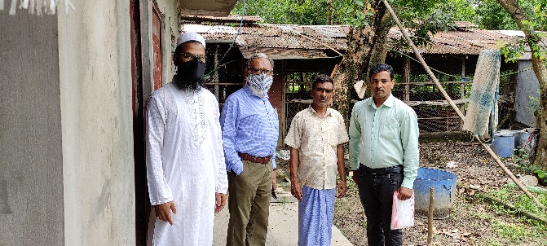 | 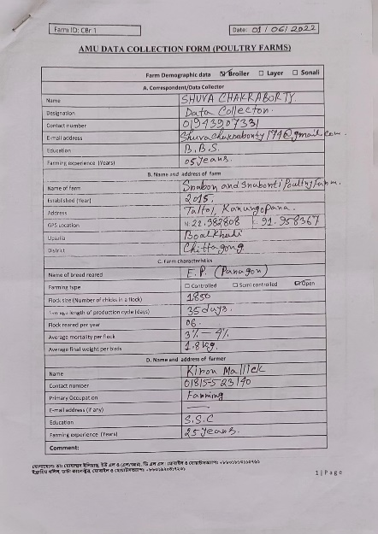
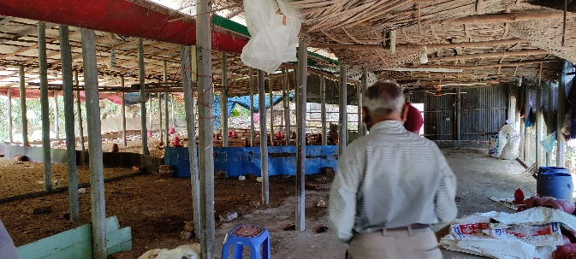
 | 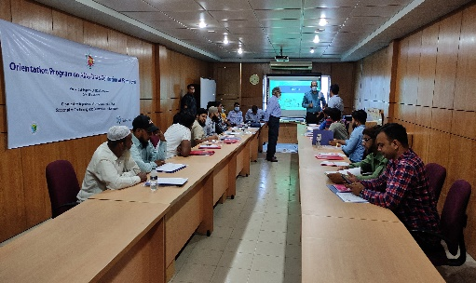
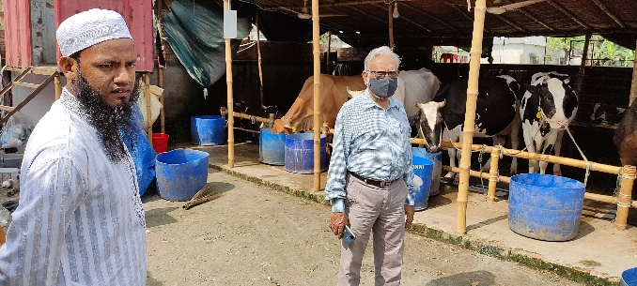 | 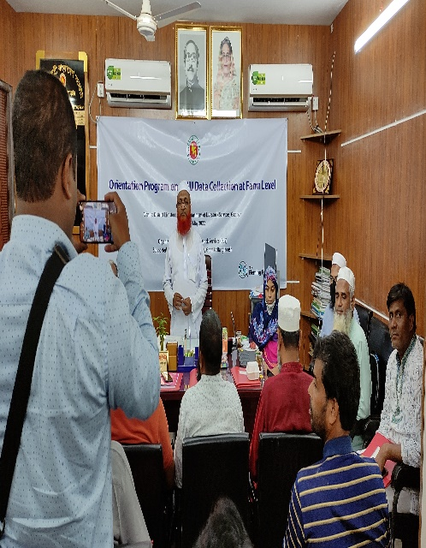
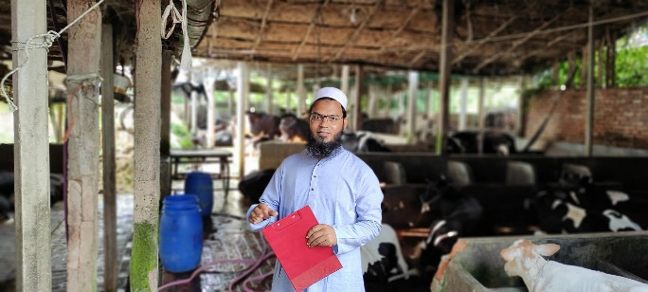

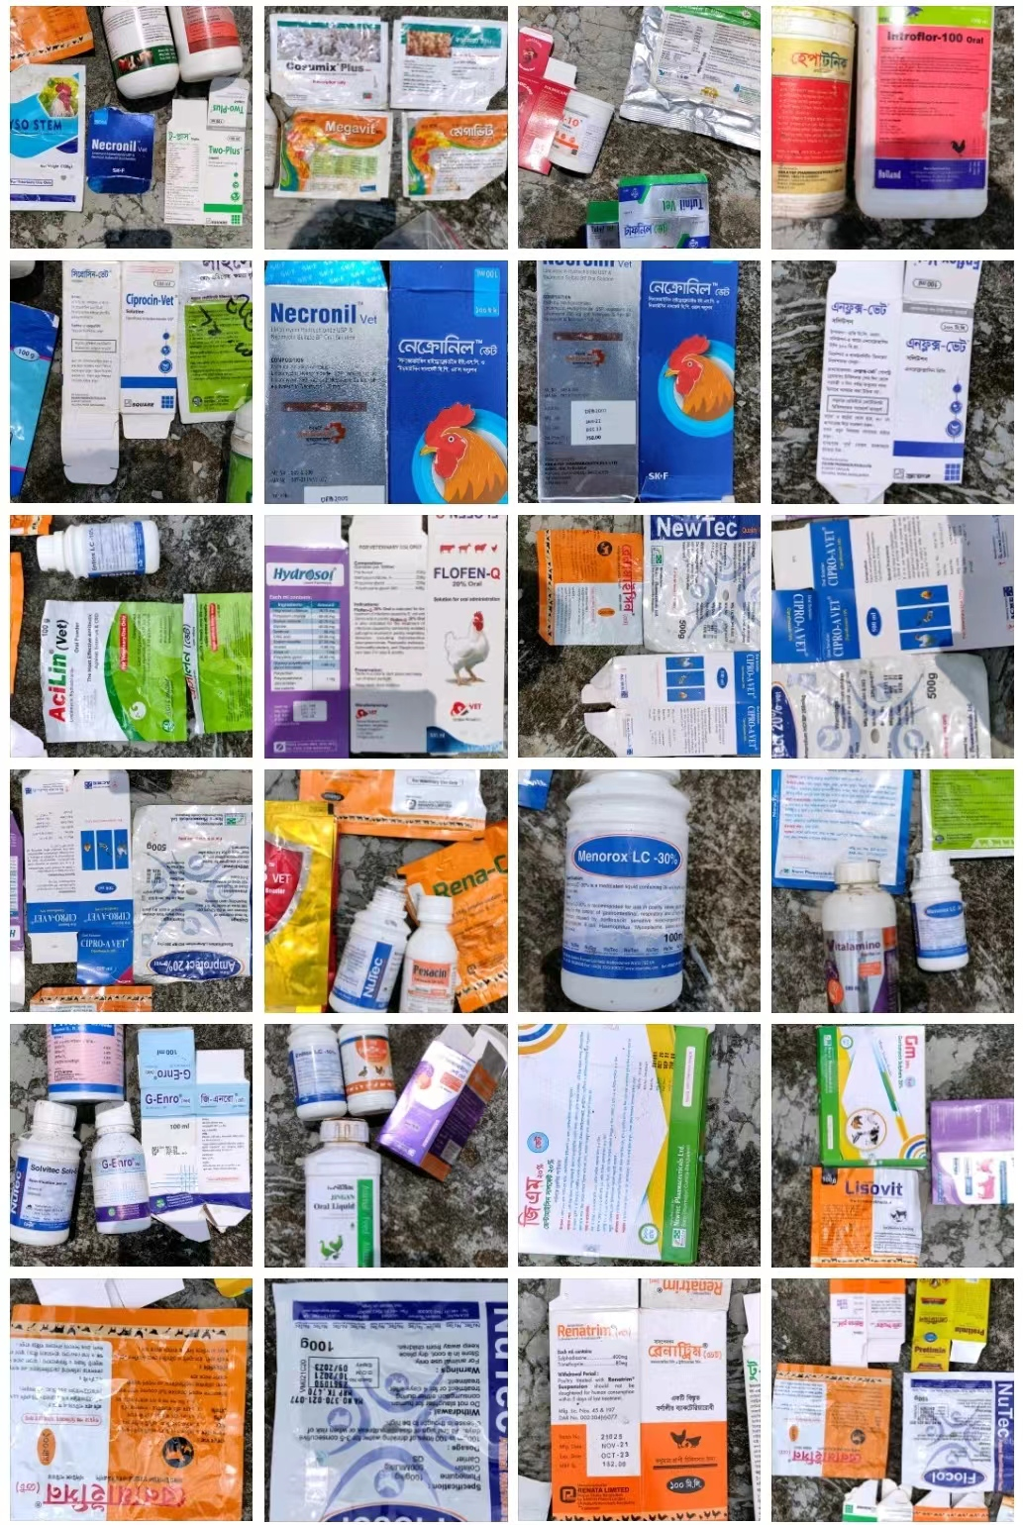

Brief Biodata of the Author
Dr. Mohammad Eliyas, an Upazila (Subdistrict) Livestock Officer of the Department of Livestock Services under the Ministry of Fisheries and Livestock, has completed both the Higher Secondary Certificate Examination and the Secondary School Certificate Examination. From Chattogram Veterinary and Animal Sciences University (CVASU), he received his DVM degree in 2005 and a Master's in Microbiology in 2009. He is currently a candidate for a second Master's degree in Applied Epidemiology under the One Health Institute, CVASU. He has immense interest to continue research on AMR and infectious disease epidemiology through One Health approach.

