Chapter-3
Materials and Methods
3.1 Materials and Methodology for prevalence study

3.1.1 Study Area and period
The study was conducted in the Upazilla Veterinary Hospital, Anwara in Chittagong. The investigation was conducted for a period of 2 months staring from 09th February to 08th April, 2014.

3.1.2 Selection of animals and Survey Design
a) Different cattle breed were selected for this study. Mainly, local breeds, Red Chittagong Cattle and Holstein Friesian (HF) crossbred cattle were selected for this study.
b) To determine the age and breed susceptibility of different parasites, cattle were categorized into three sub groups as calf (≤ 1year ie 12 month), young (>1 -<2.5years ie >12-<30 month) and adult (≥2.5years ie 30 month).
c) A total of 50 fecal samples were collected from 50 individuals which were brought for treatment in Upazilla Veterinary Hospital (UVH) during the study period. The cattle were suspected to be affected with gastro-intestinal parasitic infection on the basis of owner complaint, clinical history- emaciation and gastro-intestinal disturbances; clinical signs- diarrhoea, inappetite, unthriftiness ; and physical examination. The description of each patient age, sex & date etc. was recorded to asses their influence on the prevalence of the GI parasitic infection.
d) Random sampling was followed during sample collection.
A prototype questionnaire was used to record the information like owner’s name and address, animal Identification (ID), farm size, breed, age, sex, deworming history.

3.1.3 sample collection and preservation
One type of biological samples; feces samples were collected during this study where an individual animal was considered as a sampling unit. approximately 5-10gm of fecal sample from each individual animal was collected directly from rectum. However, freshly voided fecal samples were also considered and subsequently the collected samples were stored in plastic containers. Then, the container was filled with formalin (10%) and refrigerated at 4⁰C temperature. During sample collection, labeling of the samples were strictly maintained to prevent the misinterpretation.

3.1.4 examination of samples
In addition to gross examination of faecal samples (color, consistency, blood or mucus, etc.), three different types of qualitative tests, namely direct smear, flotation and sedimentation techniques were used to examine the fecal samples (Hendrix, 2006). Zinc Sulphate solution was used as floatation fluid. At least, two smears were prepared from each sample for each test to identify the morphological characteristics of eggs, cyst, Oocysts etc. (Hendrix, 2006 and Soulsby, 1982).
Sample
Faeces
Qualitative tests
Direct smear
Flotation
Sedimentation

Fig. 2: Experimental Design (at a glance)

3.1.5 Statistical Analysis
The obtained information was imported, stored and coded accordingly. Data management and analysis were performed using Microsoft Excel and STATA version 12 (Stata Corp, College Station, Texas). Descriptive statistics was expressed as proportion with P-value for chi-squaretest.Significance was determined when P≤0.05.

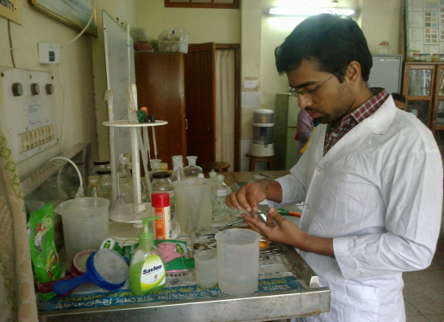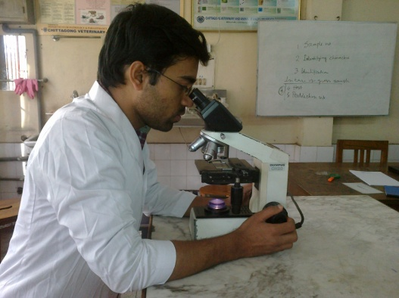
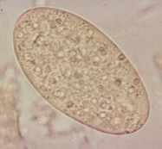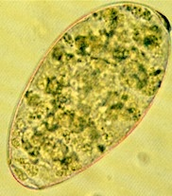
Egg of Fasciola spp. Egg of Paramphistomum spp.
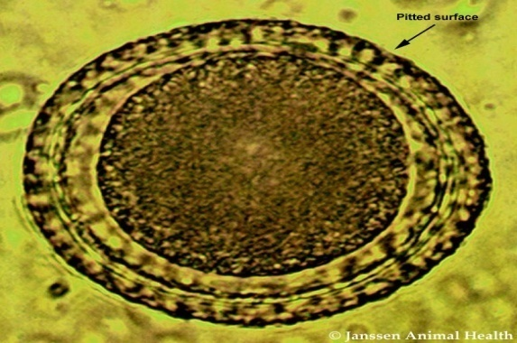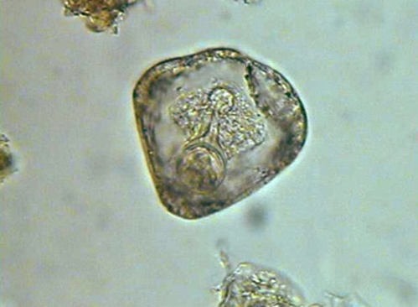
Egg of Toxocara vitulorum Egg of Moniezia expansa.
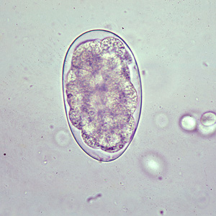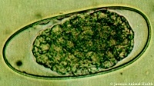
Egg of Oesophagostomum spp. Egg of Trichostrongylus spp.
Fig 8 : Fecal sample examination and Microscopic pictures of eggs of parasites during this study.

