Prevalence of Gastrointestinal Parasitism in Cattle at Anwara Upazilla in Chittagong

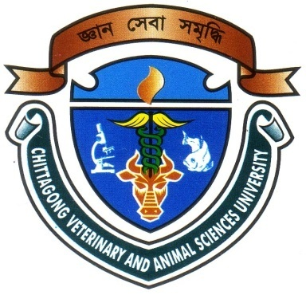

A Clinical Report Presented in Partial Fulfillment of the Requirement for the Degree of Doctor of Veterinary Medicine

A Report submitted by

Roll No: 09/54

Reg. No: 462

Intern ID: C-26

Session: 2008-2009

CHITTAGONG VETERINARY AND ANIMAL SCIENCES UNIVERSITY

KHULSHI, CHITTAGONG-4225

Prevalence of Gastrointestinal Parasitism in Cattle at Anwara Upazilla in Chittagong

A Production Report Submitted as per approved styles and contents

--------------------------  (Signature of Author)  Md. Faisal Ekram  Roll No: 09/54  Reg. No: 462  Intern ID: C-26  Session: 2008-2009 | -------------------------------  (Signature of Supervisor)  Dr. AMAM Zonaed Siddiki  Professor  Department of Pathology and Parasitology  Faculty of Veterinary Medicine

Chittagong Veterinary and Animal Sciences University

Khulshi, Chittagong-4225
January, 2014.

