CHAPTER- I

INTRODUCTION

Milk is an ideal food for human being irrespective of ages and undoubtedly the most important one among the foods of animal origin. Consumption of goat milk is gaining popularity day by day among the rural households in Bangladesh. The goat milk is highly nutritious and has a similar nutritional profile to those of human’s breast milk. But milk quality may be affected by bacterial contamination of mammary gland, which causes clinical and subclinical mastitis (Boscos et al., 1996). Mastitis in dairy goats is a disease of considerable economic importance worldwide like in dairy cows. Clinical mastitis (CM) presents significant clinical features of inflammatory signs in udder tissues and abnormal udder secretion whereas the only indicator of subclinical mastitis is higher somatic cell count in milk without any visible abnormalities in udder tissue and milk. Unlike cow milk, goat milk contains fairly high cell content because of apocrine process of secretion (Wooding et al., 1977). Mastitis in goat is mainly of sub-clinical type (McDougall et al., 2002) which causes reduced milk yield, kid mortality and is responsible for major economic losses (Contreras et al., 2003). However, gangrenous mastitis occurred as common clinical form of mastitis in goats (Samad, 2008). Several causal agents and predisposing factors have been attributed to dairy goat mastitis with Staphylococcus sp. as the main etiological agent (Ibrahim et al., 2009). Predisposing factors such as poor management and hygiene, teat injuries and faulty milking machines are known to hasten the entry of infectious agents and the course of the disease (Majic et al., 1993). Review of literature yielded very limited information on the diseases of goats in Bangladesh (Samad, 2000) particularly mastitis which is universally recognized as one of the most costly diseases in the dairy industry. Thisstudy was undertaken isolate major bacterial pathogens responsible for and to identify potential risk factors of clinical and subclinical mastitis in goats.

Mastitis is one of the devastating maladies of milch animals causing huge production losses to livestock industry. It has been recognized as one of the most economically important diseases affecting dairy animals worldwide (Hashemi et al., 2011; Chishty et al., 2007; Lightner et al., 1988; Kanenne and Hurd, 1990; Miller et al., 1993; Kossaibati et al., 1998). It causes production losses in the form of condemned milk, loss in milk yield, earlier culling of animals and replacement stocks (Khan and Khan, 2006). The annual economic loss due to reduced milk production alone caused by Sub Clinical Mastitis (SCM) in Bangladesh is Tk. 122.6 million (US $ 2.11 million) (Kader et al., 2003).
Mastitis is defined as an inflammation of the parenchyma of mammary gland, which can reduce milk yield and alter milk composition (Souto et al., 2010). The causative organisms are ubiquitous in nature and persist long time in the goat yard or barns and there is a chance of constant udder infection under poor hygiene and management systems (Rahman and Ramage, 1969). The Clinical Mastitis (CM) is accompanied by physical, chemical, pathological and bacteriological changes in milk and glandular tissues (Samad, 2008). The glandular cellulitis is termed as sub-clinical mastitis. The persistence of sub-clinical mastitis may develop clinical mastitis in any time under certain stress factor(s). The early detection of sub-clinical mastitis is of the prime importance to combat development of clinical mastitis (Schalm, 1953). In case of subclinical mastitis, milk appears normal with no visible abnormalities in udder tissues except an elevated Somatic Cell Count (SCC) (McDougall et al., 2001). Somatic cells are part of the natural defense mechanism and include lymphocytes, macrophages, polymorphonuclear cells and some epithelial cells (Hashemi et al., 2011). A bacterial count of over 200 per ml in fresh milk is usually the indication of cellular inflammation of the udder by Staphylococcus spp. (Mossel, 1962). Apart from causing huge economic losses, mastitis can also transmit zoonotic diseases like tuberculosis, brucellosis, leptospirosis and streptococcal sore throat to human beings (Radostits et al., 2000). Epidemiological study revealed that infectious agents of mastitis may be transmitted to infected animals from milker’s hand, milking cans and in milk samples (Philpot, 1975). High
yielding dairy goats are commonly affected than low yielders. Exotic . Antimicrobial therapy plays a role in mastitis control by reducing the levels of herd infection and by preventing disease causing bacteria (Unakal and Kaliwal, 2010).

Many methods have been developed to detect the disease in early infection, of which somatic cell count (SCC) and bacterial load count (BLC) are two methods accepted reliably (Thompson and Postles, 1964). These methods are time consuming and chances of error to the tests are enormous. So, some tests like California Mastitis Test (CMT), Whiteslide Test (WST) and Surf Field Test (SFT) have been developed. California Mastitis Test (CMT) is a simple, market available, rapid screening test for sub clinical mastitis, based upon the amount of cellular nuclear protein present in milk sample that react with CMT reagent (Contreras et al., 1995). White Side Test (WST) is an indirect, easily applicable screening test for sub clinical mastitis in which 4% sodium hydroxide solution is used as reagent (Kahir, 2006). Surf Field Mastitis Test (SFMT) is another simple inexpensive indirect test for detection of SCM using 3% solutions of household detergent (Muhammad et al., 1995). Reagents of these tests contain detergents which change the structure and conductivity of cell membrane and nucleus, stimulate proteolytic enzymes, and increase milk viscosity (Middleton et al., 2004). Sensitivity and specificity of a quantitative test are terms used to evaluate the accuracy of a test. The sensitivity of a clinical test refers to the ability of the test to correctly identify those patients with the disease. The specificity of a clinical test refers to the ability of the test to correctly identify those patients without the disease (Lalkhen and McCluskey, 2013).

Objectives of the study:
- To detect the prevalence of sub-clinical mastitis in lactating goat based on three indirect screening tests (i.e. CMT, WST and SFMT).
- To identify the risk factors which are responsible for the prevalence of sub-clinical mastitis.
- To evaluate the accuracy of those tests with sensitivity and specificity test

CHAPTER-II
REVIEW OF LITERATURE
2.1. Mastitis:
Mastitis is one of the most important health problems of dairy animals (Cady et al., 1983; Hussain et al., 2005; Getahun et al., 2008). Mastitis has a negative economic impact on dairy farms in terms of disordered milk, lost of production, reduced milk quality and high treatment costs (Seegers et al., 2003). Mastitis is inflammation of parenchyma of the mammary gland regardless of the cause. It is characterized by a range of physical and chemical changes in the milk, and pathological changes in the glandular tissue. The most important changes in the milk include discoloration, the presence of clots and the presence of large numbers of leukocytes (Radostits et al., 2000).

2.3. Epidemiology of mastitis:
Mastitis causes great economic impact on dairy industry with complex multifactorial etiology (Nooruddin et al., 1997). It is almost always infectious. Trauma, such as occurs with injured teats, defective or faulty milking machine function frequently leads to infection because of reduced natural defences or increased exposure to infectious agents (Haward, 1981). Predisposing factors such as poor management and hygiene, teat injuries and faulty milking machines are known to hasten the entry of infectious agents and the course of the disease (Majic et al., 1993). Bruising of mammary tissue or teats from traumas, flies bites, or other wounds predisposes the females to mastitis. The infection rate of mastitis in cows with pendulous udder is higher than those having non-pendulous udder (Sori et al., 2005). Prevalence of infection increases in multiparous doe, within 2-3 months of lactation, abnormally large udder, means of milking, unclean milker’s hand, udder wound, and mismanagement of milking machine (Alom, 2001). It is also the outcome of interaction of various factors associated with the host, pathogens and the environment, accounting for 38% of all morbidity (Smith, 1996). Prevalence of mastitis increases with the advancing age and parity (Rahman et al., 2009; Quaderi, 2005; Slettbakk et al., 1995; Radostits et al., 2000). Type of breed and pregnancy had no influence on the prevalence of mastitis (Rahman et al.,
2009). Infections of sub-clinical mastitis were more from the 2nd lactation and onwards (Prodhan et al., 1996; Kapur and Singh, 1978).

2.2. Etiology of Mastitis:
A wide range of pathogens including viruses, bacteria, fungi and their toxins can cause the disease. The primary reservoir of contagious pathogens is the mammary gland itself. Frequency of contagious pathogens among mastitis cases is greater (Sori et al., 2005). The infectious agents enter through the milk canal, interacts with the mammary tissue cells and multiplies. Majority of infections are caused by Staphylococci spp., Streptococci spp., and gram-negative bacteria (Mubarack et al., 2012). Staphylococcus aureus is the most common etiological agent causing mastitis in goat following E.coli (Unakal and Kaliwal).

2.4 Forms and clinical signs Mastitis:
Bovine mastitis is a single most common disease syndrome of adult dairy doe recognized mainly as clinical and sub-clinical types worldwide (Nooruddin et al., 1997). The clinical findings in mastitis include abnormalities of secretion, abnormalities of the size, consistency and temperature of the mammary glands and frequently a systemic reaction. According to severity it can be peracute, acute, subacute and subclinical. There is severe inflammation, swelling, heat and pain of the quarter, with a marked systemic reaction which may be fatal in peracute cases. In acute case, there is severe inflammation without a marked systemic reaction and in subacute case there is mild inflammation with persistent abnormality in the milk. The subclinical form can be characterized as a high somatic cell count without any visible abnormality of the milk or udder (Radostits et al., 2000). Subclinical mastitis affects milk
quality and quantity causing great economic loss for producers (Swinkels et al., 2005; Halasa et al., 2007). Sub-clinical mastitis is important due to the fact that it is 15 to 40 times more prevalent than the clinical form. It is of long duration, difficult to detect, adversely affects production of dairy animals and constitutes a reservoir of microorganisms. It can affect other animals within the herd due to its contagious nature (Schultz et al., 1978). A survey of 71 herds for one year showed that 95% of the milking machines were defective. Detailed clinical and bacteriological examination of teats and udders revealed at least one quarter with mastitis in 84 (7.1%) of 1183 udders; of these 73 cases were acute and 11 chronic. The commonest lesion was a change in the anatomy of the teat orifice (Abdou et al., 1987).

2.5. Treatment and prevention of mastitis:
There are only two ways to minimize mastitis: (1) decrease exposure to microorganisms, or (2) increase resistance (Smith, 1996). Maintaining hygiene at farms can reduce occurance of mastitis. Antibacterial therapy is an important part of mastitis control program in dairy cattle. Dry cow therapy or intramammary antibacterial therapy immediately after last milking of lactation is an important component of an effective mastitis control programme (Radostits et al., 2000). Out of 152 isolates of Staphylococcus aureus, resistance was detected for penicillin, streptomycin, erythromycin, tetracycline, ampicillin and cephalothin, respectively. Results indicated that these isolates exhibited the highest degree of resistance to penicillin of all antimicrobial agents tested. No resistance was detected for Gentamicin (Mubarack et al., 2012). Another study was conducted on 138 samples with confirmed positives for microorganisms. All the samples were subjected to drug sensitivity test. The most effective antibiotic was enrofloxacin (91.67%) followed by ciprofloxacin (90.15%), amikacin (87.12%), ceftriaxone (84.10%), chloramphenicol (80.31%), cefotaxime (79.55%) and gentamicin (77.27%). Microorganisms were mostly resistant to drugs like streptomycin, penicillinG, ampicillin, cloxacillin, amoxycillin and neomycin in increasing order of resistance. Hence, it is suggested that the line of treatment should be based on antibiogram study of various isolates from bovine mastitis (Ranjan et al., 2010).

2.6. Prevalence of Mastitis:

A study was conducted to determine the point prevalence of sub-clinical caprine mastitis based on parallel interpretation of results of three screening test named California Mastitis Test (CMT), White Side Test (WST) and Surf Field Mastitis Test (SFMT). Animal level and udder half level prevalence of subclinical caprine mastitis were 39.83, 38.96, 38.10% and 35.05, 34.85, 31.60% by CMT, WST and SFMT, respectively noticed when tests were interpreted individually (Islam et al., 2012).

2.7. Evaluation of diagnostic tests:
The sensitivity and specificity of a diagnostic test are important in deciding the value of the test in disease control campaigns. Events may be recorded as being true when, actually, they are not. The sensitivity of a diagnostic method is the proportion of true positives that are detected by the method. Alternatively, events may not be diagnosed when it is actually present. This constitutes a false negative record. The specificity of the method is the proportion of true negatives that are detected. Sensitivity and specificity can be quoted either as a probability between zero to one, or as a percentage (Thrusfield, 1997). Test with 100% sensitivity correctly identifies all patients with the disease and test with 100% specificity correctly identifies all patients without the disease (Lalkhen and McCluskey, 2013). Positive predictive value (PPV) is the percentage of patients with a positive test who actually have the disease. Negative predictive value (NPV) is the percentage of patients with a negative test who do not have the disease. The gold standard is the best single test (or a combination of tests) that is considered as the current preferred method of diagnosing a particular disease (Parikh et al., 2008). Likelihood ratio is defined as how much more likely is it that a patient who tests positive has the disease compared with one who tests negative (Lalkhen and McCluskey, 2013). Confidence interval is the range within which one is reasonably confident that the true mean will lie (Thrusfield, 1997).

Quarter milk bacteriology results of samples collected within the first week of parturation were used to calculate the test characteristics of the California Mastitis Test (CMT) that estimate the udder health status of fresh dairy doe. Over 1,200 quarters were cultured and CMT was performed. The overall sensitivity and specificity of the CMT was 68.8 and 71.5%, respectively. Using a cut point of any CMT reaction as a positive test and examining the results by various days in milk, the highest sensitivity and specificity occurred at day four which were 82.4 and 80.6%, respectively (Dingwell et al., 2002).

CHAPTER-III
MATERIALS AND METHODS

3.1. Place of Study:
The study was conducted at three selected area of urban and periurban areas in Chittagong district of Bangladesh named as EPZ area, Wirless area, Jawatala- Ambagan area etc.

3.2. Study Period:
The duration of the study was about two months, from September & october t, 2014.

3.3. Design of Study: Prospective study.

3.4. Unit of Study:
Individual goat and two quarters of each dairy goat were included in the study. In the selected a total of 36 numbers of dairy goat were handle. 72 samples from each quarter of 36 does were tested for mastitis by three screening tests: (1) California Mastitis Test (CMT) (2) White Slide Test (WST) and (3) Surf Field Mastitis Test (SFMT).

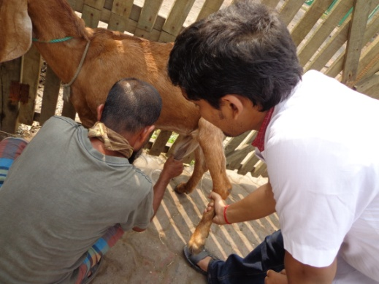
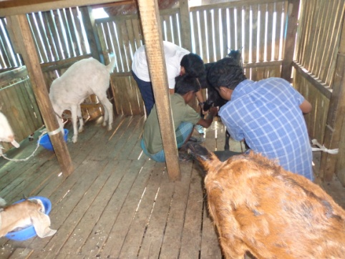

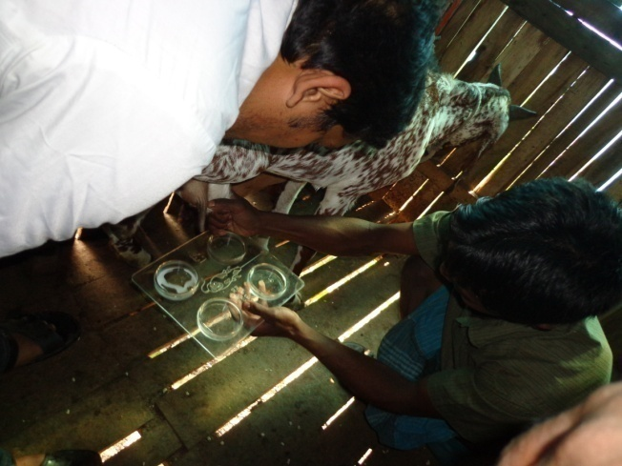
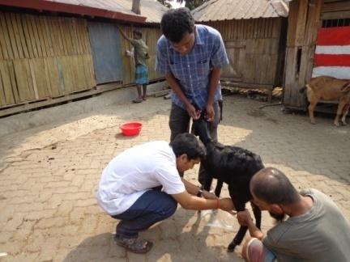

Fig-1:Collection of milk sample from various jamunapari doe.

3.5. Questionnaire preparation:
A questionnaire was prepared as desired by the supervisor. The questionnaire was designed to comprise mostly closed ended (categorical) questions to ease data processing, minimize variation and improve precision of responses (Thrusfield, 2005). It was designed to collect both herd and animal level data including type of dairy husbandry system, herd size, no. of parity, pregnancy stage, age, milk yield, history of periparturient disease, type of stimuli before milking , breed, washing of hand before milking etc. All the information of farms were recorded by interview with the animal owner, personnel of the farms, personal observation and taking records from register book. Information gathered in the questionnaire were entered in the Microsoft Excel worksheet, 2007.

Sub-clinical mastitis (SCM) was determined both for quarter positive cases and animal positive cases.

3.6. Selection of Case:
Milk samples were collected at the time of morning milking of goat. All those samples were collected from two quarters of every goat and subjected to test with three reagents: CMT reagent, 4% NaOH and 3% surf solution and results were recorded separately.

3.7. Case definition:
Sub-clinical mastitis was defined by result of California Mastitis Test (CMT), White Slide Test (WST) and Surf Field Test (SFT).

(1) California Mastitis Test (CMT):
This test requires a plastic paddle with four chambers. A kit consisting of a plastic paddle and all the necessary reagents is available commercially. The CMT was performed as described by (Britt, 1990). Equal quantities of reagent and milk were mixed in the cups of the plastic paddle by a swirling motion. Reactions occurred immediately after mixing which disappeared within 20 seconds. Positive samples showed various degrees of gelling, which was a reflection of the degree of udder inflammation. Negative samples were free from gel formation. There was a high degree of correlation between the CMT and somatic cell count.

The result was read as a negative, trace, 1, 2, or 3 depending on the amount of gel formation in the sample during test (Radostits et al., 2000).
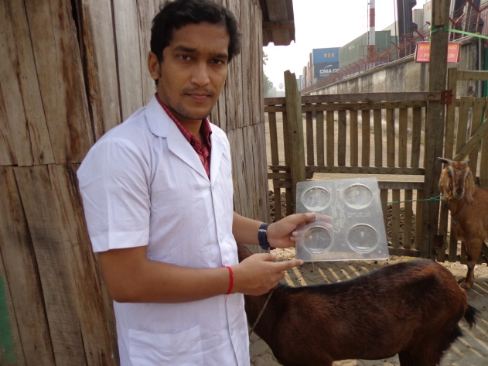
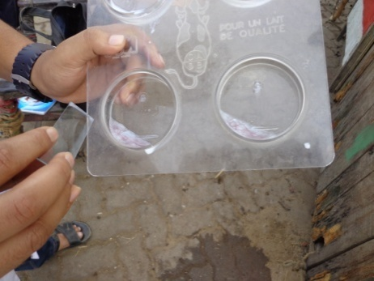

Fig: CMT from collected sample of milk of jamunapari doe.

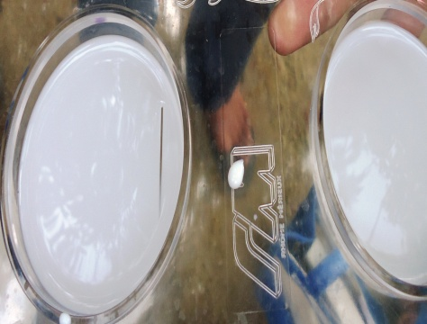

B
A
d
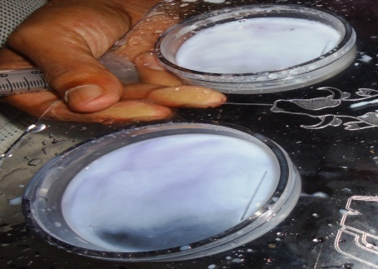

f
D
C

S
Plate 1: Scoring of SCM by California Mastitis Test (CMT). (A) (-) ve: No gel formation within 20 seconds (B)1+: Distinct slime formation without formation of peripheral mass (C) 2+: Distinct slime formation with peripheral mass (D) 3+: Distinct slime formation with ‘domed-up’ surface.

Table 1. Scoring of the California mastitis test results
Test result | Reaction observed | Equivalent milk somatic cell count
Negative | The mixture remains fluid without thickening or gel formation. | <200000 cells/ml
Trace | A slight slime formation is observed. This reaction is most noticeable when the paddle is rocked from side to side. | >200,000-4000,00 cells/ml
1+ | Distinct slime formation occurs immediately after mixing solutions. This slime may dissipate over time. When the paddle is swirled, fluid neither forms a peripheral mass nor does the surface of solution become convex or ‘domed-up’. | >400,000-800,000 cells/ml
2+ | Distinct slime formation occurs immediately after mixing solutions. When the paddle is swirled a peripheral mass and bottom of the cup is exposed. | >800,000-5000,000 cells/ml
3+ | Distinct slime formation occurs immediately after mixing solutions. This slime may dissipate over time. When the paddle is swirled the surface of the solution becomes convex or ‘domed-up’. | >5000,000 cells/ml

(2) White Slide Test:
White slide test can be performed easily. This test is dependent upon increased leukocyte content of mastitis affected milk. The WST was performed as per procedure described by (Kahir, 2006). In brief, 50 μl (five drops) of milk were placed on a glass slide with a dark background by a micropipette or dropper. Then 20 μl (two drops) of WST reagent (4% NaOH) were added to the milk sample and the mixture was stirred rapidly with a toothpick for 20-25 seconds. A breaking up of milk in flakes, shreds and viscid mass was indicative of positive reaction. On the other hand, milky, opaque and entirely free of precipitant was indicative of negative reaction. The reactions of WST were scored and shown in Table 2.

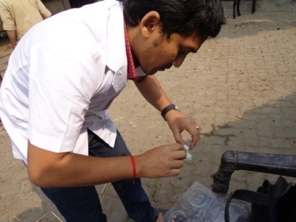
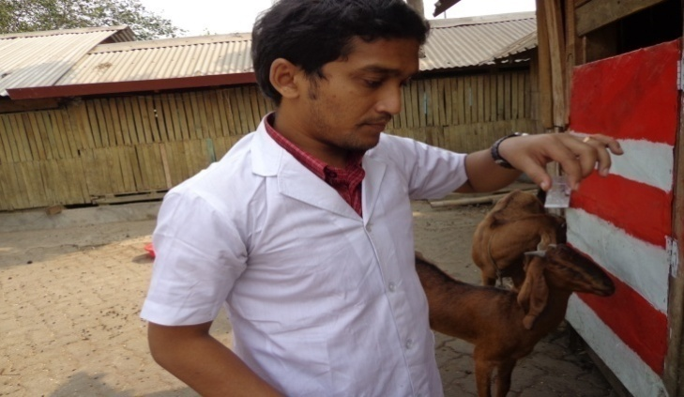

Fig-2:WST test from collected milk sample of jamunapari doe

Table 2. Scoring of the White Side Test (WST) results

Visible reaction | Interpretation | Test result
Mixture is milky and opaque and entirely free of precipitant. | Negative | -
The background is less opaque but still somewhat milky, with larger particles of coagulated materials being present and thickly scattered through the area. A slight degree of clumping is observed. | Weak positive | 1+
The background is more watery and large clumps of coagulated materials are present. If the stirring has been rapid, fine threads or strings may be present. | Distinct | 2+
The background is very watery and whey-like, with large masses of coagulated material forming into strings and shreds. | Strong positive | 3+

(3) Surf field mastitis test:
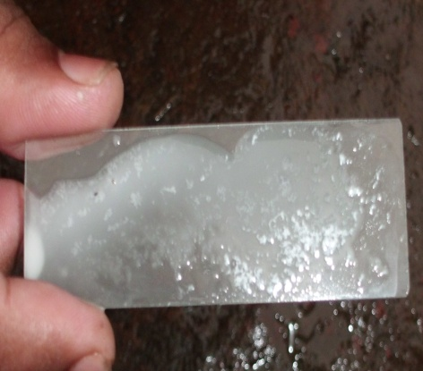
This test was performed and scored following the method described by (Muhammad et al., 1995). The samples were subjected to surf test. For this purpose, 3% surf solution was prepared by addition of three grams of commonly used detergent powder (Surf Excel, Unilever, Bangladesh) in 100 ml of water. Milk samples and surf solution were then mixed in equal quantities in slides. The reaction developed almost immediately with milk containing a high concentration of somatic cells. The formation of gel depicted the positive samples. The peak of reaction was obtained within 30 seconds and immediately scored as 1+, 2+ and 3+ like WST.

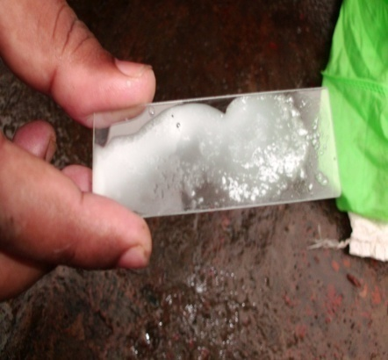
Fig-3: SFMT test from collected milk of jamunapari doe

CHAPTER-IV
RESULTS

4.1. Quarter prevalence of Sub-clinical Mastitis
During the study period as many as 72 samples from two quarters of 36 dairy goat were subjected for sub-clinical mastitis test. By thorough examinations of milk samples with CMT, WST and SFMT, sub-clinical mastitis (SCM) cases were determined, calculated and recorded. Prevalence of sub clinical mastitis by different screening tests .

Table 3: Prevalence of SCM in dairy does detected by three different tests

Variables | Tests used | No. of sample tested | No. (+)ve | % (+) ve  (Prevalence) | Overall prevalence
Tests | CMT | 72 | 28 | 38.88% | 38.42%
 | WST |  | 28 | 38.88%
 | SFMT |  | 27 | 37.50%

The overall prevalence of SCM during the study period was estimated to be 38.42% . Out of 72 samples, about 28, 28 and 27 samples were positive for SCM with CMT, WST and SFMT tests respectively. Prevalence of SCM in CMT, WST and SFMT were 38.42% .

Fig-4: Prevalence of SCM in dairy cows using three screening tests
Figure 1 showing the prevalence of SCM among lactating dairy doe detected by CMT, WST and SFMT were 38.38, 38.38 and 37.50 %, respectively.
4.2. Association of different categorical variables with SCM occurrence in dairy jamunapari goat at quarter level under the investigation
Table 4 is presented with the statistics of 72 samples of 36 jamunapari goat accoding to different categorical variables (i.e. parity, pregnancy, age, milk yield, history of periparturient disease). Association of prevalence of SCM in relation to no. of parity was prevalence was38.37%. From parity 1-3 and from parity 4-others, the prevalence of SCM were 32.5 and 44.44%, respectively. The prevalence of SCM in pregnant animal was 48.38%, significantly higher comapred with fresh animal 28.28% .

Table 4: Distribution of SCM at quarter level in relation to different variables
Variables | Level | No. of observation | Mastitis (+)ve  N (%) | Overall Prevalence (%)
Parity | Parity 1 (1-3) | 40 | 13 (32.5%) | 38.47%
 | Parity 2 (4-next) | 36 | 16(44.44%)
Pregnancy | Fresh | 45 | 13 (28.28%) | 38.33%
 | Pregnant | 31 | 15 (48.38%)
Age | <3 years | 36 | 11 (35.55%) | 38.60%
 | >3 years | 36 | 15 (41.66%)
Milk yield | Low | 20 | 5 (25%) | 38.69%
 | Medium | 24 | 9(37.50%)
 | High | 28 | 15 (53.57%)
History  Of periparturient disease | Absent | 34 | 10 (29.41%) | 38.38%
 | Present | 38 | 18 (47.36%)

The prevalence of SCM was high in high milk producing animals (53.57%) compared to low (25%) and medium (37.50%). The prevalence was higher (47.36%) in doe with a history of periparturient disease compared to goat without any history of periparturient disease (29.41%)

Fig-05: Distribution of SCM at different quarter level in relation to different variable

CHAPTER- V
DISCUSSION

In present study, like some other studies, the majority of the cases of mastitis were subclinical (Almaw et al., 2008; Getahun et al., 2008). It may be due to a higher knowledge of farmers on clinical mastitis which appears by visible changes and is treated as soon as possible (Hashemi et al., 2011). Subclinical mastitis is a complex disease and the differences in results could be due to differences in management systems between farms, stage of lactation, parity, breed (Almaw et al., 2008) severe teat end lesions (Siber and Farnsworth, 1981) and milking hygiene (Haltia et al., 2006) etc.

5.1. Type of animal houses and milking practices:
The standard of milking hygiene was poor on majority of the owners . Most of the farmers didn’t practice preventive measures i.e. use of udder disinfectants, post-milking teat dipping . Some of the farms didn’t clean floor before milking. So, always there was chance for infection by the organisms of the floor. All the owners followed cut and carry system for supplying grasses to the goat. But the grasses were not properly cleaned with water. Both clean water or simply clean water was used to wash milker’s hand before milking.
5.2. Quarter Prevalence:
All the milk samples (n=72) from two quarters of selected does (n=36) were examined thoroughly and screened for SCM. From them, 38.42% samples were positive for mastitis by any of the three indirect tests used i.e. California Mastitis Test (CMT), White Slide Test (WST) and Surf Field Test (SFT) (Table 3). The prevalence was almost nearer to the findings of (Islam et. al., 2010) who reported 36.46% prevalence of SCM in lactating dairy does. The prevalence recorded by (Kader et al., 2003) was 46.6%, which was slightly higher than my

5.3. Prevalence of mastitis in different screening tests:
The prevalence of SCM by CMT, WST and SFT were 38.88% (n=28), 38.88% (n=28) and 37.50% (n=27), respectively (Table 3). WST showed better performance in detecting sub-clinical mastitis (38.38%) among three indirect tests used. This result is in agreement with the findings of (Prodhan et al., 1996). They recorded comparatively higher prevalence rate of sub-clinical mastitis with WST (16.52%) than CMT (15.77%). Higher prevalence of SCM was recorded in CMT (37.58%) than WST (36.67%) and SFMT (35.15%) (Islam et al., 2010).

5.4. Prevalence of mastitis in relation to different variables:
5.4.1. Prevalence of mastitis in relation to parity:
The number of parity had a significant effect on the prevalence of mastitis. Several studies were in agreement with the present findings of increased mastitis in advancing parity (Slettbakk et al., 1995; Radostits et al., 2000; Quaderi, 2005; Rahman et al., 2009; Rasool et al., 1985; Devi et al., 1997 and Dego and Tareke, 2003). The prevalence (44.44%) of SCM at quarter level was significantly higher (P<0.05) from parity 4 to above 4 than parity 1 to 3 (Table 4). At animal level, 32.5% prevalence was found in parity 1 to 3 . It has been shown that high-yielding dairy goat are more prone to mastitis. In the high-yielding goat, the glandular tissues are more susceptible to infection (Slettbakk et al., 1995; Radostits et al., 2000). Polymorphonuclear leukocyte function is more active in primiparous than multiparous goat(Dulin et al., 1988).

5.4.2. Prevalence of mastitis in relation to pregnancy:
Out of 45 samples from four quarters of fresh animals, 28.38% (n=13) samples were positive of SCM. 48.38% (n=15) samples were positive for SCM taken from pregnant animal . It is reported that the prevalence of mastitis is often high in last stage of pregnancy and several days before parturition, followed by a marked decline after parturition (Radostits et al., 2000). It is reported that pregnancy had no influence on mastitis (Rahman et al., 2009).

5.4.3. Age wise prevalence of mastitis:
The distribution of SCM at quarter level in different age group is presented in Table 4. The prevalence of mastitis increased with age. The prevalence of SCM was 35.55% (n=11) in the age group before 3years, the prevalence (41.66%) found in >3 years old goat (Table 4). The prevalence of mastitis was also increased in older goat. Similar observation was also reported by (Islam et al., 2010; Slettbakk et al., 1995; Radostits et al., 2000; Quaderi, 2005; Rahman et al., 2009). The defence mechanism in aged goat is poorer than in younger ones (Dulin et al., 1988).

5.4.4 Prevalence of mastitis in relation to milk yield:
The distribution of SCM in relation to milk yield is presented in Table 4. The prevalence of SCM low (25%) to medium (37.5%) to high (53.37)yielders.
milk production in the prevalence of SCM was in agreement with the reports of (Kader et al., 2003; Islam et al., 2010).

.

CHAPTER- VI
CONCLUSION
Mastitis is a common problem of dairy industries. Reduction in milk production and an irreparable damage to the udder associated with the disease are the common cause of culling of Jamunapari goat . Milk from infected animals is not suitable for drinking and for making different milk products. So it has a major economic importance in jamunapari goat . The prevalence of sub-clinical mastitis increases in jamunapari goat with a history of periparturient disease, goat without dry goat therapy, high milk producing goat and in goat with the advancing age and parity. CMT, WST and SFMT are easily applicable and cost effective indirect screening tests for detecting sub-clinical mastitis. They can be used regularly for screening of sub-clinical mastitis at dairy farms.

Limitations of the study:
The study was carried out within a short period of time. For this reason, the distribution of SCM in relation to seasonal variation, lactation length was not reported. Some variation of result with previous study may be due to smaller sample size, limited study area. Besides these, the farmers and personnel were less co-operative as milk was collected early in the morning when they were engaged in collecting milk.

Recommendation:
The most effective way to control sub-clinical mastitis is to take preventive measures. Regular cleaning of the floor, keeping the udder clean, milkman’s cleanliness, regular teat-dipping before and after milking, dry goat therapy specially to high yielding dairy does , regular screening of sub-clinical mastitis may reduce the prevalence of sub-clinical mastitis. Farmers should be aware about the importance of the disease. As there is no vaccine for mastitis, they should maintain hygiene at farms. Care and management should be improved. Infected milk should be properly disposed. 5% phenol may be added to the infected milk at the time of disposal. All the equipments and containers should be cleaned and washed properly.

CHAPTER- VII

REFERENCES

Ameh JA and Tari IS (1999). Observations on the prevalence of caprine mastitis in relation to predisposing factors in Maiduguri. Small Ruminant Research 35: 1–5.

Assefa W, Molla B, Belihu K, Kleer J and Hildebrandt G (2006). A Cross-Sectional Study on the Prevalence, Antimicrobial Susceptibility Patterns, and Associated Bacterial Pathogens of Goat Mastitis. International Journal Applied Research Veterinary Medicine 4: 169- 176.

Bergonier D and Berthelot X (2003). New advances in Epizootiology and control of ewe mastitis. Livestock Production Science 79: 1–16

Bergoniera D, Crémouxb RD, Rupp R, Lagriffould G and Berthelota X (2003). Mastitis of dairy small ruminants. Veterinary Research 34: 689–716

Boscos C, Stefanakis A, Alexopoulos C and Samartzi F (1996). Prevalence of subclinical mastitis and influence of breed, parity, stage of lactation and mammary bacteriological status on Coulter Counter Counts and California Mastitis Test in the milk of Saanen and autochthonous Greek goats. Small Ruminant Research 21:139–. Contreras A, Luengo C,
Cady, R. A., Shah, S. K., Schermerhorn, E. C. and McDowell, R. E. (1983). Factors affecting performance of Nilli-Ravi buffaloes in Pakistan. Journal of Dairy Science 66: 578–586. cell count in goat milk. Small Ruminant Research 31: 253–260
Contreras A, Sierra D, Sanchez A, Corrales J, Marcoc J, Paape M and Gonzalo C (2007). Mastitis in small ruminants. Small Ruminant Research 68: 145–153.
Getahun, K., Kelay, B., Bekana, M. and Lobago, F. (2008). Bovine mastitis and antibiotic resistance patterns in Selalle smallholder dairy farms, Central Ethiopia. Tropical Animal Health Production 40: 261-268.
Hargital C, Egyhaze K and Markus G (1992). Trends of changes in the antibiotic sensitivity of udder pathogenic bacteria. Allatorvosok Lapja, 47: 429-43
Hashemi, M., Kafi, M. and Safdarian, M. (2011). The prevalence of clinical and subclinical mastitis in dairy cows in the central region of Fars province, south of Iran. Iranian Journal of Veterinary Research, Shiraz University 12: 3.
Haskell S (2005). Caprine milk quality and mastitis. A speech at WDGAs caprine field day, Arlington Field station, Arlington, WI, 11-12-2005

Hosmer DW and Lemeshow S (1989). AppliedLogistic Regression. New York: Wiley, xiii: 307.

Ibrahim A, Kursat K and Haci AC (2009). Identification and Antimicrobial Susceptibility of subclinical mastitis pathogens isolated from hair goats’ milk. Journal of Animal and Veterinary Advances 8: 4086-90.

Islam MR, Ahamed MS, Alam MS, Rahman MM, Sultana T, Roh YS and Kim B (2011). Identification and Antibiotic Sensitivity of the Causative Organisms of Sub-clinical Mastitis in Sheep and Goats. Pakistan veterinary Journal 32(2): 179-182.. Majic B, Jovanovic BV, Ljubic Z and Kukovics S (1993). Typical problems encountered in Croatia in the operation of goats milking machines. Proceedings of the 5th Internacional symposium on machine milking of small ruminants. Budapest, Hungary. pp. 377-379.
Kahir, M. A. (2006). A cross sectional epidemiological study on subclinical mastitis of dairy cows in Sylhet. MS Thesis., Department of Medicine, Bangladesh Agricultural University, Mymensingh, Bangladesh.
Lalkhen, A. G., McCluskey, A. (2013). Clinical tests: sensitivity and specificity. Oxford Journal 8:221-223.
McDougall S, Pankey W, Delaney C, Barlow J, Murdough PA and Scruton D (2002).Prevalence and incidence of subclinical mastitis in goats and dairy ewes in Vermont, USA. Small Ruminant Research 46: 115– 121.

Miller, G. Y., Bartlett, P. C., Lance, S. E., Anderson J. and Heider, L. E. (1993). Costs of clinical mastitis and mastitis prevention in dairy herds. Journal of American Veterinary Medical Association 202: 1230–1236
Nooruddin, M., Ali, M. L. and Debnath, N. C. (1997). Retrospective epidemiologic study of periparturient diseases in dairy cows. The Bangladesh Veterinarian Journal 14: 43-47.
Prodhan, M. A. M., kamal, A. H. M. and Mahbub-E-Elahi, A. T . M. (1996). Prevalence of sub- clinical mastitis in cows of Baghabari Milkshed area. Bangladesh Veterinary Journal 30: 59-61.
Quinn PJ, Carter ME, Markey B and Carter GR (1994). Clinical Veterinary Microbiology. Wolfe publisher, England.
Radostits, O. M., Gay, C. C, Blood, D. C and Hinchcliff, K. W. (2000). Mastitis. In: Veterinary Medicine, A Textbook of the Diseases of Cattle, Sheep, Pigs, Goats and Horses. 9th Edn, W B Saunders Co. Philadelphia, USA Pp: 603–622.
Rahman, A. and Ramage, J. C. (1969). The range of leucocytic response and the persistence of Staphylococci organism in bovine mastitis udder. Pakistan Journal Veterinary Science 3: 105-109.
Rahman, M. A., Bhuiyan, M. M. U., Kamal, M. M. and Shamsuddin, M. (2009). Prevalence and risk factors of mastitis in dairy cows. The Bangladesh Veterinarian 26(2): 54 – 60.
Rahman, M. S., Nooruddin, M. and Rahman, M. M. (1997). Prevalence and distribution of mastitis in crossbred and exotic dairy cows. Bangladesh Veterinary Journal 14: 1-4.
Rainard, P., Riollet, C. (2006). Innate immunity of the bovine mammary gland. Veterinary Research 37: 369–400.
Ramachandraiah, K., Kumar, K. S. and Sreemannarayana, O. (1990). Survey of mastitis in a pure Jersey herd. Indian Veterinary Journal 67: 103-106.
Ranjan, R., Gupta M. K., Singh, S. and Kumar, S. (2010). Current trend of drug sensitivity in bovine mastitis. Veterinary World 3(1):17-20
Rasool, G., Jabbar M. A., Kazmi, S. E. and Ahmed, A. (1985). Incidence of sub-clinical mastitis in Nilli-Ravi buffaloes and Sahiwal cows. Pakistan Veterinary Journal 5: 76-78.
Roy, S. K., Pyne, A. K., Maitra, D. N., Dattagupta, R. and Mazumder, S. C. (1989). Studies on sub-clinical mastitis in cross-breeds in hot humid conditions of West Bengal. Indian Veterinary Journal 66: 844-846.
Samad MA (2000). An overview of livestock research reports published during the twentieth century in Bangladesh. Bangladesh Veterinary Journal 34: 53 -149.

Samad MA (2008). Animal Husbanry and Veterinary Science. Volume II, LEP pub no.11, Bangladesh Agricultural University campus, Mymensingh.
Samad, M. A. (2008). Animal Husbanry and Veterinary Science, LEP pub no.11, Bangladesh Agricultural University campus, Mymensingh 2: 1184-1189.
Sanchez A and Corrales JC (2003). The role of intramammary pathogens in dairy goats. Livestock Production Science 79: 273-283

Schultz EW and Chandler R (2009). The acidity of goat’s milk in terms of hydrogen ion concentration, with comparisons to that of cow’s and human milk. http//www.jbc.org by on March 28, 2009 19. StataCorp. 2011. Stata Statistical Software: Release 12. College Station, TX: StataCorp LP.
Seegers, H. C., Fourichon, H. and Beaudeau, F. (2003). Production effects related to mastitis and mastitis economics in dairy cattle herds. Veterinary Research 24: 475–491.
White EC and Hinckley LS (1999). Prevalence of mastitis pathogens in goat milk. Small Ruminant Research 33: 117-121.

Wooding FB, Morgan G and Craig H (1977). “Sunbursts” and “christiesomes”: cellular fragments in normal cow and goat milk. Cell Tissue Research 185: 535–545.

Zeng SS, Escober EN, Hart SP, Hinclley L, Baulthaus M, Robinson GT and Jahane G (1999). Comprehensive study of the effect of testing laboratory, counting method, storage and shipment on somatic

CHAPTER- VIII
ANNEXURE

Annexure -A: Questionnaire/Data collection form

Date: sample no:
1. Name of the Farm:
Owners name……………………………..………………………………………………
Adress……………………………………………………………………………………
Farm size………………………………………………………………………………...
No. of Milking Animals………………………………………………………………….
Average Milk Production………………………………………………………………..
Breed: Local / Cross (Dam ID)………………………………………………………….
Type of breeding: Natural/Artificial……………………………………………………..

2. Description of the Animal:
a) Cow ID ………………………………………………………………………..
b) Date of Birth………………………. Age……………………………………
c) Weight……………………………… d) BCS………………………………..
e) Parity…………………………………………………………………………..
f) Status Of Animal: Non Pregnant/Pregnant(…….month)……………………...
3. Description of Milk Production:
a) Frequency of Milking ………………………………………………………
b) Milk Production Per Day:…….lit
(Morning-…..lit/Evening- …..lit)

Questionnaire

c) Days in Milk……………………………………………………………………
d) Where Milking……. (Outside/Milk Parlor/House)
e) Type of milking………Hand milking/Machine milking
f) Any infection in Udder: Y/N
g) Any infection in Teat: Y/N (If Y then No of Teat Infected……)
h) Milk Production before infection:
i) Milk Production after Infection:
j) Peri-parturient diseases during last calving….Y/N. If Y then
name of the disease
4) Environment & Management:
a) Housing…stanchion(intensive)/semi-open(semi intensive)/
open/other
b) Housing System……face in/face out/other
c) Floor Type…..concrete/semi-concrete/muddy/bamboo made
d) Frequency of floor washing………no/………..times
e) Washing the udder before milking……….Y/N. If Y then the
name of the antiseptic solution
f) Washing the udder after milking.....Y/N. If Y then the
name of the antiseptic solution

Questionnaire

g) Washing the milker’s hand before milking…..Y/N. If Y then the
name of the antiseptic solution
h) Use of any food after milking…….Y/N
i) Source of water……………….Tube-well/river/pond
j) Practice of Dry cow therapy………..Y/N
k) How long the cow remained dry before last calving…… 3 months/N
l) Stimulation of milk let down by calf………Y/N

5) Result of WST………+/-
6) Result of CMT……….+/-
7) Result of Surf Field Test...+/-

Representative pictures
Annexure –B : Some representative pictures
FIG:COLLECTION OF MILK SAMPLE FROM VARIOUS JAMUNAPARI DOE

FIG:CMT FROM COLLECT MILK OF JAMUNAPARI DOE
a

B
A
d

f
D
C

S
Plate 1: Scoring of SCM by California Mastitis Test (CMT). (A) (-) ve: No gel formation within 20 seconds (B)1+: Distinct slime formation without formation of peripheral mass (C) 2+: Distinct slime formation with peripheral mass (D) 3+: Distinct slime formation with ‘domed-up’ surface.

FIG:WST TEST FROM COLLECTED MILK OF JAMUNAPARI DOE

n

FIG: SFMT TEST FROM COLLECETED MILK OF JAMUNAPARI DOE

