CHAPTER: 1
INTRODUCTION
The economy of Bangladesh is agro based. About 21.77% of Gross Domestic products (GDP) come from agriculture sector of which livestock alone shares 7.23% (BBS, 2005-2006). Within the livestock sector poultry has the highest contribution in GDP. Poultry industry is an important part of agriculture in our country. Poultry farming is gradually taking the shape of a large industry, and it is now one of the intensive forms of agri-business in our country. In order to achieve the Millennium Development Goal (MDG), Bangladesh is committed to develop the poultry sector. The total poultry population, both backyard and commercial, accounts to approximately 246 million, providing 5400 million pieces of eggs annually and nearly 15% of total animal protein. This sector employs about 5 million people of the country and has experienced a long-term growth rate of about 4.5%, which is one of the highest in the economy and is believed to have accomplished a silent revolution in Bangladesh (BLRI, 2008).
Some diseases create problems to run poultry farming profitably, such as Newcastle disease, Infectious bursal disease, Colibacillosis, Salmonellosis, Mycoplasmosis, Coccidiosis, Necrotic enteritis etc. Among these Newcastle disease and Infectious bursal disease are threat for both commercial poultry and backyard poultry farming.
Newcastle disease (ND), popularly known as Ranikhet disease, is recognized as one of the most important problems and most serious economic threat to the poultry population of Bangladesh. The disease is acute contagious which is characterized by sudden onset and rapid spread within the flock, resulting high morbidity and mortality. The causal agent, Newcastle disease virus, is a negative-sense single-stranded RNA virus. Newcastle disease (ND) is a highly contagious viral disease that attacks many species of domestic and wild birds (Al-Garib et al., 2003). Through restriction site mapping and sequence analysis of the fusion gene (F-gene), NDV strains have been divided into eight genotypes (Ballagiet al., 1996). The strains are also classified into highly virulent (velogenic), intermediate (mesogenic) or avirulent (lentogenic) based on their pathogenicity in chickens (Beard and Hanson, 1984). ND is reported as the most important viral disease of poultry in the world including developing countries(Spradbrowet al., 1997). In Africa and Asia ND is a major constraint against the development of both industrial and village poultry production. NDV infections of poultry range from latent to rapidly fatal depending upon the pathotype of virus involved (Alexander 2003). The disease causes high economic losses due to high mortality, morbidity, stress, decreased egg production and hatchability (Alexander, 2000). No treatment for NDV exists, but the use of prophylactic vaccines and sanitary measures reduces the likelihood of outbreaks. Vaccination has been reported as the only safeguard against endemic ND (Orajakaet al., 1999). The infection still occurs in Bangladesh every year in the form of epidemic and appears to cause up to 40-60% of the total mortality in poultry population creating one of the major problems in the development of poultry industry in Bangladesh (Chowdhuryet al., 1982a). Chicks from immunized parents possess high level of maternally derived antibodies (MDA) which protect them against virulent and vaccine viruses (Allan et al., 1978) and (Rahmanet al., 2002). In order to formulate appropriate vaccination schedule and control measures the serological status of NDV among chickens need to be elucidated.

Outbreak of diseases in Bangladesh cause about 30% mortality of chickens (Ali, 1994). Among them infectious bursal disease (IBD) is one of the major viral diseases which cause 80% mortality in field outbreak (Chowdhuryet al., 1996).

Infectious bursal disease, popularly known as Gumboro disease, is a contagious disease of young chickens which cause damage to the lymphoid tissue with special predilection site for the bursa of fabricious. The name “Gumboro” disease was initially given to the condition because it was first recognized on the farm in the Gumboro district of Delawre, USA in 1962. The etiological agent of IBD, infectious bursal disease virus (IBDV), is a non-enveloped virus, belonging to the family Birnaviridae, with a bisegmented double stranded RNA genome (Kibengeet al., 1988). Since 1992, the poultry farms of Bangladesh have been experiencing the outbreaks of a disease resembling acute IBD.

Swollen bursa and sometimes atrophied bursa, edematous and hyperemic bursa, gelatinous yellowish transudate covering the serosal surface and swollen kidney were observed in post mortem examinations. Hemorrhage and areas of necrosis may be present in more severe cases of IBD. Hemorrhage may be seen in the thigh and pectoral muscles.(Butcher and Miles; 2001; Anku; 2003; Rodriguez-Chavez et al.,2002; Saifet al., 2001; Dybinget al., 1998).

IBD causes significant mortality in chickens in Bangladesh. The disease is in both private and government farms in the country. IBD is frequenty reported even from vaccinated flocks. Sometimes farmers are confused and cannot suspect clinically on their own the occurrences of ND and IBD and the prevalence estimates of these diseases at a particularupazila level are not clearly known to them as well. On the above background the study was conducted with the following objectives:
Objectives:
- To measure the prevalence of ND and IBD in chickens in a particular upazila
- To describe the post mortem findings commonly encountered in ND and IBDaffected chickens in a parrticular upazila
- To know the proper prevention and control measures to be applied to prevent their occurrence at an upazila level

CHAPTER: 2
REVIEW OF LITERATURE
2.1. General Feature of Newcastle Disease
Newcastle disease is a contagious bird disease affecting many domestic and wild avian species. First found in Newcastle, United Kingdom in 1926, then by Burnet in 1943 in Australia in connection with laboratory infection where the virus was isolated from an ocular discharge of a patient to show the specific antibody titre in the patient's blood. Newcastle has a negative sense single stranded genome which codes for a RNA directed RNA polymerase, hemagglutinin-neuraminidase protein, fusion protein, matrix protein, phosphoprotein and necleoprotein in the 5´ to 3´ direction. Its effects are most notable in domestic poultry due to their high susceptibility and the potential for severe impacts of an epizootic on the poultry industries. It is endemic to many countries.
Newcastle disease was discovered in Newcastle upon Tyne, England (Doyle 1927) but also at this time slightly different strains were found in other parts of the world.
Exposure of humans to infected birds (for example in poultry processing plants) can cause mild conjunctivitis and influenza-like symptoms, but the Newcastle disease virus (NDV) otherwise poses no hazard to human health. Interest in the use of NDV as an anticancer agent has arisen from the ability of NDV to selectively kill human tumor cells with limited toxicity to normal cells.
No treatment for NDV exists, but the use of prophylactic vaccines and sanitary measures reduces the likelihood of outbreaks.
2.1.1. History of Newcastle disease
Newcastle disease (ND) is an acute contagious disease of poultry. The first outbreaks of (ND) occurred in 1926, in Java, Indonesia (Kraneveld 1926) and in Newcastle-upon-Tyne, England (Doyle 1927). An outbreak also occurred in Ranikhet, India in 1927 (Edwards 1928).The name ND was coined by Doyle as a temporary measure because he wished to avoid a descriptive name that might be confused with other diseases (Doyle 1935). ND is now regarded to be endemic or epidemic almost all over the world. ND is included in List A of the Office International des Epizooties (OIE 2002).
ND, popularly known as Ranikhet disease, has found to appear every year in the form of epidemic, which causes 40-60% of the total mortality rate of poultry population in Bangladesh (Chowdhury 1982b). Kamal and Hossain (1992) made surveillance on disease outbreaks and bird mortality in an organized poultry farm of Bangladesh Agricultural University, which revealed that the prevalence of ND was the highest (18.65%). However, ND is frequently responsible for devastating losses in village poultry (Alexander 2000).

2.1.2. Etiology
Newcastle disease is caused by avian paramyxovirus serotype 1 (APMV-1) viruses have been placed in the genus Rubulavirus, sub-family Paramyxovirinae, family Paramyxoviridae (Rima et al., 1995). Strains of ND virus have been distinguished on the basis of the clinical signs produced in the infected chickens. On this basis NDVs have been placed in 5 pathotypes or groups (Beard and Hanson 1984):
1. Viscerotropic velogenic: viruses responsible for disease characterized by acute lethal infections, usually with hemorrhagic lesions in the intestines of dead birds.
2. Neurotropic velogenic: viruses causing disease characterized by high mortality, which follows respiratory and neurological disease, but in which gut lesions are usually absent.
3. Mesogenic: viruses causing clinical signs consisting of respiratory and neurological signs, with low mortality.
4. Lentogenic: viruses causing mild infections of the respiratory tract.
5. Asymptomatic enteric: viruses causing avirulent infections in which replication appear to occur primarily in the gut.

2.1.3. Epidemiology
ND infections have been established in at least 241 species of birds representing 27 of the 50 orders of the class (Kaleta and Beladauf 1988).
ND is transmitted from birds to birds horizontally as follows (Alexander 1988):
(a) Direct transmission: Inhalation of aerosols or dried faeces (fast); ingestion of contaminated faeces (slow).
(b) Indirect transmission: Humans, poultry products, fomites, food, etc.
Routes: Nasal, oral, ocular.
Pathogenesis
Ingestion / inhalation of infected material - replication take place in the upper respiratory tract -avirulent (lentogenic) virus remains localized there and infection is sub-clinical unless secondary infection occurs.
Virulent NDVs (mesogenic and velogenic) replicate outside the respiratory epithelium - bloodstream- target organs.
Incubation period: 2-15 days (avg. 5-6 days).

2.1.4. Clinical signs
Clinical signs depend on virulence and tropism of the virus, the age of the bird and the immune status of the birds, the route of exposure, the magnitude and duration of the infecting dose, the susceptibility of the host species, and external factors social stress and temperature (Mcferran and McCracken 1988).
In per-acute case: sudden death.
VVND - Mortality up to 100%. Listlessness, weakness, depression, oedema of the head and wattles, greenish diarrhoea. The appearance of soft-shell or shell-less eggs, followed by complete cessation of egg laying (Alexander 1997).
NVND - Morbidity up to 100%, mortality 50-90%. Sudden severe respiratory distress, muscular tremors, torticollis, paralysis, opisthotonus, drop in egg production (Alexander 1997). Mesogenic strain -Respiratory disturbances followed nervous signs, with mortality rates reaching 50% or more (Alexander 1997).
Lentogenic strain - Mild respiratory disturbances, or no signs (Alexander 1997).
Haemorrhagic lesions of the gastrointestinal tract, especially the proventriculus, may vary considerably in size and severity (Spradbrow 1987). Tracheitis, often haemorrhagic. Air-sacculitis, appear cloudy and congested. Thickening of the air sacs with catarrhal or caseous exudates is often observed (Beard and Hanson 1984).

2.1.5. Diagnosis
Samples for virus isolation and identification: Cloacal swabs or intestinal content or feces, tracheal swabs, tracheal tissues, lung, brain, liver, spleen, kidneys, and heart tissues. Culture can be done in egg embryo through allantoic cavity of specific pathogen free (SPF) embryonated chicken eggs. The allantoic fluid can be tested for HA activity.
Serological tests
- HI test - β procedure (Allan and Gough 1974).
- ELISA- Semiautomated techniques - flock screening procedures (Snyder et al., 1984).
- VNT (Beard 1980).

2.2. General Feature of Infectious Bursal Disease
Infectious Bursal Disease (IBD) is an acute, highly contagious viral infection of young chickens. Lymphoid cells, specially B cells are the primary target cells and the lymphoid tissues of the cloacal bursa is the most severely affected.

2.2.1. Etiology
Infectious bursal disease (IBD) is an acute highly contagious viral infection of young chickens. IBD is caused by double stranded RNA virus belonging to the family Birna viridae having a bi-segmented genome (MacDonald 1980). The first report about the IBDV came from USA (Cosgrove 1962). The virus is a single-shelled, nonenveloped virion with icosahedral symmetry (Ozel and Gelderblom 1985). There are two serotypes of infectious bursal disease virus (IBDV) (Mcferran et al., 1980). Serotype 1 is pathogenic while serotype 2 is also pathogenic for chicken (Saif 1984). Practically there are 3 types of IBDV:
IBDV of classical virulence (sc IBDV), which do not cause mortality and indirectly induce economic loss, usually seen as sub-clinical form.
Very virulent IBDV (vv IBDV) is responsible for typical Gumboro Disease.
Variant IBDV (var IBDV) does not give rise to mortality but is capable of infecting chickens in the presence of MDA levels that are still protective against sc IBDV and vv IBDV (Segal 2002)

2.2.2. Incidence and distribution
Infectious bursal disease (IBD) has worldwide distribution. It usually occurs in birds having the age group of 3-6 weeks. The disease was first reported by (Winterfield and Hitchner 1962). The virus was first isolated in embryonating egg (Winterfield et al., 1962). Hitchner proposed the term infectious bursal disease as the name of the disease (Hitchner 1970). The second serotype was reported in 1980 (McDonald 1980).

The control of the disease has been complicated by the recognition of variant strains of serotype 1 IBDV in the Delmarva poultry producing area (Rosenberger et al., 1985). The presence of IBD was studied for the first time in Bangladesh during the period 1992-93. The work has carried out in CDIL, Dhaka and in the Laboratory of the Department of Microbiology and Hygiene, Bangladesh Agricultural University (BAU), Mymensingh (Rahman et al., 1996).

2.2.3. Transmission of the disease
Infectious bursal disease (IBD) is an acute highly contagious and the virus is persistent in the environment of poultry house. The water, feed and droppings of infected pens were infectious after 52 days of outbreak (Benton et al., 1967).IBDV is not transmitted through the egg and a true carrier state exists in recovered birds. Virus is resistant to heat and disinfectants sufficiently. So it survives in the environment between outbreaks (Calnek 1997).

2.2.4. Mortality and morbidity of the disease
The morbidity following infection with classical strains of infectious bursal disease may be higher than 80% while mortality may be as low as5-12% (Mohanty et al., 1971) or may peak 25% in broilers (Lukert and Saif 1997). However, infection with the newly emerged very virulent strain of infectious bursal disease may cause up to 100% morbidity and over 70% mortality (Brown et al., 1994).

The mortality of chickens in early age is high (1-40%) (Saif et al., 2001). Concomitant infections with Ranikhet disease, infectious laryngotracheitis, infectious bronchitis, Marek’s disease, colibacillosis, salmonellosis, coccidiosis, anemia, gangrenous dermatitis, have been recorded by (McNulty et al., 1979). The initial outbreaks of IBD were characterized by high morbidity (80%) and correspondingly significant mortality, attaining 25% in broilers (Chettle et al., 1989). Broiler flocks often experience mortality rates of 20% to 30%.

2.2.5. Diagnosis of infectious bursal disease
In an acute outbreak in susceptible chicks, the short course bursal lesions are very suggestive of IBD. Signs and lesions often are less apparent in subsequent outbreaks and in chicks with parental immunity. Serological testing using the Agar Gel Precipitation, Virus Neutralization or ELISA tests will usually confirm the diagnosis. If susceptible chicken embryos and known positive antiserum are available in a lab, the virus can be isolated from the bursa or spleen and then identified by Neutralization test. If facilities and chicks are available, one can challenge small groups of known susceptible and known immune chickens with the isolated unknown virus and signs and lesions in the two groups can be compared. Avian Infectious Bursitis, which usually only affects chicks was diagnosed in Nigeria in flock of 1031 of broilers. The disease was spread rapidly but mortality rate was low (3.5%) (Okoye et al., 1983).

2.2.6. Clinical signs
Rodriguez-Chavez et al., (2002) reported that the clinical signs of the infectious bursal disease include depression, reluctance to move, poor feed and water intake, watery diarrhea, ruffled feathers, reduced growth and prostration and dehydration in severely affected birds. Mortality is observed with a rapid increase at 3 days post infection and a sharp decrease at 5 days post infection. Dalgaard et al., (2002) observed that in the clinical disease, morbidity could be seen in nearly 100% of the flock and mortality could range from 0% to over 50% with some very virulent IBDV (vvIBDV) strains. Immuno-suppression is presumably transient in the clinical disease.

Butcher and Miles (2001) found IBD occurred in two forms - sub-clinical and clinical forms, depending on the age at which chickens are infected. The sub-clinical form occurs in chickens less than 3weeks of age. Chickens presented no clinical signs of disease, but experience permanent and severe immuno-suppression can occur due to damage of bursa of Fabricius. The clinical form of infectious bursal disease occurs in chickens from 3 to 6 weeks of age. The clinical disease had a sudden onset and the mortality rate in the flock increases rapidly. Clinical signs of disease include dehydration trembling, ruffled feathers, vent pecking and depression. Affected chickens experienced a transient immune-suppression.

Anku (2003) observed that the severity of signs was depended upon age, breed and maternal derived antibody level of the chicken as well as virulence of the virus and reported that the disease had a high morbidity and mortality of 30-35%. It had serious economic consequences to farmers, both directly (through mortalities) and indirectly, e.g. stunted growth, increased feed conversion ratio, high susceptibility to other infections and poor immune response to other vaccinations.
Cosgrove (1962) reported that one of the earliest signs of infection in a flock was the tendency for some birds to peck at their own vent.

2.2.7. Postmortem findings
Butcher and Miles (2001) observed that initially the bursa of Fabricius is swollen (inflamed); appears edematous and hyperemic, and had a gelatinous, yellowish transudate covering the serosal surface. Anku (2003) found that the carcasses of birds dying from this infection were dehydrated; there were petechial hemorrhages’ in the leg and thigh muscles, and occasionally on the mucosa of the proventriculus, and increased mucus in the intestine. Rodriguez-Chavez et al., (2002) reported that on necropsy, bursal lesions were characterized by occasional hemorrhage, pronounced enlargement of the organ; frequent accumulation of a yellowish exudates, and pronounced longitudinal striation. Atrophic bursa was clearly observed after 6 days post-infection.

Saif et al., (2001) said that gross lesions could be seen for the most part on the bursa of Fabricius. The bursa might be swollen or showed signs of hemorrhage. In some cases, however, no lesions were observed and the bursa shrinked in size.

Dybing et al., (1998) reported that on the 3rd day of post-infection, the bursa began to increase in size and weight due to edema and hyperemia. It was approximately double its normal weight by the 4th day and then began recede in size. By the 5th day it had returned to its normal weight, but the bursa then continued to atrophy rapidly, and from the 8th day onward it was approximately 1/3 of its original weight. By the 2nd or 3rd post infection day, bursa had a gelatinous, yellowish transudate covering the serosal surface.

2.2.8. Prevention and control
Huang et al., (2002) found that effective control of IBD in commercial broilers required that field virus exposure be reduced by proper clean-up and disinfections between flocks and that traffic (people, equipment and vehicles) into the farm be controlled. The development and enforcement of a comprehensive biosecurity program is the most important factor in limiting losses due to IBD. Phenolic and formaldehyde compounds had been shown to be effective for disinfection of contaminated premises.

Saif et al., (2001) reported a third factor to consider in the infectiousbursal disease prevention and control programme was vaccination of the broilers to prevent clinical infection.
Butcher and Miles (2001) described that the timing of broiler vaccination depended on the level of maternal antibody at the time of vaccination would neutralize the vaccine virus. Thus only a limited active immune response results and chickens would be susceptible to disease as maternal titers decrease. If low levels of maternal infectious bursal disease titers were present in the chicks, vaccination might not be effective on farms contaminated with virulent field virus.
Mandeville et al. (2000) said that approximately 10 to12 days were required after vaccination for chickens to develop minimal protective titers. During this “lag time”, chickens are susceptible to infectious bursal disease.
Jackwood et al. (1999) observed that if the maternal antibody titer was not uniform in the broiler flock, multiple costly vaccinations would be required.

CHAPTER-3
MATERIALS AND METHODS
3.1. Duration of Study and Study Area
The study was conducted at Upazilla Veterinary Hospital, Bogra(UVH,B) sadar, Bogra district. The duration of the study was the period of 8 weeks, starting from 9th February, 2014 to 8th April, 2014.
3.2. Study population
A total of 123 birds were examined which were submitted to UVH,B from different commercial farms. Birds were examined postmortem at the UVH,B.
3.3. Clinical history of the diseases and associated epidemiological information
ND and IBD on the reported farms were suspected based on the farmers' perceptions on clinical histories of diseases as received by taking direct interviews with them which were recorded on questionnaires. Some epidemiological information, such as bio-security management of a farm, vaccination, mortality and feed/water source were also recorded on it.
3.4. Case Defination
Most of the time sick birds or dead birds brought to the Veterinary Hospital, examined first, history taken from the farmers and finally postmortem examination was done. The bird which represent swollen or atrophied bursa, hemorrhage /edematous fluid in bursa, hemorrhage on thigh muscles and breast muscles etc found on the postmortem examination were considered as case of IBD and ND is considered if pin point haemorrhage at the tip of the proventicular glands, haemorrhagic/diptheric ulcers on the intestine and caecal tonsils were found on postmortem. The clinical sings and post mortem findings of other concomitant infections with ND and IBD were recorded.

3.5. Post Mortem Examination
Post mortems examinations were carried out and the different disease conditions of the birds were examined and tentative diagnoses were made as described by Calnek(1997).
3.6. Equipments for Post Mortem Examination
- Post mortem trays
- Scissors
- Simple forceps
- Gloves
- Masks
- Apron
3.7. Procedure of Post Mortem Examination
- Firstly I prepared myself by wearing apron, masks and gloves before examination.
- The birds were examined outwardly before opening the bird. At first general inspection was done regarding the state of eye, presence/absence of litter materials in beak, nostrils, vent.
- Then the bird was sprinkled with water for preventing any dust.
- The bird was placed on the post mortem tray ventral side upwardly.
- The skin of abdomen was cut by scissors.
- After that the skin, muscles near xiphoid cartilage were cut and opened the abdomen.
- Then the muscle of the posterior side of thoracic region was cut.
- The ribs were cut at dorsal extremity.
- Then the whole thoracic region was pushed outwardly to open the inner organ.
- The organs were followed inside condition, then each organ dissects and examined separately.
- Every organ examined systematically and thoroughly.
- The inspection of proventriculus, gizzard, liver, intestine was done both internally and externally for detecting any sorts of lesions.
- The caecal tonsil and bursa also inspected for any edema, haemorrhages.
- Lungs and air sacs were inspected for edema and caseous exudates, froths, cloudyness.
- The esophagus, trachea were also inspected for detecting lesions.
3.8. Measures taken after Post Mortem Examination
- The birds were properly disposed by burial.
- The lesions on different organs that were found noted down on the questionnaire.
- Then the tentative diagnosis was done in relation to lesions observed.
3.9. Diagnosis of diseases
The clinical signs as seen or described by the owners and postmortem examination findings based on which ND and IBD and other diseases were diagnosed are summerized in Table 1.
Table- 1. Listed clinical sings and post mortem examinations findings based on which ND and IBD and other diseases were diagnosed in the study
Name of the Disease | Clinical signs | Postmortem examination findings
Newcastle Disease (ND) | - Depression and prostration  - Loss of appetite  - Greenish/yellowish diarrhea  - Incoordination  - Twitching of neck | - Pin point haemorrhage at the tip of the proventicular glands.  - Haemorrhagic/diptheric ulcers on the intestine and caecal tonsils
Infectious Bursal Disease (IBD) | - Soiled vent and feathers  - Whitish and watery diarrhea  - Anorexia, trembling severe prostration and death | - Swollen and edematous bursa with necrotic mass  - Haemorrhages in the thigh and breast muscles  - Haemorrhage at the junction of proventiculas and gizzard  - Nephrosis
Collibacillosis | - Listless and ruffled feathers  - Reduced food and water intake  - Huddling at corner of the shed  - Loss of body weight  - Brown color droppings | - Distended and soft abdomen  - Pericarditis  - Perihepatitis  - Air sac infection  - Omphalitis  - Edema in the body cavities  - Swollen and inflamed intestine
Salmonellosis | - Ruffled feather  - Whitish to greenish diarrhea  - Chalky white excreta adhered with the vent  - Anemic comb and wattle | - Enlarged liver and spleen showing congestion and necrotic foci  - Unabsorbed and inflamed yolk sac
Mycoplasmosis | - Oculo-nasal discharges  - Coughing and sneezing  - Respiratory distress  - Gargling sound during respiration  - Drop in feed consumption | - Air sacculitis with caseous exudates  - Catarrhal exudates in nasal and paranasal sinuses  - Congestion of the lungs  - Pericarditis and perihepatitis in complicated cases
Coccidiosis | - Ruffled feather  - Poor growth  - Bloody diarrhea and anemia  - Vent picking | - Caeca filled with blood tinged contents  - Caecal wall show patchy hemorrhages  - Diffuse hemorrhagic striation throughout the intestine
Necrotic Enteritis (NE) | Unabsorbed feed materials and excess water passed through droppings, loss of body weight. | - Thickened intestinal mucosa and hemorrhage in intestine.
Heat stress | - Respiratory distress  - High environmental temperature | - Cooked meat appearance of breast and thigh muscle.

3.10. Calculation of prevalence
The prevalence (%)of ND or IBD in the birds examined was calculated on the following formula Prevalence = $\frac{Total number of infected birds}{Total number of birds}×100$
3.11. Data analysis
All data were entered into anspreadsheetprogramme. Data management and analysis were performed using ANOVA Test: Single Factor using Microsoft Excel 2007. ANOVA Test: Single Factor done for the explanatory variables (Flock size, Age groups, Vaccination) and those having P-value ≤ 0.05 were considered significant.

CHAPTER-4
RESULTS
RESULTS
In the UVH, B during my placement 123 chickens were investigated of which 10 were found positive ND and 29 for IBD. The cardinal post mortem examination findings, especially lesions located into the proventriculus and Bursa of Fabricious based on which ND and IBD were diagnosed are portrayed in Figure 1a-1d and Fig.2a-2f. The prevalence estimates of ND by type of birds, age groups, flock sizes and status of ND-vaccination are summarized in table 2.
Table 2: Prevalance estimates of ND by type of birds, age, flock size and ND-vaccination in the investigated chickens
Variable | N | Prevalence %  (No. positive) | 95% CI | P value
Type of Bird | Sonali (63) | 14% (9) | 6-25 | 0.0258
 | Broiler (60) | 2% (1) | 0.04-8
Age | < 15 days (35) | 0% (0) | 0-10 | 0.0008
 | 15-30 days (66) | 6% (4) | 32-57
 | > 30 days (22) | 27% (6) | 0-15
Flock size | <1000 birds (36) | 0% (0) | 0-9 | 0.0738
 | 1000- <2000 birds (45) | 16% (7) | 6-29
 | 2000- <4000 birds (34) | 6% (2) | 0.72-19
 | ≥4000 birds (8) | 12% (1) | 0.32-52
ND vaccinated | Yes (107) | 8% (9) | 3-15 | 0.8451
 | No (16) | 6% (1) | 15-64
Total | 123 | 8.13% | 3-14

Of the total chickens investigated in the study 8% were positive for ND. The prevalence (%) of ND in Sonali chickens was 14%, significantly higher in Sonali chickens compared to broiler ones (P<0.05). Compared with young ones the prevalence of ND was higher in chickens belonging to the age group >30 days (P<0.05). Surprisingly, ND was evenly distributed in ND-vaccinated and non-vaccinated chickens.
Table 3: Prevalance estimates of IBD in chickens by type of birds, age, flock size and IBD-vaccination in the investigated chickens
Variable | N | Prevalence %  (No. positive) | 95% CI | P value
Type of Bird | Sonali (63) | 22% (14) | 12-34 | 0.8805
 | Broiler (60) | 25% (15) | 15-38
Age | < 15 days (35) | 0% (0) | 0-10 | 0.0001
 | 15-30 days (66) | 44% (29) | 32-57
 | > 30 days (22) | 0% (0) | 0-15
Flock size | <1000 birds (36) | 22% (8) | 10-39 | 0.0655
 | 1000- <2000 birds (45) | 13% (6) | 5-27
 | 2000- <4000 birds (34) | 32% (11) | 17-50
 | ≥4000 birds (8) | 50% (4) | 15-84
IBD vaccination | Yes (86) | 29% (25) | 20-40 | 0.0504
 | No (37) | 11% (4) | 3-25
Total | 123 | 23.58% | 16-32

Table 4: Comparison of morbidity and mortality in case of ND and IBD, on the basis of farms where the birds were from
Farm No. | Morbidity (%) |  | Mortality (%)
 | ND | IBD | ND | IBD
 |  | 0.84 |  | 0.24
 |  | 2 |  | 1
 |  | 3.2 |  | 0.2
 |  | 0.05 |  | 0.05
 |  | 0.5 |  | 0
 | 3.1 |  | 0.1
 |  | 1.55 |  | 0.67
 |  | 3.18 |  | 2.92
 |  | 1.37 |  | 1.25
 |  | 6.4 |  | 0.4
 |  | 4.16 |  | 1.67
 |  | 0.72 |  | 0.73
 | 17.5 |  | 16.66
 |  | 8 |  | 6
 |  | 8 |  | 7.5
 |  | 1.6 |  | 0.8
 |  | 0.85 |  | 0.14
 | 1.63 |  | 1.17
 | 17.14 |  | 14.28
 | 0.46 |  | 0.2
 | 1.1 |  | 0.5
 | 4 |  | 2.5
 |  | 6.25 |  | 3.13
 |  | 7.5 |  | 2.5
 |  | 1.2 |  | 0.8
 |  | 5.9 |  | 4.09
 |  | 1 |  | 0.6
 |  | 15.22 |  | 10.87
 |  | 1.37 |  | 0.13
 | 10.27 |  | 1.18
 | 4 |  | 1
 |  | 4.09 |  | 1.82
 | 2.72 |  | 2.27
 |  | 12 |  | 8
 |  | 4.8 |  | 0.35
 |  | 2.25 |  | 1.5
 |  | 1.2 |  | 0.4
 |  | 0.33 |  | 0.2
 |  | 1.33 |  | 0.33
Average | 6.19 | 3.69 | 4.00 | 2.00
The prevalence estimates of IBD in chickens by type of birds, age, flock size and IBD-vaccination are presented in Table 3. The prevalence of IBD in chicks of 15-30 days' group was 44%, significantly higher than other age groups (p<0.05). Surprisingly, IBD was 29% in vaccinated chicks which is significantly higher than non-vaccinated ones (P<0.05). Table 4 is presented with the overall farm-based morbidity and mortality in chickens based on the available data. The overall farm-based mortality attributable to ND and IBD were 4.% and 2%, respectively.

Lesions of ND found in postmortem
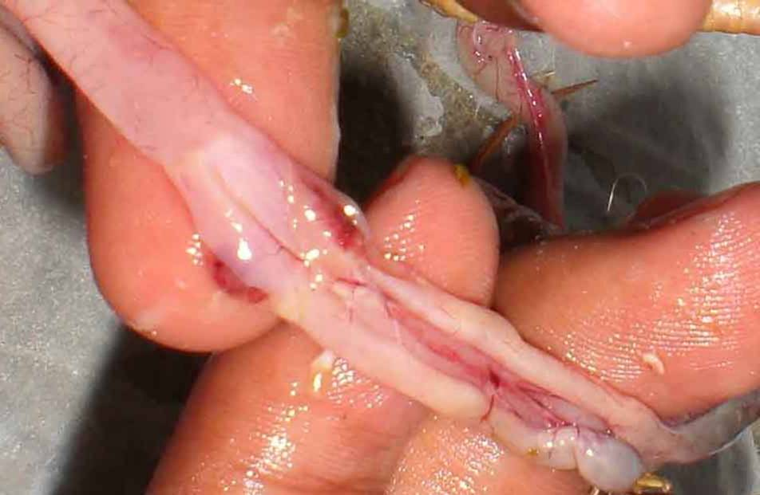
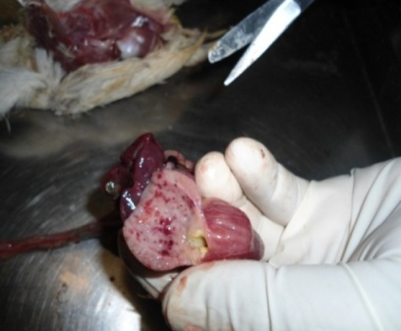
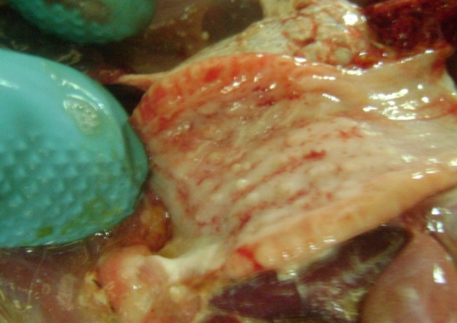
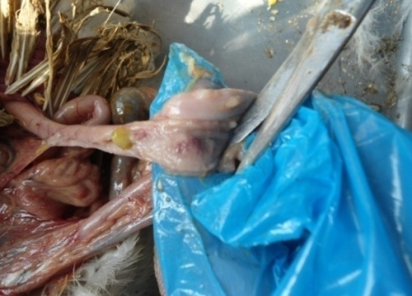

Fig 1b: Thickening of proventricular wall
Fig 1a: Hemorrhage in proventricular gland

Fig 1d: Button like ulcer in intestine
Fig 1c: Hemorrhage in cecal tonsil

Lesions of IBD found in postmortem
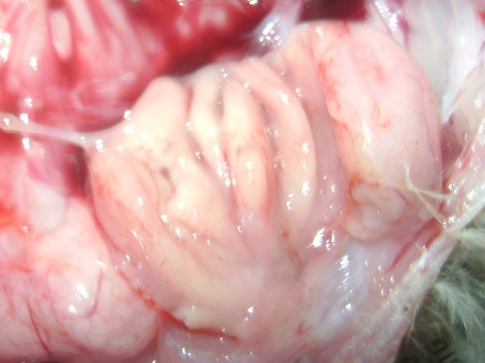
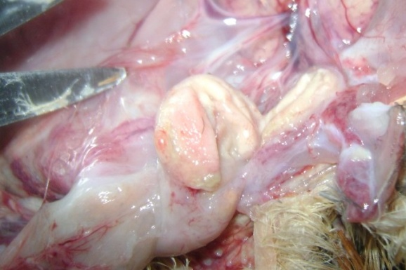

Fig 2b: Caseous mass inside the bursa
Fig 2a: Gelatinous fluid around the bursa

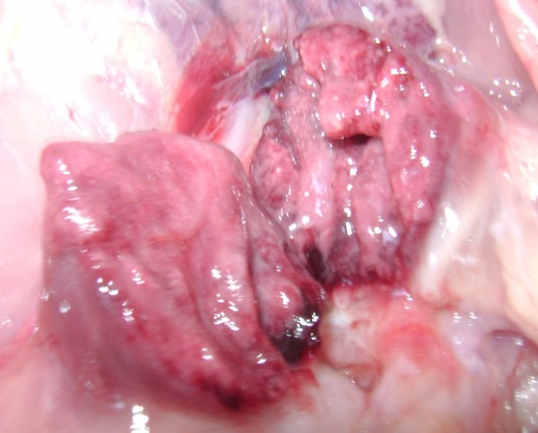
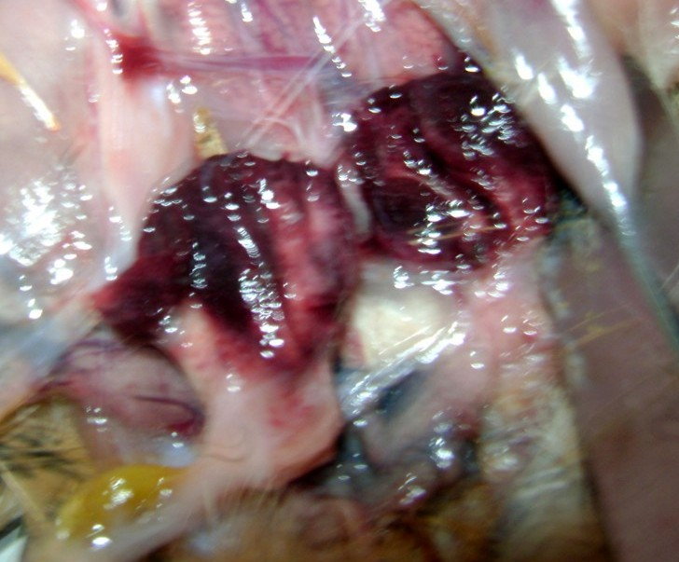

Fig 2d: Clotted blood inside the bursa
Fig 2c: Clotted blood inside the bursa
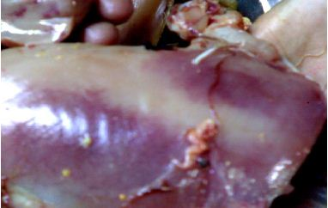
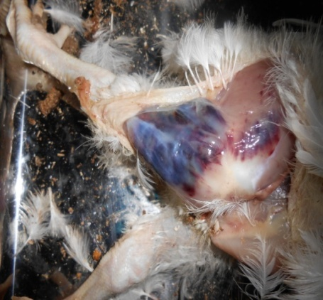

Fig 2f: Hemorrhage on breast muscle
Fig 2e: Haemorrhage in thigh muscle
DISCUSSION
About 8% of the chickens investigated were diagnosed positive with ND which were similar to the findings of Beach (1942), Banerjee et al. (1994) and Alexander (1997). Most commonly observed postmortem lesions were pin point hemorrhages at the tip of proventricular glands, hemorrhagic ulcers in intestinal wall and caecal tonsils, petechial hemorrhage in colon, hemorrhagic lungs, tracheitis with congestion and catarrhal exudates. These findings corroborate with the findings of Kotani et al. (1987), Crespo et al. (1999), Talha et al. (1999) and Pazhanivel et al. (2002).

The prevalence of ND observed in the study is however lower than the reports of BiswasPK et al. (2005), BiswasPK et al. (2006) on chickens including Sonali reared under backyard system in Bangladesh.

A higher prevalence of ND in Sonali chickens, as observed in the study might be relating to weaker biosecurity for them compared to a better system of rearing for broiler chicks. The even distribution of ND in vaccinated and non-vaccinated birds should raise a question on the quality of vaccine used or its preservation and time of vaccination.

This high prevalence of IBD found in this study is in accordance with the observation of Islam et al. (2003) who reported the proportion to be 24% in broiler chickens in Sylhet region. However, there are reports in the other parts of the country which demonstrated the occurrence of this disease is lower than the present findings (Giasuddin et al. 2002; Talha et al.2001).

Highest prevalence (44%) of IBD was found in the group of 15-30 days birds and lowest (0%) in the group of 0-15 days birds. (Lukert and Saif,1997); (Chauhan and Roy,1996) reported that clinically infectious bursal disease mostly occur in the young chicken between 3-6 weeks of age ,but the disease has also been reported to occur between 9 days to 20 weeks of age.
M.S. Rahman et al.(2010) found that the broilers of four weeks of age were highly susceptible to IBD(55%), whereas in third week 12.5% and in fifth week 32.5% chicks were infected with IBDV and the broilers of two weeks of age were not affected with the viirus.
Khan, et al. (2009) reported that IBD affected birds were four weeks old conclusively. Rajaonarison et al., (2006) showed that the birds of three to five weeks of old were most susceptible to IBD.

Wyeth et al., (2003) carried out studies IBDV in Great Britain and reported that IBDV can infect some chicksas young as fifteen days old. In this study no bird was found affected up to fifteen days. Richard and Miles, (2004); Butcher, (2003); Savova and Liupkel (2002); and Chettle et al., (1999) reported that subclinical form of IBD in chicken took placed in less than three weeks of age. In the present study no subclinical form could not be detected.

In this study outbreak of IBD in vaccinated flocks was significantly higher (P<0.05) which has also been described previously by Anku (2003) in Southern Ghana, Islam and Samad (2003) inBangladesh and Jindal et al. (2004) in India. They opined that factors like improper vaccination, poor biosecurity measures and existence of very virulent strains of IBD virus contributed to the occurrence of IBD in the vaccinated flocks.

The mortality rate of IBD (2.%) in this study was similar to a previous report of Jindal et al. (2004). Age of the bird had a significant relationship on the prevalence and mortality of the disease. Mortality due to IBD in chicks was significantly higher in vaccinated chicks, an agreement with the findings of Shil et al. (2003).

The prevalence, mortality and morbidity of IBD were 7.75%, 6.38% and 1.35 %, respectively. Raj Wali Khan (2009), Rajaonarison et al., (2006) and Sami and Baruah (1997) recorded 55 outbreaks of IBD in broiler flocks from 1993-95 with mortality ranging from 0.9-25.7%.

CHAPTER: 5
CONCLUSION
The important postmortem findings in ND and IBD cases during postmortem examinations might be observed in the proventriculus and the Bursa of Fabricious, respectively. The prevalence of ND in the UVH,B might be 8%. The prevalence (%) of ND in Sonali chickens was 14%, which is significantly higher than broiler chicks. ND was also higher in chickens more than one month of age than younger birds. The distribution of ND was even in ND-vaccinated and non-vaccinated chickens.The prevalence of IBD in chicks of 15-30 days' group was much higher than the younger chicks. IBD was also much higher in vaccinated chicks. Farm-based mortality attributable to ND and IBD appears to be 4.% and 2%, respectively.

CHAPTER: 6
REFERENCES

Alexander, D. J. (1988). Newcastle disease: Methods of spread. In: ALEXANDER, D.J. (Ed.). NewcastleDisease, pp. 256-272.
Alexander, D. J. (2003). Newcastle disease, other Parmyxoviruses and Pneumovirus Infections. In: Saif, Y. M., Barnes, H. J., Glossons, G. R., Fadly, M. A., McDougald, D. J., & Swayne, D. E. (Eds.), Diseases of Poultry (pp. 63-100), Iowa State press, Ames.
Alexander, D. J.(2000). Newcastle disease and other avian paramyxoviruses. Rev. sci. tech. Off. int. Epiz. 19(2): 443-462.
Alexnader, D. J. (1997). Newcastle disease and other avian paramyxoviridae infections. In Calnek, B.W. et al., eds. Diseases of Poultry. 10th edn. Ames. Iowa State University Press: 541-569.
Al-Garib, S. O., Gielkens, A. L. J. and Koch, G. (2003). Review of Newcastle disease virus with particular references to immunity and vaccination. World’s Poultry Science Journal, 59, 185-197.
Ali. M. J. 1994. Current status of veterinary biologics production in Bangladesh and their quality control proceeding of BSVER symposium held on july 28, 1994 at NIPSOM auditorium, Mohakhali, Dhaka, Bangladesh
Allan, W. H. and Gough, R.E. (1974). A standard Hemagglutination-inhibition test for Newcastle disease. Vet. Rec. 95:147-149.
Allan, W. H., Lancaster, J. A. and Toth, B. (1978). Newcastle disease vaccines: their production and use. FAO animal production and health series, No. 10, FAO, Rome.

Anku, G. G. 2003. Gumboro hampers efforts to improve nutrition of Ghana’s growing population. Poultry international, 12: 32-36.

Ballagi, P. A. and Wehmann, E. (1996). Identification and grouping of Newcastle disease virus strains by Restriction site analysis of a region from the F gene. Arch Virol, 141, 243-261.
Banerjee M, Reed W, Fitzgerald SD and Paniger B (1994). Neurotropic, Velogenic Newcastle disease incormorants in Michigan: pathology and virus characterization. Avian Disease 38(4): 873-8.
Bangladesh Bureau of Statistics. Livestock survey in 2005-2006.
Beach JR (1942). Avian pneumoencephalitis. Proceeding of annual meeting in US livestock sanitary association. 46: 203-223
Beard, C. W. (1980). Serologic Procedures. In Hitchner, S.B. eds. Isolation and identification avian pathogens. American Association of Avian Pathologists. Kennet Square, PA: 129- 135.

Beard, C. W. and Hanson, R.P. (1984a). Newcastle disease. In: Hofstad, M. S., Barnes, H. J., Calnek, B. W., Reid, W. M., and Yoder, H. W. (Eds.), Diseases of Poultry (pp. 450-470), Iowa State University Press, Ames.

Benton, W. J., Cover, M. S. And Rosenberger, J. K. 1967.Studies of the transmission of the infectious bursal disease agent (IBD). Avian disease, 11: 430-438.
Biswas PK, Biswas D, Ahmed S, Rahman A, Debnath NC (2005). A longitudinal study of the incidence of major endemic and epidemic diseases affecting semi-scavenging chickens reared under the Participatory Livestock Development Project areas in Bangladesh. Avian Pathol. 2005 Aug;34(4):303-12.
Biswas PK, Uddin GM, Barua H, Roy K, Biswas D, Ahad A, Debnath NC (2006). Causes of loss of Sonali chickens on smallholder households in Bangladesh. Prev Vet Med. 2006 Oct 17;76(3-4):185-95
BLRI, (2008). A Study on Highly Pathogenic Avian Influenza in Bangladesh, Bangladesh Livestock Research Institute, Savar, Dhaka.

Brown, M. D., Green, P. and Skinner, M. A. 1994. The antigenic and pathogenic diversity of the IBDV. World poultry science, 8: 41. Peptide map comparison of the proteins of the infectious bursal disease virus. Journal of virology, 32; 1046-4050.
Butcher (2003).Pathogenesis of IBD in commercial broiler flock. IFAS, Florida,32611.

Butcher, G. D. and Miles, R. D. 2001. Infectious bursal disease (Gumboro) in commercial broilers. University of Florida. pp 1-7.

Calnek, B. W. 1997. Infectious bursal disease ( LUKERT, P. D. and SAIF, Y. M. ) of poultry, 10th edition. International publisher limited, pp 721-733.

Chettle, N., Stuart, J. C. and Wyeth, P. J. 1989. Outbreaks of virulent infectious bursal disease in East Anglia. Veterinary record, 125: 271-272.

Chowdhury, E. H., Rahman and Islam, A. 1996. Observation of outbreaks and subsequent control of infectious bursal disease in the central poultry farm in Bangladesh. Bangladesh veterinary journal, 69(9).

Chowdhury, S. I., Chowdhury, T., Sarker, A. J., Amin, M. M. and Hossain, W. (1982). The role of residual maternal antibody on immune response and selection of an optimum age for primary vaccination of chicks. Studies on Newcastle disease in Bangladesh. A research report. 2 (12-22).

Chowdhury, T. I. M. R., Sarker, A. J., Amin, M. M., and Hossain, W. I. M. A. (1982). Studies on Newcastle Disease in Bangladesh. A Research Report: 3.

Cosgrove. 1962. An apparently new disease of chiken avian nephritis. Avian disease, 6: 385-389.
Crespo R, Shivaprasad HL, Woolcock, PR. Chin R.P, Davidson-York D and Tarbell R (1999). Exotic Newcastle disease in a game chicken flock. Avian Disease. 43 (2): 349-355.

Dalgaard, T. S. and Neilsen, O. L. 2002. Major histocompatibility complex-linked immune response of young chickens vaccinated with an attenuated live infectious bursal disease viral vaccine followed by an infection. Poultry science, 81: 649-656.

Doyle, T. M. (1927). A hitherto unrecorded disease of fowls due to a filter-passing virus. J. Comp. Pathol. Threp. 40: 144-169.

Doyle, T. M. (1935). Newcastle disease of fowls. J. Comp. Pathol. Threp. 48: 1-20.

Dybing, 3. K. and Jackwood D. J. 1998. Antigemc and Immunogenic properties of infectious bursal disease viral protein. Avian Disease, 42: 80-91.

Edwards, J. T. (1928). Ann. Rep. Imp. Inst. Vet. Res. Mukteswar, Mar 31st: 14-15.
Giasuddin.M., Sil. B. K., Alam. J., Koike. I., Islam. M. R. And Rahman. M. M. (2002). Prevalence of Poultry Diseases in Bangladesh.Indian Journal of Poultry Science, 2002 (Vol. 40) (No. 1) 99-101

Hitchner, S. B. 1970. Infectivity of infectious bursal disease virus for embryonating eggs. Poultry science, 49: 511-516.

Huaang, G. M. and Qia Sulan 2002. Early stages of infectious bursal disease virus infection in chicken detected by in situ reverse transcriptase polymerase chain reaction. Avian pathology, 31: 593-597.
Islam MT and MA Samad (2003). Outbreak of infectious bursal diseases in vaccinated and unvaccinated commercial cockerel farms in Bangladesh. Bangl J Vet Med, 1: 21-24.

Jackwood, D. J. and Jackwood, R. J. 1997. Molecular identification of infectious virusstarain. Avian disease, 41: 97-104.
Jindal N, NK Mahajan, D Mittal, SL Gupta and RS Khokhar, (2004). Some epidemiological studies on infectious bursal disease in broiler chickens in parts of Haryana, India. Int J Poult Sci, 7: 478-482.
Kaleta, A. F. and Baladauf, C. (1988). Newcastle disease in free-living and pet birds. In Alexander, D.J. eds. Kluwer Academic Publisher: 197-246.
Kamal, A. H. M. and Hossain, I. (1992). Pathological investigation on the mortality in BAU poultry farm. The Bangladesh Veterinarian. 9(1-2): 20-25.
Khan R.W.,Khan F.A., Farid K., Khan I., Tariq M. January (2009). Prevalence of Infectious Bursal Disease in Broiler in District Peshawar.ARPN Journal of Agricultural and Biological science. Vol.4,No.1.

Kibenge, F. S. B., Dhillon, A. S. And Russel, R. G. 1988. Biochemistry and immunology of infectious bursal disease virus. J. Gen. Viro., 69: 1757-1775.
Kotani T, Ddagiri Y, Nakamura J and Horiuchi T (1987). Pathological changes of tracheal mucosa in chickens infected with lentogenic NDV. Avian Disease 31: 491-497.
Kraneveld, F. C. (1926). A poultry disease in the Dutch East Indies. Ned Indisch B1 Diergeneeskd. 38:448-450.
Lukert, P. D. And Saif, Y. M. (1997). Infectious bursal disease: Disease of poultry 9th edition, Wolfe publishing limited, pp 684-663.

Lukert, P. D.And Saif, Y. M. 1997. Infectious bursal disease: Disease of poultry 9th edition, Wolfe publishing limited, pp 684-663.

Macdonald, R. D. 1980. Immunofluorescent detection of double stranded RNA in cells infected with reovirus, infectious pancreatic necrosis virus, and infectious bursal disease virus. Canadian journal of microbiology, 26: 256-261.

Macnulty, M. S., Allan, G. M. and Mcferren, J. B. 1979. Isolation of infectious bursal disease from turkey. Avian pathology, 8: 205-212.

Mandeville, W.F. and Cook, F.K. 2002. Heat lability of five strain of infectious bursal disease virus. Poultry Science, 79: 838-842.

McFerran, J. B. 1980. Infectious bursal disease. In Vims infections of birds (J. B. McFerran and M. S. McNulty, eds). Elsevier Science, Amsterdam., 44: 213-222.

McFerran, J. B. and McCracken, R. M. (1988). Newcastle disease. In Alexander, D.J. eds. Kluwer Academic Publisher: 161-183.

Mohanty, G. C., Pandey, A. P. and Schyns, P. 1971. Infectious bursal disease of chicken .Current Science, 40: 181-184.

OIE. (2002). Office International Des Epizooties. Manual of Standards for Diagnostic Tests and Vaccines. 4th Eds., Paris, France.

Okoye, J. O. A. 1983. The effect of late infectious bursal disease on the severity of naturally occurring Eimerria necatrix in chickens. Bull. An. Health prod. Af., 31: 263-267.

Orajaka, L. J. E., Adene, D. F., Anene, B. M. and Onuoha, E. A. (1999). Seroprevalence of Newcastle disease in local chickens from Southeast derived savannah zone of Nigeria. Revue Elevage Mẻdecine Vẻtẻrinaire Pays Tropicaux, 52 (3-4), 185- 188.

Ozel, M. and Gelderblom, H. 1985. Capsid symmetry of viruses of the proposed birna virus group. Archives of virology, 84: 149-161.
Pazhanivel N, Balsubramaniam GA, George VT and Mohan B (2002). Study of natural outbreak of Newcastle disease in and around Namakkal. Indian Veterinary Journal 79(3): 293-294

Rahman, M. M., Bari, A. S. M., Giusuddin, M., Islam, M. R., Alam, J. and Sil, G. C. (2002). Evaluation of maternal and humoral immunity against Newcastle disease virus in chicken. International Journal of Poultry Science, 1, 161-163.

Rahman, M. M., Rahman, A., Islam A. H. M. N., Miah, A. H., Mazumder, J. U. and Bhattacharjee, P. S. 1996. Observations of outbreaks and subsequent control of infectious bursal disease in the central poultry farm in Bangladesh. Bangladesh veterinary journal, 30 (1-2): 35-39.

Rahman, M. S., Islam, M. S., Rahman, M. T., Parvez, N. H. and Rahman, M. M. 2010. Analysis of prevalence of infectious Bursal disease in broiler flocks in Dinajpur. Int. J. Sustain. Crop Prod., 5, 1: 15-18.
Raj Wali Khan, Farhan Anwar Khan, Kamran Farid, Izhar Khan and Muhammad Tariq(2009). Prevalence Of Infectious Bursal Disease In Broiler In District Peshawar. ARPN Journal of Agricultural and Biological Science vol. 4, no. 1,
Rajaonarison J.J. Rakotonindrina, S.M.Rakotondramary, E.K. and Razafimanjary. S. (2006). Gumboro Disease(Infectious bursitis) in Madagascar. Rev Elev Med Vet Pays Trop. 47(1):15-17.

Rima, B., Alexander, D. J., Billeter, M. A., Collins, P. L., Kingsbury, D. W., Lipkind, M. A., Nagai, Y., Orvell, C., Pringle, C .R., Rott, R. and Meulen, V. (1995). Paramyxoviridae. In Virus taxonomy. 6th report of the International Committee on Taxonomy of Viruses. Springer-Verlag, Vienna and New York: 268-274.

Rodriguez-Chavez, R., Issac, W. S., Cloud, S. and Sandra, M. D. 2002.
Characterization of antigenic, immunogenic and pathogenic variant of infectious bursal disease virus due to propagation in different host systems ( Bursa, embryo and cell culture ). Avian pathology, 31: 4S5-492.

Rosenberger, J. K., Cloud, S. S., Gelb, J., Odor Jr. E. and Dohms, J. E. 1985. Sentinel bird survey of Delmarva broiler flocks. Proc 20thNati meet poultry health condemn, ocean city, MD, pp 95-101.

Saif, Y. M. 1984. Infectious bursal disease virus types. Proceeding 19th Nati Meet Poultry Health Condemn, ocean city, pp 105-107.

Saif, Y. M. and Abdel-Amin, G. A. 2001 .Pathogenecity of cell culture derived and bursa derived infectious bursal disease viruses in specific pathogen free chickens. Avian disease, 45: 844-852.
Sami, W. and G.K. Baruah, (1997). Incidence of infectious bursal disease in broilers in Assam. Ind. J. Vet. Pathol., 21: 67-68.
Savova M. and V. Liupkel. (2002). Asymptomatic course of infectious bursitis in Chicks. Vet Med Nauki.21(10):95-101.

Segal, Y. 2002. Preventing Gumboro disease in poultry .International poultry production, pp 17.
Shil GC, MA Ehsam, MS Rahmn, AKMM Anower and MR Ismal, (2003). diseases associated with mortality and pathological changes in cockerel birds. Bangl J Vet Med, 1:33-38.

Snyder, D. B., Matquadt, W. W., Mallinson, E. T., Savage, P. K. and Allen, D. C. (1984). Rapid serological profiling by ELISA. III Simultaneous measurements of antibody titers to infectious bronchitis virus, infectious bursal disease and Newcastle disease virus in a single serum dilution. Avian Dis. 28: 12-24.

Spradbrow, P. B. (1997). Policy framework for smallholder rural poultry development. In: Proceedings of International Workshop on Sustainable Poultry Production in Africa held in Addis Ababa, Ethiopia (pp. 30-39).

Spradbrow, P. B. (1987). Newcastle disease in Australia. In Newcastle disease in poultry: a new feed pellet vaccine. The Australian Centre for International Agricultural Research: 40-43.
Talha A. F. S. M., Hossain M. M., Chowdury E. H., Bari. A. S. M., Islam M. R. And Das P. M. (2010). Poultry Diseases Occurring in Mymensingh District of Bangladesh, The Bangladesh veterinary journal, 18: 20-23.

Winterfield, R. W., Hitchner, G. S., Appleton and Cosgrove. 1962. Avian nephrosis, nephritis and gumboro disease. L & M News and Views, 3: 103.
Wyeth P.J.,N.J.Chettle and A.R.Mohepat. (2003). Infectious bursal disease in Great Britain. Vet. Rec.130:30-32.
CHAPTER: 7
APPENDIX
QUESTIONNAIRE
Sample No: Date:
Owner name: Mobile no:
1. Type of chicken: Broiler/Layer 2. Strain:
3. Age: ……………..days 4. Flock size: …………….
5. Number of affected bird: …….. 6. Number of dead bird: ………..
7. Vaccination for IBD & ND: Yes/No 8. Age of vaccination:
Disease | Name of vaccine | 1st dose age (days) | 2nd dose age (days)
IBD
ND
9. Type of rearing system: Floor/Cage
10. Source of day old chick: …………………..
11. Source of feed: ……………………
12. Interval between two batch: ………….. days
13. PM Findings: …………………………………………………………………………
…………………………….. Presumptive diagnosis: ……………………………
14. Source of water: Tubewell/pond/others
15. Association of other disease:
16. Presence of IBD/ND in previous batch: Yes/No
17. Biosecurity:
- Presence of backyard chicken within 100 meter of the farm: Yes/No
- Presence of bazar within half kilometer of the farm: Yes/No
- Presence of Main road within 50 meter of the farm: Yes/No
- Receive visitors on the farm premises: Yes/No
- Workers live outside the farm premises: Yes/No
- Access of vendor vehicles on farm premises: Yes/No

