A CLINICAL INVESTIGATION ON PREVALENCE OF NAVEL ILL AND OTHER COMMON NON SURGICAL DISEASES IN DAIRY CALVES WHICH ARE ASSOCIATED WITH DIFFERENT RISK FACTORS SUCH AS AGE, SEX AND BREED IN CHITTAGONG REGION OF BANGLADESH

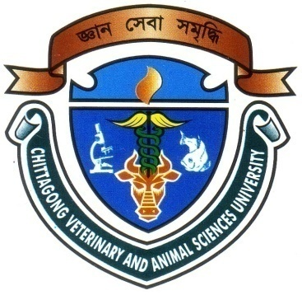

A CLINICAL REPORT
SUBMITTED AS PER APPROVED STYLE AND CONTENT

Signature of author  Mohammad Abdul Moyed Sharif  Roll No : 09/12  Reg. No :424  Intern ID: A-06  Session:2008-2009 | Signature of supervisor  Dr. M.A.Matin Prodhan  Professor & Head  Department of Medicine and Surgery

Chittagong Veterinary and Animal Sciences University
Khulshi, Chittagong-4225

CONTENTS

Chapter | Topics | Page No
 | Acknowledgement | i
 | Abstract | ii
1 | Introduction | 1-2
2 | Review of Literature | 3-9
3 | Materials and Methods | 10-12
4 | Results and Discussion | 13-21
5 | Conclusion | 22
 | References | 23-26
 | Appendix | 27

Acknowledgement

All praises are due to Almighty Allah, who has created everything of the nature and who enables the author to complete this study. The author does not have adequate words to express his heartfelt sense of gratification sincere appreciation to his benevolent teacher and report supervisor. The author expresses his sincere gratitude, heart full respect and immense indebtedness to his supervisor Dr. M.A. Matin Prodhan, Professor and Head. Department of Medicine and Surgery, Chittagong Veterinary and Animal Sciences University, for his valuable advice, guidance, suggestions, inspiration and who was involved with this study through its inception. Special thanks to Dr. Bibek Chandra Sutradhar, Associate Professor & Director (External affairs) Department of Medicine and Surgery, for his valuable advice and co-operation.

Supervisors` help and co-operation have received from many persons during the tenure of this place of report. The author is immensely grateful to all of them, although it is not possible to mention everyone by name.

The Author

i
A CLINICAL INVESTIGATION ON PREVALENCE OF NAVEL ILL AND OTHER COMMON NON SURGICAL DISEASES IN DAIRY CALVES WHICH ARE ASSOCIATED WITH DIFFERENT RISK FACTORS SUCH AS AGE, SEX AND BREED IN CHITTAGONG REGION OF BANGLADESH

ABSTRACT

The objectives of this investigation was to identify the different risk factors like age, sex, breed which have occurrence to produce some non surgical common diseases in dairy calves at Chittagong region. Clinical investigation of a total of 301 calves, where 117 infected calves of both sexes (male & female), aged between <3 to >3 weeks, in different breeds(cross, HF and RCC) were obtained by using a preset questionnaire, by taking history of the patient, clinical examination and observing presenting clinical signs. The overall diseases were diarrhea (30%), anorexia (24.7%), fever (12%), naval ill (8.5%), conjunctivitis (7.7%), pneumonia (3.4%), joint ill (1.7%), and blot (12%). The case of diarrhea was higher (30%) than that of other diseases. The occurrence of diseases was higher in cross breed (70%) than HF (20.5%) and RCC (9.5%) where navel ill higher in cross breed (6%) than HF (1.7%) and RCC (0.8%). Cases of diseases were higher in male calves (53%) than that of female calves (47%) but the variation was insignificant (p>0.05) where prevalence of navel ill also higher in male calves (7.7%) than female calves (0.8%). The effect of age on diseases were found significantly (p<0.05) higher in < 3 weeks (74.8%) than that of > 3 weeks of age (25.2%) here prevalence of navel ill also higher in <3 weeks of age (6.8%) than >3 weeks of age (1.7%).The result demonstrate significant effect of breed, age and sex on the occurrence of diseases in calves.

Key word: Navel ill, Risk factor, Dairy calves.

ii

