Chapter-I

INTRODUCTION

Rabbits are social, burrowing herbivores that are natural prey for a large number of carnivores. As a prey species they have evolved to be constantly vigilant, lightweight and fast-moving, with a highly efficient digestive system that enables them to spend the minimum time possible above ground and in danger of capture.

The domestic rabbit compared with other livestock, is early maturing and high prolific. The meat is white, high in good quality protein content, low fat and caloric contents, contains a higher percent of minerals. The potential for rabbit production in farm is high (Borter and mwanza, 2011) due to the rapid expansion and adoption of rabbit farming. However diseases of rabbit are a major challenge to rabbit farming in country level (Hungu et al. 2013; Serem et al. 2013). Systemic studies on the diseases of domestic rabbit are rare and scanty (Aleri et al. 2012; Ngatia et al.1988).

In recent years there has been rising awareness on increasing meat requirements due to rapidly increasing human population in developing countries like India and Bangladesh. The availability of meat in India is 5.2 Kg per person per year against the requirement of 16.0 Kg per person per year (FAO, 2004). Amongst meat animals, rabbit is one of the important livestock species which supplies meat protein to human consumption. In backyard rearing, rabbit can meet the animal protein needs of an average family and is a suitable and cheaper alternative to poultry. Rabbit is a herbivorous animal and strives mostly on natural vegetation. It can consume large quantities of forages that are not used by human beings. Rabbit farming shall be advantageous in view of the low capital investment, less space requirements, short generation interval, better growth rate, high reproductive potential and ability to utilize the abundant forages and fibrous agricultural byproducts (Cheeke, 1986 and Joseph et al., 1997). The diseases that are encountered by rabbits are the limiting factors for the successful multiplication and on the whole the growth of the rabbit industry. Though rabbits are susceptible to many bacterial, viral and protozoan diseases, some infections are very acute and make a clean sweep of the rabbit population. Rabbit haemorrhagic disease (RHD) is a highly infectious disease epidemic among meat type rabbits causing 100% mortality.

Bangladesh is a developing country of the world. Using of laboratory animals like rabbits, rats and guinea pigs is increasing day by day for experimental purposes. Beside this, rabbits are excellent source of lean meat with high quality proteins. The knowledge of diseases variations is important for knowing the diseases prevalence, practical and theoretical significance for experimental research and surgical practice in experimental and domestic animals and keep awareness to save the public health.

Despite of being a very familiar one, few works has been reported on morphology, physiology and pathology of digestive system of rabbit (Anna Meredith, 2001, 2010; Nathan, 2006; Cathy, 2006; sarah goulter, 2009; Smith et al., 2009; Alessandro Zotti et al., 2009; Byanet Obadiah et al., 2011) in different countries.

Records of ante- and post-mortem inspection allow to collect epidemiological data useful for the evaluation of diseases at country level and to verify the efficacy of prophylactic and therapeutic interventions (Cortesi, 1993). Unfortunately, very few papers were published on this field. According to this “epidemiological” role of rabbit diseases prevalence, the aim of this survey was to appreciate the kind and prevalence of rabbits diseases in two south Asian countries – Bangladesh and India.

Objectives of my experiment:
To determine the prevalence & etiology of diseases of domestic rabbits in the selected areas.
To determine the predisposing factors associated with rabbit diseases in the selected areas.
To estimate monthly survival and diseases prevalence rates in rabbits associated with some risk factors.
To quantify the dynamics of diseases prevalence to each virus/bacteria/parasite/fungus over time.
To compare the prevalence estimates of different diseases of rabbits clinically observed Bangladesh and India.

Chapter-II

REVIEW OF LITERATURE

Location of farm, type and maintenance status of housing structure, housing density, age and genetics of rabbits and presence of potential pathogens including coccidian, virus and bacteria are the risk factors that predispose domestic rabbits to diseases. The etiological agents involved in causing diseases of domestic rabbits are coccidia, bacteria, Spirochetosis,Deficiency syndrome and mites.Diseases of the digestive system, skin and the ears are the main causes of morbidity and mortalities in domestic rabbit.Diarrhea, alopecia and ear crust and scabs are the common clinical signs of domestic rabbit diseases observed by rabbit keepers.(OKUMU et al 2014).

The main aim of our experiment is to compare the prevalence of rabbit diseases among the Barisal UVH & with the India. From the collected data we found that the diseases prevalence are slight difference among the Bangladesh compare with India. It is true that the Diagnosis technique is very developed in India so the diseases range is high in India rather than Bangladesh. From the data analysis we found a clear scenario of diseases prevalence of rabbit that are sustain in India& Bangladesh. Comparative study of this experiment revealed that in Bangladesh the skin mange prevalence is high all over the country. As rabbit is only use in recreational purpose in Bangladesh, the main diseases is faced by the owner are mange, deficiency syndrome like vitamin A,D,E& minerals deficiency. On the other hand the rabbit Hemorrhagic disease is fatal for the rabbit and can destroy the whole farm by the diseases (Kumar R.S et al-2014). The outbreak of an epidemic was observed at the rabbit unit of the Livestock Farm, Veterinary College and Research Institute, Namakkal, Tamil Nadu, India. Initially, it was observed that adult animals were dull, went off feed and did not drink water. Subsequently, a febrile condition with temperature of 49⁰ C along with lacrimation and nasal discharge followed by dyspnoea was observed. Affected animals died within 24 to 48 hours after onset of symptoms. The dead animals showed bleeding from the nostrils and eyes. (Kumar R.S et al-2014).
For this reason, the study of rabbit disease often involves an epizootiological perspective and in practice, it is necessary to understand the causative agents as well as predisposing and enabling risk factors (Thrusfield, 1995).

In conclusion, the health status of rabbits can be considered satisfactory; tegumentary lesions continue to represent common diseases of farmed rabbits, even if enteric disorders seem increasingly becoming more significant (Albiero L. 1988.). From our findings, it is noteworthy to underline that most of the pathological lesions observed at slaughtering are the outcome of chronic diseases; whereas acute diseases, often causing significant economic losses in the modern rabbit farming, might go undetected. Consequently, it is evident that information collected at slaughterhouse could not give a complete picture of disease problems at farm level. In contrast, it is comprehensible that detecting chronic diseases at the farm level, even if at low prevalence, could mean an exponentially more severe problem at the farm. Thus, it could be hypothesized that the selection of rabbits during the growing period and at loading for abattoir could determine an underestimation of diseases occurring at the farm, particularly acute diseases. It could also be hypothesized that morbidity could be low at the farm, but this is clearly in contrast with the recent scientific literature (EFSA, 2005). Recently, commercial rabbit farming has been considerably industrialized, but domestic rabbit can easily suffer stress because it is still not completely adapted to the intensive husbandry and management systems. For this reason, diseases might cause devastating effects with high mortality rates at farm and consequently lack of detection during slaughtering process. Nevertheless, the slaughterhouse seems to play a good “epidemiological” role for chronic diseases, but it does not allow obtaining a comprehensive picture of rabbit diseases (COLIN M., LEBAS F. 1996.).

CHAPTER-III

MATERIALS AND METHODS

Location and duration of the study:
The study was conducted in different breeds of rabbit registered at the Upazilla Veterinary Hospital, Barisal shadar, during February, March and April 2014. Every Rabbit registered here was clinically examined. And this collected data was compared with the diseases found in VC&RI, Namakkal and Madras veterinary college, India from March through may 2014.

Study population:
Ninety-four rabbit were examined in February, 126 in March and 113 in April 2014 in the Upazilla Veterinary Hospital Barisal during the study period. And 307 rabbits were examined in March, 314 in April and 285 in May 2014 in India.

Case definition:
Diagnosis was made by means of Anamnesis and clinical signs. All the clinical signs were properly noted in the record sheet. Sometimes the tentative diagnosis was supported with hematological findings and post mortem examinations. The common diseases of rabbitswere diagnosed on the basis of anamneses, sharing the clinical experiences of the placements supervisors, descriptions from owners and clinical examinations, and disease register records,as described below:

Ectoparasitic diseases (mange)
Psoroptic mange is a disease due to Psoroptes cuniculi with a low prevalence (3%) and moderate incidence: 29% of the rabbitries were found to be affected (Rosell, 2003, Chantal 2004). Hot summers (high temperatures and humidity) as well as poor hygiene and microclimatic conditions and lack of essential nutrients in feeding (e.g. vitamin A) are risk factors that lead to an increase of prevalence. In severe cases, reproduction failure is observed. The consequences for rabbit welfare are obvious as they scratch and develop proliferative and often ulcerated lesions on the internal sides of auricles and along the auditive meatus due to the irritiation and is a welfare issue. Infestation has an adverse impact on productivity, and is an economical disbenefit.
Sarcoptic infestation due to Sarcoptes scabiei var cuniculi is a rare disease in commercial rabbitries. Differential diagnose is necessary with ringworm.

Coccidiosis
Definition and etiology: Enteric and hepatic coccidioses are the main parasitic infections (Peeters, 1987; Coudert et al., 1995). All eleven species that infect rabbits belong to the genus Eimeria, and they replicate in the intestinal epithelium or in the liver (E. stiedai) (Eckert et al., 1995).

Clinical signs and lesions: The replication of coccidia in the intestinal mucosa compromises gut function through a thinning of the mucosal layer and reduced absorption and secretion. Infection induces diarrhea of variable severity, and death in debilitated animals, even if the more frequent sign is just a reduction of production parameters.

Diagnosis: The diagnosis is quite easy to achieve either in live rabbits or at post mortem. It is important to count the number of oocyst in faeces, since it could be a good indicator of the environmental contamination as well as to identify the Eimeria species since they have different virulence and pathogenicity.

Rabbit Haemorrhagic Disease(RHD)
Definition: Rabbit Haemorragic Desease (RHD) is a highly contagious and acute fatal disease of wild and domestic European rabbits (Capucci and Lavazza, 2004).

Agent: RHD is caused by a non-cultivable calicivirus with one serotype and one major antigenic variant (RHDVa). In addition, at least one related non-pathogenic virus (Rabbit Calicivirus-RCV) has been identified, and the existence of other RHDV-like viruses has been indirectly demonstrated by serological evidence.

Clinical signs and lesions: acute disease with few signs and sudden mortality (nervous signs and death within 48-96h). Typical lesions are: liver degeneration (hepatitis), spleen enlargement and diffuse haemorrhages. RHD is characterised by very high morbidity (90-100%) and a mortality rate between 40-90%. Infection occurs in rabbits of all ages but clinical disease is observed only in animals over 40-50 days of age. The mechanism of resistance in young animals is still unclear and is probably correlated to the pathogenesis of the infection.

Diagnosis: Presumptive diagnosis is based on clinical signs and lesions; diagnosis of confirmation as well as strain characterization is made from laboratory tests (ELISAs and PCR).

Pasteurellosis (Snuffles)
Definition: Pasteurellosis is one of the most common and severe bacterial diseases in the rabbit. It is characterized particularly by disease of the respiratory system, by pyogenic lesions affecting other organs, and even enteritis and septicaemia.

Etiology: Pasteurella multocida, is a Gram negative bacillus. Strains are classified on the basis of capsular (A,B,D,E,F) and somatic (1-16) antigens. Rabbit strains of Pasteurella usually belong to Group A. However there is little or no relationship between serotype and pathogenic potency. The degree of virulence is linked to the presence of the enzyme ornithine decarboxylase (ODC) and the growth of the bacteria in large colonies.

Clinical signs and lesions: Pasteurella multocida causes several disorders of the rabbit. Most relevant are those concerning a respiratory syndrome: rhinitis, coryza and snuffles, and pneumonia, but also otitis and genital troubles (e.g., orchitis, and metritis), and septicemia (Di Giacomo, 1992). So called “Pasteurellosis” is frequently related to respiratory diseases of the rabbit, but there are other pathogens as determinants of respiratory diseases; for instance, Chlamydia spp. (including Chlamydophila psittaci), Mycoplasma spp., and Staphylococcus aureus. The disease can be acute causing septicaemia but it can also develop into a chronic form.

Diagnosis: The presumptive diagnosis of Pasteurellosis is based on lesions at necropsy, especially when respiratory tract is involved, and by laboratory examination: isolation of P. multocida from infected organs, nasal and vaginal swabs.

Salmonellosis (Scours)
Definition: Salmonellosis is a bacterial disease caused by several serotypes of Salmonella. Since it is a zoonosis it is of high economic and social importance.

Agent: Salmonellosis is usually caused by few species-specific serotypes: S. Typhimurium, S. Enteritidis and S. Pullorum.

Clinical signs and lesions: Rabbit salmonellosis can induce enteritis in nursing and adult rabbits, septicaemia, abortions and perinatal mortality. Such clinical signs can be seen separately or together, and the disease can be acute, chronic or even latent (Lebastard et al., 1995).

Diagnosis: Diagnosis is achieved by isolation of Salmonella from infected organs (liver, spleen, lung and uterus) or from blood in the case of septicaemia. Serotype identification is further obtained, using bacteriological and molecular methods.

Fungal infection (Dermatomycoses)
Definition and Agent: Fungal diseases are a major cause of skin disorders (as well as Pseudomonas aeruginosa, Staphylococcus aureus, sarcoptic mange) mainly due to dermatophytes such as Trichophyton mentagrophytes and Microsporum canis that can cause severe superficial infection or dermatophytosis (Cabañes, 2000). The aetiology depends on the country; for instance, in Spain, T. mentagrophytes is responsible over 90% of the infections on commercial farms (Torres-Rodríguez et al., 1992). Dermatophytoses or ringworm must be differentially diagnosed from sarcoptic mange and disorders produced by other mites, as Cheyletiella parasitovorax and Leporacus gibbus.

Clinical signs and lesions: The lesions appear mainly on the head, ears and paws. There is alopecia (complete or partial) and the skin is dry and rough. Lesions can have secondary infections and become purulent.

Enteritis Diarrhoea (Colibacilosis)
Definition: Colibacillosis constitutes one of the most important causes of diarrhoea, enteritis and mortality in suckling kits and post-weaning growing rabbits (Camguilhem et al., 1986).

Agent: All rabbit E. coli belong to the Entero Pathogenic E. coli (EPEC) group i.e. they do not produce toxins and do not invade the gut wall but just attach to the intestinal mucosa and cause a loss of microvilli, epithelial desquamation and villus atrophy.

Clinical signs and lesions: The most important sign is diarrhoea but the disease varies according to age of affected animals, the virulence of the strain and the infecting dose. In suckling rabbits mortality (up to 100%) occurs within 24-48h. At necropsy the stomach is full of milk and intestinal contents are fluid and often haemorrhagic. In postweaned rabbits, mortality rates are lower and accompanied by lethargy, diarrhoea, and distension of the intestines due to presence of gas, and mucoid enteropathy.

Diagnosis: For the diagnosis of colibacillosis, suspected on the basis of clinical signs, it is necessary to run laboratory examinations (bacteriology and strain identification by biochemical, enzymatic and molecular methods).

Mastitis
Definition and Agent: Staphylococcal diseases are produced by Staphylococcus spp., with a special incidence of pathogenic Staphylococcus aureus, a common organism of rabbit skin and the upper respiratory tract.

Clinical signs and lesions: There are two types of infections in rabbits: mild and severe. Rabbits with a normal immune status, in good health and body condition can be infected by strains of S. aureus with low-moderate virulence, but not by the most pathogenic and virulent biotypes and phage types (Vancraeynest et al., 2004). Acute cases of “blue breasts” can be seen in primiparous does in rabbitries affected by high virulent and pathogenic strains of Staphylococcus aureus, however, other organisms can also be involved, e.g. Pasteurella multocida (Cerrone et al., 2003). Acute mastitis can be lethal. Chronic forms of mastitis affecting mammary gland represents a mean prevalence of 5% (Rosell, 2003, cited 2005). Other chronic forms are, pyoderma pustulosa in nursing rabbits and lactating females (which is the only pathognomonic pattern of Staphylococcus aureus, according to Anderson, 1986), multifocal abscesses (internal, external or both), and dermatitis: e.g., dermatitis digitalis, pododermatitis ulcerosa (or “sore hocks”), pneumonia and septicemia. These chronic forms are often observed at physical examination, for instance before the beginning of a new reproduction cycle, or at insemination. Chronic forms increase mortality of newborn and nursing rabbits, and survivors are thinner at weaning.

Diagnosis: The presumptive diagnosis of Staphylococcosis is based on lesions at necropsy, especially in mastitis and in dermal lesions in the kits. It may be possible to isolate S. aureus from infected organs and tissues.

Statistical analysis:
All the data that were collected (categorical variables – Sl. No., Diseases, symptoms, diseases animal) were entered into MS excel (Microsoft office excel-2007, USA). Data management and data analysis were done by STATA version-12.1 (STATA Corporation, College Station, Texus). Prevalence was calculated according to different categories of the explanatory variables. To calculate the prevalence, total number of cases was divided with the total number of population for that specific category of the variable.

$$Prevalence\%=\frac{ Total number of affected animal }{Total number of animal}×100$$

CHAPTER-IV

RESULTS

The major diseases that were recorded in the Barisal UVH included skin mange, diarrhoea, malnutrition, abscess, coccidiosis, pneumonia, accidental injuries, mycoses and spirochetosis. Pictorial presentations of some interesting disease conditions that have been encountered are shown in Figures 1 -6, illustrating Abscess, Hemorrhagic disease, Coccidiosis, Pneumonia, Skin mange and conjunctivitis.

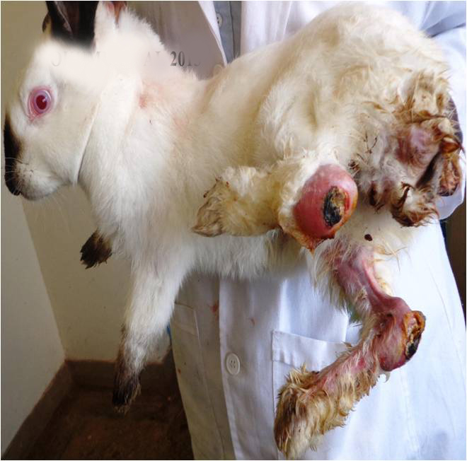
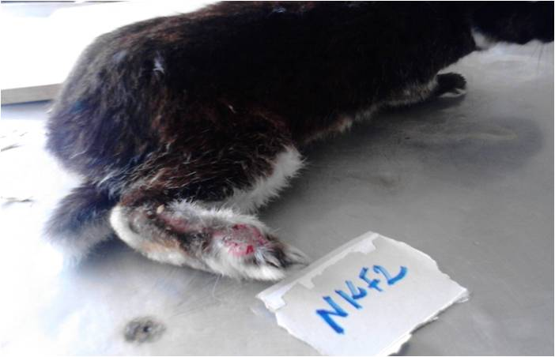

Fig 1: Abscesses in rabbit (swellings on the skin palpable)

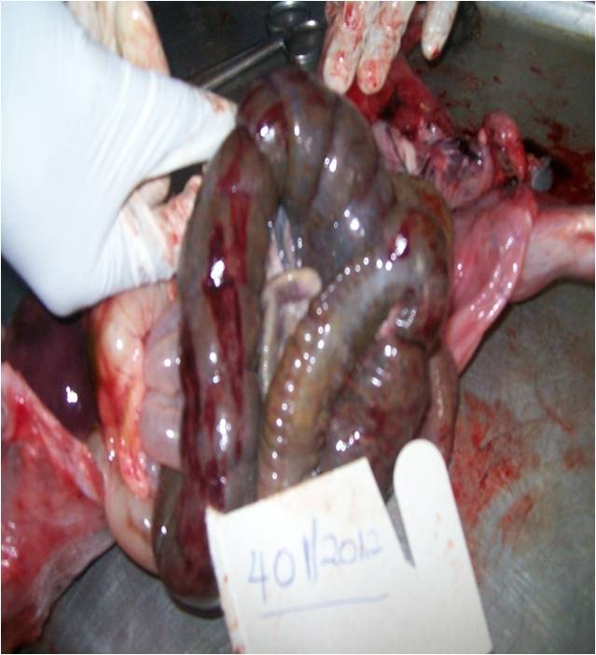
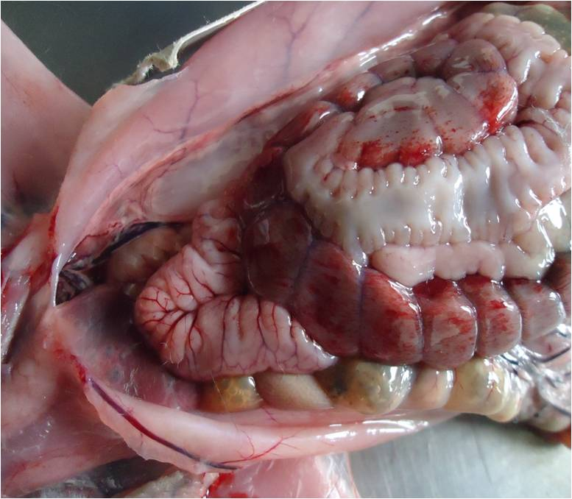

Fig 2: Hemorrhagic Diseases (Ecchymotic hemorrhages on the ceacal serosa of a rabbit)

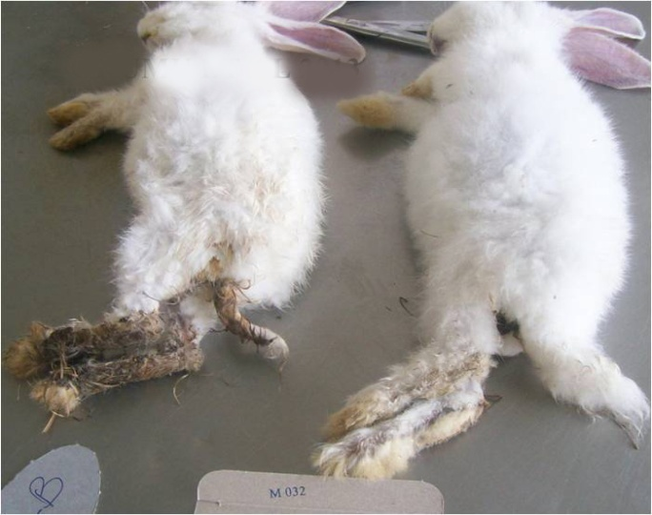
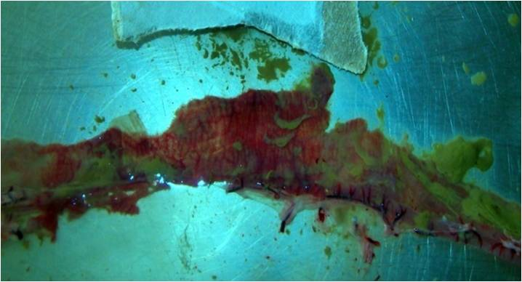
2
1

Fig 3: Intestinal Coccidiosis (1-Rabbit carcasses showing matted perineum 2. hemorrhages and congestion on the intestinal mucosa)

1
2

Fig 4: Pneumonia in Rabbit (1.Purulent nasal discharges, 2. Fibrin covers on the lung surface)

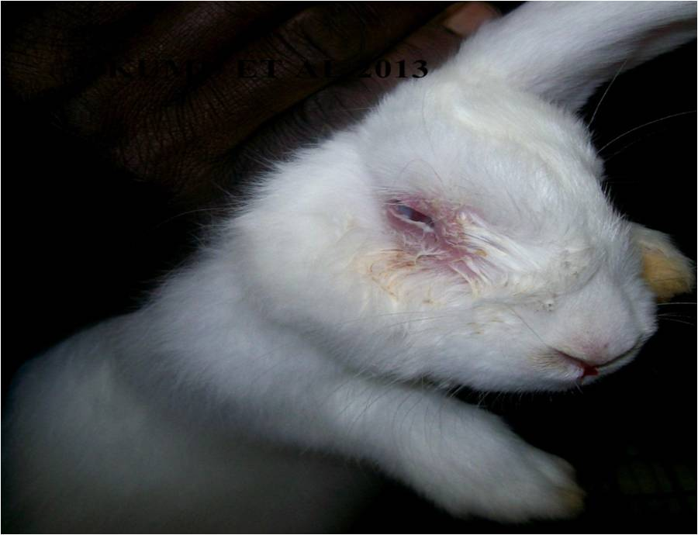
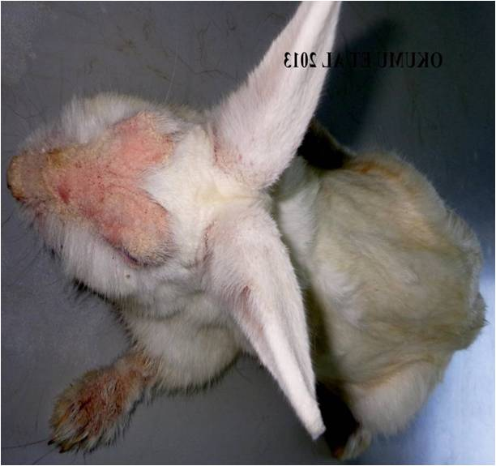

Fig 6: Conjunctivitis (Mucopurulent discharges from eye)
Fig 5: Skin Mange (Alopecia, and erythema around nostrils, upper and lower lips, eye and fore paws)

In the Barisal UVH the disease along with their prevalence estimates (in percentage) were: - Skin Mange (44.25%), Enteritis: Diarrhoea (18.0%), Malnutrition (15.54%), Abscesses (9.76%), Coccidiosis (6.22%), Pneumonia (2.21%), Accidental case (2.01%), Fungus Infection (1.65%), Spirochetosis“Vent Disease” (0.35%).

In India the diseases and their prevalence estimates were - Coccidiosis (24.98%), Skin Mange (24.46%), Enteritis: Diarrhea (8.06%), Abscesses (7.59%), Malnutrition (5.73%), Pneumonia (5.58%), Pastaurellosis “Snuffles” (4.59%), Salmonellosis “Scours” (4.54%) Haemorrhagic Disease (4.25%), Ringworm (2.57%), Spirochetosis “Vent Disease” (2.12%), Conjunctivitis “Weepy Eye” (1.62%), Accidental case (1.20%), Mastitis “Blue Breast” (1.19%), Ketosis (0.44%), Caked Mammary Gland (0.44%) Fungus Infection (0.43%), Heat Exhaustion (0.22%).

Sl. no | Diseases of Rabbit | symptoms | Number of diseases animal found(2014)
 |  |  | BARISAL UVH |  |  | MVC and VC&RI INDIA
 |  |  | February | March | April | March | April |  | May
1. | Abscesses | Bacterial infection , Purulent discharge | 10 | 9 | 13 | 33 |  | 19 | 17
2. | Caked  Mammary  Gland | Mammary glands swollen, hot and firm.  Often mistaken for mastitis. | 0 | 0 | 0 | 3 |  | 0 | 1
3. | Coccidiosis | Diarrhea, loss of flesh, pot belly, loss of appetite, rough fur coat. | 5 | 9 | 7 | 66 |  | 73 | 86
4. | Conjunctivitis  “Weepy Eye” | Tear formation and fluid runs down cheek. | 0 | 0 | 0 | 5 |  | 9 | 1
5. | Skin Mange | Scabs or a crust start forming at base of inner ear. loss of hair, scaly  skin and intense itching and scratching. | 43 | 55 | 49 | 75 |  | 81 | 66
6. | Enteritis:  Diarrhea | watery diarrhea | 12 | 33 | 17 | 23 |  | 16 | 33
7. | Haemorrhagic Disease |  | 0 | 0 | 0 | 12 |  | 9 | 17
8. | Fungus  Infection | dry scaly skin (dandruff) on the shoulders and back. | 3 | 0 | 2 | 1 |  | 3 | 0
9. | Heat  Exhaustion | Increased respiration rate, panting, prostration, and excessive saliva discharge | 0 | 0 | 0 | 0 |  | 2 | 0
10 | Ketosis | occurs just before or just after kindling. Does go off feed | 0 | 0 | 0 | 3 |  | 0 | 1
11 | Mastitis  “Blue Breast | Mammary gland will become red in color, swollen, tender and dark blue streaks may appear. | 0 | 0 | 0 | 2 |  | 7 | 2
12 | Pastaurellosis  “Snuffles” | Nasal discharge, watery eyes, head shaking, sneezing or rattling noise in breathing and a loss of weight | 0 | 0 | 0 | 23 |  | 12 | 7
13 | Pneumonia | Elevated temperature, labored breathing, nasal discharge and loss of appetite | 4 | 3 | 0 | 16 |  | 23 | 12
14 | Ringworm | Loss of hair in circular patches. A yellowish crust forms and sloughs off | 0 | 0 | 0 | 5 |  | 7 | 11
15 | Spirochetosis  “Vent Disease” | Blisters or scabs occur on the sex glands | 1 | 0 | 0 | 3 |  | 7 | 9
16 | Tyzzers  Disease | diarrhea, dehydration and death within 48 hours due to stress conditions and poor sanitation | 0 | 0 | 0 | 0 |  | 0 | 0
17 | Salmonellosis  “Scours" | diarrhea, loss of  weight, conjunctivitis, and rapid breathing. | 0 | 0 | 0 | 22 |  | 17 | 3
18 | Accidental case | Any accident | 4 | 0 | 2 | 3 |  | 6 | 2
19 | Deficiency syndrome | Vitamin & minerals deficiency | 12 | 17 | 23 | 12 |  | 23 | 17
20 | Total |  | 94 | 126 | 113 | 307 |  | 314 | 285

Table 1: The frequencies of major rabbit diseases as observed at the Bariisal UVH,
Bangladesh

The frequencies of major rabbit diseases observed at the Barisal UVH are shown in Table 1 and the monthly trends of the predominant diseases from the place are displayed in Figure 7. As many as 19 disease or disease conditions can be seen in rabbits reared in the Barisal district. Of which skin mange is the predominant one with a frequency of 44% of all the total cases recorded.

Diseases of Rabbit | Prevalence of rabbit Diseases in Barisal UVH, Bangladesh, 2014 (%)
 | February | March | April | Average
Abscesses | 10.64 | 7.14 | 11.50 | 9.76
Coccidiosis | 5.32 | 7.14 | 6.19 | 6.22
Skin Mange | 45.74 | 43.65 | 43.36 | 44.25
Enteritis: Diarrhoea | 12.77 | 26.19 | 15.04 | 18.0
Fungus Infection | 3.19 | 0 | 1.77 | 1.65
Pneumonia | 4.26 | 2.38 | 0 | 2.21
Spirochetosis“Vent Disease” | 1.06 | 0 | 0 | 0.35
Accidental case | 4.26 | 0 | 1.77 | 2.01
Malnutrition | 12.77 | 13.49 | 20.35 | 15.54
Total | 100 | 100 | 100 | 100

Table 2: Prevalence (%) of rabbit Diseases in Barisal UVH, Bangladesh.

Diseases of Rabbit | Prevalence Of Diseases MVC and VC&RI INDIA (%)
 | March | April | May | Average
Abscesses | 10.75 | 6.05 | 5.96 | 7.59
Caked Mammary Gland | 0.98 | 0 | 0.35 | 0.44
Coccidiosis | 21.50 | 23.25 | 30.18 | 24.98
Conjunctivitis “Weepy Eye” | 1.63 | 2.87 | 0.35 | 1.62
Skin Mange | 24.43 | 25.80 | 23.16 | 24.46
Enteritis: Diarrhea | 7.49 | 5.10 | 11.58 | 8.06
Haemorrhagic Disease | 3.91 | 2.87 | 5.96 | 4.25
Fungus Infection | 0.33 | 0.96 | 0 | 0.43
Heat Exhaustion | 0 | 0.64 | 0 | 0.22
Ketosis | 0.98 | 0 | 0.35 | 0.44
Mastitis “Blue Breast” | 0.65 | 2.23 | 0.70 | 1.19
Pastaurellosis “Snuffles” | 7.49 | 3.82 | 2.46 | 4.59
Pneumonia | 5.21 | 7.32 | 4.21 | 5.58
Ringworm | 1.63 | 2.23 | 3.86 | 2.57
Spirochetosis “Vent Disease” | 0.98 | 2.23 | 3.16 | 2.12
Salmonellosis “Scours” | 7.17 | 5.41 | 1.05 | 4.54
Accidental case | 0.98 | 1.91 | 0.70 | 1.20
Malnutrition | 3.91 | 7.32 | 5.96 | 5.73
Total | 100 | 100 | 100 | 100

Table 3: Prevalence (%) of rabbit diseases in Madras veterinary college and VC&RI India.

Fig 7: Monthly prevalence (%) of rabbit diseases in Barisal UVH, Bangladesh.

Fig 8: Prevalence (%) of rabbit diseases at MVC and VC&RI, India.

Fig9.Comparison of prevalence (%) estimates of major rabbit Diseases at Barisal UVH and MVC plus VC&RI, India.

The frequencies of major diseases of rabbits seen at the MVC and VC&RI, India are presented in Table 3 and Figure 8 is portrayed with the predominant ones. There, skin mange and coccidiosis are more frequently reported diseases with frequency of ~25% each. A comparative scenario of predominant diseases of rabbits at the Barisal UVH and at the MVC and VC&RI, India is shown in Figure 9. The summary of this comparison indicates that shin mange in the number one disease of rabbits registered to the Barisal UVH while this disease and another one –coccidiosis could equally be seen at the MVC and VC&RI, India.

DISCUSSION

In above experiment we saw a clear picture of different diseases and we found that in Bangladesh the main diseases prevailed in UVH is skin mange. Enteritis: Diarrhoea ,Coccidiosis, Abscesses, Deficiency syndrome are also a big problem for Bangladesh. But developing country like Bangladesh the Rabbit farming is not very popular & the rabbit keeper are not very concern about their animal health condition. The small scaled farm has very poor hygienic management and this is may be the main cause of these prevailed diseases. So the main concern of our country is to ensure the good hygienic condition for the rabbit house so that the diseases can be controlled.

On the other hand the main picture we found in India is that the main diseasesin rabbits in India probably coccidiosis and skin mange. Haemorrhagic Disease, Pneumonia, Salmonellosis “Scours” Enteritis: Diarrhoea,Abscesses,Pastaurellosis “Snuffles” are the main disease threatsof rabbits in India. In this experiment we found that diseases picture in Bangladesh and India are more or less common and same patterns.

A similar study was conducted in Kenya which identified the major diseases in rabbits there along with their prevalence estimates: Mange (8.20%), Abscesses (6.56%), Pneumonia (14.75%), Enteritis (29.51%), Intestinal coccidiosis (47.54%), Hepatic coccidiosis (11.48%), Mucoid enteropathy (8.20%), Helminthosis (3.28%), Intestinal obstructions (3.28%), Hemorrhagic diseases (3.28%). (OKUMU et al 2014).

CHAPTER-V

CONCLUSION

The main problems holding back development and improvements in rabbit health and welfare is the lack of research and of a cohesive structure in the industry by which improvement strategies can be implemented at farm level. Specific risk profiles for disease and husbandry practices are included in the report and some of the associated conclusions and recommendations have been included.

In this report, based on the scientific data as well as the experience of the Working in the field, Report we draw some conclusions and make recommendations as well as giving pointers for future research. Overall there is a serious lack of information and scientific studies on the farming of rabbits compared with other farmed species, particularly on Diseases management. While there are few data on the types of rabbit farming systems it can be generally considered to be intensive with rabbits being reared in cages rather than being kept in large areas equivalent to a free-range style as with some other farmed species.

Farmed rabbits are genetically not far removed from other rabbits used in laboratories or those in the wild and so their needs, the causes of poor hygiene, and their susceptibility to disease are very similar.

In addition to improvements in health there is also a need to improve rabbit welfare by modifying both housing and husbandry practices. In fact, disease status may actually be improved as a result of improving the environment particularly because skin mange is seeminglly the number one disease in both Bangladesh and India..

CHAPTER-VI

Reference

- Anna Meredith. (2001) The Rabbit digestive System; A delicate balance. Pp 7-15.
- Aleri, J. W., Abuom, T. O., Kitaa, J. M., Kipyegon, A. N., & Mulei, C. M. (2012). Clinical presentation, treatment and management of some rabbit conditions in Nairobi. Bulletin of Animal Health and Production in Africa, 60: 149-152.
- Alwarez WC. (1941) An introduction to gastroenterology. New York: Hoeber. Pp. 24-29.
- Albiero L. 1988. Controllo igienico sanitario degli impianti di macellazione e cause di eliminazione della carcassa. Ing. Alim., 6, 27-45.
- Borter, D.K.and Mwanza, R.N. (2011). Rabbit production in Kenya, current status and way forward. In: Proceedings of Annual Scientific Symposium of the Animal Production Society of Kenya. Driving Livestock Entrepreneurship towards attainment of Food sufficiency and Kenya Vision 2030. Animal Production Society of Kenya. Nairobi. Pp 13-19.
- Byanet Obadiah, Abdu PA and Shekaro A. (2011) Histomorphology of the gastrointestinal tract of domesticated Grasscutter (Thyronomys swinderianus) in Northern Nigeria. Pp.3-6.
- Badiola-Sáiz, J.I., Rosell, J.M., De la Fuente L.F., Cuervo L. (2000). Enfermedades del aparato respiratorio, in: Enfermedades del conejo. Vol II. Rosell, J.M. (ed). Mundi Prensa Libros. Pp 265-300.
- Cheeke, P. R. (1986) Potentials of rabbit production in tropical and sub tropical agricultural systems, J. Anim. Sci., 63: 1581-1586.
- Cathy AJ. (2006) Anatomy and Physiology of the Rabbit and Rodent Gastrointestinal System. Eastside and Exotic Medical Centre, PLLC 100th Ave NE, WA 98034, USA. Pp. 9-14.
- COLIN M., LEBAS F. 1996. Rabbit meat production in the world. A proposal for every country. Proc. 6th World Rabbit Congress, Toulouse, France, 09-12/07/1996, vol. 3:323-33.

- Cortesi M.L. 1993. Filiera cunicola. Riv. Coniglicoltura, 30, 21-26.
- Chantal, J. and Bertagnoli, S. (2004). Mixomatosis, in “Manual of Diagnostic tests and vaccines for Terrestrial Animals”. 5° ed.. OIE, Paris pp. 935-943.
- Coudert, P., Licois, D., Drouet-Viard, F. (1995). Eimeria species and strains of rabbits. In: Guidelines on techniques in coccidiosis research. Eckert J., Braun R., Shirley M.W., Coudert P. (eds). COST 89/820 (Biotechnology) European Commission, EUR 16602 EN. Luxemburg. Pp 52-73.
- . Capucci L. and Lavazza A. (2004). Rabbit Hemorrhagic Disease of Rabbits, in “Manual of Diagnostic tests and vaccines for Terrestrial Animals. 5° ed. OIE, Paris pp. 950-962.
- Coudert, P.and Rideaud, P. (2002). Pasteurellosis in rabbits. Proceedings of the 3rd Meeting of WG3 and WG4 of COST Action 848. Milan (Italy) 28/2-2/3/2002, p. 10- 11.
- Cabañes, F.J. (2000). Dermatophytes in domestic animals. Rev Iber Micol. 2000. 104- 106. Available in: http://www.dermatophytes.reviberoammicol.com/p104108.pdf.
- Camguilhem R., Mureau G., Nicolas J.A., Brocas J., Tournut J. (1986). Serological O groups and antibiotic sensitivity of Escherichia coli isoletes en France sur les lapins diarrheiques apres la sevrage"Revue de Medecine Veterinaire. 137 (3), 205-212.
- . Cerrone A, Fenizia D., Mariani F., Ciabrelli M., Fioretti A., Galiero G., De Carlo E., Bartoli M. (2003). Le patologie batteriche emergenti in Campania. Rivista di Coniglicoltura, 2, 27-38.
- . Di Giacomo, R.F. (1992). Natural History of Pasteurella multocida infection in Rabbits. In: Proceedings 5th world Rabbit Congress, Oregon, August. Vol 3, 1,515-1,523.
- Eckert J., Taylor M., Licois D., Coudert P., Catchpole J., Bucklar H. (1995). Identification of Eimeria and Isospora species and strains: Morphological and biological characteristics. In Biotechnology, Guidelines on Techniques in Coccidiosis Research (Eckert J., Braun R. Shirley M.W., Coudert P., Ed) pp. 103-119. Office for official publications of the European communities: Luxembourg.
- FAO (2004) Production year book. Food and Agricultural Organisation. Rome. www.fao.org.
- Grilli G., Orsenigo R., Gallazzi D. (1995b). Pasteurellosi. Rivista di Coniglicoltura. 9, 23- 26.
- Gallazzi D., Grieco R., Orsenigo R., Grilli G., Finazzi M. (1994). Reproductive pathology in female rabbit. In: Proceedings 7as Jorn. Intern. de Reprod. Animal. Murcia. 487- 491.
- Grilli G., Orsenigo R., Gallazzi D. (1996c) “La salmonellosi del coniglio” Rivista di Coniglicoltura. 33 (1-2), 29-33.
- Gatti R., Nigrelli A.D., Consadorig., Corradini C.E., Derossi L. (1988). Salmonellosi acuta del coniglio: riproduzione sperimentale della malattia. Obiettivi Veterinari. 10. 33 35.
- Grilli G., Orsenigo R., Finazzi M., Gallazzi D. (1996a). Enteropatia del coniglio d’allevamento intensivo. Atti Convegno Nazionale dell’Associazione Scientifica Italiana di Coniglicoltura, Forli. Ed. Fondazione Iniziative Zooprofilattiche e Zootecniche, Brescia, Vol 43, 151-156.
- Grilli G. (1999). Le malattie batteriche" Rivista di Coniglicoltura. 36 (11-12), 33-35.
- Grilli G., Toccacieli S., Gallazzi D. (1997). La stafilococcosi del coniglio. Rivista di Coniglicoltura, 34 (6), 24-29.
- Grilli G., Orsenigo R., Gallazzi D. (1996c) “La salmonellosi del coniglio” Rivista di Coniglicoltura. 33 (1-2), 29-33.
- Hungu, C.W., Gathumbi P.K., Maingi, N., and Ng’ang’a, C. J. (2013). Production characteristics and constraints of rabbit farming in Central, Nairobi and Rift-valley provinces in Kenya. Livestock Research for Rural Development 25: 1-12
- . Kumar R.S et al-2014, INCIDENCE OF RABBIT HEMORRHAGIC DISEASE (RHD) IN MEAT TYPE RABBITS
- . Kpodékon, M., Rideaud, P., Coudert, P. (1999). Pasteurelloses du lapin: revue. Revue de Médecine Vétérinaire, 150, 3, 221-232.
- Lebastard D., Morisset M.C., Michel F., Rubillard P., Dupont P. (1995). Salmonella typhimurium in un allevamento cunicolo intensivo. Summa. 12: 7, 55-59.
- Morisse J.P. and Maurice R. (1994). Welfare and the intensive production of rabbits. Rev. Sci. Tech. Off. Int. Epiz.13: 143-152.
- Moretti, A., Fioretti, D.P., Pasquali, P., Farinelli, M. (1996). Dermatofitosi del coniglio. Indagine epidemiologica in alcuni allevamenti rurali ed intensivi" Obiettivi e Documenti Veterinari. 17 (2), 31-35.
- Morisse, J.P., Boilletot, E., Maurice, R. (1985). Alimentation et modification di milieu intestinal chez le lapin (AGV, NH3, pH, flore). Recl. Méd Vét. 161, 433-449.
- MOLD (2010). Annual Report, Department of Livestock Production. Ministry of Livestock. Nairobi.
- Nathan R. Brewer. (2006) Historical Special Topic Overview on Rabbit Comparative Biology Biology of the Rabbit; 7-12.
- Ngatia, T. A., Kiptoon, J.C., Njiro, S.M., and Kuria J. K.N. (1988). Some rabbit diseases around Kabete area of Kenya: A review of post mortem cases. Bulletin of Animal Health Production in Africa 36:243 – 244.
- OKUMU et al (2014), Prevalence and Predisposing factors to diseases of domestic rabbits In Kenya, Kenya Veterinary Association, Rift valley branch, 13th Annual Field day, Scientific conference, 20th March 2014.
- Peeters, J.E. (1987). Etiology and pathology of diarrhoea in weaning rabbits. In Auxilia M.T. Rabbit production System including welfare. CEE, Luxemburg, 127-137.
- . Rosell, J.M. (2003). Health status of commercial rabbitries in the Iberian peninsula. A practitioner’s study. World Rabbit Science 11: 157-169. Also available at: http://www.nanta.es/esp/area_tecnica/documentos/health.pdf. Accessed 05 June 2004.
- Rosell, J.M. (2003). Health status of commercial rabbitries in the Iberian peninsula. A practitioner’s study. World Rabbit Science 11: 157-169. Also available at: http://www.nanta.es/esp/area_tecnica/documentos/health.pdf. Accessed 05 June 2004.
- Rosell, J.M. (2005). The suckling rabbit: health, care and survival. A field study in Spain and Portugal during 2003 – 2004. In: Proccedings 4th International Conference on Rabbit production in hot climates. Sharm-el-sheik (Egypt), February 24th-27th 2005. p 1 – 9. http://www.nanta.es/esp/area_tecnica/documentos/egypt_ros_2005.pdf.
- Rideaud P. and Coudert P. (1994). Identification des souches de Pasteurella multocida pathogenes pour le lapin. Vièmes Journées de la Recherche Cunicole – La Rochelle.
- Rosell, J.M. (2003). Health status of commercial rabbitries in the Iberian peninsula. A practitioner’s study. World Rabbit Science 11: 157-169. Also available at: http://www.nanta.es/esp/area_tecnica/documentos/health.pdf. Accessed 05 June 2004.
- Rossi G., Cordia S., Witte W., (1995). Staphylococcus aureus infection in the rabbit and the transmission of the pathogens with the sperma. In: 9. Arbeitstagung über Haltung und Krankheiten der Kaningen, Pelztiere und Heimtiere. DVG e.V. Celle, Germany, 10-11 May. Pp 251-257.
- . Thrusfield, M. (1995). Veterinary epydemiology 2nd Ed. Blackwell science. Oxford, UK pp. 479
- Torres-Rodríguez, J.M., Dronda, M.A., Rosell, J.M., Madrenys, N. (1992). Incidence of dermatophytoses in rabbit farms in Catalonia, Spain, and its repercussion on human health. European Journal of Epidemiology, 8 (3), 326-329.
- The EFSA Journal (2005), 267, 1-31, “The Impact of the current housing and husbandry systems on the health and welfare of farmed domestic rabbits”
- . Van Der Horst F., Jehl N., Koehl P.F. (1999). Influence du mode d’élevage (cage ou parc) sur les performances de croissance et les qualités bouchères des lapins de race normande 8èmes Journées de la Recherche Cunicole, Paris, 9-10 juin 1999, 71-74, ITAVI Ed.

