PLAGIARISM CERTIFICATE

Myself Zamila Bueaza Bupasha strongly assures that I have performed all works furnished here in this report. Data have been collected from veterinary hospital, some national and international journals, websites and reference materials. All references have been acknowledged duly.
Therefore, I hold entire responsibility of for collection, compilation, preservation and publication of all data accumulated here in this report.

----------------------------
The Author
January, 2015

CONTENTS

LIST OF TABLES iv
LIST OF FIGURES v
LIST OF GRAPHS v
SYMBOLS AND ABBREVIATION vi
ACKNOWLEDGEMENTS vii
ABSTRACT viii
CHAPTER-I 1
INTRODUCTION 1
CHAPTER-II 5
REVIEW OF LITERATURE 5
2.1. PPR: The Disease 5
2.2. Epidemiology 6
2.3. Etiology: The Virus 9
2.4. Morphology of the PPRV: 9
2.5. Geographical Distribution: 10
2.6. Incidence of PPRV : 12
2.7. Host Range of PPRV: 13
2.8. Transmission of PPRV: 14
2.9. Pathogenesis: 14
2.10. Clinical signs of PPR: 15
2.11. Pursuivant infection with PPR : 16
2.12. Differential Diagnosis: 16
2.13. Treatment of PPR: 16
2.14. Prevention and control of PPR: 17

CHAPTER-III 18
MATERIALS AND METHODS 18
3.1. Location and duration of the study: 18
3.2. Study population: 18
3.3. Case definition: 18
3.4. Clinical examinations of PPR cases: 19
3.5. Treatments: 20
3.6. Vaccination history of Goats: 20
3.7. Statistical analysis: 20
CHAPTER-IV 21
RESULTS AND DISCUSSION 21
CHAPTER-V 29
CONCLUSION 29
CHAPTER-VI 30
LIMITATIONS OF THE STUDY 30
CHAPTER-VII 31
REFERENCES 31

LIST OF TABLES

Tables | Titles |  | Page
Table.1 | Prevalence of PPR in relation to breeds of goat |  | 24
Table.2 | Prevalence of PPR in goats of different age groups |  | 25
Table.3 | Prevalence of PPR in male and female goats |  | 26
Table.4 | Prevalence of PPR in relation to immune status of goats |  | 26
Table.5 |  | Response of PPR- affected goats to treatments with different drugs |  | 27

LIST OF FIGURES

Figures | Titles | Page
Figure.1 | Schematic representation of the PPR morbillivirus | 10
Figure.2 | Map of PPR geographical distribution | 11
Figure.3 | Worldwide cumulative distribution of the four PPR virus lineages. | 12
Figure.4 | Map showing the location of the study site | 18
Figure.5.a | Purulent eye & nasal discharges | 21
Figure.5.b | Inflamed (reddened) eye membranes | 22
Figure.5.c | Early mouth lesions showing areas of death cells | 22
Figure.5.d | Advance mouth lesions | 22
Figure.5.e | Swollen, erosion and eroded lips | 23
Figure.5.f | Sings of diarrhea | 23

LIST OF GRAPHS

Graphs | Titles | Page
Graph.1 | Prevalence (%) of PPR according to Breed, Age, Sex and Immune Status | 28
Graph.2 | Positive response to treatment (%) | 28

SYMBOLS AND ABBREVIATION

ABBREVIATIONS | FULL NAME
PPR | Peste des petits ruminants
PPRV | Peste des petits ruminants virus
% | Percentage
IM | Intramuscular
°C | Degree Celsius
°F | Degree Fahrenheit
Fig | Figure
ORS | Oral Rehydration Solution
N | Number of animals
DLS | Department of Livestock Services
et al. | et alia(1) and other
FAO | Food and Agriculture Organization
χ2 | Chi square
i.e. | That is
RNA | Ribonucleic acid

ACKNOWLEDGEMENTS

The author wishes to acknowledge the immeasurable grace and profound kindness of Almighty “ALLAH” the supreme authority and supreme ruler of universe, who empowers the author to complete the research work successfully.
The author also grateful to honorable Professor Dr. Md. Kabirul Islam Khan, Dean, Faculty of Veterinary Medicine of Chittagong Veterinary and Animal Sciences University for arranging this type of research work as a compulsory part of this internship program.
The author wishes to express him deep sense of gratitude and thanks to Dr. Paritosh kumar Biswas, Professor of the department of Microbiology, Faculty of Veterinary Medicine of Chittagong Veterinary and Animal Sciences University for his skillful supervision and guidance to make this report.
The author deeply owe to Dr. Abdur Rahim, Veterinary surgeon of District Veterinary Hospital, Thakurgaon, for his kindfull & valuable advice during research work.
The author also pay respect and gratitude to Dr.Bibek Chandra Sutradhar, Associate professor & Director of External Affairs Chittagong Veterinary and Animal Sciences University for his skillful supervision .
Finally the author express his good wishes, thanks and warmest sense of gratitude to his father, mother, brother and friends who cooperate in research work with their useful information.

The author
January, 2015

ABSTRACT

Peste des petitis ruminants (PPR) is an acute febrile, highly contagious and infectious disease of goats along with high morbidity and mortality. The present study was conducted to determine the prevalence and variability in clinical presentation and response to treatment in terms of breed, age, sex and vaccination status in PPR affected Black Bengal and Jamuna Pari goats at the District Veterinary Hospital, Thakurgaon during February and March 2014. A total of 132 goats were examined in the hospital during the course of study period of which 52 of different breeds (Black Bangal and Jamuna Pari) were affected with PPR. Detail history, physical examination and clinical examination were assessed for the diagnosis of disease. The results revealed that Black Bengal breed was more susceptible (45%) to PPR than Jamuna Pari (30%) but it was not statistically significant. Young animals usually 4 to 12 months of age were more prone (52%) to PPR than adult animals (31%) and kids (22%), (P=0.02). Female goats were proportionately more susceptible (40%) to PPR than male goats (38%). Non-vaccinated goats were more susceptible (48%) to PPR than vaccinated goats (21%), (P=0.005). Response to treatment with parenteral (I/M) use of oxytetracycline was comparatively higher (57%) than that achieved with the parenteral use of sulphadimidine (42%). The study additionally pointed out the particular condition regarding PPR which is currently becoming endemic throughout the Bangladesh which may be reduced substantially by proper vaccination and other managemental approaches.

Key words: Peste des petitis ruminants (PPR), Goats, Prevalence, Thakurgaon

CHAPTER-I

INTRODUCTION

The disease Peste des Petits Ruminants (PPR) is literally named as “Plague of small ruminants” is an economically significant disease of sheep and goats. The traditional name ‘kata’ was given in African countries to stomatitis and pneumoenteritis of the Nigerian dwarf goat (Blood et al., 2004). But official instances like Food and Agricultural Organization (FAO) and Office International des Epizooties (OIE) use the French name PPR (Banik et al., 2008). “Peste des Petits Ruminants” was the French name of a similar disease of sheep and goats first described in Côte d'Ivoire (Ivory Coast) in 1942 (Rowland et al., 1971). These diseases had been shown to be very close to each other (Scott et al., 1971). PPR is an acute, highly contagious viral disease. International organizations for animal health has identified PPR as a notifiable and economically important transboundary viral disease of sheep and goats associated with high morbidity and mortality (Balamurugan et al., 2012). In unprotected animals the morbidity can be up to 100% and mortality may vary from 20 to 90% and in severe outbreaks with 100% case fatality particularly in goats (Samad, 2008). For many years , PPR was considered as an African disease localized mainly in western and central Africa (Losos, 1989). However, in recent years, the disease has become endemic across Sub-Saharan Africa, Southern Asia including India, Pakistan and Nepal, near East and the Arabian Peninsula including Islamic Republic of Iran, Iraq, Israel, Jordan, Kuwait, Lebanon, Oman, Saudi Arabia, the United Arab Emirates, and Yemen (Taylor and Barrett, 2007). According to Food and Agriculture Organization (FAO, 2008) the disease was present in West Africa, part of Central Africa (Gabon, Central African Republic), East Africa (north of the Equator), the Middle East and the Indian subcontinent including Nepal and Myanmar. The disease is endemic in the Indian subcontinent and is a major threat to fast-growing goat husbandry in India. In Bangladesh first outbreak of PPR occurred in 1993 as Rinderpest like infection and later it was confirmed as PPR by the British reference laboratory (Sil et al., 1995; Islam et al., 2001). It was found that the isolates from Bangladesh were closely related to other strains from India and clustered within the Asian group of PPR viruses (Barrett et al., 1997). At present the disease has emerged as a highly epidemic disease in different countries in south Asian continent especially in South Asian Association for Regional Cooperation (SAARC) countries including Bangladesh. The causative agent of this economically important disease of small ruminants is a Morbillivirus of the family Paramyxoviridae, under the order Mononegavirales following the first report of the disease in sheep and goats (Gargadennec and Lalanne, 1942). The PPRV is an enveloped virus and, like most enveloped viruses, is sensitive to environmental changes. Rapid inactivation of the virus will occur when exposed to conditions outside of the host environment (Singh et al., 2004). This virus is included in the viral group V characterized by negative sense single stranded RNA genome. The virus is closely related with rinderpest virus, another member of Morbillivirus, which causes similar disease in large ruminants. It is also closely related to measles and canine distemper virus.
Goat rearing is an integral part of farming system in Bangladesh. It is more a way of life rather than a commercial enterprise and goat herds provide substantial part of farmer’s income. Goat is considered as the poor man’s cattle. The total number of goat population in the world is over 767.90 million of which 109.8 million (FAO, 2003) are distributed in India, Pakistan and Bangladesh. The total livestock population of Bangladesh is 47.51 millions of which 20.75 millions are goat (DLS, 2007). Most goats (90%) reared in Bangladesh are of Black Bengal breed (Amin et al., 2001), reputed for their prolificacy, fertility, early sexual maturity, adaptability to hot humid conditions and superior quality meat and skin (Devendra and Burns, 1983; Hussain, 1999; Amin et al., 2001).
PPRV mostly affects sheep and goats although goats are often more severely affected than sheep (Albina et al., 2012). However, some other animals particularly captive wild ungulates from three families: gazelline (Dorcas gazelle), caprine (Nubian ibex and Laristan sheep) and Hippotraginae (gemsbox) can be infected. The American white tailer deer (Odocoileus virgininanus) has been infected experimentally (Saliki, 2008). Cattle, buffaloes, camels, and pigs are also susceptible to infection but do not exhibit clinical signs, and are unable to transmit the disease to other animals (EMPERS, 1999).
Goats and sheep are the natural hosts of PPRV, but goats appear to be more susceptible and suffer a more severe clinical diseases than sheep. In endemic areas, goats more than 4 months up to 24 months of age are affected (Samad, 2008). It has been reported that the Black Bengal goats were more susceptible (67.24%) to PPRV than Jamunapari breed (32.76%). Morbidity varies from 40 to 95% and mortality as high as 80-85% (Samad, 2000). Animals become more susceptible to the infection during rainy season as compared to dry season (Samad,1996). The incubation period is 4-5 days but may range between 6 and 10 days (Khan et al., 2005). The infection is transmitted by close contact between infected and susceptible animals (Mulindwa et al., 2011). Transmission occur by close contact, inhalation of aerosol produced by sneezing and coughing of infected animals, direct contact with ocular, nasal, oral secretions, feces, fomites such as bedding, water and feed troughs (Ozkul, 2002).

The disease clinically resembles bovine rinderpest and is characterized by high fever, necrotic stomatitis, catarrhal inflammation of the ocular and nasal mucosae, pneumonia, diarrhoea and death (Fraser, 1986). Clinically, it is an acute or sub-acute viral disease of goats which results sudden dullness in infected animals, with high fever and inappetence. One or two days later, congestion of oral, ocular and nasal mucosae leads to serous discharges that later on become more abundant and mucopurulent (Roeder and Obi, 1999 ). Bronchopneumonia, revealed by productive cough and dyspnea, and diarrhea usually appears 3 days after the oral lesions. Some animals might recover, but a dry, stertorous coughing often persists for some days (Berrada, 2008). As a consequence of pneumonia and dehydration caused by diarrhea, severely affected animals may die within 5–10 days after the onset of clinical signs (Diallo, 2006). Abortions are often observed during PPR outbreaks, caused by PPRV alone or in combination with other pathogens (Kulkarni et al., 1996; Abubakar et al., 2008). At an early stage of infection, virus excretion is massive in the exhaled air. Nasal and ocular discharges, saliva, and feces also contain large amounts of virus (Abubakar et al., 2012).

Control of PPR is based on a concerted effort of vaccination and sanitary measures. At present homologous PPR vaccine has been practiced against PPR to make up strong immunity in Bangladesh. Ravages caused by PPR act as one of the prime production limiting factors in goats all over the world. Effective disease management might play an integral part in goat’s development program to optimize the productivity of these animals. Infectious and contagious diseases are important impediments to the economical rearing of small ruminants (Radostits et al., 2000). Among these diseases, PPR has become a concern because it causes heavy economic losses. PPR like other viral diseases have no specific treatment, however mortality may be decreased by using drugs that control the bacterial complications (Taylor et al., 1984). Also, combined drug therapy can save the animal in field condition (Richrd and Adams, 1996). The present study was conducted to determine the prevalence of PPR disease and the response of animals to the antibiotic treatment at Thakurgoan District Veterinary Hospital, Thakurgoan with the following specific objectives:

- To determine the prevalence of PPR of goat in the study area.
- To get a real scenario of clinical signs and symptoms of PPR infected goats.
- To predict the association among different factors like deworming, vaccination, other disease and previous antimicrobial therapy in the magnitude of occurrences of PPR.
- To determine the responses of PPRV infected goats to different groups of antibiotics used at a District Veterinary Hospital level.

CHAPTER-II

REVIEW OF LITERATURE

Peste des petitis ruminants (PPR) is an acute febrile, extremely contagious and infectious disease of goats along with high morbidity as well as fatality rate that is caused by a non-segmented negative strand RNA virus, peste des petits ruminants virus (PPRV). This virus is a member of the morbillivirus genus and as such is closely related to rinderpest virus (RPV). As with other morbillivirus infections, PPRV needs close contact between infected and susceptible animals to spread (Lefevre and Diallo, 1990). The recent eradication of (RPV) has increased the global interest in PPRV and has highlighted its potential for elimination using a similar vaccination and surveillance strategy (Baron et al., 2011). PPRV infection causes an acute, highly contagious disease characterized by fever, anorexia, necrotic stomatitis, diarrhea, purulent ocular and nasal discharges, and respiratory distress (OIE, 2000). Infection rates in animals rise with age and the disease which varies in severity, is rapidly fatal in young animals.

2.1. PPR: The Disease
Peste des petits ruminant (PPR) is an acute viral disease of small ruminants caused by a Morbillivirus and characterized by fever, oculonasal discharges, stomatitis, diarrhoea and pneumonia. The disease is one of the major threats to about 14 million Sheep & Goat population in Bangladesh (BBS, 1999). It is also known as pseudorinderpest of small ruminants, pest of small ruminants, pest of sheep and goats, kata, stomatitis- pneumoentritis syndrome, contagious pustular stomatitis and pneumoentritis complex (Chauhan et al., 2009). The natural disease affects mainly goats and sheep, but it is usually more severe in goats where, it causes severe morbidity and mortality and is only occasionally severe in sheep (Raghavendra et al., 2000). Although, Mornet et al., (1956) reproduced the disease followed by death in calves experimentally infected with PPRV-infected tissue, no natural outbreak has been reported in cattle. It is generally admitted that cattle can only be infected sub-clinically. However, it is possible that cattle in poor health may develop lesions following PPRV infection, clinical signs of which would be ascribed to Rinderpest. Nonetheless, PPRV was Isolated from an outbreak of Rinderpest like disease in Indian buffaloes in 1995 (Govindrajan et al., 1997). PPRV was also suspected to be involved in the epizootic disease that affected single humped camels in Ethiopia in 1995–1996 (Roger et al., 2000, Roger et al., 2001). PPRV antigen and PPRV nucleic acid were detected in some pathological samples collected during that outbreak, but no live virus was isolated. Both experimental and natural infections of PPRV have been reported in wild ruminants (Hamdy and Dardiri, 1976; Furley et al., 1987). Experimentally, subclinical infection in pigs has also been demonstrated (Nawathe and Taylor, 1979). The clinical disease resembles Rinderpest in ruminants, which is acute, and after an incubation period of 3-6 days, the clinical symptoms become apparent, which include high rise of temperature, oral and ocular discharges, necrotic stomatitis, severe pneumonia, dyspnoea, coughing, enteritis, severe diarrhoea followed by death (Roeder and Obi, 1999; Pawaiya et al., 2004). The disease is highly contagious with morbidity and mortality rates reaching as high as 100 per cent and 90 per cent, respectively (Abu-Elzein, 1990). The mortality is usually low in endemic areas, but when associated with other diseases such as capripox, it can approach 100 per cent (Kitching, 1988). The disease is transmitted by aerosols between animals living in close contact (Lefevre and Diallo, 1990) and substantial amount of virus is known to be present in the ocular and nasal secretions, as well as faeces of the infected animals (Taylor, 1984).

2.2. Epidemiology
Zahur et al., (2011) estimated the sero-prevalence of PPR in the small ruminant population of Pakistan during 2005-2006. A total of 2798 samples were collected including goats (1979) and sheep (819) from villages in 27 randomly selected districts. These were tested by cELISA for PPRV and true prevalence estimates were calculated by Rogan and Gladen estimator. Overall, 1273 (45.5%) were found positive; 980 (49.5%) of 1979 samples from goats and 293 (35.8%) of 819 serum samples from sheep were positive. The true sero-prevalence of PPR was estimated to be 48.5% (95% CI, 46.6-50.3), and 52.9% (95% CI, 50.7-55.1) and 37.7 (95% CI, 34.4-41.0) for goats and sheep, respectively.
Gupta et al., (2007) conducted a study at Patiyaupazila veterinary hospital and Bandarban district veterinary hospital from May, 2003 to January, 2004 to find out the prevalence of PPR (PPR) disease in terms of age, breed, vaccinations, sources of animals purchased, seasons, regions and to observe the response of treatment towards parenteral (I/M) oxytetracycline, oral/gut active sulphonamide and parenteral (I/M) sulphonamide. Diagnosis of disease was made following the case history, physical, clinical, haematologicaland postmortem examination. They found that non-vaccinated goats were more prone (81.09%) to PPR than vaccinated goats (21.65%). Black Bengal breeds were more prone (60.29%) to PPR than Jamunapari (42.93%). 6-12 months of age was found more prone (60.87%) to PPR than other age. Difference was found in between outer region market source of purchased of goats (59.00%) and local market source of purchased (44.62%) in terms of affected PPR case. Highest prevalence was recorded in winter (56.36%) than rainy (54.36%) and autumn (38.27%). Highest relative prevalence of PPR was recorded in Patiya upazila veterinary hospital (59.33%) followed by Bandarban district veterinary hospital (28.42%). The study also showed that in early stages of PPR the average decreased percentage of lymphocytes was 25-38%. The percentage of response to treatment towards parenteral (I/M) oxytetracycline was high (33.87%) than parenteral (I/M) sulphonamide (31.58%) and oral/gut active sulphonamide (16.00%).
Gul et al., (2006) diagnosed the case of subclinical PPR in a 20 days old, male Akkaraman lamb brought to Veterinary Internal Medicine Clinic of Frat University from Cicekli Village, Derik, Mardin. In clinical examination body temperature, respiration frequency and heart rate were 38.3 degrees C, 36/min and 116/min respectively. It was observed that the animal was emaciated, unreluctant to move, stagnant, exhausted and had a contracted abdomen and deflected back. Samples (lymph nodes, spleen, liver and blood with anticoagulant) were sent to Etlik Veterinary Control and Research Institute through Elazg Veterinary Control and Research Institute. Samples were diagnosed for PPR by immunocapture-ELISA (IC-ELISA) for antigen and were positive.
Okoli, (2003) investigated for trypanosomiasis, PPR and bronchopneumonia among West African Dwarf (WAD) goats. They kept clinical reports at government veterinary clinics in Imo state, Nigeria were scrutinized for three years (1999-2001) in order to determine disease trends and modulating effects of rainfall, relative humidity and mean daily air temperature on disease occurrence. Of the 26763 such cases, 14824 (55.4%) were due to trypanosomiasis, while 25.09% (6714) and 19.5% (5225) were accounted for by bronchopneumonia and PPR respectively, indicating a significantly lower treatment figure for PPR (p<0.05). Overall, treatment figures across four seasons stayed above 6000 cases per season. However, the 4375 (29.5%) cases of trypanosomiasis recorded during early dry season were significantly (p<0.05) higher than those of other seasons. Treatment means for PPR (22.8%) during late wet season and late dry season figures for bronchopneumonia (33.5%) were significantly (p<0.05) higher than those of other seasons. Simple correlation matrix of mean monthly disease occurrence showed that trypanosomiasis and bronchopneumonia tended to vary together 41.0% of the times while for PPR and bronchopneumonia it was 44.0% indicating a moderate association between these diseases. Occurrence of trypanosomiasis became lower during the heavy rainfall, high humidity and lower daily air temperature months (July to September) while more cases of PPR and bronchopneumonia were recorded during the dry months of December to January.
Islam et al., (2001) mentioned that, in Bangladesh the first incidence of PPR was found in goats in 1993. It was firstly diagnosed as RP but in further time it was confirmed as PPR by British reference laboratory.
Kumar et al., (2001) investigated an outbreak of PPR occurred in newly purchased goats (30 males of 5-6 months age and 45 adult females) in Uttar Pradesh, during March 2000. The disease appeared on the 12th day of quarantine. Anorexia, fever, diarrhea, nasal discharge and pneumonia were the constant features of the disease, but buccal lesions, conjunctivitis and corneal opacity were observed only in few cases. The overall morbidity, mortality and case fatality rates were 32.2, 5.3 and 16.6% respectively. Necropsy findings consisted of necrotic and ulcerative lesions on lips, gums, buccal mucosa, pharynx, esophagus and nasal mucosa. Larynx, trachea and bronchi showed congestion, and pulmonary parenchyma revealed consolidation and emphysema. Erosive and haemorrhagic abomasitis and enteritis, enlargement of spleen and lymphnodes were mainly observed. Antimicrobial and rehydration therapy showed recovery in 55% of animals using enrofloxacin, 25% with trimethoprim sulfadiazine, 20% with ampicillin-cloxacillin combination and 20% with cefotaxime-amikacin combination. Overall therapeutic survivability was 85.7% with overall recovery rate of 10 days. Disease was confirmed as PPR by serum neutralization (for Morbilli virus) and PPR IC-ELISA test.
Piedy-Sreeramulu, (2000) investigated an outbreak of PPR in an organized sheep farm in the Cuddapah district of Andhra Pradesh, India, in February 1998. He reported that the overall morbidity, mortality and case fatality rates were 30.56, 13.20 and 43.20%, respectively. Symptoms were first noticed 15 days after the introduction of new stock purchased from surrounding villages. None of the original stock, which had been vaccinated three years previously with tissue culture RP vaccine, was affected. Case fatality was highest during the first 5 days of the outbreak.

2.3. Etiology: The Virus
The causative agent of this economically important disease of small ruminants is a Morbiilivirus, the Peste des Petits Ruminants Virus (PPRV), under the family Paramyxoviridae of order Mononegavirales (Murphy et al., 1999). Like other Morbilliviruses, PPRV is fragile and it can not survive for long time outside the host. Its half life has been estimated to be 2.2 minutes at 56⁰ C and 3.3 hours at 37⁰C (Rossiter and Taylor, 1994). The virus is closely related to Rinderpest virus (RPV), another member of Morbillvirus genus, which causes similar disease in large ruminants (Anderson et al., 1990; Couacy-Hymann et al., 1995). The virus is also serologically related to Measles and Canine distemper virus (Gibbs et al., 1979). A varying degree of cross protection in vivo and serological relationship is known to exist between PPR and RP viruses (Hamdy et al., 1976; Taylor and Abegunde, 1979). Further, the PPR infection in sheep and goats are known to sero-convert and protect in-contact bovines from natural infection, and also may interfere in tissue culture Rinderpest virus (TCRPV) vaccination response (Sudarshan et al., 1995).

2.4. Morphology of the PPRV:
The virus particle is pleomorphic with a diameter of intact particles varying between 130-390 nm. The virus has an envelope of 8-15 nm thickness with spikes of 8.5-14.5 nm length. The herring bone like ribonucleoprotien strands measure approximately 14-23 nm in thickness (Durojaiye et al., 1985). Genome of PPR virus is non-segmented single stranded RNA of negative polarity. The genome of PPRV encodes for eight proteins: the nucleocapsid protein (N), the phosphoprotein (P), the matrix protein (M), the fusion protein (F), the haemagglutinin protein (H), the polymerase protein (L) and the two non-structural proteins, C and V. Interaction of the PPRV H and F proteins with the host plasma membrane leads to viral entry by binding of the H protein to receptors (signal lymphocyte activating molecules and other unidentified receptors). Briefly, the P protein regulates transcription and replication and assembly of the N protein to nucleocapsids, the M proteins mediate viral assembly. The role of C and V proteins in PPRV is still not clear (Maganga et al., 2013).
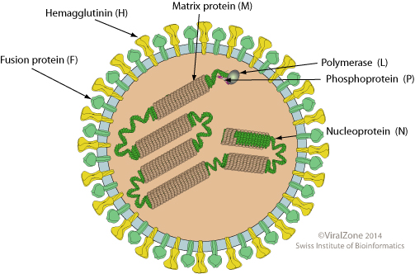 | 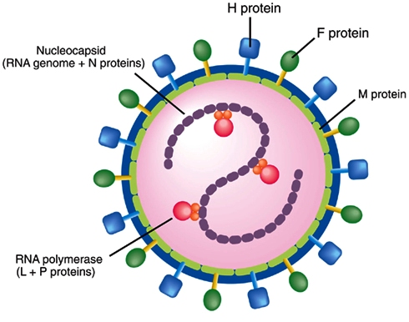
Fig.1. Schematic representation of the PPR morbillivirus

2.5. Geographical Distribution:
The global spread of PPR is probably related to the progressive control and later, eradication, of rinderpest. The cessation of rinderpest vaccination campaigns and loss of antibody cross-protection between the two diseases means that small ruminants are now fully exposed to PPR. PPR was first reported in the Ivory Coast of West Africa and was later found in other parts of the world incuding sub-Saharan Africa, the Arabian Peninsula, the Middle East, and the parts of
Asia (Balamurugan et al., 2012). The first PPR observation outside West Africa was in Sudan, between 1970 and 1972 (El Hag Ali and Taylor, 1984). In 1983, it was confirmed in the Arabic Peninsula and subsequently in Asia (Taylor et al., 1990; Maillard et al., 2008). In recent years, field data and laboratory findings have confirmed the dramatic spread of PPR toward the south of Africa, affecting Gabon, Democratic Republic of Congo, Somalia, Kenya and Tanzania (Swai et al., 2009). PPR has now been identified in Tunisia (Ayari-Fakhfakh et al., 2011) and Algeria (De Nardi et al., 2012). Outbreaks of PPR are now known to be common in India, Nepal, Bangladesh, Pakistan and Afghanistan (Abdollahpour et al., 2006). In India, PPR was first recorded in the Tamil Nadu state during 1987 and was later an epidemic in northern India. At present, PPR is enzootic in India and outbreaks occur regularly among small ruminants throughout the country, incurring significant economic losses in terms of morbidity, mortality and loss of productivity due to trade restriction (Balamurugan et al., 2012). PPR has been recognised in Pakistan since 1991 when rinderpest like disease in goats was reported in the province of Punjab (Athar et al., 1991). In Bangladesh, the presence of PPR in goats was detected by FAO expert team in 1993. Disease investigation among organized goat farm in Bangladesh showed that outbreaks were always associated with introduction of new goats to the farm. Occurrence of PPR in an epidemic form has a drastic effect on the goat population in Bangladesh ( Khan et al., 2005). Although, there is only one serotype of the virus (Barrett et al., 1993), PPRV isolates on the basis of partial sequence analysis of the fusion (F) protein gene, can be grouped into four distinct lineages (Kwiatek et al., 2007) , three of which (I, II, III) were first described in Africa, including Guinea, Ivory Coast, Senagal, Mali, Burkina Faso, Ghana, Nigeria, Uganda and Tanzania, and the fourth (IV) in Asia.

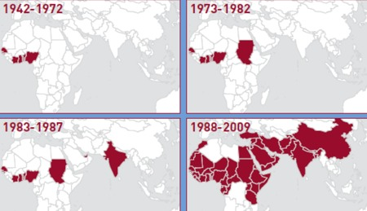

Fig.2. Map of PPR geographical distribution (FAO 2009)

However, the Asian lineage was recently introduced in some African countries, including Cameroon and Central African Republic, Sudan and Morocco, Egypt, Algeria and Uganda (Maganga et al., 2013). The PPR virus identified in Bangladesh is under the lineage 4 of PPR
phylogenetic tree based on the N gene analysis (Barrett et al., 1998). Molecular typing has revealed that Asian lineage IV has become established in an area of Sudan where PPR has
re- emerged, edging out the indigenous African lineage. Similarly, the introduction of PPR into Morocco in 2008, which was hitherto free from the disease, also involved lineage IV strains (Banyard et al., 2010).
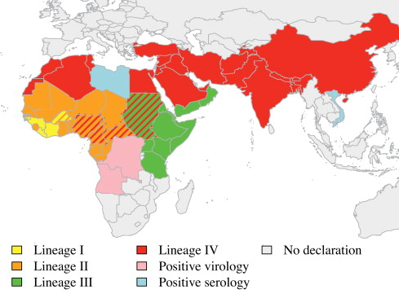

Fig.3. Worldwide cumulative distribution of the four PPR virus lineages. Different colors show different lineages and hached bars represent the last identified lineage in the corresponding country (Albina et al., 2012).

2.6. Incidence of PPRV :
Based on clinical features and cross protection assay with RP vaccine, (Asmar et al., 1980) reported two outbreaks of PPR in Saudi Arabia during July 1977 and July 1979. In both the outbreaks, the disease caused up to 60 per cent mortality and at least 90 per cent morbidity. Environmental factors influence disease occurrence. (Hegde et al., 2009) showed that incidences were highest during the rainy season and in the dry agro-climatic zones. The dusty and dry winds that characterize winter season of the year has been shown to enhance the spread of PPR (Obi, 1983). (Aruni et al., 1998) observed more than ten outbreaks of PPR in goats from Tamil Nadu. They observed that kids were susceptible than adult. An outbreak of PPRV in approximately 100
goats was diagnosed in Rawalpindi city, Pakistan in June 1997 by (Hussain et al., 1998) with mortality rate of 80 %. PPRV was detected in blood and various tissue samples using a competitive ELISA and immunocapture ELISA. It was found that the isolates from Bangladesh were closely related with other strains from India, and clustered within the Asian group of PPR viruses (Barrett et al., 1997). The outbreaks of 74.13% morbidity and 54.83% mortality in Black Bengal goats in Bangladesh (Islam et al., 2001 and Das et al., 2007). In an epidemiological study of PPR in Oyo and Ondo States of Nigeria (Mathew, 1983) reported 191 outbreaks (115 animals died) in 1977-78, 114 in 1978-79 and 122 during 1979-80. In a similar study in the same country between 1978 and 1981 (Mathew and Orafu, 1983) reported 521 outbreaks of PPR. They concluded that the disease was mainly confined to the southern states of Nigeria. (Opasina and Putt, 1985) reported three outbreaks in village goat populations in southwest Nigeria with an overall attack rates of 42.2, 13.7 and 37.1 per cent and mortality rates of 86.9, 41.0 and 63.9 per cent, respectively. (Mondal et al., 1995) noticed 73 outbreaks of PPR in goats with mortality rate of 23.8 to 38.2 per cent in West Bengal. The prevalence of disease was higher in Black Bengal goats (57.34%) than in Jamunapari breed (38.76%). (Tripathi et al., 1996) reported a severe outbreak of pest of small ruminants at Indian Veterinary Research Institute, Izatnagar, during March-April, 1994. They concluded that goats were more severely affected (275 died) than sheep (80 died). (Paritosh, 1997) observed that after introduction of Barbari goats from Makhdoom, (U.P.) to Regional Breeding Farm, Tripura, there was an outbreak of PPR with mortality rate of 45.79 per cent. Based on clinical features (Shankar et al., 1998) reported an outbreak of suspected PPR and its epidemiological features in 24 villages of Rajpura block of Chakaragar, Etawah (U.P.), between August 1994 and October 1994. Laboratory diagnosis neither revealed the presence of Rinderpest virus antigen by counter immunoelectrophoresis nor Rinderpest antibodies by ELISA, based on which, the outbreak were suspected because of PPR. (Yener et al., 2004) demonstrated presence of PPR viral antigens in 17 (40%) out of 42 pneumonic lungs of goats slaughtered in the region of Bitlis and Van.

2.7. Host Range of PPRV:
Natural disease affects mainly goats and sheep, but it is usually more severe in goats where it causes heavy losses and is only occasionally severe in sheep Black Bengal goats are more susceptible (67.24 %) to PPR than Jamunapari breed (32.76 %) (Shaila et al., 1989). Cattle, buffaloes, camels and pigs can also be infected but there is little or no evidence of disease associated with their infection. PPRV antigen has been detected in an outbreak of respiratory disease in camel and sick domestic buffaloes (Taylor et al., 1990; Scott, 2000; Abraham et al., 2005) Antelope and other small wild ruminant species can also be severely affected (Abu Elzein et al., 2004). A case of clinical disease has been reported in wildlife resulting in deaths of gazelles (Gazella dorcus), ibex (Capra ibex nubiana), gemsbok (Oryx gazelle) and Laristan sheep (Ovis orientalis laristanica). American white tailed deer (Odocoileus virginianus) can be infected experimentally (Hamdy and Dardiri, 1976). Changes in the allopatric speciation of lineages suggest that, when competing with indigenous strains, some strains have great power to spread because they are better adapted to the natural host and/or by switching to a new host.

2.8. Transmission of PPRV:
The discharges from eyes, nose, and mouth of sick animals as well as the loose feces contain large amount of the virus. Fine infective droplets are released into the air from this secretions and excretions, particularly when affected animals cough and sneeze. PPRV is shed in nasal and ocular secretions, saliva, urine and feces. It probably occurs in milk (CFSPH, 2008). Other animal inhale the droplet and are likely to become infected. Although close contact is the most important way of transmitting the disease. The disease is transmitted by aerosols between animals living in close contact. (Lefevre and Diallo, 1990). It is suspected that infectious materials can also contaminate water and feed trough and bedding, turning them into additional source of infection. (Roeder, P.L. and Obi, T.U. 1999).Newly purchased animal from market and wild animal have suspected to play a role spreading of disease (Fraser, 1986).

2.9. Pathogenesis:
The route of infection is respiratory and is spread by airborne droplets. PPR virus, Like all morbilliviruses, PPRV has an established lymphatic and epithelial tropism. The signaling lymphocyte activation molecule (SLAM) is well recognized as the universal receptor for morbillivirus infection of immune cells, and this receptor tropism results in the leukopenia observed during infection ( Bao et al., 2012). Consequently, it induces the most severe lesions in organ systems rich in lymphoid and epithelial tissues. The respiratory route is the likely portal to entry. After the entry of the virus through the respiratory tract system, it localizes first replicating in the pharyngeal and mandibular lymph nodes as well as tonsil. Viremia may develop 2-3 days after infection and 1-2 days before the first clinical sign appears. Subsequently viremia results in dissemination of the virus to spleen, bone marrow and mucosa of the gastro-intestinal tract and the respiratory system (Scott, 1981).

2.10. Clinical signs of PPR:

The clinical disease resembles Rinderpest in ruminants, which is acute, and after an incubation period of 3-6 days, the clinical symptoms become apparent, which include high rise of temperature, oral and ocular discharges, necrotic stomatitis, severe pneumonia, dyspnoea, coughing, enteritis, severe diarrhoea followed by death (Roeder and Obi, 1999 and Pawaiya et al., 2004). Animal affected by PPR shed the virus in exhaled air, in secretions and excretions (from the mouth, eye and nose, and in feces, semen, and urine) approximately 10 days after the onset of fever (Maganga et al., 2013). Clinical signs of PPR have been well documented (Hamdy et al., 1976; Obi, 1984; Lefèvre, 1987; Taylor, 1984; Bundza et al., 1988; Roeder et al., 1994; Roeder and Obi, 1999). Following infection there is a 3–4 day incubation period. The predominant form of the disease is the acute form. The salient clinical signs start with sudden rise in body temperature to 39.5 - 41°C. Affected animals breathe fast, sometimes so fast that they exhibit rocking movements with both the chest and abdominal walls moving as the animal breathes. They have obvious signs of pneumonia. A clear watery discharge starts from the eyes,
nose and mouth, later becoming thick and yellow as a result of secondary bacterial infection. Appearance of a serous to muco-purulent nasal discharge which may crust over and occlude the
nostril, sneezing, ocular discharge resulting in matting of the eyelids. The discharges wet the chin and the hair below the eye; they tend to dry, causing matting together of the eyelids, obstruction of the nose and difficulty in breathing. Unlike RP, there is a definite but inconstant, respiratory system component (Brown et al., 1991; Bundza et al., 1988). One to two days after fever has set in, the mucous membranes of the mouth and eyes become much reddened. Then, epithelial necrosis causes small, pin-point, greyish areas on the gums, dental pad, palate, lips, inner aspects of the cheeks and upper surface of the tongue. The lining of the mouth is changed in appearance. It becomes pale and coated with dying cells and, in some cases; the normal membrane may be completely obscured by a thick cheesy material. Gentle rubbing across the gum and palate with a finger may yield a foul-smelling material containing shreds of epithelial tissue (Braide, 1981). Body temperature usually remains high for about 5-8 days, and then slowly returns to normal prior to recovery or drops below normal before death. Diarrhoea commonly appears about two to three days after the onset of fever although, and death is usually preceded by pneumonia (Hamdy et al., 1976). The faeces are initially soft and then watery, foul-smelling and may contain blood streaks and pieces of dead gut tissue. Such victims may eventually become dehydrated with sunken eyeballs, and death often follows within seven to ten days from onset of the clinical reaction. Other animals will recover after a protracted convalescence. Just after showing the clinical sign the dehydration is not remarkably. After few days of diarrhea the animal become severely dehydrated which lead to animal die (Rodestits et al., 2000). Susceptibility to infection rises with age; however, the disease is rapidly fatal in the young animals (Ozkul, 2002).

2.11. Pursuivant infection with PPR :

Obi et al., (1983) showed that, the most significant bacteria associated with PPR infected goats were Pasteurella haemolytica, Klebsiella sp., Pseudomonas aeruginosa and Staphylococus pyogenes from the lungs, Salmonella sp. and E. coli from the faeces, Moraxella bovis from the eyes and Staphylococcus pyogenes from the oral cavity. Pneumonia is usually a very obviously presented sign in PPR. Pneumonic pasteurellosis is a purely respiratory disease of sheep and goats caused by the bacterium Pasteurella haemolytica.

2.12. Differential Diagnosis:

The disease must be differentially diagnosed from Foot and Mouth disease, Bluetongue, Contagious ecthyma, Pasteurellosis, Contagious caprine pleuropneumonia, Nirobi sheep disease, Coccidiosis, Plant and Mineral poisoning etc (Appel et al., 1981).

2.13. Treatment of PPR:

There is no specific treatment for PPR, however hyperimmune PPR serum produced in goats reverses the disease process if administered at the onset of fever (Ihemelandu et al., 1985). The affected animals were given antibiotics to control secondary bacterial infections along with anti-inflammatory drugs. Specifically, oxytetracycline and chlortetracycline are recommended to prevent secondary pulmonary infections (OIE, 2000). Sil et al., (2006) reported that, the use of combined antibiotic hyper immune serum therapy (ACHST) for PPR helpful to overcome the condition. For diarrhoeal conditions, they suggested that 10 ml hyperimmune serum intravenous route per animal three doses every 3 days interval. Long acting Oxytetracycline tabs 1ml/10 kg body weight 2nd dose after 72 hours of 1st dose. A mixture of Oxytetracycline tabs and Metranidiozol (1:1) oral doses twice daily until diarrhea subsides. Good nursing, symptomatictreatment with broad spectrum antibiotic, sulphur drugscan safe life of sick animal and also can improve the immunosuppressive condition of the affected goat (Sil, 2000).

2.14. Prevention and control of PPR:

The quarantine, slaughter, proper disposal of carcasses and avoiding contact fomites, decontamination mination of facilities and equipment, restrictions on importation of sheep and goats from infected areas (Nanda et al., 1996). Control of PPR outbreaks depends on movement control combined with the use of vaccine. Although vaccination against PPR is being practiced in Bangladesh and other countries, PPR is still causing major constraints to the productivity of small ruminants. Therefore, development of effective prophylactic procedures along with rapid, specific and sensitive diagnostic methods is extremely important for effective control of the disease. (Singh et al., 2009) stated that, the availability of an effective vaccine, accurate diagnostic tests for PPR and an experienced infrastructure prompt us to propose a national project for a Peste des Petits Ruminants eradication programme on the lines of National Project on Rinderpest Eradication. To control peste des petits ruminants (PPR) in Bangladesh a live attenuated conventional PPR vaccine was developed by Bangladesh Livestock Research Institute (BLRI) and currently being used in the country (Rahman et al., 2011). This would greatly enhance the prospects of PPR eradication not only on a national level but also from the Asian continent, alleviate poverty and, in turn, contribute to the national economy.

CHAPTER-III

MATERIALS AND METHODS

3.1. Location and duration of the study:
The study was conducted to determine prevalence of PPR in different breeds of goats and their response to antibiotic treatments registered at the District Veterinary Hospital, Thakurgaon during February throuh March 2014.

Fig.4. Map showing the location of the study site

3.2. Study population:
About 132 goats were examined in the hospital during the study period. Among them 52 goats of different breeds (Black Bangal and Jamunapari) were affected with PPR. The total samples were divided into different categories such as breed, age, sex and vaccination.

3.3. Case definition:
Diagnosis was made by means of Anamnesis and clinical signs. A PPR case was initially suspected if an animal showed signs of fever in the initial stage followed by pneumoenteritis evidenced by nasal and ocular discharges, conjunctivitis, erosion in oral mucosa, dyspnoea, diarrhea, dehydration, generalized weakness and finally death. The degree of dehydration was estimated by conventional skin fold test. All the clinical signs were properly noted in the record sheet. Sometimes the tentative diagnosis was supported with hematological findings and post mortem examinations.

3.4. Clinical examinations of PPR cases:

3.4.1. History:
Data were recorded by interviewing the owners regarding the breed/sex/age of the animals; probable date of clinical onset of the disease with the signs like fever, nasal and ocular discharges, diarrhea, depressed appetite from the last two or three days of clinical onset.

3.4.2. Clinical inspection:
- Close inspection was done carefully for each case to observe the signs :
- Rough hair coat
- Erosion in gum, tongue, and margin of the upper and lower lips
- Conjunctivitis
- Serous nasal discharge with froth becoming mucopurulent
- Lacrimation on the eyes
- Diarrhoea
- Per rectal temperature was recorded with a thermometer.
- Indirect auscultation was performed by means of a stethoscope to hear lung sound
- A conventional skin fold test was performed to estimate the degree of dehydration.

3.4.3. Clinical signs and symptoms:
The following clinical signs were observed while treating the patients :
- Markedly depressed and dull appearance
- Rough hair coat
- Thick serous or purulent discharge from the eyes and nose
- Sudden high fever ( 104˚-105˚ F), remaining high for 5 to 8 days, returned to normal before recovery or drop below normal before death.
- Anorexia, severe dehydration and emaciation followed by hypothermia.
- The mucous membrane of the mouth and eyes become much reddened and small pinpoint grayish areas appeared on the gum, dental pad, palate, lips, and upper surface of the tongue and characteristics foul smell came out from mouth.
- Faces were semisolid and liquid brown, yellow and black colored, watery foul smelling and contain blood streaks and pieces of dead gut tissue.
- In severe cases, difficulty in breathing marked by extension of head and neck, dilation of nostril, protrusion of the tongue and soft painful coughs.

3.5. Treatments:

To observe the treatment efficacy the goats were divided into two groups.
Group I: Renamycin-100® (Oxytetracycline) + Hista Vet® (Pheneramine meleate) + Renalyte® (ORS) and
Group II:. Combined therapy Diadin® ( Sulphadimidine-Na) + Hista Vet® (Pheneramine meleate) + Renalyte® (ORS) was given in separate groups
A response to treatment as the outcomes- recovery from the disease or death was the success or failure of a treatment applied over the two groups mentioned.

3.6. Vaccination history of Goats:

Each owner was asked about previous vaccination history of his or her goats suffering from PPR and 34 goats were vaccinated and remaining 98 goats were non vaccinated among the handled goats of different breeds.

3.7. Statistical analysis:

The data obtained were stored and coded accordingly using Microsoft Excel-2007. The data were exported from MS Excel-2007 to STATA/IC-11.0 (Stata Corporation College Station) for analysis. The results were expressed in percentage with p-value for Chi-Square Test. Significance was determined when p<0.05. Difference in occurrence of PPR in different locations was shown by using a χ² test.

CHAPTER-IV

RESULTS AND DISCUSSION

A study on prevalence of PPR and their response to antibiotic treatments was conducted in different breeds of goats registered at the District Veterinary Hospital, Thakurgaon during February and March 2014. Every goats registered here were clinically examined during the course of study. The investigation was carried out to give a detail picture of clinical symptoms generally observed in PPRV infected goats to determine the prevalence of PPR in relation with breeds, age, sex, vaccination status and to record clinical signs. During the study period 132 goats were examined at the district veterinary hospital of the Thakurgaon district of which 52 were diagnosed as PPR based on clinical assessments. The major clinical symptoms observed in the PPR cases are pictorially shown below under Figure 5.a- 5.f with corresponding brief description:

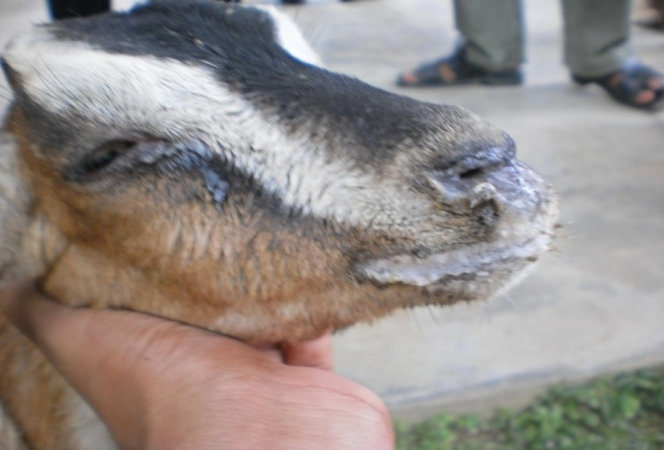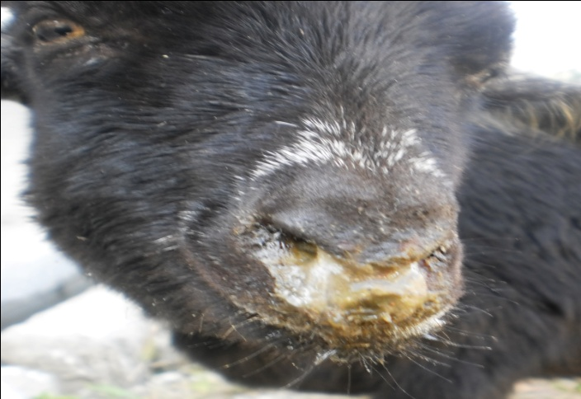
Fig 5.a: Purulent eye & nasal discharges:
Discharges from the nose & eyes in advanced PPR infection; the hair below the eyes is wet & there is matting together of the eyelids as well as partial blockage of the nostrils by dried up purulent discharges.
Fig5.b: Inflamed (reddened) eye membranes:  Reddening of the mucous membranes of the eye (the conjunctiva) in the early stage of infection. Note the Purulent eye discharges. | 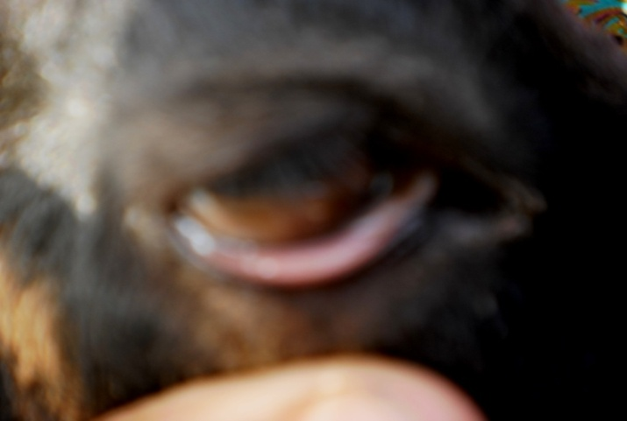

Fig 5.c: Early mouth lesions showing areas of death cells:  Early pale, grey areas dead cells on the gums | 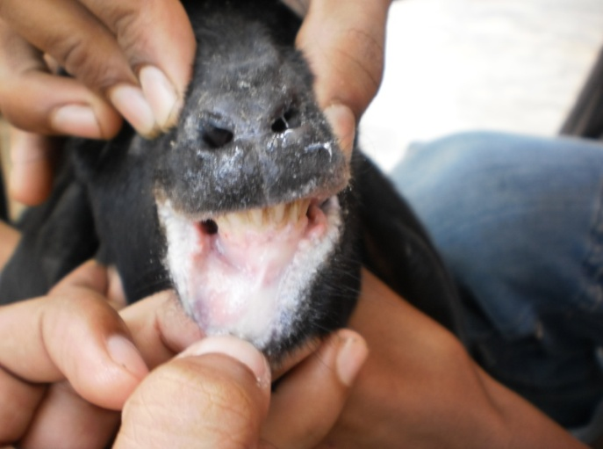

Fig 5.d: Advance mouth lesions:  The membrane lining the mouth is completely obscured by thick cheesy materials; shallow erosions are found on tongue, gum of teethes. | 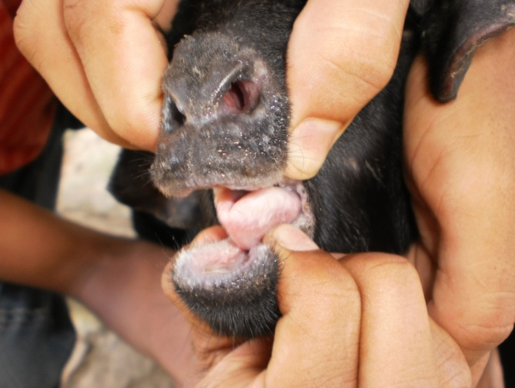

Fig 5.e: Swollen, erosion and eroded lips:  The lips & nostril are swollen, edematous & show areas of erosion. | 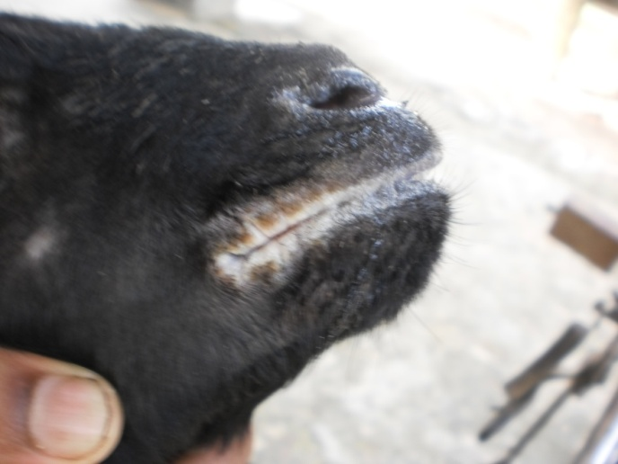

Fig 5.f: Sings of diarrhoea:  The hindquarters are soiled with liquid faeces. | 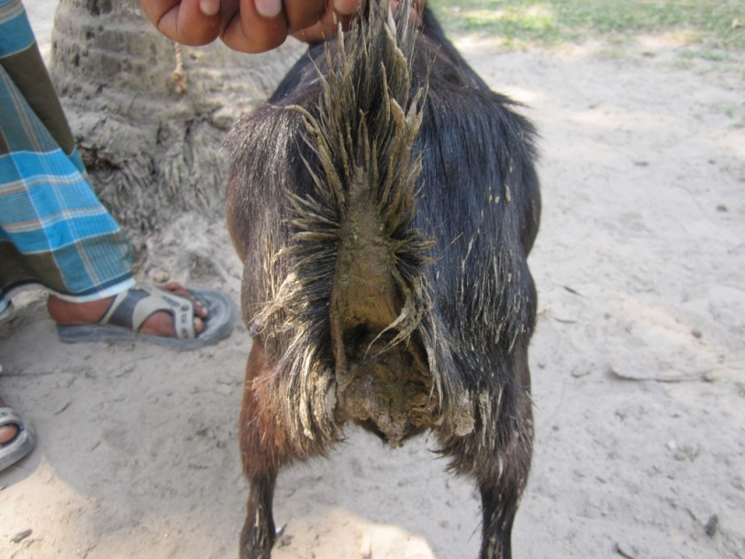

Table 1. Prevalence of PPR in relation to breeds of goat
Breed | N | PPR Positive |  | PPR Negative |  | Prevalence  (%) | χ2-value | P-value
Black Bengal | 85 | 38 |  | 47 |  | 45 | 2.23 | 0.07
Jamuna Pari | 47 | 14 |  | 33 |  | 30
Total | 132 | 52 | 80 |  | 39
N= Number of animals

Table 1 shows the overall prevalence of PPR in goats and as shown about 39% of the examined goats were positive for PPR. Similar prevalence of PPR (51%) in another region in the country was reported by Rahman et al., (2011). Conversely, the finding of this study was lower than the prevalence of 90% reported in Al-Ahsa oasis in eastern Saudi Arabia in 1988. The case mortality rate was 70 per cent (Abu-Elzein et al., 1990). It is difficult to draw any conclusions because of the differences in sampling procedures in the different studies that affect their representativeness (Ozkul et al., 2002). The prevalence of PPR in Black Bengal was 45% and 30% in Jamuna Pari. Apparently the disease does not differ significantly ( P>0.05) in relation to distribution in the two breeds mentioned. These findings are in line with (Sarker and Islam, 2011) that they found prevalence of PPR was higher in indigenous Black Bengal (27.13%) goats than Jamunapari (11.81%) and exotic breeds (9.68%). Gupta et al., (2007) also reported that Black Bengal breeds were more prone (60.29%) to PPR than Jamunapari (42.93%).

Table 2. Prevalence of PPR in goats of different age groups
Age Group | N | PPR Positive | PPR Negative | Prevalence (%) | χ2-value | P-value
Adult (more than 12 month) | 54 | 17 | 37 | 31 | 7.42 | 0.02
Young (4 to 12 month) | 60 | 31 | 29 | 52
Kid (less than 4 month) | 18 | 04 | 14 | 22
N= Number of animals

The prevalence of PPR in different age groups studied was shown in Table 2. Among the 54 adult (more than 12 months of age), 60 young (4 to 12 months of age) and 18 kid (Less than 4 months of age) the prevalence was 31%, 52% and 22%, respectively.
PPR is rapidly fatal in the young goats (60.87 %) especially at 7-12 months of age (Blood et al., 1995). Apparently the disease differs significantly ( P<0.05) between age groups and this study shows that the young goats which were 4 to 12 months of age were more susceptible to PPR and the prevalence in them was 52%, which was somewhat lower than the previous study. It is reported that goats of 4 to 12 months of age were more prone to PPR than older ( > 1 year) (Gupta et al., 2007). Singh et al., (2004) also assessed that the disease is more prevalent in the goats less than one year of age. The increased susceptibility of young goats to PPRV might be due to malnutrition, poor immunity and poor management systems (Sarker and Islam, 2011). Some study reported that, young kids of below one year of age are much more susceptible than adult ones. The maximum proportion of PPR was encountered goats between 7 and 12 months (Radostits et al., 1995). Kids over 4 months and under 1 year of age are at higher risk and cause huge economic loss (Venkataramanan et al., 2005).

Table 3. Prevalence of PPR in male and female goats
Sex | N | PPR Positive | PPR Negative | Prevalence (%) | χ2-value | P-value
Male | 47 | 18 | 29 | 38 | 0.00003 | 0.50
Female | 85 | 34 | 51 | 40
N= Number of animals

Table 3 is presented with the prevalence of PPR in male amd female goats. The prevalence of PPR in female goats were 40% and 38% in male goats. Although sexwise prevalence did not differ significantly ( P>0.05), the occurance of disease in female was littlebit higher than male goats which is supported by the study of Abdalla et al., (2012), that they estimated the disease prevalence was 54.2% in male and 64.2% in female goats. There is also agreed with Osman (2005) findings that the sex of animals had no effect on the development of PPRV antibodies. The fact that small ruminants producers keep more females for breeding purposes may explain this observation. Abdalla et al., (2012) reported that probability for females getting exposed to PPRV throughout their life time is more, than for males

Table 4. Prevalence of PPR in relation to immune status of goats
Immune status | N | PPR Positive | PPR Negative | Prevalence (%) | χ2-value | P-value
Vaccinated | 34 | 07 | 27 | 21 | 6.73 | 0.005
Non- vaccinated | 98 | 47 | 51 | 48
N= Number of animals
Table 4 shows the prevalence of PPR in vaccinated and non-vaccinated goats. Its prevalence in non-vaccinated goats were 48% and 21% in vaccinated goats. This result supported the early report of Islam et al., (2012) who reported the prevalence to be 66.40% in non-vaccinated goats compared with vaccinated 19.56% goats. Gibbs et al., (1979) also found a higher prevalence of PPR in the non vaccinated goat population. The present study indicates that the disease differ significantly between vaccinated and non vaccinated goats. It may be due to lack of antibody to PPRV in non vaccinated animals. Vaccination against the disease leads to decrease in the prevalence, but not absolute guarantee for freedom from the disesse. Banik et al., (2008) detected the protective level of antibody against PPR in the vaccinated goats suggesting that the vaccine has actively stimulated the immune system in the inoculated animals against PPRV. This finding supports the earlier observation of Das et al., (2007) who reported the efficacy of PPR vaccine against natural PPR infection.

Table 5. Response of PPR- affected goats to treatments with different drugs
Drug name  (Trade + Generic) | Response to treatment |  |  | Total case | % of response to treatment
 | Positive | Negative
Renamycin-100 (Oxytetracycline) + Hista Vet(Pheneramine meleate) + Renalyte(ORS) | 17 |  | 13 | 30 | 57
Diadin (Sulphadimidine-Na)  + Hista Vet(Pheneramine meleate) + Renalyte (ORS) | 10 |  | 14 | 24 | 42

The relative effects of drugs in treatment of PPR are presented in table 5. The percentage response of treatment towards parenteral (I/M) Oxytetracycline was higher (57%) than parenteral (I/M) use of Sulphadimidine (42%). It was reported that, where mortality rates may be decreased by the use of drugs that control the bacterial complications especially oxytetracycline and Chlortetracycline are recommended to prevent secondary pulmonary infections (Taylor et al., 1984). The result of the present study is similar to the report of Gupta et al., (2007) who found the percentage of response to treatment towards parenteral (I/M) oxytetracycline was higher (33.87%) than parenteral (I/M) use of sulphonamide (31.58%).

CHAPTER-V

CONCLUSION

PPR is highly contagious disease with higher mortality and morbidity in goat. In this study it is revealed that Black Bengal goats are more susceptible (45%) to PPRV compared to Jamuna Pari (30%). According to age groups, 4 to 12 months old goats are more susceptible than other age groups. The prevalence of PPR is higher in female goats (40%) than male (38%). Proper vaccination has direct impact in reducing PPR in goats. Although against virus, there is no specific treatment, combined therapy containing antibiotic, antihistamines as well as fluid therapy might be helpful. Response to treatment with parenteral (I/M) use of oxytetracycline was higher than the parenteral use of sulphonamide.

CHAPTER-VI

LIMITATIONS OF THE STUDY

Through the course of examination, all aspects were observed suspiciously but there was also some limitations that influence the current study. The duration for the study of prevalence of PPR of goats and their response to antibiotics was short that may results improper estimation, fluctuation in seasonal variation, sometimes diagnosis was made through tentative variables. Another limitation of the study may be inappropriate data collection, small number of sample size etc.

CHAPTER-VII

REFERENCES
Abdalla, S. A., Majok, A. A., El Malik, K.H. and Ali, A. S. (2012) Sero-prevalence of peste des petits ruminants virus (PPRV) in small ruminants in Blue Nile, Gadaref and North Kordofan States of Sudan. Journal of Public Health and Epidemiology 4(3): 59-64.
Abdollahpour, G., Roofi, A., Najafi, J., Sasani, F. and Sakhaie, E. (2006) Clinical and para-clinical findings of a recent outbreak of Peste des petits ruminants in Iran. J. Vet. Med. B, 53: 14-16.
Abraham, G., Sintayehu, A., Libeau, G., Albina, E., Roger, F., Laekemariam, Y., Abayneh, D. and Awoke, K. M. (2005) Antibody seroprevalence against PPR in camels, cattle, goats, and sheep in Ethiopia. Prev. Vet. Med. 70: 51–57.
Abu-Elzein, E.M.E.; Hassanien, M.M.; Al-Afaleq, A. I.; Abd-Elhadi M.A. and Housawi, F.M.I. (1990). Isolation of peste des petits ruminants from goats in Saudi Arabia.Vet. Rec. 127 (12): 309-310.
Abu Elzein, E. M. E., Housawi, F. M. T., Bashareek, Y., Gameel, A. A., Al- Afaleq, A. I. and Anderson, E. C. (2004) Severe PPR infection in Gazelles kept under semi-free range conditions in Saudi Arabia. J. Vet. Microbiol. 51 (2): 68–71.
Abubakar, M., Ali, Q., Khan, H.A. (2008) Prevalence and mortality rate of peste des petits ruminant (PPR): possible association with abortion in goat. Trop. Anim. Health Prod. 40: 317–321.
Abubakar, M., Arshed, M.J., Zahur, A.B., Ali, Q., Banyard, A.C. (2012) Natural infection with peste des petits ruminants virus: a pre and post vaccinal assessment following an outbreak scenario. Virus Res. 167: 43–47.
Albina, E., Kwiatek , O., Minet, C.C., Lancelot, R., Almeida, R.S., Libeau, G. (2012) Peste des petits ruminants, the next eradicated animal disease, An expanding fatal disease of small ruminants: journal home page: www.elsevier.co m/lo cat e/vetmic, Pp: 2
Albina, E., Kwiatek , O., Minet, C.C., Lancelot, R., Almeida, R.S., Libeau, G. (2012) Peste des petits ruminants, the next eradicated animal disease, State of the art in diagnosis and control strategies : journal home page: www.elsevier.co m/lo cat e/vetmic, Pp: 3
Amin, M. R., Hussain, S. S. and Islam, A. B. M. M. (2001) Reproductive peculiarities and litter weight in different genetic groups of Black Bengal does. Asian –Australasian Journal of Animal Sciences 14 (3): 197-301.
Anderson, E. C., Hassan, A., Barrett, T. and Anderson, J. (1990) Observation on the pathogenicity for sheep and goats and the transmissibility of the strain of virus isolated during the rinderpest outbreak in Sri Lanka in 1987. Vet. Microbiol. 21: 309-318.
Appel, M. J. G., Gibbs, E. P. J., Martin, S. J., Ter Meulen, V., Rima, B. K., Stephenson, J. R. and Taylor, W. P. (1981) Morbillivirus Diseases of Animals and Man. In Comparative Diagnosis of Viral Diseases IV, E. Kurstak and C. Kurstak, eds. New York: Acad. Press, Pp: 235-297.
Aruni, A. W., Lalitha, P.S., Mohan, A.C.,Chitravelu, P. and Anbumani, S. P. (1998) Histopathological study of a natural outbreak of peste des petits ruminants in goats of Tamilnadu. Small Rum. Res. 28(3): 233-240.
Asmar, J.A.; Radwan, A.I.; Abi, A.H. and Rasheid, A.A. (1980). A PPR-like disease of sheep in central Saudi Arabia: evidence of its immunologic relation to rinderpest; prospects for a control method. Proceedings of the Fourth Conference on the Biological Aspects of Saudi Arabia. University of Riyadh.; Riyadh; Saudi Arabia, 1980. pp. 325-337.
Ayari-Fakhfakh, E., Ghram, A., Bouattour, A., Larbi, I., Gribaˆa-Dridi, L., Kwiatek, O., Bouloy, M., Libeau, G., Albina, E., Ceˆtre-Sossah, C. (2011) First serological investigation of peste-des-petits-ruminants and Rift Valley fever in Tunisia. Vet. J. 187: 402–404.
Balamurugan, V., Saravanan, P., Sen, A., Rajak, K.K., Venkatesan, G., Krishnamoorthy, P., Bhanuprakash, V., Singh, R.K. (2012) Prevalence of peste des petits ruminants among sheep and goats in India. Journal of Veterinary Science, 13(3): 279-285.
Banik, S. C., Podder, S. C., Samad, M. A. and Islam, M. T. (2008) Sero surveillance and immunization in sheep and goats against Peste des Petits Ruminants in Bangladesh. Bangladesh Journal Veterinary Medicine 6 (2): 185–190.
Banik, S. C., Podder, S. C., Samad, M. A. and Islam, M. T. (2008) Sero surveillance and immunization in sheep and goats against Peste des Petits Ruminants in Bangladesh. Bangladesh Journal Veterinary Medicine 6 (2): 188.
Banyard A.C., Parida S., Batten C., Oura C., Kwiatek O. & Libeau G. (2010) Global distribution of peste des petits ruminants virus and prospects for improved diagnosis and control. J. G en. V irol., 91 (Pt 12), 2885-2897. E-pub: 2010 Sep. 15
Bao, J., Wang, Q., Parida, S., Liu, C., Zhang, L., Zhao, W. and Wang, Z. (2012) Complete Genome Sequence of a Peste des Petits Ruminants Virus Recovered from Wild Bharal in Tibet, China. Journal of Virology 86(19): 10885.
Baron, M.D., Parida, S., Oura, C.A. (2011) Peste des petits ruminants: a suitable candidate for eradication? Veterinary Record 169: 16.
Barrett T, Pronob D, Sreenivasa BP and Corteyn M (1997) Recent epidemiology of PPRV. Veterinary Microbiology 88: 125-130.
Barrett T, Pronob D, Sreenivasa BP and Corteyn M (1998) Recent epidemiology of PPRV. Veterinary Microbiology 88: 125-130.
Barrett, T., Pronob, D., Sreenivasa, B.P., and Corteyn, M. (1997) Recent epidemiology of Peste des Petits Ruminants Virus. Veterinary Microbiology 88: 125-130.
Barrett, T., Romero, C. H., Baron, M. D., Yamanouchi, K., Diallo, A., Bostock, C. J. and Black, B. (1993) The molecular biology of rinderpest and peste des petits ruminants. Ann. Med. Vet. 137 (2): 77-85.
BBS, (1999) Census of Agriculture 1996. Structure of Agricultural Holdings and livestock Population, Volume- 1, July 1999, Bangladesh Bureau of Statistics, Government of the People’s Republic of Bangladesh Dhaka, Bangladesh.
Berrada J. (2008). Observations des premiers casconfirmés de peste des petits
ruminants. Au Maroc oral presentation, El Jadida, 31-07-2008.
Blood, D.C., Radiodtits, O.M. and Hunderson, J.A. (1995).Veterinary Medicine, 6th edition, London: BailliereTinball.
Braide, V. B. (1981) Peste des petits ruminantss. World anim. Review. 39: 25-28.
Brown, C. C., Mariner, J. C., Olander, H. J. (1991) An immunohistochemical study of the pneumonia caused by PPR virus. Vet. Path. 28: 166-170.
Bundza, A., Afshar, A., Dukes, T. W., Myers, D. J., Dulac Susi, G., Becker, A. W. E. (1988): Experimental PPR (goat plague) in Goats and sheep. Canadian J. Vet. Res. 52: 46-52.
CFSPH (The Centre for Food Security and Public Health),(2008) Peste des Petits Ruminants.http://www.cfsph.iastate.edu/Factsheets/pdfs/peste_des_petits_ruminants.pdf. Access on 14th May, 2011.
Chauhan, H. C., Chandel, B. S., Kher, H. N., Dadawala, A. I. and Agrawal, S. M. (2009) Pesti des petits ruminants virus infection in animals. Veterinary World 2 (4):150-155.
Couacy-Hymann, E. R. F., Bidjeh, K., Angba, A., Domenech, J. and Diallo, A. (1995) Protection of goats against rinderpest by vaccination with attenuated peste des petits ruminants virus. Res. Vet. Sci. 59: 106-109.
Das, K.K., Shil, N.K. and Islam, M.R. (2007) Sero-epidemiological investigation on Peste des Petits Ruminants in black Bengal goats. Bangladesh Journal of Microbiology 24 : 143 – 145.
Das, K.K., Shil, N.K. and Islam, M.R. (2007) Sero-epidemiological investigation on Peste des Petits Ruminants in black Bengal goats. Bang. J. of Microbiol. 24: 143–145.
D.C. Blood, J.A. Henderson, O.M. (2004). Radostits, Veterinary Medicine, Bailmlière Tindall, London, ISBN 0-7020-0718-8.
De Nardi, M., Lamin Saleh, S.M., Batten, C., Oura, C., Di Nardo, A., Rossi, D., (2012) First evidence of peste des petits ruminants (PPR) virus circulation in Algeria (Sahrawi territories): outbreak investigation and virus lineage identification. Transbound. Emerg. Dis. 59: 214–222.
Diallo, A. (2006) Control of peste des petits ruminants and poverty alleviation? J. Vet. Med. B Infect. Dis. Vet. Public Health 53: 11–13.
DLS,(2007),Livestock population in Bangladesh. http://organization.kib.org.bd/2009/11/16/directorate-of-livestock-services-dls/
Durojaiye, O. A., Taylor, W. P. and Smale, C. (1985) The ultrastructure of peste des petits ruminants virus. Zbl. Vet. Med. B. 32 (6): 460-465.
El Hag Ali, B., Taylor, W.P., 1984. Isolation of peste des petits ruminants virus from Sudan. Res. vet. Sci. 36: 1–4.
EMPERS (Emergency Prevention System for Transboundary Animal and Plant Pests and diseases). Recognizing peste des petits ruminants. A field manual. Rome, Italy: FAO (Food and Agricultural Organization of United Nation, 1999).
FAO (Food and Agriculture Organization of the United Nations), (2003) Asian Livestock. Monthly Technical Magazine of the FAO. Anim. Prod. Health Comm. Asia Pac. (APHCA) 8: 85-87.
Fraser, C. M. 1986. Peste des petits ruminants (PPR). The Merck Veterinary Manual. 6th edition, Merck and Co. Inc. U. S. A; 402-403.
Furley, C.W.; Taylor, W.P. and Obi, T.U. (1987). An outbreak of peste des petits ruminants in a zoological collection. Vet. Rec. 121 (19): 443-447.
Gargadennec, L. and Lalanne, A. (1942) La peste des petits ruminants. Bull. Serv. Zoo AOF 5: 16–21.
Gibbs, E. P. J., Taylor, W. P., Lawman, M. P. J. and Bryant, J. (1979) Classification of the peste des- petits-ruminants virus as the fourth member of the genus Morbillivirus. Intervirology, Veterinary Journal. 11: 268-274.
Govindarajan, R.; Koteeswaran, A.; Venugopalan, A.T.; Shyam, G.; Shaguna, S.; Shaila, M.S. and Ramachandran, S. (1997). Isolation of pestes des petits ruminants virus from an outbreak in Indian buffalo (Bubalus bubalis). Vet. Rec. 141: 573–574.

Gul Y, Kzl O and Issi M. (2006). A subclinicPeste Des Petits Ruminants case in a lamb. Saglk Bilimleri Dergisi, Frat Universitesi. Vol. 20(3), pp. 245-247.

Gupta SD, Biswas PK, Habib S and Debnath NC. (2007). Prevalence of PPR in the greater Chittagong district of Bangladesh. International Journal of Sustainable Agricultural Technology. Vol. 3(2), pp. 36-41.

Hamdy, F.M. and Dardiri, A.H. (1976). Response of white tailed deer to infection with peste des petits ruminants virus. J. Wildlife Dis. 1: 516-522.
Hamdy, F.M.; Dardiri, A.H.; Nduaka, O.; Breese, S.R.Jr. and Ihemelandu, E.C. (1976). Etiology of the stomatitis pneumcenteritis complex in Nigerian dwarf goats. Can. J. Comp. Med. 40: 276-284.
Hegde, R., Gomes, A. R., Muniyellappa, H. K., Byregowda, S. M., Giridhar, P. and Renukaprasad, C. (2009) A short note on peste des petits ruminants in Karnataka, India. Rev Sci Tech. 28(3): 1031-5.
Hussain, M., Afzal, M., Muneer, R., Ashfaq, M. and Haq, E. U. (1998) An outbreak of peste des petits ruminants in goats in Rawalpindi. Pakistan Veterinary Journal 18: 224–226.
Ihemelandu, E. C., Nduaka, O. and Ojukwu, E. M. (1985) Hyperimmune serum in the control of peste des petits ruminants. Trop Anim Health Prod. 17:83-88.
Islam, M. A., Khan, M. S. I., Kader, H. A., Begum, M. R. and Asgar, M. A. (2012) Prevalence of PPR of Goat and Their Response to Antibiotic Treatment at Mirzaganj Upazila of Patuakhali District. Journal of Environmental Science and Natural Resources 5(2): 181-184.
Islam MR, Shamsuddin M, Das PM and Dewan ML. (2001). An outbreak of Peste despetits ruminants in Black Bengal goats in Mymensingh, Bangladesh. Bangladesh Journal of Veterinary Medicine. Vol. 18, pp. 14-19.
Islam, M.R., Shamsuddin, M., Das, P.M. and Dewan, M.L. (2001) An outbreak of Peste des Petits Ruminants (PPR) in Black Bengal goats in Mymensingh, Bangladesh. The Bang. Vet.18:14–19.
Kitching, R.P. (1988). The economic significance and control of small ruminant viruses in North Africa and west Asia. In Thompson, F.S. (Ed.). Increasing small ruminant productivity in semi-arid areas, ICARDA. pp 225-236.
Khan, M.R., Haider, M.G., Alam, K.J., Hossain, M.G., Chowdhury, S.M.Z.H and Hossain, M.M. (2005) Pathological investigation of Peste des Petits Ruminants (PPR) in goats. Bangladesh Journal of Veterinary Medicine. 3 (2): 134-138.
Khan, M.R., Haider, M.G., Alam, K.J., Hossain, M.G., Chowdhury, S.M.Z.H and Hossain, M.M. (2005) Pathological investigation of Peste des Petits Ruminants (PPR) in goats. Bangladesh Journal of Veterinary Medicine 3 (2): 134.
Kulkarni, D. D., Bhikane, A.U., Shila, M.S., Varalakshmi, P., Aple, M. P. and Narlabker, B.W. (1996) Peste des petits ruminant in goat in India. Veterinary record, 138: 187-188.
Kumar A, Singh SV, Rana R, Vaid RK, Misri J and Vihan VS. (2001). PPR outbreak in goats: epidemiological and therapeutic studies. Indian Journal of Animal Sciences. Vol. 71(9), pp. 815-818.
Kwiatek, O., Minet, C., Grillet, C., Hurard, C., Carlsson, E. and Karimov, B. (2007) Peste des petits ruminants (PPR) outbreak in Tajikistan. J Comp Pathol. 136: 111–9.
Lefevre, P. C. and Diallo, A. (1990) Peste des petits ruminants virus. Rev. Sci. Tech. Off. Int. Epiz. 9: 951-965.
Lefèvre, P. C. (1987) Peste des petits ruminants et infection bovipestique des ovins et caprins (Synthèse bibliographique), Institute d’Elevage et de Médecine vétérinaire des pays tropicaux, 94704 Maison-Alfort, France, Pp: 99.
Losos, G.J. (1989). Infectious tropical diseases of domestic animals. Longman Sci. Techn., Can. 12, 549–556.
Maganga, G. D., Verrier, D., Zerbinati, R. M., Drosten, C., Drexler, J. F. and Leroy, E. M. (2013) Molecular typing of PPRV strains detected during an outbreak in sheep and goats in south-eastern Gabon in 2011, http://www.virologyj.com/content/10/1/82, Virology Journal 10:82
Maganga, G.D., Verrier, D., Zerbinati, R.M., Drosten, C., Drexler, J.F. and M Leroy, E.M. (2013) Molecular typing of PPRV strains detected during an outbreak in sheep and goats in south-eastern Gabon in 2011. Virology Journal 10:82. http://www.virologyj.com/content/10/1/82
Mathew, Z and Orafu, P.I. (1983). Epidemiology of peste des petits ruminants in Nigeria. Third International Symposium on Veterinary Epidemiology and Economics, Arlington,Virginia, USA, 6-10 September 1982. pp 665.

Mondal, A.K.; Chottopadhyay, A.P.; Sarkar, S.D.; Saha, G.R. and Bhowmik, M.K. (1995).Report on epizootiological and clinicopathological observations on peste des petits ruminants (PPR) of goats in West Bengal. Indian J. Anim. Hlth. 34 (2):145-148.
Mornet, P.; Orue, J.; Gillbert,Y.; Thiery, G. and Mamadou, S. (1956). La peste des petits ruminants en Afrique occidentail francaise; ses rapports avec la peste bovines. Rev.Elev. Med.Vet. Pays Trop. 9: 313-342.
Mulindwa, B., Ruhweza, S.P., Ayebazibwe, C., Mwiine, F. N., Muhanguzi, D. and Mukani, W.O. (2011) Peste des Petits Ruminants serological survey in Karamoja sub region of Uganda by competitive ELISA. Veterinary World, 4(4): 149-152.
Murphy, F. A., Gibbs, E. P. J., Horzinek, M. C. and Studdert, M. J. (1999) Classification and nomenclature of viruses. In: Veterinary Virology, 3rd Edn, Academic press, NewYork. Pp 4-13.
Nanda, Y.P., Chatterjee, A.K., Purohit, A., Diallo, A., Innui, K., Libeau, G., Thevasagayam, J.A., Bruning, A., Kitching, R.P., Anderson, J., Barrett, T. and Taylor,W.P. (1996). The isolation of peste des petitsruminants virus from Northern India. Vet. Microbiol., 51 (3- 4): 207-216.
Nawathe, D.R. and Taylor, W.P. (1979). Experimental infection of domestic pigs with the virus of peste des petits ruminants. Trop. Anim Hlth. Prod. 11 (2): 120-122.
Obi, T.U. (1983) Studies on the epidemiology of PPR in Southern Nigeria. Trop. Vet. 1:209-217.
Obi, T. U. (1984) The detection of PPR virus antigen by agar gel precipitation test and counter-immunoelectrophoresis. J.Hyg. 93: 579-586.
Obi, T. U., Ojo, M. O., Durojaiye, O. A., Kasali, O. B., Akpavie, S. and Opasina, D. B. (1983) Peste des Petits Ruminants (PPR) in Goats in Nigeria: Clinical, Microbiological and Pathological Features. Zentralblatt für Veterinrmedizin Reihe B, 30: 751–761.
Office International des Epizooties (2000) OIE manual of standards for diagnostic tests and vaccines. List A and B diseases of mammals, birds and bees. Paris: The Office; 2000.
OIE (Office International des Epizooties/World Organization for Animal Health) (2000) Peste des petits ruminants. In: Manual of standards for diagnostic tests and vaccines. Ed 4. Chap 2.1.5. Paris: OIE, 2000.
Okoli IC. (2003). Incidence and modulating effects of environmental factors on trypanosomosis, peste des petit ruminants (PPR) and bronchopneumonia of West African dwarf goats in Imo state, Nigeria.
Opasina, B.A. and Putt, S.N.H. (1985). Outbreaks of peste des petits ruminants in village goat flocks in Nigeria. Trop. Anim. Hlth. Prod. 17 (4): 219-224.
Osman NA (2005) Peste des petits ruminants in Sudan: Detection, virus isolation and identification, pathogenicity and serosurveilance. Thesis for master degree, University of Khartoum, Sudan.
Outbreak of 'peste des petits ruminants' in Morocco. FAO Newsroom (FAO).
September 9, 2008. Retrieved 2008-09-10.
Ozkul, A.; Akea, Y.; and Alkan, F. 2002. Prevalence, distribution, and host range of peste des petits ruminants virus, Turkey. Emerg Infect Dis.; 8(7): 708-712.
Pawaiya, R.V.S.; Misra, N.; Bhagwan, P.S.K. andDubey,S.C.(2004).Pathology and distribution of antigen in goats naturally infected with peste des petits ruminants virus. Indian J. Anim. Sci. 74 (1): 35-40.

Piedy-Sreeramulu. (2000). Epidemiological observations on an outbreak of peste des petits ruminants (PPR) in an organised sheep farm in Andhra Pradesh. Indian Veterinary Journal. Vol. 77(10), pp. 840-842.
Paritosh, M. (1997). Studies on incidence of peste des petits ruminants in the regional goat breeding farm at Debipur, Tripura. Indian J. Anim. Hlth. 36 (2): 169-171.
Raghavendra, L.; Setty, D.R.L. and Raghavan, R. (2000). Clinico-biochemical changes in sheep and goats experimentally infected with Vero cell adapted peste-des petits ruminants(PPR) virus. Int. J. Anim. Sci. 15 (2): 171-173.
Rahman, M. A., Shadmin, I., Noor, M., Parvin, R., Chowdhury, E. H. and Islam, M. R. (2011) Peste des petits ruminants virus infection of goats in Bangladesh: Pathological investigation, molecular detection and isolation of the virus. The Bangladesh Veterinarian, 28(1) : 1 – 7
Richard, A. B.; Adams, B. K. and Ambumani, S. P. 1996. Peste des petits ruminents in Tamilnadu goats. Indian veterinary journal., 73:587-588.
Radostits, O.M., Gay, C.C., Blood, D.C. and Hinchcliff, K.W. (2000).Peste des petitsruminants.In: Veterinary Medicine, 9th edition, W.B. Saunders company Ltd., London, pp. 1077 1079.
Radostits, M.O., Gay, C.C., Blood, C.D., Hinchcliff, W.K. (1995). Veterinary Medicine.(A text book of the diseases of cattle, sheep, pigs, goats and horses).
Roeder, P.L. and Obi, T.U. (1999). Recognizing peste des petits ruminants . A field manual. FAO, Rome. 17: 75-81.
Roeder, P.L. and Obi, T.U. (1999). Recognizing peste des petits ruminants (A field manual).Produced by: Agriculture and consumer protection department,FAO, Published in the website: http://www.fao.org. (Accessed on 29th June 2013).
Roeder, P. L. and Obi, T. U. (1999) Recognizing peste des petites ruminants: A field manual, FAO Animal Health Manual (5), Pp: 28.
Roeder, P. L., Abraham, G., Kenfe, G. and Barrett, T. (1994) Peste des petits ruminants in Ethiopian goats. Trop. Anim. Hlth. Prod. 26 (2): 69-73.
Roger, F.; Yigezu, L.M.; Hurard , C.; Libeau, G.; Mebratu, G.Y., Diallo, A. and Faye B. (2000). Investigations on a new pathological condition of camels in Ethiopia. J. Cam. Prac. Res. 7: 163-165.
Roger, F.; Guebre, Y.M.; Libeau, G.; Diallo, A.; Yigezu, L.M. and Yilma, T. (2001). Detection of antibodies of rinderpest and peste des petits ruminants viruses (Paramyxoviridae, Morbillivirus) during a new epizootic disease in Ethiopian camels (Camelus dromedarius). Revue de Med. Vet. 152 (3): 265-268.
Rossiter, P. B and Taylor, W. P. (1994) Peste des petits ruminants. In infectious diseases of livestock. Pp758. Eds. Coezter, J.A.W. Vol. II.
Rowland A.C. Scott, G.R., Ramachandran, S. and Hill D.H. (1971). A comparative study of peste de petits ruminants and Kata in West African dwarf goats. Tropical Animal Health and Production, Vol. 3, p. 241- 245.
Shaila, M.S., Purushothaman, V., Bhavasar, D.,Venugopal, K. and Venkatesan, R.A. (1989). Peste des petits ruminants of sheep in India. Vet. Rec., 125: 602.
Saliki J.T., Wohlsein P. (2008) Peste des petits ruminants. In: US Animal Health Association, Committee on Foreign Animal Disease. Foreign animal diseases: the gray book. Ed 7. Part III, chap 36. Richmond, VA: US Animal Health Assoc, 2008:357-64.
Samad, M.A. (2008) Animal Husbandry and Veterinary Science. Volume 2, 1st Pub., LEP No. 12, BAU Campus, Mymensingh, Bangladesh.
Samad, M.A. (2000) Poshu palan o chikitsa vidya LEP publication BAU Mymensingh, Pp: 693.
Sarker, S. and Islam, M.H. (2011) Prevalence and Risk Factor Assessment of Peste des petits ruminants in Goats in Rajshahi, Bangladesh. Veterinary World 4(12): 546-549.
Sarker, S. and Islam, M.H. (2011) Prevalence and Risk Factor Assessment of Peste des petits ruminants in Goats in Rajshahi, Bangladesh. Veterinary World. 4(12): 547.
Scott, G. R. (2000) Peste des petits ruminants and rinderpest. In: Martin W. B., and I. Aitken (ed), Diseases of Sheep, 3rd edn, pp. 398. Blackwell Publishing, Oxford, UK.
Scott, G. R. (1981) Rinderpest and peste des petits ruminants. In : Gibbs, E.P.J. (Ed.). Virus Diseases of Food Animals, Vol.II, Disease monographs. Academic Press, New York. Pp: 401-425.
Shankar, H.; Gupta, V.K. and Singh, N. (1998). Occurrence of pest des petitis ruminants like disease in small ruminants in Uttar Pradesh. Indian J. Anim. Sci. 68 (1): 38-40.
Singh, R. P., Saravanan, P., Sreenivasa, B. P., Singh, R. K. and Bandyopadhyay, S. K. (2004) Prevalence and distribution of peste des petits ruminants (PPR) virus infection in small ruminants of India. Rev sci tech Off int Epiz. 23: 807–819.
Singh, R.P., Saravanan, P., Sreenivasa, B.P., Singh, R.K. & Bandyopadhyay, S.K. (2004) Prevalence and distribution of peste des petits ruminants virus infection in small ruminants in India. Rev. sci. tech. 23 (3): 807-819.
Sil B.K, Rahman MM, Taimur MJFA and Sarker AJ. (1995). Observation ofoutbreaks of PPR in organized goat farms and its control strategy. Presented at the Annual Conference of the Bangladesh Society of Veterinary Eduucation and Research, 3 December, BARC, Dhaka.
Sil, B. K., Taimur, M. J. F. A. and Giasuddin, M. (2006). Combined Antibiotic Hyper Immune Serum Therapy (ACHST) for PPR. A Compendium of Livestock Technologies developed by Bangladesh Livestock Research Institute. BLRI publication No. 130. pp. 65.
Sil, B.K. ( 2000 ). A brief introduction its diagnosis and control, peste des petits ruminants BLRI, Savar; Dhaka.
Singh, R. K., Balamurugan, V., Bhanuprakash, V., Sen, A., Saravanan, P. and Pal Yadav, M. (2009): Possible control and eradication of peste des petits ruminants from India: technical aspects. Vet Ital. Jul-Sep; 45(3):449-62.
Sudharshana, K.J.; Rajasekhar, M. and Upadhye, A.S. (1995). Prevalence of peste des petits ruminants and rinderpest antibodies in small ruminants. Indian Vet. J. 72 (12):1246-1250.
Swai, E.S., Kapaga, A., Kivaria, F., Tinuga, D., Joshua, G., Sanka, P. (2009) Prevalence and distribution of Peste des petits ruminants virus antibodies in various districts of Tanzania.Vet. Res. Commun. 33: 927– 936.
Taylor, W.P., Barrett, T. (2007) Diseases of Sheep, 4th ed. Blackwell publishing, Oxford, UK, Pp. 460–469 (Chapter 61).
Taylor, W. P., Busaidy, S. A. and Barrett, T. (1990) The epidemiology of peste des petits ruminants in the Sultanate of Oman. Vet. Microbiol. 22 (4): 341-352.
Taylor, W. P. (1984). The distribution and epidemiology of peste des petits ruminants. Preventive Veterinary Medicine, 2: 157-166.
Taylor, W. P. (1984) The distribution and epidemiology of PPR. Preventive Veterinary Medicine. 2: 157-166.
Taylor, W.P. and Abegunde, A. (1979). The isolation of peste des petits ruminants virus from Nigerian sheep and goats. Res. Vet. Sci. 26 (1): 94-96.

Tripathi, B.N.; Chattopadhyay, S.K. and Parihar, N.(1996).Clinicopathological studies on anoutbreak of peste des petits ruminants in goats and sheep. Indian J. Vet. Pathol. 20 (2):99-103.
Venkataramanan, R., Bandyopadhyay, S.K. and Oberoi, M.S. (2005). Present status and strategies for the control of transboundary and other economically important animal diseases in India. A review. Indian J. Anim. Sci., 75(4): 456-464.
Yener, Z.; Saglam, Y.S.; Temur, A. and Keles, H.(2004).Immunohistochemical detection of peste des petits ruminants viral antigens in tissues from cases of naturally occurring pneumonia in goats. Small Rum. Res. 51 (3): 273-277.
Zahur AB, Ullah A, Hussain M, Irshad H, Hameed A, Jahangir M and Farooq MS. (2011). Sero-epidemiology of peste des petits ruminants (PPR) in Pakistan. Preventive Veterinary Medicine. Vol. 102(1), pp. 87-92.

