ACKNOWLEDGEMENT

The author tales the privilege to acknowledge to the almighty Allah, who has given the opportunity to accomplish the report.

The author would like to express his deep sense of gratitude and heartfelt appreciation to Professor Dr. Md. Kabirul Islam Khan, Dean, Faculty of Veterinary Medicine, CVASU.

The author expresses his sincere gratitude, heartfelt respect and immense indebtness to his supervisor DR. Md. Shafiqul Islam (Mamun), lecturer, Department of Pathology and Parasitology, CVASU.

The author highly expresses his sincere gratitude and greatfulness to Dr. Bibek Chandra Sutradhar, Director, External affairs, CVASU.

Finally the author expresses his good wishes and warmest sense of gratitude to all his wishes friend and families.

The Author

ABSTRACT

A four (4) months survey on Anaplasmosis was conducted in indigenous and crossbred goat in Pirojpur and Chittagong district of Bangladesh. A total of 120 blood samples were collected randomly from the goats of two representative areas in two different seasons. Samples were examined by Giemsa's stained blood smear method. The effect of topography, season, age, gender, body condition score, ecto-parasitic infections (Ticks) etc. were observed during this study. The overall prevalence of anaplasmosis was 5.93% where it was recorded higher in Chittagong (7.14%) in compare to Pirojpur (4%). Moreover, anaplasmosis was predominant in summer season than rainy season. It was also revealed that adult goats showed more susceptibility to anaplasmosis than young but it was not statistically significant. Furthermore, presence of ecto-parasitic infestation in the study animals shown to have more susceptible to anaplasmosis which was statistically significant (P<0.05). In general, it could be stated that presence of ecto-parasites and season were the most important predictor in the occurrence of Anaplasmosis. Finally, as it was a very limited study, we recommended further extensive study including molecular detection of such diseases and identification of specific vectors in the study areas which will assist to take necessary preventive measures against such diseases.

Key words: Anaplasmosis, ectoparasites, Prevalence, Chittagong, Pirojpur

Chapter I
Introduction

Livestock is one of the most potential sub-sectors of agriculture in Bangladesh which plays an indispensable role in promoting human health and national economy of the country. Livestock not only assists to upgrade the financial condition but also makes a substantial contribution to human nutrition. However, livestock is an integral part of farming system which has a better contribution to enhance the economy of Bangladesh. large ruminants (Cattle and Buffalo) and small ruminants (sheep and goat) constitute the major portion of livestock. The present population of livestock is 23.12 million cattle, 1.39 million Buffalo, 24.10 million goat and 3.07 million sheep DLS (2010-11). The total contribution of livestock sub-sector to Gross Domestic Product (GDP) in Bangladesh is approximately 7.23% and livestock in agricultural production is 17.32%, Anonymous (2007). It also generates 13% of foreign currency and provides 20% fulltime employment and 50% partial employment of rural population, Alam (1993).
Haemoprotozoan diseases particularly Anaplasmosis is distributed throughout the world. They are considered as one of the major obstacle and burning veterinary problem in the health and productive performance of cattle, Rajput et al. (2005). The diseases cause devastating losses to the livestock industry throughout the world, Ananda et al. (2009) as they have got a serious economic impact due to obvious reason of death, decreased production, declined working efficiency Uilenberg (1995), financial resources for control measures, Makala et al. (2003).

in Bangladesh, 80% rural people rear indigenous cattle Siddiki et al. (2010) and many people are also involved with urban and rural farming. Most animals are reared in houses under the traditional husbandry practices. Now a day, goat farming gains its popularity among the poor people of the country for several reasons especially for poverty alleviation. The production and productivity of animals are greatly hampered by different diseases Ngole et al. (2002) including different haemo-parasitic diseases. the hot and humid weather of country favors the growth and multiplication of many arthropods vectors like tick, flies, mosquitoes etc. They are responsible for transmission of different causative agents form one diseased animal to other healthy animal. Among vector-borne haemoprotozoan diseases, Babesiosis, Anaplasmosis are more common in compared to Theileriosis, Leishmaniosis and Trypanosomiasis. Ahmed (1976), Samad and Gautam (1984). According to the earlier reports, Babesiosis and Anaplasmosis is highly prevalent in cattle of Bangladesh among different vector-borne diseases. Yet there is no epidemiological study has been conducted on haemoprotozoan diseases on goat. In cattle -
Chowdhury et al. (2006) recorded 70% Anaplasmosis in Sirajgong district, Bangladesh. Samad et al. (1989) also supported this. But, the surveys for such diseases in different districts of Bangladesh including Pirojpur and Chittagong area were very limited. Considering the above facts, the present study was undertaken to fulfill the following objectives:

- To investigate the prevalence of Anaplasmosis in different goat breeds in Pirojpur and Chittagong district of Bangladesh.
- To determine the effect of different risk factors such as, breed, age, sex, seasons etc. in the occurrence of such diseases.

Chapter II
REVIEW OF LITERATURE

Climatic condition of Bangladesh favors the tick population, which are vectors of various tick borne diseases. Prevalence of tick borne protozoan parasites such as Anaplasma centrale, Anaplasma marginale, Babesia bigemina, Theileria mutans, Babesia bovis, Babesia gibsoni, Babesia canis and Theileria ovis has been reported in animals of Bangladesh. Therefore, few important literatures related to anaplasmosis is reviewed under following headings:

Anaplasmosis
Anaplasma ovis is an obligate intra-erythrocytic rickettsial pathogen which infects sheep, goat and wild ruminants. Kuttler (1984), Zaugg (1987, 1988), Zaugg et al. (1996), Yabsley et al. (2005), De la Fuente et al. (2006).

Anaplasma ovis is an arthropod-borne rickettsial pathogen that induces acute anemia in sheep and goats following invasion and replication within erythrocytes. Experimental inoculation of goats with A. ovis has been shown to induce an acute disease characterized by depression, anorexia, fever, and progressive anemia. Although A. ovis infections in goats have been reported throughout the world and natural arthropod vectors have been described the extent of infection and the loss of livestock productivity. Palmer et al. (1994)

Anaplasmosis is an infectious, non-contagious, tick-borne hemoparasitic disease of domesticated and wild ruminants in the tropics and subtropics. Once infected, the animals tend to be carriers of A. marginale for many years if not life, and these animals can serve as a source of infection for others. Munz and Dumbell (1994)

Bovine anaplasmosis is an infectious vector borne disease of cattle caused by obligate intra-reythrocytic rickettsia like organism of the genus Anaplasma. The disease is generally characterized by fever, inappitence, a drop in milk yield, progressive anemia, icterus and constipation. Carlton et al. (1995)

The disease is characterized by fever, severe anemia, jaundice, brownish urine, loss of appetite, dullness or depression, rapid deterioration of physical condition, muscular tremors, constipation, yellowing of mucous membrane and labored breathing. Bram (1983)

Anaplasmosis, formerly known as Gall sickness, traditionally refers to a disease of ruminants caused by obligate intra-erythrocytic bacteria of the order Rckettsiales, family Anaplasmataceae, and genus Anaplasma. Cattle, sheep, goat, buffalo and some wild ruminants can be infected with the erythrocytic anaplasma. ( The Marck Veterinary Manual, 9th edition).
Anaplasmosis is of economic significance, the disease constrains efficient production and its costs include loss of production of sick and recovered animals, abortion and deaths in some clinical cases, and tick control costs. EL Sawalhy (1999)

Etiology of anaplasmosis

Anaplasma marginale is the causative agent in cattle and wild ruminants. Anaplasma central is closely related to Anaplasma marginale and causes mild anaplasmosis in cattle. Radostits et al. (2000)
Anaplasma spp. is small, pleomorphic, coccobacillary, obligate-erythrocytic parasites belonging to the order Rickettsiales. Four species are of veterinary importance; A. marginale, A. caudatum, A. centrale (cattle), and A. ovis (goats, sheep, deer). A. marginale is the most pathogenic of the Anaplasma spp. listed. Losos (1986)
There are many Anaplasma species parasites but Anaplasma marginale and Anaplasma centrale are the most important species. Bovine anaplasmosis is usually caused by Anaplasma marginale (Bram, 1983; Kocan and Stiller, 1992) and A. centrale can introduce a moderate degree of anaemia, with clinical outbreaks in the field being extremely rare.
Three species of the causative organisms occur in cattle Anaplasma marginale, Anaplasma centrale, Anaplasma caudatum. Anaplasma centrale, which enjoys a far more limited natural distribution than does Anaplasma marginale, is less pathogenic and responsible for a relatively reaction is susceptible adult cattle and should not be disregarded. Carlton (1995)

The three Anaplasma species Anaplasma marginale is the most pathogenic for cattle. Anaplasma centrale causes a relatively mild form of Bovine Anaplasmosis in Africa. Clinical bovine Anaplasmosis is usually caused by Anaplasma marginale. Cattle are also infected with Anaplasma centrale, which generally results in mild disease. Ristic and Weinman (1960)

Anaplasma marginale, a small spherical body located in the stroma of erythrocyte and Anaplasma central, a relatively non-pathogenic species located centrally in the erythrocytes are responsiblenfor anaplasmosis in cattle (The Marck Veterinary Manual, 9th edition).

Epidemiology of Anaplasmosis:

Geographical occurrence:
Arnold Theiler in South Africa first described the disease in 1910.Anaplasmosis has a worldwide distribution particularly in tropical and subtropical regions, it also seen in some temperate areas. The disease is endemic in Africa including Egypt, South and Central America, southern Europe, the Far and Middle East, India, Russia, and Australia. Bron et al. (1992)
Anaplasmosis in cattle is common on all six continents, being present in South Africa, Australia, Asia, the former USSR, South America and the United States. Radostits et al. (2000)

Anaplasmosis occurs in tropical and subtropical regions worldwide (~40°N to 32°S), including South and Central America, the USA, southern Europe, Africa, Asia, and Australia. (Marck Veterinary Manual, 9th edition).

Anaplasmosis caused by Anaplasma marginale has been reported from most tropical and subtropical parts of the world. It occurs in Europe bordering on the Mediterranean, the Middle and far East, South America, the Caribbean, the Soviet Union, Australia, North America and large parts of the African continents. Carlton (1995)
Bovine Anaplasmosis in India is an endemic disease and sub clinical infection and mild clinical cases occur in indigenous cattle. At times the animals show clinical diseases under stress of certain intercurrent diseases, inclement weather, pregnancy and lactation. The exotic and to lesser extent crossbred animals are fully susceptible. The disease causes direct losses due to prolonged period of convalescence, low productivity and mortality. Gautam and Banerjee (1982)

Anaplasmosis is transmitted by a diverse group of biological and mechanical vectors. Infection in cattle is endemic in tropical and subtropical areas that support large population of these vectors. Infection occurs sporadically in temperate climate areas. Radostits et al. (2000)
The occurrence of sub-clinical anaplasmosis in cattle was 5.93% in Bangladesh. Anaplasmosis occurs in tropical and subtropical areas throughout the world and is a major constraint to the cattle production in many countries. Samad et al. (1989)

Mode of infection

At least 20 tick species have been shown experimentally to be capable of transmitting Anaplasmosis. These include argasid ticks (Ornithodorus spp. And Argas persicus) and a number of 1 host, 2 host and 3 host tick species of which Boophilus spp, Dermocentor spp. And Rhipicephalus spp. is regarded as the most important. Trans-stadial (larva to nymph or nymph to adult) and intrastasial transmission (e.g. transfer of male ticks both hosts) appear to be the usual mode of transmission employed by both 1 host and multi host ticks. Mechanical transmission of Anaplasmosis by hemaophagous arthropods, blood sicking flies as horse flies (Tabanus spp.), stable flies (Stomoxys spp.) is considered important in the maintenance of infection, even in the absence of tick vectors. Flies of the genera Musca, Chrysops and Siphora and eye gants (Hippelates spp.) have also reported that mechanical transmission can also take place by iatrogenic means, through the unsanitary use of instruments employed for vaccination, dehorning, castration and tattooing that become contaminated with fresh infected blood. Boynton et al. (1936)
Anaplasmosis is not contagious. Spread from animal to animal occurs chiefly by insect vectors. Most transmission occurs via tick vectors through intrastadial or trans-stadial and rarely transovarial transmission. Boophilus species is the main vectors in Africa. Anaplasmosis may also transmitted mechanically by bloodsucking flies and transplacental in pregnant cows. Contaminated surgical instruments and hypodermic needles are known mechanical vectors. Bron et al. (1992)
Anaplasma is one of the most important parasites transmitted by at least 20 ticks species, including Argas persicus, Ornithodoros lahorensis, Boophilus annulatus, B. decoloratus, B. microplus, Dermocentor albipictus, D. andersoni, D. accidentalis, D. variabilis, Hyalomma excavatum, Ixodes ricinus, Rhipicephalus bursa, R. sanguineus and R. simus (Marchette and stiller, 1982) but mostly Boophilus microplaus causing Anaplasmosis. Various other biting arthropods have been implicated as mechanical vectors. Experimental transmission has been demonstrated with a number of species of Tabanus (Horse fly) and with mosquitoes of the genus Psorophora. Ristic (1981)

Experimental and epizootiological evidence incriminates horse flies (Tabanus sp) as the most significant insect vector of Anaplasmosis. Transmission by flies is affected by direct transfer of blood from infected to susceptible cattle and must take place within a few minutes after feeding on an infected animal. Friedhoff (1997)

It is reported that spread from animal occurs chiefly by insect vectors. A variety of arthropods may act as vectors but significant natural vectors are vectors are ticks in the family Ixodidae and flies in the family Tabanidae. Of ticks, the one –host Boophilus spp. are major importance in tropical and subtropical regions and three- host Dermocentor spp. major importance in the Western US. Radostits et al. (2000)

Numerous species of tick vectors (Boophilus, Dermocentor, Rhipicephalus, Ixodes, Hyaloma and Ornithodoros) can transmit Anaplasma spp. after feeding on an infected animal, intrastadial transmission may occurs. Transplacental transmission has been reported and is usually associated with acute infection of the dam in the second or third trimester of generation. Anaplasmosis may also be spread through the use of contaminated needles or dehorning or other surgical instruments ( The Marck Veterinary Manual, 9th edition).

Transmission by blood sucking flies is well recognized and Tabanids deer flies, stable flies and mosquitoes are the insects chiefly concerned. Direct transfer of infected blood must take place for insect transmission and this must occur within a few minutes after feeding on an infected animal. Mechanical transmission of Anaplasmosis is well known and major and minor operation operations in cattle husbandry such as dehorning, castration, vaccination, blood sampling etc. may be responsible for the transmission of Anaplasmosis both in and out of season. Soulsby (1986)

Risk factors:
Susceptible host:
Cattle and wild ruminants are the natural hosts for A. marginale. Infections have been reported in camels.Cattle are also infected with A. caudatum, which may result in severe disease, and A. centrale, which generally results in mild disease.Sheep, goats, and deer are the natural hosts for A.ovis that may cause mild to severe disease. Losos (1986)
Age of infection:
All goats are susceptible to infection but age at infection is a major determinant of the severity of clinical disease. Young’s are susceptible to infection but seldom show clinical signs. Infection between six months and 2 years of age has increasing risk of clinical illness and animals infected after 3 years of age are commonly affected by a per acute fatal form of the disease. Radostits et al. (2000)
Nutritional status
Clinical disease is less severe in goat on a low plane of nutrition. Exposure of infected, clinically normal animals to devitalizing environmental influences, particularly shortage of feed and the presence of other diseases may result in the development of acute introduced into outbreaks among them are not uncommon 2-3 weeks after entry. Radostits et al. (2000)

Season
In temperate climates a seasonal occurrence of disease occurs in association with seasonal occurrence of the insect vectors. Winter outbreaks are likely associated with iatrogenic transmission or possibly the winter tick. Radostits et al. (2000)

Diagnosis:
Tentative diagnosis can be made on the basis of geographical region, history, clinical signs and post mortem lesions. A definite diagnosis of anaplasmosis depends on the demonstration of Anaplasma bodies in erythrocytes of clinically affected animals. In Giemsa-stained blood smear, the organisms appear as homogenous, dense, deep purple, more or less round nodies 0.3 to 1.0 µm in diameter. In Anaplasma marginale infection, approximately 80 to 90 percent of parasites are studied it or near the periphery of RBC. Carlton (1995)

Detection of Anaplasma spp. in blood smears stained with Giemsa stain or Differential Quick stain is critical to confirm diagnosis of acute cases. It appears as polymorphic coccobacillary bodies, 0.2-1.0 mm in diameter that stains bluish purple. Munz and Dumbell (1994)
Chronically infected carriers are difficult to confirm by Giemsa-stained blood films and may be identified by either complement fixation, card agglutination tests, IFA, PCR, dot-ELISA, and DNA-based detection methods can be also used. Losos (1986)
During the acute stage of anaplasmosis, the diagnosis is made on the basis of clinical symptoms, hematological changes and microscopic examination of stained peripheral blood films for intraertthrocytic inclusion bodies. Giemsa staining is the oldest and nost frequently used method. Other staining methods include toluidine blue and acridine orange. The latter method, an ultraviolet microscope for visualization of the marginal anaplasma bodies. In contrast to the ease with which acute form of anaplasmosis are recognized. Ristic (1981)
Anaplasma organism can be diagnosed by the blood smear prepared from the peripheral blood. Diff-Quick staining of blood smears is as accurate as Giemsa in the detection of Anaplasma spp. and can be completed in 15 seconds as prepared to mearly an hour for Giemsa. Radostits et al. (2000)
Various soluble and corpuscular antigens extracted from the blood of infected animals have been used for serologic diagnosis of Anaplasmosis. Currently used tests are Complement Fixation (CF), Capillary Tube Agglutination (CTA) and Card Agglutination (CD). Ristic (1981)

The complement fixation test is the standard test for the detection of carrier animals. It is satisfacrory for use in cattle, goat and sheep but antibody titer is highest during the active phase of the disease. A rapid card agglutination test, which tests serum or plasma for antibodies against Anaplasma marginale, is cheap and quick and sufficiently accurate to be used as a hard test. Other serological tests like a capillary tube agglutination test, indirect fluorescent antibody test, a dot ELISA are also used for the detection of Anaplasma spp. Nucleic probe analysis can be used to detect low level of parasitemia. Radostits et al. (2000)

It was reported that a simple test that seems to have some value the diagnosis of anaplasmosis. The blood is allowed to clot o little clear serum is obtained. Two drops are added to 2 ml of distilled water in a tube. The serum of normal animals does not cloud the water, that of affected with Anaplasmosis causes an immediate clouding and after that tube stands overnight, a white precipitate covers the bottom. Animals affected with acute Anaplasmosis and recently recovered carriers give this reaction. The test depends on the precipitation of hemoglobin, which appears to be present in increased amount in this disease. Boynton et al. (1936).

Chapter III
Materials and Method

Description of study areas
The study was conducted in topographically two different veterinary hospitals namely, Zilla Veterinary Hospital of Pirojpur and SAQ teaching Veterinary Hospital (SAQTVH) of Chittagong Veterinary and Animal Sciences University, Chittagong. Two veterinary hospitals were selected due to heavy patient load as well as its different topographical location. Moreover, selection of study areas were based on probability of high prevalence of different vectors, the climatic condition and geographical location which might favors the occurrence of such diseases.

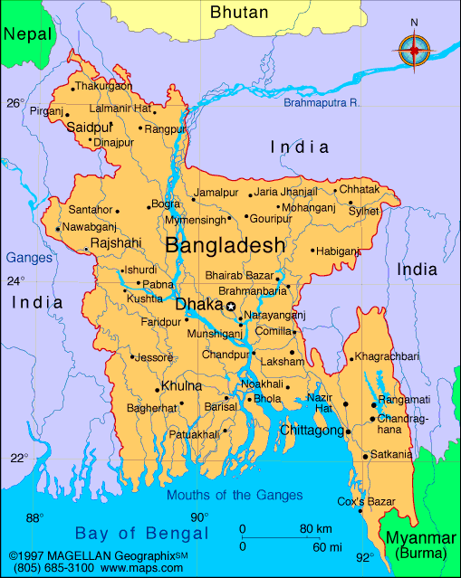
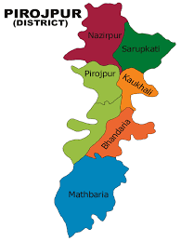

Figure 1. Study area (Pirojpur and Chittagong district)

Study period

The study was undertaken for a period of 4 months where two seasons were included as summer (March to April’2014), rainy (July to August’2014).

Selection of animals and Survey Design:

Target animals and age groups
Indigenous/crossbred (e.g. Jamnapari, Black Bengal, Crossbred) goats were selected for this study as target animal. To determine the age susceptibility to different parasites, goats were categorized into three sub-groups as ≤12 month, ≤18month and >18 months.

Target sampling
A total of 120 blood sample were collected randomly those who came to take treatment at the earlier hospitals. From the SAQTVH of Chittagong Veterinary and Animal Sciences University, Chittagong 70 samples were considered during rainy season (July to August’2014). On the other hand, rest 50 samples were taken similar way from ZVH, Pirojpur; during the summer month of March and April’2014.

A prototype questionnaire was used to record the information like area, breed, age, Body condition score (BCS), sex, seasons, presence or absence of tick etc. In the present study, the minimum age of the goat was 3 months and maximum 27 months.

sample collection and preservation
Only one biological sample (blood) was collected during this study where an individual animal was considered as a sampling unit. Smears were prepared form blood obtained from ear vein puncturing with sterile needle. Two thin blood smears were prepared by touching the coming out fresh blood and then spread by another slide. The slides were air dried and fixed by 100% methyl alcohol for 3-5 minutes. Cable (1957)

examination of samples
All the examinations were carried out at the parasitology laboratory, Chittagong Veterinary and Animal Sciences University (CVASU). The prepared thin blood smears (Hendrix, 2006) were stained with the Giemsa stain (Richardson and Kendall, 1963) for 25-30 minutes. After rinsing with water, the stained blood smears were air dried and examined under binocular microscope (X100) with immersion oil for the identification of blood parasites. Urquhart et al. (1996), Soulsby (1986) and Benbrook and Sloss (1962).

Statistical Analysis
The obtained information was imported, stored and coded accordingly using Microsoft Excel-2003 to STATA/IC-11.0 (Stata Corporation College Station) for analysis. The result were expressed in percentage with P-value for Chi-Square Test. Significance was determined when P<0.05.

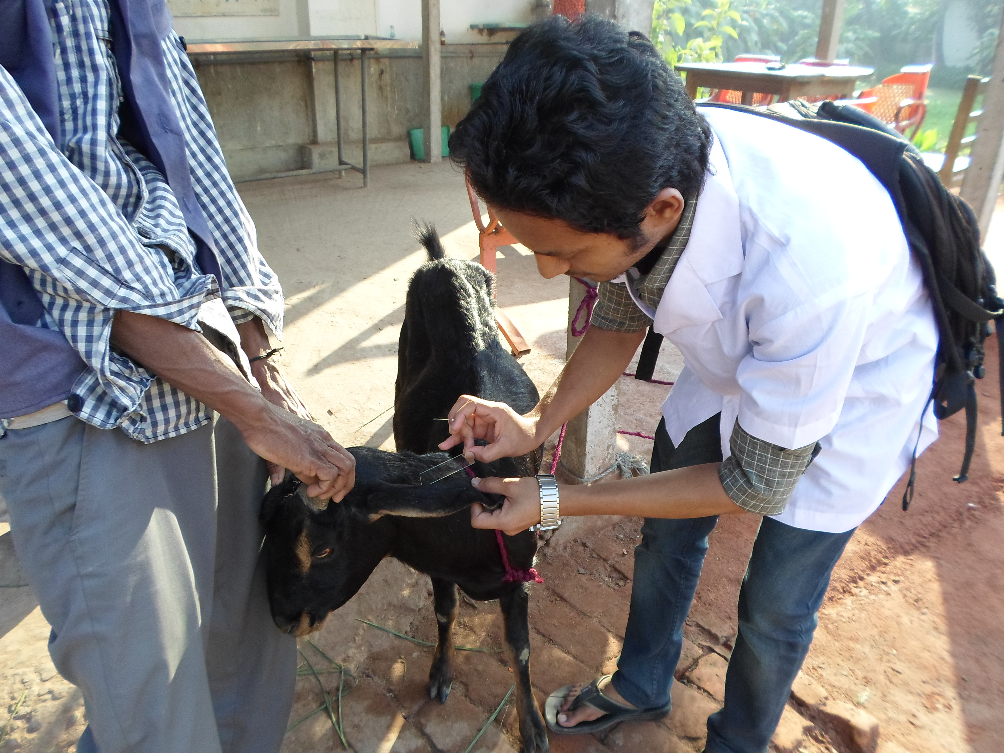
SOME PICTURES OF MY SAMPLING AND LABORATORY WORK
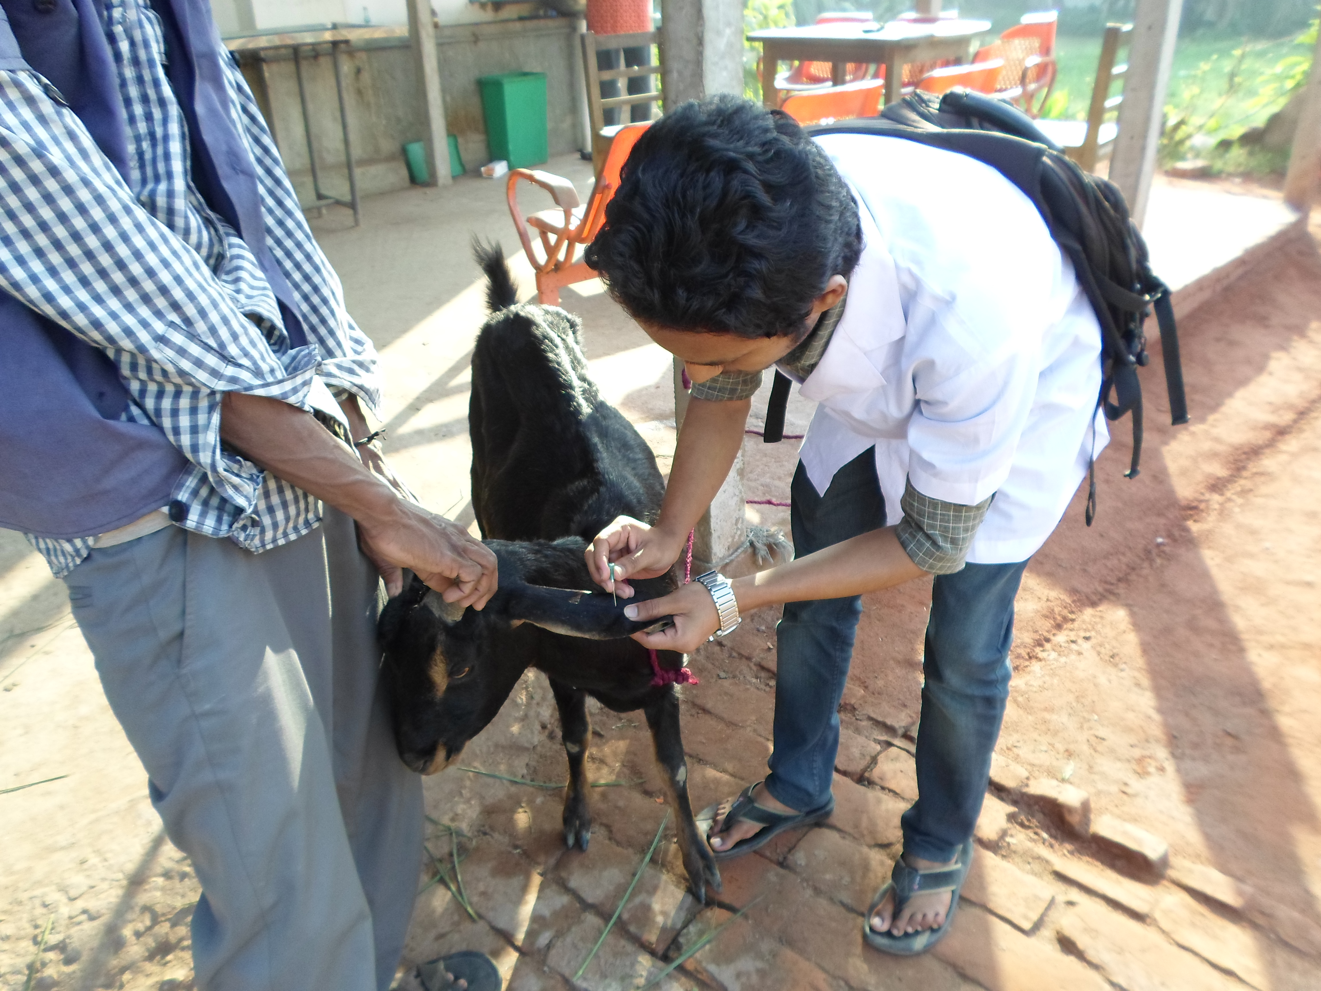

Figure 3. Taking slide impression
Figure 2. Collection of sample

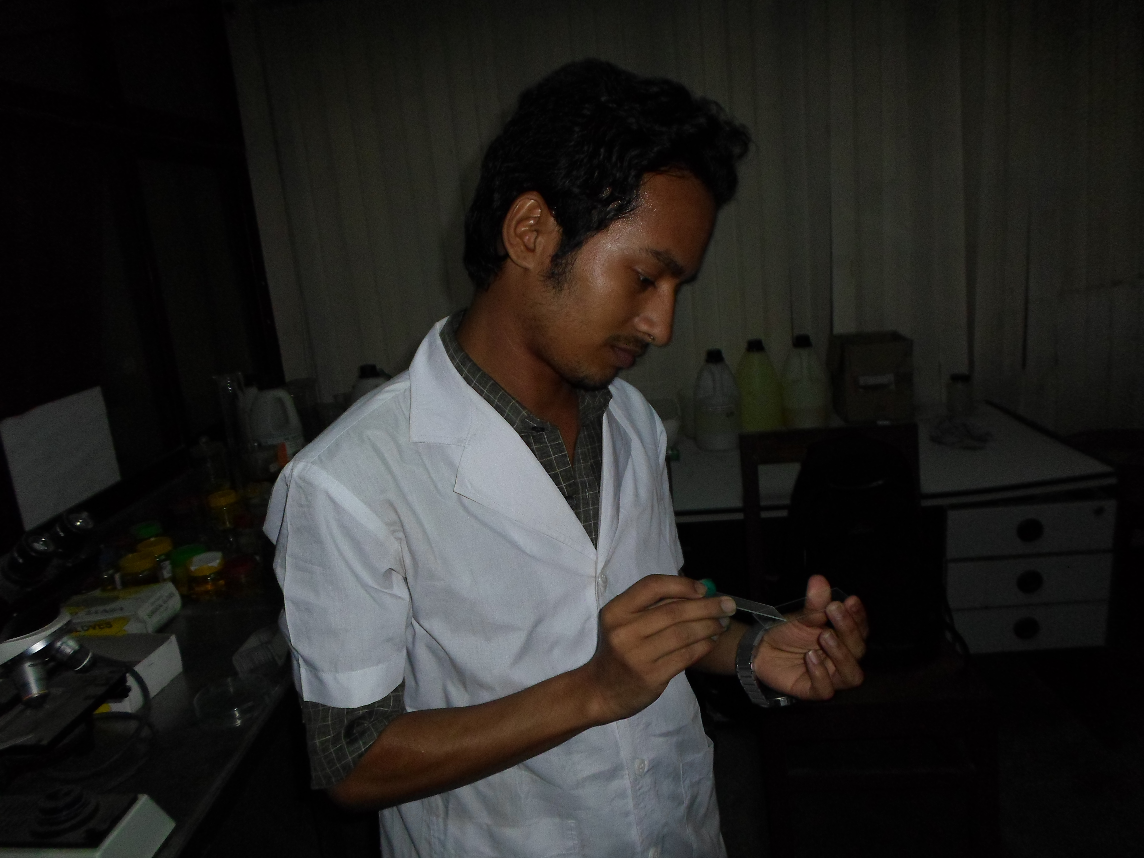
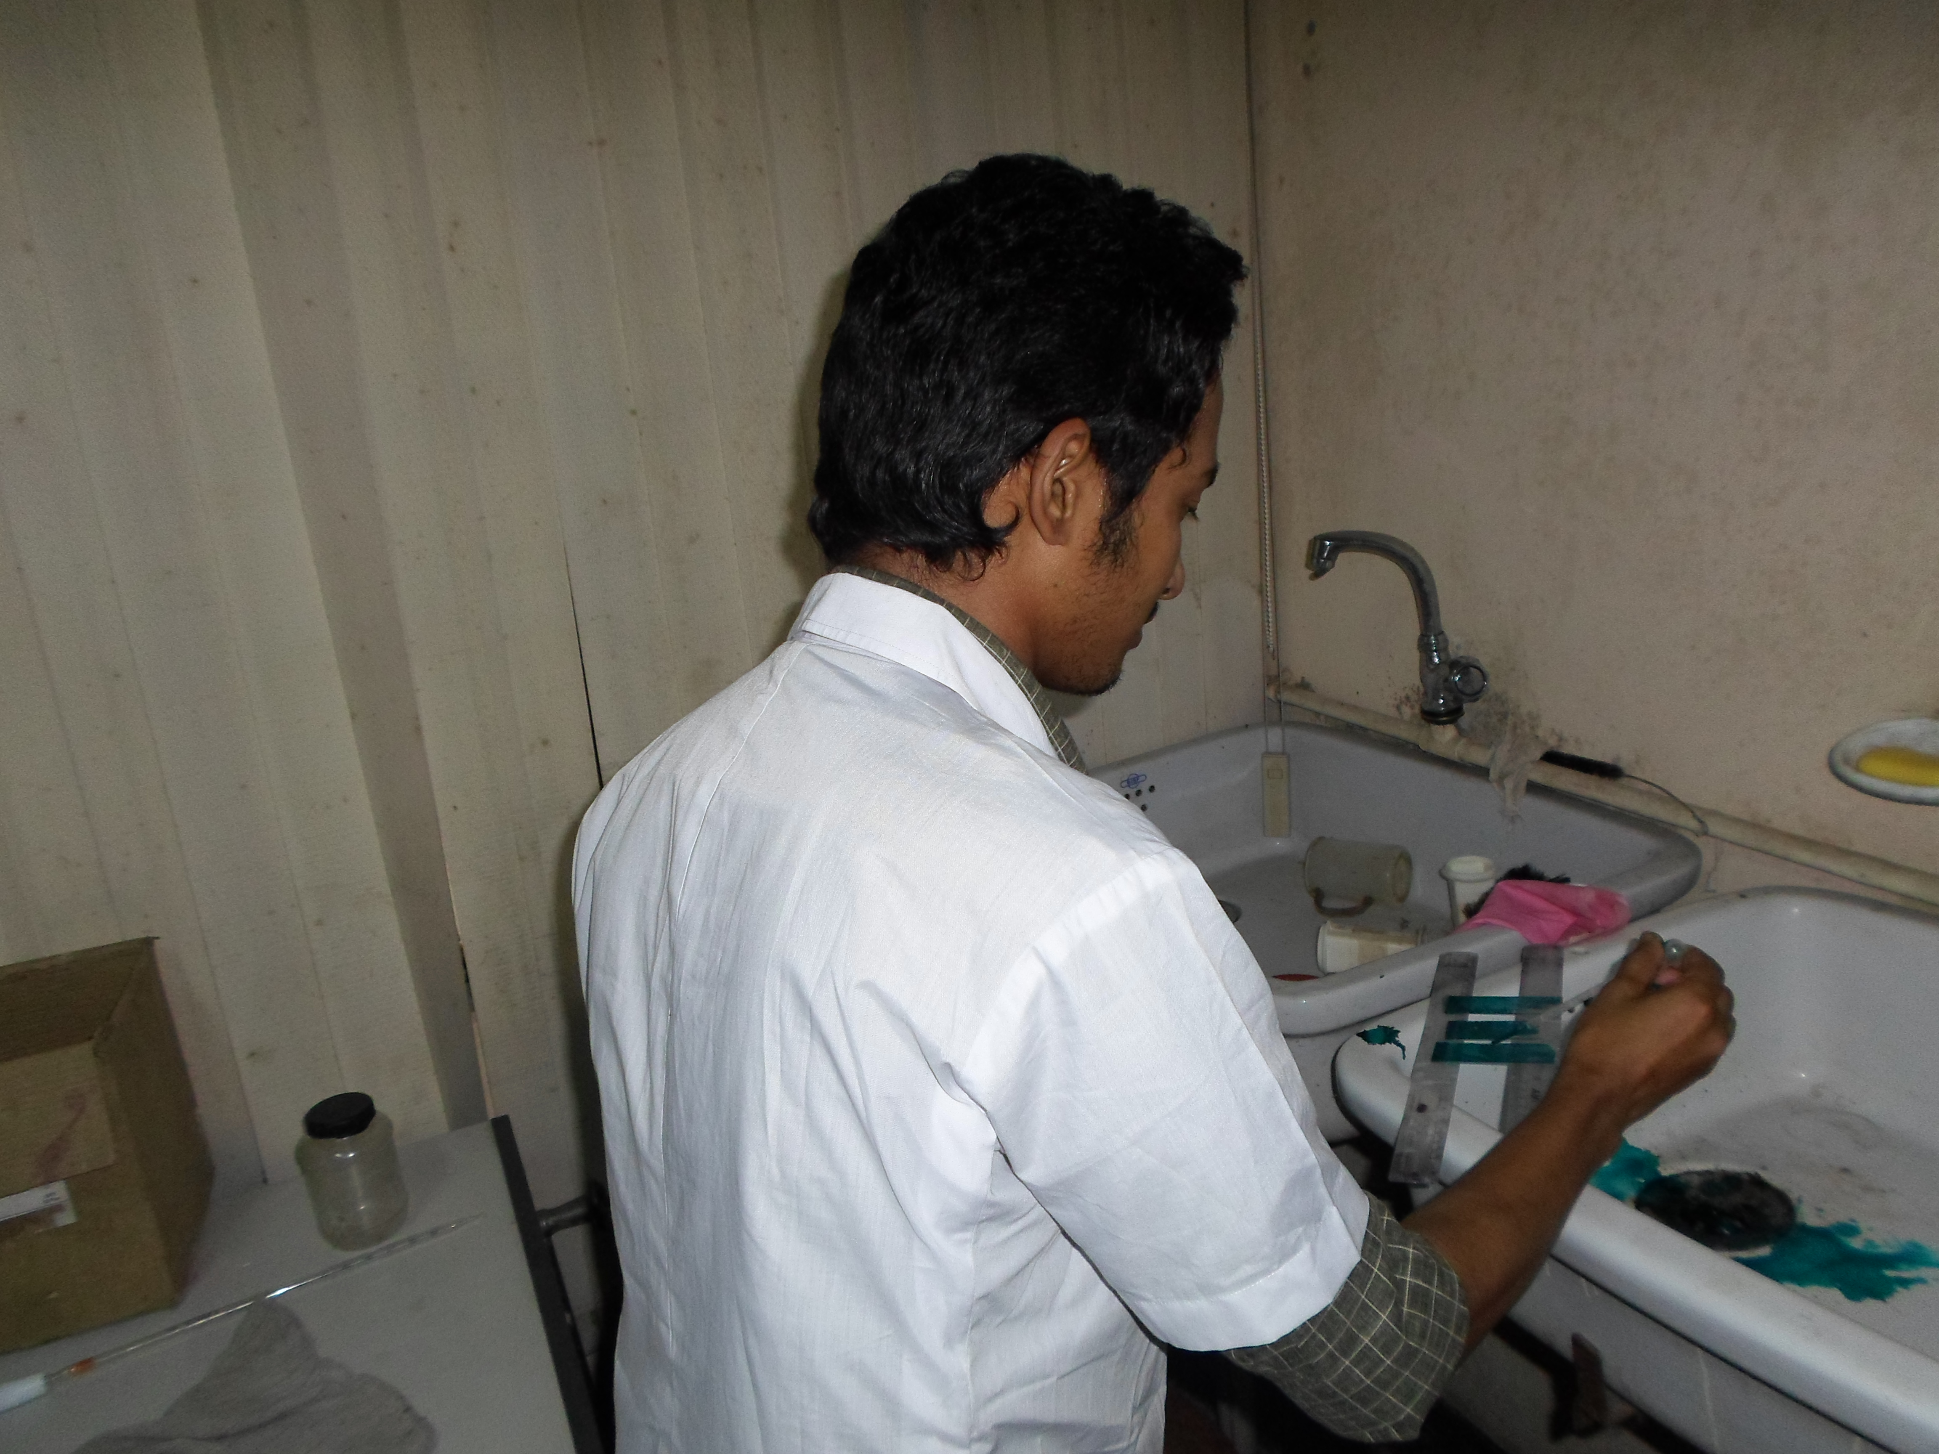

Figure 4. Making of blood smears
Figure 5. Giemsa stain application

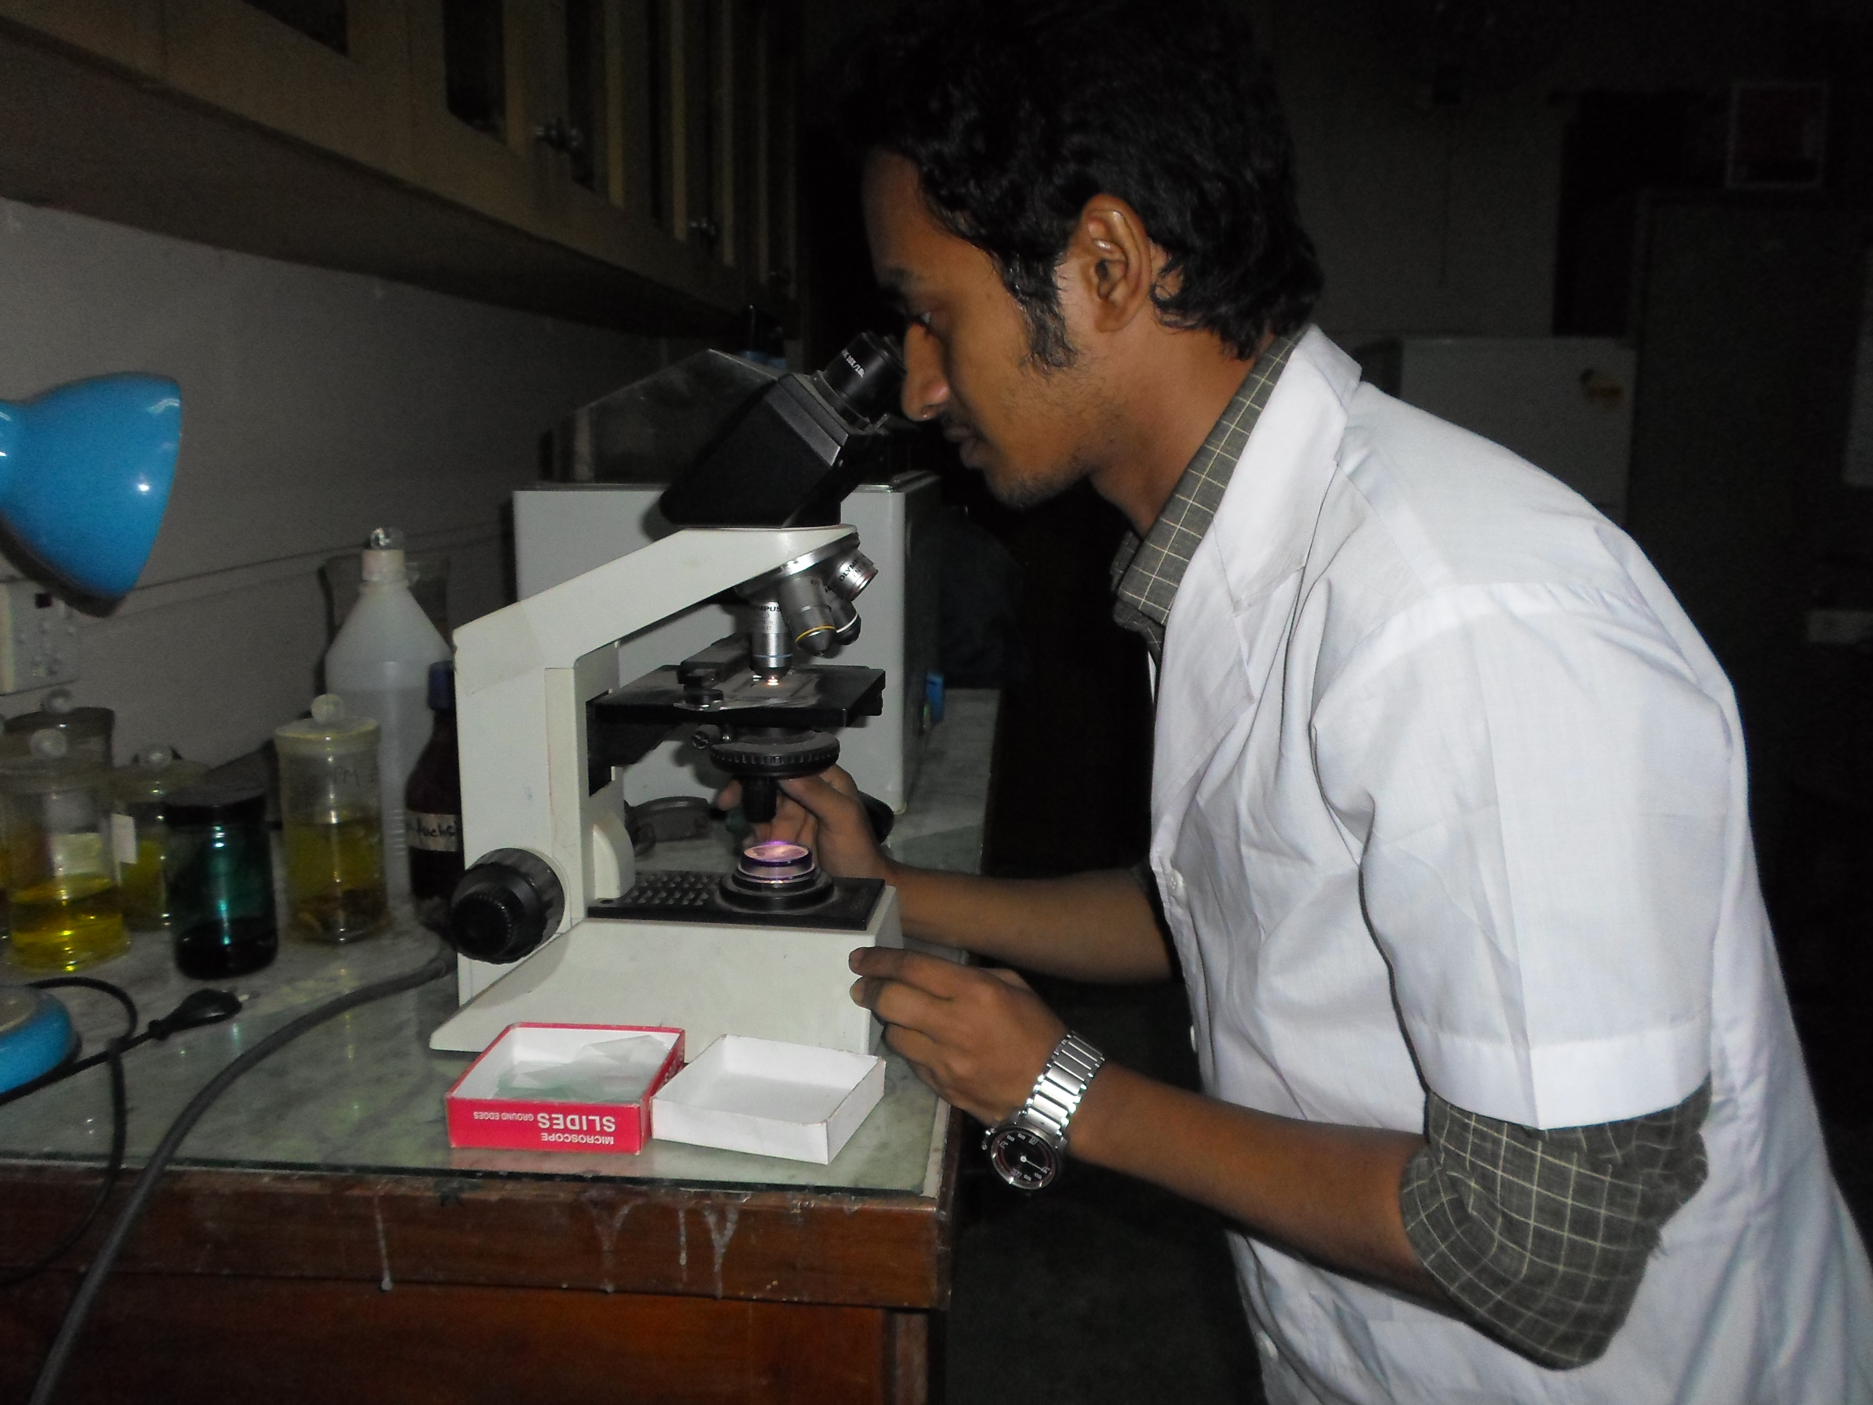
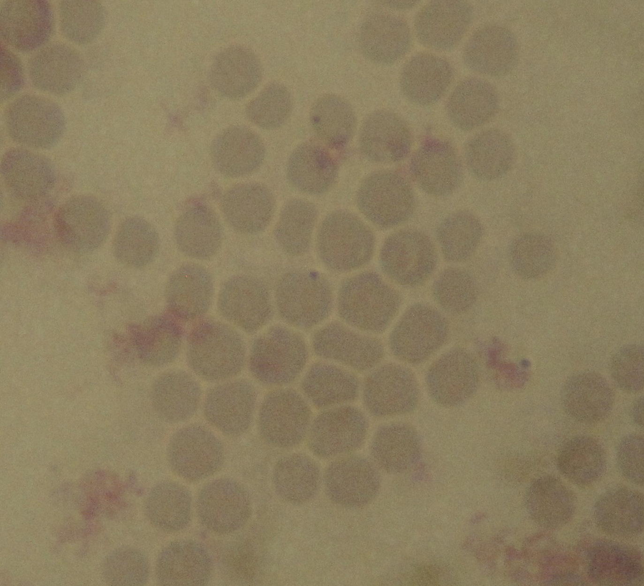

Figure 7. Anaplasma marginale was found.
Figure 6. Microscopic examination

CHAPTER IV
RESULT AND DISCUSSION

Result:
Prevalence of study area
The proportional prevalence of hemoprotozoal infections in goat was estimated by the following formula of Thrusfield (1995).
The proportional prevalence of hemoprotozoal infections
= $\frac{No.of individual having a disease in a particular point of time ×100}{No.of individual in the population at risk at the point of time}$
In present study there was no available data about babesiosis and theileriosis .That might be due to small amount of samples and two different times and locations of the study.

Table.1- Prevalence of anaplasmosis
Study area | Total number of sample | Anaplasma positive sample | Percentage (%)
Overall | 120 | 07 | 5.83
Chittagong district | 70 | 05 | 7.14
Pirojpur district | 50 | 02 | 4

In present work the overall proportional prevalence of anaplasmosis was 5.83%. But in Chittagong district it was higher (7.14%) than Pirojpur district (4%).

Graph 1. Prevalence of anaplasmosis of goats.

Factors affecting the occurrence of diseases
Host risk factors
Breed- In case of anaplasmosis the highest percentage (12.50%) was Jamnapari than Black Bengal (6.67%) while the lowest percentage (3.75%) was non descriptive breeds of goat.
Age at infection- The percentage of studied affected animals (4.35%) was of age below 12 months, while (9.3%) was of age below 18 months and lowest animals (3.23%) were of age above 18 months.
Nutritional status- Most of the affected animals were (9.76%) with BCS -2, followed by BCS- 3 (5.36%).
Sex- Most of the affected animal were male (6.67%) followed by female (5%).

Pathogen risk factors
Season – Most (7.14%) of the affected animals reported during summer (March- April) and minimum (2%) animals in rainy season (July- Aug). The occurrence of anaplasma infection was highest in summer than rainy season although season specific occurrences statistically insignificant (p> 0.05)
Presence of ectoparasite- Animals having ectoparasites mostly ticks in their body positive (31.25%) with blood parasite more than the animals having no tick in their body which is statistically significant (p< 0.05).
Breed:
It is observed that Jamnapari encountered more than (12.50%) with anaplasmosis than others although breed specific occurrences statistically insignificant (p> 0.05).
Location:
It is observed that the occurrence of anaplasmosis is higher in Chittagong surrounded by hilly area (7.14%) than plane land (2%). Although location specific occurrences statistically insignificant (p> 0.05).
Age of the animal:
Most of the affected animals were above one year (9.30%) than below one year and above two years.

Table. 2- Frequency distribution of suspected animals according to demographic and environmental variables-
Variables |  | Category Frequency | Anaplasmosis (+ve) | Percentage (%) | P- value
Demographic variables | Age | ≤ 12 months (n= 46) | 2 | 4.35 | 0.55
 |  | ≤ 18 months (n= 43) | 4 | 9.3
 |  | >18 months (n= 31) | 1 | 3.23
 | Sex | Male (n=60) | 4 | 6.67 | 0.298
 |  | Female  (n=60) | 3 | 5
 | Breed | Cross breed (n=80) | 3 | 3.75 | 0.276
 |  | Jamnapari (n= 24) | 3 | 12.5
 |  | Black Bengal (n= 15) | 1 | 6.67
 | BCS | 1 (n= 10) | 0 | 0 | 0.213
 |  | 2 (n= 21) | 0 | 0
 |  | 3 (n= 56) | 3 | 5.36
 |  | 4 (n= 33) | 4 | 12.12
Environmental variables | Season | Rainy (Jul- Aug) (n=50) | 2 | 4 | 0.469
 |  | Summer (Mar-Apr) (n= 70) | 5 | 7.14
 | Location | Pirojpur (ZVH) (n=50) | 2 | 4 | 0.469
 |  | Chittagong (SAQTVH)  (n= 70) | 5 | 7.14
 | Presence of ectoparasite | No (n=104) | 2 | 1.92 | < 0.05
 |  | Yes (n= 16) | 5 | 31.25

Discussion:
The overall prevalence of anaplasmosis in this investigation almost consistent with the earlier report of Atif et al.(2012) who recorded (5.81%) prevalence in Pakistan and partially consistent with the report of Bahzad. H. salih Mustafa (2011) who recorded slightly lower prevalence in Iraq. Opara & Nwokedi (2011) reported much higher prevalence at a rate of 18.8% and Akinboade et al. (1986) also recorded higher prevalence a rate of 17.5%. Lower prevalence of hemoprotozoan diseases in the current study might be due to random sampling rather than selection of clinically susceptible animal. However, variation in geo-climatic condition, breed, and exposure of vectors and age of the animals might contribute to variable prevalence of hemoprotozoan diseases in the study areas Muhanguzi et al. (2010).

In Bangladesh there is no authentic document about goat anaplasmosis. But in cattle the overall prevalence of anaplasmosis in Chittagong division is (4.62%) according to Alim et al. (2012). Overall prevalence of anaplasmosis was in agreement with the reports of Samad et al. (1989), Siddiki et al. (2010) and Muhanguzi et al. (2010). The slight deviation might be due to species, season, area, resistance of the animal and tick activity.

Anaplasmosis vary greatly according to seasons. In present study summer season is more vulnerable than rainy season which is supported by Alim et al. (2012). Again Mohanta et al. (2011) reported that hot and humid weather during the summer months (March-June) favors ticks building up to a high prevalence and density. Lower temperature and humidity of winter months were less favorable for the growth and multiplication of tick vectors, Muhammad et al. (1999), Zahid et al. (2005).
Age also influences the occurrence of haemo- protozoan diseases. In the current study, higher percentages of infected goats were above one year. It is assumed that aged animals are more susceptible to blood protozoan diseases than the younger animals-“inverse age resistance” Urquhart et al. (1996). Similar results were obtained by Perez et al. (1994), who reported that the prevalence of blood protozoa was higher in animals aged over 1 year. It is also supported by Alim et al. (2012) and Kamani et al. (2010). This might be due to rapid immune responses to primary infection by the youngs through a complex immune mechanism Annetta et al. (2005). Prevalence of anaplasmosis in study population supported the reports of Chakraborti (2002) and Chowdhury et al. (2006) who observed comparatively higher prevalence in adult than young. Endemic instability of the study areas might responsible for frequent infections in adults where newborns were protected by colostral immunity, Cynthia et al. (2011). On the contrary, earlier observation was in contrast with the observation of Muhanguzi et al. (2010) who found higher prevalence of anaplasmosis in young.
Sex is also predominant trait for haemoprotozoan disease. In present study male were more affected than female. But female were more susceptible to hemoprotozoan diseases according to Alim et al. (2012) and Kamani et al. (2010)
Higher prevalence in female cattle possibly due the fact that they were kept longer for breeding and milk production purpose, supplied insufficient feed against their high demand, Kamani et al. (2010) or variation in sample size. In present study female is lower due to small amount of samples and variation in the location and time.

Again present study shows that the prevalence of anaplasmosis is higher in the place which is surrounded by hilly parts than plane land and the presence of higher percentage of ectoparasites in the animal body were more susceptible to anaplasmosis. This is due to availability of ticks in the studied area. This distribution pattern of ticks has previously been reported by Mondal et al. (1995, 1996) and Islam et al. (1999, 2006). The observed result of this study indicated a constant trend of such infection in the study areas due to frequent transmission of organisms by tick vectors or mechanical means. Higher prevalence of anaplasmosis in different areas of the world was explained by endemicity of the disease, Brito et al. (2010).

CHAPTER V
CONCLUSION

From the study it might be concluded that:
The prevalence of anaplasmosis was around 6% in goat.
Among the host risk factors above one year of age were prone to blood parasitic diseases than others groups. Nutritional status plays an important role in the occurrences of diseases. The occurrence of blood parasitic diseases was highest during summer where the environmental temperature and arthropod population play an important role. Animals having ectoparasites especially ticks in their body tested positive with blood parasitic diseases more than the animals having no ticks in their body.

LIMITATIONS OF THE STUDY

The study period was too short to perform properly. Sample size is small. Farmers were not cooperative and friendly. In many cases, they were uncooperative to allow for collecting of the blood samples of their animals. In some cases, interview was not taken from the right owner. Molecular confirmation couldn’t done

CHAPTER VI
RECOMMENDATION

From the study, it may be recommended that the result of the study would be more authentic if:It was conducted for a long period of time.Population size would be more.At least three sets of data would be taken at three different times of the year.
Previous authentic record of the prevalence of the caprine anaplasmosis would be found. Molecular identification of the collected sample

REFERENCE

Akinboade O.A., Sadiq N.A., Akinrinmade J.F., Dipeolu O.O., Nwufor K.J. (1986) Anaplasmosis of small ruminants in Nigeria: incidence and parasite identification through blood smear and latex agglutination test (LAT). Int.J Zoonoses.13(3):210-4.

Alam J. (1993) Livestock the sector for more investment in Bangladesh. Asian Livestock, 18:77-81.

Alim M.A., Das S., Roy, K., Masuduzzaman M., Sikder S., Hassan M.M., Siddiki A.M. and Hossain M.A. (2012) Prevalence of hemoprotozoan diseases in cattle population of Chittagong division, Bangladesh. Pak Vet J, 32(2): 221-224.

Annetta Z., Jeremy S., Gray, Helen E., Skerrett and Mulcahy G. (2005) Possible mechanisms underlying age-related resistance to bovine babesiosis. Parasitol Immunol, 27: 115-120.
Anonymous (2007) Bangladesh Economic Review, Economic Adviser’s Wings, Finance Division, Ministry of Finance, Government of People’s Republic of Bangladesh. Pp.21-22

Ananda K.J., Placid E. and Puttalakshmamma G.C. (2009) Prevalence of hemoprozoan diseases in cross breed cattle in Bangalore north. Vet. World, 2(1): 15-16

Atif F.A., Khan M.S., Iqbal H.J. and Rohee T. (2012) “Prevalence of tick-borne diseases in Punjab (Pakistan) and hematological profile of anaplasma marginale infection in indigenous and crossbred cattle”. Pakistan Journal of Science; 64(1).

Bahzad H. salih Mustafa (2011) “Clinical and hematological study on ovine anaplasmosis in Sulaimani province, Iraq.” Bas.J.Vet.Res; 10 (2).

Benbrook E. and Sloss M.W. (1962) Veterinary Clinical Parasitology, Lowa State, University press. 3rd edn. Pp.113-114.

Blood D.C., and Henderson J.A. (1968) A text book of disease of cattle, sheep, pigs, goats and horse. 4th edn. Baillere Tindall Publication, London. pp. 1261-64, 1289-94, 1324-29.

Boynton, William Hutchins, Herms, William B., Howell D. E., Woods, Gladys M. (1936) Anaplasmosis transmission by three species of ticks in California. Amer. Vet. Med. Assoc. Jour. 88: 500-502.

Bram R.A. (1983) Tick-borne livestock diseases and their vectors: the global problem. Ticks and tick-borne diseases, FAO Animal Production and Health Paper. World Anim Rev, Rome. 36:7-11.

Brito L.G., de Sena Oliveira M.C., Rochal R.B., da Silva Netto F.G., Marim A.D., de Souza G.C.R., Vendrame F.B. and da Fonseca Moura M.N. (2010) Anaplasma marginale infection in cattle from south-western Amazonia. Pesq Vet Bras, 30: 249-254.

Bron C.G.D., Hunter A.G. and Luckins A.G. (1992) "Diseases caused by Protozoa in: "Handbook on Animal Diseases in the tropics" (Sewell, M. M. H., and Brocklesby, D. W., eds) 4 th Edit. Bailliere Tindall, London, Philadelphia, Tokyo. Pp. 895-98.

Cable R.M. (1957) An Illustrated Laboratory Manual of Parasitology. 4th edn. Burges Publishing Co., Minneapolis 15, Minnesota, USA. pp. 114-115.

Carlton, William M., Donald Mc Gavin (1995) Thomson’s Special Veterinary Pathology. Pp. 293-294.

Chakraborti A. (2002) A Textbook of Preventive Veterinary Medicine. 3rd Ed, Kalyani Publishers, New Delhi, India, pp: 683.

Chowdhury S., Hossain M.A., Barua S.R. and Islam S. (2006) Occurrence of common blood parasites of cattle in Sirajgong Sadar area of Bangladesh. Bangladesh J Vet Med, 4: 143-145.

Cynthia M., Kahn M.A., Line S., Susan E. and Ajello B.S. (2011) Marck Veterinary Manual, Online Ed. Merck Sharp & Dohme Corp, a subsidiary of Merck & Co., Inc. Whitehouse Station, NJ,USA.http://www.merckvetmanual.com/mvm/index.jsp?cfile=htm/bc/10401.htm&word=Anaplasmosis.

De la Fuente J., Atkinson M.W., Hogg J.T., Miller D.S., Naranjo V., Almazan C., Anderson N., Kocan K.M. (2006) Genetic characterization of Anaplasma ovis strains from bighorn sheep in Montana. J. Wildl. Dis. 42, 381–385.
D.L.S (2007, 10-11) Livestock and poultry profile Bangladesh, Department of Livestock Services.
El Sawalhy A. A. (1999) "Veterinary Infectious Diseases" 2nd Edit. Ahram Distribution Agency, Egypt. Pp. 365-367.

Friedhoff K. T. (1988) Transmission of Babesia, In: Babesiosis of domestic animals and man. Ristic M. (ed.) CRC, press, Boca Ration, Florida.pp-23-52.

Friedhoff K. T. (1997) Tick born diseases of sheep and goats caused by Babesia,
Theileria, or Anaplasma spp. Parasitol. 39: 99-109.

Gautam O.P. and Banerjee D.P. (1982) Anaplasma in cattle with reference of the disease in India. Indian Journal of Parasitology, 6(2): 169-181.

Hagan W.A. and Bruner D. W. (1961) The infectious diseases of domestic animals, 4th edn. Comstock Publishing Association, Ithaca, Newyork. pp. 652-686.

Howard, J. L. (1985-2003) Current Veterinary Therapy-3, Food Animal Practices. Texas A&M Vet. Med. Diagnostic Lab., Amarillo, Texas, USA. pp. 584-86,588-91,627-28.

Hungerford T.G. (1962) Disease of Livestock,5th edn. Angus and Robertson Ltd., Sydney. pp. 201-207.

Ijaz M., Rehman A., Ali M.M., Umair M., Khalid S. Mehmood K. and Hanif A. (2013) Clinico-epidemiology and therapeutical trials on babesiosis in sheep and goats in lahore, Pakistan. J. Anim. Plant Sci. 23(2).

Islam M.K. and Kibria A.K.M.G., Majumder S., Islam M.F. and Mondal M.M.H. (1999) Factors influencing Ixodid tick (Acari: Ixodidae) infestation of cattle in Bangladesh. Progr. Agric., 10: 131-135.

Islam M.K., Alim M.A., Tsuji N. and Mondal M.M.H. (2006) An investigation into the distribution , host-preference and population density of Ixodid ticks affecting domestic animals in Bangladesh. Tropical Animal Health Prod., 38: 485-490.

Julish P.K. (1966) Parasitic protozoa, Vol.IV. Academic press, INC, London, Ltd. Pp.115-120, 242-243.

Kamani J., Sannusi A., Eqwu O.K., Dogo G.I., Tanko T.J., Kemza S., Takarki A.E. and Gbise D.S. (2010) Prevalence and significance of haemoparasitic infections of cattle in North-Central, Nigeria. Vet World, 3: 445-448.

Kocan K. M., and Stiller D. (1992) Development of Anaplasma ovis(Rick-ettsiales: Anaplasmataceae) in male Dermacentor andersoni (Acari: Ixodi-dae) transferred from infected to susceptible sheep. J. Med. Entomol.29:98–107.
Kuttler K.L. (1984) "Anaplasma infections in wild and domestic ruminants ". A review J. of wild life diseases, 20:12-20.
Levine N.D. (1985) Veterinary Protozoology. 1st edn., Iowa State University Press, Ames, pp. 266-282.

Losos G.J. (1986) "Protozoal diseases in Infectious tropical diseases of domestic animals ". longman Scientific & Technical Longman Group UK. Limited, pp.742–795.

Mahoney D.F. (1994) The development of control method for tick fevers of cattle in Austrilia. Aust. Vet. J., 71(9), 283-289.

Makala L.H., Mangani P., Fujisaki K. and Nagasawa H. (2003) The current status of major tick-borne diseases in Zambia.Vet,Res. 34: 27-45
Mehlhorn H. and Shein E. (1985) The piroplasms: lifecycle and sexual stages. Adv. Parasitol. 23: 37103.

Mohanta U.K., Anisuzzaman and Mondal M.M.H. (2011) Tick and tick borne protozoan diseases of livestock in the selected hilly areas of Bangladesh. Int. J. Agril. Res. Innov. & Tech. 1 (1&2): 60-63.
Mondal M.M.H., Giasuddin M. and Islam M.K. (1996) Amblyomma testudinarium (Acari: Ixodidae) infestation frontalis) in Bangladesh. Proceedings of the 20th International Congress of Entomology, Florence, Italy, pp 63.
Mondal M.M.H., Islam M.K. and Kibria A.K.M.G. (1995) Ecological studies on Hyalomma anatolicum anatolicum (Acari: Ixodidae) of cattle in Barind area in Bangladesh. Bangladesh Vet. J., 29: 63-66.

Muhammad G.M., Saqib M., Athar M.Z. and Khan M.N. (1999) Clinico epidemiological and therapeutic aspects of bovine theileriosis. Pak Vet J, 19: 64-69.

Muhanguzi D., Ikwap K., Picozzi K. and Waiswa C. (2010) Molecular characterization of anaplasma and ehrlichia species in different cattle breeds and age groups in Mbarara district (Western Uganda).Int J Anim Vet Adv, 2: 76-88.

Munz E. and Dumbell K. (1994) "Anaplasmosis In: Infectious Diseases of Livestock with special reference to Southern Africa. Volume I (Coetzer, J. H. W.; Thomson, G. R. and Tustin, R. C.), Chapter 53 pp. 613-615. CAPE Town, Oxford, New York, Oxford University Press.

Ngole I.U., Ndamukong K.J.N. and Mbuh J.V. (2002) Internal parasitic infection and haematological values in cattle slaughtered in Buea subdivision in Cameroon, Trop. Anim. Health Prod. 34:1-5

Opara & Nwokedi (2011) “Occurrence of Haemoparasites among Small Ruminants Reared Under Traditional Husbandry System in Owerri, Southeast Nigeria.” Bulletin of Animal Health and Production in Africa; 59(4).

Palmer G.H., McElwain T.F., McGuire T.C., Kappmeyer L., Davis W.C., Stiller D., Visser E., Tebele N., Ndung’u L., Pipano E., Shkap V.and Knowles D.P. (1994) Recent advances in serological diagnosis of anaplasmosis: development of the msp-5 competitive inhibition ELISA, pp. 102–104.

Perez E., Herrero M.V., Jimenez C., Hird G. and Buening G.B. (1994) Effect of management and seroprevalence of bovine Anaplasmosis and Babesiosis in Costa Rica. Preventive Veterinary Medicine, 20(1-2): 33-46.

Piesman J. (1987) Emerging tick-borne diseases in temperate climates. Parasitology, 3, 197-199.
Rajput Z.I., Song-hua Hu, Arijo A.G., Habib H. and Khalid K. (2005) Comparative study of Anaplasma parasites in tick carrying buffaloes and cattle. J. Zhejiang Univ. Sci, 6B (11): 1057-62.

Ristic M., Weinman D. (1960) Infectious Blood Diseases of Man and Animals. Vol.11. New York, USA: Academic Press; 1968. Pp.473-542.

Ristic M. (1981) Diseases of Cattle in the Tropics. Matinus Nijhoff Publishers, the Hauge. Vol (6) pp. 327-344, 443- 468.

Roadostits O.M., Blood D.C. and Gay G.C. (2000) Veterinary Medicine: A text book of disease of cattle, sheep, pigs, goats and horse. 9th Ed, Baillere Tindall Publication, London, pp: 1172-1173, 1289-1290.

Samad M.A., Bashar S.A., Shahidullah M. and Ahmed M.U. (1989) Prevalence of hemoprotozoan parasites in the cattle of Bangladesh. Indian Vet. Med.J. 13:50-51.

Siddiki A.Z., Uddin M.B., Hasan M.B., Hossain M.F., Rahman M.M., Das B.C., Sarker M.S. and Hossain M.A. (2010) Coproscopic and haematological approaches to determine the prevalence of helminthiasis and protozoan diseases of red Chittagong cattle (RCC) breed in Bangladesh.Pak Vet J, 30: 1-6.

Soulsby E.J.L. (1986) Helminths, Arthropods and Protozoa of Domesticated Animals,7th edn. Baillere Tindall Publication, London. Pp.707-717, 729-735.

Sparagano O. (1999) Molecular diagnosis of Theileria and Babesia species. J .vet. Parasitol, 13(2):83-92.

Springer W.T. (1997) Other blood and tissue protozoa. In: Diseases of Poultry. 10th edn. Calnek BW, Barnes HJ, BeardHJ, McDougald LR and Saif YM (eds). Iowa State University Press, USA. pp. 900-911.

Thrusfield M. (1995) Veterinary Epidemiology. Blackwell Science Ltd., a Blackwell Publishing Company., pp.39-41.

Talukder M.H. and Karim M.J. (2001) Subclinical Anaplasma infection in crossbred cattle in Bangladesh. Bangladesh Vet.J. 35(3-4): 159-160.

The Merck Veterinary Manual (1997) Professional Hand of Merck and Co.; INC, pp.18-22, 30-33.

Uilenberg G. (1995) International collaborative research: significance of tick-borne hemoparasitic diseases to world animal health. Vet. Parasitol; 57: l9-4l.
Urquhart G.M., Armour J., Duncan J.L. and Jennings F.W. (1996) Veterinary Parasitology. 2nd Ed, Black well Science Ltd, Oxford, UK, pp: 213, 242-251.

Yabsley M.J., Davidson W.R., Stallknecht D.E., Varela A.S., Swift P.K., Devos J.C. and Dubay S.A. ( 2005) Evidence of tick-borne organisms in mule deer (Odocoileus hemionus) from the western United States. Vector Borne Zoonotic Dis. 5, 351–362.

Zahid I.A., Latif M. and Baloch K.B. (2005) Incidence and treatment of theileriasis and babesiasis. Pak Vet J, 25: 137-139.

Zaugg J.L. (1987) Experimental infections of Anaplasma ovis in prong horn antelope. J. Wildl. Dis. 23, 205–210.

Zaugg J.L. (1988) Experimental anaplasmosis in mule deer: per-sistence of infection ofAnaplasma marginale and susceptibility to A. ovis. J. Wildl. Dis. 24, 120–126.

Zaugg J.L., Goff W.L., Foreyt W. and Hunter D.L. (1996) Suscept-ibility of elk (Cervus elaphus) to experimental infection withAnaplasma marginale and A. ovis. J. Wildl. Dis. 32, 62–66.

