ANNEX-I
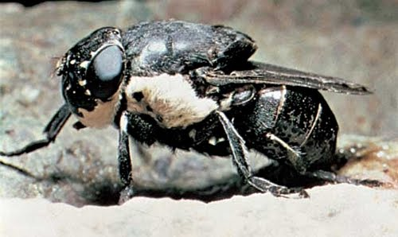
- There are three main families of flies that cause myiasis:

1.Oestridae (obligate parasites)
Flies in the family Oestridae include: bot flies
and warble flies

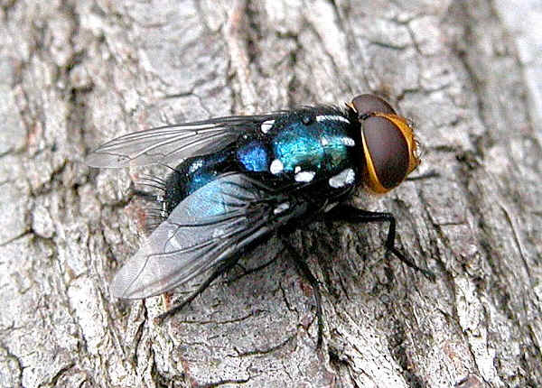

2.Calliphoridae (obligate or facultative)
Flies in the family Calliphoridae include: blow
-flies (bluebottles, greenbottles),
carrion flies or cluster flies

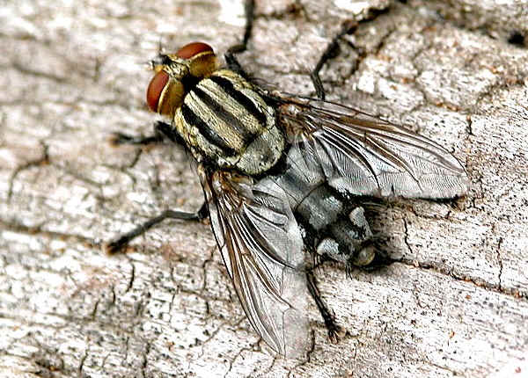

3.Sarcophagidae (obligate or facultative)
Flies in the family Sarcophagidae are
commonly known as flesh flies

(Colwell, D.D., D. Otranto and J. R. Stevens.2009. Oestrid flies: eradication and extinction versus biodiversity. Trends in Parasitology 25: 500-504)
Some of the Myiasis cases I founded during my study:
