CHAPTER I

INTRODUCTION

Namakkal is the most thickly populated poultry belt in India and gets first and second palace in egg production in Tamil Nadu and National level respectively. In Namakkal zone layer poultry population is approximately 4.0 crores and daily egg production is nearly 3.0 crores. To sustain the poultry industry in this area Tamil Nadu Veterinary and animal Sciences University upgraded the existing Poultry Research and Development Centre as a fully fledged Poultry Disease Diagnosis and Surveillance Laboratory (PDDSL). This laboratory handled and controlling the existing and emerging diseases caused by E.coli, CRD, Fowl cholera, Salmonella, Newcastle (ND),Infectious Bursal (IBD), Infectious Bronchitis(IB), Mareks and Lymphoid leukosis diseases by doing postmortem, HA, HI and culture works. It has no doubt that poultry industry in has greatly expanded over the years holding the greatest promise in affordable animal protein supply, food security and alleviation of poverty in both villagers and urban populace.
Previous studies indicated that poultry business is first on the list of currency of doublers among other financial transactions but poultry diseases are the major constraints for developing the poultry industry (Karim, 2003).
Despite of the expansion and development of the poultry industry, mortality of chickens due to several infectious and non-infectious diseases is one of the major obstacles for development of profitable poultry production. About 30% mortality of chickens in Tamil Nadu is due to various infectious diseases and outbreaks of concurrent diseases in broiler & layer farms significantly affect the optimal production and health status of the chickens (Chanie et al, 2009). Most of the farms are large-scale commercial type where chickens are reared in confined system with compromised biosecurity. Consequently birds are more vulnerable to become infected with various infectious agents. Infectious diseases also cause economic losses in terms of morbidity and mortality. However, information on the occurrence of different poultry diseases is limited, if not absent. To establish commercial poultry farms, information on the occurrence of different poultry diseases in an area is necessary to control and prevent the various diseases.

Objective:
- The present study was conducted to determine the prevalences of different diseases in poultry in Namakkal.
- To determine the pathological gross changes in Infectious diseases in poultry.

CHAPTER II

REVIEW OF LITERATURE

2. (A). Etiology, clinical signs and post-mortem findings of different diseases in poultry
2.1 Infectious Bursal Disease
Infectious bursal disease (IBD), popularly known as Gumboro disease, is a contagious disease of young chickens which cause damage to the lymphoid tissue with special predilection for the bursa of fabricious. The name “Gumboro” disease was initially given to the condition because it was first recognized on the farm in the Gumboro district of Delawre, USA in 1962.

The etiological agent of infectious bursal disease (IBD) is infectious bursal disease virus (IBDV), is a non-enveloped virus, belonging to the family Birnaviridae, with a bisegmented double stranded RNA genome (Kibenge et al, 1988). Initially Gumboro was confused with a variant from of Infectious Bronchitis virus accompanied with nephrosis (Winter and Hitchner, 1962; Cosgrove, 1962). In an embryonating egg (Winterfield et al, 1962) succeeded in isolating and the isolate was referred to as “Infectious bursal agent”. In 1987 hyper virulent IBDV strains were first reported in Belgium and Netherlands. In mid 1980s several antigenic variants of IBDV appeared in the USA (Synder et al, 1988). This was followed by the emergence of a very virulent pathotype of IBDV (vvIBDV) in western Europe, which caused an acute disease with very high mortality reaching up to 70% in natural infection and 100% in experimental infection (van den Berg et al, 1991). Within a couple of years the vvIBDV spread across Asia (Nunoya et al, 1992). Since 1992, the poultry farms of Bangladesh have been experiencing the out breaks of a disease resembling acute IBD. Now a day, IBDV has a worldwide distribution, occurring in all major poultry producing areas (Sjaak Wit and William Baxendale, 2004).
In exposure to IBDV only in the chicken distinct lesions are found. Through oral ingestion of contaminated feed and other organic materials mainly the infection occurred. Clinical signs of IBD are not specific but gross and histo-pathogenic bursal lesions in the initial stages are pathognomonic and include degeneration and necrosis of lymphocytes in the medulla of the bursa follicles. Later, there is infiltration of heterophils, pyknotic debris, and hyperplastic reticular cells. All lymphoid follicles are affected by 3 or 4 days after infection and the bursa of fabricious increases in size and weight due to severe edema, hyperemia, and marked infiltration of heterophils. As the inflammation reaction declines, cystic cavities develop in the medullary areas of follicles. Hyperplasia of epithelia is present, necrosis and phagocytosis of heterophils and plasma cell occur, followed by atrophy and fibroplasias of the bursa (Millar et al, 1979).
2.2 Newcastle disease
Newcastle disease is caused by Avian Paramyxovirdae virus, serotype-1(APMV-1) that has been placed in genus Rubela virus. The virus particle consists of an assembly of material composed of single-stranded ribonucleic acid enclosed in a protein coat. The envelope itself contains 2 glycoprotein & 7 polypeptides that initiate the virus to neutralize the antibodies in the host (Rima et al, 1995).

ND virus strains are grouped into 5 patho-types based on the clinical signs induced in chickens (i) Viscerotropic velogenic cause a high virulent form of disease in which haemorrhagic lesions are characteristically present in the intestinal tract (ii) Neurotropic velogenic causes high mortality following respiratory & nervous signs (iii) Mesogenic viruses cause respiratory and sometimes nervous signs with low mortality (iv) Lentogenic viruses cause mild or inapparent respiratory infection and (v) Asymptomatic enteric viruses cause in apparent enteric infection (Alexander, 2008).

At necropsy hemorrhagic or necrotic focal lesions are present in the mucosa of the intestine. Hemorrhages occasionally occur on the mucosal surface of the proventriculus. Caecal tonsils often are necrotic and hemorrhagic (Whiteman et al, 1989). There was no age restriction as regard infection but the young birds are more susceptible over the old birds (Chakrabaarti, 1993).

2.3 Coccidiosis
Coccidiosis could occur at any stage of the chicken's life and during any season of the year; however, it was found to be more prevalent in summer season (Boado et al, 1991). Coccidia are often present in the intestine of birds of 3-6 weeks old in most flocks. The findings of bloody intestinal content and a few oocyst by microscopic examination of smear from the intestine indicate clinical coccidiosis (Barns, 1990).

Eimeria tenella infections are found only in the caeca and can be recognized by accumulation of blood in the caeca and by bloody droppings. E. acervulina, the most common infection, is characterized by numerous, whitish, oval or transverse patches in the upper half of the small intestine and may be easily distinguished on gross examination. E. brunette, is found in the lower small intestine, rectum, ceca, and cloaca. E. maxima, develop in the small intestine, where it causes dilatation and thickening of the wall; petechial hemorrhage; and reddish, orange, or pink viscous mucous exudates and fluid (Kahn et al, 2008).

Coccidiosis is the term applied to the diseased condition caused by infection with one or more of the many species of coccidia, a subdivision of great protozoan class sporozoa & is characterized by varying degrees of enteritis that causes decreased production & performance including mortality.

2.4 Colibacillosis
The term colibacillosis refers to any localized or systemic infections caused entirely or partly by E. coli, including colisepticemia, coligranuloma (Hjarre’s disease), air sac disease (CRD), avian cellulites (inflammatory process), swollen head syndrome, peritonitis, salpingitis, osteomyelitis, synovitis, panophthalmitis and omphalitis yolk sac infection. Colibacillosis is a typically secondary localized or systemic disease, occurring when host defense have been implied or overwhelmed. Collectively infections caused by E. coli, are responsible for significant losses to poultry industry. It was reported that 43% broiler carcasses condemned during because of presence of lesions consistent with colisepticemia (Barnes and Gross, 1990).

Infections with pathogenic E. coli (APEC), causes colibacillosis, an acute and mostly systemic disease characterized by multiple organ lesions with airsaculitis, pericarditis, perihepatitis and peritonitis resulting in significant economic losses in poultry industry worldwide (Ewers et al, 2003).

The various pathological manifestations found in collibacillosis include yolk sac infection, air sac disease, bacteraemia, salpingitis, peritonitis swollen head syndrome, cellulitis, enteritis, synovitis & osteomyelitis (Gross, 1994).

2.5 Salmonellosis
Salmonellosis caused by Gram negative, non-sporeforming, & facultatively anaerobic bacteria. They are slender rods, 1.0-2.5 micrometer in length & 0.3-1.5 micrometer in width. The bacilli mostly occur singly, but occasionally two or more can be found united (Shivaprasad, 1997).

Salmonellosis refers to the infections with bacteria of the genus Salmonella are responsible for a variety of acute & chronic disease in poultry. Infected poultry moreover comprises one of the most important reservoirs of salmonellae that can be transmitted through the food chain to humans (Gust and Beard, 1990).

Pullorum diseases (PD) are caused by bacterium Salmonella pullorum. It is a common fatal malady of avian species. Mortality from pullorum disease in chickens is usually confined to the first 2-3 weeks of age (Gordon et al, 1982). In salmonellosis petechial hemorrhage or focal necrosis in the liver and spleen along with bronze discoloration are typical (Samad, 2005).

In pullorum disease classically there are gray nodules in one or more of the following sites: lung, liver, gizzard wall, heart, intestinal or caecal wall, spleen, peritoneum (Whiteman et al, 1989). In case of necropsy lesion of pullorum infection which included bronze discoloration of liver 75%, mottling 25%, haemorrhagic 60% and necrotic foci 11%. In infection due to Salmonella gallinarum, the liver showed bronze discoloration 60%, motting haemorrhage 45% cases and necrotic foci 10% (Chishti et al, 1985).

2.6 Omphalitis
Omphalitis is a condition characterized by infected yolk sacs, often accompanied by unhealed navels in young fowl. It is infectious but non-contagious and affected chicks or poults usually appear normal until a few hours before death. Depression, drooping of the head, and huddling near the heat source usually are the only signs. Opportunistic bacteria (Coliforms, Staphylococci, Pseudomonas spp, and Proteus spp.) are often involved (Kahn et al, 2008).

The necropsy lesions of omphalitis include curled and considerably thicken unabsorbed yolk in chicks. The covering of yolk appeared to be highly inflamed, thickened and edematous. The blood vessels around yolk were highly congested and hemorrhages were also evident in these areas. The livers in few chicks are markedly pale (Kamal, 1989).

2.7 Mycoplasmosis
Mycoplasmosis due to Mycoplasma gallisepticum (MG) infection is particularly important in chickens and turkeys as a cause of respiratory disease and decreased meat and egg production (Ley, 2003). It can also cause upper respiratory disease in game birds. More recently MG has been recognized in North America in house finches as a cause of conjunctivitis (Luttrell et al, 1996). In poultry the infection is spread vertically through infected eggs and horizontally by close contact; the MG nucleic acid has been identified in environmental samples (Marois et al, 2002). Other methods of spread are less well documented.

Gross lesions of respiratory tract may be almost rarely visible or consist of excess mucous and catarrhal exudates in nasal and Para nasal passages trachea bronchi and air sacs (Bradburry, 2001). Mixed infection with E. coli, the pathological changes include gastroenteritis, hepatomegaly, hemorrhages on liver few pale colored foci, perihepatitis and congestion of kidneys. In addition hemorrhages in lungs exudates and linear hemorrhages in trachea, cloudiness and marked edema in the facial sub cutis and eye lids due to exudation are also found (Rodrigues et al, 2001).

2 (B). Occurrence of infectious diseases in poultry
An investigation on 199 broiler chickens in Gazipur district showed that colibacillosis is the major problem for broiler production with a prevalence of 52.26%. Other prevalent diseases are mycoplasmosis (12.56%), omphalitis (11.56%), IBD (11.06%), coccidiosis (4.52%), salmonellosis (1.01%) and mixed infection of IBD and Coccidiosis (1.51%) (Ahmed et al, 2009).

A study conducted in Chakwal district of Pakistan showed in broilers, incidence of coccidiosis, ascites, and IBD decreased with increase in flock size, while coccidiosis was the most prevalent disease during 2nd and 3rd week of their life. Incidence of ND, mycoplasmosis and respiratory diseases increased linearly with increase in age of the broilers (Yunus et al, 2009).

Among bacterial diseases salmonellosis (53.90%), omphalitis (28.42%), colibacillosis (13.36%), necrotic enteritis (1.18%) and infectious coryza (0.59%) were found in chickens (Rahman et al, 2007).

Pathological investigation on poultry diseases in Sylhet region reported poultry diseases occur mostly in rainy season (56.36%), followed by summer (28.11%) and least in winter season (15.53%). IBD (24.26%) and aspergillosis (17.53%) are the major prevalent diseases (Islam et al, 2003).

Single disease infection (76.30%) and mixed infections (23.70%) of two (21.53%), three (1.83%) and four (0.34%) were associated with mortality of chickens in Bangladesh (Rahman and Samad, 2003).

Incidence of aflatoxicosis (27.59%) was highest followed by nutritional deficiency (12.40%), IBD (11.80%), CRD (8.11%), ND (7.50%), salmonellosis (5.56%), colibacillosis (94.42%), and fowl cholera (3.08%) (Giasuddin et al, 2002).

A study conducted by necropsy of 381 cases of either dead or sick birds revealed IBD in 19.16% (73), ND in 10.24% (39), lymphoid leucosis in 1.57% (50), colibacillosis in 5.51% (12), infectious coryza in 0.52% (2), mycoplasmosis in 8.66% (33), aspergillosis in 4.20% (16), aflatoxicosis in 1.05% (4), deficiency disorder in 8.14% (31) and miscellaneous diseases condition in 7.09% (27) cases (Talha et al, 2001).

CHAPTER III

MATERIALS AND METHODS

3.1 Study population
The study was conducted on layer,broiler,duck,pigeon and mayna.About 210 dead birds were examined in this period.

3.2 Study area
The study was carried out at poultry Disease Diagnostic & Surveillance Lab (PDDSL) in VC&RI, Namakkal, TANUVAS. Dead birds were brought by the farmer from various farms during the study period. Postmortem examinations were performed by teachers &
duty doctors at PDDSL.
3.3 Study period
The study was carried out from 16th June to 2 July, 2014.
3.4 Sample
All dead birds brought by the farmer from various farms of Namakkal to the PDDSL during the study period were included in to the study.

3.5Data collection
The following data was collected from the record sheets with the postmortem lesions of the dead birds through a structured questionnaire:
Name of farmer, name of area, total number of birds in farm, vaccination, total number of affected birds, daily mortality and total mortality. During the period present and previous history was taken from each farmer.

3.6 Case definition
A case is a standard set of criteria for determining who should be classified as a case.
OR
A standard set of criteria for deciding whether, in this investigation, a bird should be classified as having the disease or health condition under this study.

Table 1: An overview of clinical signs and postmortem findings used to determine as a case

Name of the Disease | Clinical signs | Postmortem findings
Collibacillosis | - Listless and ruffled feathers  - Reduced food and water intake  - Huddling at corner of the shed  - Loss of body weight  - Brown color droppings | - Distended and soft abdomen  - Pericarditis  - Perihepatitis  - Air sac infection  - Omphalitis  - Edema in the body cavities  - Swollen and inflamed intestine
Salmonellosis | - Ruffled feather  - Whitish to greenish diarrhea  - Chalky white excreta adhered with the vent  - Anemic comb and wattle | - Enlarged liver and spleen showing congestion and necrotic foci  - Unabsorbed and inflamed yolk sac
Omphalitis | - Lethargic  - Depressed andpoor growth performance | - Distended and soft abdomen  - Thickened and unabsorbed yolk  - Cloudy and malodorous abdominal content  - Highly congested blood vessels around the yolk
Mycoplasmosis | - Oculo-nasal discharges  - Coughing and sneezing  - Respiratory distress  - Gargling sound during respiration  - Drop in feed consumption | - Air sacculitis with caseous exudates  - Catarrhal exudates in nasal and paranasal sinuses  - Congestion of the lungs  - Pericarditis and perihepatitis in complicated cases
Coccidiosis | - Ruffled feather  - Poor growth  - Bloody diarrhea and anemia  - Vent picking | - Caeca filled with blood tinged contents  - Caecal wall show patchy hemorrhages  - Diffuse hemorrhagic striation throughout the intestine
Newcastle Disease (ND) | - Depression and prostration  - Loss of appetite  - Greenish/yellowish diarrhea  - Incoordination  - Twitching of neck | - Pin point haemorrhage at the tip of the proventicular glands.  - Haemorrhagic/diptheric ulcers on the intestine and caecal tonsils
Infectious Bursal Disease (IBD) | - Soiled vent and feathers  - Whitish and watery diarrhea  - Anorexia, trembling severe prostration and death | - Swollen and edematous bursa with necrotic mass  - Haemorrhages in the thigh and breast muscles  - Haemorrhage at the junction of proventiculas and gizzard  - Nephrosis
Lymphoid leucosis |  | - Bone enlarged.  - Enlargement of abdomen & liver.  - Nodules in liver,kidney,ovary and bursa of fabricius
Heat stress | - Respiratory distress  - High environmental temperature | - Cooked meat appearance of breast and thigh muscle.
Duck plague | - Diarrhoea  - Ruffled feather | - Free blood in body cavity

3.7General examination
At first the external appearance of the bird was observed then general condition of the chicken, condition of vent, feathers. Presence or absence of diarrhea was also marked.

3.8Post mortem examination
Post mortem examination was carried out and the different disease conditions of the birds were examined and tentative diagnosis was made as per description of Calnek, 1997.

3.9Measures taken before postmortem examination
1. At first general inspection was done on dead birds for detecting any defects or abnormalities that were present externally.
2. After that a close inspection was done regarding the state of eye, presence or absence of litter materials in the beak.
3. Then the birds were sprinkled with water for preventing any dust.

3.10 Postmortem technique
At first the chicken was laid on its back and each leg to expose the internal organs, in turn drawn outward away from the body while the skin was incised between the leg and abdomen on each side. Then the both legs were grasped firmly in the area of the femur and bent forward, downward and outward, until the head of both femurs were broken free of the acetabular attachment so that both legs lied flat on the table. The skin was cut between the two previous incisions at a point midway between keel and vent. The cut edge was then forcible reflected forward, cutting was necessary, until the entire ventral aspect of the body including the neck, was exposed. For exposing of the viscera, knife was used to cut through the abdominal wall transversely mid-way between the keel and vent, then through the breast muscle on each side. Positioning shears were used to cut first the rib cage, the coracoids and clavicle on both side. With some care this was done without severing the large blood vessels. The location of the bursa of Fabricious is on the dorsal aspect of the cloaca. Through examination of the organs was done.

3.11 Protocol followed during post mortem examination

At first, we should wet down the feathers with a disinfectant solution to limit the distribution of feathers during the dissection.

Then should placed the bird on its back with its feet towards us.

Then we should Grasped both legs and push down and away from the pelvis to loosen the joints.

Then we should tent the skin over the abdomen and cut with scissors or knife.

Then we should remove the skin overlying the abdomen and breast (from neck to cloaca).

Then we should incise the abdominal muscle and cut through the ribs on the sides of the keel bone.

Next we examine the air sacs for increased thickness and increased cloudiness. The normal air sac surfaces look like soap bubbles or clear cellophane wrap.

Then we should grasp the keel near the abdomen and pull upwards to expose the internal organs.

Then we should cut the gastrointestinal (GI) tract between the esophagus and proventriculus.

Then we should remove the proventriculus, ventriculus (gizzard), small intestines, large intestine, ceca, and cut off at the level of the cloaca. The pancreas will also be removed. It is the pinkish tan organ cradled within the loop of duodenum (a section of the small intestine).

Then we should cut all attachments close to the intestines and set the GI tract aside. At the end of the necropsy, these organs can be opened up and examined for internal parasites.

Next, we should remove the liver and spleen. A green discoloration of the liver near the gall bladder is a normal finding. The spleen is the reddish, round organ located at the junction of the proventriculus and gizzard.

Next, we should turn the bird around to face you and cut through the corner of the beak.

Then we should extend the cut through the throat and down towards the heart.

Now we can observe the organs located near the backbone of the carcass.

Then we should examine the kidneys, which are elongated, lobulated organs that are embedded in the backbone of the bird, and the left ovary/oviduct (or paired testes), which are positioned on top of the kidneys.

Then we should observe the lungs, which are attached to the ribs, can be gently teased out of the ribs cage for further examination.

After that we should cut the bursa in half. It should have wrinkles running parallel to each other on the surface and be cream colored in appearance. Note any discoloration or swelling.

Now we should return to the GI tract and starting with the proventriculus, cut lengthwise. The inside wall is bumpy and this is normal as these are digestive glands.

The outer surface of the heart should be examined for a cloudy, thickened appearance, suggesting pericarditis. Also, note if excessive fluid is located between the heart and the pericardium (membranous covering of the heart).

Then we should examine the interior surface of the esophagus and crop.
Look for the presence of food and/or parasites (worms) in the crop.
If the inside surface appears to resemble a towel,
it may be an indication of a fungal infection called "crop mycosis."

Next, we should cut through the larynx, trachea, and syrinx. The inside surface should be free of excess mucus.

Then we should turn the bird back to the previous positioning feet in front of us.

The sciatic nerve located on the interior upper thigh (located under muscle) should be exposed on both legs. The nerves should be the same size bilaterally with no swellings. Enlargement of this nerve can be an indication of Marek's disease.

With a sharp knife, cut through the stifle and hock joints, looking for yellow or white pus-like material, blood, or excess fluid. Joints should appear shiny and white with just a small amount of clear, sticky fluid. ,inside.

To find the bursa of Fabricius, cut through the cloaca and look for a grape-like structure towards the rear of the bird. The older the bird the smaller the bursa. The bursa diminishes in size as the bird reaches sexual maturity.

Cut through the ventriculus, intestines, and ceca. Note the appearance of the inside walls (mucosa) and the presence of parasites (worms), blood, and/or a thickened or discolored surfaces.

Dispose of the carcass properly and disinfect surfaces and tools.

Fig 1: Protocol followed during post mortem examination.

3.12 Equipments and appliances used for postmortem examination.
- Birds(liver, bursa, hearts)
- Postmortem tray
- Scissors
- Simple forceps
- Glass slide
- Gloves
- Masks
- Scalpel
- Zipper lock bag

3.13 Statistical analysis
The obtained information was imported, stored and coded accordingly using Microsoft Excel for analysis. Excel spreadsheet was imported to the statistical software STATA version 12 (Stata Corp. College Station, Texas, USA) for further analysis .

CHAPTER IV

RESULTS AND DISCUSSION

Analysis of the data revealed that 210 dead birds of different species were examined during the study period where 137 layer (65.87%), 51 broiler (24.52%), 7 duck (3.37%), 6 pegion (2.88%), 4 cock (1.92%) and 3 moyna (1.44%) were examined.

Prevalance:
Prevalance of poultry diseases and diseases of layers and broilers at Namakkal are shown in figure 2, 3and 4, respectively; the results of which disclosed the presence of sixteen different diseases in different species of poultry with infectious bursal disease (IBD) being the most prevalent, accounting for 38 %, followed by Heat stress 13%, New Castle disease (ND) 11%, Coccidiosis 6% and Salmonellosis 6%. The other diseases included colisepticemia, mycoplasmosis, CRD, Necrotic enteritis, gout, ND & some mixed infections, Pediculosis, duck plague and brooder pneumonia.
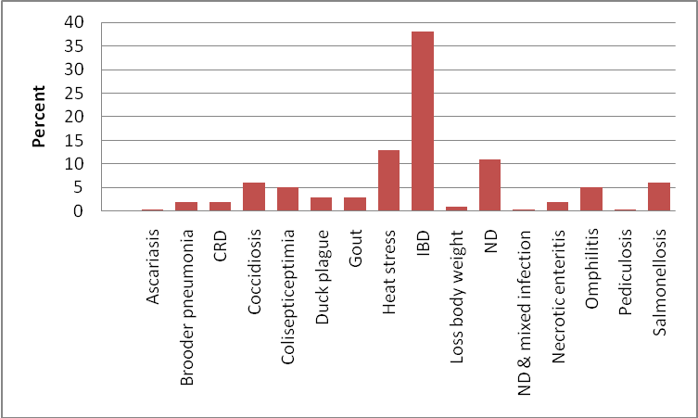

Figure 2: Percent of different poultry diseases observed during the study period in the study area.

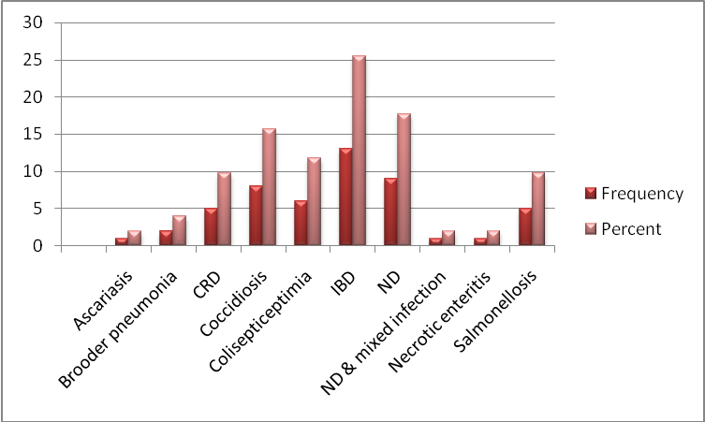
Figure 3: Occurrence of different diseases in broilers in the study area .

Figure 3 is showing the prevalent diseases in broilers with the highest occurance recorded for IBD (25%) followed by ND (18%), coccidiosis (16%), colisepticemia (12%) and salmonellosis (10%). Other diseases encountered with low prevalence in layers were chronic respiratory syndrome (CRD), ascariasis and necrotic enteritis.

Figure 4 is showing the occurrence of different diseases in layers in the study area. In broilers IBD occurred with the highest prevalence (49%). Among other diseases heat stress (20%), omphalitis (7%) and salmonellosis (5%) occurred with a notable frequency.
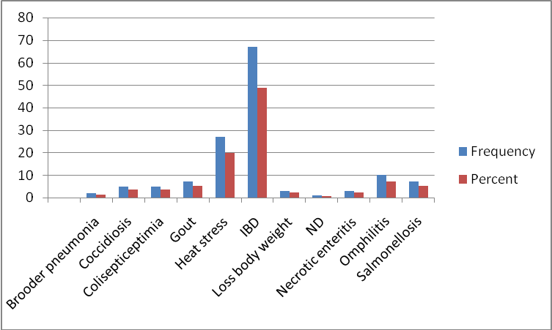
Figure 5: Occurrence of different diseases in layers in the study area during the study period.
Infectious Bursal Disease:
The present study revealed 38% prevalance of IBD in Namakkal region that was higher than those of Bhattacharjee et al, 1996; Islam et al, 1998 and Talha et al, 2001; reported 10.99%, 16.0% and 19.16% cases of IBD in Dhaka and Mymensingh, respectively, but similar to Sylhet region of Islam et al, 2002; which might be due to variation in risk factors in different geographic region, management practice or flock sizes. Most of the birds diagnosed as IBD came from the flocks where vaccination was carried out against IBD. Findings of high percentage of IBD in birds suggest that vaccination could not protect the birds. IBD infection causes immunosuppression which results in vaccination failure with causing high mortality.

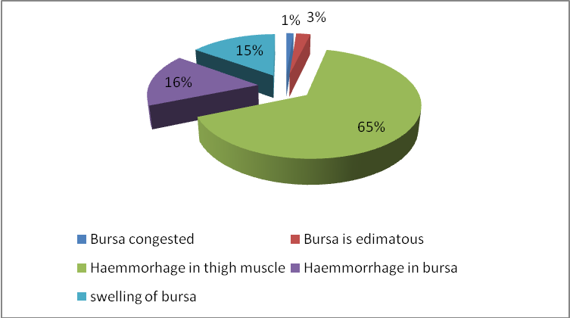

Figure 9: Pie chart is showing the percentage of different post mortem findings found in IBD affected broilers.

Postmortem lesions in IBD:
Infectious Bursal Disease has some pathognomonic lesion through which we can diagnose this disease.The pathognomonic lesion of IBD is haemmorhage in thigh muscle, haemmorhage in bursa, swelling of bursa, edimatus bursa and congestion in bursa. In our study in maximum (65 %) case we found haemmorhage in thigh muscle where haemmorhage in bursa was observed in 16 % cases, swelling of bursa in 15% case, edimatus bursa in 3% case and congestion in bursa in 1 % case (figure 9). Raj Wali Khan et al, 2009; examined that at necropsy the gross pathological lesions were hemorrhages present on pectoral, leg and thigh muscles. The kidneys were swollen and a gelatinous film was present around the bursa.

New castle Disease:
In the present investigation, 11% of ND positive cases were found in different species. 17.20% incidence of the disease was reported by Islam et al, 1998; in Bangladesh. The present findings would indicate that the reemergence of ND in commercial flocks is still a threat to the poultry industry in spite of available use of ND vaccines. It is important to investigate if the reemergence of ND is due to vaccination failure or any other factor.

Heat Stress:
Analysis revealed that, prevalance of heat stress is 13%. The negative effects of heat stress on broilers and laying hens are ranged from reduced growth and egg production to decreased poultry and egg quality and safety. However, a major concern should be the negative impact of heat stress on poultry welfare. As presented in this review, much information has been published on the effects of heat stress on productivity and immune response in poultry (broilers and laying hens) (Lucas et al, 2013).

Coccidiosis:
The prevalence of coccidiosis was constituted 6% of the total cases which is higher than the study of Talha et al, 2001 and Ahmed et al, 2009; who reported the prevalence of this disease was 4.2% and 4.2%, respectively but it was lower than the Saleque et al, 2003; who reported 7.2% in layer birds. Some factors like wet litter improper cleaning of poultry houses and disinfection before introducing day old chicks increase the susceptibility of coccidiosis in poultry farm (Sharif, 2002).

Salmonellosis:
Salmonellosis was recorded 6 % which is nearly similar to 5.56% shown by Giasuddin et al, 2002 and lower than 24.2% shown by Saleque et al, 2003. Salmonellosis can be transmitted vertically and horizontally, and it is very difficult to prevent. But the risk of the disease can be reduced by supplying the chicks from salmonellosis free flocks.

Colisepticemia:
Colisepticemia a frequently occurring disease in poultry and was found one of the major diseases recorded in the study area. The presence of this disease indicates unhygienic management of the farms. The prevalence of this disease (5%) in the study area is nearly similar reported by Talha et al, 2001; in Mymensingh region (5.51%) but lower than those reported by Ahmed et al, 2009; in Gazipur district (52.26%).

Omphilitis
Omphilitis was recorded 5% in poultry. It was frequently present in young birds. The present study findings were higher than the 2.68% reported by Uddin et al, 2010.

Apart from these diseases, other diseases found in the birds included Mycoplasmosis (CRD), Brooder pneumonia (Aspergillosis), Necrotic enteritis and Duck plague. The factors which contribute the Mycoplasma infection are poor ventilation, moist litter and no restriction on movement of technical personnel visitors and such other persons as well as biosecurity measures (Dulali, 2003). Brooder pneumonia was recorded 2.0% which is lower than the result of Talha et al, 2001 and Saleque et al, 2003; it was 4.2% and 17.5%, respectively. This result is higher than 1.1% shown by Saleque et al, 2003 and lower than shown by Islam et al, 2003. Necrotic enteritis was recorded 2% which is higher than 0.40% reported by Uddin et al, 2010.

Photo gallery

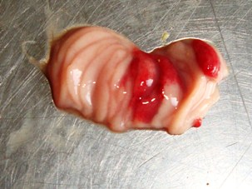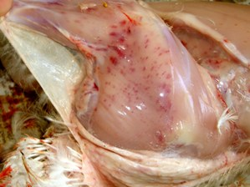

Figure 6. Swollen and hemorrhagic bursa. | Figure 7. Haemorrhage in thigh muscle
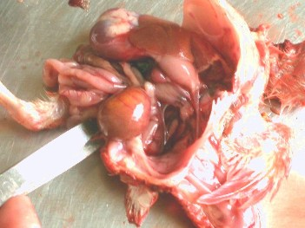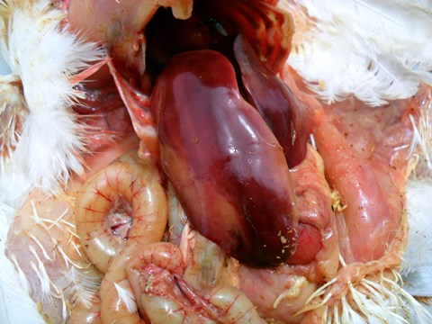
Figure 8. Unabsorbed yolk sac. Figure 9. Liver necrosis.

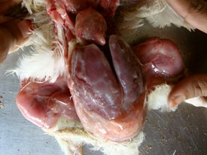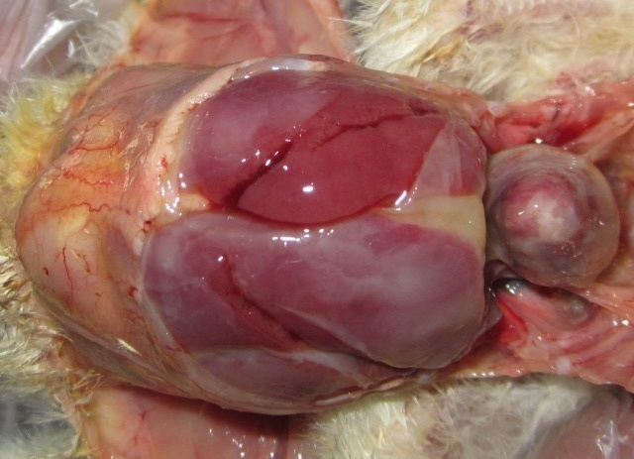
Figure 10 & 11. Perihepatitis and Pericarditis.

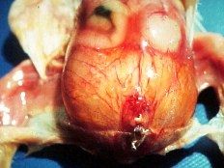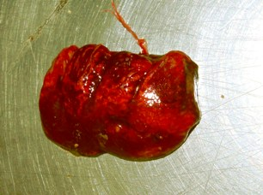
Figure 12. Omphalitis. Figure13. Congested lung.

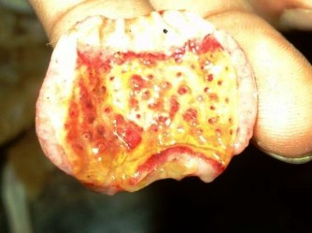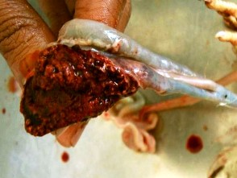
.
Figure 14: Haemorrhage at the tip of the proventicular gland.

Figure 15: Caecal haemorrhage

CHAPTER V

CONCLUSION

The present study reflects different diseases of poultry in Namakkal district, of Tamil Nadu. The infectious bursal disease was found highly prevalent followed by Newcastle disease, heat sress and salmonellosis. Chicks aged between 16-23 days and flock sizes between 1175-1460 are the most susceptible to various diseases, in particular infectious bursal disease. All of the diseases recorded are economically important for layer production and hence farmers can not earn their ultimate profit. It is important to assess the management system and husbandry practices of those farms that were affected by different diseases.

CHAPTER VI

LIMITATIONs

There were some limitations of the study.
- The immune status of the birds was not examined.
- There might be under reporting in the estimated prevalence because all cases of the area were not brought to the PDDSL during the study period.
- Data regarding managemental & environmental factors could not be collected due to short period of time.

CHAPTER VII

REFERANCES

Abdu, P. A. 1986. An outbreak of Gumboro disease in vaccinated flock In Zaria, Nigeria. Zar. Vet., 1:40-41.

Ahmed, M. S., Sarker, A. and Rahman, M. M. 2009. Prevalence of infectious diseases of broiler chickens in Gazipur district. Bangla. J. Vet. Med., 7: 326 – 331.

Alexander, J. D. 2008. Paramyxoviridae: Newcastle Disease and Other Paramyxoviruses. In: Poultry Diseases, 6th edition. Elsevier Limited, Chapter 25., pp: 296.

Barns, H. J. and Gross, W. B. 1990. Disease of Poultry, 10th edition., pp: 131-141.

Benton, W. J., Cover, M. S., Rosenberger, J. K. and Lake, R. S. 1967. Physicochemical properties of the infectious bursal agent (IBA). Avian Dis., 11: 430-438.

Bhattacharjee, P. S., Kundu, R. L., Biswas, R. K., Mazumder, J. U., Hossain, E. and Miah, A. H. 1996. Retrospective analysis of chicken diseases diagnosed at the Central Disease Investigation Laboratory, Dhaka. Bangla. Vet. J., 30: 105-113.

Boado, E., Laurenl, E., Herrera, C., Quintero, D. and Canovas, D. 1991. Prevalence of the major diseases in different categories of poultry During the Different Seasons of the Year. Poultry Abstract., 19: 164.

Bradbury, J. M. 2001. Avian Mycoplasmosis, In: Frank Jordan et al. (eds.) Poultry Diseases, 5th Edition. W.B. Saunders Company Iowa., pp: 832-837.

Chakrabarti, 1993. A Text Book of Veterinary Medicine, 3rd Edition.Kalayani Publishers, New Delhi., pp: 709-718.

Chanie, M., Neqash, T. and Tilahan, S. B. 2009. Occurrence of Concurrent Infectious Diseases in Broiler Chickens is a Threat to Commercial Poultry Farms in Central Ethiopia. Tropical Animal Health and Production., 41 (7): 1309-17.

Chishti, M. A., Khan, M. Z. and Irfan, M. 1985. Pathology of Liver in Avian Salmonellosis in a Chicken.Pak. Vet. J., 5: 157-160.

Cowen, B. S. and Braune, M. O. 1988. The propagation of avian viruses in a continuous cell-line (QT-35) of Japanese quail origin. Avian Dis., 32: 282-297.

Ewers, C., Janssen, T. and Wieler, L. H. 2003. Avian Pathogenic E. coli (APEC). Berlinerand Munchener Wochen Schrift, Berlin, Germany., 116: 381-395.

Faragher, J. T., Allan, W. H. and Wyeth, C. J. 1974. Immunosupressive effect of infectious bursal agent on vaccination against Newcastle disease., Vet. Rec., 95: 385-388.

Giambrone, J. J., Eidson, C. S., Page, R. K., Fletcher, O. J., Barger, B. O. and Kleven, S. H. 1976. Effect of early infectious bursal disease agent on the response of chicken to Newcastle disease and Mareks disease vaccination. Avian Dis., 20: 534-544.

Giasuddin, M., Sil, B. K., Alam, J., Koike, I., Islam, M. R. and Rahman, M. M. 2002. Prevalence of Poultry Diseases in Bangladesh. Indi. J. Pout. Sci., 40(1): 99-101.

Gross, W. B. 1994. Disease due to Escherichia coli in poultry. Cited in E. coli in Domestic Animals & Humans. LL Gyler (ed). CAB International. Wallingtord, UK., pp: 231-260.

Gust, R. K. and Beard, C. W. 1990. Serological detection of experimental salmonella enteritidis infection in laying hens., pp: 721-728.

Hassan, M. K., Al-Natour, M. Q., Ward, L. A. and Saif, Y. M. 1996. Pathogenecity, attenuation and immunogenicity of infectious bursal disease vims. Avian Dis., 40: 567-571.
Hirai, K. and Calnek, B. W. 1979. In vitro replication of infectious bursal disease vims in esta blished lymphoid cell lines and chicken B lymphocytes. Inject. Immun., 25 (3): 964-970.

Hitchner, S. B. 1970. Infectivity of infectious bursal disease vims for embryonating eggs. Poult. Sci., 49: 511-516.

Islam, M. R., Das, B. C., Hossain, K., Lucky, N. S. and Mostafa, M. G. 2002. A study on the occurrence of poultry diseases in Sylhet region of Bangladesh. Int. J. Poult. Sci., 2 (5): 354-356.

Islam, M. R., Das, B. C., Lucky, N. S. and Mostafa, M. G. 2003. A Study on Occurance of Poultry Diseases in Sylhet Region of Bangladesh. Int. J. Poult. Sci., 2 (5): 354-55.

Islam, M. T. and Samad, M. A. 2004. Mortality in chicks associated with economic impact and prospects of layer chick rearer package program of the participatory livestock development project in Bangladesh. Int. J. Poult. Sci., 3: 119-123.

Jackwood, D. H., Saif, Y. M. and Hughes, J. H. 1987. Replication of infectious bursal disease vims in continuous cell lines. Avian Dis., 31: 370-375.

Kahn, C. M. 2008. Mark Veterinary Manual, 9th Edition. Merck & Co. Inc.
Whitehouse Station, NJ, USA.

Kamal, A. H. M. 1989. Pathological Investigation on the Mortality of Chicken in Bangladesh Agricultural University Poultry Farm. MSc thesis, Department of Pathology, Faculty of veterinary Science. BAU, Mymensingh.

Karim, M. J. 2003. Current disease pattern in poultry with special emphasis on parasites and their methods of control.Proceeding of the 3rd International Poultry Show and Seminar of World Poultry Science Association-Bangladesh Branch. February 28-March 02, 2003. BCFCC, Dhaka., pp. 119-123.
Kibenge, F. S. B. and McKenna Pcc. Isolation and propagation of infectious bursal disease virus using the ovine kidney continuous cell line. Avian Dis., 36: 256-261.

Kibenge, F. S. B., Dhillon, A. S. and Russell, R. G. 1988. Growth of serotype I and II and variant strains of infectious bursal disease virus in Vero cells. Avian Dis., 32: 298-303.

Kibenge, F. S. B., Dhillon, A. S. And Russel, R. G. 1988. Biochemistry and immunology of infectious bursal disease virus. J. Gen. Viro., 69: 1757-1775.

Landgraf, H., Vielitz, E. and Kirsch, R. 1967. Studies on the occurrence of an infectious disease affecting the bursa of Fabricius (Gumboro disease). [In German.] Dtsch. Tierärztl Wochenschr., 74: 6-10.

Lukert, P. D. and Davis, R. Bc.1998. Infectious bursal disease virus: growth and characterization in cell cultures. Avian Dis., 18: 243-250.

Luttrell, M. P., fischer, J. R., Stallknecht, D. E. and KLEVEN, S. H. 1996. Field investigation of Mycoplasma gallisepticum infections in house finches (Carpodacus mexicanus) from Maryland and Georgia. Avian Dis., 40: 335–341.

Marois, C., Dufour-gesbert, F. and Kempf, I. 2002. Polymerase chain reaction for detection of Mycoplasma gallisepticum in environmental samples. Avian Pathol., 31: 163–168.

McFerran, J. B. 1993. Infectious bursal disease. In Vims infections of birds (J. B. McFerran and M. S. McNulty, eds). Elsevier Science, Amsterdam., 44: 213-222.

Meulemans, G. and Halen P. 1982. Efficacy of some disinfectants against infectious bursal disease vims and avian reovirus. Vet. Ree., 111: 412-413.

Müller, R., Kaufer, I., Reinacher, M. and Weiss, E. 1979. Immunofluorscent studies of early virus propagation after oral infection with infectious bursal disease virus (IBDV). Zentralbl.Veterinarmed. B., 26: 345-352.
Musa, I. W., Saidu, L., Adamu, J., Mbuko, I. J., Kaltungo, B. Y. and Abdu, P. A. 2010. Outbreak of Gumboro in growers in Zaria, Nageria. Nig. Vet. J., 31: 306-310.

Nunoya, T. Y., Otaki, M., Taj ima, M., Hiraga. and Saito, T. 1992. Occurance of acute infectious bursal disease with high mortality in Japan and pathogenecity of field isolates in specific pathogen free chickens. Avi. Dis., 36: 597-609.

Okey, J. O. A. and Uzoukwu, M. 1981. Anoutbreak of infectious bursal diease among chicken 16 and 20 weeks old. Avian Dis., 25: 1034-1038.

Okoye, J. O. A. 1983. The effect of late infectious bursal disease on the severity of naturally occurring Eimerria necatrix in chickens. Bull. An. Health prod. Af., 31: 263-267.

Pedersen, K. A., Sadasiv, E. C., Chang, P. W. and Yates, V. J. 1990. Antibodies to avian viruses in humans. Epidemiol Infect., 104: 519.

Rahman, M. 2007. Protein for All: Proceedings of 5th International Poultry Show and Seminar organized by World's Poultry Science Association, Bangladesh Branch. March 01-03, 2007. Dhaka, Bangladesh.

Rahman, M. M., Rahmanm A. Z. and Islam, M. S. 2007. Bacterial Diseases of Poultry Prevailing in Bangla. J. Poult. Sci., 1(1): 1-6.

Rahman, M. S., Islam, M. S., Rahman, M. T., Parvez, N. H. and Rahman, M. M. 2010. Analysis of prevalence of infectious Bursal disease in broiler flocks in Dinajpur. Int. J. Sustain. Crop Prod., 5, 1: 15-18.

Rima, B., Billeter, M. A. and Meulen, V. 1995. Paramyxoviridae. In: Viru. taxonomy, 6th report of the International Committee on Taxonomy of Viruses.Springer-Verlag, Vienna & New york., pp: 617-621.

Rosenberger, J. K. and Cloud, S. S. 1986. Isolation and characterization of variant infectious bursal disease viruses. In Abstracts 123rd Ame. Vet. Med. Asso. AVMA Meeting, 20-24 July, Atlanta, Georgia. AVMA, Schaumburg, Illinois, Abstract No., 181: 104.

Rosenberger, J. K. 1989. A laboratory manual for the isolation and identification of avian pathogens. American Association of Avian Pathologists, Kendall-Hunt, Dubuque, Iowa., 165-166.

Saidur Rahman, M., Sadequl islam, M., Rahman, M. T., Parvez, N. H. and Rhaman, M. M. 2010. Analysis of Prevalence of Infectious Bursal Disease in Broiler flocks in Dinajpur. Int. J. Sustain. Crop Prod., 5(1): 15-18.

Saif, Y. M., Barnes, H. J., Glisson, J. R., Fadly, A. M., McDougald, L. R. and Swayne, eds. 2002. Iowa State University Press, Ames, Iowa, USA., 722–744.

Sainsbury, D. 2000. Infectious Bursal Disease: Poultry Health and Management. 4th Edn. ,Blackwell Publishers, Oxford, UK., pp: 125-126.

Samad, M. A. 2005. Poultry Science & Medicine. LEP publication, Mymensing, Bangladesh., pp: 504-528.

Shakya S., Joshi, R. K., Gupta, N. and Chauhan, H. V. 1999. Organ culture of chicken bursa as a model to study the pathogenicity of infectious bursal disease virus isolates.Avian Dis., 43(2): 167-171.

Shane, S. 1997. Infectious Bursal Disease: The Poultry Disease Handbook, American Soybean Association, USA., pp: 57-61.

Shirai, J., Seki, R., Kamimura, R. and Mitsubayashi, R. 1994. Effects of invert soap with 0.05% sodium hydroxide on infectious bursal disease vims. Avian Dis., 33: 112-124.

Shivaprasad, H. L. and Baker, R. C. 1990. Pathogenesis of salmonella enteritidisinfection in laying chickens., pp: 547-550.

Snyder, D. B., Lana, D. P., Savage, P. K., Yancey, F. S., Mengel, S. A. and Marquardt, W. W. 1988. Differentiation of infectious bursal disease viruses directly from infected tissues with neutralizing antibodies: evidence of a major antigenic shift in recent field isolates. Avi. Dis., 32: 535-539.

Takase, K., Baba, G. M., Ariyoshi, R. and Fujikawa, H. 1996. Susceptibility of chicken embryos to highly virulent infectious bursal disease virus. J. vet. med. Sci., 58 (11): 1129-1131.

Talha, A. F. S. M., Hossain, M. M., Chowdury, E. H., Bari, A. S. M., Islam, M. R. and Das, P.M. 2001. Poultry Diseases Occurring in Mymensingh District of Bangladesh, The Bangla. Vet. J., 18: 20-23.

Tsukamoto, K., Tanimura, N., Mase, M. and Ima, K. 1995. Comparison of virus replication efficiency in lymphoid tissues among three infectious bursal disease virus strains.Avian Dis., 39 (4): 844-852.

Uddin, M. B., Ahmed, S. S. U., Hassan, M. M., Khan, S. A. and Mamun, M. A. 2010. Prevalence of Poultry Diseases at Narsingdi, Bangladesh. Int. J. Bio. Res., 1(6): 09-13.

Van den Berg, T. P., Gonze, G. M. and Meulemans, G. 1991. Acute infectious bursal disease in Poultry: isolation and characterization of a highly virulent strain. Avi. Pathol. 20: 133-143.

Van den Berg, T. P., Eterradossi, N., Toqui, D. and Meulemans, G. 2000. Infectious bursal disease (Gumboro disease). Rev. sci. tech. Off. int. Epiz., 19 (2): 527-543.

Whiteman, C. E. and Bickford, A. A. 1989. Avian Disease Manual, 3rd edition, American association of avian pathologists, Pennsylvia., pp: 323-327.
Winterfield, W. R., Hitchner, S. B., Appleton, G. S. and Cosgrove, A. S. 1962. Avian nephrosis, Nephritis and Gumboro disease. N & M Ne. Vie., 3: 103.

Yamada S., Matsuo, K. and Uchinunom, Y. 1982. Susceptibility of ducks and duck-origin cell cultures to infectious bursal disease vims. Avian Dis., 26: 596-601.

Yunus, A. W., Nasir, M. K., Aziz, T. and Bohm, J. 2009. Prevalence of Poultry Diseases in District Chakwal and Their Interaction with Mycotoxicosis: Effects of Season and Feed. J. Ani. Pla. Sci., 19 (1): 1.

APPENDIX I

QUESTIONNAIRE (PDDSL)

Date: . . . . . . . . . . . . . . . . Case no: . . . . . . . . . . . . .
- Basic Information
- Name of the farm: . . . . . . . . . . . . . . . . . . . . . . . . . . . . . . . . . . . . . . . . . . . . . . . . . . . .
- Name of the farm owner: . . . . . . . . . . . . . . . . . . . . . . . . . . . . . . . . . . . . . . . . . . . . . . .
- Address: . . . . . . . . . . . . . . . . . . . . . . . . . . . . . . . . . . . . . . . . . . . . . . . . . . . . . . . . . . . .
- Type of farm: . . . . . . . . . . . . . . . . . . . . . . . . . . . . . . . . . . . . . . . . . . . . . . . . . . . . . . . .
- Farm size and composition: . . . . . . . . . . . . . . . . . . . . . . . . . . . . . . . . . . . . . . . . . . . . .
- Age of the birds: . . . . . . . . . . . . . . . . . . . . . . . . . . . . . . . . . . . . . . . . . . . . . . . . . . . ..
- Species of birds…………………………………………………… . . . . . . . . . . . .
- Housing Pattern and Management
- Housing system: Intensive / Semi-intensive
- Floor type: Litter/ Concrete / Slat / Cage
- Ventilation: Poor / Moderate / Good
- Frequency of cleaning house: Daily/ Every alternate day/ Once in a week
- Feeding Management
- Feeding system: Scavenging/ Supplement / Both
- If supplement: Homemade / Commercial Balanced Feed
- Bio-security Status
- Foot bath: Present / Absent
- Visitor access: Restricted / Not Restricted
- Farm premises: Open / Fenced
- Vaccination: Regular / Not regular
- Disease outbreak information
- Symptoms of disease: . . . . . . . . . . . . . . . . . . . . . . . . . . . . . . . . . . . . . . . . .
- No of birds showing symptoms: . . . . . . . . . . . . . . . . . . . . . . . . . . . . . . . . .
- No of birds died: . . . . . . . . . . . . . . . . . . . . . . . . . . . . . . . . . . . . . . . . . . . . .
- Any Treatment followed: . . . . . . . . . . . . . . . . . . . . . . . . . . . . . . . . . . . . . . .
- Post-mortem findings: . . . . . . . . . . . . . . . . . . . . . . . . . . . . . . . . . . . . . . . . . . . .
- Diagnosis: . . . . . . . . . . . . . . . . . . . . . . . . . . . . . . . . . . . . . . . . . . . . . . . . . . . . .
- Treatment:
APPENDIX II

DIAGNOSTIC INFORMATION SHEET (PDDSL)

Date: . . . . . . . . . . . . . . . . Case no: . . . . . . . . . . . . .

- Name of the farm:
- Name of the owner:
- Address of the farm:
- Post mortem examination of birds:
- Nares/Nose: (Inflammation / serousexudation / mucoidexudation / catarrhal exudation)
- Tracha: (Congestion / thickening / caseous exudation / serous exudation / edema / granular appearance)
- Lungs: (Pneumonic change / yellow gray nodule / gray hepatization / congestion / granulomatous lesion / whitish spot in the lung/nodule in lung
- Proventiculus: (Pin point haemorrage on the apex of gland / thickening and firm / petechial haemorrhage at the junction of gizzard and proventiculus)
- Gizzard: (Pin point nodules / haemorrhage under horney layer)
- Small intestine: (Viscid mucous / petechial haemorrhage / necrotic foci with deposition of cheesy mass in lumen / reddish black area around the intestine/white spot in intestinal wall / wall thicken distended and flabby / purulent or diptheric inflammation / haemorrhage and ulceration or bran like deposition / necrotic mucosa with cracked surface / congestion in the wall of small intestine / intestine full with fluid and gases.
- Caeca: (Necrotic foci / filled with yellow cast / wound or ulcer in caecal tonsil / filled with casionecrotic casts / presence of caecal plug / dilated caeca containing clotted or unclotted blood / petechyon the wall / detouchedcaecal core / haemorhrage / necrosis)
- Large intestine: (Necrotic foci / normal)
- Liver: (Swollen or enlarge or hepatomegaly / dark / transparent to cloudy deposition on the surface looking like itching of cake / focal area of coagulative necrosis / petechiation/cooked appearance and friable / white or grayish necrotic foci/congestion / pin point nodules / impression of pale colour (ischemic) / various colour / brongecolour / coarse granular appearance / fragile / whitish spot on the surface / fatty change)
- Spleen: (Enlargement of spleen or spenomegali / necrotic foci / various color impression / haemorrhage / fragile)
Pericardium: (Sac filled with light yellow fibrinous exudate / thickened / fibropurulent exudates / serofibrinous gelatinous materials on the pericardium/
- pericardial adhesion / hydropericardium / sac filled with turbid yellow fluid / fibrin attached to the surface of the heart / inflammatory changes / serous exudate on pericardium)
- Heart: (Misshaped / necrotic foci and gray nodules / necrotic changes / pale heart / single or multiple number of tumor in myocardium)
- Bursa of Fabricious: (Atropic / swollen edematous / yellowish / haemorrhagic)
- Muscles: (Haemorrhage in various muscles / congestion in pectoral muscles / skeletal muscles are dark in colour / tiny whitish streaksto nodular tumors in muscles /congestion, haemorrhage in pectoral, thigh andleg muscles)

- Diagnosis: . . . . . . . . . . . . . . . . . . . . . . . . . . . . . . . . . . . . . . . . . . . . . . . . . .

