ABSTRACT

The study was carried out at Rahman poultry farm at Belabo in Narsingdi for a period of 05/02/2018 to 25/03/2018 to observe management of housing, feeding, lighting, production performance, and disease control practices of 5000 layer birds of Lohmann brown under open housing system. During study period, in case of brooding chicks, feed intake was 17gm/day in 2nd week, 19gm/day in 3rd week and 21gm/day in 4th week of age. Body weight was 56gm, 115gm, 187gm, 238gm respectively at 2nd, 3rd, 4th, 5th week of age. The average body weight gained was 60.67 gm/week. The mortality rate was 0.123% per week. In case of layer, the body weight was observed to be 1.87kg, 1.89kg, 1.94kg and mortality was 0.073%, 0.044%and 0.048% respectively at 33rd, 34th, 35th week of age and average feed intake was 115.79gm/day. As for the hens, per day egg production was 87.27% from 33rd to 35th week of age. The peak production was observed to be 88.18% at 33rd week of age. The mortality was 0.055% per week and total mortality was 0.17% over the total experimental period. It may be concluded that, peak production can be achieved during 33rd week of age.

Key words: Starter, production performance, management, layer,

CHAPTER- I

INTRODUCTION

The economy of Bangladesh is agro based. About 52% of the Gross Domestic Product (GDP) comes from agricultural sector of which crops alone shares 38.8%, livestock 65%, fisheries 3.5% and forestry 3.2%, (Sikder,1990). According to Nazir Ahmed (2003), the present poultry population is estimated to about 185.70 million of chicken of which 162.70 million is Deshi Chickens and remaining are hybrid. It is estimated that there are approximately 163.5 million chickens which are contributing partially for the alleviation of poverty and malnutrition of the people. At present situation commercial poultry eggs and meat are accomplishing the greater demand of animal protein as well as the human nutrition in the country .About 0.26 million metric tons of meat and 5210 millions table eggs are produced per year (Rahaman ,2003 ). A total of 5 million people are working presently in this sector and an amount of Tk. 22,000 millions has been invested in this sector.(Rahman,2003 ). The poultry is an important sub-sector of livestock. Chickens are major avian species kept in Bangladesh. Traditionally poultry is reared by almost all the rural families and particularly by landless people in Bangladesh. About 151 million chickens and duck were available in Bangladesh (Saleque, 2001). Thus is contributing a lot to the small farmers in Bangladesh. Mass production of chicken eggs has become a highly efficient, competitive enterprise. In a commercial layer farm pullets will begin to laying eggs at 20-22 weeks of age and once laying will eventually peak at 85-93% production. Each hen can be expected to lay about 270 quality eggs by the age of 75 weeks. About 1.8 kg feed is needed to produce per dozen eggs (Samad. M.A, 2005).The poultry industry play important role on the upliftment of socio-economic conditions and meet the demand of animal protein requirement s in human diet.In Bangladesh commercial poultry farms are few and most of our demand is fulfilled from the rural source where the farmers rear the chicken under the scavenging system.
Now- a-days the growth and automation of the commercial egg manufacturing industries have developed faster and progressed further than any other type of livestock production during a period of only about last two decades on Bangladesh.
Suitable breed and proper knowledge of management results in profitable poultry production (Mahapatra, 1990) which are lacking on traditional poultry rearing system. Poultry industry is just growing and its contribution to total poultry production is not yet satisfactory. Bangladesh thus has an improving management condition under backyard system. The productivity of indigenous chickens are very low having annual laying capacity of about 35-45 small size eggs per bird and the body weight of male and female birds is about 1.82 kg and 1.30 kg respectively (Amin,1990).
Emerging poultry industries are increasing and about 78% egg and 86% meat are produced by rural scavenging chicken (Huque, 1993).
Apart from genetic background, poor management, nutrition and diseases are main limiting factor s in back yard poultry. In case of back yard farming system of poultry, there are also some constraints. Poultry raising in this country hampered by others microbial and parasitic diseases which causes to heavy losses to farmers. Bangladesh is a highly populated country where backyard poultry farming system is unable to meet the demand of egg and meat as a source of animal protein. At present total demand of egg 1482 crores but available only 565 crores throughout the country (DLS 2006). To meet the demand we need mass production of chicken eggs intensive farming system with high yielding poultry breed or strain.
The growth and automation of the commercial egg manufacturing industry have developed faster and progressed further than any other type of livestock production during a period of only about last two decades in Bangladesh. There are two types of egg produced, which includes parent stock and commercial stock
- Parent stock: When the male and female are of two different grandparent stock are crossed to produce hybrid male and female line called parent stock.
- Commercial stock: When the male and female of different parent stocks are crossed to produce commercial stock.
The loss is attributed to the death by 15-30% as well as morbid effect like reduce weight gain, fall in egg production and unthriftness. In spite of these limitations, some highly modern commercial poultry farms were established as poultry industry in Bangladesh in recent years.
Some companies are involved to import layer parent stock and some layer strains which give high production under intensive farming system and with strict Bio-security. Some available layer strains in Bangladesh are; ISA brown, ISA White, Hisex White, Shaver 579 Brown, and Shaver White etc.
The White laying commercial leghorn strains available to industry has a high rate of lay and a smaller body, since that allowed leghorn type stock to produce dozen of eggs on less feed.

The specific objectives of the study:
- To observe the management and production performance of layer in litter system under normal management condition.
- To know the feed consumption of layer in litter system.
- To know the mortality of layer in litter system under normal management condition.
- To know egg production in different weeks of age.

CHAPTER- II
MATERIALS AND METHODS

Study area:
The study was conducted on layer farm at Rahman poultry farm at Belabo in Narsingdi district. They reared about 5000 layers of Lohmann brown in litter system. They have only one shed. They provided feed adlibidum which contains 20% cp and 2950kcal ME/kg up to 8 weeks and 16% cp and 2650kcal ME/kg up to 18 weeks and in layer 17%cp and 2750kcal ME/kg up to 72 weeks. The birds were vaccinated against Marek’s disease, Newcastle disease, Fowl cholera, chicken pox and Gumboro diseases.
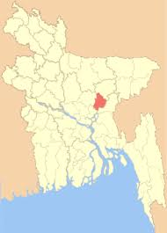
Fig: Location of Rahman poultry farm

The following standards were maintained at Rahman poultry farm during experimental period:
Birds:
The total numbers of layer birds were 5000.
Housing: The housing system was open sided house for layer.
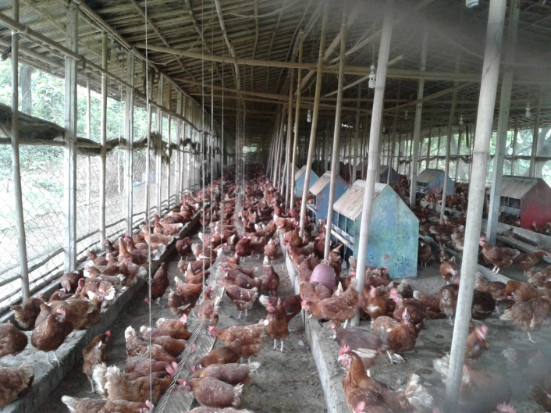
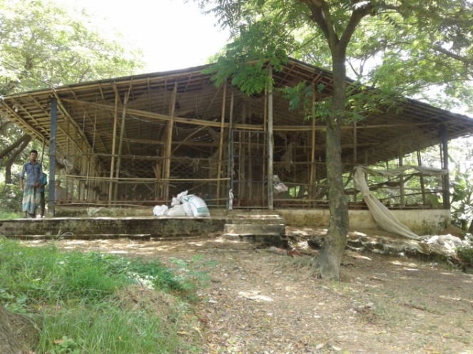

Fig: Housing of floor rearing system in the farm. Fig: Inner view of Poultry farm shed

In case of brooding: Each chick guard contains 600 chicks where space was 360 square feet, contains electric brooder. It will be increased according to age and up to 16 weeks of age.
In case of layer: It was situated on high land and 5 sheds. And open places as well as well ventilated. The house made as east west length wise and maintains on dry litter. The layers were kept in cage after 18 weeks of age@ 18”x14” x 17” for 3 birds.

Brooder house management:
The brooder house was located separated from other house because it reduces the chance of diseases transmission. The brooder home should keep clear at time. All in and all out system is the best method for this reason. The brooder house was prepared by using 3” litter on floor of brooder home. The brooder house was fumigated and disinfected before 24 hours of arrival of chicks. In this farm the brooder house was closed house.
For brooding one electric brooder used for 500 birds and floor space at first week was .4 sq ft which gradually increases day by day.
The temperature was 34⁰c and then decreased @ 3 to 4⁰c in every week which was standard as per as direction of the manual. Chick guard was made of plain metal sheet because it conserves more heat than partex board. The height of the chick guard was 18 inch and the distance between the brooder and litter was 69 inch.

Watering:
For the prevention of diseases clean water and germ free water were supplied to bird and each 100 birds need one round drinker.
Feeding and feeder:
The experimental farm supplied feed to day old chick on papers or tissue (2 inch rich polish) for 1 week. Then provide the starter ration starter 24 hours 2-3 hours brought after arrival and contained CP 19 to 20%, ME 2950/kg, lysine 1.07, methionine 0.43 to 0.54% adlibidum feeding was allowed for 3 weeks. Then weighing which compared with guide line.
Ventilation:
In favor of proper ventilation the experimental farm used timer fan. Exhaust fan and also used for preventing extreme hot.
Bio security:
Bio means life and security denotes safeguard. Its a set of manage mental practices which reduce the incidences of diseases outbreak or inhibit to entrance of diseases curing in an organism into the farm. It’s the hard fact of poultry livestock industry accounts for at least 10% of total production cost and overall costs of specific diseases in poultry. The firm disposed the dead birds with a pit and separates the diseases bird accurately.

Table-1: fumigation of farm:
Fumigation place | PPM + Formalin  (gm + ml) | Fumigation time
Layer house | (20+40).2 | 20 minutes
.
TABLE: 2, Management of Brooding at Rahman poultry farm:
Age | Temperature
1st 5 hours | 35⁰c
5 hours to 3 days | 34⁰c
4 to 7 days | 34 to 31⁰c
2 weeks | 31to 28⁰c
3 weeks | 28 to 26⁰c
4 weeks | 28 to 23⁰c
After 4 weeks | 20⁰c
Lighting:
Lighting schedule followed in this farm is given below in table:
Table:3, lighting schedule were @ watt/ sq.ft
Age/day/week | Light/day(in hour) | Watt/sq.ft
1-3day | 24hours | .56 watt
4-6day | 23 hours | .50 watt
7-8day | 23 hours | .37 watt
1-2weeks | 23 hours | .25 watt
2-3weekas | 22 hours | .19 watt
3-4weeks | 18 hours | .19 watt
4-5 | 16 hours | .19 watt
5-6 | 14 hours | .19 watt
6-10 | 13 hours | .19 watt
11-18 | 12 hours | .095 watt
18-20 | 11.30 hours | .019 watt
20-21 | 12 hours | .25 watt
21-22 | 12.30 hours | .25 watt
22-23 | 13 hours | .25 watt
23-24 | 13.30 hours | .25 watt
24-25 | 14 hours | .25 watt
25-26 | 14.30 hours | .25 watt
Debeaking: They debeaked 9th week of age but it should be done 10th weeks of age.
Use of Anthelmintics: First time, at the age of 45 days, then they used to every 45 days alternatively.
Note: when we use Anthelmentics, we did not use vitamin that day, but we had to use vitamin for following 3 days.
TABLE: 4, Chart of lighting program of Lohmann brown what we provided
Age | Temperature | Day light + Artificial light
0 to 3 days | 34⁰c | 24 hours
4 to 7 days | 31-34⁰c | 23 hours
2nd weeks | 27-31⁰c | 22 hours
3rd weeks | 23-27⁰c | 21 hours
4th weeks | 20-23⁰c | 20 hours
5th weeks | 20⁰c | 18 hours
6th weeks | 20⁰c | 16 hours
7th weeks | 20⁰c | 14 hours
8th to 18th weeks | 20⁰c | 13 hours (include maximum day light)
19th weeks | 20⁰c | 13.5 hours
20th weeks | 20⁰c | 14 hours
21st | 20⁰c | 14.5 hours
22nd weeks | 20⁰c | 15 hours
23rd weeks | 20⁰c | 15.5 hours
24th weeks | 20⁰c | 16 hours
25th to 78th weeks | 20⁰c | 16 hours

Table: 5- Definite ration (nutrient, vitamin and minerals) which supplied with some deviation of standard level:
Age in week | 0-4 | 4-7 | 8-14 | 15-17 | 17-40 | 40-60 | + 60
CP% | 21-22% | 19.5% | 17.5 | 15.0 | 17-18 | 16-17 | 15-16
ME/K CAL/KG | 2900 | 2900 | 2825 | 2775 | 2800 | 2775 | 2750
Crude Fiber% |  | 3-5 | 3-6 | 4-7 | 3-6 | 3-6 | 3-7
Crude fat % |  | 2.5-6 | 2.5-7.0 | 2.5-7.0 | 3-7 | 3-7 | 3-7
Linoleic acid |  | 1.2 | 1.0 | 1.0 | 1.2 | 1.2 | 1.2

Minerals (minimum- maximum)
Calcium % | 1-1.1 | .9-1.1 | .9-1.1 | 3.3-3.5 | 3.6-3.8 | 3.8-4.0
Available phosphorus % | .45 | .40 | .36 | .40 | .38 | .34
Chloride % | .15-.25 | .15-.25 | .15-.25 | .15-.25 | .15-.25 | .15-.25
Sodium % | .16 | .15 | .15 | .15-.2 | .15-.25 | .15-.20

Amino acid (% minimum)
Lysine % | 1.05 | .95 | .72 | .80 | .77 | .72
Methionine % | .45 | .40 | .34 | .40 | .38 | .35
Met +cystein% | .80 | .75 | .56 | .71 | .68 | .65
Tryptophan % | .20 | .17 | .15 | .18 | .17 | .16

Table: 6, Amino acid and ME/KG according to feed intake in various period of Lohmann brown (standard level)
Hen day  production | Feed  Gm/hen/day | ME/KG | Methione % | Met+ cys % | Tryptophan % | Lysine %
90%  production | 105 | 3020 | .40 | .76 | .18 | .87
 | 110 | 2880 | .38 | .72 | .17 | .83
 | 115 | 2760 | .36 | .68 | .17 | .79
 | 120 | 2650 | .35 | .65 | .16 | .76
85-90%  Production | 100 | 3080 | .4 | .73 | .18 | .84
 | 105 | 2930 | .38 | .70 | .17 | .80
 | 110 | 2800 | .36 | .66 | .16 | .76
 | 115 | 2680 | .35 | .63 | .16 | .73
 | 120 | 2570 | .33 | .61 | .15 | .70
80-85% production | 100 | 2970 | .38 | .69 | .17 | .82
 | 105 | 2830 | .36 | .66 | .16 | .78
 | 110 | 2700 | .35 | .63 | .15 | .74
 | 115 | 2580 | .33 | .60 | .15 | .71
Below 80%  production | 100 | 2900 | .36 | .66 | .16 | .79
 | 105 | 2760 | .34 | .63 | .15 | .75
 | 110 | 2640 | .33 | .60 | .15 | .72
 | 115 | 2570 | .31 | .57 | .14 | .69

Table: 7, Temperature in various production level with body weight of Lohmann Brown.
Temperature | Production | Body weight
18⁰c | Above 90% production | 1430-1390
22⁰c | 85-90%production | 1360-1320
26⁰c | Below 85% production | 1320-1280
30⁰c | Below 80% production | 1280-1220

Table: 8, % of calcium during laying period with feed intake
Feed intake/  Day | % of calcium in feed
 | 3.2% | 3.4% | 3.6% | 3.8% | 4.0%
90 | 2.88 | 3.06 | 3.24 | 3.42 | 3.60
95 | 3.04 | 3.23 | 3.42 | 3.61 | 3.80
100 | 3.20 | 3.40 | 3.6 | 3.80 | 4.00
105 | 3.36 | 3.57 | 3.78 | 3.99 | 4.20
110 | 3.52 | 3.74 | 3.96 | 4.18 | 4.40
115 | 3.68 | 3.91 | 4.14 | 4.37 | 4.60
120 | 3.84 | 4.08 | 4.32 | 4.56 | 4.80

TABLE: 9 Vaccination schedule at Rahman poultry Farm:
Age (day/week) | Name of the VACCINE | Route of administration
1st day | Mareks | S/C in neck
5th day | BCRDB+IB | Eye drop or drinking water
8thday | Gumboro | Eye drop or drinking water
9thday | GUMBORO+RANIKHET | S/C in neck
14-18thweeks | Mareks | S/C In neck
21st weeks | Ranikhet (live) | Eye drop or drinking water
28th day | Gumboro (live) | Eye drop or drinking water
35th day | IB | Eye drop or in drinking water
6th weeks | Fowl pox | Wing web
8th weeks | Ranikhet+Coryza | Drinking water
10th week | Fowl Pox + Cholera | Wing web or S/C
14th week | Cholera | BREAST muscle
16th week | Coryza | Breast muscle
18th week | IB+Ranikhet+EDS | Breast muscle or S/C
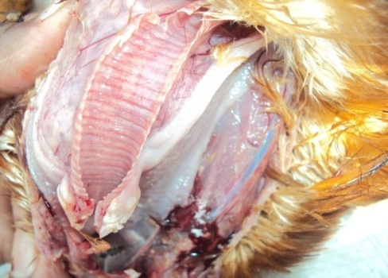
Fig: Disease diagnosis by postmortem in the farm

Egg collection: Eggs were collected manually from each shed once daily from 9 am to 1 pm. After collection, eggs were clean with soft towel soaked with Savlon ® antiseptic solution. Dirt was removed by knife through slight rubbing. Then grading was done in grading room. During grading of eggs, de-shaped eggs, jumbo eggs, small sized, broken eggs, excessively dirty eggs, abnormal color eggs were discarded. Eggs of uniform size were selected for marketing. No eggs are being stored as the marketing system is local and instant selling.
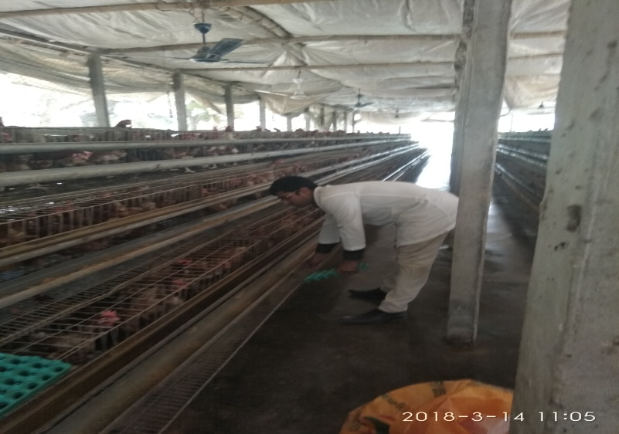

Fig: Egg collection from laying box

Figure: Collection of egg
Marketing of Egg:
The eggs are collected from the shed in the morning. The collected and graded eggs are transported to local market for selling by the won transport system. The bepary buy these eggs at whole sale rate and distributed to the consumer.
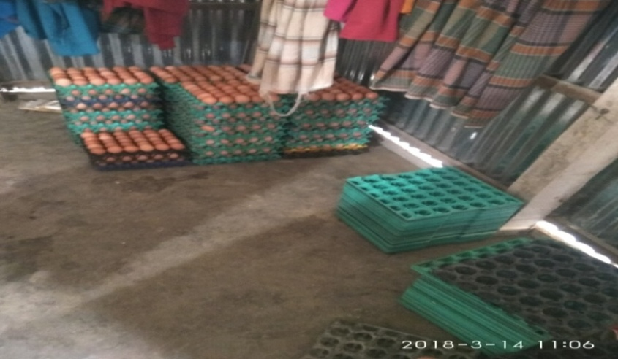
Fig: marketing of egg

CHAPTER- III
RESULTS AND DISCUSSION

In my experimental period I worked on management side, which has given me a result of experiment that has given below through:

Table-: 10, during brooding of chicks.
Obtained result on body Weight, mortality, feed intake of Lohmann brown what I have got during my study time with standard level
Total number of bird were 5000
Experimental period was 21 days (2nd to 4th week of age)
Total death of birds were 10
Average mortality per week was 0.07%
Average Body weight gained / week was 60.67 gm

 |  |  | Standard report |  |  |  |  | Observation
Age in  Week | Birds | No. of dead  In week | Age  (days) | Types  Of  feed | Bwt  (end of weeks)gm | Feed  Intake  (day/gm) | Rate  Of  mortality | Total feed  Kg/day | Feed  intake  Gm/day/bird | Bwt  Gm/week | %Mortality/  week
01 | 5000 | --- | 0-7 | Starter | 60 | -- | -- | --- | --- | 56 | ---
02 | 4993 | 7 | 8-14 | Starter | 120 | 21 | 1.2 | 106 | 14.17 | 115 | 0.14%
03 | 4989 | 05 | 15-21 | Starter | 200 | 26 | 1.6 | 121 | 16.21 | 187 | 0.10%
04 | 4983 | 6 | 22-28 | Starter | 280 | 31 | 1.7 | 134 | 18 | 238 | 0.12%

So, feed intake determined 14.17 gm, 16.21 gm, and 18 gm of per bird of per day at 2nd, 3rd and 4th week of age. Mortality rate was 0.14% at 2nd, 0.10 at 3rd and 0.13% at 4th week of age and average mortality 0.123%/week.

CHAPTER- IV
LIMITATIONS

The following limitations were faced during the experimental period:
- The duration of this experiment was short.
- Feed formulation of that farm is not fully followed by standard level of Lohmann brown.
- Bio security was not fully maintained.
- Electricity supply was not regular.
- Crisis of man power.
- The farm was not away from locality.
7. Uniformity of flock were 70% in 33rd weeks of age and 75% in 35th weeks

CHAPTER-V
CONCLUSION

Although the studied farm follows the rules of layer farming method, the egg production did not reach to the peak compared to standard level but mortality was lowest during rearing of chicks and laying period. During the placement, feeding, housing, collection of egg, cleaning and disinfection of the farm and disposal of shed waste were directly observed.

It can be noted that the overall condition of this farm is good. Its location, structure, hygiene, shed management, flock management, litter management, disease management, vaccination, egg collection and their marketing all are acceptable level. This layer farm may provide a nice economic opportunity to the farm owner.
It may be concluded that, with better management including bio security program of the farm, proper ration formulation, and disease prevention by vaccination, the egg production can be increased up to the standard level which will definitely make the farm more profitable.

CHAPTER- VI
ACKNOWLEDGMENT

First of all the author desires to express his deepest sense of gratitude to “The Almighty Allah” with whose blessing his ability to complete this valuable work.

The author would like to express his deep sense of gratitude and heartfelt appreciation to
the supervisor Prof.Md.Abdul Halim, Dean, Faculty of Veterinary Medicine, Department of Agricultural Economics and Social Sciences, Chittagong Veterinary and Animal Sciences University, Khulshi, Chittagong, for his scholastic guidance and inspiration during the study period and also preparing this production report.

The author is also grateful to the farmers of the farm, who were helpful in various aspects of the study.
The author also feels much proud to convey his profound thanks to his friends and all well-wishers who have seriously encouraged him to conduct this study work.
Lastly he expresses his deepest sense of gratitude and heart- felt thanks to his beloved parents, brothers and sisters who have sweated much to bring him up to today’s position.

REFERENCES

Alam, J., A. Sayeed, A. Rahman, F. Yasmin and J.Begum, (1998). An Economic Study on Poultry Farms in Bangladesh. Bang. J. Livest. Res., 1: 1-5.

B.B.S. (1998); Statistical pocket book of Bangladesh. Ministry of planning, Government of people’s republic of Bangladesh, Dhaka.

Chowdhury, S.D. Das, C. Pramanik, H.A.M Roy, C.R and Saha, K.S. (2003).Growth and egg production performances of purebred and crossbred chicken. The Bangladesh veterinarian, 19(1) pp.43-47.

Jull, M.A. (1970). Poultry Breeding. Third edition: Jhon wiley and sons, New York, 26, 285.

Rahman , S.M Islam ,J.M Howlider, R.A.M & Rahaman, H. M (2002). Department of Animal sciences and Avian sciences, University of Maryland. College park

Rahman, M. (2003). Growth of poultry industry in Bangladesh: Poverty alleviation and employment. Proceeding of the 3rd international poultry show and seminar, February 28 to March 2, 2003, held in Bangladesh China Friendship Conference Centre (BCFCC), Sher-e-Bangla Nagar, Dhaka, pp. 1-7.

Saleque, M. A (2001).Poultry as a tool in poverty alleviation; a special programme for the rural poor in Bangladesh, Proc. 2nd WPSA. International poultry show and seminar, pp.66-69.

Samad, M.A. (2005). Poultry Science and Medicine, 1st edition. LEP Publication, BAU Campus, Mymensingh, Bangladesh.

Status of poultry Production and consumption pattern of poultry meat and egg .The Bangladesh Veterinarian, 19(1), pp.39-42.
Biography

Name | Apu Raihan
Present position and affiliation | Intern student, 18th Batch, FVM, Chittagong
 | Veterinary and Animal Science University.
Educational background and year | Doctor of Veterinary Medicine in 2017
 | (appeared), Chittagong Veterinary and Animal
 | Science University.
Research interest | Poultry and Large Animal Sector
Aim | Establish a veterinary health complex in field level

