Chapter I
INTRODUCTION
Antimicrobials (AM) have widely been used to control various infectious diseases in livestock; throughout the world particularly in Bangladesh and the common practice is using AM to treat them. But most of the AM are becoming resistant now a day’s particularly in Bangladesh. In addition to this, global AM consumption in livestock is increasing (Figure 1). In Japan, 1,804.3 tons AM is used and the level of AM usage in animal food is 12.6%, livestock 46.1%, medicine 32.8% and 8.5% pesticide purposes during 2016. Nevertheless, AM usage in humans and animals, and resulting dispersion of AM resistant (AMR), residual effect in human body as well as destruction of beneficial gut microflora. Approximately 80% of all food-producing animals receive AM for part or most of their lives (Lee et al., 2001). AM residues may persist in milk and milk products at unacceptable levels and consumers can be easily exposed to them (Figure 2). The presence of residues may result from failure to observe the mandatory withdrawal periods, illegal or extra-label use of drugs and incorrect dosage levels. Unauthorized antibiotic use may result in residues of these substances in milk and tissues (Ivona and Mate, 2002).
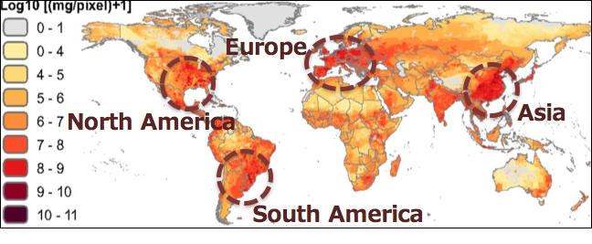
Figure 1: Global AM consumption in livestock (Van Boeckel, 2015)
The concentration levels of AM residues in raw milk were reported to be 8.5 µg/l to 53.7 µg/l for amoxicillin and 5.7µg/l to 6.4µg/1 for cefaprin (Ghidini et al., 2002), 150.4 µg /l for oxytetracycline, 33.5 µg /l for penicillin G and 7688 µg /l for neomycin whereas in market milk AM residues concentration reported 87.1 µg /l for beta lactams (Abbasi et al., 2011). In case of milk products, 8.3% powder milk containing 0.4 µg /g dicloxacillin residue was reported by Lee et al., (2001). The people of developing countries like Bangladesh have been consuming milk after boiling. Some antibiotics such as amoxicillin, oxytetracycline and ceftriaxone are heat labile, whereas gentamicin, sulphadimidine and ciprofloxacin are heat stable (EC, 2001).
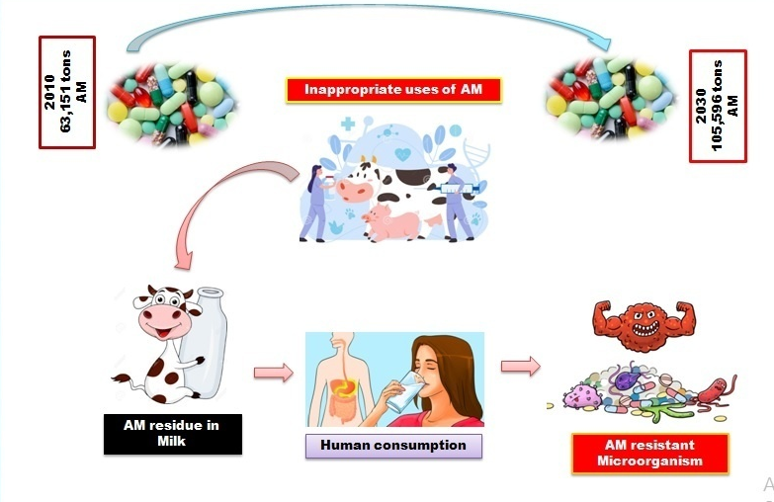
Figure 2: AM consumption in world and residual effects in milk
Our previous study Bari et al., (2020) reported that in the categories of farms, cow illness, treatment given in last week and antibiotics used in treatment were significant factors for prevalence of AM residue in raw milk (18%). The concentrations of amoxicillin (339.9 μg/l) and oxytetracycline (195 μg/l) residues in raw milk were significantly reduced by boiling. The concentrations of amoxicillin and oxytetracycline residues in all sources of milk were higher than the Maximum Residue Limit (MRL) and assumed to be causing a serious public health hazards (Figure 3).

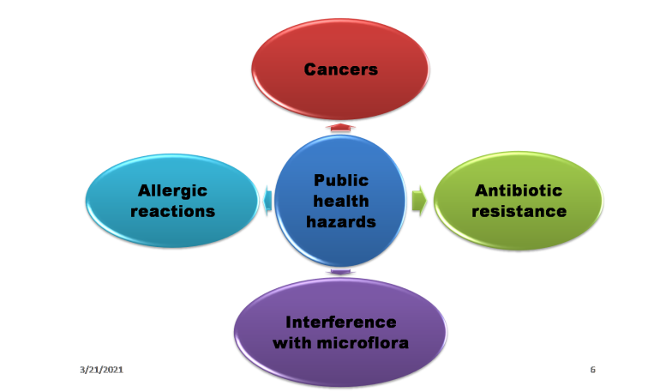

Figure 3: Public health hazard of AM
It is of utmost importance to know the level of AM residues in milk and associated risk factors to take necessary actions for minimizing the prevalence of AM residues in milk and milk products with a view to reducing public health hazards. A study is therefore required to assess the association between drugs used in dairy cows, cow sickness, and treatment given with the status of AM residues in dairy farms. Although drugs are widely being used in dairy production in Bangladesh. To best of my knowledge very limited work has been conducted in our country particularly in Chattogram area regarding the AM uses in lactating cows and its residual change in milk during AM course. Thus, need exists to this study. Considering the above facts, present study was intended to visualize an overview on the pattern of AM uses in the commercial dairy farms of Chattogram district and determining AM residue in milk samples.
The specific objectives of the present study were enlisted as follows-
⓵ To know the pattern of AM uses in farm level for dairy animals.
⓶ To get an idea about the awareness level of farmers regarding AM residue and resistance.
⓷ To determine the gradual changes of AM residue in milk during the AM course.

Chapter II
REVIEW OF LITERATURE
2.1 Introduction
Globally, most commonly used Antimicrobials (AM) belonging to B-lactams, tetracyclines, aminoglycosides, quinolones, macrolides and sulfonamides are used to prevent infection and promote rapid growth of farm stock (Brogden et al., 2003). The concerns arise mainly from the possibility of AMR bacteria may be transferred from animals to humans, through contact, water, manure or contaminated milk products (CAC, 1998). Unauthorized AM use may result in residues of these substances in milk and tissues (Ivona and Mate, 2002). However, these efforts are not practicing at all in Bangladesh. Veterinarians or livestock professionals in this country usually do not suggest farmers properly to follow the withdrawal period of drug for food producing animals, therefore farmers lack of knowledge about persistence of drug residues in milk and milk products which can easily affect human and become drug resistant against human pathogens (Apata, 2009).
This chapter summarizes the pattern of AM use in animal production and it will give a clear overview on the awareness level of the milk producers regarding AMR. This chapter also describes the previous studies on detection of AM residue in milk and milk products.
2.2 Antimicrobial (AM)
AM are the substances produced by living microorganism or their products, identical synthetic or similar semi-synthetic products that inhibit the growth of or destroy microorganisms (Ivona and Mate, 2002). AM are medicines therapeutically used to protect the health and welfare of humans and animals. It restrains or nullifies the development of microorganisms, for example, microbes, parasites or protozoa. There are at present around 250 diverse synthetic elements enrolled for use in medication and veterinary medication (Kümmerer and Henninger, 2003). AM is an agent that wipes out microorganisms or inhibits their growth. AM medicines may be classified according to the microorganisms they act primarily against. For example, AM are used against bacteria, and antifungals are used against fungi. They can likewise be characterized by their capacity. Operators that execute microorganisms are microbicidal, while those that simply restrain their development are called biostatic. The utilization of AM drugs to treat contamination is known as AM chemotherapy, while the utilization of AM medications to prevent disease is known as AM prophylaxis.
2.3 AM residue
AM residue is the small amount of an AM or its break down product(s) that remain in or an agricultural product (livestock, cereal grains, fishes etc.) following treatment with that AM (Apata, 2009). Residue of veterinary medicinal products means all pharmacologically active substances, whether active principles recipients or degradation products and their metabolites which remain in foodstuffs obtained from animals to which the veterinary medicinal products have been administered. Every living being is receiving AM in direct or indirect ways. AM are used not only for treatment purpose, but also for prevention as well as growth promoter. In livestock, intramuscular, subcutaneous and intravenous routes are followed for medication (Landers et al., 2012).
2.4 AM in animal production
AM must have a few properties for use in animals. It ought to be protected and viable when utilized on a wide scale. The medication ought not be utilized in human or veterinary medication despite the fact that exemptions might be supported to take care of major issues, cause safe strains to emerge or make cross-resistant to other drugs. It ought not antagonist the other drugs, utilized as a substitute for good sterilization, cause inordinate consequences for the body vegetation (Landers et al., 2012). At the point when AM treatment is vital, it frequently needs to provide to animals in feed or drinking water (Phillips et al., 2004). Without a doubt, AM may improve development rate by diminishing of mucous membrane in the gut, modification of gut motility, creation of ideal conditions for helpful gut microorganisms by destroying pathogenic microorganisms and parceling of proteins for muscle development. They moreover favor development by diminishing the action of resistant framework and lessening the misuse of supplements what's more, poison development (Darwish et al., 2013). By and large, animals are getting AM agents in their eating routine put on 4-5% more body weight than those that get no AM (Witte, 1998).
The high populace thickness of present day seriously overseen animals tasks brings about sharing of both commensal flora along with microorganisms, which can be helpful for quick dispersal of infectious agent. Therefore, animals in these conditions ordinarily require forceful contamination the executives methodologies, which regularly incorporate the utilization of AM treatment (Landers et al., 2012). According to McEwen and Fedorka-Cray, (2002) AM are used in food animals to treat clinical disease, to prevent and control common disease events, and to enhance animal growth. The various uses of AM in food creatures have been portrayed as restorative use, prophylactic use, and subtherapeutic use. AM can be utilized to treat a solitary animal with clinical sickness or an enormous gathering of animals. Nonetheless, these different uses are every now and again indistinguishable; meanings of each sort of utilization change, and the methodologies are regularly applied simultaneously in animals population. For instance, 16% of all lactating dairy cows in the U.S. get AM treatment for clinical mastitis every year, except essentially all dairy bovines get intramammary mixtures of prophylactic dosages of AM following every lactation to forestall and control future mastitis basically with penicillins, cephalosporins, or other beta-lactam drugs. Additionally, 15% of meat calves that enter feedlots get anti-infection agents for the treatment of clinical respiratory illness, however helpful AM dosages are additionally controlled to 10% of clearly solid calves to relieve foreseen episodes of respiratory illness. About 42 percent of hamburger calves in feedlots are taken care of tylosin a veterinary macrolide drug to forestall liver abscesses that contrarily sway development and around 88% of developing pig in the U.S. get anti-infection agents in their feed for illness counteraction and development advancement purposes, usually AM medications or tylosin (Raymond et al., 2006).
McEwen and Fedorka-Cray, (2002) stated that in the year 1989 the Institute of Medicine assessed that roughly half of the 31.9 million pounds of AM devoured in the U.S. were for non therapeutic use in animal production. Later gauges by the Union of Concerned Scientists, a promotion bunch that supports decreased agricultural AM use, recommend that 24.6 million pounds of AM are utilized for non therapeutic purposes in chickens, cows, and pig, contrasted and simply 3.0 million pounds utilized for human medication. Figuring by the drug industry supported Animal Health Institute are more traditionalist, proposing that of 17.8 million pounds of AM utilized for creatures, just 3.1 million pounds are utilized non therapeutically (Raymond et al., 2006). Twelve classes of AM arsenicals, polypeptides, glycolipids, antibiotic medications, elfamycins, macrolides, lincosamides, polyethers, beta-lactams, quinoxalines, streptogramins, also, sulfonamides might be utilized at various occasions in the existence pattern of poultry, cows, and swine (Sarmah et al., 2006). While a portion of the AM utilized in creatures are definitely not as of now used to treat human sickness, many, for example, AM medications, penicillins, and sulfonamides, are too utilized in the treatment of contaminations in humans (It, 2001). The WHO has created standards for the arrangement of anti-infection agents as "fundamentally significant," "exceptionally significant," furthermore, "significant" in view of their significance in the treatment of human disease (Angulo et al., 2009)
2.5 AM residue in milk and milk products
The AM these days are regularly utilized for improved development particularly in broiler and flattener (Nisha, 2008). To advance development and for efficiency purposes, AM are given occasionally during the lifetime of the broilers. Utilization of AM agents in the avoidance and treatment of bacterial illness in animals creation is a practically same way to those utilized in human medication yet with a shaky distinction (Sapkota et al., 2019). The growth promoter effect of AM was discovered in the 1940s, when it was observed that animals fed dried mycelia of Streptomyces aureofaciens containing chlortetracycline residues improved their growth (Castanon, 2007).
The most likely cause of drug residues is the failure to observe withdrawal times (Nisha, 2008), improper maintenance of treatment records or failure to identify treated animals (Apata, 2009). Fecal recycling, where the drug excreted in feces of treated animals contaminates the feed of untreated animals, can be the cause of residues of certain AM groups (Bai et al., 2005). Drug residues can also occur as a result of improper use of a licensed product or through the illegal use of an unlicensed substance. Extra label dosages and use of drugs which have not been approved for the species in question may lead to drug residues (Nisha, 2008). Residues can also occur in calves fed milk and/or colostrum from cows receiving AM. Disease may affect the pharmacokinetics of the drugs, metabolism, or the presence of infection and/or inflammation may cause the drug to accumulate in affected tissues Subcutaneous and intramuscular administrations increase the potential for residues at the injection sites (Nisha, 2008).
2.6 AM residue in dairy food products
2.6.1 Raw milk
Ghidini et al., (2002) investigated 53 bovine raw milk samples and found penicillin G in 49.1% samples at concentrations ranging from 3.7 µg/l to 6340 µg/l and, amoxicillin in 5.7% samples at concentrations ranging from 8.5 µg/l to 53 µg/l and cefaprin in 3.8% samples at the concentrations of 5.7 µg/l and 6.4 µg/l. Amatya, (2010) found 14 % of raw milk samples contained Amoxicillin and 16 % contained Penicillin. Amoxicillin and Penicillin was the most common residue found in milk sample. Khaskheli et al., (2008) showed that of all samples 36.5% were contaminated by betalactam AM residues in cow raw milk in Pakistan. In a study by Ceyhan and Ghidini et al., (2002) from a total 200 milk samples collected from Ankara region, 5.5% was positive for AM residues. Ardic and Durmaz (2006) reported 21.3% of beta-lactam AM residues in unpacked milk consumed in Sanliurfa region, Turkey. In 204 raw milk samples, 44% was positive for AM residues in Turkey. Kang’ethe et al., (2005) showed 16% incidence of AM residues in milk in Kenya. Rybinska et al., (1995) studied on AM residues in milk in Poland and found 13-22% samples were positive for AM residues. Elizabeta et al., (2011) studied and measured range of concentrations (in µg/kg) was 13.5-147.9 for sulfonamides, 0.6-22.0 for quinolones and 17.4-149.1 for tetracyclines, with calculated mean values (in µg/kg) 24.7 for sulfonamides, 12.6 for qinolones and 41.9 for tetracyclines.
Kaya and Filazi, (2010) found the minimum detectable concentrations for penicillin G, oxytetracycline, gentamicin, streptomycin and neomycin, as µg/l were 4, 100, 200, 100 and 1000, respectively and recovery rate were 75.6%, 79.7%, 80.9%, 84.7% and 73.5%, respectively. The concentrations found among pasteurized samples were 150.4 µg/l oxytetracycline and 33.5 µg/l penicillin G and 7688.4 µg/l of neomycin among raw samples. According to the total number of samples analysed, the percentages of contamination with AM was detected as 1.25%. Khaskheli et al., (2008) studied 400 milk samples by Delvotest SP assay and HPLC. 8.5% were found positive with AM residues. The mean residue level of oxytetracycline l42.0 µg/l and penicillin G was 4.78µg/l. The concentration of oxytetracycline was found above WTO/FAO/CAC established residue limit of l00 µg/l. The result suggested that oxytetracycline and penicillin G were imprudently used in dairy farms. Abbasi et al, (2011) suggested that the mean of total TCs residues in 114 samples were 97.6 ng/g and that of pasteurized, sterilized and raw milk samples were 87.1 ng/g, 112.0 ng/g and 154.0 ng/g respectively. Twenty five percent of the all samples, and 24.4%, 30% and 28.6% of the pasteurized, sterilized and raw milk samples, respectively had higher tetracycline residues than the recommended maximum levels (l00 ng/g).
Sources of AM residue in milk (Booth, 1982; Kirk et al., 1984):
- Extended usage or excessive dosage of approved drugs
- Poor records of treatment
- Failure to observe recommended label withdrawal time
- Prolonged drug clearance
- Treated animal identification problems
- Contaminated milking equipment
- Multiple dosing
- Milker or producer mistakes- accidental transfer into bulk tank
- Products not used according to label directions
- Lack of advice on withdrawal period
- Withholding milk from treated quarters only
- Early calving or short dry periods
- Purchase of treated cows
- Use of dry cow therapy to lactating cows
2.6.2 Pasteurized milk
Khaskheli et al., (2008) found 2.7% samples were positive for beta-lactam AM residues in pasteurized milk in the northwest region of Iran. Bando et al., (2009) studied on the incidence of AM residues in Brazilian UHT milk and got 4% samples indicated probable presence of AM residues. Frenich et al., (2010) studied the prevalence of AM residues in preprocessed and processed cow milk in Trinidad, and showed that 10.8% samples were positive. Shitandi (2004) showed 21% of 1109 milk samples were positive for AM residues in Kenya.
Aning et al., (2007) carried out a study to determine the extent to which AM drugs may be translocated into milk and the associated risk of exposure by consumers by using Charm aim-96 AM inhibition assay screening kit. Overall, 35.5% (140/394) of the milk samples collected were contaminated with one or more of the AM drugs screened. This translates into an average risk of exposure every third time a consumer drinks locally produced milk. There was no significant difference in contamination levels between season and area of sampling. Among market agents, contamination levels ranged from 16.6% (9/54) for wholesalers or milk assemblers to 54.2% (13/24) for milk processors. There were no significant differences in prevalence of drug residues in milk from different types of traders between and within locations.
2.6.3 Milk products
The widespread use of various classes of AM within the dairy industry has led to increased concern over consumption of contaminated milk products and associated human health risks. Although establishment of various safeguards (e.g., maximum residue limits) have facilitated more effective monitoring of commercial milk product quality, recent studies suggest that AM residue contamination is still problematic in some countries like Brazil, China, Kenya (Martins-Junior et al., 2007; Bando et al., 2009; Bai et al., 2005; Jian and Suzhen , 2006; Shitandi and Sternesjo, 2004).
Adetunji, (2011) tested 58 examples (40 cheddar and 18 yogurt tests) from five soft cheese and two ordinary yogurt processors. The examples were gathered along the preparing lines of these dairy items and broke down for AM buildups (streptomycin, penicillin-G and antibiotic medication). The mean lingering levels for cheese was; streptomycin (0.0040±0.0018), penicillin-G (0.0062±0.0026) and tetracyclin (0.0023±0.0008), while levels in yogurt was; streptomycin (0.0014±0.0010), penicillin-G (0.0017±0.0017) and tetracylcin (0.0011±0.0071). Penicillin-G surpassed Maximum Residue Limit (MRL) in raw milk and cheese for 4 out of the 5 processors. In yogurt handling just powdered milk for processor F surpassed MRLs for penicillin-Kaya and Filazi, (2010) stated that, the twelve powder milk samples were analyzed by HPLC method and dicloxacillin was found at the concentration of 0.4 µg/1 in one brand of powder milk. 83% samples of that brand was found positive for AM residue (Figure 4).
Finally, the bacterial processes required for the elaboration of fermented products such as cheeses and yoghurt may be inhibited by such residues (Berruga et al., 2008; Cabizza et al., 2017), an important- aspect when considering that milk is primarily intended for cheese-making.
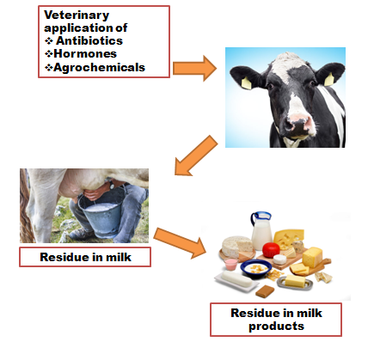
Figure 4: Sources of AM in milk and milk products

2.7 Actions of AM residue in food products
AM residues in foods of animal origin may cause problems for several reasons. In addition to toxic effects, effects on intestinal microbiota and the immune system are important (Khaskheli et al., 2008). Microbiological endpoints are considered more valid and sensitive in the safety evaluation of AM residues in production animals than standard toxicological endpoints (Nouws et al., 1990). Four microbiological endpoints have been identified that could be of public health concern: modification of the metabolic activity of microbiota, changes in bacterial populations, selection of resistant bacteria, and perturbation of the barrier effect (Mumba et al., 2012).
Drug hypersensitivity is defined as an immune-mediated response to a drug agent in a sensitized patient, and drug allergy is restricted to a reaction mediated by Ig E (Lander et al., 2012). The principal types of disorder are: Type 1: anaphylactic shock, asthma and angioneurotic edema; type II: hemolytic anaemia and agranulocytosis; type III: serum sickness and allergic vasculitis, and type IV: allergic dermatitis (Khaskheli et al., 2008). Notwithstanding their non-toxic nature, B-lactams appear to be responsible for most of the reported human allergic reactions to AM. Aminoglycosides, sulphonamides and tetracyclines may also cause allergic reactions.
Hazards of chloramphenicol observed in association with clinical use in humans include dose-related, reversible suppression of the bone marrow, gray baby syndrome, which is a circulatory collapse in children less than 30 days on high doses, and irreversible, idiosyncratic, non-dose related aplastic anemia (Khaskheli et al., (2008). Toxic and allergic reactions in humans and animals caused by tetracyclines have only been observed at therapeutic doses (Thomas, 1983) Residual AM can induce cancers and other non cancer hazardous effects on the body (Witte, 1998).
2.8 Acceptable range of AM
The Acceptable Daily intake (ADI) is an estimate of the residue, expressed on a body weight basis which can be ingested daily over a lifetime without any appreciable health risk (EC, 2001) (Table 1). The Acceptable daily intake was calculated by dividing this by a suitable safety factor, usually 100, which assumes that humans are 10 times more sensitive than animals and that within the human population there is a 10-fold range of sensitivity (Zurhelle et al., 2000). In the EU, the classical toxicology tests required include single dose toxicity, repeated dose toxicity, tolerance in the target species, reproductive toxicity, mutagenicity and carcinogenicity. Studies on other effects include immunotoxicity, microbiological properties of residues, observations in humans, and neurotoxicity (EC, 2001).

Table 1: Acceptable limits of AM in milk and milk products (EC, 2001)
AM | Minimum (µg/kg) | Maximum (µg/kg)
Amoxicillin | 4 | 40
Tetracyclin | 15 | 100
Oxytetracycline | 15 | 100
Chlortetracyclin | 15 | 100
Sulphonamides | 25 | 100
Trimethoprim | 8 | 50
Erythromycin | 12 | 40
Quinolones | 47 | 147

According to Council Regulation 2377/90 maximum residue limit means the maximum concentration of residue resulting from the use of a veterinary medicinal product which may be legally permitted or recognized as Development of microbiological methods for the detection and identification of AM residues in milk. Possible persistence of residues in organs or at the injection site is also considered (EC, 2001). Once the process of safety evaluation is complete and Maximum Residue Limits (MRL) have been derived for a particular substance, consideration is given to the likely level of residue which may be expected to remain after the use of the substance in accordance with good veterinary practice, and to the availability of analytical detection methods suitable for use for routine monitoring purposes. The maximum residue limits may be further reduced to take account of these factors (EC, 2001) (Table 2).
Table 2: Maximum Residues Limit (MRL) (µg/kg) for AM residues (Nisha, 2008)
AM | MRL
Benzyl penicillin | 4
Ampicillin | 4
Amoxycillin | 4
Oxacillin | 30
Cloxacillin | 30
Dicloxacillin | 30
Tetracycline | 100
Oxytetracycline | 100
Chlortetracycline | 200
Streptomycin | 200
Dihydrostreptomycine | 200
Gentamycine | 100
Neomycin | 100
Sulphonamides | 100
Trimethoprime | 50
Spiramycin | 200
Tylosine | 50
Erythromycine | 40
Quinalones | 75
Polymyxine | 50
Ceftiofur | 100
Cefquinome | 20
Nitrofurans | 0
Nitromidazoles | 0
Other chemotherapeutics (Chloramphenicol, Novobiocine) | 0

2.9 AM withdrawal period from animal body
To ensure that drug residues have declined to a safe concentration following the use of drugs in animals, a specified period of drug withdrawal must be observed prior to providing any products for human consumption. It is the time which passes between the last dose given to the animal and the time when the concentration of residues in the tissues: muscle, liver, kidney, and skin/fat or products milk, eggs, honey is lower than or equal to the Maximum Residue Limits (Jackson. 1980). The CVMP recommends the use of e statistical method in the assessment of a withdrawal period whenever possible, and particularly for products containing new chemical entities. A withdrawal period is determined at the time when the upper one-sided tolerance limit with e given confidence is below the Maximum Residue Limits (Table 3). For old chemical entities data are often insufficient to assess the withdrawal time by a statistical method. A simpler method consists of declaring the withdrawal time as the time in which the residues in all tissues of all observed animals have fallen below the respective MRLs (Concordet and Toutain, 1997). However, establishment of accurate pre slaughter withdrawal times is hardly possible with irritative drug formulations which are administered intramuscularly or subcutaneously (Nouws et al., 1990).
Table 3: Withdrawal period of different AM in dairy cows (Mahmood et al., 2016)
AM | Withdrawal period (Days)
Amoxicillin | 5
Oxytetracycline | 7
Ciprofloxacin | 6
Trimethprim | 10
Sulphaquinoxaline | 10
Sulphadimethoxine | 5

2.10 Heat stability of AM
Just a little extent of animal inferred food stuffs are consumed raw so the cooking measure is significant for the decrease of anti-toxin deposits in food (Katz and Brady, 2000). By and by, this cycle isn't sufficient for the evacuation of AM buildups. Herman et al. (1969) considered the impacts of cooking methodology on AM residues with cooking rainbow trout fillers in various cooking techniques. The filets were heated at 350°F for 20 min, bubbled for 10 min and singed for 5-10 min to decimate residues at normal levels (Table 4). Nonetheless, they have discovered that singing or heating didn't demolish all the deposits in the fillers (Herman, 1969).
Table 4: Heat stability of different AM after autoclaving at 121° C for 15 minutes (Furusawa and Hanabusa, 2002)
Stable | Partially stable | Labile
Ciprofloxacin | Nitrofurantoin | Amoxicillin
Gentamycin | Polymixin B | Cefixime
Trymethoprim | Amoxicillin | Doxicyclin
Sulpfamethoxazole | Panicillin G | Ceftriaxone
Clindamycin | Rifampicin | Erythromycin
Nalidixic acid | Ampicillin | Tetracyclin

2.11 Control measures of AM residue in milk
Veterinary drugs are monitored for Maximum Residue Limits compliance. The directive establishes the groups of substances to be controlled for each food commodity. Commission Decision 97/747/EC (EC, 2001) provides further rules for certain animal products: milk, eggs, honey, rabbit and game meat. In the USA, the National Residue Program conducts two types of residue testing programs. Under the monitoring programme, a statistically based selection of random samples from normal animal population is collected. The surveillance program focuses on obtaining samples from animals suspected to contain drug residues in their tissues (Kummerer and Henninger, 2003). In Finland, the national residue control programme is carried out in accordance with both national and EU legislation. The samples are taken from both live animals and foodstuffs of animal origin. In addition to the control programme, AM residues in meat are tested in meat inspection at slaughterhouses. In 2003 a total of 4422 suspected kidney samples were tested with microbiological methods in meat inspection, and 5241 samples according to the national residue control programme (Khaskheli et al., 2008). AMs are indiscriminately used in lactating cows and withdrawal periods are not being maintained in Bangladesh. Ultimately dairy cows are leaving AM residues in milk during and after medication period.
2.12 Detection of AM residue
A screening method is the first-hand analysis of the sample to establish the presence or absence of residues (Sarmah et al., 2006). It should be a low-cost and high-sample throughput method, optimized to prevent false-negative results and to have an acceptable number of false-positive results. In order to prevent false-negative results, it should be positive for all samples that contain residues at MRL levels; preferably at 50% of the MRL (Rybinska et al., 1995). Microbiological methods are suitable for large scale screening because of their convenience and broad spectrum characteristics (Sarmah et al., 2006). In the search for rapid methods for determining the interaction of Development of microbiological methods for the detection and identification of AM residues in meat AM agents and organisms, intermediate and end products of bacterial metabolism, as well as the interaction of the organism with various energy sources have been examined (Rybinska et al., 1995). Microbiological tests are unspecific, indicating only the presence of an inhibiting agent. Therefore, a post-screening test such as Thin Layer Chromatography (TLC) is needed for the preliminary characterization of the residue (Sarmah et al., 2006).
2.13 Methods of the detection of AM residue
Commonly used procedures for the detection of veterinary drug residues include High Performance Liquid Chromatography (HPLC), gas chromatography (GC), thin layer chromatography (TLC) and mass spectrometry. Chemical methods usually proceed with a preliminary extraction in order to isolate the drugs of interest Rom the biological matrix. The main objectives of sample treatment are removal of macromolecules and other matrix constituents that may either adversely affect the chromatographic system or interfere with the detection, and enrichment of the analytes in order to achieve the required low limits of detection (Aerts et al., 1995). Liquid chromatography (LC) has emerged as the method of choice for determination of AM which are rather polar, non-volatile, and sometimes heat sensitive (Sarmah et al., 2006). With the automated sequential trace enrichment of dialysates sample pretreatment is restricted to homogenization and dilution of samples; clean up is by on-line dialysis and on-line solid phase extraction (Zurhelle et al., 2000).
Accordin to Kneebone et al., (2010) rapid AM screening tests are widely used in the dairy industry to monitor milk for the presence of AM residues above regulated levels. Given the persistent concern over contamination of milk products with AM residues, we investigated the utility of IDEXX Snap test devices (IDEXX Laboratories Inc., Westbrook, ME) as tools for detecting antibiotic residues in powdered milk products.
Along with this LC-MS techniques have been extensively introduced to analyze veterinary drug residues in food products (Frenich et al., 2010; Jiménez et al., 2012; Bousova et al., 2013; Jia et al., 2014). Tandem quadrupole MS has been widely accepted as the main tool for quantitative analysis of veterinary drugs due to its superior sensitivity and specificity (Kaufmann and Widmer, 2013).
2.14 Public health significance
AM use plays a major role in the developing public health emergency of AM resistance. Although the majority of AM use helds in agricultural settings, less attention has been paid to how AM use in farm animals contributes to the overall problem of AM resistance (Landers et al., 2012). While anti-infection use in food creatures may speak to a danger to human wellbeing, the degree and relative effect have not been very much described. AM opposition is an approaching general wellbeing emergency. While once accepted to be the territory of clinics also, other medical services offices, a large group of network factors are currently known to promote AM opposition, what's more, network related safe strains have now been embroiled as the reason for some emergency clinic procured diseases (Boyce, 2008; Popovich and Weinstein, 2009). The most important adverse effect of AM residues is the transfer or AM resistant bacteria to the humans due to the mobile properties of resistance. Because of these undesirable effects, it is important to regulate the use of AM in food animals (Bacanlı and Başaran, 2019).
AM agents are directed to animals in various ways: oral, parenteral or topical. It is realized that buildup levels happening from injectable sources are more than those subsequent from feeding (Katz and Brady, 2000). The fundamental utilization of AM in animal is for the treatment and counteraction of maladies including mastitis, joint inflammation, respiratory sicknesses, gastrointestinal and other bacterial diseases (Darwish et al., 2013). Improvement in development because of anti-infection agents was first depicted in 1940s and inside five years the expansion of development advancing AM has become a typical practice. The World Health Association (WHO), the American Medical Association and the American Public Health Affiliation have asked a prohibition on development advancing AM agents contending that their utilization prompts different medical issues in people (Graham et al., 2007).
2.15 Conclusion
According to the review AM residue in milk and milk products is a major public health issue in the present century very limited work has been conducted in our country particularly in Chattogram area regarding the AM uses in lactating cows and its residual change in milk during AM course. This study focuses the present AM using pattern in dairy farm of Chattogram metropolitan area. Along with this, estimate the gradual change of antibiotic concentration in milk during antibiotic course of lactation animal.

Chapter III
MATERIALS AND METHODS
3.1 Study area
Chattogram consists of an area of about 168.07 square kilometer (64.89 sq mile). This city is known for its hilly terrain that stretches throughout the district. The location of the city is 22°22’0” N 91.98°E on the bank of Karnaphuli river. Sikalbaha is the area under Karnaphuli upazilla which is situated to the south bank of Karnaphuli river next to the Chattogram metropolitan area (CMA). Commercial dairy farms of CMA, Patiya, Boalkhali and Sikalbaha were selected for the study (Figure 5).
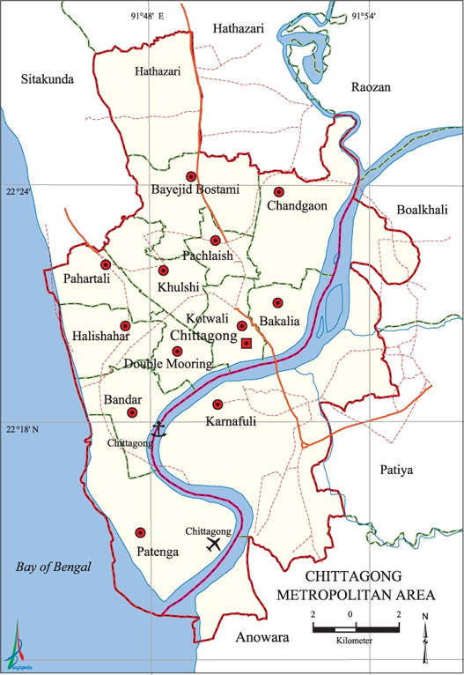

Figure 5: Study area
3.2 Study period
This study was conducted during the period of December 2018 to June 2019.
3.3 Reference farms
A complete list of dairy farms in Chattogram who had at least 3 dairy cows were developed (Bari et al., 2020). All the cows of these selected farms were considered as the reference population. The farms were located in CMA, Boalkhali, Patiya and Sikalbaha under Karnaphuli upazilla.
3.4 Target population
All the lactating cows in commercial farms of CMA, Boalkhali, Patiya and Sikalbaha area were considered as the target population.
3.5 Data collection
The following data were collected from the farmers by using preformed questionnaire (Figure 6, 7) (Annex 1).
3.5.1 Farm related data
After selecting the farm these data were collected (Figure 8, 9),
- Farmer’s details
- Size of the farm
- Housing condition
- Hygienic management
- Feeding history
- Production
- Economic stability of the farm
3.5.2 Data related to AM use
- Details of diseased animal
- Details of treatment
- Vaccination details
- Deworming details
- Type of antibiotic use
- Consultation with veterinarian or not
3.6 Sample collection
The following sampling strategy was followed to collect the milk sample. To obtain the AM residual effect in the milk, the milk sample were collected from the animal that were undergoing under AM medication. The milk sample was collected for day 1, 2, 3, 5 and 7 days after completing AM course of the animal to observe the withdrawal period of used AM from the milk. Falcon tube was used during sampling of each milk sample (Figure 10, 11). The collected milk samples were marked with a unique identification number along with the animal details and the details of AM uses.
Total 100 milk samples were collected from 20 different animals to determine the AM residue and to check the milk constituent (Fat and Protein).
3.7 Extraction of milk for Thin Layer Chromatography (TLC)
Raw milk samples were used (Figure 12). All categories of milk samples were extracted for TLC. A mixture of acetonitrile-methanol and Deionized water at a ratio of 40:20:40 was made (Figure 13). In order to precipitate the protein in milk, 1 ml of mixture was added to 1 ml of milk sample in sterile falcon tube and mixed properly (Figure 14). This mixture was then centrifuged at 3000 rpm for 20 minutes (Figure 15) and the supernatant was collected in eppendorf tube (Figure 16) for TLC (Popelka et al., 2005; Bari et al., 2020).
3.8 TLC
TLC procedure for quantitative evaluation of AM residue was done as described by (Popelka et al., 2005; Bari et al., 2020). TLC detects type specific AM residue. The procedure was performed in the Biochemistry laboratory under the Department of Physiology Biochemistry and Pharmacology.
Reagents for TLC
De-ionized water, distilled water, Acetonitrile, Methanol, Acetones were required for TLC.
Silica plates for sample running
TLC plate with 0.25mm thickness (MERCK, Germany), was activated at 120°C for two hours before use.
Preparation of solvent system
In order to perform Thin Layer Chromatography along with stationary phase of absorbent, a mobile phase or solvent preparation was done as directed by (Popelka et al., 2005; Bari et al., 2020). Here, a volume of 50ml of methanol and 50ml acetone were mixed properly and used as mobile phase.
Preparation of standard solution
Stock solution of pure amoxicillin, OTC and ciprofloxacin were prepared by dissolving exactly 0.5ml of each in 10ml of methanol. Working solutions were prepared as required dilution. These solutions were stored in well-closed vessels and direct light was avoided (Popelka et al., 2005; Bari et al., 2020).
Preparation of developing chamber (TLC tank)
A glass made beaker with a watch glass on the top was used as developing chamber.
Pointing on TLC plate
For pointing on TLC plate first precoated TLC plates were cut according to the shape of TLC Tank with scissors (Figure 17). Then, the following steps were performed
1. Firstly a line was drawn with the help of pencil on TLC plate and scaled. This line was sufficiently high up (0.5cm) the plate so that when it was placed in the solvent the spots made on the TLC plate, this was remaining high on the level of the solvent.
2. Then pointing of standard solution was done with capillary tube on this line (Figure 18). Proper care was taken to ensure that the spots were kept as small as possible. The spots were never greater than 2-3 mm in diameter.
3. After drying the spot of standard solution points the spot of sample solution by capillary tube about 2 cm distance from previous spot. After 2 spots had been put and dried up, the plates then were placed in the TLC tank and were allowed for running (Figure 19).
Development of Chromatogram
1. Five milliliter solvent (Methanol and Acetone mixture) was placed in the developing chamber. The solvent level has to be below the starting line of the TLC plate, otherwise the spots were dissolved away.
2. The lower edge of the plate was then dipped in the solvent. The solvent (elute) travels up the matrix by capillarity, moving the components of the sample at various rates because of their different degrees of interaction with the matrix (stationary phase) and solubility in the developing solvent. The solvent was allowed to travel the solvent up the plate until 1 cm below from the top.
3. The plates were taken out and marked the solvent front immediately. The solvent was not allowed to run over the edge of the plate. Then, the plates were dried to evaporate the solvent completely (Figure 20) (Popelka et al., 2005; Bari et al., 2020).
Examination of Chromatogram under UV detector
In the TLC, the chromatogram was examined under ultra-violet lamp at 256nm for spots i.e., spot that fluorescence (Figure 21). The outline of the spot was marked with a series of dots using a sharp pencil. The color of each fluorescent spot was recorded on a separate paper. Then again visualizing agent ferric chloride was sprayed on the paper and dried with hot air oven at temperature of 105°C. Then again the plates were examined under ultraviolet lamp for further fluorescent spots and color was noted on the paper (Figure 22) (Popelka et al., 2005; Bari et al., 2020).
Determination of Retardation factor (RF) value
The distance that each spot had traveled from the start line was measured (cm). This was taken from the center of the spot to the last point of the traveling of that spot. Also the distance of the solvent was measured from the start line. Then calculation of RF values was done using the following equation
$$RF=\frac{Distance moved by substances }{Distance moved by solvent}$$
Results of all RF values were recorded on a paper of tabular form.

Interpretation of result
The Chromatogram of the standard solution and sample were compared based on following criteria.
1. Same color under UV light.
2. Same color with the spray reagent.
3. Same RF value as those of the reference sample.
If the color of the standard and sample spot was same in Ultraviolet (UV) ray after traveling or after using ferric chloride or the Refractive value of standard and sample solution was same, the sample was positive to that standard antibiotic.
3.9 Evaluation of milk constituent
To check the effect of AM treatment in milk constituent collected milk samples were tested for fat and protein.
3.9.1 Determination of fat percentage
Fat percentage was determined by volumetric method (Gerber method).10ml of concentrated sulfuric acid (H₂SO₄) was taken in butyrometer (Figure 23) and 10.75 ml of well mixed milk sample was added to it (Figure 24). After that 1 ml of amyl alcohol was added (Figure 25) and shaken the butyrometer until the disappearance of white particles (Figure 26). Centrifuge was done at 1100 RPM for 5 minutes (Figure 27) and reading was recorded by keeping the butyrometer in vertical position (Figure 28) (Kleyn et al., 2001).
3.9.2 Determination of protein percentage
Protein percentages of the milk samples were measured. Ten ml well mixed milk sample was taken in a conical flask (Figure 29) and 0.4 ml potassium oxalate was added to it (Figure 30) and kept the mixture for two minutes. 2-3 drops of phenolphthalein indicator was added (Figure 31) and titration was done against 0.1 N sodium hydroxide solution up to the appearance of faint pink color (Figure 32).
2ml formaldehyde solution was added to the mixture and kept for 30 minutes (Figure 33). After adding 2-3 drops of phenolphthalein indicator, titration was done by the same procedure (Figure 34) (G. Pyne, 1932).
Total required alkali (NaOH) was recorded and percentage protein was calculated by,
Protein percentage= ml of alkali (NaOH) required×1.70

3.10 Data analysis
All data were included in Microsoft excel 2007 spread sheet to evaluate statistical analysis and analyzed by using STATA-2017 (Stata Corp, 4905, Lakeway Drive, CollegeStation,Texas77845,USA).
Picture gallery
Data and milk collection
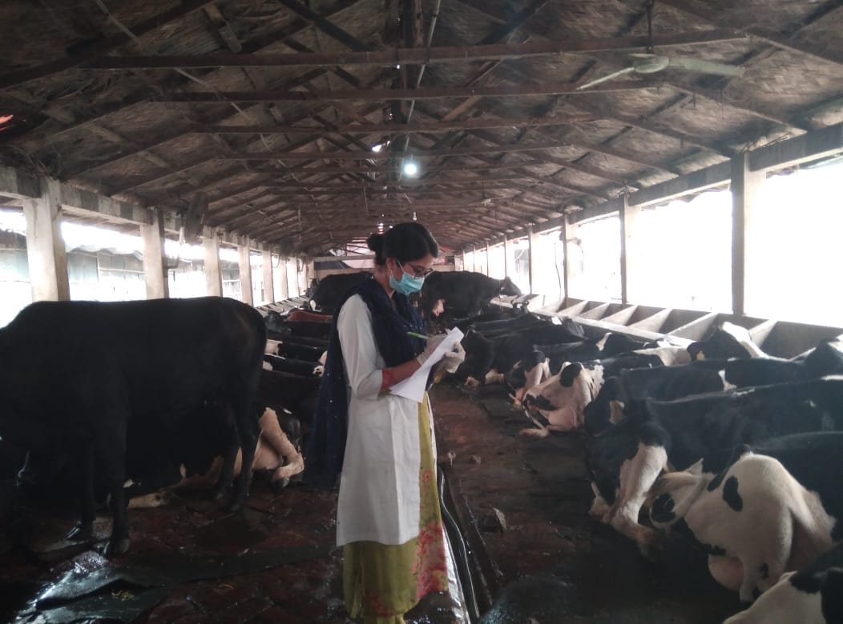
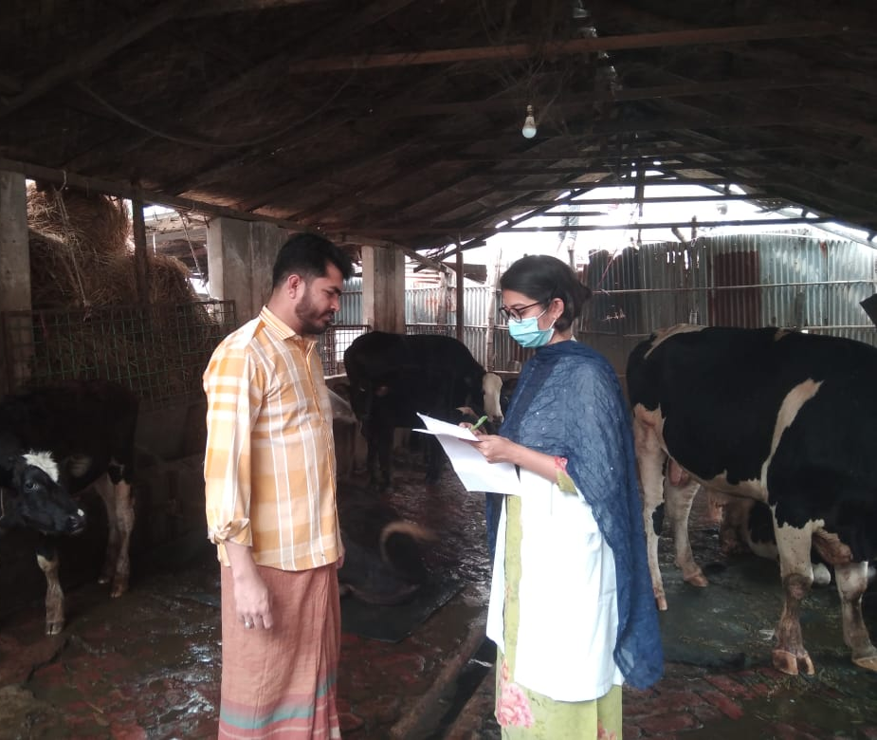
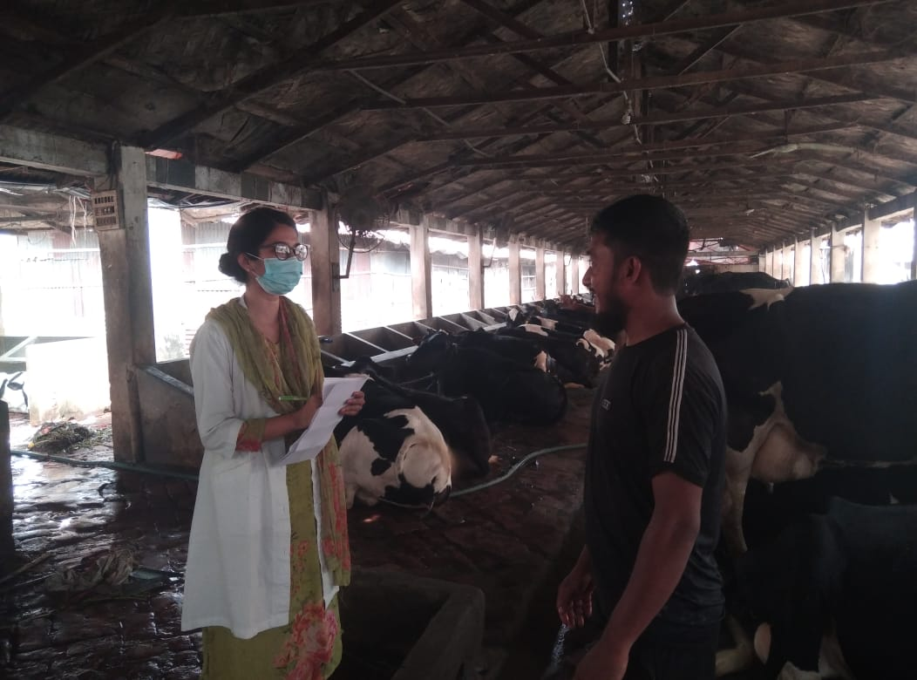
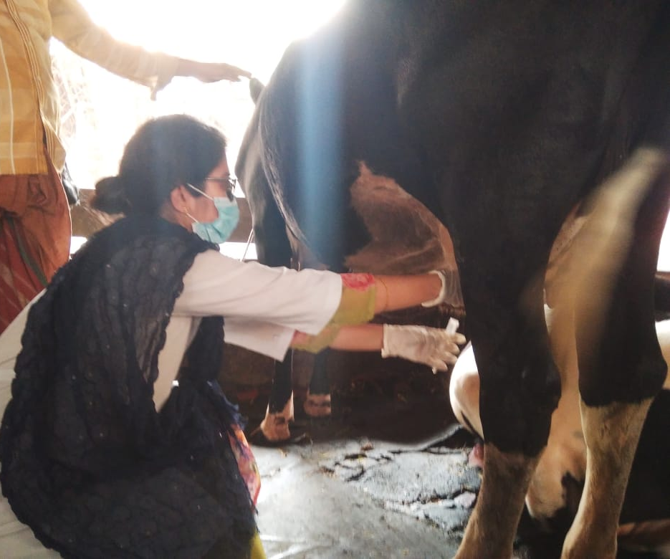
Figure 11: Milk sample collection

Figure 10: Interviewing of farmers over phone.

Figure 8: Interviewing of farmers

Figure 9: Collecting data from farmers

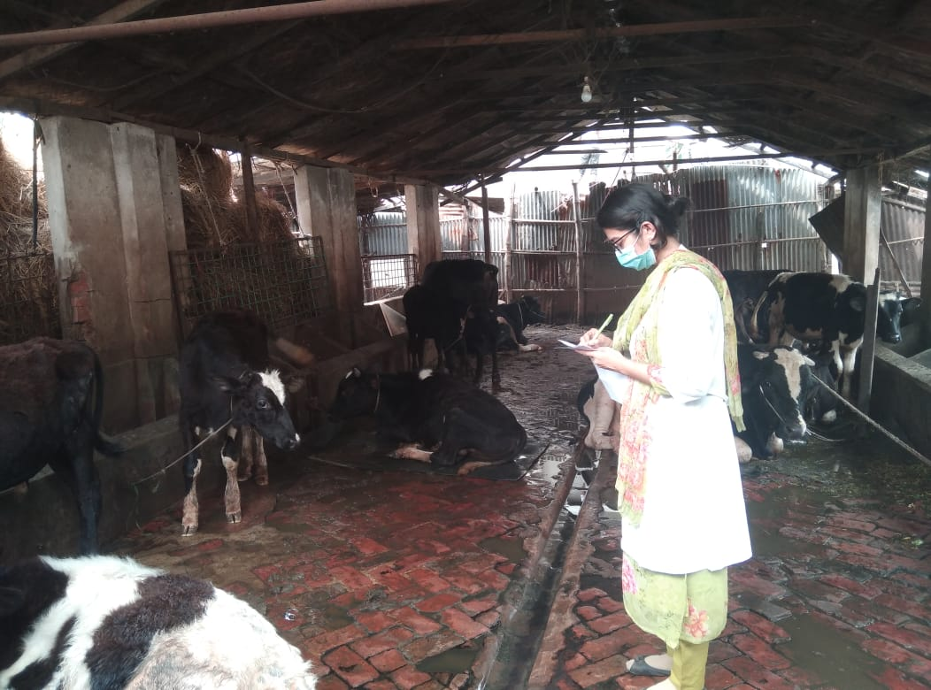
Figure 6: Farm visit
Figure 7: Inspecting management of cow shed

Detection of AM residue by TLC
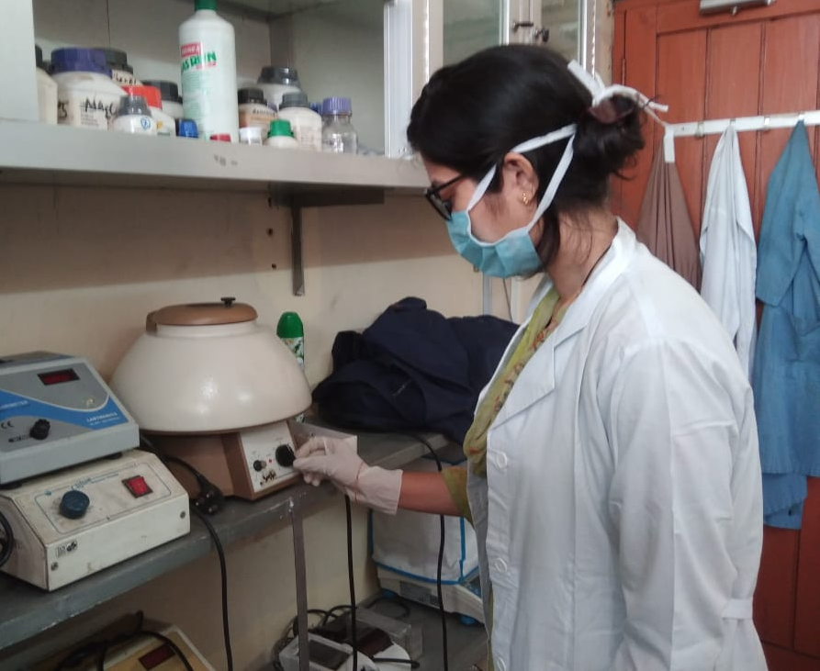
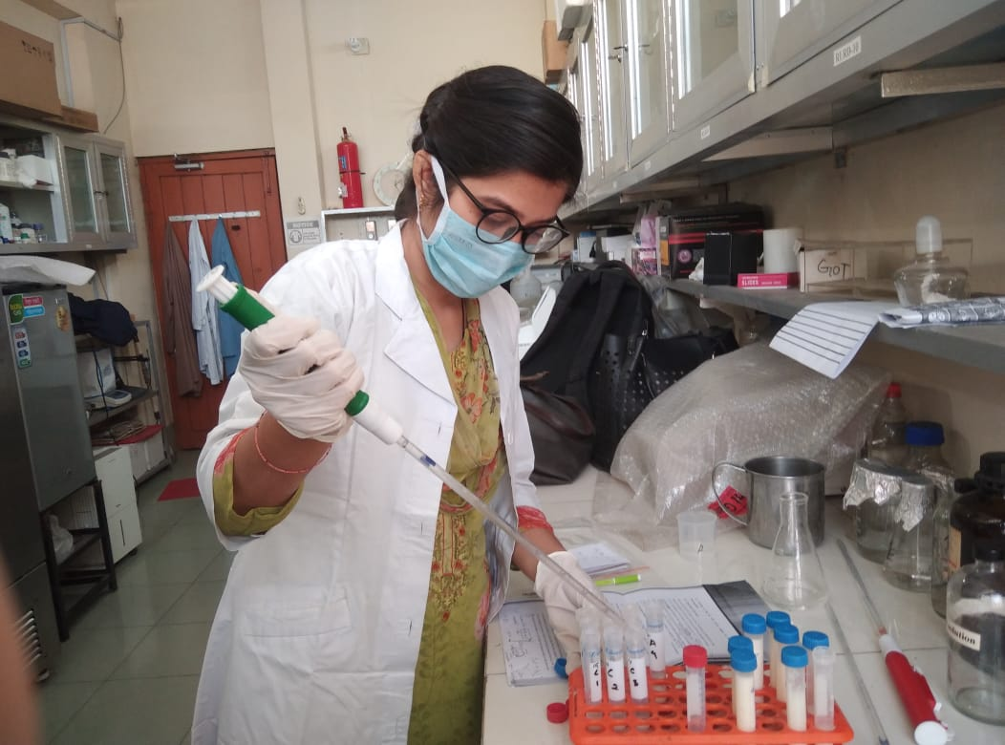
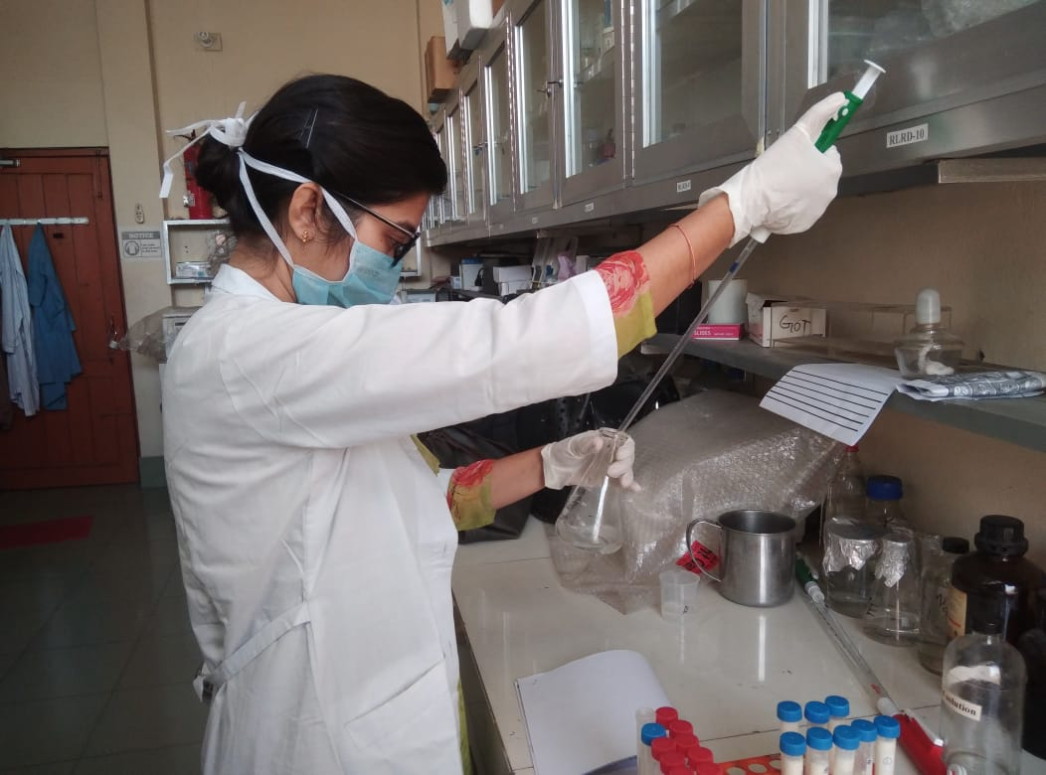
Figure 13: Preparing solution for extraction
Figure 12: Milk samples for TLC
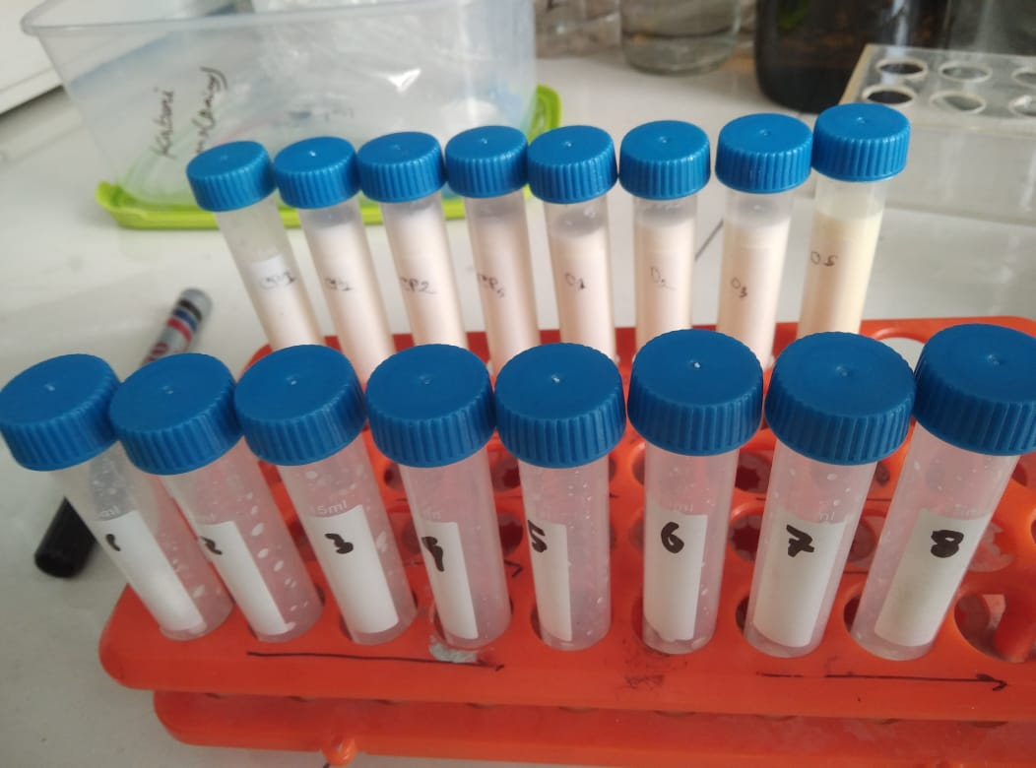

Figure 15: Centrifugation to separate the supernatant

Figure 14: Extraction of the samples

Figure 16: Collecting supernatant

Figure 17: Cutting TLC plate

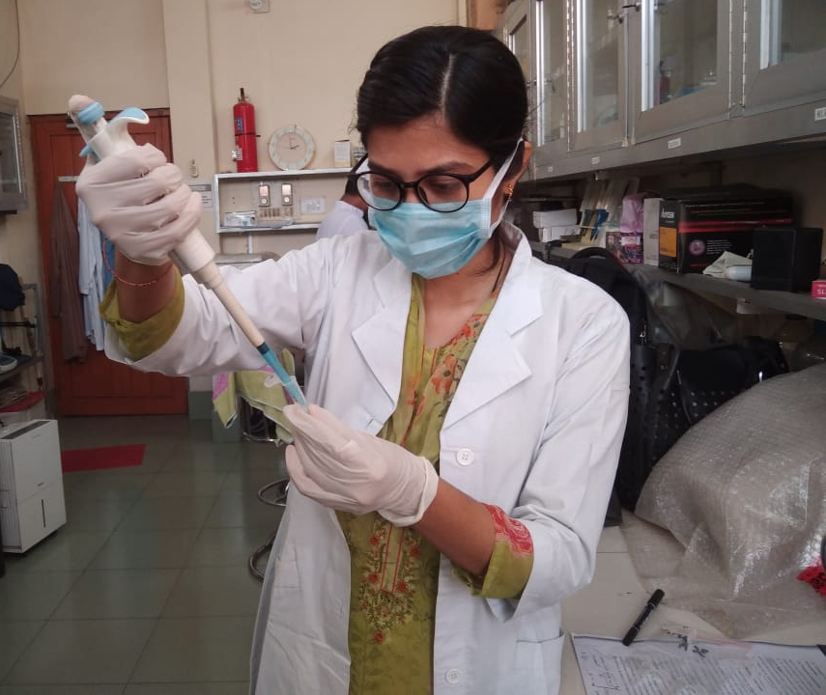

Figure 22: Observing the result

Figure 19: Running of TLC

Figure 18: Pointing on TLC plate with standard and sample

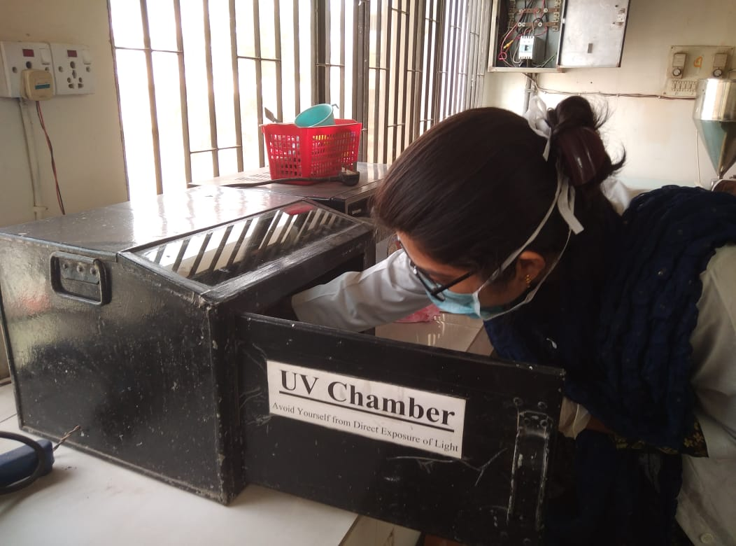
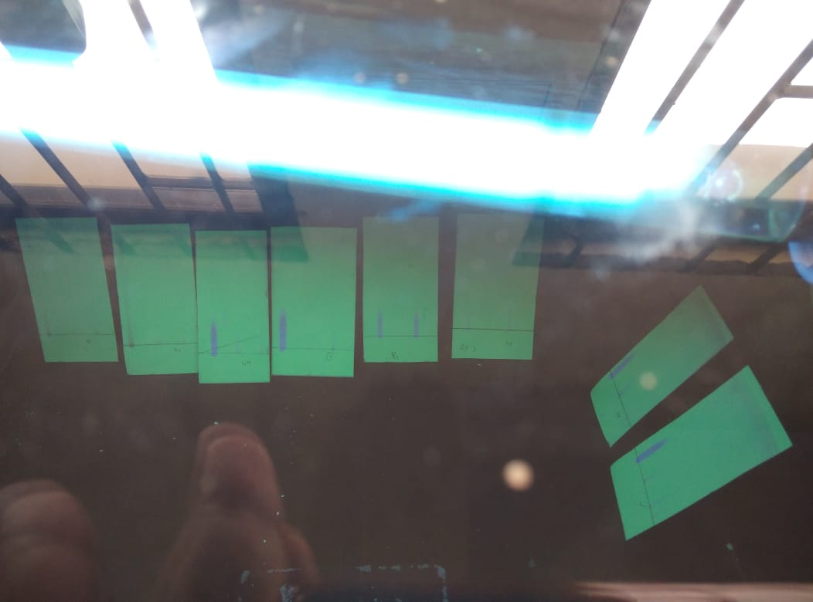
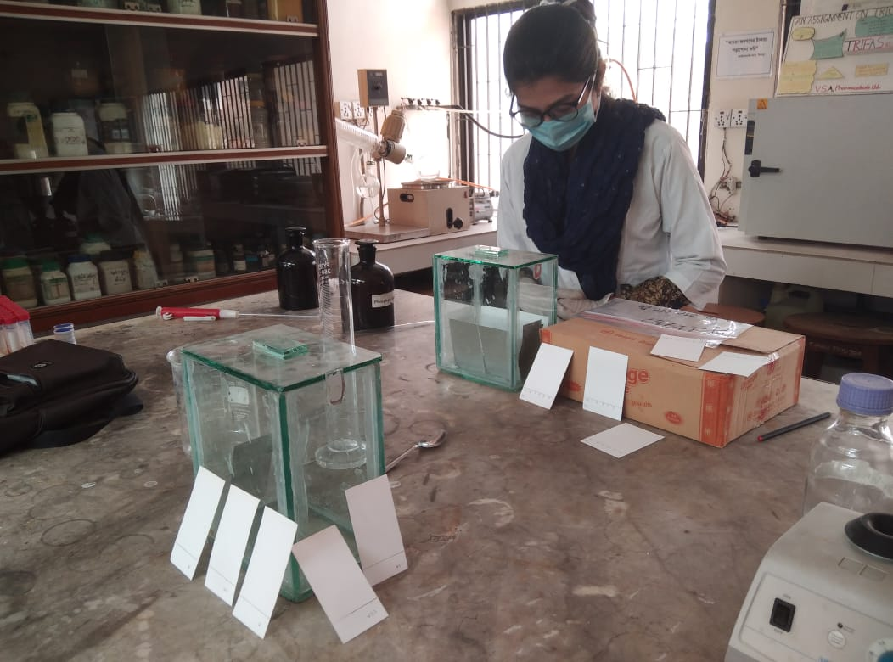
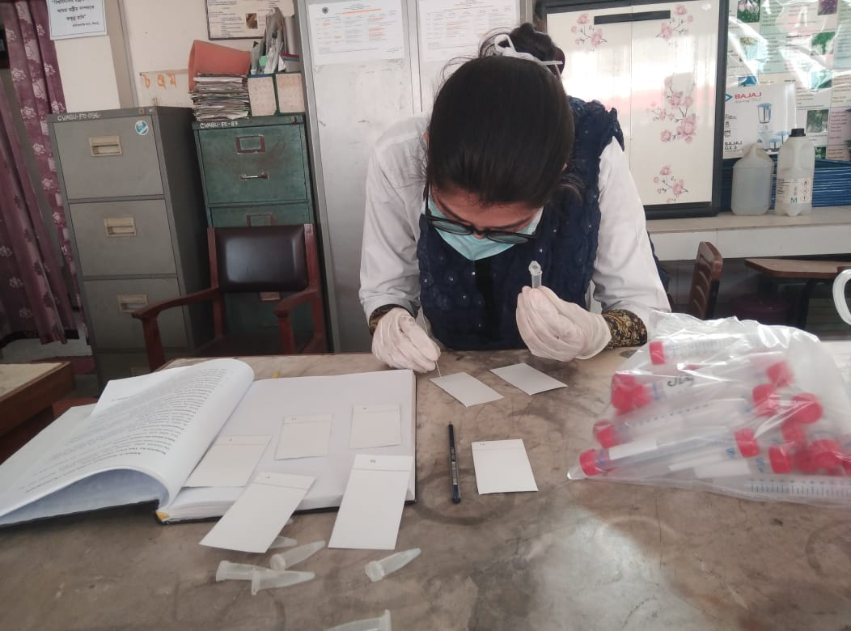
Figure 21: Setting in UV chamber

Figure 20: Air drying of TLC plate

Detection of milk fat percentage
Figure 26: Digestion of milk protein

Figure 25: Adding amyl alcohol

Figure 24: Adding 10.75ml milk sample

Figure 23: Adding sulfuric acid in butyrometer

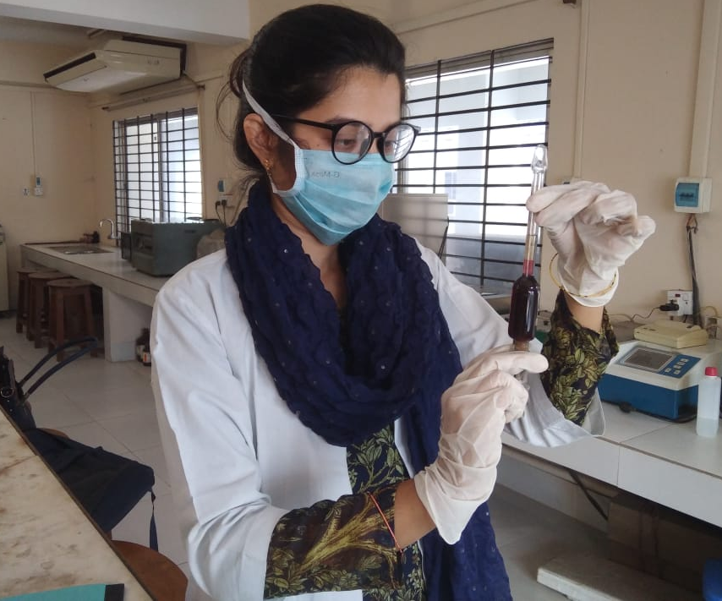
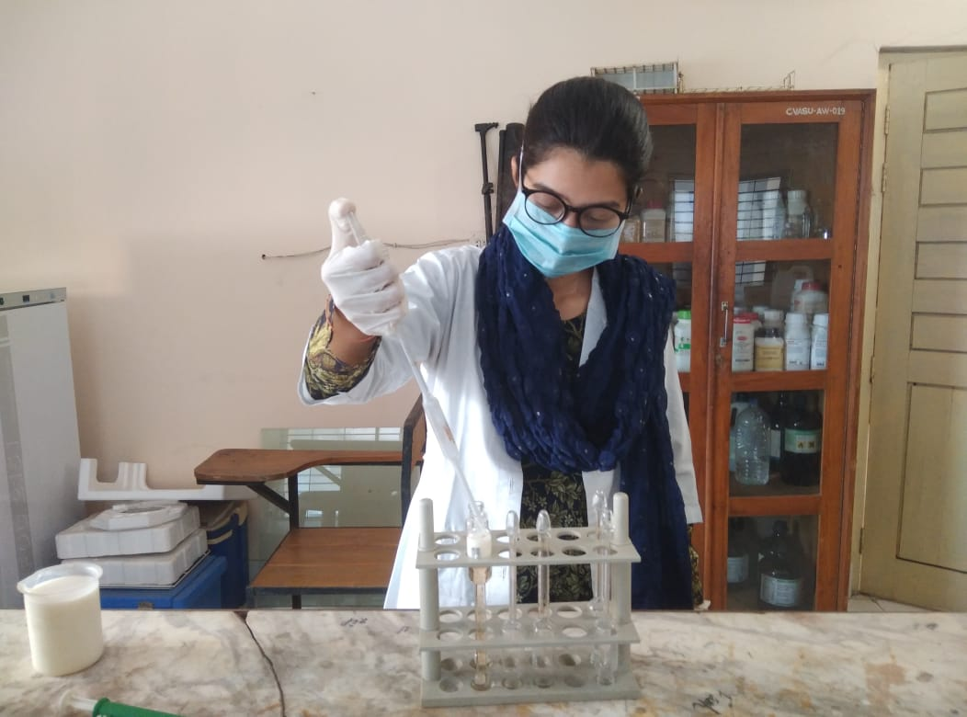
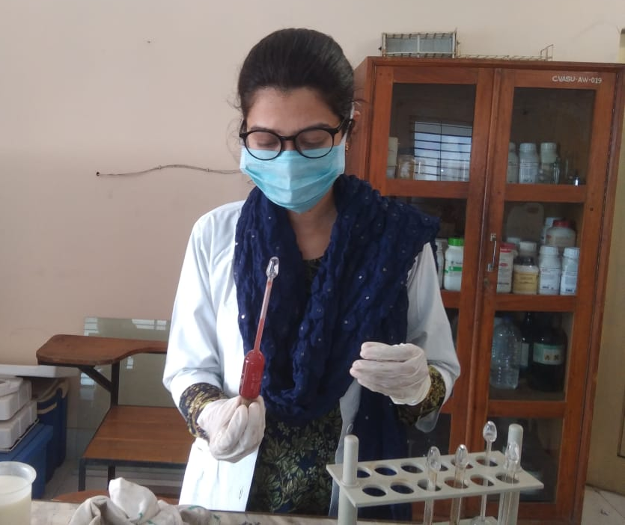
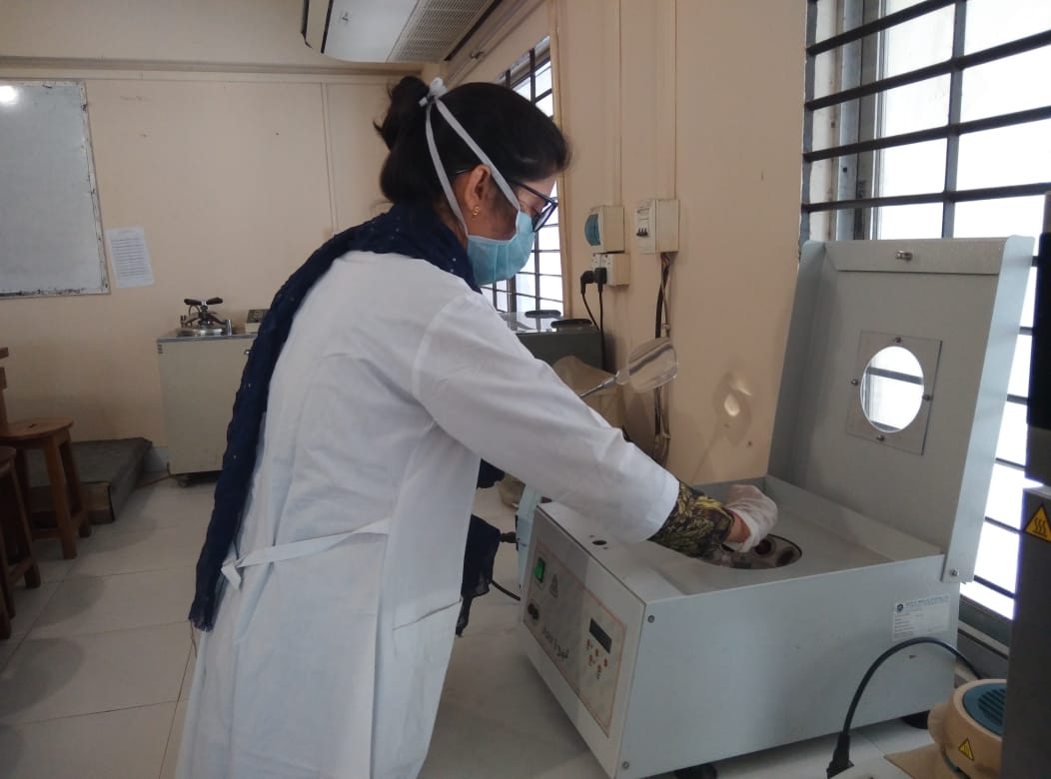
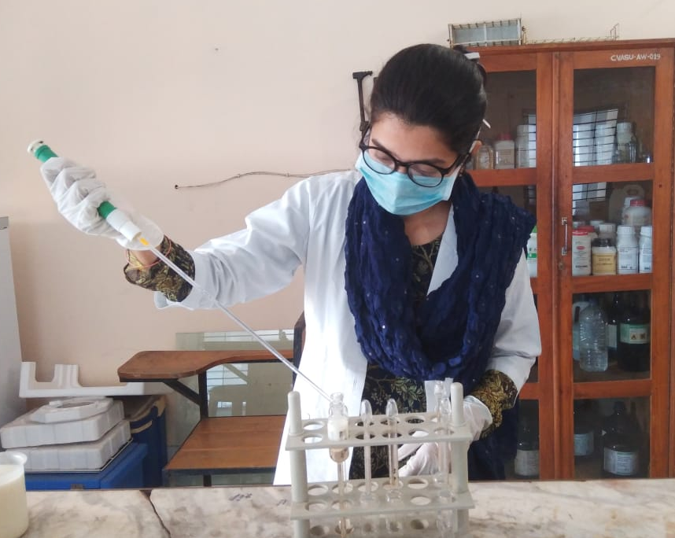
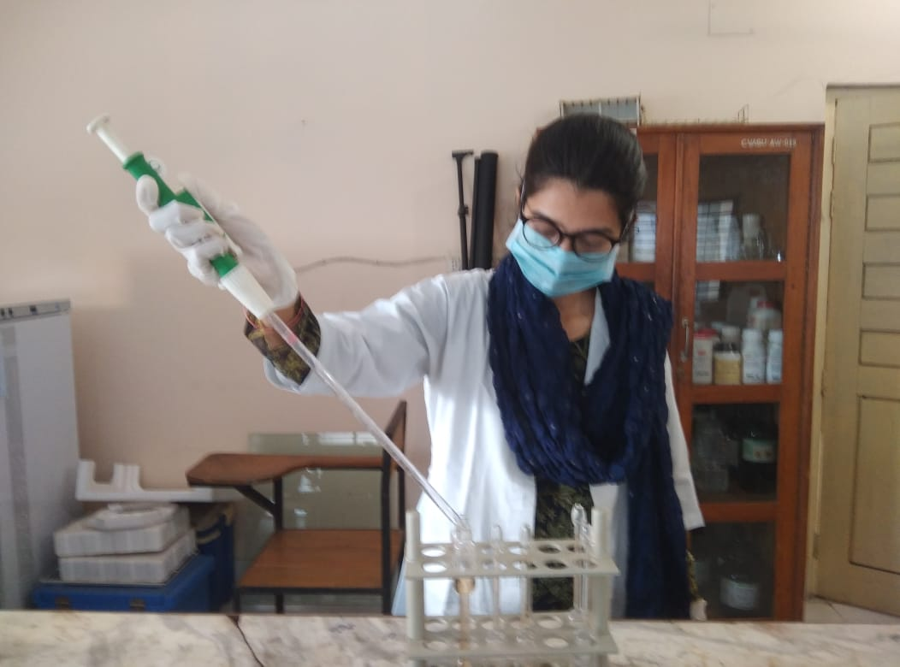
Figure 28: Reading of fat

Figure 27: Centrifugation of butyrometer

Detection of milk protein percentage
Figure 33: Adding formaldehyde

Figure 32: Titration against 0.1N NaOH

Figure 31: Adding phenolphthalein

Figure 30: Adding potassium oxalate

Figure 29: Taking 10 ml milk sample

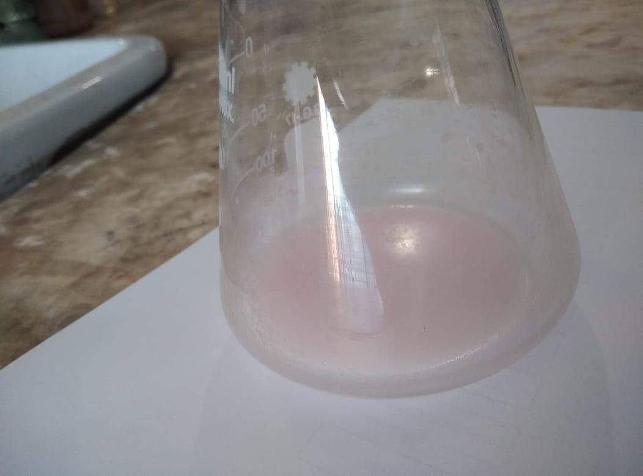
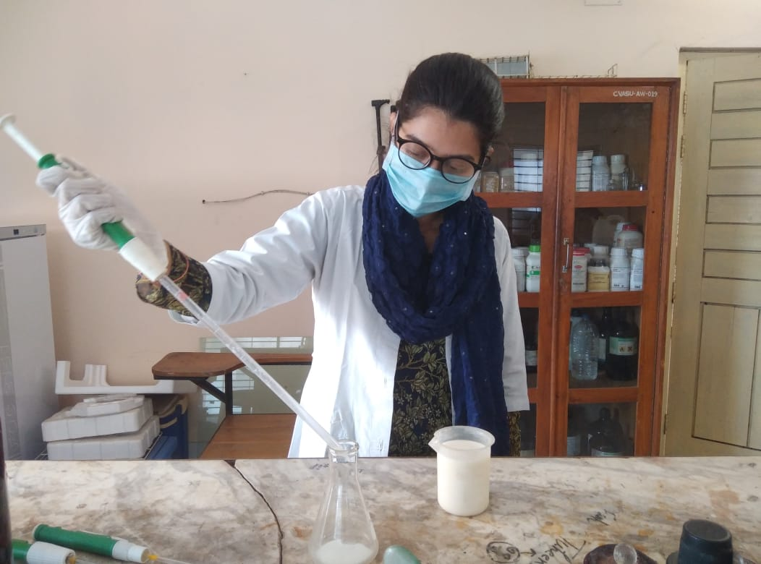
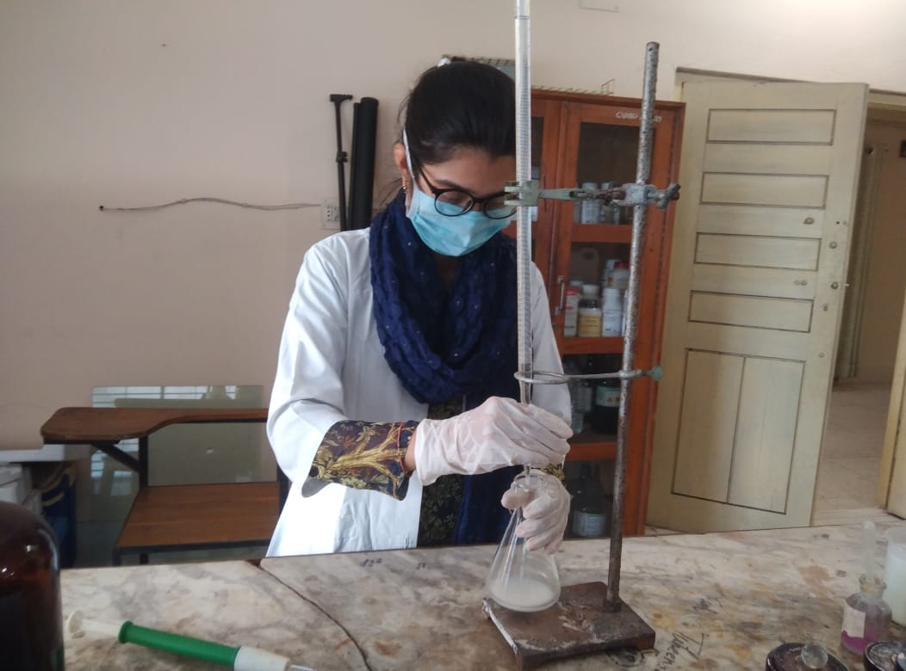
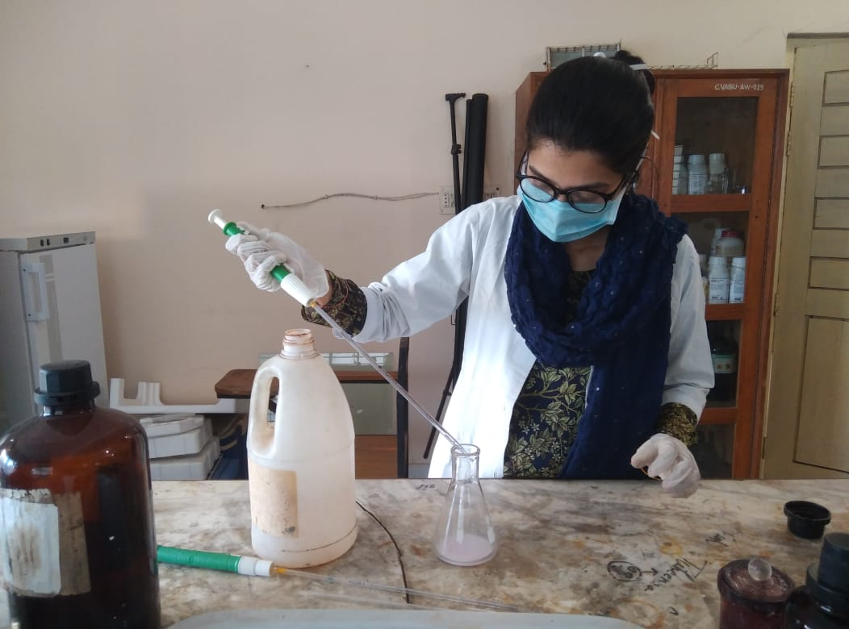
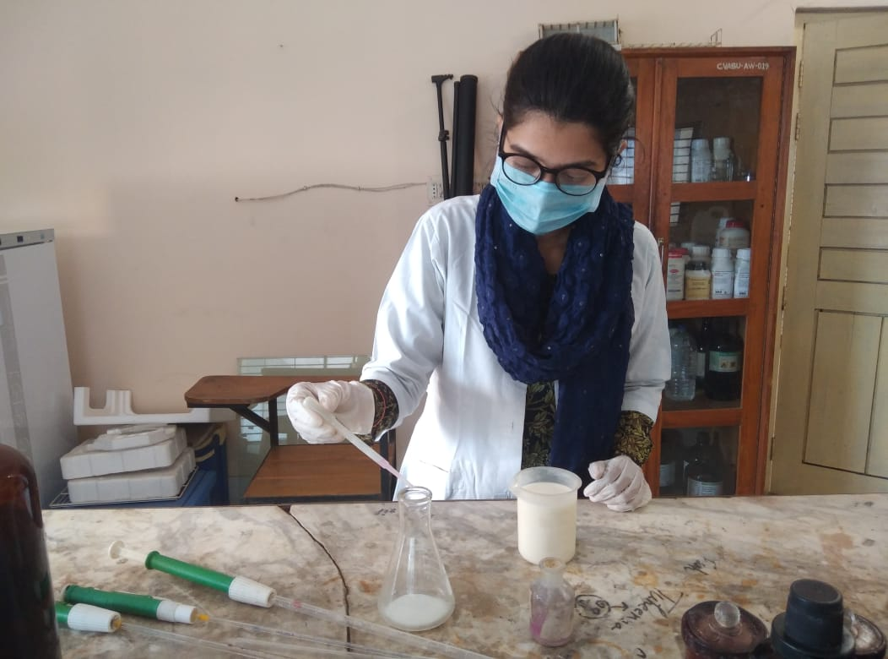
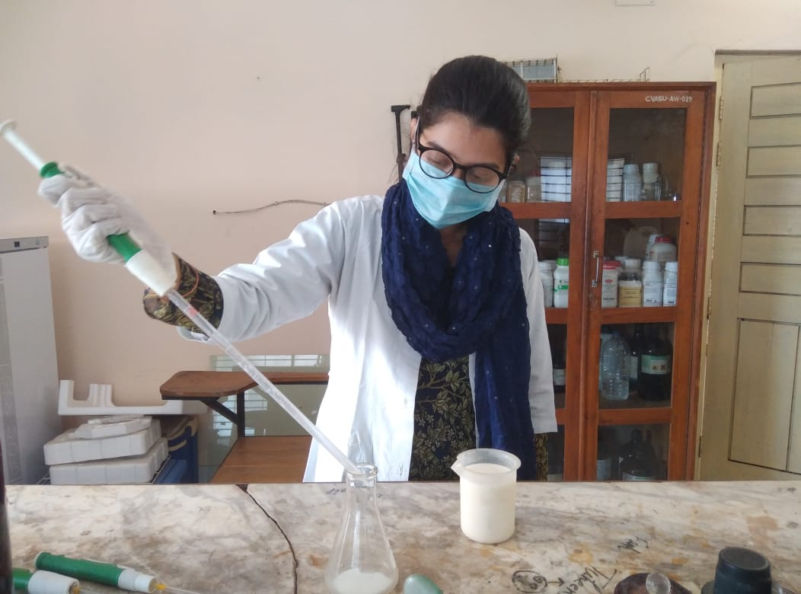
Figure 34: Observing the faint pink color

Chapter IV
RESULTS
4.1 Description of the selected farms
4.1.1 Size of the farms
Among the selected farms the number of Category A (3-25 cows), category B (26-50 cows) and category C (above 50 cows) farms were 19 (38%), 26 (52%) and 5 (10%), respectively (DLS, 2012).
4.1.2 Location of the selected farms
Among the selected farms, 11 (22%) farms located in Chattogram metropolitan area (CMA), 29 (58%) farms located in Sikalbaha (Karnaphuli upazilla), 7 (14%) farms located in Boalkhali and another 3 (6%) were located in Patiya upazilla. In this study the highest numbers of farms were included from Sikalbaha (58%) area and the lowest were picked from Patiya (6%) (Figure 35).

Figure 35: Location of the selected farms.
4.2 Description of the farmers
4.2.1 Age group of the farmers
All the farmers that were selected for present study was divided into four age groups. Group 1 (18-30years), Group 2 (31-45 years), Group 3 (46-60 years) and Group 4 (above 60 years). Result showed that 6%, 36%, 34% and 12% were acquired from group 1, group 2, group 3 and group 4, respectively. The highest was from group 2 and the lowest was from group 1.
4.2.2 Educational status of the farmers
Among the selected commercial dairy farmers 2 (4%) were illiterate, 23 (46%) were studied up to SSC, 11 (22%) were studied up to HSC and rest 14 (28%) were graduates. Results showed that the highest amount of farmers (46%) were studied up to SSC and the lowest (4%) were illiterate (Figure 36).

Figure 36: Educational status of the dairy farmers.

4.3 Vaccination status of the farms
Among the selected farms 46 (92%) farms were vaccinated their farm animal for foot and mouth disease (FMD), 31 (62%) farms use anthrax vaccination for their animal. The amount of farms using Black quarter (BQ) and Hemorrhagic septicemia (HS) vaccine for their animal was 5 (10%) and 12 (24%), respectively. From the results the highest percentage (92%) farms using FMD vaccine and the lowest percentage (10%) obtained in case of BQ vaccine.
Vaccination status according to location shows a different result. In case of FMD vaccination the percentage of the vaccine used in Sikalbaha, CMA, Patiya and Boalkhali was 96%, 83%, 66% and 75%, respectively. In case of Anthrax vaccination the percentage of the vaccine used in Sikalbaha, CMA, Patiya and Boalkhali was 93%, 33%, 0% and 0%, respectively. In case of BQ vaccination the percentage of the vaccine used in Sikalbaha, CMA, Patiya and Boalkhali was 14%, 8%, 0% and 0%, respectively. On the other hand, HS vaccination the percentage of the vaccine used in Sikalbaha, CMA, Patiya and Boalkhali was 24%, 33%, 0% and 14%, respectively (Table 5).
Table 5: Vaccination status according to the location of the farm.
Vaccine | Area | Uses in farm | Total farms in specific location | Percentage
FMD | Sikalbaha | 28 | 29 | 96%
 | CMA | 10 | 11 | 83%
 | Patiya | 2 | 3 | 66%
 | Boalkhali | 6 | 7 | 75%
Anthrax | Sikalbaha | 27 | 29 | 93%
 | CMA | 4 | 11 | 33%
 | Patiya | 0 | 3 | 0
 | Boalkhali | 0 | 7 | 0
HS | Sikalbaha | 7 | 29 | 24%
 | CMA | 4 | 11 | 33%
 | Patiya | 0 | 3 | 0
 | Boalkhali | 1 | 7 | 14%
BQ | Sikalbaha | 4 | 29 | 14%
 | CMA | 1 | 11 | 8%
 | Patiya | 0 | 3 | 0
 | Boalkhali | 0 | 7 | 0

4.4 Deworming status of the farms
Among the selected farms 49 (98%) were performed deworming for milking animal. 38 (76%) of the farmers maintained ideal 4 month interval for deworming in this studied farms, another 12 (24%) did not maintain the ideal interval of deworming. About 5 (10%) farmers take veterinarian’s advice before deworming. On the other hand, 45 (90%) of the farmers solely decided about the deworming without consultation. Only 1 (2%) farmers maintain withdrawal period after using anthelmentics before marketing the milk (Table 6).

Table 6: Deworming scenario of the farms.
Parameter | Response type | Uses in farm | Total selected farms (N) | Percentage
Performed deworming | Yes | 49 | 50 | 98%
 | No | 1 | 50 | 2%
Maintained interval | Yes | 38 | 50 | 76%
 | No | 12 | 50 | 24%
Took Veterinarian consultancy | Yes | 5 | 50 | 10%
 | No | 45 | 50 | 90%
Maintained withdrawal period | Yes | 1 | 50 | 2%
 | No | 49 | 50 | 98%

4.5 Isolation and quarantine activities
In case of the management of diseased animal in the selected farms of this study, 6 (12%) of the farmers obeyed proper isolation rules for diseased animals, 18 (36%) of the farmers never performed isolation in their farms, another 26 (52%) farmers maintained isolation occasionally in case of highly contagious disease like FMD.
In case of management of newly bought animals in the selected farms, 11 (22%) farmers maintained proper quarantine procedure and 39 (78%) farmers did not maintain quarantine
4.6 Consultancy of the farms
For the diseased animal and other production related issues statistics of the technical consultancy of the selected farms showed in (Table 7). In the selected farms for the consultancy and treatment in the last six months Veterinary surgeon (VS)/ Upazilla livestock officer (ULO) from associated livestock office, Private registered veterinarian, sub assistant livestock officer (SALO), AI technicians, village quacks and by farmer himself were done 13 (26%), 34 (68%), 23 (46%), 41 (82%), 11 (22%) and 43 (86%), respectively.

Table 7: Technical person in the selected farms
Technical person | Number of farms | Total selected farms (N) | Percentage
VS/ULO | 13 | 50 | 26%
Private registered Veterinarian | 34 | 50 | 68%
Sub assistant livestock officer | 23 | 50 | 46%
AI technicians | 41 | 50 | 82%
Village quack | 11 | 50 | 22%
By farmers | 43 | 50 | 86%

According to the different location of the selected farms the scenario of the technical service has been shown in figure 37.

Figure 37: Consultancy by different technical person in the selected farms.

4.7 Diagnosis of the diseased animal
Disease diagnosis of the sick animals in the selected farms of the study was done by veterinarian in 38 (76%) farms. From which, laboratory test for specific diagnosis was done in 10 (26%) of farms, diagnosis by clinical findings was done in 23 (61%) farms and diagnosis was done by veterinarian over phone in 5 (13%) farms. On the other hand, diagnosis by village quack was done in 10 (20%) of the farms. Apart from this, in 40 (80%) farms of the selected farms diagnose the disease and perform treatment from their previous experience (Table 8).
Table 8: Diagnosis of the diseased animals
Diagnosed by | Number of farms | Total selected farms (N) | Percentage
Veterinarians | 38 | 50 | 76%
- Lab test performed | 10 | 38 | 26%
- Clinical examination | 23 | 38 | 61%
- Over phone | 5 | 38 | 13%
Village quack | 10 | 50 | 20%
Farmer | 4 | 50 | 80%

4.8 Different AM uses in the selected farms
Different types of AM were used in the selected farms whether prescribed by veterinarians or by the farmers themselves. Different antibiotics that used in the selected farms were tabulated in the Table 9. The percentage of the AM used in selected farms was Oxytetracycline, ceftiofore, ceftriaxone, gentamycin, amoxicillin, penicillin, streptomycin, ciprofloxacin, marbofloxacin, sulphar drug, metronidazole and tylosin was 62%, 36%, 70%, 70%, 76%, 62%, 64%, 82%, 22%, 58%, 74% and 36%, respectively. The highest used AM in the selected farms were Ciprofloxacin (82%) and the lowest used AM was Marbofloxacin (22%).

Table 9: Different AM used in the selected farms.
AM | Used in farms | Total selected farms (N) | Percentage
Oxytetracycline | 31 | 50 | 62%
Ceftiofore | 18 | 50 | 36%
Ceftriaxone | 35 | 50 | 70%
Gentamycin | 35 | 50 | 70%
Amoxicillin | 38 | 50 | 76%
Penicillin | 31 | 50 | 62%
Streptomycin | 32 | 50 | 64%
Ciprofloxacin | 41 | 50 | 82%
Marbofloxacin | 11 | 50 | 22%
Sulphar drug | 29 | 50 | 58%
Metronidazole | 37 | 50 | 74%
Tylosin | 18 | 50 | 36%

4.9 Uses of banned AM by BARA (Bangladesh AM Resistance Association)
Some AM that were banned by BARA used in some farms of this study. 5 (10%) farms used amoxicillin+colistin, 35 (70%) farms used gentamycin, 7 (14%) farms used azithromycin, 8 (16%) used KCND and 3 (6%) farms used sulphar drug+streptomycin combination (Figure 38).

Figure 38: Uses of banned AM in the farms.
4.10 Knowledge of the farmer on AM residue and resistance
According to the knowledge and awareness level of the selected farmers were divided into four groups. 6 (12%), 14 (28%), 20 (40%) and 10 (20%) farmers were categorized as very aware, aware, just know and never heard, respectively
The awareness of the farmer according to the farm location has been shown in the Figure 39.

Figure 39: Awareness of the farmers on AM residue and resistance in different location.
4.11 Maintain complete course of AM
Among the farmers of this study 30 (60%) farmers usually complete the full course of AM as per recommended by specific AM course. On the other hand, 20 (40%) farmers did not maintain proper AM course as per recommendation
4.12 Maintaining withdrawal period
Proper withdrawal period after introducing AM to the dairy animals were not maintained in most of the farms. 43 (86%) farms of this study never maintained withdrawal period before selling milk and milk products after using AM. Five (10%) farms maintain withdrawal period occasionally. On the other hand only 2 (4%) farms maintained proper withdrawal period before selling of milk to the consumers after using AM (Table 10).
Table 10: Maintaining withdrawal period in selected farms
Withdrawal period | Number of farms | Total selected farms (N) | Percentage
Properly maintained | 2 | 50 | 4%
Occasionally maintain | 5 | 50 | 10%
Never maintained | 43 | 50 | 86%

4.13 Selling milk from AM treated animal
Among the selected farms, 48 (96%) farmers sold milk from the animals that were going under AM treatment, only 2 (4%) farmers avoided such type of practices. From the 48 farmers who sold milk from AM treated cows, 46 (96%) farmers mixed the milk with other healthy animal’s milk, another 2 (4%) farmers sold this milk separately (Table 11).

Table 11: Selling of milk from AM treated animal
Parameter | Response type | Number of farmers | Total | Percentage
Sell milk from AM treated animal | Yes | 48 | 50 | 96%
 | No | 2 | 50 | 4%
Mixed the milk with normal milk | Yes | 46 | 48 | 96%
 | No | 2 | 48 | 4%

4.14 Milk selling area of the selected farms
All 50 (100%) of the farms sold milk to the local consumer directly from the farms, 21 (42%) farms supplied a certain amount milk to the milk vita, 7 (14%) farms sold milk in selling centre of CMA and 39 (78%) farms supplied milk to the different sweetmeat shops located local area and CMA. Milk selling area according to location showed in the Figure 40.

Figure 40: Milk selling area according to location

4.15 Residual status of Ciprofloxacin
Among the collected milk samples from ciprofloxacin treated animals, all cows showed positive results in TLC for first three consecutive days. On the 5th day milk of 7 cows showed positive result in TLC for ciprofloxacin residue. In contrast, on 7th day all milk samples showed negative results in TLC for ciprofloxacin residue (Table 12).
Table 12: Residual status of Ciprofloxacin
Animal ID | Residue result in TLC for Ciprofloxacin
 | Day 1 | Day 2 | Day 3 | Day 5 | Day 7
C-1 | + ve | + ve | + ve | + ve | - ve
C-2 | + ve | + ve | + ve | + ve | - ve
C-3 | + ve | + ve | + ve | + ve | - ve
C-4 | + ve | + ve | + ve | - ve | - ve
C-5 | + ve | + ve | + ve | - ve | - ve
C-6 | + ve | + ve | + ve | + ve | - ve
C-7 | + ve | + ve | + ve | + ve | - ve
C-8 | + ve | + ve | + ve | - ve | - ve
C-9 | + ve | + ve | + ve | + ve | - ve
C-10 | + ve | + ve | + ve | + ve | -ve

4.16 Residual status of Oxytetracycline
Among the collected milk samples from ciprofloxacin treated animals, all cows showed positive results in TLC for first two consecutive days. On the 3rd day milk of 8 cows showed positive result in TLC for oxytetracycline residue. In contrast, on the 5th and 7th day all milk samples showed negative results in TLC for oxytetracycline residue (Table 13).
Table 13: Residual status of Oxytetracycline
Animal ID | Residue result in TLC for Oxytetracycline
 | Day 1 | Day 2 | Day 3 | Day 5 | Day 7
O-1 | + ve | + ve | + ve | - ve | - ve
O-2 | + ve | + ve | + ve | - ve | - ve
O-3 | + ve | + ve | + ve | - ve | - ve
O-4 | + ve | + ve | + ve | - ve | - ve
O-5 | + ve | + ve | + ve | - ve | - ve
O-6 | + ve | + ve | + ve | - ve | - ve
O-7 | + ve | + ve | - ve | - ve | - ve
O-8 | + ve | + ve | + ve | - ve | - ve
O-9 | + ve | + ve | - ve | - ve | - ve
O-10 | + ve | + ve | + ve | - ve | -ve

4.17 Milk constituents in collected milk samples
4.17.1 Changes in milk fat percentage
The highest fat percentages were observed in the milk of 7th day, which was ranges from 3.37±0.23 to 3.67±0.21 and the lowest were observed in the milk of 1st day, which was ranges from 2.80±0.10 to 3.00±0.10 (Table 14).
Table 14: Fat percentage of collected milk samples in different days after AM treatment.
Animal id | Day (Mean±SD) |  |  |  |  | P  value | Level of significance
 | 1 | 2 | 3 | 5 | 7
C-1 | 2.80^{b}±0.10 | 2.97±0.05 | 3.20±0.10 | 3.66ª±0.06 | 3.43±0.15 | 0.0001 | ***
C-2 | 2.83^{b}±0.15 | 3.10±0.10 | 3.30±0.17 | 3.43±0.06 | 3.53ª±0.23 | 0.0018 | **
C-3 | 2.80^{b}±0.10 | 2.86±0.06 | 3.17±0.21 | 3.33±0.06 | 3.47ª±0.29 | 0.0027 | **
C-4 | 2.97±0.15 | 2.90^{b}±0.10 | 3.10±0.26 | 3.37±0.25 | 3.47ª±0.32 | 0.05 | *
C-5 | 2.90^{b}±0.10 | 3.17±0.06 | 3.27±0.15 | 3.53±0.06 | 3.56ª±0.06 | 0.000 | ***
C-6 | 3.00±0.10 | 2.93^{b}±0.06 | 3.20±0.26 | 3.46±0.35 | 3.56ª±.41 | 0.05 | *
C-7 | 2.76^{b}±0.06 | 3.03±0.06 | 3.26±0.21 | 3.37ª±0.23 | 3.37ª±0.23 | 0.008 | **
C-8 | 2.80^{b}±0.10 | 2.97±0.05 | 3.30±0.10 | 3.53±0.25 | 3.57ª±0.25 | 0.009 | **
C-9 | 2.93^{b}±0.06 | 3.10±0.10 | 3.20±0.10 | 3.73ª±0.21 | 3.67±0.21 | 0.002 | **
C-10 | 2.87±0.11 | 2.86^{b}±0.06 | 3.30±0.17 | 3.47ª±0.15 | 3.46±0.15 | 0.003 | **
O-1 | 2.80^{b}±0.10 | 2.90±0.10 | 3.17±0.21 | 3.40±0.17 | 3.50ª±0.30 | 0.0045 | **
O-2 | 2.83^{b}±0.15 | 3.16±0.06 | 3.10±0.26 | 3.37±0.05 | 3.57ª±0.29 | 0.0085 | **
O-3 | 2.80^{b}±0.10 | 2.93±0.05 | 3.26±0.15 | 3.43±0.05 | 3.57ª±0.21 | 0.0001 | ***
O-4 | 2.97^{b}±0.15 | 3.03±0.06 | 3.20±0.26 | 3.33±0.06 | 3.50ª±0.26 | 0.03 | *
O-5 | 2.96^{b}±0.15 | 3.03±0.05 | 3.20±0.27 | 3.35±0.21 | 3.50ª±0.06 | 0.03 | *
O-6 | 2.90^{b}±0.10 | 3.17±0.05 | 3.26±0.21 | 3.36±0.25 | 3.53ª±0.12 | 0.0085 | **
O-7 | 3.00±0.10 | 2.93^{b}±0.06 | 3.30±0.10 | 3.53ª±0.06 | 3.53ª±0.50 | 0.000 | ***
O-8 | 2.80^{b}±0.10 | 3.17±0.12 | 3.26±0.21 | 3.36±0.23 | 3.46ª±0.06 | 0.0037 | **
O-9 | 2.80^{b}±0.10 | 2.96±0.06 | 3.20±0.10 | 3.36±0.05 | 3.43ª±0.15 | 0.001 | ***
O-10 | 2.83^{b}±0.15 | 3.10±0.10 | 3.30±0.10 | 3.43±0.06 | 3.53ª±0.23 | 0.001 | ***

[C1-C10= Cows id, that were treated with Ciprofloxacin,
O1-O10= Cows id, that were treated with Oxytetracycline.
a= highest value, b= lowest value, SD= Standard deviation, *= statistically significant (p<0.05), **= statistically significant (p<0.01), ***= statistically significant (p<0.001)].

4.17.2 Changes in milk protein percentage
The highest protein percentages were observed in the milk of 7th day, which was ranges from 3.37±0.01 to 3.64±0.03 and the lowest were observed in the milk of 1st day, which was ranges from 2.91±0.07 to 3.11±0.02 (Table 15).
Table 15: Protein percentage of collected milk samples in different days after AM treatment.
Animal id | Day (Mean±SD) |  |  |  |  | P  value | Level of significance
 | 1 | 2 | 3 | 5 | 7
C-1 | 2.95^{b}±.02 | 3.05±0.06 | 3.08±0.09 | 3.20±0.01 | 3.47ª±0.02 | 0.0003 | ***
C-2 | 3.08^{b}±0.09 | 3.15±0.09 | 3.24±0.11 | 3.31±0.09 | 3.47ª±0.07 | 0.0034 | **
C-3 | 3.03^{b}±0.10 | 3.16±0.06 | 3.27±0.13 | 3.31±0.03 | 3.48ª±0.07 | 0.0008 | ***
C-4 | 2.99^{b}±0.02 | 3.17±0.04 | 3.22±0.08 | 3.28±0.04 | 3.44ª±0.05 | 0.0000 | ***
C-5 | 3.11^{b}±0.02 | 3.22±0.06 | 3.26±0.07 | 3.38±0.07 | 3.56ª±0.11 | 0.0001 | ***
C-6 | 3.05^{b}±0.09 | 3.16±0.05 | 3.24±0.09 | 3.32±0.13 | 3.51ª±0.06 | 0.0008 | ***
C-7 | 3.04^{b}±0.13 | 3.05±0.07 | 3.15±0.17 | 3.28±0.14 | 3.47ª±0.16 | 0.019 | *
C-8 | 3.03^{b}±0.04 | 3.16±0.05 | 3.24±0.06 | 3.28±0.04 | 3.44ª±0.05 | 0.000 | ***
C-9 | 3.06^{b}±0.08 | 3.14±0.08 | 3.24±0.11 | 3.31±0.08 | 3.45ª±0.04 | 0.0018 | **
C-10 | 3.00^{b}±0.07 | 3.12±0.03 | 3.15±0.17 | 3.32±0.13 | 3.55ª±0.10 | 0.0012 | **
O-1 | 3.05^{b}±0.07 | 3.17±0.05 | 3.23±0.04 | 3.31±0.04 | 3.50ª±0.03 | 0.000 | ***
O-2 | 2.91^{b}±0.07 | 3.03±0.11 | 3.22±0.05 | 3.29±0.01 | 3.37ª±0.01 | 0.000 | ***
O-3 | 3.11^{b}±0.02 | 3.22±0.06 | 3.26±0.07 | 3.38±0.07 | 3.56ª±0.11 | 0.0001 | ***
O-4 | 3.05^{b}±0.09 | 3.16±0.05 | 3.24±0.09 | 3.32±0.13 | 3.51±0.06 | 0.0008 | ***
O-5 | 3.09^{b}±0.02 | 3.19±0.02 | 3.35±0.06 | 3.51±0.05 | 3.64ª±0.03 | 0.0000 | ***
O-6 | 3.03^{b}±0.10 | 3.16±0.06 | 3.27±0.13 | 3.31±0.03 | 3.48ª±0.07 | 0.0008 | ***
O-7 | 3.00^{b}±0.07 | 3.12±0.04 | 3.15±0.17 | 3.32±0.13 | 3.55ª±0.10 | 0.0012 | **
O-8 | 3.02^{b}±0.06 | 3.19±0.02 | 3.24±0.03 | 3.31±0.04 | 3.49ª±0.03 | 0.0000 | ***
O-9 | 3.11^{b}±0.02 | 3.22±0.06 | 3.26±0.07 | 3.38±0.07 | 3.56ª±0.11 | 0.0001 | ***
O-10 | 3.05^{b}±0.09 | 3.16±0.05 | 3.24±0.09 | 3.32±0.13 | 3.51ª±0.06 | 0.0008 | ***

[C1-C10= Cows id, that were treated with Ciprofloxacin,
O1-O10= Cows id, that were treated with Oxytetracycline.
a= highest value, b= lowest value, SD= Standard deviation, *= statistically significant (p<0.05), **= statistically significant (p<0.01), ***= statistically significant (p<0.001)].

Chapter V
DISCUSSION
In the present study, almost 52% farms of the selected study were medium sized (26-50 cows). This result actually reflects the dairy farm size of the Chattogram region. Here most of the dairy farmers especially in the CMA and Sikalbaha region are mainly focusing on dairy business for their partial income source. On the other hand, Sikalbaha is gradually turned itself as a dairy developed area of Chattogram, this is due to the availability of fodder land and the huge marketing opportunity of the milk and milk products in CMA. In this study among the selected farms 58% were located in Sikalbaha. Age of respondent was taken as one of the explanatory variables to understand the influence of age on the management of dairy farming. It is argued that the age of the respondent farmer is crucial for his or her decision making (Mumba et al., 2012). Young farmers are more enthusiastic to acquire new knowledge on AM residue and resistant. In this study most of the farmers were from the age group 2 (31-45 years).
In this study, 46% of the farmers were studied upto SSC. Educational status is a very important factor for the scientific management of a dairy farm. This statement also supported by the study of Nchinda and Mendi, (2008), they stated that the profitability of dairy farming might be positively associated with the level of education of milk producers. Better education would allow them to acquire knowledge and skills about improved dairy production technologies quickly and their willingness to learn might also be higher (Chagunda et al., 2006).
In case of vaccination most of the commercial dairy farmers of the present study vaccinated their animal to reduce the treatment cost and to minimize production loss due to various diseases. In the study of Trisha et al., (2020) and Begum et al., (2017) majority of the farmers from Bangladesh vaccinated their cattle. Results of this study also showed that almost all farmers used FMD vaccine to protect their animals from FMD. This might be due to FMD is a highly contagious disease and the incidence of FMD in Bangladesh is highly increased during Eid-ul-azha. This results supported by the findings of Mannan et al., (2009) the prevalence of FMD was 24.51%. On the other hand 93% of the farmers from Sikalbaha area used anthrax vaccination. This might be due to some recent outbreaks of anthrax in this area in previous years. As like as vaccination 98% of the farmers used anthelmentics to control parasitic infestation of the lactating animal, this results resembles the results of Mannan et al., (2009) about 98.00% farmers used anthelmintics for de-worming purpose.
In this study only 12% of the farmers managed proper isolation for diseased animal of their farms and 22% farmers maintained proper quarantine procedure for newly bought animals. This indicates lack of awareness of the farmers in contagious disease issue. This might be due to the lower educational status of the farmers and also frigidity mind set up of the farmers. Results of the present study showed that 26% of the farmers took veterinary services from VS and ULO of the associated upazilla livestock office and 68% took services form private registered veterinarian. This is due to the inadequate number of registered veterinarian for the large number of farms and livestock population. Less availability of the state veterinary service often becomes a cause of dissatisfaction among the farmers (Roess et al., 2015). In the contrast 82% farmers took services from AI technicians for any disease related problems, because the availability and they are frequently visiting the farms for AI purposes. On the other hand 86% of the farmers were willing to treat their animals for minor diseases by themselves. The reason behind this is the overconfidence of the farmers and previous experience of same clinical diseases of the farm animals. These practices radically increase the AM uses in an inappropriate way. These results of the present study supported by the findings of Al Amin et al., (2020). They found that, in rural Bangladesh, 57.7% of households own livestock, including large animals (cattle and buffalo), small ruminants (sheep and goats), and poultry (back yard and commercial). Government veterinary healthcare providers rarely (9.7%) visit these households. In the absence of adequate veterinary healthcare service, animal owners in rural areas avail low-cost animal health care from pharmacies and unlicensed village doctors (82.5%). As field veterinarians are limited in Bangladesh, para vets and farmers also treat animals (Bari et al., 2020). Additionally, farmers can easily purchase drugs from shops in markets without a prescription. Thus, antibiotics are indiscriminately used in lactating cows without consulting veterinarians (Founou et al., 2016)
Another factor is the lack of laboratory diagnosis facility in the veterinary treatment field (Ngangom et al., 2019). About 61% of the clinical cases were diagnosed only by the existing clinical signs. This leads to use of broad spectrum nonspecific AM agent targeting a large number of infectious agents. These also increase the prevalence of AM residue in dairy products. Due to the absence of adequate government animal healthcare system, farm owners mostly depend on informal and unqualified healthcare providers for the treatment of their animals. Therefore, irrationally prescribed and easy access to antibiotics leads to misuse, abuse, suboptimal, or overuse of these drugs in farms (Roess et al., 2015). Moreover, inadequate numbers of competent veterinarians at field level squeeze the scope of proper monitoring, surveillance, and AMR stewardship activities on AM use to contain this burden. The scarcity of proper animal disease diagnostic facilities in veterinary hospitals and laboratories is resulting in presumptive and wrong AM treatments; ultimately in AMR development (Al Amin et al., 2020).
In the present study, it was showed that in the dairy farms mostly used AM were ciprofloxacin, oxytetracycline, amoxicillin, ceftriaxone. This might be due to excess uses of these antibiotics for their broad spectrum of action. This statement is justified by the findings of Bari et al., (2020) the frequent use of oxytetracycline and gentamicin for treating cows in rural areas. The beta lactams and oxytetracycline were imprudently used in commercial dairy farms for treatment purposes, which coincided with the findings of Abebew et al. (2014) who determined oxytetracycline residues in milk within Ethiopia. Moreover, antibiotics are also used as prophylactic and sometimes as growth promoters, specifically in large-scale commercial farms of Bangladesh (Schar et al., 2018). In this study only 4% farmers maintained proper withdrawal period after AM treatment of dairy animals. This might be due to the lack of awareness of the dairy farmers about AM residue and resistance. In this study it showed that only a few number of farmers were aware of the facts of AM residue and resistance. This finding resembles the statement of Al Amin et al., (2020). The selected farms of this study were used to sell milk to the local consumers from the farms. In case of the farms of Sikalbaha they provided milk to the milk vita cooperative. This is due to the availability of milk chilling facility of milk vita in karnaphuli upazilla. 96% of the farmers from this study used to sell milk from the AM treated animal. This plays an important role in the AM residue in milk and causing public health hazard. In previous studies also reported that it is very much important to maintain the antibiotic withdrawal period to avoid the residual effect in milk (Abbasi et al., 201; Chowdhury et al., 2015). According to Amin et al., (2020) and Alam et al., (2020) the irrational, suboptimal, or overuse of antibiotics has resulted in the evolution of different species of pathogenic and zoonotic AMR bacteria in animal farming settings of Bangladesh. Unhygienic animal husbandry practices in Bangladesh are creating an important risk factor for disseminating these pathogenic and zoonotic AMR bacteria into humans and the environment (Sobur et al., 2019; Hoque et al., 2020).
In this study in case of oxytetracycline residue test in TLC, showed positive result upto 3rd day after last dose of treatment. No residue was detected in day 5th and 7th milk. This result showed similarity with the findings of Anika et al., (2019). They also found that the withdrawal period for OTC was less than 7 days. According to Hassan, (2012) the minimum withdrawal period for oxytetracycline is 3 days. On the other hand, in case of ciprofloxacin, present study obtained positive results in TLC for ciprofloxacin residue up to 5th day after completing last dose of treatment. No residue was detected in the milk sample collected on 7th day after treatment. This results resembles the findings of Anika at al., (2019) who found no residue in the milk sample collected 9th day of completing ciprofloxacin medication. Mahmood et al., (2016) stated in the favor of present study findings, that minimum withdrawal period for ciprofloxacin is six days. In addition, previous studies showed that withdrawal period may vary between different antibiotics, and the minimum withdrawal period maintained for the drugs was 7 days after the last dose of administration (Jayalakshmi et al., 2017).
In this study milk constituents (fat and protein) of collected milk samples showed a significant difference from day 1 to day 7. In the day 1, 2 and 3 the milk constituents were very low than the normal recommended level of averaging 3.6 percent fat, 3.2 percent protein (Young et al., 1986) due to the illness and stress of the cow. Because of the illness, the lactating cow used to loss its appetite. This leads to lower energy intake and this low energy diet leads the animal to negative energy balance. This results in loss of body weight and loss of milk production along with lowering the milk constituents of the milk. Dietary crude protein affects milk yield and consequently milk protein yield more than milk protein percentage (Kaufman, 1980; Thomas, 1983).
Apart from negative energy balance, illness of cows also cause hormonal imbalance in the cow’s physiology of milk production, The hormone requirement for milk synthesis and secretion is prolactin, adrenocorticotrophic hormone, and estrogens and the relative absence of progesterone. Other than that particular importance to milk protein synthesis is prolactin (Tucker, 1985). These cumulative factors cause lower fat and protein percentage. At the 7th day in case of all cows, the milk constituent almost matched the recommended level of milk composition that indicated the animals were back in its normal physiological state.

Chapter VI
CONCLUSIONS
From my present study, it can be concluded that, lack of awareness of the farmers and inadequate veterinary technical facilities lead to irrational uses of AM in the dairy animal. Pattern of AM uses in the selected farms revealed the percentage of most picked AMs were oxytetracycline, ceftiofore, ceftriaxone, gentamycin, amoxicillin, penicillin, streptomycin, ciprofloxacin, marbofloxacin, sulphar drug, metronidazole and tylosin were 62%, 36%, 70%, 70%, 76%, 62%, 64%, 82%, 22%, 58%, 74% and 36%, respectively. The consultancy as well as treatment in the last six months were performed by Veterinary surgeon (VS)/ Upazilla livestock officer (ULO) from associated livestock office, Private registered veterinarian, sub assistant livestock officer (SALO), AI technicians, village quacks and by farmer himself were done 13 (26%), 34 (68%), 23 (46%), 41 (82%), 11 (22%) and 43 (86%), respectively. Inappropriate uses of AM and marketing the milk from AM treated animals cause health hazard for human by consuming milk that poses AM residue. About 43 (86%) farms of this study never maintained withdrawal period before selling milk and milk products after using AM. About 5 (10%) farms maintained withdrawal period occasionally. According to the knowledge and awareness level of the selected farmers were divided into four groups. 6 (12%), 14 (28%), 20 (40%) and 10 (20%), farmers were categorized as very aware, aware, just know and never heard, respectively. These practices threaten a serious health hazard. This type of health hazards are developing problems like AMR and transmission of resistant pathogenic microbes. Gradual changes of AM residue showed that minimum withdrawal period for oxytetracycline in milk is 5 days. After 5 days no residue was detected in milk. Minimum withdrawal period for ciprofloxacin in milk is 7 days. After 7 days no residue was detected in milk. Milk constituents (fat and protein) are greatly affected by the physical condition of the cow. This study suggested that further study is needed to evaluate the gradual changes in residual concentration of AM in milk after completing the AM course through UHPLC. Therefore, further similar study to the present research work is suggested to confirm the present results and observations.
Chapter VII
RECOMMENDATIONS
Following points can be recommended from the study:
1. Awareness and Education
- Declare AMR awareness month
- National Council on Counter-measures against AMR
- Distributing leaflets and related magazine.
- AMR Symposium
2. Surveillance and Monitoring
- Ensure withdrawal period.
- Stop selling drugs without authorized prescription
3. Prevention and control of infection
- Proper vaccination of animal
- Proper veterinary care
4. Appropriate use of antibiotics
- Owner should respect the veterinarian’s prescription
- Avoid self treatment practices.
- Veterinarian should use proper antibiotic according to laboratory diagnosis.
5. Research and Development
- Researcher should focus more on antibiotic residue in milk and milk products.
- More research grants need to be provided by the government.

Chapter VIII
REFERENCES
Abbasi, M. M., Babaei, H., & Ansarin, M. (2011). Simultaneous determination of tetracyclines residues in bovine milk samples by solid phase extraction and HPLC-FL method. Advanced Pharmaceutical Bulletin, 1(1), 34.
Abebew, D., Belihu, K., & Zewde, G. (2014). Detection and determination of oxytetracycline and penicillin G antibiotic residue levels in bovine bulk milk from Nazareth dairy farms, Ethiopia. Ethiopian Veterinary Journal, 18(1), 1-15.
Adetunji, V. O. (2011). Effects of processing on antibiotic residues (streptomycin, penicillin-G and tetracycline) in soft cheese and yoghurt processing lines. Pakistan Journal of Nutrition, 10(8), 792-795.
Aerts, M. M. L., Hogenboom, A. C., & Brinkman, U. T. (1995). Analytical strategies for the screening of veterinary drugs and their residues in edible products. Journal of Chromatography B: Biomedical sciences and applications, 667(1), 1-40.
Al Amin, M., Hoque, M. N., Siddiki, A. Z., Saha, S., & Kamal, M. M. (2020). Antimicrobial resistance situation in animal health of Bangladesh. Veterinary World, 13(12), 2713.
Alam, S. B., Mahmud, M., Akter, R., Hasan, M., Sobur, A., Nazir, K. H. M., ... & Rahman, M. (2020). Molecular detection of multidrug resistant Salmonella species isolated from broiler farm in Bangladesh. Pathogens, 9(3), 201.
Amatya, R. (2010). Multi-class, multi residue method for determination of penicillins, cephalosporins and quinolones in cow milk and validation in accordance with Commission Decision 2002/657/EC (Doctoral dissertation).
Amin, M. B., Sraboni, A. S., Hossain, M. I., Roy, S., Mozmader, T. A. U., Unicomb, L., & Islam, M. A. (2020). Occurrence and genetic characteristics of mcr-1-positive colistin-resistant E. coli from poultry environments in Bangladesh. Journal of Global Antimicrobial Resistance, 22, 546-552.
Angulo, F. J., Collignon, P., Powers, J. H., Chiller, T. M., Aidara-Kane, A., & Aarestrup, F. M. (2009). World Health Organization ranking of antimicrobials according to their importance in human medicine: a critical step for developing risk management strategies for the use of antimicrobials in food production animals. Clinical Infectious Diseases, 49(1), 132-141.
Anika, T. T., Al Noman, Z., Ferdous, M. R. A., Khan, S. H., Mukta, M. A., Islam, M. S., Rafiq, K. (2019). Time dependent screening of antibiotic residues in milk of antibiotics treated cows. Journal of Advanced Veterinary and Animal Research, 6(4), 516.
Aning, K. G., Donkor, E. S., Omore, A., Nurah, G. K., Osafo, E. L. K., & Staal, S. (2007). Risk of exposure to marketed milk with antimicrobial drug residues in Ghana. The Open Food Science Journal, 1(1).
Apata, D. F. (2009). Antibiotic resistance in poultry. International Journal of Poultry Science, 8(4), 404-408.
Ardiç, M., & Durmaz, H. (2006). Investigation of Beta-Lactam Residues in Unpacked Milk Consumed in Sanlıurfa. Atatürk Üniversitesi Veteriner Bilimleri Dergisi, 1(1-4), 74-77.
Bacanlı, M., & Başaran, N. (2019). Importance of antibiotic residues in animal food. Food and Chemical Toxicology, 125, 462-466.
Bai, J., Liang, W. T., Sun, H. X., Cao, J., & Huang, S. Z. (2005). Examination of residue of antibiotics in pure milk from retail market. Beverage Fast Frozen Food Industry, 11(3), 34-37.
Bando, E., Oliveira, R. C., Ferreira, G. M. Z., & Machinski, M. (2009). Occurrence of antimicrobial residues in pasteurized milk commercialized in the state of Paraná, Brazil. Journal of Food Protection, 72(4), 911-914.
Bari, M. S., Kober, A. K. M. H., Hoque, M. A., Debnath, G. K., & Chanda, G. C. (2020). Prevalence of antibiotic residues and associated risk factors in milk in Chittagong, Bangladesh. Advanced Animal and Veterinary Sciences, 8(7), 701-708.
Begum, M., Begum, J., Majumder, M. K. H., Hasan, M. M., Hossain, M. S., & Islam, F. (2017). Milk production performances of crossbred cattle at the villages of Jamalpur district in Bangladesh. Research in Agriculture Livestock and Fisheries, 4(2), 91-98.
Berruga, M. I., Noves, B., Molina, M. P., Roman, M., & Molina, A. (2008). Influence of cephalosporins on the coagulation time of yogurt made from ewes’ milk. International Journal of Dairy Technology, 61(4), 372-378.
Booth, J. (1982). Antibiotic residues in milk. In practice, 4(4), 100-109.
Bousova, K., Senyuva, H., & Mittendorf, K. (2013). Quantitative multi-residue method for determination antibiotics in chicken meat using turbulent flow chromatography coupled to liquid chromatography–tandem mass spectrometry. Journal of Chromatography A, 1274, 19-27.
Boyce, J. M. (2008). Community-Associated Methicillin-Resistant Staphylococcus aureus as a Cause of Health Care—Associated Infection. Clincal Infectious Diseases ;46:795-8
Brogden, K. A., Ackermann, M., McCray Jr, P. B., & Tack, B. F. (2003). Antimicrobial peptides in animals and their role in host defences. International Journal of Antimicrobial Agents, 22(5), 465-478.
Cabizza, R., Rubattu, N., Salis, S., Pes, M., Comunian, R., Paba, A., ... & Urgeghe, P. P. (2017). Transfer of oxytetracycline from ovine spiked milk to whey and cheese. International Dairy Journal, 70, 12-17.
Castanon, J. I. R. (2007). History of the use of antibiotic as growth promoters in European poultry feeds. Poultry Science, 86(11), 2466-2471.
Chagunda, M. G. G., Msiska, A. C. M., Wollny, C. B. A., Tchale, H., & Banda, J. W. (2006). An analysis of smallholder farmers’ willingness to adopt dairy performance recording in Malawi. Livestock Research for Rural Development, 18(5).
Chowdhury, S., Hassan, M. M., Alam, M., Sattar, S., Bari, M. S., Saifuddin, A. K. M., & Hoque, M. A. (2015). Antibiotic residues in milk and eggs of commercial and local farms at Chittagong, Bangladesh. Veterinary World, 8(4), 467.
Codex Alimentarius Commission (CAC).(1998). Guidelines for the preservation of raw milk by use of the lactoperoxidase system (CAC GL 13/91).
Companyó, R., Granados, M., Guiteras, J., & Prat, M. D. (2009). Antibiotics in food: legislation and validation of analytical methodologies. Analytical and Bioanalytical Chemistry, 395(4), 877-891.
Concordet, D., & Toutain, P. L. (1997). The withdrawal time estimation of veterinary drugs revisited. Journal of Veterinary Pharmacology and Therapeutics, 20(5), 380-386.
Darwish, W. S., Eldaly, E. A., El-Abbasy, M. T., Ikenaka, Y., Nakayama, S., & Ishizuka, M. (2013). Antibiotic residues in food: the African scenario. Japanese Journal of Veterinary Research, 61(Supplement), S13-S22.
EC, (2001). Antimicrobial activity of certain Indian medicinal plants used in folkloric medicine; Cited from: https://scholar.google.com/scholar?q=EC+2001+ antimicrobial +uses&hl=en&as_sdt=0&as_vis=1&oi=scholar (Cited on July 2020)
Elizabeta, D. S., Zehra, H. M., Biljana, S. D., Pavle, S., & Risto, U. (2011). Screening of veterinary drug residues in milk from individual farms in Macedonia. Mac Vet Rev, 34(1), 5-13.
FAO. Food Outlook—Biannual Report on Global Food Markets. 2014. pp. 1-8. Available from: www.fao.org/ docrep/019/i3751e/i3751e.pd [Accessed: 12 march 2020]
Founou, L. L., Founou, R. C., & Essack, S. Y. (2016). Antibiotic resistance in the food chain: a developing country-perspective. Frontiers in Microbiology, 7, 1881.
Frenich, A. G., del Mar Aguilera-Luiz, M., Vidal, J. L. M., & Romero-González, R. (2010). Comparison of several extraction techniques for multiclass analysis of veterinary drugs in eggs using ultra-high pressure liquid chromatography–tandem mass spectrometry. Analytica Chimica Acta, 661(2), 150-160.
Furusawa, N., & Hanabusa, R. (2002). Cooking effects on sulfonamide residues in chicken thigh muscle. Food Research International, 35(1), 37-42.
Ghidini, S., Zanardi, E., Chizzolini, R., & Varisco, G. (2002). Prevalence of molecules of beta-lactam antibiotics in bovine milk in Lombardy and Emilia-Romagna (Italy). Annali della Facolta'di Medicina Veterinaria-Universita'degli Studi di Parma (Italy).
Graham, J. P., Boland, J. J., & Silbergeld, E. (2007). Growth promoting antibiotics in food animal production: an economic analysis. Public health reports, 122(1), 79-87.
Hassan, B. (2012). HPLC uses and importance in the pharmaceutical analysis and industrial field. Pharmaceut Anal Acta, 3(9).
Herman, R. L. (1969). Oxytetracycline residues in different tissues of trout. Wildl. Serv. Tech, Pap, 37, 1-6.
Hoque, M. N., Istiaq, A., Clement, R. A., Gibson, K. M., Saha, O., Islam, O. K., ... & Hossain, M. A. (2020). Insights into the resistome of bovine clinical mastitis microbiome, a key factor in disease complication. Frontiers in Microbiology, 11, 860.
It, H. (2001) Estimates of Antimicrobial Abuse in Livestock-The use of antimicrobials in animal agri-culture is eroding physicians’ ability to treat infectious disease in humans. By Margaret Mellon, Charles Benbrook, and Karen Lutz Benbrook. UCS,
Ivona, K., & Mate, D. (2002). Evaluation of the sensitivity of individual test organisms to residualconcentrations of selected types of drugs. Slov. Veterinary. Residues., 9: 78, 82.
Jackson, B. A. (1980). Safety assessment of drug residues. Journal of the American Veterinary Medical Association, 176(10 Spec No), 1141-1144.
Jayalakshmi, K., Paramasivam, M., Sasikala, M., Tamilam, T. V., & Sumithra, A. (2017). Review on antibiotic residues in animal products and its impact on environments and human health. J Entomol Zool Stud, 5(3), 1446-51.
Jia, W., Chu, X., Ling, Y., Huang, J., & Chang, J. (2014). High-throughput screening of pesticide and veterinary drug residues in baby food by liquid chromatography coupled to quadrupole Orbitrap mass spectrometry. Journal of Chromatography A, 1347, 122-128.
Jian, B., & Suzhen, H. (2006). Assay on Residue of Antibiotics in Pure Milk Journal of Dairy Science and Technology, 1.
Jiménez, V., Rubies, A., Centrich, F., Companyó, R., & Guiteras, J. (2011). Development and validation of a multiclass method for the analysis of antibiotic residues in eggs by liquid chromatography–tandem mass spectrometry. Journal of Chromatography A, 1218(11), 1443-1451.
Kang'ethe, E. K., Aboge, G. O., Arimi, S. M., Kanja, L. W., Omore, A. O., & McDermott, J. J. (2005). Investigation of the risk of consuming marketed milk with antimicrobial residues in Kenya. Food Control, 16(4), 349-355.
Katz, S. E., & Brady, M. S. (2000). Antibiotic residues in food and their significance. Food Biotechnology, 14(3), 147-171.
Kaufmann, A., & Widmer, M. (2013). Quantitative analysis of polypeptide antibiotic residues in a variety of food matrices by liquid chromatography coupled to tandem mass spectrometry. Analytica Chimica Acta, 797, 81-88.
Kaufmann, W. (1980). Protein degradation and synthesis within the reticulo-rumen in relation to milk protein synthesis [fats, dairy cattle]. International Dairy Federation.
Kaya, S. E., & Filazi, A. (2010). Determination of antibiotic residues in milk samples. Kafkas Univ Vet Fak Derg, 16(Suppl-A), S31-S35.
Khaskheli, M., Malik, R. S., Arain, M. A., Soomro, A. H., & Arain, H. H. (2008). Detection of ß-lactam antibiotic residues in market milk. Pakistan Journal of Nutrition, 7(5), 682-685.
Kirk, J. H., & Kaneene, J. B. (1984). Comparison of on-farm methods for detecting antibiotic residue in bovine milk and urine. The Compendium on continuing education for the practicing veterinarian. 6:S 499.
Kleyn, D. H., Lynch, J. M., Barbano, D. M., Bloom, M. J., & Mitchell, M. W. (2001). Determination of fat in raw and processed milks by the Gerber method: collaborative study. Journal of AOAC International, 84(5), 1499-1508.
Kneebone, J., Tsang, P. C., & Townson, D. H. (2010). Rapid antibiotic screening tests detect antibiotic residues in powdered milk products. Journal of Dairy Science, 93(9), 3961-3964.
Kümmerer, K., & Henninger, A. (2003). Promoting resistance by the emission of antibiotics from hospitals and households into effluent. Clinical Microbiology and Infection, 9(12), 1203-1214.
Landers, T. F., Cohen, B., Wittum, T. E., & Larson, E. L. (2012). A review of antibiotic use in food animals: perspective, policy, and potential. Public Health Reports, 127(1), 4-22.
Lee, H. C., Chen, C. M., Wei, J. T., & Chiu, H. Y. (2018). Analysis of veterinary drug residue monitoring results for commercial livestock products in Taiwan between 2011 and 2015. Journal of Food and Drug Analysis, 26(2), 565-571.
Lee, M. H., Lee, H. J., & Ryu, P. D. (2001). Public health risks: Chemical and antibiotic residues-review. Asian-Australasian Journal of Animal Sciences, 14(3), 402-413.
Mahmood, T., Abbas, M., Ilyas, S., Afzal, N., & Nawaz, R. (2016). Quantification of fluoroquinolone (enrofloxacin, norfloxacin and ciprofloxacin) residues in cow milk. IJCBS, 10, 10-15.
Mannan, M. A., Siddique, M. P., Uddin, M. Z., & Parvaz, M. M. (2009). Prevalence of foot and mouth disease (FMD) in cattle at Meghna upazila in Comilla in Bangladesh. Journal of the Bangladesh Agricultural University, 7(2), 317-319.
Martins-Júnior, H. A., Kussumi, T. A., Wang, A. Y., & Lebre, D. T. (2007). A rapid method to determine antibiotic residues in milk using liquid chromatography coupled to electrospray tandem mass spectrometry. Journal of the Brazilian Chemical Society, 18(2), 397-405.
Martins-Júnior, H. A., Kussumi, T. A., Wang, A. Y., & Lebre, D. T. (2007). A rapid method to determine antibiotic residues in milk using liquid chromatography coupled to electrospray tandem mass spectrometry. Journal of the Brazilian Chemical Society, 18(2), 397-405.
McEwen, S. A., & Fedorka-Cray, P. J. (2002). Antimicrobial use and resistance in animals. Clinical Infectious Diseases, 34(Supplement_3), S93-S106.
Morton N. Swartz, Institute of Medicine (US). Committee on Human Health Risk Assessment of Using Subtherapeutic Antibiotics in Animal Feeds, Institute of Medicine (US). Division of Health Promotion, Disease Prevention, & Drug Administration. (1989). Human health risks with the subtherapeutic use of penicillin or tetracyclines in animal feed. National Academies.
Mumba, C., Samui, K. L., Pandey, G. S., & Tembo, G. (2012). Econometric analysis of the socio-economic factors affecting the profitability of smallholder dairy farming in Zambia. Livestock Research for Rural Development, 24(4), 66.
National Research Council. (1999). The use of drugs in food animals: benefits and risks. National Academies Press.
Nchinda, V. P., & Mendi, S. D. (2008). Factors influencing the adoption of yoghurt technology in the Western Highlands Agroecological zone of Cameroon. Livestock Research for Rural Development, 20(7), 1-6.
Ngangom, B. L., Tamunjoh, S. S. A., & Boyom, F. F. (2019). Antibiotic residues in food animals: Public health concern. Acta Ecologica Sinica, 39(5), 411-415.
Nisha, A. R. (2008). Antibiotic residues-a global health hazard. Veterinary World, 1(12), 375.
Nouws, J. F. M., Smulders, A., & Rappalini, M. (1990). A comparative study on irritation and residue aspects of five oxytetracycline formulations administered intramuscularly to calves, pigs and sheep. Veterinary Quarterly, 12(3), 129-138.
OECD/FAO. OECD-FAO Agricultural Outlook, OECD Agriculture Statistics (Database). 2018. http://dx.doi.org/10.1787/agr-outl-data-en. [Accessed: 12 march 2020]
Phillips, I., Casewell, M., Cox, T., De Groot, B., Friis, C., Jones, R., & Waddell, J. (2004). Does the use of antibiotics in food animals pose a risk to human health? A critical review of published data. Journal of Antimicrobial Chemotherapy, 53(1), 28-52.
Popelka, P., Nagy, J., Germuška, R., Marcinčák, S., Jevinova, P., & De Rijk, A. (2005). Comparison of various assays used for detection of beta-lactam antibiotics in poultry meat. Food additives and contaminants, 22(6), 557-562.
Popovich, K. J., & Weinstein, R. A. (2009). The graying of methicillin-resistant Staphylococcus aureus. Infection Control & Hospital Epidemiology, 30(1), 9-12.
Pyne, G. T. (1932). The determination of milk-proteins by formaldehyde titration. Biochemical journal, 26(4), 1006.
Raymond, M. J., Wohrle, R. D., & Call, D. R. (2006). Assessment and promotion of judicious antibiotic use on dairy farms in Washington State. Journal of Dairy Science, 89(8), 3228-3240.
Roess, A. A., Winch, P. J., Akhter, A., Afroz, D., Ali, N. A., Shah, R., ... & Bangladesh Projahnmo Study Group. (2015). Household animal and human medicine use and animal husbandry practices in rural Bangladesh: risk factors for emerging zoonotic disease and antibiotic resistance. Zoonoses and Public Health, 62(7), 569-578.
Rybińska, K., Postupolski, J., & Szczesna, M. (1995). Residues of antibiotics and other inhibitory substances in milk. Roczniki Panstwowego Zakladu Higieny, 46(3), 239-241.
Sarmah, A. K., Meyer, M. T., & Boxall, A. B. (2006). A global perspective on the use, sales, exposure pathways, occurrence, fate and effects of veterinary antibiotics (VAs) in the environment. Chemosphere, 65(5), 725-759.
Schar, D., Sommanustweechai, A., Laxminarayan, R., & Tangcharoensathien, V. (2018). Surveillance of antimicrobial consumption in animal production sectors of low-and middle-income countries: Optimizing use and addressing antimicrobial resistance. PLoS Medicine, 15(3), e1002521.
Seymour, E. H., Jones, G. M., & McGilliard, M. L. (1988). Comparisons of on-farm screening tests for detection of antibiotic residues. Journal of Dairy Science, 71(2), 539-544.
Shitandi, A., & Sternesjö, Å. (2004). Factors contributing to the occurrence of antimicrobial drug residues in Kenyan milk. Journal of Food Protection, 67(2), 399-402.
Sobur, M. A., Sabuj, A. A. M., Sarker, R., Rahman, A. T., Kabir, S. L., & Rahman, M. T. (2019). Antibiotic-resistant Escherichia coli and Salmonella spp. associated with dairy cattle and farm environment having public health significance. Veterinary World, 12(7), 984.
Song, J. S., Park, S. J., Choi, J. Y., Kim, J. S., Kang, M. H., Choi, B. K., & Hur, S. J. (2016). Development of analytical method and monitoring of veterinary drug residues in Korean animal products. Korean Journal for Food Science of Animal Resources, 36(3), 319.
Thomas, P. C. (1983). Milk protein. Proceedings of the Nutrition Society, 42(3), 407-418.
Trisha, A. A., Sumon, M. R. A., Hossain, M. S., Amin, M. R., & Islam, F. (2020). Health Care, Feeding Practices and Lucrative Dairy Farming in Bangladesh. Int. J. Bus. Soc. Sci. Res, 8(3), 20-19.
Tucker, H. A. (1985). Endocrine and neural control of the mammary gland.
Van Boeckel TP, Brower C, Gilbert M, Grenfell BT, Levin SA, Robinson TP, Teillant A, Laxminarayan R. (2015). Global trends in antimicrobial use in food animals. PNAS. 12, 5649–5654.
Witte, W. (1998). Nutritional composition of red meat. Nutrition & Dietetics, 64, S113-S119.
WWF Report. Social, Economic and Environmental Analysis of Soybean and Meat Production in Paraguay. 2016. Available from: www.awsassets.panda. org [Accessed: 12 march 2020]
Young, C. W., Hillers, J. K., & Freeman, A. E. (1986). Production, consumption, and pricing of milk and its components. Journal of Dairy Science, 69(1), 272-281.
Zurhelle, G., Müller-Seitz, E., & Petz, M. (2000). Automated residue analysis of tetracyclines and their metabolites in whole egg, egg white, egg yolk and hen’s plasma utilizing a modified ASTED system. Journal of Chromatography B: Biomedical Sciences and Applications, 739(1), 191-203.

.

Annex 1
Dept. of Dairy & Poultry Science
Chattagong Veterinary And Animal Sciences University
Survey Questionnaire
Survey Questionnaire on existing condition of antimicrobial uses in lactating cows
To fill up the Questions:
Section A (General Information)
- Farm name: …………………………………………………
- Address: ………………………………………………………............
- Name of the farmer:……………… …………………..
- Age of the farmer: 18-30/31-45/46-60/above 60
- Educational Background: Illeterate/ up t SSC/up to HSC/ Graduate to above
- Composition of the farm:
  - Milch cow:
  - Dry cow:
  - Pregnant cow
  - Calf
  - Bull
- Average Milk Production/cow/day:……………
- Average feed given: Concentrate: …………….. Green Grass………….
- Price of milk:…………………………………………………………………
- Place of milk selling:…………………………………………………………
- Vaccination: Yes/No
- If yes,Name of the vaccine with route and date
a. ……………………………………
b. ……………………………………
c …………………………………….
d…………………………………….
13. Deworming details:
14. Maintain isolation:
15. Maintain quarantine:
Section B (Antimicrobial related)
1. Consultancy taken from: VS/ULO/Private vet/AI technicians/Village quack/himself
2. Diagnosis by: Veterinarian/ Quack/Himself
3. Lab test: Yes/No
4. Type of antibiotic uses in last 6 months:

5. Awareness on antimicrobial residue: Very aware/Aware/Just know/never heard
6. Maintain the full course: Yes/NO
7. Maintain withdrawal period: Yes/No/sometimes
8. Selling milk from treated animal: Yes/No

Signature of respondents Signature of Interviewer

Brief biography
Myself, Kaberi Talukder, daughter of Pranesh Chandra Talukder and Khela Rani Sarker. I have born at Chattogram district in Bangladesh. I have successfully completed my S.S.C. from Chittagong Board in 2009 and H.S.C from Chittagong Board in 2011. I have completed my graduation on Doctor of Veterinary Medicine (DVM) from CVASU in 2017. Currently, I am a Master’s student of Dairy science under the Department of Dairy and Poultry science, Faculty of Veterinary Medicine, Chattogram Veterinary and Animal Sciences University (CVASU).

