**CONTENT**

|  |  |
| --- | --- |
| **Contents** | **Page** |
| **Acknowledgment** | **2** |
| **Abstracts** | **3** |
| **Introduction** | **4** |
| **Methods and materials** | **5-7** |
| **Results** | **8-10** |
| **Discussions** | **11-12** |
| **Conclusions** | **13** |
| **References** | **14** |
| **Annexure** | **15** |
| **Biography** | **16** |

**ACKNOWLEDGEMENTS**

All thanks go to the Almighty God, the creator and utmost sovereign of the earth, who gave me the opportunity to complete the work fruitfully. The author is so much thankful to the honorable internship supervisor **Prof. Dr. Md. Kabirul Islam Khan**, Department of Genetics and Animal Breeding, Chittagong Veterinary and Animal Sciences University, Chittagong; for his pedagogic supervision, kind cooperation, sincere assist, valuable suggestions, inspiration, constructive criticism, who was involved with this study from its initiation.

The author is also grateful to Prof. Dr. A. K. M. Saifuddin, Department of Physiology, Biochemistry and Pharmacology and Director of External Affairs, Chittagong Veterinary and Animal Sciences University, Chittagong. The author would like to express his deep sense of gratitude and thanks to the people of lemshikhali, Cox’sbazar district for helping me to collect data of scavenging chicken. The author expresses his thankfulness to the other teachers, elder brothers of Masters, well-wishers for their co-operation and instructive suggestions. Last but not least, the author is profoundly grateful to the Father and mother for their endless sympathies, kind co-operation, sacrifices and prayers.

**Author**

**September, 2018**

**ABSTRACTS**

The study was conducted in lemshikhali village at Cox’sbazar district to know the productive and reproductive traits of different generation of indigenous chicken under scavenging system and to study the performance of chickens in consideration of age and relationship between body weight with egg production, egg production and hatchability. It was observed that the average live weight of chickens was 1173.133±119.18g, the average egg weight was 34.733±0.449g, the average egg production per clutch was 12.93±2.789 no of eggs and average hatchability percentage was 81.9±12.2. The live weight of hen was less than her dam and grandparents live weight. The highest egg production was observed at the age of 24 month or 2 years old chicken and highest egg size when the age of hen was 8 month. The study helps the people to know about productive, reproductive traits and live weight and weight gain of indigenous chicken under scavenging system and their genetic potentialities.

**Key word**: Deshi chicken, productive and reproductive traits, genetic potentialities.

**Introduction**

Bangladesh is a densely populated country and most of the peoples live in the village. Most of the village people depend upon the agriculture for their livelihood. Agriculture is an important sector in Bangladesh where poultry is one of the fastest growing segments of this sector (M A Hamid et al). The production system for indigenous chicken is smallholder backyard scavenging in nature with each family keeping an average of 6-7 chickens to meet family requirements. Indigenous chickens are locally known as Deshi (*Gallus domesticus*) chickens and it was reported that deshi chicken was originated from *Gallus gallus.* Approximately there are 268.67 million chickens (DLS 2015-16) scattered throughout the country and most of them are indigenous /non-descript type. The non-descript deshi chicken constitutes about 90% of the indigenous population (Hossen, 2010). Through the rural poultry are playing a vital role both in national economy and nutrition, they are poor meat and egg producers. Productivity of chickens depends on its productive traits. It was reported that about 74 % households rear poultry domestically.

The size of hens and number of eggs setting under each hen might influence the hatchability of eggs and subsequent successful rearing of chicks. In scavenging system of rearing the indigenous chicken cannot attain their full production due to exposure of risk which influences their survivability and productivity. The indigenous chicken population of Bangladesh has been undergoing genetic erosion, following the introduction of improved stock from developed countries as a result the performance of crossbreed are higher than indigenous chicken. (Bekele et al. 2010). Therefore there is a necessity of maintain the average performance of indigenous chicken. Therefore the current study was designed with the objectives.

**Objectives of study:**

1. To study the productive (age chicken egg production, live weight, egg weight, clutch size) and reproductive (hatchability) traits of different generation of indigenous chicken under scavenging system.
2. To study the performance of chickens in consideration of age and relationship between body weight with egg production, egg production and hatchability.

**METHODS AND MATERIALS**

**Study area**

The study was conducted at different households having indigenous chicken (local name deshi) of area at leshikhali, Cox’sbazar in Bangladesh

**Study population**

Fifteen hens with their 15 Dams and 15 grandparents were selected through random sampling technique. Total 45 chickens was considered in this study.

The owner of households would not keep any written record of their chickens. So all the data was collected by using a pre-prepared questionnaire. The parameter of the questionnaire were total no poultry, total no of laying hen, age of sexual maturity, hatchability, clutch size, egg weight, hatched weight, finally dam and grandparent data of the hens.

**Housing and management of indigenous chicken**

The housing system of the indigenous chicken was mainly backyard farming system. The house was made of wood or bamboo or tin- shed or mud. As indigenous chickens were scavengers by nature so there were no practices of supplementary feeding. The birds scavenge for their own feed from morning to evening around houses and fields. They depend on field grains, insect’s earthworms, green matters crop residues homestead pickings and kitchen wastes. In study area, boiled rice, broken rice, rice polish was given as a feed supplements. No commercial diets were given to them. At the age of 170-190 days sexual maturity was achieved. Indigenous chicken normally yield 50-70 egg in a year. The color of egg was brown. The eggs were naturally incubated under broody hens. Every day at morning 6 am the door of the house was opened and at evening 6.30 pm the door of was closed.

**Method of data collection**

A total of 45 individual households, rearing indigenous chicken from Lemshikhali area in Cox’sbazar were selected for study and The data were collected from selected household owners by conducting personal interviews (total no poultry, age of poultry, age of sexual maturity, feed supplement, diseases, vaccination and deworming schedule). Some other parameters like body weight and egg weight were also collected and recorded directly by research technique. The individual laying hen live weight, egg weight was taken by using a top loading weighing balance. Indigenous chicken laying eggs clutch size was recorded in the questionnaire.

**Statistical analysis**

All the data including different traits (age, body weight, age of sexual maturity, egg weight, clutch size,) were entered into MS Excel (Microsoft Office excel 2010) and means with standard deviation was analyzed by the PROC GLM of SAS (SAS, 2008) using the following statistical model.

Yijk= μ + Li + Sj+ eijk

Where,

Yijk is the traits value

μ is the overall mean

Li is the effects of locations

Sj is the effect of sex

and Eijk is the effect of error distributed as N (0,σ2).

**Activities during data collection**:

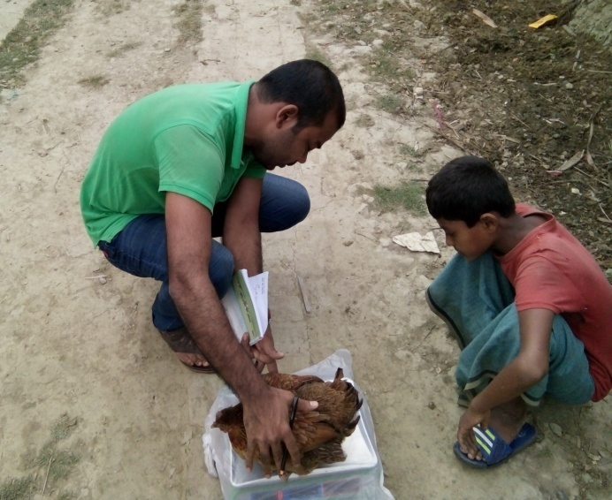 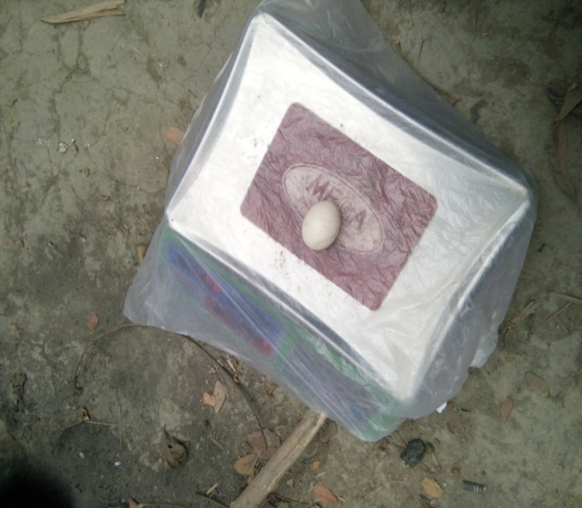

Fig: Balancing of live weight of hen Fig: Balancing of egg weight

 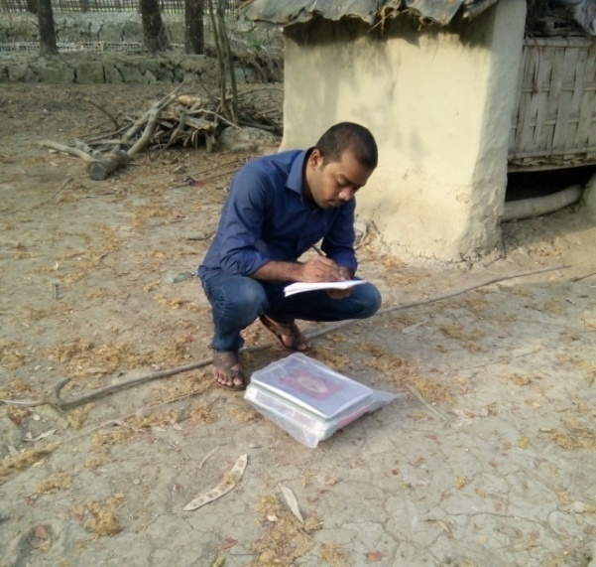  
 Fig: House of indigenous chicken Fig: Recording of data

**RESULTS**

The mean and standard deviation of different productive traits of indigenous hen, dam, GP under scavenging rearing system was showed in table 1.highest average live weight was in Grandparent (1239.73±70) and highest egg weight was in also in grandparent (36.47±5.3). Again highest egg production per clutch was in dam (14.33±2.41). But the highest percentage of hatchability was in the hen (81.9±12.2) than her Dam and Grandparent (table 1)

**Table 1:** Average performance of indigenous chicken pf different generations

|  |  |  |  |  |
| --- | --- | --- | --- | --- |
| **Different generation** | **Average performance of indigenous chicken** | | | |
| **Live weight (gm)** | **Egg weight (gm)** | **Clutch size(number)** | **Hatchability (%)** |
| Hen | 1173.133±119.18 | 34.733±.449 | 12.93±2.789 | 81.9±12.2 |
| Dam | 1193.33±131.44 | 35.8±5.91 | 14.33±2.41 | 78.47±12.65 |
| Grandparent | 1239.73±70.07 | 36.47±5.3 | 13.66±2.19 | 77.13±23.13 |

The mean and standard deviation of age, egg production and egg weight of indigenous hen is showed in table 2. the average egg weight was highest(44±0) in age 8 month than the age of 24 month(36±2.83),age of 18 month(36±0), age of 12 month (35.33±8.08),age of 6 month (33.5±13.43)and age of 9 month(33.4±4.98) respectively.

In that study the different ages of hen have different number of egg production. The highest egg production of indigenous chicken was at the age of 24 month hen .at this age the hen average production was 17.The lowest egg production was at the age of 6 month or at first laying stage of indigenous chicken (table.2).

**Table 2:** Mean and Standard deviation of egg production and egg weight with the relation of age of the chicken

|  |  |  |
| --- | --- | --- |
| **Age of the chicken** | **Traits** | |
| **Egg production/hen/clutch(no)** | **Egg weight(gm)** |
| 6 months | 11±0 | 33.5±13.43 |
| 8 months | 12±0 | 44±0 |
| 9 months | 12.4±1.52 | 33.4±4.98 |
| 12 months | 13±4.36 | 35.33±8.08 |
| 18 months | 12±0 | 36±0 |
| 24 months | 17±4.2 | 36±2.83 |
| 48 months | 13±0 | 29±0 |

The mean and standard deviation of hatchability of hen egg with the relation of egg production per clutch is observed in table 3.in that study showed that the hatchability of egg of hen was highest in the clutch size 14 .when the hen lay 14 egg per clutch then the hatchability was highest (92.8±0) than the others.(table 3)

**Table 3**: Mean and standard deviation of hatchability percentages of hen with the clutch size

|  |  |
| --- | --- |
| **Egg production /hen/clutch** | **Hatchability of hen eggs (%)** |
| 10 | 90±0 |
| 11 | 87.7± 4.6 |
| 12 | 80.04±9.35 |
| 13 | 92±0 |
| 14 | 92.8±0 |
| 15 | 33±0 |
| 18 | 83.3±0 |
| 20 | 65±0 |

There was a genetic relationship between the egg weight and body weight of chicken. When the body weight increases then the egg weight also increased, the highest egg weight was when the body weight hen was 1354 gm.Then the egg weight also decrease in 1370gm body weight hen. So the peak body weight for highest was 1345gm (table.4).

**Table 4:** Relation between body weight and egg weight

|  |  |
| --- | --- |
| **Body weight of the hen(gm)** | **egg weight (gm)** |
| 980 | 34 |
| 986 | 34 |
| 1058 | 34 |
| 1098 | 36 |
| 1100 | 25 |
| 1128 | 28 |
| 1150 | 28 |
| 1200 | 38.7 |
| 1310 | 38 |
| 1354 | 44 |
| 1370 | 43 |

**DISCUSSION**

The average live weight of grandparent (1239.73±70.7) was higher than the hen (1173.13±131.18) and dam (1193.33±141.44).It might be due to good feed supply and environment. Similar finding found that indigenous chicken hen average weight 1.0 to 1.2 kg (Bulbul.1983).The average egg weight was also highest in the grandparent (36gm) than the hen(34.73gm) and dam(35.8gm) similar finding was found average egg weight of indigenous chicken was 34-40gm(Sazzad, 1986).

The clutch size of indigenous chicken was highest in the dam (14.33) than the hen (13.66) and grandparent (12.93).similar finding in previous study found the average egg production per clutch was 13-15(Huque and Hoque, 1990).

The hatchability of indigenous was highest in the hen (83.9%) than her dam and grandparent. Similar result was also found that the highest hatchability was in hen 83% (Faruque et al. 2013) There was a relation between the age of the hen and weight of the egg .in our study we found different age categories chicken. Among the ages the average highest weight of egg was at the age of 8 month of the hen (44gm) and the lowest egg weight was at the age of 48 month (29gm).it might be the nutritional status of chicken and less infection of disease at that time due to high immunity at that age.

The age also has an impact for egg production in indigenous chicken. The highest egg production in per clutch was when the age of chicken was 24 month. The lowest egg production was found at the age of 6 month. It might be the due the lower age the follicle not develops fully and the ideal age for highest egg production was at the age of 24 month. This is contrast to the study of Bekele et al. (2010) their result was highest egg production of indigenous chicken at the age of 12 month age.

The clutch size of indigenous chicken is important factor for hatchability of chicken. The highest hatchability of chicken was found when the clutch size was 14 than the other clutch size and the lowest hatchability was when clutch size were 20.it might be the highest egg production decreases the hatchability of chicken and the highest egg production was in 14 clutch size.

There have a strong relationship between the egg weight and body weight of chicken hen (Kruger et al., 1952; Peeler et al., 1955 and Meritt 1968 Duncan and Mench, 2000; Santos et al ,2000; Webster, 2000) .The highest egg weight(44gm) when the body weight of hen was 1354gm and the egg weight also decreases when the after this body weight ,when the body weight was 1370gm then egg weight was 43gm.the lowest egg weight found at the 1100 gm body weight hen.

**CONCLUSION**

From the study it may be concluded that the average live weight of indigenous hens was 1173.15g and the highest egg weight produced when the hen body weight was 45gm. The live weight of hen was less than her dam and grandparents live weight. The highest egg production was observed at the age of 24 month or 2 years old chicken and highest egg size when the age of hen was 8 month. The highest percentages of hatchability were found when the egg production of hen was 14 in a clutch.

The study helps the people to know about productive, reproductive traits and live weight and weight gain of indigenous chicken under scavenging system. There will also chance to know whether the non-descriptive deshi chicken genetics is inert or not. Due to short duration of the study period sample size of current study was very small. If the sample size is large, the more significant result could be achieved.

**References**

Bulbul S M 1983 More protein for the under nourished through a village poultry project. Maximum livestock production from minimum land*, Proceedings of the 4th seminar held in Bangladesh Agricultural University, Mymensingh, Bangladesh.*

Fassill Bekele, T. Ådnøy, H.M. Gjøen, J. Kathle and Girma Abebe*, International Journal of Poultry Science 9 (7): 702-710, 2010*

Huque Q M E and Haque M E 1990 the onset of lay in indigenous hens following hatching of Chicks*. Poultry Adviser, 12(8) 57-60*.

Khatun, R., Islam, M., Faruque, S., Azmal, S., Uddin, M., 2005. Study on the productive and reproductive performance of 3 native genotypes of chicken under intensive management. *Journal of Bangladesh Agricultural University 3, 99-104*.

Krueger, W.F., Dickerson, G.E., Kinder, Q.B., and HL., Kempster, 1952. The Genetic and environmental relationship of total egg production to its components and to body weight in the domestic fowl*. Poult., Sci., 31: 922*

Meritt, ES. 1968. Genetic parameters associated with characters affecting egg production in a random bred control strain of meat type fowl*. Poult. Sci. 47: 190-199*

Peeler, RT., Glazener, E. W., and Blow. WL. 1955. The heritability of broiler weight and age at several maturity and the genetic and environmental correlation between these traits. *Poult. Sci., 34: 420-426*.

Santos, TT. Dos A., Corzo, Kidd, MT., McDaniel, CD., Torres Filho, RA. and Araújo LF. 2000. Influence of in ovo inoculation with various nutrients and egg size on broiler performance*. J. Appl. Poultries, 19: 1-12.*

Sazzad M H 1986 Reproductive performance of desi (indigenous) hens under scavenging and intensive system of rearing .*Proceedings of the First Annual Livestock Research Workshop, Bangladesh Livestock Research Institute, Savar, Dhaka,Bangladesh. Pp 63-6*

S. FARUQUE, M.S. ISLAM* , M. A. AFROZ1 AND M. M. RAHMAN *;Journal of Bangladesh Academy of Sciences, Vol. 37, No. 1, 93-101, 2013*

Webster, AB. 2000. Behavior of White Leghorn laying hens after withdrawal of feed. Poultry Science, 79: 192- 200.

**ANNUXURE**

**Questionnaire**

Farm Owner name: …………………………………………

Address: ………………………..

Age: ………………

Sex: ……….

Mobile no: ………………………………………..

Total no of poultry…..

Total no of laying Hen……

Age of laying hen……….

Clutch size…………….

Hatchability: ……………………….

Age of sexual Maturity: ....................

Rearing system: Scavenging / semi scavenging

Feed intake…………..

Body weight of hen………….

Egg weight of hen……………

Body weight of dam………...

Egg weight of dam……………

Body weight of grandparent……

Egg weight of grandparent………

Diseases…………………………………..

Vaccination and deworming……….

**Data collector: Saddam Hossain**

**Intern id: 09**

**Date of data collection**:

**Biography**

I am Saddam Hossain, son of Mr. Abdul Gapur and Mrs.Azimon Nahar.I passed SSC from Kishaloya Model Shikkha Niketon in 2009 and HSC from Hazera Taju Degree College in 2011 from Chittagong board, Bangladesh. Now I am intern student of faculty of veterinary medicine,

Chittagong Veterinary and Animal Sciences University. This study was the inauguration of myself in the era of research and I have a strong intention to involve myself in this types of activities in future. I want to be a veterinarian and poultry practitioner in future.