Performance of indigenous chicken in consideration of different factors under scavenging rearing system at Cox’sbazar district

A Production Report is submitted for partial fulfillment of the Degree of
Doctor of Veterinary Medicine (DVM)

Submitted by:
Saddam Hossain
Roll No: 2013/09
Reg. No: 0918
Intern I.D: B-09
Session: 2012-2013

Faculty of Veterinary Medicine
Chittagong Veterinary and Animal Sciences University.
Khulshi, Chittagong – 4225
September, 2018
Performance of indigenous chicken in consideration of different factors under scavenging rearing system at Cox’sbazar district
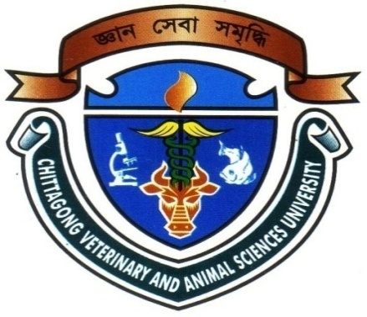

A Production Report Submitted as per Approved Style and Contents.

………………………………
Signature of Supervisor:

Dr. Md. Kabirul Islam Khan
Professor
Department of Genetics and Animal Breeding
Faculty of Veterinary Medicine
Chittagong Veterinary and Animal Sciences University
Khulshi, Chittagong – 4225

September, 2018

