Study on the Structural Characteristics and Composition of Two Marine Fish Species (Carangoides malabaricus and Scomberoides commersonnianus) of Bangladesh

Jubydun Nesa
Roll No.: 0122/04
Registration No.: 1126
Session: 2022-2023

A thesis submitted in the total fulfillment of the requirements for the degree of Master of Science in Department of Fishing and Post-Harvest Technology

Department of Fishing and Post-Harvest Technology
Faculty of Fisheries
Chattogram Veterinary and Animal Sciences University
Chattogram-4225, Bangladesh

JUNE 2023
Authorization
I hereby declare that I am the sole author of the thesis. I also authorize the Chattogram Veterinary and Animal Sciences University (CVASU) to lend this thesis to other institutions or individuals for the purpose of scholarly research. I further authorize the CVASU to reproduce the thesis by photocopying or by other means, in total or in part, at the request of other institutions or individuals for the purpose of scholarly research.
I, the undersigned, and author of this work, declare that the electronic copy of this thesis provided to the CVASU Library, is an accurate copy of the print thesis submitted, within the limits of the technology available.
The Author
June, 2023

Study on the Structural Characteristics and Composition of Two Marine Fish Species (Carangoides malabaricus and Scomberoides commersonnianus) of Bangladesh

Jubydun Nesa
Roll No.: 0122/04
Registration No.: 1126
Session: 2022-2023

This is to certify that we have examined the above Master’s thesis and have found that is complete and satisfactory in all respects, and that all revisions required by the thesis examination committee have been made

----------------------------------------------------  Dr. Mohammed Nurul Absar Khan | -----------------------------------------------  Dr. Md. Kamal
Supervisor | Co-supervisor

-----------------------------------------------
Dr. Md. Faisal
Chairman of the Examination Committee

Department of Fishing and Post-Harvest Technology
Faculty of Fisheries
Chattogram Veterinary and Animal Sciences University
Chattogram-4225, Bangladesh

JUNE 2023

Acknowledgements
I begin with the foremost praise and gratitude to ALLAH (SWT), the Almighty, for His boundless mercy and guidance, bestowing upon me the strength and blessings necessary to pursue higher education and successfully complete the thesis for the Masters of Science (MS) degree in Fishing and Post-Harvest Technology under the Department of Fishing and Post-Harvest Technology, Faculty of Fisheries, Chattogram Veterinary and Animal Sciences University, Chattogram, Bangladesh.
I would like to convey my heartfelt appreciation and profound indebtedness to Professor Dr. A.S.M Lutful Ahasan, Vice-Chancellor of Chittagong Veterinary and Animal Sciences University and Professor Dr. Mohammed Nurul Absar Khan, Dean, Faculty of Fisheries, CVASU, for their invaluable administrative support, which played a pivotal role in facilitating the completion of my research work.
I am grateful to Profrssor Dr. Zonaed Siddiki, Co-ordinator, Advanced Studies and Research (CASR), CVASU, for providing funding that facilitated the completion of my research work.
I would like to express my sincere gratitude, heartfelt appreciation, profound regards, and indebtedness to my respected teacher and research supervisor, Dr. Mohammed Nurul Absar Khan, Professor, Department of Fishing and Post-Harvest Technology, Faculty of Fisheries, CVASU, for his unwavering cooperation, constant inspiration, valuable time, kindness, and continuous guidance throughout the period of research.
I find it a great pleasure in expressing my heartfelt gratitude and immense indebtedness to my research co-supervisor Professor Dr. Md. Kamal, Treasurer, CVASU, for his sympathy, continuous cooperation, relentless support and intellectual guidance, valuable suggestions, and inspiration to carry out the research systematically and smoothly. His extended support and guidance in all aspects have definitely enriched my knowledge.
I would like to convey my heartfelt thanks to Dr. Md. Faisal, Associate Professor, Department of Fishing and Post-Harvest Technology, CVASU, for his unwavering support and mentorship throughout my M.Sc. study and research journey.
I would like to express my heartfelt gratitude to Tahsin Sultana, Assistant Professor, Fishing and Post-Harvest Technology, CVASU, for her advice and assistance in data analysis and interpretation.
I am extremely glad to take the opportunity to express my heartfelt thanks and gratitude to all the other respected teachers of the Faculty of Fisheries, CVASU, for their valuable teaching and continuous encouragement throughout her university life.
I hold an eternal appreciation in my heart for my beloved parents for their boundless love, unwavering prayers, tireless efforts, and countless sacrifice in educating and preparing me for my future. I am filled with gratitude for my siblings, whose steadfast support and assistance has been a pillar of strength throughout my journey. I am also thankful to all of my friends and well-wishers for their continuous encouragement and mental support that have propelled me towards achieving success.
The Author

Table of Contents
 | Contents |  |  |  |  |  | Page No.
Title Page |  |  |  |  |  |  | i
Authorization |  |  |  |  |  |  | ii
Signature Page |  |  |  |  |  |  | iii
Acknowledgements |  |  |  |  |  |  | iv-v
Table of Contents |  |  |  |  |  |  | vi- ix
List of Abbreviations |  |  |  |  |  |  | x
List of Tables |  |  |  |  |  |  | xi
List of Plates |  |  |  |  |  |  | xii
List of Figures |  |  |  |  |  |  | xiii
Abstract |  |  |  |  |  |  | xiv
CHAPTER 1 |  |  |  |  | INTRODUCTION |  | 1 – 5
 | 1.1 | Background |  |  |  |  | 1-4
 | 1.2 | Significance of the Study |  |  |  |  | 4
 | 1.3 | Objectives of the Study |  |  |  |  | 5
CHAPTER 2 |  |  |  |  | REVIEW OF LITERATURE |  | 6 –18
 | 2.1 Fish Identification and Characteristics |  |  |  |  |  | 6-7
 |  | 2.1.1 |  | Malabar cavalla (Carangoides malabaricus) |  |  | 6
 | 2.1.2 |  |  | Talang queenfish (Scomberoides commersonnianus) |  |  | 7
 | 2.2 | Muscle Structure |  |  |  |  | 7-9
 | 2.3 | Processing Yield Determination |  |  |  |  | 9
 | 2.4 | Proximate Composition of Fish |  |  |  |  | 9-11
 | 2.5 | Proximate Composition of Dark and White Muscle |  |  |  |  | 11-12
 | 2,6 | Proximate Composition of Different Body Parts |  |  |  |  | 13
 | 2.7 | Cooking Effects on Proximate Composition |  |  |  |  | 13-14
 | 2.8 | Gel Forming Ability |  |  |  |  | 15-19
 |  | 2.8.1 | Gel forming ability of marine fish of Bangladesh |  |  |  | 15
 |  | 2.8.2 | Gel forming ability of freshwater fish |  |  |  | 15
 |  | 2.8.3 | Factors affecting gel forming ability |  |  |  | 16-18
 |  |  | 2.8.3.1 |  |  | Effect of temperature | 16
 |  |  | 2.8.3.2 |  |  | Effect of washing | 16
 |  |  | 2.8.3.3 |  |  | Effect of NaCl on gel forming ability | 17
 |  |  | 2.8.3.4 |  |  | Effect of ice storage on gel forming ability | 17
 |  | 2.8.4 | Gel Color |  |  |  | 18
CHAPTER 3 |  |  |  |  | MATERIALS AND METHODS |  | 19-30
 | 3.1 | Collection of Samples |  |  |  |  | 19
 | 3.2 | Identification of Common Characteristics of Fish |  |  |  |  | 19
 | 3.3 | Myotomes (myomeres) Structure Determination |  |  |  |  | 20
 | 3.4 | Determination of Processing Yields |  |  |  |  | 20
 | 3.5 | Sample Preparation for Proximate Composition |  |  |  |  | 21-23
 |  | 3.5.1 | Different muscle type |  |  |  | 21
 |  | 3.5.2 | Different body parts of fish |  |  |  | 21
 |  | 3.5.3 | Cooked (boiled and fried) sample |  |  |  | 22
 |  |  | 3.5.3.1 |  |  | Cooking methods | 22
 |  |  | 3.5.3.2 |  |  | Cooking loss | 23
 |  |  | 3.5.3.3 |  |  | Sensory evaluation | 23
 | 3.6 | Proximate Composition Analysis |  |  |  |  | 23-25
 |  | 3.6.1 | Protein |  |  |  | 24
 |  | 3.6.2 | Lipid |  |  |  | 24
 |  | 3.6.3 | Moisture |  |  |  | 25
 |  | 3.6.4 | Ash |  |  |  | 25
 | 3.7 | Gel Forming Ability |  |  |  |  | 26-29
 |  | 3.7.1 | Organoleptic test |  |  |  | 26
 |  | 3.7.2 | Preparation of mince |  |  |  | 26
 |  | 3.7.3 | Preparation of gel |  |  |  | 27
 |  | 3.7.4 | Assessment of gel properties |  |  |  | 28-29
 |  |  | 3.7.4.1 |  |  | Puncture test | 28
 |  |  | 3.7.4.2 |  |  | Folding test | 29
 | 3.8 | Statistical Analysis |  |  |  |  | 30
 | CHAPTER 4 |  |  |  | RESULTS |  | 31 –48
 | 4.1 | Muscle Structure and Processing Yield of Carangoides malabaricus and Scomberoides commersonnianus |  |  |  |  | 31-36
 |  | 4.1.1 |  | Muscle Structure of Carangoides malabaricusa and Scomberoides commersonnianus |  |  | 31-35
 |  | 4.1.2 |  | Processing yields of the Experimental fish |  |  | 35-36
 | 4.2 | Proximate Composition of Carangoides malabaricus and Scomberoides commersonnianus |  |  |  |  | 37 –41
 |  | 4.2.1 | Proximate composition of different muscle of fish |  |  |  | 37-39
 |  | 4.2.2 | Proximate composition of different body parts of fish |  |  |  | 39-41
 |  | 4.2.3 | Effects of cooking methods (boiling and frying) on proximate composition |  |  |  | 41-45
 |  |  | 4.2.3.1 |  |  | Sensory evaluation of cooked fish samples | 41-42
 |  |  | 4.2.3.2 |  |  | Proximate composition of cooked samples | 43-45
 | 4.3 | Gel Forming Ability of Washed and Unwashed Mince of Carangoides malabaricus and Scromberoides commersonnianus |  |  |  |  | 45-48
 |  | 4.3.1 | Freshness of fishes assessed by organoleptic test |  |  |  | 45
 |  | 4.3.2 | Measurement of gel Strength |  |  |  | 46-48
 |  |  | 4.3.2.1 |  |  | Puncture Test | 46-47
 |  |  | 4.3.2.2 |  |  | Folding Test | 47-48
 | CHAPTER 5 |  |  |  | DISCUSSION |  | 49- 62
 | 5.1 | Muscle Structure and Processing Yield of Carangoides malabaricus and Scomberoides commersonnianus |  |  |  |  | 49-52
 |  | 5.1.1 | Muscle structure of Carangoides malabaricus and Scomberoides commersonnianus |  |  |  | 49-51
 |  | 5.1.2 | Processing yields of the experimental fish |  |  |  | 51-52
 | 5.2 | Proximate Composition of Carangoides malabaricus and Scomberoides commersonnianus |  |  |  |  | 52-57
 |  | 5.2.1 | Proximate composition of different types of muscle |  |  |  | 52-55
 |  | 5.2.2 | Proximate composition of different body parts |  |  |  | 55-57
 |  | 5.2.3 | Effects of cooking methods (boiling and frying) on Proximate composition |  |  |  | 57-59
 |  |  | 5.2.3.1 |  |  | Proximate composition of cooked sample | 57-58
 |  |  | 5.2.3.2 |  |  | Cooking loss | 58-59
 | 5.3 | Gel Forming Ability of Washed and Unwashed Mince of Carangoides malabaricus and Scromberoides commersonnianus |  |  |  |  | 59-63
 |  | 5.3.1 | Gel forming ability at different temperature |  |  |  | 59-60
 |  | 5.3.2 | Effect of washing |  |  |  | 60
 |  | 5.3.3 | Effect of NaCl |  |  |  | 61
 |  | 5.3.4 | Heating duration |  |  |  | 61
 |  | 5.3.5 | Gel color |  |  |  | 62
 |  | 5.3.6 | Folding test |  |  |  | 62
CHAPTER 6 |  |  |  |  | CONCLUSIONS |  | 63
CHAPTER 7 |  |  |  |  | RECOMMENDATIONS AND FUTURE PROSPECTS |  | 64
References |  |  |  |  |  |  | 65-78
Brief Biography of the Author |  |  |  |  |  |  | 79

List of Abbreviations
Short form | Abbreviations
ANOVA | One-way Analysis of Variance
AOAC | Association of Official Analytical Chemists
cm | Centimeter
CVASU | Chattogram Veterinary and Animal Sciences University
DoF | Department of Fisheries
et al. | And his associates
FAO | Food and Agriculture Organization
FT | Folding test
GDP | Gross Domestic Product
g | Gram
HCl | Hydrochloric Acid4.2.3.1
H₂SO₄ | Sulfuric acid
NaOH | Sodium Hydroxide
SD | Standard Deviation
% | Per cent
°C | Degree Celsius

List of Tables
Table No. | Title | Page No.
1 | Grade used in folding test of the gel | 29
2 | Summary of muscle characteristics of Carangoides malabaricus and Scomberoides commersonnianus fish samples | 35
3 | Processing yields of total muscle, white and dark muscle, carcasses and intestinal parts of Carangoides malabaricus and Scomberoides commersonnianus fish samples | 36
4 | Chemical composition of different types of muscles of Carangoides malabaricus and Scomberoides commersonnianus fish | 37
5 | Chemical composition of three body region of Carangoides malabaricus and Scomberoides commersonnianus | 40
6 | Organoleptic characteristics of raw, boiled and fried samples of Malabar cavalla (Carangoides malabaricus) and Talang queenfish (Scomberoides commersonnianus) fish | 42
7 | Poximate composition of raw and cooked samples of Carangoides malabaricus and Scomberoides commersonnianus | 43
8 | Cooking loss of two marine fish | 45
9 | Gel forming ability of washed and unwashed mince of Carangoides malabaricus and Scomberoides commersonnianus at different heating temperature | 46
10 | Grades on folding of both washed and unwashed gel at different heating temperature | 48

List of Plates
Plate No. | Title | Page No.
1 | Carangoides malabaricus | 20
2 | Scomberoides commersonnianus | 20
3 | Carcass weighing of (a) Carangoides malabaricus and (b) Scomberoides commersonnianus | 21
4 | White and dark muscle | 21
5 | Three body parts of fish (a) Carangoides malabaricus and (b) Scomberoides commersonnianus | 22
6 | Boiling and frying of sample | 23
7 | Titrated protein sample | 24
8 | Extracted lipids of sample | 25
9 | Ash content of sample | 26
10 | Preparation of washed and unwashed mince: (a)grinding of sample, (b) washing of mince, (c) stayed for settling, (d) staining,(e) washed mince and (f)mixing with salt and water | 27
11 | Preparation of gel: (a) gel setting tube, (b) placed in water bath, (c) placed on ice for cooling and (d) prepared gel | 28
12 | Measure breaking force of gel by plunger | 29
13 | Folding test of gel | 29

List of Figures
Figure No. | Title | Page No.
1 | Location of sample collection (Sabrang Bazar, Teknaf, Cox’s Bazar) | 19
2 | Myotome structure of Carangoides malabaricus | 32
3 | Myotome structure of Scomberoides commersonnianus | 32
4 | Dark and white muscle percentage Carangoides malabaricus | 33
5 | Dark and white muscle percentage of Talang queenfish(Scomberoides commersonnianus) | 33
6 | Muscle structure of Carangoides malabaricus | 34
7 | Muscle structure of Scomberoides commersonnianus | 34
8 | Breaking force of gel from washed and unwashed mince of (a) Carangoides malabaricus and (b) Scomberoides commersonnianus at different heating temperature | 47

Abstract
Knowledge of biochemical constituents in fish is essential for effective implementation of preservation and processing practices. Thus, the study aimed to examine the muscle characteristics and proximate composition of two marine fish species Scomberoides commersonnianus and Carangoides malabaricus from the Bay of Bengal. Fresh specimens of these two species were collected from day fishing boat of Teknaf. Samples were immediately frozen at -20 °C and transported the CVASU laboratory for subsequent experiment. Muscle structural characteristics mainly myotome identification, processing yield, proximate compositions on different type of muscles and cooking methods, and gel forming ability of muscle were studied. The results indicated that the processing yield of S. commersonnianus was 53.35% with white muscle comprising 92.84% and dark muscle 7.16%, while muscle yield of C. malabaricus fish was 39.30% in which white muscle accounting for 90.23% and dark muscle for 9.77 %. White muscle in both fish species had higher moisture and protein content, while dark muscle had higher lipid levels, particularly in the middle and tail regions. The head had the highest moisture and lowest protein content. There were changes in color, texture, and odor in all samples after boiling and frying. After boiling and frying, protein and ash content remained unchanged, but moisture content slightly decreased and fat content increased, with boiling reducing fat content. The gel forming ability and breaking force were investigated under different temperature (40, 50, and 60 °C) in a water bath for 120 mins. The highest breaking force was found at 50 °C for both washed (322±2.64 g and 600±4.35 g) and unwashed (176±4.58 g and 450±2.00 g) fish mince in C. malabaricus and S. commersonnianus respectively. These results suggest that both fishes were suitable for producing value-added products.

Keywords: Scomberoides commersonnianus, Carangoides malabaricus, Myotomes, Processing yield, Dark muscle, White muscle, Proximate composition, Gel forming ability, Breaking force.

CHAPTER 1: INTRODUCTION
1.1 Background
Bangladesh's coastal and marine ecosystems are blessed to have a warm, tropical climate, an abundance of rain each year, and nutrients from the surrounding land, which together provide one of the planet's richest ecosystems and high production (Hossain, 2001; Islam, 2003; Hossain et al., 2015; Shamsuzzaman et al., 2017). With over 800 species in fresh, brackish, and coastal waters, the nation has the third-largest aquatic fish biodiversity in Asia, below China and India (Hussain and Mazid, 2001). In Bangladesh, the GDP of the nation is contributed by fishing, which accounts for 2.41% of the total and over 21.83% of the agricultural GDP (DoF, 2022). During the fiscal year 2021–2022, Bangladesh's marine fisheries produced 4.759 million Metric ton (MT) (DoF, 2022). The coastal and marine waters of the Bay of Bengal have produced a total of 475 fish species, belonging to 133 families (DoF, 2015). 100 species are commercially important in the local fish market. The other fish species are available almost round the year in artisanal sector. Their values are comparatively low in the fresh market and most of them can be classified as small fishes. To produce high-quality food through developing products with additional value, it is important to introduce small and low-value marine fish species. Muscle fibers, intramuscular connective tissue, and intramuscular fat play important roles on meat and fish flesh quality. Producers, processors, distributors, and consumers all have various quality criteria based on how they use the products. Consumers' perceptions of attributes drive satisfaction. They include colour, texture, and juiciness, as well as flavor, which is related with the scents generated in the mouth when the product is ingested (Prache et al., 2022).
The fish muscle structure is unique. The edible component of fish, known as fillets, is made up of many muscles called myomeres that are fitted into one another and separated by myosepta, which are a few millimeters thick connective tissue sheaths. The myosepta have structural continuity all the way to the skin from the vertebral axis. They are responsible for transmitting fibre contraction pressures from one myomere to the next, as well as to the bones and skin. The term "metameric organization" refers to the specific structure that has alternating muscle and connective sheaths. Different animals have different myomere shapes. Myomeres are frequently zigzag, "V" (in lancelets), or "W" (in fishes). The fillet in a "round" fish of commercial scale has W-shaped myomeres. Sometimes, myomere counts are utilized to identify specimens (Listrat et al., 2016). The goal of the study is to understand the organoleptic form of two selected fishes found in our marine water by determining the direction of myoseptums, myotom forms, muscle color, width, color of dark muscle, and presence of subcutaneous tissues. Such details are required to prevent fraud in the selling of fish fillets. The usage of certain organic wastes is not very common. However, the significant amount of production also results in the production of byproducts that are not suitable for human consumption. Fish processing industries produced over 37,900 MT of non-food items in 2016 (FAO, 2018). Backbones, belly flaps, fish fins, gills, heads, liver, roe, skin, and flesh clinging to the bones are among the aquaculture by-products (Vazquez et al., 2019).
It is now required to have a basic understanding of the biochemical constituents and fundamental structure of fish muscles to adopt the proper preservation and processing practices to limit post-harvest loss and prevent post-harvest spoiling. Quality of fish, nutrient content, physiological condition, and habitat are all indicated with some precision by the chemical composition of the fish flesh (Ravichandran et al., 2011). From a variety of perspectives, customers, producers, and scientists highly value the research of fish's moisture, protein, fat, and ash concentrations. The ability of fish proteins to gel and their ideal ability to hold water provide the fish processing industries with unmatched functional qualities (Taheri et al., 2013). Although the fish protein is extremely reactive to deteriorating changes that result in a loss of fresh quality, these changes can be avoided or postponed under the right circumstances (Shahidi and Simpson, 2004). Aside from determining the nutritional content of fish, research can help with better processing and preservation (Mridha et al., 2005) and routine monitoring of the physiological state of fish from a fisheries perspective (Bolawa et al., 2011). The chemical constituents of fish can be used by nutritionists to identify readily available sources of low-fat, high-protein foods for human consumption (Foran et al., 2005; Mozaffarian et al., 2003) as well as by food scientists to create high-protein foods with high nutritional value (Mohamed et al., 2010). Appropriate information about the proximate components of fish has use in a variety of extensive fields.
Several species of fish have a small portion of dark tissue that is either red or brown in color, despite the fact that the muscles of fish are typically white in color. This black muscle is referred to as "dark muscle". Due to the meat's high myoglobin concentration, which gives the flesh a reddish brown hue, the meat is dark in color (Chaijan et al., 2004). Based on the fish's activity, the percentage of dark muscle may change. Dark muscle makes up 48% of the body weight of pelagic fish, which swim continually (Love, 1970). Dark muscle has higher lipid content than white muscle, making it more susceptible to lipid oxidation (Shahidi and Spurvey, 1996). It has also been found that the anatomical position of the sample has an impact on its proximate composition. The results showed a lack of homogeneity amongst samples taken from the same fish's neck, tail, and trunk (Ahmed et al., 2022).
Cooking may have an impact on the nutritious content of foods in both positive and negative ways. Heating in fish and food processing takes several forms, including boiling, baking, roasting, frying, and grilling. Heat is used in fish processing procedures to enhance taste and flavour while also extending the shelf life of fish and fish products (Alipour et al., 2010). Proteins, lipids, vitamins, minerals, and sensory qualities such as colour, flavour, texture, and overall look are the most important fish compositional ingredients that may be influenced by processing procedures (Kocatepe et al., 2011). Frying is one of the oldest food preparation processes. It enhances food sensory quality by forming fragrance compounds, appealing colour, crust, and texture.
A key indicator of the functional and textural characteristics of fish muscle is its ability to form gel. It is a significant operational characteristic in fish processing technology since it is the essential quality of surimi-based products (Asghar et al., 1985). The muscle's potential to form gel differs among species and even across a single species, based on the fish's biological conditions. Differences within a species are influenced by a variety of factors, including age, season, sex, death conditions, freshness, fishing location, fishing season, muscle pH, freezing, the quantity of starch used, the salt content added to raw ground fish, and other additions like sugar, oil, and polyphosphate etc. (Shimizu, 1981; Tanikawa, 1985; Shimizu and Kaguri, 1986; Roussel and Cheftel 1988). Additionally, the mince's high lipid content, the fluctuations of the muscle proteins, the quantity of sarcoplasmic protein, and the high ratio of dark to white muscle all affect the capacity of the mince to form gels. Even with the use of an efficient processing procedure, fish that are not fresh are unable to be turned into mince due to the muscle's high fat content (Suzuki and Watabe, 1986). The processing of surimi includes a crucial step called washing. In order to get rid of fat, pigments, and other unwanted things such as sarcoplasmic proteins, washing is required. The amount of water used and the quantity of washing cycles depend on the fish's species, its freshness, and the desired surimi quality (Hall and Ahmad, 1997). Approximately 0.1 million MT of insufficiently utilized marine species are being landed in Bangladesh each year, with shrimp by-catch species accounting for half of this total. Every year, government-run and privately owned shrimp trawlers discard thousands of tonnes of undesired species, and the by-catch that is caught is typically utilized to make fishmeal. Utilizing these overlooked marine species as a potential supply of animal protein is vital because fish production is unable to keep up with population growth (Hossain et al., 2019). There is a lot of interest in utilizing the plentiful inexpensive, fatty pelagic fish for human consumption, especially for the creation of surimi. Due to the scarcity of fish resources for the production of surimi, dark muscle fish has attracted increased attention as a feasible alternative raw material (Ochiai et al., 2001; Chen, 2002).
1.2 Significance of the Study
Malabar cavalla (Carangoides malabaricus) and Talang queenfish (Scomberoides commersonnianus) are abundantly available in Bangladesh marine water but it has limited value in the fresh fish market. There is no sufficient data on overall muscle structure, processing yield, proximate composition of different types of muscle and body parts, effect of cooking method on proximate composition, gel forming ability of muscle on marine fish of Bangladesh. Since, marine fish is a vital nutritional resource, understanding their proximate composition is important for processing, preservation and nutritive purposes. For effective processing it is essential to understand the processing yields of these fish species. Despite the fact that there have been some studies on the proximate composition and fatty acids of marine fish, minimal data are available on cooked fish. For utilization of available low valued marine fish in processing, value added fish products and surimi based products sector in Bangladesh, knowing their chemical composition and structural characteristics of muscle is necessary.

1.3 Objectives of the Study
- To know the muscle structure and processing yield of Malabar cavalla (Carangoides malabaricus) and Talang queenfish (Scomberoides commersonnianus).
- To evaluate proximate composition of different muscle types, body parts (head, middle and tail) and cooked samples (fried and boiled) of both fish samples.
- To assess the gel forming ability of fish mince in the washed and unwashed condition of the muscles of these two species.

CHAPTER 2: REVIEW OF LITERATURE
2.1 Fish Identification and Characteristics
2.1.1 Malabar cavalla (Carangoides malabaricus)
Malabar cavalla is one of the 21 species from the genus Carangoides, which belongs to the order Carangiformes and the family Carangidae, which includes the jack and horse mackerel. The species is almost always referred to in English by the common names Malabar trevally and Malabar cavalla, with Malabar kingfish being a far less popular name. There are also many regional names that are used that are in different languages. Malabar mouri, Bangada, and kapri are the local names in Bangladesh. The fish's type locality, Tranquebar, was discovered in the southern Indian region of Malabar (Hosese et al., 2007).
Salient Features: Dorsal spines (total): 9; dorsal soft rays (total): 20-23; Anal spines: 3; anal soft rays: 17 - 19. These fish exhibit a characteristic body profile reminiscent of a jackfish, featuring a distinctly compressed, nearly oval-shaped body with elongated dorsal and anal fins. Their head possesses a prominent upward curvature towards the nape, appearing nearly straight. Both upper and lower jaws are lined with rows of fine villiform teeth, although the front teeth may take on a conical shape. While their maximum recorded up to 60 cm, they are typically more commonly found at sizes below 30 cm. In terms of coloration, these fish typically display a silvery hue, with a bluish-grey overlay on their upper side that gradually transitions to a silvery white shade on the lower side that gradually transitions to a silvery white shade on the lower side and lower flanks. These fish are known to inhibit a range of inshore environments and are often found in waters ranging from 30-140 meters in depth, particularly on coral and rocky reefs. Their diet primarily consists of crustaceans, small squids, and various species of fish.
2.1.2 Talang queenfish (Scomberoides commersonnianus)
The Talang queenfish (Scomberoides commersonnianus), is a species of ray-finned fish from the western Indo-Pacific that is also known as the giant dart, giant leatherskin, giant queenfish, largemouth queenfish, and Talang leather-skin. It is known locally as Chapa kuri and Futki chapa in Bangladesh. It is a big species that is significant for both commercial and recreational fishing (Pippard et al., 2017). One of the three species of the genus Scomberoides that are widely dispersed in the Indo-West Pacific is S. commersonnianus (Panhwar et al., 2014). The inexpensive cost, excellent flavor, and common consumption of queenfish in fresh, frozen, dried, and salted forms make it suitable for fish-based goods (Jamshidi and Shabanpour, 2013).
Salient Features: Dorsal spines (total): 7 - 8; dorsal soft rays (total): 19-21; anal soft rays: 16 - 19. This species is a coastal waters’ species that occasionally enters estuaries. Upper jaw extends past eye, no scutes on caudal peduncle, silvery or yellowish with 5 to 8 dark blotches on side mostly above lateral line. Maximum length is 120cm. This species generally swims in small schools near reefs and offshore islands and feeds during the day primarily on fishes and cephalopods. Often used for human consumption, popular game fish.
2.2 Muscle Structure
According to Alexander (1969), the architecture and fine structure of the muscle define its textural features. The deeper white muscle fibers have more complicated trajectories and are positioned at an angle to the horizontal and median planes, whereas the red coloured muscle fibers run parallel to the fish's longitudinal axis. The deeper muscle fibers of gnathostome fishes are arranged in intricate three-dimensional patterns, some of which make angles of at least 30° with the long axis of the fish. The superficial red muscular fibers of gnathostome fishes run more or less longitudinally. There are two fundamental patterns, one of which is present in all myomeres of selachians, the first bony fishes, including Salmo and Anguilla.
Lampila (1990) studied a “comparative microstructure of red meat, poultry and fish muscle” where differences of muscle structure of fish are reported. The segments of fish muscles known as "myotomes" are separated by thin membranes of connective tissue termed "mycommata." Muscle fibers that are parallel to the fish's long axis make up each myotome. The muscle fibers typically measure 0.02 to 1 mm in diameter and fewer than 20 mm in length. A membrane known as the "sarcolemma," which is composed of fine collagenous fibrils, surrounds each fiber. At the intersection of the myotome and mycommata, these small fibrils unite to form mycommata. The muscular mass in the terrestrial animal, in contrast, is lengthened into a tendon.
According to Videler (1993), fish's body muscles are organized into segmental myotomes, each of which has a sophisticated three-dimensional structure. A wave of body curvature that travels down the fish is the result of a combination of factors, including muscle activity, the configuration and characteristics of skeletal and other passive parts, and the interaction between the fish and the reactive forces of the water.
Johnston (2001) reported that, on the either side of the body, the muscle tissue is organized into blocks or myotomes. Even in very big fish, individual muscle fibers rarely measure more than 1-2 cm in length. They enter each myotome through the myosepts, which are thin sheets of collagen. On either side of the medium septum, the myotomes are stacked in a metametric configuration and have the shape of cones. Therefore, cutting transversely through the trunk will slice numerous myotomes at various levels.
Listrat et al. (2016) investigated the features of various muscle segments and how they related to the technological, dietary, and sensory qualities of meat and flesh from various livestock and fish species. To ascertain the appearance, color, tenderness, juiciness, flavor and technological significance of flesh, several variables need to be considered. These variables encompass contractile and metabolic types, the size and quantity of muscle fibers, the content, composition, and distribution of connective tissue, as well as the quantity and lipid composition of intramuscular fat. Muscle fiber biochemical and structure, intramuscular connective tissue, and intramuscular fat all seem to have distinct functions. This implies that genetics or environmental variables may independently alter the traits of these several muscle components to enhance production effectiveness and meat/flesh quality.
Muscle fibre growth and quality in fish is studied by Kiessling et al. (2006) where resulted that red muscle fibers generally make up less than 10% of the myotomal musculature and are restricted to a small strip along the lateral line. According to their name, intermediate or pink muscle fibers are in the middle of the spectrum in a variety of ways, not just where they are located in relation to red and white muscle fibers. Pink fibers don't seem to exist in salmonids. The majority of fish species continue to grow throughout their lives, unlike other higher vertebrates, and muscle growth is a result of both the production of new muscle cells (fibres) and the enlargement of existing fibres.
According to Altringham and Ellerby (1999), the segmental body muscles of the myotomes in fish are what propel undulatory swimming. A backward-moving wave of lateral displacement of the body and caudal fin is produced by the power produced by this muscle and interactions between the fish and the water. The body and tail generate forward force by pushing against the water. This shows that different animals may have different muscle functions. The intricate interplay between muscle mechanical characteristics, fish body structure, swimming mode, swimming speed, and evolutionary relationships must be a significant factor in this diversity.
2.3 Processing Yield Determination
When fish is not sold fresh or frozen, the viscera is removed, and the process proceeds to produce fillets, canned fish, and other products after size categorization and scale, carcass, and fin removal by washing. The co-products consist of various components, with muscle cuts accounting for approximately 15–20% of the total, followed by skin and fins at 1-3%, bones at 9-15%, heads at 9-12%, viscera at 12-18% and scales 5% as per the study conducted by Martinez-Alvarez et al. (2015). Utilization alternatives for marine by-products were the focus of research by Rustad et al. (2011). According to their assessment, up to 75% of the catch may be byproducts from the fish industry, depending on the post-harvest or industrial preparation operations. The head is sometimes eaten as food in some parts of the world, but it is typically lost with dressing losses. Chickens can be fed the leftovers, including the head, fins, skin, and scales (Choi and Regestein, 2000). An important supply of protein, lipids, and minerals can be found in the fish skin and scales that are discarded off as dressing losses (Iqbal, 2002).
2.4 Proximate Composition of Fish
Fish are categorized into four groups based on their crude protein content as per Sikorski, (2012): those with less than 10% crude protein, those containing 10-15% crude proteins, those with 15- 20% crude protein, and those with over 20% crude protein, especially in commercial contexts. The crude protein content of seafood typically falls within the range of on 11.0% and 28.4%, with an average content of approximately 19% (Venugopal and Shahidi, 1996). According to Pilla et al. (2014), a crucial instrument for assessing the physiological criteria of the fish is its protein content. According to Balami et al. (2019), fish muscles are typically regarded as more digestible than other animal proteins due to the presence of the lower quantities of connective tissue. According to Khalili and Sampels (2018), fish protein has long been regarded as having a high nutritional value and having significant positive health benefits on human nutrition. The protein content of is considered a crucial factor when evaluating the texture and overall quality of fish muscle. It is wide acknowledged as one of the most valuable sources of protein, particularly in developing nations.
Several biotic and abiotic factors, including water temperature, salinity, pH, season, the kind and quantity of feed available, and the reproductive cycle, have been found to have an impact on fish fat content, according to the literature by Shirai et al. (2002). Fish are divided into four classes based on how much fat they contain in their bodies (Ackman, 1994): 1. Lean fish: cod, haddock, and shellfish (<2% fat); 2. Fish with little fat (2-4% fat): sole, halibut, flounder; 3. Wild salmon with medium fat (4-8% fat); 4. High fat (> 8% fat): farmed herring, salmon, mackerel, and sablefish.
According to reports, wet fish muscle typically contains between 0.6% and 1.5% of the total mineral weight of the fish as a whole. About 65% of minerals are stored in the skeleton, particularly the vertebra, which makes fish muscle and bones a great source of dispensable minerals (Njinkoue et al., 2016). According to Rahman et al. (2020), a variety of elements, including nutrition, species, environmental variables, including temperature, seasons, salinity, geographic location, and other factors, are considerable for differences in fish and shellfish's mineral concentration.
Okland et al. (2005) studied the proximate composition of several deep-sea teleosts and elasmobranchs where they found that Alepocephalus bairdii had the highest moisture content at 87.20% and Centroscymnus coelolepis had the lowest at 79.90%. In case of lipid content A. agassizii had the highest level (3.60%), whereas Mora moro had the lowest level (0.41%). According to Mazumder et al. (2008)'s research of small, indigenous fish species from Bangladesh lipid content of Gudusia chapra had the highest fat content, 5.41%, and C. nama had the lowest, 1.53% while moisture content ranged from 65.88% to 78.62%, with Ailia coila reporting the highest value and Chanda nama showing the lowest value. Based on a study of the proximate composition of four significant electric rays found in the Bay of Bengal, Bangladesh, it was found that Dasyatis pastinaca exhibited the highest moisture content at 78.19%, whereas D. zugei had the lowest moisture at 76.50% (Barua et al., 2012).
Proximate composition varies on different habitat (freshwater, brackish and marine) and each habitat group of fish has unique biological significance. Study on the nutritional value of six significant Indian commercial fish species was done by Ravichandran et al. (2011).The moisture percentage of the two brackish water fishes Mugil cephalus and Lates calcarifer, ranges from 77.6 to 81.2%, with L. calcarifer having the maximum moisture content. The protein composition of marine fishes, on the other hand, varied greatly. It varied between 17.04 and 28.01%. The lowest protein content is seen in Sardinella longiceps (17.04%). The lowest figure of 0.45% was found in Oreochromis mossambicus, whereas Catla catla showed a lipid content of 1.5%.
Azam and Naeem (2022) conducted a study on the proximate body composition of talang queenfish (Scomberoides commersonnianus Lacépède, 1801) in Pakistan. Their research revealed mean percentage values for various constituents were 73.95% water, 3.58% ash, 3.98% fat, 18.48% protein content. Additionally, they observed highly significant relationships with respect to fish size, both in terms of weight and total length. Sutharshiny and Sivashanthini (2011) examined three species of the Scomberoides Genus, namely Scomberoides lysan, S. tol, and S. commersonnianus fish species, which match to distinct grades of inclination of the Sri Lankan consumers. The proportions of raw muscle's main nutrients, including protein, fat, moisture, glucose, and ash, were calculated. The species' proximate components varied. S. lysan had the highest moisture content (75.67%), whereas S. commersonnianus had the lowest (72.57%). Ash content was calculated to be 1.42, 1.49, and 1.6% in S. lysan, S. tol, and S. commersonnianus, respectively. Estimated protein contents for S. lysan, S. tol, and S. commersonnianus were 19.47%, 18.99%, and 21.68%, respectively. The findings showed that the highest levels of protein, fat, and ash were reported in S. commersonnianus.
2.5 Proximate Composition of Dark and White Muscle
The white muscle is utilized for quick bursts of swimming, whereas the dark muscle, which is located beneath the skin, is used for sluggish, continuous swimming (Tsukamoto, 1981). Bottom-dwelling fish like flounder and cod have less dark muscle than active fish like tuna, herring, mackerel, etc. (Kobayashi et al., 2006). Compared to white muscle, dark muscle contains more lipids, making it more vulnerable to lipid oxidation (Shahidi and Spurvey, 1996). An experiment by Bone (1964) resulted that dark fish muscles frequently contain three to four times as much lipid as white muscles. On another study, Sikorski et al. (1990) found that Sardine dark muscle has 4.8 times higher lipid content than mackerel muscle.
Mai and Kinsella (1979) found from their study that, dark muscle of white sucker (Catostomus commersoni) had higher total lipid content than white muscle (6.2% vs. 1.4%). A study was conducted to examine the proximate composition, fatty acid profile, texture colour and freshness of both white and dark muscle of little tuna (Euthynnus affinis). The moisture content in the white muscle was higher at 75.52±0.13% compared to the dark muscle, which had moisture content of 74.85±0.10%. Both white and dark muscle displayed elevated protein levels, with the white muscle containing 23.12±0.13%protein and dark muscle containing 23.15±0.02% protein.
The dark muscle, which can account for 15–30% of the total muscle in fish that migrate, such as mackerel, is often concentrated along the lateral line of the body. Fish with lower activity levels have between 2 and 12% of their total muscle as dark muscle (Haard, 1992). White muscle in both mackerel (Rastrelliger kanagurta) and sardine (Sardinella gibbosa) species has more moisture than dark muscle. The amount of ash in every muscle from both species was comparable, though (Chaijan et al., 2004). Polyunsaturated fatty acids are prevalent in fish with dark meat, such as sardines and mackerel, although they are very susceptible to oxidation (Ohshima et al., 1988).
Liu et al. (2014) found that compared to dark muscle, Katsuwonus pelamis white muscle had lower crude lipid concentration but a higher crude protein level. The ash contents of either the white or the dark muscle samples did not significantly differ between the two muscle types. There was a noticeable difference in the quantities of lipids, crude protein, and hydration between white muscle and dark muscle.

2.6 Proximate Composition of Different Body Parts
It is common knowledge that the majority of fish processors favor dorsal fish muscles for the creation of various fish products with additional value. Ray liver has a high concentration of oil that is a good source of vitamin A (Ormanci, 2006). Stansby (1962) examined the pink muscles of the salmon from the neck, center, and tail regions to ascertain the alteration that was occurring to the fish muscle. The study found that between 75.0% and 77.0% more moisture was present in the tail to neck area than elsewhere. From the neck to the tail portion, however, there was a drop in fat content of 4.8% to 2.6%. The variation in protein and ash percentages, which ranged from 18.8% to 19.9% and 1.1% to 1.2%, respectively, was not as great, even though these findings might not apply to all fish species.
2.7 Cooking Effects on Proximate Composition
Eight freshwater fish species and 8 marine species that are commonly have in Thailand were examined by Puwastien et al. (1999) to identify their chemical composition and non- protein nitrogen (NPN). Fish was prepared using standard home culinary techniques such boiling, steaming, roasting, and frying. All of the fresh fish tested had substantial levels of protein (17–22%). Protein content varied greatly (16–32%) with species and cooking techniques. While roasting and frying indicated a proportional rise in fat values of the cooked items, boiling and steaming did not change the percentage fat of the cooked fish.
In their study, Oduro et al. (2011) looked into the effects of grilling, microwave cooking, steaming, and frying on moisture content and protein content in fish. Different cooking techniques have an impact on the concentration of the proximate composition of both fresh and frozen fish, according to Garcia-Arias et al. (2003). It was discovered that frying had a negative impact on the amount of EPA, DHA, and omega-3 fatty acids present. Fried fish's lipid composition may vary as a result of the exchange of oils during frying.
The effects of several cooking technique such as boiling, baking, frying, grilling, and microwave heating on the mineral and proximate composition of rainbow trout (Oncorhynchus mykiss) were studied by Gokoglu et al. (2004). For all cooking techniques, it was discovered that the changes in the dry matter, protein, and ash levels were considerable. However, the samples cooked using other ways did not show a substantial increase in fat content. In microwave cooked samples, the Na and K concentrations increased, but the Cu content increased in fried samples. Fish prepared by various techniques experienced lower mineral content losses than fish cooked by boiling. The results showed that heating significantly changed the proximate composition and mineral concentrations of the fish as compared to raw fish. The greatest cooking techniques for producing wholesome meals were discovered to be baking and grilling.
Ghelichpour and Shabanpour (2011) studied the effects of several cooking techniques (steaming, frying and grilling) on the protein solubility and proximate composition of golden grey mullet (Liza aurata) fillets. All cooked fish had higher protein and ash concentrations. The most noticeable changes in proximate composition were an increase in fat content and a decrease in moisture content. The amount of fat in fillets did not change substantially after steaming, but it did after frying and grilling (p<0.05). The minimal protein solubility of fillets was found at a pH range of 5–6, confirming the isoelectric point of fillets.
Various cooking techniques' impacts on nutritional values, such as the proximate composition of different catfish, have been researched in the past (Weber et al., 2008; Ersoy and Ozeren, 2009). Weber et al. (2008) conducted an assessment of the impact of 7 distinct cooking methods (boiling, conventional baking, microwave baking, grilling, deep-frying in soybean oil, canola oil, or partially hydrogenated vegetable oil) on the oxidative, proximate, and fatty acid composition of silver catfish (Rhamdia quelen) fillets. Across all treatments, there was a reduction in moisture content and an increase in protein content. Notably, the alterations in proximate compostion were more pronounced in the fried fillets. In cooked African catfish, Ersoy and Ozeren (2009) estimated the approximate composition. Different cooking methods (baking, grilling, microwaving, and frying) were employed. All cooked fish had higher protein and ash concentrations. Only the fried fillets showed an increase in fat content. Fish that has been cooked has less moisture.

2.8 Gel Forming Ability
2.8.1 Gel forming ability of marine fish of Bangladesh
A study was conducted on gel forming ability of 18 underutilized marine fish and shellfish species. A comparison between raw fish and surimi products was made in terms of differences in proximate composition and muscle pH. In addition to eight species with moderately elastic gel (A), four species, T. thalassinus, S. sihama, L. savala, and C. macrolepidotus, were discovered to have highly elastic gel producing abilities. A very low gelling quality was identified in two species, C. guttatum and M. cordyla (Ahmed et al., 2000). The ability of the mince of 11 underutilized marine species to form gels as well as other features was examined by Nowsad et al. (2000). They included the following species: the Bombay duck, silver belly, sea catfish, silver jewfish, jewelled shad, queenfish, Spanish mackerel, hardtail, Indian tuna, tripletail, and false conger eel. Both washed and unwashed mince were subjected to one step at 25 °C, 30 °C, 35 °C, 40 °C, 50 °C, 60 °C, 70 °C, and 80 ºC for 60, 120, and 180 minutes and two steps heating followed by pre-heating (one step heating) then immediately heated to 85 ºC for 30 minutes. When compared to one-step heating, two-step heating significantly increased the gel strength. Except for Bombay duck, all of the gels benefited after washing in terms of texture and color.
2.8.2 Gel forming ability of freshwater fish
The effects of washing solution, washing time, and salt content on the gel characteristics of pangas (Pangasius hypophthalmus) and silver carp (Hypophthalmichthys molitrix) were examined by Hossain et al. (2004) and their findings indicated that a single washing with 0.1% NaCl and a washing time restriction of 10 minutes (7 minutes of agitation and 3 minutes of settling) were necessary to create a high-quality surimi fish mince. The best temperature setting for achieving the highest gel strength was discovered to be 50 ºC. Regardless of the heating schedule, adding 3% NaCl to the fish minces while they were being ground produced the strongest gel. The whole study demonstrates that both tropical fresh fish can be used successfully as a raw ingredient in the creation of Surimi.

2.8.3 Factors affecting gel forming ability
Suzuki and Watabe, (1986) were studied on factors affecting gelation of muscle. High lipid content, instability of muscle proteins, presence of sarcoplasmic proteins, and a high ratio of dark to white muscle fibers are among the additional parameters that affect the ability to produce gels. Even with the use of efficient processing technologies, making surimi from fish that are not fresh is impossible because to the high fat content in the muscle that impairs the capacity to gel form. The variation in quality of gel due to variation in moisture content level was also reported by Holmquist et al. (1984). Sarcoplasmic proteins could be eliminated with the right washing, leaving concentrated myofibrillar proteins—which are crucial for gel formation. The strength and deformability of myofibril protein gels can be negatively impacted by small concentrations of sarcoplasmic proteins (Hultin and Kelleher, 2000).
2.8.3.1 Effect of temperature
Study of Hossain et al. (2005) was carried to determine the ideal heating temperature for the queen fish (Chorinemus lysan)'s ability to form gels of both washed and unwashed fish paste at various temperatures of 40, 50, and 60 ºC for 120 minutes where 50 ºC temperatures was found to be suitable to from good gel. This outcome is consistent with the findings of Nowsad et al. (2000) who found that queen fish (Chorinemus lysan) heated in a single phase for 120 minutes at 50 ºC had the maximum gel strength. Studies that heated surimi in a 2-step process at 35 or 40 ºC for a brief period of time and subsequently at 80 or 90 ºC revealed improvements in textural features. Without first setting at 30 or 40 degrees, surimi cooked at 80 or 90 ºC generated a hard but less elastic gel (Montejano et al., 1984). This result revealed that in order to facilitate the production of a more elastic gel, it is crucial to permit fish muscle proteins to align before heat denaturation at high temperature.
2.8.3.2 Effect of washing
Increasing the washing cycle, time, and quantity of water can improve the color of surimi (Kim et al., 1996). Within a brief washing period, horse mackerel mince's color could be improved by ozonized water (Chen et al., 1997). A study by Chaijan et al. (2004) examined the characteristics and gel properties of muscles obtained from (Sardinella gibbosa) and mackerel (Rastrelliger kanagurta). The first washing cycle eliminated a significant amount of myoglobin, but the second washing cycle removed considerably fewer of it. When the mince washed with 0.2% and 0.5% NaCl, respectively, the maximum elimination of myoglobin from sardine and mackerel muscle was accomplished. Sardine and mackerel mince gels' color, expressible drip, and textural characteristics were significantly impacted by washing media. Washing also led to an enhancement in whiteness and a reduction in expressible moisture. Overall, sardine Surimi exhibited superior gel- forming capabilities and greater whiteness when compared to mackerel gel. Washing off is essential for the gel strengthening and color improvement in surimi made from whole muscle.
2.8.3.3 Effect of NaCl on gel forming ability
As indicated by Chaijan et al. (2004), the use of water containing an appropriate quanity amount of NaCl during washing proved effective in enhancing gel-forming ability and whiteness of sardine and mackerel mince. In a related context, Hennigar et al. (1988) reported that washing with NaCl solution could enhance the gel strength of cod and flounder muscles, as evidenced by an increase in fold test scores. However, it’s worth noting that the gel strength of of red hake muscle did not display any significant influence from the NaCl solution.
2.8.3.4 Effect of ice storage on gel forming ability
Hossain et al. (2005) conducted experiments to investigate the impact of ice storage on the gel-forming ability, myofibrillar protein solubility, and Ca²⁺ -ATPase activity in queen fish (Chorinemus lysan). They observed that the maximum breaking force was achieved in both washed and unwashed mince at an incubation temperature of 50°C. However, over time, the gel strength of both unwashed and washed meat paste gradually decreased during storage. Sabina (2009) examined the relationship between gel strength and ice storage in the case pangas (Pangasius hypothalmus). Her findings revealed a decrease in the gel- forming ability of pangas with an extended storage period. In her study, the initial breaking force was measured at 669.33 ±0.67g, which decreased to 205±0.88g with one step heating, while with two step heating, the initial breaking force was 1005.67±3.93g, decreasing to 480.23 ±0.88g after 16 days of ice storage. Tsapla et al. (2018) conducted a study on the effect of ice storage on the textural and rheological properties of proteins from freshwater fish, specially the common carp (Cyprinus carpio). Hossain et al. (2019) studied 3 marine fish- the silver jewfish, ribbon fish, and Bombay duck to determine their ability for gel formation. The researchers subjected samples to heating for 2 hours using a water bath at 40, 50, 60, 70, and 80 ºC. Subsequently, after 10 days in ice storage condition, they observed a reduction in the breaking forces of the fish gel
2.8.4 Gel color
Alaska Pollock is predominantly utilized in surimi production because of its favorable attributes, including excellent gelation properties, a pristine white color and a desirable odor as highlighted by Luo et al. (2001). Notably, gels derived from washed mince exhibit superior whiteness compared to those from unwashed mince. Additionally, research by Chaijan et al. (2004) reported that sardine-based gels tend to exhibit greater whiteness compared to gels produced from mackerel.

CHAPTER 3: MATERIALS AND METHODS
3.1 Collection of Samples
Two species of fish Carangoides malabaricus (average length 15.7 cm and weight 43.1g) and Scomberoides commersonnianus (average length 29.74cm and weight 200.2g) were collected from day fishing fishermen of Teknaf in fresh condition. Immediately after purchase, they were kept in an insulated box in iced condition and latter frozen at -20ºC in a freezer. The samples were then transported to the Fishing and Post-harvest Technology Laboratory of Chattogram Veterinary and Animal Sciences University (CVASU) in frozen conditions in an insulated box. Each species of fish samples was divided into several lots for the subsequent experiment. In the laboratory, the fish were subjected to a washing process, following which measurements of length (cm) and weight (g) were taken before commencing further experiments.
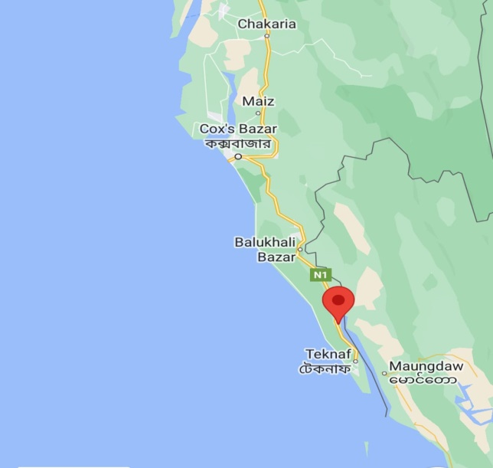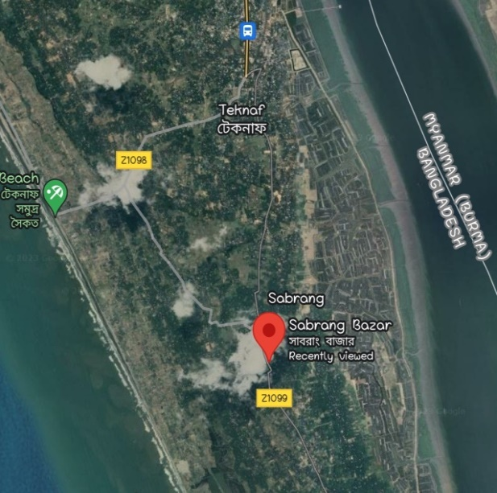
Figure 1: Location of sample collection (Sabrang Bazar, Teknaf, Cox’s Bazar)
3.2 Identification of Common Characteristics of Fish
Following a thorough washing in potable water, the fish were carefully examined to determine their genus and species. Specific information, including body shape, color, number of fins, fin rays, and habitat, was noted and compared to the available literature.
Plate 1: Carangoides malabaricus
Plate 2: Scomberoides commersonnianus
3.3 Myotomes (myomeres) Structure Determination
A crucial aspect of fish fillet identification involves the number of myotomes which can differ from one species to another. Myotomes are categorized into two types: one comprises wide fibers of white muscle, while other is composed of slender fibers containing myoglobin, responsible for the red coloration (referred to as dark muscle).
Five samples of each species were taken for this experiment. After scale removing and washing properly, the fishes were dissected, filleted longitudinally from tail to head in both sides. Then W-like segments (myotomes) were counted from tail to head region. Even in cases where the tail is partially removed, it is still possible to observe the segments by making cross-sectional slices that cut across overlapping myotomes.

3.4 Determination of Processing Yields
For processing yield determination, both fish (C. malabaricus and S. commersonnianus) were defrosted first. Then the weight and length were measured. Intestinal part was removed carefully and weighed again. Scales and skin were also peeled off. Dark and white muscles were excised respectively from each fish and measured by electric balance. The remaining fish body parts such as head, operculum, vertebral column, inter-muscular bones, fins, scales and skin were measured altogether considering as carcass part of fish.
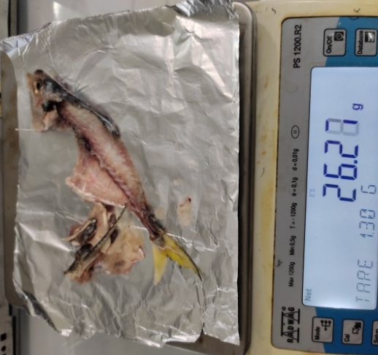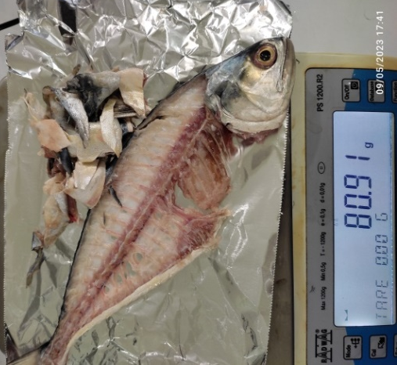
(a) (b)
Plate 3: Carcass weighing of (a) C. malabaricus and (b) S. commersonnianus
3.5 Sample Preparation for Proximate Composition
3.5.1 Different muscle type
Fish that had been frozen were partially defrosted in a 2-4 ºC cold condition. Fish were then washed, headed, gutted, and skinned well. On the dorsal side of those specimens, the deep-seated, dark muscles were carefully removed. The proximate composition was determined by analysis of normal white and dark muscle.
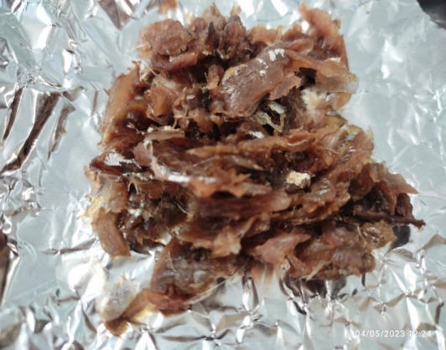
(a) (b)
Plate 4: (a) White and (b) dark muscle
3.5.2 Different body parts of fish
The complete fish was divided into three body pieces, such as the head, middle part, and tail, after the frozen fish had been thawed. Skin and scales were gently removed. Each section had both white and dark muscles excised very carefully. The sample of these three bodily parts was then individually minced using a pestles and mortar and used for biochemical analysis (AOAC, 2016).
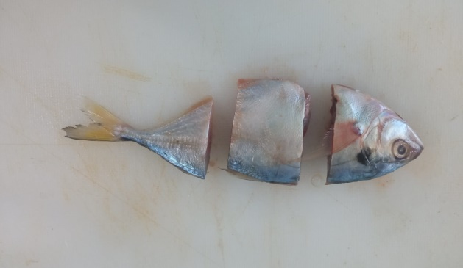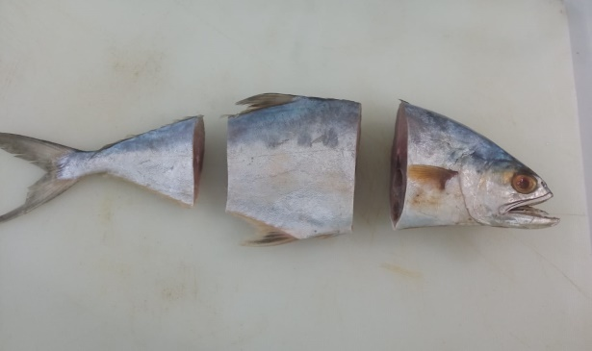
(a) (b)
Plate 5: Three body parts of fish (a) C. malabaricus and (b) S. commersonnianus
3.5.3 Cooked (boiled and fried) sample
On arrival at the laboratory the fish samples were washed with potable tap water to remove adhering blood and slime. They were then eviscerated and cut into pieces and weighed. Then pieces were randomly divided in to 3 lots, which were assigned to the three repetitions of each one of the two cooking (boiling and frying) methods and to the raw group that was used as a reference. Chemical compositions of both raw and cooked samples were also analyzed by AOAC, (2016) methods.
3.5.3.1 Cooking methods
The samples were cooked by frying and boiling. The fish samples were fried in soybean oil. The temperature of oil during the frying process was 100-150˚C for 10 minutes in a pan. Boiling was performed in a regular cooking pot at approximately 100 ºC for 15 minutes. Turmeric or other spices were not used in both boiling and frying. Then boiled and fried sample were weighed again to measure cooking loss. Samples of raw or cooked fish fillets were immediately homogenized using a kitchen blender and analyzed to determine proximate composition (AOAC, 2016).
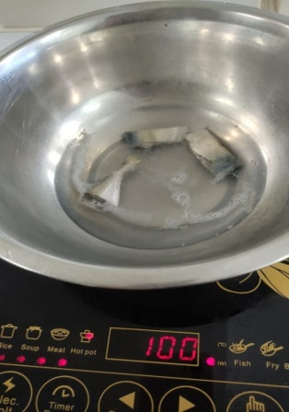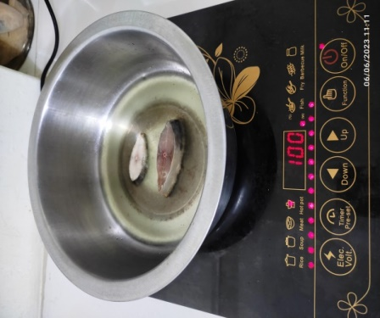
Plate 6: Boiling and frying of sample
3.5.3.2 Cooking loss
Cooking loss was determined using the procedure outlined by Niamnuy et al. (2008) and was calculated based on the disparities in the mass of Malabar cavalla (Carangoides malabaricus) and Talang queenfish (Scomberoides commersonnianus) pieces before and after each cooking methods (frying and boiling).
Calculation of cooking loss is below:
Cooking loss (%) = $\frac{Mass before cooking – Mass after cooking}{Mass before cooking }$×100
3.5.3.3 Sensory evaluation
Studies were also conducted to evaluate the changes of organoleptic aspects after cooking of the fish sample by sensory evaluation. A 10 person panel was constituted for the organoleptic assessment. Panelists were teachers and graduate students of the Faculty of Fisheries, CVASU who had similar experiences before. Observed three organoleptic aspects were muscle color (white, light red, red), texture (firm, soft and burst) and smell (strong, medium, weak).
3.6 Proximate Composition Analysis
According to the Association of Official Analytical Chemists' procedure (AOAC, 2016), the percentages of moisture, ash, crude protein, crude fat were calculated for proximate analysis on wet weight basis. For each proximate composition investigation, triplicate samples were employed.
3.6.1 Protein
The total protein content was calculated using the Micro Kjeldahl instrument. Digestion system (DK20/26, VELP scientific) and distillation system (Model: UDK 129, VELP scientific). The wet fish samples (0.3 g), 4 g of catalyst, and 5 ml of concentrated H₂SO₄ were put into the digestion tube. The digestion tube was put into the digestion apparatus, and it was continued there for 30 minutes. The digestive tube was then cooled at room temperature for 1to1.5 hours. A 25 ml of distilled water were added to the digestion tube after digestion. 10 ml of mixed indicator were introduced to the conical flask of the distillation unit. A 25 ml of NaOH and 25 ml of distilled water were added to the distillation unit's lower pipe. The samples were titrated with 0.2 N HCl.
Total nitrogen content was determined by following formula:
% of N =$\frac{mL of titrant ×Strength of HCl \left(0.2N\right)×equivalent of Nitrogen \left(0.014\right)}{weight of sample}×100$
The following formula was then used to determine the amount of crude protein:
% Protein Content = N% $×$ 6.25
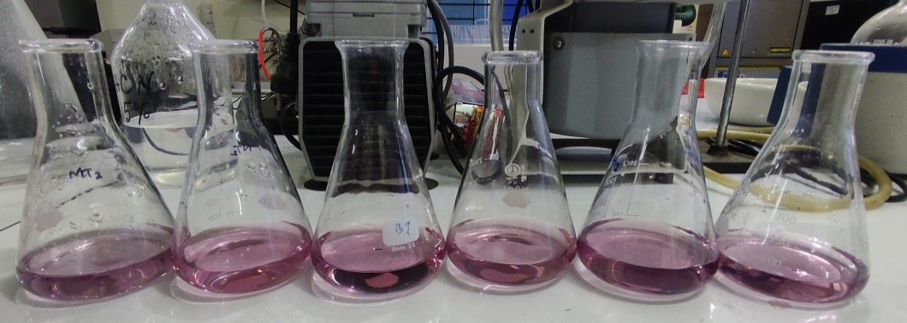
Plate 7: Titrated protein sample
3.6.2 Lipid
The lipid content of the sample was determined using the Soxhlet device (Model: RD 40, Food ALYT). On thimble paper, 2 g of the wet ground sample was placed. Thimble papers were set under the magnetic holder by magnetic ring and lift it up. The beaker was weighed, and 75 ml of diethyl ether were added. Beaker was screwed with solvent under the condenser. Thimble was dipped into the beaker and extraction beaker was placed in burner by lifting lever handle. Then the solvent was heated for 20 minutes at 100 °C. After then lifting the thimbles up, the water was heated at 100 °C for a further 20 minutes. The solvent vaporized over the course of 10 to 15 minutes. Finally, the extraction beaker was weighed after cooling in the desiccator.
Formula for determination of lipid:
% of Lipid = $\frac{weight of lipid}{weight of sample}$ $×100$
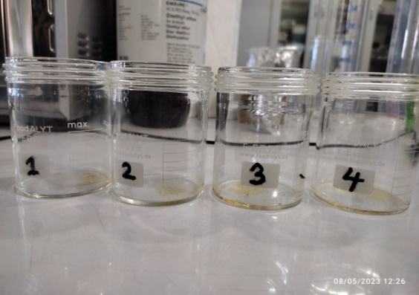

Plate 8: Extracted lipids of samle
3.6.3 Moisture
The moisture content of the sample was measured using the Laboratory Drying Oven (Model: BINDER, ED 115).
The empty crucible was weighed. Then, 3g ground samples were weighed. Sample was put in the crucible and heated in the hot air oven chamber for 12 hours at 105 °C. The sample's final weight in the crucible was determined after cooling in a desiccator.
Formula for determination of moisture-
% of Moisture = $\frac{Weight of moisture}{Weight of sample}×100$
3.6.4 Ash
With the use of a Muffle Furnace (Model: LHMF 100A, LABNICS Equipment), the amount of ash in the sample was determined.
The sample was ground up, and the weight of the empty crucible was weighed. In a muffle furnace, a 3 g sample was heated to 550 ºC for 5 hours in a porcelain crucible. After chilling the sample in the desiccator, the final weight of the sample using the crucible was determined.

Formula for determination of ash
% of Ash =$\frac{Weight of ash}{Weight of sample}×100$
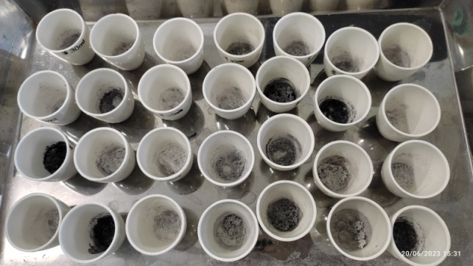
Plate 9: Ash content of sample
3.7 Gel Forming Ability
3.7.1 Organoleptic test
The freshness of the two fish, Carangoides malabaricus and Scomberoides commersonnianus, was evaluated by assessing organoleptic aspects prior to the experiment on the suitability of the fish to assess the gel forming ability for value-added product. Determining defects points considered as the base for the process of assessing quality. Qualities of fresh fishes were determined by observing defect points arranged by Howgate et al. (1992). Gel-forming ability of fish muscle gel has been studied by following the procedure of Hossain et al. (2005).
3.7.2 Preparation of mince
The fish were gutted and then beheaded before being washed in cold water. The amount of time needed to drain the extra blood had elapsed. After a thorough washing, the fish was delicately filleted, excluding all scales, integument, dark muscles, belly flaps, and kidney tissue. The fillet was subjected to deboning and chopped using a mortar- pestle. A fine mesh sieve was used for separating the meat from any remaining bones and connective tissue fibers. The mince was washed two times with ice-cold, pure water that contained 0.1% NaCl. The mince was washed using 4 volumes of the washing solution, agitated for 2 minutes, and then allowed to settle for 10 minutes before being dewatered. Squeezing the cotton cloth bag for 10 to 15 minutes with hand pressure allowed the water to be removed. Both unwashed and washed minces were ground in a mortar for duration of 20 minutes with a mixture containing 3% NaCl and 20% cooled water. The entire procedure was completed in a cold temperature. Two kinds of meat gel, washed and unwashed, were prepared from each fish.
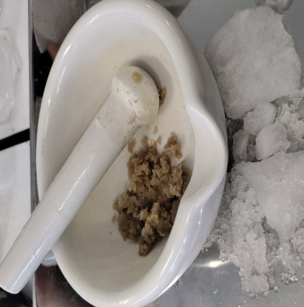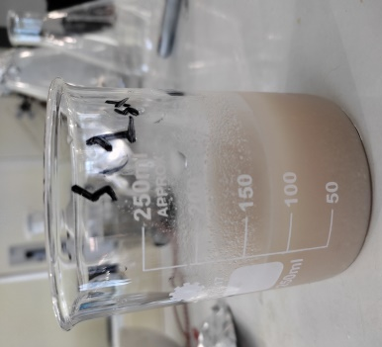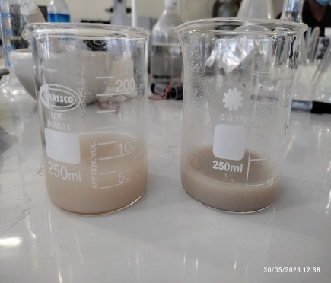
(a) (b) (c)
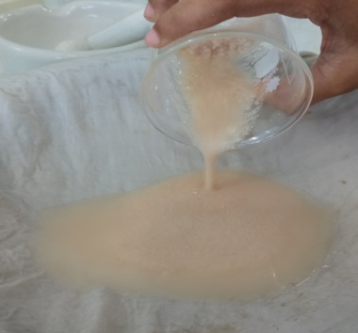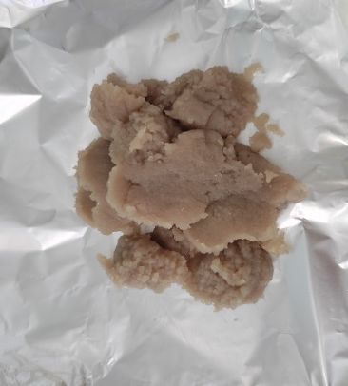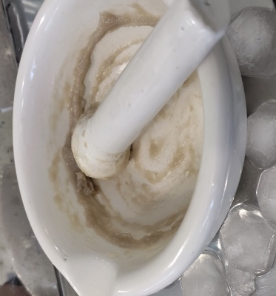
(d) (e) (f)
Plate 10: Preparation of washed and unwashed mince: (a) grinding of sample, (b) washing of mince, (c) stayed for settling, (d) staining,(e) washed mince and (f)mixing with salt and water
3.7.3 Preparation of gel
Afterwards, the NaCl ground flesh paste was carefully inserted inside a heat stable PVC tube that was 2 inches long and 1.8 cm in diameter, and the ends of the tubes were sealed with polythene wrap. For 120 minutes, the paste in the tube was heated in water bath (Model: Sub Aqua Pro) at 40, 50, and 60°C. The final gels were removed from the water bath and immediately placed in ice water for 60 minutes.

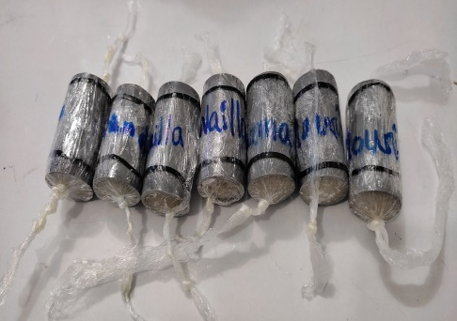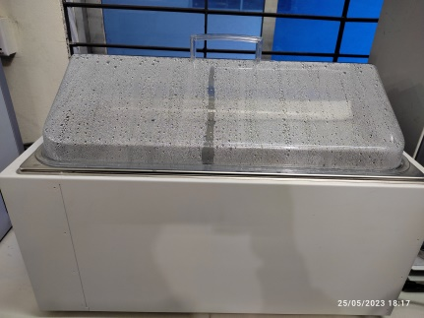
(a) (b)
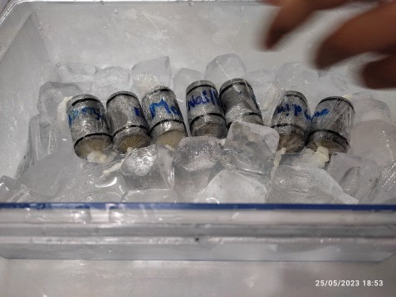
(c) (d)
Plate 11: Preparation of gel: (a) gel setting tube, (b) placed in water bath,
(c) placed on ice for cooling and (d) prepared gel
3.7.4 Assessment of gel properties
The gel was removed from the tube and subjected to puncture test and folding test for obtaining physical measurements of its properties.
3.7.4.1 Puncture test
The test involved taking the gels out of the tube and cutting them into equal pieces measuring 2 cm. A ball-type spherical plunger with a 5 mm diameter was used to penetrate the gel on electronic balance’s pan to quantify the breaking force of the gel. Pressure of plunger was applied to the sample until it broke. It displays the force or strength applied to the sample up until it breaks. The electronic balance was used to record the force, measured in g that the plunger needed to exert to break the gel.
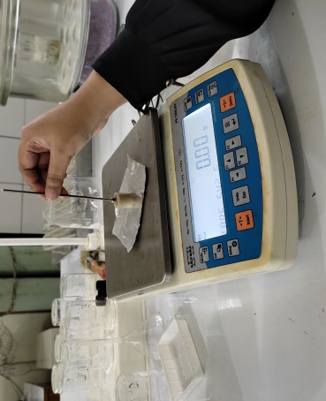
Plate 12: Measure breaking force of gel by plunger
3.7.4.2 Folding test
In the folding test, a spherical disc of gel, measuring 1 mm in thickness, was carefully cut and positioned on the index and middle finger of right hand. Subsequently, the gel disc was folded into quarters and then halves, utilizing the thumb and index finger. The evaluation of the gel was conducted in accordance with scoring presented in Table 1, as recommended by Poon et al. (1981).
Table 1: Grade used in folding test of the gel
Grade | Results on folding
AA | No crack visible when disc is folded into quarter
A | No crack when disc is folded into half but one or more cracks are visible when folded into quarter
B | One or more cracks are visible when folded into half
C | Breaks, but doesn’t split into halves
D | Splits into halves when folded into half
O | Sample too soft to evaluate
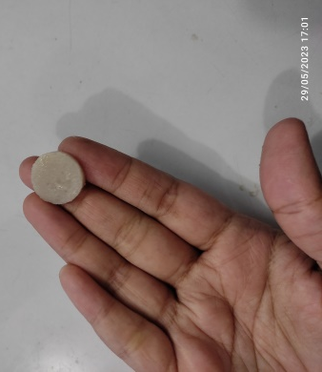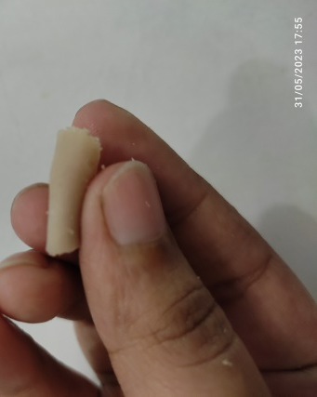
Plate 13: Folding test of gel
3.8 Statistical Analysis
Measurements were conducted in triplicate, and the resulting data were expressed as mean standard deviation (SD). Analysis of variance (ANOVA) was employed to assess the variation in all the data. Differences in mean values were determined using the least significant difference (Tukey HSD, p<0.05) method. Data analysis was carried out using IBM SPSS Statistics 20 for Windows, SPSS for Windows version 20.

CHAPTER 4: RESULTS
4.1: Muscle Structure and Processing Yield of Carangoides malabaricus and Scomberoides commersonnianus
4.1.1 Muscle Structure of Carangoides malabaricus and Scomberoides commersonnianus
Figure 2 and 3 which depict the muscular structure of the Carangoides malabaricus and Scomberoides commersonnianus, respectively. Fish's body muscles are organized into segmental myotomes with a complex three-dimensional structure. The findings showed that there are two skeletal muscle bundles on either side of the vertebral column, each of which is further divided into an upper mass above the horizontal axial septum and a ventral mass below this septum. The fillet is made up of the muscle mass on each side of the fish, of which the upper portion is known as the dorsal muscle and the bottom portion as the ventral muscle. Between two myocommata, all muscle cells run parallel to the fish's longitudinal axis for their entire length. Fish muscles are divided into dorsal and ventral muscular areas by a horizontal septum. Epiaxial muscles are those located above the horizontal septum, and hypoaxial muscles are those located below the horizontal septum. The body cavity is likewise encircled by hypoaxial muscles. The fish muscle is divided into left and right parts by a vertical septum. Myotomes are collections of parallel muscle cells. In lateral views, the superficial red muscle started right behind the operculum, extended down the lateral line toward the tail, and terminated in the last caudal spine. The white muscle was significantly more thinly layered over the red muscle as it moved away from the horizontal septum, towards both dorsal and ventral sides. It is clear from the present study that white muscle fibers have a larger diameter than dark muscle fibers.

Myoseptum
Myotome

Epiaxial line
Hypoaxial line
Figure 2: Myotome structure of Carangoides malabaricus
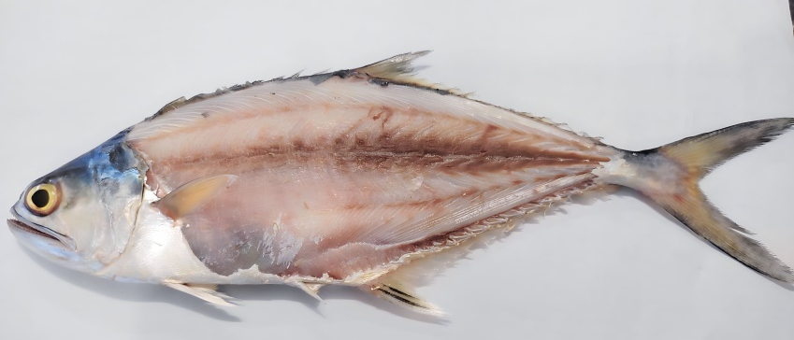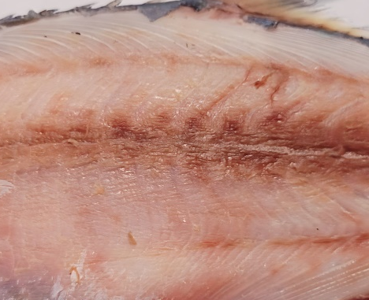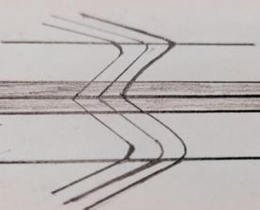
Hypaxial line
Myoseptum

Myotome

Epiaxial line
Figure 3: Myotome structure of Scomberoides commersonnianus
The findings also indicate that both fish species' muscle tissue is predominantly white, making up roughly 90% of their skeletal muscle, with the remaining 10% being dark tissue that is brown or reddish in color. Just beneath the skin along the side of the body is the dark muscle. Two different fish species have different ratios of dark to white muscle. Carangoides malabaricus includes 9.77% dark muscle and 90.23% white muscle and in contrast, Scomberoides commersonnianus has 92.84% white muscle and 7.16% dark muscle shown in Figure 4 and 5.
White Muscle 90.23%
Dark Muscle 9.77%

Figure 4: Dark and white muscle percentage of Carangoides malabaricus
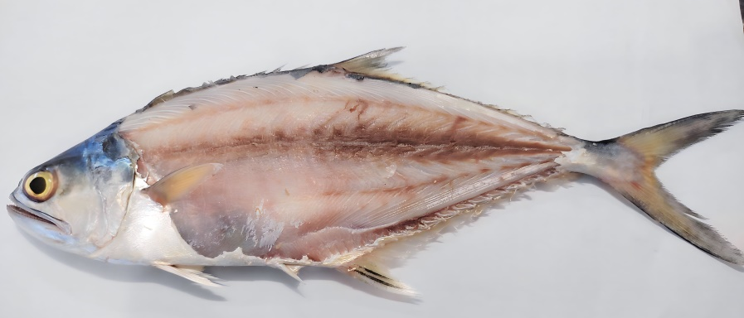
White Muscle 92.84%
Dark Muscle 7.16%

Figure 5: Dark and white muscle percentage of Scomberoides commersonnianus
The partial cross section view of the muscle structure of Carangoides malabaricus and Scomberoides commersonnianus fish samples are shown Figure 6 and Figure 7, respectively. From the present study, the muscle cells appears to run parallel to one another, attached to connective tissue sheaths (myocommata), and anchored to the bones and skin like in other fish.
Horizontal Septum
Dark Muscle
Hypaxialis Muscle
Belly Cavity
Vertebra
White Muscle
Vertebral Septum
Epaxialis Muscle
Figure 6: Muscle structure of Carangoides malabaricus
Dark Muscle
Vertebra
Hypaxialis Muscle
Belly Cavity
White Muscle
Horizontal Septum
Vertebral Septum
Epaxialis Muscle
Figure 7: Muscle structure of Scomberoides commersonnianus

Table 2: Summary of muscle characteristics of Malabar cavalla (Carangoides malabaricus) and Talang queenfish (Scomberoides commersonnianus) fish
Attributes | Fish Sample
 | Malabar cavalla | Talang queenfish
Direction of Myoseptums
Number of Myotoms | 21-23 | 50-55
Form of Myotoms | Wavy over epi-axial and hypoaxial lines. Broken over horizontal septum. Wavy over dorsal and ventral sides. | Wavy over epi-axial and hypoaxial lines. Broken over horizontal septum. Wavy over dorsal and ventral sides.
Ordinary Muscle Color | White | White
Dark Muscle Color | Dark red | Dark red
Width of Dark Muscle | Thin over horizontal septum. Not so deep. | Wide over horizontal septum. Very deep.

4.1.2 Processing yields of the experimental fish
The processing yield of the two experimental fish species, of Carangoides malabaricus and Scomberoides commersonnianus were also investigated. Wastes after fish processing in the industries include skin, scales, intestinal contents, and bones. The processing yields of total muscle, white and black muscle, carcasses, and intestine components were examined in this study and are compiled in table 3.
Table 3 shows that average total body weight of cavalla (Carangoides malabaricus) was 46.9 g. Total carcasses and intestinal parts of this fish species was 26.32g and 2.15 g, respectively, which is the 60.70 % of the total body weight. On the other hand, muscle yield of this fish species was 18.43g in which 1.80 g dark muscle and 16.63g white muscle. Muscle yield in percentage was 39.30% in which dark muscle represents 9.77 % and white muscle 90.23%. In case of Scomberoides commersonnianus fish samples, average total body weight of the fish was 199.57g. Carcass and intestinal parts were 80.29g and 12.81g, respectively, which is the 46.65% of the total body weight. In this fish species, total muscle yield was106.47g in which 7.62g dark muscle and 98.85g white muscle. Muscle yield from this fish species was 53.35% in which dark muscle represents 7.16% and white muscle 92.84%. From the study it is clearly evident that muscle yield including proportion of white muscle in Scomberoides commersonnianus fish samples is quite high compared to Carangoides malabaricus. The results also indicates that Scomberoides commersonnianus fish species is suitable for processing of fillets and other value added products due to high muscle yields and also higher proportion of white muscles. Carangoides malabaricus can be used for processing of whole dried fish, salting, smoking and frozen purposes.
Table 3: Processing yields of total muscle, white and dark muscle, carcasses and intestinal parts of Carangoides malabaricus and Scomberoides commersonnianus fish samples
Processing Yield | Carangoides malabaricus | Scomberoides commersonnianus
Total body weight (g) | 46.9 | 199.57
Carcass weight with skin (g) | 26.32 | 80.29
Intestinal part weight (g) | 2.15 | 12.81
Carcass and intestinal parts (%) with body weight | 60.70 | 46.65
Total muscle weight(g) | 18.43 | 106.47
Dark muscle weight (g) | 1.80 | 7.62
White Muscle Weight (g) | 16.63 | 98.85
Muscle (%) with body weight | 39.30 | 53.35
Dark muscle (%) total muscle | 9.77 | 7.16
White muscle (%) with total muscle | 90.23 | 92.84

4.2 Proximate Composition of Carangoides malabaricus and Scomberoides commersonnianus
4.2.1 Proximate composition of different muscle of fish
In an attempt to show the chemical constituents of fish, Stansby (1962) suggested that the following factors should be used to determine the fish's approximate composition: i) on a dry weight basis, and ii) on a wet weight basis. In view of it, the biochemical composition of fish dark muscle, white muscle and mixed muscles of Carangoides malabaricus and Scomberoides commersonnianus fish were investigated and the results shown in Table 4.
Table 4: Chemical composition of different types of muscles of Carangoides malabaricus and Scomberoides commersonnianus fish
Fish Name | Muscle  Type | Moisture  (%) | Protein  (%) |  | Lipid  (%) | Ash  (%)
Carangoides malabaricus | Dark | 73.04±.62^{b} | 22.3±.32^{b}  *82.72±1.06^{c} |  | 2.98±.26ª  *11.03±.78ª | 1.68±.16ª  *6.24±.43ª
 | White | 74.23±1.42ª | 24.02±1.46ª  *93.19±.53ª |  | 0.96±.08ª  *3.74±.48^{c} | 0.79±.05ª  *3.11±.15^{b}
 | Mixed | 72.53±.38ª | 23.86±.26^{ab}  *86.86±.95^{b} |  | 1.93±.22^{b}  *7.02±.71^{b} | 1.65±.12ª  *6.12±.42ª
Scomberoides commersonnianus | Dark | 72.28±.50^{b} |  | 23.50±.68ª  *84.76±1.19 ^{c} | 2.83±.08ª  *10.22±.30ª | 1.39±.23ª  *4.48±.50ª
 | White | 73.09±.42ª |  | 24.81±.56^{b}  *91.85±.64ª | 0.75±.06^{c}  *2.78±.20^{c} | 1.45±.18ª  *5.54±.59 ª
 | Mixed | 72.60±.38ª |  | 23.94±.28^{b}  *87.46±.29^{b} | 2.12±.15^{b}  *7.73±.46^{b} | 1.34±.06ª  *4.80±.32 ª
* Values indicate dry weight basis composition.
All the values are represented as the mean values of three replications ±SD. Different superscripts small letters (a, b, c) in the same column within the different muscle type denote significant differences among values of the proximate compositions of various samples considerably p<0.05, one-way ANOVA, Tukey-HSD test.
As shown in the table 4, moisture content varies from 72.53±.38% to 74.23±1.42 % with highest value in white muscle and lowest value in mixed muscle in Carangoides malabaricus. On the other hand, moisture content in different types muscle varies 72.28±.50% to 73.09±.42% in Scomberoides commersonnianus. The result shows that there is little significant difference (p<0.05) in the moisture contents among dark, white and mixed muscles of both fish. Protein content in dark, white and mixed muscle of the Carangoides malabaricus ranged from 22.3±.32% to 24.02±1.46% with the highest value was in mixed muscle and lowest value in dark muscle on wet weight basis. For better understanding, the values obtained from various muscles were calculated on dry weight basis. On dry weight basis, protein ranged 93.19±.53% to 82.72±1.06% with highest value in white muscle and lowest value in dark muscle. Protein content of mixed muscle (86.86±.95%) is in between of dark and white muscle. In case of protein content of Scomberoides commersonnianus, values were in the range of 23.50±.68% to 24.81±.56% in wet weight basis where highest value was obtained from white muscle and lowest value in dark muscle. Almost similar value of 23.94±.28% protein content was observed in mixed muscle. On dry weight basis, highest calculated protein value of 91.85±.64% found in white muscle and 84.76±1.19 % in dark muscles. Protein value of mixed muscle was 87.46±.29% which is more or less near to the value obtained from dark muscle. Protein content was higher in white muscle compared to the dark muscle. There are statistically significant differences (p˂0.05) in protein levels observed across all samples, whether analyzed on a wet or dry basis, for both types of fish.
Lipid content of the different muscles of Carangoides malabaricus and Scomberoides commersonnianus varies considerably and shows significant differences (p˂0.05) among different muscle type. In case of Carangoides malabaricus it ranged from 0.96±.08% to 2.98±.26% with highest value in dark muscle and lowest value white muscle. Lipid content 1.93±.22 % found in mixed muscle. On dry weight basis, highest lipid content of 11.03±.48% was found in dark muscle and lowest value of 3.74±.48% in white muscle of the same fish species. On the other hand, in case of Scomberoides commersonnianus, lipid content in different muscle type ranged from 0.75±.06% to 2.83±.08%, with highest value in dark muscle and lowest in white muscle on wet weight basis. Lipid content of the mixed muscle was 2.12±.15%. On dry weight basis, similar trend also observed with higher value of 10.22±.30% and 7.73±.46% lipid content found in dark and mixed muscle and low value of 2.78±.20% lipid content in white muscle. Lipid contents of both fish show high significant difference (p<0.05) among different muscle type in both wet and dry basis.
Ash content of Carangoides malabaricus, in dark, white and mixed muscle was 1.68±.16%, .79±.05% and 1.65±.12% respectively on wet weight basis. In case of dry weight basis ash content was 6.24 ±.43%, 3.11±.15% and 6.12±.42%. Where there is no significant differences (p>0.05) in ash contents on wet weight basis but in case of dry weight basis there is little significant (p<0.05) among three muscle types. There is no significant differences (p>0.05) in the values of ash content among the different muscle types of Scomberoides commersonnianus which ranged from 1.34±.06% to 1.45±.18% on wet weight basis. Similar results were obtained on dry weight basis, where ash content ranged from 4.48±.50 to 5.54±.59 %.
4.2.2 Proximate composition of different body parts of fish
There is little or no information is available on chemical compositions of the muscles of different body parts of the marine fish species available in Bangladesh sea water. Therefore, studies on chemical composition of the muscles of different body regions (Head, Middle and tail) of Carangoides malabaricus and Scomberoides commersonnianus were conducted and the results are shown in Table 5.

Table 5: Chemical composition of three body region of Carangoides malabaricus and Scomberoides commersonnianus
Fish Name | Fish Muscle | Moisture | Protein | Lipid | Ash
Carangoides malabaricus | Head region | 75.48±1.16ª | 22.75±.81^{b}  *92.84±1.19ª | 0.58±.03^{b}  *2.37±.13^{b} | 1.31±.03^{ab}  *4.78±1.23ª
 | Middle region | 72.57±.75^{b} | 24.26±.88^{ab}  *88.43±80^{b} | 1.74±.10ª  *6.35±.57ª | 1.43±.08ª  *5.21±.35ª
 | Tail  region | 72.17±.42^{b} | 24.69±.46 ª  *88.71±.60^{b} | 1.87±.11ª  *6.72±.44ª | 1.27±.40^{b}  *4.56±.17ª
Scomberoides commersonnianus | Head  region | 74.35±.45^{b} | 23.4±.54^{b}  *91.22±.93ª | 0.97±.22^{b}  *3.78±.84^{b} | 1.28±.87ª  *4.99±.43ª
 | Middle  region | 71.95±.41^{c} | 25.10±.26ª  *89.17±.53ª | 1.60±.16ª  *5.70±.48ª | 1.35±.13ª  *4.81±.44ª
 | Tail  region | 73.21±.46^{b} | 24.20±.48^{ab}  *90.33±.76ª | 1.40±.15^{ab}  *5.22±.59^{ab} | 1.19±.05ª  *4.44±.17ª
* Values indicate dry weight basis composition
All the values are represented as the mean values of three replications ±SD. Different superscripts small letters (a, b, c) in the same column within the different body part denote significant differences among values of the proximate compositions of various samples considerably p<0.05, one-way ANOVA, Tukey-HSD test.
As shown in the table 5, moisture content in the muscles of head, middle and tail region of Carangoides malabaricus were 75.48±1.16%, 72.57±.79 % and 72.17±.41%, respectively. There are variations in moisture content and values were significantly different (p < 0.05) from each other regions of the muscle. In case of Scomberoides commersonnianus, moisture content measured in the muscles of head, middle and tail region of were 74.35±.45%, 71.95±.41% and 73.21±.45% with significant difference (p<0.05).
Protein value of the muscles of head, middle and tail regions of Carangoides malabaricus were 22.75±.81%, 24.26±.88% and 24.69±.46 %, respectively on wet weight basis and calculated values of protein were 92.84±1.19 %, 88.43±.80% and 88.71±.60% respectively on dry weight basis. On the other hand, protein content of the muscles of head, middle and tail regions of Scomberoides commersonnianus, on wet weight basis were 23.4±.54%, 25.10±.26% and 24.20±.48%, respectively. On dry weight basis, accordingly protein contents of the muscles of different organs were 91.22±.93%, 89.17±.53% and 90.33±.76%, respectively. Protein content was found to differ significantly (p < 0.05) among the different parts of both fish on wet weight basis. The results also indicated that, protein content in dry weight basis, Carangoides malabaricus has significant difference (p < 0.05) but no variations in Scomberoides commersonnianus.
There was little significant variation in lipid contents among the muscles of different body parts of both fish. In the present study, on wet weight basis lipid contents of Carangoides malabaricus were 0.58±.03%, 1.74±.10% and 1.87±.11%, respectively in the muscles of head, middle and tail regions. On dry weight basis, accordingly lipid contents were 2.37±.13%, 6.35±.57% and 6.72±.44% respectively. But in Scomberoides commersonnianus fish, Lipid content in the muscles of different parts had significant difference (p < 0.05). The values were 0.97±.22%, 1.60±.16% and 1.40±.15%, respectively in muscles of head, middle and tail regions. On dry weight basis, these calculated values were 3.78±.84%, 5.70±.48% and 5.22±.59%, respectively.
Ash contents on wet weight basis were 1.31±.03%, 1.43±.08% and1.27±.40%, respectively for muscles of head, middle and tail regions of Carangoides malabaricus. Ash content in wet weight basis has significant difference (p<0.05). The calculated values of ash contents on dry weight basis were 4.56±.17% to 5.21±.35%, with no significant differences (p>0.05) among the values of different regions of the fish body. On wet weight basis, percentage ash content of Scomberoides commersonnianus in head, middle and tail region was 1.28±.87, 1.35±.13 and 1.19±.05, respectively. The calculated values of ash contents in dry weight basis were 4.44±.17% to 4.99±.43%, with no significant differences (p>0.05) among the values of different regions of the fish body.
4.2.3 Effects of cooking methods (boiling and frying) on proximate composition
Although there are some researches on the proximate composition and fatty acids of marine Fish, the available food composition tables provide minimal data on nutritive values of cooked fish. Therefore, the aim of this research was to determine the effects of boiling and frying methods on proximate composition of (Carangoides malabaricus) and Talang queenfish (Scomberoides commersonnianus).
4.2.3.1 Sensory evaluation of cooked fish samples
When boiled and fried samples were compared to raw muscle, changes in the color, texture, and smell of the muscle were seen. It denotes the variations in muscle color, texture, and mostly the strength or level of smell produced by a fish during the raw, boiling, and fried stages. This information is crucial for processing since fish with varying degrees of muscle severance may require various processing precautions. The following information was provided by panelists.
Table 6: Organoleptic characteristics of raw, boiled and fried samples of Malabar cavalla (Carangoides malabaricus) and Talang queenfish (Scomberoides commersonnianus) fish
Sample Name |  | Muscle Color |  |  | Texture |  |  | Smell
 |  | White | Light Red | Red | Firm | Soft | Burst | Strong | Mediu-m | Low
Malabar cavalla | Raw | 100% | _ | _ | 100% | _ | _ | 20% | 80% | _
 | Boiled | 100% | _ | _ | 100% | _ | _ | _ | 100% | _
 | Fried | 100% | _ | _ | 100% | _ | _ | _ | 100% | _
Talang queen  Fish | Raw | 100% | _ | _ | 60% | 40% | _ | _ | 80% | 20%
 | Boiled | 100% | _ | _ | 100% | _ | _ | _ | 100% | _
 | Fried | 100% | _ | _ | 100% | _ | _ | 100% | _ | _

Muscle color in fresh fish was white. The color developed light red after boiling. After being fried, the color of both fishes became red. The muscles were firm and elastic in terms of texture. But after boiling, the majority of the sample turned firm while other samples were soft. The muscle was incredibly soft and partially disintegrated after being fried but fried Talang queenfish was mostly firm. Compared to Scomberoides commersonnianus, the scent of raw fish muscle from Carangoides malabaricus was stronger. It became stronger when it was boiled. It released stronger aromas after boiling than raw muscle did. In contrast to Carangoides malabaricus, the fish with a high proportion of dark muscles had a greater fragrance after being fried.
4.2.3.2 Proximate composition of cooked samples
Table- 7 shows the proximate composition of raw samples, and cooked samples in two conditions: (i) boiled and (ii) fried.
Table 7: Proximate composition of raw and cooked samples of Carangoides malabaricus and Scomberoides commersonnianus

Fish Name | Fish Sample | Moisture (%) | Protein (%) | Lipid (%) | Ash (%)
Carangoides malabaricus | Raw | 72.53±.38ª | 23.86±.26^{c}  *86.86±.55ª | 1.93±.22^{b}  *7.01±.71^{b} | 1.68±.12^{c}  *6.12±.42^{c}
 | Boiled | 70.84±.55^{b} | 25.39±.54^{b}  *87.06±.23ª | 1.66±.03^{b}  *5.69±.19^{c} | 2.11±.05^{b}  *7.24±.14^{b}
 | Fried | 55.72±.15^{c} | 34.54±.10ª  *78.01±.03^{b} | 6.16±.02ª  *13.91±.04ª | 3.57±.04ª  *8.07±.07ª
Scromberoides commersonnianus | Raw | 72.60±.38ª | 23.94±.28^{c}  *87.46±.29^{b} | 2.12±.15^{b}  *7.73±.46^{b} | 1.34±.05^{c}  *4.80±.32^{c}
 | Boiled | 71.02±1.14ª | 25.52±1.03^{b}  *88.05±.12ª | 1.44±.04^{c}  *4.96±.07^{c} | 2.02±.06^{b}  *6.98±.08^{b}
 | Fried | 56.96±.16^{b} | 33.43±.07ª  *77.68±.12^{c} | 6.19±.03ª  *14.38±.04ª | 3.42±.06ª  *7.94±.10ª
* Values indicate dry weight basis composition
All the values are represented as the mean values of three replications ±SD. Different superscripts small letters (a, b, c) in the same column within the raw and cooked (boiled and fried) samples of fish denote significant differences among values of the proximate compositions of various samples considerably p<0.05, one-way ANOVA, Tukey-HSD test.
In table 7, moisture content of Carangoides malabaricus, was 72.53±.38%, 70.84±.55% and 55.72±.15%, respectively for raw, boiled and cooked samples. The result shows that moisture content slightly decreased in boiled samples and greatly reduced in fried samples compared to the raw original samples. The results indicated that there is some kind of loss of moisture in cooking process with significant differences (p<0.05) among the values. Moisture content of the raw, boiled and fried samples were calculated 72.60±.38%, 71.02±1.14% and 56.96±.16% respectively of Scomberoides commersonnianus samples which shows little significance differences (p< 0.05).
The protein content of raw Carangoides malabaricus sample on wet weight basis was 23.86±.26%. After boiling and frying, protein contents were 25.39±.54% and 34.54±.10%, respectively. On moisture free basis, these values were 86.86±.63%, 87.06±.23% and 78.01±.03%, respectively for raw, boiled and fried samples. The protein content of raw, boiled and fried samples of other fish species (Scomberoides commersonnianus) were 23.94±.28%, 25.52±1.03% and 33.43±.07%, respectively, on wet weight basis while on dry weight basis, these values were 87.46±.29%, 88.05±.12% and 77.68±.12%, respectively. The results obtained from the present study indicated that there was significant differences (p<0.05) in protein contents of this fish samples from the original raw samples after boiling and frying.
The lipid content of raw, boiled and fried samples of Carangoides malabaricus were 1.93±.22%, 1.66±.03% and 6.16±.02%, respectively, on wet weight basis. On dry weight basis, these values were 7.01±.71%, 5.69±.19% and 13.91±.04% for raw, boiled and fried samples. In Scomberoides commersonnianus the lipid content of three sample type was 2.12±.15%, 1.44±.04% and 6.19±03%, respectively on wet weight basis. On dry weight basis, the values were 7.73±.46%, 4.96±.07% and 14.38±.04%, respectively for raw, boiled and fried samples. The result shows that decrease in lipid content after boiling and increasing its value after frying of the samples with significant differences (p< 0.05) among samples. The results indicate that cooking has great effect on decreasing lipid content of the samples, while frying adding the oil in the samples.
The ash content of raw, boiled and fried samples of Carangoides malabaricus were 1.68±.12%, 2.11±.05% and 3.57±.04% respectively, on wet weight basis. On dry weight basis, these values were 6.12±.42%, 7.24±.14% and 8.07±.07% for raw, boiled and fried samples. There was increasing pattern of ash content in samples in both fish species after boiling and frying with significant difference (p<0.05). The ash content of the raw, boiled and fried samples was 1.34±.05%, 2.02±.06% and 3.42±.06%, respectively on wet weight basis. But on dry weight basis, the values were 4.80±.42%, 6.98±.08% and 7.94±.10%, respectively for raw and cooked samples.
Table 8: Cooking loss of two marine fish
Fish Name | Cooking loss (%)
 | Boiling | Frying
Carangoides malabaricus | 13.48% | 41.51%
Scomberoides commersonnianus | 10.82% | 30.08%

Cooking loss in Carangoides malabaricus and Scromboides Commersonianus was measured after each cooking treatment. In table 8, the boiling loss was 13.48% for Carangoides malabaricus and 10.82% in Scomberoides Commersonnianus. The loss after frying it was 41.51% and 30.08%, for Carangoides malabaricus and Scomberoides Commersonnianus, respectively. The loss is high in Carangoides malabaricus compared to that of Scomberoides commersonnianus both after boiling and frying. Probably, these losses are related to the loss of water due to lacking of water holding capacity of fish muscle during boiling and frying.

4.3 Gel Forming Ability of Washed and Unwashed Mince of Carangoides malabaricus and Scromberoides commersonnianus
4.3.1 Freshness of fishes assessed by organoleptic test
The gills and neck had a natural odor, and the color of the gills was distinctively red. In case of general appearance, there was complete bloom, enough of brightness, shine, and iridescence, with slightly dullness and bloom loss. Typically, slime was present; it was clear, translucent, and evenly distributed. Some fish have developed turbid, opaque milky slime. Although some fish were observed with somewhat clouded lenses and sunken, the majority of the fish had protruding eyes and bulging lense. Some of the flesh was relatively soft, some was firm and elastic and some had lost part of its elasticity. According to the sample's organoleptic evaluation, all of the fish were in excellent/acceptable to good condition (<2 to <5). Scromberoides commersonnianus scored an average defect point of 2 (excellent/acceptable), while Carangoides malabaricus fish scored an acceptable quality score (according to Howgate et al. (1992) freshness grading scale).

4.3.2 Measurement of gel strength
4.3.2.1 Puncture test
Table 9 displays the gel’s breaking force of washed and unwashed mince of Carangoides malabaricus and Scromberoides commersonnianus at different heating temperature (40 ºC, 50 ºC and 60 ºC). At 40 ºC the breaking force was found 150±4.35 and 95±2.64g for washed and unwashed mince, respectively. The highest gel-forming ability in both washed and unwashed paste was found at 50 ºC for 120 min showing the maximum value 322±2.64g for washed paste and 176±4.58g for unwashed mince paste of Carangoides malabaricus. Breaking force of Scomberoides commersonnianus washed gel were 220±3.60g, 600±4.35g and 437±4.35g at 40, 50 and 60 ºC respectively. In case of unwashed gel, breaking force was 113±3.60g, 450±2.00g and 394±7.93g at same heating temperature. The result indicated that there are clear differences between breaking force of washed and unwashed gel because of washing. As shown in the table, breaking force of both washed and unwashed gel were lowest at 40 ºC and highest in 50 ºC heating temperature for both fish. The gel strength decreased with the rising of heating temperature at 60 ºC for both washed and unwashed gel. When compared to unwashed mince, the whiteness of the gels from the washed mince was found to be higher. Both washed and unwashed samples from Scomberoides commersonnianus had higher breaking force than samples of Carangoides malabaricus, when compared.
Table 9: Gel forming ability of washed and unwashed mince of Carangoides malabaricus and Scomberoides commersonnianus at different heating temperature
Fish Name | Condition | Breaking Force (g) of gel at Different Heating Temperature (ºC)
 |  | 40 | 50 | 60
Carangoides malabaricus | Washed | 150±4.35 | 322±2.64 | 193±3.60
 | Unwashed | 95±2.64 | 176±4.58 | 129±1.52
Scomberoides commersonnianus | Washed | 220±3.60 | 600±4.35 | 437±4.35
 | Unwashed | 113±3.60 | 450±2.00 | 394±7.93
*All the values are represented as the mean values of three replications ±SD.

(a)

(b)
Figure 8: Breaking force of gel from washed and unwashed mince of (a) Carangoides malabaricus and (b) Scomberoides commersonnianus at different heating temperature
4.3.2.2 Folding test
Folding test of gel from both washed and unwashed mince was carried out by following the Table 1. Results of folding test of gels are outlined in the Table 10. At 40 ºC heating temperature gels of both unwashed and washed Carangoides malabaricus mince produced B (one or more cracks are visible when disc is folded into half) grade gel. Gel Grade’s on folding test of washed mince of Carangoides malabaricus was A (no crack when disc is folded into half but one or more cracks or breaks are visible when folded into quarter) at 50 ºC heating temperature. Both washed and unwashed mince of Scomberoides commersonnianus at produced ‘A’ grade gel at 50 and 60 ºC except AA (No crack visible when disc is folded into quarter) grade gel was found from washed mince at 50 ºC. From this gradation there is clear evidence that from washed mince good quality gel is produced. Washed mince from both fish were produced good quality gel at 50 ºC incubation temperature which is consistent with puncture test’s result.

Table 10: Grades on folding of both washed and unwashed gel at different heating temperature
Fish Name | Temperature (ºC) | Grades on folding of gel at different temperature
 |  | Washed | Unwashed
Carangoides malabaricus | 40 | B | B
 | 50 | A | A
 | 60 | A | B
Scomberoides commersonnianus | 40 | A | B
 | 50 | AA | A
 | 60 | A | A

CHAPTER 5: DISCUSSION
5.1: Muscle Structure and Processing Yield of Carangoides malabaricus and Scomberoides commersonnianus
5.1.1 Muscle structure of Carangoides malabaricus and Scomberoides commersonnianus
Studies were conducted on muscle structure of Carangoides malabaricus and Scomberoides commersonnianus. Skeletal muscles come in a vast variety of forms, dimensions, anatomical locations, and physiological uses. They have a composite appear due to the presence of connective, adipose, vascular, and neurological tissues in addition to muscle fibers. Quality of meat and fish flesh is greatly influenced by muscle fibers, intramuscular connective tissue, and intramuscular fat. Fish quality selection for processing is of interest to many stakeholders in different ways. Not every fish species is equally suited for processing various items. Depending on how they intend to use the items, producers, processors, distributors, and consumers all have different quality standards. The results of the current investigation make it clear that white muscle fibers have a larger diameter than dark muscle fibers. The outcome is consistent with observations indicating white muscle fiber is densely packed with myofibrils which occupy 75–95% of the fiber volume (Kiessling et al., 2006). The results also show that the muscular tissue of both fish species is mainly white, constituting around 90% of their skeletal muscle, while the remaining 10% is dark tissue, which is brown or reddish in color. The dark muscle runs along the side of the body, just under the skin. It is well known that the proportion of red to white muscle differs over a fish's length. Bone (1966) calculated that Scyliorhinus canicula (L.) varied by around 6-20% from head to tail. Similar findings for a 36 centimeter Gadus merlangus were also reported; this specimen displayed 2% red muscle at 0-35 cm from the head and 14.30% at 0.79 cm. At the sample site, the percentage was 11.70% (Love et al., 1974). These fish have muscle cells that run parallel to one another and are connected by connective tissue sheaths (myocommata), which are coupled to the skeleton and the skin, according to the findings of the current study. Muscle cell parallel groupings are called myotomes. In their trunk musculature, fish with an active lifestyle have a higher proportion of red fibers. Small hearts, low hemocrits, and high water content are characteristics of the deep ocean fish (Macrouridae and Chimaeridae), a separate family. These fish are probably slow-moving in nature and have minimal red muscle. Other instances are given by Blaxter et al. (1971). Numerous studies have examined the differences between white and dark muscle fiber. The qualities of dark and white muscle fiber have been extensively studied. Low mitochondrial concentrations and a sparse capillary network can be found in white muscle fibers (Johnston, 1981; Keissling et al., 2006). White fibers are used for rapid activities, such as avoiding predators and capturing prey, since they contract quickly but tire easily (Love, 1970). However, fish that have an active lifestyle have a larger proportion of dark muscle (Walker and Pull, 1973). In comparison, red muscle makes up roughly 10% of the skeletal muscle of fishes. With the fish's activity level changes the ratio of dark to light muscle. Up to 48% of the body weight of pelagic fish, or species like herring and mackerel that swim more or less continually, may be made up of dark muscle (Love, 1970). The amount of dark muscle is relatively minimal in demersal fish, or species that eat on the bottom and only often move. For movement, fishes have two primary types of muscles. According to Sanger (2001), dark fibers feature a dense capillary network, a short diameter, and high mitochondrial densities. For long-distance movements and other constant swimming movements driven by aerobic metabolism, dark muscle fibers are enlisted (Johnston et al., 1977; Rome et al., 1984). In addition, several species have fast-oxidative (pink) fibers that resemble dark and white fibers in both form and function (Johnston, 1981). According to Chaijan et al. (2004), the meat has a reddish brown color due to the high myoglobin content, which gives the flesh its dark color. 40–50% of all fish caught worldwide have dark muscle (Hultin and Kelleher, 2000). The white muscle is employed for fast bursts of swimming, whereas the black muscle, which is situated just beneath the skin, is used for slow, continuous swimming (Tsukamoto, 1981). According to Kiessling et al. (2006), these are the red and white muscles that are most suited for swimming slowly for a sustained period of time and quickly for a brief period of time. Fish travel through the water by combining the motions of their paired and unpaired fins with the waves of their segmental myotomal muscles. Because aquatic mobility requires more energy than terrestrial locomotion, fish muscles are really more specialized than those of terrestrial animals (Johnston, 1981). Compared to bottom-dwelling fish like flounder and cod, active fish like tuna, herring, and mackerel have more dark muscle (Kobayashi et al., 2006). According to Hiratsuka et al. (2011), headless skipjack tuna comprise 13–16% dark muscle, which enables this species of fish to swim quickly for longer stretches of time without becoming exhausted. The lipid in white meat might differ depending on the fish species and the timing of harvesting. In contrast, dark muscle, which contains higher lipid levels, is consequently more susceptible to lipid oxidation compared to white muscle (Shahidi and Spurvy, 1996). The muscular systems of bony fishes contribute in their mobility. Muscles are made up by myotomes, which are a combination of myomeres and myosepta. They have specialized abilities that enable them to catch prey or successfully resist off predators. In this activity, the various parts of the muscular systems of the bony fishes were studied, and their functions were also familiarized. For long-distance, energy-efficient swimming, red muscular fibers, often known as slow muscles, are used. Red muscles are typically only seen in a few spots along the lateral line. Less than 10% of the body's muscles are made up of these tiny (24–45 m) muscles. This muscle type has a good capillary supply, a lot of mitochondria, lipid droplets, and glycogen stores. White muscles, on the other hand, are said to be energy inefficient, which suggests that they are better adapted for quick bursts of movement (such prey capture and escape response) and are not appropriate for protracted swimming (Kiessling et al., 2006).
5.1.2 Processing yields of the experimental fish
There are a lot of information available on processing and various bodily sections for efficient utilization. The ration of food fish to by-products is influenced by factors such as fish size, species, season, and fishing zone, as demonstrated by Rustad et al. 2011. According to the study, the head makes up 9%–12% of a fish's total weight, the viscera 12%–18%, the skin 1%–3%, and the scales 5%. Bones can make up 9%–15% of a fish's total weight, according to Villamil et al. (2017). Gelatin (a type of protein) is primarily found in fish skins. The use of gelatin in the food, pharmaceutical, and photographic industries is well known. According to Gudmunsson and Hafsteinsson (1997), gelatin is typically extracted either alkalinely or acidically from skin and bones of mammalian origin (mostly beef and pork). According to Choi and Regenstein (2000), in addition to being used to make fish gelatin, the commercial usage of skin and bones, which are typically thrown away as trash, can be successfully exploited through good waste management and as well as economic advantage. The fish scales and skin that are thrown away as dressing losses are a valuable source of minerals, lipids, and protein (Iqbal, 2002). However, fish collagen often contains more amino acids than mammalian collagen, which could account for the lower temperature of denaturation (Jamilah and Harvinder, 2002). Cod has been reported to have gelatin extracted (Gudmunsson and Hafsteinsson, 1997). Jamilah and Harvinder (2002) isolated gelatin from the skin of red and black Tilapia and identified its physiochemical properties. They came to the conclusion that gelatin's viscosity and melting points suggested it may be utilized for purposes other than those for which cold water fish gelatin is typically used. Although it is frequently lost during dressing losses, the head is also consumed in several regions of the world. According to Choi and Regestein (2000), the leftover parts, including as the head, fins, skin, and scales, can be fed to chickens.
5.2 Proximate Composition of Carangoides malabaricus and Scomberoides commersonnianus
5.2.1 Proximate composition of different types of muscle
The chemical composition of a product can provides a preliminary hint about its nutritional characteristics, and when it comes to fish, analyzing its moisture, protein, fat, and ash content is of paramount significance. The examination holds considerable value for consumers, producers, and scientists alike, serving multiple purposes. It aids in understanding the nutritional profile of fish, enhancing the processing and preserving fish, as demonstrated by Mridha et al. (2005). Additionally, it facilitates the ongoing evaluation of fish’s physiological state within the exemplified by Cui and Wootton, (1988).
The chemical composition of fish a crucial role in assisting nutritionists in identifying easily accessible sources of high-protein, low-fat foods sources for human consumption, as demonstrated by Foran et al. (2005) and Mozaffarian et al. (2003). Furthermore, it serves as valuable information for food scientists in their efforts to develop high-protein foods with high nutritional value (Mohamed et al., 2010). In today’s context, a comprehensive understanding of the proximate composition of fish is finding increasing relevance and application in various profound fields. The findings of the current study indicate that the dark, white, and mixed muscles of the two fishes under study differ slightly in terms of their moisture levels in different types muscle of Scomberoides commersonnianus, it varies 72.28±.50% to 72.99±.42%. In Carangoides malabaricus muscle, moisture content varies from 72.53±.38% to 74.23±1.42 % with highest value in white muscle and lowest value in mixed muscle. It is widely recognized that water constitutes the predominant components of the all animals, fish included. It acts as a medium for the transport of various nutrients, facilitates the exchange of chemical energy, and plays a pivotal role in numerous cytoplasmic processes. According to several research, the majority of fish species had moisture values that typically ranged between 60% and 80% (Aberoumand, 2014; Love, 1970) and in other fishes, the value has been discovered to be considerably higher than the numbers mentioned above; for example, over 90% in the case of Bombay duck (Harpadon nehereus) and several other deep water fishes that live on the bottom. It has been widely recognized that both qualitatively and quantitatively, fish protein has been considered to be particularly nutritious. It has significant positive benefits on human nutrition in terms of health (Khalili and Sampels, 2018).
Protein content in dark, white and mixed muscle of the Carangoides malabaricus ranged from 22.3±.32% to 24.02±1.46% with the highest value was in white muscle and lowest value in dark muscle on wet weight basis. For better understanding, the values obtained from various muscles were measured on dry weight basis. On dry weight basis, protein ranged 82.72±.1.06% to 93.19±.53% with highest value in white muscle and lowest value in dark muscle. Protein content of mixed muscle (86.86±.95) is in between of dark and white muscle. In case of Scomberoides commersonnianus, protein contents were in the range of 23.50±.68% to 24.81±.56% in wet weight basis where highest value was obtained from white muscle and lowest value in dark muscle. Almost similar value of 23.94±.28% protein content was observed in mixed muscle. On dry weight basis, highest calculated protein value of 91.85±.64% found in white muscle and 84.76±1.19% in dark muscles. Protein value of mixed muscle was 87.46±.29% which is more or less similar to the value obtained from dark muscle. In both fishes, protein content was higher in white muscle compared to the dark muscle. The result shows significantly differences (p˂0.05) in protein contents among the samples both in wet and dry basis. Lipid content of the different muscles of Carangoides malabaricus and Scomberoides commersonnianus varies considerably and shows significant differences (p˂0.05) among different muscle type. Between 15% and 25% of fish muscle is typically made up of protein (Ryu et al., 2021). If the protein level of the fish is less than 15%, between 15% and 20%, or beyond 20%, it is regarded to be very high. It is clear from the results of the conducted study that the muscles of Carangoides malabaricus and Scomberoides commersonnianus had protein contents greater than 20%, putting them in the category of fish with very high protein contents. When the percentages of these two components are combined, they make up roughly 80% of the fish tissue's total amount of moisture and lipids (Svenning et al., 2019). The present study is in agreement with these previous findings. Between white and dark muscle, there were discernible changes in terms of moisture, crude protein, and lipid content. Compared to dark muscle, white muscle had a higher crude protein concentration. White muscle had a lower crude lipid content, nevertheless. Protein concentration varies depending on the kind of muscle, with dark muscles often having lower levels of both protein and moisture than white muscle. According to Moradi et al. (2011), lipid is the third most important component of fish muscle and is typically found in the subcutaneous tissue, liver, muscle tissue, mesenteric tissue, belly flap, and head. Lipid content of the different muscles of Carangoides malabaricus and Scomberoides commersonnianus varies considerably and shows significant differences (p˂0.05) among different muscle type both in dry and wet basis. It ranged from .96±.08% to 2.98±.26% in Carangoides malabaricus and .75±.06% to 2.83±.08% in Scomberoides commersonnianus, with highest value in dark muscle and lowest value white muscle. On dry weight basis, Highest and lowest lipid content was 11.03±.78% and 3.74±.48% respectively found in dark and white muscle of Carangoides malabaricus. Similar trend also observed in dry weight basis of Scomberoides commersonnianus where higher and lower value were 10.22±.30% and 2.78±.20% respectively in dark and white muscle. Between the two muscle types, there were no appreciable variations in the ash contents of either the white or the dark muscle samples (p>0.05). The ash content values of the various Scomberoides commersonnianus muscle groups, which ranged from 1.34±.06% to 1.45±.18% on a wet weight basis, did not differ significantly (p>0.05). On a dry weight basis, where ash concentration ranged from 4.48±.50 to 5.54±.59 %, similar results were also attained. The ash concentrations of the three different muscle types in the case of Carangoides malabaricus varied significantly (p<0.05) based on dry weight but not based on wet weight. According to reports, wet fish muscle typically contains between 0.6% and 1.5% of the total mineral weight of the fish as a whole. About 65% of minerals are stored in the skeleton, particularly the vertebra, which makes fish muscle and bones a great source of dispensable minerals (Njinkoue et al., 2016). According to Rahman et al. (2020), a variety of elements, including nutrition, species, environmental variables, including temperature, seasons, salinity, geographic location, and other factors, are to blame for differences in fish and shellfish's mineral concentration. Proximate composition is typically an effective predictor of a fish's physiological status. According to Kannaiyan et al. (2019), the moisture content was greater in white muscle (75.52±0.13%) than in dark muscle (74.85±0.10%) and protein content was high in both dark and white muscle 23.12±0.13% and 23.15±0.02%, respectively in Euthynnus affinis fish. The researcher also stated that dark muscle’s nutritional quality was higher than white muscle by analyzing fatty acid profile. Present study result is consistent with Kannaiyan et al. (2019)’s findings according to high protein and moisture in white of both studied fish. Stansby (1962) studied proximate composition of white and dark tissue of Oncorhynchus gorbuscha and Tuna albacore species. In case of Oncorhynchus gorbuscha fish, white muscle consisted 77.40%, 20.40% 2.10% and 1.25% moisture, protein, lipid and ash contents respectively. Dark muscle of same fish had 69.90% moisture, 17.50%, protein, 12.50% fat and 1.20% ash. White muscle of Tuna albacore had 64.90%, 25%, 10.30% and 1.26% ash and in dark muscle 68.60%, 22.80%, 8.25%, 1.18% moisture, protein, lipid and ash contents, respectively. Present study result is in agreement with this study. According to Liu et al. (2014), white muscle of Katsuwonus pelamis of showed a lower crude lipid concentration but a greater crude protein level than dark muscle. Between ordinary and dark muscle, a significant difference (p<0.05) was seen in the amounts of moisture, crude protein, and lipids. As in case of white muscle moisture, protein is higher than that of dark muscle, lipid content is higher in dark muscle and no variation is found in ash content of both Carangoides malabaricus and Scomberoides commersonnianus.
5.2.2 Proximate composition of different body parts
Studies were also conducted on proximate Composition of different body parts of Carangoides malabaricus and Scomberoides commersonnianus. It has also been found that the sample's anatomical position influences the proximate composition. The results showed that the samples from the neck and nape region and the samples from the trunk and tail region of the same fish are not homogeneous. 'Chemical heterogeneity' is the term used to describe it. Carangoides malabaricus's head, middle, and tail muscles had moisture contents of 75.48±1.16 %, 72.57±75% and 72.17±.42%, respectively. Similar results of 74.35±.45%, 71.95±.41% and 73.21±.46% moisture content were found in the muscles of the Scomberoides commersonnianus' three studied parts. Significant fluctuation exists in moisture content, and values between different muscle areas were significantly different (p<0.05). Stansby (1962) studied the pink muscles of salmon from the neck, center, and tail in an effort to determine the change occurring in the fish muscle. According to the study, there was a noticeable rise in moisture content of between 75.0% and 77.0% from the nape to the tail. Carangoides malabaricus's head, middle, and tail muscles have protein contents of 22.75±.81%, 24.26±.88% and 24.69±.46% respectively. The protein content of the muscles in the head, middle, and tail sections of Scomberoides commersonnianus was 23.4±.54%, 25.10±.26% and 24.20±.48%, respectively. The different regions of the fish body were found to have significantly varied protein contents (p<0.05). There results obtained from the conducted study align with the finding from a previous study on Ray fish, which also reported significant variances in protein content between main body and tail (p < 0.05) (Tufan et al., 2013). On the other hand, there was a decrease in the quantity of fat content from the nape to the tail, from 4.8% to 2.6%. However, the variance in the protein and ash percentages was not as great, ranging from 18.8% to 19.9% and 1.1% to 1.2%, respectively, even though these findings do not apply to all fish species. Significant differences in lipid content were found in the muscles of Scomberoides commersonnianus of various sections (p <0.05). The values for the muscles of the head, middle, and tail regions of Scomberoides commersonnianus fish samples were 0.97±.22%, 1.60±.16% and 1.40±.15%, respectively. Wet basis lipid contents in the muscles of the head, middle, and tail regions of Carangoides malabaricus were 0.58±.03%, 1.74±.10% and 1.87±.11%, respectively, in the present study, which is little significant, dry weight basis showed also significant differences. Consistent outcomes were obtained in a prior study conducted by Tufan et al. ( 2013), which similarly identified significant differences in protein content between main body and tail (p < 0.05). The present study results indicated that there is variations (p<0.05) in protein contents among the different parts (head, middle and tail) of the fish body. The results found from the conducted study is corroborates with the finding of Ray fish where there were also significant differences in protein content between main body and tail (p < 0.05) (Tufan et al., 2013). As shown in the table, lipid contents in the muscles of middle region were comparatively higher than those of tail and head regions of Scomberoides commersonnianus. The result is in agreement with the findings of Tufan et al. (2013) for ray fish. But in case of Carangoides malabaricus was higher in tail region.
5.2.3 Effects of cooking methods (boiling and frying) on proximate composition
5.2.3.1 Proximate composition of cooked sample
The effects of cooking methods (Boiling and Frying) on proximate composition were also investigated. The results found from the present study is more or less in agreement with the finding of Kocatepe et al. (2011), where highest value of water loss was evident in fried anchovy (49.55%). In present study, moisture of fried Carangoides malabaricus and Scomberoides commersonnianus was 55.72±.15% and 56.96±.16%. Similar findings were also consistent across a range of cooking methods and fish species. Boiled and fried samples of common silver barb, Nile tilapia, and walking catfish displayed analogous outcomes (Puwastien et al., 1999). Likewise, fried Spanish mackerel exhibited similar results (Puwastien et al., 1999), as did fried, oven-baked and grilled preparations of Sardina pilchardus (Garcıa-Arias et al., 2003). The trend was also observed in oven-cooked and microwave cooked Oncorhynchus mykiss (Nurhan, 2007), as well as in fried, baked and microwave-cooked Dicentrarcus labrax (Turkkan et al., 2008). Furthermore, fried Clarias gariepinus displayed a comparable pattern (Ersoy and Ozeren, 2009). The higher level of protein content in boiled and fried fish samples compared to raw fish samples in both fish species are related to loss of moisture content where dry matter content increased. Similar results were obtained by previous researchers with other fish species. Gokoglu et al. (2004)’s observe that fried fish contained considerably more protein than raw fish. Gall et al. (1983) showed that deep-fried fish fillet had considerably more protein than raw fillet. Fried rainbow trout and African catfish both had comparable outcomes when cooked in sunflower oil (Gokoglu et al., 2004; Rosa et al., 2007). These findings are similar with present study where in fried Carangoides malabaricus and Scomberoides commersonnianus has highest protein 34.54±.10% and 33.43±.07%, respectively. The present study result shows that there is decrease in lipid content after boiling (1.66±.03%, 1.44±.04% ) and increase of its value after frying (6.16±.02, 6.19±03% ) of both Carangoides malabaricus and Scomberoides commersonnianus samples. The results indicate that cooking has great effect on decreasing lipid content of the samples, while frying adding the oil in the samples. The results obtained from the present study is in consistent with the findings of previous other researchers (Afzal et al., 1994; Unlusayin et al., 2001). For all cooking techniques, changes in dry matter, protein, and ash contents were found to be statistically significant (p<0.05). Fish that had been fried had more fat than fish that had been boiled or eaten raw, primarily because the fish had absorbed more fat. Additionally, frying fat absorption increased the amount of dry matter. Similar results have been reported by Steiner et al. (1991) and Unlusayın et al. (2001). They reported that the fat content of the fried silver catfish was significantly (by a factor of two) higher than that of the raw fillets when the data were represented on a dry matter basis. This suggests that oil absorption during the frying process is also connected to the rise in fat content of the fried fish fillets. Sardines fried in sunflower oil had outcomes that were comparable (Candela et al., 1998). After some water is partially evaporated off of food, oil can penetrate the surface and cause an increase in fat (Saguy and Dana, 2003). There was increasing pattern of ash content in samples in both fish species after boiling and frying. They’re supposed to be not much distinct changes in ash content after boiling and frying. The trend observed from the present study is not well understood. The available studies suggest that processing and cooking procedures showed little to no impact on the total minerals (Puwastien et al., 1999; Garcia-Arias et al., 2003; Gokoglu et al., 2004; Morris et al., 2004; Turkkan et al., 2008; Weber et al., 2008; Ersoy and Ozeren, 2009; HassabAlla et al., 2009).
5.2.3.2 Cooking loss
Cooking loss is an important issue in processing of fishery products which was also investigated. Depending on the cooking method, the cooking loss varied. According to the current investigation, the cooking loss for fried and steamed Mullet fish was considerably largest (47.32%) and lowest (32.61%), respectively. The decrease of water-holding ability of muscles was caused by the accumulation and denaturation of protein caused by heating in the muscles of golden grey mullet. As a result, a significant decrease in cooking was noted (Ghelichpour and Shabanpour, 2011). Cooking loss was observed in shrimp muscle during the course of the shrimp's boiling in salt solution, according to Niamnuy et al. (2008). Kocatepe et al. (2011) studied the influence of several cooking techniques (grilling, baking, frying, and microwave cooking) on the proximate composition of anchovy (Engraulis encrasicolus). The results of comparing the cooked and raw fish showed that the chemical composition was remarkably impacted by the cooking techniques. Fried anchovies had the highest amount of water loss (49.55%). Grilled fish has the highest protein, lowest fat, and highest energy content. These authors advocate grilling as the best cooking technique for balanced diet.
5.3 Gel Forming Ability of Washed and Unwashed Mince of Carangoides malabaricus and Scromberoides commersonnianus
5.3.1 Gel forming ability at different temperature
Both washed and unwashed fish paste of Carangoides malabaricus in the heat stable PVC tube was heated in water bath at various temperatures of 40, 50 and 60 ºC for 120 min. From our investigation it is clearly visible that breaking force of gel was lowest at 40 ºC and highest at 50 °C. Result of the present study is in agreement with Nowsad et al. (2000) who reported that heated for 120 min at 50 ºC in single-step heating treatment had the highest gel-strength of queenfish. Hossain et al. (2005) assessed the gel-forming characteristics of queenfish (Chorinemus lysan). They observed that the highest breaking force was recorded in both washed and unwashed mince when incubated at a temperature of 50°C. At 40 ºC temperature, unwashed paste had a breaking force of 425 g while washed paste had a breaking force of 534 g measured by puncture test. With a maximum value of 685g for unwashed paste and 736 g for washed mince paste, the highest gel-forming ability in both types of paste was discovered at 50 ºC for 120 min. As the heating temperature increased to 60°C, the gel's strength reduced.
Kongpun (1999) found that highest gel strength and folding test scores for both unwashed and washed lizardfish meat were observed at 30° and 40 ºC during heating, but decreased at 60 and 70 °C. This decline gel-forming ability of at or above 60 ºC aligns with our findings. Specially, at 60 °C, the gel-forming ability of both fish mince significantly deteriorated, resulting in an inferior gel matrix. This suggests the occurrence of proteolysis or gel degradation at this temperature. The decline in gel strength within the temperature range of 50-60 ºC during heating, as noted by Saeki et al. (1995), is a characteristics behavior observed in myofibrillar proteins of certain fish species. This phenomenon is attributed to proteolysis, as highlighted in the studies by (Shimizu et al., 1983). Ishioroshi et al. (1979) emphasized that the heating rate is an important factor influencing the properties of the resulting gel. Montejano et al. (1984) made a noteworthy discovery: when Surimi underwent a two-step heating process, with an initial short heating at 35 or 40 °C followed by subsequent heating at 80 or 90 °C, they observed improvements in textural characteristics. In contrast, surimi that was directly cooked at 80 or 90 °C without prior setting at 30 or 40 °C, resulted in a rigid but less elastic gel. Benjakul and Visessanguan (2003) proposed that setting at different temperatures might lead to variations in gel characteristics, particularly when dealing with different fish species. Chaijan et al. (2004) studied on the characteristics and gel properties of muscles from sardine (Sardinella gibbosa) and mackerel (Rastrelliger kanagurta), it was observed that washed mince from sardine exhibited a higher breaking force when comparing the properties of the gels.
5.3.2 Effect of washing
Washing plays a crucial role in the elimination of water-soluble substances, primarily sarcoplasmic proteins, fats, and other undesirable materials such as pigments. The removal of sarcoplasmic proteins leads to concentration of myofibrillar proteins, which is the key components responsible for the formation of three-dimensional gel structure, responsible for surimi’s gel forming ability. Variations in gel-forming ability may arise from differences in protein integrity and bonds formed during thermal process. The gel-forming ability of dark muscle generally exhibits a lower gelling ability compared to ordinary muscle. When comparing the breaking force between gels produced directly through heating and kamaboko gels derived from fish mince, whether washed with water or salt solution, it was observed that the former showed a lower breaking force compared to the latter, as reported by Benjakul and Bauer (2001). Present study result shows that the breaking force was higher for washed gel than unwashed gel at every heating temperature, where a portion of the mince was washed with water containing 0.1% NaCl and then both washed and unwashed mince were ground with 3% NaCl for 20 min at cold temperature. From present study, it was clearly noticeable that washed mince has higher breaking force, or ability to create gel, than unwashed one. Hossain et al. (2004) also found similar result where gel-forming ability of the washed minces from silver carp and pangas surpassing that of unwashed counterpart. In contrast, Nowsad et al. (2000) found that washing did not enhance the gel quality of Bombay duck fish mince. However, they found washing effectively reduced the extent of gel disintegration in queenfish (Chorinemus lysan), which is consistent with our finding for both studied fishes.
5.3.3 Effect of NaCl
Hennigar et al. (1988) reported that, using NaCl solution for washing could increase the gel strength of muscles from cod and flounder. This enhancement was evident through an increase in folding test scores. However, there was no observed effect of the NaCl solution on gel strength of muscle from red hake. The results obtained from the current study about washing effects on gel forming ability of both Carangoides malabaricus and Scomberoides commersonnianus fish as washed mince showed the greater gel strength than unwashed muscle is in agreement with previous studies.
5.3.4 Heating duration
In a study conducted by Nowsad et al. (1999), it was noted that silver carp paste did not solidify at lower incubation temperatures until 40ºC during a one-step heating process, with the highest gel-setting ability found at around 50°C. The current findings align with these earlier observations. Hermansson (1979) documented that when protein aggregation proceeded at a slower rate compared to denaturation, it resulted in the formation of gels greater elasticity. This was in contrast to situations where random aggregation and denaturation occurred simultaneously, or when random aggregation preceded denaturation. It has been suggested that employing a slow heating rate may facilitate more favorable interactions between proteins, leading to the formation of a stronger, better-structured 3-dimensional gel (Camou et al., 1989).
In a study conducted by Nowsad et al. (2000), they observed significant variations in the ability of different species to form gels from minced fish. The study focused on 11 underutilized marine fish species, namely Bombay duck, silver belly, sea catfish, silver jewfish, jewelled shad, queenfish, Spanish mackerel, hardtail, Indian tuna, tripletail and false conger eel. Their research findings indicated that jewelled shad, queenfish, silver jewfish, sea catfish, tripletail and false conger eel displayed promising characteristics for use as raw materials in Surimi production. According to the current study’s results, both of these fish species have the potential to be utilized effectively in Surimi production.
5.3.5 Gel color
When compared to unwashed mince, the whiteness of the gels from the washed mince was found to be higher. As per Suwansakornkul’s (1993) findings, washed mince surimi consistently exhibits superior gel quality and color when compared to unwashed mince. Chaijan et al. (2004) also indicated that gels derived from sardine tend to display greater whiteness than those from mackerel. Furthermore, they suggested that washing the meat with a solution containing an appropriate concentration of salt could enhance gel-forming ability and whiteness of the studied fish mince, which included sardine and mackerel. It’s worth noting that at a temperature of 40 °C, the unwashed meat from both fish mince types did not yield the satisfactory color even after undergoing a 2-hour heating process. The highest gel-forming ability was achieved when the washed meat heated at 50 ºC for duration of 2 hours.
5.3.6 Folding test
Hossain et al. (2019) discovered that ice storage of fish has effect on gel forming ability. In the initial folding test of silver jewfish, the rating was ‘AA’, which subsequently decreased to ‘B’. Similarly, for ribbon fish, the initial FT was ‘AA’ which later reduced to ‘A’. In the case of Bombay duck, the results differed somewhat, with an initial FT rating of ‘C’. Ahmed et al. (2000) was found in his investigation that the gels J. belangari, H. neherius, C. madrasensis, P. diacanthus,. A. hians, G. punctatus, E. affinis and C. talabon were resulted as moderately elastic (A). In case of gels of P. haste and D. zugei were found slightly elastic nature (B) and gels of C. guttatum and M. cordyla were not evaluated elastic (C).In our present study we found both Carangoides malabaricus and Scomberoides commersonnianus fishes produced ‘A’ (no crack when disc is folded into half, but one or more cracks or fractures are visible when folded into quarter) graded gel from washed mince at 50 ºC incubation temperature. From both two fishes, Scomberoides commersonnianus washed mince only produce ‘AA’ (no crack visible when disc is folded into quarter) graded gel. Both studied fish were excellent to acceptable graded according to freshness test which was done before starting gel forming ability experiment. Freshness of fish is also related with better graded gel formation which is an evident of this study.
CHAPTER 6: CONCLUSIONS
The muscle structural features and variation in the proximate composition of the Talang queenfish (Scomberoides commersonnianus) and Malabar cavalla (Carangoides malabaricus) were studied. The findings of this study could be used as basis for future research. Scomberoides commersonnianus has a high yield of muscle (more than 50%), and the muscle can be used to make different kinds of value added products. On the other hand, Carangoides malabaricus can be used for processing of whole dried fish, salting, smoking and frozen purposes because of comparatively low muscle yields. From a manufacturer's perspective, this study offers useful information on variations in the proximate composition of the fish species studied. From a consumer perspective, it helps to distinguish their nutritional value and make decisions based on it. These species are very appropriate as raw materials for the food sector based on their nutritional, textural, and proximate composition of white and dark muscles. Carangoides malabaricus and Scomberoides commersonnianus had varied dark and white muscle compositions. Both fish have more protein in their white muscles in comparison to their dark muscles. Regarding its total lipid content and the fact that it is primarily in the form of PUFAs, the dark muscle offers a high nutritional value. These two fish have high protein content that is comparable to other marine species with commercial interest. So, it should be marketed as being very beneficial for the fishing industry in terms of food processing for nutritionists and marketers as well as to raise meat consumption. The research has demonstrated the higher nutritional content of Carangoides malabaricus and Scomberoides commersonnianus. Food loses moisture while cooking because evaporation is induced by heat. Other nutrients may concentrate as a result of the decrease in moisture, changing the texture of the food. Compared boiling; frying caused a considerable loss of moisture and an increase in the quantity of fat and protein. Both fishes have a delicious aftertaste when cooked based on smell. Both fish are better at producing gels. Both fish excel at producing gels. The color and texture of the washed mince gel were superior to the unwashed counterparts of each fish. These species could be a good source of raw materials for surimi production. These findings can help the fish processing and marketing industries, nutritionists, and researchers.

CHAPTER 7: RECOMMENDATIONS AND FUTURE PROSPECTS
- Further research is necessary to provide an in-depth understanding of fish species' ability to produce value-added products as well as their muscle structure, muscle yield, and chemical compositions.
- A comprehensive data base on the muscle properties and nutritional values of Bangladesh's commercially available marine fish species should be developed.
- More research should be conducted into Bangladesh's commercially important marine fish species' seasonal fluctuations in nutritional value.
- People may receive these fish in the form of surimi-based goods including fish balls, fish nuggets, and fish burgers. On the nutritional qualities of these value-added products, more research is needed. In order to exploit this widely available, inexpensive fish species in the production of various value-added products, it is imperative to study its capacity to form gel as well as additional relevant features.
- Scomberoides commersonnianus may be appropriate for export as fillets. Further research on its fillet can be conducted to determine whether it is fit for the international market.

References
Ackman RG. 1994. Seafood lipids. In Seafoods: Chemistry, processing technology and quality. Boston, MA: Springer US. pp. 34-48.
Aberoumand A. 2014. Preliminary studies on nutritive and organoleptic properties in processed fish fillets obtained from Iran. Food Science and Technology. 34: 287-291.
Afzal M, Rab A, Akhtar N. 1994. Fish composition and balance in population of Rawal Dam reservoir of Pakistan. Pakistan Journal of Zoology. 26(1): 51-55.
Ahmed SU, Karnal M, Islam MS, Haq A. 2000. Investigation on the Gel Forming Ability of Some Under-utilized Marine Fish and Shell Fish 6pecies of Bay of Bengal. Pakistan Journal of Biological Sciences. 3(2): 205-208.
Ahmed I, Jan K, Fatma S, Dawood MA. 2022. Muscle proximate composition of various food fish species and their nutritional significance: A review. Journal of Animal Physiology and Animal Nutrition. 106(3): 690-719.
Alexander RM. 1969. The orientation of muscle fibres in the myomeres of fishes. Journal of the Marine Biological Association of the United Kingdom. 49(2): 263-290.
Alipour HJ, Shabanpoor B, Shabani A, Mahoonak AS. 2010. Effects of cooking methods on physico-chemical and nutritional properties of Persian sturgeon (Acipenser persicus) fillet. International Aquatic Research. 2(1): 15.
Altringham JD, Ellerby DJ. 1999. Fish swimming: patterns in muscle function. Journal of Experimental Biology. 202(23): 3397-3403.
AOAC . 2016. AOAC official methods of analysis of AOAC international. (20th ed.).
Asghar A, Samejima K, Yasui T, Henrickson RL. 1985. Functionality of muscle proteins in gelation mechanisms of structured meat products. Critical Reviews in Food Science & Nutrition. 22(1): 27-106.
Azam SM, Naeem M. 2022. Proximate body composition of talang queenfish (Scomberoides commersonnianus Lacépède, 1801) from Pakistan. Sarhad Journal of Agriculture. 38(1): 204-209.
Balami S, Sharma A, Karn R. 2019. Significance of nutritional value of fish for human health. Malaysian Journal of Halal Research. 2(2): 32-34.
Barua P, Pervez MA, Sarkar D, Sarker S. 2012. Proximate biochemical composition of some commercial marine fishes from Bay of Bengal, Bangladesh. Mesopotamian Journal of Marine Sciences. 27(1): 59–66.
Benjakul S, Bauer F. 2001. Biochemical and physicochemical changes in catfish (Silurus glanis) muscle as influenced by different freeze–thaw cycles. Food Chemistry. 72(2): 207-217.
Benjakul S, Visessanguan W. 2003. Transglutaminase-mediated setting in bigeye snapper surimi. Food Research International. 36(3): 253-266.
Blaxter JHS, Wardle CS. Roberts BL. 1971. Aspects of the circulatory physiology and muscle systems of deep-sea fish. Journal of the Marine Biological Association of the United Kingdom. 51(4): 991-1006.
Bolawa OE, Gbenle GO, Ayodele SO, Adewusi OR, Mosuro AO, Apata OS. 2011. Proximate composition properties of different fish species obtained from Lagos, Nigeria.
Bone Q. 1964. Patterns of muscular innervation in the lower chordates. International Review of Neurobiology. 6:99-147.
Bone Q. 1966. On the function of the two types of myotomal muscle fibre in elasmobranch fish. Journal of the Marine Biological Association of the United Kingdom. 46(2): 321-349.
Camou JP, Sebranek JG, Olson DG. 1989. Effect of heating rate and protein concentration on gel strength and water loss of muscle protein gels. Journal of Food Science. 54(4): 850-854.
Candela M, Astiararan I, Bello J. 1998. Deep-fat frying modifies high-fat fish fraction. Journal of Agricultural and Food Chemistry. 46: 2793–2796.
Chaijan M, Benjakul S, Visessanguan W, Faustman C. 2004. Characteristics and gel properties of muscles from sardine (Sardinella gibbosa) and mackerel (Rastrelliger kanagurta) caught in Thailand. Food Research International. 37(10): 1021-1030.
Chen HH, Chiu EM, Huang JR. 1997. Color and gel‐forming properties of horse mackerel (Trachurus japonicus) as related to washing conditions. Journal of Food Science. 62(5): 985-991.
Chen HH. 2002. Decoloration and gel-forming ability of horse mackerel mince by air-flotation washing. Journal of Food Science. 67: 2970–2975.
Choi SS, Regenstein JM. 2000. Physicochemical and sensory characteristics of fish gelatin. Journal of Food Science. 65(2): 194-199.
Cui Y, Wootton RJ. 1988. Effects of ration, temperature and body size on the body composition, energy content and condition of the minnow, Phoxinus phoxinus (L.). Journal of Fish Biology. 32(5): 749-764.
DoF. 2015. National Fish Week, 2015 Compendium (In Bengali). Department of Fisheries. Ministry of Fisheries and Livestock, Bangladesh. 144. http://www.fisheries.gov.bd/site/page/cc02ff66-b470-4b76-aadd-25c7f18a09a7/Sonkolon
DoF. 2022. Yearbook of fisheries statistics of Bangladesh, 2021–22. Fisheries Resources Survey System (FRSS): Ministry of Fisheries and Livestock. 39: 139.
Ersoy B, Ozeren A. 2009. The effect of cooking methods on mineral and vitamin contents of African catfish. Food chemistry. 115(2): 419-422.
FAO. 2018. Agriculture Organization of the United, Fisheries, D. Aquaculture. The State of World Fisheries and Aquaculture 2018: Meeting the Sustainable Development Goals; FAO: Rome, Italy.
Foran JA, Carpenter DO, Hamilton MC, Knuth BA, Schwager SJ. 2005. Risk-based consumption advice for farmed Atlantic and wild Pacific salmon contaminated with dioxins and dioxin-like compounds. Environmental health perspectives. 113(5): 552-556.
Gall KL, Otwell WS, Koburgier JA, Appledorf H. 1983. Effects of four cooking methods on the proximate, mineral and fatty acid composition of fish fillets. Journal of Food Science. 48(4): 1068-1074.
Garcia-Arias MT, Pontes EA, Garcıa-Linares MC, Garcıa-Fernandez MC, Sanchez-Muniz FJ. 2003. Cooking–freezing–reheating (CFR) of sardine (Sardina pilchardus) fillets. Effect of different cooking and reheating procedures on the proximate and fatty acid compositions. Food chemistry. 83(3): 349-356.
Ghelichpour M, Shabanpour B. 2011. The investigation of proximate composition and protein solubility in processed mullet fillets. International Food Research Journal. 18(4): 1343.
Gokoglu N, Yerlikaya P, Cengiz E. 2004. Effects of cooking methods on the proximate composition and mineral contents of rainbow trout (Oncorhynchus mykiss). Food chemistry. 84(1): 19-22.
Gudmundsson M, Hafsteinsson H. 1997. Gelatin from cod skins as affected by chemical treatments. Journal of Food Science. 62(1): 37-39.
Haard NF. 1992. Biochemistry and chemistry of color and color change in seafoods. Advances in seafood biochemistry. 305-360.
Hall GM, Ahmad NH. 1997. Surimi and fish-mince products. In Fish processing technology. Boston, MA: Springer US. pp. 74-92.
HassabAlla AZ, Mohamed GF, Ibrahim HM, Abdelmageed MA. 2009. Frozen cooked catfish burger: effect of different cooking methods and storage on its quality. Global Veterinaria. 3(3): 216-226.
Hennigar CJ, Buck EM, Hultin HO, Peleg M, Vareltzis K. 1988. Effect of Washing and Sodium Chloride on Mechanical Properties of Fish Muscle Gels: A Research Note. Journal of Food Science. 53(3): 963-964.
Hermansson AM. 1979. Aggregation and denaturation involved in gel formation. American Chemical Society. 81–103
Hiratsuka S, Aoshima S, Koizumi K, Kato N. 2011. Changes of the volatile flavor compounds in dark muscle of skipjack tuna during storage. Nippon Suisan Gakkaishi. 77(6):1089-1094.
Holmquist JF, Buck EM, Hultin HO. 1984. Properties of kamaboko made from red hake (Urophycis chuss) fillets, mince, or surimi. Journal of Food Science. 49(1): 192-196.
Hosese DF, Bray DJ, Paxton, JR, Alen GR. 2007. Zoological Catalogue of Australia. Fishes. Sydney. 35 (2): 1150.
Hossain MS. 2001. Biological aspects of the coastal and marine environment of Bangladesh. Ocean and Coastal Management. 44(3-4): 261-282.
Hossain MI, Kamal MM, Shikha FH, Hoque MS. 2004. Effect of washing and salt concentration on the gel forming ability of two tropical fish species. International Journal of Agriculture and Biology. 6(5): 762-766
Hossain MI, Kamal M, Sakib MN, Shikha FH, Neazuddin M, Islam MN. 2005. Influence of Ice Storage on the Gel Forming Ability, Myofibrillar Protein Solubility and Ca"-ATPase Activity of Queen Fish (Chorinemus lysan). Journal of Biological Sciences. 5(4): 519-524.
Hossain MS, Chowdhury MS, Novera UK, Hossain MSA, Imam B, Sharifuzzaman SM. 2015. Background paper for preparation of the 7th Five Year Plan: Opportunities and Strategies for Ocean and River Resources Management. Food and Agriculture Organization (FAO) of the United Nations (UN), Dhaka, Bangladesh.
Hossain MI, Shikha FH, Haque SAH. 2019. Changes in muscle gel-forming ability, protein solubility and pH of three marine fish species of Bangladesh during ice storage. Bangladesh Journal of Fisheries. 31(1): 137-146.
Howgate P, Johnston A, Whittle KJ, West European Fish Technologists' Association. 1992. Multilingual guide to EC freshness grades for fishery products, December 1992.
Hultin HO, Kelleher SD. 2000. Surimi processing from dark muscle fish. Food Science and Technology-New York-Marcel Dekker. 59-78.
Hussain MG, Mazid MA. 2001. Genetic improvement and conservation of carp species in Bangladesh. Bangladesh Fisheries Research Institute.
Iqbal Z. 2002. Proximate composition of scales, skin in wild and farmed Catla catla and Labeo rohita. Doctoral dissertation, M. Sc. Thesis. Department of Zoology, GC University, Faisalabad.
Ishioroshi M, Jima KS, Yasui T. 1979. Heat‐induced gelation of myosin: factors of pH and salt concentrations. Journal of Food Science. 44(5): 1280-1284.
Jamilah B, Harvinder KG. 2002. Properties of gelatins from skins of fish—black tilapia (Oreochromis mossambicus) and red tilapia (Oreochromis nilotica). Food chemistry.77(1): 81-84.
Jamshidi A, Shabanpour B. 2013. The effect of hydroxypropyl methylcellulose (HPMC) gum added to predust and batters of talang queen fish (Scomberoides Commersonnianus) nuggets on the quality and shelf life during frozen storage (-18ºC). World Journal of Fish and Marine Sciences. 4: 382-391.
Johnston IA, Davison W, Goldspink G. 1977. Energy metabolism of carp swimming muscles. Journal of comparative physiology. 114: 203-216.
Johnston JA. 1981. Structure and function of fish muscles. Symposia of the Zoological Society London. 48:71–113.
Johnston IA. 2001. Implications of muscle growth patterns for the colour and texture of fish flesh. Farmed fish quality. 13-30.
Kannaiyan SK, Bagthasingh C, Vetri V, Aran SS, Venkatachalam K. 2019. Nutritional, textural and quality attributes of white and dark muscles of little tuna (Euthynnus affinis).
Khalili TS, Sampels S. 2018. Nutritional value of fish: lipids, proteins, vitamins, and minerals. Reviews in Fisheries Science and Aquaculture. 26(2): 243-253.
Kiessling A, Ruohonen K, Bjornevik M. 2006. Muscle fibre growth and quality in fish. Archiv Tierzucht Dummerstorf. 49:137-146.
Kim JM, Liu CH, Eun JB, Park JW, Oshimi R, Hayashi K., Ott B, Aramaki T, Sekine M, Horikita Y, Fujimoto K, Long R. 1996. Surimi from fillet frames of channel catfish. Journal of food Science. 61(2): 428-432.
Kobayashi A, Tanaka H, Hamada Y, Ishizaki S, Nagashima Y, Shiomi K. 2006. Comparison of allergenicity and allergens between fish white and dark muscles. Allergy. 61(3): 357-363.
Kocatepe D, Turan H, Taşkaya G, Kaya Y, Erden R, Erdoğdu F. 2011. Effects of cooking methods on the proximate composition of black sea anchovy (Engraulis encrasicolus, Linnaeus 1758). Gida. 36(2): 71-75.
Kongpun O. 1999. The gel forming ability of washed and unwashed fish meat (lizardfish and Nile tilapia). Agriculture and Natural Resources. 33(2): 258-269.
Lampila LE. 1990. Comparative microstructure of red meat, poultry and fish muscle. Journal of Muscle Foods. 1(4): 247-267.
Listrat A, Lebret B, Louveau I, Astruc T, Bonnet M, Lefaucheur L, Picard B, Bugeon J. 2016. How muscle structure and composition influence meat and flesh quality. The Scientific World Journal. 2016.
Liu S, Li X, Zhou X, Zhang X, Ding Y. 2014. Comparative study of basic characteristics of ordinary and dark muscle in skipjack tuna (Katsuwonus pelamis). Food Science and Biotechnology. 23: 1397-1404.
Love RM. 1970. The chemical biology of fishes. With a key to the chemical literature.
Love RM, Robertson I, Lavéty J, Smith GL. 1974. Some biochemical characteristics of cod (Gadus morhua L.) from the Faroe Bank compared with those from other fishing grounds. Comparative Biochemistry and Physiology Part B: Comparative Biochemistry. 47(1): 149-161.
Luo YK, Kuwahara R, Kaneniwa M, Murata Y, Yokoyama M. 2001. Comparison of gel properties of surimi from Alaska pollock and three freshwater fish species: effects of thermal processing and protein concentration. Journal of Food Science. 66(4): 548-554.
Mai J, Kinsella JE. 1979. Lipid composition of dark and white muscle from white sucker (Catostomus commersoni). Journal of Food Science 44(4): 1101-1105.
Martinez-Alvarez O, Chamorro S, Brenes A. 2015. Protein hydrolysates from animal processing by-products as a source of bioactive molecules with interest in animal feeding: A review. Food Research International. 73: 204-212.
Mazumder MSA, Rahman MM, Ahmed ATA, Begum M, Hossain MA. 2008. Proximate composition of some small indigenous fish species (SIS) in Bangladesh. International Journal of Sustainable Crop Production. 3(4): 18–23.
Mohamed HE, Al-Maqbaly R, Mansour HM. 2010. Proximate composition, amino acid and mineral. African Journal of Food Science. 4(10): 650-654.
Montejano JG, Hamann DD, Lanier TC. 1984. Thermally induced gelation of selected comminuted muscle systems–rheological changes during processing, final strengths and microstructure. Journal of Food Science. 49(6): 1496-1505.
Moradi Y, Bakar J, Motalebi AA, Syed Muhamad SH, Che Man Y. 2011. A review on fish lipid: Composition and changes during cooking methods. Journal of Aquatic Food Product Technology. 20(4): 379-390.
Morris A, Barnett A, Burrows O. 2004. Effect of processing on nutrient content of foods. Cajanus. 37(3): 160-164.
Mozaffarian D, Lemaitre RN, Kuller LH, Burke GL. Tracy RP, Siscovick DS. 2003. Cardiac benefits of fish consumption may depend on the type of fish meal consumed: the Cardiovascular Health Study. Circulation.107(10): 1372-1377.
Mridha MA, Lipi SY, Narejo NT, Uddin MS, Kabir MS, Karim M. 2005. Determination of biochemical composition of Cirrhinus reba (Hamilton, 1822) from Jessore, Bangladesh. Journal of Science and Technology University Peshwar. 29(1): 1-5.
Niamnuy C, Devahastin S, Soponronnarit S. 2008. Changes in protein compositions and their effects on physical changes of shrimp during boiling in salt solution. Food Chemistry. 108(1): 165-175.
Njinkoue JM, Gouado I, Tchoumbougnang F, Ngueguim JY, Ndinteh DT, Fomogne‐Fodjo CY, Schweigert FJ. 2016. Proximate composition, mineral content and fatty acid profile of two marine fishes from Cameroonian coast: Pseudotolithus typus (Bleeker, 1863) and Pseudotolithus elongatus (Bowdich, 1825). Nutrision and Food Science Journal. 4: 27–31.
Nowsad AA, Khan AH, Niwa E. 1999. Five Tropical Freshwater Fish Species: Setting Ability and Other Characteristics of the Minces. Asian Fisheries Science. 12(2): 175-186.
Nowsad AA, Chanda SC, Kanoh S, Niwa E. 2000. Gel forming ability and other properties of eleven underutilized tropical marine fish species. Journal of Aquatic Food Product Technology. 9(3): 71-89.
Nurhan U. 2007. Change in proximate, amino acid and fatty acid contents in muscle tissue of rainbow trout (Oncorhynchus mykiss) after cooking. International journal of food science and technology. 42(9): 1087-1093.
Ochiai Y, Ochiai L, Hashimoto K, Watabe S. 2001. Quantitative estimation of dark muscle content in the mackerel meat paste and its products using antisera against myosin light chains. Journal of Food Science. 66(9): 1301-1305.
Oduro FA, Choi ND, Ryu HS. 2011. Effects of Cooking Conditions on the Protein Quality of Chub Mackerel Scomber japonicus. Fisheries and aquatic sciences. 14(4): 257-265.
Ohshima T, Wada S, Koizumi C. 1988. Influences of heme pigment, non-heme iron, and nitrite on lipid oxidation in cooked mackerel meat. Nippon Suisan Gakkaishi. 54(12): 2165–2171.
Okland HM, Stoknes IS, Remme JF, Kjerstad M, Synnes M. 2005. Proximate composition, fatty acid and lipid class composition of the muscle from deep‐sea teleosts and elasmobranchs. Comparative Biochemistry and Physiology, Part B: Biochemistry and Molecular Biology. 140(3): 437–443.
Ormanci HB, Kunili IE, Colakoglu FA. 2019. Fish processing wastes: potential source of byproducts. In Proceedings of the International scientific and practical conference “Bulgaria of regions”. (Vol. 2, No. 1).
Panhwar SK, Qamar N, Jahangir S. 2014. Fishery and stock estimates of Talang queenfish, Scomberoides commersonnianus (Fam: Carangidae) from the Arabian sea coast of Pakistan. Pakistan journal of agricultural sciences. 51(4): 1011-1016.
Pilla S, Ratnakala M, Vijaya LM, Sree RK. 2014. Biochemical compositions in muscle and liver of normal and infected fish of Lutjanus johni off Visakhapatnam coast. International Journal of Engineering and Science. 4(9): 38-42.
Pippard H, Ralph GM, Harvey MS, Carpenter KE, Buchanan JR, Greenfield DW, Harwell HD, Larson HK, Lawrence A, Linardich C, Matsuura K. 2017. The conservation status of marine biodiversity of the Pacific Islands of Oceania.
Poon KH, Lim PY, Ng MC. 1981. The suitability of leached meat of small demersal fish for making fish jelly products. Singapore Journal of Primary Industries. 9(1): 28-37.
Prache S, Adamiec C, Astruc T, Baeza-Campone E, Bouillot PE, Clinquart A, Feidt C, Fourat E, Gautron J, Girard A, Guillier L. 2022.Quality of animal-source foods. Animal. 16. 100376.
Puwastien P, Judprasong K, Kettwan E, Vasanachitt K, Nakngamanong Y, Bhattacharjee L. 1999. Proximate composition of raw and cooked Thai freshwater and marine fish. Journal of Food Composition and Analysis. 12(1): 9-16.
Rahman MM, Hajar S, Yunus KB. 2020. Comparative analysis of chemical composition of some commercially important fishes with an emphasis on various Malaysian diets. Open Chemistry. 18(1): 1323–1333.
Ravichandran S, Kumaravel K, Florence EP. 2011. Nutritive composition of some edible fin fishes. International Journal of Zoological Research. 7(3): 241.
Rome LC, Loughna PT, Goldspink GE. 1984. Muscle fiber activity in carp as a function of swimming speed and muscle temperature. American Journal of Physiology-Regulatory, Integrative and Comparative Physiology. 247(2): 272-279.
Rosa R, Bandarra NM, Nunes ML. 2007. Nutritional quality of African catfish Clarias gariepinus (Burchell 1822): a positive criterion for the future development of the European production of Siluroidei. International journal of food science and technology. 42(3): 342-351.
Roussel H, Cheftel JC. 1988. Characteristics of surimi and kamaboko from sardines. International Journal of Food Science and Technology. 23(6): 607-623.
Rustad T, Storro I, Slizyte R. 2011. Possibilities for the utilisation of marine by‐products. International journal of food science and technology. 46(10): 2001-2014.
Ryu B, Shin KH, Kim SK. 2021. Muscle protein hydrolysates and amino acid composition in fish. Marine Drugs. 19(7): 377.
Sabina Y. 2009. Functional properties and gel-forming ability of fresh water pangas (Pangasius pangasius) under different storage condition. MS thesis submitted to Department of Fisheries Technology, Bangladesh Agricultural University.
Saeki H, Iseya Z, Sugiara S, Seki N. 1995. Gel forming characteristics of frozen surimi from chum salmon in the presence of protease inhibitors. Journal of food science. 60(5): 917-921.
Saguy IS, Dana D. 2003. Integrated approach to deep fat frying: engineering, nutrition, health and consumer aspects. Journal of food engineering. 56(2-3): 143-152.
Sanger AM, Stoiber W, Johnston IA. 2001. Muscle development and growth. Fish Physiology. 18:187-250.
Shahidi F, Spurvey SA. 1996. Oxidative stability of fresh and heat‐processed dark and light muscles of mackerel (Scomber scombrus). Journal of Food Lipids. 3(1): 13-25.
Shahidi F, Simpson BK. 2004. Seafood quality and safety: Advances in the new millennium. DEStech Publications, Inc.
Shamsuzzaman MM, Islam MM, Tania NJ, Al-Mamun MA, Barman PP, Xu X. 2017. Fisheries resources of Bangladesh: Present status and future direction. Aquaculture and Fisheries. 2(4): 145-156.
Shimizu Y. 1981. Species variations in the gel-forming characteristics of fish meat paste. Nippon Suisan Gakkaishi. 47: 95-104.
Shimizu Y, Nishioka F, Machida R, Shiue CM. 1983. Gelation characteristics of salt-added myosin sol. Bulletin of the Japanese Society of Scientific Fisheries. 49(8): 1239-1243.
Shimizu Y, Kaguri A. 1986. Influence of death condition and freshness on the gel-forming property of fish (common mackerel and tilapia). Bulletin of the Japanese Society of Scientific Fisheries. 52: 1837-1841.
Shirai N, Suzuki H, Tokairin S, Ehara H, Wada S. 2002. Dietary and seasonal effects on the dorsal meat lipid composition of Japanese (Silurus asotus) and Thai catfish (Clarias macrocephalus and hybrid Clarias macrocephalus and Clarias galipinus). Comparative Biochemistry and Physiology Part A: Molecular and Integrative Physiology. 132(3): 609–619.
Sikorski ZE, Kolakowska A, Pan BS. 1990. The nutritive composition of the major groups of marine food organisms. Seafood: Resources, nutritional composition and preservation. 29-54.
Sikorski Z. 2012. Seafood proteins. Springer Science and Business Media.
Stansby ME. 1962. Proximate composition of fish In E. Heen and R. Kreuzer (ed.) Fish in Nutrition. pp. 55-60.
Steiner AM, Julshamn K, Lie O. 1991. Effect of local processing methods (cooking, frying and smoking) on three fish species from Ghana: Part I. Proximate composition, fatty acids, minerals, trace elements and vitamins. Food Chemistry. 40(3): 309-321.
Sutharshiny S, Sivashanthini K. 2011. Proximate composition of three species of Scomberoides fish from Sri Lankan waters. Asian Journal of Clinical Nutrition. 3: 103-111.
Suwansakornkul P. 1993. Identification of Proteolytic Activities of Gel-Degrading Factors in Three Lizardfish Species. Nippon Suisan Gakkaishi. 59(6): 1039-1045.
Suzuki T, Watabe S. 1986. New processing technology of small pelagic fish protein. Food Reviews International. 2(3): 271-307.
Svenning JB, Dalheim L, Eilertsen HC, Vasskog T. 2019. Temperature dependent growth rate, lipid content and fatty acid composition of the marine cold-water diatom Porosira glacialis. Algal Research. 37: 11-16.
Taheri A, Anvar SAA, Ahari H, Fogliano V. 2013. Comparison the functional properties of protein hydrolysates from poultry byproducts and rainbow trout (Onchorhynchus mykiss) viscera. Iranian Journal of Fisheries Sciences. 12(1): 154-169.
Tanikawa E. 1985. Marine products in Japan. Fish-Fushi 'Dried Fish Sticks'. 246-252.
Tsapla TC, Chandra MV. Womeni HM, Zambou NF, Ndomou S, Tchoumbougnang F, Dzoukoua DA, Nayak BB, Anandan R, Pankaj K. 2018. Effect of Ice Storage on the Textural and Rheological Properties of Proteins from Freshwater Fish, Cyprinus carpio (Common Carp). Fisheries and Aquaculture Journal. 9(3): 1-11.
Tsukamoto K. 1981. The role of the red and white muscles during swimming of yellow tail, Nippon Suisan Gakkaishi. 50 (12): 2025-2030.
Tufan B, Koral S, Kose S. 2013. The variations in proximate chemical composition and fatty acid profile in different parts of the thornback ray (Raja clavata) caught from Black Sea, Turkey. Journal of Aquatic Food Product Technology. 22(1): 83-95.
Turkkan AU, Cakli S, Kilinc BE. 2008. Effects of cooking methods on the proximate composition and fatty acid composition of seabass (Dicentrarchus labrax, Linnaeus, 1758). Food and bioproducts processing. 86(3): 163-166.
Unlusayin M, Kaleli S, Gulyavuz H .2001. The determination of flesh productivity and protein components of some fish species after hot smoking. Journal of the Science of Food and Agriculture. 81(7): 661-664.
Vazquez JA, Meduina A, Duran AI, Nogueira M, Fearnndez-Compas A, Perez-Martín R I, Rodriguez-Amado I. 2019. Production of valuable compounds and bioactive metabolites from by-products of fish discards using chemical processing, enzymatic hydrolysis, and bacterial fermentation. Marine drugs. 17(3):139.
Venugopal V, Shahidi F.1996. Structure and composition of fish muscle. Food Reviews International, 12(2):175-197.
Videler JJ. 1993. Fish swimming. Springer Science and Business Media. pp. 260.
Villamil O, Vaquiro H, Solanilla JF. 2017. Fish viscera protein hydrolysates: Production, potential applications and functional and bioactive properties. Food chemistry. 224:160-171.
Walker MG, Pull G. 1973. Skeletal muscle function and sustained swimming speeds in the coalfish Gadus virens L. Comparative Biochemistry and Physiology Part A: Physiology. 44(2): 495-501.
Weber J, Bochi VC, Ribeiro CP, Victório ADM, Emanuelli T. 2008. Effect of different cooking methods on the oxidation, proximate and fatty acid composition of silver catfish (Rhamdia quelen) fillets. Food chemistry, 106(1), 140-146.

Brief Biography of the Author
Jubydun Nesa; was born on January, 1998, in Chattogram, Bangladesh. She is the youngest child among the four children of Md. Jahurul Alam and Ziluara Begum. Her academic journey includes achieving a remarkable GPA of 5.00 in the Secondary School Certificate (SSC) Exam in 2013 and a GPA of 4.75 in the Higher Secondary Certificate (HSC) Exam in 2015. She graduated in 2020 from the Faculty of Fisheries, Chattogram Veterinary and Animal Sciences University (CVASU), Khulshi – 4225, Chattogram. She is presently a candidate for the MS in Fishing and Post-Harvest Technology at the Faculty of Fisheries, CVASU, Department of Fishing and Post-Harvest Technology. Her research interests include value-added fish product development and underutilized marine fish.

