Chapter-1
INTRODUCTION

Mastitis is an inflammatory condition of the mammary gland, and is characterized by physical, chemical, and usually bacteriological changes in the milk and by pathological changes in the udder. Generally, mastitis occurs in two forms -- clinical and sub-clinical. In clinical mastitis, features of inflammatory signs in udder tissues with abnormal udder secretion are present, while the sub-clinical mastitis is characterized by lacking of any obvious manifestation of inflammation.

Mastitis is one of the most important diseases of dairy goats having considerable economic importance and poses the risk for the transmission of milk borne zoonotic diseases (Samad, 2008). It causes the changes in glandular tissues and subsequently affects the quality and quantity of milk. Unlike cow milk, goat milk contains high cell content because of apocrine process of secretion (Wooding et al., 1977). Mastitis in goat is mainly of sub-clinical type (McDougall et al., 2002) which causes reduced milk yield. Numerousbacterial agents have been associated with mastitis in dairy goats with Staphylococcusaureus being the principal etiological agent (Ibrahim et al., 2009). The bacterium represents 10 to 12 percent of all clinical mastitis infections (Tenhagenet al. 2009). Severe cases of Staphylococcal infection may progress to gangrene which is characterized by discoloration of udder, abscess development, draining pus and systemic signs of toxaemia. Other organisms frequently isolated from infected udderinclude several species belonging to the generaStreptococcus,Pasteurella, Escherichia, Pseudomonas and Nocardia(Radostitset al., 2007). Poor management and hygiene, teat injuries and faulty milking machines are known to facilitate the infection.

Clinical mastitis results in significant fluctuations in hematological and serum biochemical parameters (Abba et al., 2013). The responses in tissues are mostly associated with exudations and cellular infiltration which alter the counts of blood cells (Sordilloet al., 2005). The biochemical changes in blood are of paramount importance in assessing the level of cellular and systemic responses of tissues and organs.But the information concerningthe relationships between mastitis and hematological and biochemical alterations in goats with mastitis are limited, if not absent. Here the report describes a case of mastitis in a 3-year old Jamunapari goatand also evaluates the effect of mastitis onthe alterations in hematological and biochemical parameters.

Objectives
The preset study was undertaken with an aim to achieve the following objectives -
- To isolate and identify bacteria from milk of a Jamunaparigoat with mastitis
- To assess the antibiotic susceptibility pattern of the isolated organism to commonly used antimicrobial agents
- To evaluate the alterations in hematological and biochemical parameters of goat with mastitis

Chapter-2
REVIEW OF LITERATURE

Mastitis is an inflammation of the mammary gland and primarily results from the invasion of pathogenic organisms through the teat canal, resulting in loss of potential milk production in the affected quarter of the gland (Erskine 2001).The economic, animal productivity, international trade and animal welfare issues associated with the diseases make it of great importance to the agricultural industry (Owen et al.,2000).

Infecting organisms
Two types of pathogen are responsible for causing mastitis-contagious and environmental pathogens. Contagious mastitis occurs with organisms that are spread from one infected quarter to another. Environmental organisms however are generally ubiquitous organisms in the housing environment (Erskine 2001).

Contagious mastitis
Contagious mastitis in defined as intramammary infection transmitted directly from goat to goat.The main contagious organisms are Streptococcus agalactaiae Staphylococcus aureus,Corynebacteriumbovisand Mycoplasma spp. Staphylococcus aureus is considered to be the most prevalent cause of intramammary infection.

Environmental mastitis
The main environmental organisms are gram-negative bacteria, which include the coliforms and environmental streptococci.The Gram-negative bacteria include Escherichia coli, Klebsiellaspp, Enterobacterspp, CitrobactersppandActinomycespyogenes.The environmental Streptococcus includesS.uberis,S.dysgalactiae, and S.equinus.The environmental Streptococcus infections generally last less than 30 days(Smith and Hogan, 1993).E.coli and Klebsiella are the most commonly isolated environmental bacteria.Approximately 80% of Gram-negative intramammary infection results in clinical mastitis, where as 50% of environmental streptococci infections result in clinical mastitis (Smith and Hogan, 1993).Numerous organisms have been associated with mastitis in goats. An attribute common to nearly all of them is an ability to colonize the streak canal through which mastitis causing organisms gain access to the gland. Improper milking techniques and poor milking hygiene are known to encourage infection.

Staphylococcus aureus
Staphylococcus aureus is a major pathogen of the mammary gland and a common cause of contagious bovine mastitis.Staphylococcus aureus are Gram-positive cocci, non-motile, non-spore-forming, facultative anaerobes and catalase positive. This organism is responsible for 30-40% of sub- clinical and 20-30% of clinical cases of mastitis and still remains the most problematic and significant of the bovine mastitogenic pathogens (Sandholmet al.,1995). Staphylococcus aureus is the most important mastitic pathogen in most herds. Symptoms vary from acute clinical to subclinical. In particularly severe cases the infection may progress to gangrene. It is characterized by the presence of a watery, dark red secretion which may be accompanied by gas bubbles resulting from secondary infection with gas forming organisms (particularly Clostridium spp.). Death may be immediate or occur after several days. Some animals will recover and eventually slough away the necrotic tissue.

Streptococcus agalactiae
Most common cause of subclinical mastitis which spread during milking machine, contaminated operators, hands and materials (cloths) used to wash the udder.Streptococcus agalactiae are Gram-positive facultative anaerobic organisms and belong to the pyogenic group and serologically to Lancefield group B.

Streptococcus uberis and Streptococcus dysgalactiae
These organisms are found in bedding (especially organic bedding: straw, sawdust, etc. standing water and soils.These two organisms are usually transferred from the environment to the teat between milking, but some transfer can also take place during milking. The rate of infection from these bacteria tends to increase when conditions favor their growth-for example, during the wet and humid months of the year.Streptococcus uberis and Streptococcus dysgalactiaeare also responsible for most of the mastitis that occurs at either the beginning or end of the dry period.

Coliform bacteria
Coliform Bacteria can cause mastitis only if contaminated particles from the environment come in contact with the udder. The coliform do not attach to the ducts and alveoli in the udder, rather they multiply rapidly in the milk and produce toxins that are absorbed into the blood stream. As a result, coliform infections lead to acute clinical mastitis.

Mycoplasma species
Mycoplasma spp. are highly contagious organisms, these are less common than Streptococcus agalactiae and Streptococcus aureus,causing outbreaks of clinical mastitis. Mycoplasma spp. suspected in herds when multiple goats have clinical mastitis in more than one quarter but continue to eat and have little evidence of systemic disease.Mycoplasma spp.may damage the secretory tissue and produce fibrosis in the udder as well as abscesses with thick fibrous walls, and great enlargement of the supramammary lymph nodes.

Diagnosis
Diagnosis is mainly based on physical examination (Hot, swollen, and pain) of the udder and test for abnormalities of milk. The detection of sub clinical mastitis in affected goat was detected by using California Mastitis Test for which required special kits and CMT reagent. Milk always contains a certain amount of cells. There can be anti-cells from the blood and dead milk cells from the glandular tissue. Other test includes Hotis and Miller test. This test helps to detect the presence of Streptococcus agalactiae. Streptococcus agalactiae ferment lactose of milk rendering it acidic. Thus the indicator bromocresol purple turns to yellow.The test is carried out by adding 0.5 ml of 0.5% solution of bromocresol purple into 9.5% ml of milk. After 24 hours of incubation at 37°C,the test is read. Streptococcus agalactiae colonies grow on the walls of the test tube and appear as canary yellow. The yellow color is formed by fermentation of lactose with acid formation which changes bromocresol purple to yellow Streptococcus dysagalactiaeand Streptococcus uberis also ferment lactose but do not grow as clumps.

Isolation and identification of organism
Mahbubet al., 1997 conducted a study for the isolation and identification of the organism from the milk sample where Staphylococcus aureus, Staphylococcus epidemicus, Streptococcus spp, Corynobacteriumpyogenes, Escherichia coli and Bacillus spp. were identified with 31.33%,18%,14%,8%,6% and 4.67% respectively.

Antimicrobials susceptibility test
Increased antibiotic resistance is growing concern among members of the agricultural community as well as the public.Resistance to traditional antimicrobial agents has increased over the last few decades due, in a large part, to the problems of both over-use and under use (Detillieus 2001).The antibiotics are usually used to treat infection as well as for growth promoters. As a result, normal flora and pathogenic microorganisms are routinely exposed to the antibiotics creating selecting advantage to resistant strains. Under-use refers to improper use of antibiotics. Inadequate antibiotic concentration or use for an insufficient period of time leads to the elimination of only the sensitive organisms and the proliferation of the more resilient.

Blood parameter of goat
The fluid consisting plasma, red blood cells, white blood cells, and platelets that’s is circulated by the heart through the arteries and veins, carrying oxygen and nutrients to and wastes materials away from all body tissues. The hematological feature has attracted many workers to look at these features in order to make clinical predictions of the health status of a particular animal, the blood picture changes with the advancement of the animal age and also varies with certain condition as stress bacteria, viral intoxication. The blood of the domestic animals contains erythrocyte, non-granular and granular leucocytes as well as platelets suspended in plasma.

Fasuyi (2007) stated that blood with its myriad of constituents provides a valuable medium both for clinical investigation and nutritional evaluation of the organism. The ingestion of numerous dietary components has measurable effects on blood constituents. Nutrients levels in blood and body fluid might not be valid indication of nutrients function at cellular levels. They are considered to be the proximate measure of long term nutritional status. Consequently blood sampling for the assay of biochemical constituents and hematological traits are frequently employed in nutritional and clinical studies. Changes in the constituent’s components of blood when compared to normal value could be used to interpret the metabolic state of the animal as well as quality of feed.

Navarre Christine (2007) stated that in most cases, a complete blood count (CBC) is not going to be helpful in determining a specific diagnosis, but it can be helpful in determining the severity of a problem and a prognosis. He also stated that RBC indices (MCV, MCHC and MCH) might be helpful in discovering the type of anemia (regenerative versus non-regenerative) if physical examination and other laboratory tests are inconclusive.

Schalmet al., (1975) and Davidson et al., (1975) stated that in practices, red blood cell, packed cell volume, hemoglobin concentration are helpful in the evaluation of anemia.

Bichardet al., (2006)stated that anemia is characterized by a reduction in the overall erythrocyte content, number of erythrocytes or hemoglobin concentration.

Schalmet al., (1975) and Bichardet al., (2006) stated that anemia may develop when there is blood loss through hemorrhage or blood sucking parasites, accelerated erythrocyte destruction and reduced or defective erythropoeisis increased MCV may be seen in vit B12, folate deficiency and blood parasite infection i.e. Babesia spp., Theileria spp.

Navarre Christine (2007) stated that when anemia is suspected after a physical examination, a packed-cell volume (PCV) is helpful in assessing the severity of the anemia. Care must be taken to interpret a PCV in light of the hydration status of the animal. An anemic animal that is dehydrated might have a normal PCV. A red blood cell (RBC) count does not offer any more information than the PCV, but RBC morphology should be evaluated to make sure cell size isn't changed enough to affect the PCV .If blood loss is chronic, animals have time to adapt and might show only mild clinical signs with a PCV of less than 10 .He also stated that Total protein (TP) levels usually are interpreted with the PCV, and hydration status also must be considered. Anemia and hypoproteinemia suggest acute blood loss in the last few days. The clinician often will already know acute blood loss has occurred from the history and physical examination. In my experience, there is no magic value for PCV and TP when trying to decide whether a transfusion is necessary .There is no time for adaptation with acute blood loss from hemorrhage, and animals might show signs of severe weakness and respiratory distress with a PCV of 15. If the animal is not showing signs of distress, a transfusion might not be necessary for saving the animal's life, but it might speed recovery.

Treatment
Treatment strategies vary with clinical severity of the disease. It may be extended as follows:
- Healthy quarter should be milked first before milking of affected quarter.
- Removal of secretion as much as possible should be attempted .If necessary, sterile test syphon should be used to drain out the milk/secretion.
- Attempt should be made to culture and antibiotic sensitivity test to provide a rational therapy.
- Intramammary antibiotic therapy may be necessary where systemic reactions are evident.
- Supportive treatment may be required. It includes parenteral injection of large quantities of isotonic fluid containing glucose, antihistamines and corticosteroids. Corticosteroids act as fibrinolytic agents and check fibrosis in the mammary gland.
- In order to ensure complete “led down” of milk and to assist flushing out of inflammatory debris oxytocin is necessary.
- Hot fomentation: Fomentation with magnesium sulphate is done to relief inflammation.

Preventive and control
While mastitis cannot be totally eliminated from the goat herd, incidence can be held to a minimum. Key elements in control are sound husbandry practices and sanitation. The barn, milking area, and exercise lots should be well-drained and ventilated, thus providing a clean and comfortable environment for the goat herd. There should be minimal trash and barbed wire littering the pasture area. All goats should be dehorned and have regular foot care, thereby reducing potential for traumatic injury to the teats and udder. Goats with open, draining abscesses should be isolated or preferably eliminated from the herd.

Chapter-3
MATERIALS AND METHODS

Case history and clinical observation
A 3-year old Jamunapari goat belonging to a local farmer was presented to SAQ teaching veterinary hospital, Chittagong Veterinary and Animal Sciences University (CVASU) with ahistory of swollen udder and anorexia. Clinical examination of the animal exhibited a temperature of 105°F, an accelerated pulse (90/minute) and slightly swollen udder withreddish appearance (Fig 1). The udder was sensitive to touch. The milk color was normal and the pH of the milk wasrecorded7.4.All other parameters were found normal.Based on these observations, the animal was suspected to be infected with mastitis.Initially, intramammary infusion containing neomycin and procaine penicillin (Neomast®) for 3 days in association with parental injection with antibiotics gentamicin and amoxicillin (Gentason®) for 5 days had been prescribed. As a supportive therapy, ketoprofen (Ketovet®) and chlorpheniramine maleate (Histavet®) were prescribed for 5 days. Before providing the initial treatment milk and blood samples were collected to establish the etiology. To follow up the treatment process, the owner was advised to contact further.

California mastitis test (CMT)
The California mastitis test (CMT) is a rapid, accurate, animal-side test to help determine somatic cell counts (SCC). The test was performed according to the procedure described by Quinn et al. (2002). Each teat was cleaned with alcohol and a small sample of milk (approximately ½ teaspoon) from each teat was squirtedin to separate compartments of a plastic paddle that had shallow cups marked with A, B, C and D (Fig 2). An equal amount of CMT reagent was added to the milk in A and B cups but C and D were used as controls. The paddle was rotated to mix the contents properly. The score was read after 10 seconds, while continuing to rotate the paddle. The result was scored as 0, +1, +2 or +3 depending on the intensity of reaction.

Collection of milk and blood samples
Milk samples were collected aseptically and brought to the microbiology laboratory, CVASU for bacteriological examination. The udder of the goat was thoroughly washed with water and dried with clean paper towel. After disinfecting the teats with 70% ethyl alcohol, milk was collected. The first 3-4 streams of milk were discarded and then 5-10 ml of milk was collected from each teat aseptically in separate sterile syringes.In addition, 5 ml of blood was drawn by venipuncture of the jugular veinthrough 25 no gauge disposal syringe in a tube containing Ethylene di amine tetraacetate(EDTA at 2 mg/ml of blood) as the anticoagulant. The blood sample was shipped to Physiology, Biochemistry and Pharmacology laboratory, CVASU for haematological examination. Both milk and blood samples were carried to the laboratories at ambient temperature and stored at 4°C until further investigation.

Bacteriological investigation
Isolation and identification of Staphylococcus sp.
The milk sample was plated on to MacConkey and 5% blood agar. Both the media were obtained from Oxoid, UK. The media were prepared following instructions of the manufacturer. Blood agar was prepared by adding 5% citrated bovine blood in the blood agar base. The inoculated plate was incubated aerobically at 37°C for 24 hours. Suspected colonies from blood agar were subcultured to mannitol salt agar (Oxoid, UK) and incubated aerobically at 37°C for 24 hours. Smear from the suspected colonies were prepared and stained with Gram’s stain. All the positive samples were investigated for catalase test for biochemical confirmation. After that five cross-sectional colonies were picked up and transferred to a 10 ml test tube containing brain heart infusion (BHI) broth (Oxoid, UK) and incubated at 37°C overnight. This overnight culture was stored at -85°C using 15% glycerol until further investigation.

Gram’s staining
A Gram-stained smear from suspected colonies was performed to determine the morphology and staining characteristics of bacteria. A smear was made and fixed by gentle heating. Crystal violet was then applied on smear to stain for two minutes and then washed with running water. The slide was exposed to Gram’s iodine for one minute and washed with tap water. Aceton alcohol was then applied to decolorize the stained smear. After washing with water, safraninwas placed and allowed to stain for 2 minutes. Finally the slide was washed, blotted, air-dried and examined under microscope with oil immersion objective (Fig 3 and 4).

Catalse test
A loopful of the bacterial growth on blood agar plate was taken from the top of the colonies. The bacterial cells were placed on a clean microscope slide and a drop of 3% H₂O₂was added.Positive reaction was indicated by bubble formation.

Antibiotic susceptibility test
Antimicrobial susceptibility testing was performed by disk diffusion according to the Clinical and Laboratory Standards Institute (CLSI) standards (CLSI, 2008) (Fig 7 to Fig 10). A total of 12 antimicrobials was included at the indicated concentrations: ampicillin (10µg), amoxicillin (10µg), chloramphenicol (30µg), ciprofloxacin (5µg), colistin (10µg), enrofloxacin (5µg), erythromycin (15µg), gentamicin (10µg), kanamycin (30µg), penicillin (10U), streptomycin (10µg) and tetracycline (30µg).Antimicrobial sensitivity test was carried on Mueller Hinton agar prepared according to the manufacturer’s instruction. A bacterial turbidity equivalent of 0.5 McFarland standards was used as inoculum. The McFarland standard was prepared by adding 0.5 ml of 1% BaCl₂.3H₂O to 99.5 ml of 1% H₂SO₄. A sterile swab was dipped into the inoculums, and rotated against the side of the tube with firm pressure to remove access fluid. Then the Muller Hinton agar plate was inoculated by streaking the swab three times over the entire agar surface rotating the plates approximately at 60° for each time to ensure a homogenous distribution of the inoculums. The antimicrobial discs were then placed on the surface of the inoculated agar. The discs were placed carefully on the surface of the agar with a gentle pressure to make a complete contact. Then the plate was incubated at 37°C for 24 hours. At the end of the incubation the size of zone of inhibition around a disc was measured with measuring scale and the result was interpreted according to CLSI guidelines. The antibiotic resistance pattern was determined considering the zone of inhibition sizes for each of the antibiotics as resistant (R), intermediately resistant (I) and sensitive (S).

Table 1.List of antibiotics with diameter of zone for resistance or susceptibility

Sl no. | Antibiotic discs | Disk concentration | Diameter of zone in mm* |  |  | Manufacturer
 |  |  | S | I | R | Oxoid Ltd. Basingstoke, Hampshire, England
1 | Ampicillin (AMP) | 10µg | ≥17 | 14-16 | ≤13
2 | Amoxycillin (AML) | 10µg | ≥17 | 14-16 | ≤13
3 | Ciprofloxacin (CIP) | 5µg | ≥21 | 16-20 | ≤15
4 | Enrofloxacin (ENR) | 5µg | ≥23 | 17-22 | ≤16
5 | Tetracycline(TE) | 30µg | ≥19 | 15-18 | ≤14
6 | Erythromycin(E) | 15 µg | ≥23 | 14-22 | ≤13
7 | Chloramphenicol (CH) | 30µg | ≥18 | 13-17 | ≤12
8 | Kanamycin(K) | 30µg | ≥18 | 14-17 | ≤13
9 | Streptomycin (S) | 10µg | ≥15 | 12-14 | ≤11
10 | Penicillin(P) | 10U | ≥29 | - | ≤28
11 | Colistin(CT) | 10µg | ≥11 | - | ≤10
12 | Gentamicin (CN) | 10µg | ≥15 | 13-14 | ≤12
*S = Susceptible, I = Intermediate, R = Resistant

Haematological analysis
Total leucocyte count (TLC)
TLC was done following the procedure described by Alcon (2000). Briefly, a dry and clean counting chamber was placed under microscope. Afterward the chamber was examined under low power objectives without cover slip to understand the rolling.Blood was mixed properly with 4% sodium citrate and was sucked into the WBC pipette up to mark .5 keeping the pipette nearly horizontal. The diluting fluid was sucked in the pipette until the mixture of blood and the reaches 11 marks above the bulb. The pipette was rotated and inverted several times to ensure thoroughly mixture of blood with the diluting fluid. One drop was discarded from the tip to avoiding bubble. Then one drop was kept under the cover slip and waiting to sable the cells. The cells were counted in the small 80 square chambers according to zigzag method under microscope.

Total erythrocyte count (TEC)
The TEC was done according to the procedure described by Alcon (2000). In brief, the tip of the dry clean red pipette was dipped into the blood sample and blood was sucked up to .5 mark of the pipette.Outside of the tip of the pipette was wiped with cotton. Then the tip of this pipette was immediately placed in to red cell diluting fluid and the pipette was tilted with the fluid up to 101 marks.The rubber tube was stretched at the other end of the pipette and both ends were held with thumb and finger. The content of the pipette were mixed thoroughly by shaking with 8 knot method for 3-5 minutes.The counting chamber was placed with cover glass under microscope using low power (10x) objectives.After discarding 2 to 3 drops of fluids from the pipette a small drop was placed to the edge of the cover glass placed on the counting chamber and the area under the cover glass was filled by the fluid introduced.One-minute time was spread to allow the cells to settle over the chamber uniformity.The cells were counted from the recognized 80 small squares under high power objectives (40x).After completion of counting total cells,the number of RBC recorded from the supplied samples were expressed in million/mm³.

Different leukocyte count
The method was done with reference of the method described by Alcon (2000). One drop blood sample was taken in a dry, clean slide and another slide use as spreader. The spreader was taken back and touch with blood. Then waiting for spreading of blood with capillary action, the spread slide was drawn over the main slide at 45° angles. Then the slide was kept for few minutes to dry. Then it was kept in staining rack and flooded with stain and blow of air was kept over slide for 5 minutes for uniform staining. Then the slide was clean in running water to clean off stain. It was dried with the bloating paper and examine under microscope at 100xby using immersion oil. The cells were recognized according to lobulation, granulation, shape, and color.

Estimation of PCV
The citrated blood was drawn into the special loading pipette. The tip of the pipette was inserted to the bottom of a clean, dry wintrobe hematocrit tube. The rubber bulb of the pipette was pressed continuously to expel the blood out of the pipette. The wintrobe hematocrit tube was filled from the bottom.As the blood came out, the pipette was slowly withdrawn but pressure was continued on the rubber bulb of the pipette so as to exclude air bubbles. The tip of the pipette was tried to keep under the rinsing column of blood to avoid foaming. The tube was filed exactly to the 10 mark. The tube was then placed in a centrifuge machine. Centrifuge was turned on and brought to full speed about 3000 rpm for 30 minutes. After 30 minutes the tube were taken out of centrifuged machine and PCV was read directly from the calibrated on the right side of the tube. The result was expressed in percentage.

Plasma analysis
All biochemical analysis was performed by using SCEEN MASTER 3000.Following biochemical elements are analyzed.
- Total protein
- Calcium and phosphorus and others.

Total protein estimation
Cupric ions react with protein in alkaline solution to form a purple complex. The absorbance of this complex is proportional to the proportional to the protein concentration in the sample. The evaluation was made by using Photometric Colorimetric Test for Total Protein according to the reference of Weichselbaumet al. (1946) and Josehsonet al. (1957).
Reagents:Sodium hydroxide, potassium sodium tartrate, copper sulphate, potassium iodide and irritant R 36/38
Standard: Protein or sodium aside

Calcium
Calcium in an alkaline medium combines with O- cresolphthalein complexioned to form a purple colored complex. Intensity of the color formed is directly proportional to the amount of calcium presence in a sample. GOBAL’S calcium kits was used for the determination of calcium in serum of plasma with the reference of Barnett et al. (1973).This is done by colorimetric method.
Contents: Buffer agent, color reagent, calcium standard

Phosphorus
Inorganic phosphate in serum reacts with molybdic acid to form a phosphor molybdic acid complex, which is reduced by ammonium iron sulphate to molybdenum blue,which is measured at 690 nm .This method is done by colorimetric method with the reference of Tausskyet al. (1953)and Goldenberg et al. (1966).
Contents: Molbdate reagent, reductant, reductant dilute and phosphorusstandard
Other blood parameterswere counted by auto analyzer.

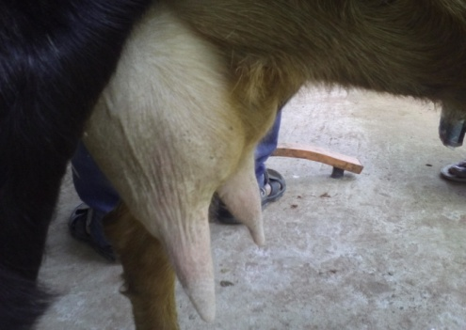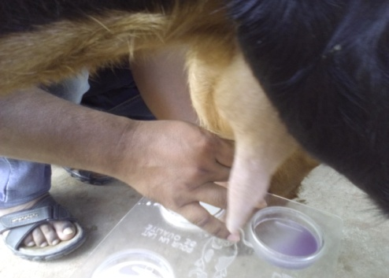
Fig 2: CMT Test
Fig 1: Swollen udder of Goat

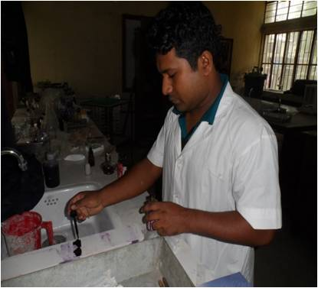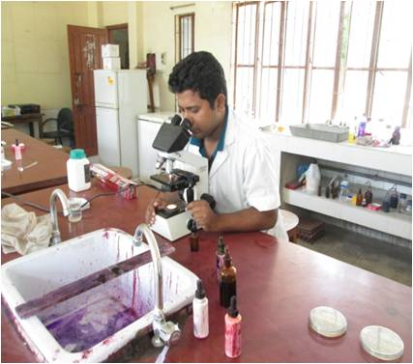
Fig 4: Under Microscope Examination
Fig 3: Gram’s Staining

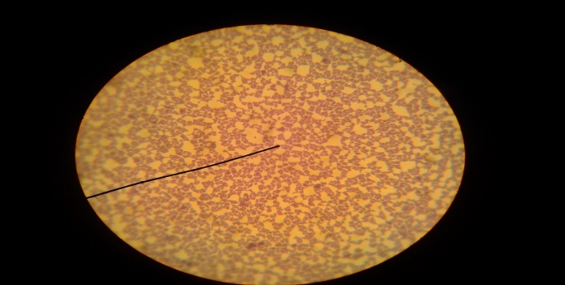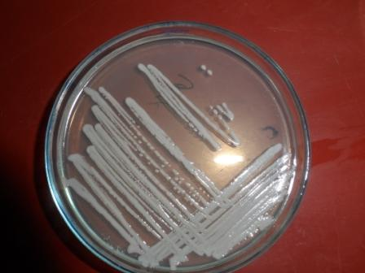
Fig 6: Staphylococcal growth on MHA
Fig 5: Gram-positive Staphylococci

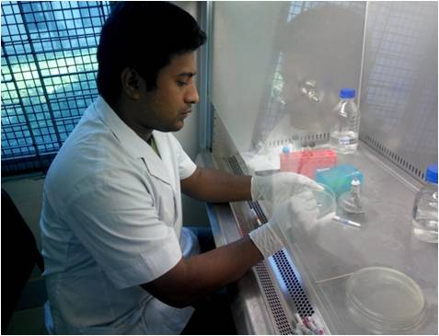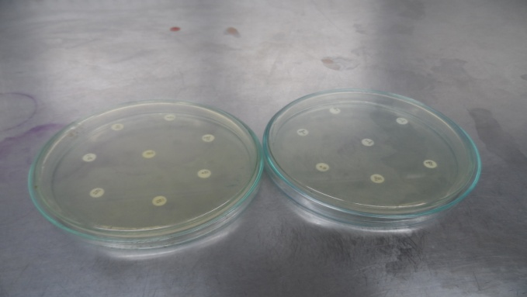
Fig 8: Placement of discs on MHA
Fig 7: Antibiotics susceptibility test
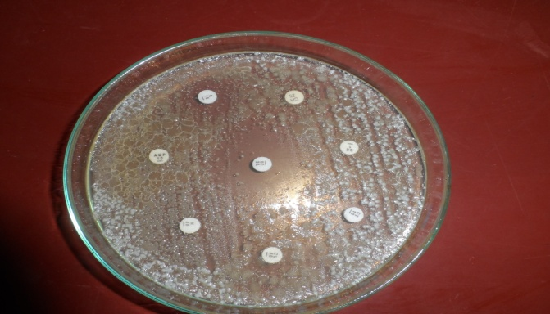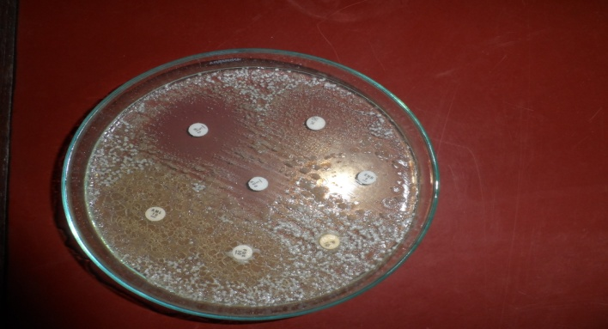
Fig 9: Results of CS test

Fig 10: Results of CS test

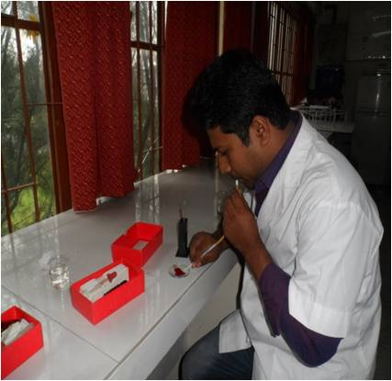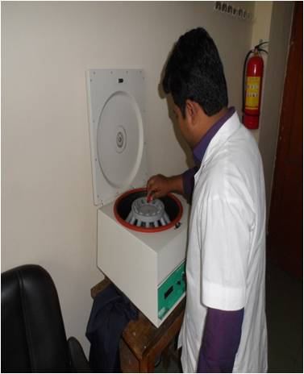
Fig 12: Centrifuging Blood
Fig 11: Hematological test

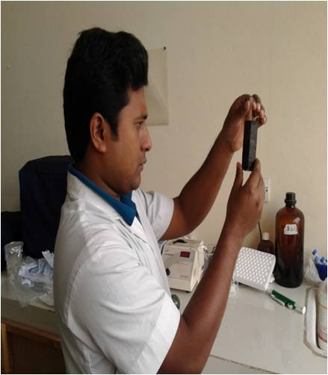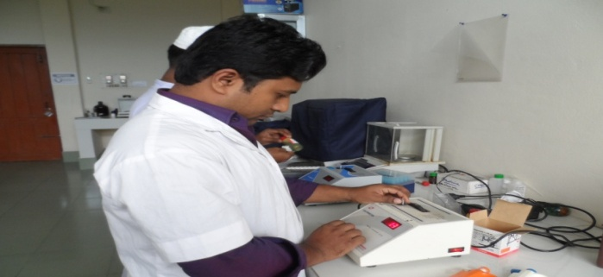
Fig 13: Color comparing for Hb test (1&2)
Fig 14: Bio-chemical test by Colorimeter

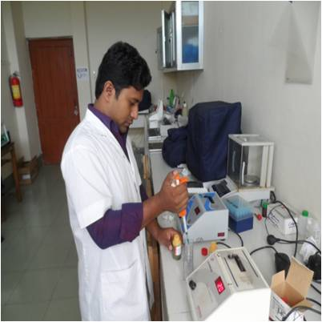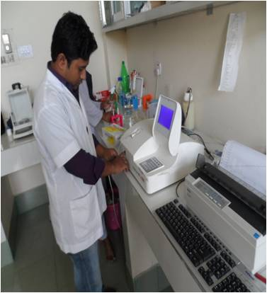
Fig 13: Mixing chemical agent
Fig 14: Bio-chemical test by Auto Analyzer

Chapter-4
RESULTS & DISCUSSION

Isolation and identification of Staphylococcus aureus
In the present study, the milk pH was recorded 7.4 and CMT was scored 3+. The causal agent associated with the mastitis was characterized by growth characteristics on blood and mannitol salt agar. Greyish white beta hemolytic, round, smooth and glistening colonies were obtained on blood agar after 24 hours of incubation while on mannitol salt agar, medium-sized yellow colonies were observed. No growth was found on MacConkey agar. The Gram-stained smear from the colonies revealed Gram-positive cocci with irregularly arranged grapes like cluster (Fig 5). The isolate was given positive reaction to catalase test. Based on these observations, the isolate was identified as Staphylococcus aureus and the finding is in consistent with the study of Islam et al. (2011). Staphylococci are the most important and prevalent pathogen associated with mastitis globally. Thisbacteriumis a contagious pathogen which can be transmitted during unhygienic milking procedures (Menzies and Ramanoon, 2001). S. aureus secretes several toxins contributing to the pathogenesis of mastitis. Minor occurrences in mammary infections of small ruminants are associated with E. coli and other bacteria, but they have also been involved with severe clinical mastitis. In the present case, clinical picture produced by Staphylococcus aureus could be due to different toxins produced by the bacterium which led to tissue damage and systemic reaction (Radostitset al., 2007).

Antimicrobial susceptibility test
The antimicrobial susceptibility of Staphylococcus aureus isolate was determined by disc diffusion method on Mueller Hinton agar plates against 12 different antibiotics. The isolate was sensitive to ciprofloxacin, erythromycin, enrofloxacin, gentamicin and colistin while displayed resistance to ampicillin, amoxicillin, chloramphenicol, tetracycline, kanamycin, streptomycin and penicillin.The resistance of staphylococci to different antibiotics is a major obstacle to the successful treatment of mastitis. Production of ß-lactamase by certain staphylococcal strains is the principal reason for failure. The prevalence of penicillin-resistant strains of Staphylococcusaureus differs from country to country. Kuwajocket al. (1999) reported 73% of Staphylococcusaureus isolates were resistant to multiple antibiotics. Resistance to macrolide antimicrobial agents is much less prevalent than resistance to penicillin, with rates of 14 to 17% being reported (Quinn et al., 2002).

In the present study, gentamicin was prescribed in association with amoxicillin, although amoxicillin was found to be resistant by the pathogen isolated from the case. The treatment was provided before getting the result of antimicrobials susceptibility test. The farmer could not be contacted further and it was not possible tofollow-up the animal. Therefore, the interpretation of the prescribed treatment remained unknown.

Haematology
The result of haematology in mastitis infected goat is illustrated in Table 2. The results showed that the red blood cell counts, packed cell volume, and haemoglobin were decreased, while total leukocytes count (TLC), lymphocytes, eosinophils, monocytes and basophils were unaffected. There was an increasein the neutrophil counts (Table 2), in agreement with the findings of Abba et al. (2013).The changes could be due to the degree of inflammatory responses at the systemic levels. The increased value of neutrophils indicates chemotactic factors released by the infectious agents and other immune system components that signal for the recruitment of neutrophil to the sites of infection.Neutrophils promote tissue injury and disturb mammary function and granular enzyme release responsible for tissue degranulation (Kehrliet al., 1994). The decrease in the values of TEC, haemoglobin and PCV could be attributed to parasitic infection which was not investigated in this study.

Blood plasma biochemistry
The results of blood plasma biochemistry are given in Table 3. No changes were observed with regard to calcium, sodium, potassium, chloride and iron. But the concentration of albumin and total protein was found in increasing level which is surprising. The reason for this high level of concentration cannot be explained from this study. Further study is warranted to determine the causes of this change.

Table 2.Results of hematological test in mastitis infected goat
Sl. no. | Haematology | Unit | Normal range | Result
1 | Red bloodcorpuscles | (TEC) ×10⁶/μl | 8 - 18 | 2.88
2 | Total Leukocytes Count | (TLC) ×10³/μl | 8 - 12 | 8.35
3 | Haemoglobin | (Hb) g/dl | 8 - 12 | 5.2
4 | Haematocrit | (PCV) Ratio | 22 - 38 | 13
5 | Erythrocyte sedimentation  rate | (ESR) Hours | 1 - 3 | 1
6 | Differentialleukocyte  count | %
i. | Neutrophils |  | 30 - 48 | 50
ii. | Lymphocytes |  | 50 - 70 | 55
iii. | Monocytes |  | 0 - 4 | 2
iv. | Eosinophils |  | 1 - 8 | 3
v. | Basophils |  | 0 - 1 | 0

Table 3. Results of biochemical test of blood in mastitis infected goat
Sl. no. | Blood plasma biochemistry | Unit | Normal range | Result
1 | Albumin (ALB) | mmol/l | 2.4 - 4.4 | 68.7
2 | Total protein ( TPROT) | mmol/l | 6.4 –7.8 | 27
3 | Calcium | g/dl | 8.9 - 10.6 | 8.6
4 | Phosphorus | g/dl | 3.2 - 9.8 | 5.3
5 | Sodium | mmol/l | 133.5 – 154 | 147.5
6 | Potassium | mmol/l | 4.6-9.8 | 5.2
7 | Magnesium | mmol/l | 2.1 - 2.9 | 3.7
8 | Chloride | mmol/l | 105 – 120 | 104.5
9 | Iron | μg/dl | 60-170 | 138.25

Chapter-5
CONCLUSION

The results in the present study indicate that Staphylococcusaureus is the major bacterial pathogen responsible for causing goat mastitis.The isolated bacteriawere sensitive to ciprofloxacin, erythromycin, enrofloxacin, gentamicin and colistin while exhibited resistance to ampicillin, amoxicillin, chloramphenicol, oxytetracycline, kanamycin, streptomycin and penicillin. There are fluctuations in hematological and blood plasma biochemical parameters which could be due to the physical, pathological, and glandular changes.

Chapter-6
REFERENCES

Ameh, J.A., Addo, P.B., Adekeye, J.O., and Gyang, E.O., (1993).Prevalence of clinical mastitis and of intramammary infections in Nigerian goats.Preventive Veterinary Medicine 17: 41-46.
Abba, Y.,Ikechuckwu,O.,Lawan,A., Ibrahim, B., (2013) . Alterations in hematological and serum biochemical parameters of Sahel goats with clinical mastitis.IOSR Journal of Agriculture and Veterinary Sciences 4: 74-77.

Boscos, C., Stefanakis, A., Alexopoulos, C., and Samartzi, F., (1996).Prevalence of subclinical mastitis andinfluence of breed, parity, stage of lactation and mammary bacteriological status on Coulter Counter Countsand California Mastitis Test in the milk of Saanen and autochthonous Greek goats.Small RuminantResearch 21:139–147.

Bhujbal, J., Deshumukh, V., Abdul, A., Gujar, M., and Aziz, A., (1999). Goat mastitis microflora and antibiogram.Indian Journal of Comparative Microbiology, Immunology and Infectious Diseases 20: 44-46.

Contreras, A., Luengo, C., Sanchez, A., and Corrales, J.C., (2003).The role of intramammary pathogens in dairy goats.Livestock Production Science 79: 273-283.

Contreras, A., Sierra, D., Sanchez, A., Corrales, J., Marcoc, J., Paape, M., and Gonzalo, C., (2007). Mastitis in small ruminants.Small Ruminant Research 68: 145–153.

Detilleus,J.,(2001).Genetic improvement of resistance to infectious diseases in livestock.journal of Dairy science 84,E-39,E-46.

Egwu, G.O., Zaria, L.T., Onyeyili, P.A., Ambali, A.G., Adamu, S.S.,and Birdling, M .,(1994).Studies on the microbiological flora of caprine mastitis and antibiotic inhibitory concentrations in Nigeria.Small RuminantResearch 14: 233-239.

Erskine, R.J.,(2001): Mastitis control in dairy herds:Radstitis O.M (Ed.)Herd Health.Food Animal production Health

Fausyi, A. O., (2007). Amaranthuserentus leaf meal as a protein supplement in goat; Hematological response carcass characteristics and relative organ weights. Food Agriculture nutrition and development; 7(6):239-247.

FAO (2007).Production Yearbook 2007.Food and Agriculture Organization of the United Nations.Statistical Series, Rome, Italy.

Ibrahim, A., Kursat, K., and Haci, A.C., (2009). Identification and Antimicrobial Susceptibility of subclinical mastitis pathogens isolated from hair goats’ milk. Journal of Animal and Veterinary Advances 8: 4086-90.

Jain, N.C.,(1986).Schalms Veterinary Haematology. 4thed.,Lea and Febiger, Philadelphia,USA

Jha, V.C., Thakur, P.R., and Yadav, J.N., (1994). Bacterial species isolated from clinical bovine mastitis and theirantibiotic patterns. Veterinary Review Kathmandu 9: 21-23

McDougall, S., Pankey, W., Delaney, C., Barlow, J., Murdough, P.A., and Scruton, D., (2002).Prevalence and incidence of subclinical mastitis in goats and dairy ewes in Vermont, USA.Small Ruminant Research 46: 115– 121.

Menzies, P.I., and Ramanoon, S.Z., (2001).Mastitis of sheep and goats.Veterinary Clinical North America Food Animal Practice 17: 332-352.

Navarre, C., (2007). A comperative study on Haematology and serum Biochemistry, Indian Veterinary Journal,58.526 – 528.

Owen,J.B.,Axfor, R. F.E.,and Bishop,S.C.,(2000).Mastitis in dairy cattle .In:Axfort ,R.F.E., Bishop,S.C.,Nicholas,F.W and Owen,J.B.,(eds)Breeding for disease resistance in farm animals .CAB International , Wallingord pp.243-252.

Radostits, O.M., Gay, C.C., Hinchcliff, K.W., et al. (eds). Veterinary medicine –A Textbook of the Diseases of Cattle, Horses, Sheep, Pigs, and Goats. 10. ed. Philadelphia:
Saunders, 2007.p.673-762.

Ribeiro, M. G., Lara, G. H. B., Bicudo, S. D., Souza, A. V. G., Salerno, T., Siqueira, A. K., Geraldo,J.S.,(2007). An unusual gangrenous goat mastitis caused by Staphylococcus aureus, Clostridium perfringens and Escherichia coli co-infection. Arq Bras Med Vet Zootec. 59(3):810–812. Doi: 10.1590/S0102-09352007000300037.

Rahman, A., (1981). Mastitis in goat and its treatments with leukomycin.Veterinary Medical Review2: 183-185.

Rahman MM and Samad MA (1984).A note on the incidence of mastitis in Black Bengal goat.Veterinarian (India) 8: 11.

Smith,K.L.,&Hogen,J.S.,(1993):Envirenmental mastitis.Veterinary Clinics of North America:Food Animal Practice9,489-498.

Sanholm,J.M.,Hokanen-Buzalski,T.,Kaartinen,L.,and Pyorala,S.,(1995).The bovine udder and mastitis .University of Helsinki, Faculty of Veterinary Medicine

Samad, M.A., (2008).Animal Husbandry and Veterinary Science.Volume 2, 1st edn., LEP No.11, BAU Campus, Mymensingh, Bangladesh.

Stela,Z.,Irina,T.,and Dorina,N.,(2010).observations concerning heaematological profileing goat www.Univagro_iasi,ro/revista_zoo/ro/pdf...../z018_stela=zamfirescu.pdf.

Schalm, O.W., jain, N.C., Carrol, E.J., (1975).Veterinary Hematology, 3rd Edition. Leu&Febiger.Philadelphia,405-470.Global distribution of peste des petits ruminants
virus and prospects for improved diagnosis and control.
Sordillo, L. M.,(2005). Factors affecting mammary gland immunity and mastitis susceptibility.LivestockProductionSciences. 98:88-99.

Szabo, A.; Mezes, M.; Horn, P.;Suto, Z.; Bazar, G.; Romvari, R., (2005).Developmental dynamics of some blood biochemical parameters.

Tambuwal, F.M., B.M. Agaie and A. Bangana.,( 2002).Serum electrolyte Hematological and biochemical values of and protein levels in Nigerian White Fulani and apparently healthy Red Sokoto goats.

Quinn, P.J., Carter, M.E., Markey, B., and Carter, G.R., (1999).Clinical Veterinary Microbiology.Mosby Publishing, London. p 327-244.

Wooding, F.B., Morgan, G., and Craig, H., (1977). “Sunbursts” and “christiesomes”: cellular fragments in normal cow and goat milk. Cell Tissue Research 185: 535 –545

Wakwoya, A., Molla, B., Belihu, K., Kleer, J., and Hildebrantdt, G., (2006).A cross-sectional study on the prevalence, antimicrobial susceptibility patterns and associated bacterial pathogens of goat mastitis.International Journal of Applied Research in Veterinary Medicine 4: 169-176.

