*TABLE OF CONTENTS*

*LIST OF FIGURES 2*

*LIST OF TABLES 3*

*PLAGIARISM CERTIFICATE 4*

*ACKNOWLEDGEMENT 5*

*ABSTRACT 6*

*Chapter: 1 7*

*INTRODUCTION 7*

*Chapter: 2 10*

*REVIEW OF LITURATURE 10*

*2.1 PPR (Peste des petits ruminants) 10*

*2.2 Morphology of the PPRV 10*

*2.3 Geographical Distribution 11*

*2.4 Incidence of PPRV 12*

*2.5 Host Range of PPRV 12*

*2.6 Association between PPR and age of goat 12*

*2.7 Association between PPR and sex of goat 12*

*2.8 Transmission of PPRV 12*

*2.9 Pathogenesis 13*

*2.10 Clinical signs of PPR 13*

*2.11 Concomitant infection with PPR: 14*

*2.12 Differential Diagnosis 14*

*2.13 Treatment of PPR 14*

*2.14 Prevention and control of PPR 15*

*CHAPTER: 3 15*

*MATERIALS AND METHODS 16*

*3.1 Location and duration of the study 16*

*3.2 Study population 16*

*3.3 Case definition 16*

*3.4 Clinical examinations of PPR cases 16*

*3.5 Follow up treatment 18*

*3.6 Data analysis 18*

*Chapter: 4 19*

*RESULTS AND DISCUSSION 20*

*4.1 Prevalence of PPR based on age category 20*

*4.2 Association of prevalence with sexes of goats 21*

*4.3 Prevalence of PPR in both breeds of goats 22*

*4.4 Response to trearment in relation to different drugs 23*

*4.5 Limitation of the study 24*

*Chapter: 5 25*

*CONCLUSION 25*

*Chapter: 6 26*

*REFERENCES 26*

# 

# *LIST OF FIGURES*

|  |  |  |
| --- | --- | --- |
| ***SL. No.*** | ***Title*** | ***Page No.*** |
| *1* | *Schematic representation of the PPR morbillivirus* | *10* |
| *2 (a)* | *Goat showing ocular discharge* | *16* |
| *2 (b)* | *Goat showing nasal discharge* | *16* |
| *2 (c+d)* | *Oral lesions (erosions) in PPR affected goat* | *16* |
| *2 (e)* | *Diarrhoea in PPR affected goats* | *16* |
| *2 (f)* | *PPR affected goat having high fever* | *16* |
| *4.1* | *Prevalence of PPR in relation to age* | *21* |
| *4.2* | *Prevalence of PPR in relation to sex* | *22* |
| *4.3* | *Prevalence of PPR in relation to breed* | *23* |
| *4.4* | *Response to treatment in relation to different drugs* | *24* |

# *LIST OF TABLES*

|  |  |  |
| --- | --- | --- |
| ***SL. No.*** | ***Title*** | ***Page No.*** |
| *4.1* | *Prevalence of PPR in goats in different age categories.* | *20* |
| *4.2* | *Prevalence of PPR in goats of different sexes* | *21* |
| *4.3* | *Prevalence in relation to breeds of goat.* | *22* |
| *4.4* | *Response to treatment in relation to different drugs* | *23* |

# PLAGIARISM CERTIFICATE

Myself Md.Asrafur Rahman strongly assures that I have performed all works furnished here in this report. The Informations have been collected from books, national and international journals, websites and other references. All references have been acknowledged duly.

Therefore, I hold entire responsibility of for collection, compilation, preservation and publication of all data accumulated here in this report.

# 

# ACKNOWLEDGEMENT

All praises are due to “Almighty Allah”, who has given the opportunity to accomplish of this report successfully.

The author wishes to express his deepest sense of gratitude, sincere appreciation, indebtedness and profound regards to his respected supervisor **Dr. Tania Ferdushy,** AssociateProfessor, Department of pathology and parasitology, Chittagong Veterinary and Animal Sciences University, for her constructive and constant guidance in planning and execution of this research work, continuous encouragement, scholastic guidance, and affectionate feelings throughout the course of research work.

I also grateful to honorable **Dr.Oshim Kumar Pramanik,** Thana Livestock Officer(Metro), Boalia, Rajshahi, for his supervision and kind co-operation during the period of internship in TVH,Boalia, Rajshahi.

Finally, it is my pleasure to express big thanks to all of my well-wishers, roommates, close friends for this encouragement and inspiration to complete my clinical report during study period.

The Author

# ABSTRACT

The study was carried out to investigate the prevalence of Peste des petitis ruminants (PPR) in goats in Rajshahi District of Bangladesh, and its relation to age, sex, breeds and response to treatment. In total, 268 goats were examined where 160 were males and 108 were females. The overall prevalence of PPR in goats was found to be 20.14% (n=54). From the various risk factors analyzed, age, sex and breed categories of goats were found not to be significantly associated (p>0.05) with the prevalence of PPR. The influence of sex on PPR outbreaks was found to be higher in male (23.12%) than female (15.15%) goats. As regards to age, PPR was significantly higher in young (26.05) compared to suckers (15.15%) and adult (16.00%). The susceptibility of Black Bengal goats to PPR was higher than other breeds. The percentage response of treatment towards parenteral (I/M) oxytetracycline was higher (66.66%) than parenteral (I/M) Sulphadimidine (55.55%).The results of this study showed that PPR is an important goat disease in the studied areas. Thus, an appropriate control strategy has to be designed and applied, which could involve prevention of contact with infected goats and vaccination against the PPR virus

**Keywords:** goats,Peste des petitis ruminants, prevalence, risk factors

## Chapter: 1

# INTRODUCTION

Small ruminants especially goat is very important in rural economy and nutrition and has the potentially of using it as a tool for poverty reduction in Bangladesh. Goats, as far as known, were probably the first domesticated animals (Herre and Rohrs, 1973). At present, there are 677 million goats and represents fourth largest livestock group of the world (Morand-Fehr and Boyazoglu, 1999). Most of the goats (90%) reared are Black Bengal (Amin *et al.*, 2001), reputed for their prolificacy, fertility, early sexual maturity, adaptability to hot humid conditions and superior quality meat and skin (Devendra and Burns, 1983; Hussain, 1999; Amin *et al.*, 2001). Goat meat and skin ranked 38% and 28% respectively, of the total meat and skin produced from livestock in Bangladesh (FAO, 1997). Goats participate in a vital position with lasting agricultural farming, employment generation as well as enhance the traditional economy of Bangladesh. Goats husbandry is one of the most important sources of incomes for rural families, marginal farmers, children, landless laborers and distress women who cannot afford to rear cattle, hence, goat is called "The cow of poor people" in Bangladesh. They provide mainly milk, meat, hides and skins as important export item. There are about 20.75 million goats in Bangladesh. This goats acquired second placement with regards to meat, milk along with skin manufacturing addressing information about 38.0%, 23.0% in addition to 28.0% respectively around the overall contribution involving livestock in Bangladesh (Devendra, 2007).

According to the data of DLS (2012) there are about 23.1 million cattle, 1.39 million buffaloes and 24.2 million goats in the country. Most goats (90%) reared in Bangladesh are of Black Bengal breed (Amin *et al.,* 2001), reputed for their prolificacy, fertility, early sexual maturity, adaptability to hot humid conditions and superior quality meat and skin (Devendra and Burns, 1983; Hussain, 1999; Amin *et al.,* 2001). Goat rearing is a subsidiary income source to rural poor along with agriculture. In majority of cases the flock size ranges from 1 to 4 (56%). Male female ratio in adult flock is observed as 1:8 in field condition. The animals are mostly housed along with residential housing (67.1%); houses are mostly kachha type (82.63%) with earthen floor (86.47%) and straw roof (91.33%). All most all the farmers used to graze their goats for feeding. Ponds water is the major source for drinking water (58.14%) of goats. Black Bengal Goats have natural resistant power to many diseases but are vulnerable to cold, water logging situation, diarrhoea, ecto and endo parasitic infestation and respiratory diseases. Under field condition mortality rate is 9.63% (Nandi *et al.*, 2011).

Goat is numerically and economically important and promising animal resources in the developing countries especially in Asia and Africa (Hussain, 1999). It is an important source of income for the poor people. Goats are raised by poor farmers and distressed women with little capital investment (FAO, 1991). It is estimated that more than 90% of goat population comprised of Black Bengal goat (BBGs). Goats rank first position in terms of total livestock population in Bangladesh (FAO, 1999). Bangladesh Government has also given special emphasis and adopted a national programme on Black Bengal goats for poor farmers to reduce poverty with targeting the Millennium Development Goals(MDGs) achievement since 2003 (Kader, 2006).

PPR (5.2%), tetanus (1.1%), mastitis (0.9%), Gid disease (2.5%), urolithiasis (1.1%) and myiasis (16.4%) in goat was reported by (Rahman *et al,.* 2012). Peste des Petits Ruminants (PPR) is the French name of a Rinderpest like disease in sheep and goats first described in Ivory Coast, West Africa in 1942. Many others prefer the appellation of stomatitis-pneumoentritis complex disease, pseudorinderpest of small ruminants and kata. But official instances like *Food and Agricultural Organization (*FAO) and *Office International des Epizooties (*OIE*)* use the French name PPR (Banik *et al.,* 2008).

The disease is endemic in the Arabian Peninsula (Taylor *et al.*, 1990), the Middle East and in the Indian subcontinent (Shaila *et al.*, 1996). The existence of PPR in goats has been recognized and confirmed by the World Reference Laboratory, National Reference Laboratory for PPR, Greifswald, as early as 1993 (Sil *et al*., 1995). It was found that the isolates from Bangladesh were closely related with other strains from India, and clustered within the Asian group of PPR viruses (Barrett *et al.*, 1997).

The outbreaks of PPR caused 74.13% morbidity and 54.83% mortality in Black Bengal goats in Bangladesh (Islam *et al.*, 2001 and Das *et al.*, 2007). Since, no studies on the prevalence of PPR in goats have been undertaken in this area, the present study was therefore carried out to investigate the prevalence of PPR in goats in Rajshahi of Bangladesh, and its relation to age, sex, breeds and seasonality.

Control of PPR is based on a concerted effort of vaccination and sanitary measures. At present homologous PPR vaccine has been practiced against PPR to make up strong immunity in Bangladesh. Ravages caused by PPR act as one of the prime production limiting factors in goats all over the world. Infectious and contagious diseases are important impediments to the economical rearing of small ruminants (Radostits *et al.,* 2000). Among these diseases, Peste des petits ruminants (PPR) have become a concern because it causes heavy economic losses. In this study efforts have been made to estimate the prevalence of PPR of goats in TVH, Boalia, Rajshahi of Bangladesh. In this report the diagnosis was based on owners complain, clinical history, clinical signs.

With the background mentioned above this study was undertaken with the following specific objectives:

* To know the prevalence of PPR affected goat in TVH, Boalia, Rajshahi.
* To know the efficacy of drugs against PPR.
* To know antimicrobial drug used against PPR.

## Chapter: 2

# REVIEW OF LITURATURE

### 2.1 PPR (Peste des petits ruminants)

Peste des petits ruminants (PPR) are an acute and highly contagious viral disease of small ruminants that is caused by a non segmented negative strand RNA virus, Peste des Petits Ruminants Virus (PPRV). This virus is a member of the morbillivirus genus and as such is closely related to rinderpest virus (RPV). The etiological agent, Peste des Petits Ruminants virus (PPRV) has been classified under Order Mononegavirales, family Paramyxoviridae and Genus Morbillivirus (Murphy *et al.,* 1999). The recent eradication of (RPV) has increased the global interest in PPRV and has highlighted its potential for elimination using a similar vaccination and surveillance strategy (Baron *et al.,* 2011).Peste des Petits Ruminants Virus infection causes an acute, highly contagious disease characterized by fever, anorexia, necrotic stomatitis, diarrhoea, purulent ocular and nasal discharges, and respiratory distress (OIE, 2000). Infection rates in animals rise with age, and the disease, which varies in severity, is rapidly fatal in young animals. As with other morbillivirus infections, PPRV needs close contact between infected and susceptible animals to spread (Lefevre and Diallo, 1990). Goats are more severely affected than sheep. It is also known as pseudorinderpest of small ruminants, pest of small ruminants, pest of sheep and goats, kata, stomatitis-pneumoentritis syndrome, contagious pustular stomatitis and pneumoentritis complex (Chauhan *et al,* 2009*).*

### 2.2 Morphology of the PPRV

The virus particle is pleomorphic with a diameter of intact particles varying between 130-390 nm. The virus has an envelope of 8-15 nm thickness with spikes of 8.5-14.5 nm length. The herring bone like ribonucleoprotien strands measure approximately 14-23 nm in thickness (Durojaiye *et al.,* 1985). Genome of PPR virus is non-segmented single stranded RNA of negative polarity. The genome of PPRV encodes for eight proteins: the nucleocapsid protein (N), the phosphoprotein (P), the matrix protein (M), the fusion protein (F), the haemagglutinin protein (H), the polymerase protein (L) and the two non-structural proteins, C and V. Interaction of the PPRV H and F proteins with the host plasma membrane leads to viral entry by binding of the H protein to receptors (signal lymphocyte activating molecules and other unidentified receptors). Briefly, the P protein regulates transcription and replication and assembly of the N protein to nucleocapsids, the M proteins mediate viral assembly. The role of C and V proteins in PPRV is still not clear (Maganga *et al.,* 2013).

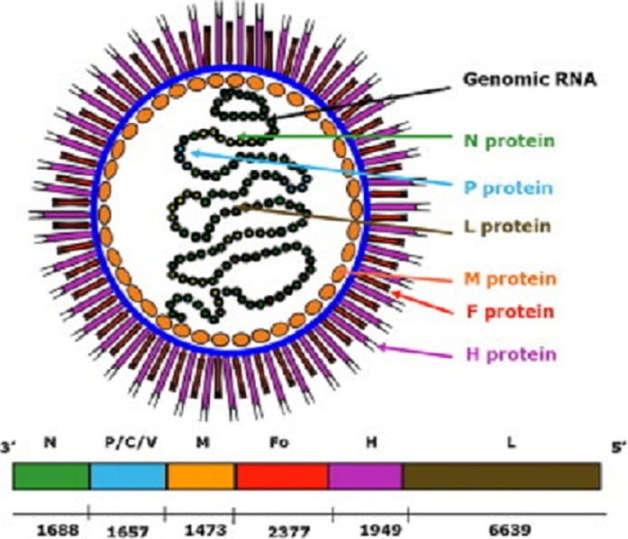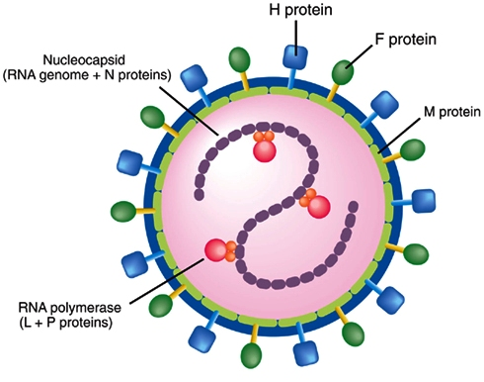

**Fig. 1.**Schematic representation of the PPR *morbillivirus*

### 2.3 Geographical Distribution

PPR was first reported in the Ivory Coast of West Africa and was later found in other parts of the world incuding sub Saharan Africa, the Arabian Peninsula, the Middle East, and the parts of Asia (Balamurugan *et al.,* 2012). Outbreaks of PPR are now known to be common in India, Nepal, Bangladesh, Pakistan and Afghanistan (Abdollahpour *et al.*, 2006). In Bangladesh, the presence of PPR in goats was detected by FAO expert team in 1993. Disease investigation among organized goat farm in Bangladesh showed that outbreaks were always associated with introduction of new goats to the farm. Occurrence of PPR in an epidemic form has a drastic effect on the goat population in Bangladesh (Khan *et al.,* 2005). PPR in Bangladesh is distributed across the country throughout the year however significantly higher in western provinces. There are several diseases of goat especially PPR, causes higher mortality and great economic losses. PPR is an exotic disease of goats in Bangladesh (Debnath, 1995; Islam *et al.,* 2001).

### 2.4 Incidence of PPRV

Environmental factors influence disease occurrence. Hegde *et al.* (2009) showed that incidences were highest during the rainy season and in the dry agroclimatic zones. The dusty and dry winds that characterize winter season of the year has been shown to enhance the spread of PPR (Obi, 1983).The outbreaks of 74.13% morbidity and 54.83% mortality in Black Bengal goats in Bangladesh in rainy season (Islam *et al.,* 2001 and Das *et al.,* 2007).

### 2.5 Host Range of PPRV

Cattle, buffaloes, camels and pigs can also be infected but without having any clinical sign. PPRV antigen has been detected in an outbreak of respiratory disease in camel and sick domestic buffaloes (Taylor *et al.*, 1990; Scott, 2000; Abraham *et al.*, 2005)Antelope and other small wild ruminant species can also be severely affected (Abu Elzein *et al.*, 2004).

### 

### 2.6 Association between PPR and age of goat

Young kids of below one year are much more susceptible than adult one (Radostits *et al*, 2000). The maximum proportionate of PPR was encountered 37.5% at the category of 7 to 12 month subacute manner. The young goat may die due to anoxia.The high risk of having disease in goat Kids over 4 months and under 1 year of age cause huge economic loss (Venkataramanam *et al*, 2005).

### 2.7 Association between PPR and sex of goat

There is no detail finding about the PPR infection of goat in different sex.Both male and female goats are equally susceptible to PPR (Samad, 2001).

### 2.8 Transmission of PPRV

Although the virus is highly contagious, it can only be transmitted when a healthy animal comes into direct contact with the secretions or excretions of a sick animal. Inhalation is thought to be an important route of spread. PPRV is shed in nasal and ocular secretions, saliva, urine and feces. It probably occurs in milk (Centre for Food Security and Public Health, 2008). Since the virus is enveloped, it is extremely sensitive to inactivation by environmental factors such as heat, sunlight and chemicals. It, therefore, require close contact with an infected animals for successful transmission. The disease is transmitted by aerosols between animals living in close contact (Lefevre and Diallo, 1990).

### 2.9 Pathogenesis

PPR virus, Like all morbilliviruses, PPRV has an established lymphatic and epithelial tropism. The signaling lymphocyte activation molecule (SLAM) is well recognized as the universal receptor for morbillivirus infection of immune cells, and this receptor tropism results in the leukopenia observed during infection ( Bao *et al.*, 2012). Consequently, it induces the most severe lesions in organ systems rich in lymphoid and epithelial tissues. The respiratory route is the likely portal to entry. After the entry of the virus through the respiratory tract system, it localizes first replicating in the pharyngeal and mandibular lymph nodes as well as tonsil. Viremia may develop 2-3 days after infection and 1-2 days before the first clinical sign appears. Subsequently viremia results in dissemination of the virus to spleen, bone marrow and mucosa of the gastrointestinal tract and the respiratory system (Scott, 1981).

### 2.10 Clinical signs of PPR

Animal affected by PPR shed the virus in exhaled air, in secretions and excretions (from the mouth, eye and nose, and in feces, semen, and urine) approximately 10 days after the onset of fever (Maganga *et al.*, 2013). Clinical signs of PPR have been well documented (Roeder *et al.*, 1994; Roeder and Obi, 1999). Following infection there is a 3–4 day incubation period. The predominant form of the disease is the acute form. The salient clinical signs start with sudden rise in body temperature to 39.5 - 41°C. Affected animals breathe fast, sometimes so fast that they exhibit rocking movements with both the chest and abdominal walls moving as the animal breathes. They have obvious signs of pneumonia. A clear watery discharge starts from the eyes, nose and mouth, later becoming thick and yellow as a result of secondary bacterial infection. Appearance of a serous to mucopurulent nasal discharge which may crust over and occlude the nostril, sneezing, ocular discharge resulting in matting of the eyelids. The discharges wet the chin and the hair below the eye; they tend to dry, causing matting together of the eyelids, obstruction of the nose and difficulty in breathing. Unlike RP, there is a definite but inconstant, respiratory system component (Brown *et al.*, 1991; Bundza *et al.*, 1988).

Body temperature usually remains high for about 5-8 days, and then slowly returns to normal prior to recovery or drops below normal before death. Diarrhoea commonly appears about two to three days after the onset of fever although, and death is usually preceded by pneumonia (Hamdy *et al.*, 1976). The faeces are initially soft and then watery, foul-smelling and may contain blood streaks and pieces of dead gut tissue. Such victims may eventually become dehydrated with sunken eyeballs, and death often follows within seven to ten days from onset of the clinical reaction. Other animals will recover after a protracted convalescence.

### 2.11 Concomitant infection with PPR:

The most significant bacteria associated with PPR infected goats were *Pasteurella haemolytica, Klebsiella* spp., *Pseudomonas aeruginosa* and *Staphylococus pyogenes* from the lungs, *Salmonella* spp. and *E. coli* from the faeces, *Moraxella bovis* from the eyes and *Staphylococcus pyogenes* from the oral cavity. Pneumonia is usually a very obviously presented sign in PPR. Pneumonic pasteurellosis is a purely respiratory disease of sheep and goats caused by the bacterium *Pasteurella haemolytica* (Obi *et* *al*. 1983).

### 2.12 Differential Diagnosis

The disease must be differentially diagnosed from Foot and Mouth disease, Bluetongue, Contagious ecthyma, Pasteurellosis, Contagious caprine pleuropneumonia, Nirobi sheep disease, Coccidiosis, Plant and Mineral poisoning etc. (Appel *et al.*, 1981).

### 2.13 Treatment of PPR

There is no specific treatment for PPR, however hyperimmune PPR serum produced in goats reverses the disease process if administered at the onset of fever (Ihemelandu *et al.,* 1985). The affected animals were given antibiotics to control secondary bacterial infections along with antiinflammatory drugs. Specifically, oxytetracycline and chlortetracycline are recommended to prevent secondary pulmonary infections (OIE, 2000). Sil *et al.* (2006) reported that, the use of combined antibiotic hyper immune serum therapy (ACHST) for PPR helpful to overcome the condition. For diarrhoeal conditions, they suggested to administer 10 ml hyperimmune serum intravenous route per animal three doses every three days interval. Long acting Oxytetracycline tabs 1ml/10 kg body weight 2nd dose after 72 hours of 1st dose. A mixture of Oxytetracycline tabs and Metranidiozol (1:1) oral doses twice daily until diarrhoea subsides.

### 2.14 Prevention and control of PPR

Control of PPR outbreaks depends on movement control combined with the use of vaccine. Although vaccination against PPR is being practiced in Bangladesh and other countries, PPR is still causing major constraints to the productivity of small ruminants. Therefore, development of effective prophylactic procedures along with rapid, specific and sensitive diagnostic methods is extremely important for effective control of the disease. Singh *et al.,* (2009) said that, the availability of an effective vaccine, accurate diagnostic tests for PPR and an experienced infrastructure prompt us to propose a national project for a Peste des Petits Ruminants eradication programme on the lines of National Project on Rinderpest Eradication. To control peste des petits ruminants (PPR) in Bangladesh a live attenuated conventional PPR vaccine was developed by Bangladesh Livestock Research Institute (BLRI) and currently being used in the country (Rahman *et al.,* 2011). This would greatly enhance the prospects of PPR eradication not only on a national level but also from the Asian continent, alleviate poverty and, in turn, contribute to the national economy.

## 

## CHAPTER: 3

# MATERIALS AND METHODS

### 3.1 Location and duration of the study

The study was conducted at the Thana Veterinary Hospital (Metro), Boalia, Rajshahi during February, March and April 2014. All the goats registered here were clinically examined for the presence of PPR.

### 3.2 Study population

A total of 268 goats were examined in the hospital during the study period 54 of them were affected with PPR. All the examined animals were divided into different categories such as age (Adult,Young and Suckler), breed (Black Bangal, Jamunapari and Cross breeds), sex (Male and Female) and treatment.

### 3.3 Case definition

Diagnosis was made by means of history and clinical signs. A PPR case was initially suspected if an animal showed signs of fever in the initial stage followed by pneumoenteritis evidenced by nasal and ocular discharges, conjunctivitis, and erosion in oral mucosa, dyspnoea, diarrhoea, dehydration, generalized weakness and finally death. The degree of dehydration was estimated by conventional skin fold test. All the clinical signs were properly noted in the record sheet.

### 3.4 Clinical examinations of PPR cases

**History:**

Data were recorded by interviewing the owners regarding the breed/sex/age/vaccination status/management practice of the animals; probable date of clinical onset of the disease with the signs like fever, nasal and ocular discharges, diarrhea, depressed appetite from the last two or three days of clinical onset.

**Clinical inspection:**

1. Close inspection was done carefully for each case to observe the signs :
2. Rough hair coat
3. Erosion in gum, tongue, and margin of the upper and lower lips
4. Conjunctivitis
5. Serous nasal discharge with froth becoming mucopurulent.
6. Lacrimation on the eyes.
7. Diarrhoea
8. Per rectal temperature was recorded with a thermometer.
9. Indirect auscultation was performed by means of a stethoscope to hear lung sound
10. A conventional skin fold test was performed to estimate the degree of dehydration.

**Clinical signs and symptoms:**

The following clinical signs were observed while treating the patients :

1. Markedly depressed and dull appearance
2. Rough hair coat
3. Thick serous or purulent discharge from the eyes and nose
4. Sudden high fever ( 104˚-105˚ F), remaining high for 5 to 8 days, will return to normal before recovery or drop below normal before death.
5. Anorexia, severe dehydration and emaciation followed by hypothermia.
6. The mucous membrane of the mouth and eyes become much reddened and small pinpoint grayish areas appeared on the gum, dental pad, palate, lips, and upper surface of the tongue and characteristics foul smell came out from mouth.
7. Feces were semisolid and liquid brown, yellow and black colored, watery foul smelling and contain blood streaks and pieces of dead gut tissue.
8. In severe cases, difficulty in breathing marked by extension of head and neck, dilation of nostril, protrusion of the tongue and soft painful coughs.

### 3.5 Follow up treatment

For observing the treatment efficacy the goats were divided into two groups. Combined therapy **Teatment-1** [Diadin (Sulphadimidine-Na) + Dellergen (Promethazine Hcl) + Renalyte(ORS)] and **Treatment-2** [Renamycin-100 (Oxytetracycline) + Histavet (Chlorphenaramine maleate) + Filin (Aminophyline)]was given in separete groups.

### 3.6 Data analysis

All the data that were collected (age, sex breed and treatment) were entered to MS excel (Microsoft office 2007, USA) and analyzed by using SPSS version 13 (Coakes *et al.*, 2006). Descriptive statistics were used to determine the prevalence of the disease and the chi- square (χ2) test was utilized to examine the significance of the differences observed within the categories analyzed.

## 

**PPR Infected goat**

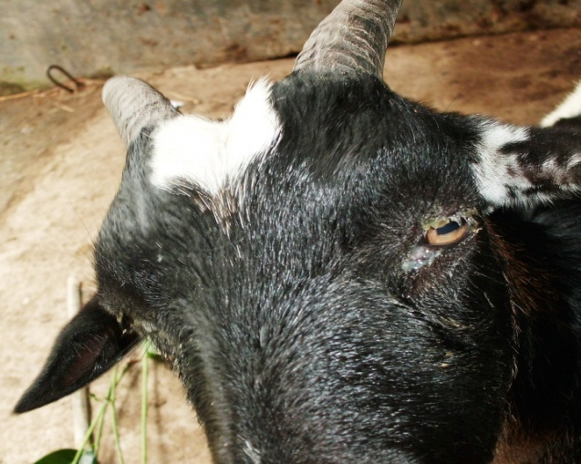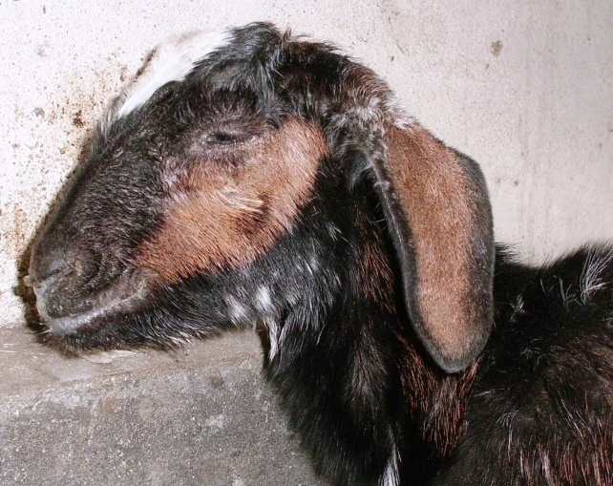

**b**

**a**

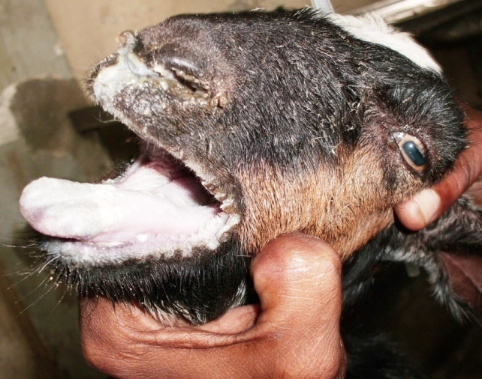

**d**

**c**

**d**

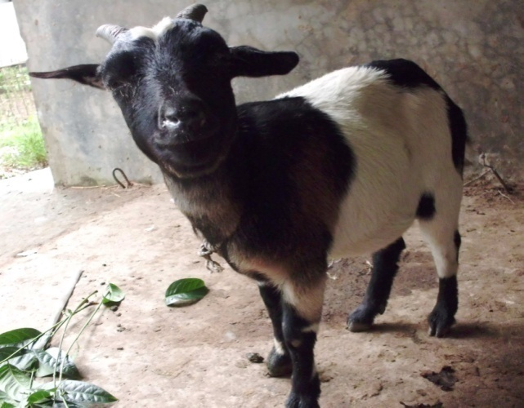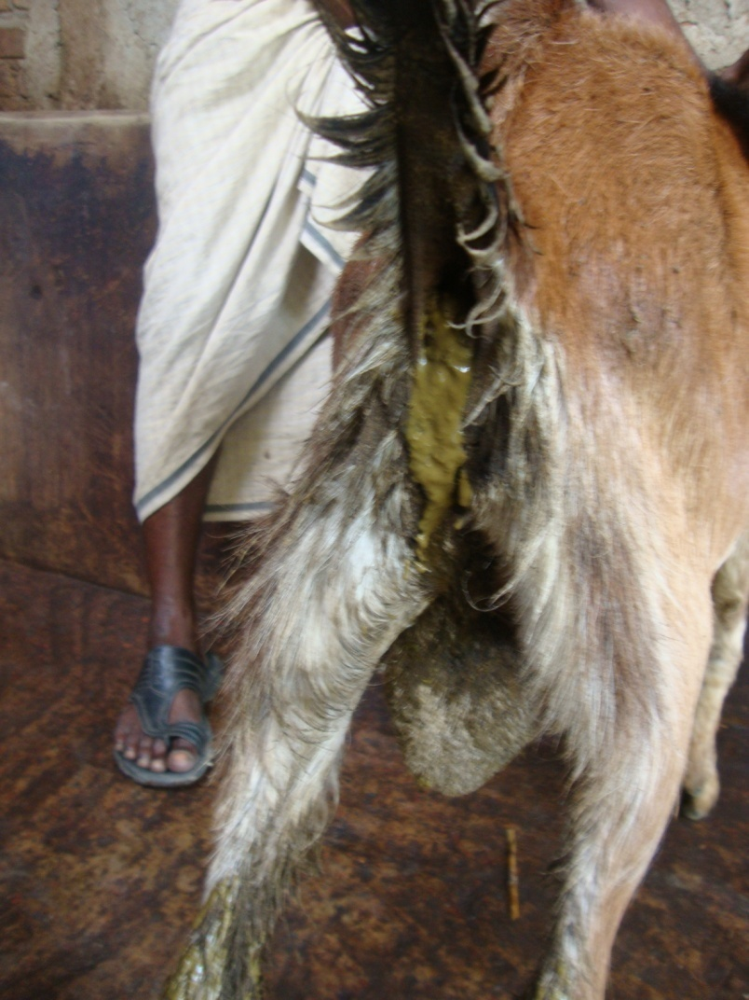

**f**

**e**

**Figure.2: Clinical signs of PPR affected goats.** **( a )** Goat showing ocular discharge **( b )** Goat showing nasal discharge **( c + d )** oral lesions (erosions) in PPR affected goat **(e )** Diarrhoea in PPR affected goats **( f )** PPR affected goat having high fever .

## Chapter: 4

# RESULTS AND DISCUSSION

A total of 268 goats examined for the presence of PPR, 54 of them were found to be clinically affected. The overall prevalence of PPR in goats was found to be 20.20%. This observation was supported by Ozkul *et al.* (2002) where they found that the prevalence of PPR in goats was 20% in Turkey. On the other hand the finding of this study was slightly lower than that of 32.4% prevalence in India while 4,407 goats sample were examined (Singh *et al.*, 2004). This deference could be because of the lower sample size, management and geographical location.

### 4.1 Prevalence of PPR based on age category

Age of animals was analysed in three categories. The prevalence of PPR in goats with age categories adult (>1 year), young (between 4 to 12 months) and sucklers (between 1 to 3 months) was found to be 16.0%, 26.05% and 15.15%, respectively (**Table 4.1**) and the difference was statistically significant Radostits *et al.* (2000) and Singh *et al.* (2004) also assessed that the disease is most prevalent in the goats less than 1 year of age. Goats in Bangladesh are typically reared as scavengers. Graphical presentation of prevalence in different age category is shown in **Fig.4.1**

**Table 4.1** Prevalence of PPR in goats in different age categories.

|  |  |  |  |  |
| --- | --- | --- | --- | --- |
| **Age** | **Animals Examined** | **Animals Clinically Affected** | **Prevalence (%)** | $χ^{2}$**(p-value)** |
| Adult (over 1 year) | 50 | 8 | 16.00 | 6 (0.199) |
| Young (4 to 12 month) | 119 | 31 | 26.05 |
| Sucklers (1 to 3 month) | 99 | 15 | 15.15 |
| Total | 268 | 54 | 20.20 |

**Figure 4.1:** Prevalence of PPR in relation to age.

### 4.2 Association of prevalence with sexes of goats

The association between sex and prevalence of PPR in goats was also investigated (**Table 4.2**). The study revealed that the prevalence of PPR in goats was higher (23.13%) in males than females (15.74%), which is in agreement with the findings of Rahman *et al.* (2004). The results showed that the prevalence of PPR was not significantly (p>0.05) associated with the sexes of goats. Prevalence of PPR in relation to sex was presented in **Fig.4.2**

**Table 4.2** Prevalence of PPR in goats of different sexes.

|  |  |  |  |  |
| --- | --- | --- | --- | --- |
| **Sex** | **Animals Examined** | **Animals Clinically Affected** | **Prevalence (%)** | $χ^{2}$**(p-value)** |
| Male | 160 | 37 | 23.13 | 2 (0.157) |
| Female | 108 | 17 | 15.74 |
| Total | 268 | 54 | 20.20 |

**Figure 4.2:** Prevalence of PPR in relation to sex.

### 4.3 Prevalence of PPR in both breeds of goats

In the present investigation, no significant (p>0.05) breed susceptibility was observed indigenous Black Bengal goats were mostly affected (29.13 %) followd by Jamunapari(20.27%) and cross breed (14.76%). This observation is supported by that of Mondal *et al.*, (1995), where they found that the prevalence of PPR is higher in indigenous Black Bengal (27.13 %) goats followed by Jamunapari (11.81 %) and exotic (9.68%). Higher incidence of PPR in indigenous Black Bengal goats may be due to immunosuppression and irregular vaccination compared to cross breeds Mondal *et al.*, (1995). Prevalence in relation to breed is shown in **Fig.4.3**

**Table 4.3** Prevalence in relation to breeds of goat.

|  |  |  |  |  |  |
| --- | --- | --- | --- | --- | --- |
| **Name of the breeds** | **No. of PPR cases** | **No. of other cases** | **Total cases** | **Prevalence (%)** | $χ^{2}$**(p-value)** |
| Black Bengal | 30 | 103 | 133 | 29.13 | 6 (0.199) |
| Jamunapari | 15 | 59 | 74 | 20.27 |
| Cross breed | 9 | 52 | 61 | 14.76 |

**Figure 4.3:** Prevalence of PPR in relation to breed.

### 4.4 Response to trearment in relation to different drugs

The relative effects of drugs in treatment of PPR are presented in **Table 4.4**. The percentage response of treatment towards parenteral (I/M) oxytetracycline was higher (66.66%) than parenteral (I/M) Sulphadimidine (55.55%). This is similar to the report of Taylor *et al.,* (1984) where mortality rates decreased by the use of drugs that control the bacterial complications especially oxytetracycline and Chlortetracycline are recommended to prevent secondary pulmonary infections. Graphical presentation of treatment with respose is given at Fig.4.4

**Table 4.4** Response to treatment in relation to different drugs.

|  |  |  |  |  |  |
| --- | --- | --- | --- | --- | --- |
| **Drug name (Trade + Generic)** | **Response to Treatment** | | **Total Case** | **% of Response to Treatment** | $χ^{2}$**(p-value)** |
| **Positive** | **Negative** |
| Diadin (Sulphadimidine-Na) + Histavet (Chlorphenaramine maleate) + Renalyte(ORS) (**Treatment-1**) | 15 | 12 | 27 | 55.55 | 2 (0.157) |
| Renamycin-100 (Oxytetracycline) + Histavet (Chlorphenaramine maleate) + Filin (Aminophyline) (**Treatment-2**) | 18 | 9 | 27 | 66.66 |

**Figure 4.4:** Response to treatment in relation to different drugs.

### 4.5 Limitation of the study

During the course of examination, all aspects were observed carefully but there is also some limitations that influence the present study. The duration for the study of disease was short that may results improper estimation, fluctuation in seasonal variation, sometimes diagnosis was made through tentative variables, inappropriate data collection, small number of sample size etc might limitate the study.

## 

## Chapter: 5

# CONCLUSION

In this study it is revealed that younger (<1year) goats were more susceptible than older age. This study provided valuable data on the prevalence of PPR in goats in Rajshahi District and its association with different risk factors. Although against virus, there is no specific treatment, combined therapy containing antibiotic, antihistamines as well as fluid therapy noticed line of treatment in PPR infection of goat. PPR is highly contagious disease with higher mortality and morbidity in goat. It causes heavy economic losses in every year and also decreases the productive performances of goat. A great deal of more research into this aspect of the disease is urgently required. So, Proper surveillance and regular vaccination program should be undertaken to eradicate PPRV throughout the country. We recommend pastoralist awareness to enhance participation in disease surveillance and control program for better controlling the PPR in Rajshahi.

## 

## Chapter: 6

# REFERENCES

Abdollahpour, G., Roofi, A., Najafi, J., Sasani, F. and Sakhaie, E. 2006. Clinical and para clinical findings of a recent outbreak of Peste des petits ruminants in Iran. *Journal of Veterinary Medicine. B,* 53: 14-16.

Abu Elzein, E.M.E., Housawi, F.M.T., Bashareek, Y., Gameel, A.A., Al-Afaleq, A.I. and Anderson, E.C. 2004. Severe PPR infection in Gazelles kept under semi-free range conditions in Saudi Arabia*. Journal of Veterinary Microbiology,* 51 (2): 68–71

Abubakar, M., Irfan, M. 2014. An overview of treatment options to combat Peste des Petits Ruminants (PPR). Res. J. Vet. Pract. 2 (1S): 4 – 7. Al–Dubaib MA 2009. Peste des petitis ruminants morbillivirus infection in lambs and young goats at Qassim region, Saudi Arabia. *Tropical Animal Health and Production,* 41: 217 – 220.

Alam, J.S., Rahman, A. and Sayeed, M.A.1998. A study on Livestock Credit in Rural Bangladesh. *Bangladesh Journal of Livestock Research*. 1:15-18.

Albina, E., Kwiatek , O., Minet, C.C., Lancelot, R., Almeida, R.S., Libeau, G. 2012. Peste des petits ruminants, the next eradicated animal disease, An expanding fatal disease of small ruminants: journal home page: www.elsevier.com/locate/vetmic*,* Pp: 2

Al-Tarazi, Y.H.M. and Daghall, G.J.K. 1997. Nasal carriage of Pasteurella hemolytica serotypes by the sheep and goats in the Jordan. *Tropical Animal Health and Production*, 29:177-179.

Amin, M. R., Hussain, S. S. and Islam, A. B. M. M. 2001. Reproductive peculiarities and litter weight in different genetic groups of Black Bengal does. Asian –*Australasian Journal of Animal Sciences,* 14 (3): 197-301.

Appel, M.J.G., Gibbs, E.P.J., Martin, S.J., Ter Meulen, V., Rima, B.K., Stephenson, J.R. and Taylor, W.P. 1981. Morbillivirus Diseases of Animals and Man. In Comparative Diagnosis of Viral Diseases IV, E. Kurstak and C. Kurstak, eds. New York: Acad. Press, Pp: 235-297.

Awa, D.N., Njoya, A. and Ngo–Tama, A.C. 2000. Economics of prophylaxis against peste des petits ruminants and gastrointestinal helminthosis in small ruminants in north Cameroon. *Tropical Animal Health and Production,* 32: 391 – 403.

Ayari-Fakhfakh, E., Ghram, A., Bouattour, A., Larbi, I., Gribaˆa-Dridi, L., Kwiatek, O., Bouloy, M., Libeau, G., Albina, E., Ceˆtre-Sossah, C. 2011. First serological investigation of peste-des-petits-ruminants and Rift Valley fever in Tunisia. *Veterinary Journal,* 187: 402–404.

Bandopadhay, S.K.2011. Workshop to Develop Regional Roadmap for Progressive Control of peste des petits ruminants (PPR) for South Asian countries. 7-9 December 2011, Kathmandu, Nepal.

Banik, S.C., Podder, S.C., Samad, M.A. and Islam, M.T. 2008. Sero–prevalence and immunization in sheep and goats against Peste des petits ruminants in Bangladesh. Bangl. *Journal of Veterinary Medicine,* 6 (2): 185 – 190.

Banyard A.C., Parida S., Batten C., Oura C., Kwiatek O. & Libeau G. 2010. Global distribution of peste des petits ruminants virus and prospects for improved diagnosis and control. *Journal of General* *Virology*, 91 (Pt 12), 2885-2897. E-pub: 2010 Sep. 15

Bao, J., Wang, Q., Parida, S., Liu, C., Zhang, L., Zhao, W. and Wang, Z. 2012. Complete Genome Sequence of a Peste des Petits Ruminants Virus Recovered from Wild Bharal in Tibet, China. *Journal of Virology* 86(19): 10885.

Baron, M.D., Parida, S., Oura, C.A. 2011. Peste des petits ruminants: a suitable candidate for eradication? Veterinary Record 169: 16.

Barrett, T., Pronob, D., Sreenivasa, B.P. and Corteyn, M. 1997. Recent epidemiology of PPRV. *Veterinary Microbiology,* 88:125-130.

BBS. 2002. Statistical Year Book of Bangladesh. Bureau of Statistics, Statistical Division, Ministry of Planning, Government of the People's Repablic of Bangladesh, Dhaka.

Bundza, A., Afshar, A., Dukes, T. W., Myers, D. J., Dulac Susi, G., Becker, A. W. E. 1988. Experimental PPR (goat plague) in Goats and sheep. *Canadian Journal of Veterinary Research,* 52: 46-52.

CFSPH (The Centre for Food Security and Public Health),2008. Peste des Petits Ruminants.http://www.cfsph.iastate.edu/Factsheets/pdfs/peste_des_petits_ruminants.pdf Access on 14th May, 2011.

Chauhan, H. C., Chandel, B. S., Kher, H. N., Dadawala, A. I. and Agrawal, S. M. 2009. Pesti des petits ruminants virus infection in animals. *Veterinary World* 2 (4):150-155.

Coakes, S.J., Steed, L., and Dzidic, P. 2006. SPSS Version13.0 for Windos. John Willey and Sons Australia Ltd., Australia.

Das, K.K., Shil, N.K. and Islam, M.R. 2007. Sero-epidemiological investigation on Peste des Petits Ruminants in black Bengal goats. *Bangladesh Journal of Microbiology,* 24:143–145.

Das, K.K., Shil, N.K. and Islam, M.R. 2007. Sero–epidemiological investigation on Peste des Petits Ruminants in black Bengal goats. *Bangladesh Journal of Microbiology*, 24: 143 – 145.

De Nardi, M., Lamin Saleh, S.M., Batten, C., Oura, C., Di Nardo, A., Rossi, D., 2012. First evidence of peste des petits ruminants (PPR) virus circulation in Algeria (Sahrawi territories): outbreak investigation and virus lineage identification. *Transbound. Emerg. Dis.* 59: 214–222.

Debnath, N.C.1995. Peste des petits ruminants (PPR); an overview proceeding of the BSVER Symposium on Eradication of Rinderpest and Related Diseases.2nd December, 1995, Dhaka; 9-13.

Devendra, C. 2007. Perspectives on animal production systems in Asia. *Livestock Science,* 106: 1–18.

Dhar, P., Sreenivasa, B.P., Barrett, T., Corteyn, M., Singh, R.P. and Bandyopadhyay, S.K. 2002. Recent epidemiology of peste des petits ruminants virus (PPRV). *Veterinary Microbiology*, 88: 153 – 159.

Diallo, A., Minet, C., Goff, C.Le., Berhe, G., Albina, E., Libeau, G. and Barrett, T. 2007. The threat of peste des petits ruminants: progress in vaccine development for disease control. *Vaccine.* 25 (30): 5591 – 5597.

DLS .2012. Annual Report on Livestock, Division of Livestock Statistics, Ministry of Fisheries and Livestock, Farmgate, Dhaka, Bangladesh.

Durojaiye, O. A., Taylor, W. P. and Smale, C. 1985. The ultrastructure of peste des petits ruminants virus. *Zbl. Veterinary Medicine, B*. 32 (6): 460-465.

El Hag Ali, B., Taylor, W.P., 1984. Isolation of peste des petits ruminants virus from Sudan. *Research veterinary Science,* 36: 1–4.

FAO (Food and Agriculture Organization of the United Nations), 1997. Production Year Book, Rome, Italy, 51:189-228

FAO (Food and Agriculture Organization of the United Nations), 2003. Asian Livestock. Monthly Technical Magazine of the FAO. Anim. Prod. Health Comm. Asia Pac. (APHCA) 8: 85-87.

Fraser, C.M.1986. Peste des petits ruminants (PPR). The Merck Veterinary Manual. 6th edition, Merck and Co. Inc. U. S. A; 402-403.

Gibbs, E. P. J., Taylor, W. P., Lawman, M. P. J. and Bryant, J. 1979. Classification of the peste des- petits-ruminants virus as the fourth member of the genus *Morbillivirus*. *Intervirology, Veterinary Journal.* 11: 268-274.

Hamdy, F. M. and Dardiri, A. H. 1976. Response of white tailed deer to infection with peste des petits ruminants virus. [*Journal of Wildlife Diseases*](http://www.google.com.bd/url?sa=t&rct=j&q=&esrc=s&source=web&cd=1&ved=0CB4QFjAA&url=http%3A%2F%2Fwww.jwildlifedis.org%2F&ei=SZ-2VJOnNY6MuATMj4KwBw&usg=AFQjCNHaKaqSMjQgNKUDyc1etgAiVfmI5Q&sig2=uv9X08QsKqw8k7Dnxhz2yQ)*,* 1: 516-522.

[Hegde, R](http://www.ncbi.nlm.nih.gov/pubmed?term=%22Hegde%20R%22%5BAuthor%5D)., [Gomes, A. R](http://www.ncbi.nlm.nih.gov/pubmed?term=%22Gomes%20AR%22%5BAuthor%5D)., [Muniyellappa, H. K](http://www.ncbi.nlm.nih.gov/pubmed?term=%22Muniyellappa%20HK%22%5BAuthor%5D)., [Byregowda, S. M](http://www.ncbi.nlm.nih.gov/pubmed?term=%22Byregowda%20SM%22%5BAuthor%5D)., [Giridhar, P](http://www.ncbi.nlm.nih.gov/pubmed?term=%22Giridhar%20P%22%5BAuthor%5D). and [Renukaprasad, C](http://www.ncbi.nlm.nih.gov/pubmed?term=%22Renukaprasad%20C%22%5BAuthor%5D). 2009. A short note on peste des petits ruminants in Karnataka, India. [Revue scientifique et technique](http://www.google.com.bd/url?sa=t&rct=j&q=&esrc=s&source=web&cd=1&cad=rja&uact=8&ved=0CB4QFjAA&url=http%3A%2F%2Fwww.researchgate.net%2Fjournal%2F0253-1933_Revue_scientifique_et_technique_International_Office_of_Epizootics&ei=w562VMO-NYycuQT_u4LYDQ&usg=AFQjCNHhiN3GZAJZiCiak0oXquywy1v3oQ&sig2=qsSllIMrQRdNZT30ArZuvg) 28(3): 1031-5.

Ihemelandu, E. C., Nduaka, O. and Ojukwu, E. M.1985 Hyperimmune serum in the control of peste des petits ruminants. *Tropical Animal Health Production,* 17:83-88.

Islam, M.R., Shamsuddin, M., Das, P.M. and Dewan, M.L. 2001. An outbreak of Peste des Petits Ruminants (PPR) in Black Bengal goats in Mymensingh, Bangladesh. *The Bangladesh* *Veterinary,* 18:14–1

Ismail, T.M., Yamanaka, M.K., Saliki, J.T., Kholy, A.E.L., Mebus, C. and Yilma, T. 1995. Cloning and expression of the nucleoprotein of peste des petits ruminants virus in baculovirus for use in serological diagnosis. *Virology*. 208 (2): 776–778.

Jones, T.C., Hunt, R.D. and King, N.W. 1997. Diseases caused by viruses. In: Veterinary Pathology, 6th edition. William and Wilkins, a Waverly Company. Philadelphia, USA.PP 197.

Khan, M.R., Haider, M.G., Alam, K.J., Hossain, M.G., Chowdhury, S.M.Z.H and Hossain, M.M. 2005. Pathological investigation of Peste des Petits Ruminants (PPR) in goats. Bangladesh *Journal of Veterinary Medicine* 3 (2): 134.

Kwiatek, O., Minet, C., Grillet, C., Hurard, C., Carlsson, E. and Karimov, B. 2007. Peste des petits ruminants (PPR) outbreak in Tajikistan. *Journal of Comperative Pathology,* 136: 111–9

Lefever, P.C. and Diallo, A. 1990. Peste des petits ruminants virus. *Rev. Sci. et Tech. de l'Off. International desease Epizootics*, 9(4):951-965.

Maganga, G.D., Verrier, D., Zerbinati, R.M., Drosten, C., Drexler, J.F.,and M Leroy, E.M. 2013. Molecular typing of PPRV strains detected during an outbreak in sheep and goats in south-eastern Gabon in 2011. *Virology Journal* 10:82. <http://www.virologyj.com/content/10/1/82>

Majiyabe, K.A., D. Shamaki, T.K.C. Udeani 1994. Further studies on epidemiology of peste des petits ruminants in Nigeria.The small ruminent. Research Net. New. 29: 2-5.

Mondal, A.K., Chottopadhuay, A.P., Sarkar, S.D., Saha, G.R. and Bhowmik, M.K. 1995. Report on epizootological and clinico-pathological observation on peste des petits ruminants (PPR) in West Bengal. *Indian Journal of Animal Health* *Bulletin,* 64:261.

Murphy, F. A., Gibbs, E. P. J., Horzinek, M. C. and Studdert, M. J. 1999. Classification and nomenclature of viruses. In: Veterinary Virology, 3rd Edn, Academic press, NewYork. Pp 4-13.

Nandi, D., Roy, S., Bera, S., Kesh, S.S. and Samanta, A.K. 2011. The rearing system of Black Bengal Goat and their farmers in West Bengal, India. Veterinary World, 4(6): 254-257.

Obi, T.U. 1983. Studies on the epidemiology of PPR in Southern Nigeria. *Tropical Veterinary*, 1:209- 217.

OIE (Office International des Epizooties/World Organization for Animal Health) 2000. Peste des petits ruminants. In: Manual of standards for diagnostic tests and vaccines. Ed 4. Chap 2.1.5. Paris: OIE, 2000.

Onyekweodiri, E.O. and Uzoukwu, M. 1992. Epidemiology of PPR under the traditional husbandry systems in Eastern Nigeria, Proceedings 29th Annual Conference of Nigeria Veterinary Medicine Association, 27th -30th October 1992, Kaduna, Nigeria.

Ozkul, A., Akca, Y., Alkan, F., Barrett, T., Karaoglu, T., Dagalp, S.B., Anderson, J., Yesilbag, K., Cokcaliskan, C., Gensay, A. and Burgu, I. 2002. Prevalence, distribution and host range of Peste des petits ruminants virus, Turkey. *Emerging Infectious Diseases,* 8:708-712.

Radostits, O.M., Gay, C.C., Blood, D.C. and Hinchcliff K.W. 2000. Veterinary Medicine, 9th ed. W. B. Saunders Company Ltd. London. pp 563–565.

Rahman, A.U., Ashfaque, M., Rahman, S.U., Akhtar, M. and Ullah, S. 2004. Pest des petits ruminants antigen in mesenteric lymph nodes of goats slaughtered at D.I. Khan. *Pakistan Veterinary Journal*, 2:159-160

Rahman, M.M., Bhuiyan, A.R., Parvin, R., Giasuddin, M., Haque, M.E., Sayem, S.M., Islam, M.R. and Chowdhury, E.H. 2011. Immune response of goats to thermostable PPR vaccine in Bangladesh. *SAARC Journal of Agriculture 9 (2): 73-81.*

Richard, A.B., Adams, B.K. and Ambumani, S.P.1996. Peste des petits ruminents in Tamilnadu goats. *Indian veterinary journal*, 73:587-588.

Roeder, P. L. and Obi, T. U. 1999. Recognizing peste des petites ruminants: A field manual, FAO Animal Health Manual (5), Pp: 28.

Saadullah, M. 1991. Research and Development Activities and Needs of Small Ruminants in Bangladesh. In: Research and Development Needs of Small Ruminants in Asia. Small Ruminant Production Systems Network in Asia (SRUPNA). Ed. Andi Djajianegara and C. Devendra. Indonesia.

Samad, M.A. 1996. Poshu Palon O Chikitsavidya (Animal Husbandry and Medicine). Published by M. Bulbul, Bangladesh Agricultural University campus, Mymenshingh,Bangladesh.

Scott, G. R. 1981. Rinderpest and peste des petits ruminants. In : Gibbs, E.P.J. (Ed.). Virus Diseases of Food Animals, Vol.II, Disease monographs. Academic Press, New York. Pp: 401-425.

Scott, G. R. 2000. Peste des petits ruminants and rinderpest. In: Martin W. B., and I. Aitken (ed), Diseases of Sheep, 3rd edn, pp. 398. Blackwell Publishing, Oxford, UK.

Seifert, H.S.H. 1996. Tropical animal health Kluwer Academic publishers, London.

Shaila, M.S., David, S., Foryth, M.A., Diallo, A., Goatley, L., Kitching, R.P. and Barret, T. 1996. Geographical distribution and epidemiology of PPR viruses. *Virus Research,* 43:149-153.

Sil, B. K., Taimur, M. J. F. A. and Giasuddin, M. 2006. Combined Antibiotic Hyper Immune Serum Therapy (ACHST) for PPR. A Compendium of Livestock Technologies developed by Bangladesh Livestock Research Institute. BLRI publication No. 130. pp. 65.

Sil, B.K., Rahman, M.M., Taimur, M.J.F.A. and Sarker, A.J. 1995. Observation of outbreaks of PPR in organized goat farms and its control strategy, Presented at the Annual Conference of the Bangladesh Society for Veterinary Education and Research. December 3, 2005, BARC, Dhaka.

[Singh, R. K](http://www.ncbi.nlm.nih.gov/pubmed?term=%22Singh%20RK%22%5BAuthor%5D)., [Balamurugan, V](http://www.ncbi.nlm.nih.gov/pubmed?term=%22Balamurugan%20V%22%5BAuthor%5D)., [Bhanuprakash, V](http://www.ncbi.nlm.nih.gov/pubmed?term=%22Bhanuprakash%20V%22%5BAuthor%5D)., [Sen, A](http://www.ncbi.nlm.nih.gov/pubmed?term=%22Sen%20A%22%5BAuthor%5D)., [Saravanan, P](http://www.ncbi.nlm.nih.gov/pubmed?term=%22Saravanan%20P%22%5BAuthor%5D). and [Pal Yadav, M](http://www.ncbi.nlm.nih.gov/pubmed?term=%22Pal%20Yadav%20M%22%5BAuthor%5D). 2009. Possible control and eradication of peste des petits ruminants from India: technical aspects. [*Vet Ital.*](javascript:AL_get(this,%20'jour',%20'Vet%20Ital.');)Jul-Sep; 45(3):449-62.

Singh, R.P., Saravanan, P., Sreenivasa, B., Singh, R.K. and Bandyopadhyay, S.K. 2004. Prevalence and distribution of Peste des petits ruminants virus infection in small ruminants in India. *Review of Science and Technology,* 23:807-819.

Singh, R.P., Saravanan, P., Sreenivasa, B., Singh, R.K. and Bandyopadhyay, S.K. 2004. Prevalence and distribution of Peste des petits ruminants virus infection in small ruminants in India. *Review of Science and Technology*, 23 (3): 807 – 819.

Taylor, W.P., Al-Busaidy S. and Barrett, T. 1990. The epidemiology of peste des petits ruminants in the Sultanate of Oman. *Veterinary Microbiology,* 22(4):341-352.

Taylor, W.P.1984. The distribution and epidemiology of peste des petits ruminants. *Preventive Veterinary Medicine,* 2: 157-166.

Venkataramanan, R., Bandyopadhyay, S.K., Oberoi, M.S. 2005. Present status and strategies for the control of transboundary and other economically important animal diseases in India. A review*. Indian Journal of Animal Science,* 75(4): 456-464.