ACKNOWLEDGEMENT

All praises are due to Almighty “Allah” who has created everything of the nature and who enable the author to complete this report. The author does not have adequate words to express his heartfelt sense of gratification, sincere appreciation to his benevolent teacher and report supervisor. The author expresses his sincere gratitude, heartful respect and immense indebtness to his supervisor Professor, Mohammad Alamgir Hossain, Department of Pathology and Parasitology, CVASU for sacrificing many of his precious hours amid extensive preoccupation with his professional and academic responsibilities. Special thanks to Dr. Bibek Chandra Sutradhar, Associate Professor & Director (External affairs), Department of Medicine & Surgery, CVASU for his valuable advice and co-operation. I would like to give special thanks to Md. Monakka Ali, Veterinary Surgeon, Patgram for his scholastic guidance, innovative suggestions, constant supervision, timely instruction and inspirations throughout the tenure of the report work and has taught me so much over the study period.
Supervisors’ help and co-operation have been received from many persons during the tenure of this place of report. The author is immensely grateful to all of them, although it is not possible to mention every one by name.

The Author:

ABSTRACT

An investigation was undertaken to determine the clinical prevalence of skin diseases of goat in goats at the Upazilla Veterinary Hospital (UVH), Patgram under Lalmonirhat district during February to April, 2014. Total goats were 83, among them goats affected with skin diseases were 31. Diagnosis was done on the basis of general examination, physical examination and clinical examination. Clinical examinations detected 3 different types of skin diseases in 31 (37.34% of total goats). Whereas 83.87% parasitic skin diseases, 12.90% fungal skin diseases and 3.23% viral skin diseases of total affected goats were recorded. From the parasitic infested goat mite infestations were 03 (11.53%), tick infestations were 09 (34.63%), lice infestation were 07 (26.92%) and myiasis were 07 (26.92%). Age wise prevalence in young and adult goat were 16 (51.61%) and 15 (48.39%) respectively. Sex wise prevalence in male and female goat were 14 (45.16%) and 17 (54.84%) respectively. Diseases and disorders of goats which were recorded more or less present in both young and adult animals.

Keywords: Goat, skin disease, virus, parasite, fungus

CHAPTER-1
INTRODUCTION

There are about 34.5 million goats in Bangladesh (Anon, 2003). Next to Africa (41.3%), the Indian subcontinent has the largest (31.4%) goat population (Anon, 1979). The Black Bengal goat occupies the second position in livestock population and it plays an important role in the rural economy and export trades of Bangladesh. About 97.90% of goats are distributed in rural areas and 2.10% in urban areas (Anon, 1986). Most of these goats belong to indigenous Black Bengal breed. But goat rearing is hindered by various problems, among them skin disease is an important limiting factor in Bangladesh as the climatic condition of the country favors the development and survival of various bacteria, virus, parasites and fungus.

Skin diseases in goats can be classified into four general categories: fungal, parasitic, viral, and bacterial (Suzanne et al, 2010). Common ectoparasites of animals are ticks, lice and mites (Nooruddin and Mondal, 1996; Nooruddin and Dey, 1989; Rahman and Mondal, 1985; Huq and Mollah, 1972; Kader and Huq, 1973). They are annoying pests because of their movement over the skin. The damage done by the ectoparasites cause considerable amount of blood loss, irritation and annoyance. Common fungal disease is ringworm, viral disease is contagious ecthyma. As a result, feeding and digestion is hampered that may lead to retarded growth, loss of weight and reduced milk and meat production. The infested goats bite and rub the affected area so that the affected skin becomes abraded. Ultimately myiasis and other infections may occur which might lead to death of the animals (Soulsby, 1982). Ectoparasitic infestations reduce the quality and market value of valuable skin. Besides, ectoparasites transmit various types of deadly pathogens of animals (Soulsby, 1982).

Veterinary hospital is an ideal and reliable source of information about animal diseases and their solution. People from the neighboring areas bring their sick animals to the Veterinary hospital every day. Analysis of the case record gives a comprehensive idea about the disease problems at local areas. The objectives were to determine clinical prevalence of skin diseases in goats at the Upazilla Veterinary Hospital, Comparative prevalence of diseases and disorders of male vs. female and young vs. adult in goat at the Upazilla Veterinary Hospital, Patgram, Lalmonirhat.

Therefore the current study was designed with the following objectives:

- To detect the prevalence of skin disease in goat during February to April, 2014.

- To detect the prevalence of skin disease in male and female goat.

- To detect the prevalence of skin disease of young and adult goat.

CHAPTER-2
MATERIALS AND METHODS

Study area:
This clinical study was undertaken at the Upazilla Veterinary Hospital, Patgram, Lalmonirhat to determine the general clinical prevalence of skin diseases ingoats during the two months study period from February to April, 2014. All diseased goats were brought for treatment to the Veterinary Hospital and the entry of them in the registered book.

General examination:
Physical condition, behavior, posture, gait, superficial skin wound, prolapse of the uterus and vagina, salivation, nasal discharge, distension of the abdomen, locomotive disturbance etc. were observed by visual examination of the patient.

Physical examination:
Examination of different parts and system of the body of each of the sick animals were examined by using procedure of palpation, percussion, auscultation, needle puncture and walking of the animals.

Clinical examination:
The temperature, pulse, and respiratory rate from each of these sick animals were recorded. Clinical examinations of all 31 goats, 15 adult goats (male and female) and 16 young goats (male and female) were conducted on the basis of diseases history, owner complaint, symptoms, to diagnose the following diseases and disorders. History of each case (Present and past) was carefully taken which gave a guideline for examination of the animals. According the merit of the individual case, general clinical examination were conducted on the basis of disease history and owners complaint, symptoms and techniques such as microscopic examination, laboratory common techniques.

Collection, preservation and identification of ectoparasites:
Ticks and lice were collected from different parts of the body of the goats by hand picking and by using tools. When required, small camel hair brush dipped in ethanol was used for the collection of ticks and fine black comb was used for the collection of lice. The point of attachment was smeared with ethanol. Adequate precautions were taken to preserve the mouth parts and appendages of the ectoparasites during collection. To collect mites, skin scrapings from the affected areas were collected and the skin scrapings were examined by adding 10% potassium hydroxide (Hendrix and Robinson, 2006). Ticks and lice were preserved in 70% alcohol in clean, well-stopper glass vials. Permanent slides were prepared by following the procedures described by Cable (1957). Ectoparasites were identified according to the keys and descriptions given by Ferris (1951), Roberts (1952), Hoogstraal (1956) and Soulsby (1982).

Statistical analysis
Statistical analyses were carried out by using Statistical Package for Social Sciences (SPSS). To determine the susceptibility of different groups of goats to ectoparasitic infestation, odds ratio was calculated according to the formula given by Sclesselman 1982.
CHAPTER-3
RESULTS AND DISCUSSION

Among 83 examined goats 31 goats (37.34% of total goats) were affected with skin diseases. 3 different types of skin diseases were observed during the study period. Whereas 83.87% parasitic skin diseases, 12.90% fungal skin diseases and 3.23% viral skin diseases of total affected goats were recorded (Table-1). Parasitic infestation mainly caused by mite, tick, lice and dipteran fly. Fungal skin disease is mainly caused by dermatophytes of Microsporum spp and Tricophyton spp. Commonly found viral skin disease is contagious ecthyma.

Table-1: Total no. of goats affected with different kind of skin diseases

Month | Parasitic skin disease | Fungal skin disease | Viral skin disease
February(09-28) | 9 | 2 | -
March | 15 | 2 | 1
April (01-09) | 2 | - | -
Total | 26 | 4 | 1
Percentage | 83.87% | 12.90% | 3.23%

Graph-1: Goats affected with different kind of skin diseases (Month wise)

From the parasitic infested goats were mainly infested by ectoparasites. Whereas mite infestations were 03 (11.53%), tick infestations were 09 (34.63%), lice infestation were 07 (26.92%) and myiasis were 07 (26.92%), (Table-2). Generally P. cuniculi mite infested the goat. In case of goat H. bispinosa, R. sanguineus, B. microplus tick infestations are found. In lice infestation mainly D. caprae, L. stenopsis infestation is found. Several types of myiasis are found in goat, of them Oestrous ovis, Gastrophilus spp are commonly found.

Table-2: Total no. of ectoparasitic infested goats (month wise)
Month | Mite | Tick | Lice | Myiasis
February(09-28) | 1 | 2 | 3 | 3
March | 2 | 4 | 4 | 3
April (01-09) | - | 1 | 2 | 1
Total | 3 | 7 | 9 | 7
Percentage | 11.53% | 34.63% | 26.92% | 26.92%

Graph-2: Goats affected with different kind of ectoparasitic infestation

Age wise prevalence in young and adult goat were 16 (51.61%) and 15 (48.39%) respectively during the study period. It was seen that skin disease in young is higher than adult in goat.

Table-3: Prevalence of skin disease (age wise)
Month | Young(˃1 year) | Adult(˂1 year)
February (09-28) | 5 | 6
March | 8 | 7
April (01-09) | 3 | 2
Total | 16 | 15
Percentage | 51.61% | 48.39%

Graph-3: Age wise prevalence of skin disease of goat

Sex wise prevalence in male and female goat were 14 (45.16%) and 17 (54.84%) respectively. It was seen that female goats are more susceptible to skin diseases than male goats.
Table-4: Prevalence of skin disease in goat (sex wise)
Month | Male | Female
February (09-28) | 8 | 7
March | 4 | 9
April (01-09) | 2 | 1
Total | 14 | 17
Percentage | 45.16% | 54.84%

Graph-4: Sex wise prevalence of skin disease in goat

Pathological lesions produced by different agents

Mite infestation (P. cuniculi):
The mites were mostly found on the ear, face, hind quarter and abdomen. Affected skin was rough, dry and leathery with loss of hair (alopecia). In some cases, skin was thick with mild to moderate corrugation. Dandruff was common (Figure 7, 8). Histopathological lesions were characterized by hyperkeratosis, eosinophilic infiltration, acanthosis and superficially by the loss of cornified layer associated with aggregation of necrotic cellular debris (Figure 11, 12) (Table 1).

Tick infestation (H. bispinosa, R. sanguineus, B. microplus):
Ticks were found mostly on the external ears on both sides. However, they were also detected on the base of horn, neck, tail and on the interdigital spaces at the level of coronary band. Skin of the affected areas became rough and reddened. Loss of hair (alopecia) was seen in the heavily infested area. The site of attachment was slightly elevated. Sloughing of skin was also observed as a result of rubbing (Figure 9, 10).

Lice infestation (D. caprae, L. stenopsis):
In lice infestation, the pathological changes were not so pronounced. The site of attachment of lice was red and slightly elevated (Table 1). In some cases, pinpoint hemorrhages were noticed.

Myiasis (Larvae of Dypteran fly):
In myiasis, Wounds that may become infested by Dipteran fly include those caused by engorged ticks, bites of vampire bats, castration, dehorning, branding, wire cuts, sore mouth in goat and a multitude of other causes. Navels of newborn mammals are a common site for myiasis infestation. Early stages of the larvae feeding in a wound are very difficult to see; only slight movement may be observed. As the larvae feed, the wound is gradually enlarged, becoming wider and deeper. By the third day, as many as 100 to 200 tightly packed, vertically oriented larvae can easily be observed embedded deep in the wound. Dipteran larvae tend to burrow deeper in a wound when disturbed and will generally not be seen crawling on the surface. After 5 to 7 days, a wound may be expanded to 3 cm or more in diameter and 5 to 20 cm deep with larvae from a single screwworm egg mass. Usually by this stage, additional Dipteran flies have deposited eggs, resulting in a multiple infestation. A serosanguineous discharge often exudes from the infested wounds, and a distinct odor may be detected. In some cases, the openings in the skin may be small with extensive pockets of Dipteran larvae beneath.

Screwworm infestations in anal, vaginal, and nasal orifices may be difficult to detect, even in the later stages. Goats with myiasis infestation usually display discomfort, may go off feed, and produce less milk. Typically animals with myiasis will separate themselves from the rest of the flock or herd and seek dark or shady areas to lie down. Goats frequently hide in caves. Goats with screwworm myiasis may die in 7 to 14 days if wounds are not treated to kill the larvae — especially in cases of multiple infestation. As many as 3,000 larvae may be found in a single wound. Death probably results from toxicity, secondary infections or both. Smaller animals usually die of myiasis in a shorter time than larger animals. Location of the wound infestation is also a determining factor in the time of death.

Dermatophytosis (Ringworm):
Ringworm is a fungal skin infection; the infection is also called dermatophytosis.
The fungi that cause ringworm live as infective spores in the environment. Direct contact to these spores leads to the disease. These spores may be on the hair of an infected animal or even on items used on the animals like brushes or clippers. Goats could also pick up these fungi by direct contact with the soil. After exposure, it takes two to four weeks before animal shows clinical signs. There may be areas where the hair is gone and crusts or scales may develop on the skin in the affected areas. Often the skin in these areas is red and very itchy. An appearance of a circle or ring in animal’s fur may be seen. This is where the term ringworm comes from.

Contagious ecthyma (Orf.):
Contagious ecthyma results from infection by the orf virus, a member of the genus Parapoxvirus in the family Poxviridae. The initial signs are papules, pustules and vesicles, found on the lips, nose, ears and/or eyelids, and sometimes on the feet or perineal region. Lesions can also occur inside the mouth, particularly in young kids. Rarely, the lesions may extend into the esophagus, stomach, intestines or respiratory tract. Nursing kids can transmit the virus to their dam, resulting in lesions on the teats and udder. The skin lesions eventually develop into thick, brown, rapidly growing scabs over areas of granulation, inflammation and ulceration. The scabs are often friable and bleed easily. Papillomatous growths sometimes occur. Contagious ecthyma lesions are painful and may result in anorexia or even starvation. Young animals may refuse to nurse, and lesions on the udder of the dam can cause it to abandon its offspring. Foot lesions can cause lameness. Uncomplicated infections usually resolve in 1 to 4 weeks. Secondary bacterial infections and maggot infestations can occur. Contagious ecthyma may predispose animals to bacterial mastitis. More severe infections have been described in Boer and Boer cross goats. In these animals, the disease consisted of multifocal, severe proliferative dermatitis accompanied by chronic pneumonia, arthritis and moderate to severe lymphadenopathy. The disease persisted for three months until the animals were euthanized.

Picture Gallery

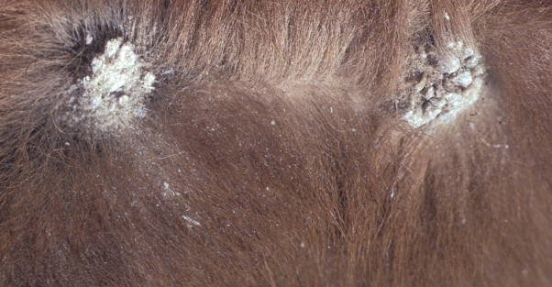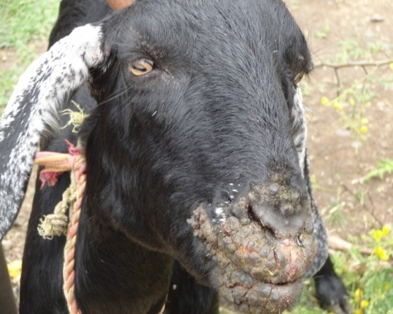
Fig: Ringworm Fig: Sore mouth

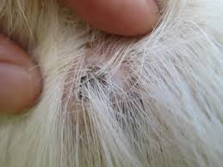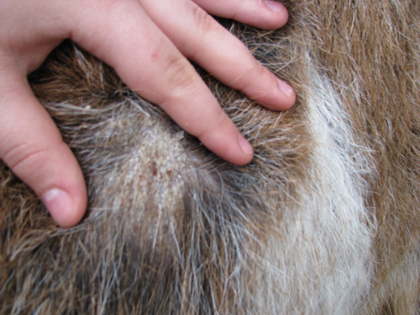
Fig: Mite infestation Fig: Tick infestation

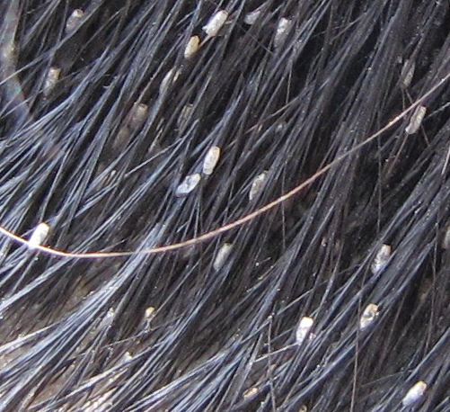
Fig: Lice infestation

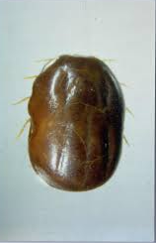 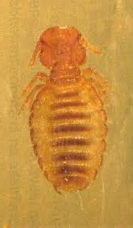 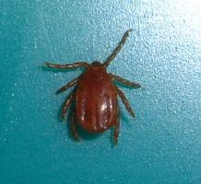Fig: Boophilus microplus Fig: Damalinia caprae Fig: Haemophysalis spp

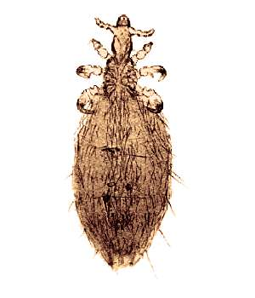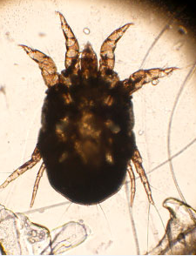
Fig: Linognathus stenopsis Fig: Psoroptes cuniculi Fig: Rhipicephalus spp

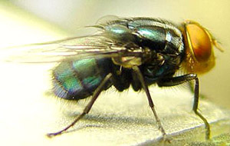
Fig: Dipteran fly
CHAPTER-4
CONCLUSION

The result of the study indicates that the Black Bengal goats are very susceptible to ectoparasitic infestation. About 83.87% Black Bengal goats were found to be infested with ectoparasites, of them prevalence of mite infestations were 03 (11.53%), tick infestations were 09 (34.63%), lice infestation were 07 (26.92%) and myiasis were 07 (26.92%). Kamal et al. (1996) reported that 44.4 % goats were infested with ticks in the hilly area of Chittagong. Rahman and Mondal (1985) recorded H. bispinosa (74 %) and B. microplus (1.7%) in goats in Bangladesh. Huq and Mollah (1972) detected 36.2 % goats infested with D. caprae and L. africans. Kader and Huq (1973) found that 76.3% goats were infested with H. bispinosa and B. microplus in Bangladesh. Parija et al. (1995) observed that 2.22% goats were infested with Psoroptes sp. in India. Dalapati and Bhowmik
(1995) reported 16.3% infestation with P. cuniculi in goats. Kumer et al. (1994) recorded 38 % L. africans infestation in goats in India. Chakrabarti (1994) observed 13.4 % Psoroptes sp. infestation in goats in India. Pratap et al. (1991) found L. stenopsis (68%), B. microplus (60%) and R. haemaphysaloides (52%) in goats in India. The differences among the results of present and earlier studies might be due to variation in the geographical locations, climatic conditions of the experimental area, methods of study and breed of goats.

During the study, it was revealed that age of the goats had a significant (P<0.05) effect on ectoparasitic infestation. Kids (51.61%) were more susceptible to skin diseases in goat. The prevalence of Psoroptes sp. was higher in young goats in India (Chakrabarti, 1994). L. africans infestation was the highest on the kids during the first few months of their lives (Horak et al., 2001). It is very difficult to explain exactly the frequent occurrence of ectoparasitic infestation in kids and older animals. But it may be assumed that the less developed immune system of the kids and exhausted immune system of the older animals may be responsible for the higher prevalence of ectoparasitic infestation in kids and older goats.

The prevalence of skin diseases was higher in females (54.84%) than in males (45.16%). The prevalence of mange infestation was reported higher in females (29.4%) in India (Chakrabarti, 1994). The prevalence of L. africans in female and male goats and the ratio of female to male was 23:5 in Brazil (Santos et al., 2006).
Although the exact cause of higher prevalence of ectoparasitic infestation in female goats cannot be explained but it can be assumed that some hormonal influences may be associated with this phenomenon. In fact, higher level of prolactin and progesterone hormones could make the females more susceptible to any infection (LIoyd, 1983). Moreover, stress of production, such as, pregnancy and lactation could have made the female animals more susceptible to infection.

Seasonal fluctuation of the year had a significant (P<0.01) effect on the prevalence of ectoparasitic infestation in Black Bengal goats. Similarly, overall prevalence of ectoparasites was higher in rainy season in Brazil (Brito et al., 2005) and tick infestation was abundant in rainy season in India (Latha et al., 2004) and Botswana (Mushi et al., 1996). In contrast, mite infestation was higher in winter season in goats of India (Parija et al., 1995; Chakrabarti, 1994; Mittal and Mathur, 1998).

CHAPTER-5
REFERENCES

- A. H. M. Kamal, K. H. Uddin, M. M. Islam, M. M. H. Mondal (1996). Prevalence of economically important ticks in cattle and goat at Chittagong Hilly areas of Bangladesh. Asian-Australasian Journal of Animal Sciences 1996; 9(5): 567-570. doi: http://dx.doi.org/10.5713/ajas.1996.567.

- Anon. (1979). Statistical Pocketbook of Bangladesh, Statistics Division, Ministry of Planning, Government of the Peoples’ Republic of Bangladesh, Dhaka, 258 pp.

- Anon. (1986). Statistical Pocketbook of Bangladesh, Statistics Division, Ministry of Planning, Government of the Peoples’ Republic of Bangladesh, Dhaka, 258 pp.

- Anon. (2003). Statistical Pocketbook of Bangladesh, Statistics Division, Ministry of Planning, Government of the Peoples’ Republic of Bangladesh, Dhaka, 258 pp.

- Brito DRB, Santos ACG, Guerra RMSNC (2005). Ectoparasites in goat and sheep herds from the Alto Mearim andGrajau microregion, State of Maranhao. Revista Brasileira de Parasitologia Veterinaria, 14: 59-63.

- Cable RM (1957). An Illustrated Laboratory Manual of Parasitology. 4th edn., Burgess publishing Co., Minneapolis, Minnesota, U.S.A.,. 127-128 pp.

- Chakrabarti A (1994). Incidence of mange in goats in Tripura. Cheiron 23: 122-126.

- Dalapati MR, Bhowmik MK (1995). An epizootiological study on cutaneous acariasis of goats in West Bengal. Ind. J. Ani. Heal., 34: 1-5.

- Dunn P (1982). The Goat Keeper’s Veterinary Book. 1st edn., Farming Press Limited, Wharfedale Road, Ipswtch, Suffolk, 171 pp.

- Ferris GF (1951). The Sucking Lice. Vol. I., New York Lithographing Corporation, New York, 3 - 285 pp.

- Hendrix CN, Robinson E (2006). Diagnostic Parasitology for Veterinary Technicians. 6th edn., Mosby Inc, Elsevier. 252-253 pp.

- Hoogstraal H (1956). African Ixodoidea. Vol. I, Department of the Navy, Bureau of Medicine and Surgery, U.S. Naval Medical Research Unit, No. 3, Cairo, Egypt, 50-360 pp.

- Horak IG, Macivor KM, Greeff CJ (2001). Parasites of domestic and wild animals in South Africa. Helminth and arthropod parasites of Angora goats in the southern Karoo. Onderstepoort J. Vet. Res. 68: 27-35.
- Huq MM, Mollah MA (1972). A survey of the prevalence of lice on sheep and goats of Dhaka and Mymensingh districts, Bangladesh. Bang. Vet. J. 6: 21-25.

- Kader SA, Huq MM (1973). A survey on the prevalence of ticks of sheep and goats in Comilla Kotwali Police Station, Bangladesh. M. Sc. (Vet, Sci.) Thesis, Bangladesh Agricultural University, Mymensingh, 27-52 pp.

- Kumer A, Rawat BS, Saxena AK, Agarwal GP (1994). Prevalence of ectoparasites on goats in Dehradun (India). Appl. Parasitol. 35: 227-236.

- Latha BR, Aiyasami SS, Pattabiraman G, Sivaraman T, Rajavelu G (2004). Seasonal activity of ticks on small ruminants in Tamil Nadu State, India. Trop. Anim. Heal. Prod. 36: 123-133.

- Lloyd S (1983). Effect of pregnancy and lactation up on infection. Vet. Immunol. Immunopath. 4: 153-176.

- Mittal JP, Mathur BK (1988). Effect of house climate on incidence of goat mange in desert region. Rapport, Institutionen for Husdjurshygien, Veterinarmedicinska Fakulteten, Sveriges Lantbruksuniversitet 1: 167-171.

- Mushi EZ, Isa JFW, Sakia RM (1996). Monthly fluctuation of ixodid tick infestation on indigenous goats in Botswana.Small Rum. Res. 21: 277-279.

- Mushi EZ, Isa JFW, Seabokeng IB, Kapaata RW (1996). The seasonal fluctuation of ixodid ticks on indigenous Tswana goats in Botswana. Zimb. Vet. J. 27: 41-49.

- Nooruddin M, Dey AS (1989). Further study on the prevalence of skin diseases in domestic ruminants in Bangladesh.Bang. Vet. 7: 75-81.

- Nooruddin M, Mondal MMH (1996). Otoacariasis in Bengal goats of Bangladesh. Small Rum. Res. 19: 87-90.

- Parija BG, Misra SC, Sahoo PK (1995). Changing pattern in the epidemiology of caprine mange in Bhubaneswar. Ind. Vet. J. 72: 536-538.
- Pratap G, Misra SC, Panda MR (1991). A note of the incidence of ectoparasites on Black Bengal goats at Bhubaneswar. Ind. Vet. J. 68: 92-94.

- Rahman MH, Mondal MMH (1985). Tick fauna of Bangladesh. Ind. J. Parasitol. 9: 145-149.

- Roberts FHS (1952). Insects Affecting Livestock. 1st edn, Angus and Robertson Ltd., London, 17-191 pp.

- Santos SBD, Cancado PH, Piranda EM, Faccini JL (2006). Infestation with Linognathus africanus (Linognathidae) and Bovicola caprae (Trichodectidae) in goat flock of the State of Rio de Janeiro, Brazil, Review of Brazilian Veterinary Parasitology 15 (1): 41-43.

- Schesselman JJ (1982). Case-Control Studies, Oxford University Press, New York, 174-177 pp.

- Soulsby EJI (1982). Helminths, Arthropod and Protozoa of Domesticated Animals, 7th edn, Bailliere Tindal, London. 136 -778 pp.

- Suzanne W. Gasparotto, ONION CREEK RANCH. Common skin diseases in goat. Revised 11-21-10.

- Wall R, Shearer D (1997). Veterinary Entomology. 1st edn., Published by Chapman and Hall, London, 43-135.

