THE PRODUCTIVITY OF BROILER CHICKENS FED BETAINE SUPPLEMENTED DIETS

MD. BADIUL ALAM
Roll No. 0118/01
Registration No. 496
Session: 2017-2018
A thesis submitted in the partial fulfillment of the requirements for the degree of Master of Sciences in Poultry Sciences

Department of Dairy and Poultry Sciences
Faculty of Veterinary Medicine
Chittagong Veterinary and Animal Sciences University
Chattogram-4225, Bangladesh
JUNE 2020

Authorization
I hereby declare that I am the sole author of the thesis. I also authorize the Chittagong Veterinary and Animal Sciences University (CVASU) to lend this thesis to other institutions or individuals for the purpose of scholarly research. I further authorize the CVASU to reproduce the thesis by photocopying or by other means, in total or in part, at the request of other institutions or individuals for the purpose of scholarly research.
I, the undersigned, and author of this work, declare that the electronic copy of this thesis provided to the CVASU Library, is an accurate copy of the print thesis submitted, within the limits of the technology available.

Md. Badiul Alam
June 2020

THE PRODUCTIVITY OF BROILER CHICKENS FED BETAINE SUPPLEMENTED DIETS

MD. BADIUL ALAM
Roll No. 0118/01
Registration No. 496
Session: 2017-2018
This is certifying that we have examined the above Master’s thesis and have found that is complete and satisfactory in all respects, and that all revisions required by the thesis examination committee have been made

(Dr. Mohammad Abul Hossain)  Professor  Department of Dairy and Poultry Science  Supervisor | DR. Nasima Akter  Assistant Professor  Department of Dairy and Poultry Science  Co-Supervisor
(Dr. Mohammad Abul Hossain)
Professor and Head
Department of Dairy and Poultry Science
Chairman of the Examination Committee

Department of Dairy and Poultry Sciences
Faculty of Veterinary Medicine
Chittagong Veterinary and Animal Sciences University
Chattogram-4225, Bangladesh
JUNE 2020

Acknowledgements
The Allah is the most gracious, sublime and the most merciful, to whom, all praises go for. I am indebted to Almighty Allah, who enabled me to complete the research work and write up of the dissertation successfully for the degree of Master of Science (MS) in Poultry Science under the Department of Dairy and Poultry Science, CVASU, Chittagong.
First and foremost, I would like to express great gratitude to my respected supervisor, Prof. Dr. Mohammad AbulHossain, Head, Department of Dairy & Poultry Science (DDPS), CVASU, for their scholastic guidance, invaluable suggestions, kind cooperation and enthusiasm in course of my study. While carrying out heavy duties or responsibilities, his precious comments and criticisms, thorough corrections and enthusiastic cooperation have enabled me to complete my research work fruitfully.
Further, I am very pleased to express my cordial appreciation to Prof. Dr. A. K HumayunKober, Prof. G. K. Debnath, Prof. A. Zaman, Asst. Prof. DR. NasimaAkter, Assoc. Prof. Dr. MarjinaAkteri including other staffs of the DDPS of this university, for their valuable advice, support, suggestions and encouragement during my study period.
My special appreciations also go to the Honorable Vice Chancellor, Prof. Dr. G. B. Das, for his kind cooperation and help during various aspects of our study period in this university.
I do acknowledge the UGC research grants, NST fund and the internal grant of research of CVASU for conducting this work successfully. I also give special thanks to all the technical staff of CVASU, who spent their valuable time to show me various things around the laboratory.
Special thanks go to my fellow colleagues DR. Rakib Mahmud, DR. Sajjad Hossain, and DR. Md. Rakibul Hasan for their tremendous help during sampling and laboratory analyses.
Moreover, I could not but to call upon the Coordinator of Advanced Studies & Research, Director of the Research & Extension, Librarian including all other personnel of this CVASU, who also helped me in various ways to complete my study successfully during my candidature.
Last but not least, my heartfelt admiration also goes to my family members, because their whole-hearted blessings, continuous encouragement and support had invigorated me to come up this stage of life. I could not but forget the contribution of my fellow colleagues and other well-wishers for their encouraging support, help and advice during my study period.
Md. Badiul Alam
June 2020
Contents
Authorization 2
Acknowledgements 4
List of Tables 7
List of figures 8
List of the abbreviations 9
Abstract 10
Chapter-I: Introduction 11
Chapter-II: Review literature 14
2.1 Introduction 14
2.2 Sources of betaine 15
2.3 Functions and chemistry of Betaine 15
2.4 Absorption and metabolism of Betaine 16
2.5 Betaine as methyl donar 17
2.6 Betaine as Osmolyte 17
2.7 Effects of betaine on broiler chicken 19
2.7.1 Effect of betaine in reduceing heat stress 19
2.7.2 Effect of betaine on the gross performances of broiler chicken 19
2.7.3 Effect of betaine on gut development and nutrient digestibility 21
2.7.4 Effect of betine on carcass yield traits of broiler chicken 21
2.7.5 Meat quality and betaine 22
2.7.6 Broiler survivability and betaine 23
2.7.7 Effect of betaine on the blood metabolites of broiler chickens 23
2.7.8 Effect of betaine on the profitability of broiler chickens 24
Chapter—III: Materials and Methods 26
3.1 Statement of the experiment 26
3.2 Preparation of the experimental shed 26
3.3 Collection of day-old broiler chicks and experimental design 30
3.4 Collection of the experimental feed and feedstuffs 30
3.5 Formulation of test diets 31
3.6 Feed grinding, mixing and preparing the diets 31
3.7 Management 32
3.7.1 Brooding 32
3.7.2 Floor space 32
3.7.3 Feeder and drinker space 34
3.7.4 Feeding and watering 34
3.7.5 Lighting: 34
3.7.6 Immunization of birds 34
3.7.7 Sanitation 35
3.7.8 Data and sample collection 35
3.7.9 Method of broiler processing: 36
3.8 Record keeping 36
3.8.1 Mortality 36
3.8.2 Body weight 36
3.8.3 Feed intake 36
3.9 Calculation of data 36
3.9.1 Weight gain 36
3.9.2 Feed conversion ratio (FCR) 37
3.9.3 Mortality and livability 37
3.9.4 Dressing percentage 37
3.10 Sample processing and Analyses 37
3.10.1 Feed sample 37
3.10.2 Serum biochemical parameters and analyses 38
3.10.3. Gut morphology of broiler 38
3.11 Evaluation of meat yield parameters 39
3.12 Production cost 39
3.13 Statistical analyses 39
Chapter-IV: Results 40
4.1 Gross responses of broiler chickens fed betaine supplemented diet 40
4.1.1 Feed intake 40
4.1.2 Live weight 40
4.1.3 The feed conversion ratio (FCR) 41
4.1.4 Livability 41
4.1.5 Meat yield parameters of broiler chickens 42
4.1.6 Meat quality of broiler chicken fed betaine diet 42
4.1.7. Gastro-intestinal development 43
4.1.8 Serum metabolites of broilers fed betaine diet 43
4.1.9 Intestinal morphology of broiler 44
4.2 Cost benefit analyses 45
Chapter-V: Discussion 46
5.1 Growth performances of broiler fed betaine diet 46
5.2 Livability of broiler 48
5.3 Carcass yield traits of broiler 48
5.4 Meat quality of broiler 49
5.5 Gastro-intestinal development 50
5.6 Serum metabolites of broilers fed betaine diet 51
5.7 Gut morphology 51
5.8 Profitability of broiler 52
Chapter VII: Recommendations 55
Referrences 56

List of Tables
Table 1: Betaine content of different feed ingredients (mg/kg) (Chendrimada et al., 2002) 15
Table 2: Layout of the experiment 30
Table 3: Nutrient composition of ready-made starter diet 31
Table 4: Nutrient and ingredient composition of finisher diet 32
Table 5: Vaccination schedule 35
Table 6: Feed intake (FI) (g/b) of broilers fed betaine supplemented diets 40
Table 7: Live weight (LW) (g/b) of broilers fed betaine diets 41
Table 8: The FCR of broiler fed betaine supplemented diet 41
Table 9: Meat yield traits (g/100g) of broilers fed betaine on days 33 42
Table 10:Relative visceral organs weight (g/b) of broiler chickens fed diet supplemented with betaine on day33 43
Table 11: Blood serum parameters of broilers fed diet supplemented with betaine 44
Table 12:Ileal tissue morphometry of broiler chicken fed betaine diets 44
Table 13: Cost of production and profit of broiler fed betaine diet on d33 45

List of figures
Figure 1: Chemical structure of betaine 16
Figure 2: Disinfection of pens 27
Figure 3: Drying of feeder and drinkers 27
Figure 4: Weighing of micronutrients 27
Figure 5: Mixing of feed ingredients 27
Figure 6: Adding oil with feed 27
Figure 7: packaging of test diets with marking 27
Figure 8: Spreading pre-starter feed on paper 28
Figure 9: Prepared brooding pen 28
Figure 10: Floor space for 7 birds in each pen 28
Figure 11: Feeding at early stage 28
Figure 12: Feeding and drinking at grower stage 28
Figure 13: Vaccine Vial 29
Figure 14: Diluted vaccine 29
Figure 15: Vaccination via Eye drop 29
Figure 16: Slaughtering 29
Figure 17: Evisceration 29
Figure 18: Different body parts of Broiler 29
Figure 19: Measuring of body weight for keeping records 29
Figure 20: Diet drawing from marked specific packet to specific pen. 29
Figure 21: Measuring feed weight for feed intake record 29
Figure 22: Livability (%) of broilers fed betaine diets on day 33; Bar with similar letter has no significant differences (P>0.05) between treatments 42
Figure 23: Abdominal fat (%) of broilers fed betaine diets on day 33; Bar with similar letter has no significant differences (P>0.05) between treatment 43

List of the abbreviations
ABBREVIATIONS | ELABORATIONS
< | Less Than
> | Greater Than
AA | Amino acids
ANOVA | Analyses of Variance
BD | Basal Diet
Ca | Calcium
CF | Crude Fiber
Cm | Centimeter
CP | Crude Protein
CRD | Completely Randomized Design
CVASU | Chattogram Veterinary and Animal Sciences University
DM | Dry Matter
DOC | Day Old Chick
e.g. | Example Given
EE | Ether Extract
etc. | Etecetera
FCR | Feed Conversion Ratio
FI | Feed Intake
G:F | Feed to Gain Ratio
Gm/Kg | Gram Per Kg

Abstract
The study was conducted to investigate the productivity of broiler chicken fed diets supplemented with betaine. Day-old broiler chicks (Cobb 500, n=280) of either sex were assigned randomly into four dietary treatments, i.e D₀(Control), D₁(0.15 % betaine), D₂(0.20 % betaine) and D₃(0.25% betaine) in a CRD. Each treatment was replicated seven times with ten birds per replicate. Chicks were reared in the battery cages of equal size entire the trial period from d1-33d. Starter diet (crumble-pellet) was fed the chicks up to 14d, after that test diet was fed the birds rest of the trial period All the formulated diets were iso-caloric and iso-nitrogenous. Data on feed intake (FI), live weight (LW), feed conversion ratio (FCR) and livability were recorded. Besides, gut morphology and blood metabolites were assessed from the samples collected on d30. Carcass yield traits, relative visceral organ weights, leg bone traits and profitability were measured on d33. The data revealed that FI, LW and FCR of broilers were influenced (P<0.05). Birds fed D₃ diet attained higher (P<0.05) LW at the expense of higher FI than that of other diets on 33d. The livability (%) and visceral organ weights (proventriculus, gizzard, liver, heart, pancreas) were unaffected (P>0.05) between treatments. The results of meat yield traits revealed that except for dressing % and thigh weight, other meat cuts say, breast weight, wing weight, shank weight, drumstick weight, and abdominal fat content percentages etc., were found similar (P>0.05) between treatments. Only dressing % and thigh weight % differed significantly (P<0.05) between treatments. The highest dressing % and thigh weight % were observed in D₃ group and the lowest dressing % and thigh weights being in D₀. Blood serum concentrations (glucose, total protein, albumin, uric acid and creatinine) did not differ (P>0.05) except for triglyceride. The result of intestinal morphology revealed that except for villus width, no other ileal characters i.e. villus height (VH), crypt depth (CD), VH:CD ratio and surface area etc., were found significant (P>0.05) between treatments. Higher profit (P<0.01) and lower production cost (P<0.05) were observed in the birds fed D₃ and D₁ diet group than other diet groups. It can be inferred that broilers fed on betaine treated diet (D₃) might show a better growth performance for profitable poultry production.
Key words: Growth, carcass trait, visceral organ, blood metabolites, intestinal morphology, viability, betaine, profitability, broiler chicken

Chapter-I: Introduction
The most popular, rapidly growing, emerging farming enterprise is now poultry production all over the world. It is known to all that a very good and cheap sources of animal protein is now poultry meat compared to other meat say beef, mutton, chevon and pork. The shorter life span, no dietary restriction over poultry meat and egg amongst the different races of people,, and its worldwide popularity for cheaper cost and availability, have made the poultry products more favorable and acceptable to the consumer world as a major source of animal protein. The current broiler production industry has been developed very fast in the last decades, and has become one of the most important sectors in the animal production industry that contributes to employing manpower, and its revenue is the main source of income for agricultural holders.
Though tremendous improvement has been occurred in nutrition, genetics and environment for poultry industry, improving broiler performance is still an essential and challenging task in animal production, especially under certain difficulties and environmental challenge conditions. The application of different dietary supplements in broiler diet has long been attempted to achieve the goal for optimum broiler production (Attia et al., 2005, Zhan et al,, 2006, Michiels et al., 2012).
Broiler production has been a profitable business across the globe. The main goal of poultry farmers is to achieve optimum production with low investment. This trend is pushing the poultry geneticists and nutritionists to find out alternative policies, for profitable poultry production. The restriction on animal by-products and indiscriminate uses of antibiotics in animal nutrition, has also driven a force over the poultry nutritionists and researchers for searching alternative feed supplements to enhance poultry performance (Adil et al., 2010). One such alternative might be using of betaine in poultry diets for boosting productivity of broiler chicken.
Betaine is a trimethyl derivatives of the amino acid glycine and widely found in the natural resources (Liu et al., 2019). Natural betaine is found in several plants and organisms, and is commonly extracted and purified from beetroot (Botch et al, 1997). It is a highly valuable natural feed additive that has positive effects on animal performance (Rao et al., 2011; Dunshea et al, 2019). Now it is commercially available in synthetic form to formulate diet for poultry and other livestock as a natural feed additive.
It is reported that betaine can perform multiple function in animal body. It helps in fat metabolism as lipotropic agent, acts as a methyl group donor in chicken metabolism, anti-heat stress feed additive, and also helps in immune, cardiovascular, nervous, and renal systems as osmoprotectant agent (Klasing et al, 2002; Alirezaei et al, 2012, Sakomura et al, 2013). It has been demonstrated that the biosynthesis of betaine is made by the oxidation of choline in the cell mitochondria. Betaine can be used safely in poultry diets as feed supplement, which is known to improve the growth performance and feed efficiency of broilers and duck (Wang et al., 2004; Zhan et al., 2006; Attia et al.,2005,2009). Akhavan-Salamat and Ghasemi, (2016) reported that the growth performance of birds also improves under heat stress condition.
Although poultry do not have a specific requirement for betaine, the osmolytic property of betaine could be beneficial to heat stressed birds. Betaine has been shown to protect cells from osmotic stress and allow them to continue regular metabolic activities in conditions that would normally inhibit the cell function (Hamidi et al, 2010). Betaine can be used safely in poultry diets as supplements, which is known to improve the growth performance of broilers broilers (Wang et al., 2004; Sun et al., 2008; Attia et al., 2009). Although poultry do not have a specific requirement for betaine, the osmolytic property of betaine could be beneficial to heat stressed birds. Betaine has been shown to protect cells from osmotic stress and allow them to continue regular metabolic activities in conditions that would normally inhibit the cell function (Hamidi et al., 2010). As this compound has methyl donor properties, betaine is involved in methylation reactions in the organism and may therefore partly substitute other methyl group donors such as methionine and choline. In Bangladeshi environment this sort of research work yet not investigated. Further, the heat stress is a great problem in Bangladesh which reduces the productivity of the broiler chicken. Betaine has a potential to reduce the heat stress of birds, and is assumed to improve the broiler performance under tropical condition. Betaine supplement in the vegetable diet might be economical or could have potential to improve the productivity by decreasing the production cost of broiler chicken. Despite the clear beneficial effects of betaine on water metabolism, anti-oxidant, anti-heat stress feed additive, cell volume regulation, osmoprotectatnt, methyle group donor etc., very scanty information is available on the performance and physiological responses of broilers. In view of above and to improve the growth performances of broiler chicken, the present study has been designed to examine the effects of dietary betaine on growth performance, gut morphology, blood metabolites, carcass traits, meat and bone quality, and cost effectiveness in broilers fed on betaine supplemented diet. Considering the above, the present study was undertaken to explore the following objectives:
Objectives of the study:
- To ascertain the weight gain, feed consumption, feed conversion ratio (FCR) and mortality of broilers fed betaine supplemented diet
- To investigate the carcass traits and meat quality of broiler chickens fed betaine diet
- To assess the intestinal tissue morphology (villi length, breadth, crypt length and breadth) and blood metabolites of broilers fed supplemented diet
- To appraise the cost benefit analysis of raising broiler chickens fed test diet

Chapter-II: Review literature

2.1 Introduction
Broiler chickens face lot of environmental challenges or stressors every day in a tropical climatic condition of Bangladesh, which include physical, nutritional, chemical, psychological, and thermal stressors. Heat stress is considered one of the most important stressors in the tropical, subtropical, arid, and semiarid regions of the world (Lara and Rostagno, 2013; Silanikove and Koluman, 2015). Heat stress as a major constraint of the tropical and subtropical regions, adversely affects poultry production (Virden and Kidd, 2009). It has a detrimental effect not only broilers’ health and production, but also causes multiple physiological disturbances, such as endocrine disorders, systemic immune dysregulation, and electrolyte imbalance (Nawab et al, 2018). In this regard, nutritional manipulation could be a viable option to minimize the adverse impacts of heat stress on broilers (Cheng et al., 2018), including supplementation of functional feed additives, such as probiotics, prebiotics, and natural active substances. Betaine is considered as natural feed additives, which has a good capacity to reduce heat stress and adverse impact of broiler performance in a challenging environmental condition of Bangladesh.
Poultry are likely to be influenced by different management practices and environmental stressors. These stressors can cause economic loss to producers that are related with poor growth and diseases. To raise healthy broiler chicken, establishment of an effective stress management program is necessary. Among different stressors broiler are most susceptible to heat stress. High ambient temperature affects neuroendocrine activity by increasing plasma corticosterone concentration, due to activation of hypothalamic-pituitary-adrenal (HPA) axis. High corticosterone concentration may reduce the immune system functionality. High temperature is also responsible for lowering the secretion of thyroid hormones T3 and T4, which play a vital role in energy metabolism. Thus high temperature can cause lower feed intake, increase FCR and lower growth rate etc. Supplementation of betaine may be a good decision for reducing heat stress related problems in broiler chicken, as it has anti-stress heat reducing properties.

2.2 Sources of betaine
Betaine is a trimethyl derivative which is also a zwitterionic compound. It can be found in many foods and it may be manufactured in mitochondria, although this process is not considered essential. A German chemist named Scheibler isolated a new organic base from sugar beet (Beta vulgaris) in 1860. He coined the name “betaine” and identified its structure. Commercially available betaine is obtained as a natural byproduct of the sugar beet industry .
Sugar beets contain high levels of betaine. Several researches show the existence of betaine in plants, bacteria (Robinson & Jones, 1986) and marine organisms(Le Rudulier et al., 1984). Betaine is often produced and agglomerated in plants and bacteria to endure salt and temperature stress(Clarke et al., 1994). In a study Xing and Rajashekar (2001) determine the betaine content of different feed ingredients. According to this study betaine contained by different feed ingredients given in table 1.
Table 1: Betaine content of different feed ingredients (mg/kg) (Chendrimada et al., 2002)
Feed ingredients | Betaine content
wheat | 3960
Wheat middlings | 4980
Fish meal | 1180
Meat and bone meal | 600
Maize | -
Soybean meal | -

2.3 Functions and chemistry of Betaine
Betaine is also known as trimethylglysine or N,N,N-trimethylaminoacetate. Chemically It is a neutral methyl derivative of glycine which contain a positively charged tri-methylammonium group and a negatively charged carboxyl group which is a specific type of zwitterion that accomplish methylation in addition to osmoregulation (Chendrimada et al., 2002).
As a nutrient, betaine may be used as two forms. The anhydrous form of betaine is extracted from suger beets. Beets are still the main source of commercially available betaine. It is non-toxic, stable and highly soluble in water. Betaine hydrochloride is produced through synthetic procedures. Nutritional properties of both forms are equal because of their identical nature after gastric passage. Due to betaine’s underline chemistry it acts as osmolyte and chemical chaperone. Osmolytes are small organic compounds. In stressful external condition it is accumulated by cells (Craig, 2004).

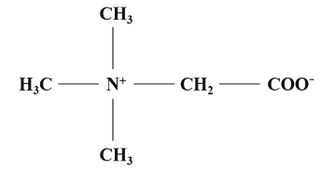
Figure 1: Chemical structure of betaine

2.4 Absorption and metabolism of Betaine
The cellular absorption of betaine in many organisms from bacteria to vertebrates stated by Yancey (2005). Animal studies have revealed postprandial absorption of betaine rapidly in the small intestine through duodenum route (Kettunen et al., 2001a).
After consumption of betaine with feed or water, it is absorbed in the intestine via Na+ dependent and Na+ independent factors (Kettunen et al., 2001b). The two epithelial betaine transport systems are the betaine γ-aminobutyric acid transporter (BGT-1) and amino acid transport system A (Kettunen et al., 2001a; Craig, 2004) (Kettunen et al. (2001a); (Kettunen et al., 2001a); Craig (2004)). The addition of dietary betaine has been shown to increase its own rate of absorption via Na+ dependent transport, most markedly in the duodenum (Kettunen et al., 2001a). After intestinal absorption, betaine enters the portal blood where it is conveyed to the liver. After the entrance of betaine to the liver, betaine goes to hepatic cells and remains in the cytosol. Once in the cytosol, betaine is then capable to either donate a methyl group to homocysteine, or remain structurally unbroken and confer osmo-protective properties to the cell. Betaine absorb rapidly than choline or methionine. Although choline and methionine are associated with plasma lipoprotein, betaine remains in a free state in the plasma. Choline must be transported from the cytosol into the mitochondria than it is oxidised to betaine, which is transported to the cytosol. However, the capability of converting choline to betaine is decreased by polyether ionophore anticoccidials by inhibiting mitochondrial membrane transport of the compound.

2.5 Betaine as methyl donar
Betaine acts as a methyl donor. It contains three methyl groups in its structure and donates these in several reactions. As a result, betaine can provide compounds such as methionine, choline and folic acid and betaine supplementation may reduce the need for supplementation of these nutrients. The first methyl group is contributed to homocysteine in its enzyme-induced conversion to methionine in the liver. The other two-methyl groups are supplied to one-carbon pool and they will be handled by folic acid. Methyl tetra hydrofolate can also give methyl group to homocysteine for methionine synthesis. Betaine enhance the concentration of S-adenosyl methionine and homocysteine in liver. They facilitate in-vivo methionine synthesis by utilising methyl groups from a single carbon pool. Metzler-Zebeli et al. (2009) stated that dietary betaine may act better than other methyl group donars like choline and methionine. On a molecular weight basis, betaine contains about 3.75 times more methyl groups than methionine and 0.90 times methyl group than choline. In chicks, betaine donates a methyl group (CH₃) to homocysteine approximately three times more efficiently than choline for the synthesis of methionine. However, a sufficient concentration of cysteine is required to achieve the beneficial effects of betaine supplementation. Inadequate dietary concentration of cysteine may affect the activity of betaine by decreasing the concentrations of homocysteine for methionine formation.

2.6 Betaine as Osmolyte
The effects of betaine as an osmolyte have been investigated in many studies. Dipolar zwitterionic nature and high solubility in water are responsible for the osmo-protective property of betaine. As an osmolyte betaine maintain cellular function and structure by enhanceing the cell’s ability to regulate the movement of water in and out of the cell (Siljander-Rasi et al., 2003).
Sodium ions (Na+) move from the cellular fluid into the cell in heat stress and dehydration. Inhibition of nutrient uptake by the cell is proportional to the higher the concentration of Na+. Higher concentrations of potassium (K+), magnesium and phosphorus within the cell also inhibit the activity of enzymes necessary for metabolism of nutrients. To maintain normal enzyme activity, function and volume, cells raise the intracellular concentrations of organic osmolytes such as methyl amines, choline and betaine. Betaine protects against dehydration by increasing water-holding capacity of the cell. The chemical structure of betaine is an important reason for its osmo-protective properties. Betaine is a zwitterion. Zwitterionic molecules possess a net neutral charge. It has a positive charge on one atom and a negative charge on another atom and the charged atoms must be joined by one or more covalent bonds. Zwitterion is soluble in water and this solubility enhances the ability of its accumulation in cells and cell organelles that are in osmotic stress (Kidd et al., 1997). Since the molecule is a zwitterion, and possesses no net charge, betaine is able to accumulate in cells without altering intracellular ionic balance, and is undisruptive to the molecular conformation of native intracellular proteins (Kidd et al., 1997). Additionally, betaine does not bind or attach to intracellular proteins, thus leaving the molecule’s mobility unrestricted, and not inducing conformational changes in native proteins (Lever & Slow, 2010).
In terms of energy expenditure in osmo-regulation and compatibility with the cell organelles, utilization of betaine as an osmolyte is more beneficial than inorganic electrolytes. Birds fed a betaine supplemented diet increases the stability of mucosal cell structure and decreases movement of water from the mucosal cell even at higher osmotic pressure in the gut lumen. By reducing the activity of the ‘Na/K’ and ‘calcium pump’ by 64% and 73% respectively betaine supplementation also reduces the energy required for osmoregulation. This process mainly uses adenine triphosphate (ATP) as an energy source.
The concentration of electrolytes increases within the cell during dehydration. Potassium ion (K+) is pushed into the cell against the concentration gradient to regulate the required concentration of water within the cell. One molecule of ATP is necessary to pump any ion against the concentration gradient. Higher concentrations of electrolytes in the cell inactivate enzymes and proteins. The higher concentrations of the electrolytes bind with active sites of enzymes and deactivate them. Energy is not required for the movement of betaine across the cell membrane and cell ecosystem or cell metabolism is not hampered for the movement of betaine. Betaine in feed or drinking water can control different osmoregulatory conditions including diarrhea, catharsis, diuresis and ascites. Thus the accumulation of betaine in cells during times of dehydration allows the cells to maintain osmotic homeostasis by minimizing water loss to hyperosmotic extracellular fluid.
Betaine causes changes in the structure of the gut epithelium that increase gut surface area. Betaine stimulates the proliferation of cells of the mucosal membrane in the intestine. The enlarged surface area of gut wall epithelium may increase nutrient absorption. Betaine Reduces gut pH and increases intestinal villi height thus improves the digestibility of methionine and other nutrients.

2.7 Effects of betaine on broiler chicken

2.7.1 Effect of betaine in reduceing heat stress
High environmental temperature reduces productive performances in poultry. The optimum temperature for the performance of poultry is likely to be 18°C to 24°C, depending on the age and breed of the birds.The normal body temperature of the broiler is 41°C. When the environmental temperature exceeds 35°C, the broiler experiences heat stress because of failure in maintaining the balance between body heat loss and body heat production. To regulate their body temperature within a comfort zone, broiler depends on a range of mechanisms at high environmental temperature.
Betaine plays a crucial role in alleviating heat stress in poultry. Betaine supplemented diets can reduce symptoms like panting and even prevent the increase in body temperature. Betaine hydrochloride at a rate of 1.3 kg/ton and 2 kg/ton reduced rectal temperature and respiration rate on days 21 and 28 (Porter et al., 1992). This study was performed at temperatures varying between 28°C and 35°C.

2.7.2 Effect of betaine on the gross performances of broiler chicken
Traditionally, the growth rate, FCR and carcass composition of broiler are considered as the key criteria for evaluating the productivity of broiler chicken (Rezaei et al, 2004).
The application of betaine in poultry nutrition has been known to influence productivity. Inclusion of betaine in feed has been the subject of studies on improvement of weight gain and feed efficiency (Virtanen and Rosi, 1995; Hassan et al., 2005; Chen et al., 2018). It is reported that the betaine has the property of contributing methionine and choline as methyl-group donors and assumed to improve the broiler performance. Betaine acts as an osmoprotectant that reduces the heat stress and maintain acid-base balance along with physiological and metabolic functions in the body, which might contribute greater broiler performance and feed efficiency (Klasing et al., 2002; Honarbaksh et al, 2007). Betaine is a functional active substance from a variety of plants, which can act as methyl group donor and organic osmolyte, and has the ability to improve growth performance in animals (Rao et al., 2011).Diet supplemented with different levels of betaine results in superior of FCR reported by several investigators (Tolba et al.,2007; Honarbakhsh et al., 2007; Zulkifli et al., 2004) .Shaojun et al. (2015) reported that used betaine by (0.1% , 0.2% , 0.4 %) with heat stress in broiler chicks diets, birds fed diet with betaine-supplementation had a higher feed intake, body weight gain and lower FCR. Likewise, supplementation of betaine at 0.05% and 0.075%, did not significantly effect on feed intake, body weight gain and feed con-version ratio (Sakomura et al., 2013).
Awad et al. (2014) found using betaine at levels of 0, 0.5, 1.0 and 1.5 g/kg diet, had significant effects on live body weights and body weight gain, feed intake, feed conversion ratio and viability rate(%). Dietary supplement of betaine can influence the performance of animal. The dietary supplementation of betaine in poultry diets had improved weight gain and feed efficiency by an approximate range from 3 to 15% ((Singh et al., 2015, Hassan et al., 2005)). Using betaine at levels of 0, 0.5, 1.0 and 1.5 g/kg diet, Sayed and Downing (2011) had found significant effects on live body weights and body weight gain, feed intake, feed conversion ratio and viability rate (%). Awad et al. (2014) claimed that live body weight, body weight gain, feed conversion ratio and mortality rate were improved significantly by adding betaine at 0.1% and 0.2% with diet. Nofal et al. (2015) reported that birds fed diet with betaine-supplementation had a higher feed intake, body weight gain and lower FCR, which are obtained by using betaine at levels of 0.1%, 0.2%, and 0.4 % in poultry diets. Likewise, betaine did not affect feed intake, body weight gain, and feed conversion ratio significantly at the rate of 0.05% and 0.075% supplementation (He et al., 2015). However, diet supplemented with different levels of betaine results in superior of feed conversion ratio ((Sakomura et al., 2013),(Tollba et al., 2007, Honarbakhsh et al., 2007).

2.7.3 Effect of betaine on gut development and nutrient digestibility
Betaine may influence intestinal function and growth. Eklund et al. (2005) reported that betaine could maintain gut villi integrity and consequently promote better nutrient digestibility and absorption in broilers. Accumulation of betaine in intestinal cells results in increased water binding capacity of these cells (Zulkifli et al., 2004). This process helps in maintaining the structure of gut epithelium. Betaine can increase the tensile structure of intestinal cells (Kettunen et al., 2001a). The height of villus may be reduced by coccidial infection and it was cured after dietary inclusion of betaine(Remus & Quarles, 2000). In a study performed by (Klasing et al., 2002) reported that supplementation of betaine causes lower crypt:villus ratio in coccidian infected as well as healthy chickens and the lesion score was reduced in coccidian infected chicks (Kettunen et al., 2001a; Virtanen, 1995). The osmolytic capability of betaine can positively affect the digestibility in poultry because evidence has showed that the mechanism of digestion and absorption is dependent on intact gut epithelium (Amerah & Ravindran, 2015; Csonka, 1989; Eklund et al., 2006b). Supplementation of betaine can improve fat digestibility because betaine is metabolized to glycine (Hu et al., 2017). According to Augustine and Danforth (1999)betaine supplementation to broiler diets at level of 0.15% may increase digestibility of crude protein, ether extract, lysine, and catotinoids.

2.7.4 Effect of betine on carcass yield traits of broiler chicken
Betaine is often considered as a carcass modifier due to methyl group donor property, which causes a higher availability of methionine and cystine for protein deposition, thus contributing to improving quality carcass yield (Yang et al., 2016).
Different researchers have different opinions on the effects of betaine on carcass. Remus et al. (1995) found no significant effect on carcass, breast yield and internal organs of adding betaine with negative control diet. However, Sakomura et al. (2013)found that breast weight at 21 day of age was significantly influenced by betaine supplemented diets. Rao et al. (2011) reported that dietary betaine effects on carcass characteristics (carcass weight, dressing, thigh, breast and giblets percentages) and these were improved significantly by betaine supplementation at levels of 0.1 or 0.2%. According to the study of Nofal et al. (2015) and McDevitt et al. (2000) supplementation of betaine in feed increased breast percentage of male broiler. On the other hand, Zeisel (2017) did not find any improvements in breast meat yield of broilers fed diet containing 0.1% betaine. Waldroup and Fritts (2005)reported that the percentages of liver, gizzard and giblets were not affected by dietary treatments and the abdominal fat decreased significantly by betaine addition. Many previous investigators (Zhan et al., 2006, Konca et al., 2008, El-Shinnawy, 2015), who found similar results in the relative weight of visceral organs, when broiler fed betaine supplemented diets. The percentages of visceral organs say liver, gizzard and gib-lets were unaffected when broiler fed betaine diet reported by El-Shinnawy, (2015).

2.7.5 Meat quality and betaine
The amount of fat content in the meat determines its quality. Extra fat accumulation in broiler carcass is generally considered as an unfavourable characteristic in the poultry industry (Remignon and Le Bihan-Duval, 2003). Feed nutrients appear to be metabolised at different rates when supplied in diets to the birds. This influences deposition of fat in the carcass. In general, bone development occurs first, followed by muscle and then fat deposition. As one phase nearly completes, the rate of the next phase increases, so that birds that grow rapidly tend to enter the fat deposition phase earlier than those that grow slowly (Hossain et al., 2015).
People prefer lean meat or fatless, green or organic meat. So lean meat implies quality meat, as it contributes greater protein % than fat content in the carcass. Eklund et al. (2005) stated that betaine is so called carcass modifier for its nature of fat redistribution. The multiple properties of betaine are the lipotrophic, methylation and antioxidant, which could inhibit increased fat accumulation leading to higher protein deposition in the body. This is supported by Alirezaei et al. (2012), who stated that betaine could act as an antioxidant agent and improve broilers’ meat quality. Apart from this, the methyl group donor property of betaine might synthesize methionine and cystine for protein deposition, and thus contribute lean carcass meat of broiler (Yang et al., 2016). Many previous investigators (Esteve-Garcia and Mack, 2000, Konca et al., 2008), who reported that betaine fed diet did not affect the abdominal fat and liver weight. However, betaine is beneficial for supplying lean meat by means of improving dressed yield and reducing abdominal fat (Wang et al., 2004, Hassan et al, 2005, Zhan et al., 2006).

2.7.6 Broiler survivability and betaine
Betaine can act on the defensive mechanism of the body, as it has been indicated that betainecould work positively on the immune system of broiler chickens and rats (Klasing et al, 2002). The humoral immunity of broiler chickens could be improved by dietary betaine supplementation reported by previous researchers (Klasinget al., 2002; Kettunen et al., 2001). Awad et al. (2014) found using betaine at levels of 0, 0.5, 1.0 and 1.5 g/kg diet had significant effects on viability rate (%) including gross responses of broilers. Afrin et al .(2018) noticed no effect of viability of broiler when fed betaine diet.

2.7.7 Effect of betaine on the blood metabolites of broiler chickens
The serum blood metabolites such as total protein, glucose, albumin, uric acid, creatinine and triglycerides etc. of broiler chicken might be affected by dietary supplementation of betaine. Because betaine is called multifunction agent. It is reported that betaine can perform myriad function in animal body. It helps in fat metabolism as lipotropic agent, acts as a methyl group donor in chicken metabolism, anti-heat stress feed additive, and also helps in immune, cardiovascular, nervous, and renal systems as osmoprotectant agent (Klasing et al, 2002; Alirezaei et al, 2012, Sakomura et al, 2013). It has been demonstrated that the biosynthesis of betaine is made by the oxidation of choline in the cell mitochondria.
Blood triglycerides (TG), cholesterol (CHOL), HDL-C, and LDL-C are also considered as salient factors of lipid metabolism balance (Helkin et al., 2016), If broilers are fed diet with a higher calorie protein (ME:CP) ratio could increase lipogenesis or extra-fat deposition in the body (Rosebrough and Steele, 1985). The incremental effect of betaine on serum TG in animal body is likely due to its function to mobilize the stored fat into the blood vessels to be metabolized and oxidized in tissues. An elevated blood TG level of animal fed with betaine diet likely due to usage of dietary carbohydrates as an energy source rather than free fatty acids (Ghasemi and Nari, 2020).
The role of betaine on blood lipid profile in the poultry is still unclear or contradictory. Different researchers demonstrated both positive and negative findings regarding this. Shin et al.(2019) reported that supplementation of betaine in heat-stressed ducks reduced the serum CHOL and TG levels,, whereas increased serum CHOL with unchanged TG level in broiler chicken were observed by Rama Rao et al. (2011) in another study.
Besides, Matthews et al. (2011) also found the increase of serum CHOL in pig fed betaine supplemented diets. The discrepancies of findings among three different experiments might happen due to numerous factors such as species, age, duration, experimental condition, ration, dosage, mode of application and so on. The reason for the higher plasma protein accretion in blood vessel, might be due to as a result of betaine supplementation in broiler diets. Because it is reported that betaine can increase the availability of amino acids (methionine and cysteine) level for synthesizing of protein formation in broiler chicken (Yang et al., 2016).As betaine is known to regenerate amino acids methionine, cystine and choline and reduces its requirement in the body (Eklund et al., 2006). Eklund et al. (2005) revealed that supplementation of betaine in broilers’ diet could improve the apparent nutrient digestibility, including protein, methionine, and crude fat. Wang et al. (2018) reported that betaine supplementation increased the activities of amylase, lipase, trypsin, and chymotrypsin of the small intestine in stressed rats.
Further, the increased absorption of betaine diet might increase the protein level and thereby the increased growth of the broiler chicken. Eklundet al. (2005) reported that betaine could maintain gut villi integrity and consequently promote better nutrient digestibility and absorption in broilers.

2.7.8 Effect of betaine on the profitability of broiler chickens
Feed cost or production cost represents the farm’s profitability. Higher profitability depends on production cost. So production cost varies by multiple factors say-market price, feed, bird, processing method, mode of selling or marketing, house, labor, treatment and so on. Today‘s broiler industries are adopting multiple polices for selling their finished product in the market with a view to earing higher profitability and cutting cost. Now broiler chicken in diversified forms such as live bird, dressed carcass, different meat cut, deboned or fillet meat etc., are available in the super shop to increase farm’s profitability by reducing production cost (Akter et al., 2020).
This sudden change in the market forms for poultry industry recently, from a whole live bird commodity to modern highly diversified processed products, has been an emerging issue to look ahead for quality poultry production along with low investment and cost. The result of previous investigator found increased profitability when broiler raised with betaine fed diet (Afrin et al, 2018).

Chapter—III: Materials and Methods

3.1 Statement of the experiment
The experiment was carried out at the Department of Dairy and Poultry Science, Chattogram Veterinary and Animal Sciences University (CVASU) to ascertain the efficacy of betaine on the growth performance and gastro-intestinal development of broiler chickens fed betaine supplemented diet. Feeding trial in broiler chicken was performed at the Poultry Research Shed of CVASU campus, during September-October, 2019. Laboratory analyses were performed in Poultry Nutrition Laboratory of CVASU, Khulshi, Chattogram.

3.2 Preparation of the experimental shed
Firstly, the experimental poultry shed was prepared by swiping and removing of dust dirt by broom. The battery cage was also washed and cleaned by whisk. Both shed and battery cages was then washed and cleaned properly with tap water containing detergent. The shed and cages were left for air drying for 3 days. After that, ceiling, wall and floor along with battery cages were treated with disinfectant with FAM 30^{R} (5ml/1L water) via sprayer and again left for drying for 1 week.The cage divided into 12 pens of equal size to accommodate broiler chicken. Before allowing the entrance of chick, the individual tube feeder, drinker and each pen were marked properly by sticker (bearing cage no. and treatment). Chicks were brooded with an electric bulb (60 watt) set at the roof of each pen by hanging condition. The floor space provided for each bird was 0.5 sq. ft in the cage. The floor of each pan was covered with medium thick paper to reduce leg injury and to maintain warm temperature within each pen. All equipment was cleaned and disinfected accordingly outside the shed.

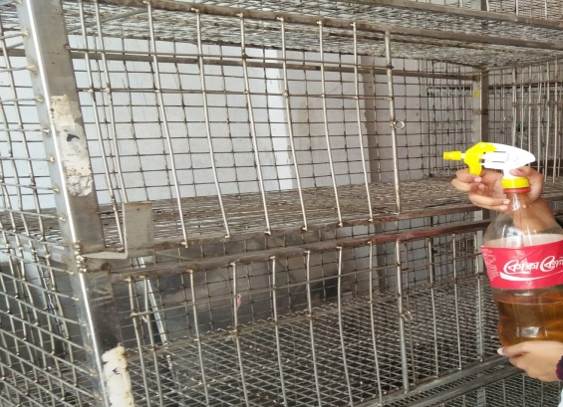
Figure 2: Disinfection of pens
Figure 3: Drying of feeder and drinkers

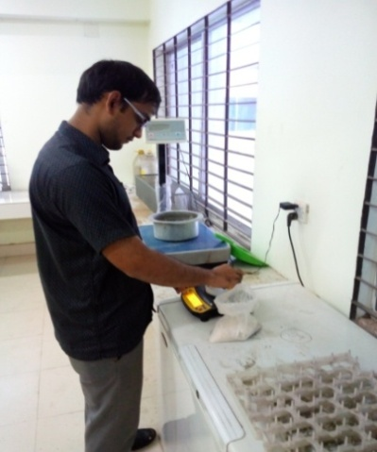
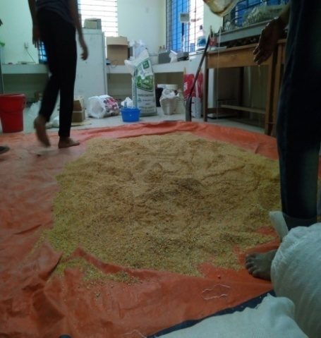
Figure 4: Weighing of micronutrients
Figure 5: Mixing of feed ingredients

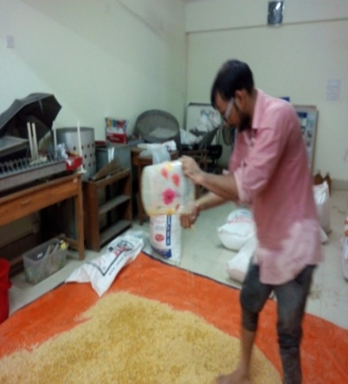
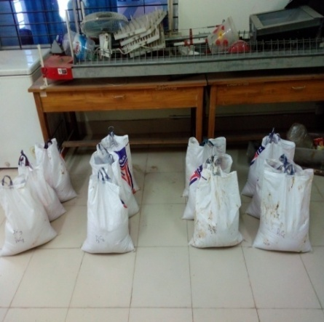
Figure 6: Adding oil with feed
Figure 7: packaging of test diets with marking

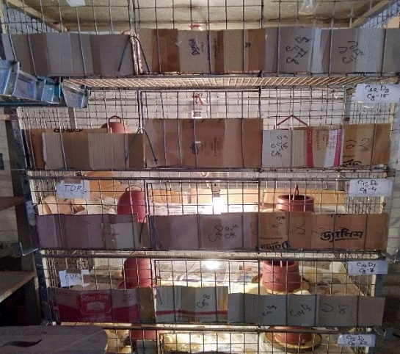
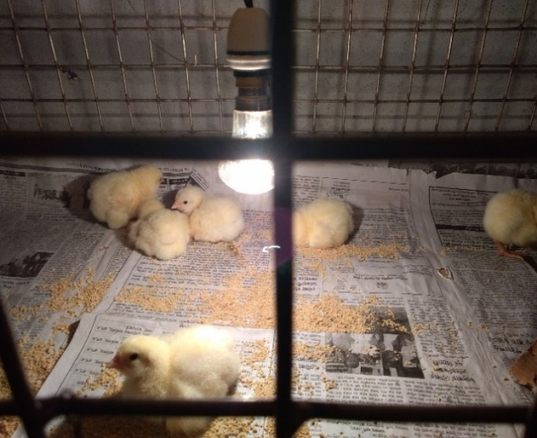
Figure 8: Spreading pre-starter feed on paper
Figure 9: Prepared brooding pen

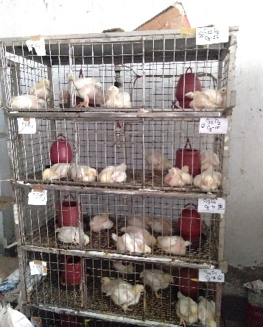
Figure 10: Floor space for 7 birds in each pen

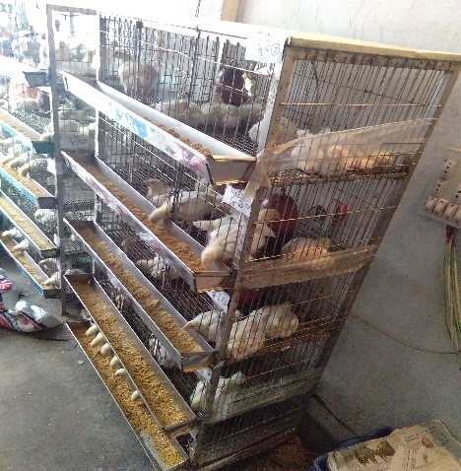
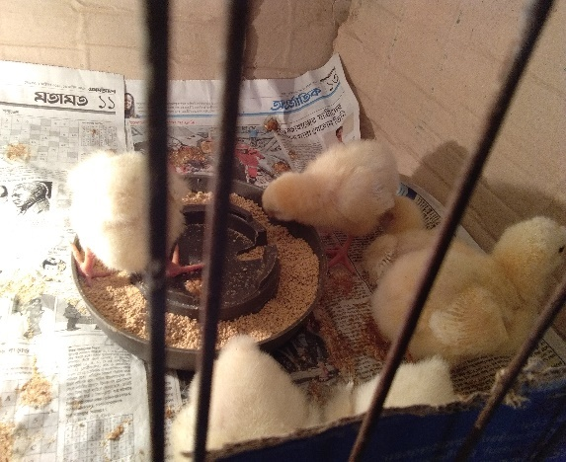
Figure 11: Feeding at early stage
Figure 12: Feeding and drinking at grower stage

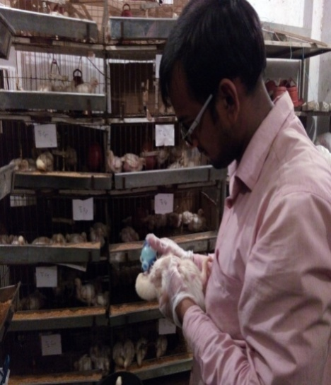
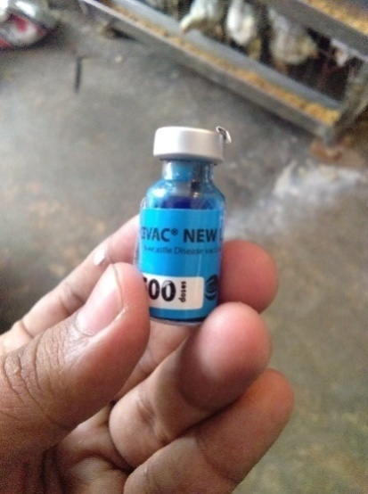
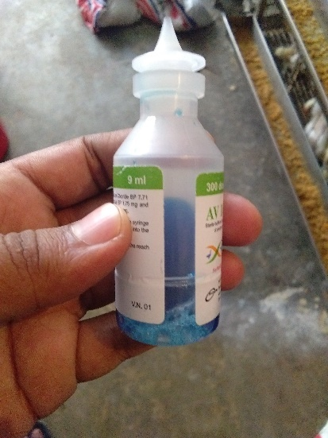
Figure 13: Vaccine Vial

Figure 14: Diluted vaccine
Figure 15: Vaccination via Eye drop

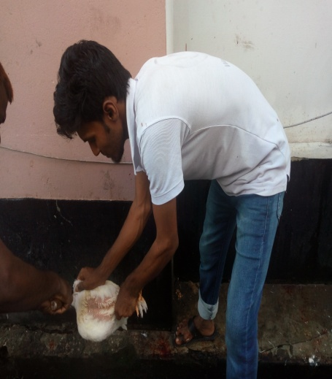
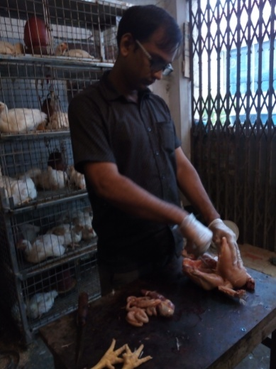
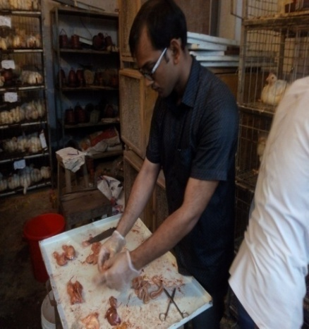
Figure 16: Slaughtering
Figure 17: Evisceration
Figure 18: Different body parts of Broiler

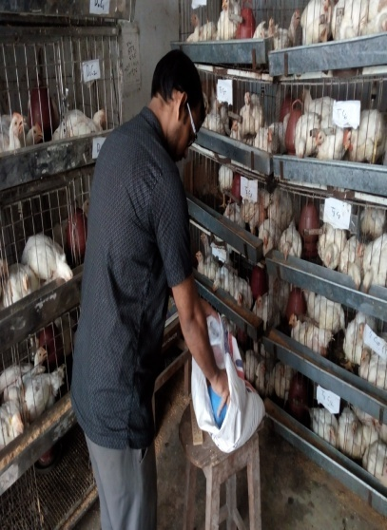
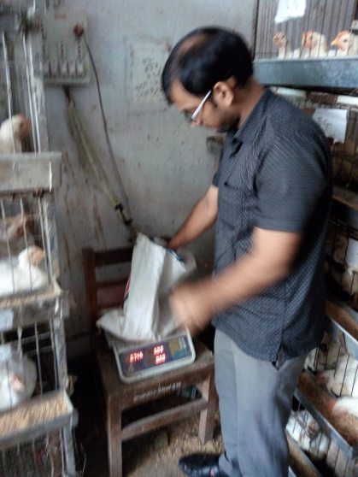
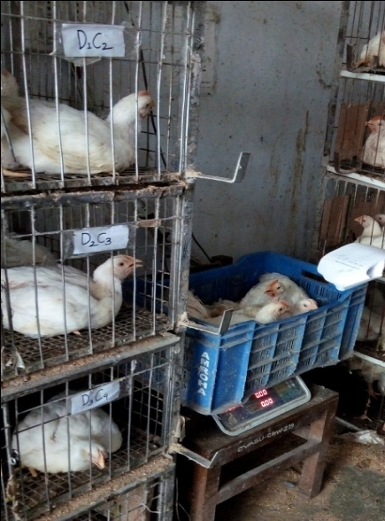
Figure 19: Measuring of body weight for keeping records
Figure 20: Diet drawing from marked specific packet to specific pen.
Figure 21: Measuring feed weight for feed intake record

3.3 Collection of day-old broiler chicks and experimental design
A total of 280 (Cobb 500) day-old broiler chicks of either sex was purchased from a local renowned hatchery (M M Aga Farm Ltd.) on a pre-order basis to run the experimental trial from day 1 to 33d. The chicks were weighed on receiving day and then randomly assigned into four dietary treatment groups (D₀, D₁, D₂, and D₃), where each treatment was replicated 7 times with 10 birds per replicate in a completely randomized design (CRD). The layout of the experimental trial was demonstrated below in Table 2.
Table 2: Layout of the experiment
Treatment | No. of birds per replicate |  |  |  |  |  |  |  | No. of bird per treatment
 | R₁ | R₂ | R₃ | R₄ |  | R₅ | R₆ | R₇
D₀ | 10 | 10 | 10 | 10 |  | 10 | 10 | 10 | 70
D₁ | 10 | 10 | 10 | 10 |  | 10 | 10 | 10 | 70
D₂ | 10 | 10 | 10 | 10 |  | 10 | 10 | 10 | 70
D₃ | 10 | 10 | 10 | 10 |  | 10 | 10 | 10 | 70
Total | 40 | 40 | 40 | 40 |  | 40 | 40 | 40 | Grand Total=280

3.4 Collection of the experimental feed and feedstuffs
Broiler pre-starter (crumble) diet (NourishTM) was collected from the local market and used to feed the birds up to 2 weeks of age. After that, finisher or test diets were prepared manually and feed the birds from 15-33 days. The macro-feed ingredients (maize, wheat, soybean meal, til oil cake, palm oil, and limestone) required for the feed formulation were purchased from the local market of Pahartali and Rajakhali Bazar, Chattogram. Each macro-ingredient was purchased based on thorough selection by visual observation like organoleptic test (color, odor, moisture etc.). The micro-nutrients were procured from another local market (Hazari lane, Terry Bazar, Chattogram). Particularly, test ingredient (Betaine) was collected from a pharmaceuticals company named Eon Group Bangladesh Co. Limited. Samples were taken from the procured and handmade diets prior to supplying the chicks in trial pen and sent to lab for proximate analyses. The proximate composition and reporting values of chemical composition of ready-made pre-starter diet (NourishTM) were shown in Table 3.
Table 3: Nutrient composition of ready-made starter diet
Nutrient component (%) | Proximate values of ready-made (Nourish feed) | Reporting values of ready-made (Nourish feed)
ME (kcal/kg) | - | 3000
Moisture | 10.40 | 12
DM | 89.60 | 88
CP | 21.80 | 20
CF | 3.30 | 5.0
EE | 5.70 | -
Ash | 6.20 | 6.0
Ca | 1.00 | 0.95
Total P | 0.58 | 0.45

3.5 Formulation of test diets
Four different test diets (D₀, D₁, D₂ and D₃) were formulated with the locally available feed ingredients to meet or exceed the requirements of NRC (1994), as shown below in Table 3, where all diets were iso-caloric and iso-nitrogenous. All feedstuffs were used to formulate control diet without betaine, whereas D_{1,} D₂and D₃ test diets were prepared with the supplementation of betaine at the rate of 0.15%, 0.20% and 0.25%,respectively. Pre-starter diet (crumble) was procured from the local market which was provided to the chicks up to 14 days of age as an adjustment period. After that, formulated diets (finisher mash) were allowed to feed the birds from d15-33 day. All the birds had a free access to the diets, and adlibitum fresh, clean and cool drinking water entire the trial period. All the formulated diets were supplemented with the multi-enzyme (Natuzyme®, Bioproton Pty Ltd., Sunnybank, Australia) which contains microbial enzyme like amylase, xylanase, β-glucanase, cellulase, pectinase, protease and phytase activities, and supplemented to the basal diet according the level stated by the manufacturing company. The composition and nutritive values (calculated and analyzed in the lab) of the formulated or test diets (finisher) were shown below in the Table 4.

3.6 Feed grinding, mixing and preparing the diets
First of all, the macro ingredients collected from local market in ground form having a desirable particle size, weighed and mixed. Then micro-ingredients were also weighed by electric balance one by one and then put in a small bucket for each diet and mixed properly by turning layer by layer. After that, the weighed macro-ingredients were spread on the wide plastic paper kept on floor of house and mixed thoroughly by the help of shovel. After that, the micro-nutrients were mixed on feed mixture equally. Vegetable oil (Palm) was added at half of the required amount by sprinkling over the feed mixture and then mixed thoroughly with hand as well as shovel. Remaining half amount of vegetable oil was finally sprinkled over feed mixture and again mixed thoroughly by both hand and shovel. A thorough mixing was done manually with shovel after weighing all ingredients as per the requirement of individual diet. Finally, the mixed diets were stored in the bags with marking, and later used for feeding the bird as mash feed. Same procedures were followed for the preparation of all diets.

3.7 Management
The following management procedures were pursued during the whole experimental period and tried to maintain the uniformity (similar feeding, lighting, environmental condition) in the management practices as much as possible.

3.7.1 Brooding
Day old chicks (DOC) were placed into the 28 equal sized pen of battery cage, each pen was furnished with a tube feeder and a drinker. Electric bulb was used to brood the chicks. A 60watt electric bulb was hanged at a height of 45 cm in the upper middle of each pen roof in order to maintain brooding temperature. The birds were exposed to a temperature of 35º C for the first two days. Then temperature was gradually reduced by 1 or 2º C after every 1 or 2 days until the chicks arrived at10 days of old. Afterwards, the poultry shed temperature was maintained at 25º C for the rest of the trial.

3.7.2 Floor space
Birds were reared in battery cage of 28 equal size pens. Each pen (4.4 sq. ft.) was allotted for 10 birds. Therefore, floor space for each bird was 0.44 sq. ft.

Table 4: Nutrient and ingredient composition of finisher diet
Ingredient (%) | Treatment
 | D₀ | D₁ | D₂ | D₃
Maize | 58.00 | 58.00 | 58.20 | 58.12
Wheat | 3.00 | 2.54 | 2.30 | 2.10
Soybean meal | 30.00 | 30.00 | 29.30 | 29.30
Protein concentrate | 2.34 | 2.36 | 3.00 | 3.00
Palm oil | 3.70 | 3.87 | 3.80 | 3.89
DCP | 0.40 | 0.37 | 0.34 | 0.34
Limestone | 1.50 | 1.60 | 1.80 | 1.89
Table salt | 0.25 | 0.30 | 0.25 | 0.30
Choline chloride | 0.04 | 0.04 | 0.04 | 0.04
Vitamin-mineral-premix | 0.25 | 0.25 | 0.25 | 0.25
L-lysine | 0.18 | 0.18 | 0.18 | 0.18
DL-methionine | 0.25 | 0.25 | 0.25 | 0.25
Betafin | 0.00 | 0.15 | 0.20 | 0.25
Enzymes (natozyme) | 0.04 | 0.04 | 0.04 | 0.04
Toxin binder | 0.05 | 0.05 | 0.05 | 0.05
Nutrients (%)-calculated value
ME(Kcal/kg) | 3118 | 3119 | 3120 | 3119
CP | 20.54 | 20.51 | 20.57 | 20.54
CF | 3.43 | 3.42 | 3.40 | 3.39
EE | 3.49 | 3.48 | 3.50 | 3.48
Ca | 1.02 | 1.04 | 1.15 | 1.18
P | 0.63 | 0.62 | 0.62 | 0.63
Nutrients –analyzed values (%)
DM | 88.00 | 88.50 | 88.00 | 87.30
CP | 21.20 | 21.40 | 21.20 | 21.23
CF | 4.20 | 4.80 | 4.30 | 4.50
EE | 5.10 | 5.20 | 5.40 | 5.30
Ash | 5.60 | 5.90 | 5.60 | 5.700
Ca | 1.67 | 1.60 | 1,62 | 1.70
P | 0.84 | 0.80 | 0.83 | 0.88
[Except for diet D0, the rest of the diet was supplemented with 0.15, 0.20, 0.25 % betaine in D₁, D₂ and D₃, respectively]

3.7.3 Feeder and drinker space
One feeder and one drinker were kept in each pen. One feeder (4.5 linear inches per bird) and one round drinker with a capacity of 3.0 L were provided for each pen. The tube feeder and drinker were arranged in a pattern so that the birds were able to eat and drink conveniently. Drinkers are cleaned and dried by detergent water 3-5 days interval. Birds were allowed to mash diet from linear feeder from d 15-33 days.

3.7.4 Feeding and watering
Feed and drinking water were supplied ad-libitumto the birds throughout the experimental period. Pre-starter feed was supplied to birds up to 14d, once a day in the tube feeder in the early morning as an adjustment diets. Paper along with tube feederand drinkers were used for feeding and watering the chicks during the early stages soon after coming from the hatchery. The finisher mash diets were given to the experimental birds from d15-33days two times daily, where once in the morning at 6 AM and another in the afternoon at 6 PM. Fresh, clean and cool drinking water was supplied the birds three times a day i.e. at 6 AM, 12 AM, and 6 PM.

3.7.5 Lighting:
The birds were exposed to a continuous lighting (23 h: 1h) in each 24 hrs of photoperiod.

3.7.6 Immunization of birds
Birds were vaccinated against Ranikhet (New Castle Disease), and Gumboro disease (Figure 14), according to the schedule mentioned in Table 5. Ranikhet live vaccine (Cevac New L^{R}) and Gumboro live vaccine (Cevac Gumbo L^{R}) were procured from local veterinary medicine Dispensary. Vaccines were collected in ice contained air tight flask and individual vaccine was collected at the vaccination date. Nearly 25 ml distilled water was added to vaccine vial via syringe to make 500 dose diluted live vaccine. Vaccine was administered to individual birds via eye within 2 hours of collection. Individual vaccines were administered at the evening time of respective vaccination date.

Table 5: Vaccination schedule
Age (Days) | Name and type of the vaccine | Name of disease | Route of administration
5 | Cevac New L^{R}, Live | Newcastle disease | One drop in one eye
12 | Cevac Gumbo L^{R}, Live | Gumboro | One drop in one eye
17 | Cevac New L^{R}, Live | Gumboro | One drop in one eye
22 | Cevac Gumbo L^{R}, Live | Newcastle disease | One drop in one eye

3.7.7 Sanitation
Adequate and proper hygiene and sanitary measures were adopted and followed throughout the experimental period. Proper cleaning and disinfection of all equipment were done prior to the beginning of the trial. Potassium permanganate (KMnO₄) solution (1.5%) was prepared and kept into a plastic bottle fitted with a sprayer at its opening mouth. It was kept at the entry point of poultry shed and used as disinfectant before entry into poultry shed. Hands and feet were also properly disinfected with 70% alcohol before entry into the shed.

3.7.8 Data and sample collection
Both pre-starter feed sample and test diets sample were collected prior to supplying birds for the assessment of the nutritive value of each diet. Body weight, feed intake and remaining feeds were recorded in record sheet in weekly basis to calculate body weight gain and feed conversion ratio (FCR). Blood samples of two birds from each replicate cage were collected on day 30 for measuring serum blood profile (total tissue, albumin, glucose, triglycerides, uric acid, creatinine). Besides, two healthy birds from each replicate were also selected randomly and then slaughtered halal way to collect intestinal tissue (small Intestine) for assessing gut morphology (villus width, villus height, crypt depth, villus height and crypt depth ratio, surface area), Meat yield traits like dressing percentage, breast weight, thigh weight, drumstick weight, shank weight, wing weight etc., were also recorded on d33. Abdominal fat content and Individual weight of gastrointestinal organs (liver, pancreas, heart, small intestine, proventiculus, gizzard,) was also recorded to ascertain the gastrointestinal organ development of the birds. Cost benefit analysis was calculated at the end of trial period.

3.7.9 Method of broiler processing:
At the end of trial period, two broilers were selected randomly, weighed and killed humanely from each replicate pen to assess carcass yield traits, abdominal fat accumulation and visceral organ weight. Feed and water were withdrawn from the pens 3 hours prior to killingin order to facilitate proper bleeding and skinning. After slaughter, birds were processed by removing the feather, skin, head, shank, viscera, oil gland, heart, kidneys, liver, lungs and small and large intestine of the carcasses. Heart and liver were removed from the gastro-intestinal tract by cutting and traction gently to let them loose. Gall-bladder was removed from liver. Gizzard and proventiculus was separated from gastro-intestinal tract by cutting it loose in front of the duodenum and behind the last end of oesophagous. Spleen was also collected by gentle cut and traction from liver parenchyma. Pancreas was collected from loop of duodenum by gentle cut and traction by scissors. Small intestine was collected by making two cut where one at the proventiculus and gizzard junction and another cut in front of the blunt sac of cecum.

3.8 Record keeping
The following parameters were recorded during the entire experimental period.

3.8.1 Mortality
Mortality was recorded when it occurred.

3.8.2 Body weight
Live weight of broiler was taken replication wise for each treatment weekly. Average live weight of the broilers was also recorded at the beginning of the experiment and at the end of each weekend.

3.8.3 Feed intake
Feed intake was calculated by deducting the left over from the total amount of feed supplied to birds at each weekend .

3.9 Calculation of data

3.9.1 Weight gain
The weight gain was calculated by deducting the initial body weight from the final weight.

3.9.2 Feed conversion ratio (FCR)
The amount of feed needed for per unit of production is called feed conversion ratio. The efficiency of converting feed into meat called feed efficiency. It was calculated by using the following formula.
FCR = $\frac{Feed intake}{Body weight gain}$

3.9.3 Mortality and livability
Mortality of birds was calculated on the basis ofnumber of dead birds throughout the experimental period divided by the total number of birds housed at the start of experiment. Livability was calculated from mortality of birds per replicate cage.
The percentage of mortality was calculated by this formula.
Mortality (%) = $\frac{Number of birds died}{Total No. of birds housed}$× 100

3.9.4 Dressing percentage
The dressing percentage of birds was calculated as follows:
Dressing (%) = $\frac{Dressed Weight}{Body Weight}$×100
Slaughtering data’ such as body weight, blood loss, feather loss, abdominal fat, shank weight, heart weight, gizzard weight, heart weight, small intestine, pancreas, bursa etc., were expressed in percentage.

3.10 Sample processing and Analyses

3.10.1 Feed sample
Ten feed samples (2 samples for each diet) were collected from ready-made and formulated test diets prior to feeding the birds. The samples were processed by grinding with the help of mortar and pestle and then mixed thoroughly for lab analyses. About 500gm of each diets of finisher as well as starter diet were taken and sent to the Animal Nutrition Lab for proximate analysis. Each analysis was done three times for each sample to minimize technical errors. The samples were tested for proximate analysis of dry matter (DM %), moisture %, crude protein (CP %), crude fiber (CF %), ether extract (EE %) and ash using standard laboratory procedures (AOAC, 2007). Dry matter estimation was done by oven dry method. Crude protein estimation was accomplished by Kjeldahl Method. Ether Extract estimation was done by Soxhlet apparatus. Ash was measured by igniting the pre-ashing sample on a Muffle furnace at a temperature of 600°C for four to six hours. Additionally, calcium (Ca %) and phosphorus (P %) were determined by atomic absorption and spectrophotometry, respectively (AOAC, 2007). Metabolizable energy (ME) was determined indirectly on the basis of true metabolizable energy (TME) contents of the feed samples, assuming that TME was 8% higher than the ME, as it is reported that TME is 5 to 10% higher than ME (Wiseman, 1987). The formula of TME is: 3951 + 54.4EE - 88.7CF - 40.8 Ash.

3.10.2 Serum biochemical parameters and analyses
On day 30, one bird was selected randomly from each replicate cage, weighed and killed humanely to collect blood sample for the assessment of blood metabolites such as total protein (TP), glucose, albumin (Alb), uric acid (UA), creatinine vand triglycerides (TG). The blood samples were then centrifuged at 3000 g at 4ºC for 15 minutes to obtain the serum, and these serum samples were collected in clean-plastic vials, and immediately frozen at -80ºC, until further chemical analyses were done in the lab. Serum total protein, albumin, triglyceride, glucose, uric acid and creatinine were determined using standard kits (Randox Laboratories Ltd., UK) and automatic analyzer (Humalyzer300, Merck®, Germany) as per the instructions given by the manufacturers’ company.

3.10.3. Gut morphology of broiler
At 30 days of age, one bird from each replicate was sacrificed after 12 hours of fasting and samples of ileum were taken. The specimens were fixed in 10% formalin after which they were dehydrated in 100% ethanol. The specimens were then cleared with xylene and embedded in paraffin. A microtome was used to make 5mm cuts that were mounted on glass slides and stained using the H and E (Haematoxyline and Eosin) method. Five readings each of villus height and crypt depth were taken per specimen. This was done with a light microscope (Olympus). Villus height was measured from the apical to the basal region which corresponded to the superior portion of the crypts. Crypts were measured from the basis until the region of transition between the crypt and the villus.

3.11 Evaluation of meat yield parameters
On day 33, two broilers were killed humanely and different meat yield parameters such as carcass weight, dressed weight, and abdominal fat content, weights of different meat cuts (neck, thigh, wings, breast, back, shank, drumstick) and giblets weights (heart, liver, pancreas, proventiculus, gizzard) were recorded properly.

3.12 Production cost
Cost of production was calculated considering the expense on chick, feed, medicine, labor, etc. Chick cost was calculated from the purchasing cost. Feed cost was considered from sale price of the feed marketed through dealers. Market price of all feeds was shown in Appendix (Table 8).

3.13 Statistical analyses
All collected data were subjected to analysis by one way ANOVA procedure using Minitab software (Minitab, Minitab Version, 16, 2000). The significance of differences between means was tested using the Duncan’s multiple range tests (DMRT). Statistical significance was considered at P≤0.05.

Chapter-IV: Results

4.1 Gross responses of broiler chickens fed betaine supplemented diet
The gross responses of broilers in terms of fed intake, body weight, FCR and viability are stated below in a tubular form. Apart from this, meat quality, carcass traits, visceral organ weights and profitability of broiler data also represented below in this section

4.1.1 Feed intake
The result of the feed intake (FI) of broiler up to 33 days was shown in Table 6. The data show that the FI of broiler was influenced significantly (P<0.05) between treatments from d28-33 and d1-33 days, respectively.The FI of broilers on D₃ diet group had significantly (P<0.05) the highest compared to other group during 28-33 and d1-33 days, respectively.
Table 6: Feed intake (FI) (g/b) of broilers fed betaine supplemented diets
 | Age (days) | Treatment |  |  |  | SEM | P -Value
 |  | D₀ | D₁ | D₂ | D₃
FI(g/b) | 14-21 | 804.43 | 905.0 | 918.57 | 895.57 | 15.225 | 0.102
 | 21-28 | 977.10 | 984.00 | 992.20 | 1035.00 | 13.626 | 0.477
 | 28-33 | 715.81^{b} | 631.95^{c} | 659.52^{c} | 741.38ª | 12.970 | 0.015
 | 14-33 | 2497.40 | 2321.0 | 2570.30 | 2712.00 | 30.600 | 0.136
 | 1-33 | 3300.10^{c} | 3210.2^{b} | 3370.10ª | 3450.30ª | 15.762 | 0.05
[[Data indicate mean values of 10 birds per replicate from day 1-33 days; D_{o} refers to control diet with no supplemental betaine, whereas D₁, D₂ and D₃ diets are supplemented with 0.15, 0.20, and 0.25% betaine, respectively; Values (mean) bearing different superscript in a row differ significantly at *P<0.05 ; SEM- standard errors of mean]

4.1.2 Live weight
The live weight (LW) of broiler chicken is shown below in Table 7. It is clear from the LW data that there was no significant(P>0.05)difference among treatment from1-14 days, 1-21 days and 1-28 days respectively except for the days of 1-33 in this study. The LW of broiler was influenced significantly (P<0.05) among treatments from 1-33 days. The birds fed on D₃ group attained the highest LW compared to others dietary group.
Table 7: Live weight (LW) (g/b) of broilers fed betaine diets
 | Age (days) | Treatment |  |  |  | SEM | P-value
 |  | D₀ | D₁ | D₂ | D₃
LW(g/b) | 1-14 | 508.62 | 517.29 | 492.0 | 512.81 | 10.188 | 0.828
 | 1-21 | 974.6 | 1028.40 | 1004.30 | 1012.10 | 1.799 | 0.596
 | 1-28 | 1441.00 | 1524.0 | 1447.40 | 1538.40 | 22.026 | 0.334
 | 1-33 | 1742.20 ^{b} | 1862.40ª | 1784.50ª | 1902.4ª | 14.261 | 0.015
[Data indicate mean values of 10 birds per replicate from day 1-33 days; D_{o} refers to control diet with no supplemental betaine, whereas D₁, D₂ and D₃ diets are supplemented with 0.15, 0.20, and 0.25% betaine, respectively; Values (mean) bearing different superscript in a row differ significantly at *P<0.05 ; SEM- standard errors of mean]

4.1.3 The feed conversion ratio (FCR)
Theresult show that FCR was influenced significantly (P<0.05) between treatments during d1-33 days only, as shown below in Table 8.
Table 8: The FCR of broiler fed betaine supplemented diet
 | Age (days) | Treatment |  |  |  | SEM | P-value
 |  | D₀ | D₁ | D₂ | D₃
FCR | 14-21 | 1.58 | 1.63 | 1.66 | 1.67 | 0.0242 | 0.662
 | 21-28 | 1.92 | 1.82 | 2.04 | 1.82 | 0.449 | 0.306
 | 28-33 | 2.30 | 1.87 | 2.03 | 2.18 | 0.096 | 0.335
 | 14-33 | 2.02 | 1.87 | 1.98 | 1.95 | 0.022 | 0.184
 | 1-33 | 1.94ª | 1.77^{c} | 1.94ª | 1.86^{b} | 0.018 | 0.042
[Data indicate mean values of 10 birds per replicate from day 1-33 days; D_{o} refers to control diet with no supplemental betaine, whereas D₁, D₂ and D₃ diets are supplemented with 0.15, 0.20, and 0.25% betaine, respectively; Values (mean) bearing different superscript in a row differ significantly at *P<0.05 ; SEM- standard errors of mean]

4.1.4 Livability
The response of broiler in terms of livability fed with betaine supplemented diets on 33 days was not found significant (P>0.05) among treatments as shown below in Fig.2. The result revealed that supplemental diets have no detrimental effect on viability of chicks.

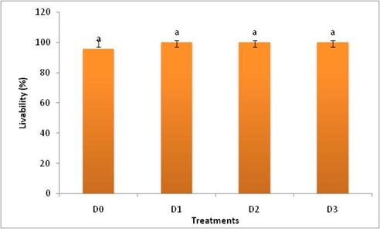
Figure 22: Livability (%) of broilers fed betaine diets on day 33; Bar with similar letter has no significant differences (P>0.05) between treatments

4.1.5 Meat yield parameters of broiler chickens
Results of meat yield parameters shown in Table 9 demonstrate that only the dressing percentage (P<0.05) and thigh weight (P<0.05) were significantly affected by the dietary treatment. The highest dressing (%) and thigh weight % were found in the birds fed on the D₃ diet group and the lowest dressing (%) and back weight were on the D₀ diet Other meat characteristics such as the weights of breast, drumstick, shank and wing etc., were not significantly different (P>0.05) between treatments.
Table 9: Meat yield traits (g/100g) of broilers fed betaine on days 33

 | Treatment |  |  |  | SEM | P-value
 | D₀ | D₁ | D₂ | D₃
Dressing% | 62.64^{c} | 64.94^{b} | 66.91ª | 67.58ª | 0.146 | 0.05
Breast weight | 22.72 | 25.39 | 26.74 | 27.18 | 0.570 | 0.143
Drumstick weight | 7.17 | 8.57 | 8.57 | 8.49 | 0.129 | 0.432
Thigh weight | 8.50^{b} | 9.09ª | 10.25ª | 9.17ª | 0.118 | 0.05
Wing weight | 4.33 | 4.77 | 5.05 | 5.53 | 0.162 | 0.209
Shank weight | 4.0 | 3.75 | 3.98 | 4.0 | 0.080 | 0.616
[Each value indicates the mean of five replicates consisting of10 birds per replicate cage at 33 days; Values (mean) bearing different superscript in a row differ significantly at *P<0.05 ;]

4.1.6 Meat quality of broiler chicken fed betaine diet
The abdominal fat content of broiler was measured herein this study to assess meat quality based on the fat deposition. The result showed that there was no difference (P>0.05) in the abdominal fat content (%) of broiler chicken between treatment (Figure 3). The data showed that the lowest fat content (1.43%) was observed in D₃ diet followed by 1.56 %, 2.15%, and 2.16 % in D_{o}, D₁ and D₃, respectively.

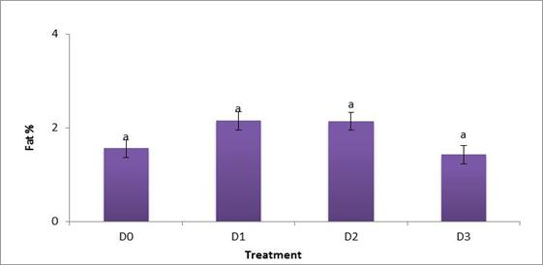
Figure 23: Abdominal fat (%) of broilers fed betaine diets on day 33; Bar with similar letter has no significant differences (P>0.05) between treatment

4.1.7. Gastro-intestinal development
The relative weight of visceral organs of broiler chicken fed on the supplemented diet (betaine) is shown in Table 10. The data show that the weights of proventriculus, gizzard, liver, heart, and pancreas of birds were identical (P>0.05) between treatments. .
Table 10:Relative visceral organs weight (g/b) of broiler chickens fed diet supplemented with betaine on day33
 | Treatment |  |  |  | SEM | P-value
 | D₀ | D₁ | D₂ | D₃
Proventriculus+ gizzard weight | 62.05 | 71.97 | 60.45 | 59.74 | 1.619 | 0.152
Liver weight | 36.96 | 39.57 | 37.27 | 39.56 | 1.804 | 0.921
Heart weight | 8.43 | 8.63 | 8.75 | 9.53 | 0.352 | 0.719
Pancreas weight | 3.21 | 3.32 | 4.27 | 3.57 | 0.192 | 0.373
[Data represent man values of five replicates consisting of 9 birds on day 33; Treatment D₀ refers to control diet, D₁, D₂ and D₃ refers to diets supplemented with 015 % , 0.20 and 0.25 % betaine, respectively;]

4.1.8 Serum metabolites of broilers fed betaine diet
The results of blood metabolites (total protein, glucose, albumin, uric acid, creatinine and triglycerides etc.) of broiler chickens are shown in Table 11. Except for serum triglycerides (TG), the data of serum metabolites indicate that there is no significant influence (P>0.05) between treatments. The TG was significantly increased (P<0.05) in the supplemental dietary groups compared to control diet. The total protein (P<0.065) and uric acid (P<0.07) were also tended to be significant between treatment.
Table 11: Blood serum parameters of broilers fed diet supplemented with betaine
 | Treatment |  |  |  | SEM | P-value
 | D₀ | D₁ | D₂ | D₃
Albumin (g/L) | 14.55 | 15.75 | 16.90 | 17.10 | 0.589 | 0.480
Glucose (g/L) | 246.55 | 268.90 | 236.70 | 264.70 | 5.828 | 0.248
Total protein (g/dL) | 1.43 | 1.50 | 1.65 | 2.25 | 0.079 | 0.065
Triglyceride (mg/dL) | 115.0^{b} | 123.050ª | 120.15ª | 127.15ª | 1.106 | 0.038
Creatinine (mg/dL) | 0.55 | 0.55 | 0.49 | 0.59 | 0.045 | 0.567
Uric acid (mg/dL) | 3.95 | 4.35 | 6.1 | 4.45 | 0.105 | 0.07
[[Data represent man values of five replicates consisting of 9 birds on day 33; Treatment D₀ refers to control diet, D₁, D₂ and D₃ refers to diets supplemented with 0.15 % , 0.20 and 0.25 % betaine, respectively; Values (mean) bearing different superscript in a row differ significantly at *P<0.05]

4.1.9 Intestinal morphology of broiler
The data show that majority of the ileal characters i.e. villus height (VH), crypt depth (CD), VH:CD ratio and surface area etc., were not significantly (P>0.05) improved by supplemental diets, except for villi width in this study. The villi width (VW) was improved (P<0.05) in the supplemental group compared to non-supplemented group (Table 12). It is obvious from the data that increasing trend was observed in the ileal tissue of villi width, crypt depth and surface area of broiler chickens by increased level of betaine diets fed the birds. The CD was marginally improved (P<0.056) in the betaine treated group as compared to control.
Table 12: Ileal tissue morphometry of broiler chicken fed betaine diets
[Data indicate mean value of two birds per replicate at 30d; Values beari]
 | Treatment |  |  |  |  | P-value
 | D₀ | D₁ | D₂ | D₃ | SEM
Villus height (µm) | 602.50 | 608.0 | 611.0 | 617.50 | 1.57 | 0.148
Crypt depth (µm) | 111 | 116.50 | 118.0 | 129.50 | 1.570 | 0.056
Villus width (µm) | 220^{b} | 229.5ª | 233.5ª | 236.0ª | 0.728 | 0.01
VH:CD ratio | 5.43 | 5.22 | 5.18 | 4.78 | 0.068 | 0.106
Surface area (mm²) | 0.16 | 0.19 | 0.20 | 0.18 | 0.011 | 0.668

4.2 Cost benefit analyses
The data on cost benefit analyses of broiler was presented in the Table 13. Higher production cost was found in the birds fed non-supplemented or basal diets (D₀). Total cost of production (Tk/Kg live broiler) was significantly (P<0.05) less for the birds fed Betaine supplemented diets. Higher (P<0.05) profit margin was obtained for Betaine supplemented dietary group. The greater profit margin might result in increased body weight gain and reduced production cost per treatment group. On the other hand, lower profit (P<0.05) (Tk/Kg live broiler) was counted for the birds fed diets without Betaine diets.
Table 13: Cost of production and profit of broiler fed betaine diet on d33
 | Treatment |  |  |  | SEM | P-values
 | D₀ | D₁ | D₂ | D₃
Live weight (g/b) | 1742.20^{c} | 1862.40ª | 1784.50^{b} | 1900.40ª | 14.261 | 0.05
Viability (%) | 97.78 | 100.00 | 100.00 | 100.00 | 0.554 | 0.418
Feed cost (Tk/kg live weight) | 69.88 | 63.60 | 69.77 | 66.87 | - | -
Total production cost (Tk/kg live wt.) | 122.12ª | 111.87^{b} | 120.21ª | 114.1^{b} | 0.323 | 0.01
Market price (Tk/kg live bird) | 135.00 | 135.00 | 135.00 | 135.00 | - | -
Profit (Tk/kg live bird) | 12.18^{c} | 23.13ª | 14.79^{b} | 21.0ª | 0.443 | 0.01
Cost: benefit ratio | 9.21ª | 4.84^{b} | 8.13ª | 5.43^{b} | 0.209 | 0.05
[Values bearing different superscript in a row differ significantly at **P<0.01 and *P<0.05]

Chapter-V: Discussion

5.1 Growth performances of broiler fed betaine diet
Traditionally, the most important criteria of evaluating broiler performance have been the growth rate, FCR and carcass composition (Rezaei et al, 2004). The gross response of broiler chickens has been regarded as the primary criterion for determining the feed nutrient requirements, because the broiler chick is an ideal experimental subject with a limited nutrient store, high nutrient demand and rapid growth rate (Ammerman, 1995).
The present study aimed to determine the effects of betaine supplementation, and their relationships with growth performance, blood profiles, carcass yield, meat quality, gastro-intestinal development, gut morphology, bone quality of broiler chickens. The application of betaine in poultry nutrition has been known to influence productivity. Addition of betaine in feed has been the subject of studies on improvement of weight gain and feed efficiency (Virtanen and Rosi, 1995; Hassan et al., 2005; Chen et al., 2018).
In this study, overall gross performance of broiler chicken was improved by feeding betaine treated diets, confirming the results obtained by many previous investigators (Attia et al.,2005, 2009;Nofal et al., 2015, Afrin et al., 2018), However, it is obvious from the current study that live weight of broiler was increased by the increased level of the supplemental betaine offered to the birds. The higher feed intake of broilers of this diet group might be a result of increased body weight of broiler chicken fed betaine diet, as is observed in this current study. The increased feed intake of broilers on betaine supplemented diet likely due to amino acid balance (Bunchasak, 2009). As betaine is known to regenerate amino acids methionine, cystine and choline and reduces its requirement in the body (Eklund et al., 2006). Eklund et al. (2005) revealed that supplementation of betaine in broilers’ diet could improve the apparent nutrient digestibility, including protein, methionine, and crude fat. Wang et al. (2018) reported that betaine supplementation increased the activities of amylase, lipase, trypsin, and chymotrypsin of the small intestine in stressed rats. Further, the increased absorption of betaine diet might increase the protein level and thereby the increased growth of the broiler chicken. Eklund et al. (2005) reported that betaine could maintain gut villi integrity and consequently promote better nutrient digestibility and absorption in broilers. It is reported that the betaine has the property of contributing methionine and choline as methyl-group donors and assumed to improve the broiler performance. Further, it is stated that betaine acts as an osmoprotectant that reduces the heat stress and maintain acid-base balance along with physiological and metabolic functions in the body, which might contribute greater broiler performance and feed efficiency (Klasing et al., 2002; Honarbaksh et al, 2007). However, our results are agreed with the findings of previous investigators (Wang et al., 2004; Sun et al, 2008; Attia et al., 2005, 2009; Afrin et al., 2018), who found similar results when broilers fed beyaine diets. Bird’s body weight and FCR improved by usage of betaine feeding (Attia et al., 2005).
Betaine is a functional active substance from a variety of plants, which can act as methyl group donor and organic osmolyte, and has the ability to improve growth performance in animals (Rao et al., 2011). Zhan et al. (2006) claimed that live body weight, body weight gain, feed conversion ratio and mortality rate was improved significantly by adding betaine at 0.1% and 0.2% with diet.

Heat stress is very common in poultry industry which causes reduction in feed intake and lower weight gain. Reduction in feed intake may be due to little energy requirement for heat preservation (Nofal et al., 2015). This study was mainly conducted to assess the effect of inclusion of betaine in broiler diets on performance of broilers during the rearing period. This study showed that betaine supplementation resulted in an improved growth performance with increased feed intake. Freeman (1988) as well as Awad et al. (2014) reported that betaine supplementation to broiler significantly increase feed intake as compared to control group. Weight gain was significantly affected by the supplementation of betaine to broiler feed during the experimental period of 1-33 days of this study. During the whole experimental period broiler offered with betaine at the rate of 2.5g/kg feed had significantly higher weight gain as compared to the control group. Betaine can improve the specific nutrient’s digestibility which can help in increasing body weight of broiler (Sakomura et al., 2013). Eklund et al. (2006a) and Attia et al. (2005) showed improvement of weight gain in poultry as a result of betaine supplementation of betaine. On the other hand, this study did not agree with Hassan et al. (2005) and Zulkifli et al. (2004) who stated that supplemental betaine in diet has no significant effect on body weight gain. In this study, during the whole experimental period improved FCR was found in D₁ group where broiler of this group were offered betaine supplement at the rate of 1.5g/kg feed. Esteve-Garcia and Mack (2000) showed that betaine supplementation significantly improved FCR at the rate of 1.5 to 2.0 g/kg feed.

5.2 Livability of broiler
The result of livability indicates that supplemental diets had no influence on viability of the broiler chicks. The livability (%) of broilers was unaffected between treatments, as is observed from the current study. It can be assumed that betaine-fed diet had no detrimental effect on the viability of broiler chickens for the growth and development of broiler. Further, it can be assumed that betaine feed in the broiler diets can be used undoubtedly, as it had no detrimental impact on the growth and survivability of the broiler chicken. It can be surmised that betaine can act on the defensive mechanism of the body, as it has been indicated that betaine could work positively on the immune system of broiler chickens and rats (Klasinget al, 2002). The humoral immunity of broiler chickens could be improved by dietary betaine supplementation (Klasing et al., 2002; Kettunen et al., 2001).

5.3 Carcass yield traits of broiler
The increased dressing % and thigh weight of broiler might be due to greater body weight gain, as is seen in this study. Broilers gained higher body weight fed on betaine diet. The increased body weight of broilers on the betaine-fed diet might give rise to better dressing yield along with other associated organs of the body. However, the current findings of our study could claim to supply the Cobb 500 strain with a greater amount of betaine concentrated diets, if we wish to attain a greater body weight with increased dressing yield of broiler chicken (Akter et al., 2020). The similar result was also found by the previous investigators (Waldroup and Fritts, 2005, El-Shinnawy, 2015, Afrin et al, 2018), who found greater % of dressing yield when broiler raised with betaine fed diet. El-Shinnawy, (2015) reported that birds fed on rations supplemented with betaine showed significantly higher percentages of carcass yield, total edible parts and breast yield. Improved carcass weight, dressing %, thigh, breast and giblet % were found by Nofal et al., (2015), when broiler fed betaine diet. Betaine is often considered as a carcass modifier due to methyl group donor property, which causes a higher availability of methionine and cystine for protein deposition, thus contributing to improving quality carcass yield (Yang et al., 2016).
This study showed that supplementation of betaine at higher level like 0.20% and 0.25 % improved dressing percentage. Similar result was found in the study of Chand et al. (2017). Osmotic effect of betaine may increase dressing percentage by increasing water retention (Chand et al., 2017). The results of our study are alike the study of Waldroup and Fritts (2005) who showed that supplementation of betaine significantly increased the dressing percentage in chicken. El-Shinnawy (2015) noticed significantly better dressing percentage at 42 days of age at the rate of 1g/kg betaine.

5.4 Meat quality of broiler
The amount of fat content in the meat determines its quality. Extra fat accumulation in broiler carcass is generally considered as an unfavourable characteristic in the poultry industry (Remignon and Le Bihan-Duval, 2003). Broiler chickens fed on betaine supplemented diet deposited similar fat content in their carcasses. It implies that diet had no influence on the fat accumulation of broiler, though increasing trend of depositing fat (%) content was observed in the supplemented group (D₁, and D₂). The probable reason for the increase in abdominal fat on the diets might be due to more rapid growth, leading to earlier transition from muscle to fat deposition (Hossain et al., 2013). Feed nutrients appear to be metabolised at different rates when supplied in diets to the birds. This influences deposition of fat deposition. As one phase nearly completes, the rate of the next phase increases, so that birds that grow rapidly tend to enter the fat deposition phase earlier than those that grow slowly (Hossain et al., 2015).
Numerically lowest fat content was found in the birds of D₃ dietary group, which indicates decreasing trend of fat accumulation in betaine supplemented diet . Lower the fat content gives rise to higher lean meat carcass yield. Generally people prefer lean meat or fatless meat. So lean meat implies quality meat because it assures higher protein % than fat content in the carcass. Eklund et al. (2005) stated that betaine is so called carcass modifier for its nature of fat redistribution. The uniform fat accumulation of broiler chicken might be due to the lipotrophic, methylation and antioxidant properties of betaine, which could inhibit increased fat accumulation leading to higher protein deposition in the body. This is supported by Alirezaeiet al. (2012), who stated that betaine could act as an antioxidant agent and improve broilers’ meat quality. Apart from this, the methyl group donor property of betaine might synthesize methionine and cystine for protein deposition, and thus contribute lean carcass meat of broiler (Yang et al., 2016). Our result is agreed with the previous investigators (Esteve-Garcia and Mack, 2000, Konca et al., 2008), who reported that betaine fed diet did not affect the abdominal fat and liver weight. However, the present findings and others denote that betaine is beneficial for supplying lean meat by means of improving dressed yield and reducing abdominal fat (Wang et al., 2004, Hassan et al, 2005, Zhan et al., 2006). There were no significant differences in meat quality criteria between treatments in this study. This might be probably due to fewer numbers of observations, or the detected criteria of meat quality were insufficient. The possible reasons of these results might be due to the experimental conditions and genetic background of broilers. So future study might warrant to increase sample size, more investigation of other criteria i.e TBARS, intramuscular fat, lactic acid, etc, can be done.

5.5 Gastro-intestinal development
It is obvious from the data that the relative weights of proventriculus, gizzard, liver, heart, and pancreas of birds were identical between treatments. It is generally known that visceral organs associated with digestive function develop most rapidly in the first 7 to 10 days of life (Nitsan et al., 1991; Iji et al., 2001a,b). However, how the nature of the diets influences this development has not been adequately studied.. The liver, heart, pancreas and gizzard are the main gastro-intestinal or secretory organs of the chicken. The uniform growth of visceral organ development might be due to similarity in body growth (Hossain et al., 2014). Our result agrees with the report of previous investigators (Zhan et al., 2006, Konca et al., 2008, El-Shinnawy, 2015), who observed similar results in the relative weight of visceral organs, when broiler fed betaine supplemented diets. The percentages of visceral organs say liver, gizzard and gib-lets were unaffected when broiler fed betaine diet reported by El-Shinnawy, (2015). Waldroup and Fritts (2005) also reported that the percentages of liver, gizzard and giblets were not influenced by dietary treatments and the abdominal fat decreased significantly by betaine addition.

5.6 Serum metabolites of broilers fed betaine diet
Except for serum triglycerides (TG), the data of serum metabolites indicate that there is no significant influence between treatments. It is obvious from the data that inclusion of betaine in the broiler diets caused a significant increase in serum TG, and tend to increase higher cholesterol (CHOL) level. The incremental effect of dietary betaine on serum TG in the current study is likely due to its function to mobilize the stored fat into the blood vessels to be metabolized and oxidized in tissues. This result suggests that the chicken fed with betaine diet preferably used dietary carbohydrates as an energy source rather than free fatty acids, resulting in an elevated blood TG level (Ghasemi and Nari, 2020).
Blood TG, CHOL, HDL-C, and LDL-C are also considered as salient factors of lipid metabolism balance (Helkin et al., 2016), If broilers are fed diet with a higher calorie protein (ME:CP) ratio could increase lipogenesis or extra-fat deposition in the body (Rosebrough and Steele, 1985). The role of betaine on blood lipid profile in the poultry is still unclear or contradictory. Different researchers demonstrated both positive and negative findings regarding this. Shin et al.(2019) reported that supplementation of betaine in heat-stressed ducks reduced the serum CHOL and TG levels,, whereas increased serum CHOL with unchanged TG level in broiler chicken were observed by Rama Rao et al. (2011) in another study. Besides, Matthews et al. (2011) also found the increase of serum CHOL in pig fed betaine supplemented diets. The discrepancies of findings among three different experiments might happen due to numerous factors such as species, age, duration, experimental condition, ration, dosage, mode of application and so on. The total protein (TP) content and uric acid level of broiler were also slightly increased in the treated group of broiler chicken in this study. The reason for the higher plasma protein accretion in blood vessel might be due to as a result of betaine supplementation in broiler diets. Because it is reported that betaine can increase the availability of amino acids (methionine and cysteine) level for synthesizing of protein formation in broiler chicken (Yang et al., 2016).

5.7 Gut morphology
The multiple properties of betaine might be responsible for the improved growth of CD and VW of ileal epithelial tissues of broiler chickens fed betaine supplemented diet in this study. Besides, the increased growth of VW and CD might be an indication of greater absorption, assimilation and utilization of nutrients by the birds fed betaine diets resulting in heavier body growth responses, as is seen in this study. As we know that ingested nutrients are absorbed by the intesinal wall of the villi. It is supported by the previous investigator (Eklund et al., 2005), who reported that betaine could maintain gut villi integrity and consequently promote better nutrient digestibility and absorption in broiler chicken. Burkholder et al. (2008) reported that ischemia and hypoxia of the intestine can cause epithelial shedding, leading to a deeper crypt depth and shorter villus height. This study demonstrated that intestinal epithelial tissue was proliferated by the supplementation of betaine in broiler diet, as the methyl group donor character of betaine could help to grow and multiply the intestinal epithelial tissues; the osmotic effect of betaine could improve the intestinal environment; and the antioxidant activity of betaine could reduce the intestinal oxidative damage (Wang et al., 2018).
Our results contradict with the findings of previous researcher (Sukomura et al., 2013) who revealed that, the morphometrics of the intestinal crypts and villi in heat stressed broilers were unaffected by supplementation of betaine in diet. The extent and duration of heat stress, species of broilers, growth stages, and the type of diet could help to explain these inconsistencies. Overall, betaine favorably affected the intestinal structure and tissue growth could account for the boosted growth performance of broiler chickens in this study.

5.8 Profitability of broiler
Higher profit margin in betaine dietary group might be due to increased body weight gain and reduced production cost per treatment group. On the other hand, lower profit (Tk/Kg live broiler) was counted for the birds fed diets without betaine diets. Our result is agreed with the findings of previous investigator (Afrin et al,,2018), who found similar result in profitability when broiler raised with betaine fed diet.
Today‘s broiler industries are flourishing rapidly with a goal of selling their finished products in the market in diversified forms such as live bird, dressed carcass, different meat cut, deboned or fillet meat etc., to increase farm’s profitability by reducing production cost (Akter et al., 2020). This sudden change in the market forms for poultry industry recently, from a whole live bird commodity to modern highly diversified processed products, has been an emerging issue to look ahead for quality poultry production along with low investment and cost.
It is clear from the cost benefit data that broilers fed diet supplementation with betaine attained greater body weight with lower cost in this study. The higher profit margin might be occurred due to gaining higher body weight and lower production cost. Net cost was also varied among the experimental groups. However, the variation of return or profit margin occurred mainly due to variation in feed intake, variation in feed cost (per kg) and variation in mortality in different experimental groups. The results agree with the previous rescuers reported that net profit was significantly highest in the broilers fed betaine supplemented diets
However, the criteria by which the cost and benefit and performance of birds are evaluated (live weight, carcass yield, or cut-up parts value, total production cost of per kg live weight) as well as the current feed costs and market meat prices, might affect feed cost or production cost in relation to its economic returns. Because feed ingredient prices, meat prices and other costs required for the broiler production is constantly changing, it is necessary to continually re-evaluate the relationship between feed ingredient costs and subsequent chick cost, processing yield in order to maximize profits.

Chapter V1: Conclusion and recommendation
An overview of the results obtained in this study revealed that the supplementation of betaine in broiler diet enhanced the feed intake, body weight gain with improved feed efficiency, increased dressing yield, and higher net profit. Besides, bone length, TG, VW, CD and profitability were also improved by betaine diet fed to the birds. No significant improvement of abdominal fat accumulation was observed in the broiler fed diet regardless of supplemented or non-supplemented feed in this study. The current findings indicate that betaine can play an effective role as an alternative feed additive for supplying lean meat via ameliorating growth performance, better dressed yield with reduced abdominal fat content of broiler chicken under farming condition.
From the result it is obvious that, considerable further research study is required regarding the limitations to the use of natural feed additives (betaine) diets and how these diets could be used prudently for profitable livestock and poultry production. Because, higher doses of betaine might cause toxicity in the animal, and it could be detrimental for the birds as well. Despite the limitations of betaine regardless the sources, appropriate strategies can be adopted to improve the quality of supplemented diets, eliminating their intrinsic problems for economic poultry production. Further research on supplemented diets would go a long ways to improve such diets for profitable poultry business.

Chapter VII: Recommendations
Our present study suggests the following recommendations on further study regarding trials on betaine diets.
- Betaine can be a substitute of choline or other feed additives as a synthetic source of feed supplemnet.
- Further research should be conducted on point out the optimum level of betaine in feed with in a larger population of broiler chickens.
- Feed mixing should be done mechanically for proper assimilation.
- Floor rearing of birds in an open sided house is strongly recommended.

Referrences
Adil, S., Banday, T., Bhat, G. A., Mir, M. S., & Rehman, M. (2010). Effect of dietary supplementation of organic acids on performance, intestinal histomorphology, and serum biochemistry of broiler chicken. Veterinary medicine international, 2010.
Afrin, K., Shiblee, A. S., Das, G. B., Sikder, H., & Hossain, M. E. (2018). Effects of betaine supplementation on productive performance, blood parameters and carcass characteristics of broiler.
Akhavan-Salamat, H., & Ghasemi, H. A. (2016). Alleviation of chronic heat stress in broilers by dietary supplementation of betaine and turmeric rhizome powder: dynamics of performance, leukocyte profile, humoral immunity, and antioxidant status. Tropical animal health and production, 48(1), 181-188.
Akter, N., Islam, M. S., Zaman, S., Jahan, I., & Hossain, M. A. (2020). The impact of different levels of L-methionine (L-Met) on carcass yield traits, serum metabolites, tibial characters, and profitability of broilers fed conventional diet. Journal of Advanced Veterinary and Animal Research, 7(2), 253.
Akter, N., Islam, M. S., Zaman, S., Jahan, I., & Hossain, M. A. (2020). The impact of different levels of L-methionine (L-Met) on carcass yield traits, serum metabolites, tibial characters, and profitability of broilers fed conventional diet. Journal of Advanced Veterinary and Animal Research, 7(2), 253.
Al-Dawood, A., & Büscher, W. (2014). Air velocity produced by different types of mixing and ceiling fans to reduce heat stress in poultry houses. International Journal of Agriculture and Forestry, 4(3), 145-153.
Alirezaei, M., Gheisari, H. R., Ranjbar, V. R., & Hajibemani, A. (2012). Betaine: a promising antioxidant agent for enhancement of broiler meat quality. British poultry science, 53(5), 699-707.
Amerah, A. M., & Ravindran, V. (2015). Effect of coccidia challenge and natural betaine supplementation on performance, nutrient utilization, and intestinal lesion scores of broiler chickens fed suboptimal level of dietary methionine. Poultry Science, 94(4), 673-680.
Ammerman, C. B., Baker, D. P., & Lewis, A. J. (Eds.). (1995). Bioavailability of nutrients for animals: Amino acids, minerals, vitamins. Elsevier.
Attia, Y. A., Hassan, R. A., & Qota, E. M. A. (2009). Recovery from adverse effects of heat stress on slow-growing chicks in the tropics 1: Effect of ascorbic acid and different levels of betaine. Tropical animal health and production, 41(5), 807-818.
Attia, Y. A., Hassan, R. A., Shehatta, M. H., & Abd-El-Hady, S. B. (2005). Growth, carcass quality and serum constituents of slow growing chicks as affected by betaine addition to diets containing 2. Different levels of methionine. Int. J. Poult. Sci, 4(11), 856-865.

Augustine, P. C., & Danforth, H. D. (1999). Influence of betaine and salinomycin on intestinal absorption of methionine and glucose and on the ultrastructure of intestinal cells and parasite developmental stages in chicks infected with Eimeria acervulina. Avian diseases, 89-97.
Awad, A. L., Fahim, H. N., Ibrahim, A. F., & Beshara, M. M. (2014). Effect of dietary betaine supplementation on productive and reproductive performance of Domyati ducks under summer conditions. Egyptian Poultry Science Journal, 34(2).
Boch, J., Kempf, B., & Bremer, E. (1994). Osmoregulation in Bacillus subtilis: synthesis of the osmoprotectant glycine betaine from exogenously provided choline. Journal of Bacteriology, 176(17), 5364-5371.
Bunchasak, C. (2009). Role of dietary methionine in poultry production. The Journal of Poultry Science, 46(3), 169-179.
Burkholder, K. M., Thompson, K. L., Einstein, M. E., Applegate, T. J., & Patterson, J. A. (2008). Influence of stressors on normal intestinal microbiota, intestinal morphology, and susceptibility to Salmonella enteritidis colonization in broilers. Poultry Science, 87(9), 1734-1741.
Chand, N., Naz, S., Maris, H., Khan, R. U., Khan, S., & Qureshi, M. S. (2017). Effect of betaine supplementation on the performance and immune response of heat stressed broilers. Pakistan Journal of Zoology, 49(5).
Chen, Y., Gu, Y., Zhao, H., Zhang, H., & Zhou, Y. (2020). Effects of graded levels of dietary squalene supplementation on the growth performance, plasma biochemical parameters, antioxidant capacity, and meat quality in broiler chickens. Poultry Science, 99(11), 5915-5924.
Chendrimada, T. P., Neto, M. G., Pesti, G. M., Davis, A. J., & Bakalli, R. I. (2002). Determination of the betaine content of feed ingredients using high‐performance liquid chromatography. Journal of the Science of Food and Agriculture, 82(13), 1556-1563.
Clarke, W. C., Virtanen, E., Blackburn, J., & Higgs, D. A. (1994). Effects of a dietary betaine/amino acid additive on growth and seawater adaptation in yearling chinook salmon. Aquaculture, 121(1-3), 137-145.
Craig, S. A., 2004: Betaine in human nutrition. The American Journal of Clinical Nutrition,80, 539-549.
Csonka, L. N. (1989). Physiological and genetic responses of bacteria to osmotic stress. Microbiology and Molecular Biology Reviews, 53(1), 121-147.
Dunshea, F. R., Oluboyede, K., DiGiacomo, K., Leury, B. J., & Cottrell, J. J. (2019). Betaine improves milk yield in grazing dairy cows supplemented with concentrates at high temperatures. Animals, 9(2), 57.
Eklund, M., Bauer, E., Wamatu, J., & Mosenthin, R. (2005). Potential nutritional and physiological functions of betaine in livestock. Nutrition research reviews, 18(1), 31-48.
Eklund, M., R. Mosenthin and H. Piepho, 2006a: Effects of betaine and condensed molasses solubles on ileal and total tract nutrient digestibilities in piglets. Acta Agriculturae Scand Section A,56, 83-90.
Eklund, M., R. Mosenthin, M. Tafaj and J. Wamatu, 2006b: Effects of betaine and condensed molasses solubles on nitrogen balance and nutrient digestibility in piglets fed diets deficient in methionine and low in compatible osmolytes. Archives of Animal Nutrition,60, 289-300.
El-Shinnawy, A. M. (2015). Effect of betaine supplementation to methionine adequate diet on growth performance, carcass characteristics, some blood parameters and economic efficiency of broilers. Journal of Animal and Poultry Production, 6(1), 27-41.
Esteve-Garcia, E., & Mack, S. (2000). The effect of DL-methionine and betaine on growth performance and carcass characteristics in broilers. Animal Feed Science and Technology, 87(1-2), 85-93.
Freeman, B. M. (1988). The domestic fowl in biomedical research: physiological effects of the environment. World's Poultry Science Journal, 44(1), 41-60.
Ghasemi, H. A., & Nari, N. (2020). Effect of supplementary betaine on growth performance, blood biochemical profile, and immune response in heat-stressed broilers fed different dietary protein levels. Journal of Applied Poultry Research, 29(2), 301-313.
Hamidi, H., Jahanian, R., & Pourreza, J. (2010). Effect of dietary betaine on performance, immunocompetence and gut contents osmolarity of broilers challenged with a mixed coccidial infection. Asian Journal of Animal and Veterinary Advances, 5(3), 193-201.
Hassan, R. A., Attia, Y. A., & El-Ganzory, E. H. (2005). Growth, carcass quality and serum constituents of slow growing chicks as affected by betaine addition to diets containing 1. Different levels of choline. Int. J. Poult. Sci, 4(11), 840-850.
He, S., Zhao, S., Dai, S., Liu, D., & Bokhari, S. G. (2015). Effects of dietary betaine on growth performance, fat deposition and serum lipids in broilers subjected to chronic heat stress. Animal Science Journal, 86(10), 897-903.
Helkin, A., Stein, J. J., Lin, S., Siddiqui, S., Maier, K. G., & Gahtan, V. (2016). Dyslipidemia part 1—review of lipid metabolism and vascular cell physiology. Vascular and endovascular surgery, 50(2), 107-118.
Honarbakhsh, S., Zaghari, M., & Shivazad, M. (2007). Can exogenous betaine be an effective osmolyte in broiler chicks under water salinity stress?. Asian-Australasian Journal of Animal Sciences, 20(11), 1729-1737.
Hossain, M. A., Bhuiyan, M. M., & Iji, P. A. (2015). Nutritive value of vegetable protein diets for broiler chickens and selection of diets containing different vegetable or animal proteins. World's Poultry Science Journal, 71(1), 15-26.
Hossain, M. A., Islam, A. F., & Iji, P. A. (2013). Growth responses, excreta quality, nutrient digestibility, bone development and meat yield traits of broiler chickens fed vegetable or animal protein diets. South African Journal of Animal Science, 43(2), 208-218.
Hossain, M. A., Islam, A. F., & Iji, P. A. (2014). Effect of production phase on growth, enzyme activities and feed selection of broilers raised on vegetable protein diet. Asian-Australasian journal of animal sciences, 27(11), 1593.
Hossain, M.A., and Iji, P.A. (2015). Effect of Conventional or Plant-Based Diets on the Productivity of Broiler Chickens. Global Journal of Animal Scientific Research, 3(2), 477-486.
Hu, Y., Sun, Q., Zong, Y., Liu, J., Idriss, A. A., Omer, N. A., & Zhao, R. (2017). Prenatal betaine exposure alleviates corticosterone-induced inhibition of CYP27A1 expression in the liver of juvenile chickens associated with its promoter DNA methylation. General and comparative endocrinology, 246, 241-248.
Iji, P. A.; Saki, A.; Tivey, D. R., 2001a: Body and intestinal growth of broiler chicks on a commercial starter diet. 1. Intestinal weight and mucosal development. British Poultry Science 42, 505–513.
Iji, P. A.; Saki, A.; Tivey, D. R., 2001b: Body and intestinal growth of broiler chicks on a commercial starter diet. 2. Development and characteristics of intestinal enzymes. British Poultry Science 42, 514–522.
Kettunen, H., K. Tiihonen, S. Peuranen, M. Saarinen and J. Remus, 2001b: Dietary betaine accumulates in the liver and intestinal tissue and stabilizes the intestinal epithelial structure in healthy and coccidia-infected broiler chicks. Comparative Biochemistry and Physiology Part A: Molecular & Integrative Physiology,130, 759-769.
Kettunen, H., S. Peuranen, K. Tiihonen and M. Saarinen, 2001a: Intestinal uptake of betaine in vitro and the distribution of methyl groups from betaine, choline, and methionine in the body of broiler chicks. Comparative Biochemistry and Physiology Part A: Molecular & Integrative Physiology,128, 269-278.
Kidd, M. T., Ferket, P. R., & Garlich, J. D. (1997). Nutritional and osmoregulatory functions of betaine. World's Poultry Science Journal, 53(2), 125-139.
Klasing, K. C., Adler, K. L., Remus, J. C., & Calvert, C. C. (2002). Dietary betaine increases intraepithelial lymphocytes in the duodenum of coccidia-infected chicks and increases functional properties of phagocytes. The Journal of nutrition, 132(8), 2274-2282.
Konca, Y. U. S. U. F., Kirkpinar, F., Mert, S., & Yaylak, E. (2008). Effects of betaine on performance, carcass, bone and blood characteristics of broilers during natural summer temperatures. Journal of Animal and Veterinary Advances.
Lara, L. J., & Rostagno, M. H. (2013). Impact of heat stress on poultry production. Animals, 3(2), 356-369.
Le Rudulier, D., Strom, A. R., Dandekar, A. M., Smith, L. T., & Valentine, R. C. (1984). Molecular biology of osmoregulation. Science, 224(4653), 1064-1068.
Lever, M., & Slow, S. (2010). The clinical significance of betaine, an osmolyte with a key role in methyl group metabolism. Clinical biochemistry, 43(9), 732-744.
Liu, W., Yuan, Y., Sun, C., Balasubramanian, B., Zhao, Z., & An, L. (2019). Effects of dietary betaine on growth performance, digestive function, carcass traits, and meat quality in indigenous yellow-feathered broilers under long-term heat stress. Animals, 9(8), 506.
Matthews, J. O., Southern, L. L., Higbie, A. D., Persica, M. A., & Bidner, T. D. (2001). Effects of betaine on growth, carcass characteristics, pork quality, and plasma metabolites of finishing pigs. Journal of animal science, 79(3), 722-728.
McDevitt, R. M., Mack, S., & Wallis, I. R. (2000). Can betaine partially replace or enhance the effect of methionine by improving broiler growth and carcase characteristics?. British Poultry Science, 41(4), 473-480.
Metzler-Zebeli, B. U., Eklund, M., & Mosenthin, R. (2009). Impact of osmoregulatory and methyl donor functions of betaine on intestinal health and performance in poultry. World's Poultry Science Journal, 65(3), 419-442.
Michiels, J., Maertens, L., Buyse, J., Lemme, A., Rademacher, M., Dierick, N. A., & De Smet, S. (2012). Supplementation of guanidinoacetic acid to broiler diets: effects on performance, carcass characteristics, meat quality, and energy metabolism. Poultry science, 91(2), 402-412.
Nawab, A., Ibtisham, F., Li, G., Kieser, B., Wu, J., Liu, W., ... & An, L. (2018). Heat stress in poultry production: Mitigation strategies to overcome the future challenges facing the global poultry industry. Journal of Thermal Biology, 78, 131-139.
Nitsan, Z., Dunnington, E. A., & Siegel, P. B. (1991). Organ growth and digestive enzyme levels to fifteen days of age in lines of chickens differing in body weight. Poultry Science, 70(10), 2040-2048.
Nofal, M. E., Magda, A. G., Mousa, S. M. M., Doaa, M. M., & Bealsh, A. M. A. (2015). effect of dietary betaine supplementation on productive, physiological and immunological performance and carcass characteristic of growing developed chicks uinder the condition of heat stress. Egyptian Poultry Science Journal, 35(1).
Porter, R. K., Scott, J. M., & Brand, M. D. (1992). The nature of betaine efflux from rat liver mitochondria. Portland Press Ltd.
Chen, R., Zhuang, S., Chen, Y. P., Cheng, Y. F., Wen, C., & Zhou, Y. M. (2018). Betaine improves the growth performance and muscle growth of partridge shank broiler chickens via altering myogenic gene expression and insulin-like growth factor-1 signaling pathway. Poultry science, 97(12), 4297-4305.
Rao, S. V., Raju, M. V. L. N., Panda, A. K., Saharia, P., & Sunder, G. S. (2011). Effect of supplementing betaine on performance, carcass traits and immune responses in broiler chicken fed diets containing different concentrations of methionine. Asian-Australasian Journal of Animal Sciences, 24(5), 662-669.
Remignon, H., & Le Bihan-Duval, E. (2003). Meat quality problems associated with selection for increased production. Poultry Genetics, Breeding and Biotechnology (Edited by WM Muir and SE Aggrey), 53-66.
Remus, J. C., & Quarles, C. L. (2000). The effect of betaine on lesion scores and tensile strength of coccidian-challenged broilers. Poult. Sci, 79(Suppl 1), 118.
Remus, J., Virtanen, E., Rosi, L., & McNaughton, J. (1995, October). Effect of betaine on nutrient utilization of 21-day-old broilers during coccidiosis. In 10th European Symposium of Poultry Nutrition.
Rezaei, M., Moghaddam, H. N., Reza, J. P., & Kermanshahi, H. (2004). The effects of dietary protein and lysine levels on broiler performance, carcass characteristics and N excretion. International Journal of Poultry Science, 3(2), 148-152.
Robinson, S. P., & Jones, G. P. (1986). Accumulation of glycinebetaine in chloroplasts provides osmotic adjustment during salt stress. Functional Plant Biology, 13(5), 659-668.
Rojina, A., Hasan, M. K., & Rahman, G. M. M. (2020). Productivity analysis of timber and fruit tree-based agroforestry practices in Madhupur Sal forest, Bangladesh. Journal of the Bangladesh Agricultural University, 18(1), 68-75.
Rosebrough, R. W., & Steele, N. C. (1985). Energy and protein relationships in the broiler: 1. Effect of protein levels and feeding regimens on growth, body composition, and in vitro lipogenesis of broiler chicks. Poultry Science, 64(1), 119-126.
Sakomura, N. K., Barbosa, N. A. A., da Silva, E. P., Longo, F. A., Kawauchi, I. M., & Fernandes, J. B. K. (2013). Effect of betaine supplementation in diets for broiler chickens on thermoneutral environment. Revista Brasileira de Ciências Agrárias (Agrária), 8(2), 336-341.
Sayed, M. A. M., & Downing, J. (2011). The effects of water replacement by oral rehydration fluids with or without betaine supplementation on performance, acid-base balance, and water retention of heat-stressed broiler chickens. Poultry science, 90(1), 157-167.
Shin, J. S., Um, K. H., Park, H. J., Choi, Y. S., Lee, H. S., & Park, B. S. (2019). Effect of betaine and ascorbic acid in drinking water on growth performance and blood biomarkers in meat ducks exposed to heat stress. South African Journal of Animal Science, 49(3), 417-423.
Silanikove, N., & Koluman, N. (2015). Impact of climate change on the dairy industry in temperate zones: predications on the overall negative impact and on the positive role of dairy goats in adaptation to earth warming. Small Ruminant Research, 123(1), 27-34.
Singh, A. K., Ghosh, T. K., Creswell, D. C., & Haldar, S. (2015). Effects of supplementation of betaine hydrochloride on physiological performances of broilers exposed to thermal stress. Animal Physiology, 7, 111-120.
Sun, H., Yang, W. R., Yang, Z. B., Wang, Y., Jiang, S. Z., & Zhang, G. G. (2008). Effects of betaine supplementation to methionine deficient diet on growth performance and carcass characteristics of broilers. American Journal of Animal and Veterinary Sciences.
Tollba, A. A. H., Shabaan, S. A. M., & Wagdy, A. Z. (2007). Improvement of Fayoumi laying hens performance under hot climate conditions: 2-Betaine, folic acid and choline. Egyptian Poult. Sci. J, 27, 21-35.
Virden, W. S., & Kidd, M. T. (2009). Physiological stress in broilers: Ramifications on nutrient digestibility and responses. Journal of Applied Poultry Research, 18(2), 338-347.
Virtanen, E. I. (1995). Effects of betaine on methionine requirement of broilers under various environ-mental conditions. In Proceedings, Australian Poultry Science Symposium, 1995 (Vol. 7, pp. 88-92).
Wang, H., Li, S., Fang, S., Yang, X., & Feng, J. (2018). Betaine improves intestinal functions by enhancing digestive enzymes, ameliorating intestinal morphology, and enriching intestinal microbiota in high-salt stressed rats. Nutrients, 10(7), 907.
Wang, Y. Z., Xu, Z. R., & Feng, J. (2004). The effect of betaine and DL-methionine on growth performance and carcass characteristics in meat ducks. Animal feed science and technology, 116(1-2), 151-159.
Xing, W., & Rajashekar, C. B. (2001). Glycine betaine involvement in freezing tolerance and water stress in Arabidopsis thaliana. Environmental and Experimental Botany, 46(1), 21-28.
Yancey, P. H. (2005). Organic osmolytes as compatible, metabolic and counteracting cytoprotectants in high osmolarity and other stresses. Journal of experimental biology, 208(15), 2819-2830.
Yang, Z., Wang, Z. Y., Yang, H. M., Zhao, F. Z., & Kong, L. L. (2016). Response of growing goslings to dietary supplementation with methionine and betaine. British poultry science, 57(6), 833-841.
Zeisel, S. (2017). Choline, other methyl-donors and epigenetics. Nutrients, 9(5), 445.
Zhan, X. A., Li, J. X., Xu, Z. R., & Zhao, R. Q. (2006). Effects of methionine and betaine supplementation on growth performance, carcase composition and metabolism of lipids in male broilers. British poultry science, 47(5), 576-580.
Zulkifli, I., Mysahra, S. A., & Jin, L. Z. (2004). Dietary Supplementation of Betaine (BetafinⓇ) and Response to High Temperature Stress in Male Broiler Chickens. Asian-australasian journal of animal sciences, 17(2), 244-249.

Bio-data
I am Md. Badiul Alam, son of Md. Abdullah and Nasima Begum. I have completed my Doctor of Veterinary medicine (DVM) degree Chittagong Veterinary and Animal Sciences University (CVASU). I want to do further research in the field of poultry sciences.

