Table of Contents
TITLE |  | PAGE
TABLE OF CONTENTS |  | 1
LIST OF FIGURES |  | 2
ABSTRACT |  | 3
CHAPTER 1 | INTRODUCTION | 4-5
CHAPTER 2 | MATERIALS AND METHODS  2.1 Study area and period  2.2 Taking photographs  2.3 Browsing internet and information collection  2.4 Direct observation | 6
CHAPTER 3 | RESULT AND DISCUSSION  3.1 Species with classification  3.2 Distinctive identification  3.3 Diet  3.4 Behavioral characteristics  - Foraging behavior  - Reproduction  - Aviculture  - Voice and mimicry  3.5 Status and conservation | 7-11  7  8  8  9  9  10  10  11  11
CHAPTER 4 | Limitation | 12
CHAPTER 5 | Conclusion | 13
 | References | 14-15
 | Acknowledgement | 16
 | Biography | 17

List of figures
No | FIGURE | PAGE
1 | Global distribution of Ring-necked parakeet | 7
2 | Body characteristics | 8
3 | Feeding of Ring-necked parakeet | 9
4 | Nesting and Foraging behavior | 9
5 | Mating behavior | 10
6 | Ring-necked parakeet as a pet | 11

Abstract
A study on Ring-necked parakeet in Bangladesh

This study was conducted to know the status, common characteristics and description of Ring-necked parakeet found in Bangladesh. It is a beautiful social bird with varied distribution across the globe including Bangladesh. Two out of four subspecies of ring-necked parakeet, namely Psittacula krameri manillensis and Psittacula krameri borealis are found in Bangladesh. Hill tract areas of this country were found to be the popular habitat of ring-necked parakeet. These birds have moderate body size with bright green plumage with red bills. Seeds and fruits were found to be the primary diet of these birds. It only rears one brood per year. In the wild, this is a noisy species and in captive condition they can be taught to speak. The number of this bird was found enough to be excluded from being listed as the endangered species. But as the number is declining, it requires conservation.

Key words: Ring-necked parakeet, plumage, hill, seeds, brood, noisy, speak, pet.

Introduction
Birds (class Aves) are a group of endothermic vertebrates, characterized by feathers, a beak with no teeth, the laying of hard shelled eggs, a high metabolic rate, a four chambered heart and a lightweight but strong skeleton. Birds are considered as a symbol of fortune, peace, scavengers, angel of heaven etc. around the world. According to the IOC World Bird List (2015), there are about 10,612 extant species and 153 extinct species of birds in the world. All birds are categorized under about 239 families. Worldwide, there are about 350 species of parrots and parakeets (order: Psittaciformes). According to the analyses of Cassey et al. (2004), 54 of these species have been introduced to areas outside their native ranges, and 38 species have become established in the nonnative range. The ring-necked parakeet (Psittacula krameri) is undoubtedly the world’s one of the most successful introduced parrot species.

The ring-necked parakeet falls under kingdom Animalia, phylum Chordata, class Aves, order Psittaciformes, family Psittaculiade, genus Psittacula and species Psittacula krameri, The genus name Psittacula is a diminutive of Latin psittacus, "parrot", and the specific krameri commemorates the Austrian naturalist Wilhelm Heinrich Kramer (Jobling, James A, 2010). It is also known as rose ringed parakeet. One of the few parrot species that have successfully adapted to living in disturbed habitats, it has withstood the onslaught of urbanisation and deforestation.

Due to their large popularity as pets (caged birds), ring-necked parakeets have established feral populations in at least 35 countries (Butler 2003), which makes this species the most widely introduced parrot in the world. In fact, the Invasive Species Compendium (2012) reports that 76 countries currently have ring necked parakeets or had them in the past. Of the four recognized subspecies of Psittacula krameri (two are from sub-Saharan Africa, including Senegal, Uganda, Sudan, Somalia, and Ethiopia; and two are from Asia, including India, Sri Lanka, Nepal, and Pakistan), the majority of the invasive rose-ringed parakeets are from northern India and Pakistan (Jackson et al. 2015). Temperature apparently provides some
limitation to where they can become established (Roscoe et al. 1976; Butler 2005),
yet they have successfully colonized tropical, subtropical, and temperate environments.

The objectives of this study are:
1. To know the species of Ring-necked parakeet in context to Bangladesh.
2. To analyze their feeding, breeding, bio-physical and other related traits.
3. To evaluate the conservation value of the region including presence of a near-pristine landscape, occurrence of species which are threatened or elsewhere.

CHAPTER 2
MATERIALS AND METHODS
2.1 Study Area and Period:
The study was conducted in some specific areas in Bangladesh as per convenience to accomplish the study on ring-necked parakeet in Bangladesh. As an intern student some areas of Chittagong were visited to collect information and photography during January to August, 2018.
2.2 Taking Photographs:
It was a very difficult task to taking photographs of the bird. However, some photographs were taken during my study period.
2.3 Collection of Information:
Information were collected through direct observation, photography, books, journals, periodicals, magazines. The relevant data were collected from websites also. Beside this, many data were collected from relevant persons, wild life conservation team. Some other data were collected from direct field survey.
2.4 Direct Observation:
Observation used as a tool for studying about of ring-necked parakeet. This facilitates to study their body characteristics, habitats, feeds and feeding, breeding, diseases etc. Binocular and digital cameras were used for distance observation and roasting sites were visited physically to observe the habitats and nests.

\

CHAPTER 3
RESULTS AND DISCUSSION

3.1 Species with classification:

The ring-necked parakeet (P. krameri) is a common species of parakeet found in Bangladesh. It is a widely distributed gregarious parrot, naturally distributed in tropical Sub-Saharan Africa and in the Indian subcontinent with four subspecies recognized on morphological and geographical bases (Cramp 1985; Del Hoyo et al.1997).
- Asian subspecies:
- Indian ring-necked parakeet (P. k. manillensis): It originates from the southern Indian subcontinent and has feral and naturalized populations worldwide. In Australia, Great Britain (mainly around London), the United States, and other western countries, it is often referred to as the Indian ringneck parrot (Pithon et al. 2001). It is the largest subspecies, slightly paler and yellower than P. k. borealis. Its distribution range includes Southern India and Sri Lanka. The general plumage is clear emerald green; the long tail is blue-green, yellow in the ventral part. The beak, large and hook-shaped, is red in color, although the lower mandible is black in adult males. Wing span may reach 40 cm, as well as the total body length including the tail feathers.

- Boreal ring-necked parakeet (P. k. borealis): It is distributed in Bangladesh, Pakistan, northern India and Nepal to central Burma; introduced populations are found worldwide. Boreal ring-necked parakeet contains wholly red upper mandible and black markings on lower mandible.

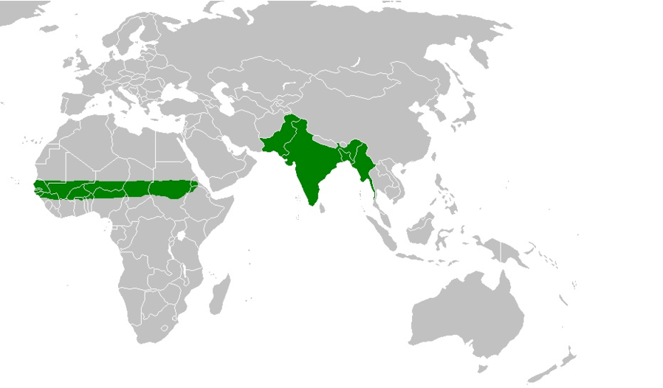

Fig 1: Global distribution of Ring-necked parakeet

3.2 Distinctive Identification:

Ring-necked parakeets are medium to large in size. They are sexually dimorphic. The adult male sports a red and black neck ring and the hen and immature birds of both sexes either show no neck rings, or display shadow-like pale to dark grey neck rings. Both sexes have a distinctive green color. Ring-necked parakeets measure on average 40 cm (16 in) in length, including the tail feathers, a large portion of their total length. Their average single-wing length is about 15 to 17.5 cm (5.9 to 6.9 in). Average weight is 110–182g (Butler 2003). Juvenile males cannot be readily distinguished from adult or juvenile females. The adult males have a dark ring (sometimes reddish) around their neck, which justices the naming of this species as the rose-ringed, or ring-necked, parakeet.
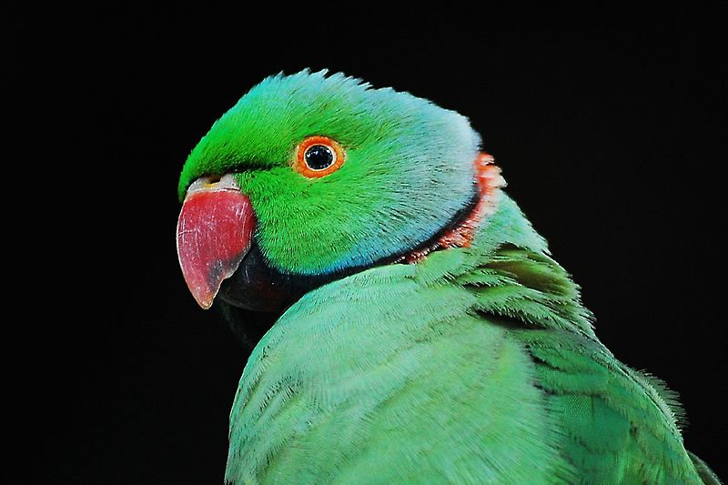

Red and black neck ring

Fig 2: Body characteristics
3.3 Diet:
The Ring-necked parakeet are opportunistic granivores-frugivores, largely consuming dry and fleshy fruits and seeds, but they are also known to consume nectar and flower buds (Ali and Ripley 1969; Clergeau and Vergnes 2011). In the wild, rose-ringed parakeets usually feed on buds, fruits, vegetables, nuts, berries, and seeds. Wild flocks also fly several miles to forage in farmlands and orchards, causing extensive damage. In Indian subcintinent, they feed on cereal grains, and during winter also on pigeon peas (Sailaja et al. 1988). In Egypt during the spring, they feed on mulberry and in summer they feed on dates and nest inside palm trees and eat from sunflower and corn fields. In captivity, rose-ringed parakeets will take a large variety of food and can be fed on a number of fruits, vegetables, pellets, seeds, and even small amounts of cooked meat for protein. Oils, salts, chocolate, alcohol, and other preservatives should be avoided.
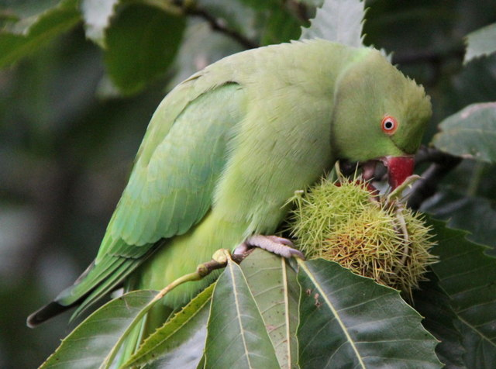

Fig 3: Feeding of Ring-necked parakeet

3.4 Behavioral Characteristics:
I. Habitat and foraging behavior: The ring-necked parakeet may be found in a variety of habitat types, including wood lands, urban parks and cultivated areas surrounded by trees.
Fig 4: Nesting and Foraging behavior
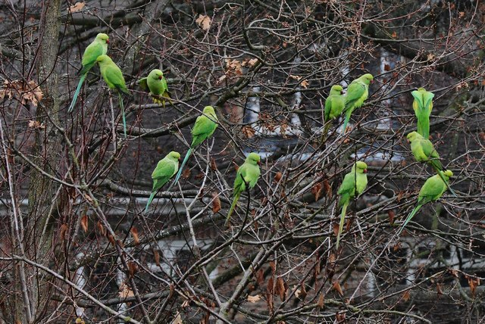
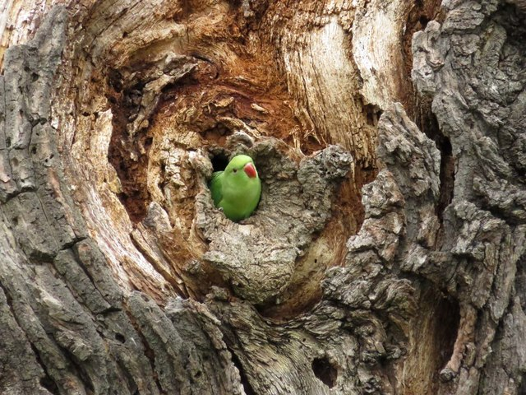

II. Reproduction: In the natural range in Indian subcontinent, Rose-necked parakeet breeds in cavities of trees, where the nest often contains a layer of debris or wood dust, and in crevices of buildings. They breed both in single pairs and in colonies with up to nine couples in one tree (Morgan et al. 1993). The females occupy nests long before the 1st egg is laid and defend their cavities against competitors, especially other female. The clutch size ranges from 2-6, but mostly 3-4 eggs are laid. Only the female incubates and incubation lasts 22-24 d. Chicks hatch asynchronously as the female starts incubation as soon as the 1st egg has been laid. The time lag between the laying of two sequent eggs is 1-2 days. Chicks fledge at an age of six to seven weeks. After leaving the nest, the chicks are still being fed by their parents, especially by the father for at least two weeks. After that time, fledglings gather in groups, while parents separate themselves from the young, and later from each other. Breeding period is related to the latitude, from November to June in Asia (Del Hoyo et al. 1997).

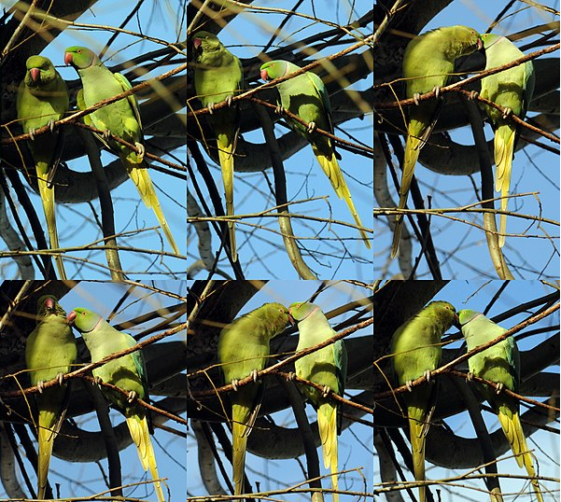

Fig 5: Mating behavior

III. Aviculture: Rose-ringed parakeets are popular as pets and they have a long history in aviculture. The ancient Greeks kept the Indian sub species P. krameri manillensis, and the ancient Romans kept the African sub species P. krameri krameri. Color mutations of the Indian rose-ringed parakeet subspecies have become widely available in recent years (Alderton et al. 2003).

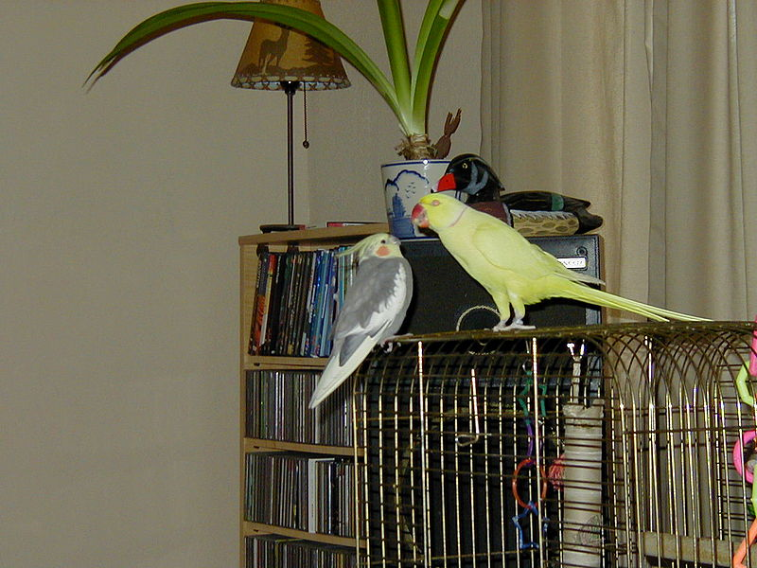

Fig 6: Ring-necked parakeet as a pet

IV. Voice and mimicry: In the wild, this is a noisy species with an unmistakable squawking call, and captive individuals can be taught to speak. Both males and females have the ability to mimic human speech. First, the bird listens to its surroundings, and then it copies the voice of the human speaker. Some people hand-raise rose-ringed parakeet chicks for this purpose. Such parrots then become quite tame and receptive to learning.

V. Status and conservation: The species is listed as least concern by the International Union for Conservation of Nature (IUCN) because its population appears to be increasing, but its popularity as a pet and unpopularity with farmers have reduced its numbers in some parts of its native range. This species has an extremely large range, and hence does not approach the thresholds for Vulnerable under the range size criterion (Extent of Occurrence <20,000 km² combined with a declining or fluctuating range size, habitat extent/quality, or population size and a small number of locations or severe fragmentation). The population trend appears to be increasing, and hence the species does not approach the thresholds for Vulnerable under the population trend criterion (>30% decline over ten years or three generations). The population size has not been quantified, but it is not believed to approach the thresholds for Vulnerable under the population size criterion (<10,000 mature individuals with a continuing decline estimated to be >10% in ten years or three generations, or with a specified population structure). For these reasons the species is evaluated as Least Concern.

CHAPTER 4
Limitation

The limitations of this study were-
1. As the study period was short, it was difficult to collect all information by direct observation.
2. It was difficult to take pictures as the birds were so fidgety. So some related pictures were collected from different websites.
3. Research papers on yellow footed green pigeon is very less in number. So it was difficult to collect all relevant information of the bird in detail.

CHAPTER 5
Conclusion
Birds are the beautiful gift of nature that make our crops safe from harmful insects, helps in pollination and seed dispersing in nature. The ring-necked parakeet is a beautiful wild bird. Among 4 subspecies of ring-necked parakeet, there are 2 subspecies P. k. manillensis and P. k. borealis are available in Bangladesh. The study was conducted on the basis of information available on internet, books, journals, periodicals, magazines and direct observation of the bird along with their feeding, breeding behavior, nesting and other behaviors in different roosting sites in some areas of Bangladesh. The ring-necked parakeet is a widely distributed gregarious parrot, naturally distributed in tropical Sub-Saharan Africa and in the Indian subcontinent. It is the most successful introduced parrot which are medium to large in size. These birds have tails approximately equal in length to their bodies, and are of bright green plumage with red bills. It is a strictly herbivorous parrot and feeds on buds, flowers, shoots, seeds, and fruits. It only rears one brood per year. In the wild, this is a noisy species with an unmistakable squawking call, and captive individuals can be taught to speak. These cavity-nesting birds are highly social, foraging, roosting, and loosely nesting in the same areas. Rose-ringed parakeets are popular as pets. In Bangladesh, it is not yet considered as endangered or vulnerable bird species. But number of some species is declining day by day. We all should remain concerned about the conservation of this bird to keep safe the ecological balance.

References

Ali, S. and Ripley, S. D. 1969. Handbook of the Birds of India and Pakistan, vol. 3. Oxford: OUP.

Butler, C. J. 2003. Population biology of the introduced rose-ringed parakeet Psittacula krameri in the UK. PhD Diss., University of Oxford. Invasive Species Compendium. 2012. Psittacula krameri (Rose-Ringed Parakeet). Wallingford, UK: CABI Publishing. www.cabi.org

Butler, C. J. 2005. Feral parrots in the continental United States and United Kingdom: Past, present, and future. J Avian Med Surg 19:142–149.

Cassey, P., Blackburn, T. M., Jones, K.E. and Lockwood, J.L. 2004. Mistakes in the analysis of exotic species establishment: Source pool designation and correlates of introduction success among parrots (Psittaciformes) of the world. J Biogeogr 31:277–284.

Clergeau, P. and Vergnes, A. 2011. Bird feeders may sustain feral rose-ringed parakeets Psittacula krameri in temperate Europe. Wildl. Biol. 17:248–252.

Cramp, S. (ed) 1985 Handbook of the birds of Europe, the Middle East and North Africa. The birds of the Western Palearctic. Volume IV. Terns to woodpeckers. OUP, New York.

Alderton, D. 2003. The Ultimate Encyclopedia of Caged and Aviary Birds. London, England: Hermes House. pp. 189–190. ISBN 1-84309-164-X.

Hoyo, J.D. , Elliott, A. and Sargatal, J. (eds) 1997 Handbook of the birds of the world. Sangrouse to cuckoos, vol 4. BLI, Cambridge 12 Effects of the Recent World Invasion by Ring-Necked Parakeets Psittacula 264.
Jackson, H., Strubbe, D., Tollington, S., Prys-Jones, R., Matthysen, E. and Groombridge, J. J.. 2015. Ancestral origins and invasion pathways in a globally invasive bird correlate with climate and in-uences from bird trade. Mol. Ecol. 24:4269–4285. DOI: 10.1111/mec.13307. Monk and Rose-Ringed Parakeets 355.

Jobling and James, A. 2010. The Helm Dictionary of Scientific Bird Names. London: Christopher Helm. pp. 215, 321. ISBN 978-1-4081-2501-4.

Josephine, P. and Calvin, D. (2001). "Determination of the origin of British feral Rose-ringed Parakeets". British Birds: 74–79. Retrieved 14 October 2017.

Roscoe, D. E., Stone, W. B., Petrie, L., and Renkavinsky, J. L. 1976. Exotic psittacines in New York State. New York fish game J 23:99–100.

Sailaja, R., Kotak, V.C., Sharp, P. J., Schmedemann, R. and Haase, E. 1988. Environmental, dietary, and hormonal factors in the regulation of seasonal breeding in free-living female Indian rose-ringed parakeets (Psittacula krameri). Hormones and Behavior 22 (4): 518–527.

Acknowledgement

The author is ever grateful and indebted to the Almighty Allah without whose grace it would never been possible to pursue this study in this field of science and to complete this clinical report for the Degree of Doctor of Veterinary Medicine(DVM).

The author would like to thank his beloved teacher and supervisor, Dr. Arup Ratan Sen, Department of dairy and poultry science, Chittagong Veterinary and Animal Sciences University, for his valuable advice, suggestions and kind co-operation during the study period.

The author would like to thank to the Director of External Affairs, Professor Dr. A.K.M Saifuddin, Dept. of Physiology, Biochemistry and Pharmacology, Chittagong Veterinary and Animal Sciences University for his suggestion.

Biography

This is Muhammad minhajul karim from Chittagong. He completed his Secondary School Certificate (SSC) examination in 2008 with GPA-5 from Nanupur A.S. high school, Chittagong and Higher Secondary School Certificate (HSC) examination in 2009 with GPA-4.9 from Govt. Haji Mohammad Mohsin College, Chittagong. Currently he has been doing his internship program which is the compulsory of DVM degree under the Faculty of Veterinary Medicine, Chittagong Veterinary and Animal Sciences University. He feels massive interest in pet bird practice.

