**CHAPTER–I**

**INTRODUCTION**

The people of Bangladesh are blessed with a variety of agricultural resources of which chicken rearing is considered to have potential both for poverty alleviation and food production (Sumy *et al*., 2010). Poultry sector has turned out to be promising dynamic sector with enormous potential for rapid poverty reduction. This sector as a whole has shown growth rate of about 2.8 percent annually over the nineties (PRSP, 2004). Therefore, broiler farming plays an important role in improving livelihood, food security and poverty alleviation in rural and semi-urban communities in developing countries including Bangladesh.

Broiler production has become a specialized and speedy business at present time for the people of the country. Short life cycle of the broiler and requirement of relatively less amount of capital attributed to its popularity to the farmers. This industry has immense potentialities from the point of view of the economic growth of the country as well as fulfillment of basic needs and to keep the price at a minimum level and ensuring food especially animal protein for the human being. This industry has immense scope for the country through changing livelihood and food habit, reduction of dependence of meat related to cow and goat and ultimately has positive impact on GDP growth rate of the country (Ahmed JU *et al;* 2009). The overall socio-economic condition of the beneficiaries, their egg and meat intake ability, empowerment of rural women in decision making and employment opportunities were significantly increased by rearing poultry after the intervention made by Smallholder Livestock Development Project (SLDP) (Alam J, 1997).

Study showed that commercial broiler farming provided employment opportunities for unemployed family persons, developed socio economic conditions and increased women empowerment among rural people of Bangladesh (Rahman SMA *et al;* 2006). Broiler farming has encouraged the people of different sections such as small farmers, landless labourers and educated unemployed as well as for industrialists to establish broiler farms on small & large scale. The better growth performance of broiler bird might simply be a function of higher feed intake. Feed consumption followed similar trend to that of weight gain. These non significant differences in growth performances support the finding of Oliveira et al (1974), Shanmugasundaran *et al.* (1976), Haque and Chowdhury (1994), Anisuzzaman & Chowdhury (1996), Hussain *et al* (1996), Haque and Chowdhury (1994), Anisuzzaman & Chowdhury (1996), Hussain *et al* (1996) & Sarica *et al* (1998) Findings of the study clearly indicate that all broiler farms made good profit & the large farms , however, carried little higher profit (Bang, vt. 2001.)

Broiler meat contains high quality protein and micro-nutrients which has had a tremendous impact on health and nutrition for the poor people in rural areas (Neumann et al., 2002; Barroetoa, 2007). Again, another study reported that it can be the main source of family earning or can provide sufficient income and gainful employment opportunity to rural farmers throughout the year (Bhende, 2006). For this reason, broiler farming has been playing a key role in providing meat to overcome the malnutrition and serve as a tool for employment generation and poverty alleviation (Raha, 2007). All these evidences suggested that commercial broiler farming deserve wider scale expansion throughout the country as a poverty reduction activity. Despite its high potential the broiler farming is not based on sound footings. Studies revealed that most of the broiler farm owners suffered from adequate amount of credit to run their farms and provision of credit for poultry farming is not yet very regular and well established practice among all the financial institutions - banks and NGOs in Bangladesh (Jabbar *et al.*, 2005). So, broiler farm owners face various problems like shortage, high price and poor quality of DOC (Day-old chick); high price, poor quality and unavailability of feeds; high cost and low quality of medicine, vaccine and veterinary services shortage of capital; inadequate marketing facilities; and poor transportation and communication (Raha, 2007).

Though broiler farming faces various problems, a huge scope exists for development of broiler industry in Bangladesh. It is interesting to note that broiler farming is solely in the private sector particularly in the hands of small farmers who are running their enterprise through self-finance. So it is very much necessary to assess whether broiler farming is contributing positively for the socio-economic development of the broiler farmers or not. The present study was undertaken to estimate the weight gain and feed conversion ratio, estimation of the cost and return from broiler fanning and to assess the extent of improving livelihood of small scale commercial broiler farmers. It also identifies and analyzes the problems faced by the farm holders, management pattern of broiler farming in Dinajpur district of Bangladesh.

**CHAPTER - II**

**METHODOLOGY**

**Study area:**

The study was conducted in Birampur sadar Upazilla in Dinajpur District which is about 211.81 sq km, located in between 25°18' and 25°29' north latitudes and in between 88°50' and 89°05' east longitudes.

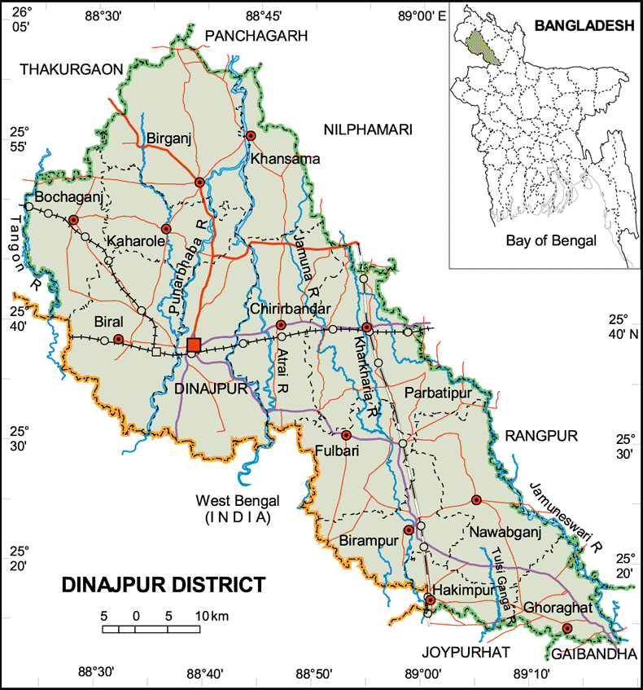 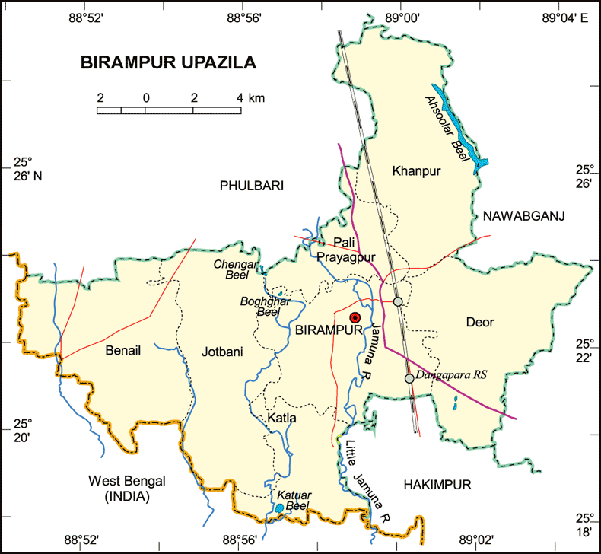

**Fig: Location of the study area**

In Birampur upazilla most of the farms are situated near the house. Some of the farms are separated from the house. For improved faming system, transport facilities and other facilities are considered during site selection for farming.

**Study period:**

The study was carried out in Upazilla, Birampur, Dinajpur during internship placement period from 1February to 29 March, 2018. During this period I visited some farms & collected data on prospects and problems of Broiler farming at Birampur upazilla by using an interview schedule through face to face interviewing.

**Population and sample size:**

All the poultry farms of the district engaged in poultry production were considered as population and a sample size of 15broiler farms were selected.

**Sampling methods:**

Dinajpur district and Birampur upazilla were selected in bias (Non-random selection). 15 farms of Birampur upazilla were selected randomly (Stratified random sampling). Each farm rearing at least 1000 bird is taken under consideration.

**Methods of data collection:**

Data were collected through direct interview schedule and recorded in a questionnaire. The schedule was prepared maintaining relevance with the objectives of the study. Before launching the survey, the questionnaire was pre-tested and improved accordingly. In order to collect the more purified data of various farms an organized questionnaire was formatted.

**Data analytical Techniques:**

The collected data were analyzed after coding, decoding, summarized. Simple statistical methods such as mean, percentage, standard deviations etc. were applied for analyzing the collected data to meet up the study goals and objectives.

**CHAPTER- III**

**FARM INFORMATION**

**Socioeconomic status of the farmers**:

Broiler farming was a income generating enterprise for almost all the farmers. People from all strata of the society, irrespective of religion, education, occupation & economic background were involved. About one third of the farmers were literate, the other were illiterate. The majority (70%) were not engaged in other form of occupation and by this occupation their economic condition was sound enough to maintain their families.

**Strains that are used by farms:**

The broiler were non descript types widely differing phenotypes. The so- called Hab chicks, Starbro, ISa-I 757 are common. Some farmers collected chicks from Kazi farm and some farmers from BRAC farm.

**Husbandry practices:**

The most practical program for broiler rearing has been the use of all-in, all-out system in which   
only one age of broilers is on the farm at the same day and later sold on the same day,  
after which there is a period when no birds are on the premises. This lack of birds breaks   
any cycle of an infectious disease: the next group of birds has clean start with no possibility   
of contracting a disease from older flocks on the farm. The downtimes maintain the  
farmer ranges from 14 to16 days.

**Flock Size**

The majority (85%) of flocks comprised 1500-2500 birds within the overall range between 1000-3000.

**Poultry population in each farm, ( Source: Field Survey, 2018)**

|  |  |  |
| --- | --- | --- |
| Serial No. | Name of the farm | Flock size |
| 1 | Mominur poultry farm | 3000 |
| 2 | Fozlur poultry farm | 3000 |
| 3 | Rasel poultry farm | 3000 |
| 4 | Kafi poultry farm | 2500 |
| 5 | Jahir poultry farm | 2500 |
| 6 | Rashed poultry farm | 2000 |
| 7 | Taleb poultry farm | 2000 |
| 8 | Bari poultry farm | 2000 |
| 9 | Momotaz poultry farm | 2000 |
| 10 | Mosarof poultry farm | 1700 |
| 11 | Arif poultry farm | 1500 |
| 12 | Khondokar poultry farm | 1500 |
| 13 | Sabbir poultry farm | 1200 |
| 14 | Adorsho poultry farm | 1000 |
| 15 | Mostak poultry farm | 1000 |

**Table 1: Poultry population in each farm Housing.**

There are of course many different styles and designs of houses such as shed   
hype, combination hype, Gable type etc. during my study I found that   
most or the farmers constructed gable Type house for their bird which is made by bamboo & tin and suing the wire net around the houses, almost all of the houses are south facing  
& keep the house in well ventilated.

**Floor, Feeder and water space followed by tile farmers are as follows:**

|  |  |  |  |
| --- | --- | --- | --- |
| **Age** | **Floor space** | **Water space** | **Feeder space** |
| First week | 0.5sqft/bird | 0.5 inch/bird | 1 inch/bird |
| Second week | 0.5sqft/bird | 0.57 inch/bird | 1.5 inch/bird |
| Third week | 1 sqft/bird | 0.75 inch/bird | 1.5 inch/bird |
| Fourth week | 1 sqft/bird | 1 inch/bird | 2 inch/bird |
| Fifth week | 1 sqft/bird | 1 inch/bird | 2 inch/bird |

**Treatment of the chick in the house:**

After arrival of the chick in the house farmers firstly gave the chick water with the   
mixer of Glucose, Vitamin and minerals. Then feed is given in a paper sheet for the first   
3 hours, after that feed was given in feeder. Number of waterer & feeder used by  
the farmer is shown in following table:

**Number of Feeder:**

|  |  |  |
| --- | --- | --- |
|  | **0-2 Weeks** | **3-5 Weeks** |
| Chicks feeder | 2 ft long feeder/ 50 chicks | - |
| Tube Feeder | - | 4 in number/100 birds |

**Number of waterer:**

|  |  |  |
| --- | --- | --- |
| Waterer | **0-2 weeks** | **3-5 weeks** |
| 1 plastic drinker/50 birds | - |
| - | 1 Plastic drinker/50 birds |

**Brooding:**

Artificial heat was use in brooding chick. It was seen that 5-10 brooder /500 bird & electric   
bulb were used by the fanners as a heat source for the first 2 weeks of age Number.   
of electric bulb were used by farmers for heat source is shown in following  
table:

|  |  |  |
| --- | --- | --- |
| **Number of chicks** | **No. of electric bulb** | |
| **Summer** | **Winter** |
| 500 | 100 watt 2 in number and 60 watt 1 in number | 200 watt 2 in number and 100 watt 2 in number |

After 2 weeks brooder guard had been withdrawn and the brooder house ere used as grower house.

**Temperature schedule:**

|  |  |
| --- | --- |
| **Age(weeks)** | **Temperature of Brooding** |
| 0-1 | 90ºF |
| 1-2 | 85ºF |
| 2-3 | 80ºF |
| 3-4 | 75ºF |
| 4-5 | 75ºF |

* It was seen that most of the farmer used thermometer for measuring temperature.

**Litter management:**

|  |  |  |
| --- | --- | --- |
| **Litter material** | **Depth** | |
| **Winter** | **Summer** |
| Rice husk | 1.5-2 inch | 1 inch |

**Feeding:**

Feeding is main function in rearing broiler chicks. More feed consumption, more weight gain. The chicks should be given small quantity of feed frequently for the 1st week. Some farmers collected feed from C.P feed and some farmers from Aman feed.

The farmer use the following way for feeding the broiler.

**Feeding Practices of Broiler Farming**

|  |  |
| --- | --- |
| **Age** | **Nature of feed** |
| 1st week | Crumble |
| 2nd week | Crumble |
| 3rd week | Pellet |
| 4th week | Pellet |
| 5th week to finishing | Pellet |
| 6th week to finishing | Pellet |

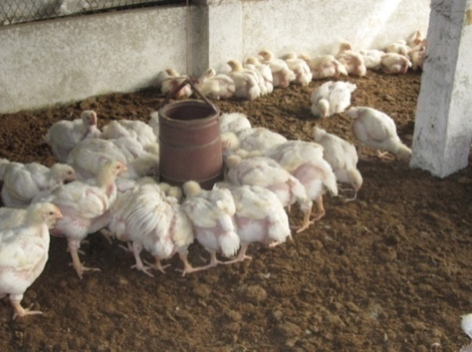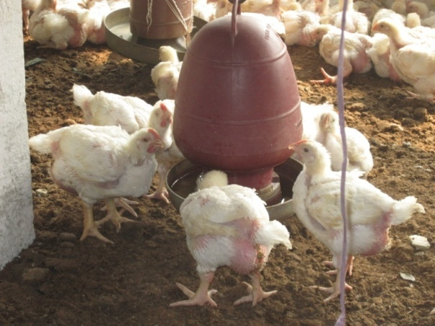

Fig: Feeding and watering practices in broiler farm

**Weight gain:**

After proper feeding weight gain which is recorded by the farm owner are given bellow:



Weight(gm)

Fig: Graphical Representation of weight gain

**Week**

**Fig1: Graphical representation of weight gain.**

**Health maintenance program:**

A health program is fundamental for successful broiler production. Under health program  
farmers only done vaccination & used foot bath (1% ppm) in front of the shed.

**Vaccination schedule:**

|  |  |  |
| --- | --- | --- |
| **Age** | **Vaccine(Trade)** | **Route** |
| 3rd day | BCRDV | Eye drop |
| 7th day | Gumboro (228E) | Eye drop |
| 14th day | Gumboro (228E) | Eye drop |
| 21st day | BCRDV | Eye drop |

**Marketing information of Broilers:**

Broilers in this region were raised & sold when age at 5 weeks either at the local market or at the farmer doorstep to individual and local traders.

|  |  |  |  |
| --- | --- | --- | --- |
| **Parameters** | **Purchase cost/chick** | **Feed cost/Kg** | **Price of meat/Kg** |
| Farm-1 | 29 | 35 | 132 |
| Farm-2 | 30 | 34 | 135 |
| Farm-3 | 30 | 35 | 134 |
| Farm-4 | 29 | 35 | 132 |
| Farm-5 | 31 | 32 | 135 |
| Farm-6 | 29 | 35 | 135 |
| Farm-7 | 30 | 35 | 135 |
| Farm-8 | 30 | 32 | 137 |
| Farm-9 | 29 | 34 | 134 |
| Farm-10 | 30 | 35 | 133 |
| Farm-11 | 29 | 34 | 137 |
| Farm-12 | 31 | 35 | 130 |
| Farm-13 | 30 | 35 | 133 |
| Farm-14 | 31 | 35 | 130 |
| Farm-15 | 29 | 33 | 137 |

**Table 2: Marketing information of Broilers, (Field Survey, 2018)**

**CHAPTER- IV**

**RESULT AND DISCUSSION**

**Performance of commercial broiler at different farms in Birampur upazilla:**

|  |  |  |  |  |  |
| --- | --- | --- | --- | --- | --- |
| **Parameters** | **Farm-1** | **Farm-2** | **Farm-3** | **Farm-4** | **Farm-5** |
| Body wt(kg) | 1.6 | 1.5 | 1.6 | 1.7 | 1.5 |
| Feed intake (Kg)/bird | 3.2 | 3.1 | 3.1 | 3.2 | 3 |
| FCR | 2:1 | 2.06:1 | 1.9:1 | 1.88:1 | 2:1 |
| Mortality rate | 3% | 2.8% | 3% | 2.5% | 2.9% |
| *Cost involve/bird | 152 | 145 | 148 | 152 | 142 |
| Return/bird | 212 | 203 | 214 | 224 | 203 |
| Benefit/bird | 60 | 58 | 66 | 72 | 61 |
| Cost Benefit ratio | 1:.39 | 1:.40 | 1:.44 | 1:.47 | 1:.42 |

|  |  |  |  |  |  |
| --- | --- | --- | --- | --- | --- |
| **Parameters** | **Farm-6** | **Farm-7** | **Farm-8** | **Farm-9** | **Farm-10** |
| Body wt(kg) | 1.6 | 1.5 | 1.5 | 1.6 | 1.7 |
| Feed intake (Kg)/bird | 3.1 | 2.9 | 3 | 3.1 | 3.2 |
| FCR | 1.9:1 | 1.9:1 | 2:1 | 1.9:1 | 1.8:1 |
| Mortality rate | 3% | 2.5% | 3% | 2.9% | 3.1% |
| *Cost involve/bird | 148 | 142 | 142 | 145 | 152 |
| Return/bird | 216 | 203 | 206 | 215 | 226 |
| Benefit/bird | 68 | 61 | 64 | 70 | 72 |
| Cost Benefit ratio | 1:.45 | 1:.42 | 1:.45 | 1:48 | 1:.47 |

|  |  |  |  |  |  |
| --- | --- | --- | --- | --- | --- |
| **Parameters** | **Farm-11** | **Farm-12** | **Farm-13** | **Farm-14** | **Farm-15** |
| Body wt(kg) | 1.4 | 1.8 | 1.6 | 1.8 | 1.45 |
| Feed intake (Kg)/bird | 2.8 | 3.3 | 3 | 3.2 | 3 |
| FCR | 2:1 | 1.8:1 | 1.8:1 | 1.7:1 | 2.06:1 |
| Mortality rate | 2.5% | 3% | 2.1% | 3.5% | 2.4% |
| **\***Cost involve/bird | 135 | 157 | 145 | 153 | 138 |
| Return/bird | 192 | 234 | 213 | 234 | 199 |
| Benefit/bird | 57 | 77 | 68 | 81 | 61 |
| Cost Benefit ratio | 1:.42 | 1:.49 | 1:.46 | 1:.52 | 1:.44 |

**Table 3: Performance of commercial broiler at different farms in Birampur upazilla**

**Fig2: Graphical representation of body weight and feed intake**

**Fig 3: Graphical representation of benefit (%) of respective farms**

**Total Cost**

\***(Cost involve/bird=**

**Total no of birds**

Cost involve per bird including housing, vaccination, medication, electricity, feed and chick cost.

The above table shows that body Weight was highest in farm-**12, 14(1.8)** followed by farm-4, 10(1.7), farm-1, 3, 6, 9, 13(1.6), farm-2, 5, 7, 8(1. 5), farm-15(1.45) and farm-11(1.4) respectively.

FCR was found best in farm -**14(1.7)** followed by farm-10, 12, 13(1.8), farm-4(1.88), farm -3, 6, 7, 9(1.9), farm-1, 5, 8, 11(2.0) and farm-2, 15(2.06) respectively.

Return /bird varied from farm to farm due to high market price. The farm **-12, 14** got highest market price **(234**) then farm-10(226), farm-4(224), farm-6(216), farm-9 (215), farm-3(214), farm-13(213), farm-1 (212), farm-8 (206) farm-2, 5, 7 (203) farm-15 (199) and farm-11(192).

Benefit was estimated highest in Farm**-14(81)** followed by farm-12(77), farm -4, 10(72), farm -9(70), farm-6, 13(68), farm-3(66), farm-8(64), farm-5, 7, 15(61) farm-1(60), farm-2(58) and farm-11(57) respectively.

And cost benefit ratio was determined best in farm**-14(1:0.52)** followed by farm-12(1:0.49), farm-9(1:0.48),farm-4, 10(1:0.47),farm-13(1:0.46),farm-6,8(1:0.45),farm-3, 15(1:0.44) farm-5, 7, 11(1:0.42) farm-2(1:0.40)andfarm-1(1:0.39) respectively.

In the study, we notice that production performance long stand depend on chick's quality i.e. different hatchery.Production variation was also dependent on different strains (Zaman, 2008). It is also observable that some hatchery supply often different quality maintaining chicks. It is depend on demand and supply of chicks. In the study the chicks of KAZI farm (1.7:1) have shown better performance than others. The farmers who will rear the chicks of KAZI and fed their flock C.P's feed, will get more profit. On the other hand the chicks of BRAC (2.06:1) show lower performance due to low quality chicks. Their chick’s weight, feed conversion ratio, are low but disease prevalence and mortality is higher than other. Overall the whole study shows that the average weight gain, feed convertion ratio of broiler at Birampur Upazilla is almost satisfactory.

**Development of socio-economic condition of broiler farmers in the study area:**

**Employment opportunity**

Small scale commercial broiler farming provided an annual employment opportunity to the family members of broiler farmers. It was also observed that similar type of employment opportunities created for rural poor, landless labourers, small and marginal farmers and unemployed or under employed laborers. Thus, adopting of small scale broiler farming made a positive impact on the employment opportunities to the unemployed family labors in the study area.

**Socio-economic status of the farmers**

Different variables and categories used to describe socio-economic status of the farmers are enlisted in Table 4.

**Table 4: Factors associated with socio-economic status of the farmers** (N=15)

|  |  |  |
| --- | --- | --- |
| Variables | Categories | No. of farm |
| Type of farmer | Landless (0.00-0.50 acre) | 1 |
| Marginal (0.51-1.24 acre) | 1 |
| Small (1.25-2.47 acre) | 2 |
| Medium (2.48-4.94 acre) | 4 |
| Large ( 4.95 acre) | 7 |
| Investment source | Own | 8 |
| Bank loan | 4 |
| With interest from money lender | 2 |
| Without interest from money lender | 1 |
| Size of the farm (No. of birds) | <1500 | 3 |
| 1500-2500 | 9 |
| 2500< | 3 |
| Condition of latrines | Non-sanitary | 0 |
| Semi-sanitary | 4 |
| Sanitary | 11 |
| Poultry farm management skill | High | 6 |
| Medium | 6 |
| Poor | 3 |
| Source of drinking water | Own tube-well | 12 |
| Shared-in tube-well | 1 |
| deep tube-well | 2 |
| Health status | Good | 5 |
| Moderate | 8 |
| Poor | 2 |

**Monthly household income and expenditure**

The overall monthly income of the farmers increased day by day. Thus positive changes in household income occurred due to the adoption of small scale commercial broiler farming in Birampur upazilla.

**Current savings and investment**

The percentage of exchange of cash in hand and savings with banks were increased by adoption of broiler farming. These changes were bearing a direct financial impact on investment in broiler business.

**Conditions of school-going children**

School-going boys and girls of broiler farmers increased successively. Most of the respondents expressed that the education expenses of their children increased which was affordable with their increased income from broiler farming

**Fig 4: Graphical representation socio-economic condition of broiler farmers**

**Problems of broiler farming in Birampur Upazilla :**

1. Shortage of feed & proper nutrition
2. Lack of transport facilities
3. Low quality feed and chick
4. Lack of knowledge
5. Lack of well established diagnostic lab and post mortem facilities
6. Lack of proper vaccination
7. Lack of bio-security knowledge
8. Unavailability of expert consultants
9. Unavailability of drugs and High cost of drug
10. Absence of proper disease control model
11. Acute shortage of veterinary support staff
12. Influence of Drugs Company
13. Influence by feed supplying company
14. Lack of Govt. influence

**LIMITATIONS**

The required information of the study was collected by a single visit to each farm at the end of one batch of broiler marketing due to shortage of time and fund during the internship placement period at Birampur upazilla Veterinary Hospital. The result will be more appropriate if the no, of farm increased.

**CHAPTER- V**

**CONCLUSION**

From the above discussion it can be concluded that Birampur upazilla under Dinajpur district is a very suitable and prospectious zone for broiler farming and broiler production. But first it is crying need to solve the above mentioned problems and other constraints. Then it would be possible to establish broiler farms to meet the protein demand of the people and to remove the poverty of people creating employment opportunities for the unemployment people. Government is to take proper steps and play an important role for establishment of a poultry zone in this area by solving the all problems and giving more opportunities to the existing farm owners. The government can take a mega plan to establish a farm in each upazilla of Bangladesh using which as a model, local people would create their own farm. Finally, it can be said that small scale broiler farming contributed positively to the socio-economic development of the broiler farmers as well as the improvement of rural livelihood, in the study area.

The following recommendations may be put forward:

* Government should monitor the reasonable price of poultry feed and day old chicks.
* Facilities of the institutional loan to the owners of poultry farms should be made so that they can get the credit on easy terms.
* Hatcheries should increase the supply of day old chicks.
* For proper housing, nutrition, disease control, marketing and management-DLS should provide short term training for the owners of the poultry farms.
* The regular supply of electricity should be ensured.
* Government support should be provided to medicine and vaccine producing Institutions to ensure the availability of the medicine and vaccine in the area.
* Price stabilization of the market should be monitored by the government to ensure the reasonable profitability of the farmers.

**ACKNOWLEDGMENT**

First of all the author desire to express his deepest sense of gratitude to “**The Almighty Allah**” with whose blessing his ability to complete this valuable work.

The author also feels grateful to the supervisor **Mr. Md. A. Halim**, Professor of department of Agricultural Economics and Social Sciences, Faculty of veterinary medicine in Chittagong Veterinary and Animal Sciences University, Khulshi, Chittagong, for his guidance, inspiration during the study period and also preparing of this production report. The author extends his gratefulness to **DR. Babu Kanti Nath**, Assistant Professor, Department of Dairy and Poultry Science, Faculty of Veterinary Medicine Chittagong Veterinary and Animal Sciences University (CVASU) for his scholastic guidance. The author also grateful to the farmers of those areas for their patience in giving information.

The author also grateful to the placement supervisor **Dr. Mohammad Idris Ali**, Upazilla livestock officer, Birampur Upazilla Hospital, Dinajpur, for his sincere co-operation.

The author also feels much proud to convey his profound thanks to his friends and all well-wishers who have seriously encouraged him to run this study work.

Lastly but not the least express his deepest sense of gratitude and heart- felt thanks to his beloved parents, brothers and sisters who have sweet much to bring his up today’s position.

The Author September 2018

**REFERENCES**

Agarwal *et al*; (1986). Broiler feeding and nutrition. Pakistan journal of Nutrition2(2);60-67

Anisuzzaman and Chowdhury (1996), An Economic Study On Poultry Farms In Bangladesh,

Bangladesh Bureau of Statistic, statistical year book of Bangladesh (1996), Dhaka p-46.

Del Ninno *et al;* (2001). Commercial Broiler production. North Carolina state University

Haque and Chowdhury, (1994), Current Ststus of Poultry and Marketing System of Bangladesh, Agricultural Research Project – 2.

Hoffmann and J.Otte.,(2005),The contribution of poultry of Rural Development,World`s Poultry Science Journal. Vol.61

Islam,F. *et al*; (2007).An Analytical evolution of broiler farm units in Malakand agency.International Journal of Life Sciences.1(4):377-384

Karlon (2001).Broiler production,Taxas Agricultural Extension Services bulletin. Texes A&M

L. Mozumdar. *et al;* (2009), Broiler farming: An approach to improve rural livelihood, J. Bangladesh Agril. Univ. 7(2): 395–402

Nauta WJ, *et al;* (2001). Animal Breeding in Organic Farming.Discussion paper, Louis Bolk Institute, Driebergen.

PRSP, (2004). Unlocking the Potential, National Strategy for Accelerated Poverty Reduction, General Economics Division, Planning Commission, Government of the People’s Republic of Bangladesh.

Raha SK (2007). “Broiler industry in Bangladesh: some issues”. Proceedings of the fifth International Poultry Show and Seminar, Organized by World’s Poultry Science Association, Bangladesh Branch, Dhaka, Bangladesh. 7

Rahman MM, *et al;* (2002). Study on the Scientific Knowledge and Managemental Skill in Commercial Broiler Farming Programme at the Farmers Level of Rajshahi District. OnLine J. Biol. Sci. 2(11): 767- 768.

Rahman, M (2003 ) Growth of Poultry Industry in Bangladesh. Poverty Alleviation and Employment Opportunity7  3rd  International Poultry Show and Seminar, Dhaka, Bangladesh.

Sumy MC. *et al*; (2010). Study on the socioeconomic condition and productive performances of backyard chicken in some selected areas of Pabna district. J. Bangladesh Agril. Univ. 8(1): 45-50.

**BIOGRAPHY**

A.M.M. Golam Mortuza, Son of Md. Nurul Islam and Mst. Moriam Begum. He is an interned veterinary doctor under the faculty of Veterinary Medicine (FVM) in Chittagong Veterinary and Animal Sciences University (CVASU). He passed his Secondary School Certificate (SSC) Examination in 2008 followed by Higher Secondary Certificate (HSC) Examination in 2010 from Rajshahi board. In future he would like to do Research work about animal welfare, epidemiological study and Zoonotic diseases those take public health significance in the world regarding one health constitution.

**APPENDIX**

**Study on Commercial Broiler farming in Birampur upazilla**

**Questionnaire**

1. A. Name of the farm.................................................

B. Name of the owner/Farmer/Employee.................

C. Address: Village.........Union................

P.O.................Thana.............District……….

2. Husbandry practice:

A. Housing: a. Brooder house b. Grower cum finisher house

B. Feeding:

* Collection of feed...........................................
* Storage of feed …..........................................
* Types of feed...................................................
* How many times feed supplied daily.............

C. Watering:

* Source of water
* Frequency of water supply

D. Litter materials................................................................

E. Ventilation

a. Sufficient .b. Insufficient

F. Lighting schedule…………………………………………

G. Bio-security.............................................................

H. Foot bath: ………………………………………… 3. Number of sheds.......................................................

4. Incidence of diseases……………………………….

5. Management of disease condition:

a. Self management

b. Quack

c. Veterinary doctor

6 .Health programme:

a. Vaccination. b. Anthelmintic

7. Marketing system:……………………………………

8. Cost & return:………………………………………..

9 The farm is profitable or not......................................

Name of the interviewee............... Name of the interviewer...........

Date.......... Date: ……………

Signature............. Signature